Month 2
Combined NHS Wales Joint Commissioning Committee Report
July 2025

Detailed table of contents

Detailed table of contents 2
Introduction 4
Appendix 1: Operational Performance Report Month 2 7
Key Information for Month 2 7
Key Planned Care Specialties Summary: 8
Services in Escalation 13
Quality Dashboard 14
Welsh Government Performance Measures 18
Service Performance Scorecard 19
Welsh Government Post Covid Targets 23
Cardiac Surgery Performance 30
Cardiology Performance (Specialised Only) 33
Cardiology Performance (Waiting List) 35
Bariatric Performance 37
Thoracic Surgery Performance 39
Plastic Surgery Performance 41
Plastic Surgery Performance (Waiting List 1) 43
Positron Emission Tomography Performance 45
Paediatric Surgery Performance 47
In Vitro Fertility (IVF) Performance 49
In Vitro Fertility Performance (Waiting List) 51
Neurosurgery Performance 53
Posture and Mobility Performance 56
Posture and Mobility (Waiting List) 58
CAMHS – Placement Performance 59
Adult Medium Secure Bed-day Performance 61
Ambulance Services and NHS 111 Wales 63
Appendix 2: Q1 Implementation of NWJCC Foundation Plan 64
Summary of the progress made in Quarter 1 against the published strategic priorities 65
Detailed update against Quarter 1 milestones for the strategic priorities 66
Appendix 3: Workforce Report 75
Sickness Absence 75
PADR Compliance 76
ESR Core Skills Statutory and Mandatory Training Compliance 76
Wellbeing 77
Current Wellbeing Initiatives 77
List of Figures 79
List of Tables 79

Introduction

The NHS Wales Joint Commissioning Committee (NWJCC) was formally established on 1 April 2024, with delegated commissioning authority from Health Boards for services within the portfolios of Ambulance and NHS 111, Mental Health and Learning Disabilities (including Vulnerable Groups), and Specialised Services.

Throughout 2024/25, the NWJCC adopted a phased approach to implementing its transition programme, aimed at consolidating and fully embedding the new organisational structure. In July 2024, Directors were appointed to their respective roles, initiating a period of organisational change. By March 2025, this process was mostly complete, with few actions remaining.

As part of the reorganisation, recruitment activity was temporarily paused in line with HR policy requirements. Consequently, the capacity to fully align resources to key priority areas was limited until all senior and supporting roles, including Directors, were in place. As of early May 2025, the NWJCC was operating at a reduced capacity. This reduced staffing level significantly affected the delivery of planned programmes, necessitating a continually reviewed and prioritised work plan, discussed regularly with the Joint Commissioning Committee.

Month 2 Operational Performance Report (Appendix 1)

To support the main body of this report, the month 2 Operational Performance Report is included as appendix 1. This comprehensive report provides a detailed analysis of NHS Wales Joint Commissioning Committee (NWJCC) commissioned services, covering key metrics such as waiting times, service activity, quality indicators, and workforce compliance. It spans multiple portfolios including Ambulance Services, NHS 111 Wales, Mental Health, Specialised Services, and Planned Care. The report also includes updates on services in escalation, incident trends, and delivery against national targets. Developed to inform evidence-based decision-making, it complements this report by offering a more granular view of system pressures, emerging risks, and provider performance.

An accompanying interactive Power BI dashboard is available to allow stakeholders to explore and interrogate the data further.

Quarter 1 Position report against plan (Appendix 2)

The Joint Commissioning Committee endorsed the Foundation Plan 2025/2026 at its March meeting. The plan was subsequently submitted to Welsh Government.

Programme and project management arrangements have been wrapped around
the implementation of the plan, enabling co-ordination, tracking and management at a variety of levels, and to a variety of audiences/recipients. However, the approach here is one of pragmatism in order to ensure both good discipline, coupled with pace/delivery).

This Appendix provides members with an update for assurance against the Quarter 1 deliverables of the NWJCC Foundation Plan for 2025/2026.

Workforce Report (Appendix 3)

This element provides an update on workforce matters for the reporting period 1 January 2025 to 31 March 2025 and consolidates key performance indicators across Sickness Absence, Staff Turnover and Performance Development Reviews (PADRs), the Core Skills Statutory and Mandatory Training Compliance modules, and Staff Movements.

Overview and Highlights

- Workforce Size: The JCC has a total headcount of 108 (102.27 FTE) as of 31 March 2025,

- Sickness Absence: the current sickness absence rate stands at 2.81%, which is a reduction from 3.41% reported in the last quarter,

- Performance Appraisal and Development Review (PADR): Compliance is at 50.48%, which is significantly below the required target of 85%.

- Core Skills Statutory and Mandatory Training Compliance: compliance levels vary across the online training modules, with critical gaps in Fire Safety and Health & Safety training,

- Staff Turnover: The rolling turnover rate stands at 1.81%, reflecting a stable workforce but requiring continued monitoring. This has reduced since the last quarter figure of 3.71% on a total headcount of 109; and

- Data Integrity: there is a requirement to undertake an ongoing data cleansing exercise of the data stored on the Electronic Staff Record (ESR) to improve reporting accuracy.

Appendix 1: Operational Performance Report Month 2

This appendix provides a high-level summary of NHS Wales service performance across multiple specialties. It focuses on key indicators such as waiting times, activity levels, incident trends, and overall performance. The insights are intended to support evidence-based decision-making and promote equitable, high-quality care across Wales.

To complement this appendix, an interactive Power BI dashboard is also available. It offers enhanced analytical functionality, including drill-down features and year-on-year comparisons, enabling users to explore data in greater detail and derive meaningful insights. Click this link to explore the dashboard: Interactive Performance Report

Key Information for Month 2

Services in escalation

There are currently 7 services in escalation as shown in table 1 (Page 14), these included:

- 2 service at Level 1,
- 2 services at level 2,
- 2 services at level 3.
- North Wales Plastics outreach clinic is also under Welsh Government escalation.

As previously reported, there are now two Women and Children’s services in Cardiff & Vale University Health Board at Level 3 escalation. Following a review by the Senior Leadership Team, the escalation objectives were reset in September 2024, in partnership with the Health Board to enable further improvements to be made.

Quality: Incidents: During this period, 28 incidents were recorded - comprising 20 reportable incidents (71%), 6 Datix entries (21%), and 2 Early Warning Notifications (7%) - with the highest single cluster (4) in Women & Children’s services at BCU (Q1), recurrent reportable incidents in Cardiac services at SBU and C&V (Q1), a concentration of low-severity incidents in SBU Mental Health (Q4), and notable reporting across Renal, WAST, Cancer & Blood, and Women & Children’s services in multiple Health Boards, highlighting both the predominance of serious incidents and the variation in escalation practices across regions.

Quality: Complaints: A total of 8 concerns were recorded over two quarters, with 7 classified as patient concerns and 1 ministerial concern (Neurosciences, BCU, Q1), the highest volume linked to Women & Children’s services across multiple Health Boards, while notable entries also came from Neurosciences, Cancer & Blood, and Cardiac services—highlighting ongoing pressures in key specialties and suggesting either improved local resolution or delayed reporting into the new financial year.

Key Planned Care Specialties Summary:

Cardiac Surgery: Inpatient activity across the top five providers showed varied trends, with Cardiff & Vale peaking at 62 episodes in Month 12 of 2024/25 before falling to 38 in Month 2 of 2025/26, while Swansea Bay and Liverpool Heart & Chest experienced steadier volumes with early-year declines. Outpatient appointments were more consistent overall, though Swansea Bay’s attendance dropped sharply after Month 9, whereas Cardiff & Vale and Liverpool Heart & Chest maintained stable levels. Waiting times for outpatient appointments largely remained within 25 weeks with no breaches over 52 weeks, but inpatient waiting lists saw sustained pressure - particularly in Cardiff & Vale - with 35 patients waiting over 52 weeks by Month 2 of 2025/26, highlighting ongoing challenges in elective admission capacity.

Specialised Cardiology: Cardiff & Vale and Swansea Bay University Health Boards consistently recorded the highest levels of activity in 2024/25, both peaking in Month 12 before showing only modest declines in the new financial year, indicating strong and sustained service demand. Betsi Cadwaladr experienced steady growth through Month 10 followed by a brief decline and partial rebound, while Aneurin Bevan recovered sharply from a mid-year drop to end the year stronger than it began. In contrast, Cwm Taf Morgannwg reported consistently low volumes, highlighting significant variation in specialist cardiology throughput across providers.

Cardiology Performance (Waiting List) New outpatient appointments account for the largest share of cardiology demand, with 293,488 patients (69%) waiting during the period, reflecting sustained referral pressure and consistently high volumes. Follow-up outpatient appointments (15%), diagnostics (8%), and admitted diagnostic interventions (4%) together highlight additional system pressures, while a reduction in ‘Unknown’ pathway entries suggests improved data capture. Overall, the data underscores the urgent need for targeted demand management and outpatient capacity planning to address the dominant source of backlog growth.

Bariatric Surgery: Bariatric inpatient activity for 2025/26 currently appears low, with 10 procedures recorded in the first two months, but this reflects an incomplete year and is not directly comparable to the 149 procedures delivered during Months 4–12 of 2024/25 across Swansea Bay and Salford. Waiting list volumes remain steady, with most patients waiting under 25 weeks and a small number exceeding 52 weeks, primarily in pre-assessment. These early figures should be viewed with caution, and a clearer performance picture will emerge by mid-year.

Thoracic Surgery: Inpatient activity among the top five specialist providers showed notable variation, with Cardiff & Vale peaking at 99 episodes in Month 10 of 2024/25 before declining at the start of 2025/26, while Swansea Bay maintained lower but stable volumes. Outpatient appointments were consistently highest at Cardiff & Vale and Swansea Bay, though Liverpool Heart & Chest delivered steady moderate volumes, and other providers reported minimal activity. Waiting lists for both admissions and new outpatient appointments remain under pressure, particularly in the 5–25 and 26–51 week ranges, with a small but persistent cohort exceeding 52 weeks, indicating unresolved long-wait challenges.

Plastic Surgery Performance: Swansea Bay University Health Board continues to record the highest inpatient and outpatient plastic surgery activity, though recent months show some decline from earlier peaks. While other providers, including outreach clinics in North Wales, report lower and more stable volumes, long waits for admission and outpatient appointments remain a concern - particularly in North Wales, where 643 patients are waiting over 52 weeks for admission and 419 for outpatient care.

Plastic Surgery Waiting List: Swansea Bay delivered 6,759 plastic surgery inpatient episodes across the 14-month period, with 61% elective and 37% emergency activity; a peak occurred in Month 11 (589 episodes), followed by a slight decline into early 2025/26. Outpatient activity remained consistently high, totalling 61,385 appointments, including a notable spike to 5,220 in Month 1 of 2025/26 - likely linked to backlog clearance. Pre-op and general clinic attendances (41,292 in total) showed steady monthly variation, indicating maintained flow and continuity of care across both elective and follow-up pathways.

PET Performance: PET scan activity remained stable across providers during 2024/25, with peaks in Months 4 and 11 driven by increased volumes at BCU and Swansea PET; activity remained strong into 2025/26, indicating sustained capacity. However, performance against the 10-day scanning target remained below the 95% benchmark, with BCU PET demonstrating the most consistent compliance and PETIC and Swansea PET showing more variability, particularly on cancer pathways. Significant delays in PSMA PET scanning at PETIC due to national supply issues have now been resolved, with resumed production and coordinated mitigation steps helping restore access and reduce waiting times.

Paediatric Surgery: Cardiff & Vale UHB recorded a peak of 193 inpatient episodes in Month 11 before activity tapered to 156 by Month 2 of 2025/26, while Alder Hey maintained modest and stable volumes across the period. Outpatient appointments followed a similar pattern, with Cardiff peaking mid-year and recovering after a dip, and both providers showing consistently stable waiting list profiles, with no patients waiting over 52 weeks for either inpatient or outpatient treatment.

In-Vitro Fertilisation (IVF) Performance: Swansea Bay University Health Board continues to deliver the highest number of IVF cycles, peaking at 48 in Month 4 and recovering to 30 by Month 12 after a mid-year dip, while Shrewsbury and Liverpool Women’s maintained lower but steady volumes, with Liverpool missing data for Months 9 and 10. Despite leading in absolute cycle numbers, Swansea Bay has delivered only 47% of its contracted annual activity compared to 73–74% for Shrewsbury and Liverpool Women’s, indicating underperformance relative to contract expectations.

In-Vitro Fertilisation (IVF) Waiting List: IVF waiting list volumes remained broadly stable across providers during 2024/25, with Swansea Bay consistently accounting for the largest number of patients and peaking at 321 in Month 9 before falling to 239 by Month 11. Shrewsbury maintained steady demand, while Liverpool Women’s showed a gradual decline, although data is incomplete beyond Month 8. Most patients across all providers are waiting within 25 weeks, with no reported breaches over 52 weeks, highlighting generally well-managed access despite the absence of formal waiting time standards.

Neurosurgery: Cardiff and Vale University Health Board consistently recorded the highest inpatient and outpatient volumes for neurosurgery in 2024/25, with stable inpatient activity and peaks in outpatient attendance during Months 7 and 12. The Walton Centre reported higher outpatient volumes than Cardiff for much of the year and experienced a rise in long inpatient waits from Month 9, with 12 patients waiting over 52 weeks by Month 1 of 2025/26. Waiting lists for new outpatient appointments remained largely stable across providers, with most patients seen within 25 weeks.

Posture and Mobility Performance: Cardiff reported fluctuating referral and non-emergency activity throughout the year, with peaks in Months 4 and 7, followed by declines and a gradual recovery by Month 12, while standard wheelchair activity remained steady. North Wales and Swansea both showed stable referral and waiting list trends, with most patients waiting under 26 weeks and only minor month-to-month variation, though Swansea data was not received for Months 10 to 12.

Posture and Mobility Waiting List: Across all Posture and Mobility services in Wales, 4,100 patients are currently waiting, with the majority falling within the 0–26 week category. Cardiff holds the largest share of the total, with 1,949 patients on the list, including 14 waiting over 52 weeks. While most other services report low or no long waits, smaller but consistent numbers of patients exceeding 26 weeks are also present in EAT, prosthetics, and the Welsh Artificial Eye Service, highlighting localised pressure points.

CAMHS: Total bed-day activity ranged between just under 600 and just over 650 per month, peaking in Months 7 and 11, with CTM consistently accounting for the largest share. Betsi Cadwaladr and Out of Area (OOA) placements showed greater variability, with recent increases pointing to rising system pressures or shifting care patterns.

Adult Medium Secure Services: Total bed-day activity remained stable throughout the year, ranging between 3,000 and 3,400 bed-days per month, with peaks in Months 7 and 10. Swansea Bay consistently recorded the highest volumes, Betsi Cadwaladr maintained steady usage, and Out of Area (OOA) placements fluctuated, reflecting ongoing pressures on in-area capacity.

Welsh Kidney Network: Comprises three regional providers delivering renal services across NHS Wales, with varying levels of performance across service areas. Unit dialysis demand is growing at a rate of 3.7% nationally, with many units already operating at full capacity. To relieve this pressure, new capacity has been added in Bridgend (21-station unit) and Welshpool, while all providers continue to prioritise expansion and uptake of Home Therapies.

Ambulance Services / NHS 111 Wales: The Five-Step Model prioritises ambulance services based on clinical need, highlighting significant system pressures. During the reporting period, NHS 111 Wales received 423,699 website visits, with dental issues as the top reason, while 999 services answered 45,814 calls, primarily for breathing problems, falls, and chest pain. RED calls (5,145) fell short of the 8-minute response target, and AMBER calls (13,829) experienced long delays (median: 1h 33m). Despite strong pre-hospital care—such as 90.1% pain management in fractured hips and 89.9% full stroke care bundle compliance—hospital handover delays persisted, with just 15.3% completed within 15 minutes and 19,275 hours.

Services in Escalation

Table 1 below shows the number of services currently in escalation, this totals 6.
Escalation Level | Movement | Provider | Service | Notes
WG Escalation | ⬄ | NHS England | Plastic Surgery Outreach | WG led escalation
Level 3 | ⬄ | Cardiff and Vale | Neonatal Intensive Care | Escalation since September 2023
Level 3 | ⬄ | Cardiff and Vale | Paediatric Intensive Care | Escalation since May 2023
Level 2 | ⬄ | Swansea Bay | Adult Burns | Escalation since December 2023
Level 2 | ⬄ | Swansea Bay | Plastic Surgery | Escalation since July 2023
Level 1 | ⬄ | Cardiff and Vale | Cardiac Surgery | Escalation since June 2024
Table 1 - Services in Escalation

Quality Dashboard

Incidents

Figure 1 summarises reported incidents by Health Board, commissioning team, and incident severity across two quarters: Q4 2024/25 and Q1 2025/26. A total of 28 incidents were recorded during this period, with classifications as follows:

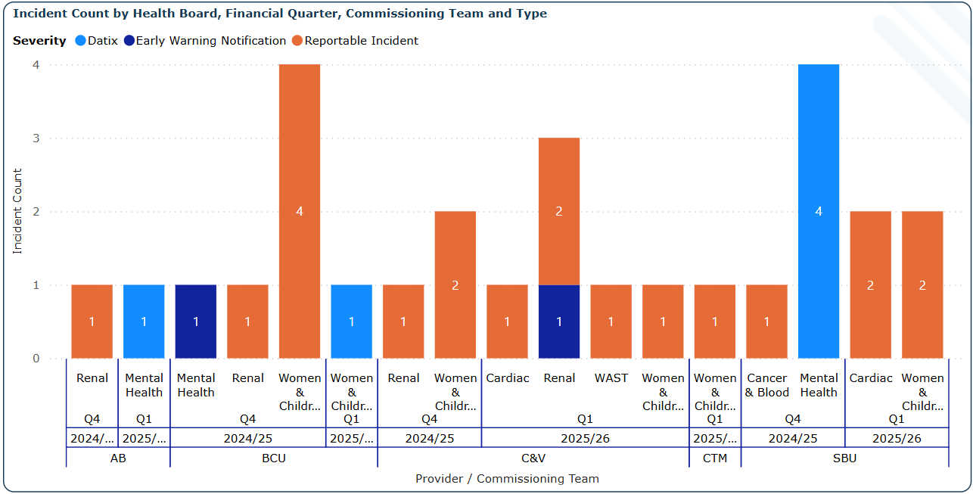
Figure 1 - Health Board incidents.
A total of 28 incidents were recorded during this period, with classifications as follows:
- Reportable Incidents (orange): 20
- Early Warning Notifications (dark blue): 2
- Datix entries (light blue): 6
Key Findings:
- Reportable incidents dominate the overall volume, accounting for over 70% of reported events.

- The highest single incident count occurred within Women & Children’s services in BCU (Q1), with 4 reportable incidents.

- Cardiac services in SBU and C&V (Q1) both recorded 2 reportable incidents, indicating recurrent concerns in this high-risk area.

- Mental Health services saw:

- One Datix entry in AB (Q1) and one Early Warning Notification in AB (Q4).

- A cluster of 4 Datix entries in SBU (Q4) - the highest number of low-severity incidents in any team or quarter.

- Renal services had notable reporting in:

- C&V (Q1) with 1 Datix and 2 reportable incidents.

- BCU and AB (Q4) each with a single incident logged (Datix or reportable).

- WAST, Cancer & Blood, and Women & Children’s services in multiple Health Boards (CTM, C&V, and SBU) show a mixed but consistent presence of incidents.

Severity Mix:
- 20 incidents (71%) were categorised as Reportable, indicating significant clinical or governance thresholds were met.

- 6 incidents (21%) were submitted through Datix, flagging lower-severity issues but still important for local assurance and review.

- 2 incidents (7%) were raised as Early Warning Notifications, reflecting a proactive stance on emerging concerns.

This pattern underlines the continued prominence of Women & Children’s and Cardiac services in incident reporting and the need for ongoing review. The visible spread across Health Boards also suggests varying levels of sensitivity and escalation practices, which may benefit from further benchmarking and learning.
Complaints
Figure 2 presents complaints and concerns by Health Board, commissioning team, and origin type for Q4 2024/25 and Q1 2025/26.

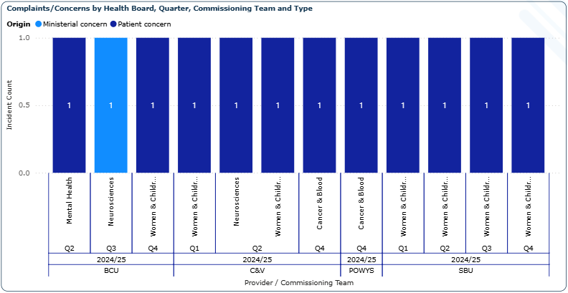
Figure 2 - Health Board complaints or concerns.
A total of 8 concerns were recorded during this two-quarter period.

Breakdown by Type:

- 7 complaints (88%) were categorised as Patient Concerns (dark blue).

- 1 complaint (12%) was identified as a Ministerial Concern (light blue), linked to Neurosciences in BCU during Q1 2025/26.

Key Observations:

- Women & Children’s services accounted for the highest number of concerns, with 4 individual entries spread across AB, C&V, and SBU in both Q4 and Q1.

- Neurosciences in BCU recorded both a ministerial and a patient concern in Q1, making it the only team with multiple complaint origins in a single quarter.

- Cancer & Blood services recorded 2 patient concerns, one each in C&V and Powys.

- Cardiac services in SBU (Q1) reported a single patient concern.

This data reflects a consistent trend of Women & Children’s services attracting the highest volume of concerns, while also highlighting Neurosciences as an area requiring attention due to the presence of escalated (ministerial) issues. The relatively low number of complaints overall during this period may reflect better handling of concerns at local levels or a lag in reporting for the new financial year.

Welsh Government Performance Measures

Performance measures were introduced by the Welsh Government in January 2022 as part of the updated Performance Framework for 2022/23. These measures aim to drive improvement across key areas of healthcare delivery. Several targets for the 2023/24 financial year were revised in June to address changing priorities and challenges. The measures specifically relevant to NWJCC activity are outlined below.

While Welsh Government has not set definitive timelines for the revised targets, they have emphasised that all NHS Wales services were expected to achieve the 104-week treatment target by December 2024. This clear expectation highlights the ongoing commitment to reducing waiting times and improving patient outcomes, aligning with the broader objectives of planned care recovery, diagnostics, and pathways of care.

Performance Measure |  | Target |  | Reporting | Source |  | Ministerial Priority | Status
28 | Number of patient waiting more than 52 weeks for a new outpatient appointment | Improvement trajectory towards a national target of zero |  | Monthly | RTT (combined) Dataset (DHCW) |  | Planned Care Recovery. Diagnostics and Pathways of Care | Revised
28 |  | Rational: The number patients waiting for a new outpatient appointment has increase year on year whilst capacity has been unable to meet demand. NHS Organisations are required to improve service planning and clinical pathways to deliver sustainable planned care services where waiting lists are reduced to a manageable level.
29 | Number of patient waiting more than 36 weeks for a new outpatient appointment | Improvement trajectory towards a national target of zero |  | Monthly | RTT (combined) Dataset (DHCW) |  | Planned Care Recovery. Diagnostics and Pathways of Care | New
29 |  | Rational: As above
31 | Number of patient waiting more than 104 weeks for a new outpatient appointment | Improvement trajectory towards a national target of zero |  | Monthly | RTT (combined) Dataset (DHCW) |  | Planned Care Recovery. Diagnostics and Pathways of Care | Revised
31 |  | Rational: Patients receiving timely access to high quality elective treatment and care should experience improved outcomes. Reducing the time that a patient waits for treatment reduced the risk of the condition deteriorating and alleviates the patient’s symptoms, pain and discomfort sooner. The measure provides greater transparency and encourages improvement in the timeliness of treatment across NHS Services.
32 | Number of patient waiting more than 52 weeks for a new outpatient appointment | Improvement trajectory towards a national target of zero | Monthly |  | RTT (combined) Dataset (DHCW) | Planned Care Recovery. Diagnostics and Pathways of Care |  | New
32 |  | Rational: As above
Table 2 - Welsh Government performance measures

Service Performance Scorecard
Tables 3 provides a summary of performance metrics across Specialised and Mental Health, LD and Vulnerable Groups services, measured against specific tolerance levels for February, March and April 2025.
Specialised Services | Feb 25 | Mar25 | Apr 25 | Last Move | Measure | Tolerance Levels
Cardiac Surgery | 88.51% | 86.36% | 87.87% |  | RTT < 36 weeks - admissions | <95% | 95-99% | 100%
Cardiothoracic Surgery | 100.00% | 87.50% | 83.33% |  | RTT < 36 weeks - admissions | <95% | 95-99% | 100%
Neurosurgery | 92.87% | 93.07% | 93.48% |  | RTT < 36 weeks - admissions | <95% | 95-99% | 100%
Paediatric Surgery | 88.06% | 89.98% | 89.26% |  | RTT < 36 weeks - admissions | <95% | 95-99% | 100%
Plastic Surgery | 67.96% | 71.81% | 72.66% |  | RTT < 36 weeks - admissions | <95% | 95-99% | 100%
Plastic Surgery (non-burns) | 71.80% | 72.01% | 70.95% |  | RTT < 36 weeks - admissions | <95% | 95-99% | 100%
Spinal Surgery Service | 82.14% | 76.00% | 69.23% |  | RTT < 36 weeks - admissions | <95% | 95-99% | 100%
Thoracic Surgery | 89.08% | 86.49% | 85.85% |  | RTT < 36 weeks - admissions | <95% | 95-99% | 100%
Bariatric Surgery | 81.82% | 77.50% | 68.50% |  | RTT < 36 weeks - admissions | <95% | 95-99% | 100%
PET Scans | 55.22% | 74.71% | 80.13% |  | Pet scan < 10 days after referral | <90% | 90-95% | >=95%
Posture & Mobility RTT - Adult | 94.36% | 94.20% | 92.62% |  | RTT < 36 weeks | <90% | 90-95% | >=95%
Posture & Mobility RTT - Paediatrics | 93.58% | 94.54% | 93.60% |  | RTT < 36 weeks | <90% | 90-95% | >=95%
CAMHS Bed days (excl. Out of Area) | 86.82% | 95.67% | 76.89% |  | NHS Bed days against contract | <85%,>105% | < 90%, >100% | 90% - 100%
CAMHS Home Leave (excl. Out of Area) | 12.72% | 14.60% | 25.42% |  | NHS Home Leave against total | <20%, >40% | <25%, >35% | 25%-35%
Medium Secure Bed days | 67.96% | 74.28% | 72.38% |  | NHS Bed days against contract | <90%,>110% | < 95%, >105% | 95% - 105%
CAMHS Bed days (excl. Out of Area) | 86.82% | 95.67% | 76.89% |  | NHS Bed days against contract | <85%,>105% | < 90%, >100% | 90% - 100%
CAMHS Home Leave (excl. Out of Area) | 12.72% | 14.60% | 25.42% |  | NHS Home Leave against total | <20%, >40% | <25%, >35% | 25%-35%
Medium Secure Bed days | 67.96% | 74.28% | 72.38% |  | NHS Bed days against contract | <90%,>110% | < 95%, >105% | 95% - 105%
Table 3 - Specialised and Mental Health, LD and Vulnerable Groups services Performance Scorecard

Specialised Services – RTT <36 Weeks (Admissions)

Most surgical specialties remain below the 95% target, indicating ongoing pressures in access to treatment:

- Cardiac Surgery, Neurosurgery, Paediatric Surgery, and Thoracic Surgery have remained relatively stable, performing just under target in the 85–93% range.

- Cardiothoracic Surgery dropped from 100% in February to 83.33% in April, indicating potential capacity or demand challenges.

- Plastic Surgery (including non-burns) and Spinal Surgery remained well below tolerance, with performance below 75% by April.

- Bariatric Surgery showed a consistent decline across the period, down to 68.5% in April - significantly below expected tolerance.

PET Scans (<10 Days Post Referral)

- Performance improved month-on-month, rising from 55.2% in February to 80.1% in April, though still below the 90% threshold.

- The upward trend is promising but falls short of meeting the target range.

Posture and Mobility RTT (36 Weeks)

- Adult and Paediatric services continued to perform strongly, consistently within the 90–95% tolerance band — suggesting a well-managed pathway despite slight drops in April.

Mental Health, Learning Disabilities and Vulnerable Groups

- CAMHS Bed Days (excluding Out of Area) fluctuated significantly:

- Performance peaked at 95.67% in March, within contract tolerance.

- However, it dropped sharply to 76.89% in April, potentially highlighting seasonal or capacity-related variation.

- CAMHS Home Leave showed a positive movement, reaching 25.42% in April, now sitting within the 25–35% target zone for the first time in this period.

- Medium Secure Bed Days remained below contract expectations, with all three months well under the 95% minimum tolerance. April closed at 72.38%, indicating potential underutilisation or changes in admission policy.

Summary

Across Specialised Services, no pathway achieved 100% compliance, and most sit below 95%, particularly in surgical specialties. PET Scan performance is improving but not yet optimal.

In Mental Health services, variability remains an issue, particularly within CAMHS and Medium Secure bed usage, which may require further investigation into underlying demand, capacity, and commissioning intent.

Welsh Government Post Covid Targets

Table 4 presents Referral to Treatment Time (RTT) performance for admissions across multiple specialties and providers, specifically against the 105-week threshold.

RTT < 105 weeks - admissions | Feb 25 | Mar25 | Apr 25 | Last Move | Measure | Tolerance Levels
Cardiac Surgery | 100.00% | 100.00% | 100.00% |  | RTT < 105 weeks - admissions | <95% | 95-99% | 100%
Cardiothoracic Surgery | 100.00% | 100.00% | 100.00% |  | RTT < 105 weeks - admissions | <95% | 95-99% | 100%
Neurosurgery | 100.00% | 100.00% | 100.00% |  | RTT < 105 weeks - admissions | <95% | 95-99% | 100%
Paediatric Surgery | 100.00% | 100.00% | 100.00% |  | RTT < 105 weeks - admissions | <95% | 95-99% | 100%
Plastic Surgery | 99.86% | 100.00% | 100.00% |  | RTT < 105 weeks - admissions | <95% | 95-99% | 100%
Plastic Surgery (non-burns) | 99.01% | 100.00% | 100.00% |  | RTT < 105 weeks - admissions | <95% | 95-99% | 100%
Spinal Surgery Service | 100.00% | 100.00% | 100.00% |  | RTT < 105 weeks - admissions | <95% | 95-99% | 100%
Thoracic Surgery | 100.00% | 100.00% | 100.00% |  | RTT < 105 weeks - admissions | <95% | 95-99% | 100%
Bariatric Surgery - Swansea Bay UHB | 100.00% | 100.00% | 100.00% |  | RTT < 105 weeks - admissions | <95% | 95-99% | 100%
Bariatric Surgery - Salford Royal | 100.00% | 100.00% | 100.00% |  | RTT < 105 weeks - admissions | <95% | 95-99% | 100%
Table 4 - RTT <105 Weeks – admission
Across all reporting months - February, March, and April 2025 - performance was consistently strong, with the majority of specialties achieving or maintaining 100% compliance with the RTT <105 weeks standard.
This reflects excellent waiting time performance across specialised surgical services, with no patients waiting over 105 weeks for admission across any reported area by April. These results suggest strong operational grip and scheduling controls for long-wait backlogs, particularly when compared to RTT <36 week metrics.

Table 5 presents Referral to Treatment Time (RTT) performance for admissions under the 52-week standard across specialised surgical services.

RTT < 52 weeks - admissions | Feb 25 | Mar25 | Apr 25 | Last Move | Measure | Tolerance Levels
Cardiac Surgery | 96.28% | 96.90% | 97.87% |  | RTT < 52 weeks - admissions | <95% | 95-99% | 100%
Cardiothoracic Surgery | 100.00% | 100.00% | 100.00% |  | RTT < 52 weeks - admissions | <95% | 95-99% | 100%
Neurosurgery | 99.28% | 99.31% | 98.85% |  | RTT < 52 weeks – admissions | <95% | 95-99% | 100%
Paediatric Surgery | 99.15% | 99.26% | 98.63% |  | RTT < 52 weeks – admissions | <95% | 95-99% | 100%
Plastic Surgery | 89.02% | 90.92% | 93.29% |  | RTT < 52 weeks – admissions | <95% | 95-99% | 100%
Plastic Surgery (non-burns) | 85.83% | 86.03% | 86.38% |  | RTT < 52 weeks – admissions | <95% | 95-99% | 100%
Spinal Surgery Service | 96.43% | 96.00% | 92.31% |  | RTT < 52 weeks – admissions | <95% | 95-99% | 100%
Thoracic Surgery | 99.27% | 98.82% | 97.84% |  | RTT < 52 weeks - admissions | <95% | 95-99% | 100%
Bariatric Surgery | 97.27% | 96.67% | 94.49% |  | RTT < 52 weeks - admissions | <95% | 95-99% | 100%
Table 5 - RTT < 52 weeks – admission
Most services maintained high levels of compliance, with several specialties consistently performing within or above the 95–99% tolerance band. However, some variation was observed:

High Performers:

- Cardiothoracic Surgery delivered 100% compliance across all three months.

- Neurosurgery, Paediatric Surgery, Thoracic Surgery, and Cardiac Surgery all remained within the 95–99% range, with Cardiac Surgery showing a steady upward trend, reaching 97.87% in April.

Areas of Concern:

- Plastic Surgery showed gradual improvement month-on-month, rising from 89.02% in February to 93.29% in April, but remained below the 95% threshold throughout the period.

- Plastic Surgery (non-burns) remained the weakest performing pathway, consistently around 86%, highlighting ongoing backlog pressures.

- Spinal Surgery saw performance dip from 96.43% in February to 92.31% in April, falling below the target range for the first time.

- Bariatric Surgery decreased to 94.49% in April, just below the acceptable range after two months above 95%.

Summary:

While overall RTT <52 week compliance is strong across most services, sustained underperformance in Plastic and Spinal Surgery indicates the need for continued focus. The downward trend in Spinal and Bariatric Surgery by April warrants closer monitoring to prevent slippage below tolerance levels.

Table 6 presents Referral to Treatment Time (RTT) performance for first outpatient appointments across specialised services, assessed against the 36-week standard.
< 36 weeks for First OP | Feb 25 | Mar25 | Apr 25 | Last Move | Measure | Tolerance Levels
Cardiac Surgery | 99.19% | 98.68% | 99.24% |  | < 36 weeks for First OP | <95% | 95-99% | 100%
Neurosurgery | 93.90% | 94.81% | 94.78% |  | < 36 weeks for First OP | <95% | 95-99% | 100%
Paediatric Surgery | 100.00% | 100.00% | 100.00% |  | < 36 weeks for First OP | <95% | 95-99% | 100%
Plastic Surgery | 52.23% | 60.90% | 63.85% |  | < 36 weeks for First OP | <95% | 95-99% | 100%
Plastic Surgery (non-burns) | 86.27% | 85.29% | 84.28% |  | < 36 weeks for First OP | <95% | 95-99% | 100%
Spinal Surgery Service | - | 100.00% | 100.00% |  | < 36 weeks for First OP | <95% | 95-99% | 100%
Thoracic Surgery | 97.19% | 97.11% | 96.86% |  | < 36 weeks for First OP | <95% | 95-99% | 100%
Bariatric Surgery - Swansea Bay UHB | 100.00% | 97.14% | 66.67% |  | < 36 weeks for First OP | <95% | 95-99% | 100%
Table 6 - < 36 weeks for First op
Performance was mixed, with most services either maintaining compliance within the 95–99% range or showing significant variation month-to-month.

High Performers:

- Paediatric Surgery, Spinal Surgery, and Cardiac Surgery all demonstrated strong performance, with Cardiac Surgery averaging above 98% and Paediatric Surgery maintaining 100% across all three months.

- Thoracic Surgery also remained within the 95–99% tolerance band, showing consistent compliance.

Partial Compliance:

- Neurosurgery hovered just below target at 94.78% in April, narrowly missing the 95% threshold despite improvements in February and March.

- Plastic Surgery (non-burns) remained consistently below 90%, with a declining trend, suggesting persistent access issues.

Underperformance:

- Plastic Surgery (burns-inclusive) showed substantial improvement, rising from 52.23% in February to 63.85% in April, but remains well below acceptable levels.

- Bariatric Surgery (Swansea Bay) dropped sharply from 100% in February to just 66.67% in April, indicating a significant backlog or access bottleneck that may warrant immediate attention.

Summary:

While core surgical services such as Cardiac, Paediatric, and Spinal Surgery are performing well, Plastic Surgery and Bariatric services remain under considerable pressure in delivering timely first outpatient appointments.

Table 7 highlights performance against the 52-week referral to treatment time standard for first outpatient appointments across specialist services.

< 52 weeks for First OP | Feb 25 | Mar25 | Apr 25 | Last Move | Measure | Tolerance Levels
Thoracic Surgery | 100.00% | 100.00% | 100.00% |  | < 52 weeks for First OP | <95% | 95-99% | 100%
Bariatric Surgery | 99.19% | 99.90% | 99.41% |  | < 52 weeks for First OP | <95% | 95-99% | 100%
Cardiac Surgery | 100.00% | 100.00% | 100.00% |  | < 52 weeks for First OP | <95% | 95-99% | 100%
Neurosurgery | 70.65% | 73.94% | 80.76% |  | < 52 weeks for First OP | <95% | 95-99% | 100%
Paediatric Surgery | 100.00% | 100.00% | 100.00% |  | < 52 weeks for First OP | <95% | 95-99% | 100%
Plastic Surgery | - | 100.00% | 100.00% |  | < 52 weeks for First OP | <95% | 95-99% | 100%
Plastic Surgery (non-burns) | 100.00% | 100.00% | 100.00% |  | < 52 weeks for First OP | <95% | 95-99% | 100%
Spinal Surgery Service | 100.00% | 100.00% | 100.00% |  | < 52 weeks for First OP | <95% | 95-99% | 100%
Table 7 - < 52 weeks for First op
Performance is consistently strong, with most specialties achieving 100% compliance, reflecting effective management of long waits and strong pathway recovery.

Top Performers:

- Cardiac Surgery, Thoracic Surgery, Paediatric Surgery, Plastic Surgery (non-burns), Spinal Surgery, and Plastic Surgery (March–April) all maintained 100% compliance, with no patients waiting over 52 weeks.

- Bariatric Surgery also performed well, with minor monthly fluctuation but remaining within the 95–99% tolerance band throughout.

Notable Outlier:

- Neurosurgery remains the only specialty underperforming:

- It improved steadily from 70.65% in February to 80.76% in April but remained well below the 95% threshold across all three months.

Conclusion:

The data shows a high level of compliance across most specialties, indicating strong backlog clearance for long-wait outpatients. However, Neurosurgery remains a persistent outlier and should remain a priority area for scrutiny in future.

Cardiac Surgery Performance

Figure 3 below shows the trend of episode counts for cardiac services, below is a narrative summary:

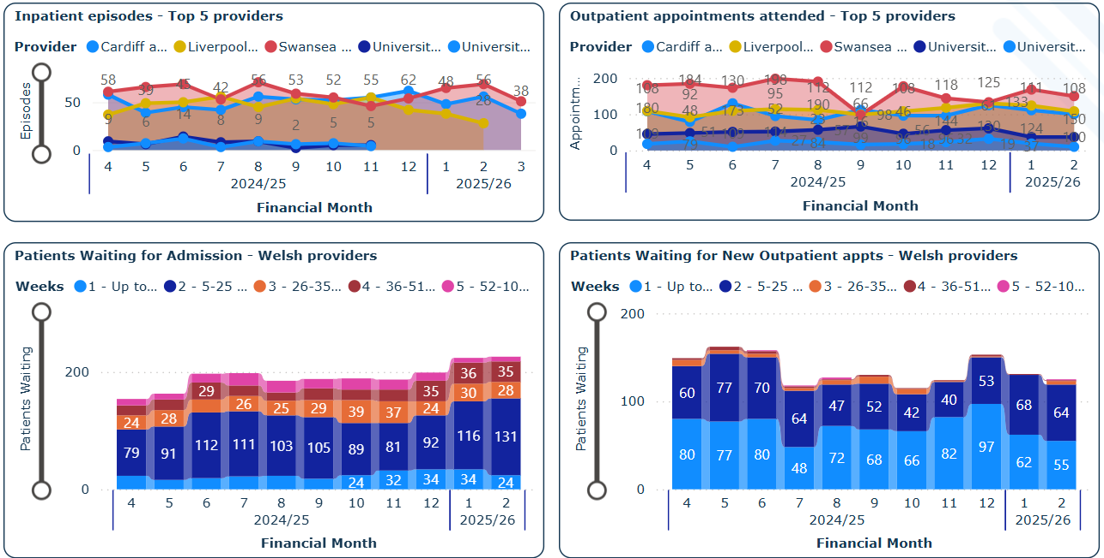
Figure 3 - Cardiac Surgery Performance

Current Performance

Inpatient Episodes - Top 5 Providers
Inpatient episodes across the top five providers show variable trends. Cardiff & Vale University Health Board experienced a rise in activity throughout the latter half of 2024/25, peaking at 62 episodes in Month 12, before declining to 38 episodes by Month 2 of the current year. Liverpool Heart & Chest Hospital displayed a more stable trend during 2024/25, with a slight dip into early 2025/26. Swansea Bay’s activity remained relatively high through Month 12 but dropped notably in the first two months of the new financial year. Other providers such as University Hospital Birmingham and University Hospital of North Midlands maintained consistently lower activity volumes throughout the reporting period.

Outpatient Appointments Attended – Top 5 providers
Outpatient appointments attended show a broadly consistent pattern across providers, although some fluctuations are evident. Swansea Bay saw the highest volume of outpatient appointments during 2024/25, peaking at 198 in Month 6, but activity declined sharply from Month 9 onward, falling to 50 by Month 2 of 2025/26.
Cardiff & Vale and Liverpool Heart & Chest maintained relatively stable outpatient volumes, with only minor month-to-month variation.

Patients Waiting for New Outpatient Appointments
The graph shows the distribution of patients waiting for new outpatient appointments across various timeframes during the year. The majority of patients fall within the shorter waiting categories of up to 25 weeks, with 0 waiting over 52 weeks.

The trend indicates some fluctuations in waiting times, with the number of patients gradually increasing in later months; however, there was a decrease in Month 10.

Patients Waiting for Admission
Waiting times for new outpatient appointments across Welsh providers indicate that most patients were seen within 25 weeks, with no reported breaches over 52 weeks. The waiting list grew gradually from Month 4 through Month 6 of 2024/25, then stabilised, with a brief dip around Months 9 and 10. However, there was an increase in waiting numbers in Month 12, continuing into the early months of 2025/26, before flattening again by Month 2. The majority of patients continue to be seen within expected timeframes, reflecting effective outpatient access management in most specialties.

In contrast, admission waits show greater pressure, with a consistently high number of patients waiting between 5 and 25 weeks. The most notable increase in patients waiting occurred between Months 5 and 6 of 2024/25, with further incremental growth observed into the new year. By Months 1 and 2 of 2025/26, there were 35 patients waiting over 52 weeks, predominantly within Cardiff & Vale. Liverpool Heart & Chest performed better overall, with most patients waiting under 26 weeks and only a small number breaching the 52-week threshold. These trends indicate that while outpatient waits remain largely within tolerance, sustained pressures continue to impact inpatient pathways and long-wait clearance.

What actions are NWJCC taking?
NWJCC continues to progress its planned Cardiac Review, of which Phase 1 sought to re-baseline the TAVI/cardiac surgery contract, ascertain whether the TAVI policy remains fit for purpose, and consider the differential costs of TAVI valve types. The outcomes of Phase 1 were reported to Joint Committee in January 2024 and are being taken forward via negotiation with health boards relating to the TAVI/cardiac surgery contract.

Phase 2 – which is focussed on the optimising the configuration of the cardiac surgery service – has been commenced with the collation of related evidence and analysis, and the undertaking of a Clinical Working Group in June 2024 to discuss a draft service specification. The revised service specification was subsequently issued for consultation in October 2024 and has since been finalised and endorsed by the NWJCC Policy Board.
Moving forward, discussions between the Health Boards and NWJCC Interim Chief Commissioner have led to agreement that the demand and capacity work and options development undertaken under the ambit of Phase 2 will be taken forward in collaboration with the Regional and Specialised Services Provider Planning Partnership (RSSPPP), overseen by the NWJCC. To this end, a Project Initiation Document has been prepared and will be processed through the correct channels during Quarter 2.

With regards to Liverpool Heart & Chest, NWJCC will continue to monitor waits and activity.
What are the main areas of risk?
Recent Risk and Assurance meetings have highlighted a number of theatre cancellations for Cardiac Surgery at Cardiff and Vale University Health Board resulting in longer waiting times for patients and growing waiting lists. Mitigation is in place through discussions with Swansea Bay University Health Board to support waiting times, and regional waiting lists are being discussed as an option at the RSSPPP. This situation will be continued to be monitored and may develop as an emerging risk in future reports.

Cardiology Performance (Specialised Only)

Figure 4 presents monthly activity levels across five Health Boards - Aneurin Bevan, Betsi Cadwaladr, Cardiff & Vale, Cwm Taf Morgannwg, and Swansea Bay - from Month 4 of 2024/25 through to Month 1 of 2025/26. The data shows marked variation in service activity between providers, with some significant changes over time.

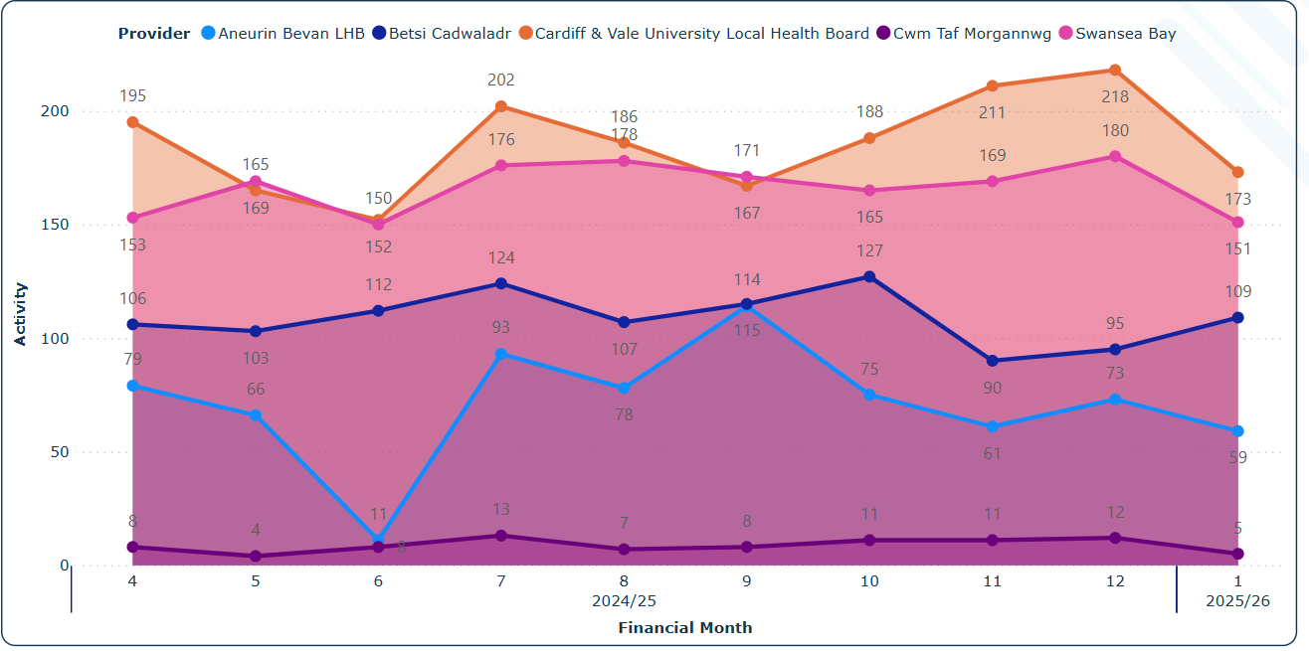
Figure 4 - Specialised Cardiology Inpatient Activity
Cardiff & Vale University Health Board consistently recorded the highest levels of activity, peaking at 218 in Month 12, before dropping to 173 in Month 1 of the new financial year. This provider demonstrated a generally upward trend throughout 2024/25, with notable peaks in Months 7 and 12. Swansea Bay followed a similar trajectory, maintaining high levels across the year, peaking at 180 in Month 12 and only marginally declining to 151 in Month 1 of 2025/26, suggesting relatively stable demand and throughput.

Betsi Cadwaladr showed steady growth from 106 in Month 4 to a peak of 127 in Month 10, before dipping to 90 and 95 in Months 11 and 12. This was followed by a moderate rebound to 109 in Month 1. The reduction in late 2024/25 reflects a real decline in activity rather than missing data, as PCI figures are now included.

Aneurin Bevan saw a sharp decrease in activity mid-year, falling to just 11 in Month 6, before rebounding strongly in Month 7 (93) and reaching 115 in Month 9. While volumes have tapered slightly since, Aneurin Bevan closed the year and began 2025/26 at higher levels than it started with, reporting 59 episodes in Month 1.

Cwm Taf Morgannwg continued to report low levels of activity throughout the period, generally in single digits, with a brief rise to 13 in Month 7 but returning to lower levels thereafter. It recorded just 5 episodes in Month 1, maintaining its position as the lowest-activity provider in the dataset.

Overall, the data reveals sustained high activity in Cardiff & Vale and Swansea Bay, recovery in Aneurin Bevan, and moderate but stable throughput in Betsi Cadwaladr, with minimal contribution from Cwm Taf Morgannwg.

What actions are NWJCC taking?

A Cardiac Devices Review is scheduled to begin in Quarter 3 of 2025/26. This work will be brought forward to start in Quarter 2.

What are the main areas of risk?
There are currently no risks on the risk register for this area of work. This will be monitored through Risk and Assurance Meetings.

Cardiology Performance (Waiting List)

Figure 5 below shows the cardiology waiting list across all providers remains substantial, with a cumulative 425,310 recorded patient waits from April 2024 (Month 4) to February 2025 (Month 11 of 2024/25 and Month 1 of 2025/26). The data is broken down into key waiting list categories, reflecting the scope of cardiac service demand nationally.

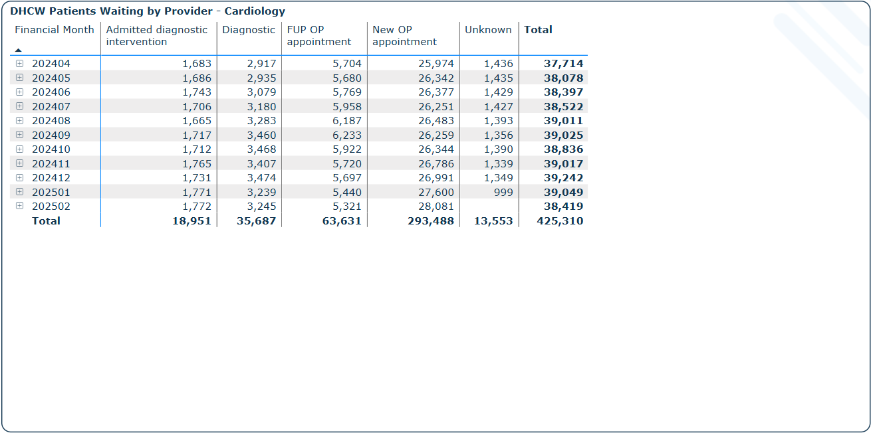
Figure 5 - Cardiology Waiting Times
The largest area of demand is for new outpatient appointments, which account for 293,488 patients over the period - around 69% of all cardiology waits. Monthly volumes remained high and stable, rising from 25,974 in April 2024 to a peak of 28,081 in February 2025, suggesting consistent referral pressure into outpatient services.

A total of 63,631 patients were waiting for follow-up outpatient (FUP OP) appointments, representing 15% of total waits. Volumes fluctuated modestly over the period, with a peak of 6,233 patients in September 2024, before gradually declining to 5,321 by February 2025.

Diagnostic procedures accounted for 35,687 patient waits, with monthly volumes ranging from 2,917 to 3,474. Meanwhile, admitted diagnostic interventions contributed a smaller but still significant total of 18,951 patients, with monthly values hovering around 1,700–1,770.

The ‘Unknown’ category includes 13,553 patient waits, which likely reflects data entry or pathway coding gaps. This field decreased sharply in January 2025 (999), potentially indicating improved data capture.

Overall, the dataset illustrates persistent pressure across the cardiology pathway, with new outpatient appointments continuing to dominate. The figures reinforce the need for targeted demand management and capacity planning, particularly in outpatient settings where the majority of backlog growth resides.

What actions are NWJCC taking?
NWJCC monitors specialist cardiology performance in Cardiff & Vale University Health Board and Swansea Bay University Health Board via bimonthly Risk, Assurance and Recovery meetings, agreeing mitigating actions as required. The performance of Aneurin Bevan, Betsi Cadwaladr and Cwm Taf Morgannwg University Health Boards is monitored via SLA meetings.

What are the main areas of risk?
NWJCC will be working to agree performance baselines for Aneurin Bevan, Betsi Cadwaladr and Cwm Taf Morgannwg University Health Boards (per the 2025/26 NWJCC Foundation Plan) in order to facilitate robust performance monitoring and the gauge the success (or otherwise) of recent repatriations. It had been intended that this planned action would be undertaken during 2024/25, but the objective was curtailed as a result of capacity challenges and a prolonged staff secondment. The anticipated delay will ensure that delivery of the objective is heedful of the outcomes of the ongoing cardiac review.

Bariatric Performance

Figure 6 provides an overview of bariatric inpatient activity and waiting lists:
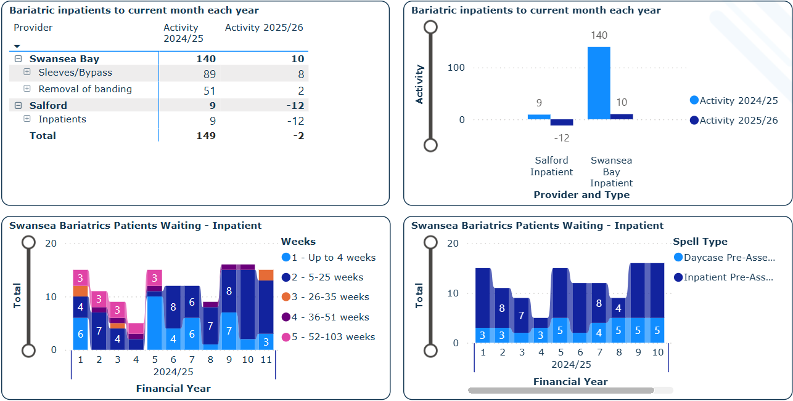
Figure 6 - Bariatric Inpatients

Current Performance
Bariatric inpatient activity for 2025/26 is currently low but reflects only the first two months of the financial year and therefore is not directly comparable to the fuller nine-month dataset for 2024/25.

During Months 4 to 12 of 2024/25, Swansea Bay University Health Board recorded a total of 140 inpatient procedures, including 89 sleeve/bypass operations and 51 band removals. In the first two months of 2025/26, activity stands at 10 procedures (8 sleeve/bypass and 2 band removals). While this appears significantly lower, it represents an early snapshot of the new year, and not a like-for-like timeframe.

Salford recorded 9 inpatient procedures in 2024/25 but currently shows a net adjustment of –12 for 2025/26, which may reflect data corrections or cancelled activity rather than in-period delivery. As a result, the overall total across both providers was 149 procedures in Months 4–12 of 2024/25, compared with a net figure of –2 in Months 1–2 of 2025/26.

Waiting list data for Swansea Bay indicates relatively small but steady volumes. Most patients are waiting up to 25 weeks, though a small number exceed 52 weeks. The majority are in pre-assessment stages, with a split between day case and inpatient pathways.

Although current activity is low, this is expected at this stage of the year. Caution should be applied when comparing partial-year data, and performance should be reviewed again at mid-year to assess emerging trends.

What actions are NWJCC taking?
NWJCC continues to meet with the service on a bi-monthly basis to monitor the position and agree any mitigating actions as required. NWJCC also continues to work with the National Healthy Weight Pathway Steering Group in order to understand and enable the integration of Level 4 services and the Level 1-3 weight management pathway and continues to correspond with the Welsh Government concerning the post-surgical follow-up needs of patients returning from private surgery abroad, mindful of any impact on NWJCC-commissioned Level 4 provision.
What are the main areas of risk?
The Welsh Government has advised that patients returning from private surgery abroad who require post-surgical follow-up can be referred to Level 4 services. In the absence of any corresponding enabling resource, there may be a significant and potentially unmanageable effect on Level 4 services, impacting on waits and the activity delivered for patients who have been referred to the service via the Weight Management Pathway.
The Welsh Government is therefore working with service commissioners and providers from across the Weight Management Pathway to explore what additional resource may be required.
In addition, the impact of obesity drugs on demand for obesity surgery is currently unknown, but their increasingly widespread availability is likely to have implications for the number of procedures commissioned by the NWJCC moving forward. The NWJCC will continue to work with services to monitor demand. Finally, in view of ongoing concerns with the number of procedures undertaken, the service delivered by Salford Royal Hospital has recently been placed in escalation by means of the NWJCC escalation framework, with follow-up actions to be agreed subject to Salford’s engagement with the process. Due to delays in identifying an appropriate executive lead at Salford to take forward this escalation, Swansea Bay University Health Board have agreed to receive referrals from patients who would normally have been referred to Salford for 2025/26. Swansea Bay currently have identified capacity to accommodate 15 patients for this financial year. Should the escalation process continue to be delayed, alternative commissioning options will be considered for this service.

Thoracic Surgery Performance

Figure 7 provides an overview of activity and waiting lists for inpatient and outpatient services across Welsh providers:

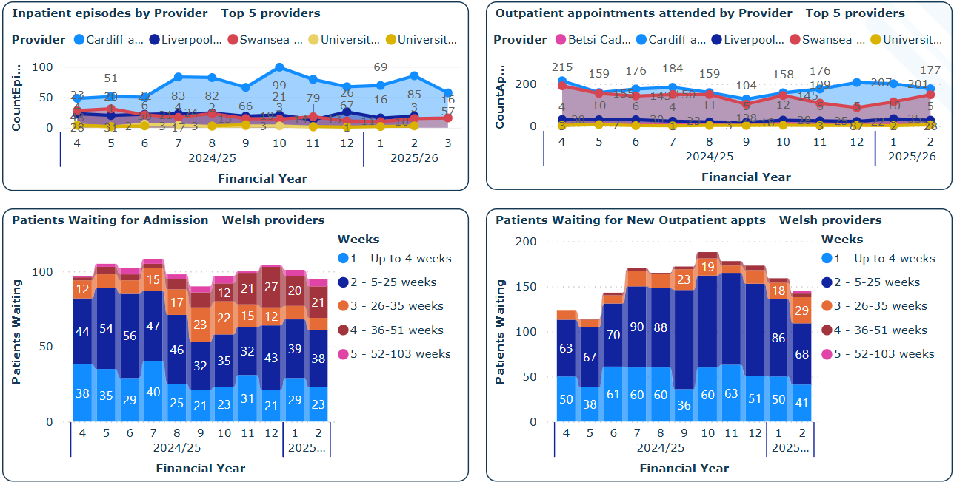
Figure 7 - Thoracic Surgery Performance

Current Performance
Inpatient activity across the top five specialist providers shows clear variation between providers and over time. Cardiff and Vale University Health Board saw a steady increase in inpatient activity from Month 7 to Month 10 of 2024/25, peaking at 99 episodes, before declining through Months 11 and 12, and continuing to fall into 2025/26, reaching 57 episodes by Month 3. Swansea Bay demonstrated more stable but lower volumes throughout, with activity fluctuating between 28 and 33 episodes, and no significant recovery since its decline in Month 6. Liverpool Heart & Chest showed early-year variation with lower activity in Months 4 and 5 but remained relatively stable afterward. The other providers - University Hospitals Birmingham and North Midlands - continue to report low volumes across the period.

Outpatient attendance shows a different trend. Cardiff & Vale and Swansea Bay consistently report the highest volumes of outpatient appointments, ranging from 145 to over 200 per month. Both providers show some fluctuation, but attendance levels remain relatively strong.

In contrast, Liverpool Heart & Chest has maintained a steady and moderate attendance rate across all months, while University Hospitals Birmingham and North Midlands continue to deliver only minimal outpatient appointments.

Waiting times for new outpatient appointments continue to show pressure across Welsh providers. The majority of patients fall within the 5–25 week category, with increasing volumes observed from Month 6 through Month 10 of 2024/25, peaking with more than 90 patients per month. Although total waits declined slightly by Month 12, the number of patients waiting over 26 weeks - particularly in the 26–35 and 36–51 week bands - remains a concern. A small number of patients are also waiting over 52 weeks, indicating long-standing access issues in some pathways.

For admissions, the waiting list profile is similar, with the largest share of patients waiting between 5 and 25 weeks, followed by substantial numbers in the up to 4 weeks and 26–35 week bands. While the number of patients waiting had steadily increased throughout most of 2024/25, a decrease was observed in Months 8 and 9, before climbing again in Months 10 to 12, and remaining elevated into the first two months of 2025/26. A notable rise is also visible in patients waiting over 52 weeks, which although smaller in volume, reflects ongoing long-wait challenges.

What actions are NWJCC taking?
NWJCC continue to monitor performance at all thoracic centres.

What are the main areas of risk?
Since cancer and other urgent surgery is prioritised, a small number of patients waiting for elective procedures (pectus surgery in particular) experience long waits. However, there are no patients waiting in excess of the 104 weeks target.

Plastic Surgery Performance

Figure 8 presents a summary of inpatient and outpatient activity, as well as waiting list volumes across specialist paediatric and outreach providers.
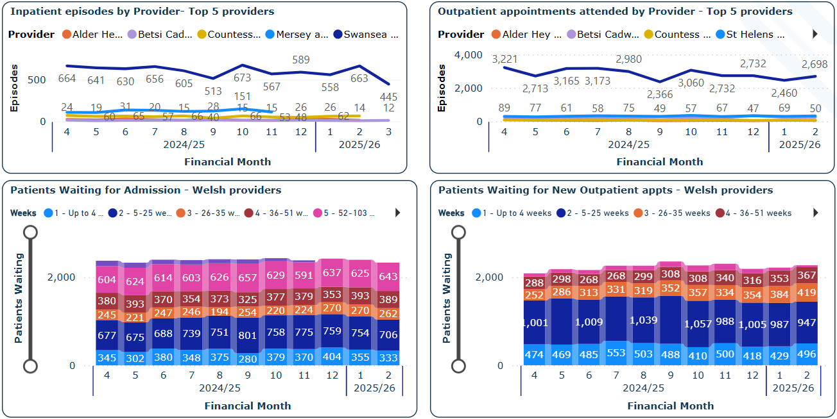
Figure 8 - Plastic Surgery Performance
Current Performance
Swansea Bay University Health Board continues to record the highest number of inpatient episodes, peaking at 589 in Month 11 of 2024/25, followed by a drop to 445 episodes in Month 2 of 2025/26. While volumes remain high, there has been some decline in recent months. Other providers, including Alder Hey Children’s Hospital, Betsi Cadwaladr University Health Board (via outreach from Mersey and West Lancashire NHS Trust), and St Helens and Knowsley, report significantly lower activity levels, typically below 70 episodes per month. Activity commissioned from the Countess of Chester Hospital, also on behalf of Betsi Cadwaladr, has remained stable, while Mersey and West Lancashire NHS Trust has seen minor month-to-month variation.

Outpatient attendances show similar patterns. Swansea Bay reached a high of 3,221 attendances in Month 4, but volumes have since fluctuated, most recently reporting 2,698 attendances in Month 2 of 2025/26. Other providers, including St Helens, maintain stable and lower attendance volumes - typically around 50–80 appointments per month. Betsi Cadwaladr’s outpatient activity, again delivered via outreach, remains comparatively low but consistent across the year.

In terms of patients waiting for admission, the majority fall within the 5–25 week category, with consistent numbers across the last year. However, there are significant numbers also waiting longer, including over 2,300 patients waiting more than 26 weeks and 643 patients exceeding 52 weeks as of Month 2 of 2025/26. While the overall total has remained relatively static over the last four months, the proportion of long-waiters has increased slightly, with a small but notable rise between Months 11 and 12.

Waiting times for new outpatient appointments remain a concern. Although most patients are within the 5–25 week range, increasing numbers are breaching the 26–51 week thresholds, with 419 patients now waiting over 52 weeks - a substantial increase from earlier in the year. Notably, these long waits are concentrated in north Wales outreach clinics delivered by Mersey and West Lancashire NHS Trust, as flagged in Figure 13. In contrast, no patients in Swansea Bay were recorded as waiting over 52 weeks for outpatient appointments in Month 12 of 2024/25, although the overall volume of outpatient waits is trending upward into 2025/26.

What actions are NWJCC taking?
Utilising planned care funding from Welsh Government, Swansea Bay UHB was able to treat all patients waiting longer than 104 weeks by March 2025. Achievement of the target has been sustained through April. However, the health board’s delivery plan for plastic surgery suggests that breaches could reoccur from quarter 2 and increase through quarters 3 and 4 due to increases in patients entering the breach cohort each month. This position is being monitored through monthly performance meetings. There is significant risk to sustaining the target through 2025/26 in the absence of further additional funding above contract baseline. SBU are currently delivering their contracted activity. There are no patients at Mersey & West Lancashire waiting for surgery in excess of 104 weeks.

There is a task & finish group in place, involving Betsi Cadwaladr UHB, Mersey & West Lancs and NWJCC, to address the issues relating to these clinics including the gap between demand and capacity. Waiting List Initiatives are currently being planned to address the backlog. The T&F group is currently undertaking work to agree the contract for 2025/26 to consolidate existing capacity, with further work to follow on the proposal for addressing the recurrent capacity gap.

Plastic Surgery Performance (Waiting List 1)

Figure 9 provides an overview of Plastic Surgery activity at Swansea Bay University Health Board continues at scale, covering a wide range of elective and emergency procedures, outpatient appointments, and assessments. The data includes all episodes and subsets excluding NIL/diagnostic episodes, providing a layered view of operational throughput.
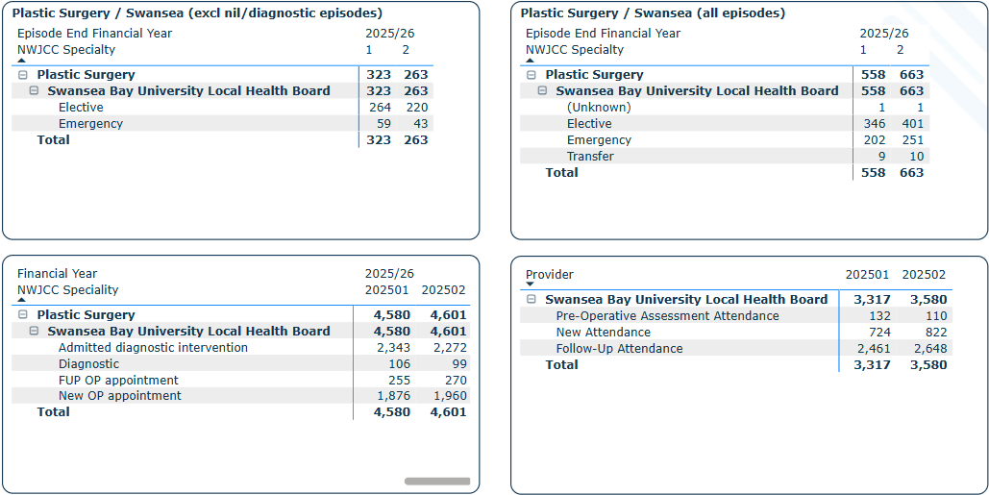
Figure 9 - Plastic Surgery Waiting Times at Mersey & West Lancashire

Inpatient Episodes
Across all plastic surgery episodes, Swansea Bay reported a total of 6,759 episodes over the full period, with 5,538 episodes in 2024/25 (Months 4–12) and 1,221 in the first two months of 2025/26. Of these, 61% (4,157 episodes) were elective procedures, while 2,518 (37%) were emergency admissions. Transfer activity remained low at 79 episodes total. There was a general decline in activity between Months 4–9, followed by a peak in Month 11 (589 episodes), before dipping slightly at the start of 2025/26.

When excluding NIL/diagnostic cases, total inpatient activity still amounted to 4,450 episodes, comprising 3,864 in 2024/25 and 586 in the early part of 2025/26. The vast majority were elective procedures (3,312 cases), indicating the elective programme continues to drive surgical activity, though the 2025/26 start suggests slightly reduced elective throughput.

Outpatient Activity
Plastic Surgery outpatient attendances were consistently high across the board. Swansea Bay recorded 61,385 total outpatient appointments across the 14-month reporting period.
This includes:

- 32,704 admitted diagnostic interventions

- 1,344 diagnostic attendances

- 3,189 follow-up outpatient appointments

- 24,148 new outpatient appointments

Outpatient activity remained steady throughout 2024/25, generally fluctuating between 4,181 and 4,515 appointments per month, before a dramatic increase in Month 1 of 2025/26, where activity spiked to 5,220 appointments, likely due to backlog clearance or additional clinics.

Assessment & Appointment Type Detail
A further breakdown of appointment types shows that Swansea Bay delivered a total of 41,292 attendances across pre-op assessments and general clinics:

- 1,388 Pre-operative assessment attendances

- 9,146 New attendances

- 30,758 Follow-up attendances

Monthly activity fluctuated between 3,176 and 4,232 attendances, with peaks observed in Months 4, 6, and 10. The final two months (2025/26) showed a gradual return to 2024/25 averages, suggesting consistent patient flow management and continuity of care post-operatively.

What actions are NWJCC taking?
The service at Swansea Bay UHB has maintained achievement of the 104 weeks target through April and May. Planned care funding has been agreed to the end of Quarter 2 to maintain achievement of the target. Monthly performance meetings remain in place.

What are the main areas of risk?

Sustaining the target of 104 weeks for plastic surgery at Swansea Bay remains a red risk on the JCC risk register.

Positron Emission Tomography Performance

Figure 10 presents an overview of contract monitoring for PET scan activity and performance across Welsh PET centres, including BCU PET, Cardiff PETIC, and Swansea PET, spanning from Month 4 of 2024/25 to Month 2 of 2025/26.

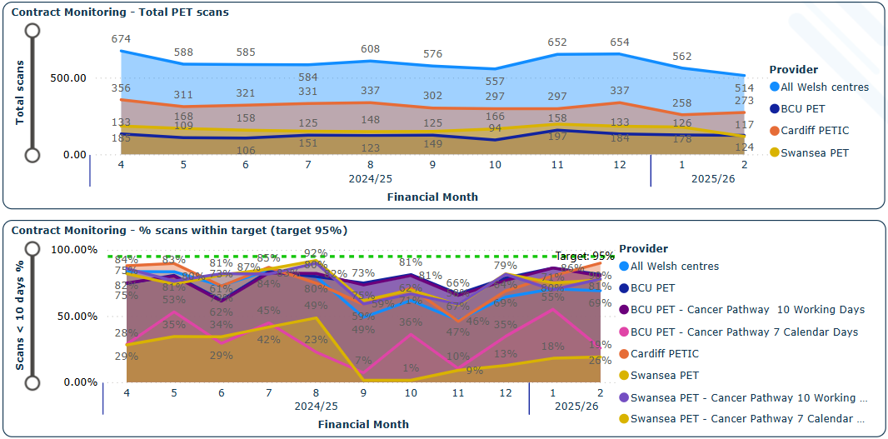
Figure 10 - Pet Scan Performance

Current Performance

The upper graph shows the total volume of PET scans across providers. Activity has remained generally stable, ranging between 543 and 674 scans per month, with a peak in Month 4 (674 scans) and a secondary rise in Month 11 (652 scans), largely driven by increases at BCU PET and Swansea PET. Cardiff PETIC maintained steady activity levels throughout the period, averaging between 133–168 scans monthly, while Swansea PET increased its contribution notably in the latter months. Into 2025/26, scan activity remains strong, with 514 scans in Month 1 and 273 in Month 2, demonstrating sustained delivery capacity across centres.

Timeliness of Scanning (Target: 90% within 10 Days)
The lower graph illustrates the proportion of scans completed within the 10-day target. Performance across all Welsh centres remains consistently below the 90% target, with most months tracking between 66% and 92%, peaking in Month 8. BCU PET demonstrates the most stable and highest compliance, regularly approaching or exceeding 90%.

In contrast, PETIC and Swansea PET show more variability, particularly for cancer pathway scans, where performance dips significantly - notably for the 7-day calendar-day measures. It should be noted this is currently a shadow target to monitor how the service performs against the best practice component target to deliver the suspected cancer pathway.

What actions are NWJCC taking?

Quarterly performance meetings are in place between JCC and the PET services.

What are the main areas of risk?
There are not infrequent issues relating to the reliability of radioisotope supply and distribution which if disrupted (e.g. equipment fault) can lead to increases in PET turnaround times. The Swansea Bay and Wrexham services are currently delivered via mobile scanners. This introduces risk of lost scanning activity due to occasional road closures or even breakdown of the vehicle.

Paediatric Surgery Performance

Figure 11 presents a summary of inpatient and outpatient activity and associated waiting lists for Welsh providers, covering Financial Months 4 (April 2024) to 2 (May 2025) across 2024/25 and the early months of 2025/26.

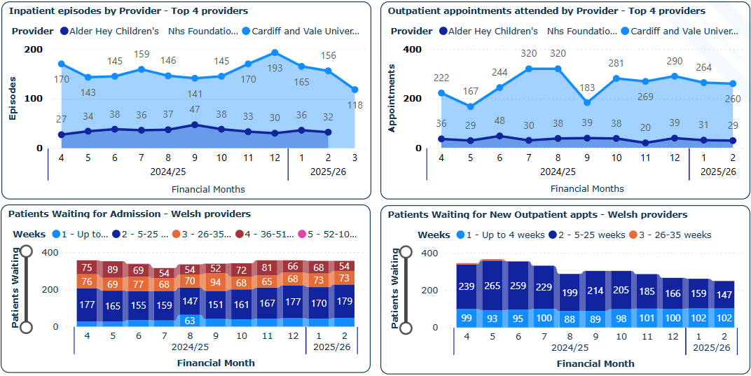
Figure 11 - Paediatric Surgery Performance

Inpatient Activity

Cardiff and Vale University Health Board recorded a gradual rise in inpatient episodes through 2024/25, peaking at 193 episodes in Month 11, followed by a slight decline to 156 in Month 2 of 2025/26. Activity remained relatively consistent between Months 4 to 10, with notable growth from Month 9 onwards.
Alder Hey Children’s Hospital reported more modest but steady inpatient activity, increasing gradually from 27 episodes in Month 4 to a peak of 47 in Month 9, before declining to 32 episodes in Month 2. Despite these fluctuations, overall activity levels remained within a narrow range, indicating a stable delivery pattern.
Outpatient Appointments
Cardiff and Vale University Health Board outpatient activity rose significantly between Months 5 and 8, peaking at 320 appointments in both Months 7 and 8. A decline to 183 appointments in Month 9 was followed by a steady recovery, with 264 appointments recorded in Month 2 of 2025/26.

Alder Hey Children’s Hospital showed more consistent outpatient numbers, peaking at 48 attendances in Month 6, and largely maintaining between 29 and 36 appointments per month thereafter.

Inpatient Waiting List
The inpatient waiting list continues to be dominated by patients in the 5–25 week category, with smaller but persistent numbers waiting in the 26–35 and 36–51 week ranges. Importantly, there have been no patients waiting over 52 weeks throughout the reporting period.

Overall waiting list volumes have remained broadly stable across the months, with only minor monthly variation. Alder Hey’s position has notably improved across the year, with no long waits reported and a continued downward trend in total numbers waiting.

New Outpatient Waiting List
Most patients waiting for a new outpatient appointment continue to fall within the 5–25 week category. A smaller cohort consistently waits up to 4 weeks, while a limited number are recorded in the 26–35 week band.

Total waiting list volumes remained relatively stable through 2024/25, with a dip in Months 7 and 8 followed by modest increases in Months 9 and 10. Into 2025/26, numbers have stabilised again, with 260 patients recorded in Month 2.

What actions are NWJCC taking?
Paediatric surgery was escalated to level 3 in line with the WHSSC escalation framework in March 2023. Regular meetings ensued to ensure that targets were being met, and that patient care was priority in meeting these targets. An action plan was developed. The JCC (previously WHSSC) supported the health board during this period, where they made improvements to their service to reduce waiting times ensuring that all patients were treated within their <52-week target. In June 2024 following completion of the action plan with targets being met the JCC Women & Children’s commissioning team agreed to de-escalate the service to Level 0, routine monitoring. Paediatric surgery has been removed from the JCC risk register. The service continues to supply data monthly and to date there are no patients waiting over 52-weeks for surgery in the CHfW, Cardiff. The situation continues to be monitored.

In Vitro Fertility (IVF) Performance

Here’s the revised narrative for Figure 12, updated for clarity, accuracy, and alignment with the provided chart and contract data noting performance through to Month 12 only:

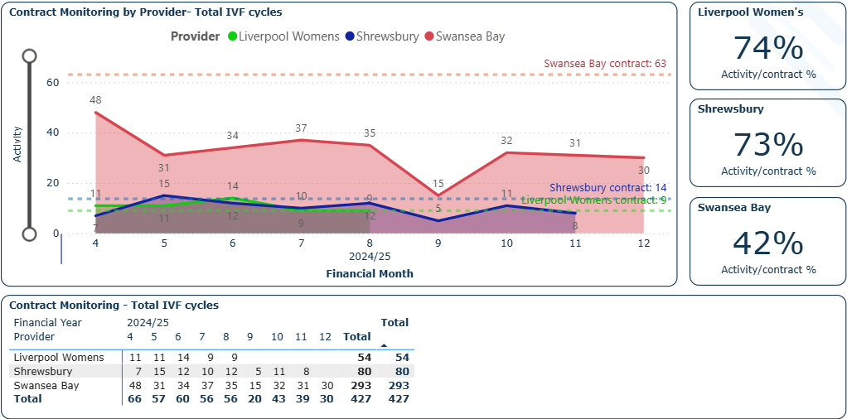
Figure 12 - In Vitro Fertility (IVF) Performance

Total IVF Cycles (Graph): Swansea Bay University Health Board continued to deliver the highest volume of IVF activity, with monthly cycles ranging from 30 to 48, peaking in Month 4 (48 cycles). While activity remained relatively stable between Months 5–8, a sharp decline occurred in Month 9, dropping to 15 cycles, with moderate recovery observed by Month 12 (30 cycles).

Shrewsbury maintained consistently moderate levels of activity, typically between 7 and 15 cycles per month, peaking in Month 6 (15 cycles) and ending the year with a total of 80 cycles delivered.

Liverpool Women’s reported lower activity overall, delivering between 8 and 14 cycles per month, with a notable gap in Month 9 and lower values in the latter part of the year. A total of 54 cycles were recorded by Month 12.
Contracted IVF Cycles (Tables): The total number of contracted cycles for 2024/25 across all three providers was 8,942, distributed as follows:

- Swansea Bay: 693 cycles/year

- Shrewsbury: 109 cycles/year

- Liverpool Women’s: 73 cycles/year

By Month 12, the number of cycles delivered was:

- Swansea Bay: 293 cycles (47% of annual contract)

- Shrewsbury: 80 cycles (73% of annual contract)

- Liverpool Women’s: 54 cycles (74% of annual contract, based on submitted data)

Contract Performance (% Activity/Contract): Activity relative to contract value highlights significant variation:

- Liverpool Women’s achieved 74% of expected activity based on their contract (despite missing data in two months).

- Shrewsbury also performed strongly at 73%.

- Swansea Bay has delivered 47% of its contracted activity to date, the lowest among the three, though it continues to record the highest volume of IVF cycles overall.

What actions are NWJCC taking?
NWJCC are holding regular quality and performance meetings with all the fertility providers. Furthermore, NWJCC are holding additional contracting meetings with finance colleagues to review the contracting arrangements.

What are the main areas of risk?
There is a risk SBU and NWJCC may not reach an agreement on the financial currencies for the service. Furthermore, the current review of the evidence base for accessing fertility services may lead to changes in access criteria and increase the number of patients accessing the service.

In Vitro Fertility Performance (Waiting List)

While IVF services are not subject to standard Referral to Treatment (RTT) waiting time targets, Figure 13 provides a high-level summary of waiting list activity across three providers: Liverpool Women’s, Shrewsbury, and Swansea Bay University Health Board (SBU) from Financial Month 4 to Month 11 of 2024/25.
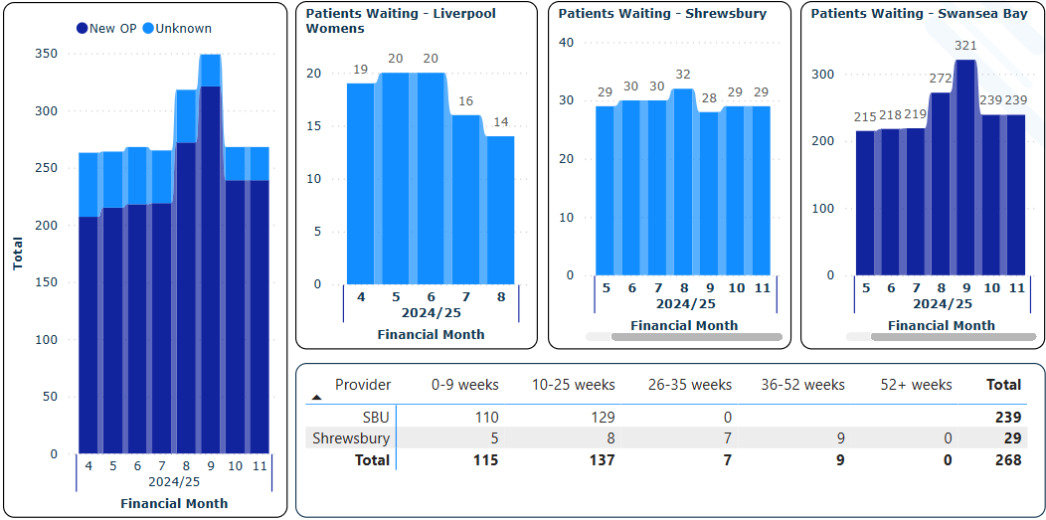
Figure 13 - In Vitro Fertility Performance (Waiting List)

Current Performance
The main bar chart presents the combined number of patients waiting for New Outpatient appointments (New OP) and appointments of unknown type. Neither Liverpool Women’s nor Shrewsbury provide separate categorisation by appointment type.

Across providers, total patient numbers remained broadly stable from Month 4 to Month 7, followed by a noticeable increase in Month 8 and Month 9. Activity fell slightly in Month 10 and remained steady in Month

- Liverpool Women’s saw a gradual reduction in waiting numbers from 20 patients in Months 5–6 to just 14 by Month 8. This downward trend reflects improvement but should be interpreted cautiously due to the absence of data beyond Month 8.

- Shrewsbury maintained a consistently steady waiting list, with monthly totals fluctuating only slightly between 28 and 32 patients, suggesting stable demand and capacity.

- Swansea Bay University Health Board accounted for the largest proportion of patients on the IVF waiting list. Numbers remained consistent between 215 and 219 from Month 5 to Month 7, followed by a rise to 272 in Month 8 and a peak of 321 in Month 9, before falling to 239 in both Month 10 and Month 11.

Waiting Time Breakdown
As of the most recent complete data:

- 239 patients were waiting at Swansea Bay, the majority (239/239) within 25 weeks (129 between 10–25 weeks, 110 within 0–9 weeks).

- Shrewsbury reported 29 patients, with 17 of those waiting under 25 weeks, and the remainder spread across longer wait categories (including 9 patients waiting 36–52 weeks).

- No patients were recorded as waiting over 52 weeks at any provider.

This data provides useful insight into IVF access pressures despite the absence of formal waiting time targets and highlights the need to continue close monitoring where data is available.

What actions are NWJCC taking?
NWJCC are in the process of working with SBUHB to review the current contracting model, which has consistently underperformed over a number of years.

Neurosurgery Performance

Figure 14 provides a summary of inpatient and outpatient activity, as well as waiting list trends, across the four main neuroscience providers commissioned by NHS Wales during the 2024/25 financial year. Data from 2025/26 Month 2 has been excluded from this analysis.

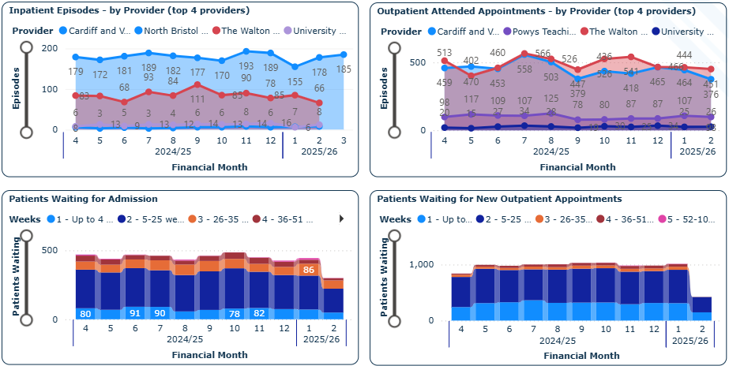
Figure 14 - Neurosurgery Performance

Inpatient Activity
Cardiff and Vale University Health Board consistently recorded the highest inpatient neurosurgery volumes, ranging from 155 to 193 episodes per month. Activity peaked in Month 11 (193 episodes) and dipped to its lowest in Month 1 of 2025/26 (155 episodes), before recovering to 185 in Month 2. Overall, Cardiff has maintained a strong and stable throughput, reflecting its role as the major neurosurgical centre in Wales.
The Walton Centre showed greater variation, with activity fluctuating between 66 and 111 episodes. A sharp peak occurred in Month 9 (111 episodes), followed by a general decline to 66 episodes by Month 2 of 2025/26. The centre's contribution remains significant but more volatile month to month.
University Hospitals of North Midlands, North Bristol, and other specialist English providers recorded lower volumes of activity, generally between 3 and 16 episodes per month. These figures remained relatively stable across the year, with minor fluctuations reflecting their more specialised or referral-based caseloads.
Outpatient Activity
Outpatient activity for neurosurgery was consistently led by The Walton Centre and Cardiff and Vale University Health Board, which together accounted for the vast majority of episodes each month.

The Walton Centre recorded the highest outpatient volumes overall, peaking at 558 episodes in Month 7, and sustaining high levels through to Month 12, with 541 episodes. Although activity declined to 451 in Month 2 of 2025/26, volumes remain substantial and demonstrate the centre’s continued importance in regional outpatient neurosurgery provision.

Cardiff and Vale followed a similar pattern, with activity ranging from 376 to 566 episodes per month. The highest level was observed in Month 7 (566 episodes), followed by some variation and a notable drop to 376 in Month 2 of 2025/26. Despite fluctuations, Cardiff maintained strong performance across the year.

University Hospitals Birmingham showed lower but steady activity, with episodes ranging from 20 to 34 per month, peaking in Month 12 (34 episodes) and Month 10 (30 episodes), suggesting a consistent but more limited contribution.

Powys Teaching Local Health Board activity fluctuated between 78 and 125 episodes, peaking in Month 8, and then stabilising around the 98–107 mark toward the end of the year.

Waiting Lists – Inpatient Admissions
Most patients waiting for admission at Cardiff and Vale were concentrated in the 5–25 week category. The number of patients waiting longer than 36 weeks remained low, and no patients were reported as waiting over 52 weeks.

The Walton Centre showed a similar profile through the first half of the year, but an increase in long waits was observed from Month 9 onwards. In Month 1 of 2025/26, 12 patients were waiting more than 52 weeks, with 86 patients waiting in total.

Waiting Lists – New Outpatient Appointments
Waiting list volumes for new outpatient appointments remained relatively stable across the year, with most patients waiting under 25 weeks. From Month 5 to Month 11, total waiting list numbers fluctuated around 1,000 patients, with a reduction seen in Month 1 of 2025/26.

What actions are NWJCC taking?
Quarterly performance meetings with Cardiff & Vale University Health Board have led to patient level activity data now being received on a regular basis and monitoring waiting times and plans for patients waiting over 26 weeks.

NWJCC has raised the waiting lists at the SLA Walton meeting on the 24th of February requesting a trajectory by the next SLA meeting scheduled for 10th July 2025 . Quarterly performance meetings resumed with The Walton in April 2025.

What are the main areas of risk?
A key factor relating to waiting times is the prioritisation of emergency over elective surgery. The commissioning team continue to monitor waiting times through quarterly assurance meetings where plans for individual patients waiting longer than 26 weeks are discussed, including assurance over clinical prioritisation processes.

Posture and Mobility Performance

Figure 15 provides an overview of Posture & Mobility Key Performance Indicators (KPIs) and Referral to Treatment Times (RTT) for Cardiff, North Wales, and Swansea during the financial year 2024/25.

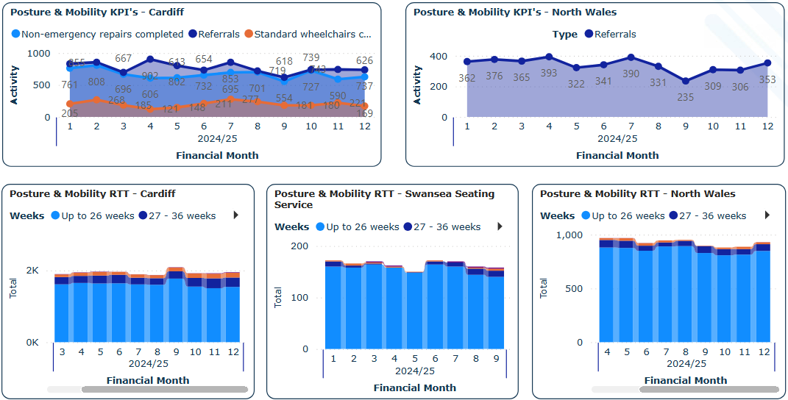
Figure 15 - Posture and Mobility Performance

Current Performance
Cardiff shows fluctuating activity levels across financial months. Referrals peaked at 902 in month 4 before declining to 618 in month 9. Month 10 saw an increase to 727 and a slight decrease in month 12 to 737. Standard wheelchair activity remains steady throughout the year, while non-emergency responses follow a similar trend to referrals, peaking at 701 in month 7; however, decreasing in month 9 to 554 before rising again in month 10 and dropping again to 626 in month 12.

Referrals in North Wales are stable, with minor fluctuations between 322 and 393 across months. The activity levels are consistent, showing a slight peak in month 7 at 390 referrals before reducing slightly to 235 in month 9. Month 10 has seen an increase to 309 which has been maintained in month 11 at 306.

Most patients waiting for posture and mobility services in Cardiff fall within the "up to 26 weeks" category, with smaller groups waiting 27-36 weeks. The total waiting numbers remain relatively stable up to month 8 there was a dip in month 9 to 235 followed by steady increase to 353 in Month 12.
Waiting times for Swansea’s seating service are concentrated within the "up to 26 weeks" category. Patient numbers are consistent across months, with minimal fluctuations. No data received for month 10, 11 or 12.

Again, most of the patients in the North Wales service are waiting up to 26 weeks, with only a small number waiting over 27 weeks. Total waiting numbers remain steady, showing little variation across financial months, but there has been a decrease in Month 9 and a smaller decrease in month 10 before rising slightly in month 11 and 12.

What actions are NWJCC taking?
Regular performance meetings with the services have led to patient level activity data being received regularly from all 3 centres, along with the patient waiting data. The longest waiters are discussed at quarterly performance meetings, where it has been reported that delays are due to ordering times or complex needs that require bespoke solutions.

There is also a new PROMS system being developed, with data to be received this financial year.

What are the main areas of risk?
The number of referrals are increasing year on year together with increasing levels of patient complexity which in turn impacts on waiting times. There is a risk that patients waiting a long time may deteriorate, resulting in poor patient experience and outcomes.

Posture and Mobility (Waiting List)

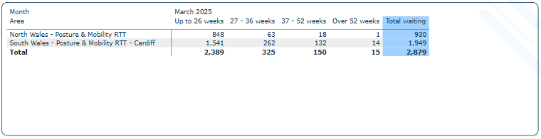
Figure 16 - Posture and Mobility Waiting List

As of March 2025, there were 2,879 patients awaiting Posture & Mobility services across Wales. The majority (2,389; 83%) were waiting up to 26 weeks, indicating timely access for most patients. However, a significant cohort of 490 individuals (17%) had been waiting longer, including 325 patients in the 27–36 week category, 150 in the 37–52 week range, and 15 patients waiting over 52 weeks, reflecting a concerning level of long waits in a specialist service.

The Cardiff (South Wales) service accounted for the highest demand, with 1,949 patients (68%) on the waiting list - more than double the volume in North Wales (930). Cardiff also had the highest number of long waiters, including 14 of the 15 patients waiting over a year. North Wales had comparatively fewer long waits, with just 1 patient exceeding 52 weeks and a larger proportion (1024/930 = 90.7%) waiting under 37 weeks.

What actions are NWJCC taking?
The NWJCC continues to monitor performance of all Artificial Limb and Appliance Services. ALAS is a strategic priority in the 2025-26 Foundation Plan, with a focus on contracting and benchmarking. The scope of the work is currently being defined.

What are the main areas of risk?
Key areas of risk include an increasing number of referrals year on year and increasing levels of patient complexity in the postural mobility and electronic assistive technology (EAT) service contributing to increased waiting times and cost.

CAMHS – Placement Performance

Figure 17 illustrates monthly bed-day activity for 2024/25 across three provider groups: Betsi Cadwaladr University Health Board, Cwm Taf Morgannwg University Health Board (CTM), and Out-of-Area (OOA) placements. The data excludes trial leave from CTM counts, though other providers may include some.

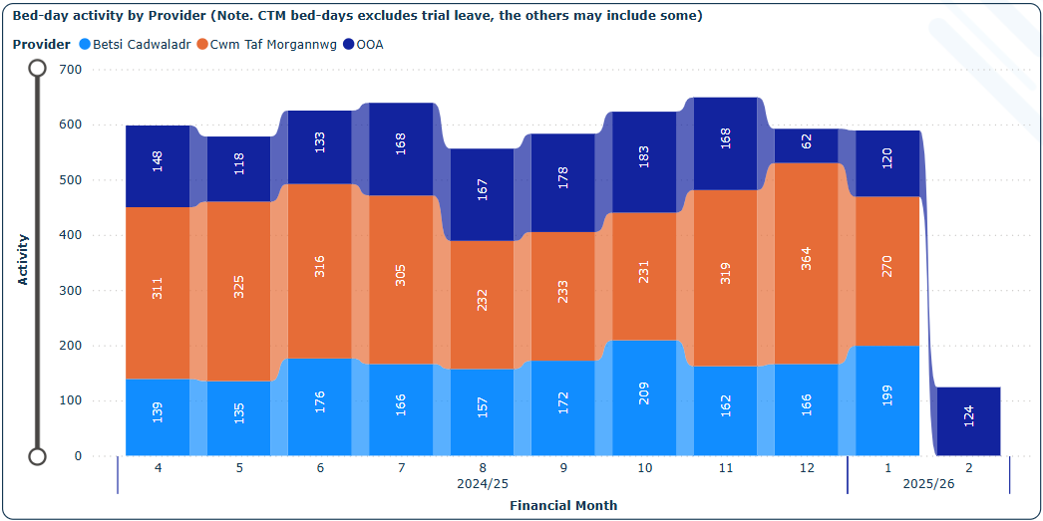
Figure 17 - CAMHS – Placement Performance

Current Performance
Total bed-day activity fluctuated between just under 600 and just over 650 bed-days per month across the financial year, with peaks in months 7 and 11. The distribution of bed-days between providers remained broadly consistent, with CTM continuing to account for the largest share each month.

Betsi Cadwaladr activity was relatively stable, ranging from 135 to 209 bed-days, with a noticeable increase between months 9 and 11. There was a small dip to 162 in month 10 before rising again to 199 in month 1 of 2025/26, followed by a drop to 124 in month 2.

CTM consistently recorded the highest bed-day volumes, varying between 232 and 364 bed-days per month. After minor dips in months 4 and 8, activity increased steadily through the remainder of the year, peaking at 364 bed-days in month 12, before decreasing to 270 in month 1 of 2025/26.

OOA placements fluctuated more notably. Activity ranged from 62 bed-days (month 12) to a high of 183 (month 10). The latest data shows a partial recovery in month 2 of 2025/26 to 120 bed-days, following a previous sharp drop.

Overall, the data shows that while CTM continues to manage the majority of inpatient provision, Betsi Cadwaladr and OOA activity levels remain variable, with recent increases suggesting higher system pressures or changes in placement patterns.

Adult Medium Secure Bed-day Performance

Figure 18 presents monthly bed-day activity across Betsi Cadwaladr University Health Board (BCU), Swansea Bay University Health Board (SBU), and Out of Area (OOA) placements for 2024/25 and the start of 2025/26. The data provides insight into mental health service utilisation and the level of reliance on external (OOA) placements.

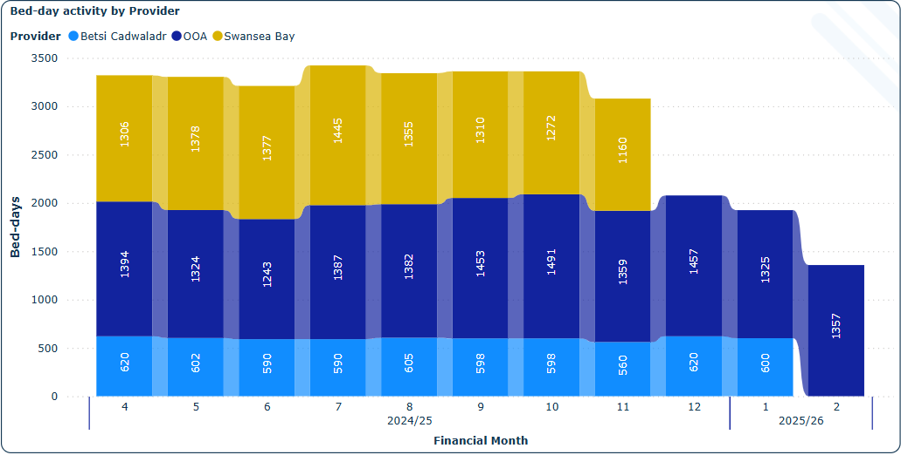
Figure 18 - Adult Medium Secure Bed-day Performance

Current Performance
Total bed-day activity remained consistent throughout the year, ranging from approximately 3,000 to 3,400 bed-days per month, with peaks in months 7 and 10. The distribution of activity across the three provider categories has remained stable over time.

Betsi Cadwaladr recorded activity between 560 and 620 bed-days across most months. After dipping slightly in month 8 (to 598), activity rose again to 620 bed-days in month 12 and continued at a stable level into the start of 2025/26.

Swansea Bay consistently contributed the largest share of bed-days each month, with values ranging from 1160 to 1445 bed-days. The highest activity occurred in month 7, with minor variations throughout the year suggesting a steady demand for in-area beds.

OOA placements have fluctuated, reflecting pressures on local capacity. Activity ranged from 1243 bed-days in month 6 to 1491 bed-days in month 10, with a notable increase in months 9 and 10. Despite a slight drop in month 11, activity remained elevated at 1359 bed-days, with similar levels continuing into 2025/26.

Overall, the graph highlights continued system-wide pressure, particularly for Swansea Bay and Out of Area provision, while BCU maintains a relatively steady level of local bed-day usage.

Ambulance Services and NHS 111 Wales

The Ambulance Service Indicators (ASI) Report for May 2025 provides an overview of ambulance service performance and clinical outcomes.

Figure 19 - 5-Step Ambulance Care Pathway

The Five-Step Model ensures ambulance resources are prioritised based on clinical need:

Help Me Choose – The NHS 111 Wales website had 423,699 visits, with dental problems as the top reason for calls. Frequent callers (273 individuals) accounted for 8.2% of incidents.

Answer My Call – 45,814 emergency 999 calls were answered, with the most common cases being breathing problems, falls, and chest pain. 4,044 urgent calls were made by healthcare professionals for patient transfers.

Come to See Me – 5,145 RED calls (immediately life-threatening) were received, but the 8-minute target response time (65%) was not met at a national level. 13,829 AMBER calls (serious but not immediately life-threatening) were logged, with long response times (median: 1 hours 33 minutes). Community first responders attended 954 incidents, arriving first in 83.1% of cases.

Give Me Treatment – Pre-hospital clinical care included treatment for cardiac arrests, strokes, heart attacks (STEMI), fractured hips, febrile convulsions, and sepsis. Return of Spontaneous Circulation (ROSC) was achieved in 22.6% of resuscitation attempts. Stroke patients received the full care bundle in 89.9% of cases, and 90.1% of fractured hip patients received pain management.

Take Me to Hospital – 11,898 patients were transported to hospital. Only 15.3% of handovers were completed within 15 minutes, leading to 19,275 hours lost due to delays.

The report highlights ongoing challenges in ambulance response times, handover delays at hospitals, and efforts to optimise care through telephone triage and alternative pathways.

Appendix 2: Q1 Implementation of NWJCC Foundation Plan

The NHS Wales Joint Commissioning Committee (NWJCC) Foundation Plan was developed during the NWJCCs first year of establishment representing a year of transition from three predecessor organisations to a single commissioning body acting on behalf of NHS Wales. The Joint Commissioning Committee endorsed the Foundation Plan 2025/2026 at its March meeting. The plan was subsequently submitted to Welsh Government.

Programme and project management arrangements have been wrapped around the implementation of the plan, enabling co-ordination, tracking and management at a variety of levels, and to a variety of audiences/recipients. However, the approach here is one of pragmatism in order to ensure both good discipline, coupled with pace/delivery).

This report provides members with an update for assurance against the Quarter 1 deliverables of the NWJCC Foundation Plan for 2025/2026.

A summary of the progress made in Quarter 1 against the published strategic priorities is outlined on page 65 followed by a detailed update on from page 66 against Quarter 1 milestones for the strategic priorities.

Summary of the progress made in Quarter 1 against the published strategic priorities

NWJCC FOUNDATION PLAN IMPLEMENTATION
STRATEGIC PRIORITY PROJECT SUMMARY Q1
RAG Rating: GREEN - On Track, AMBER - Slight Slippage (Not completed within Qtr), RED - Significant Slippage (More than 1 Qtr behind)
Project | Project Delivery Qtr | Project Progress RAG Rating
SP1 - Strategy Development | Q4
SP2 - Centre of Excellence for Collaborative Commissioning | Q4
SP3 - Increased Public Health perspective | Q4
SP4 - Strategic Service Reviews | 2026-2029 IMTP
SP4.1 - Cardiac | 2026-2029 IMTP
SP4.2 - Neonatal | 2026-2029 IMTP
SP4.3 - Ambulance Model Review | Q4
SP4.4 - Mental Health | 2026-2029 IMTP
SP5 - Pathways and Referral Management | Q3
SP6 - Manchester Arena Inquiry Response | Q4
SP7 - Benchmarking and Contracting | Q3
SP7 B&C7.1 - ALAS | Q3
SP B&C7.2 - Cystic Fibrosis | Q3
SP B&C7.3 - Ambulance | Q3
SP B&C7.4 - Immunology | Q3
SP8 - Third Sector Commissioning | To be confirmed

Detailed update against Quarter 1 milestones for the strategic priorities

Strategic Priority | Unique Identifier (Strategic) | Unique Identifier (Local) | JCC Responsible Officer | Outcome | Deliverable / Output | Milestone | Delivery Qtr | RAG Rating  G - On Track,  A - Slight Slippage (Not all actions completed within Qtr),  R - Significant Slippage (Project is more than 1 Qtr behind),  B - Project Milestone Complete  W - Project Not Yet Started | Progress Update / Comment
Strategic Priority 1: Strategy Development | SP1 | SP1 | Georgina Galletly | Develop a 5/10 Year Strategy for the NWJCC | No Q1 deliverables.
Strategic Priority 2: Centre of Excellence for Collaborative Commissioning | SP2 | SP2 | Georgina Galletly | The JCC will become the Centre of Commissioning Excellence on behalf of NHS Wales | No Q1 deliverables.
Strategic Priority 3: Population Health Perspective | SP3 | SP3 | Iolo Doull | Population health based commissioning will underpin the work undertaken by the NWJCC through an increased population health perspective |  | Discussion with PHW and secured staff member | Q1 | R | No update received.
Strategic Priority 4: Strategic Service Reviews SP4.1 - Cardiac Service Review (Note dependency on SS5 & SS6 until this review has concluded and made recommendations) | SP4.1 | SP4.1 | Mel Wilkey | Cardiac services are reviewed for optimum commissioning/value/productivity/sustainability | Recommendations arising from review used to inform commissioning intentions for IMTP | Develop the scope of the review | Q1 | B | PID Complete and with MW for progression.

Strategic Priority 4: Strategic Service Reviews SP4.1 - Cardiac Service Review (Note dependency on SS5 & SS6 until this review has concluded and made recommendations) | SP4.1 | SP4.1 | Mel Wilkey | Cardiac services are reviewed for optimum commissioning/value/productivity/sustainability | Recommendations arising from review used to inform commissioning intentions for IMTP | Identify & appoint project team | Q1 | B | Project Team identified and ready to be established following agreement of PID.
Strategic Priority 4: Strategic Service Reviews SP4.2 - Neonatal Service Review | SP4.2 | SP4.2 SS12 | Mel Wilkey | Neonatal Model to be reviewed for optimum commissioning/value/productivity/sustainability | Recommendations arising from review to inform commissioning intentions for JCC & Health Board IMTPs | Develop the scope of the review | Q1 | G | Project initiated. Milestones set at JCC meeting held on 20/05/2025. CEO and CCLG lead engaged via email and meetings. Project manager has been identified and project scope completed. The Project Team has been identified and the first meeting arranged for 14/08/2025.
Strategic Priority 4: Strategic Service Reviews SP4.3 - Ambulance Model Review | SP4.3 | SP4.3 | Ross Whitehead | Ambulance Model to be reviewed for optimum commissioning/value/productivity/sustainability |  | Develop the scope of the review | Q1 | G | Scope developed in conjunction with relevent stakeholders.

Strategic Priority 4: Strategic Service Reviews SP4.3 - Ambulance Model Review | SP4.3 | SP4.3 | Ross Whitehead | Ambulance Model to be reviewed for optimum commissioning/value/productivity/sustainability | Report to include recommendations on optimum service model for Ambulance Services | Identify project team | Q1 | A | Joint arrangements agreed with Finance and Value Directorate to combine with benchmarking and contracting review.
Strategic Priority 4: Strategic Service Reviews SP4.3 - Ambulance Model Review | SP4.3 | SP4.3 | Ross Whitehead | Ambulance Model to be reviewed for optimum commissioning/value/productivity/sustainability |  | Develop PID | Q1 | A | Joint arrangements agreed with Finance and Value Directorate to combine with benchmarking and contracting review.
Strategic Priority 4: Strategic Service Reviews SP4.3 - Ambulance Model Review | SP4.3 | AMB3 | Ross Whitehead | Patients will have the right response from the Ambulance Service resulting in improved clinical outcomes for patients. | Performance dashboard | Appointment of evaluation team | Q1 | A | Joint arrangements agreed with Finance and Value Directorate to combine with benchmarking and contracting review.
Strategic Priority 4: Strategic Service Reviews SP4.3 - Ambulance Model Review | SP4.3 | AMB3 | Ross Whitehead | Patients will have the right response from the Ambulance Service resulting in improved clinical outcomes for patients. | The development and implementation of the evolved clinical response model | Development of quality and performance metrics | Q1 | B | Evolved clinical response model phase 1 go live 01/07/2025, quality and performance metrics agreed during the implementation process.

Strategic Priority 4: Strategic Service Reviews SP4.4 - Mental Health Service Review | SP4.4 | SP4.4 | Adrian Clarke | Mental Health service model to be reviewed for optimum commissioning/value/productivity/sustainability |  | Develop the scope of the review | Q1 | A | Slippage in commencing review scope due to resource. Asst. Director vacancy and DD vacancy have either been recruited to or will be recruited to in next few weeks. This will enable scope to be developed ASAP in Q2.
Strategic Priority 4: Strategic Service Reviews SP4.4 - Mental Health Service Review | SP4.4 | SP4.4 | Adrian Clarke | Mental Health service model to be reviewed for optimum commissioning/value/productivity/sustainability | Recommendation on optimum service model for Mental Health Services | Identify project team | Q1 | A | Project team will be identified once recruitment process ends. Interviews have already taken place and commencement dates within Q2. Different areas for review have been identified. I.E review of EDOS, FACTS, Neuropsychiatry and National community Forensic team.
Strategic Priority 4: Strategic Service Reviews SP4.4 - Mental Health Service Review | SP4.4 | SP4.4 | Adrian Clarke | Mental Health service model to be reviewed for optimum commissioning/value/productivity/sustainability |  | Develop PID | Q1 | R | PID will be developed in Q2 as above.

Strategic Priority 4: Strategic Service Reviews SP4.4 - Mental Health Service Review | SP4.4 | MHLD3 | Adrian Clarke | All MHLD services commissioned by the NWJCC are reviewed to ensure optimum commissioning. |  | Complete and publish report relating to first review completed in this portfolio (Perinatal demand and Capacity) | Q1 | B | Perinatal review completed and published.
Strategic Priority 5: Pathway and Referral Management | SP5 | SP5 | Stacey Taylor | Develop a Framework for referrals to English providers to ensure value, quality and equity. |  | Develop scope review | Q1 | G | On Track - Project milestones and SRO are established, the scope is drafted, and Executive Sponsor has been identified as Hayley Thomas CEO Powys THB. CCLG Lead (Steve Powell) to be agreed. Next steps - identifying Project Team members, finalising the scope. Finalising data deep dive for border organisations. Promptly identifying the Project Manager.

Strategic Priority 5: Pathway and Referral Management | SP5 | SP5 | Stacey Taylor | Develop a Framework for referrals to English providers to ensure value, quality and equity. | Agree and implement new commissioning and delivery models. | Identify project teams | Q1 | A | Slight Slippage - Next steps - identifying Project Team members, finalising the scope. Finalising data deep dive for border organisations. Promptly identifying the Project Manager.
Strategic Priority 6: Manchester Arena | SP6 | SP6 | Ross Whitehead | Enable a NWJCC Commissioner response to the Manchester Arena Inquiry |  | Develop review scope | Q1 | B | Review scope developed in line with the scope for the collaborative assessment workshop held on 27/06/2025.
Strategic Priority 6: Manchester Arena | SP6 | SP6 | Ross Whitehead | Enable a NWJCC Commissioner response to the Manchester Arena Inquiry | Commissioner response to 106 recommendations from MAI review | Identify project teams | Q1 | B | Project team identified and meetings in place as per project requirement. Regular update reports made to CCLG and JCC.

Strategic Priority 6: Manchester Arena | SP6 | SP6 | Ross Whitehead | Enable a NWJCC Commissioner response to the Manchester Arena Inquiry |  | Develop PIDs | Q1 | B | PID developed and signed off by SLT.
Strategic Priority 6: Manchester Arena | SP6 | SP6 | Ross Whitehead | Enable a NWJCC Commissioner response to the Manchester Arena Inquiry |  | Seek legal advice on recommendations | Q1 | B | Legal advice received on the 24/06/2025 and initial feed back has been provided via the relevant mechanisms. Advice will be used to form part of the final recommendations to be made to the JCC Joint Committee.
Strategic Priority 7: Focus on Benchmarking and Contracting  SP7 B&C7.1 - ALAS | SP7 | B&C 7.1 | Mel Wilkey | ALAS |  | Develop scope for the ALAS review | Q1 | A | There is a delay in agreeing on the CEO and CCLG leads and arranging engagement to discuss the scope.
Strategic Priority 7: Focus on Benchmarking and Contracting  SP7 B&C7.1 - ALAS | SP7 | B&C 7.1 | Mel Wilkey | ALAS |  | Identify project team | Q1 | A | The identification of the Project Manager and Team is pending and is required as soon as possible, the project scope is incomplete, and a team meeting needs to be arranged.

Strategic Priority 7: Focus on Benchmarking and Contracting  SP7 B&C7.2 Cystic Fibrosis | SP7 | B&C 7.2 | Mel Wilkey/Stacey Taylor | Cystic Fibrosis |  | Finalisation of report and appropriate governance to progress the work | Q1 | A | Report of the review findings has been completed which can be used for phase 2. It has been shared with the working group which includes the service for comments. It has also been supported by the cardiac commissioning team. It also awaits support from women and children commissioning team which is due in July.  An SBAR is due to be shared with the SSCG in August for information.
Strategic Priority 7: Focus on Benchmarking and Contracting  SP7 B&C7.3 - Ambulance | SP7 | B&C 7.3 | Ross Whitehead/Stacey Taylor | Ambulance |  | Develop scope for Ambulance Review | Q1 | A | Initial scoping proposal developed, finance and commissioning team to work collaboratively during the first part of Q2 to confirm final scope.  CCLG and JCC leads to be engaged.

Strategic Priority 7: Focus on Benchmarking and Contracting  SP7 B&C7.3 - Ambulance | SP7 | B&C 7.3 | Ross Whitehead/Stacey Taylor | Ambulance |  | Identify project team | Q1 | A | Project team to be identified following agreement of project scope above.
Strategic Priority 7: Focus on Benchmarking and Contracting  SP7 B&C7.4 - Immunology | SP7 | B&C 7.4 | Mel Wilkey | Immunology |  | Develop scope for Immunology Review | Q1 | G | Scope completed.
Strategic Priority 7: Focus on Benchmarking and Contracting  SP7 B&C7.4 - Immunology | SP7 | B&C 7.4 | Mel Wilkey | Immunology |  | Identify working group | Q1 | G | A working group has been established and the outputs of the work will be considered for implementation during phase 2 which will be led by the cancer and blood commissioning team.
Strategic Priority 7: Focus on Benchmarking and Contracting  AMB11 - Maximise the productivity of NHS 111 Wales commissioned capacity | SP7 | AMB11 | Ross Whitehead | Maximise the productivity of NHS 111 Wales commissioned capacity. |  | Scope on Review of productivity of revised arrangements | Q1 | A | Work ongoing with WAST to reconfigure rosters to align capacity with demand.  Discussions planned as part of JCC strategy session in August regarding future arrangements for 111.

Appendix 3: Workforce Report

The data below consolidates key performance indicators across Sickness Absence, Turnover, Performance Appraisal and Development Review (PADR), Statutory and Mandatory Training Compliance, and Staff Movements, covering the period 1 January 2025 to 31 March 2025. The data reflects current workforce trends and highlights areas requiring further attention and intervention.

Sickness Absence

Whilst the current sickness absence rate stands at 2.81%, a slight reduction from 3.41% reported in the last quarter, nevertheless does have financial and operational implications.

Long-term absence is a concern, necessitating stronger occupational health interventions:

- Total absence days logged: 1,039 days.
- Short-term sickness (1-7 days): 0.36%
- Long-term sickness (over 28 days): 2.36%

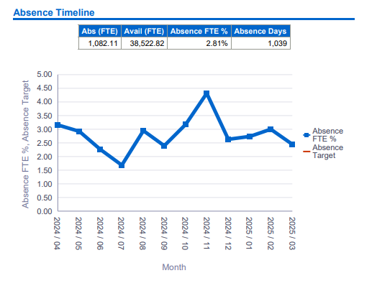
Figure 20 - Sickness Absence Timeline

PADR Compliance

Compliance is at 50.48%, which is significantly below the required target of 85%. This poses a risk and could impact on staff morale, professional development, and eligibility for pay progression.

Responsible Director | Staff | PADR Completed | % PADR Completed
Ambulance and NHS 111 Wales | 2 | 1 | 50.00%
Corporate Planning and Strategy | 23 | 13 | 56.52%
Finance and Value | 18 | 11 | 61.11%
Mental Health, LD and Vulnerable Groups | 18 | 14 | 77.78%
Nursing and quality | 5 | 3 | 60.0%
Specialised Services | 17 | 6 | 35.29%
Chief commissioner | 8 | 0 | 0.0%
Organisational Running Costs | 14 | 5 | 35.71%
Total | 105 | 53 | 50.48%
Table 23 – PADR Compliance by responsible director

ESR Core Skills Statutory and Mandatory Training Compliance

The training compliance percentage varies across different training module subject areas, with low completion rates in Fire Safety and Health, Safety and Welfare, posing a potential risk to workforce safety and regulatory compliance:

Responsible Director | Staff | Required | Achieved | Compliance
Ambulance and NHS 111 Wales | 2 | 31 | 29 | 93.55%
Corporate Planning and Strategy | 23 | 447 | 390 | 87.25%
Finance and Value | 18 | 388 | 310 | 79.90%
Mental Health, LD and Vulnerable Groups | 18 | 279 | 229 | 82.08%
Nursing and quality | 5 | 115 | 99 | 86.09%
Specialised Services | 17 | 366 | 285 | 77.87%
Chief commissioner | 8 | 174 | 42 | 24.14%
Organisational Running Costs | 14 | 283 | 207 | 73.14%
Total | 105 | 2,083 | 1,591 | 73.68%
Table 24 – ESR Core Skills Statutory and Mandatory Training Compliance

Subject | Staff | Required | Achieved | Compliance
Equality, Diversity and Human Rights | 101 | 101 | 84 | 83.17%
Fire Training | 101 | 230 | 135 | 58.70%
Health, Safety and Welfare | 101 | 158 | 90 | 56.96%
Infection, Prevention and control | 62 | 62 | 47 | 75.81%
Information Governance | 101 | 101 | 81 | 80.20%
Moving and Handling | 101 | 161 | 115 | 71.43%
Resuscitation | 62 | 62 | 49 | 79.03%
Safeguarding Adults | 60 | 62 | 46 | 74.19%
Safeguarding Children | 60 | 60 | 46 | 76.67%
Violence and Aggression | 62 | 62 | 55 | 88.71%
Table 25 – ESR Core Skills Statutory and Mandatory Training Compliance by subject

- Overall Compliance Rate: 76.38%

- Critical gaps remain in Fire Safety (58.70%) and Health, Safety & Welfare (56.96%).

Wellbeing

Employee wellbeing continues to be a priority, particularly in light of the Ongoing Organisational Change (OCP) process. The organisation remains committed to providing supportive initiatives, resources, and policies to promote staff health and wellbeing aimed at building resilience.

Current Wellbeing Initiatives

The following measures have been in place during the reporting period:

- CTMUHB Wellbeing Service - Employees have access to dedicated wellbeing support, including guidance on stress management, mental health, and self-care. The organisation has Mental Health First Aiders which promote health and wellbeing activities to staff.

- Flexible Working Arrangements - Staff are encouraged to utilise agile and hybrid working options where operationally feasible, helping to improve work-life balance. Bespoke training took place in March 2025 to raise awareness.

- Occupational Health Support - Line managers are encouraged and /or signposted to request support to address long-term sickness absence or advice on workplace adjustments for appropriate interventions.

- Staff wellbeing - Plays an essential role in reducing absence rates, supporting retention, and promoting a positive workplace culture. The NWJCC will continue to enhance awareness, strengthen managerial support, and refine workforce policies to foster a healthy and resilient workforce.

It must be highlighted that the OCP process, which recently concluded, has impacted on staff morale. Work will continue on improving internal communication about existing support services, ensuring staff and managers are aware of wellbeing resources to aid with this change management process.

List of Figures

Figure 1 - Health Board incidents. 14
Figure 2 - Health Board complaints or concerns. 16
Figure 3 - Cardiac Surgery Performance 30
Figure 4 - Specialised Cardiology Inpatient Activity 33
Figure 5 - Cardiology Waiting Times 35
Figure 6 - Bariatric Inpatients 37
Figure 7 - Thoracic Surgery Performance 39
Figure 8 - Plastic Surgery Performance 41
Figure 9 - Plastic Surgery Waiting Times at Mersey & West Lancashire 43
Figure 10 - Pet Scan Performance 45
Figure 11 - Paediatric Surgery Performance 47
Figure 12 - In Vitro Fertility (IVF) Performance 49
Figure 13 - In Vitro Fertility Performance (Waiting List) 51
Figure 14 - Neurosurgery Performance 53
Figure 15 - Posture and Mobility Performance 56
Figure 16 - Posture and Mobility Waiting List 58
Figure 17 - CAMHS – Placement Performance 59
Figure 18 - Adult Medium Secure Bed-day Performance 61
Figure 19 - 5-Step Ambulance Care Pathway 63
Figure 20 - Sickness Absence Timeline 112

List of Tables

Table 1 - Services in Escalation 13
Table 2 - Welsh Government performance measures 18
Table 3 - Specialised and Mental Health, LD and Vulnerable Groups services Performance Scorecard 19
Table 4 - RTT <105 Weeks – admission 23
Table 5 - RTT < 52 weeks – admission 24
Table 6 - < 36 weeks for First op 26
Table 7 - < 52 weeks for First op 28
Table 8 – Cancer and Blood 71
Table 9 – Cardiac 75
Table 10 – Mental Health 80
Table 11 – Vulnerable Groups 82
Table 12 – Neuroscience 88
Table 13 – Women and Children’s 94
Table 14 – Wales Kidney Network 99
Table 15 – Major Trauma 100
Table 16 – Spinal Services 101
Table 17 – Cross Cutting 105
Table 18 – Ambulance and 111 106
Table 19 – Emergency Ambulance Services 108
Table 20 – Non-Emergency Patient Transport Services 109
Table 21 – Emergency Medical Retrieval and Transfer Service / Adult Critical Care Transfer Service 110
Table 22 – NCCU Work Plan 111

