Agenda Item
2.1

Emergency Ambulance Services Committee

EMERGENCY AMBULANCE SERVICES COMMITTEE
PERFORMANCE REPORT

Dyddiad y Cyfarfod /  Date of Meeting | 21/12/2023
Statws Cyhoeddi / Publication Status | Open/ Public
Statws Cyhoeddi / Publication Status | Not Applicable
Awdur yr Adroddiad / Report Author | Phill Taylor, Head of Commissioning & Performance
Cyflwynydd yr Adroddiad / Report Presenter | Ross Whitehead, Deputy Chief Ambulance Services Commissioner
Noddwr Gweithredol yr Adroddiad /  Report Executive Sponsor | Stephen Harrhy, Chief Ambulance Services Commissioner

Pwrpas yr Adroddiad /  Report Purpose | For Noting

Engagement (internal/external) undertaken to date
(including receipt /consideration at Committee/Group)
Committee / Group / Individuals | Date | Outcome
EASC Management Group meeting | 14 December 2023 | Noted

Acronyms / Glossary of Terms
CASC  DAG  EMRTS  IQPD  NEPTS  WAST  WG  EMS | Chief Ambulance Services Commissioner  Delivery Assurance Group  Emergency Medical Retrieval and Transfer Service  Integrated Quality, Planning and Delivery Meeting  Non-Emergency Patient Transport Service  Welsh Ambulance Services NHS Trust  Welsh Government  Emergency Medical Services

- SITUATION/BACKGROUND

  - The purpose of the report is to present to EASC Members the most recent publication of the:
- Ambulance Service Indicators (ASIs) – Attached at Appendix 1
- EASC Performance Dashboard – Attached at Appendix 2.

- SPECIFIC MATTERS FOR CONSIDERATION BY THIS MEETING (ASSESSMENT)

Ambulance Service Indicators

  - The narrative and overview document for the latest reporting period – October 2023 is available at Appendix 1.

  - Full access to the ASI information for all publication is available at https://easc.nhs.wales/asi/asipublicnarrative/

EASC Performance Dashboard

  - The Performance Dashboard is available at Appendix 2.

  - The dashboard presents time series information across a number of periods, including daily, monthly and annual time periods.

  - Of particular note within the dashboard for this reporting period:
- 999 call volumes in October 2023 were 7.7% lower than October 2022
- 7.4% reduction in incidents in October 2023 compared to October 2022
- Hear and Treat levels are 2.3% higher in October 2023 compared to October 2022
- Red incidents in October 2023 were 7.8% higher compared to October 2022.
- Amber incidents in October 2023 were 6.1% higher compared to October 2022.
- Ambulance handover lost hours in October 2023 are 19.8% lower compared to October 2022. Some improvements on a number of metrics, % handed over in 15 min and handovers over 4 hours have been seen in 2023 but between September 2023 and October 2023 there has been a 18.4% increase in handover lost hours.

EASC Action Plan

  - Following receipt of confirmation of the EASC IMTP 23/26 from Welsh Government officials, further revisions to the EASC Action Plan are required (letter shared at the last meeting of EASC on 21 November 2023).

  - A revised format for this report will be shared through ICAP meeting and to Management Group members for comment and amendments prior to submission to EASC.

Integrated Commissioning Action Plan (ICAP)

  - In line with the requirements set out in the IMTP response letter, the ICAPs are undergoing a review to reflect the challenges in 2023/24 and the requirement set out within the letter.

  - A revised draft will be shared through ICAP meetings and management group for comment and amendments prior to submission to EASC.

  - The actions contained within ICAPs have been jointly analysed and remain appropriate for the delivery of improved ambulance services.

  - Members of the EASC Management Group were asked to reaffirm their commitment to the actions within ICAPS and with the support of the EASC team review delivery on an individual health board basis in partnership with WAST.

Immediate Release Requests

  - Within the EASC Weekly Performance Dashboard, the dashboard includes data on immediate release request compliance. In addition to this, WAST circulate a weekly immediate release request report and via the ICAP meetings, health boards have raised questions regarding the data and its validity. This matter has also been raised by health boards at the EASC Management Group meeting.

  - In response to this matter, the EASC Team have facilitated a meeting between health boards and WAST to understand the issues raised and look to identify opportunities for improvement.

  - The outcomes of this work are included in the attached report at Appendix 3.

Statistical Process Control (SPC) Charts

  - At the EASC Joint Committee meeting in September 2023, Members discussed the content of performance reports produced by the EASC Team. Members discussed how the information within the reports were used and how additional information could assist in understanding the system.

  - Members discussed how SPC charts could be a used to gain a greater understanding of the system at a local and national level.

  - The CASC agreed that that the EASC Team would develop the approach of including SPC Charts within reporting. Appendix 4 is a draft report consisting of operational performance within SPC Charts.

Resource Utilisation

  - Within the ICAP meetings, a review of performance within each health board is undertaken. In those health boards where improvements have been made in reducing ambulance handover delays, health boards have sought to identify the correlating improvements in WASTs community response performance.

  - It is recognized that there had been improvements within some handover performance metrics between December 2022 and June 2023. However, from July 2023 the total cumulative handover lost hours have continued to increase month on month. In September 2023, the total ambulance lost hours were 19,617.

  - To note, the EASC IMTP performance ambition for ambulance handover delays, were
- 15,000 lost hours by the end of Q2 and
- 12,000 lost hours by the end of Q3.
Additionally, the 2019 EMS Demand and Capacity Review was predicated on 6,000 lost hours per month.

  - There have been some improvements to WAST resource utilisation at individual sites within health boards with the exception of Cardiff and Vale (CVUHB). The EASC Team has worked with WAST to review this matter.

  - An initial exercise was undertaken within the south east Wales region to review CVUHB ambulance performance, aligned to the health boards’ significant reduction in handover delay lost hours.
  - The key outcome of this exercise identified that although CVUHB had significantly reduced their handover lost hours, which resulted in ambulance resources becoming more readily available, these available ambulance resources were then responding to incidents within ABUHB and CTMUHB areas.

  - The high ambulance handover levels within ABUHB and CTMUHB are limiting ambulance availability within those areas.

  - Ambulance resources from CVUHB are therefore responding to patients within the communities in ABUHB and CTMUHB. The exercise identified that since 2020, the number of CVUHB and ABUHB ambulance resources responding to incidents outside of their health boards has increased year on year, but the number of CTMUHB resources responding to health boards outside of their health board has remained consistent.

  - Table 1 illustrates the flow of resources within the south east Wales region. Further work is being undertaken to review the flow of resources across Wales. Once finalized, this work with be shared with Members.

Table 1.

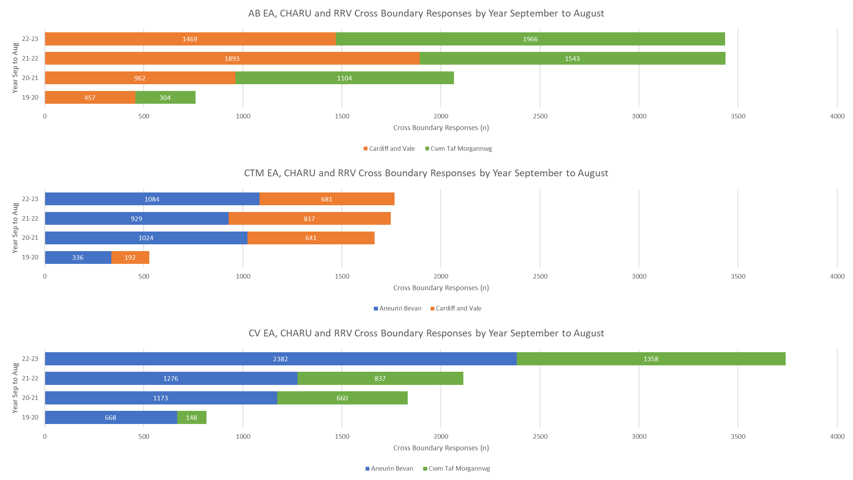

- KEY RISKS/MATTERS FOR ESCALATION TO THE COMMITTEE

  - Whilst some improvements are being made, Members will note that within the ASIs and the Performance Dashboard there are a number of areas of concern regarding response performance and lost hours and the resulting impact on patient care.

- ASSESSMENT

Objectives / Strategy
Dolen i Nod (au) Strategol BIP CTM /  Link to CTMUHB Strategic Goal(s) | Improving Care
 | If more than one applies please list below:
Dolen i Feysydd Strategol BIP CTM /  Link to CTMUHB Strategic Areas | Living Well
 | If more than one applies please list below:
Dolen i Ddeddf Llesiant Cenedlaethau'r Dyfodol – Nodau Llesiant /  Link to Wellbeing of Future Generations Act – Wellbeing Goals  150623-guide-to-the-fg-act-en.pdf (futuregenerations.wales) | A Healthier Wales
If more than one applies please list below:
A more equal Wales
Dolen i Hwyluswyr Ansawdd  (Canllawiau Statudol Dyletswydd Ansawdd (llyw.cymru)) /  Link to Enablers of Quality  (Duty of Quality Statutory Guidance (gov.wales)) | Data to Knowledge
If more than one applies please list below:
Whole systems perspective
Leadership
Learning, improvement and research
Dolen i Feysydd Ansawdd  (Canllawiau Statudol Dyletswydd Ansawdd (llyw.cymru)) /  Link to Domains of Quality  (Duty of Quality Statutory Guidance (gov.wales)) | Effective
If more than one applies please list below:
Efficient
Equitable
Patient centred
Timely
Safe

Effaith Amgylcheddol/ Cynaliadwyedd (5R) /  Environmental /Sustainability Impact (5Rs) | No - Not Applicable
 | If more than one applies please list below:

Impact Assessment
Ansawdd  Ydych chi wedi ymgymryd â Sgrinio Asesiad o’r Effaith ar Ansawdd? /  Quality  Have you undertaken a Quality Impact Assessment Screening? | Yes: ☐ | No: ☒
 | Outcome: | If no, please include rationale below:  Reporting on performance matters from last EASC meeting.
Cydraddoldeb  Ydych chi wedi ymgymryd â Sgrinio Asesiad o'r Effaith ar Gydraddoldeb? /  Equality  Have you undertaken an Equality Impact Assessment Screening? | Yes: ☐ | No: ☒
 | Outcome: | If no, please include rationale below:  Reporting on performance matters and the impact on the wider health system. Quality and safety matters also considered.
Cyfreithiol / Legal | There are no specific legal implications related to the activity outlined in this report.
Enw da / Reputational | Yes (Include further detail below)
Enw da / Reputational | Ambulance performance of significant concern to the public and impacts on health boards reputation
Effaith Adnoddau  (Pobl /Ariannol) /  Resource Impact  (People / Financial) | There is no direct impact on resources as a result of the activity outlined in this report.

5. RECOMMENDATION
  - The Emergency Ambulance Services Committee is asked to:
- NOTE the content of the report
- NOTE the Ambulance Services Indicators
- DISCUSS and NOTE the information within the performance dashboard
- DISCUSS the inclusion of SPC Charts within EASC reporting dashboard
- NOTE the ongoing work regarding resource utilisation.

6. NEXT STEPS
  - The EASC Performance Report and the Quality and Safety Report will continue to be presented as the first agenda items at each meeting of the Emergency Ambulance Services Committee
  - Subject to agreement SPC charts will be included in the dashboard.

