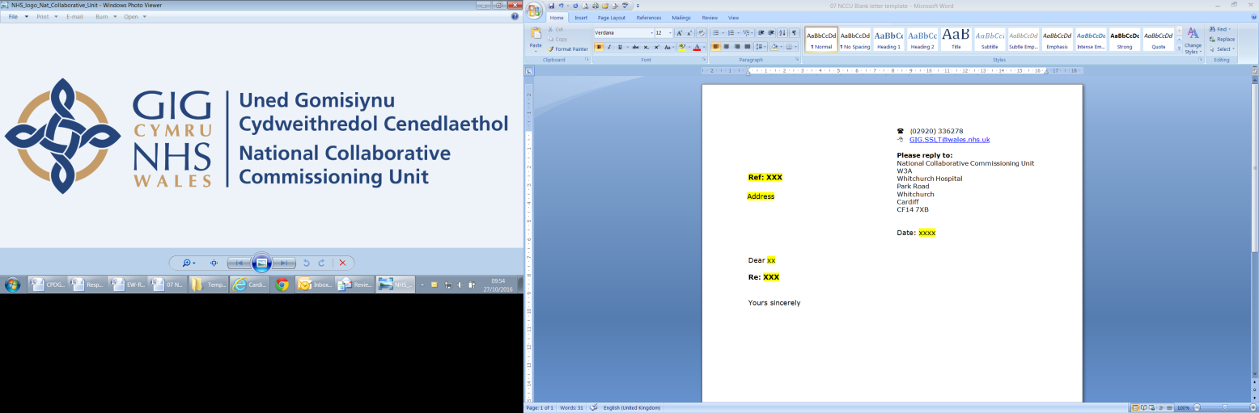

Amber Review
Implementation Programme

January 2019

Director-Shane Mills, Director of Quality & Patient Experience
Lead- Ross Whitehead, Assistant Director of Quality & Patient Experience

Contents

1. Background 3
2. Findings from review 4
2.1. Explaining Amber 4
2.2. Exploring Amber 4
2.3. Delivering Amber 5
2.4. Improving Amber 5
3. Amber Review Implementation Programme-overview 7
4. Programme Team and roles 8
5. Programme governance 8
6. Programme Assurance 8
7. Programme oversight 11
8. Programme reporting 13
9. Integrated information 13
Appendix A Communication/Responsibility matrix 14

Amber Review Implementation Programme

Background

This strategy paper sets out the Implementation Programme that has resulted from the Amber Review.
The Amber Review endeavoured to answer two main areas that, based issues raised by the health service, the public, media and other stakeholders. Firstly, is there a systemic problem with the Amber category that is resulting in worsening outcomes for patients? Secondly, are those patients, whose condition places them within the in the Amber category waiting too long for an ambulance response and if so what is the impact on their health and experience.
The Amber Review found that the Welsh Ambulance Service was an essential component for delivering care in a complex adaptive system and that models, measurement and targets for Ambulance service delivery across the UK are becoming increasingly disparate, although there is a general trend towards reducing the emphasis on response targets as the primary outcome measure.
As part of the Amber Review a public survey was undertaken (representative 1000 people) and when asked the public:
- Supported the principle of the Welsh model ‘to get the best response even if this is not the quickest response’.

- supported Ambulance services doing as much as possible to avoid the need for them to go to hospital

- agreed that the continued focus for the Welsh Ambulance Services must be quality of care
The Amber Review found that calls to the Welsh Ambulance Service increased by 11.3% and recommended more work to understand this. Despite an increase in calls the Amber review found WAST were taking less people to hospital although there was agreement that more can be done by both the service and the wider NHS.
The Amber Review reinforced the need to ensure the emotional and physical wellbeing of ambulance staff is supported as sickness levels remain high.
The Amber Review provided assurance that the majority of patient outcomes have not been effected by ambulance response times although a small number have been effected and some patients will have had poor experiences. The Review also demonstrated that the majority of patients categorised as Amber received a prompt response and Ambulance services in Wales are getting to the sickest patients first. The review also found there are opportunities to enhance and improve the unscheduled care system.
As a summary the Amber review found that increasing delays in ambulance response was due to the availability of ambulance resources not the clinical response model.

Findings from review

The Amber Review was split into in four parts, each with its own set of findings:

Explaining Amber

In this part the Review explained the current Welsh Ambulance Service clinical response model, how ambulance calls are prioritised and the public and staff understanding of the Amber category. This part found:
- The prioritisation of calls is complex.
- There is a range of different responses depending on the patient’s condition.
- Ambulance staff felt frustrated by the restrictive nature of the prioritisation system.
- The public felt that it was important to get the best response for their condition even if this was not the quickest.

Exploring Amber

In this part the Review explored the ‘five step pathway’ used by Welsh Ambulance Services, starting from a patient making a 999 call for ambulance services to being taken to hospital. It demonstrated the changes that have occurred with calls and incidents in the Amber category over time. This part found:
- There was increased demand in the Amber category.
- Ambulance staff felt that expanding the numbers and roles of clinicians in the control room was essential.
- Receiving a quick ambulance response but ensuring this is the right response for your condition is important to the public.
- Further work is required to explore the relationship between cancellations and re-categorisations and ambulance response.
- Further work is required to explore the relationship between hoax calls, refusals and ambulance response.
- The Public support ambulance services doing as much as possible to avoid the need for them to go to hospital.

- Staff require more information on alternative services.
- Measures of quality is as important as response times.
- Measurement of the ambulance service should be refined to reflect the whole patient journey.
- Measures should be developed in partnership with patients.
- Members of the public wish to be supported and be better informed when making a 999 call.
- More patients in the Amber category are having their incident resolved or closed over the phone

Delivering Amber

In this part the Review considered how Welsh Ambulance Services were using their resources to meet the demands placed on it. It will also explore what happens when the daily demand cannot be met and some patients end up waiting a long time for an ambulance and what effect that may have on their health and experience. This part found:
- Funding for ambulance services has increased.
- The ambulance service does not always deliver sufficient resources to meet demand.
- The time ambulances are waiting outside hospitals has increased.
- Sickness levels remain high.
- Emotional and psychological wellbeing of staff is important.
- Call handlers should be supported, especially during periods of increased activity.
- Resource availability is the foremost factor in providing an appropriate response.
- A lack of resource availability can result in longer waits for some patients.
- There has been an increase in the number of Serious Adverse Incidents reported.
- The clinical response model is a valid and safe way of delivering ambulance services.
- Members of the public support the principles of the clinical model.
- The length of time you wait for an ambulance response in the Amber category, does not appear to correlate with worse outcomes.
- There are further opportunities to use the Integrated Information Environment.

Improving Amber

In this part, the Review highlighted opportunities for improvement and summarised the recommendations, which were:
- Measures of quality and response time should continue to be published although they need to reflect the patient’s whole episode of care.

- Measures should be developed in collaboration with patients
- There should be a programme of engagement to ensure clarity on the role of emergency ambulance services and how calls are prioritised and categorised
- NHS services in Wales must improve and simplify their offering of alternative services
- There must be sufficient numbers of clinicians in the contact centres to ensure patients receive the most appropriate level of care.
- The ambulance service must ensure that planned resources are sufficient to meet expected demand.
- The ambulance service must deliver against its planned resource.
- Health Boards must take appropriate actions to ensure that lost hours for ambulances outside hospitals reduce.
- The longest waits for patients in the community must reduce.
This part also recommended some further work be undertaken in association with the Amber Review such as:
- Understand the change in activity and explore opportunities for improvement in:
  - number of calls
  - patient cancellations
  - re-categorisation
  - refusals of treatment and transportation

- The role of the clinical support desk within the wider unscheduled care system should be reviewed.
- Health boards and the Welsh Ambulance Service should work together to ensure the current alternative services to hospital admission are being effectively used.
- A review should be undertaken by the Chief Ambulance Services Commissioner to support the Welsh Ambulance Service t0 maximise front line staff availability.
- A review should be undertaken by the Chief Ambulance Services Commissioner to support Health Boards to minimise lost hours to handover delay.
- The Chief Ambulance Services Commissioner will develop and implement a long wait reduction programme
- There should be a review of the Serious Adverse Incidents reported and Regulation 28 notices received over the most recent winter to ensure lessons are learnt and shared.
- The Integrated Information Environment should be used to identify opportunities for improvement within the unscheduled care services.

Amber Review Implementation Programme-overview

The Amber Review Implementation Programme will consist of establishing an overarching time limited programme group to:
- Provide assurance to stakeholders on the recommendations of the Amber Review
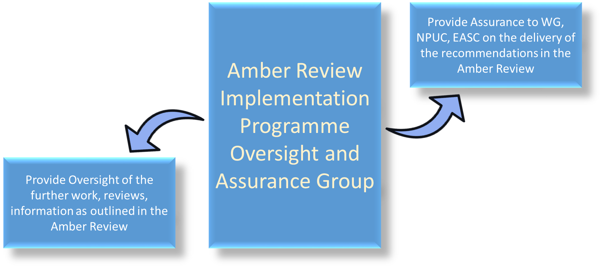
- Provider oversight and direction for the ‘further work’ as outlined in the Amber Review
The programme is expected to run no longer than 12 months with a projected end date of November 2019. A midpoint review will take place in May 2019. Individual tasks will have their own timeframe although all are expected to finish before the programme end date. Any legacy issues will be flagged early and will be expected to be incorporated into the WAST commissioning arrangements or other longer term schemes
A midpoint update will be made available to Welsh Government and EASC in June 2019
The Programme will be delivered within a culture of collaboration with designated delivery partners such as WAST, NWIS and DU
A final external evaluation report will be available to Welsh Government and EASC in November 2019

Programme Team and roles
The Programme team and their corresponding roles are:
- Programme Chair: Mr Stephen Harrhy
- Programme Director: Mr Shane Mills
- Operational delivery lead: Mr Ross Whitehead
- Policy and delivery lead: Mr Aled Brown
- WAST liaison Mrs Racheal Marsh
- Integrated information lead: Dr Gareth John
- Health Board representation TBC
Administrative support will be provided by NCCU and WG. Other persons may be co-opted onto the programme group as required and Health board representation will be sort as is appropriate to the subject mater

Programme governance

A programme oversight group will be established - chaired by the programme chair. This group will meet monthly and membership will consist of the programme team and other co-opted members.
Some tasks and projects may require small task and finish groups which will meet as and when required. Membership will be specific for each project. New groups can be established by the programme oversight group.

Programme Assurance

The Amber Review Implementation Programme will provide assurance to the following stakeholders:
- Welsh Government- As requested in the letter from the Cabinet Secretary for Health and Social Care through regular updates
- Emergency Ambulance Services Committee- As commissioners of the Amber Review by formal feedback at EASC Committee
- National Programme Of Unscheduled Care- As senior oversight group of this aspect of services by regular updates
- The Public- As described in the Amber review through patient representative groups by publication and engagement

The assurance mechanism and corresponding recommendations laid out in the table below

AMBER REVIEW RECOMMENDATION | ASSURANCE MECHANISM
Measures of quality and response time should continue to be published although they need to reflect the patient’s whole episode of care | Provide an assurance statement to stakeholders on:  - The extant work being undertaken in NHS Wales on designated conditions such as Stroke and STEMI.  - the progress and limitation of each extant work stream/programme  - whether the extant work streams are utilising contemporary integrated information
Measures should be developed in collaboration with patients | Provide an assurance statement to stakeholders on:  - the level of engagement and collaboration with patient representative groups for the extant work being undertaken in NHS Wales on designated extant conditions such as Stroke and STEMI
There should be a programme of engagement to ensure clarity on the role of emergency ambulance services and how calls are prioritised and categorised | - Receive from WAST a plan for ensuring engagement with patients to improve understanding of:  - Call categorisation and opportunities to consider renaming  - Call prioritisation- and opportunities to impart information on the scarcity of ambulance resources and how patients can support better use of emergency ambulances  - Receive regular progress updates from WAST on the plan  - Provide updates to stakeholders on the delivery against the WAST engagement strategy
NHS services in Wales must improve and simplify their offering of alternative services | - Receive an assessment from WAST and HB of the current unscheduled care services accessible by ambulance services  - Use contemporary integrated information to understand unnecessary variation and highlight opportunities for harmonisation  - Provide recommendations to stakeholders on future harmonisation work
There must be sufficient numbers of clinicians in the contact centres to ensure patients receive the most appropriate level of care. | - Receive an update from WAST on the impact of the recent increase in clinical desk staffing  - Receive from WAST a strategy paper on the optimum number of clinicians that will result in maximum impact on (i) ambulance resources and (ii) unscheduled care  - Provide recommendations to stakeholders on future commissioning intentions for the clinical desk
The ambulance service must ensure that planned resources are sufficient to meet expected demand. | - WAST to provide regular updates of delivery against demand and capacity review  - WAST to provide regular updates of on staffing roster reviews  - WAST to provide regular updates on spend split between front line deployment and other areas of spend  - Provide updates to stakeholders on the planned resource work
The ambulance service must deliver against its planned resource. | - WAST to provide monthly gap analysis between planned and actual with explanations of any gap beyond 1%. Expectation would be a betterment against the average 3.3% as detailed in the amber review
Health Boards must take appropriate actions to ensure that lost hours for ambulances outside hospitals reduce. | - Health Boards to reconsider internal escalation to ensure sufficient focus and recourse to action on handover delays  - EASC to receive a report by hospital on the most recent handover delays, this report will detail a 12 month trend analysis  - Each Health Board will be expected to provide details on all actions to reduce any handover delays and this to be shared at EASC  - CASC to produce a monthly report by time bandings of handover delays to be shared with relevant stakeholders
The longest waits for patients in the community must reduce. | - WAST to produce a monthly report by time bandings of long waits to be shared with relevant stakeholders. This report will detail a 12 month trend analysis  - WAST to consider internal escalation to ensure appropriate operational time is available to prevent backstop breach  - WAST to produce a non-compliance report for every breech of the agreed community wait backstop with actions to minimise reoccurrence

Programme oversight

The Amber Review Implementation Programme will provide oversight and direction to for the work programme as laid out in the table below:

Amber review statements | Outline of further work
Health boards and the Welsh Ambulance Service should work together to ensure the current alternative services to hospital admission are being effectively used. | - NCCU should work with willing Health boards partners to undertake an assessment of specific unscheduled care services currently being utilised by patient groups highlighting opportunities for improvement
The role of the clinical support desk within the wider unscheduled care system should be reviewed | - NCCU should understand the patient groups accessing and being discharged from the clinical desk, understanding re presentations to unscheduled care
A review should be undertaken by the Chief Ambulance Services Commissioner to support the Welsh Ambulance Service to maximise front line staff availability. | - NCCU should work with WAST to understand the financial spend in respect of various service aspects (for example emergency ambulance staffing, vehicle type) and look for opportunities to maximise front line spend  - NCCU will develop a skills mapping matrix to allow EASC to have a clearer picture of each specific paramedicine post role and responsibilities
A review should be undertaken by the Chief Ambulance Services Commissioner to support Health Boards to minimise lost hours to handover delay | - NPUC to work with Health Board partners to develop a greater understating of the local factors responsible for increasing handover delays.  - Each hospital with major ED to be supported to develop a local Handover Delay improvement plan
The Chief Ambulance Services Commissioner will develop and implement a long wait reduction programme | - NPUC to work with WAST to understand the factors relating to longest waits, especially in relation to those patients experiencing very long waits are given sufficient operational focus
The Integrated Information Environment should be used to identify opportunities for improvement within the unscheduled care services | - NPUC to look for opportunities to utilised the extant data set  - NPUC to work with NWIS to update and provide contemporaneous data set  - NWIS to provide analytical support to NPUC to ensure appropriate interpretation of data and seek opportunities for innovate use of data to drive improvement
Understand the change in activity and explore opportunities for improvement in:  - number of calls  - patient cancellations  - re-categorisation  - refusals of treatment and transportation | - NPUC to work WAST to understand trends in data  - NPUC and WAST to consider how to look at appropriate betterment in trends
There should be a review of the Serious Adverse Incidents reported and Regulation 28 notices received over the most recent winter to ensure lessons are learnt and shared. | - NPUC to work with WAST to ensure a comprehensive review of winter SAI and Reg 28 of 2018 is undertaken and common trends and improvement opportunities are highlighted
The NPUC should work with nursing homes to help reduce calls by providing lifting equipment and training | - NPUC should ensure eligible care homes should be supplied with a camel lifting device  - The project should be undertaken with shared services to ensure compliance with procurement and legal requirements
A review should be undertaken to understand the impact of a trained mental health professional working in the contact centre would | - A baseline assessment should be undertaken of calls to ambulance services from those categorised as mental health
There is required a better understanding of the demand from those with substance misuse, drug or alcohol issues and transient mental distress on ambulance and the unscheduled care system | - A baseline assessment should be undertaken of calls to ambulance services from those categorised as mental health

Programme reporting

The Amber Review Implementation Programme will deliver a number of products linked to the amber review recommendations. Communication to Health Boards and other stakeholders will be as required. The roles and responsibilities of various group and organisations is laid out in Appendix A

Integrated information

The Amber Review developed an innovative methodology to apply clinical and analytical expertise to a an large integrated data set which follows a patients journey through unscheduled and hospital care a shown I the graphic below

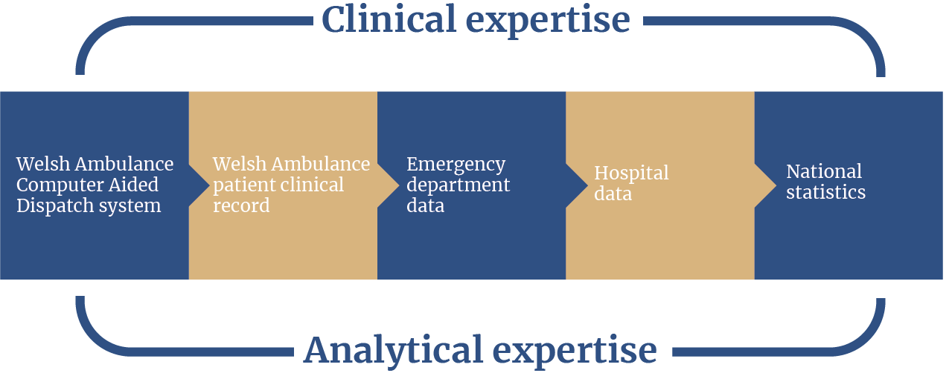

The Amber Review Implementation Programme will ensure a continued application of this methodology in a consistent manner. The programme will ensure information is presented in a uniform manner and suitable for publication and sharing with a range of stakeholders. It will drive for inclusion of patient representative groups in the development of information sets in line with the recommendations of the amber review.

Appendix A Communication/Responsibility matrix

This matrix lays out the participation and communication across different roles and groups for the Amber Review Implementation Programme, although only in respect of recommendations.
There are 4 roles as set out below:
- Responsible for completing the task or project
- Accountable for making final decisions/closing project or tasks
- Consulted person/group/organisation consulted before major action/decision is made
- Informed person/group/organisation consulted after major action/decision is made

Task\Role | EASC | CASC | WAST | NPUC | Amber Review Implementation Programme Group
Measures of quality and response time should continue to be published although they need to reflect the patient’s whole episode of care | A | I | C | R | C
Measures should be developed in collaboration with patients | A | I | I | R | I
There should be a programme of engagement to ensure clarity on the role of emergency ambulance services and how calls are prioritised and categorised | A | C | R | I | I
NHS services in Wales must improve and simplify their offering of alternative services | R | I | C | A | I
There must be sufficient numbers of clinicians in the contact centres to ensure patients receive the most appropriate level of care | A | C | R | I | I
The ambulance service must ensure that planned resources are sufficient to meet expected demand. | C | A | R | I | I
The ambulance service must deliver against its planned resource. | C | A | R | I | I
Health Boards must take appropriate actions to ensure that lost hours for ambulances outside hospitals reduce. | R | C | I | A | I
The longest waits for patients in the community must reduce. | R | C | I | A | I

