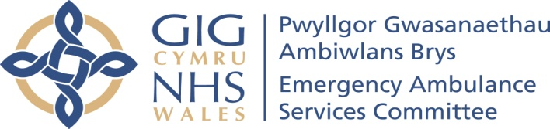
Agenda item 4.2

Reporting Group | Planning, Development and Evaluation Group
Chaired by | Mr Julian Baker
Lead Director | Chief Ambulance Services Commissioner (CASC)
Author and contact details. | Julian Baker
Date of last meeting | 15 January 2019
Summary of key matters including achievements and progress considered by the group and any related decisions made.
EASC inserts within IMTPs / (3 Year Plans)

Five out of six Health Boards agreed they were including the insert in a form which fitted with the tone of their document and in some instances a more summarised form. Powys were going to check. (Action 1: Powys tHB)

Financial Assumptions

Health Boards advised they were following the approach agreed for WHSSC, however, to date it was acknowledged the CASC had not been involved in discussions between HBs and the WG on a similar stance for EASC, which he would clarify with the WG. (Action 2: CASC)

It was noted that the WAST developments of APPs and Clinical Desk were a continuation of 2018/9 initiatives and not ‘additional’ initiatives for 2019/20. It was noted in the review of Joint WAST & HB improvements (Table 2s) there didn’t appear to be any joint initiatives which were additional and requiring funding in 2019/20.

It was noted that to date WAST had not identified additional initiatives for 2019/20.
It was noted that a pay related item would show ‘below’ the line and a minor reconciliation between Health Boards would be included within the next update.

Joint WAST & Health Board performance improvements

Drafted Table 2s to be reissued to WAST and Health Boards (Action 3: NCCU) for there to be:
- Identification of each initiative against the 4 Joint Performance Improvements stated in the EMS Commissioning Intentions for i) Pathways ii) HCP calls iii) Alternatives to ED iv) Handover (Amber Review related); plus those which relate to HB Service Transformations; and those which relate to other (Action 4: WAST & HBs)
- Confirmation by WAST & HBs that there are no additional financial requirements to deliver ‘additionality’ (Action 5: WAST & HBs)

Local Population Measures for EMS and NEPTS

Health Boards to identify the lead individual(s) for identifying with WAST & NCCU measures across the EMS 5 steps and across the NEPTS 5 steps, drawing upon the comprehensive measures available for both EMS and NEPTS (Action 6: HBs plus for NEPTS Velindre & Renal)

EASC Sub Groups

Health Boards to identify the representatives for the EASC sub groups of:
- JMAG
- PDEG
- EMRTS DAG
- NEPTS DAG
(Action 7: Health Boards)

NPUC: Winter Funding 2018/19 Initiatives and Evaluation

Access to the Winter Funding templates to be provided to Health Boards, WAST and Welsh Government (Action 8: NCCU)
Health Boards, WAST and Welsh Government to complete template (Action 9: Health Boards, WAST & Welsh Government)

NPUC: Home to ED Service Change Initiatives

Access to the Table 3s to be provided to Health Boards & WAST (Action 10: NCCU)
Health Boards to complete the table 3s (Action 11: Health Boards)

EMRTS

The position summarised by the CASC re the principles of the support to the expansion by EASC would be reviewed and confirmed to Health Boards (Action 12: CASC)

Key risks and issues/matters of concern and any mitigating actions
- There were none
Matters requiring Emergency Ambulance Services Committee level consideration and/or approval
- There were none.
Matters referred to other Sub Groups
- There were none

