


NATIONAL COLLABORATIVE COMMISSIONING UNIT
INTEGRATED MEDIUM TERM PLAN 2020/2023

Table of Contents
1 Foreword 4
2 Executive Summary 5
3 Introduction 6
3.1 Our Vision 6
4 Our Strategic Aims 6
4.1 Development of the NCCU Strategic Aims 6
4.2 NCCU Operating Model 7
4.3 NCCU Operating Model in action 8
4.4 Transformational Drivers 9
4.5 Collaborative Commissioning 11
4.6 Integrated Thinking 15
4.7 Shared Insight 16
4.8 Evidence-Based Outcomes 16
5 Achievements and Benefits Realisation 2019/20 18
5.1 NCCU Achievements 18
5.2 EASC Commissioned Services 18
5.3 National Programme for Unscheduled Care 23
5.4 Improving Care, Improving Experience in Mental Health and Learning Disability Services Programme 28
6 Opportunities and Benefits to be realised 2020-23 29
6.1 NCCU Opportunities 29
6.2 Emergency Ambulance Services Committee (EASC) 29
6.3 National Programme for Unscheduled Care 32
6.4 Improving Care, Improving Experience in Mental Health & Learning Disability Services Programme 38
7 Our Enablers, Collaborations & Workforce Plan 40
7.1 NCCU collaborations to support and enhance delivery 40
8 EASC Work Programme 44
8.1 Background 44
8.2 EASC Key Deliverables 44
8.3 EASC Collaborative Commissioning Integrated Delivery Model 44
8.4 Commissioning Development & Support 45
8.5 Quality Assurance & Improvement 51
8.6 Insight & Innovation 53
8.7 EASC Model Standing Orders 55
8.8 EASC Financial Values 58
9 National Programme for Unscheduled Care (NPUC) Work Programme 62
9.1 Background 62
9.2 NPUC Key Deliverables 62
9.3 NPUC Programme Vision 62
9.4 Unscheduled Care Quality Statements 63
9.5 National Policy Framework for Unscheduled Care 63
9.6 What does good look like for the Emergency Department in Wales? 64
9.7 Developing further National Collaborative Commissioning Quality & Delivery Frameworks for Unscheduled Care 70
9.8 Influencing Behaviour: Changing the conversation 71
9.9 Welsh Emergency Department Frequent Attenders Network (WEDFAN) 71
9.10 IMTP Guidance – Alignment with planning 72
9.11 National Clinical Pathways 72
9.12 Winter Planning & Evaluation 73
9.13 Clinical Procurement of 3rd Sector Services 73
10 Improving Care, Improving Experience in Mental Health & Learning Disability Services Programme 75
10.1 Background 75
10.2 Improving Care, Improving Experience in Mental Health & Learning Disability Key Deliverables 75
10.3 Commissioning Development & Support 76
10.4 Quality Assurance & Improvement 78
10.5 Insight & Innovation 78
10.6 Together for Mental Health Delivery Plan 80
11 NCCU Financial & Workforce Plans 81
11.1 Background 81
11.2 NCCU Financial Plan 2020/21 81
11.3 NCCU Organisation structure 84
11.4 NCCU Workforce Plan 2020/21 84
11.5 NCCU Supporting Savings Opportunities 85
11.6 NCCU Supporting the Efficiency Agenda 85
11.7 Key Risks to Service Delivery and the Financial Plan in 2020/21 85
11.8 NCCU Digitalization Plan 2020/21 87
12 Appendix 1: EASC Key Deliverables 88
13 Appendix 2: Emergency Medical Services Commissioning Intentions 2020/21 91
14 Appendix 3: Non-Emergency Patient Transport Services Commissioning Intentions 2020/21 96
15 Appendix 4: EMS Action plan (2020/21 Commissioning Intentions) 101
16 Appendix 5: NEPTS Action plan (2020/21 Commissioning Intentions) 112
17 Appendix 6: NEPTS Storyboard 117
18 Appendix 7: Strategic Health Board Service Changes 118
19 Appendix 8: NPUC Key Deliverables 125
20 Appendix 9: Improving Care, Improving Experience Key Deliverables 127
21 Appendix 10: EASC – Chairs Objectives January 2020 130

Foreword
Welcome to our Integrated Medium Term Plan for 2020/21 – 2023. This plan builds on our approved IMTP from 2019/20 and outlines the strategic and operational developments in place to achieve our vision:

“Leading quality assurance and improvement for NHS Wales through collaborative commissioning.”
In order to deliver against our vision and respond to the growing demand for our services the NCCU has developed strategic aims and a plan to enable delivery. The work programmes we deliver on behalf of:
- Emergency Ambulance Services Committee (EASC) through the Chief Ambulance Services Commissioner (CASC)
- NHS Wales and the Welsh Government through the National Programme for Unscheduled Care (NPUC)
- Improving Care, Improving Experience in Mental Health and Learning Disability Services Programme
EASC’s Strategic Commission Intent aligns the Quadruple Aim to the care standards of each commissioned service to enable the benefits to be realised across each element.
Our collaborative commissioning approach integrates the Well-being of Future Generations (Wales) Act 2015, and the ‘Five Ways of Working’ into everyday practice. It promotes prevention; engages staff; enables collaboration and drives standards. It provides the evidence of the delivery of the Quadruple Aim in practice through our commissioning services.
We think and work nationally; and deliver locally with clinical leadership supporting the alignment of the work programmes of EASC and the National Programme of Unscheduled Care (NPUC).
We work across organisational boundaries; collaborating with Welsh Government, Health Boards, Local Authorities, Regional Partnership Boards, WAST, NHS Wales’s central supporting organisations and external experts to deliver our vison and the work programme of the NCCU.

We have refreshed the innovative and award winning National Collaborative Commissioning Mental Health and Learning Disability Frameworks on behalf of NHS Shared Services which have improved quality and reduced costs across health and social care.

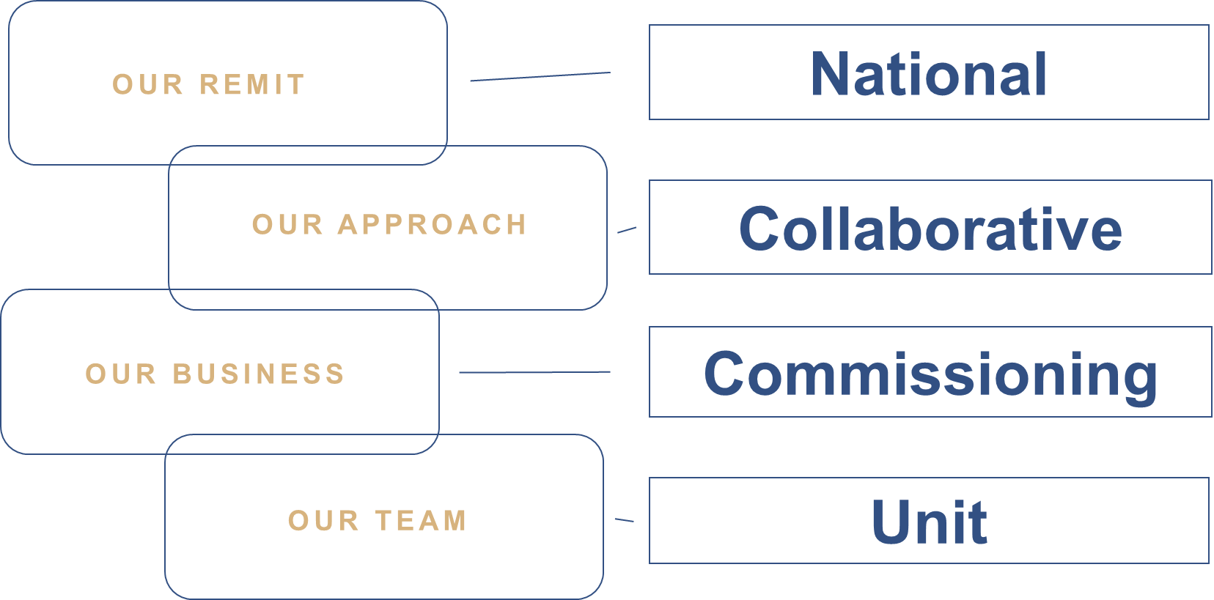
Our collaborative approach creates value through the development of insight driven innovations that improve quality, safety and patient experience.

Mr. Stephen Harrhy heads the unit and is the
Chief Ambulance Services Commissioner and
Director of the Unscheduled Care Programme for Wales.

Figure 1: NCCU IMTP Structure

Executive Summary
This National Collaborative Commissioning Unit (NCCU) IMTP 2020/23 sets out the work programme for the Unit for the next 3 years.
In constructing our integrated plan we have given consideration to how our strategic aims support local delivery of national policy on a Once for Wales basis. We have sought to explain the nature of the work that we undertake and the customers on whose behalf we deliver: We aim within this IMTP to describe:
    - Our vision.
    - Our Strategic Aims and the principles that guide the work we deliver for our customers.
    - Our Achievements within the last year.
    - Our opportunities we intend to maximise to help deliver national policy and shape the future of NHS Wales.
    - Our infrastructure and workforce requirements to enable us to deliver at scale and pace.

The policy agenda in Wales is ambitious and world leading; it requires collaboration across the systems of health, social care, public sector and with each and every community in Wales to deliver the transformative vison outlined in Wellbeing of Future Generations Act.

In order to deliver the ambition outlined in our vision the NCCU has developed strategic aims to align our programmes of work, deliver value and provide the evidence of policy being put into practice.

The delivery of strategic commissioning intentions for the Emergency Ambulance Services Committee (EASC) enables collaborative commissioning to evidence how EASC commissioned services support the delivery of the Quadruple Aims.

Through our work with Emergency Departments, we have developed National Enablers for Service Improvements (NESIs). These will drive up standards, enable collaboration and engage staff to deliver the Quadruple Aims across national services.

The refresh of the externally commissioned frameworks through our Improving Care, Improving Experience in Mental Health and Learning Disability Services Programme will drive improvement in quality, standards and value within these services; ensuring that patient experience and safety is at the centre of the work we deliver.

The 2019/22 NCCU IMTP completion and submission saw us talk about beginning a journey as an organisation. This 2020/23 NCCU IMTP shows how we have refined plans and developed sophistication in response to national policy. It articulates how we will use the transformational drivers that exist within Wales and use our collaborative commissioning approach to deliver long term service change.

Our position as an organisation and our collaborative commissioning approach enables us to deliver integrated thinking to join the system up. The NCCU will also play a pivotal role in sharing intelligence across boundaries to reduce risk and maximise opportunities for improvement. We aim through all of these actions to support the delivery of evidence base outcomes that challenge behaviours and embed change.

Introduction
The National Collaborative Commissioning Unit (NCCU), hosted by Cwm Taf Morgannwg University Health Board is the collaborative commissioning service of NHS Wales.

Our Vision
“Leading quality assurance and improvement for NHS Wales through collaborative commissioning”.

Our Strategic Aims

Development of the NCCU Strategic Aims
The 2019/22 NCCU IMTP saw us outline the journey to realise our vision.

The NCCU has developed a set of Strategic Aims that will support and enable us to deliver against our vision and respond to the growing demand for our services.

Our strategic aims frame the content of the 2020/23 NCCU IMTP. These five strategic aims define the NCCU commitment to delivering long term system change through collaborative commissioning. They enable us to operate & deliver across system boundaries and support our whole system approach to risk and opportunity. They frame our ethos of listening, understanding and being agile in our response to customer need as well as enabling the development of evidence to support policy. Our strategic aims are:

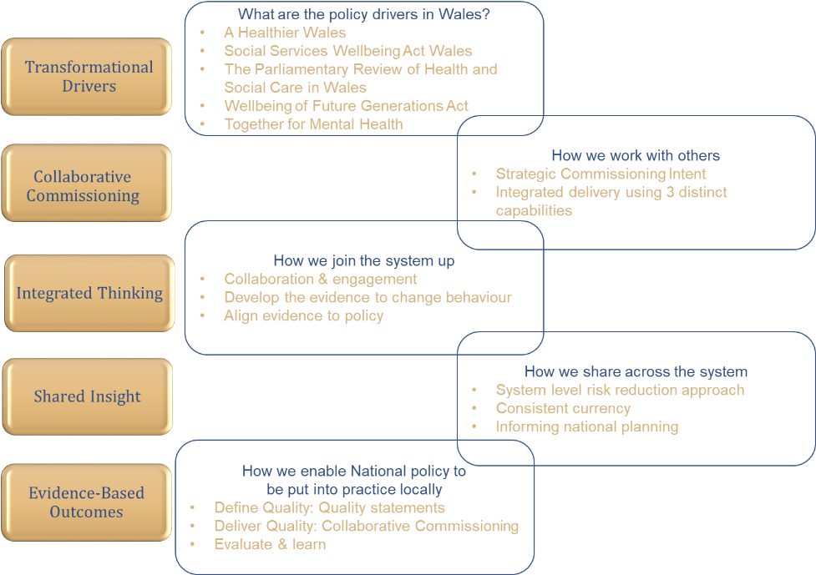
- Transformational drivers
- Collaborative Commissioning
- Integrated Thinking
- Shared Insight
- Evidence-Based Outcomes

Our ambitious work programmes described in this IMTP align and support the delivery of our aims.
Our work programmes are:

- Emergency Ambulance Services Committee (EASC) work programme
- What does good look like for the Emergency Department in Wales Work Programme
- National Programme For Unscheduled Care Work Programme
Figure 2: NCCU Strategic Aims

- Improving Care, Improving Experience in Mental Health and Learning Disability Services Programme

NCCU Operating Model
Our strategic aims are delivered through our operating model. This model provides evidence of the implementation of the transformational drivers across Wales.
We use collaborative commissioning as the vehicle to define and deliver what good looks like for services and populations.
Our collaborative commissioning approach and position within NHS Wales enables the NCCU to join up the system and to share insight and intelligence.
Our collaborative commissioning approach develops evidence of what works and utilises that evidence to inform policy.

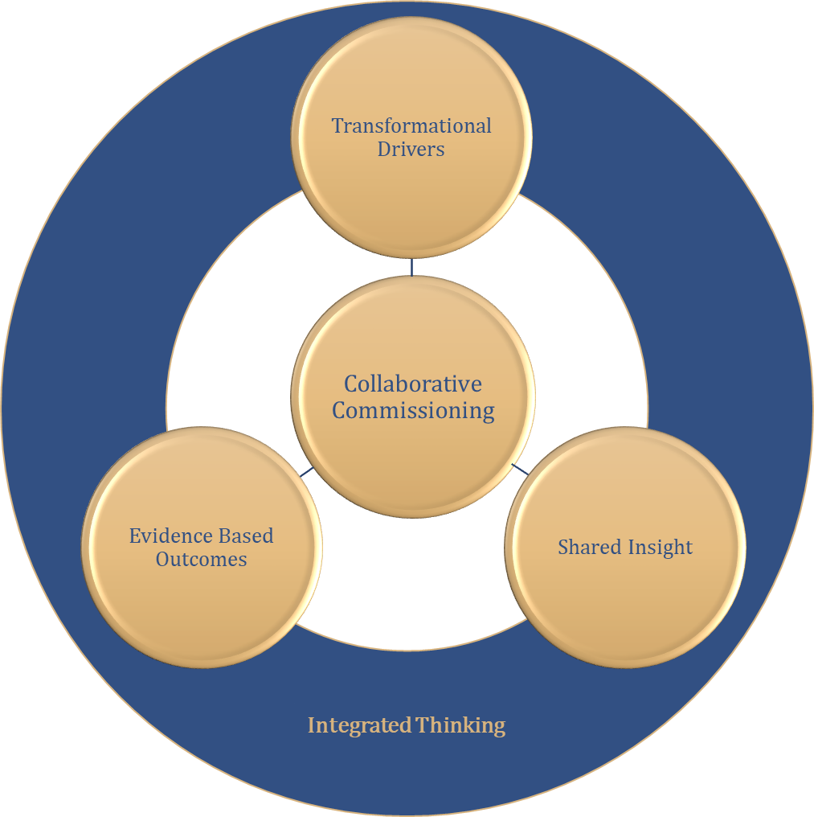

Figure 3: NCCU Operating Model

NCCU Operating Model in action
The NCCU Operating Model enables us to take national policy and put this into practice locally through collaborative commissioning. The national policy context the NCCU works to implement is varied and specific to the customers that we deliver on behalf of. Within this IMTP we describe that policy context as transformational drivers. These include:
- Model Standing Orders for the Emergency Ambulance Services Committee, new clinical model for ambulance services and Implementation of Amber Review
- Parliamentary Review of Health & Social Care Wales
- The Wellbeing of Future Generations Act (Wales) 2015 wellbeing goals, five ways of working and prevention definition.
- A Healthier Wales
- Together for Mental Health
- Commissions for specific work from NHS Wales organisations and Welsh Government

We work within the NHS Planning Framework to ensure alignment to the five ways of working of the Wellbeing of Future Generations Act and the 10 design principles of A Healthier Wales, as described in figure 4 below.

Our operating model enables the sharing of intelligence across system boundaries, minimizing risk and maximizing opportunities. Our independent position within NHS Wales enables us to deliver services collaboratively across traditional organisational and service boundaries.

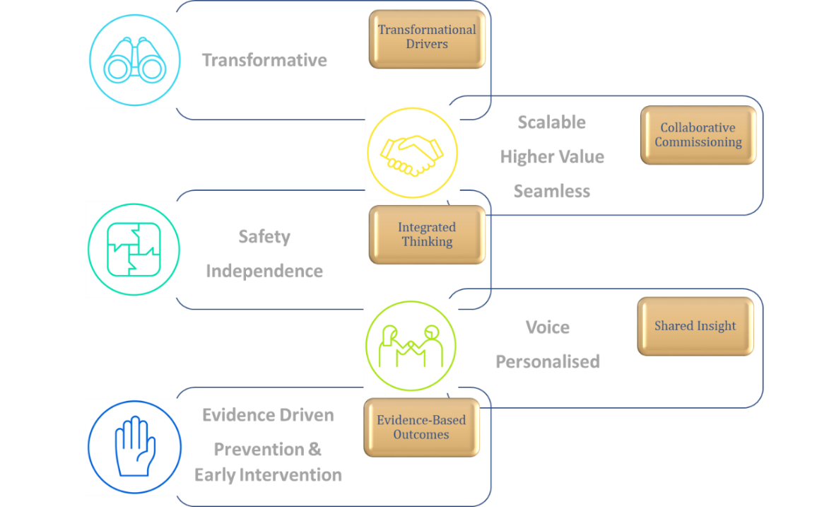
Our approach enables us to work in collaboration to define and deliver quality, value and deliver outcomes.
Figure 4: NCCU Strategic Operating Model in action

NB: Images used with permission from the office of the Future Generations Commissioner

Transformational Drivers
National policy sets the long term expectations for transformation across health and social care in Wales. The policy direction in Wales is world leading and ambitious, requiring system level transformation if the ambition is to be realised. The NCCU through its strategic aims and operating model works to enable national policy to be delivered locally. Our commissioning approach delivers long term system change and improvement by:

- Enabling collaboration
- Reducing variation and adopting best practice across health boards
- Enabling evidence to influencing planning at a national level
- Creating value by enabling meaningful measurement

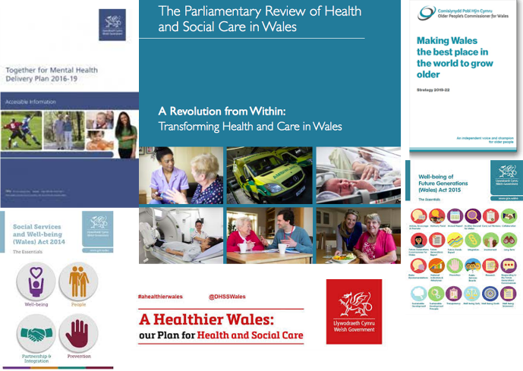
The Parliamentary Review of Health and Social Care in Wales- "Wales needs a different system of care"

The vision for care that Wales should achieve is one being pursued by most developed nations in the face of similar circumstances. This is to revolutionise care so that it empowers individuals to take decisions, tailors care to the individual’s expressed needs and preferences, is far more proactive and preventative, is provided as close as possible to people’s homes, is seamless, and is of the highest quality.
Figure 5: Transformational Drivers
In our view this approach builds on values already developed in Wales and will help to give clear purpose and guide the vision into action. Therefore, we recommend that the vision should aim to deliver against four mutually supportive goals – ‘the Quadruple Aim’ – each of which should be vigorously pursued.

EASC Work Programme
Key transformational drivers for the EASC Work programme are the EASC Model Standing Orders; the clinical model; Amber Review; Strategic service changes around South Wales Major Trauma Network and the Grange University hospital.
The EASC Model Standing Orders outlines the expectation that safe, effective and timely services are delivered. It also includes the creation, development, operation, refresh and evaluation of National Collaborative Commissioning: Quality & Delivery Frameworks for Ambulance Services within NHS Wales covering Emergency Ambulance Services, Non-Emergency Ambulance Services and Emergency Medical Retrieval Transfer Services and enables closer working relationships between EASC and the National Programme of Unscheduled Care.

National Programme for Unscheduled Care Work Programme
Key Transformational drivers for the National Programme of Unscheduled Care will be the work led by the Director & Clinical Director of the programme to define “What good looks like for unscheduled care”.

This work will utilise the policy framework for unscheduled care that is in development and sets out medium to long term ambitions for unscheduled care services to be delivered consistently across Wales by Local Health Boards and Trusts. The initial steps in implementing the policy framework for Unscheduled Care for NHS Wales will be:
- Scope defined and agreed for services within Unscheduled Care.
- Opportunities from EDQDF to be identified
- Delivery resources agreed
- Team appointed
- Phase one commenced “What does good look like for the unscheduled care system in Wales?”

The products and approach the NCCU utilises to collaboratively develop what good looks like have been developed and refined through the national commissioning of Mental Health & Learning Disability Services; Emergency Ambulance Services; Non-Emergency Patient Transport Services and most recently the “What does good look like for the Emergency Department in Wales?” Programme (EDQDF)

Defining good and then building the detail collaboratively into National Collaborative Commissioning Quality & Delivery Frameworks is well established and enables Once for Wales collaborations to deliver enable and whole system measurement and indicators aligned to the quadruple aims of A Healthier Wales.

The EDQDF programme has enabled national collaborations with:
- NWIS to develop pioneering KPIs that change the conversation beyond the tradition 4 & 12 hour measures.
- NHS Benchmarking Network to develop national benchmark for value.
- Happy or Not to ensure that patient experience can be measured in every ED in Wales
- Picker Institute EUROPE to engage with staff around their experiences of working within ED
- NHS Delivery Unit and Financial Delivery Unit to support the implementation of the programme
- C3 Faculty (Swansea University) to enable evaluation

This collaborative approach will enable the NCCU to maximise the learning opportunities gained from the EDQDF programme to deliver at scale and pace the following new work programmes:
- What does good look like for same day emergency care across Wales?
- What does good look like for intermediate care across Wales?

Improving Care, Improving Experience in Mental Health & Learning Disability Services Programme
Our Improving Care, Improving Experience in Mental Health & Learning Disability Services Programme will ensure that Metal Health and Learning Disability policy is implemented and opportunities maximised to improve outcomes for patients.

Collaborative Commissioning


In pursuit of the policy expectation, our strategy supports Welsh Governments IMTP planning requirements to secure greater maturity in commissioning arrangements and improve collaborative decision making. This reinforces the NCCU evidence based non-competitive and collaborative approach to commissioning.

NCCU Collaborative Commissioning Integrated Delivery Model
The 2020/23 NCCU IMTP describes our collaborative commissioning approach through three distinct capabilities that we deploy in order to meet the needs of our customers; namely:

- Commissioning Development & Support Service (CDSS)
- Quality Assurance and Improvement Service (QAIS)
- Insight & Innovation (I²)

These capabilities combined and integrated form the NCCU Collaborative Commissioning Model Integrated Delivery Model, they can be deployed individually or in based on customer need.
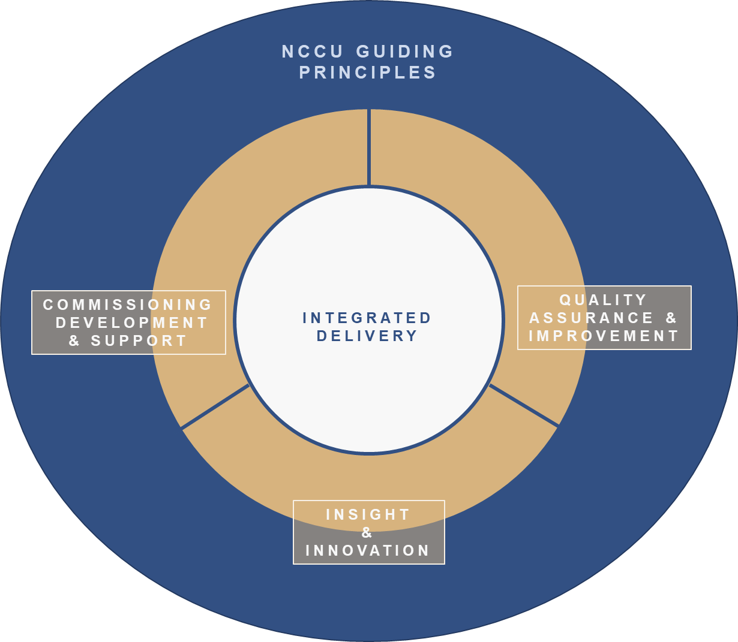

Figure 6: NCCU Collaborative Commissioning Integrated Delivery

Commissioning Development & Support
The NCCU commissions using CAREMORE® National Collaborative Quality and Delivery Frameworks. CAREMORE® is an award winning transformation programme for healthcare.

Frameworks developed using this method are scale free and developed through a collaborative process that defines the quality statement of “What does good look like for services or populations?” with front line staff and provides ownership and accountability from ward to board.

We deploy our commissioning development and support capability for the following work programmes:

EASC Work Programme
For our EASC Work Programme our commissioning model and methods support the national commissioning of:
- Emergency Ambulance Services
- Non-Emergency Patient Transport Services
- Emergency Medical Retrieval Transfer Services

The commissioning model and methods will support the national commissioning of future services; namely:
- National Transfer & Discharge service with the following components:
  - Transfer and discharges across Wales
  - Critical Care Transfer Services
  - Inter Hospital Transport provision for the Grange University Hospital
  - Neonatal Transfers
  - Stroke Thrombectomy repatriations
  - Major Trauma repatriations

What does good look like for the Emergency Department in Wales Programme
Under the National Programme of Unscheduled Care our commissioning model supports the national commissioning of:
- Emergency Departments across Wales; through “What does good look like for the Emergency Department in Wales” programme.

Improving Care, Improving Experience in Mental Health & Learning Disability Services Programme
For our Improving Care, Improving Experience in Mental Health & Learning Disability Services
Programme our commissioning model supports the national commissioning of:

- Mental Health & Learning Disability Adult Hospitals
- Mental Health & Learning Disability CAMHS hospitals
- Mental Health & Learning Disability Adult Care Homes

The deployment of commissioning development and quality assurance capabilities enable the NCCU to gain insight and develop innovative approaches to meet the needs of our customers. This ability alongside a reputation built on delivering has seen demand for our services increase and our customer base widen.

Quality Assurance & Improvement

Improving Care, Improving Experience in Mental Health & Learning Disability Services Programme
The objectives of Quality Assurance and Improvement capability in relation to this programme are:

• Ensure providers reduce risk and dependency and promote hope, recovery and rehabilitation;
• Robustly challenge substandard provider performance;
• Provide advice and support to improve the quality of care;
• Ensure all procured services are provided and deliver value for money for the public purse;
• ensure provider quality and safety concerns are raised, discussed and disseminated with commissioners and statutory agencies;
• Ensure safe, effective and high quality care that improves patient experience;
• Facilitate collaborative working between providers and commissioners.

Insight & Innovation (I²)
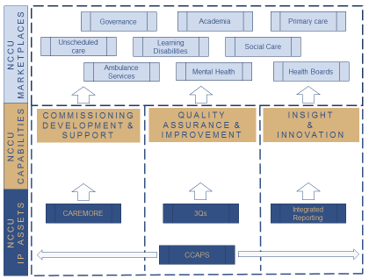
Our Commissioning and Quality Capabilities enable the NCCU to develop insight, build specialist knowledge and understanding of the services and service areas we commission. This insight enables us to develop our own products or intellectual property assets to deliver solutions for our customers. This ability enables the NCCU be able to support and undertake reviews as commissioned by Health Boards and Welsh Government.

We develop our own IP assets as solutions to deploy on behalf of customers. Described in the diagram below these assets today form the basis of our approach that supports commissioning and quality assurance.

CAREMORE®
The NCCU utilises CAREMORE® to support the development of National Collaborative Commissioning Quality and Delivery Frameworks. CAREMORE®:
Figure 7: NCCU IP Assets
  - Defines the quality and safety expectations in the form of standards.
  - Ensures these standards are in accordance with Welsh Government standards, regulatory and statutory requirements, and best practice; and are regularly reviewed and kept up to date for each service.
  - Determines the activity currencies which are used to measure the work.
  - Ensures the activity is regularly counted and reported, and is also used to support demand and capacity work for each service.
- Identifies all available resources, including revenue, capital and alternative funding sources.
  - Ensures the resources and financial value payable is agreed between all applicable parties to all the frameworks.
  - Leads the designing of the service model(s). Ensuring that these are presented in a way which is understandable to the public and patients.
  - Ensures the component parts of the service model(s) are understood and agreed, and the activity, resources and performance of each service is measured and performance managed.
  - Articulates how the interactions between professionals between parties to the frameworks operate to support delivery of the service model.
  - Defines performance measures to evidence whether the standards are being met and that a balance is being achieved between improved clinical outcomes, better patient experience and value for money and are regularly reported and acted upon to ensure continuous improvement.

Commissioning Care Assurance Performance System (CCAPS).
This system has been developed in partnership with the NHS Wales Informatics Service and is a key enabler of the commercial Framework, providing standardised information with the functionality to connect all users from different organisations to support NHS Wales to proactively performance manage providers and provide assurance to commissioners and patients .

CCAPS supports patients requiring care by:
- Giving a choice of care setting.
- Providing assurance on the expected quality of care.
- Monitoring health and wellbeing improvements.
- Ensuring prompt response to any complaints, incidents/safeguarding concerns.
CCAPS supports providers of care by:
- Standardised commissioning process.
- Displaying and ability to update bed availability.
- Facilitating the reporting of concerns to commissioners and care coordinators.

CCAPS supports provider’s commissioners of care by:
- Sharing intelligence on care providers.
- Matching a care setting to a patient’s needs.
- Knowledge about a care setting’s quality.
- Evidencing the care received for the cost incurred.

3Qs
This is quality assurance rating enabled through the framework agreements for Mental Health and Learning Disabilities. Providers are required to meet every framework standard to maintain a 3Q rating. The system ranks providers based on the following weighted criteria:
- Quality
- Price
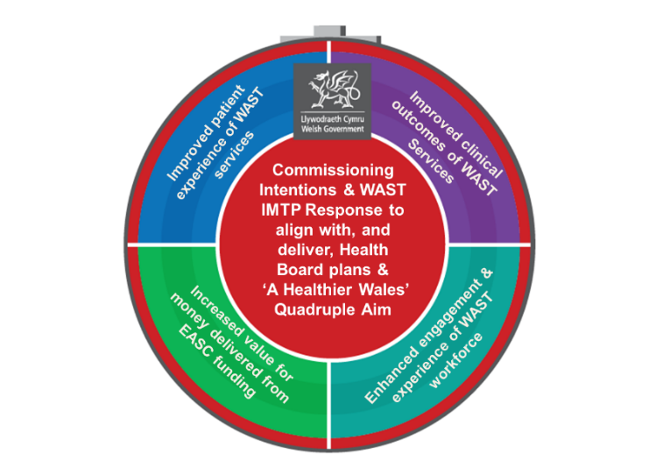
- Other factors

EASC Strategic Commissioning Intent
We have developed strategic commissioning plans for EASC Commissioned Services. These plans align the care standards within the model of care for commissioned services to the Quadruple Aim. Each care standard is aligned to one or more elements of the Quadruple Aim, delivery of the care standards will deliver a Quadruple Aim benefit.

The 2020/21 commissioning intentions for EASC Commissioned Services will enable these services to articulate how through the commissioning arrangements they are putting policy into practice.
Figure 8: EASC Strategic Commissioning Intent

National Enablers for Service Improvement (NESIs)
The collaborative commissioning process for “What does good look like for the Emergency Department in Wales” has developed innovative National Enablers for Service Improvement (NESIs). These NESIs support the alignment of the Quadruple Aim through our commissioning model as well as providing a mechanism to ensure the boards of health and social care organisations are sighted on developments locally. Our integrated approach provides the opportunity to deploy the national enabler concept into existing commissioned services to support sustained and continuous improvement.

Pathway Improvement Projects (PIPs)
Developed through the collaborative commissioning of Emergency Departments across Wales; Pathway Improvement Projects (PIPs) focus on the operational arrangements to deliver the national Care Standards for services.
Each PIP has clinical leadership; nationally through the Clinical Director for the NPUC, or locally from a Clinical Lead identified locally. These project offer short, medium and long term wins and opportunities to improve the standards of care immediately across NHS Wales

Integrated Thinking

“Integrated Thinking is a term that refers to the conditions and processes that are conducive to an inclusive process of decision making, management and reporting, based on the connectivity and interdependencies between a range of factors that affect an organization’s ability to create value over time.”

Integrated Thinking, CIMA Global Academic Research Programme, CIMA Research Executive Summary Vol. 13 Issue 3.

Our national role enables us to work in between Welsh Government, across Health Boards boundaries with WAST. This independent position and the work that we undertake allows us to join intelligence and learning across the system and provide assurance through:

- Collaborative Commissioning National Quality and Delivery Frameworks.
- Undertaking and implementing the outputs from reviews on behalf of Health Boards and Welsh Government

Our approach engages frontline clinicians and other stakeholders and defines what good looks like for services. We are constantly evolving our approach; using evidence and learning to develop sophisticated scale free mechanisms that drive standards and improve quality.

EASC Work Programme
We support EASC to put national policy into practice locally. Our collaborative commissioning capabilities enable the production of data and evidence that we use system wide supporting ‘Once for Wales’ improvements and enables WAST and Health Boards to:

• Integrate Emergency Ambulance Services into the wider Unscheduled Care system
• Deliver the plurality model for Non-emergency Patient Transport Services
• Deliver a world leading consultant led Emergency Medical Retrieval and Transfer Service.

Our experience, intelligence relationships built through the collaborative commissioning of national transport services will enable us work with clinicians to develop new national transport solutions under EASC that support the wider system and deliver benefits.

What does good look like for the Emergency Department in Wales Programme
Through this programme we will deliver 20 Pathway Improvement Projects (PIPs) aligned to the care standards for Emergency Departments. These projects will deliver national consistent care standards for Emergency Departments across a 5 step patient pathway. They will enable closer alignment between the work of EASC and NPUC through standardisation of patient handover.

Improving Care, Improving Experience in Mental Health & Learning Disability Services Programme
This programme publishes an annual national review of the services it commissions. These reviews allow other areas of the system to gain insight into the role of the programme and the benefits that arise from the approach. These reviews and the consistent delivery of quality and value as well as a reduction in risk by this programme have increased demand for services.

Shared Insight

The shared insight of our strategy articulates how we enable the sharing of knowledge and intelligence across organisational and system boundaries. Our strategy enables whole system risk reduction through our Once for Wales approach to:
- Highlighting and reducing variation
- Consistently delivering national care standards
- Creating value and enabling meaningful measurement

National Collaborative Commissioning frameworks and the role of the NCCU are now integral to the development and delivery of IMTPs across Wales. The NCCU will drive the sharing and spreading of successful innovation arising from commissioning across NHS Wales learning from both public and private sectors and the third sector. Our strategy also enables services to maximise opportunities for improvement we aim to deliver this through:
- Developing collaborative commissioning as a vehicle to transform services.
- Standardised IMTP descriptors for nationally commissioned services.
- Reducing variation across Health Boards through the use of National Collaborative Commissioning Quality & Delivery Frameworks.
- Enabling alignment and measurement between the care standards for services or populations and Quadruple Aim of a Healthier Wales.
- Enabling better value through the Net Effect concept of triangulation of activity, resources and performance.
- Learning from Local and National Care Reviews.

Evidence-Based Outcomes

Our strategy enables services to define and deliver quality and evaluate outcomes and impact. We create quality statements and our collaborative commissioning approach develops the evidence to inform policy. We believe the creation of Wales’ first Quad Aim Group will support the development of the national Single Integrated Outcomes Framework for Health and Social Care 2020 as described in the NHS Planning Framework 2020/23.

NCCU has established the C3 Faculty with Swansea University. The Faculty will evaluate the impact of collaborative commissioning frameworks as well as provide tools and methodologies to enable evaluation to be accessible and embedded. The faculty will also evaluate the impact of the Winter Initiative funded schemes for NPUC.

During 2020/23 we will continue to work with the C3 Faculty to provide support to EASC in terms of the EASC 1% A Healthier Wales Commissioning Allocation, Winter Planning Evaluation 2019/20 and to inform the future direction of EASC and support the evaluation of ambulance and Unscheduled Care Services service change initiatives in order to share and spread nationally an understanding of what works and doesn’t work.

The Improving Care, Improving Experience in Mental Health & Learning Disability Services Programme produces an annual position statement for the National Collaborative Commissioning Frameworks for Mental Health & Learning Disabilities.

Achievements and Benefits Realisation 2019/20

NCCU Achievements
This section outlines some of the key achievements delivered by the NCCU as a unit during 2019/20, including:
- National Acknowledgement – Through the profile of the work we have delivered, we have built a national reputation with a number of key partners, including Health Boards, EASC, Welsh Government, NWIS, Delivery Unit (FDU), as a unit focused on delivery
- Enhanced Reputation for Delivery – The NCCU use a structured and programmatic approach to the delivery of products and services. We work collaboratively with specialist services, recognising their skills and knowledge of our partners including NHS Shared Services, Picker Institue EUROPE, Happy or Not
- Increased Demand for Services - 2019/20 has seen an increase demand for the products and services provided by NCCU. Our collaborative commissioning and quality assurance capabilities have enabled the NCCU to undertake and deliver insight driven innovate work on behalf of a number of key partners, including Health Boards, EASC, Welsh Government, NWIS, NHS Delivery Unit and Financial Delivery Unit
- Increased Customer Base – 2019/20 has seen the NCCU increase its customer base for delivery of work on behalf a number of key partners including EASC, Welsh Government (through National Programme for Unscheduled Care), NHS Shared Services Partnership, Health Boards and Local Authorities.
- Collaborative Relationships with National Enabling Organisations – Our collaborative approach enables the NCCU to maximise the learning opportunities gained from the EDQDF programme, and successfully build relationships with key partners including, NWIS, NHS Benchmarking, Happy or Not, Picker Institute Europe, NHS Delivery Unit and Financial Delivery Unit, C3 Faculty (Swansea University)
- Collaborative Relationships with Non Emergency Patient Transport Services (NEPTS) – Our collaborative approach has enabled and drive successful working relationships with our WAST partners. The continued success of the NEPTS Delivery Assurance Group have enabled joint working to identify opportunies for improvement and the creation of transparent and consistent reporting mechnaisms.

EASC Commissioned Services
The work programme described within the 2019/22 NCCU EASC IMTP outlined the potential benefits that would be delivered to Patients & Public, Welsh Government, Health Boards and Welsh Ambulance Services NHS Trust (WAST).

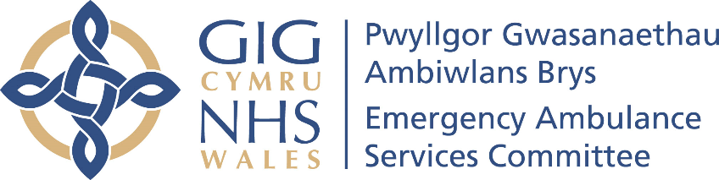
For the EASC component of the NCCU IMTP 2019/22 we provide assurance to Welsh Government against five key accountability conditions; they are detailed below: work delivered in response to those is detailed below:

- Work to further strengthen the performance management of WAST, including the overseeing of amber review actions and system implementation
- Undertake demand and capacity assessment of WAST for system discussion and actions
- Ensure Collaborative Governance is in place and key collective decisions made
4. Review and agree further EASC actions to underpin winter planning 2019-20
5. Facilitate more of WAST options beyond 999 response as enablers for WAST role in community services and alternatives to hospital
To support all of the accountability criteria the NCCU utilise National Collaborative Commissioning Quality & Delivery Frameworks to commission EASC Services. These deliver the following benefits to Patients & Public, Welsh Government, Health Boards and WAST:
- Improved understanding of EASC Commissioned Services by public & professionals.
- Delivery of the National Care standards for the service that have been created by the service
- Putting national policy into practice locally
- Understanding of the resource envelope to identify alternatives models which may improve patient flow and reduce variation & waste
- Transparency for balancing activity and resources with performance
- Identification of opportunities for direction of the public to alternative services
- Identification of opportunities for direction patients to more appropriate services
- Transparent and consistent all Wales data reporting
- Sharing of good practice
- Improved Staff Health & Well Being
- Understanding of the population profiles

As such delivery of the actions contained within the approved NCCU/EASC IMTP 2019/22 has been a key priority for the NCCU. In line with the recommendations featured in the McClelland Strategic Review of Emergency Ambulance Services there is a need for simple governance and accountability for planning and delivery of emergency ambulance services.
During 2019/20 the NCCU commissioned by the CASC has developed the commissioning capability to support the Ministers expectations we will continue support the CASC to hold WAST to account for delivery of EMS, alongside holding Health Boards to account for their role in enabling timely ambulance response to be delivered.
The capabilities and work we have deployed and delivered in support of the accountability conditions are listed below:

Commissioning Development & Support

Emergency Medical Services (EMS)
- Strategic Commissioning Plan for EASC agreed.
- EMS commissioning intentions for 2020/21 issued including EMS Strategic Commissioning Intent 2020/21 onwards.
- Mid-year review of 2019/20 Commissioning Intentions completed.
- EMS Quality & Delivery Framework refreshed.

Non-Emergency Patient Transport Services (NEPTS)
- NEPTS commissioning intentions for 2020/21 issued including NEPTS Strategic Commissioning Intent 2020/21 onwards.
- NEPTS National Collaborative Quality & Delivery Framework Signed October 2019
- Development of local reporting NEPTS
- Scoping for National Transfer & Discharge Service commenced.
- Thrombectomy Repatriations commissioned on behalf of WHSSC
- NEPTS Delivery Assurance Group functioning effectively
- Transparent and consistent all Wales data reporting
- Identification of opportunities for reduction in conveyance of non-eligible patients.

Emergency Medical Retrieval Transfer Service (EMRTS)
- EMRTS Collaborative Commissioning Quality & Delivery Framework signed Q4 2019/20
- 24/7 EMRTS expansion Business case summited to Welsh Government.
- EMRTS Major Traumas Business Case development supported and submitted.

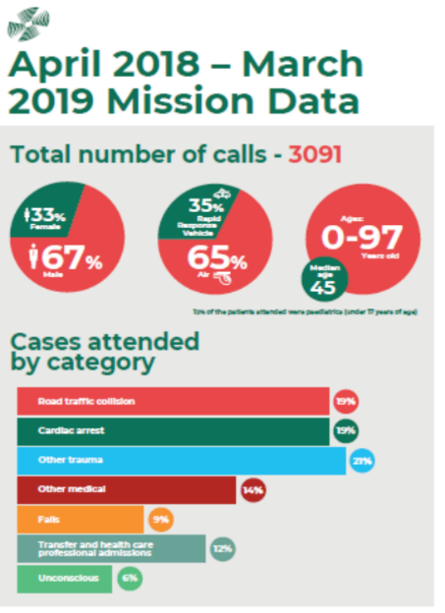

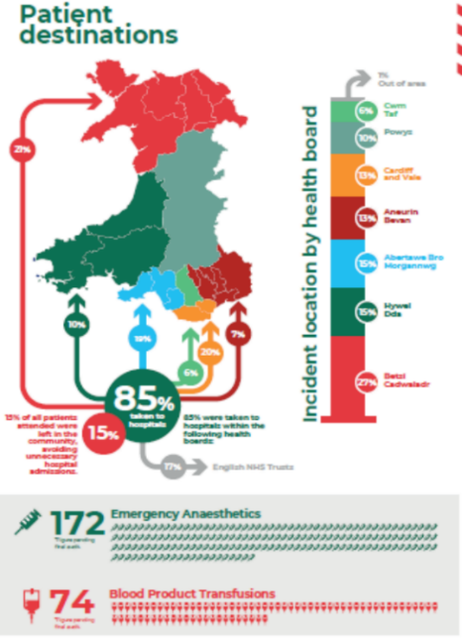
In addition to EMRTS Cymru detail in the graphic the service was a winner in the Institute of Collaborative Working, Social Impact: Collaborative Awards 2019.
“The evolution pioneered by the Welsh Air Ambulance has pushed the boundaries in support of those in need. Working in collaboration with NHS Wales their Emergency Medical Retrieval and Transfer Services puts skilled consultants and trauma equipment right at the point of need.”
Figure 9: EMRTS year in numbers

Quality Assurance & Improvement

Emergency Medical Services (EMS)
- EASC Performance management framework development under development.
- WAST Relief gap reference document October 19.
- Delivery of Amber Review Implementation Programme
- Demand & Capacity assessment of WAST undertaken 2019/20.
- Expanded roles of Advanced Paramedic Practitioners.
- NHS Symptom checkers went live in 2019

Non-Emergency Patient Transport Services (NEPTS)
- NEPTS performance reporting to EASC Jan 2020.
- Standardisation of commissioner provider meetings
- All Wales equity of NEPTS service through WAST centrally managed Plurality Model
- Improved quality assurance on 3rd party providers of NEPTS transport.
- National Renal project group formed for NEPTS
- NEPTS demand and capacity assessment commenced 2019/20. Concludes 2020/21.

Emergency Medical Retrieval Transfer Service (EMRTS)
- NCCU & EMRTS Cymru have commenced development of the EMRTS Collaborative Commissioning Quality & Delivery Framework

Insight & Innovation
- EMS Relief Gap Reference Document produced October 2019.
- EASC 1% a Healthier Wales Awarding Evaluation Panel (HWAEP)
- Development of EARTH Test to support service planning and evaluation.
- Mixed method evaluation methodology developed to enable HBs WAST to better evaluate initiatives.
- Innovation identified through HWAEP process enabled Once for Wales proposals to be developed
    - NCCU Winter Evaluation report 2018/19 produced in August 2019
    - NCCU Winter Evaluation informed Winter 2019/20 winter Planning Guidance
    - Programme Management Infrastructure: Respiratory Health Implementation Group (RHIG)
    - NCCU led on 2019/20 WG Winter planning priorities: Alternatives to ED and Frailty
- Increased NEPTS Transfer & Discharge provision to support Winter Pressures
- Developed positive relationships with Wellbeing of Future Generations Commissioners Office resulting this year in engagement on the 2020/21 NCCU IMTP and permission to use their IP within this document.

EASC Governance
- EASC management group established May 2019. EASC Management group forward plan developed.
- Developing the systems and processes to deliver the revised EASC Model Standing Orders and Standing Financial Instructions.
- Clinical governance / quality Joint working between QAIS and WAST Quality Division including attending QUEST
- EASC HWAEP panel formed & commissioning allocation process run at national level.
- Positive EASC Internal Audit report giving assurance on NCCU managing of EASC business.
- Positive NEPTS Internal Audit report showing progress and assurance on NEPTS provision through the development process of the quality and delivery framework.
- Implementation of Internal Audit findings around EASC Governance
- EASC Risk management framework agreed by Joint Committee

Enhanced Assurance & Evaluation

EMS Demand & Capacity Review 2019
NCCU working collaboratively with WAST have scoped and delivered a demand and capacity assessment for EMS. The outputs of this review will take the form of a plan to support an improvement in EMS performance.

NEPTS Demand & Capacity Review 2020
NCCU have worked collaboratively with WAST to support the procurement process to select a provider to deliver the NEPTS Demand & Capacity review within 2020. This review will be key to realising the efficiencies within the NEPTS Business Case.

EASC 1% A Healthier Wales Commissioning Allocation
The NCCU facilitated a national process on behalf of EASC to identify the bids that Heath Boards and WAST wanted to put forward for funding through the EASC 1% Heathier Wales Allocation. NCCU formed the Healthier Wales Awarding Evaluation Panel (HWAEP) and a set of guiding principles to evaluate submissions independently. We designed the EARTH template to support stakeholders to complete bids. We also visited Health Board leads and hosted workshops to support completion. The completed bids were submitted to the HWAEP and a list of 9 schemes were put forward to development. These were as follows:
- WAST Older Peoples Framework: making better decisions with Older People by bringing additionality to the older people we come into contact with in the community
- WAST Mental wellbeing by design - enabling colleagues to sustain a longer, more fulfilling, healthier and happier working life
- WAST Transport solutions: Right transport, right patient, right time
- WAST Falls Response Model- Providing a timely, appropriate and proportionate response to patients who have fallen
- PTHB: Respiratory MDT Response - 3 month trail
- BCUHB: To support SICAT project until year end whilst working up all wales solution
- SBUHB: To support SBUHB GP stack project until year end whilst working up all wales solution
- CVUHB, ABUHB, CTMUHB: Clinical Pathway Redesign for Patients Diagnosed with non-ST Elevation Acute Coronary Syndrome (NSTEACS)
- EASC: To support the Clinical Desk for Major Trauma

EASC Researcher
HWAEP also agreed to fund recurrently from the EASC 1% A Healthier Wales Commissioning Allocation a FTE Band 6 post to support independent evaluation.

EASC Assurance and Performance Management
In order to develop the enhanced assurance and performance management arrangements, the NCCU, on behalf of EASC, will work collaboratively with WAST to develop the documents required to support the Model Standing Orders and a set of Key Performance Indicators which will be reported into EASC Management Group in order to provide assurance to EASC Joint Committee on the performance of WAST as an organisation. It is expected that as part of an integrated approach these measures will be aligned to the strategic commissioning intentions and designed to cover quality, safety, risk, finance and value.

Embedded Research Capability
NCCU during 2019/20 we scoped embedded research capability to support research capability to evaluate EASC & WAST initiatives.

National Programme for Unscheduled Care

What does good look like for the Emergency Department in Wales?

Quarter 1 Achievements
- Early Adopters agreed which are six Emergency Department sites across the three Health Boards of Aneurin Bevan University Health Board, Betsi Cadwalladr University Health Board, and Cardiff & Vale University Health Board.
- Welsh Government funding to support the NCCU’s central EDQDF Programme Team and each of the Early Adopters.
- Recruitment commenced for EDQDF Programme Team and EDQDF Early Adopter Teams.
- EDQDF Programme Team undertook National EF Winter Staff Survey with support that was commissioned from Picker (Europe),
- EDQDF Programme Team agreed specialist support with NWIS for ongoing delivery of ED Pioneering KPIs; the EDDS to ECDS (data definitions) project and alignment of working on the WEDS (Welsh ED Systems) programme.
- Building of EDQDF Collaborations with NWIS; Picker (Europe); NHS Benchmarking Unit; Delivery Unit; HEIW, Finance Delivery Unit; Kings Fund; Health Foundation, etc
- Report by Swansea University on the initial Qualitative Findings (EDQDF Programme) from Phase 1.

Quarter 2 Achievements
- Presentations to Health Services Research UK Annual Conference 2 July which has national and international coverage on: “The development of novel and existing care standards” for Welsh EDs at their annual conference; and the CAREMORE® collaborative commissioning methodology.
- There were 182 attendees at three events held in July (144 unique attendees - if double and triple attendances are excluded). This included significant clinical representation, from Health Boards / ED sites, Welsh Government, Finance Delivery Unit, Delivery Unit, Public Health Wales, Royal College of Emergency Medicine (RCEM); with inputs from professional experts such as NHS Wales Informatics Service (NWIS), Picker (Europe), NHS Benchmarking Network (NHSBN), and the suppliers of a smiley face concept approach for patient experience.
- The events were; 4 and 5 July Event: Working with individual emergency departments to implement the Quality and Delivery Framework; 17 July: National Pathway Improvement Projects (PIPs) Summit; 23 July: Changing the conversation for Welsh Emergency Departments: Ministerial Launch of EDQDF Phase 2. Initial feedback from the events was that the EDQDF programme approach was novel as it was ‘bottom up’ led by frontline ED staff with the opportunity to participate, influence and make change nationally, with the subsequent delivery of benefits locally.
- A Pathway Improvement Project (PIP) Template was developed and then shared at the July events as a guide to the production of ‘what looks good’ for turning the Care Standards into day to day operational practice. The outputs from the 17 July Event enabled the production of first version template for the Ambulance Arrivals and Clinical Triage PIPs.
- The principle of National Enablers for Service Improvements (NESIs) was established which focus on a ‘Once for Wales’ collaboration and wider organisational infrastructure and support delivery of the Healthier Wales Quadruple Aim by the EDQDF for Welsh EDs. Following work progressed between the Central EDQDF Programme Team; national supporting central organisations and professional experts, plus the participation in the facilitated exercises by attendees at July events, led to the initial creation of NESIs for: ED Benchmarking; ED Patient Experience (‘Smiley face concept’ feedback terminals); ED Staff Engagement & Experience; and ED Pioneering KPIs.
- Reporting of the ED Winter Staff Survey which had over a 20% response rate for each of the 13 ED sites and produced a National Free Text Report; a Bespoke to each ED site Improvement Map Report; and an Inquiry Tool enabling free text responses and quantitative responses to be correlated, with the reports shared for action at the national July events.
- Meetings by Director NPUC and Clinical Director NPUC with Minister outlining progress; providing assurance on clinical engagement & ownership; and development of national ED measures alongside 4 & 12 hours an update on Phase 2 and next steps.
- Finalisation with Swansea University on the Logic Model for the EDQDF evaluation against the Quadruple Aim
- NHSWSSP Procurement Support commissioned for drafting ‘smiley face concept patient survey reporting’ service specification with a supplier demonstration session held on the 23rd September attended by 23 people from across all Health Boards. Three companies were given an opportunity to present to NHS Wales colleagues identified for participation in the NESI.
- NHSBN commissioned for ED sites’ Bespoke benchmarking reports.

Quarter 3 Achievements
- EDQDF Programme Board and governance arrangements established for Phase 2, with meetings of the NPUC Measurement Advisory Group focussing on the reporting of measures to supplement ED 4 & 12 hours this Winter for the Minister;
- Further recruitment as planned to EDQDF Central Team of Senior Improvement Managers and the Clinical Lead Nurse.
- NWIS completion of their recruitment process for posts to EDQDF Programme of a Business Change Facilitator; Data Standards Analyst; and Data Scientist.
- Recruitment continued of Early Adopter posts through sharing of job profiles and use of national processes.
- An EDQDF storyboard produced explaining NESIs, PIPs and their relationship together with a timeline of key milestones and supporting activities.
- 8th October: Staff Engagement and Experience Event provided 25 staff members from Health Boards across Wales, including WAST with an opportunity to review the ED Winter 2019 Staff Survey Results; consider follow up actions and plan for the next survey Health Boards consider how to streamline the next survey and record how they are utilising the results.
- 23 October: Benchmarking Event provided 25 staff members from Health Boards across Wales and supporting organisations including the DU and FDU with the opportunity to discuss the challenges and solutions around the submission and dissemination of Benchmarking data.
- Presentation to EASC by the Programme Director and Clinical Directors on delivery of the EDQDF programme and its products.
- EDQDF Ambulance Handover and Triage Clinically led Pathway Improvement Projects Working Group 10 & 11 December 2019 Update clinicians agreed 5 fast track solutions for ambulance handover and triage flow to start working on, things that will make Ambulance Handover and Triage function better, these initial 5 Frontline Fast-track Solutions are: Stretcher swap for immediate release; 24x7 Health Care Support Worker for Triage; ED Receptionist Staff Red Flag Training; HAS in accessible locations; Fit to Sit review and joint training. However, the main focus remains to find sustainable alternative ways for people who really need to get into hospital (as identified by staff) that are reliable, not too expensive, and will relieve congestion and this is the focus of the next Ambulance Handover & Triage PIPs Working Group planned on the 29 & 30 January
- ED Patient Experience Survey Terminals contract awarded to Happy or Not following procurement exercise and these are being delivered to all 13 ED sites in December 2019, with the intention for them to be operational early in New Year.
- The ED Pioneering KPIs to be reported upon this winter across the majority of the 13 ED sites have been advised to the Welsh Government as: Time from arrival to Triage by Triage Category (KPI 4); Time from arrival to contract with ED Clinical decision make (KPI 7): Record the ED discharge and destination of every patient when they leave ED (KPI 13), which follows the Pioneering KPI event held on 19 November 2019, that was attended by NWIS, Welsh Government and UHB Clinical and Information Staff, with an updated Achievability Matrix Report produced to that previously shared which gives an assessment for the ease of reporting each of the 15 KPIs into red, amber, green for each of the 13 ED sites.

Pathway Improvement Projects (PIPs)
Pathway Improvement Projects (PIPs) focus on the operational arrangements to deliver the Care Standards. A draft PIP Production Template was shared during the event on the 4th & 5th July. It is the intention for each PIP to be launched at the National Workshop on the 10th December, and then be clinically led either nationally through the Clinical Director for the NPUC, or a Clinical Lead from one of the Early Adopter sites. The template is a guide to the production of ‘what looks good’ for the operational arrangements and covers: the establishment of a Working Group; clarification of what is within and out of scope; identification of relevant existing documentation such as protocols, policies, etc.; a detailed description of what is required to deliver the care standard and ensure continuous improvement; and a supporting implementation plan. The outputs from the 17th July Event will enable the production of first version templates for both the Ambulance Arrivals and Clinical Triage PIPs.

Influencing Behaviour: Changing the conversation

Ensuring effective clinical leadership across Unscheduled Care
2019/20 saw the NCCU work to closer align the work of EASC & NPUC. the clinical director for NPUC working closer with EASC. There is an opportunity enables stronger clinical leadership and oversight for the Joint Committee as well as supporting delivery of the EASC Chair’s actions from the Minister; namely.

Professional Advisory Group / Measurement Advisory Group
Under the leadership of the Clinical Director NPUC, Director of National Collaborative Commissioning the PAG & MAG have supported the EDQDF programme professionally and with the ambition to change the conversation around measures within an ED.

Welsh Emergency Department Frequent Attenders Network (WEDFAN)
This programme in 2019 delivered:
- 2 national conferences for WEDFAN - training, sharing best practice
- Continued 1:1 operational support to individual health board leads
- Assertive Outreach Model training to all FA panels and associated partners and stakeholders
- 2.0 WTE posts per ED for Frequent Attenders work (funded by Welsh Government). Each Emergency Department to have a Full Time Lead, Case Managing the Top 20 complex cases known to the Tripartite Services (ED, WAST, OOH GP)
- Full Time Band 3 admin support in each Emergency Department to have for data collection of monthly spreadsheet, record minutes in panel meeting as well as any other professional meetings.
- Mortality Review has elicited further streams of work with Velindre and the Acute Oncology Service with Velindre providing a data analyst, service improvement manager and 2 clinical fellows to audit the patient journey of frequently attending cancer/palliative care patients into USC with the view of understanding where the system failures or potential changes are (30% of all frequent attender deaths are cancer/palliative care patients)
- Work with 111 and CALL helpline to both integrate the management of their frequent callers into our network and to utilise other pathways for our patients to use
- Red Cross projects currently running in BCUHB/ABUHB and HDUHB supporting frequent attenders
- Meetings with Third Sector Substance Misuse Agencies in order to open discussions around Care Pathways for the patient group
- Collecting and auditing data on support needs of this cohort in order to create alternative pathways
- Engagement work with the Partnership Delivery Team in Cardiff Council to support and link work with homeless and rough sleepers
- Working with national homeless and rough sleeper organisations on Youth Homelessness (unseen homelessness/sofa surfers/insecure housing)
- Working with Head of Service integration at Her Majesty’s Prison and Probation Service to look at the creation of a specialised pathway for risky frequent attenders within the probation system
- Working with Head of MAPPA to bolster links with MAPPA co-ordinators and the Frequent Attender Case Load managers – managing complex risk
- WEDFAN continues to offer support to other trusts nationally in the UK and external to the UK around the implementation of the Welsh model of care for frequent attenders – including Norway, the Island of Jersey, Oxford University Hospital Trusts, Taunton, Hull, Humber amongst others
- Supporting the set up of the Oxford Regional Frequent Attender Network – via the Q Community
- Data analysis with Police HQ on demand nationally of frequent callers and the cross over between them and health 999 callers
- Partner on the Tri Service Intelligence Hub with Police/Fire/WAST working on frequent callers and hotspot analysis
- Working with GP Clusters/Community Pharmacies/Transformation Teams on Primary Care and USC Frequent attender cross overs
- Creating network links to Mental Health Sanctuary projects within Swansea Bay and Hywel Dda Health Board areas
- Launched research project with Cardiff Uni, South Wales Police, WAST and primary care to discover if early linkage of data could predict subsequent FA behaviour
- Completion of 2 years’ worth of data and clinical study from the National Programme Manager, including individualised health board RAG status for Frequent Attender Service Provision
- Supporting WAST and Swansea University on INFORM and STRETCHED research - analysing multi agency support to frequent callers of 999
- Integrated Case Management IT system (whose build was funded by WG ETTF) is now integrated with C&V IT systems and pulling through live data. This system will be audited across all outcome measures over next quarter before Phase 2: National Rollout is commenced with NWIS and Welsh Government.
- Business Case being created for a full time team for each ED Frequent Attender Panel

Insight & Innovation Services

Supporting winter evaluation
NCCU commissioned by Welsh Government produced a Winter 2018/19 Evaluation report in August 2019. The contents of this report supported and influenced Welsh Government planning process and priorities for winter 2019/20.

Supporting winter planning
The NCCU has supported Welsh Government in respect of 2019/20 Winter delivery. We provided national oversight for frailty and preventing conveyance. The evaluation of Winter 2018/19 report produced by the NCCU in August 2019 supported the Welsh Government planning lead to shape the 2019/20 themes. These themes are:
- Optimising cross organisational and sector working
- Urgent primary care out-of-hours resilience
- Preventing unnecessary conveyance and admission to hospital
- Discharge to assess/recover (D2AR)
- Community step-down capacity
- An enhanced focus on the respiratory pathway
- An enhanced focus on frailty pathway
NCCU supported winter planning event 24th June 2019 around evaluation of winter 2018/19.

Clinical Procurement of 3rd Sector Services
NCCU supported nationally procured, locally delivered third sector winter 2018/19 pilots to support patient flow, experience and outcomes including the;
- British Red Cross Emergency Department assisted discharge service;
- Care & Repair ‘hospital to home service;
- Pharmacists in Emergency Department
- Provision of inflatable lifting equipment for 600 care homes in Wales.

Improving Care, Improving Experience in Mental Health and Learning Disability Services Programme

Externally Commissioned Provision (Independent sector and NHS England)
NCCU QAIS Team have:
- Increased our providers so that now we manage 602 hospital wards/homes (272 adult wards, 53 CAMHS wards and 277 care homes) as part of the National Frameworks , this is serval magnitudes more than that directly provided by the whole of NHS Wales.
- Undertaken 209 quality assurance reviews (113 in adult, 6 in CAMHS and 90 in care home) as part of the National Framework for MH & LD adult Hospitals resulting in the issuing of over 800 improvement actions. Processed several freedom of information requests and media interests in MH provision
- Processed 16,072 safety incidents (14, 471 incidents in adult, 365 in CAMHS and 1,236 in Care homes)
- Considered 413 complaints (376 incidents in adult, 1 in CAMHS and 36 in Care homes)
- Scrutinised 522 safeguarding events (465 incidents in adult, 8 in CAMHS and 49 in Care homes)
- Signed an MOU with NHS England to share information on quality and safety.
- Introduced as a pilot a patient dashboard focusing on outcomes.
- Reviewed all Framework units that have cared for Welsh Patients have received at least once. We have written reports and Action plans developed following each review and follow up reviews also produced and published the QAIS Annual Report for 2018/19.
- Developed a refreshed Hospital framework agreement in preparation for launch April 2020.
- Undertaken audits of all new units that have applied to be included as services on the refreshed framework from April 2020
- Commenced the renewal process for the Framework which has been extended but will expire March 31st 2021. As part of this process we have engaged with a number of universities in relation to Research Updated our Memorandum of Understanding between QAIS and Heath Inspectorate Wales.

Insight and Innovation
NCCU QAIS Team have:
- Undertaken over 700 audits as part of the Care mapping of learning disability homes at the request of each and every health board.
- Planned, progressed and published a National Care Review of CAMHS services on behalf of Welsh Government.
- Planned and progressed a National Care Review of LD Hospital services on behalf of Welsh Government due for publication in February 2020.
- Planned and progressed a National Access and Conveyance Review on behalf of Welsh Government due for publication in March 2020.
- Worked in partnership with BCUHB to establish a joint repatriation team resulting in more patients being cared for in local services and a saving in excess of £4 million.
- Supported BCUHB to develop a rehabilitation services strategy.
- Supported the safer staffing strategy buy leading on the Safer Staffing in Care Homes element of the Safer Staffing Wales programme.
- Supported the MH National Benchmarking in adult and CAMHS and hosted an all wales feedback event.
- Collaborated with 14 countries to deliver the second MH International Benchmarking report.

Opportunities and Benefits to be realised 2020-23
This IMTP sees the NCCU opportunities and potential benefits that could be be realised (subject to the NCCU securing funding and resource) by Health Boards, EASC, Welsh Government, Local Authorities and Regional Partnership Boards through the work delivered by the NCCU on behalf of:
- Emergency Ambulance Services Committee
- The National Programme for Unscheduled care
- Improving Care, Improving Lives Mental Health & Learning Disabilities Programme

NCCU Opportunities

Developing the NCCU relationship with the NHS Executive
The NCCU will work closely with colleagues who are developing the scope and governance arrangements for the commissioning and establishment of the new NHS Executive. It is clear that the work that the NCCU delivers would be done on behalf of the NHS Executive, however it is important that appropriate governance mechanism are introduced to ensure that this relationship is clear and complimentary with other work being delivered by the NCCU for Health Boards.

Collaborative Commissioning

Expand the influence of collaborative commissioning
NCCU will identify collaborators and partner organisations to develop the influence and uptake of its collaborative commissioning products and services.

Development of CAREMORE®
NCCU will undertake a market testing exercise to identify social enterprise partners to commercialise its CAREMORE® methodology

NCCU Intellectual Property Assets
NCCU will audit and document the intellectual property assets developed through its Commissioning & Quality Assurance Capabilities.

Emergency Ambulance Services Committee (EASC)

EASC service specific opportunities and benefits

EMS & NEPTS Strategic Commissioning Intent 2020/21 onwards
This capability has been developed for EASC Commissioned Services and for the “What does good look like for the Emergency Department in Wales?” programme. It enables the care standards for each service to align to and deliver Quadruple Aim benefits. For this round of IMTP the development of the EASC strategic commissioning plan will enable the following opportunities:
- Revision of NCCU Memorandum of Understanding with Welsh Government.
Figure 10: EASC Strategic Commissioning Intent

- Alignment of Quad aim across care standards for services.
- Delivering Ministerial expectation and alignment across A Healthier Wales and the Wellbeing of Future Generations Act.
- Enabling a whole system risk reduction approach and closer alignment between the work of EASC and the National Programme for Unscheduled Care.

Delivery of the 2020/21 Commissioning Intentions (EMS & NEPTS)
The WAST & Health Board action Plans in response to the 2020/21 Commissioning Intentions will form the basis for the continuous improvement trajectory for EMS & NEPTS. These action plans are included as appendices 4 (EMS) & 5 (NEPTS) within this IMTP. Progress on the delivery of these plans will be reported through the governance arrangements for EASC, WAST & Health Boards.

Emergency Medical Services (EMS)
Within EMS there are opportunities to develop the enhanced assurance and performance management arrangements on behalf of EASC. Working collaboratively with WAST to develop the documents required to support the Model Standing Orders and a set of Key Performance Indicators. The KPIs will be reported into EASC Management Group in order to provide assurance to EASC Joint Committee on the performance of WAST as an organisation. This integrated approach and these measures will be aligned to the strategic commissioning intentions and designed to cover quality, safety, risk, finance and value.

Non-Emergency Patient Transport Service (NEPTS)
Within 2020/21 and beyond we will work collaboratively to implement the plurality model for Non-Emergency Patient Transport Services, this will enable WAST as the provider of NEPTS in Wales to realise efficiencies through economies of scale. Through NEPTS transport solutions we will develop a consistently eligibility criteria and booking processes that will support full implementation of the Welsh Health Circular 2007 (005) around non-emergency patient transport services. The NEPTS storyboard attached as Appendix 6 shows the work to be delivered collaboratively during this IMTP cycle.

Emergency Medical Retrieval Transfer Service (EMRTS)
We will work with EMRTS and Welsh Government to support the 24/7 expansion of the EMRTS Service. This service will support the transport component of the South Wales Major Trauma Network as well as providing 24/7 all Wales equity for patients requiring time critical transfers.

Development of further EASC Commissioning Opportunities

National Transfer & Discharge Services
We will work to define what good looks like for to develop an All Wales Transfer and Discharge service. Mandated and funded through EASC the scoping of this service began in collaboratively in June 2019/20 with a national event hosted by WAST.
We will support the commissioning of the transport provision for the Grange University Hospital which is seen as a key driver for the development of the proposed All Wales Transfer and Discharge Model.

The scope of a national transfer and discharge service will include:
- Critical Care transfers Service. This work is funded through the Critical Care Network.
- Inter hospital transport provision for the Grange University Hospital within Clinical Futures at ABUHB.
- Neonatal transfers. Funded by WHSSC; NCCU will work with WHSSC and other colleagues on the potential transfer of commissioning arrangements to EASC.
- Thrombectomy repatriations patients requiring cross border repatriation from England. Funded by WHSSC; NCCU be responsible for the commissioning framework.
- Major Trauma repatriations.
- Mental Health transport provision identified through the all Wales Mental Health Access Review.

National Call Hander of Choice Services
This work identified in the 2019/20 IMTP has already began. Within this IMTP round we will work collaboratively with WAST and Health Boards to define what good looks like for call handling services across NHS Wales. The insight gained through the EASC 1% Heathier Wales Commissioning allocation bidding process has seen innovative schemes from BCUHB & SWUHB that use GPs to answer calls from the 999 stack and avoid hospital conveyance. These schemes identified through the Healthier Wales process have been agreed by EASC and by Welsh Government as WAST priority development areas. We will further look to maximising opportunities from existing services, i.e. 111, NHS Direct into the National Framework.

Major Services change requiring transport
We will continue to support the commissioning component for transport for major service changes across Wales. This will include:

South Wales Major Trauma Network
We will support WAST & EMRTS to enable the implementation of the South Wales Major Trauma Network. This will include the development of the EMRTS staffed Clinical Trauma desk within WAST and the delivery of repatriations and the WAST conveyance component of the Major Trauma Business Case.

Enhanced Assurance and Evaluation
In order to develop the enhanced assurance and performance management arrangements, the NCCU, on behalf of EASC, will work collaboratively with WAST to develop the documents required to support the Model Standing Orders and a set of Key Performance Indicators which will be reported into EASC Management Group in order to provide assurance to EASC Joint Committee on the performance of WAST as an organisation. It is expected that as part of an integrated approach these measures will be aligned to the strategic commissioning intentions and designed to cover quality, safety, risk, finance and value.

Expanding the role of the Clinical Director NPUC
2020/21 onwards will see the opportunity to close align the work of EASC through the clinical director for NPUC working closer with EASC. This opportunity enables stronger clinical leadership and oversight for the Joint Committee as well as supporting delivery of the EASC Chair’s actions from the Minister around closer working and alignment between EASC and the National Programme for Unscheduled Care.

EMS Demand & Capacity Review 2019
We will enact the implementation of the Demand and Capacity review of the emergency ambulance service in Wales, our focus will be on maximising the efficiency of current and additional investment to support improved performance and clinical outcomes. This will include the development of in house capability to support the ongoing delivery of demand and capacity management.

NEPTS Demand & Capacity Review 2020
NCCU have worked collaboratively with WAST to support the procurement process to select a provider to deliver the NEPTS Demand & Capacity review within 2020. This review will be key to realising the efficiencies described in the NEPTS Business Case.

Ambulance Productivity and Availability
Availability of ambulances is the most important determinant of an effective and efficient ambulance service. We will deliver an improvement plan for increasing ambulance availability this work will focus on 4 major themes:
  - Core functions of the Emergency Ambulance Service
  - Workforce, recruitment and wellbeing
  - Digital change and technology
  - Measurement for improvement

EASC Front Line in Year Allocation Reserve
NCCU will manage on behalf of EASC a Non recurrent fund. Reserved by Health Boards and managed in order to boost spend on front line resource. This will be drawn down / allocated to WAST when delivery is evidenced.

National Programme for Unscheduled Care

What good looks like for the Emergency Department in Wales (EDQDF)
Funded by Welsh Government the development of an Emergency Department National Collaborative Commissioning Quality and Delivery Framework (EDQDF) was launched by the minister in June 2018. Phase 1 of this work was conclude by June 2019. The programme moved into phase 2 in July 2019 with a Ministerial Launch Event. Phase 2 will deliver:

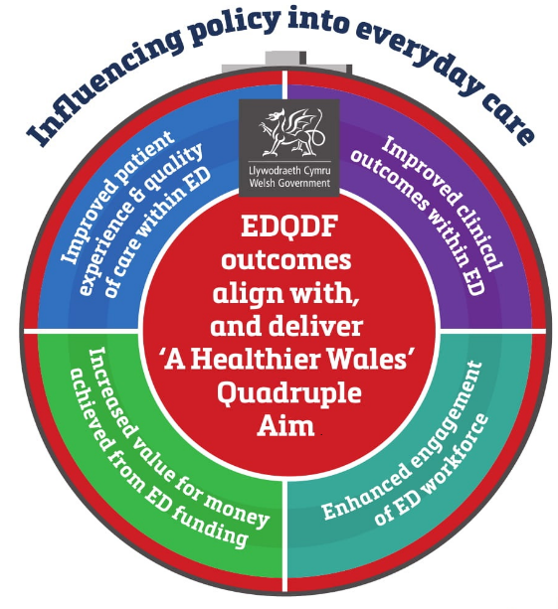
National Enablers for Service Improvement (NESIs)
Developed through the collaborative commissioning of Emergency Departments across Wales; National Enablers for Service Improvement (NESIs) require collaboration between expert organisations to deliver national solutions.
National enablers align the Quadruple Aims of A Healthier Wales as well as providing a mechanism to ensure the boards of health and social care organisations are sighted on developments locally. The EDQDF programme is developing 4 NESIs as part of phase 2 production. These are:

- ED Benchmarking: delivered with NHS Benchmarking NWIS this work will support a consistent use of the collection of data and use of benchmarking outputs to drive improvement in ED’s across Wales.
Figure 11: NESIs supporting delivery of the Quadruple Aim
- ED Patient Experience: This NESI will enable patient experiences of ED to be recorded in real time. It will also enable ED’s to benchmark on patient experience against other ED sites across the UK and Europe.
- ED Staff engagement & experience: Working with the Picker Institute EUROPE we delivered an ED staff experience survey about their experiences of working during Winter 2018/19. This work produced for each ED site an improvement map to support delivery of the priority changes that would deliver most impact.
- ED Pioneering KPIs: Working collaboratively with NWIS to change the conversation beyond the traditional 4 and 12 hours within ED. This work will develop initially 15 measures (3 across each of the 5 steps of the care pathway) from the front to the back door of an ED. This work will enable each organisation to better understand a patients flow through ED. The programme will develop over time 3 measures for each of the 20 care standards for EDQDF. This suite of 60 measures will be ensure NHS Wales remains at the forefront of innovation.

Pathway Improvement Projects (PIPs)
As part of the development process Pathway Improvement Projects (PIPs) focus on the operational arrangements to deliver the national Care Standards for services.
Each PIP is national, has clinical leadership; nationally through the Clinical Director for the NPUC, or locally from a local Clinical Lead. These national projects offer short, medium and long term wins and opportunities to improve the standards of care across NHS Wales. The EDQDF programme has 20 care standards and will deliver 20 PIPs through the production process.
The EDQDF Programme has produced a PIP Production Template to support the production of ‘what looks good’; it covers:
- the establishment of a PIP Working Group;
- clarification of what is within and out of scope;
- identification of relevant existing documentation such as protocols, policies, etc.;
- a detailed description of what is required to deliver the care standard and ensure continuous improvement;

National Policy delivered locally
The EDQDF programme has identified 6 ED early adopter sites across ABUHB, BCUHB & CVUHB. Welsh Government support has enabled each of these sites to employ a consultant and clinical nurse lead to provide clinical leadership and oversight locally. The programme has also funded the recruitment of project and administration within each early adopter site to embed change.
The EDQDF is supported by a core NCCU team. This is also funded through Welsh Government. The core team will drive the programme and support the early adopter sites and the partner organisations through effective programme management to implement and embed the PIPs and NESIs.

Frontline FastTrack Solutions
The frontline clinicians from within the Early Adopter sited for EDQDF programme identified for ambulance handover and triage flow things that will make Ambulance Handover and Triage function better. These real solutions when developed from proof of concepts by front line clinicians that when scoped, delivered and embedded will deliver real benefits outlined in the policy agendas.

EDQDF Clinical Innovation Fund
Supported by Welsh Government the programme will develop a clinically led innovation fund to support and deliver the innovations that will improve performance within the Emergency Department.

Development of further Commissioning Opportunities within Unscheduled Care

Defining what good looks like for Unscheduled Care in Wales
Led by the Director NPUC and supported by the Clinical Director NPUC we take the opportunity to work collaboratively with clinicians and services to define what good looks like for Unscheduled Care in Wales. Using the production process developed through the EDQDF programme the outputs of this work will support the development of further commissioning opportunities across unscheduled care.

What does good look like for Intermediate Care?
Our 2019/20 IMTP outlined our intention to begin scoping what good looks like for intermediate care in Wales. Building on National Audit of Intermediate Care (NAIC) Project 2018/19 and led by the Deputy Clinical Director for the National Programme of Unscheduled Care we will commence in 2020/21 the process of recruiting the staff and creation of the service specification in 2020/21. This programme will begin to define what good looks like from 2021/22 by scoping a national collaborative commissioning quality and delivery framework for these services. Working collaboratively with clinical leadership to agree quality statements and care standards, a uniform approach to measuring activity through a National Collaborative Commissioning Intermediate Care Quality & Delivery Framework will enable optimisation of clinical outcomes and patient experience

What does good look like for same day emergency care?
Using the production process developed through the EDQDF programme the outputs of this work will support the development of what good look like for same day emergency care.

Enhanced Clinical Capacity Services
We will scope the develop of high quality, sustainable and efficient enhanced services that could be rapidly deployed to support a reduction in unscheduled care system pressures or proactively reduce demand. Years 1 and 2 of this IMTP will focus on the development of;:
- Clinical capacity intervention service
- All Wales non-injury falls provision (Level 1 – 3)
- End of Life Services
- Priority developments by WAST using multi-disciplinary teams to prevent hospital conveyance.

Working with other National Programmes
Our collaborative commissioning approach and methods will be used to support and to work with other National Programmes within Wales, namely:

What does good look like for GP Out of Hours?
If sanctioned by the Minister during years 2 & 3 of this IMTP NCCU working with the National Programme for Primary Care will support clinical leaders to develop a quality and delivery framework for these essential services and agreeing care standards, a uniform approach to measuring activity and a nationally agreed high performing model of care for GP Out of Hours Services will enable optimisation of clinical outcomes and patient experience.

Influencing Behaviour: Changing the conversation
The NCCU collaborative commissioning approach and use of National Collaborative Commissioning methods empower staff and enable a different conversation to take place around key issues within Unscheduled Care. This is fundamental to delivering transformational change as opposed to transactional initiatives. The learning from the commissioning of ambulance services and through the EDQDF programme through the Clinical Director of NPUC there are opportunities to change the conversation across unscheduled care.

Unscheduled Care Dashboard
To support the better delivery of care and understand performance there is a need to have in place an improved Unscheduled Care Dashboard accessible to all within NHS Wales. The plan by Welsh Government is that this will be operational by September 2020. The solution will be a systems agnostic software platform with visualisation capabilities that can support data inputs from various sources to accommodate the variation in information sources across NHS Wales. The ambition is that this will be a self-populating electronic dashboard The NCCU supported by Welsh Government will facilitate a phased approach:
- Phase 1: Market consultation and testing for a system agnostic software platform and visualisation tool
- Phase 2: Scope content for USC Dashboard

The NPUC Programme Board will set the standards and the Health Boards will provide the data. This dashboard will utilise the initial 15 Pioneering KPI measures being developed through the EDQDF Programme to as well as over time enabling the full suite of 60 ED Pioneering KPI measures to be available.

Unscheduled Care Regional Escalation Policy
Revised arrangements for Regional Escalation are due to be enacted on the 27th of January 2020. The EASC team will lead on the review and future development of these arrangements.

Ensuring effective clinical leadership across Unscheduled Care
2020/21 onwards will see the opportunity to close align the work of EASC through the clinical director for NPUC working closer with EASC. There is an opportunity enables stronger clinical leadership and oversight for the Joint Committee as well as supporting delivery of the EASC Chair’s actions from the Minister; namely:
- Oversee amber review actions and system implementation.
- Review and agree further EASC actions to underpin winter planning 2019-20.
- Facilitate more of WAST options beyond 999 response as enablers for WAST role in community services and alternatives to hospital.
- Align EASC with broader work on unscheduled care.

Changing the Conversation around Measurement
The development and use of the Collaborative Commissioning Frameworks for Emergency Medical Services (EMS) and Non-Emergency Patient Transport Services (NEPTS) has enabled closer working relationships in order to provide more robust information and data collection. It has enabled EMS to move away from time based targets to more outcome focuses measurements based on the clinical response model, it has allowed the production of Ambulance Quality indicators for public consumption. Within NEPTS the approach has empowered health boards as commissioners to full uptake responsibility for commissioning and performance collaboratively with Welsh Ambulance Service. The EDQDF programme in collaboration with NWIS is working to deliver Pioneering KPIs that will change the conversation above and beyond the tradition 4 & 12 hours measures within an ED.

System wide risk reduction approach
We will work with Welsh Government, EASC and NPUC to share the insights developed through existing nationally commissioned services. Our aim is to deliver the recommendation in the 2020/21 NHS Wales Planning guidance to enable wider adoption of collaborative commissioning. The system risk reduction enabled from our approach will be key in delivering the policy expectations of A Healthier Wales, the Quadruple Aim and Wellbeing of Future Generations Act.

Supporting National and Regionally Integrated Planning
The use of National Collaborative Commissioning Quality & Delivery Frameworks to improve the system’s capacity to plan effectively and efficiently.
- NCCU enables organisations to understand and focus on delivery of priorities.
- NCCU enables health and social care & central supporting organisations to articulate their contribution to nationally commissioned services through the NHS Wales planning process.

WEDFAN
Discussions are ongoing with Improvement Cymru around the transfer of the WEDFAN programme to the NCCU on behalf of NPUC.

Enhanced Assurance and Evaluation

Expanding the role of the Clinical Director NPUC
2020/21 onwards will see the opportunity to close align the work of EASC through the clinical director for NPUC working closer with EASC. This opportunity enables stronger clinical leadership and oversight for the Joint Committee as well as supporting delivery of the EASC Chair’s actions from the Minister around closer working and alignment between EASC and the National Programme for Unscheduled Care.

Enhanced evaluation
NCCU We will look to develop the concept of the embedded researcher and develop a model that enables research staff to work alongside programme staff. This will deliver the benefits of fully embedded research and evaluation across EASC and EDQDF work programmes. The roles will also support NPUC in the evaluation of specific targeted initiatives.

Insight & Innovation Services

Evaluation of winter
We will build upon the success of previous winter evaluations and have been commissioned by Welsh Government to provide a mixed method evaluation approach to understand the impact of the National respiratory programme in depth targeted evaluation for the National Respiratory Implementation programme and in support of the plans submitted by Regional Partnership Boards.

Mental Health Urgent Care Access
The National Programme for Unscheduled Care commissioned a pilot to introduce ICAN Mental Health urgent care centres at Ysbyty Gwynedd, Ysbyty Glan Clwyd and Wrexham Maelor Hospital to provide alternative support services for people attending emergency departments in need of emotional support, over the winter period (December 2018-March 2019). Based on data, the pilot was extended for a further four months.
The winter pilot and extension have been supported by Welsh Government funding.
The NPUC team are a review of Mental Health urgent care access, using the methodology used for the Amber Review and expect to report findings February 2020.
Following publication of the review in April 2020 there is an opportunity for NPUC through the NCCU to develop an implementation programme that around the evidence based findings and enable multi agency collaboration to meets the policy recommendations outlined in Together for Mental Health.

Working with Wellbeing of Future Generations Commissioners Office
We will work with the commissioners office on the development of the strategic commissioning intentions for EASC, the implementation of unscheduled care policy into practice and the utilisation of the Quadruple Aim to measure outcomes, value, experience and engagement across the work of the NCCU.

Regional Escalation
The CASC and his team will undertake independent retrospective reviews of the application of the revised regional escalation procedure to ensure trust and confidence is enhanced. Furthermore this information will be used to update the regional escalation procedures and share system wide best practice.

Clinical Procurement of 3rd Sector Services
Working on behalf of Health Board and Welsh Government there is an opportunity to support the development of national initiatives that are implemented locally. The NCCU will work with NHS Shared Services Partnership and other key partners to procure 3rd sector and other support initiatives into unscheduled care.

British Red Cross emergency department well-being and home safe service
As part of funding agreed to support service delivery for the remainder of 2019/20, the emergency department well-being and home safe service, delivered in collaboration with the British Red Cross will be extended until the end of March 2020. An open tender exercise is currently in progress to allow other third and independent sector organisations to bid to deliver this service on a substantive basis. The expected contract commencement date is April 2020.

Care & Repair Cymru – Hospital to A Healthier Home service
As part of funding retained for nationally targeted actions to support service delivery for the remainder of 2019/20, the Hospital to A Healthier Home service, delivered in collaboration with Care & Repair Cymru will be extended until the end of March 2020.

Improving Care, Improving Experience in Mental Health & Learning Disability Services Programme

National Collaborative Commissioning Adult/CAMHS Mental Health & Learning Disabilities Hospitals
NCCU QAIS team will:
- Renew our adult and CAMHS frameworks for the first time in 8 years, merging the two. We will ensure focus on outcomes and prioritise local placements as well as quality.
- Undertake reviews of all wards and care homes where welsh adults and children are placed.
- Work with the 600+ hospital wards to ensure safe, effective care is delivered.

National Collaborative Commissioning Adult Mental Health & Learning Disabilities Care Homes
NCCU QAIS team will:
- Support commissioners to place under this framework including offering transitional support.
- Continue to host a future pricing network that brings together commissioners and providers to harmonise and improve current care pricing.

NCCU & WHSSC working collaboratively to improve quality in Mental Health & Learning Disabilities
NCCU QAIS team will:
- Undertake reviews of the 2 CAMHS units as part of our quality assurance MOU with WHSSC.
- Undertake reviews of the 2 medium secure units as part of our quality assurance MOU with WHSSC.
- Work with WHSSC to consider enhancing our quality assurance partnerships, possibly considering case management of secure care.

NCCU & WG Working Together for Mental Health
NCCU QAIS team will:
- We will undertake a secure Mental Health inpatient review to better to aid national, regional and local planning.
- We will support the CAMHS pathway development for bed based care.
- We will publish the National MH Access and Conveyance Review on behalf of Welsh Government and we will support the delivery of any accepted recommendations.
- We will support the MH National Benchmarking in adult and CAMHS and host an all Wales feedback event.
- We will collaborate with 14 other countries to produce an international benchmarking report.

NCCU & WG Improving Care, Improving lives Learning Disabilities
NCCU QAIS team will:
- Support the delivery of any accepted recommendations of the National Care Review of LD Hospital services.
- Plan, progress and publish a National Care Review of LD patients in MH hospitals.
- Scope and possibly deliver the children with LD National Care Review on behalf of Welsh Government.
- Support the new Learning Disability National Benchmarking and host an all Wales feedback event.

NCCU & Welsh Government Safer Staffing Programme
NCCU QAIS team will:
- Agree the safer staffing element as part of the new hospitals framework
- Roll out the safer staffing programme to MH & LD care homes
- Pilot the Levels of Care in Older Adult Care Homes as part of the Safer Staffing in Care Homes element

NCCU & Health Boards-Improving Care in Mental Health & Learning Disabilities
NCCU QAIS team will:
- Support BCUHB in the implementation of the internal MH ward quality review undertaken in 2019.
- Explore options to strengthen the partnership with BCUHB and expand the joint repatriation team to cover all the £110m CHC spend.
- Commence and complete the care mapping of MH care homes at the request of any health board, already 3 of the 7 HBs have requested this.

NCCU Working collaboratively to Improve Care & Improve Experience
NCCU QAIS team will:
- Explore the commissioning of our quality assurance services by the Isle of Man government
- Scope and possibly deliver the commissioning of the sexual assault referral services as requested by this programme
- Support the development of a value in MH project in partnership with Shared services, FDC and MH network
- Continue to collaborative with NHS England, especially in relation Welsh patients cared for in England and English patients cared for in Wales.

Our Enablers, Collaborations & Workforce Plan

NCCU collaborations to support and enhance delivery
We collaborate and coordinate the input of a wide range of partners, organisations, clinicians, specialist knowledge and skills to augment and enhance delivery for our customers. The table below maps the existing (green) and potential future collaborations (orange) we will develop to support the delivery of our vision and the contents of this plan over the next 3 years.

EASC Collaborations
Figure 12 illustrates the relationship between the customer and collaborations to realise the benefits for the EASC Work Programme:
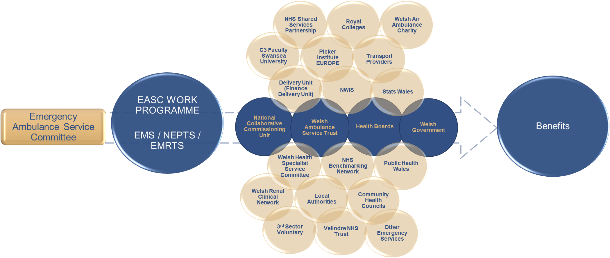
Figure 12: EASC Collaborations

EDQDF Collaborations
Figure 13 illustrates the relationship between the customer and collaborations to realise the benefits of the EDQDF work programme:

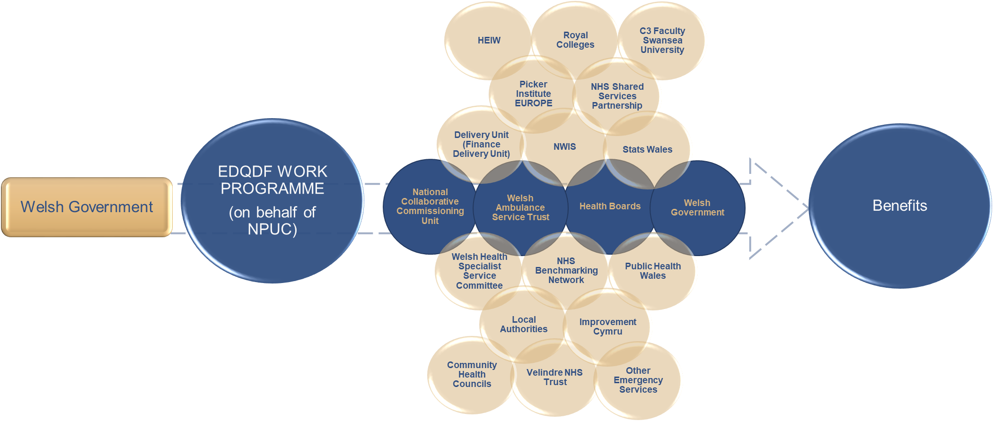
Figure 13: EDQDF Collaborations

NPUC Collaborations
Figure 14 illustrates the relationship between the customer and collaborations to realise the benefits of the National Programme of Unscheduled Care (NPUC):

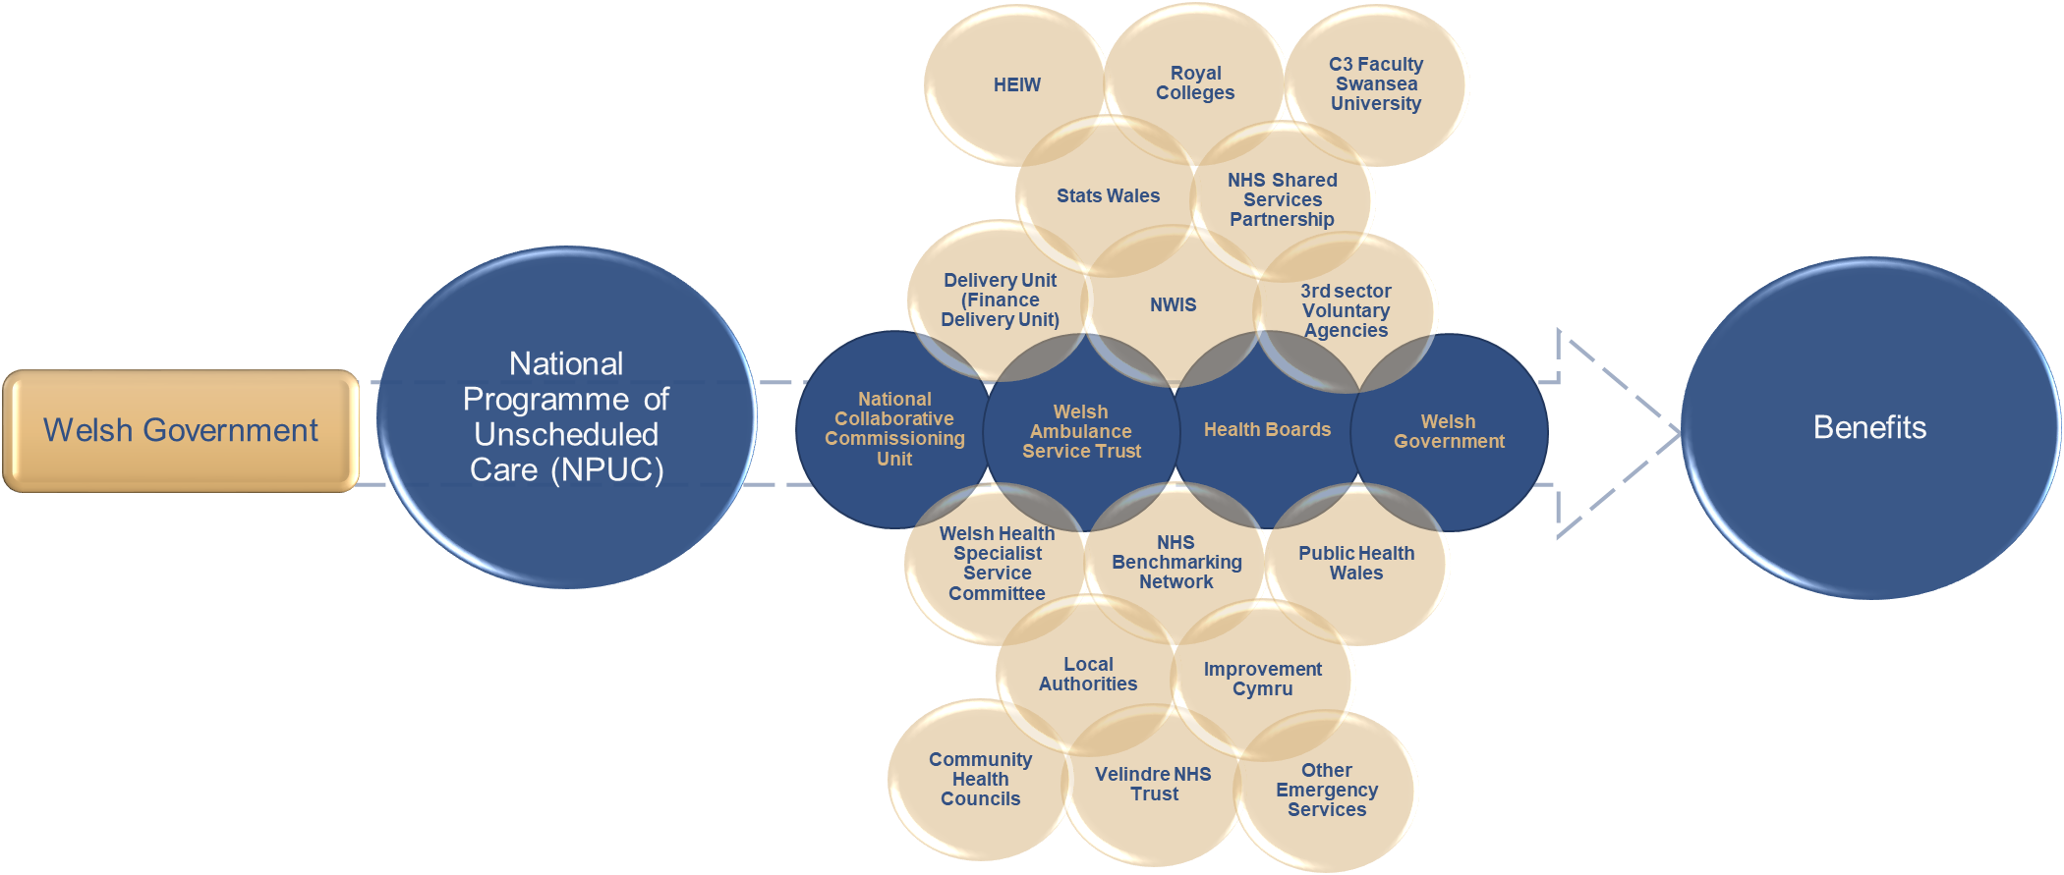
Figure 14: NPUC Collaborations

Improving Care, Improving Experience in Mental Health & Learning Disabilities
Figure 15 illustrates the relationship between the customer and collaborations to realise the benefits of the Improving Care, Improving Experience in Mental Health & Learning Disabilities work programme:

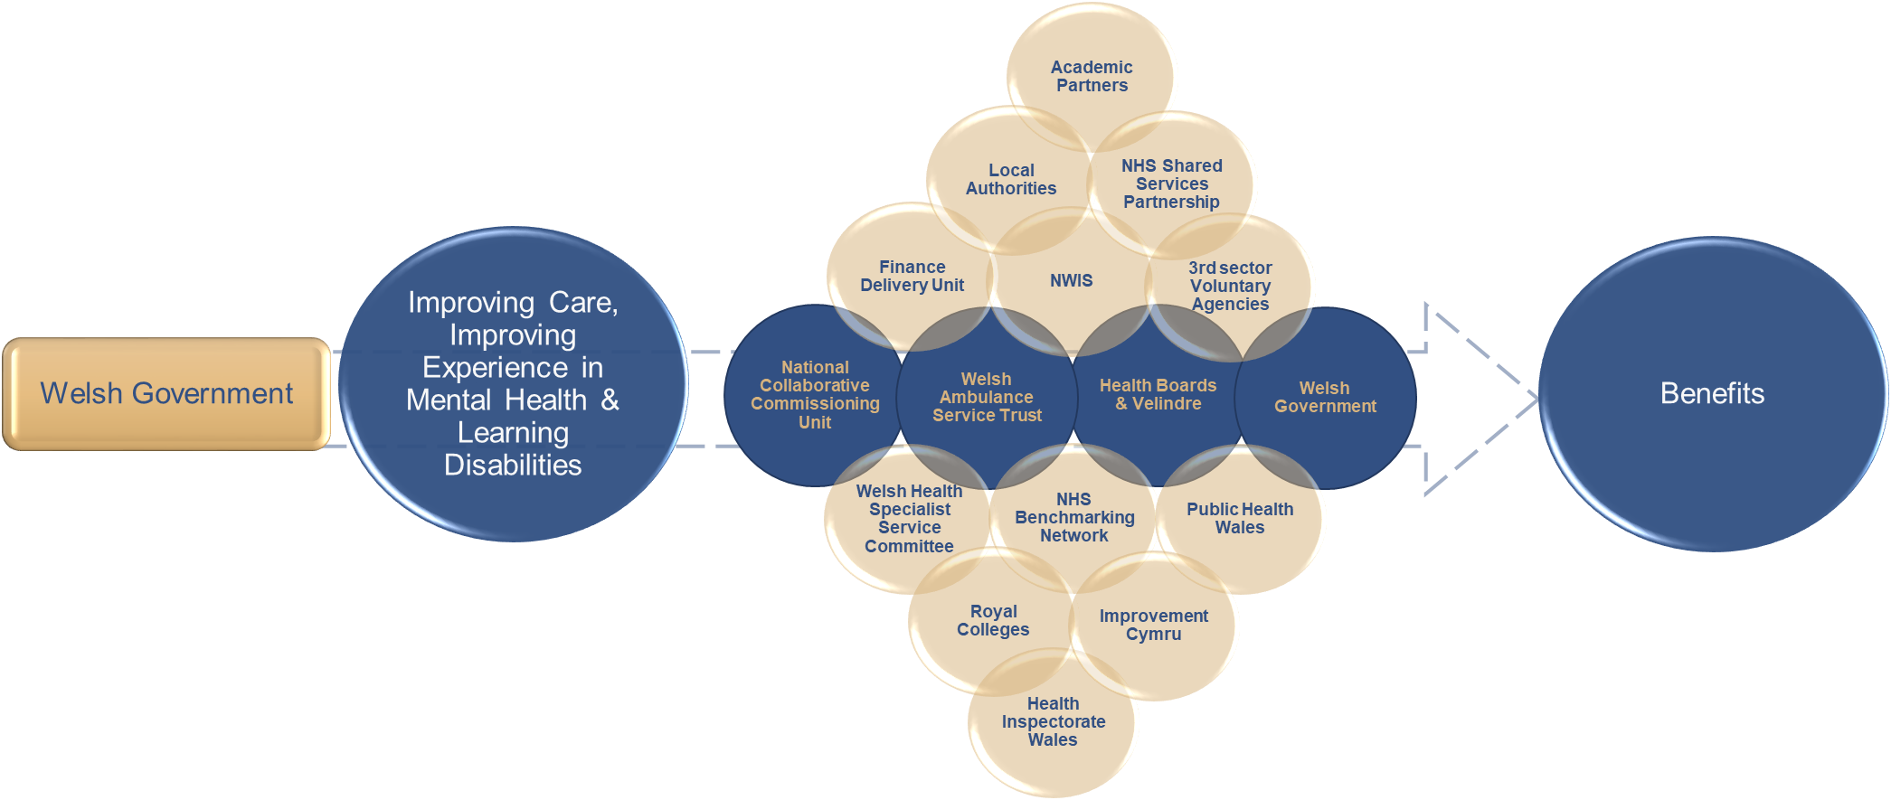
Figure 15: Improving Care, Improving Experience Collaborations

EASC Work Programme

Background
The Emergency Ambulance Services Committee (“Joint Committee”) was formed by statutory instrument 2014 No. 566 (W. 67) on the 10th May 2014. The Joint Committee is made up of the Chief Executives of the seven Local Health Boards, Chief Ambulance Service Commissioner (CASC) and an Independent Chair both appointed Ministerially.

The seven Local Health Boards in Wales are required under the legislation to work jointly to exercise functions relating to the planning and securing of emergency ambulance services. The CASC exercises these duties on behalf of the Joint Committee. EASC support the commissioning intentions and the financial envelope required to improve and deliver ambulance services across Wales.

EASC Key Deliverables
The key deliverables for the EASC work programme can be found in Appendix 1.

EASC Collaborative Commissioning Integrated Delivery Model
This is the model by which the NCCU commission:
- Emergency Medical Services (EMS)
- Non-Emergency Patient Transport Services (NEPTS)
- Emergency Medical Retrieval Transfer Services (EMRTS)

The NCCU commissions services through an integrated delivery model. The collaborative commissioning process deploys its 3 capabilities and is supported by the EASC Model Standing Orders.

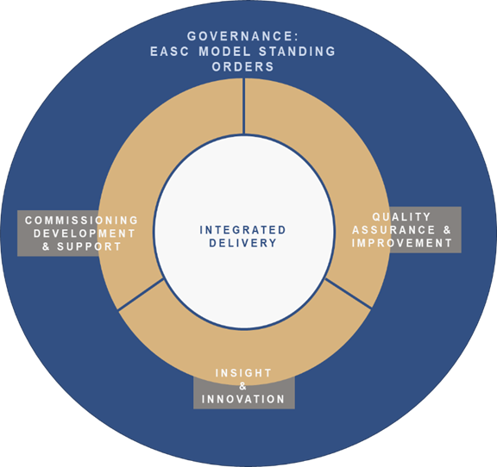

Figure 16: EASC Collaborative Commissioning Integrated Delivery Model

Commissioning Development & Support

Commissioning Development & Support (EASC)
The Commissioning Development Support Service delivers the following capabilities:
  - Defines the quality and safety expectations for EMS, NEPTS and EMRTS in the form of standards.
  - Ensures these standards are in accordance with Welsh Government standards, regulatory and statutory requirements, and best practice; and are regularly reviewed and kept up to date for each service.
  - Determines the activity currencies which are used to measure the work of EMS, NEPTS and EMRTS.
  - Ensures the activity is regularly counted and reported, and is also used to support demand and capacity work for each service.
  - Identifies all available resources for EMS, NEPTS and EMRTS, including revenue, capital and alternative funding sources.
  - Ensures the resources and financial value payable is agreed between all applicable parties to all the frameworks. This includes each Health Board, WAST, Velindre NHS Trust, WHSSC and the Air Ambulance Charity.
  - Leads the designing of the service model(s) to operate across EMS, NEPTS and EMRTS. Ensuring that these are presented in a way which is understandable to the public and patients.
  - Ensures the component parts of the service model(s) are understood and agreed, and the activity, resources and performance of each service is measured and performance managed.
  - Articulates how the interactions between professionals between parties to the frameworks across EMS, NEPTS and EMRTS operate to support delivery of the service model.
  - Defines performance measures to evidence whether the standards for each of the EMS, NEPTS and EMRTS are being met and that a balance is being achieved between improved clinical outcomes, better patient experience and value for money and are regularly reported and acted upon to ensure continuous improvement.

National Collaborative Quality and Delivery Frameworks

The NCCU is responsible to EASC via the CASC for the creation, development, operation, refresh and evaluation of National Collaborative Commissioning: Quality & Delivery Frameworks for ambulance services within NHS Wales this includes:
- Emergency Ambulance Services (EMS)
- Non-Emergency Patient Transport Services (NEPTS) Figure 17: CAREMORE® Logo
- Emergency Medical Retrieval and transfer Services (EMRTS)

National Collaborative Commissioning Frameworks are developed and maintained using the award winning CAREMORE® methodology.

National Collaborative Commissioning Quality & Delivery Framework: EMS

Commissioning value of £158.809m. The NCCU is responsible to EASC via the CASC for the creation, development, operation, refresh and evaluation of CAREMORE® National Collaborative Commissioning: Quality & Delivery Frameworks for Emergency Ambulance Services within NHS Wales. Figure 18: 5 step Emergency Ambulance Patient Care Pathway

National Collaborative Commissioning Quality & Delivery Framework: NEPTS
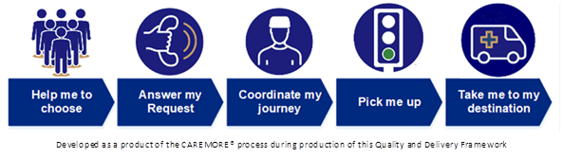
Commissioning value of £20.893m, the CAREMORE® National Collaborative Commissioning: Quality & Delivery Frameworks for Non-Emergency Patient Transport Services has been operational from October 2019 covering WAST, all Health Boards, WHSSC and Velindre NHS Trust, it reflects the ‘plurality model’ required by The Minister for Health & Social Services and is exceptionally complex given the variety of current contractual arrangements operated by WAST, all Health Boards, WHSSC and Velindre NHS Trust, between each other and with external providers. Figure 19: NEPTS Steps patient Care Pathway

The work programme for NEPTS for the duration of this IMTP are listed as Appendix 6: NEPTS Storyboard

National Collaborative Commissioning Quality & Delivery Framework: EMRTS

EMRTS Cymru is a pre-hospital critical care service for Wales which has been operating since 2015 with four helicopters and five Rapid Response Vehicles (RRVs) to “To provide advanced decision making and critical care for life or limb-threatening emergencies that require transfer for time critical specialist treatment at an appropriate facility”. It is a partnership between Wales Air Ambulance Charity, Welsh Government and NHS Wales. Figure 20: EMRTS Cymru fleet

EMRTS has been developed to bring specific benefits to Wales, there is also a service provision for the enhancement of neonatal and maternal pre-hospital critical care (both for home deliveries and deliveries in free-standing midwifery-led units (MLUs), specifically:
  - reductions in geographical inequity for patients with critical care needs
  - health gains by improving clinical outcomes, and
  - improved clinical and skills sustainability – improving the clinical skills, recruitment and retention in key acute care areas.

The service provides a highly-trained Critical Care team comprising of Consultants (from an emergency medicine, anaesthesia and intensive care background) and Critical Care Practitioners (including paramedics and nurses). The service has two main areas of activity:
  - Pre-hospital critical care for all age groups (i.e. interventions/decisions that are outside standard paramedic practice).
  - Undertaking time-critical, life or limb-threatening adult and paediatric transfers from peripheral centres for patients requiring specialist intervention at the receiving hospital.

Commissioning value of £3.833m, not including the contribution from the Wales Air Ambulance (WAA) Charity of circa £4m, the Framework will be operational from quarter 4 2019/20 and will be between EASC and the host of EMRTS, ABMU Health Board; its development utilises the approach used for creating the emergency ambulance services framework.

EASC Strategic Commissioning Intent 2020/21 onwards
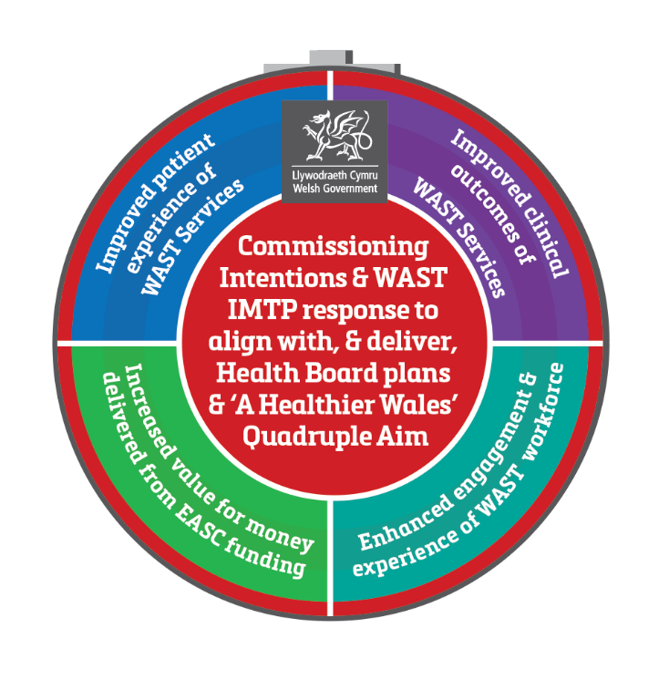
The 2019/22 NCCU/EASC IMTP articulated the development of a strategic commissioning plan for EASC. In November 19 EASC Joint Committee approved the plan. The strategic commissioning intentions were issued to WAST and Health Boards through the EASC Management Group. These strategic intentions will enable:
- Revision of NCCU Memorandum of Understanding with Welsh Government.
- Alignment of Quadruple Aim across care standards for services.
- Production of a Quadruple Aim Benefit Map enabled through the delivery of the care and core standards for each service.
- Delivery of Ministerial expectation and alignment across A Healthier Wales and the Wellbeing of Future Generations Act.
- A whole system risk reduction approach and closer alignment between the work of EASC and the National Programme for Unscheduled Care. Figure 21: EASC Strategic Commissioning Plan

EASC Annual Commissioning Intentions, Financial Assumptions and IMTP Alignment 2020/21
The 2020/21 EMS & NEPTS commissioning intentions were accepted by EASC on 12th November 2019. They were shared with WAST and EASC Management Group following EASC. A response has been received by WAST and the finalised commissioning intentions were agreed by the EASC Management Group on 20th December 2019. They will be shared nationally by NCCU through the Directors of Planning; Finance; Primary Community & Mental Health as well as Chief Operating Officers.

NCCU will share a standard descriptor of EASC Commissioned Services and the below process guidance for inclusion in Health Board IMTPs, as well as details of the financial payable to EASC for each Health Board.
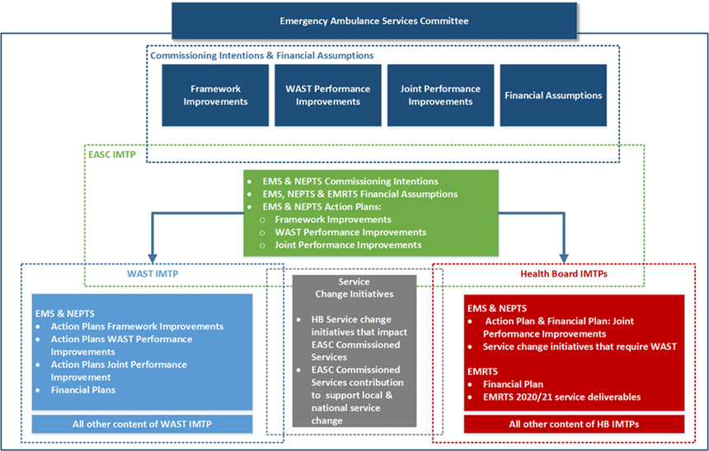

Figure 22: EASC Commissioning Intentions, Finance & Value IMTP alignment process

The commissioning intentions set annually by NCCU on behalf of the CASC contain 3 components:
- Framework Improvements – updates to the framework agreement
- WAST Performance Improvements – the performance improvements WAST are expected to make
- Joint Performance Improvements - the joint WAST and Health Board improvements that need to be undertaken.
These action plans in response to the commissioning intentions actions are documented within WAST, EASC and Health Boards IMTPs and progress on the delivery of the 2020/21 commissioning intentions will be through the EASC Management Group.
NCCU have also supplied each Health Board with a standard descriptor of EASC commissioned services for their IMTP in 2019/22.

- EMS 2020/21 Commissioning Intentions are attached as Appendix 2
- NEPTS 2020/21 Commissioning Intentions are attached as Appendix 3
- Actions Plans in response to these are attached as Appendix 4 (EMS) & 5 (NEPTS)

Future Developments and EASC Commissioned Services
The Commissioning Development and Support Service will begin scoping and support existing work on behalf of EASC As well as supporting the scoping of new all Wales services, namely:

National Collaborative Commissioning Discharge and Transfer Quality & Delivery Framework
To scope and deliver a dedicated discharge and transfer service across Wales we will work with Welsh Ambulance Service Trust and Partners to develop a detailed during 2020 a business case and to develop a National Collaborative Commissioning Quality and Delivery Framework using the CAREMORE® method. This service will include the following components:

Critical Care transfers
The Task and Finish Group on Critical Care: Final Report (Welsh Government, July 2019) set out the case for further improvements across critical care services in Wales. A written statement by the Cabinet Secretary in July 2018 announcing the establishment of a nationally directed programme for critical care and £15m additional funding for critical care services in Wales from 2019-20 emphasised this as a priority in Wales.

Further, correspondence from the Deputy Chief Medical Officer in September 2019 provided confirmation of an indicative allocation of £1.7m to the Emergency Ambulance Service Committee (EASC) to develop a national transfer service for critically ill adults. An implementation plan has been submitted to WG with the proposal that the new service operates as a parallel organisation within the EMRTS, delivered using a national collaborative commissioning quality and delivery framework under EASC.

Inter Hospital Transport Grange University Hospital
NCCU are working with Aneurin Bevan UHB and WAST to commission the new transport model for the Grange University Hospital opening April 2021.

Building on existing Emergency Ambulance and Non-Emergency Patient Transport services on behalf of EASC and with WAST and Health Boards the NCCU will develop this model through the work it is undertaking to support the transport workstream of the Clinical Futures programme within Aneurin Bevan UHB for the Grange University Hospital.

This work will inform the development of the National Transport and Discharge service and the implementation of the clinical model across Aneurin Bevan UHB.

Thrombectomy Repatriations
The NCCU will be funded by and take commissioning responsibility from WHSSC for Stroke Thrombectomy patients who require cross border repatriation.

Neonatal Transfers
NCCU will work with WHSSC and other colleagues on the potential transfer of commissioning arrangements to EASC.
Major Trauma repatriations
The work will include ensuring patients requiring repatriation following major trauma are delivered effectively.

National Call Hander of Choice Quality and Delivery Framework
This work identified in the 2019/20 IMTP has already began. Within this IMTP round we will work collaboratively with WAST and Health Boards to define what good looks like for call handling services across NHS Wales. The insight gained through the EASC 1% Heathier Wales Commissioning allocation bidding process has seen innovative schemes from BCUHB & SWUHB that use GPs to answer calls from the 999 stack and avoid hospital conveyance. These schemes identified through the Healthier Wales process have been agreed by EASC and by Welsh Government as WAST priority development areas. We will further look to maximising opportunities from existing services, i.e. 111, NHS Direct into the National Framework.

National Enhanced Clinical Capacity & Support Services Quality and Delivery Framework
We will develop a framework to deliver high quality, sustainable and efficient enhanced services that could be rapidly deployed to support a reduction in unscheduled care system pressures or proactively reduce demand. Years 1 and 2 of this IMTP will focus on the development of;
- Clinical capacity intervention service
- All Wales non-injury falls provision (Level 1 – 3)
- End of Life Services
- Priority developments by WAST using multi-disciplinary teams to prevent hospital conveyance.

Supporting the national commissioning of transport to support major service change
EASC will support the commissioning of the transport component of major service change across Wales. These include:

EMRTS Hours expansion
The service, in collaboration with EASC and the Wales Air Ambulance Charity, has developed a fully costed proposal for a staged 24-hour operation. The EMRTS Service Expansion Review has been approved by Welsh Government with the 24-hour service commencing on 1st April 2020.

The service expansion project is currently the focus for the service with good progress having been made in planning for the expanded service and in recruiting the required additional staff.

The preferred option presented by the Review provides (in addition to the existing 12-hour 3 base model):
- 2000-0800: Consultant, CCP at a North Wales base
- 2000-0800: Consultant, CCP at a South Wales base
- 2000-0800: Double pilot crew and aircraft, available at a South Wales base to support either crew
- 1400-0200: Consultant, CCP and RRV to meet the main peak of unmet demand
- Extension of operating hours of Air Support Desk to cover whole 24 hour period

The preferred option includes 3 operational rotas with an indicative implementation timescale of 12 months per rota/phase. The timescale will ensure:
- delivery of a robust implementation plan
- appropriate evaluation
- minimal impact on the existing core EMRTS 12 hour service
- consolidation of the expanded service before progressing to the next phase as directed by EMRTS DAG

Phase 1 will deliver the following:
- 2000-0800: Consultant, CCP, RRV, dual pilot crew and aircraft at Cardiff Heliport with the ability to be tasked anywhere in Wales
- Extension of ASD to 24 hour working to support the above operation in terms of communications, logistics, liaison with emergency agencies.
- Recruitment of support staff

It is important to note that all regions of Wales will benefit from each implementation phase and the 3 operational rotas included within the preferred option demonstrate a commitment to ensuring equity for the population of Wales, in line with the key investment objectives.

The funding requirements for the preferred option are:
- Initial capital costs of £0.707m and subsequent costs of £1.61m over a ten year period
- One-off revenue costs relating to recruitment and training of £0.564m over the project phases
- Recurring revenue costs of £3.1m (£3.162m from year 4)
- Non-recurring costs of £91k

South Wales Major Trauma Network
The NHS Wales Health Collaborative has been developing a Trauma Network for South and West Wales and South Powys. One of the key enablers of introducing a successful trauma network in South Wales has been identified as the availability of 24/7 enhanced care teams (NHS Clinical Advisory Group Report 2010). The EMRTS already provides pre‐hospital critical care and advanced decision-making to this subset of patients, and provides time-critical transfers to those patients requiring a higher level of care. This provision would be strengthened with a 24/7 service but EMRTS may also play a role in the coordination of major trauma patient’s care via the ASD, consultant advice and ensuring that smaller hospitals are supported in the care and onwards transfer of these patients via EMRTS clinical teams.

We have also supported the WAST component and business case submissions for the ambulance contribution to the South Wales Major Trauma Network.

Health Board strategic change
There are many strategic change programmes underway across NHS Wales. These for ambulance services are captured as part of the commissioning process. A list of these schemes is attached as Appendix 7. Some of these have clear implications for the transfer of critically ill and injured patients around the clock and EMRTS is committed to supporting these where appropriate.

Quality Assurance & Improvement

Quality Assurance & Improvement Services (EASC)
The CASC has the authority and responsibility to hold WAST to account for delivery of services in respect of performance, service delivery, and quality and safety. This is alongside responsibility for holding Health Boards to account for their role in enabling timely ambulance response to be delivered.

The NCCU is responsible to EASC through the CASC for the quality assurance and improvement of the EASC commissioned services. We deliver this responsibility through:

- Quarterly CASC / EASC Quality and Delivery meetings with Welsh Government
- Incidents and complaints reporting and reviews
- Daily performance reviews
- Clinical risk assurance reviews
- Enactment of the recommendations from PACEC Review and expectations of The Minister for Health & Social Services
- Published reporting of accurate Ambulance Quality Indicators (AQI) including enhanced user friendly reporting of AQIs
- Development of a comprehensive suite of performance and outcome measures across clinical, patient experience and value for money which are regularly reported
- Development, operation and enhancement of the electronic Benchmarking Toolkit.

Enhanced Assurance & Evaluation

Enhanced role of the CASC
In line with the recommendations featured in the McClelland Strategic Review of Emergency Ambulance Services and in addition to the Model Standing Orders, Welsh Government requested the CASC and EASC to take on an enhanced role in performance management of WAST citing:
“There is a need for simple governance and accountability for planning and delivery of emergency ambulance services. Ministerial expectation is clear; he expects greater ownership of the emergency medical services (EMS) commissioning process through the EASC mechanism with the Chief Ambulance Services Commissioner (CASC) empowered to hold both Health Boards and WAST to account for delivery of agreed commissioning intentions and agreed actions.”
In order to develop the enhanced assurance and performance management arrangements, the NCCU, on behalf of EASC, will work collaboratively with WAST to develop the documents required to support the Model Standing Orders and a set of Key Performance Indicators which will be reported into EASC Management Group in order to provide assurance to EASC Joint Committee on the performance of WAST as an organisation. It is expected that as part of an integrated approach these measures will be aligned to the strategic commissioning intentions and designed to cover quality, safety, risk, finance and value.
To enable this the NCCU will develop the performance management framework to support the CASC; this will include:
- Developing a formal communication mechanism between the commissioner and WAST.
- Enhanced commissioning and performance focused reporting to EASC across all EASC Commissioned Services.
- Full utilisation of the EASC Governance structures to make effective decisions

Enhanced role of EASC
The key deliverables for enhancing the role of EASC, through chairs objectives, can be found in Appendix 21.

Enhanced EASC Governance Arrangements
In September 2019, Welsh Government issued an updated version of Model Standing Orders for EASC. As part of Joint Committee’s governance and accountability framework the Standing Orders require a set of Standing Financial Instructions to be in place alongside other documents such as a Scheme of Delegation, Values and Standards of Behaviour Framework, Risk Register and Key Policy Documents. These documents require development in order to enhance the governance and accountability framework.. It is expected that as part of an integrated approach these measures will be aligned to the strategic commissioning intentions and designed to cover quality, safety, risk, finance and value.

EMS Ambulance Quality Indicators (AQIs)
EASC through the EMS commissioning framework requires that WAST maintain a repository of data to allow the production of AQIs. EASC will continue to be an official publisher of Ambulance Quality Indicators. EASC will work to report the EMS AQIs monthly via StatsWales.

Expanding the role of the Clinical Director NPUC
2020/21 onwards will see the opportunity to close align the work of EASC through the clinical director for NPUC working closer with EASC. This opportunity enables stronger clinical leadership and oversight for the Joint Committee as well as supporting delivery of the EASC Chair’s actions from the Minister around closer working and alignment between EASC and the National Programme for Unscheduled Care.

Enhanced Research capability
During 2020/21 we will continue to work with the C3 Faculty to provide support to EASC in terms of the Winter Planning Evaluation 2019/20 and to inform the future direction of EASC and support the evaluation of ambulance and Unscheduled Care Services service change initiatives in order to share and spread nationally an understanding of what works and doesn’t work.

We will look to develop the concept of the embedded researcher and develop a model that enables research staff to work alongside programme staff. This will deliver the benefits of fully embedded research and evaluation across EASC and EDQDF work programmes. The roles will also support NPUC in the evaluation of specific targeted initiatives.

Maximising ambulance Productivity availability programme
We will scope and implement a programme of work to address ambulance performance and to maximise ambulance availability across Wales. This work will contain a number of elements of existing work to include:

Ambulance Productivity and Availability
We will deliver a programme of work to understand the current levels of productivity delivered by emergency ambulance services in Wales, and describe the service model required to deliver a more equitable and efficient level of productivity to support the whole unscheduled care system.
Availability of ambulances is the most important determinant of an effective and efficient ambulance service. We will deliver an improvement plan for increasing ambulance availability this work will focus on 4 major themes:
  - Core functions of the Emergency Ambulance Service
  - Workforce, recruitment and wellbeing
  - Digital change and technology
  - Measurement for improvement

EMS Demand & Capacity Review 2019
We will enact the implementation of the Demand and Capacity review of the emergency ambulance service in Wales, our focus will be on maximising the efficiency of current and additional investment to support improved performance and clinical outcomes. This will include the development of in house capability to support the ongoing delivery of demand and capacity management.

NEPTS Demand & Capacity Review 2020
NCCU will work collaboratively with WAST to scope and implement the 2020 NEPTS Demand & Capacity. This review will be key to realising the efficiencies described in the NEPTS Business Case.

Amber Review Implementation Programme (ARIP)
This programme will address any legacy issues arising from the completion of the ARIP. This will include developing and implementing a long wait reduction programme and a review to support health boards to minimise hours lost to handover delays.

Insight & Innovation

1% a Healthier Wales Awarding Evaluation Panel (HWAEP)
In 2019/20 the NCCU formed the Heathier Wales Awarding Evaluation and process for WAST and Health Boards to bid against the EASC 1% A Healthier Wales Commissioning Allocation. This process saw 9 schemes agreed for funding.
The process will be repeated within each IMTP year and will provide the opportunity for submitting organisations share ideas and concepts and to enable collaboration to develop these regionally and nationally.
The process will support the EASC Chair’s objectives around closer working between EASC and NPUC, it will promote closer working between WAST and Health boards and will support the identification of innovation. The NCCU researcher will support the evaluation of all agreed and new schemes. The HWAEP principles developed to support this process will remain

HWAEP Principles
- Total sum of EASC 1% set aside for ‘additionality’ of all EASC commissioned services.
- Service Initiatives to be considered consistently and in the context of the 1% allocation available not the contribution for that particular service.
- Service Initiatives related to Joint Improvements for EMS & NEPTS 2020/21 Commissioning Intentions and IMTPs to be identified and considered; plus the IMTP related additional APP development.
- A Standardised EARTH Template for proposed Service Initiatives to be completed.
- Funding may be used for: a) ‘pump priming’ initiatives, b) non-recurrent pilot initiatives, and c) recurrent initiatives – though evidence base needs to be sound for such a commitment
- Health Boards may wish to provide extra funding (e.g from their own transformational funds) to the Service Initiatives identified through this process.
- As detailed within the Commissioning Intentions for WAST and the EASC / WAST IMTPs, WAST are required to improve their existing resource utilisation towards supporting performance improvements.
- As an all Wales discharge & transfer service of the future is yet to be scoped and commissioned by EASC through WAST then this is not to be included.
- Tertiary related service changes via WHSCC which have a transport element should be considered by WHSSC and not to be included.
- An equitable approach to Service Initiatives by Health Boards should be adopted – so for example a) those that are scalable across Wales to be favoured, and b) Health Boards can supplement baseline provision through additional local funding as per 6) above.

Research & Evaluation
The Healthier Wales long-term plan for better population health centralises the Quadruple Aim for health care. Similar aims have been adopted worldwide and increasingly health care research adopts a quadruple aim perspective (cf. Liddy and Keely 2018). Similarly, the NCCU will deliver a framework that provides stakeholders with a Quadruple Aim perspective on health care initiatives across Wales, allowing for a fair comparison of initiatives. Due to its unique position as a collaborator working across health boards, the NCCU is able to find similar initiatives and analyse the commonalities and differences to support the sharing of knowledge and expertise, leading to the overall improvement of health care programmes. Ultimately, this framework will:

• Provide an easy to read comparative analysis of initiatives across Wales
• Ensure that like is compared with like
• Support the sharing of knowledge with regard to what works well and why
• Provide a Quadruple Aim perspective in line with government policy

EASC Evaluation Activity
During 2020/23 we will continue to work with the C3 Faculty to provide support to EASC in terms of the EASC 1% A Healthier Wales Commissioning Allocation, Winter Planning Evaluation 2019/20 and to inform the future direction of EASC and support the evaluation of ambulance and Unscheduled Care Services service change initiatives in order to share and spread nationally an understanding of what works and doesn’t work.

Evaluation of WAST Initiatives
NCCU has delivered evaluation of the WAST initiatives around the expansion of the clinical desk, National Falls Schemes and Advanced Paramedic Practitioners. Utilising baseline measures and a mixed methods evaluation approach as well as being clear around the benefits that will be realised to ensure that funded schemes provide the value to the system.

EMRTS Formal Service Evaluation
The independent EMRTS Cymru Service Evaluation is being undertaken by Swansea University to produce a comprehensive evaluation of three years of EMRTS service activity and outcomes. The review is being undertaken against the agreed benefits realisation plan and key investment objectives of Health Gain, Equity and Clinical & Skills Sustainability.

EMRTS is well placed to develop research and quality improvement initiatives to improve knowledge and treatment of critically ill patients. A research and development strategy will be developed in 2020/21.This has supported the development and approval of the business case for 24/7 EMRTS operating hours. It will also support evaluation on the impact of 24/7 operating.

An EMRTS Research & Audit Group has been established to lead on this work, reporting to the EMRTS Clinical & Operational Board. A key initial output will be the ongoing data analysis and evaluation of the service performed in partnership with Swansea University. Work is also underway with national partners to deliver research relating to technological innovation, wellbeing, equipment and clinical care. It is anticipated that future research activities will include working in partnership with Welsh Ambulance Service, other pre-hospital services and academic institutions.

CASC advice to stakeholders on EMS, NEPTS & EMRTS
Chief Ambulance Services Commissioner (CASC) provides advice on ambulance services to a wide range of stakeholders. A list of current EASC Chair actions can be found in Appendix 10.

Engagement with Key Strategic Partners
Our collaborative approach support local and strategic engagement with Community Health Councils (CHC) regarding the transformation of NEPTS services across Wales. NCCU facilitates an all Wales strategic meeting with CHC's and supports Health Boards with local meetings to share information on service development.

EASC Model Standing Orders
These Model Standing Orders are issued by Welsh Ministers to Local Health Boards using powers of direction provided in section 12 (3) of the National Health Service (Wales) Act 2006. When agreeing SOs Local Health Boards must ensure they are made in accordance with directions as may be issued by Welsh Ministers. Each Local Health Board (LHB) in Wales must agree Standing Orders (SOs) for the regulation of the Emergency Ambulance Services Committee’s (the EASC or the Joint Committee) proceedings and business.

These EASC Standing Orders (EASC SOs) form a schedule to each LHB’s own Standing Orders, and have effect as if incorporated within them. They are designed to translate the statutory requirements set out in the Emergency Ambulance Services Committee (Wales) Regulations 2014 (2014 No.566 (w.67)) and LHB Standing Order 3 into day to day operating practice. Together with the adoption of a Schedule of decisions reserved to the Joint Committee; a Scheme of delegations to officers and others; and Standing Financial Instructions (SFIs), they provide the regulatory framework for the business conduct of the Joint Committee.

EASC Governance Arrangements
As outlined in the EASC Model Standing Orders the responsibility for EASC will move from Cwm Taf UHB to the NCCU. In response to this change the NCCU will produce a governance programme of work to meet the requirements outline in the Model Standing Orders.
Figure 23: EASC Governance Arrangements

EASC Committee Secretariat
NCCU will take responsibility from CTUHB corporate directorate for the EASC Committee Secretariat. NCCU will maintain the structures to ensure effective functioning of the EASC subcommittees in relation to EMS, NEPTS & EMRTS. The structure and groups are outlined below:

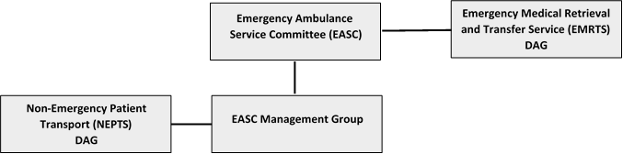
Figure 24: EASC Subgroups & reporting routes

EASC Integrated Medium Term Plan
We will continue to develop an NCCU EASC IMTP submission in line with Welsh Government planning guidance. We will work collaboratively to ensure that the policy leads for the sections of our plan within Welsh Government are sighted through the development process.

EASC Risk Management Framework
EASC as a commissioning body has an approved IMTP 2019-2022. The IMTP lays out in detail the existing and planned activity for EASC commissioned services and the National Programme for Unscheduled Care (NPUC).

The Chair of EASC, has had his objectives for 2020/20 agreed by the Minister for Health and Social Care. Core to these are the delivery of EASC & WAST IMTP actions and the closer alignment between the work of EASC and NPUC.

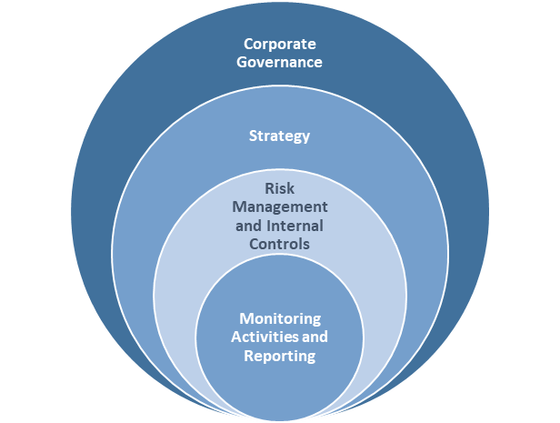
An effective approach to risk management is required to provide assurance to the committee that risks and opportunities in relation to the strategic objectives of EASC are:

1. Identified
2. Assessed
3. Planned
4. Implemented

The development of an integrated risk management framework for EASC seeks to strengthen the control environment and sustain good corporate governance, implement effective internal controls and monitoring activities which support the running of EASC and the delivery of strategic commissioning plans.

Figure 25: EASC Risk Management Framework

Implementation of Audit Findings
In July 2017 the Auditor General published the National Audit Office Review of Emergency Ambulance Services Commissioning Arrangements in Wales. One of the key recommendations identified in the report was:

“The subgroup structure of EASC lacks clarity and purpose which is impacting on the ability of the subgroups to make a meaningful contribution to the commissioning agenda. EASC should urgently review the structures, roles and memberships of its three subgroups to ensure they are mutually exclusive, have a clear purpose and appropriately support the work of EASC.”

The NCCU will work with WAST & Health Board representatives to ensure the functioning of the subgroups listed in Figure 20 delivers against the recommendations.

NCCU will work to implement the 2019 NEPTS Internal Audit Findings and will report progress through the NEPTS Delivery Assurance Group.

Implementation of EASC Governance Statement Actions.
EASC is required to produce an annual governance statement which is included as part of the annual account process. Actions contained within the governance statement are included in the delivery plan for EASC and progress is reported to the Joint Committee via the CASC report on a regular basis.

EASC Financial Values

EASC NCCU 2020/21 Summary Financial Values

Emergency Ambulance Services Committee /  National Collaborative Commissioning Unit  2020/21 Summary | Swansea Bay UHB | Aneurin Bevan UHB | Betsi Cadwaladr UHB | Cardiff & Vale UHB | Cwm Taf UHB | Hywel Dda UHB | Powys THB | Velindre NHS | EASC
 |  |  |  |  |  |  |  | Trust | Requirement
 | £m | £m | £m | £m | £m | £m | £m | £m | £m
EASC: WAST EMS Provision 2020/21 | 17.114 | 27.962 | 43.090 | 20.054 | 21.568 | 22.973 | 12.479 | - | 165.239
EASC: NEPTS Provision 2020/21 | 3.767 | 2.804 | 4.927 | 4.663 | 1.373 | 2.106 | 1.075 | 0.679 | 21.394
EASC: EMRTS Provision 2020/21 | 0.488 | 0.749 | 0.947 | 0.612 | 0.570 | 0.517 | 0.203 | - | 4.087
NCCU 2020/21 | 0.150 | 0.247 | 0.379 | 0.177 | 0.190 | 0.201 | 0.109 | - | 1.453
EASC and NCCU Total Requirement 2020/21 | 21.519 | 31.761 | 49.342 | 25.507 | 23.700 | 25.798 | 13.866 | 0.679 | 192.173
Recurrent Financial Values at Risk * | 1.098 | 1.795 | 2.771 | 1.287 | 1.385 | 1.475 | 0.802 | - | 10.613
Total inc. Financial Values at Risk | 22.618 | 33.556 | 52.113 | 26.794 | 25.085 | 27.273 | 14.668 | 0.679 | 202.786

Emergency Medical Services 2020/21 Financial Values
*To be confirmed - this will not exceed the financial value at risk set out below

Non-Emergency Patient Transport Services 2020/21 Financial Values
EASC: NEPTS Provision 2020/21 | SBUHB | Aneurin Bevan UHB | Betsi Cadwaladr UHB | Cardiff & Vale UHB | Cwm Taf UHB | Hywel Dda UHB | Powys THB | Velindre NHS | EASC
Quality & Delivery Framework Agreement |  |  |  |  |  |  |  | Trust | Requirement
 | £m | £m | £m | £m | £m | £m | £m | £m | £m
2019/20 NEPTS Requirement through EASC | 3.679 | 2.738 | 4.811 | 4.554 | 1.341 | 2.057 | 1.049 | 0.663 | 20.893
Healthier Wales 1% System Reallocation (recurrent) | - 0.034 | - 0.025 | - 0.044 | - 0.042 | - 0.012 | - 0.019 | - 0.010 | - 0.006 | - 0.192
2019/20 NEPTS Adjusted requirement 2019/20 | 3.645 | 2.713 | 4.767 | 4.512 | 1.328 | 2.038 | 1.040 | 0.657 | 20.701
Pay Award (Per Pay Funding Matrix 2020/21) | 0.049 | 0.037 | 0.064 | 0.061 | 0.018 | 0.027 | 0.014 | 0.009 | 0.279
2% uplift | 0.073 | 0.054 | 0.095 | 0.090 | 0.027 | 0.041 | 0.021 | 0.013 | 0.414
2020/21 NEPTS Requirement through EASC | 3.767 | 2.804 | 4.927 | 4.663 | 1.373 | 2.106 | 1.075 | 0.679 | 21.394
Proportions | 17.61% | 13.11% | 23.03% | 21.80% | 6.42% | 9.85% | 5.02% | 3.18%

Emergency Medical Retrieval Transfer Services
EASC: EMRTS Provision 2020/21 | Swansea Bay UHB | Aneurin Bevan UHB | Betsi Cadwaladr UHB | Cardiff & Vale UHB | Cwm Taf UHB | Hywel Dda UHB | Powys THB | EASC
Quality & Delivery Framework Agreement |  |  |  |  |  |  |  | Requirement
 | £m | £m | £m | £m | £m | £m | £m | £m
2019/20 EMRTS Requirement through EASC | 0.468 | 0.716 | 0.897 | 0.588 | 0.544 | 0.491 | 0.190 | 3.893
Healthier Wales 1% System Reallocation (recurrent) | - 0.004 | - 0.007 | - 0.008 | - 0.006 | - 0.005 | - 0.004 | - 0.002 | - 0.036
Healthier Wales 1% System Reallocation (recurrent) | 0.016 | 0.025 | 0.039 | 0.018 | 0.020 | 0.021 | 0.011 | 0.150
19/20 EMRTS Revised Baseline | 0.479 | 0.735 | 0.928 | 0.600 | 0.558 | 0.507 | 0.199 | 4.007
2 % uplift | 0.010 | 0.015 | 0.019 | 0.012 | 0.011 | 0.010 | 0.004 | 0.080
2020/21 EMRTS Requirement through EASC | 0.488 | 0.749 | 0.947 | 0.612 | 0.570 | 0.517 | 0.203 | 4.087

National Collaborative Commissioning Unit 2020/21 Financial Values
National Collaborative Commissioning Unit 2020/21 | Swansea Bay UHB | Aneurin Bevan UHB | Betsi Cadwaladr UHB | Cardiff & Vale UHB | Cwm Taf UHB | Hywel Dda UHB | Powys THB | EASC
 |  |  |  |  |  |  |  | Requirement
 | £m | £m | £m | £m | £m | £m | £m | £m
2019/20 NCCU Baseline
EASC Commissioning Support | 0.052 | 0.086 | 0.132 | 0.061 | 0.066 | 0.070 | 0.038 | 0.506
NPUC Clinical Lead | 0.006 | 0.010 | 0.016 | 0.007 | 0.008 | 0.008 | 0.005 | 0.060
Quality Assurance & Improvement Services - MH and LD | 0.081 | 0.132 | 0.203 | 0.094 | 0.102 | 0.108 | 0.059 | 0.779
2019/20 NCCU Baseline | 0.139 | 0.227 | 0.351 | 0.163 | 0.175 | 0.187 | 0.102 | 1.345
Healthier Wales 1% System Reallocation (recurrent) | 0.008 | 0.014 | 0.021 | 0.010 | 0.010 | 0.011 | 0.006 | 0.080
2019/20 NCCU Revised Baseline | 0.147 | 0.241 | 0.372 | 0.173 | 0.186 | 0.198 | 0.108 | 1.425
2 % uplift | 0.003 | 0.006 | 0.006 | 0.004 | 0.004 | 0.003 | 0.002 | 0.028
2020/21 NCCU Requirement through EASC | 0.150 | 0.247 | 0.379 | 0.177 | 0.190 | 0.201 | 0.109 | 1.453

National Programme for Unscheduled Care (NPUC) Work Programme

Background
The Welsh Government has placed improving unscheduled care services for patients at the heart of their commitments to the Welsh public during the current Assembly term. It is considered a priority for NHS Wales and Ministers have been clear that they expect to see optimal outcomes for citizens who access unscheduled care services, through a patient-centred, safe, timely and effective approach. The Welsh Government’s stated intention for achieving this goal is through organising all local services as part of a single planned, integrated system, where all elements work seamlessly and reliably to deliver the right patient centred response, by the right clinician, at the right time to optimise patient outcomes.

The national programme for unscheduled care is a long running programme established to facilitate and enable change and improvement for unscheduled health and care services in Wales. The programme Board is chaired by the Deputy Chief Executive NHS Wales.

Significant work has seen a recalibration of the programme to ensure there is clarity for future programme arrangements and deliverables which will make a real difference to the service our patients are receiving across Wales each and every day.

NPUC Key Deliverables
The key deliverables for NPUC can be found in Appendix 8: NPUC Key Deliverables.

NPUC Programme Vision
The National Programme for Unscheduled Care’s vision is:

“To delivery optimal clinical outcomes and a better experience for citizens who access unscheduled health and care services in Wales.”

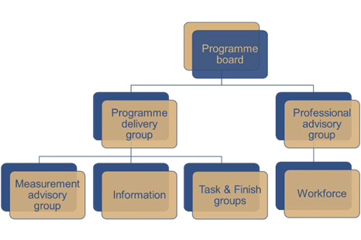
NPUC Governance
NCCU deliver the National Programme for Unscheduled Care using the following programme structure.

Professional Advisory Group (PAG)
The Professional Advisory group is chaired by the Clinical Director for the National Program for Unscheduled Care. The group meets bi monthly. The membership of the group has been reinvigorated to include “core “members” and “specialist members”.
Figure 25: NPUC Governance structure
The core members represent every sector of professionals delivering unscheduled care. It is envisaged that the specialist members will be co-opted depending upon the clinical advice being sought.

Measurement Advisory Group (MAG)
The Measurement Advisory Group is chaired by the Director of National Collaborative Commissioning and attended by the Clinical Director for Unscheduled Care. The aim of this group is to develop measures to support the delivery of the future frameworks.

Both groups will also consider their supporting roles as part of a “What does good look like for the Emergency Department in Wales?” as requested by The Minister for Health & Social Services.

Clinical Director: National Programme for Unscheduled Care (CDNPUC)
This role supports the NCCU in its work programme giving clinical assurance to the National Program Unscheduled Care. The release of the Parliamentary Review of Health and Social Care in Wales and subsequent recommendations are drivers for NPUC. In particular the development of Recommendation 3: Bold New Models of Seamless Care – national principles local delivery is particularly important to this national clinical role.

To enable delivery of Recommendation 3 the Minister for Health & Social Services for Health commissioned the Clinical Director for NPUC to describe ‘What Good looks like for the Emergency Department in Wales’. This work funded by Welsh Government is described in the next section.

We will look to expand the role of Clinical Director NPUC to directly support the Chair of EASC in the delivery of his objectives around closer working between EASC and NPUC.

Enhanced Assurance and Evaluation

Expanding the role of the Clinical Director NPUC
2020/21 onwards will see the opportunity to close align the work of EASC through the clinical director for NPUC working closer with EASC. This opportunity enables stronger clinical leadership and oversight for the Joint Committee as well as supporting delivery of the EASC Chair’s actions from the Minister around closer working and alignment between EASC and the National Programme for Unscheduled Care.

Enhanced evaluation
NCCU We will look to develop the concept of the embedded researcher and develop a model that enables research staff to work alongside programme staff. This will deliver the benefits of fully embedded research and evaluation across EASC and EDQDF work programmes. The roles will also support NPUC in the evaluation of specific targeted initiatives.

Unscheduled Care Quality Statements
The Director and Clinical Director of NPUC will lead the development of a series of unscheduled care ‘Quality Statements’ which describe the outcomes and standards we would expect to see in high quality, patient focused services. Unscheduled care quality statements will be the first stepping stone to put national policy into practice locally. These quality statements will:

  - Describe what good looks like for Unscheduled Care in Wales.
  - Define outcomes against quadruple aim.
  - Outline the commitment to deliver quality, excellence & improvement.
  - Explain how effective our methods for delivering these will be as prescribed in the policy guidance.

Our national programmes of work deliver against Quality Statements through a variety of collaborative approaches that ensure consistency across Wales. Through EASC; the National Programme for Unscheduled Care and our Improving Care, Improving Experience in Mental Health and Learning Disability Services Programme we provide national oversight and assurance through the NHS Wales planning and performance framework.

National Policy Framework for Unscheduled Care
A policy framework for unscheduled care is in development to set out medium to long term ambitions for unscheduled care services to be delivered consistently across Wales by Local Health Boards and Trusts. We will work to implement the draft National Policy Framework for Unscheduled Care using the production process outline above.

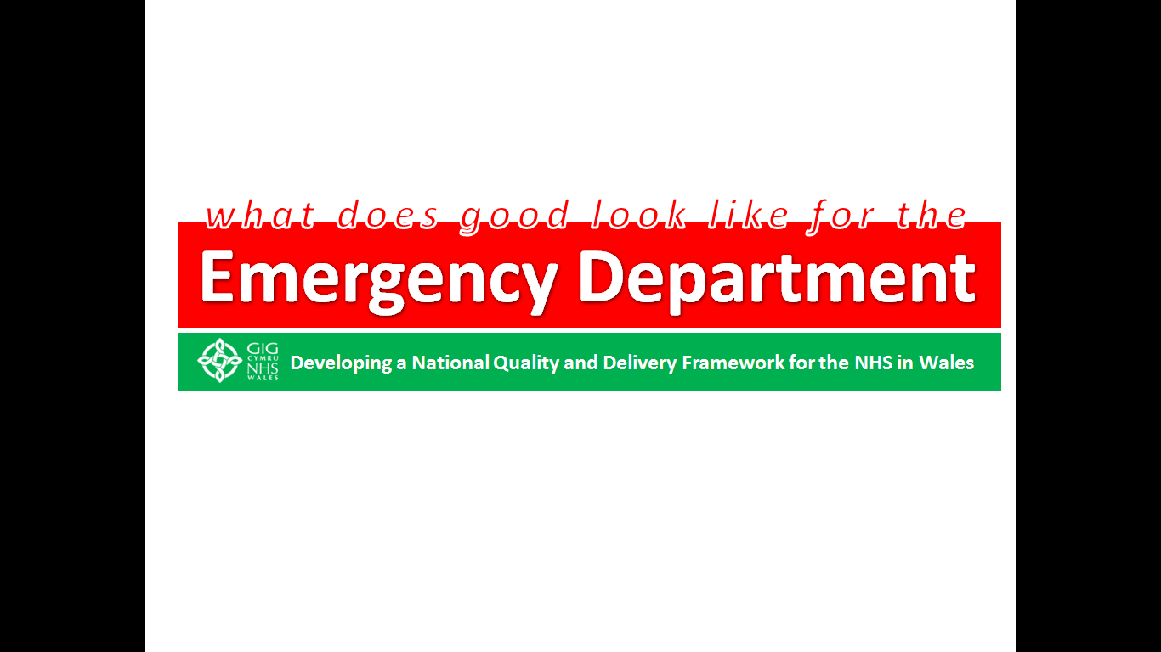
What does good look like for the Emergency Department in Wales?

Background
The Minister for Health & Social Services has requested an understanding of ‘what good looks’ like for patients accessing an Emergency Department and the creation of a National Collaborative Commissioning Emergency Department Quality & Delivery Framework (EDQDF) for NHS Wales.

This work; predominantly clinically led by front line staff has agreed care standards, a uniform approach to measuring activity and a nationally agreed model of care to enable optimization of clinical outcomes and patient and staff experience.

The EDQDF has three phases, as follows:
- Phase 1: Developing an understanding of where we are now and identifying what good looks like
- Phase 2: Working with individual Emergency Departments to implement the Quality and Delivery Framework
- Phase 3: “Go live” within an Emergency Department and sharing insight and experience for wider adoption in NHS Wales

Commissioning Development & Support (EDQDF)
The NCCU commissions services through an integrated delivery model. The collaborative commissioning process deploys its 3 capabilities and is supported by the NPUC governance structure. The Commissioning Development Support Service delivers the following capabilities:
  - Defines the quality and safety expectations for Emergency Departments care standards.
  - Ensures these standards are in accordance with Welsh Government standards, regulatory and statutory requirements, and best practice; and are regularly reviewed and kept up to date for each service.
  - Determines the activity currencies which are used to measure the work of Emergency Departments.
  - Ensures the activity is regularly counted and reported, and is also used to support demand and capacity work for each service.
  - Identifies all available resources for Emergency Departments, including revenue, capital and alternative funding sources.
  - Leads the designing of the service model(s) to operate across Emergency Departments. Ensuring that these are presented in a way which is understandable to the public and patients.
  - Ensures the component parts of the service model(s) are understood and agreed, and the activity, resources and performance of each service is measured and performance managed.
  - Articulates how the interactions between professionals between parties to the frameworks across Emergency Departments operate to support delivery of the service model.
  - Defines performance measures to evidence whether the standards for each of the Emergency Departments are being met and that a balance is being achieved between improved clinical outcomes, better patient experience and value for money and are regularly reported and acted upon to ensure continuous improvement.

Quality Assurance & Improvement (EDQDF)
The EDQDF Programme is now at Phase 2 undertaking enabling work with many collaborations that focus on putting the care standards and A Healthier Wales’ Quadruple Aim into every day care. Clinically led through the early adopter sites Phase 2 will see the programme support the national delivery of:
- Pathway Improvement Projects (PIPs)
- National Enablers for Service Improvement (NESIs)

Insight & Innovation (EDQDF)
The production process for EDQDF is clinically led. It is a collaborative bottom up approach to commissioning that we believe is unique. The approach to development involves bringing together clinicians, planners operational and support staff and creating an environment for them to discuss, share, create and collaborate. We believe this approach fully engages staff, enables collaboration and drives standards.

Once for Wales: National Enablers for Service Improvement (NESIs)
These programmes focus on ‘Once for Wales’ collaborations and wider organisational infrastructure to deliver one or more of the Quadruple Aim for Welsh Emergency Departments. The current NESIs being developed and delivered by the EDQDF Programme are as follows:

ED Pioneering KPIs

EDQDF is working collaboratively with NWIS & NHS Delivery Unit to change the conversation beyond the traditional 4 and 12 hours within ED. This work will develop initially 15 measures (3 across each of the 5 steps of the care pathway) from the front to the back door of an ED. This work will enable each organisation to better understand a patients flow through ED. The programme will develop over time 3 measures for each of the 20 care standards for EDQDF. This suite of 60 measures will be ensure NHS Wales remains at the forefront of innovation.

Initial ED Pioneering KPIs
The agreed initial 15 measures are detailed below:
- Record the level of escalation within each ED and the date and time when it changes.
- Description of Emergency Care Communications within Winter Plans.
- Chart the levels of escalation of each ED over time, against number of attendance
- Time from arrival to Triage by Triage category.
- Description of the planned staffing roster, dedicated to undertaking Triage.
- Chart the waiting time from Registration to complete Triage by Triage Category.
- Time from Arrival to contact with ED clinical decision maker (formerly triage time instead of Arrival time) (This will be interpreted as arrival time to treatment start time).
- Record the number of unmet Hours of Staff deployment, against the planned roster including Bank, Agency & Locum.
- Chart the time from Arrival, to the initial consultation in each Clinical Area.
- Time from treatment end to administrative end for patients whose outcome of attendance was Inpatient Admission.
- Audit of the staff time spent in the ED, by Acute Inpatient Specialities.
- Chart the top 10 conditions by time from Registration to completion of Treatment.
- Record the ED discharge time and destination of every patient when they leave the ED.
- Describe the range in the Unit Cost of Care, for every patient by discharge destination.
- Chart the time from Registration to Discharge by Clinical Area, Top 10 Condition and Triage Category.

ED Pioneering KPIs for Winter 2019/20
The Pioneering KPIs to be reported upon this winter across the majority of the 13 ED sites have been advised to the Welsh Government as:
    - Time from arrival to Triage by Triage Category (KPI 4)
    - Time from arrival to contract with ED Clinical decision make (KPI 7)
    - Record the ED discharge and destination of every patient when they leave ED (KPI 13)

ED Pioneering KPI Achievability Matrix
NWIS & EDQDF Programme team have developed an achievability matrix. The aim of this Achievability Matrix is to assess each of the Major Emergency Departments ability to achieve the pioneering KPI’s outlined by the EDQDF programme.

The report was reviewed at the event on the 19th November 2019, in which HB’s were asked to re-evaluate their responses and see if anything has changed due to having more clarity around the measures or system changes have been made in ED’s.

The aim of this Achievability Matrix is to assess each of the Major Emergency Departments ability to achieve the pioneering KPI’s outlined by the EDQDF programme.

Responses were received from:

- Aneurin Bevan University Health Board
- Betsi Cadwaladr University Health Board
- Cardiff and Vale University Health Board
- Cwm Taf Morgannwg University Health Board
- Hywel Dda University Health Board
- Swansea Bay University Health Board

This development work will continue through years 1 & 2 of this IMTP.

ED Patient Experience

EDQDF has completed a national procurement exercise and is working with Happy or Not to install patient experience terminal to all 13 ED sites in Q4 2019, with the intention for them to be operational by shortly after. A national event is planned during week commencing 24th February 2020 which will:
    - Review their use and further plan their utilisation;
    - Learn from each other about actions (to be) taken in response to feedback received; and
    - Consider future broader forms of patient experience information and mechanisms.


ED Staff Engagement & Experience
EDQDF ED Staff engagement & experience work involves collaboration between Health Boards and Picker Institute Europe. This work aims to give ED’s a voice within their own organisation through engaging staff to better understand their experiences of working within an ED. This work has already delivered the first ever Wales Urgent and Emergency Care Services Winter pressures survey. Issued following winter 2018/19 the outputs of this survey have been 13 improvement maps (one for every ED in Wales) that show the issues that staff have raised and enable each Health Board to formulate plans to address and improve the experiences of staff working within ED.


ED Benchmarking
NHS Benchmarking Network are collaborating with EDQDF in Wales by delivering a workshop and bespoke reports for the Network’s Emergency Care benchmarking project. This will support and enable consistency of approach to ED delivery across Wales.

ED Benchmarking Scope
- The reports and workshop will cover the Type 1&2 element of the Network’s Emergency Care project.
- Thirteen EDs have participated in the Network’s Emergency Care project this year.

ED Benchmarking Deliverables
            - Bespoke reports for each of the thirteen Welsh EDs comparing them with each other. The reports will not include comparison with English EDs or the England mean positions.
            - A workshop with Network project participants to discuss the results, service improvement opportunities and any data issues.

Future NESIs
The NESI concept for EDQDF has identified a number of future NESIs that it intends to bring on line within years 2 and 3 of this IMTP. These are:
- Clinical Outcomes & Quality
- Workforce solutions
- Stakeholder engagement and communications
- Digitalisation

Pathway Improvement Projects (PIPs)
Pathway Improvement Projects (PIPs) focus on the operational arrangements to deliver the Care Standards. Launched at the National Workshop on the 10th December 2019 each PIP has clinical leadership; nationally through the Clinical Director for the NPUC, or locally from a Clinical Lead from one of the Early Adopter sites.
The EDQDF Programme has produced a PIP Production Template to support the production of ‘what looks good’ in each of the early adopter sites; it covers:
- the establishment of a PIP Working Group;
- clarification of what is within and out of scope;
- identification of relevant existing documentation such as protocols, policies, etc.;
- a detailed description of what is required to deliver the care standard and ensure continuous improvement;
- a supporting implementation plan.

Frontline FastTrack Solutions
The collaborative approach to the development of the framework has enabled frontline clinicians to identify ideas that could be implemented easily to support sustainable change. These solutions when developed from proof of concepts by front line clinicians that when scoped, delivered and embedded will deliver real benefits outlined in the policy agendas.

The frontline clinicians from within the Early Adopter sited for EDQDF programme identified for ambulance handover and triage flow things that will make Ambulance Handover and Triage function better, these initial 5 Frontline Fast-track Solutions are:

- Stretcher swap for immediate release
- 24x7 Health Care Support Worker for Triage
- ED Receptionist Staff Red Flag Training
- HAS in accessible locations
- Fit to Sit review and joint training

In order to realise the benefits from these solutions that have been identified by frontline clinicians they will be rolled out through the 6 early adopter sites by the end of March 2020 with a further rollout to the remaining ED sites when the benefits are realised early in 2020/21.

National ED Networks
We will deliver through the EDQDF programme a number of national ED networks. These will be clinically focused but will also support the sharing of intelligence and embedding of the PIPs and NESIs into organisations whilst providing ED’s across Wales with a voice within the system and within individual Health Boards.

EDQDF Stakeholder Engagement & Communications Strategy
The EDQDF Stakeholder Engagement & Communications Strategy (SECs) is being updated and further developed with support from the Early Adopters. This has been enabled as a consequence of the enhanced engagement and communication activities already underway as part of Phase 2 both locally and nationally.

EDQDF Quadruple Aim Group
The EDQDF programme will see the formation of Wales’ first Quadruple Aim group. its goal is to give assurance & oversight to EDQDF Board; NPUC Board and Minister, on the delivery of the EDQDF and provide guidance & support on evaluation activities for its delivery of measures above & beyond ED 4/12 Hours.

It will be Chaired by Professor Ceri Phillips, Head of the College of Human and Health Sciences at Swansea University and Professor of Health Economics at Swansea Centre for Health Economics; utilising his expertise and ongoing support to the EDQDF Programme through the NCCU’s collaboration with Swansea University for ‘researchers in residence’ which supported the work completed during Phase 1 of the EDQDF Programme that has included a ‘baseline understanding’ – qualitative study of the current ED positions throughout NHS Wales pre-EDQDF; and the drafting of a ‘logic model’ for evaluation.

The independent membership will include representation from each of the early adopter University Health Boards, namely Aneurin Bevan, Cardiff & Vale and BCU, together with a WAST Non-Executive Director, to ensure a link with Emergency Ambulance Services, and the EASC Chair to ensure all work is complimentary between ambulance services and broader unscheduled care services.

The intent of the Quad Aim Group aligns with the Strengthening Governance and Accountability section of WHC/2019/029, NHS Planning Framework 2020-23, where it states boards are required to have an understanding of how their organisations IMTP deliverers the Quadruple Aim.

EDQDF Storyboard
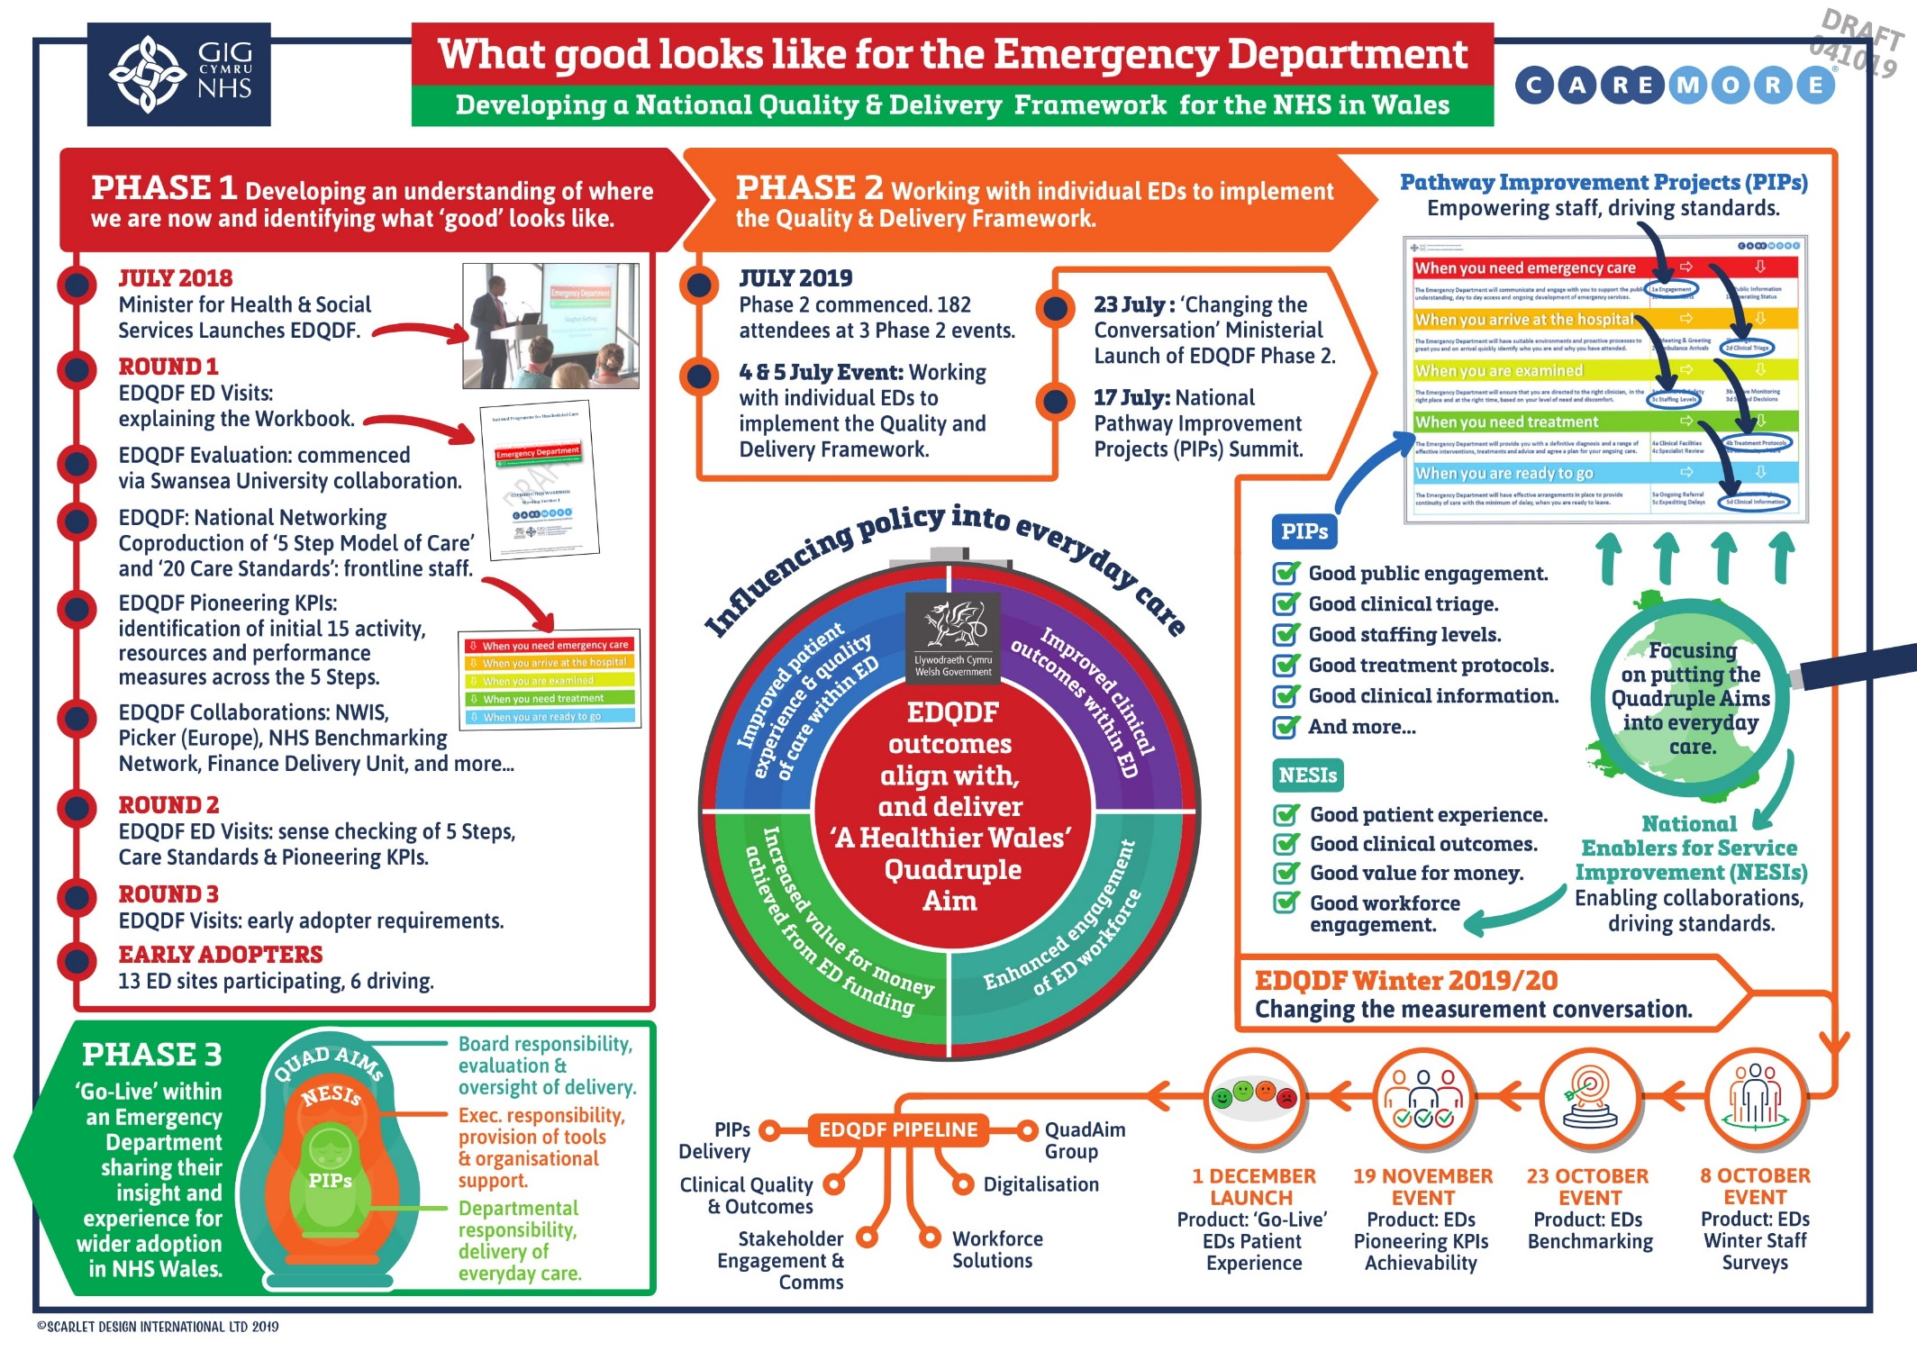
The key activities to date; delivered, underway; and planned for the EDQDF Programme are shown in the EDQDF Storyboard:

Developing further National Collaborative Commissioning Quality & Delivery Frameworks for Unscheduled Care
The NCCU IMTP 2019/20 outlined the intention in 2021/21 and 2021/22 to begin scoping a number of National Collaborative Commissioning Quality and Delivery Frameworks. The development of these frameworks will support the national policy to be delivered locally.

Defining “What good looks like” for Unscheduled Care Services in Wales
The next 3 year planning cycle will see us expand influence of collaborative commissioning through the use of National Collaborative Commissioning Quality & Delivery Frameworks to transform of services in line with expectations of A Healthier Wales and the Wellbeing of Future Generations Act.

Production of what good looks like into a National Collaborative Commissioning Quality & Delivery Framework follows a 3 phased approach:
- Phase 1: Develop an understanding of where we are now in parallel with identifying what good looks like.
- Phase 2: Work with individual Services/populations to implement the National Collaborative Commissioning Quality and Delivery Framework.
- Phase 3: “Go-Live” and share insight and experience for wider adoption across NHS Wales.

The EDQDF Programme will identify the opportunities for complimentary services to improve by adoption of the Quality & Delivery Framework approach and the broad timelines and associated activities are
- Year 1: Define Scope, Agree Delivery Funding, commence Phase 1
- Year 2: Complete Phase One & Commence Phase 2
- Year 3: Complete Phase 2 and Achieve Phase 3

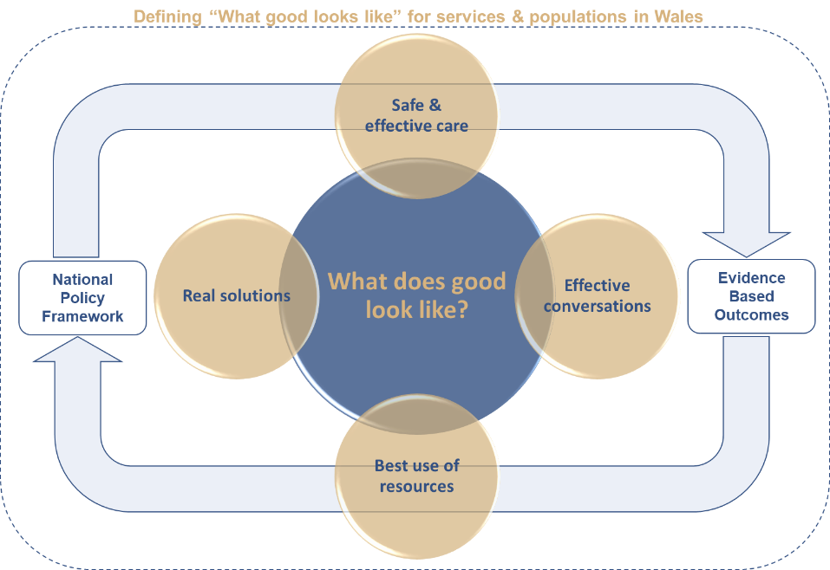
This production process enables collaboration, empowers staff and drives standards. It uses collaborative commissioning as the vehicle to evidence the impact of national policy being put into practice locally. It is this production approach that allows the NCCU to deliver Once for Wales programmes at scale and pace. The production process also allows the NCCU to manage customer expectation through the production lifecycle as well as supporting quality assurance processes, reviews and improved performance.
The production process and National Collaborative Commissioning Quality & Delivery Frameworks enable insight and innovation as well as collaborations with other organisations to deliver measures beyond those that already exist and aligned to the 4 areas of the quadruple aim; namely:
- Patient Experience
- Staff Engagement
Figure 26: Development process for defining “What good looks like”

- Value for Money
- Improved Outcomes

What does good look like for Intermediate Care?
NCCU commissioned by NPUC will begin the process of scoping a National Collaborative Commissioning Quality and Delivery Framework for these services during 2020/21. Working with clinicians and building on the National Audit of Intermediate Care (NAIC) Project 2018/19 it will agree care standards, a uniform approach to measuring activity and a nationally agreed high performing model of care for Intermediate Care will enable optimisation of clinical outcomes and patient experience.

What does good look like for Same day emergency care?
Following the development of good for unscheduled care across Wales the NCCU commissioned by NPUC will begin the process of defining what good looks like for same day emergency care during 2020/21. Working collaboratively with clinicians and organisations the programme will agree care standards, a uniform approach to measuring activity and a nationally agreed high performing model of care for same day emergency care in Wales and will enable optimisation of clinical outcomes and patient experience.

What does good look like for Ambulatory Care?
In year 3 of this IMTP we will look at scoping the inclusion of Ambulatory Care Services into the EDQDF programme commissioned by NPUC.

Influencing Behaviour: Changing the conversation
The NCCU collaborative commissioning approach and use of National Collaborative Commissioning methods empower staff and enable a different conversation to take place around key issues within Unscheduled Care. This is fundamental to delivering transformational change as opposed to transactional initiatives. The learning from the EDQDF programme will present further opportunities to apply this within and across unscheduled care; included below is an example of where collaborative commissioning has enabled this around measurement:

Changing the Conversation around Measurement
The development and use of the Collaborative Commissioning Frameworks for Emergency Medical Services (EMS) and Non-Emergency Patient Transport Services (NEPTS) has enabled this. It has enabled EMS to move away from time based targets to more outcome focuses measurements based on the clinical response model, it has allowed the production of Ambulance Quality indicators for public consumption. Within NEPTS the approach has empowered health boards as commissioners to full uptake responsibility for commissioning and performance collaboratively with Welsh Ambulance Service. The EDQDF programme in collaboration with NWIS is working to deliver Pioneering KPIs that will change the conversation above and beyond the tradition 4 & 12 hours measures within an ED.

NHS Benchmarking
NCCU has established a working relationship with the NHS Benchmarking Network (NHSBN) of which all Welsh Health Boards are members, and it takes a national leadership role on specific projects, such as Emergency Care, Urgent Care and the National Audit of Intermediate Care, ensuring consistency and completeness. The NCCU also facilitates the commissioning of all reports bespoke to each organization. All of which supports an improvement in local knowledge about the nature and flow of patients and over time will strengthen capacity and demand planning across the whole USC system.

Welsh Emergency Department Frequent Attenders Network (WEDFAN)
The national programme for frequent attenders into USC will move from Improvement Cymru into the NCCU and will deliver the following during 2020/21:

Quarter 1
- evaluation of the 2019/2020 winter funding
- publishing national report
- alignment with EDQDF programme
- steering group
- continued clinical and operational support to Emergency Departments
- completion of business case for funding per Emergency Departments site
- completion of considerations paper for governance and ownership of the frequent attender workstream
- engaging with 3rd sector national support for frequent attender diversionary pathways
- publication of national data for 2019 frequent attenders to Emergency Departments
- benchmarking with NHS England/NHS Rightcare frequent attender services

Quarter 2
- implementation phase post considerations paper
- communications strategy post considerations paper
- steering group
- national training event
- audit of it case management system in CVUHB
- continued work with Swansea and Cardiff university on research projects
- recruiting into frequent attender service teams in each Emergency Departments site (pending funding)
- clinical model/pathway and policies standardisation
- engaging with 3rd sector national support for frequent attender diversionary pathways
- continued clinical and operational support to Emergency Departments

Quarter 3
- commence project work with NWIS/Welsh Government/case management team on roll out of national it system
- review of mortality work
- continued clinical and operational support to Emergency Departments
- steering group
- engaging with 3rd sector national support for frequent attender diversionary pathways
- monitor data themes for new workstreams
- commence patient engagement work with patients and other stakeholders

Quarter 4
- commence audit work for previous year
- review of data and workstream planning for next quarter
- continue it system work
- continued clinical and operational support to Emergency Departments
- national training event
- engaging with 3rd sector national support for frequent attender diversionary pathways

IMTP Guidance – Alignment with planning
This project will deliver the following:
  - Priorities for EASC and NPUC guidance for IMTPs 2020/21.
  - Share progress reports on the progress of delivery of the 2020/21 Commissioning Intentions for NEPTS & EMS.
  - Update the EMS Quality & Delivery Framework.

National Clinical Pathways
EASC via the CASC will now lead and coordinate this work on the use of alternative pathways, following agreement at the recent chairs meeting. This directory of pathways to include 3 additional pathways per health board will be published by the end January 2020. Take up of pathways and impact will be monitored with effect from February 2020. Evaluation and lessons learnt and good practice will be disseminated to ensure a once for Wales approach is adopted.

Winter Planning & Evaluation

Winter Planning
NCCU will support Welsh Government with winter planning 2020/21. The evidence from the targeted evaluations from 2019/20 schemes informing the process. We will also support winter planning through the Clinical Director NPUC and the Assistant Director Quality and Safety taking national leadership roles for key priority work streams.

Evaluation of winter monies
NCCU will build on the evaluation work that we have delivered for Welsh Government since 2017/18 in support of the evaluation of winter funded initiatives. For winter 2019/20 we will deliver a targeted mixed methods evaluation of a number of small schemes. The evidence around the impact of these schemes will inform winter planning 2020/21 as to whether these become rolled out nationally.
Changes to the winter funding allocation process was made in 2019/20. Regional Partnership Boards have been allocated funds which they then distribute to Health Boards in line with long-term plans and policy.
The NCCU intends to review the quality of the relationships between Health Boards and Regional Partnership Boards to help identify factors contributing to robust and productive relationships, and also those that hinder beneficial work and processes.
In addition on behalf of Welsh Government NCCU will review these important relationships. NCCU will consider and evaluate the allocation procedure to help foster its continued improvement and fine-tuning, the impact of the funding, and if or how that funding helps to effect results that align with Welsh government’s policies and plans for better health care in Wales. The aim is to support the building of strong and integrated relationships through review and research utilising mixed methods that include staff perspectives in relation to the measurable results of initiatives.

Clinical Procurement of 3rd Sector Services
Working on behalf of Health Board and Welsh Government there is an opportunity to procure 3rd Sector support to augment the development of national initiatives that are implemented locally. The NCCU will work with NHS Shared Services Partnership and other key partners to procure 3rd sector and other support initiatives into unscheduled care.

British Red Cross emergency department well-being and home safe service
As part of funding agreed to support service delivery for the remainder of 2019/20, the emergency department well-being and home safe service, delivered in collaboration with the British Red Cross will be extended until the end of March 2020. An open tender exercise is currently in progress to allow other third and independent sector organisations to bid to deliver this service on a substantive basis. The expected contract commencement date is April 2020.

Care & Repair Cymru – Hospital to A Healthier Home service
As part of funding retained for nationally targeted actions to support service delivery for the remainder of 2019/20, the Hospital to A Healthier Home service, delivered in collaboration with Care & Repair Cymru will be extended until the end of March 2020.

Mental Health Urgent Care Access
The National Programme for Unscheduled Care commissioned a pilot to introduce ICAN Mental Health urgent care centres at Ysbyty Gwynedd, Ysbyty Glan Clwyd and Wrexham Maelor Hospital to provide alternative support services for people attending emergency departments in need of emotional support, over the winter period (December 2018-March 2019). Based on data, the pilot was extended for a further four months.
The winter pilot and extension have been supported by Welsh Government funding.
The NPUC team are a review of Mental Health urgent care access, using the methodology used for the Amber Review and expect to report findings February 2020.
Following publication of the review in April 2020 there is an opportunity for NPUC through the NCCU to develop an implementation programme that around the evidence based findings and enable multi agency collaboration to meets the policy recommendations outlined in Together for Mental Health. Mental Health Urgent Care Access.

Improving Care, Improving Experience in Mental Health & Learning Disability Services Programme

Background
Prior to 2012 mental health and learning disabilities hospital care provided by NHS England and the independent sector was commissioned separately by each Health Board or through the Welsh Health Specialised Services Committee. These commissioning arrangements led to disparity in costs, contractual obligations, standards and performance management across NHS Wales. Oversight of these hospitals was the remit of individuals or small teams within Health Boards with little or no collaboration. An independent review in 2012 stated that the use of the independent sector and NHS England services by NHS Wales prior to the development of the National Framework was “inefficient, ineffective and inconsistent”.

In March 2012 a National Collaborative Quality & Delivery Framework for medium and low secure care was developed and deployed and was immediately successful in improving quality assurance and reducing costs.

Subsequently the Chief Executives of the NHS Wales Health Boards considered that a broader suite of services required this level of assurance and the NHS Wales National Collaborative Commissioning Quality & Delivery Framework for Adult Mental Health & Learning Disability Hospital Services was developed and launched in April 2014.

This was followed in 2015 with a National Collaborative Commissioning Quality & Delivery Framework for CAMHS hospital services and in 2017 with a National Collaborative Commissioning Quality & Delivery Framework for adult mental health and learning disability care homes.

Improving Care, Improving Experience Governance
Improving Care, Improving Experience in Mental Health & Learning Disability Services Programme delivers a formal agreement and mechanism developed by the NCCU and NHS Wales Shared Services Partnership – Procurement. This enables all parts of NHS Wales to procure and performance-manage services under pre-agreed standards, costs, terms and conditions of a contract in a compliant manner in accordance with EU and UK Procurement Regulations and Health Board Standing Orders and Financial Instructions.

The National Collaborative Commissioning Quality Delivery Frameworks provide the enacting mechanism for the commissioning of services. These services commence once a patient is compliantly placed through the National Collaborative Framework process and an individual patient agreement is issued, and therefore a contract enacted between the commissioner (Health Board or Welsh Health Specialised Services Committee) and provider.

Improving Care, Improving Experience in Mental Health & Learning Disability Key Deliverables

The key deliverables for Improving Care, Improving experience can be found in Appendix 9: Improving Care, Improving Experience Key Deliverables.

Commissioning Development & Support

Commissioning Development & Support (ICIE)
The objectives of the service in relation to the Improving Care, Improving Experience in Mental Health & Learning Disability Services Programme are:
• Ensure providers should reduce risk and dependency and promote hope, recovery and rehabilitation;
• Robustly challenge substandard provider performance;
• provide advice and support to improve the quality of care;
• Ensure all procured services are provided and deliver value for money for the public purse;
• ensure provider quality and safety concerns are raised, discussed and disseminated with commissioners and statutory agencies;
• Ensure safe, effective and high quality care that improves patient experience;
• Facilitate collaborative working between providers and commissioners.

National Collaborative Quality and Delivery Frameworks
The NCCU is responsible to Health Boards for the creation, development, operation, refresh and evaluation of National Collaborative Commissioning: Quality & Delivery Frameworks for Mental Health and Learning Disability services this includes:
- Mental Health & Learning Disability Adult Hospitals
- Mental Health & Learning Disability CAMHS hospitals
- Mental Health & Learning Disability Adult Care Homes

Externally commissioned provision (Independent Sector & NHS England)

National Collaborative Commissioning Quality & Delivery Framework: Mental Health & Learning Disability Adult Hospitals
Commissioning value of circa £53.5m per annum, and is on behalf of WHSSC for Medium Secure Services (20% of value) and All Health Boards for Low Secure and Locked / Lockable Rehabilitation Services (80% of value). It covers over 341 patients across 28 providers with 86 hospital sites with 278 wards, and is refreshed at 18 monthly intervals.

It was first established in 2012 following a Welsh Government Invest to Save Project that received an NHS Efficiency Award in 2013 in recognition of its success in improving quality and delivering over £6m savings (at that time).

The work undertaken to deliver this framework will include:
- Meetings with central supporting organisations, Welsh Government , All Wales Peer Groups and Health Boards
- Adult/CAMHS Hospital Framework agreements have been extended up until April 2021.
- The QAIS, with NHSWSSP Procurement and Legal advisors will develop a Renewed Framework agreement ready for launch on 1st April 2021. Preparation will include: development of new standards, enhancing and fully implementing the RAPID process, refreshing the reporting Matrix, auditing all services prior to their entry onto the framework agreement, liaising with relevant expert by experience groups and other stakeholders, such as HIW etc, development of new audit process, development of new ranking process.
- Audit of Patient Placement Agreements and Termination Notices
- Provide opportunities for all 22 Providers to meet and discuss performance against the current Framework requirements.
- Continue to review all services where Welsh patients are currently cared for under the current Framework agreement.
- Produce Annual report on Framework use and provision.

National Collaborative Commissioning Quality & Delivery Framework: Mental Health & Learning Disability CAMHS hospitals
Commissioning value of circa £711k per annum, 3 patients across 9 providers with 10 hospital sites with 43 wards, was completed on behalf WHSCC and went live in April 2015 and is now refreshed at eighteen month intervals. Delivers a legal framework used to support commissioning of mental health / learning disability services external to NHS Wales provision.

The work undertaken to deliver this framework will include:
- Meetings with central supporting organisations, Welsh Government , All Wales Peer Groups and Health Boards/Local Authorities
- Audit of 10 new Framework units.
- Ongoing review of 2 units
- Management of suspension and subsequent termination of Framework provider.
- Audit of Patient Placement Agreements/Termination Notices
- Met with 9 Providers during Q3 to discuss performance against the Framework requirements.
- Production of Annual Report
- Launch of refreshed Framework.
- Engagement with a Welsh university in relation to R&D of the Framework Agreement.
- Performance and verification visits

National Collaborative Commissioning Quality & Delivery Framework: Mental Health & Learning Disability Adult Care Homes
Commissioning value of circa £8.6m the National Framework Agreement for mental health and learning disability adult care homes on behalf all Welsh Health Boards and Local Authorities covers 108 residents across 93 providers with 281 care homes and was developed between in place since September

The work undertaken to deliver this framework will include:
- Meetings with central supporting organisations, Welsh Government , All Wales Peer Groups and Health Boards/Local Authorities
- Ongoing review of 35 care homes
- Care Home Framework agreement refresh
- Meeting with All Wales People First to engage individuals in the process for standards and contracts within the care home environment.
- Audit of Resident Placement Agreements.
- Development of self-assessment tool
- Engagement with a Welsh university in relation to R&D of the Framework Agreement.
- Performance and verification visits
- Sharing Best Practice Day
- Production of Annual Report

Internally Externally commissioned provision (NHS Wales)
The QAIS will undertake reviews of the 2 Adult Medium Secure Units and the 2 CAMHS Units provided by NHS Wales. Reviews will be undertaken at least once per year with a full report with recommendations being produced following each review, The QAIS will assist WHSSC as commissioners and the units as providers to understand the recommendations made and how improvements can be introduced.
The QAIS will negotiate with WHSSC with regards to the possibilities of further enhancing Tour quality assurance agreements which may include the implementation of case management of secure care.

Quality Assurance & Improvement

Quality Assurance & Improvement (ICIE)
The NCCU Quality Assurance Improvement Service (QAIS) works in partnership with NHS Wales Shared Services Partnership: Procurement to performance manage the National Collaborative Commissioning Quality & Delivery Framework providers.

Commissioning Care Assurance Performance System (CCAPS).
This system has been developed in partnership with the NHS Wales Informatics Service and is an key enabler of the commercial Framework, providing standardised information with the functionality to connect all users from different organisations to support NHS Wales to proactively performance manage providers and provide assurance to commissioners and patients .

CCAPS supports patients requiring care by:
• Giving a choice of care setting.
• Providing assurance on the expected quality of care.
• Monitoring health and wellbeing improvements.
• Ensuring prompt response to any complaints, incidents/safeguarding concerns.

CCAPS supports providers of care by:
• Standardised commissioning process.
• Displaying and ability to update bed availability.
• Facilitating the reporting of concerns to commissioners and care coordinators.

CCAPS supports provider’s commissioners of care by:
• Sharing intelligence on care providers.
• Matching a care setting to a patient’s needs.
• Knowledge about a care setting’s quality.
• Evidencing the care received for the cost incurred.

Insight & Innovation
The established commission support and quality assurance frameworks and processes enable the QAIS to offer and deliver the following insight driven services on behalf of a wide range of customers: These include:
- Planning, progress and publish a National Care Review of patients in MH hospitals with a learning disability possibly aligning this with the MH inpatient review.
- Care mapping of MH care homes at the request of any health board.
- Publish the National MH Access and Conveyance Review on behalf of Welsh Government.
- Support the delivery of any accepted recommendations of the National MH Access and Conveyance Review on behalf of Welsh Government.
- Strengthen the partnership with BCUHB and expand the joint repatriation team to cover all the £110m CHC spend.
- Pilot the Levels of Care in Older Adult Care Homes as part of the Safer Staffing in Care Homes element of the Safer Staffing Wales programme.
- Scope and if commissioned deliver the children with LD National Care Review on behalf of Welsh Government.
- Support the delivery of any accepted recommendations of the National Care Review of LD Hospital services on behalf of Welsh Government.
- Support the MH National Benchmarking in adult and CAMHS and host an all wales feedback event.
- Support the new LD National Benchmarking and host an all wales feedback event.
- Collaborate with New Zealand, currently chairing the MH International Benchmarking to produce an international benchmarking report.
- Explore the commissioning of our quality assurance services by the Isle of Man government.
- Scope and possibly deliver the commissioning of the sexual assault referral services as requested by this programme.
- Support the development of a value in MH project in partnership with Shared services, FDC and MH network.

Together for Mental Health Delivery Plan
The QAIS will support the delivery of Together for Mental Health through the specific deliverables contained within this plan as well as the delivery of the wider Improving Care, Improving Experience in Mental Health & Learning Disability Services Programme.

National and International Benchmarking for Adult Mental Health, Learning Disabilities and CAMHS services.
The QAIS will continue their membership of the NHS Mental Health and Learning Disabilities Benchmarking Network in the UK along with the International Benchmarking membership on behalf of Wales. This will enable Wales to continue to be able to understand how Wales performs in relation to others at a Health Board, National and International level. The QAIS will also continue to organise the NHS Wales Benchmarking conference each year. We will liaise with New Zealand Health Service, the current chair country of International Benchmarking for MH in order to support the publication of the next International Benchmarking report.

National care review of the NHS Mental Health and Learning Disability estate in Wales.
The QAIS will support the development of a strategy for Mental Health /Learning Disabilities estate across NHS Wales.

Mental Health Access and Conveyance review.
Recommendations from the review will be fully implemented over next 2 years. The QAIS will provide support to Welsh Government, Mental Health services and other stakeholders in relation to implementation of actions to meet recommendations made following the review.

CAMHS
The QAIS will undertake reviews of both NHS Wales CAMHS units at least once per year as described in the Service Level agreement designed by the QAIS/WHSSC. Support will be given to WHSSC and the services, if required, with regards to any recommendations made following each review.

NCCU Financial & Workforce Plans

Background
Since the internal market in Wales ended in 2009, conventional commissioning of services has largely ceased, although many forms of contracting remain including inter-health board trading. There is, however, a growing realisation that explicit agreements covering care standards, pathways, expected performance, incentives/ disincentives and finances could lever quality improvements and increase value in an integrated non- competitive environment. This was given further traction by the advent of Prudent Healthcare - ‘healthcare which is conceived, managed and delivered in a cautious and wise way characterised by forethought, vigilance and careful budgeting which achieves tangible benefits and quality outcomes for patients’. This has given rise to the concept of collaborative commissioning which offers the potential for a Once for Wales approach to initiate, share and develop innovation and enable delivery of prudent healthcare principles through a commissioning lens.

Our Role
NCCU is an agile resource that provides the focus for the alignment of current national commissioning activities, this includes creating the infrastructure, funding opportunities and partnerships to support improved and cohesive commissioning activities across primary, community and secondary care between and across NHS Wales Health Boards and between health boards and local authorities.

Key to the success of NCCU in delivering transformation is the ability to work using a matrix approach, removing the traditional silos that organisation structures enforce. We identify opportunities to facilitate cross- functional team working.

Developing shared accountability and responsibility for delivery of specific programmes, projects and goals. We recruit on this basis and expect our personnel to be agile and flexible in their approach and able to develop ideas and create innovative solutions to deliver transformation.

- We influence policy making
- We are the collaborative commissioning provider in NHS Wales
- We join the system up
- We share insight and intelligence across the system.
- We put policy into practice

How we define ourselves
We define ourselves by:
- Our commitment to delivering long term system change.
- Our collaborative commissioning approach.
- Our ability to operate & deliver across system boundaries.
- Our whole system approach to risk and opportunity.
- Our culture/ethos to listen understand & respond
- Our development of evidence to measure outcomes.

NCCU Financial Plan 2020/21

Funding Arrangements
The National Collaborative Commissioning Unit is currently funded by several different sources of income on both a recurrent and non-recurrent basis. These sources include funding from Health Boards, via the WHSSC risk sharing arrangement, Welsh Government policy units and initiatives such as Invest to Save.

Neither EASC nor NCCU hold any statutory responsibility for a resource limit. EASC services, hosted by the NCCU, are funded by income from Local Health Boards and based on an agreed financial plan. The EASC committee accounts for all expenditure on agreed services against the income received as part of their plans. All variances from plan are allocated to Health Boards on the basis of an agreed risk sharing framework and matched by income adjustments consistent with this framework. The net operating cost for the financial year is therefore zero.

Financial Assumptions
In line with the guidance issued in the Welsh Health circular, funding allocations are still to be made in relation to EASC (critical care transfer service) – these will be confirmed in separate allocation letters and have not been included in the financial plan presented in this document.

Welsh Government will provide funding for the Major Trauma centre, specialised services, pre hospital and network costs for the Major Trauma Network for South Wales, West Wales and South Powys. Health Boards will fund the Trauma Unit elements.

The NCCU has assumed that it will receive 2% increase in funding for EASC and QAIS recurrent services, which are funded by Health Boards through the risk sharing arrangement.
Non recurrent funding is assumed to remain in line with the programme funding plans presented to Welsh Government.

Pay costs included in the plan are based on 2020/21 AfC rates and no uplift assumption has been made for pay in the years following 2020/21.

NCCU Planned Sources & Applications of Funds 2020/21
The figures below demonstrate a deficit in funding position which is driven by the shortfall in funding available for the National Programme for Unscheduled Care.
Figures in £m | 2020/21 | 2021/22 | 2022/23
Income
EASC | 598.000 | 598.000 | 598.000
NPUC | 60.000 | 60.000 | 60.000
QAIS (MH and LD) | 795.000 | 795.000 | 795.000
EDQDF Phase 2 | 900.000
I2S | 575.000 | 215.000
Total Income | 2,928.000 | 1,668.000 | 1,453.000
Figures in £m | 2020/21 | 2021/22 | 2022/23
Spend
Pay | -2,518.413 | -1,991.643 | -1,991.643
Non Pay | -1,037.500 | -302.500 | -302.500
Total Spend | -3,555.913 | -2,294.143 | -2,294.143
Net Position | -627.913 | -626.143 | -841.143

NCCU Organisation structure
The internal NCCU structure reflects the structure of the work in this IMTP. Organising our internal structure in this way enables the NCCU to identify and co-opt resources across functions to support and deliver NCCU objectives.
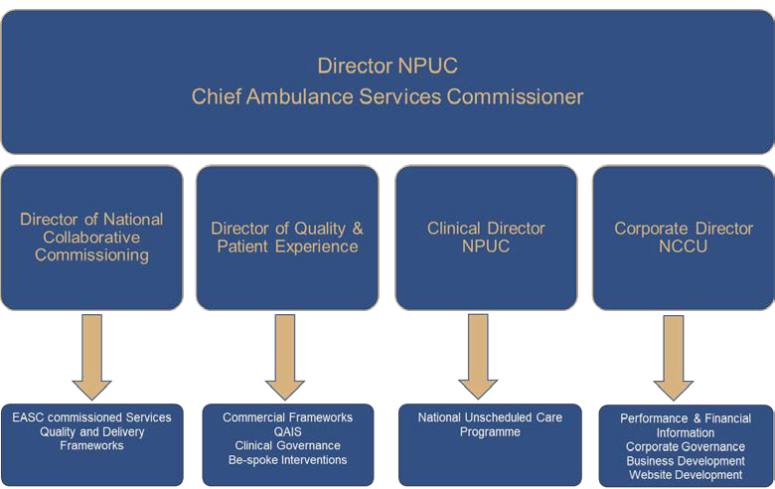

NCCU Workforce Plan 2020/21
Aligned to the applications of funds This workforce plan outlines the core and project specific roles and subsequent budget required to deliver this IMTP.

NCCU WTE Resources | 2020/21 | 2021/22 | 2022/23
EASC | 9.00 | 9.00 | 9.00
NPUC | 3.90 | 3.90 | 3.90
QAIS (MH and LD) | 13.00 | 13.00 | 13.00
EDQDF Phase 2 | 4.00 | - | -
I2S | 9.00 | 3.00 | -
Total | 38.90 | 28.90 | 25.90

NCCU Supporting Savings Opportunities
The NCCU is a small unit and therefore aims to maximise the use of resources that it has. Given that the unit continues to see a growth in the demand for its services there is no intention for the NCCU to deliver savings but continue to utilise and apply the funding allocation that it receives most efficiently.
The NCCU does however play a role in supporting the identification and support with delivery of savings opportunities for Health Boards. Examples of this are as follows:
MH and LD Care Homes
- Utilising tools co-produced with NHS Benchmarking, the NCCU identified potential cost savings of £0.5m on a national basis for the second half of 2019/20 financial year as part of the launch of the refreshed framework in October 2019.

MH and LD Hospitals, CAMHS and Care Homes
- As part of the procurement exercises delivered in 2019, the NCCU was able to control and limit the cost pressures passed onto providers across Wales. Additionally, as part of the process, the team has continued to monitor financial stability of providers in the independent sector on behalf of Health Boards.

EASC
- The NCCU’s role in delivering enhanced assurance of WAST’s financial performance will mean that funding from Health Boards is provided to WAST on a more efficient basis and will be allocated once evidence of delivery is provided

NCCU Supporting the Efficiency Agenda
In order to further the efficiency and value agenda, the NCCU will collaborate with the Finance Delivery Unit to further develop and share knowledge with NHS colleagues across Wales as part of the Efficiency Framework in 2020/21.

Key Risks to Service Delivery and the Financial Plan in 2020/21
The NCCU has seen increased demand for the services that it provides and as a result has built up a portfolio of opportunities for further value to be delivered through collaborative commissioning. However, there are several opportunities that are at risk of not being delivered due to funding constraints. These have been identified as follows:

Emergency Ambulance Services Commissioning

Commissioning Development & Support
Additional resource will be required in order to deliver additional the future commissioning services opportunities e.g. national Transfer and Discharge Services set out in section 6.2.2.

Quality Assurance & Improvement
Additional resource will be required in order to deliver the Enhanced Assurance and Evaluation services identified within the opportunities in section 6.2.3 of this document. This will include the development and implementation of a new set of Standing Financial Instructions.

National Programme for Unscheduled Care

Ref: 6.2.3.1 Expanding the role of the Clinical Director NPUC
Currently the NCCU is funded on a part time basis for the Clinical Director NPUC role. With the expansion of the role and time commitment required, which is expected to deliver the benefits outlined in section 6, comes a requirement for additional funding for the post in order to mitigate the risk of capacity constraints.
In addition to this, there are other areas of the National Programme for Unscheduled Care that are at risk of not being delivered due to not having the funding and resources in place in time for the start of financial Year 2020/21. These other areas are as follows:

Ref: 6.3.2.1 Defining what good looks like for Unscheduled Care in Wales

Ref: 6.3.2.2 What does good look like for Intermediate Care?

Ref: 6.3.2.3 What does good look like for same day emergency care?

Ref: 6.3.2.4 Enhanced Clinical Capacity Services

Ref: 6.3.3.1 Unscheduled Care Dashboard
The comprehensive plan and full set of requirements for the Unscheduled Care Dashboard is being developed. Given the breadth and scale of the data that may be incorporated into the dashboard and the number of stakeholders that may be engaged as part of its development, there is a risk that the NCCU will not be able to deliver the full set of requirements with the resources available to it currently.

Improving Lives, Improving Experience in Mental Health and Learning Disability Services Programme
Ref: 6.4.7 NCCU & Health Boards-Improving Care in Mental Health & Learning Disabilities - Betsi CHC review
There is a risk that unless funding is found for the NCCU to support a review of BCUHB CHC services, this opportunity may not be delivered.
Additionally, the NCCU manages a QAIS team in BCUHB which has utilised Mental Health Transformation funding from Welsh Government. This funding is due to expire at the end of the 2019/20 financial year and no alternative source of funding has been established which means there is a risk that these services will no longer be operational in 2020/21. Since its inception, the QAIS team in BCUHB has delivered in excess of £4m net benefit to the Health Board and would have the opportunity to support the delivery of further value.
Ref: 6.4.8 Sexual Assault Referral Centres (SARC) Commissioning
There is a level of funding assigned to SARC commissioning. The scope and level of resource required to commission this service is however at this point no clear. There is therefore a risk that the amount of funding available to NCCU as part of the SARC commissioning programme is not sufficient to cover the resource requirement for delivery of the programme.

Key Risks to the Financial Plan and Service Delivery after 2020/21
Beyond 2020/21, the NCCU will need to identify recurrent sources of funding for the further development of the following services if they are still to be kept operational:

Mental Health and Learning Disabilities Care Homes Framework
There will be £215k of invest to save funding remaining for the Invest to Save initiative in 2021/22 but this will not cover a full year of services for the MH and LD Care Homes Framework. It is expected that further uptake of the framework will lead to improvements in quality of care delivered alongside efficiency savings

EDQDF
The Quality and Delivery Framework that is currently in development for Emergency Departments across Wales will need to transition into a ‘business as usual’ operating model. In order to enable this transition, a source of funds and mechanism for transfer will need to be identified.

NCCU Digitalization Plan 2020/21
Digitalization represents one of the biggest opportunity areas for the NCCU. Given our national remit and the need for collaboration to deliver the ambitions of a progressive policy agenda we are well placed to take a lead on the use of technology to share information, develop concepts, develop & transform services and support smarter working. Through our digitization plans we will outline the developments that we wish to take forward as part of this IMTP. The key developments and their application are outlined below:

NCCU Informatics Plan
NCCU Informatics Manager will develop an NCCU Informatics Plan. This will identify the informatics capabilities of the NCCU and its individual programs of work, around the key informatics elements set out in the IMTP and digital technologies and their use. It will:
- Enable and support the development of well-designed, maintained and effectively used information systems throughout and within the National Collaborative Commissioning Unit;
- Improve efficiency of data exchange & effective use of data;
- Analyse and disseminate data and information in a timely, ethical, open and transparent way in accordance with Information Governance and GDPR regulations.

NCCU Website Development
The NCCU Informatics Manager will lead development of the NCCU website. Our website will be the central point of contact between us and our customers. This IMTP document has been constructed to become the blueprint for the development of the NCCU website. NCCU will also use it to disseminate research evidence and intelligence from the work that we deliver.

EASC Website
We will continue to maintain and develop the EASC website including publishing of Joint Committee papers and AQI’s.

Appendix 1: EASC Key Deliverables
EASC | Year 1 | Year 2 | Year 3
EASC Business as Usual Activity 2020/23 | - Assessing and recommending for approval business cases which may be revenue, capital or from alternative funding sources in relation to EMS, NEPTS and EMRTS developments  - Ongoing production of the quality assurance and production performance reports required by EASC, EASC’s Planning Development & Evaluation Group and EASC’s Joint Management Assurance Group.  - Reporting of any findings in relation to quality assurance and improvement of the EASC commissioned service of NEPTS which may come to light through the NEPTS Delivery Assurance Group.  - Reporting of any findings in relation to quality assurance and improvement of the EASC commissioned service of EMRTS which may come to light through the EMRTS Delivery Assurance Group.  - The production of annual commissioning intentions for EMS, NEPTS and guidance support for EMRTS.  - The sharing of EAS NEPTS EMRTS commissioning intentions across Welsh Government, Health Boards as commissioners of EAS NEPTS EMRTS; WAST as providers of EAS and NEPTS; WHSSC and Velindre NHS Trust as commissioners of NEPTS; and ABMU as host of EMRTS.  - Review and subsequent recommendation for approval of the WAST IMTP.  - Support Health Boards; WHSSC and Velindre NHS Trust’s IMTPs for their consideration of EMS EASC Management Group to undertake  - a planning role – to link the strategic intentions of services for which EASC is responsible with related services across NHS Wales particularly across the Unscheduled Care System and advise EASC upon their inclusion in planning processes across Welsh Government, Health Boards and WAST on a local, regional or national basis;  - a development role – to consider the initiation, development and implementation of service changes across the 5-Steps of the Ambulance Patient Care Pathway / pre hospital USC Pathway; and key enabling products in support of frameworks to include:  - proposed service changes; and  - key enabling products, are robustly evaluated and underpinned by credible research & development activities; with any learning and evidence shared.  - Produce reports required by the EASC Meetings to effectively discharge its responsibilities.  - Establish and manage groups which are created from time to time to develop quality & delivery frameworks such as those presently operating in support of the EASC commissioned service of NEPTS through at present the NEPTS Delivery Assurance Group; and the EASC commissioned service of EMRTS through at present the EMRTS Delivery Assurance Group.*  - Preparation of the Annual Governance Statement for EASC.  - Development and undertaking of External / Internal Audit work plans for EASC.  - Consideration and subsequent implementation of any actions arising following internal and external audit reviews.  - Establish, monitor and maintain oversight of the refresh requirements for both EASC and providers under the quality & delivery frameworks which it creates.  - C3 Faculty identifies opportunities and develops bids for submission to relevant R&D Funding Calls in support of EASC’s responsibilities and products.  - C3 Faculty prepares and presents publications on findings from work undertaken in relation to EASC’s responsibilities, products and the application of the CAREMORE® methodology in support of the quality & delivery frameworks created on behalf of EASC.  - Deliver the EASC information management requirements of:  - meeting the expectations of EASC being a designated official publisher of statistics through its submission of accurate Ambulance Quality Indicators (AQIs) for publication by Stats Wales;  - designing the EMS, NEPTS and EMRTS data repositories including the reporting of what, when and to whom  - supporting the use of the data repository in reviewing and analysing EMS NEPTS EMRTS performance  - development of a comprehensive suite of performance and outcome measures across clinical, patient experience and value for money which are regularly reported  - tailoring reports to EASC and its sub-groups  - acting as the conduit between WAST and HBs for EMS NEPTS and EMRTS for the development and then reporting of local measures relevant for Health Boards’ populations  - Operation and enhancement of the electronic Benchmarking Toolkit.
EMS | - Enhanced assurance on finance & performance to both Welsh Government & EASC by CASC;  - Continued challenge & scrutiny by EASC Management Group on behalf of EASC  - EASC & CASC MOU with Welsh Government revised.  - Quadruple Aim aligned to Care Standards.  - Delivery, management and control of Demand & Capacity Review's findings Ambulance Productivity Task Force  - Quality Assurance & Improvement Services established  - EASC Standing Order & Standing Financial Instructions created, adopted and complied.  - EAS & NPUC closer aligned; expanded role of Clinical Director NPUC  - Determine the resources needed in support of EASC’s Enhanced requirements.  - Delivery of the improvements to the EMS Quality & Delivery Framework as specified within Commissioning Intentions 20120/21 and agreed as part of the EASC and WAST IMTP 2020/21 Alignment process and its associated documentation  - Delivery of EMS performance improvements by WAST as specified within Commissioning Intentions 2020/21 and agreed as part of the EASC and WAST IMTP 2020/21 Alignment process and its associated documentation  - Delivery of EMS performance improvements by both WAST and Health Boards as specified within Commissioning Intentions 2020/21 and agreed as part of the EASC and WAST IMTP 2020/21 Alignment process and its associated  - Establishment with the use of additional resources a quality assurance and improvement service for EASC commissioned services of EMS and NEPTS which will include:  - incidents and complaints reporting and reviews;  - daily performance reviews;  - Clinical risk assurance reviews. | - Enhanced assurance on finance & performance to both Welsh Government & EASC by CASC;  - Continued challenge & scrutiny by EASC Management Group on behalf of EASC  - Quadruple Aim aligned to Care Standards.  - Delivery, management and control of Demand & Capacity Review's findings Ambulance Productivity Task Force  - EAS & NPUC closer aligned; expanded role of Clinical Director NPUC | - Enhanced assurance on finance & performance to both Welsh Government & EASC by CASC;  - Continued challenge & scrutiny by EASC Management Group on behalf of EASC  - Quadruple Aim aligned to Care Standards.  - Delivery, management and control of Demand & Capacity Review's findings Ambulance Productivity Task Force  - EAS & NPUC closer aligned; expanded role of Clinical Director NPUC
NEPTS | - Delivery of the improvements to the NEPTS Quality & Delivery Framework as specified within Commissioning Intentions 2020/21 and agreed as part of the EASC and WAST IMTP 2020/21 Alignment process and its associated documentation  - Delivery of NEPTS performance improvements by WAST as specified within Commissioning Intentions 2020/21 and agreed as part of the EASC and WAST IMTP 2020/21 Alignment process and its associated documentation  - Delivery of NEPTS performance improvements by both WAST and Health Boards / Velindre NHS Trust / WHSSC (Renal Network) as specified within Commissioning Intentions 2020/21 and agreed as part of the EASC and WAST IMTP 2020/21 Alignment process and its associated documentation  - Plurality model fully enacted & all Health Board Provision transferred to WAST  - NEPTS Demand & Capacity Review | - NEPTS Demand & Capacity Review  - Transport solutions delivering WHC 2007(005). | - NEPTS Demand & Capacity Review
EMRTS | - Enhanced role & function of the EMRTS Delivery Assurance Group  - Supporting EMRTS 24/7 expansion | - Enhanced role & function of the EMRTS Delivery Assurance Group  - Supporting EMRTS 24/7 expansion | - Enhanced role & function of the EMRTS Delivery Assurance Group  - Supporting EMRTS 24/7 expansion
EASC Future Commissioned Transport Services | - National Transfer & Discharge Services  - Critical Care Transfers  - Inter hospital transport for the Grange University Hospital  - Neonatal transfers  - Stroke Thrombectomy Repatriations  - Major Trauma Repatriations  - Mental Health transport  - Health Boards' Core Service Changes  - South Wales Major Trauma Network  - Determine the commissioning resources needed in support of EASC’s future commissioning opportunities Enhanced requirements. | - Determine the commissioning resources needed in support of EASC’s future commissioning opportunities. | - Determine the commissioning resources needed in support of EASC’s future commissioning opportunities.

Appendix 2: Emergency Medical Services Commissioning Intentions 2020/21
Care Standards | Activity | Resource Envelope | Model |  | Operations | Review |  | Evaluate
Goal: Define care standards for emergency ambulance services to meet | Goal: Know & understand demand & capacity requirements | Goal: Identify total resources which may be utilised and affected | Goal: Define model(s) of care across the ambulance patient care pathway |  | Goal: Mechanisms are established to ensure effective delivery of the Framework | Goal: Detail the ongoing performance metrics, management & improvements |  | Goal: Define outcomes & methods as criteria for judging benefits from the framework
Principle: The right expectations are defined for quality and safety | Principle: The right capacity is available to meet the right demand | Principle: The right ambition to make best use of all existing resources | Principle: the right staff, at the right place, at the right time |  | Principle: The right interaction between patients, professionals and organisations | Principle: The right measures, monitoring and management to ensure continuous improvement |  | Principle: The right patient outcomes from the right patient experience at the right cost
EASC Strategic Commissioning Intent 2020/21 onwards
EASC Strategic Commissioning Intent supports a whole system risk reduction approach; promotes the Quadruple Aim across WAST & utilises the IMTP process to realise a Quadruple Aim Benefit against each Care Standard for EMS. It aligns and supports delivery of:  - Refreshed National Collaborative Commissioning: Quality & Delivery Frameworks for EASC Commissioned Services and the assessment of the WAST IMTP submission.  - Ministerial priorities for Emergency Ambulance Services  - A Healthier Wales ‘Quadruple Aim’ namely:  - Improved patient experience of WAST services.  - Enhanced engagement and experience of WAST workforce.  - Improved clinical outcomes of WAST services.  - Deliver higher value emergency health and social care services with EASC funding.  - Wellbeing of Future Generations Act requirements as described in Welsh Government Planning Guidance  - Whole systems approach through alignment with wider initiatives such as the National Programmes for Unscheduled Care & Primary Care |  |  |  | EMS Quadruple Aim Benefit Map  (Appendix 1 for reference)
 |  |  |  | Improved patient experience of WAST services.  Care standards (PCP), Core Requirements (CR) reference:  PCP3, PCP4, PCP6, PCP7, PCP8, PCP9, PCP10, PCP12, PCP13  CR1, CR2, CR3 |  |  | Enhanced engagement and experience of WAST workforce.  Care standards (PCP), Core Requirements (CR) reference:  PCP3, PCP4, PCP6, PCP7, PCP8, PCP9, PCP10, PCP12, PCP13  CR1, CR2, CR3, CR5
 |  |  |  | Improved clinical outcomes of WAST services.  Care standards (PCP), Core Requirements (CR) reference:  PCP5, PCP6, PCP11, PCP14  CR1, CR3, CR4, CR6 |  |  | Deliver higher value emergency health and social care services with EASC funding.  Care standards (PCP), Core Requirements (CR) reference:  PCP1, PCP2, PCP6, PCP7, PCP8, PCP9, PCP10, PCP12, PCP13, PCP15  CR1, CR3, CR5
EASC Annual Commissioning Intentions 2020/21
Care Standards | Activity | Resource Envelope | Model |  | Operations | Review |  | Evaluate
- Care Standards and requirements remain extant.  - Core Requirements remain extant.  - The principle is that core and clinical standards will be measured through a self-assessment process by WAST, utilising relevant reports and documentation produced, for example, Welsh Government Health & Care Standards; Internal & External Audit Reports; Health Inspectorate Wales Annual Governance Statement; etc. on a six monthly basis. This will also be reported to the WAST Board. Particular assurance required remains as:  - transition to the use of the NHS number as a patient identifier;  - reduction in variation in operational performance and an improvement in patient quality & safety across health boards;  - effective and timely use of clinical audit & information. | - Activity to ‘shift’ left for WAST within each individual health board where safe and appropriate to do so ensuring the right response & right resource first time. | - EASC will set a resource envelope in line with previously approved WAST 2019-22 IMTP & 2020/21 commissioning intentions by working in an open, transparent and collaborative way with WAST, LHBs and NCCU to identify resources to be allocated and efficiency improvements to be delivered by WAST.  - EASC will be responsible for the application to WAST of any uplift, savings and investment expectations from LHBs set by Welsh Government in line with the Allocation Letter for 2020/21.  - There will be an increased focus by EASC and NCCU on the connectivity of activity, resource and performance (i.e. the ‘net effect’) in reporting to EASC on Quadruple Aim outcomes delivered by WAST.  - Tapering funding will be made available on a non-recurrent basis, in agreement with EASC and CASC, to support WAST’s internal reallocation of resources to front line services, in order to bring the direct spend on the 5 step model in line with 2013/14 levels. | - No change to the over-arching 5-Step Ambulance Patient Pathway model of care:  - Step1: help me choose  - Step 2: answer my call  - Step 3 come to see me  - Step 4 give me treatment  - Step 5 take me to hospital  - Recognition that service delivery may vary across Wales due to Health Board service changes and models, geographics and demographics.  - Demonstrate the impact and benefits of the following initiatives that support delivery of the Clinical Response Model:  - Clinical Contact Centre  - Alternative Pathways  - Advanced Paramedic Practitioners  - Band 6 Paramedics |  | - Participation and collaboration by WAST and Health Boards as required under EASC.  - Commissioning process to align:  - EASC, WAST and Health Boards IMTPs is adopted by all organisations.  - To include EASC 2020/21 strategic and annual commissioning intentions and financial assumptions and Health Board and WAST response to intentions in the form of action and financial plans.  - National Collaborative Commissioning: Quality & Delivery Framework Agreements informed by IMTPs and used as the basis for assuring delivery and monitoring progress by EASC.  - National Collaborative Commissioning: Quality & Delivery Framework Agreements to be maintained electronically and reviewed annually.  - EASC will collaborate with NCCU to develop financial assurance arrangements for funding allocation and monitoring alongside EASC Standing Financial Instructions | - Assurances on delivery of Care Standards demonstrate alignment to and delivery against EASC Strategic Commissioning Intent.  - Assurances on Core Requirements demonstrate alignment to and delivery against EASC Strategic Commissioning Intent.  - Performance improvements across the steps of the Ambulance Patient Care Pathway to be agreed with WAST and aligned to and delivered against EASC Strategic Commissioning Intent.  - AQIs will be drawn from data repository described within the EMS National Collaborative Commissioning Quality and Delivery Framework.  - WAST will provide EASC with access to data to enable wholes system analysis, modelling and risk reduction.  - Development and adoption of Local Measures by Health Boards for their populations. |  | - Enhanced and robust evaluation activities to be undertaken by EASC in collaboration with Swansea University through C3 (Collaborative Commissioning Cymru) Faculty) and other partners.
Fundamental Principles agreed by EASC
- Outstanding WAST approved 2019/22 IMTP & Collaborative Commissioning Frameworks commitments will be carried forward and delivered in 2020/23.
- Financial commitments: WAST approved 2019/22 IMTP & Collaborative Commissioning Frameworks; and increase spend on front line staff within existing resources back to the proportion being delivered in 2013/14 will remain.
- WAST IMTP 2020/23 will prioritise and provide assurance on the delivery of Commissioning Intentions & core business as defined in the Collaborative Commissioning Frameworks.
- WAST IMTP 2020/23 will demonstrate how services are delivered in line with EASC Strategic Commissioning Intent 2020/21 onwards.
- WAST IMTP 2020/23 will clearly identify its key risks and describe mitigating actions.
- EASC will work on behalf of Health Boards to ensure that the right balance is achieved between improvements to WAST core services & WASTs wider support to Health Boards.
- EASC in 2020/21 will lead the development of a national transfer and discharge service.

Framework Improvements
Enablers to support service delivery across all steps of the 5 step ambulance pathway | - [Carried Forward from 2018/19] Identification of NHS Number for all activity with effect from 01/04/20.  - [Carried Forward from 2018/19] Call to door times for STEMI (pPCI door) and Stroke to be produced with effect from 01/04/20.  - CAD/PCR data link with effect from 01/04/20.  - Transition of AQIs to monthly reporting of clinical indicators (Steps 4 & 5) with effect from 01/04/20.  - Adoption of collaborative approach to optima predict modeling and implementation.  - Review of 2020/21 IMTP financial assumptions and financial plan versus forecast outturn for 2019/20 and 2020/21 financial assumptions and financial plan.  - Review Financial Value Payable by EASC and associated assumptions for inclusion in 2020/21 IMTPs.  - Utilisation of additional pathways made available by Health Boards.  - Mid and end year progress review of 2019/20 IMTP actions.  - Inclusion of completed IMTP 2020/21 tables following EASC IMTP approval.  - Maintain data repository covering A1 Activity, RE1 Resource Envelope, R1 Performance Measures, including the AQIs.  - Collaboratively identify trigger points which indicate poor deteriorating performance against performance metrics to be reported to the CASC and specific actions to warrant corrective action identified.  - Review the data repository for appropriate metrics across 111, NHS & Commissioning Framework.  - Reporting against core requirements to be undertaken annually as described under the Commissioning Intentions for Care Standards.  - Agreement on the measures by each Health Board & the suite of reports.  - Report of agreed clinical indicators which compliment the benefit realisation assumptions for Band 6 Paramedic investment.  - Develop and enable the mechanisms to deliver improved scrutiny & monitoring of delivery.  - Payments for key programmes and initiatives will be linked to delivery milestones in accordance with Front Line in Year Allocation Resource agreed by EASC/EASC Management Group.  - Business case funding will align to EASC Strategic Commissioning Intent and EASC SFIs. Business cases will be collaboratively agreed through EASC Management Group and/or Joint Committee.  - Any EASC/WAST revenue implications arising from Welsh Government’s capital investment will be agreed by the CASC in advance of business case submission.  - Engage with NCCU to develop financial assurance arrangements for funding allocation and monitoring alongside EASC Standing Financial Instructions.  - Adoption of evaluation capability, methods and programme of work.
WAST Performance Improvements
Care Standards
Activity | Step 2  - Patient demographics recording to be improved to support patient identifier for linked data.  - Clinical Desk activity types to reflect all activity undertaken.
Resource Envelope | - [Carried Forward from 2018/19] Resource utilisation will improve:  - sickness rates reduced for all direct staff across each of the steps  - rosters aligned to demand (across days and time of day) for direct staff across each step  - compliance with planned rosters to increase  - Collaborate to develop and deliver a coherent Implementation programme arising from the demand & capacity review.  - Key Performance Indicator to monitor the percentage of funding spent on the 5 step model will be collaboratively developed.  - Known ‘Net Effect’ in terms of activity impact, resource impact and performance impact will be identified, monitored & reported for key initiatives.
Model | - Implications of the Demand & Capacity implementation programme are reflected into the fleet SOP & BJC  - Implications of the Demand & Capacity implementation programme are reflected into the estate SOP & BJC  - Implications of the Demand & Capacity implementation programme are reflected in the workforce plan and skill mix  - WAST to demonstrate how they will meet statutory Welsh Government Climate Targets.
Operations | - Adoption of Demand and Capacity (2019) dispatch desk configurations (Steps 2&3)
Review | Step 2  - Transition to the use of the NHS number as a patient identifier  - Reduction in CCC sickness levels (Step 2&3)  - Improvement in 999 call answer time. (999 call definitions as per AQIs). 30 second breaches in 99 call answer time to be reported.  - Reduction in call duration in line with collaborative agreed trajectory.  - Realign the activity of the clinical support desk in line with the findings of the Demand & Capacity review 2019 where it is clinically safe to do so.  Step 3  - [Carried Forward from 2018/19] Amber 95th percentile times to reduce across each health board area  - Multiple vehicle arrivals at scene to reduce for Amber and Green Incidents  - The percentage of incidents where the first arriving vehicle is the ideal to increase  - Red performance of 65% at Health Board to be achieved and 95th percentile to reduce  - Minimum of 90 extra FTE front line EMS staff by 31/03/21 (Steps 3,4 & 5)  Step 4  - [Carried Forward from 2018/19] 95th percentile call to door times (STEMI & Stroke) to reduce across each health board area  - [Carried Forward from 2018/19] Clinical Indicator performance to improve, and be above 95% in all health board areas (except ROSC)  - Reduction in sickness levels (Steps 4 & 5)  - Increase in the EA:RRV Ratio in line with agreed Demand & Capacity implementation programme (2019) and red demand (Steps 4&5).  Step 5  - Maintain handover to clear times to reduce across all health board areas  - Reduce variation in conveyance rates across Wales.
Evaluate | - Routinely undertake patient experience & staff engagement activities and implement the findings
Joint Performance Improvements
Care Standards
Activity | - Delivery of the WAST contribution of national plans  - Agree level of sustainable reduction in post-production lost hours (steps 4 & 5)
Resource Envelope | - Maintain a culture of openness, transparency and collaboration with regards to use of resources
Model | - Collaborate and support EASC and Health Boards to develop a national model for transfer & discharge (including critical care transfers)
Operations | - Roll out of APPs for core ambulance service (CCC & ambulance response) in line with Demand & Capacity implementation programme.  - Expansion of APPs into primary care will not be detrimental to core Ambulance Service Delivery.  - Implement WAST elements of the agreed MTN Business case
Review | - [Carried Forward from 2018/19] Compliance with HCP time requests to improve across each health board area.  - [Carried Forward from 2018/19] Proportion of conveyance to locations other than major Emergency Departments to increase across each health board area.  - [Carried Forward from 2018/19] Notification to handover times to reduce across all health board areas.  - Proportion of patients referred to alternative pathways/services to increase following ‘hear and treat’ and ‘see and treat’.  - Demonstrate improved public & Health Care Professional awareness around appropriate use of EMS.
Evaluate

Appendix 1 EMS Care Standards and Core Requirements
Reference against EMS 2020/21 Commissioning Intentions: Quadruple Aim Benefit Map
EMS Care Standards
Step 1 – Help me to choose
PCP1 | WAST must participate in citizen and community engagement events to minimise the use of the ambulance service as a first response for non-life threatening calls.
PCP2 | WAST must participate in service development initiatives at National, Regional (Alliance) and local events with other healthcare providers where there is a potential impact upon the future delivery of emergency ambulance services.
Step 2 – Answer my call
PCP3 | WAST must answer all healthcare professional calls [non-999] promptly.
PCP4 | WAST must answer all 999 calls promptly.
PCP5 | WAST must ensure a procedure is in place to identify life threatening conditions with minimum delay.
PCP6 | WAST should ensure all appropriate non-life threatening calls are diverted to “hear and treat”.
PCP7 | WAST must ensure a clinically appropriate response to non-serious, non-life threatening calls – “signposting” to the correct care option within NHS Wales (“hear & direct”).
Step 3 – Come to see me
PCP8 | WAST must ensure that the right resource(s) are dispatched to provide the right care and treatment as quickly as possible.
PCP9 | WAST must ensure a clinically appropriate ambulance response is dispatched with minimum delay to serious, non-life threatening calls.
PCP10 | WAST must ensure an emergency response is dispatched with minimum delay to immediate life threatening calls.
Step 4 – Give me treatment
PCP11 | Where a face to face assessment is required WAST must ensure all interventions adhere to best practice e.g. Joint Royal Colleges Ambulance Liaison Committee (JRCALC)
PCP12 | All patients determined by WAST not requiring conveyance are referred by WAST to the appropriate service and a record of the referral is left with the patient / family /carer/service.
Step 5- Take me to hospital
PCP13 | WAST must only convey patients to A&E where no alternative (e.g. community-care or direct ward admission) is safe or available to meet the care needs of the patient.
PCP14 | WAST must ensure conveyance by EMS is only undertaken when the patient condition requires Advanced Life Support (ALS) or intervention/monitoring on route to hospital.
PCP15 | WAST must ensure that resources are available to respond to their next call without delay.
Core Requirements
CR1 | Governance  WAST must ensure:-  that there are effective systems and processes in place to assure, patients, commissioners and other stakeholders, that they are providing high quality, evidence based treatment and care through services that are patient focused;  external validation of governance arrangements.
CR2 | Patient experience & satisfaction  WAST must ensure:-  - it undertakes Patient satisfaction surveys;  - systems are in place to collect feedback from Patients and their families or carers on the experience of care;  - a record of all complaints of whatever nature regarding any of its emergency ambulance services is maintained.  WAST must ensure that the views and comments are gathered through (i), (ii) & (iii) using effective engagement mechanisms which are then actively used to inform service improvement and development;  WAST must ensure it has a system in place to record, investigate, report and learn from incidents and accidents.
CR3 | Equity  WAST must ensure that patients have equal access to services regardless of their location or the location of the incident.
CR4 | Clinical Care  WAST must ensure:-  - that all activities and programmes are developed from:  - evidence based practice;  - using a model that has measurable outcomes; and  - delivered by appropriately qualified and experienced staff educated in their use;  - that the health, safety and wellbeing of patients who receive treatment is not adversely affected by inadequate training, accountability, operational systems or arrangements.  WAST must develop clinically led national strategies for services which are then locally delivered.
CR5 | Staffing  WAST must ensure:-  - staff members are appropriately recruited, educated and qualified for the services they provide;  - staff have health & wellbeing support;  - there are workforce planning arrangements in place that identify staffing requirements and action plans such as recruitment and training to meet those requirements;  - there are staff appraisal processes in place  - an adequate and safe establishment with the correct skill mix of staff to ensure the needs of the patients are met;  - Systems are in place systems to manage unplanned absenteeism, holidays, vacancies, and emergencies.
CR6 | Safety  WAST must ensure that any services it provides to the public and any patient interventions it undertakes protects public / patients from avoidable harm and clinical risk.

Appendix 3: Non-Emergency Patient Transport Services Commissioning Intentions 2020/21
Care Standards | Activity |  | Resource Envelope | Model |  | Operations | Review |  | Evaluate
Goal: Define care standards for NEPTS services to meet | Goal: Know & understand demand & capacity requirements |  | Goal: Identify total resources which may be utilised and affected | Goal: Define model(s) of care across the NEPTS Steps |  | Goal: Mechanisms are established to ensure effective delivery of the Framework | Goal: Detail the ongoing performance metrics, management & improvements |  | Goal: Define outcomes & methods as criteria for judging benefits from the framework
Principle: The right expectations are defined for quality and safety | Principle: The right capacity is available to meet the right demand |  | Principle: The right ambition to make best use of all existing resources | Principle: the right staff, at the right place, at the right time |  | Principle: The right interaction between patients, professionals and organisations | Principle: The right measures, monitoring and management to ensure continuous improvement |  | Principle: The right patient outcomes from the right patient experience at the right cost
EASC Strategic Commissioning Intent 2020/21 onwards
EASC Strategic Commissioning Intent supports a whole system risk reduction approach; promotes the Quadruple Aim across WAST & utilises the IMTP process to realise a Quadruple Aim Benefit against each Care Standard for NEPTS. It aligns and supports delivery of:  - Refreshed National Collaborative Commissioning: Quality & Delivery Frameworks for EASC Commissioned Services and the assessment of the WAST IMTP submission.  - Ministerial priorities for Emergency Ambulance Services  - A Healthier Wales ‘Quadruple Aim’ namely:  - Improved patient experience of WAST services.  - Enhanced engagement and experience of WAST workforce.  - Improved clinical outcomes of WAST services.  - Deliver higher value emergency health and social care services with EASC funding.  - Wellbeing of Future Generations Act requirements as described in Welsh Government Planning Guidance  - Whole systems approach through alignment with wider initiatives such as the National Programmes for Unscheduled Care & Primary Care |  |  |  |  | NEPTS Quadruple Aim Benefit Map  (Care Standard outcome & measure referenced in EMS Quality & Delivery Framework R1 Schedule)
 |  |  |  |  | Improved patient experience of WAST services.  Care standards (PCP), Core Requirements (CR) reference:  PCP4, PCP5, PCP6, PCP10, PCP11, PCP12, PCP13, PCP14, PCP16, PCP17  CR1, CR2, CR3 |  |  | Enhanced engagement and experience of WAST workforce.  Care standards (PCP), Core Requirements (CR) reference:  PCP4, PCP5, PCP6, PCP10, PCP11, PCP12, PCP13, PCP14, PCP16, PCP17  CR1, CR2, CR3
 |  |  |  |  | Improved clinical outcomes of WAST services.  Care standards (PCP), Core Requirements (CR) reference:  PCP6, PCP7, PCP11, PCP12, PCP14, PCP16  CR1, CR3, CR4, CR6 |  |  | Deliver higher value emergency health and social care services with EASC funding.  Care standards (PCP), Core Requirements (CR) reference:  PCP1, PCP2, PCP3, PCP6, PCP8, PCP9, PCP10, PCP11, PCP12, PCP14, PCP15  CR1, CR3, CR5
EASC Annual Commissioning Intentions 2020/21
Care Standards | Activity | Resource Envelope |  | Model |  | Operations | Review |  | Evaluate
- Care Standards and requirements remain extant.  - Core Requirements remain extant.  - The principle is that core and clinical standards will be measured through a self-assessment process by WAST, utilising relevant reports and documentation produced, for example, Welsh Government Health & Care Standards; Internal & External Audit Reports; Health Inspectorate Wales Annual Governance Statement; etc. on a six monthly basis. This will also be reported to the WAST Board. | - Transfer of all HB/Velindre & WHSSC commissioned WRCN NEPTS activity to WAST.  - Ensure NEPTS activity is identified at Regional/Health Board level across each of the 5 steps.  - Activity to ‘shift’ left for WAST within each individual health board where safe and appropriate to do so ensuring the right response & right resource first time. | - HB spend for all NEPTS activity is identified and transferred to WAST as part of the transfer process.  - EASC will set a resource envelope in line with previously approved WAST 2019-22 IMTP & 2020/21 commissioning intentions by working in an open, transparent and collaborative way with WAST, LHBs and NCCU to identify resources to be allocated and efficiency improvements to be delivered by WAST.  - EASC will be responsible for the application to WAST of any uplift, savings and investment expectations from LHBs set by Welsh Government in line with the Allocation Letter for 2020/21.  - There will be an increased focus by EASC and NCCU on the connectivity of activity, resource and performance (i.e. the ‘net effect’) in reporting to EASC on Quadruple Aim outcomes delivered by WAST.  - Tapering funding will be made available on a non-recurrent basis, in agreement with EASC and CASC, to support WAST’s internal reallocation of resources to front line services, in order to bring the direct spend on the 5 step model in line with 2013/14 levels. |  | - Recognition that service delivery may vary across Wales due to Health Board service changes and models, geographics and demographics pre and post plurality enactment.  - No change to the over-arching 5-Step Ambulance Patient Pathway model of care  - Step1: help me choose  - Step 2: answer my request  - Step 3: coordinate my journey  - Step 4: pick me up  - Step 5: take me to my destination. |  | - Operational arrangements to be updated following transfer of HB NEPTS Service to WAST.  - Participation and collaboration by WAST and Health Boards as required under EASC.  - Commissioning process to align:  - EASC, WAST and Health Boards IMTPs is adopted by all organisations.  - To include EASC 2020/21 strategic and annual commissioning intentions and financial assumptions and Health Board and WAST response to intentions in the form of action and financial plans.  - National Collaborative Commissioning: Quality & Delivery Framework Agreements informed by IMTPs and used as the basis for assuring delivery and monitoring progress by EASC.  - National Collaborative Commissioning: Quality & Delivery Framework Agreements to be maintained electronically and reviewed annually.  - EASC will collaborate with NCCU to develop financial assurance arrangements for funding allocation and monitoring alongside EASC Standing Financial Instructions | - Assurances on delivery of Care Standards demonstrate alignment to and delivery against EASC Strategic Commissioning Intent.  - Assurances on Core Requirements demonstrate alignment to and delivery against EASC Strategic Commissioning Intent.  - Performance improvements across the steps of the Ambulance Patient Care Pathway to be agreed with WAST and aligned to and delivered against EASC Strategic Commissioning Intent.  - Development and adoption of Local Measures by Health Boards for their populations. |  | - Collaboration and agreement between WAST & Health Boards to agree baseline data ahead of Health Board Activity transferring to WAST.  - Enhanced and robust evaluation activities to be undertaken by EASC in collaboration with Swansea University through C3 (Collaborative Commissioning Cymru) Faculty) and other partners.
Fundamental Principles agreed by EASC
- Outstanding WAST approved 2019/22 IMTP & Collaborative Commissioning Frameworks commitments will be carried forward and delivered in 2020/23.
- Financial commitments: WAST approved 2019/22 IMTP & Collaborative Commissioning Frameworks; and increase spend on front line staff within existing resources back to the proportion being delivered in 2013/14 will remain.
- WAST IMTP 2020/23 will prioritise and provide assurance on the delivery of Commissioning Intentions & core business as defined in the Collaborative Commissioning Frameworks.
- WAST IMTP 2020/23 will demonstrate how services are delivered in line with EASC Strategic Commissioning Intent 2020/21 onwards.
- WAST IMTP 2020/23 will clearly identify its key risks and describe mitigating actions.
- EASC will work on behalf of Health Boards to ensure that the right balance is achieved between improvements to WAST core services & WASTs wider support to Health Boards.
- EASC in 2020/21 will lead the development of a national transfer and discharge service.

Framework Improvements
Enablers to support service delivery across all steps of the 5 step ambulance pathway | - Review of 2019/20 IMTP financial assumptions and financial plan versus forecast outturn for 2019/20 and 2020/21 financial assumptions and financial plan.  - Review Financial Value Payable by EASC and associated assumptions for inclusion in 2020/21 IMTPs.  - Data repository aligned to report activity against relevant step nationally & at Health Board Level.  - Develop infrastructure to be able identify how much is spent at a HB level across the 5 steps.  - Model of Care wiring diagram updated following implementation of plurality model & transfer of each Health Board.  - Update O3 Schedule – extant policies, protocols & pathways following enactment of plurality model for each HB.  - WAST maintain self-assessment related to the Core Requirements in Care Standards.  - Payments for key programmes and initiatives will be linked to delivery milestones.  - Business case funding will align to EASC Strategic Commissioning Intent and EASC SFIs. Business cases will be collaboratively agreed through EASC Management Group and/or Joint Committee.  - Any EASC/WAST revenue implications arising from Welsh Government’s capital investment will be agreed by the CASC in advance of business case submission.  - Engage with NCCU to develop financial assurance arrangements for funding allocation and monitoring alongside EASC Standing Financial Instructions.
WAST Performance Improvements
Care Standards
Activity | - Work collaboratively throughout life cycle to enable a NEPTS of Demand & Capacity Efficiency Review  - Collaborate to develop and deliver a coherent Implementation programme arising from the review.
Resource Envelope | - WAST to demonstrate savings and efficiencies in each HB following enactment of the plurality model in line with the agreed transfer of work timescales.  - Demonstrate WAST NEPTS resources are being utilised effectively following transfer of HBs.  - Known ‘Net Effect’ in terms of activity impact, resource impact and performance impact will be identified, monitored & reported for key initiatives.
Model | - Fleet and staff mix to be reviewed for each health board area tailoring the delivery of the 5 Step Ambulance Patient Pathway to local population needs.  - WAST to demonstrate how they will meet statutory Welsh Government Climate Targets.
Operations | - WAST to ensure benefits are realised from NEPTS Transport Solutions proposal (Steps 1&2)
Review | - WAST to ensure robust quality assurance mechanisms are in place to manage providers delivering the plurality model (Steps 2,3,4)  - Implement collaboratively agreed management response to 2019 NEPTS Internal Audit findings.  - Implementation of the NCC WAST agreed work programme arising from the core requirements self-assessment of care standards reported annually.  - WAST to demonstrate improvement in each HB following enactment of the plurality model.  - WAST to ensure data is available to Health Boards to support the enactment of the plurality model.
Evaluate
Joint Performance Improvements
Care Standards
Activity
Resource Envelope
Model | - WAST & Health Boards to deliver NEPTS Transport Solutions Proposal (Steps 1&2)  - Deliver agreed transport service models to support NHS service changes.
Operations | - Maintain a culture of openness, transparency and collaboration with regards to use of resources.
Review | - WAST & Health Boards to ensure robust quality assurance to manage providers (Steps 2,3,4)  - WAST & Health Boards will collaborate to deliver the following National improvements for NEPTS as outlined in the “Future of NEPTS in Wales Business Case” (2015):  - Reduce the number of on the day discharge & bookings  - Reduce the number of aborts & cancellations  - Deliver National Call Taking for NEPTS across Wales  - Embed dynamic purchasing framework across Wales  - Improve performance for Enhanced Provision (Renal, Oncology, End of Life)  - Agreement on the measures by each Health Board & the suite.
Evaluate

Appendix 2 NEPTS Care Standards and Core Requirements
Reference against NEPTS 2020/21 Commissioning Intentions: Quadruple Aim Benefit Map

Core Requirements

Step 1 – Help me to choose

PCP1 | WAST must participate in citizen and community engagement to maximise appropriate use of the Non-Emergency Patient Transport Services
PCP2 | WAST, health boards and Trusts must participate in service development initiatives at National, Regional (Alliance) and local events with other healthcare providers where there is a potential impact upon the future delivery of Non-Emergency Patient Transport Services.
PCP3 | WAST must engage with all healthcare providers to ensure that operational hours, eligibility criteria and alternative travel options for patients are well understood to optimise use of services.
Step 2 – Answer my Request

PCP4 | All calls must be answered and requests dealt with promptly.
PCP5 | A range of booking methods must be available
PCP6 | WAST must have robust system in place to establish patient eligibility.
Step 3 – Coordinate my journey

PCP7 | WAST must ensure procedures are in place to accurately record and confirm booking.
PCP8 | WAST must have in place effective systems to manage resource requirements and availability
PCP9 | WAST must have in place a system to utilise alternative providers and have a system in place that automatically informs providers of the bookings for their services. This system should be fully auditable.
PCP10 | WAST must have in place a system to plan journeys efficiently.
Step 4 – Pick me up

PCP11 | WAST must ensure that the right resource(s) are dispatched to provide the right type of transport for patients modality.
PCP12 | Vehicles must be fit for purpose for the patient’s modality and meet any statutory safety standards.
PCP 13 | WAST must ensure that patients are collected before and after their appointment in a timely manner
PCP14 | WAST must have in place a system for patient to notify them of being ready for collection.
Step 5 – Take me to my destination

PCP15 | WAST must ensure patients arrive at their destination (home or appointment) in a timely manner.
PCP16 | WAST must ensure that it has a system for recording the outcome of a patient journey (delivery to destination, time etc)
PCP 17 | WAST must ensure that it has a system in place for monitoring and ensuring patient journey times are of a reasonable duration
Core Requirements

Underpin service delivery across all of the 5 steps

CR1 | Governance  WAST must ensure:-  - that there are effective systems and processes in place to assure, patients, commissioners and other stakeholders, that they are providing high quality, evidence based care through services that are patient focussed;  - external validation of governance arrangements.
CR2 | Patient experience & satisfaction  WAST must ensure:-  - it undertakes Patient satisfaction surveys;  - systems are in place to collect feedback from Patients and their families or carers on the experience of care;  - a record of all complaints of whatever nature regarding any of its Non-emergency Patient Transport Service is maintained.  - WAST must ensure that the views and comments are gathered through (i), (ii) & (iii) using effective engagement mechanisms which are then actively used to inform service improvement and development;  - WAST must ensure it has a system in place to record, investigate, report and learn from incidents and accidents.
CR3 | Equity  WAST must ensure that patients have equal access to services regardless of their location.
CR4 | Patient Care  WAST must ensure:-  - that all activities and programmes are developed from:  - using a model that has measurable outcomes; and  - delivered by appropriately qualified and experienced staff educated in their use;  - that the health, safety and wellbeing of patients who receive transport is not adversely affected by inadequate training, accountability, operational systems or arrangements.  WAST must develop national strategies for services which are then locally delivered.
CR5 | Staffing  WAST must ensure:-  - staff members are appropriately recruited, educated and qualified for the services they provide;  - staff have health & well-being support;  - there are workforce planning arrangements in place that identify staffing requirements and action plans such as recruitment and training to meet those requirements;  - there are staff appraisal processes in place  - an adequate and safe establishment with the correct skill mix of staff to ensure the needs of the patients are met;  - systems are in place systems to manage unplanned absenteeism, holidays, vacancies, and emergencies.
CR6 | Safety  WAST mast ensure that any services it provides to the public and any patient interventions it undertakes protects public / patients from avoidable harm and clinical risk

Appendix 4: EMS Action plan (2020/21 Commissioning Intentions)

EMS and/or NEPTS | Commissioning Intention Proposed Wording | Commissioning Intention (November 2019)  (if different) | Type | Step | WAST IMTP Strategic Theme | LDP | Executive | Assistant Director | Start Date | Finish Date | Comments | IMTP Body? (HB) | Deliverable Map | Deliverable
EMS | Collaborate, agree and deliver to milestones, a development plan for the transition to the NHS Number, prioritising the use of the number in the Clinical Support Desk | [Carried Forward from 2018/19] Identification of NHS Number for all activity with effect from 01/04/20 (if different) | Framework Improvement |  | Ensure the Design & Infrastructure of the Organisation are at the Forefront of Innovation & Technology | Digital | Director of Digital | Head of Health Informatics | 01-Apr-20 | 31-Mar-21 |  | Y | Y | 14
EMS | [Carried Forward from 2018/19] Call to door times for STEMI (pPCI door) and Stroke to be reported. |  | Framework Improvement |  | Continue to Provide the Best Possible Care, Outcomes & Experience to our Patients | Digital | Director of Digital | Head of Health Informatics | 01-Apr-20 | 31-Mar-21 |  | N | N
EMS | Develop and go live on CAD/PCR data link, with in year go live milestone to be collaboratively agreed. | CAD/PCR data linked with effect from 01/04/20 | Framework Improvement |  | Ensure the Design & Infrastructure of the Organisation are at the Forefront of Innovation & Technology | Digital | Director of Digital | Head of Health Informatics | 01-Apr-20 | 31-Mar-21 |  | N | Y | 17
EMS | Transition of AQIs to monthly reporting of clinical indicators (Steps 4 & 5) with effect from 01/04/20 |  | Framework Improvement |  | Continue to Provide the Best Possible Care, Outcomes & Experience to our Patients | Medical | Medical Director | AD of Research, Audit and Service Improvement, | 01-Apr-20 | 01-Apr-20 |  | N | N
EMS | Adoption of collaborative approach to optima predict modelling and implementation. |  | Framework Improvement |  | Ensure the Design & Infrastructure of the Organisation are at the Forefront of Innovation & Technology | S, P&P | Director of S,P&P | AD C&P | 01-Apr-20 | 30-Jun-20 |  | Y | Y | 15
EMS | Review of 2020/21 IMTP financial assumptions and financial plan versus forecast outturn for 2019/20 and 2020/21 financial assumptions and financial plan. |  | Framework Improvement |  | Value and Efficiency in Everything We Do | Finance & Resources | Director of F&R | DD F&R | 01-Apr-20 | 30-Jun-20 |  | N | N
EMS | Review Financial Value Payable by EASC and associated assumptions for inclusion in 2020/21 IMTPs. | Financial Value Payable by EASC and associated assumptions | Framework Improvement |  | Value and Efficiency in Everything We Do | Finance & Resources | Director of F&R | DD F&R | 01-Apr-20 | 30-Jun-20 |  | N | N
EMS |  | Operational arrangements to be reviewed by EASC on an ongoing basis
EMS | Utilisation of additional pathways made available by Health Boards (joint intention with Health Boards). |  | Framework Improvement |  | Provide the right care in the right place, wherever & whenever it is needed. | Medical | Medical Director | AD Paramedicine | 01-Apr-20 | 31-Mar-21 | Joint intention. HBs will need to measure the use. | Y | Y | 24
EMS | Mid and end year progress review of 2019/20 IMTP actions. |  | Framework Improvement |  | Value and Efficiency in Everything We Do | S, P&P | Director of S,P&P | AD S&P | 01-Apr-20 | 31-Mar-21 |  | N | N
EMS | Inclusion of completed IMTP 2020/21 tables following EASC IMTP approval. |  | Framework Improvement |  | Value and Efficiency in Everything We Do | S, P&P | Director of S,P&P | AD S&P | 01-Apr-20 | 31-Mar-21 |  | N | N
EMS | Maintain data repository covering A1 Activity, RE1 Resource Envelope, R1 Performance Measures, including the AQIs | Data repository covering A1 Activity, RE1 Resource Envelope, R1 Performance Measures, including the AQIs, to be utilised with when, who, when specifically stated trigger points which indicate poor deteriorating performance against performance metrics within the data repository to be identified by CASC and specific actions to warrant corrective action identified. | Framework Improvement |  | Continue to Provide the Best Possible Care, Outcomes & Experience to our Patients | S, P&P | Director of S,P&P | AD C&P | 01-Apr-20 | 31-Mar-21 |  | N | N
EMS | Collaboratively identify trigger points which indicate poor deteriorating performance against performance metrics to be reported to the CASC and specific actions to warrant corrective action identified. | Reporting against core requirements to be undertaken twice per year as described under the Commissioning Intention for Care Standards | Framework Improvement |  | Continue to Provide the Best Possible Care, Outcomes & Experience to our Patients | S, P&P | Director of S,P&P | AD C&P | 01-Apr-20 | 30-Jun-20 |  | N | N
EMS | Review the data repository for appropriate metrics across the Commissioning Framework. | Review the data repository for appropriate metrics across 111, NHS and Commissioning Framework. |  |  | Continue to Provide the Best Possible Care, Outcomes & Experience to our Patients | S, P&P | Director of S,P&P | AD C&P | 01-Apr-20 | 30-Sep-20 |  | N | N
EMS | Implementation of the NCCU WAST agreed work programme arising from the core requirements self-assessment of care standards reported annually. |  |  |  | Quality at the Heart of Everything We Do | QSPE | Director of QSPE | AD Q, G &A | 01-Apr-20 | 31-Mar-21 |  | N | N
EMS | Agreement on the measures by each Health Board & the suite of reports. | Development and adoption of local measures by Health Board. | Framework Improvement |  | Continue to Provide the Best Possible Care, Outcomes & Experience to our Patients | S, P&P | Director of S,P&P | AD C&P | 01-Apr-20 | 30-Jun-20 |  | N | N
EMS | Reporting of agreed clinical indicators which compliment the benefit realisation assumptions for Band 6 Paramedic investment. | Development of Clinical Indicators which compliment the benefit realisation assumptions for Band 6 Paramedic investment to be produced. | Framework Improvement |  | Provide the right care in the right place, wherever & whenever it is needed. | Medical | Medical Director | AD of Research, Audit and Service Improvement, | 01-Apr-20 | 31-Mar-21 |  | Y | Y | 24
EMS | Develop and enable the mechanisms to deliver improved scrutiny & monitoring of delivery. |  | Framework Improvement |  | Value and Efficiency in Everything We Do | S, P&P | Director of S,P&P | AD C&P | 01-Apr-20 | 30-Jun-20 |  | N | N
EMS | Payments for key programmes and initiatives will be linked to delivery milestones (the programmes, payments and milestones to be collaboratively agreed). | Payments for key programmes and initiatives will be linked to delivery milestones. | Framework Improvement |  | Value and Efficiency in Everything We Do | Finance & Resources | Director of F&R | DD F&R | 01-Apr-20 | 31-Mar-21 |  | N | N
EMS | Business case funding will align to EASC Strategic Commissioning Intent and EASC SFIs. Business cases will be collaboratively agreed through EASC Management Group and/or Joint Committee. | Business case funding will be agreed between WAST, WG, Health Boards, NCCU and EASC in line with EASC Strategic Commissioning Intent and EASC SFIs | Framework Improvement |  | Value and Efficiency in Everything We Do | Finance & Resources | Director of F&R | DD F&R | 01-Apr-20 | 31-Mar-21 |  | N | N
EMS | Any EASC/WAST revenue implications arising from Welsh Government’s capital investment will be agreed by the CASC in advance of business case submission. | No revenue implications are expected for EASC from Welsh Government’s capital investment. | Framework Improvement |  | Value and Efficiency in Everything We Do | Finance & Resources | Director of F&R | DD F&R | 01-Apr-20 | 31-Mar-21 |  | N | N
EMS | Engage with NCCU to develop financial assurance arrangements for funding allocation and monitoring alongside EASC Standing Financial Instructions |  | Framework Improvement |  | Value and Efficiency in Everything We Do | Finance & Resources | Director of F&R | DD F&R | 01-Apr-20 | 30-Jun-20 |  | N | N
EMS | Collaborate on evaluation capability, methods and programme of work. | Creation of evaluation methods and programme of work. | Framework Improvement |  | Value and Efficiency in Everything We Do | S, P&P | Director of S,P&P | AD C&P | 01-Apr-20 | Dependent on NCCU |  | Y | Y | 30
EMS |  | Patient demographics recording to be improved to support patient identifier for linked data | WAST Performance Improvements | 2
EMS | Develop regular reporting of Clinical Support Desk activity types to reflect all activity undertaken. | Clinical Desk activity types to reflect all activity undertaken. | WAST Performance Improvements | 2 | Ensure the Design & Infrastructure of the Organisation are at the Forefront of Innovation & Technology | Digital | Director of Digital | Head of Health Informatics | 01-Apr-20 | Dependent on scoping exercise by Health Informatics |  | N | N
EMS | [Carried Forward from 2018/19] Resource utilisation will improve: |  | WAST Performance Improvements
EMS | o sickness rates reduced for all direct staff across each of the steps |  | WAST Performance Improvements |  | Enable our People to Be the Best They Can Be | Operations | Director of Operations | AD Ops | 01-Apr-20 | 31-Mar-21 |  | Y | Y | 8
EMS |  | Overtime use to reduce | WAST Performance Improvements |  | Enable our People to Be the Best They Can Be
EMS |  | Use of external providers to be reduced | WAST Performance Improvements
EMS | o rosters aligned to demand (across days and time of day) for direct staff across each step, linked to EMS D&C implementation programme |  | WAST Performance Improvements |  | Continue to Provide the Best Possible Care, Outcomes & Experience to our Patients | Operations | Director of Operations | AD Ops Response | 01-Apr-20 | 31-Mar-21 |  | Y | Y | 1-4
EMS | o compliance with planned rosters to increase |  | WAST Performance Improvements |  | Continue to Provide the Best Possible Care, Outcomes & Experience to our Patients | Operations | Director of Operations | AD Ops | 01-Apr-20 | 31-Mar-21 |  | Y | Y | 1-4
EMS | Collaborate to develop and deliver a coherent Implementation programme arising from the EMS demand & capacity review. | Proportion of spend will shift from Steps 5 & 4 to Steps 3 & 2 | WAST Performance Improvements |  | Continue to Provide the Best Possible Care, Outcomes & Experience to our Patients | S, P&P | Director of S,P&P | AD C&P | 01-Apr-20 | 31-Mar-21 |  | Y | Y | 1-4
EMS |  | Reduced spend on operating expenses | WAST Performance Improvements |  |  |  |  |  | 01-Apr-20 | 31-Mar-21 |  |  | N
EMS | Known ‘Net Effect’ in terms of activity impact, resource impact and performance impact will be agreed, identified, monitored & reported for key initiatives. |  | WAST Performance Improvements |  | Value and Efficiency in Everything We Do | S, P&P | Director of S,P&P | AD C&P | 01-Apr-20 | 31-Mar-21 |  | Y | Y | 30
EMS | Shift of front line spend from current levels to 75% | Original intention referred to 77% | WAST Performance Improvements |  | Value and Efficiency in Everything We Do | Finance & Resources | Director of F&R | DD F&R | 01-Apr-20 | 31-Mar-21 |  | Y | Y | 30
EMS | Implications of the Demand & Capacity implementation programme are reflected into the fleet and estates SOP & BJC | Carried Forward from 2019/20] Fleet and staff mix to be reviewed for each health board area tailoring the delivery of the 5 Step Ambulance Patient Pathway to local population needs. Ensure alignment with Demand & Capacity (2019) & Carbon reduction targets. | WAST Performance Improvements |  | Ensure the Design & Infrastructure of the Organisation are at the Forefront of Innovation & Technology | Finance & Resources | Director of F&R | DD F&R | 01-Apr-20 | 30-Sep-20 |  | Y | Y | 19
EMS | Implications of the Demand & Capacity implementation programme are reflected in the workforce plan and skill mix |  | WAST Performance Improvements |  | Enable our People to Be the Best They Can Be | WOD | Director of WOD | Deputy Director WOD | 01-Apr-20 | 30-Jun-20 |  | Y | N | IMTP Appendix
EMS | WAST to demonstrate how they will meet statutory Welsh Government Climate Targets. |  | WAST Performance Improvements |  | Ensure the Design & Infrastructure of the Organisation are at the Forefront of Innovation & Technology | Finance & Resources | Director of F&R | AD Estates | 01-Apr-20 | 31-Mar-21 |  | Y | Y | 20
EMS | Adoption of Demand and Capacity (2019) dispatch desk configurations (Steps 2&3) |  | WAST Performance Improvements | 2,3 | Ensure the Design & Infrastructure of the Organisation are at the Forefront of Innovation & Technology | Operations | Director of Operations | AD CCC | 01-Apr-20 | 31-Mar-21 |  | Y | N
EMS | Confirm time allocation to Red calls has reduced as a result of C3 implementation and provide assurance mechanism that improvement maintained | [Carried Forward from 2015/16] Time to allocation for Red calls to reduce | WAST Performance Improvements | 2 | Continue to Provide the Best Possible Care, Outcomes & Experience to our Patients | Operations | Director of Operations | AD CCC | 01-Apr-20 | 31-Mar-21 |  | N | N
EMS |  | Transition to the use of the NHS number as a patient identifier | WAST Performance Improvements | 2
EMS |  | Reduction in CCC sickness levels (Step 2&3) | WAST Performance Improvements | 2,3
EMS | Improvement in 999 call answer time (with 30 second breaches reported). (999 call definitions as per AQIs) |  | WAST Performance Improvements | 2 | Continue to Provide the Best Possible Care, Outcomes & Experience to our Patients | Operations | Director of Operations | AD CCC | 01-Apr-20 | 31-Mar-21 |  | Y | Y | 1-4
EMS | Reduction in call duration in line with collaborative agreed trajectory. | Reduction in call duration (to benchmarked average) in line with Demand & Capacity 2019 | WAST Performance Improvements | 2 | Continue to Provide the Best Possible Care, Outcomes & Experience to our Patients | Operations | Director of Operations | AD CCC | 01-Apr-20 | 31-Mar-21 |  | N | N
EMS | Realign the activity of the clinical support desk in line with the findings of the Demand & Capacity review 2019 where it is clinically safe to do so. | Increase in Hear and Treat Rate in line with Demand & Capacity 2019 | WAST Performance Improvements | 2 | Ensure the Design & Infrastructure of the Organisation are at the Forefront of Innovation & Technology | Operations | Director of Operations | AD CCC | 01-Apr-20 | 31-Mar-21 |  | Y | Y | 3, 25
EMS |  | Impact of closer working with 111, GPOOH and other GP call handling schemes | WAST Performance Improvements | 2
EMS | [Carried Forward from 2018/19] Amber 95th percentile times to reduce across each health board area i.e. WAST improves what it can control and this is not offset by worsening handover lost hours. | [Carried Forward from 2018/19] Amber 95th percentile times to reduce across each health board area | WAST Performance Improvements | 3 | Continue to Provide the Best Possible Care, Outcomes & Experience to our Patients | Operations | Director of Operations | AD CCC | 01-Apr-20 | 31-Mar-21 |  | Y | Y | 1-4
EMS | Multiple vehicle arrivals at scene to reduce for Amber and Green Incidents i.e. WAST improves what it can control and this is not offset by worsening handover lost hours. | Multiple vehicle arrivals at scene to reduce for Amber and Green Incidents | WAST Performance Improvements | 3 | Continue to Provide the Best Possible Care, Outcomes & Experience to our Patients | Operations | Director of Operations | AD CCC | 01-Apr-20 | 31-Mar-21 |  | N | N
EMS | The percentage of incidents where the first arriving vehicle is the ideal to increase i.e. WAST improves what it can control and this is not offset by worsening handover lost hours. | The percentage of incidents where the first arriving vehicle is the ideal to increase | WAST Performance Improvements | 3 | Continue to Provide the Best Possible Care, Outcomes & Experience to our Patients | Operations | Director of Operations | AD CCC | 01-Apr-20 | 31-Mar-21 |  | Y | Y | 1-4
EMS | Red performance of 65% at Health Board to be achieved and 95th percentile to reduce i.e. WAST improves what it can control and this is not offset by worsening handover lost hours. | Red performance to be maintained and the 95th percentile to reduce | WAST Performance Improvements | 3 | Continue to Provide the Best Possible Care, Outcomes & Experience to our Patients | Operations | Director of Operations | AD CCC | 01-Apr-20 | 31-Mar-21 |  | Y | Y | 1-4
EMS | Minimum of 90 extra FTE front line EMS staff by 31/03/21 (Steps 3,4 & 5) |  | WAST Performance Improvements | 3,4,5 | Continue to Provide the Best Possible Care, Outcomes & Experience to our Patients | S, P&P | Director of S,P&P | AD C&P | 01-Apr-20 | 31-Mar-21 |  | Y | Y | 1-4
EMS | [Carried Forward from 2018/19] 95th percentile call to door times (STEMI & Stroke) to reduce across each health board area subject to confirmation of baseline position | [Carried Forward from 2018/19] 95th percentile call to door times (STEMI & Stroke) to reduce across each health board area | WAST Performance Improvements | 4 | Continue to Provide the Best Possible Care, Outcomes & Experience to our Patients | Operations | Director of Operations | AD CCC | 01-Apr-20 | 31-Mar-21 | Will depend on what baseline is. | Y | Y | 3
EMS | [Carried Forward from 2018/19] Clinical Indicator performance to improve. | [Carried Forward from 2018/19] Clinical Indicator performance to improve, and be above 95% in all health board areas (except ROSC) | WAST Performance Improvements | 4 | Continue to Provide the Best Possible Care, Outcomes & Experience to our Patients | Medical | Medical Director | AD of Paramedicine | 01-Apr-20 | 31-Mar-21 |  | Y | Y | 1-4
EMS | Reduction in sickness levels (Steps 4 & 5) |  | WAST Performance Improvements | 4,5 | Continue to Provide the Best Possible Care, Outcomes & Experience to our Patients | Operations | Director of Operations | AD Response | 01-Apr-20 | 31-Mar-21 |  | Y | Y | 1-4
EMS |  | Rosters aligned to Demand and Capacity (2019) roster keys (Steps 4 & 5) | WAST Performance Improvements | 4
EMS | Increase in the EA:RRV Ratio in line with agreed Demand & Capacity implementation programme (2019) (Steps 4&5). |  | WAST Performance Improvements | 4 | Ensure the Design & Infrastructure of the Organisation are at the Forefront of Innovation & Technology | Finance & Resources | Director of F&R | DD F&R | 01-Apr-20 | 31-Mar-21 |  | N | N
EMS | Maintain handover to clear times to reduce across all health board areas | Carried Forward from 2018/19] Handover to clear times to reduce across all health board areas | WAST Performance Improvements | 5 | Continue to Provide the Best Possible Care, Outcomes & Experience to our Patients | Operations | Director of Operations | AD Response | 01-Apr-20 | 31-Mar-21 |  | N | N
EMS | Reduce variation in conveyance rates across Wales (joint commissioning intention). | Reduce variation in conveyance rates across Wales. | WAST Performance Improvements | 5 | Provide the right care in the right place, wherever & whenever it is needed. | Medical | Medical Director | AD of Paramedicine | 01-Apr-20 | 31-Mar-21 | Joint intention with health boards. | Y | Y | 24
EMS | Routinely undertake the collection and analysis of staff survey data. | Routinely undertake patient experience & staff engagement activities and implement the findings | WAST Performance Improvements |  | Enable our People to Be the Best They Can Be | WOD | Director of WOD | DD WOD | 01-Apr-20 | 31-Mar-21
EMS | Collaboratively review options for providing routine patient experience information | Routinely undertake patient experience & staff engagement activities and implement the findings | WAST Performance Improvements |  | Quality at the Heart of Everything We Do | QSPE | Director of QSPE | AD Q, G &A | 01-Apr-20 | 31-Mar-21 |  | N | N
EMS | Delivery of the WAST contribution to national plans | WAST delivery of national plans for: respiratory, falls and mental health | Joint Performance Improvements |  | Provide the right care in the right place, wherever & whenever it is needed. | Medical | Medical Director | AD of Paramedicine | 01-Apr-20 | 31-Mar-21 |  | Y | Y | 24,26
EMS | Agree level of sustainable reduction in post-production lost hours (steps 4 & 5) |  | Joint Performance Improvements | 4,5 | Continue to Provide the Best Possible Care, Outcomes & Experience to our Patients | Operations | Director of Operations | AD Response | 01-Apr-20 | 30-Jun-20 |  | N | N
EMS | Maintain a culture of openness, transparency and collaboration | Maintain a culture of openness, transparency and collaboration with regards to use of resources | Joint Performance Improvements |  | Value and Efficiency in Everything We Do | S, P&P | Director of S,P&P | AD C&P | 01-Apr-20 | 31-Mar-21 |  | N | N
EMS | Collaborate and support EASC and Health Boards to develop a national model for transfer & discharge (including critical care transfers) |  | Joint Performance Improvements |  | Provide the right care in the right place, wherever & whenever it is needed. | S, P&P | Director of S,P&P | AD S&P | 01-Apr-20 | 31-Mar-21 |  | Y | Y | 27
EMS | Collaboratively agree the APP expansion programme for core ambulance service delivery and primary care | Identify and implement most effective APP utilisation per HB area. | Joint Performance Improvements |  | Provide the right care in the right place, wherever & whenever it is needed. | Medical | Medical Director | AD of Paramedicine | 01-Apr-20 | 31-Mar-21 |  | Y | Y | 24
EMS | Implement WAST elements of the agreed MTN Business case |  | Joint Performance Improvements |  | Whole System Partnership & Engagement | S, P&P | Director of S,P&P | AD S&P | 01-Apr-20 | 30-Sep-20 | Subject to funding all elements of the business case will be in place. Training will be ongoing and thus transfer to business as usual | Y | Y | 12
EMS | [Carried Forward from 2018/19] Compliance with HCP time requests to improve across each health board area i.e. WAST improves what it can control and this is not offset by worsening handover lost hours. | [Carried Forward from 2018/19] Compliance with HCP time requests to improve across each health board area | Joint Performance Improvements |  | Continue to Provide the Best Possible Care, Outcomes & Experience to our Patients | Operations | Director of Operations | AD Response | 01-Apr-20 | 31-Mar-21 |  | Y | Y | 1-4
EMS | [Carried Forward from 2018/19] Proportion of conveyance to locations other than major Emergency Departments to increase across each health board area. |  | Joint Performance Improvements |  | Provide the right care in the right place, wherever & whenever it is needed. | Medical | Medical Director | AD of Paramedicine | 01-Apr-20 | 31-Mar-21 | Joint intention.
EMS | [Carried Forward from 2018/19] Notification to handover times to reduce across all health board areas. |  | Joint Performance Improvements |  | Continue to Provide the Best Possible Care, Outcomes & Experience to our Patients | Operations | Director of Operations | - | 01-Apr-20 | 31-Mar-21 | Health Board responsibility. | N | N
EMS | Proportion of patients referred to alternative pathways/services to increase following ‘hear and treat’ and ‘see and treat’. |  | Joint Performance Improvements |  | Provide the right care in the right place, wherever & whenever it is needed. | Medical | Medical Director | AD of Paramedicine | 01-Apr-20 | 31-Mar-21 |  | Y | Y | 24
EMS | Demonstrate improved public & Health Care Professional awareness around appropriate use of EMS. | Demonstrate improved public knowledge around appropriate use of EMS | Joint Performance Improvements |  | Quality at the Heart of Everything We Do | Medical | Medical Director | AD of Research, Audit and Service Improvement, | 01-Apr-20 | 31-Mar-21 |  | N | N
EMS |  | Reduction in handover delays to modeling assumptions in line with Demand & Capacity Review | Joint Performance Improvements

Appendix 5: NEPTS Action plan (2020/21 Commissioning Intentions)
EMS and/or NEPTS | Commissioning Intention Proposed Wording | Commissioning Intention (November 2019)  (if different) | Type | Step | WAST IMTP Strategic Theme | LDP | Executive | Assistant Director | Start Date | Finish Date | Comments | IMTP Body? (HB) | Deliverable Map | Deliverable
NEPTS | Review of 2019/20 IMTP financial assumptions and financial plan versus forecast outturn for 2019/20 and 2020/21 financial assumptions and financial plan. |  | Framework Improvement |  | Value and Efficiency in Everything We Do | Finance & Resources | Director of F&R | DD F&R | 01-Apr-20 | 30-Jun-20 | Review not contained in detail in IMTP but 2020/21 NEPTS financial plan forms part of the overall IMTP financial plan | N | N
NEPTS | Data repository aligned to report activity against relevant step nationally & at Health Board Level. |  | Framework Improvement |  | Continue to Provide the Best Possible Care, Outcomes & Experience to our Patients | S, P&P | Director of S,P&P | AD C&P | 01-Apr-20 | 31-Mar-21 |  | N | N
NEPTS | Develop infrastructure to be able identify how much is spent at a HB level across the 5 steps. |  | Framework Improvement |  | Value and Efficiency in Everything We Do | Finance & Resources | Director of F&R | DD F&R | 01-Apr-20 | 30-Jun-20 |  | N | N
NEPTS | Model of Care wiring diagram updated following implementation of plurality model & transfer of each Health Board. |  | Framework Improvement |  | Quality at the Heart of Everything We Do | NEPTS | Director of Operations | DD NEPTS | 01-Apr-20 | 31-Mar-21 |  | N | N
NEPTS | Update O3 Schedule – extant policies, protocols & pathways following enactment of plurality model for each HB. |  | Framework Improvement |  | Provide the right care in the right place, wherever & whenever it is needed. | NEPTS | Director of Operations | DD NEPTS | 01-Apr-20 | 31-Mar-21 |  | N | N
NEPTS | WAST maintain self-assessment related to the Core Requirements in Care Standards. |  | Framework Improvement |  | Quality at the Heart of Everything We Do | QSPE | Director of QSPE | AD Q, G &A | 01-Apr-20 | 31-Mar-21 |  | N | N
NEPTS | Engage with NCCU to develop financial assurance arrangements for funding allocation and monitoring alongside EASC Standing Financial Instructions. |  | Framework Improvement |  | Value and Efficiency in Everything We Do | Finance & Resources | Director of F&R | DD F&R | 01-Apr-20 | 30-Jun-20 |  | N | N
NEPTS | WAST to demonstrate how they will meet statutory Welsh Government Climate Targets. |  |  |  | Ensure the Design & Infrastructure of the Organisation are at the Forefront of Innovation & Technology | Finance & Resources | Director of F&R | AD Estates | 01-Apr-20 | 31-Mar-21 |  | Y | Y | 20
NEPTS | Deliver agreed transport service models to support NHS service changes. |  |  |  | Whole System Partnership & Engagement | NEPTS | Director of Operations | DD NEPTS | 01-Apr-20 | 31-Mar-21 |  | Y | Y | 12, 13
NEPTS | Work collaboratively throughout life cycle to enable a NEPTS of Demand & Capacity Efficiency Review | Implement findings of Demand & Capacity Efficiency Review | WAST Performance Improvements |  | Continue to Provide the Best Possible Care, Outcomes & Experience to our Patients | S, P&P | Director of S,P&P | AD C&P | 01-Apr-20 | 30-Sep-20 |  | Y | Y | 5
NEPTS | Collaborate to develop and deliver a coherent Implementation programme arising from the review. |  | WAST Performance Improvements |  | Continue to Provide the Best Possible Care, Outcomes & Experience to our Patients | S, P&P | Director of S,P&P | AD C&P | 01-Apr-20 | 31-Mar-21 |  | Y | Y | 5
NEPTS | WAST to demonstrate savings and efficiencies in each HB following enactment of the plurality model in line with the agreed transfer of work timescales. | WAST to demonstrate savings and efficiencies in each HB following enactment of the plurality model | WAST Performance Improvements |  | Value and Efficiency in Everything We Do | Finance & Resources | Director of F&R | DD F&R | 01-Apr-20 | 31-Mar-21 |  | N | N
NEPTS | Demonstrate WAST NEPTS resources are being utilised effectively following transfer of HBs. |  | WAST Performance Improvements |  | Value and Efficiency in Everything We Do | NEPTS | Director of Operations | DD NEPTS | 01-Apr-20 | 31-Mar-21 |  | N | N
NEPTS | Known ‘Net Effect’ in terms of activity impact, resource impact and performance impact will be identified, monitored & reported for key initiatives. | Known ‘Net Effect’ in terms of activity impact, resource impact and performance impact from all initiatives | WAST Performance Improvements |  | Value and Efficiency in Everything We Do | S, P&P | Director of S,P&P | AD C&P | 01-Apr-20 | 31-Mar-21 |  | N | N
NEPTS | Fleet and staff mix to be reviewed for each health board area tailoring the delivery of the 5 Step Ambulance Patient Pathway to local population needs. | Fleet and staff mix to be reviewed for each health board area tailoring the delivery of the 5 Step Ambulance Patient Pathway to local population needs & ensuring NEPTS contribution to carbon reduction targets. | WAST Performance Improvements |  | Continue to Provide the Best Possible Care, Outcomes & Experience to our Patients | S, P&P | Director of S,P&P | AD C&P | 01-Apr-20 | 30-Sep-20 |  | Y | Y | 5
NEPTS | WAST to ensure benefits are realised from NEPTS Transport Solutions proposal (Steps 1&2) |  | WAST Performance Improvements | 1,2 | Value and Efficiency in Everything We Do | NEPTS | Director of Operations | DD NEPTS | 01-Apr-20 | 31-Mar-21 |  | N | N
NEPTS | WAST to ensure robust quality assurance mechanisms are in place to manage providers delivering the plurality model (Steps 2,3,4) |  | WAST Performance Improvements | 2,3,4 | Quality at the Heart of Everything We Do | NEPTS | Director of Operations | DD NEPTS | 01-Apr-20 | 31-Mar-21 |  | N | N
NEPTS | Implement collaboratively agreed management response to 2019 NEPTS Internal Audit findings. | Implement 2019 NEPTS Internal Audit findings | WAST Performance Improvements |  | Value and Efficiency in Everything We Do | NEPTS | Director of Operations | DD NEPTS | 01-Apr-20 | 31-Mar-21 |  | N | N
NEPTS | Implementation of the NCC WAST agreed work programme arising from the core requirements self-assessment of care standards reported annually. | Compliance with core requirements of care standards reported on a six monthly basis | WAST Performance Improvements |  | Quality at the Heart of Everything We Do | QSPE | Director of QSPE | AD Q, G &A | 01-Apr-20 | 31-Mar-21 |  | N | N
NEPTS | WAST to demonstrate improvement in each HB following enactment of the plurality model. | WAST to demonstrate the Net Effect of services (Activity, Resources & Performance) is improved in each HB following enactment of the plurality model. | WAST Performance Improvements |  | Value and Efficiency in Everything We Do | NEPTS | Director of Operations | DD NEPTS | 01-Apr-20 | 31-Mar-21 |  | N | N
NEPTS | WAST to ensure data is available to Health Boards to support the enactment of the plurality model. |  | WAST Performance Improvements |  | Ensure the Design & Infrastructure of the Organisation are at the Forefront of Innovation & Technology | Digital | Director of Digital | Head of Health Informatics | 01-Apr-20 | 31-Mar-21 |  | N | N
NEPTS | WAST & Health Boards to deliver NEPTS Transport Solutions Proposal (Steps 1&2) |  | Joint Performance Improvements | 1,2 | Continue to Provide the Best Possible Care, Outcomes & Experience to our Patients | NEPTS | Director of Operations | DD NEPTS | 01-Apr-20 | 31-Mar-21 |  | N | N
NEPTS | Maintain a culture of openness, transparency and collaboration with regards to use of resources. |  | Joint Performance Improvements |  | Value and Efficiency in Everything We Do | S, P&P | Director of S,P&P | AD C&P | 01-Apr-20 | 31-Mar-21 |  | N | N
NEPTS | WAST & Health Boards to ensure robust quality assurance to manage providers (Steps 2,3,4) |  | Joint Performance Improvements | 2,3,4 | Quality at the Heart of Everything We Do | NEPTS | Director of Operations | DD NEPTS | 01-Apr-20 | 31-Mar-21 |  | N | N
NEPTS | WAST & Health Boards will collaborate to deliver the following National improvements for NEPTS as outlined in the “Future of NEPTS in Wales Business Case” (2015): |  | Joint Performance Improvements |  | Continue to Provide the Best Possible Care, Outcomes & Experience to our Patients | NEPTS | Director of Operations | DD NEPTS | 01-Apr-20 | 30-Mar-21 |  | N | N
NEPTS | Reduce the number of on the day discharge & bookings |  | Joint Performance Improvements |  | Continue to Provide the Best Possible Care, Outcomes & Experience to our Patients | NEPTS | Director of Operations | DD NEPTS | 01-Apr-20 | 30-Mar-21 |  | N | Y | 5
NEPTS | Reduce the number of aborts & cancellations |  | Joint Performance Improvements |  | Continue to Provide the Best Possible Care, Outcomes & Experience to our Patients | NEPTS | Director of Operations | DD NEPTS | 01-Apr-20 | 30-Mar-21 |  | Y | Y | 5
NEPTS | Deliver National Call Taking for NEPTS across Wales |  | Joint Performance Improvements |  | Continue to Provide the Best Possible Care, Outcomes & Experience to our Patients | NEPTS | Director of Operations | DD NEPTS | 01-Apr-20 | 31-Mar-21 |  | N | Y | 5
NEPTS | o Embed dynamic purchasing framework across Wales |  | Joint Performance Improvements |  | Value and Efficiency in Everything We Do | NEPTS | Director of Operations | DD NEPTS | 01-Apr-20 | 31-Mar-21 |  | N | N
NEPTS | Improve performance for Enhanced Provision (Renal, Oncology, End of Life) |  | Joint Performance Improvements |  | Continue to Provide the Best Possible Care, Outcomes & Experience to our Patients | NEPTS | Director of Operations | DD NEPTS | 01-Apr-20 | 31-Mar-21 |  | N | Y | 5
NEPTS | o Agreement on the measures by each Health Board & the suite. | Development and adoption of Local Measures for NEPTS. | Joint Performance Improvements |  | Continue to Provide the Best Possible Care, Outcomes & Experience to our Patients | S, P&P | Director of S,P&P | AD C&P | 01-Apr-20 | 30-Jun-20 |  | N | N

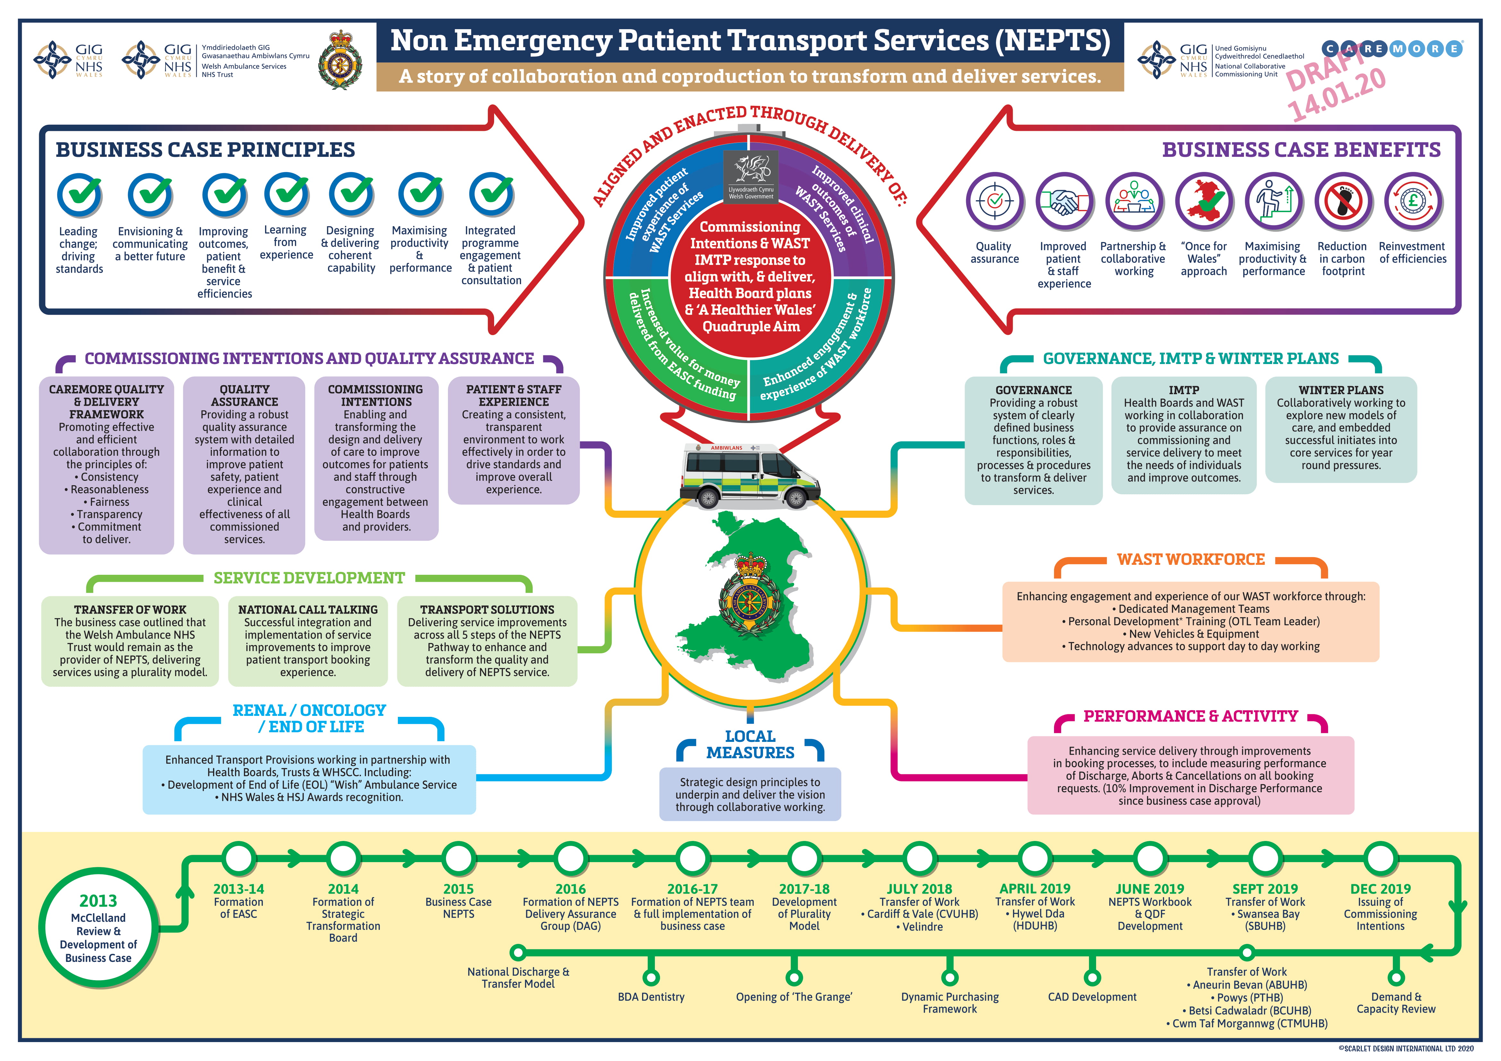Appendix 6: NEPTS Storyboard

Appendix 7: Strategic Health Board Service Changes
Short Title | Summary Description | Organisation | Status
Frequent Callers - Phase 2 | Phase 2 scoping: Nursing/care homes to avoid unnecessary 999 calls & admission to hospital.  Working in partnership with 53 care homes within Aneurin Bevan, I stumble, manger elks, aeds, education & support. | ABUHB | Complete
ETTF Telemetry Project: Telemetry of Diagnostic ECGs direct to Primary Percutaneous Coronary Intervention Facilities | To improve early recognition of cardiac conditions in the community / aligned to national delivery plans e,g, identifying new AF cases. Paramedic interpretation of ECG with ability for clinicians at receiving unit to view ECG via telemetry to inform clinical decisions.  Phase 3 roll out to GPs - pathway complete, awaiting GPC Wales confirmation. | ABUHB | In Progress - On Track
Falls | Falls Vehicle: Operational 7 days a week, (aligned with community resource teams) Paramedic and Physiotherapist on a Specialised Falls Vehicle adapted to store additional equipment and full paramedic kit as per RRV. Emergency response capable.  Falls Tier 1 assistants for winter period.  Consider in context of Strategic Falls WAST work and any further opportunites. | ABUHB | In Progress - On Track
Potential roll out of 111 | Roll out 111 within AB | ABUHB | Complete
Pathways | Programme to review and where necessary refresh pathways including trauma, obs & gynae, ENT, backpain | ABUHB | In Progress - On Track
Changes to the provision of obstetrics, neonatal, gynae and paediatric services | Planning for any potential interim solution, prior to relocation to The Grange Hospital | ABUHB | In Progress - On Track
Clinical Futures Strategy | Clinical Futures Strategy overarching clinical, workforce and estates strategy that encompasses reconfiguration of primary, community, LGHs and the development of The Grange University Hospital | ABUHB | In Progress - Off Track
HCP Pilot | Pilot to diarise HCP admissions utlising booked UCS crews | ABUHB | Archived
APP | Further roll out of Advanced Paramedic Practitioners into ABUHB following pilot.  Pilot Operational 18 hours per day 7 days a week. APPs rotate between Clinical Contact Centre (CCC) and operational RRV. APP in CCC dispatches APPs in RRV to ensure tasked with most appropriate calls. | ABUHB | In Progress - On Track
Fraility | Development of direct access pathway to frailty beds, advanced care plans and end of life care. | ABUHB | In Progress - On Track
Physician Response Unit (PRU) | WAST provide vehicle, equipment, PPE for consultants and RRV paramedic. LHB provide consultant from Nevill Hall 9-5 (approx 3 days) and any other equipment & medications. Additional appropriate jobs selected from stack. If patient requires admission then patient can be referred direct to appropriate speciality team therefore bypassing ED. | ABUHB | In Progress - On Track
Vascular (arterial surgery) | Centralisation of arterial vascular surgery in South East Wales | ABUHB,CTMUHB,CVUHB | Unknown
Acute Coronary Syndrome Pathway Development | Redesign Acute Coronary Syndrome service to meet the NICE guidelines for the ACS pathway for Heart Disease. The ACS pathways pilot has seen a reduction in referral to transfer times down to 2 days in 2017. Further evaluation will take place ahead of potential roll out in 2018  Dedicated transport being piloted for 3 months as part of pathway. | ABUHB,CTMUHB,CVUHB | Unknown
Frequent Callers - Phase 2 | Work in Wrexham and Flintshire to provide basic first aid training by CFRs in nursing homes, which has had a positive impact on call numbers. Linked to Community Team.  Joint work to identify top 10 Nursing Homes and measure admissions - link with Integrated Clinical Hub. Monthly meeting to consider frequent calls by nursing and residential care settings. Group reports formally to BC UHB West Area Director and BC UHB Clinical Director. ISTUMBLE model shared amongst BCUHB colleagues and BC UHB Conwy Falls Group.  Frequent caller work also undertaken with Vulnerable Adult Review Meetings chaired by N Wales Police and being piloted in Anglesey area - suggests expansion across BC UHB.  Work completed to identify FCs across Anglesey, N Gwynedd, Conwy and Denbighshire over 12 month period (Dec 2016 - Nov 2017) and common themes. Monthly frequent caller group established at Ysbyty Gwynedd Hospital chaired by an ED consultant. Referals to most appropriate agency for support, with collective support of the group. Contact with GP practice is integral to the process. | BCUHB | In Progress - On Track
ETTF Telemetry Project: Telemetry of Diagnostic ECGs direct to Primary Percutaneous Coronary Intervention Facilities | To improve early recognition of cardiac conditions in the community / aligned to national delivery plans e,g, identifying new AF cases. Paramedic interpretation of ECG with ability for clinicians at receiving unit to view ECG via telemetry to inform clinical decision at LHB area. The funding for the project is until end March 2019 and WAST is currently collating the data that will inform the decision as to whether this is handed over as business as usual from 1st April 2019. | BCUHB | Complete
Single Integrated Clinical Assessment and Triage (SICAT) Hub | Other actions in this template support the development of the SICAT.  This brings together work on the Clinical Desks and health board Clinical Hubs. SICAT clinicians provide secondary clinical assessment and triage for 999 calls (including HCP calls) and calls from WAST operational crews on scene with patients. APPs in the CCC will identify suitable calls on the WAST stack for enhanced triage to be undertaken by BC UHB clinicians. | BCUHB | In Progress - On Track
Advanced Paramedic Practitioners | Following the successful 5 month study pilot in BC UHB area with 10 APPs, this will be rolled out on a permanent basis across BC UHB. The business case outlines a rotational model and 3 year Pacesetter funding was received for the APP pilot to support the provision of Primary Healthcare. A joint WAST/HB project group is currently being established. | BCUHB | In Progress - On Track
Preparatory work for 111 | National programme timescales in development. WAST and health board to work together to prepare for implementation once timescales confirmed. Current timeline is suggesting that the 111 programme will be completed in Q3/4 of 2020-21. It is necessary to confirm anticipated dates so that the preparatory work can be scoped. | BCUHB | In Progress - On Track
Develop the alcohol treatment centre model | Alcohol Treatment Centre in Wrexham (Wrexham Welfare Centre). This project is supported by WAST, BC UHB and the Local Authority on a seasonal basis with the service delivered by The British Red Cross. There is anecdotal evidence of its success as a concept and initial data shows that A&E attendances are reduced (Jan - Oct 2018: 12,742 people treated; 56 ambulances cancelled or referred to more appropriate alternatives). It should be noted that the centre also impacts on the wider drug and alcohol agenda as part of the North Wales Area Planning Board (APB) work on Reducing Harm from Alcohol programme. Projects may also flex up and down in different areas such as Rhyl on a less frequent basis, depending on service need. | BCUHB | In Progress - On Track
Maximising utilisation of GP OOH pathways | GP OOH provision in Emergency Dept OOH. Standardisation of criteria across EDs. Linked to SICAT and directory of services. Part of current 90 day planning includes feasibility study to understand the potential increases in Primary Care capacity through use of Tele Health for urgent referrals. Work commenced in October 2018 and will continue into 2019 - immediate focus on reviewing existing business case for use of telehealth, engagement with GP clusters and options appraisal with associated scale and scope of benefits. | BCUHB | In Progress - Off Track
Develop and implement new alternative care pathways | The following care pathways are now in place: GGP & OOH/drug & alcohol/cardiac care/COPD/epilepsy/falls/diabetic/midwife/palliative care/mental health/specialist practitioner/mental health/social care. A reporting template/data set is being developed to assess the referral rates from ambulance crews. Referral pathways and improving their utilisation is also be a project under the BCUHB Unscheduled Care Programme.  This action is being delivered to plan and is a core work stream within the BCU USC Transformation Programme with a specific 90 Day Action Plan concerning Clinically Safe Admission Avoidance. Existing performance has been baselined and a stretch target set for Q3 of increasing MIU utilisation by 25% | BCUHB | In Progress - On Track
Implement referral pathway for mental health | Mental health pathway in place with Glan Clwyd Hospital and went live on 20th November 2017. The on call Psychiatric Liaison Team Professional will discuss the case with the referring paramedic. Over the Christmas period a pilot was put in place across police, clinicians and mental health. There is an opportunity to widen out to CAMHS. Referral of patients to other healthcare professionals in appropriate setting. Some further work being done around real time utilisation of pathways and information on use. Need to publicise pathways. Awaiting confirmation of HB colleagues of capcity to support MH Pathway in West and East (pathway is ready to be implemented once assurance of capacity in the system to support referrals) | BCUHB | In Progress - On Track
Implement referral pathway for MIU | MIU pathways in place with a need for increased number of conveyances via this route. WAST has developed and distributed the policy to crews and work is ongoing to ensure that access to MIUs is supported by appropriately trained staff and services. Some further work being done around real time utilisation of pathways and information on use. Need to publicise pathways. | BCUHB | Complete
Rapid handover - Paramedic Pathfinder to be implemented in Ysbyty Gwynedd and Ysbyty Glan Clwyd EDs | Maximising the utilisation of existing pathways of care supported by use of Paramedic Pathfinder. Rapid handover to be explored in further detail by both WAST and health board - consideration of Fit to Sit and assessment in ED to progress 15minute handover - part of the Unscheduled Care Programme. Working with Ysbyty Glan Clwyd to work up rapid handover protocols and training for ED staff in early 2019. Paramedic Pathfinder is for our paramedics to use to triage patients, we are emphasising the pathfinder through the B5-6 competencies this year (Ieuan copied in has details). New paramedics are being trained on Pathfinder as part of their conversion course. | BCUHB | Complete
Falls pathways | CAT pilot has ended and there is a need to link in with the national WAST falls work. The health board and WAST will work together to determine the model required and this may require additional resource.  CFRs currently being issues with Manger Elk lifting devices and trained in their use along with diagnostic equipment to assist with clinical assessment support from CCCl. WAST in early liaison with health board re falls management as part of unscheduled care programme. WAST CFRs continue to be utilised as Tier 1 falls response with additional resources from BC UHB primary care and community services being identified who could also provide Tier 1 response e.g. Anglesey Night Owls. Resource mapping exercise to be completed identifying additional resources. | BCUHB | In Progress - On Track
Service change across the BC UHB region | Unscheduled care system - work streams split between 2 AOM's in the North. Liz Hughes to lead on SICAT and represent WAST on the Unscheduled care board (USB) and Jon Sweet to lead on Pathway utlisation. All tasks from the USB to be reported via feedback after each meeting. | BCUHB | Complete
Service change across the BC UHB region | Stroke and thrombectomy services - health board currently considering options for acute and hyper acute stroke care, as well as wider model for rehabilitation. WAST is engaged in this work | BCUHB | In Progress - On Track
Service change across the BC UHB region | Vascular surgery - changes due to be implemented in April 2019 with centralisation at YGC. Hybrid theatre currently in development. WAST working with the health board to identify potential patient numbers, and clinical flows. | BCUHB | In Progress - On Track
Service change across the BC UHB region | Orthopaedics - potential three year move from 5 sites to 3. FURTHER DETAIL TO BE PROVIDED | BCUHB | Complete
Service change across the BC UHB region | Orthopaedics - potential three year move from 5 sites to 3. FURTHER DETAIL TO BE PROVIDED | BCUHB | In Progress - On Track
Service change across the BC UHB region | Urology. FURTHER DETAIL TO BE PROVIDED | BCUHB | In Progress - On Track
Service change across the BC UHB region | Eye care - provision of some ophthalmology services closer to home. FURTHER DETAIL TO BE PROVIDED | BCUHB | In Progress - On Track
Falls pathway development | Pathway to be reviewed , also considering models across Wales as part of the Falls Framework developed within WAST and implementation of the falls assistant pilot for winter 2018/19.  Needs consideration jointly with CT Transformational plan; Stay Well in Your Community.  Also work in partnership with regards the roll out of the virtual ward. | CTMUHB | In Progress - On Track
Potential roll out of 111 | Implementation of the national 111 programme in the C&V area - this is subject to nationally agreed timescales and will be updated once confirmed dates are known. | CTMUHB | In Progress - On Track
Service reconfiguration: Vascular (arterial surgery) | Centralisation of arterial vascular surgery in South East Wales | CTMUHB | Unknown
Service reconfiguration:  Major Trauma | Live major trauma network by October 2019 and functioning major trauma centre at UHW and designated trauma units by April 2020. | CTMUHB | In Progress - On Track
Changes to the provision of obstetrics, neonatal and paediatric services | Implementation of the recommendations of the South Wales Programme; centralisation of paediatric inpatient services at Prince Charles with a Paediatric Assessment Unit developed at Royal Glamorgan Hospital . Centralisation of obstetric services at Prince Charles Hospital with a free standing midwifery unit at the Royal Glamorgan | CTMUHB | In Progress - Off Track
Acute Coronary Syndrome Pathway Development | Redesign Acute Coronary Syndrome service to meet the NICE guidelines for the ACS pathway for Heart Disease. The ACS pathways pilot has seen a reduction in referral to transfer times down to 2 days in 2017. Further evaluation will take place ahead of potential roll out in 2018.  Dedicated transport piloted as part of pathway. | CTMUHB | Unknown
Boundary change in Bridgend & Ambulance handovers policy, review of explorer 3. | Ambulance handover and our continued work to ensure that we adopt a zero tolerance approach to ambulance delays across the Cwm Taf area – implicit in this statement is the need to work with POW post transferring into the Cwm Taf management area.  Continue to engage and support the future planning and manage the operational impacts of the Bridgend Locality boundary change to Cwm Taf UHB. | CTMUHB | In Progress - On Track
ENT | Reconfiguration of ear, nose and throat (ENT) services within CT; hub & spoke model. Hub at Royal Glam for adults and paediatrics at POW TBC | CTMUHB | In Progress - On Track
Orthopaedics | Implications of Rapid review of Orthopaedic services undertaken by GIRFT. Proposed model for PCH and POW to receive HOT, RGH to be cold only. | CTMUHB | In Progress - On Track
Frequent Callers & CHIST | Phase 2 WAST: Nursing/care homes to avoid unnecessary 999 calls & admission to hospital. Building on the pilot in Cardiff and Vale UHB; expanding from 8 to 11 care homes.  Further development of the Care Home Integrated Support Team (CHIST). linked to Transformational Funding.  Linked work to supoprt care homes to reduce the calls make to WAST and the number of residents who are admitted to the Emergency Department | CVUHB | Complete
Direct Access Pathway | Develop and implement additional ‘direct-access’ care pathways via WAST:  • Ambulatory Emergency Care- further develop pathway linked t o ambulatory transformation  • Cardiology care (for certain conditions) | CVUHB | In Progress - On Track
Falls Response Team | WAST/CRT Falls Response Team Operating Mon-Fri, 08:30-16:30, patients referred via 999 following a fall to receive same day urgent home based assessment by paramedic and CRT therapist. To provide confirmation of physical injury and advice/signposting to other community based services as appropriate | CVUHB | In Progress - On Track
Code Stroke | Continue to review Code Stroke processes to identify opportunities to improve performance including working with WAST on refining pre-hospital pathways to reduce door to needle time | CVUHB | In Progress - On Track
Focus on Amber/ Green Calls | Analysis and understanding of Amber/Green performance to support improvement  Pilot Hospital Avoidance Vehicle | CVUHB | Archived
Potential roll out of 111 | Implementation of the national 111 programme in the C&V area - this is subject to nationally agreed timescales and will be updated once confirmed dates are known. | CVUHB | In Progress - On Track
APP Trial | Introduction of Advanced Paramedic Practitioners into SE | CVUHB | In Progress - On Track
Service reconfiguration: Vascular (arterial surgery) | Centralisation of arterial vascular surgery in South East Wales | CVUHB | Unknown
Service reconfiguration:  Major Trauma | Live major trauma network by October 2019 and functioning major trauma centre at UHW and designated trauma units by April 2020. | CVUHB | Unknown
Service reconfiguration: Relocation of Rockwood Hospital to UHL | Reprovision of Specialist Neuro and Spinal Rehabilitation Services and Clinical Gerontology Services | CVUHB | In Progress - On Track
Service reconfiguration: Hyper Acute Stroke Unit | Work with regional partners on the establishment of HASU | CVUHB | In Progress - On Track
Acute Coronary Syndrome Pathway Development | Redesign Acute Coronary Syndrome service to meet the NICE guidelines for the ACS pathway for Heart Disease. The ACS pathways pilot has seen a reduction in referral to transfer times down to 2 days in 2017. Further evaluation will take place ahead of potential roll out in 2018.  Dedicated transport piloted as part of pathway. | CVUHB | Unknown
Enhance access and utilisiation of Alternative Care Destinations / Pathways (other than ED) | Increase the utilisation of ambulance patients accessing care at their local Minor Injury unit or alternative care pathway.  Action (i) Engage with Heath Board to review admission criteria for Cardigan MIU  Action (ii) Engage with Health Board to review admission criteria in Llandovery MIU  Action (iii) Review utilisation rates and put into place mechanisms to ensure the clinically apprpriate patients are directed to the most apprpriate unit.  Action (iv) Implement a Mental Health Pathway (aligned to pathways developed in other Health Boards). | HDUHB | In Progress - On Track
Enhance the provision of Advanced Paramedic Practitioners across HDda | Fully embed the Advanced Paramedic Practitioner rotational model across HDda.  Actions to include:  Action (i) Recruit and fully embed the 4 x additional APPs across the three rotational pillars (Primary care / WAST community response and CCC) following Winter investment monies  Action (ii) Support the Trust wide initiative to expedite a national APP model (subject to business case approval) | HDUHB | In Progress - On Track
Improve service for non injury / low risk fallers across Hywel Dda | Preliminary discussions underway to support various County led bids for funding to improve response to elderly frail fallers Action (i) IAA bid for 'pick me up service' for Llanelli (bid to be submitted) Carmarthenshire Action (ii) Referral pathway via ART under discussion across Carmarthenshire Action (iii)Potential referral via Social Services pathway (bid to be submitted) by Ceredigion Action (iv) Preliminary discussions underway with MWWFRS regarding UFRs also attending non injured fallers for 'pick me up' service.  Action (v) Explore the feasibility of introducing a Falls Response Service. | HDUHB | In Progress - On Track
Reduce 999 demand from Nursing / Residential Homes across Hywel Dda | Continue to engage and work collaboratively with Nursing / Residential Home providers to reduce 999 activity. Action to include:  Action (i) Fully roll out 'IStumble' falls assessment tool across all Residential & Nursing homes in HDda to improve the management of non-injury falls patents to avoid unnecessary ambulance attendance and onward conveyance to ED.  Action (ii) Support delivery of lifting aids to all CSSIW registered Nursing & Residential Homes across HD  Action (iii) Proactively review and monitor activity data to identify opportunities to better manage demand through direct engagement and education with Nursing / Care Home providers | HDUHB | In Progress - On Track
Joint Conveyance reduction programme with HDda | A joint group has been established to identify joint opportunities to reduce the number of patients conveyed to hospital.  Actions to include:  Action (i) Fully establish conveyance reduction working group  Action (ii) Undertake a systematic review of WAST & Health Board clinical audit data to identify patient case mix and improvement opportunities  Action (ii) Develop a robust joint conveyance reduction action plan | HDUHB | Archived
Transforming Clinical Services | The TCS Programme has been established to transform the delivery of health care for patients in Hywel Dda. The scope of the project includes the re-design of all Planned, Urgent & Emergency and Out of Hospital care. A new clinical model is being developed and capital investment in new health infrastructure is required. Actions include:  Support key TCS Programme Groups including (i) Regional Clinical Strategy Group; (ii) WAST Partnership Model; and  (iii) Explore options to undertake bespoke modelling to understand operational, resource and capacity impacts of the future clinical model | HDUHB | In Progress - On Track
Support the Mid & West Regional Stroke Model work stream | Continue to engage and support the development of a regional Stroke model for Mid & West Wales.  Actions to include:  (i) Continue to attend and support the Stroke Project Group,  (ii) Support the development of the regional model and undertake bespoke ambulance modelling to identify the ambulance specific impacts.  (iii) Explore WASTs role to support the preferred clinical model | HDUHB | In Progress - On Track
Pro-active monitoring and management of service change proposals. | WAST will continue to engage proactively with Health Boards to identify and jointly plan for all local service change . Actions to include:  (i) WAST & the three M&W regional Health Boards (ABMU, HDda & Powys) to regularly meet and review service change with planning and operational leads via the Joint Mid & West Wales Planning Forum; | HDUHB | In Progress - On Track
Enhanced services to manage Falls Patients | Continue to develop and enhance care for the management of non-injury and low-acuity falls patients.  Actions to include:  (i) Fully roll out 'IStumble' falls assessment toolkits across all Residential & Nursing homes across Powys to improve the management of non-injury falls patents.  (i) Establish a Falls Pathway for Paramedics to access and refer clinically appropriate falls patients to the Powys Urgent Response Service at Home (PURSH) | PTHB | In Progress - On Track
Increase the availability and access to Alternative Care Pathways | Explore and scope with the PTHB the following additional Care Pathways:  Action (i) Explore and scope the development of a Respiratory Pathway (aligned to the ongoing review of Respiratory care across PTHB)  Action (ii) Develop a Single Point of Access Pathway | PTHB | In Progress - On Track
Enhance the provision of Advanced Paramedic Practitioners across Powys | Fully embed the Advanced Paramedic Practitioner rotational model across Powys THB  Actions to include:  Action (i) Engage with PTHB and support the Trust wide initiative to expedite a national APP model (subject to business case approval). | PTHB | In Progress - On Track
SaTH Future Fit Programme | Cross border service change: The Future Fit Programme is a regional transformation programme reviewing hospital services across Shropshire, Telford & Wrekin. Two proposed options the reconfigure all planned and Urgent & Emergency Care, identifying the two following options:  Option 1: The Royal Shrewsbury Hospital becomes the Emergency Care site and the Princess Royal Hospital becomes the Planned Care site.  Option 2: The Princess Royal Hospital becomes an Emergency Care site and the Royal Shrewsbury Hospital becomes a Planned Care site.  Under either option, both hospitals would have an Urgent Care Centre that is open 24 hours a day, seven days a week. | PTHB | In Progress - On Track
Hereford & Worcester Regional Stroke Model | Cross border service change: Proposals have been put forward to re reconfigure stroke services across Hereford & Worcester.  The two core options being considered are:  Option 1: HASU at Hereford and ASU at Worcester with a Triage, Thrombolise and Transfer service  Option 2: HASU at Worcester and ASU at Hereford with a Triage, Thrombolise and Transfer service | PTHB | In Progress - On Track
Other regional service transformation | There are a range of other regional service transformational agendas, including:  Action (i) Mid & West Region Stroke reconfiguration proposals  Action (ii) Mid Wales Joint Committee for Health & Social Care Action (iii) WAST & the three M&W regional Health Boards (ABMU, HDda & Powys) to regularly meet and review service change with planning and operational leads via the Joint Mid & West Wales Planning Forum; | PTHB | In Progress - On Track
Multi-disciplinary response to respiratory patients in Powys | Funding has been agreed through Healthier Wales circa 3 million pounds to hold a three-month trial with a WAST RRV, Paramedic and Disciplinary Nurse to respond to respiratory patients in Powys. | PTHB | In Progress - On Track
Further enhance access to Alternative Pathways of Care | Work closely with Health Board leads to identify opportunities to enhance and develop Alternative Care Pathways.  Actions to include:  (i) Monitoring referral and compliance of established ACPs,  (ii) Review WAST & ABM data to identify opportunities to develop new ACPs  (iii) Undertake an evidence based approach to establish new ACPs based upon clinical need. | SBUHB | In Progress - On Track
Enhanced management of Frequent Service users | (i) Continue the Multi-disciplinary team approach with Health Board clinical / service leads to identify, review and manage frequent service users.  (ii) Regular review activity data to identify high volume service users and engage with service leads to understand the reasons and put into place mitigating actions to reduce demand (for example continue to work closely with Parc Prison, Bridgend to reduce 999 generated attendances). | SBUHB | In Progress - On Track
Enhanced services to manage Falls Patients | Continue to develop and enhance care for the management of non-injury and low-acuity falls patients.  Actions to include:  (i) Fully roll out 'IStumble' and 'I Fell Down' falls assessment toolkits across all Residential & Nursing homes in ABMU to improve the management of non-injury falls patents to avoid unnecessary ambulance attendance and onward conveyance to ED.  (ii) Seek funding to establish a dedicated Joint Falls Response vehicle in collaboration with Health Board clinical leads to manage low acuity falls patients in the community (Risk - availability of funding).  (iii) Work closely with Health Board to identify and trial any new initiatives to improve the care and management of non-injury / low acuity falls patients. | SBUHB | In Progress - On Track
Enhance the provision of Advanced Paramedic Practitioners across ABMU | Fully embed the Advanced Paramedic Practitioner rotational model across ABMU.  Actions to include:  (i) Recruit and fully embed the new 6 x APPs across the three rotational pillars (Primary care / WAST community response and CCC) following Winter investment monies  (ii) Support the Trust wide initiative to expedite a national APP model (subject to business case approval) | SBUHB | In Progress - On Track
Management of Hospital Handover Delays | Joint working between WAST & Health Board to proactively manage and minimise hospital handover delays. Actions to include:  Action (i) Implement robust operational arrangements to proactively manage periods of peak hospital activity to improve patient flow and minimise delayed ambulance handover  Action (ii) Put in place clear action plans to manage handover delays (including Joint Winter Plans). | SBUHB | In Progress - On Track
Bridgend Locality Boundary Proposals | Continue to engage and support the future planning and manage the operational impacts of the Bridgend Locality boundary change to Cwm Taf UHB. | SBUHB | Complete

Appendix 8: NPUC Key Deliverables

NPUC | 2020/21 | 2021/22 | 2022/23
PAG & MAG | - Development of a work programme for PAG & MAG.  - Support the development of the EDQDF.  - PAG and MAG will use the C3 Faculty to undertake supporting Research, development and evaluation activities in relation to the work outlined under the Commissioning development and support.
Measurement | Measurement  - Leaning from the EDQDF programme changing the conversation around Measures beyond 4 & 12 Hours  - Learning and understanding from EASC’s development of Ambulance Quality Indicators.  - Learning from 2018-21 EASC Emergency Ambulance Services Commissioning Intentions and NPUC Priorities, Joint Performance Improvements completions from WAST and Health Boards to inform current state of measurements in relation to service change initiatives across urgent and emergency care from home to hospital (including ED) and applicable services.  - Learning from the NHS Wales NHS Benchmarking Network Projects (NPUC related) for strategic commissioning and alignment with future years IMTPs.  - More accurate and timely reporting of ED data by Health Boards to Stats Wales.  - Research of measures in use across urgent and emergency care from home to hospital
Measurement | NHS Benchmarking  - Ongoing working with the NHS Benchmarking Network to disseminate and give access to Health Board and ED staff on the Emergency Care project  - Work with NHS Benchmarking Network to support the use of benchmarking across Unscheduled Care.  - Learning from the NHS Wales NHS Benchmarking Network Projects (NPUC related) for strategic commissioning and alignment with future years IMTPs.
Measurement | Winter Pressure Monies  - C3 Faculty through funding under the NPUC will commence supporting the work undertaken by the NCCU in evaluation the Winter Funding 2019/20 initiatives.  - Support Welsh Government with targeted evaluation of Winter funded initiatives; specifically:  - Q1 working with HB Winter Planning and Table 3 Leads to fully complete the planning templates, collate existing data and implementation plans, then to analyse data submissions .  - Q2 collecting data on implementation and working with HB leads to provide data on net effect of investment, then to contribute to the evaluation report.  - Q3 sharing, learning and planning priorities with HBs for winter 2020-21 with resilience plans aligned with IMTP cycle, then to support the new planning cycle as in Quarter 4 2018/19.  - Q4 reporting and disseminating recommendations for forecasting / evaluation process for ongoing winter resilience plans and USC service improvement plans
Policy & Guidance | Escalation
Policy & Guidance | Strengthening Winter Resilience
Policy & Guidance | IMTP Guidance  - Q3 EASC / NPUC Commissioning Intentions and alignment with IMTPs 2020/21 process and associated documentation was produced by the NCCU in support of both EASC and the NPUC.  - Q3 Share progress of IMTP Responses to the EMS & NEPTS Commissioning Intentions with Policy Leads within Welsh Government  - Q3 Share learning from Evaluation of winter monies evaluation with Welsh Government & Health Boards Government  - Q4 Completion of NCCU IMTP.
EDQDF | - Phase 2 completed & Phase 3 underway for 6/13 Early Adopter ED sites  - Phase 2 underway for remaining 7/13 ED sites  - NESIs commenced for Clinical Quality & Outcomes  - majority of PIPs delivering improvements  - Round 1 NESIs of Staff Engagement  - Patient Experience  - Pioneering KPIs & Benchmarking supporting service improvements for ED sites | - Phase 3 Go-Live for all ED sites  - All PIPs delivering improvements  - Further NESIs established  - National arrangements to support EDQDF as UHBs business as usual model for EDs designed & established |  | - EDQDF established by all UHBs as business model for delivering ED services
Commissioning same day Emergency Care, including Ambulatory Care | - Scope defined and agreed  - Opportunities from EDQDF to be identified  - Delivery resources agreed  - Team appointed  - Phase One commenced | - Phase One completed  - Commence Phase Two |  | - Phase Two completed  - Phase Three 'go-live'
Commissioning Intermediate Care | - Scope defined and agreed  - Opportunities from EDQDF to be identified  - Delivery resources agreed  - Team appointed  - Phase One commenced | - Phase One completed  - Commence Phase Two |  | - Phase Two completed  - Phase Three 'go-live'
Commissioning Ambulatory Care | - Scope defined and agreed  - Opportunities from EDQDF to be identified  - Delivery resources agreed  - Team appointed  - Phase One commenced | - Phase One completed  - Commence Phase Two |  | - Phase Two completed  - Phase Three 'go-live'
Commissioning GP OOH | - Scope defined and agreed  - Opportunities from EDQDF to be identified  - Delivery resources agreed  - Team appointed  - Phase One commenced | - Phase One completed  - Commence Phase Two |  | - Phase Two completed  - Phase Three 'go-live’

Appendix 9: Improving Care, Improving Experience Key Deliverables
Improving Care, Improving Experience | 2020/21 | 2021/22 | 2022/23
Mental Health & Learning Disability Adult Hospitals | - Meetings with central supporting organisations, Welsh Government , All Wales Peer Groups and Health Boards  - Adult/CAMHS Hospital Framework agreements have been extended up until April 2021. Therefore The QAIS, with NHSWSSP Procurement and Legal advisors will develop a Renewed Framework agreement ready for launch on 1st April 2021. Preparation will include: development of new standards, enhancing and fully implementing the RAPID process, refreshing the reporting Matrix, auditing all services prior to their entry onto the framework agreement, liaising with relevant expert by experience groups and other stakeholders, such as HIW etc, development of new audit process, development of new ranking process.  - Audit of Patient Placement Agreements and Termination Notices  - Provide opportunities for all 22 Providers to meet and discuss performance against the current Framework requirements.  - Continue to review all services where Welsh patients are currently cared for under the current Framework agreement.  - Produce Annual report on Framework use and provision. | - Q1-4 Meetings with central supporting organisations, Welsh Government, All Wales Peer Groups and Health Boards/Local Authorities.  - Q1-4 Ongoing meetings with MH/LD expert by experience groups.  - Q1-2 Ongoing reviews of Framework providers, 89 units  - Sharing Best Practice Day  - Production of Annual Report  - Launch of refreshed Framework.  - Launch of RAPID  - Ongoing development of new Framework  - Annual Provider Performance Meetings  - Production of Annual Report  - Relevant Health Board Summit Meetings  - Renewal of Memorandum of Understanding with Health Inspectorate Wales.  - Quality Assurance Statements for Health Boards.  - Engagement with a Welsh university in relation to R&D of the Framework Agreement.  - Performance and Verification Visits | - Q3 Enhancement of CCAPS in relation to measuring performance outcomes etc.  - Launch of ITT and PQQ for new Framework Agreement for launch April 2020 Including audits of all service provision  - Review of circa 70 units that currently provide services via Framework agreement
Mental Health & Learning Disability CAMHS hospitals | - Meetings with central supporting organisations, Welsh Government , All Wales Peer Groups and Health Boards/Local Authorities  - Audit of 10 new Framework units.  - Ongoing review of 2 units  - Management of suspension and subsequent termination of Framework provider.  - Audit of Patient Placement Agreements/Termination Notices  - Met with 9 Providers during Q3 to discuss performance against the Framework requirements. | - Q1-4 Meetings with central supporting organisations, Welsh Government , All Wales Peer Groups and Health Boards/Local Authorities  - Q1-2 Ongoing reviews of Framework providers  - Sharing Best Practice Day  - Production of Annual Report  - Launch of refreshed Framework.  - Engagement with a Welsh university in relation to R&D of the Framework Agreement.  - Performance and verification visits | - Q3-4 Enhancement of CCAPS in relation to measuring performance outcomes etc.  - Q3-4 Ongoing reviews of Framework providers  - Launch of ITT and PQQ for new Framework Agreement for launch April 2020 Including audits of all service provision  - Review of circa 18 units that currently provide services via Framework agreement
Mental Health & Learning Disability Adult Care Homes | - Meetings with central supporting organisations, Welsh Government , All Wales Peer Groups and Health Boards/Local Authorities  - Ongoing review of 35 care homes  - Care Home Framework agreement refresh  - Meeting with All Wales People First to engage individuals in the process for standards and contracts within the care home environment.  - Audit of Resident Placement Agreements. | - Q1-4 Meetings with central supporting organisations, Welsh Government , All Wales Peer Groups and Health Boards/Local Authorities  - Q1-4 Ongoing reviews of 41 Framework providers  - Q1-2 Ongoing engagement with All Wales People First  - Development of self-assessment tool  - Engagement with a Welsh university in relation to R&D of the Framework Agreement.  - Performance and verification visits  - Sharing Best Practice Day  - Production of Annual Report | - Q3 Launch of refreshed adult MH/LD Care Home Framework  - Q3 Enhancement of CCAPS in relation to measuring performance outcomes etc.  - Review of circa 60 units that currently provide services via Framework agreement
Internally Commissioned Provision | - The QAIS will undertake reviews of the 2 Adult Medium Secure Units and the 2 CAMHS Units provided by NHS Wales. Reviews will be undertaken at least once per year with a full report with recommendations being produced following each review, The QAIS will assist WHSSC as commissioners and the units as providers to understand the recommendations made and how improvements can be introduced.  - The QAIS will negotiate with WHSSC with regards to the possibilities of further enhancing Tour quality assurance agreements which may include the implementation of case management of secure care. | - The QAIS will undertake reviews of the 2 Adult Medium Secure Units and the 2 CAMHS Units provided by NHS Wales. Reviews will be undertaken at least once per year with a full report with recommendations being produced following each review, The QAIS will assist WHSSC as commissioners and the units as providers to understand the recommendations made and how improvements can be introduced. | - The QAIS will undertake reviews of the 2 Adult Medium Secure Units and the 2 CAMHS Units provided by NHS Wales. Reviews will be undertaken at least once per year with a full report with recommendations being produced following each review, The QAIS will assist WHSSC as commissioners and the units as providers to understand the recommendations made and how improvements can be introduced.
Together for Mental Health Delivery Plan | - National and International Benchmarking for Adult Mental Health, Learning Disabilities and CAMHS services.  - The QAIS will continue their membership of the NHS Mental Health AND Learning Disabilities Benchmarking Network in the UK along with the International Benchmarking membership on behalf of Wales. This will enable Wales to continue to be able to understand how Wales performs in relation to others at a Health Board, National and International level. The QAIS will also continue to organise the NHS Wales Benchmarking conference each year.  - National care review of the NHS Mental Health and Learning Disability estate in Wales.  - The QAIS will undertake assurance reviews of all Mental Health/Learning Disabilities inpatient units supplied by NHS Wales. This will include all secure facilities throughout Wales.  - Mental Health Access and Conveyance review.  - The QAIS will complete the Mental Health access and Conveyance review mid- 2020. The outcomes of that review will be shared and discussed with Welsh Government. The QAIS will support Welsh Government to make and implement recommendations that will arise from this review.  - CAMHS  - The QAIS will undertake reviews of both NHS Wales CAMHS units at least once per year as described in the Service Level agreement designed by QAIS/WHSSC. Support will be given to WHSSC and the services, if required, with regards to any recommendations made following each review. | - National and International Benchmarking for Adult Mental Health, Learning Disabilities and CAMHS services.  - The QAIS will continue their membership of the NHS Mental Health AND Learning Disabilities Benchmarking Network in the UK along with the International Benchmarking membership on behalf of Wales. This will enable Wales to continue to be able to understand how Wales performs in relation to others at a Health Board, National and International level. The QAIS will also continue to organise the NHS Wales Benchmarking conference each year. We will liaise with New Zealand Health Service, the current chair country of International Benchmarking for MH in order to support the publication of the next International Benchmarking report.  - National care review of the NHS Mental Health and Learning Disability estate in Wales.  - The QAIS will support the development of a strategy for Mental Health /Learning Disabilities estate across NHS Wales.  - Mental Health Access and Conveyance review.  - Recommendations from the review will be fully implemented over next 2 years. The QAIS will provide support to Welsh Government, Mental Health services and other stakeholders in relation to implementation of actions to meet recommendations made following the review.  - CAMHS  - The QAIS will undertake reviews of both NHS Wales CAMHS units at least once per year as described in the Service Level agreement designed by the QAIS/WHSSC. Support will be given to WHSSC and the services, if required, with regards to any recommendations made following each review. | - National and International Benchmarking for Adult Mental Health, Learning Disabilities and CAMHS services.  - The QAIS will continue their membership of the NHS Mental Health AND Learning Disabilities Benchmarking Network in the UK along with the International Benchmarking membership on behalf of Wales. This will enable Wales to continue to be able to understand how Wales performs in relation to others at a Health Board, National and International level. The QAIS will also continue to organise the NHS Wales Benchmarking conference each year.  - National care review of the NHS Mental Health and Learning Disability estate in Wales.  - The QAIS will support WHSSC and the seven Health Boards to commence the implementation of the National MH/LD estate strategy.  - Mental Health Access and Conveyance review.  - Recommendations from the review will be fully implemented over next 2 years. The QAIS will provide support to Welsh Government, Mental Health services and other stakeholders in relation to implementation of actions to meet recommendations made following the review.  - CAMHS  - The QAIS will undertake reviews of both NHS Wales CAMHS units at least once per year as described in the Service Level agreement designed by the QAIS/WHSSC. Support will be given to WHSSC and the services, if required, with regards to any recommendations made following each review.
Insight and Innovation | - QAIS will Plan, progress and publish a National Care Review of patients in MH hospitals with a learning disability possibly aligning this with the MH inpatient review  - QAIS will commence and complete the care mapping of MH care homes at the request of any health board  - QAIS will publish the National MH Access and Conveyance Review on behalf of Welsh Government  - QAIS will support the delivery of any accepted recommendations of the National MH Access and Conveyance Review on behalf of Welsh Government  - QAIS will work to strengthen the partnership with BCUHB and expand the joint repatriation team to cover all the £110m CHC spend  - QAIS will pilot the Levels of Care in Older Adult Care Homes as part of the Safer Staffing in Care Homes element of the Safer Staffing Wales programme  - QAIS will scope and possibly deliver the children with LD National Care Review on behalf of Welsh Government  - QAIS will support the delivery of any accepted recommendations of the National Care Review of LD Hospital services on behalf of Welsh Government  - QAIS will support the MH National Benchmarking in adult and CAMHS and host an all wales feedback event  - QAIS will support the new LD National Benchmarking and host an all wales feedback event  - QAIS will collaborate with New Zealand, currently chairing the MH International Benchmarking to produce an international benchmarking report  - QAIS will explore the commissioning of our quality assurance services by the Isle of Man government  - QAIS will scope and possibly deliver the commissioning of the sexual assault referral services as requested by this programme  - QAIS will support the development of a value in MH project in partnership with Shared services, FDC and MH network

Appendix 10: EASC – Chairs Objectives January 2020
Objective | Actions | Progress to date
Oversee Amber Review actions and system implementation  Oversee Amber Review actions and system implementation cont.  Oversee Amber Review actions and system implementation cont.  Oversee Amber Review actions and system implementation cont. | The Amber Review Programme is underway and will be completed in November.  An interim call response time action plan has been agreed.  Sustainable improvements re number of lost hours due to handover delays | - Implementation is being actioned and monitored via the Programme Board. The programme ended in November 2019.  - EASC will receive a closure report at their January 2020 meeting this will include the establishment of a taskforce on ambulance availability and the phase 1 implementation of the Demand and Capacity review.  - Wider unscheduled care system pressures have impacted on Red and Amber performance. The need to strike a balance has meant that expected progress on long waits in the Amber category is taking longer than originally planned.  - Lost Hours to handover delays have shown a deterioration against the expected improvement trajectory, implementation of managed cohorting areas at the worst performing sites are being implemented to supplement existing plans:  - Ysbyty Glan Clwyd – 16th December 2019  - Princess of Wales – 20th of January 2020  - Royal Gwent – 3rd February 2020  - Morriston – Phase 1 – February 2020  - As a consequence of delayed progress in the use of alternative pathways, EASC via the CASC will now lead and coordinate this work, following agreement at the recent chairs meeting:  - Directory of pathways to include 3 additional pathways per health board will be published by the end January.  - Take up of pathways and impact will be monitored with effect from February.  - Lessons learnt and good practice will be disseminated to ensure a once for Wales approach is adopted.  - Conveyance to locations other than the Emergency Department is being picked up as part of the development of local performance reports for each health board.  - Revised arrangements for Regional Escalation are due to be enacted on the 27th of January. The EASC team will lead on the review and future development of these arrangements.  - The EASC team are providing support to Welsh Government and coordination the specification and delivery of a national whole system unscheduled care information and alert dashboard. This will be delivered in phases that will be agreed shortly.
 | - An interim Amber call response time action plan  - The benefit realisation case for the Band 6 programme  - The WAST Mental Health Plan | - EASC receives regular updates on Amber performance, alongside wider system performance and pressures.  - Benefits realisation of band 6 Paramedics will be considered at the March 2020 EASC. Delivery of the benefits are included in the 2020/21 Commissioning intentions and should be included in the WAST IMTP.  - The Mental Health Access review being undertaken by the NCCU on behalf of Welsh Government is due to by published early summer 2020.  - The NCCU are supporting WG and the MH network on developing a Mental Health crisis care and transport model for Wales.
 | Monitoring through regular reports at EASC the Service and Performance improvements and Developments for the:
 | - Completion of the NEPTS service transfer  - The roll out of the 111 service | - Work programme agreed and on target with end date Sept 2020  - Progress to date includes:  - Signed framework operational in October 2019  - Local reporting arrangements in place across Wales  - Demand and Capacity Review has been commissioned to be delivered by the end of 2020/21  - Quality assurance function established.  - Positive internal audit report  - Improved NEPTS delivery against standards  - Developing close working relationship with 111 service to ensure alignment between WAST and 111 prior to formal commissioning  - Included in commissioning intentions and EASC IMTP for 2020/21
Undertake demand and capacity assessment of WAST for system discussion and actions | The independent review of demand and capacity in partnership with health boards on increased demand | - The final demand and capacity review has been received and considered by the EASC Management Group. EASC will receive the report at the January 2020 meeting.  - Phase 1 of implementation has already been supported by EASC. A longer term implementation plan is being developed.  - The recruitment of at least an additional 90 WTE above establishment has been set as a commissioning intention for 2020/21.
Ensure collaborative governance in place and key collective decisions | EASC working with optimum attendance and common purpose. | - Attendance is good with all CEOs now having nominated deputies.  - Development sessions are working well and will continue.  - Revised standing orders are being implemented, following recent guidance issued by Welsh Government.  - EASC management group has been established and attendance at health boards has been good, with consistent representation supporting robust discussions and positive progress.
Review and agree further EASC actions to underpin winter planning 2019-20. | Evaluation of 2018-19 interventions and opportunities for 2020 | - The NCCU winter evaluation of 2018/19 was submitted to WG in the summer and used to inform winter priorities and guidance for 2019/20  - A targeted evaluation of winter 2019/20 will be undertaken by the NCCU to inform ongoing winter planning and will extend to the schemes submitted by regional partnership boards.
Facilitate more of WAST options beyond 999 response as enablers for WAST role in community services and alternatives to hospital | Development and piloting of alternative pathways  Adopting multi-disciplinary team working | - As a consequence of delayed progress in the use of alternative pathways, EASC via the CASC will now lead and coordinate this work, following agreement at the recent chairs meeting:  - Directory of pathways to include 3 additional pathways per health board will be published by the end January.  - Take up of pathways and impact will be monitored with effect from February.  - Lessons learnt and good practice will be disseminated to ensure a once for Wales approach is adopted.  - EASC has support the expansion and roll out of the APP project. The numbers of APPs in 2020/21 will be more than the number recommended within the Demand and Capacity review.
Align EASC with broader work on unscheduled care actions | Evaluate opportunities working in the pre hospital care environment | - Discussed in detail during an EASC development session.  - Support from EASC members and confirmation that EASC is the correct place to coordinate and share best practice.  - Schemes included in the IMTP guidance for 2020/21 and specific projects included in regional transformational bids.
EMRTS | Move to 24 / 7 working | - Business case approved  - Recruitment completed for phase 1  - Funding provided to support additional twilight car over winter which has accelerated staff training.  - Phase 1 to be operational April 2020  - Alignment with Major Trauma Network
Commissioning Intentions | Issue and monitor commissioning intentions that promote improvements:
Commissioning Intentions | Develop strategic commissioning intentions  To the performance on Red calls and ensure consistency across Health Boards  To the response to low acuity, high volume calls  That facilitate the continuous improvement against the three Welsh Government clinical indicators  Systematic collection of Patient and Staff Experience data | - Schedule discussion at EASC and issue by end of 2019 / 20  - Due to wider system pressures and delay in WAST implementing elements of its winter plan, Red performance was below 65% for November and December 2019.  - It is worth noting that more calls were responded to in 8 minutes in December 2019 than in December 2018, but there has been a significant increase in the number of calls categorised as red.  - Additional actions have been agreed with WAST and the performance at the start of January is encouraging.  - The Demand and Capacity review provides a range of recommendations for ensuring appropriate response to patients, which have been agreed in principle by EASC.  - A key commissioning priority has been agreed with WAST to improve the timeliness and accuracy of clinical audit data  - This will enable the ongoing continuous improvement against the 3 current clinical indicators.  - Identify opportunities to extend the range clinical indicators e.g. stroke  - Development of Patient and Staff Experience indicators to be included in the 2020 commissioning intentions

