AGENDA ITEM
3.2

EMERGENCY AMBULANCE SERVICES COMMITTEE

welsh ambulance services nhs trust (WAST)
provider update

Date of meeting | 28 January 2020

FOI Status | Open/Public

If closed please indicate reason | Choose an item.

Prepared by | Hugh Bennett, Assistant Director of Commissioning and Performance (WAST)
Presented by | Jason Killens, Chief Executive WAST
Approving Executive Sponsor | Chief Executive

Report purpose | FOR DISCUSSION / REVIEW

Engagement (internal/external) undertaken to date (including receipt/consideration at Committee/group)
Committee/Group/Individuals | Date | Outcome
(Insert Name) | (DD/MM/YYYY) | Choose an item.

ACRONYMS
D&C  EMS  NCCU  NEPTS  SAI  WAST | Demand and Capacity  Emergency medical services  National Collaborative Commissioning Unit  Non-emergency patient transport services  Serious Adverse Incident  Welsh Ambulance Services NHS Trust

- SITUATION/BACKGROUND

  - The purpose of this report is to provide EASC with an update on key issues affecting quality and performance for Emergency Medical Services (EMS) and Non-Emergency Patient Transport Services (NEPTS) and also to provide an update on strategy and planning for EMS and NEPTS respectively.
  - The EASC meets on a bi-monthly basis, and it has been agreed that it would be helpful for EASC members to receive a written report. This report is the third of such written briefings, designed to enable a more comprehensive update to be received and improve understanding of the issues being managed by the Trust in relation to quality, performance, resources and strategy.

- SPECIFIC MATTERS FOR CONSIDERATION BY THIS MEETING (ASSESSMENT)

Quality, Safety & Patient Experience

  - Serious Adverse Incidents
  - WAST continues to review and discuss potential Serious Adverse Incidents (SAIs) at its Serious Case Incident Forum. The themes and trends from those cases reported as SAI’s include response delays, call categorisation, missed allocation and clinical practice issues.

  - The following table shows the total numbers of SAIs reported to Welsh Government by WAST, by Health Board area. It is evidenced below that there has been a reduction in the total number of SAIs reported to Welsh Government in the current year to date.

SAIs Reported to Welsh Government
 | ABUHB | SBUHB | BCUHB | CVUHB | CTMUHB | HDUHB | PtHB | Total
2017/18 | 17 | 10 | 12 | 6 | 2 | 1 | 0 | 48
2018/19 | 11 | 7 | 13 | 15 | 1 | 4 | 0 | 51
2019/20 to date | 10 | 12 | 0 | 5 | 1 | 3 | 1 | 32

  - The data shows that 69% of the reported SAIs year to date are across the Aneurin Bevan and Swansea Bay University Health Board areas.

  - Following a Patient Safety event held in October 2018 with Welsh Government and the Delivery Unit, a Joint Investigation Framework has been developed and implemented. Since ratification this has clarified the process to be followed where a potential SAI relates to a delayed ambulance response as a consequence of identified hospital notification to handover delays. This was agreed at the Directors of Nursing forum, and outlines which organisation will be responsible for the investigation and the potential reporting of the SAI.

  - In addition to the volumes reported above, the Trust has passed 25 incidents in 2019/20 to the Health Boards for investigation.

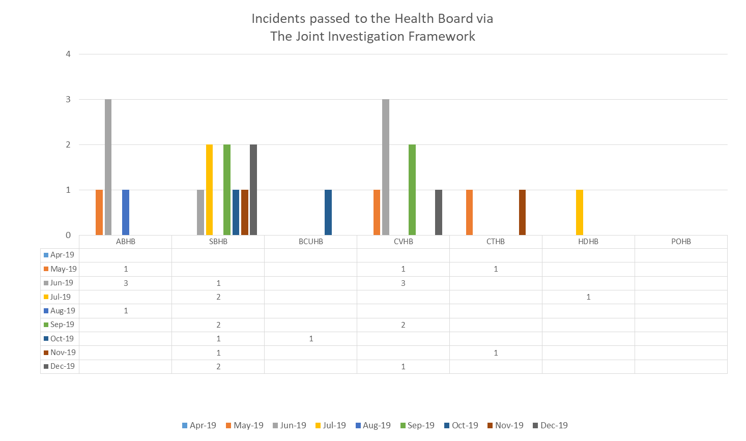
  - There have been some very difficult patient experience stories which have played out in the media. Events like these are extremely distressing to the families concerned and also to the clinical colleagues involved, which is beginning to cause burnout and departures from the service.

  - Coroners’ Activity
  - WAST is continuing to receive large numbers of requests for information from coroners. During 2019 (January to December), a total of 236 requests have been received relating to coroner requests for information / requesting staff attendance / informing WAST they are an interested party. Again, the majority of these cases relate to incidents where there was a delayed ambulance response to a patient in the community. Work will be underway in the near future to reconcile Datix, ensuring that WAST hold up to date and accurate information.

  - Longest Waits
  - The Patient Safety Team are now undertaking regular reviews of the longest responses to patients, even where no complaint or concern has been received or raised, this is to provide assurance around the quality of the care that they received. The following table details patient waits 12 hours and over.

  - In the first 9 months of 2019/20, 1,985 patients waited 12 hours or over, compared to 1,032 in the same period last year i.e. the numbers are worsening. There has been a significant spike in the last three months as we have moved into the winter period, with 540 patients waiting 12 hours or over in Dec-19. Revised escalation procedures have been introduced in the Clinical Contact Centres. As part of the Amber Review Implementation Programme assurance mechanisms, a community back stop of 18 hours has been agreed with the NCCU. Previous modelling work has identified that the Amber tail is particularly sensitive to small changes to in ambulance resource availability.

EASC is asked to note: the increase in the number of patients waiting 12 hours or over for a response, the continuing risks to patient safety and the increased number of SAIs and coroners’ activity that are being dealt with by WAST which relate, in the main, to incidents where there was a delayed ambulance response to patients in the community.

Performance

  - Demand
  - Year on year (Jan-19 to Dec-19 compared to same period the previous year) verified demand has decreased by 1.71% i.e. it is broadly stable; however, Red demand has increased by 12.07% using the same comparison. This increase in Red demand is largely attributable to a patient safety change in application of the Medical Priority Dispatch System (MPDS) which is seeing a greater proportion of breathing difficulties coded as Red. This change occurred in May-19 and Red demand May-19 to Dec-19 is 19.40% higher than the same period in 2018. The change was introduced as a result of a visit from the Academy and the Trust is working closely with them to ensure that the guidance is being applied appropriately. It is possible that this level of Red demand will continue into the future.

  - Red Performance
  - Red performance been declining for some time, which triggered WAST going into “enhanced performance management” for Red performance in Apr-19. In Nov-19 and Dec-19 Red 8 minute performance was less than 65% for the first time since the move to the Clinical Response Model in Oct-15. There continues to be variation in health board performance with Cardiff & the Vale the highest performer and Hywel Dda and Powys the lowest performers, which reflects the urban and rural nature of these health boards (conversely, the reverse is true for Amber performance).
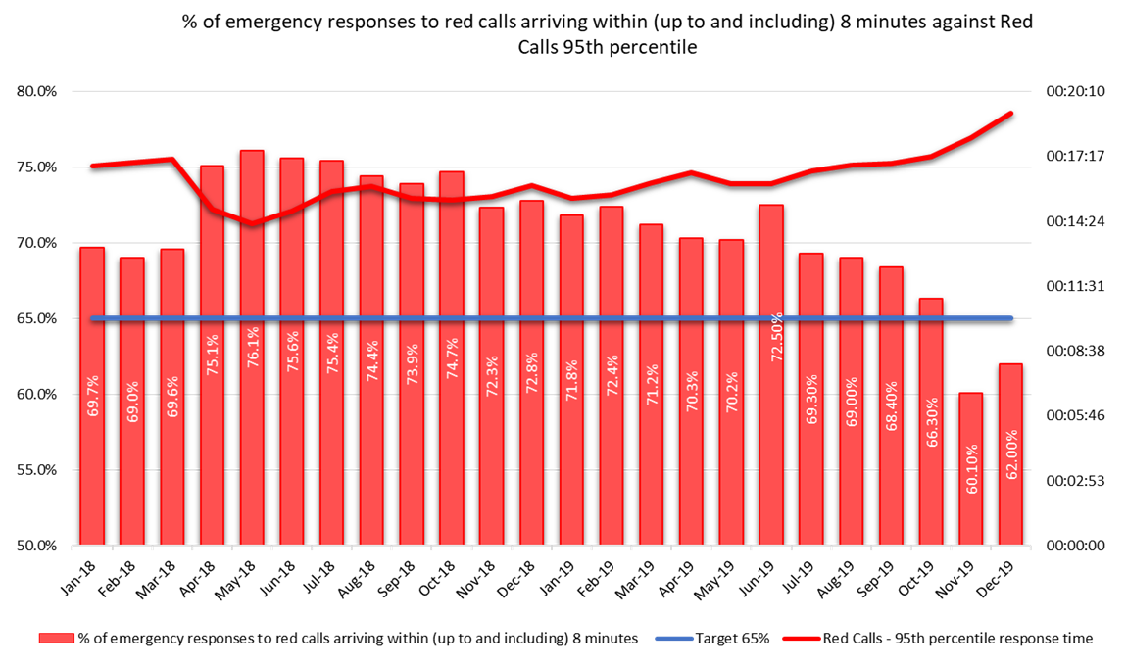
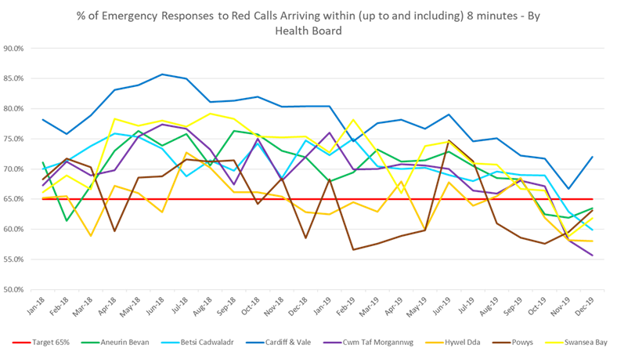
  - The reduction in the contribution of running calls to Red performance is also a contributory factor, as previously outlined to EASC.

  - WAST is complying with a requirement for “enhanced performance management”, in particular, a Red Improvement Plan and the supply of regular data and scrutiny with the NCCU. A Weekly Red Improvement Plan meeting chaired by Director of Operations has been introduced. A Red Performance Dashboard is also now shared on a weekly basis with key stakeholders.

  - The Red Improvement Plan is an operational plan aimed at making marginal gains in Red performance (marginal gains being important when seconds count). Whilst accepting that there are many actions which can be taken as set out in paragraphs below, the three key determinants of Red performance are: demand (which is increasing), actual resource deployed and lost hours to handover.

  - The informal commissioning intention for Emergency Ambulance (EA) Unit Hours Production (UHP) is 95% (this is challenging within the context of the relief gap). WAST has not been able to achieve this. EA UHP has been 90% of over for six of the nine months of 2019/20 with performance dipping below 90% in Jul-19, Aug-19 and Sep-19; however, WAST has put out 1.4% more responding hours (all resource types) in 2019/20 (to Dec-19) compared with the same period 2018/19. As a result of detailed winter planning discussions internally and with the CASC, a series of incentives have been put in place to increase overtime uptake at key times. This was very successful over the festive period: see Winter Planning section paragraph 31.

  - Aneurin Bevan and Cwm Taf Morgannwg roster reviews are now complete. This now completes the roster reviews undertaken following the previous D&C review.

  - The third key determinant of Red performance is handover lost hours. The Quarter 3 Ambulance Quality Indicators (AQIs) show that notification to handover lost hours increased by 117.24% (compared to the same period last year), from their already high levels. WAST lost 36,420 hours to handover delays or 34 shifts per day in Quarter 3. The impact will be higher in some health board areas.
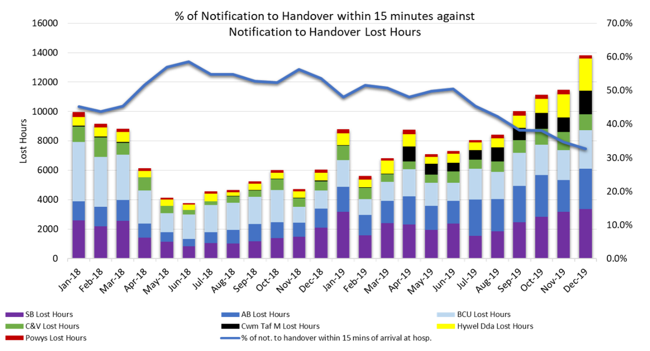
  - The Red Improvement Plan is reviewed weekly by the Director of Operations. Key highlights from the Red Improvement Plan include:
- Community First Responders (CFRs): 24 additional CFRs being trained by St John, due to come on stream in quarter 4;
- Computer Aided Dispatch (CAD) system updated with all Public Access Defibrillators (PAD) locations and active promotion and use of GoodSam app;
- Assistant Director level increased focus and abstractions management;
- Clinical Contact Centre (CCC) Clinical Review completed, which has identified a range of improvements;
- Regular use of new software for forecasting and modelling to improve performance management and decisions e.g. station locations, deployment of resource;
- Use of Immediate Release Protocol being monitored and reported on weekly;
- Review of station mobilisation (egress and information) undertaken with changes being implemented and update to data recording to ensure changes can be monitored; and
- Introduction of dual pin technology for handover, which has had very positive impact on handover to clear performance.

  - For the detailed live actions: 15 are red (significantly off target), three are amber (off target) and three are green (on-target). An additional 65 actions are complete and nine stopped. The increase in Red RAG rated actions is attributable to the progress made on the plan and the remaining live actions being the more difficult to resolve.

  - As reported to Sep-19 EASC, WAST has recently revised its process for Managing Immediate Release Requests. The revised process has allowed improved accuracy of reporting with effect from 30 Jul-19. The graph below shows the number of requests split by those declined and accepted. There has been a significant spike as WAST has moved into the winter with 118 requests being declined in Dec-19.
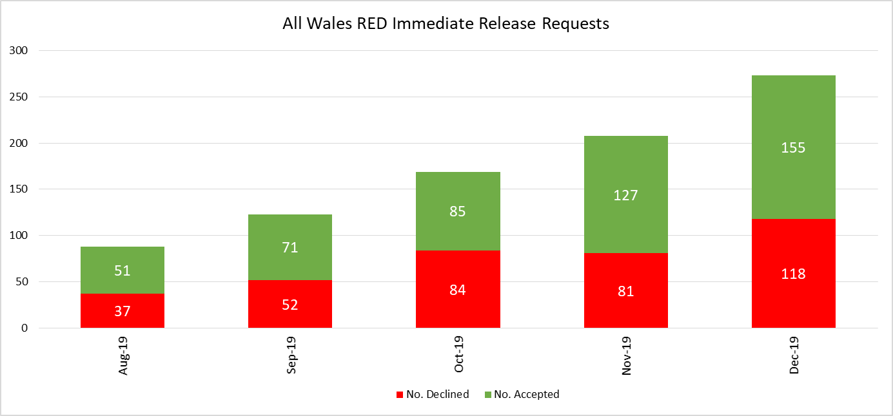
  - Amber Response times / Amber Review
  - Amber response times remain an area of significant concern with Amber median, 65th centile and 95th centile times on an upward trend. The median was 48 minutes (Dec-19) compared to 44 minutes in the same period last year. The 65th percentile was one hour and 17 minutes (Dec-19) compared to one hour and nine minutes in the same period last year. The 95th percentile was five hours and 48 minutes (Dec-19) compared to four hours and 56 minutes in the same period last year. Again, there is a strong correlation between Amber waits and notification to handover lost hours.
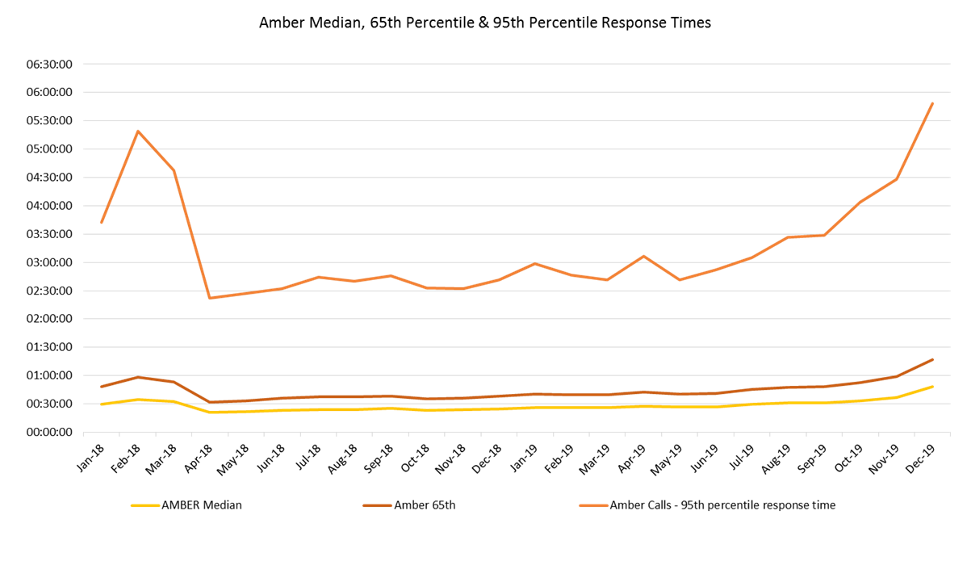
  - WAST established an internal WAST Amber Delivery Group with the NCCU co-opted onto the Group. NCCU/WAST had to deliver on nine “assurance mechanisms” agreed by EASC. The Delivery Group has now been closed down, as the programme has been largely completed. A closure report will be provided to the NCCU.

  - The key action in the Amber Review Implementation Programme was the EMS Demand & Capacity Review (see separate report) which will enable EASC to consider options for improving the response to Amber patients (and other categories). The Review forecasts a year on year increase in verified call demand of 2.3%, includes a range of agreed performance parameters for modelling purposes, a range of agreed efficiencies and shift left service initiatives and a modelled two phase implementation. The modelled FTEs required to achieve the response parameters at Dec-24, based on the forecast demand and the delivery of the agreed efficiencies is an increase of 537.5 FTEs above 2018/19 budgeted establishment.

  - WAST have also been working to reduce hours lost from handover to clear. As part of this work to cleanse and refine the data, a dual pin system for handover was rolled out in each emergency department with all hospitals live in Aug- 19. This has had a significant impact on to clear lost hours, with the number of hours reducing from 3,011 in Q3 2018/19 to 1,952 in Q3 2019/20, a reduction of 65% (ORH identified that WAST already benchmarked favourably for this indicator, prior to the reduction of dual pin).

  - Winter Planning

  - WAST had in place a three weekly Corporate Winter Plan Group from 29 Mar-19. The Group has put in place an approved WAST National Winter Plan, underpinned by WAST area (health board) level plans. As part of the Winter Plan, a range of key initiatives were agreed with EASC to support performance which have been pro-actively managed through the winter to date. These include:-
- Improved access to clinical information, patient records and senior decision making in support of on-scene clinical assessment via Clinical Support Deck (CSD)/NHSDW (implemented in Jan-20 and available from 08:00 to midnight);
- An additional 24 CFRs are being trained for Hywel Dda UHB and Powys THB, who will come on stream in Feb-20 and Mar-20. It is estimated that each volunteer will provide an additional six hours per week;
- Single Integrated Clinical Assessment and Triage (SICAT) model (GP in CCC) in operation in Betsi Cadwaladr UHB , Swansea Bay UHB operating similar model and Aneurin Bevan UHB continue to pilot an approach from the Clinical Contact Centre in Vantage Point House;
- Patient Flow Co-ordinators in Aneurin Bevan UHB and Swansea Bay UHB;
- Additional Unscheduled Care Service (UCS) capacity via St John (an extra 377 hours per week);
- Falls Assistants rolled out to the whole of Wales via St John, with between 7 and 10 vehicles operational each month through the winter plan period;
- Patient Cohorting at key emergency department sites: YGC: live 16 Dec-19, RG: expected go live early Feb-2020, POW: live 20 Jan-20 (work is continuing at Morriston to secure the estate in which to care for these patients); and
- NEPTS additional discharge and transfer capacity: offered to every health board and taken up by Swansea Bay UHB and Hywel Dda UHB with Cwm Taf Morgannwg making their own arrangements.

  - A separate report has been provided to the CASC on every initiative in the Winter Plan and initiatives outside the Winter Plan that will impact on the quality and performance, in particular, the additional activity/capacity produced. The 2020/21 Corporate Winter Planning Group will be established in Apr-20 to work on the 2020/21 winter plan, including evaluations of this winter’s initiatives, with the option of including an NCCU representative on the Group to further aid system collaboration.

  - A range of staff welfare initiatives have also been put in place, in particular welfare vans and the flu vaccination programme is being actively managed by the Medical Directorate. The flu vaccination rate for EMS and NEPTS front line was at Dec-19 was 35% (the 2018/19 rate was 40.3%). Work continues on the programme.

  - For the festive period (23 Dec-19 – 05 Jan-20) UHP was good, as a result of additional incentives on overtime: EA UHP 94% or above (week 1) and 95% or above (week 2). RRV UHP was above 95% (week 1) with exception of Xmas Day (83%) and 99% (week 2) with exception of Sunday 05/01 (87%). Red performance on Christmas Day was 62% and on 05 Jan-20 69%. There were very high levels of lost hours. WAST had a specific festive winter plan in place and a Winter Coordination cell – 13 Dec-19 – 5 Jan-20. Actions included demand led rosters, incentivised overtime over the festive period, a Mobile Response Team (MRT) in Cardiff & the Vale, Alcohol Treatment centres (Cardiff & the Vale and Swansea Bay), a mental health practitioner North Wales, demand led Community First Responder volunteering and Christmas meals delivered to all stations.

EASC is asked to note: that the Red 8 minute 65% target was not achieved in Nov-19 and Dec-19; that WAST has robust performance plans in place (Red Improvement Plan/Winter Plan), which are being actively managed; but that the unprecedented levels of handover lost hours are a significant drain on ambulance availability.

EASC is asked to note: the further lengthening of Amber response times, in particular, the Amber 95th percentile and the increase in 12 hour and over waits; and that the Amber Review Implementation Programme i.e. the nine assurance mechanisms has concluded, with further implementation transferring to the Ambulance Availability Taskforce, EASC Management Group and EMS Demand & Capacity Review Implementation Programme.

Resources

  - The EMS Demand & Capacity Review has identified a Response relief gap of 262.5 FTEs i.e. the gap between budgeted establishment and the number of FTEs to fill the roster lines based on a benchmarked relief rate. Further collaborative modelling is required on the relief gap i.e. the level of abstractions that drive the required rate of relief, which will be undertaken through the implementation programme associated with the Review. EASC agreed to initially fund 46 FTES “Quick Wins” in this financial year and WAST is currently seeking to recruit up to these levels, although recruitment has proved more difficult than expected.

  - There is a separate report on the agenda which considers the Review’s final report in more detail and the implications for 2020/21 and beyond.

  - In the Nov-19 WAST Provider Report, WAST identified an EMS average vacancy factor through the Winter Plan period of 5.8%. The current level of vacancies is less at 5.7% and is predicted to fall to 3.2% by the end of the Winter Plan period i.e. 31 Mar-20 (all workforce planning is based on assumptions, forecasts and judgements).

  - The Demand & Capacity Review identified that WAST benchmarked above the average for abstractions from its CCC and Response rosters, with sickness absence being identified as a particular outlier. Sickness rates have deteriorated and have been higher through the first part of 2019/20 than previous years. WAST has a Resource Availability Programme in place with nine work streams, one of which is absence management. Sickness absence levels in Nov-19 were improved and better than previous years. WAST will continue to monitor this area closely, in particular, whether this improvement is sustained.

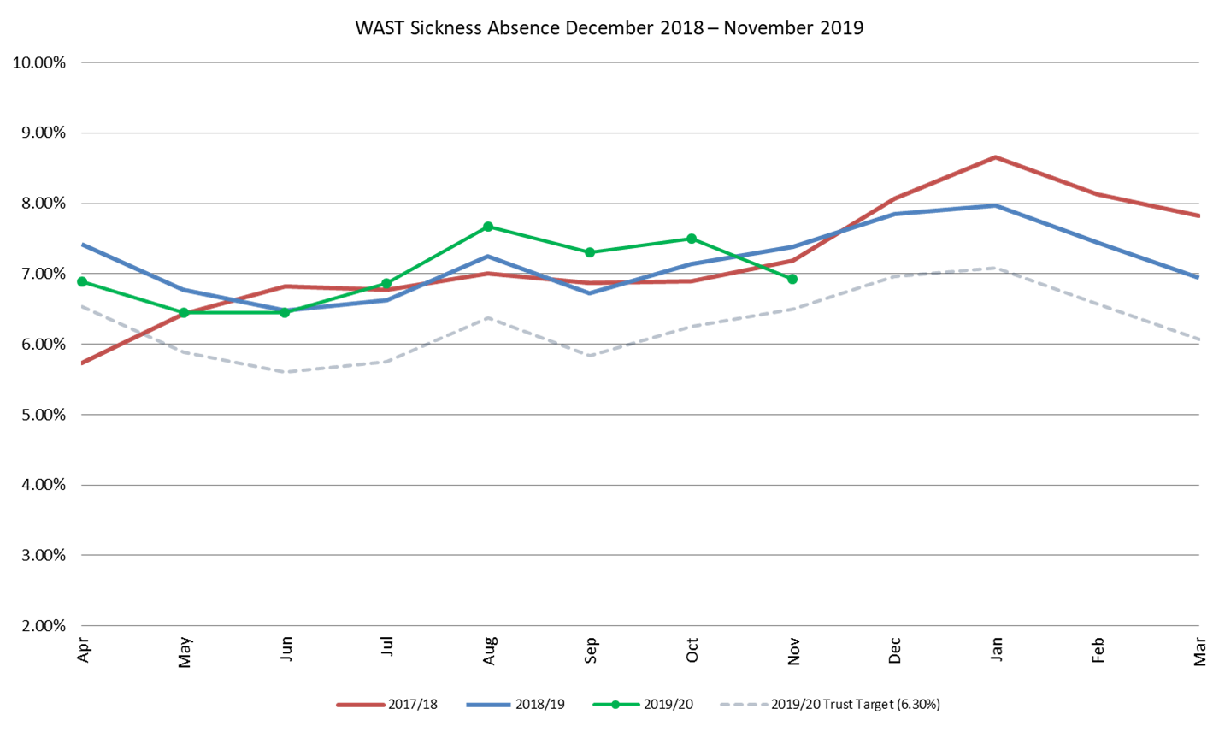
  - A proportion of the Healthier Wales funding has been approved recurrently. The Trust has four approved bids which are being actively managed through the Trust’s Strategic Transformation Board:
- Falls Framework’ Healthier Wales bid approved by EASC enabling the continuation and expansion of the Falls Assistant provision (Level 1) to provide operational cover across all Health Boards (see Winter Planning section above);
- The NEPTS Healthier Wales Bid was approved and work is well underway to develop and implement a new Transport Solutions Model. Transport Solutions Service will focus on eligibility and alternative, more appropriate, transport solutions for patients who are not medically eligible for NEPTS transport. Transport Solutions will deliver a solution that: empowers and assists non-eligible patients to identify and access suitable provision to meet their healthcare transport needs; accurately identifies the transport needs of non-eligible patients across Wales; works in partnership with the patient and alternative service providers to deliver solutions that meet patient transport needs in the most effective and prudent manner possible; and supports improvements in service quality to patients medically eligible for transport.
- The Healthier Wales bid that will support the progression of the Older Peoples Framework has now appointed the Improvement Lead for Older People, who commenced in post on the 13 Jan-20. The Improvement Lead for Falls will commence in post on the 10 Feb-20. The Older People Framework Steering Group membership has expanded to include Third Sector, so that the development of the Framework will be informed by multiple stakeholders.

- Healthier Wales funding has been secured to recruit a Consultant Psychologist to fulfil the role of Organisational Culture and Workplace Wellbeing Lead. An appointment has been made and the successful applicant will commence on a part time basis in Jan-20 before taking up the role full time from April. The post-holder will lead the development of the Trust’s Wellbeing Strategy.

EASC is asked to note: that additional (over and above current establishment) staff are being recruited by 31 Mar-20; the active workforce planning, in particular, the current vacancy level and predicted vacancy level at 31 Mar-20; the relief gap of 262.5 FTEs and further collaborative modelling required on the relief gap; and progress on the four Healthier Wales initiatives.
Developments / Planning

  - Health board Service Changes
  - The most imminent strategic service change which is of material importance to WAST relates to the launch of a South Wales and South Powys Major Trauma network on the 01 Apr-20. The WAST business case has previously been considered by EASC and ‘in year’ funding was provided to support the establishment of the Major Trauma desk in the Clinical Contact Centre, Vantage Point House, Cwmbran.

  - The outstanding requirements identified by WAST have been discussed with EASC in Dec-19. The commitment to funding has been included within Welsh Government Allocation Letters, but without full confirmation of the values. It was reiterated at EASC Management Group in Dec-19 that the lead in times required to train staff and recruit staff for the service, requires detailed confirmation and timely decision making.

  - The other key system wide service change relates to the development of The Grange hospital. The proposed clinical model will fundamentally alter flows in the area and significantly increase demand on transfer and discharge activity.

  - WAST remains fully engaged in fortnightly meetings with both Health Board leads and officers from the NCCU to understand and agree the activity implications for The Grange. WAST has recently been provided with more detailed information on the clinical transport model required for The Grange and is currently modelling this. The required ambulance FTEs for The Grange could be a significant drain on the total FTEs available through increased recruitment and training in 2020/21 for the EMS Demand & Capacity Implementation Programme.

  - WAST now has access to two advanced ambulance simulation models, so is well placed to model the impact of further changes to NHS Configurations in collaboration with the health boards and the NCCU. The key is early agreement on the transport models and provision of data in a timely manner, enabling sufficient time to model options and recruit and train ambulance FTEs.

  - All Wales Transfer and Discharge Service
  - Both the WAST and NCCU (EASC) Integrated Medium Terms Plans (IMTP) articulate a commitment to develop a single “All Wales” transfer and discharge service. It is noted that the NCCU IMTP confirms the intention that NCCU provides a leadership role in developing the service and WAST will work closely with NCCU to develop the model throughout 2020/21.

  - Whilst the establishment of the major trauma network on the 01 Apr-20 provides the opportunity to pilot this service, the Clinical Futures hospital network in Aneurin Bevan UHB affords greater potential to. Being able to pilot an All Wales model is contingent on the transfer and discharge element of the major trauma business case being supported by EASC/WHSCC in Dec-19 and agreement on the final model for The Grange University Hospital by Mar-20.

  - Electronic Patient Clinical Records (ePCR)
  - The ePCR Outline Business Case (OBC) was submitted to Welsh Government (WG) in Jun-19. The preferred option in the OBC is to procure a commercial product from the frameworks available to NHS Wales. The Trust’s original business case was considered for funding from the NHS Capital provision; however, a change in Government arrangements means the case is now being considered as part of the Digital Transformation Funding arrangements. Welsh Government feedback in Aug-19, requested further work on the OBC, in particular, to scope the feasibility of an additional fifth option to “extend the Welsh Clinical Portal out of hospital” by developing an in-house portal solution for the WAST’s ePCR rather than purchasing a commercial product.

  - In Sep-19, WAST gained Welsh Government support to procure specialist services to complete this work. WAST undertook a procurement process for consultancy services to undertake the feasibility study and awarded a contract to EY and Channel 3 Alliance. The feasibility report was completed in Dec-19, concluding that it was not feasible to develop and implement an in-house solution by March 2021 and these findings were discussed with Welsh Government in Jan 2019. WG agreed the findings are advised WAST to progress to development of the full business case.

  - The key benefits of this project are in the removal of issues associated with the digital pen system and the establishment of a stable digital platform for AQI reporting and development of clinical indicators to improve patient experience and outcomes. WAST has a corporate risk associated with the business continuity of recording patient records digitally, for which the Executive Management Team have established an ePCR Project Board to gain external funding and deliver this project.

  - NEPTS (Non-Emergency Patient Transport Service)
  - NEPTS is supported with a unique 5 step model and a set of NEPTS ambulance quality indicators (AQIs). WAST has recently updated its Board Quality & Delivery Report with improved information on NEPTS using these NEPTS AQIs.

  - The NEPTS management team are focused on delivering key elements of the NEPTS Business Case and the NEPTS Commissioning Intentions:

  - Completing the remaining transfers of work:
Each transfer of work has presented a broad range of complexities when analysing local commissioning arrangements in preparation for transfer:-
- To enable the transfers of work to take place, advice was sought from NWSSP Legal Services and detailed journey activity and financial data was analysed to inform the Transfer Agreement document. This builds on the previously known information provided by the health boards during the development of 02 schedules in support of the Quality and Delivery Assurance Framework in Oct-17;
- To date, Velindre NHS Trust, Cardiff & Vale UHB, Hywel Dda UHB and Swansea Bay UHB have successfully transferred their non-emergency patient transport services to WAST;
- The remaining four Health Boards to transfer NEPTS work to WAST are: Aneurin Bevan UHB, Powys THB, Cwm Taf Morgannwg UHB and Betsi Cadwaladr UHB. Each remaining health board has a range of complexities and issues which are being considered and worked through;
- ABUHB is currently undertaking extensive service change through the development of the Critical Care Centre (CCC) at The Grange Hospital site. This includes reconfiguration of primary and secondary care services which will impact on transport requirements;
- ABUHB have proposed a phased transfer. Extra Contractual Referrals (ECR’s) are in the final stages of ‘phase 1’ preparation and the transfer will be completed by Mar-20;
- ABUHB also commission two Dedicated Discharge Vehicles (DDV’s), one at RGH and the other at Neville Hall. To support the new transport requirements for The Grange Hospital and ensure effective vehicle management and utilisation, WAST proposes for both vehicles to transfer to WAST, in-line with ABUHB ‘phase 2’ transfer of work process;
- PTHB are in contractual cross-border arrangements and two contracts have recently been re-tendered. One new contract is due to commence Apr-20, the other is still in progress. There are a number of other transport providers being utilised by Powys THB. These have been identified and we are currently in the final stages of analysing activity data and levels of financial spend. PTHB NEPTS will transfer to WAST by March 2020;
- CTMUHB has completed the Bridgend boundary change. WAST played a key role in the analysis of non-WAST transport spend and activity identified as part of the boundary change. CTMUHB have been requested to provide transport activity and spend data, along with copies of contracts and service level agreements. To date, data related to ECR’s has been received related to CTUHB activity pre-boundary change and there is on-going negotiation to agree Dedicated Discharge Vehicles (DDV’s) being in or out of scope for transfer. Data has been requested from PoW. To date, PoW data has not been received; and
- BCUHB remains in discussion with the Trust to resolve an outstanding AS3 issue. This needs to be resolved before the transfer of work can take place.

  - Reducing bookings made by fax:
The planned cut-off date is 31 Mar-20. To date, significant work has been undertaken to reduce fax bookings by approximately 50%. Eradicating bookings by fax will improve information governance and reduce risks in relation to sharing patient data.

  - Reducing aborted journeys: (Cardiff & the Vale is a significant outlier).
Working with Health Boards through the EASC NEPTS Delivery Assurance Group we have collaboratively developed plans and interventions focussed on joint-working to reduce aborted journeys.

  - Reducing non-eligible patient journeys:
NEPTS has been awarded funding from Healthier Wales to develop a Transport Solutions Service to support patients who may not be eligible for NEPTS services. NEPTS resource needs to be focussed on patients who are eligible for transport as described in WHC 2007(05). To support this, a new Transport Solutions Model, designed in partnership with Health Boards and the NCCU, is being implemented. The Transport Solutions Model focuses on Step 1 and Step 2 of the NEPTS 5-Step Pathway, identifying key messages for patients to enable them to make informed decisions about NEPTS to access healthcare provision. The Model will introduce NEPTS ‘help me choose’ messaging to meet patient need and deliver a system that is clear, well publicised and reflects actual service provision. The Model, once fully operational, will signpost non-eligible patients to alternative transport options.

  - Improving performance levels for discharge and transfer journeys across wales:
Health boards that have enacted the ‘plurality model’ have already seen improvements in discharge and transfer performance. To support this work WAST is working with Health boards through the EASC NEPTS Delivery Assurance Group to develop interventions to reduce failed discharges. We are also working collaboratively with EMS and Health Boards to develop a National Discharge and Transfer Model.

  - National Call Taking:
WAST is committed to developing a ‘Once for Wales’ National Call Taking Service to ensure patients and Health Care Professionals (HCP’s) can access NEPTS provision in a clear and consistent way. We have successfully amalgamated three WAST regional call centres into a National Call Taking Service improving patient experience and standardising booking information and processes. The next phase is to consider, in partnership with Cwm Taf Morgannwg and Powys Health Boards, to transfer their individual call taking services into ours to achieve the ambition of ‘Once for Wales’. This will improve patient experience by creating a single point of access with a consistent and standardised process to accessing NEPTS services. Discussions with Powys THB are in advanced stages and the transfer of PTHB call centre is due to transfer by Mar-20 as part of the transfer of work plan.
  - Local Performance Measures
New local performance measures have been agreed with the Renal Network and all Health Boards. Provided on a monthly basis this will give a more local deep-dive into performance with each health board area.

  - The NEPTS management team have procured a NEPTS Demand & Capacity Review, in collaboration with the NCCU, to aid understanding of this complex logistics business and help further develop the service.

  - IMTP 2020/23
  - WAST’s IMTP will need to be submitted by the 31 Jan-19, and the final draft is on the agenda for this meeting to secure EASC approval. WAST has engaged with the NCCU, in particular, on the 2020/21 commissioning intentions in order to meet the required deadline. EASC Management Group has been updated at its last meeting on the progress of the IMTP and how the Commissioning Intentions will now be incorporated into the body of the document as an integral driver for how WAST shapes its plans. There has been further engagement through NEPTS DAG on the commissioning intentions in relation to non-emergency transport.

  - The key issues being updated within the IMTP are:
  - Agreements reached on the phased implementation of the outcome of the EM Demand & Capacity Review, including a developing workforce plan;
  - Agreed Commissioning Intentions for EMS and NEPTS, incorporated into the main body of the plan;
  - Priority given to national scale up schemes including Advanced Paramedic Practitioners (APPs), falls services, SICAT type models and alternative referral pathways;
  - Developing our strategic intent in relation to call taking, clinical triage and assessment models;
  - Articulating our strategy for a national discharge and transfer service;
  - Health and Social Care (Quality and Engagement) (Wales) Bill;
  - Learning from the Cwm Taf Morgannwg Maternity services review;
  - Wellbeing of Future Generations (WBFGA) - Sustainability, including environmental sustainability; and
  - Preparations for the opening of The Grange Hospital.

EASC is asked to note: the expected go live (01 Apr-20) of the Major Trauma Network in South Wales; the potentially significant impact of The Grange clinical transport model on the 2020/21 ambulance FTEs available through enhanced recruitment and training; the continued work on the All Wales Discharge & Transfer Service; the Welsh Government advice to move to the full business case stage of the ePCR solution; the complexities associated with the health board transfers of work to NEPTS and the four remaining transfers; the forthcoming NEPTS Demand & Capacity Review; and WAST’s progress on completing its 20-23 IMTP.
  - Regional Escalation
  - At the Sep-19 EASC meeting there was a paper on system leadership, in particular, considering changes to escalation processes and dynamic ambulance deployment. Since the meeting a workshop has been held between health boards, NCCU and WAST, two further regional meetings at CEO level were held in November and a final meeting of CEOs was held in January 2020.

  - As a result, it has been agreed to implement a new system of unscheduled care calls and procedures which will see a greater collaborative and action focused response to pressures and risks across the system, based on an agreed set of principles.

  - In summary, these will include:
- Improved and updated escalation plans within each organisation;
- Revised arrangements for the daily escalation calls, including a split into South/West and North calls, with WAST chairing, recording and monitoring the actions agreed;
- Introduction of 4 levels of regional escalation, with actions to be taken at each level based on improved system-wide information, an increased level of support presumed across organisations specifically at the highest level of escalation, but an expectation that the highest level will only be reached on an exceptional basis;
- Regular and frequent monitoring of arrangements to ensure that there are no unintended consequences for the system.

  - The system will be implemented incrementally from 27th January 2020, with the full impact taking place in 2020/21. COOs have been engaged in developing the indicators further and a detailed operational procedure will be developed in support. To support this work and to get the system off the ground, WAST has abstracted key managers to take a lead, and further discussions will take place with the commissioners on the scale and scope of the longer term implications.
  - Finally, the Minister for Health and Social Services released a written statement on 15 Jan-20: update on unscheduled care pressures over winter 2019/20 and next steps to improve ambulance services:-
https://gov.wales/written-statement-update-unscheduled-care-pressures-over-winter-201920-and-next-steps-improve

  - The announcement included the establishment of a Ministerial Ambulance Availability Taskforce to be jointly chaired by the CASC and Emergency Medical Retrieval Service Cymru (EMRTS Cymru) National Director. The written statement identified five areas for the Taskforce to lead on:
- Implementation of recommendations from a recently commissioned independent “Demand and Capacity” Review;
- Rapid delivery of alternative pathways and community-based solutions to prevent avoidable conveyance to emergency departments;
- Optimisation of the ambulance patient handover process;
- Improvement in Red performance, and
- Build on progress made by the Amber Review Implementation Programme

  - The announcement identified that the issue of ambulance responsiveness will require “wider improvements”, in particular, the wider health and social care landscape. WAST is well placed to respond to the five areas identified and will collaborate fully with the Taskforce.

- KEY RISKS/MATTERS FOR ESCALATION TO THE COMMITTEE

Members of the EAS Committee are asked to note:

  - The increase in the number of patients waiting 12 hours or over for a response, the continuing risks to patient safety and the increased number of SAIs and coroners’ activity that are being dealt with by WAST which relate, in the main, to incidents where there was a delayed ambulance response to patients in the community.

  - That the Red 8 minute 65% target was not achieved in Nov-19 and Dec-19; that WAST has robust performance plans in place (Red Improvement Plan/Winter Plan), which are being actively managed; but that the unprecedented levels of handover lost hours are a significant drain on ambulance availability.

  - The further lengthening of Amber response times, in particular, the Amber 95th percentile and the increase in 12 hour and over waits; and that the Amber Review Implementation Programme i.e. the nine assurance mechanisms has concluded, with further implementation transferring to the Ambulance Availability Taskforce, EASC Management Group and EMS Demand & Capacity Review Implementation Programme.

  - That additional (over and above current establishment) staff are being recruited by 31 Mar-20; the active workforce planning, in particular, the current vacancy level and predicted vacancy level at 31 Mar-20; the relief gap of 262.5 FTEs and further collaborative modelling required on the relief gap; and progress on the four Healthier Wales initiatives.

  - The expected go live (01 Apr-20) of the Major Trauma Network in South Wales; the potentially significant impact of The Grange clinical transport model on the 2020/21 ambulance FTEs available through enhanced recruitment and training; the continued work on the All Wales Discharge & Transfer Service; the Welsh Government advice to move to the full business case stage of the ePCR solution; the complexities associated with the health board transfers of work to NEPTS and the four remaining transfers; the forthcoming NEPTS Demand & Capacity Review; and WAST’s progress on completing its 20-23 IMTP.

- IMPACT ASSESSMENT

Quality/Safety/Patient Experience implications | Yes (Please see detail below)
Quality/Safety/Patient Experience implications | Identified within the report
Related Health and Care standard(s) | Governance, Leadership and Accountability
Related Health and Care standard(s) | And all health and care standards
Equality impact assessment completed | Not required
Legal implications / impact | Yes (Include further detail below)
Legal implications / impact | Included within the body of the report
Resource (Capital/Revenue £/Workforce) implications /  Impact | Yes (Include further detail below)
 | Included within the body of the report
Link to Main Strategic Objective | The Committee’s overarching role is to ensure its Commissioning Strategy for Emergency Ambulance Services utilising the five step patient pathway outlined within the National Collaborative Commissioning Quality and Delivery Agreement and the related outcomes for each care standard aligned with the Institute of Healthcare Improvement's (IHI) ‘Quadruple Aim’ are being progressed.  This report focuses on all the above objectives, but specifically on providing strong governance and assurance and safe and effective patient care
Link to Main WBFG Act Objective | Service delivery will be innovative, reflect the principles of prudent health care and promote better value for users

- RECOMMENDATION

  - The EASC Committee is asked to:
- DISCUSS and NOTE the WAST provider report.

