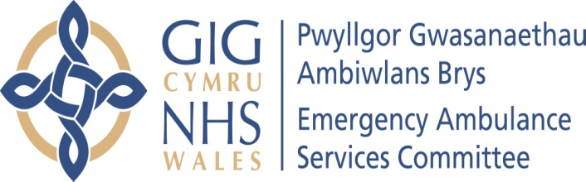 | AGENDA ITEM 2.1  23 July 2019

Emergency Ambulance Services Committee Report
EASC CHAIR’S REPORT

Lead: Chris Turner Chair of the Emergency Ambulance Services Committee (EASC)
Author: Chris Turner
Contact Details for further information: Chris.Turner2@wales.nhs.uk 01443 744946

Purpose of the Emergency Ambulance Services Committee Report
The purpose of this report is for the Committee to receive an update on key matters related to the work of the Chair.

Governance
Link to the Commissioning Agreement | The Committee’s overarching role is to ensure its Commissioning Strategy for Emergency Ambulance Services utilising the five step patient pathway outlined within the National Collaborative Commissioning Quality and Delivery Agreement and the related outcomes for each care standard aligned with the Institute of Healthcare Improvement's (IHI) ‘Quadruple Aim’ are being progressed.  This report focuses on all the above objectives, but specifically on providing strong governance and assurance.
Supporting evidence | The development of this report has where appropriate been informed by updates provided through established governance processes.  A number of the issues highlighted within the report are covered in more detail within the main agenda of the Committee meeting.
Engagement – Who has been involved in this work?
The Emergency Ambulance Services Commissioning Team has contributed to the development of information contained within this report.

Emergency Ambulance Services Committee Resolution to:
APPROVE |  | ENDORSE |  |  | DISCUSS | √ | NOTE | √
Recommendation |  | The Emergency Ambulance Services Committee is asked to:  - DISCUSS and NOTE the report
Summarise the Impact of the EASC Report
Equality and diversity |  |  | There are no equality and diversity implications contained within this report.
Legal implications |  |  | There are no legal implications contained within this report.
Population Health |  |  | No impact.
Quality, Safety & Patient Experience |  |  | Ensuring the Committee and its Sub Groups make fully informed decisions is dependent on the quality and accuracy of the information presented and considered by those making decisions. Informed decisions are more likely to impact favourably on the quality, safety and experience of patients and staff.
Resources |  |  | No impact.
Risks and Assurance |  |  | Ensuring the Committee is fully sighted on key areas of its business is essential to Board Assurance processes and related risks.
Health and Care Standards |  |  | The 22 Health & Care Standards for NHS Wales are mapped into the 7 Quality Themes;  - Staying Healthy; Safe Care; Effective Care  - Dignified Care; Timely Care; Individual Care; Staff & Resources  Within an overarching Governance Framework.  Welsh Government Health & Care Standards Framework 2015  This report focuses mainly on Governance & Accountability but also spans some of the 7 quality themes.
Workforce |  |  | No impact.
Freedom of information status |  |  | Open

CHAIR’S REPORT

1. SITUATION / PURPOSE OF REPORT

The purpose of this report is for the Committee to receive an update on key matters related to the work of the Chair.

2. BACKGROUND / INTRODUCTION

Since the last Committee meeting Members should note:

4 June | - I attended the all Wales Chairs meeting
7 June | - The Chief Ambulance Services Commissioner (CASC) and I met with Welsh Ambulance Services NHS Trust (WAST) Chair and Chief Executive for a regular update
12 June | - I (and CASC) met with Professor David Lockey, National Director for Emergency Medical Retrieval and Transfer Service (EMRTS). We discussed operational requirements, including those related to 24/7 working
19 June | - met with Angela Hughes, Chief Executive of the Wales Air Ambulance. Important to hear about the development of the charity and their preparations for 24/7 working.
8 July | - Appraisal held with the Minister for Health and Social Services.

3. ASSESSMENT / GOVERNANCE AND RISK ISSUES

Members should note that during the appraisal with the Minister, the emphasis was on driving change across the system and ensuring that the EAS Committee was operating corporately. Other issues discussed included Amber implementation and the Red performance.

Members will also wish to note that a request has been received from the Deputy Chief Executive at NHS Wales for a discussion to take place at EASC on the regional escalation processes. Members will note that this is included later on the agenda in the WAST provider report.
.
4. RECOMMENDATION

The Emergency Ambulance Services Committee is asked to:

- DISCUSS and NOTE the report.

Freedom of information status | Open

