AGENDA ITEM
2.2

EMERGENCY AMBULANCE SERVICES COMMITTEE (EASC)

welsh ambulance services nhs trust (WAST)
provider update

Date of meeting | 14 July 2020

FOI Status | Open/Public

If closed please indicate reason | Choose an item.

Prepared by | Rachel Marsh, Director of Strategy, Planning and Performance (WAST)
Presented by | Jason Killens, Chief Executive WAST
Approving Executive Sponsor | Chief Executive

Report purpose | FOR DISCUSSION / REVIEW

Engagement (internal/external) undertaken to date (including receipt/consideration at Committee/group)
Committee/Group/Individuals | Date | Outcome

ACRONYMS
ABUHB  CASC  CTMUHB  D&C  EMS  NCCU  NEPTS  SAI  WAST | Aneurin Bevan University Health Board  Chief Ambulance Services Commissioner  Cwm Taf Morgannwg University Health Board  Demand and Capacity  Emergency medical services  National Collaborative Commissioning Unit  Non-emergency patient transport services  Serious Adverse Incident  Welsh Ambulance Services NHS Trust
- SITUATION/BACKGROUND

  - The purpose of this report is to provide EASC with an update on key issues affecting quality and performance for EMS and NEPTS and also to provide an update on strategy and planning for EMS and NEPTS respectively.

- SPECIFIC MATTERS FOR CONSIDERATION BY THIS MEETING (ASSESSMENT)

CoVID-19

Pandemic Influenza Plan/Business Continuity
  - At the May-20 EASC WAST reported that it triggered its Pandemic Influenza Plan on 4 Mar-20 WAST with two clear corporate objectives. These were:
- Take all reasonable, necessary and proportionate measures in all the circumstances to fulfil the objectives set in our pandemic strategy and
- Continue with recruitment to fulfil the minimum of 136 FTE growth of the EMS service as agreed with EASC for 2020/21. All other, non-essential WAST activity would cease to enable the Trust to focus solely on these two critically important tasks.

  - WAST undertook planning around six key areas of business in response to i. above and delivered a range of tactical responses to increase capacity across 111, EMS and NEPTS.

  - As reported previously WAST also introduced a specific pandemic protocol for 999 call handling (Card 36). This 999 call handling triage protocol, which supplements others within the Medical Priority Dispatch System (MPDS) is designed specifically for pandemic management. We will keep this arrangement in place and only withdraw it when the prevalence and risk of CoVID-19 to people in Wales has diminished.

  - As the rate of CoVID-19 incidents has reduced, WAST has moved to a “monitor, response” phase and also switched back on a range of key projects (see IMTP 20/23 section below).

  - WAST has maintained a weekly dialogue with the CASC on quality, performance, governance and financial commitments.

  - The current focus is on managing a return to business as “usual”, recognising that this will be a changed “usual”. WAST will continue to monitor the system’s requirement from an ambulance transport perspective and flex its capacity in response to changes in demand. In line with other organisations across Wales, WAST has had to develop operational plans for Q1 and Q2, which articulates in more detail the priorities through this phase.

  - The Plan has proved effective and WAST has responded in a coordinated manner and in collaboration with the NCCU. Initial lessons were captured by 31 May-20 with a full lessons learnt and evaluation due to be completed and reported to WAST’s Board in Jul-20.

EASC is asked to NOTE that:
WAST’s Pandemic Influenza Plan/ business continuity arrangements continue and that WAST is now in a period of monitoring/flex response as the wider health care system returns to “normal”.

Quality, Safety & Patient Experience

Serious Adverse Incidents (SAIs)
  - WAST continues to review and discuss potential SAIs at its Serious Case Incident Forum (SCIF). Following the outbreak of the Pandemic, WAST has witnessed (over time) a reduction in the volume of adverse incidents being reported by staff though Datix. This has had an impact on the volume of cases being discussed at SCIF, and consequently a reduction in cases being reported as WAST SAIs or being passed to the relevant health board for investigation as a Patient Safety Incident or under the umbrella of the Joint Investigation Framework.

  - The tables below are illustrative of the following:
- Cases being discussed at SCIF and WAST reported SAIs, and
- Cases being discussed at SCIF and either passed to health boards as Patient Safety Incidents or under the Joint Investigation Framework.

  - The figures are representative of the health board area in which the incidents occurred.

  - There were three WAST SAIs in Jun-20. WAST currently has 13 open SAIs, with the high level themes and trends being:
- Call categorisation issue – 3
- Clinical practice issues, which include 2 from NEPTs – 6
- Delayed response – 1
- Dispatch issue - 1, and
- Other – 2.

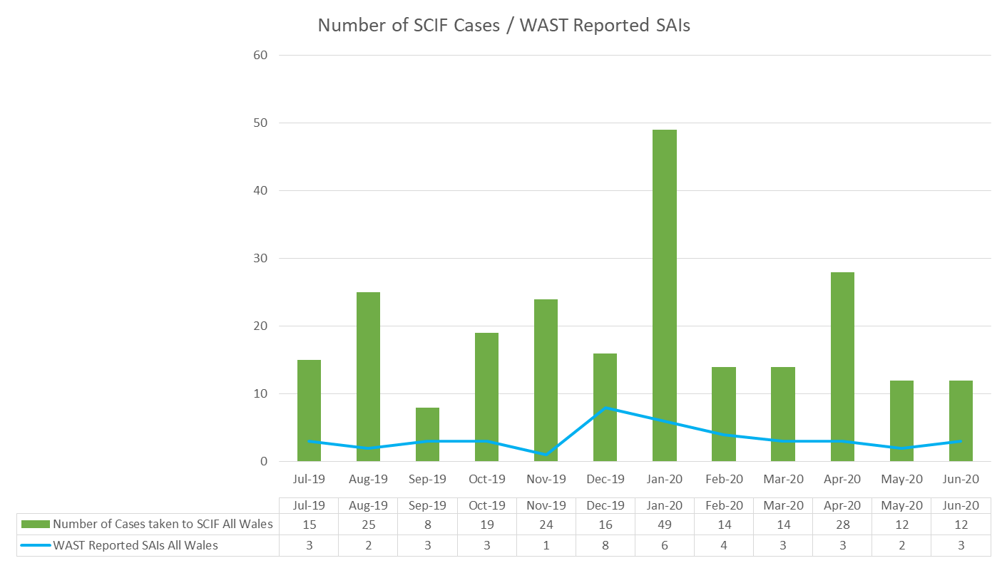

SAIs Reported to Welsh Government
 | ABUHB | SBUHB | BCUHB | CVUHB | CTMUHB | HDUHB | PTHB | Total
2017/18 | 17 | 10 | 12 | 6 | 2 | 1 | 0 | 48
2018/19 | 11 | 7 | 13 | 15 | 1 | 4 | 0 | 51
2019/20 | 13 | 15 | 1 | 6 | 5 | 3 | 1 | 44
2020/21 (Apr to Jun) | 1 | 1 | 1 | 3 | 1 | 1 | 0 | 8

  - Since the last report to EASC no SCIF cases have been passed to health boards:

Coroners’ Activity
  - As of the end of Jun-20 WAST has 64 open coroner cases, of which it is known that the Trust is or is likely to be an interested party in 14 Inquests pan-Wales at this time. These are at various stages of investigation from statement disclosure to date(s) listed for full hearing later in the year.

Longest Waits
  - The Patient Safety Team undertake regular reviews of the longest responses to patients, even where no complaint or concern has been received or raised, this is to provide assurance around the quality of the care that these patients received. The following table details patient waits 12 hours and over.

  - Numbers increased during the winter months with a significant reduction in Apr-20 to Jun-20 triggered by “lockdown” and the significant reduction in demand and increase in ambulance capacity (ambulance units produced and reduction in lost hours). Prior to CoVID-19 the Trust agreed with the CASC (as part of the Amber Review Programme) to dip sample five long waits per month, always including the longest wait. WAST agreed to reinstate this from Jun-20.

EASC is asked to NOTE that:
there are currently 13 open SAIs and 8 in quarter 1 20/21 (compared to 9 in the same period last year).
Three SCIFs have been passed to health boards in quarter 1.
WAST currently has 64 Coroner’s cases open.
WASTs quality, safety and patient experience monitoring arrangements have remained in place during the business continuity period.

Performance

Red Performance
  - Red performance has been maintained above the 65% target in Q1 (it should be noted that the current Welsh Government advice is that there is no formal publication of the monthly statistical release or Ambulance Quality Indicators, so the data is not formally verified at this point in time). There continues to be variation in health board performance with Cardiff & the Vale traditionally the highest performer and Cwm Taf Morgannwg, Hywel Dda and Powys missing the 65% target. The reduction in single crewed Rapid Response Vehicles (RRVs) will be a factor in these three health board areas missing the 65% target. A detailed analysis of Hywel Dda’s performance has been completed, comparing May-20’s performance with Sep-19’s performance, the last time the 65% target was achieved until a significant improvement in Jun-20. WAST has identified a range of options for addressing Hywel Dda’s performance, but will now undertake further analysis on Jun-20’s performance before determining what options to pursue. Similarly, a review of Powys’s performance is being completed.

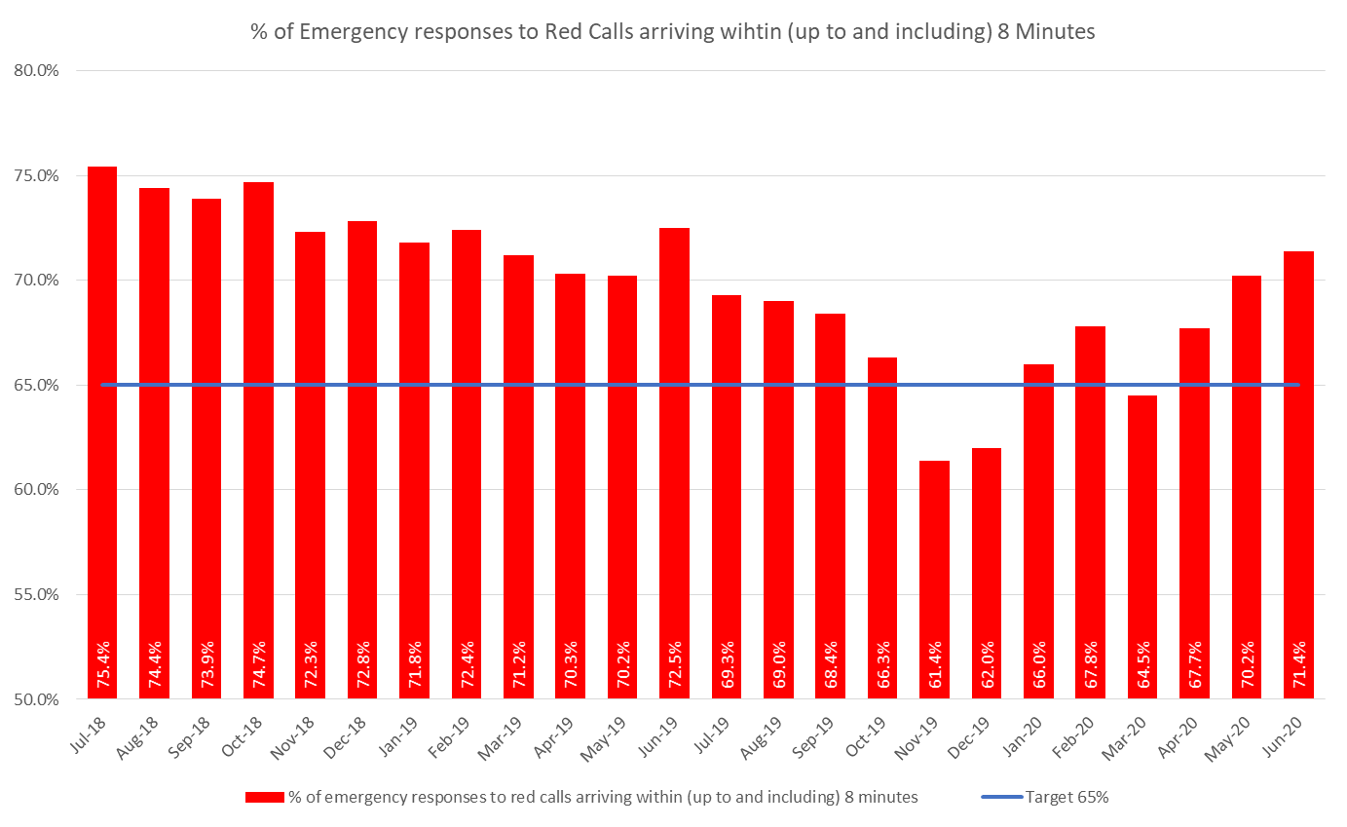

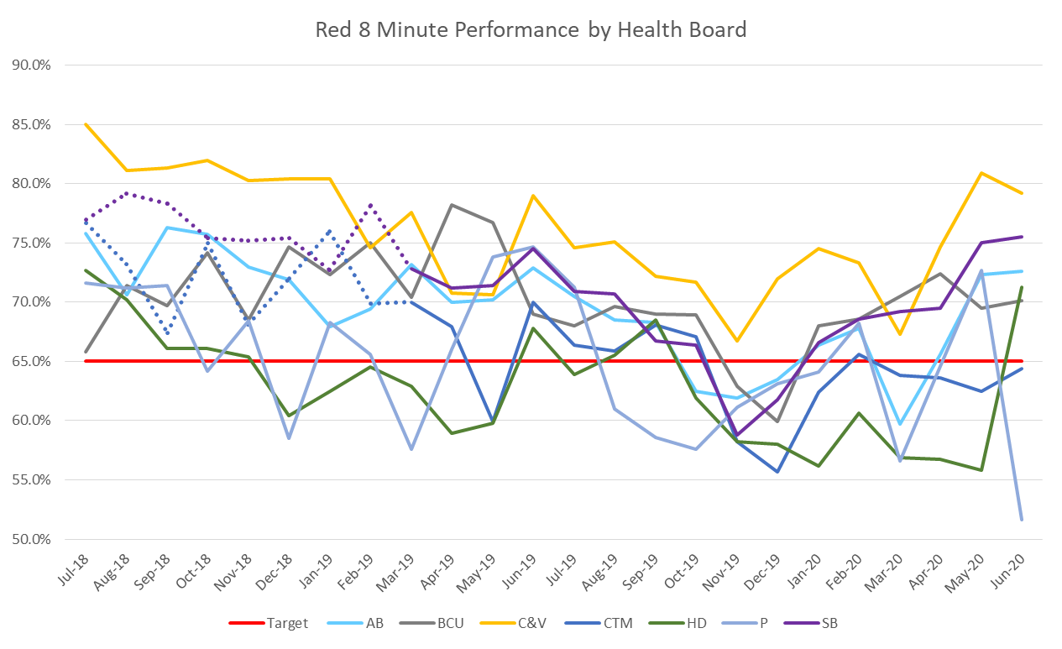
  - Demand changes are one of the main factors affecting performance for all categories of calls. Red demand is shown in the graph below. Red demand increased through 2019/20 as a result of a change in application of the Medical Priority Dispatch System (MPDS) which is seeing a greater proportion of breathing difficulties coded as Red, as previously reported to EASC. Red demand was reduced by 12% in quarter 1, compared to the same period last year, and during the period of “lockdown”. Some initial work has been undertaken by WAST on which Red incident types have reduced during “lockdown”. The CASC requested further analysis at the Jul-20 CASC Quality & Delivery meeting.

  - Overall demand was 12% lower in Jun-20 compared to Jun-19 with the reduction being mainly seen in the Amber 2 category. We may have expected reductions in lower acuity categories in the Clinical Response Model. This does suggest suppressed demand. Further investigation is required and has been requested by the CASC.

  - The number of hours produced by WAST is a second major determinant of performance. WAST reported to the last EASC that with the advent of “lockdown” and the possibility of increased demand and reduced hours produced as a result of staff sickness a decision was made to continue to boost unit hours produced through overtime/use of bank staff and also to increase/maintain our conveying resource by switching Paramedics from Rapid Response Vehicles (RRV) to Emergency Ambulances (EA) (increasing EA actual hours produced and reducing RRV actual hours produced). As a result WAST produced 456,344 hours in the period Mar-20 to Jun-20 compare to 452,434 hours in the same period last year.

  - The third key determinant of performance is handover lost hours. The graph below shows the increasing levels of lost hours over the past year, but a significant reduction in Feb-20, with big improvements seen in AB and CTM UHBs as a result of the cohorting initiatives deployed.

As CoVID-19 took effect and core unscheduled care system demand was suppressed there have been dramatic reductions in handover lost hours during Q1, but with some increase in Jun-20 and localised issues in late Jun-20.

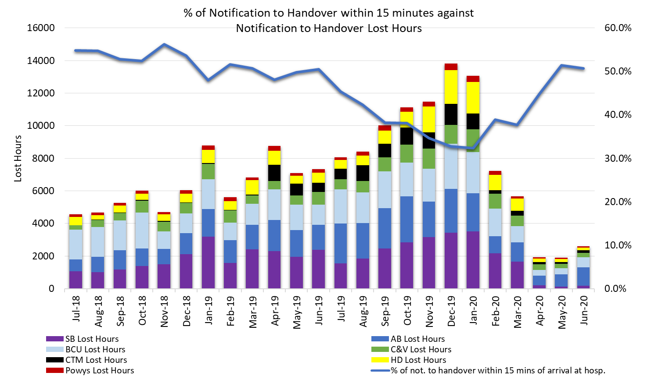

Amber Response times / Amber Review

  - Amber response times are a significant concern and a key issue to be addressed by the EMS Demand & Capacity Programme; however, during the initial phase of the CoVID-19 response there has been a significant improvement in the Amber median, 65th centile and 95th centile times. The reduction in demand, increase in ambulance hours produced and reduction in handover lost hours has had a significant impact on Amber times, in particular, the Amber tail (the 95th percentile) which is sensitive to changes in demand and capacity.

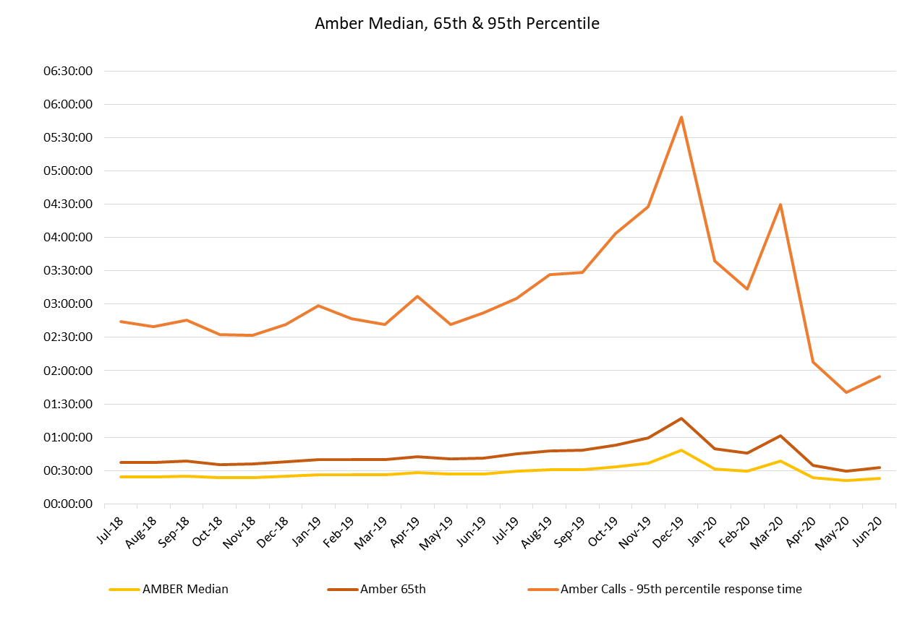
  - The key action in the Amber Review Implementation Programme was the EMS Demand & Capacity Review. A summary of progress to date in implementing the outcome of the EMS Demand & Capacity Review is included later in this report. WASTs Amber Review Implementation Programme is now closed with any residual actions being taken forward through the Ministerial Ambulance Availability Taskforce in collaboration with the CASC and NCCU.

Tactical Seasonal Planning

  - WAST held a tactical seasonal planning workshop on 01 Jul-20. Due to CoVID-19 there will be no formal evaluation of winter 2019/20; however, the workshop reviewed quality and performance through winter 2019/20 and identified the need to undertake some “quick and dirty” evaluations of various 2019/20 initiatives.

  - Whilst there is no formal Welsh Government requirement to produce a winter plan for 2020/21, WAST has decided to produce a tactical seasonal plan that will straddle Q3 and Q4, and will be a key part of the Q3/Q4 organisational plans The plan will be produced around Welsh Government’s six goals for urgent and emergency care and five enablers.

  - WAST has also undertaken scenario modelling for three points in time, including Dec-20 (December usually being the month with the highest demand). WAST’s current forecasting and modelling assumption is that a second wave is unlikely to be higher than the first wave, but what is more difficult to forecast and model is the extent to which core demand and other variables, for example, handover lost hours will be suppressed during a second wave period. WAST is linking the forecasting and modelling to Welsh Government information on R1.1 and “circuit breakers” being applied.

EASC is asked to NOTE that:
the Red 8 minute 65% target has been met through quarter 1 2020/21; however, there is variation between health boards and also variation month on month in the same health board, both of which are currently subject to further analysis by WAST.

EASC is asked to NOTE:
the reduction in the Amber tail (the 95th percentile) which is an on-going area of patient safety/experience concern for EASC and WAST; and how the reduction in demand and increase in capacity has affected performance.

Demand and Capacity Review – Implementation

  - EASC approved the final full report of the independent collaborative EMS D & C Review at its Jan-20 meeting. EASC has agreed to provide non-recurrent funding in 2020/21 to WAST to support the increase in its front line establishment by 136 full time equivalents (FTEs) by Mar-21 (made up of 11.5 Paramedics, 102.4 Emergency Medical Technicians (EMTs) and 22.1 Unscheduled Care Staff (UCS)). The Trust will also be contributing to the funding of this increased number of staff.

  - The planned recruitment forms part of a wider EMS Demand & Capacity Programme (with seven projects). During the initial phase of CoVID-19 only the recruitment & training project remained switched on; however, WAST is now in the process of switching back on the programme. WAST provided updates to the EASC Management Group 26 Jun-20 and CASC Quality & Delivery meeting (03 Jul-20). The CASC has requested a separate one off EASC Management Group in Jul-20 on the programme and WAST IMTP delivery (see paragraph 2.23 below).

  - WAST has established an EMS Demand & Capacity Programme Board, with the NCCU represented, mirroring the collaborative approach adopted for the Review itself.
  - Despite CoVID-19 WAST has made good progress on the recruitment and training project:-
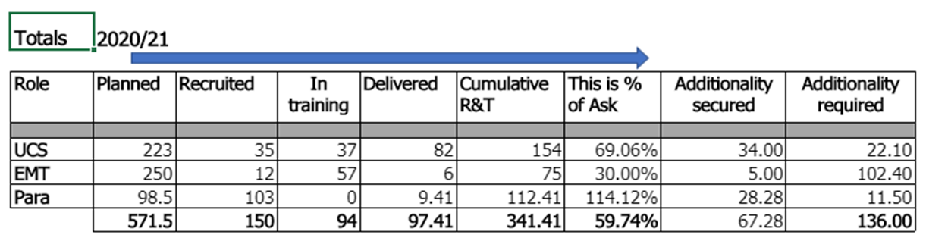
Note: Information accurate as per 12 Jun-20 i.e. 15 Jun-20 programme board.

  - 60% of the recruitment and training plan has been recruited/in-training/delivered and 49% of the “additionality” i.e. of the 136 FTEs additional FTEs funded by EASC for 20/21 has been recruited/in-training/delivered (these figures do not include the impact of the opening of the Grange University Hospital or any other major service changes).

  - The current estimated costs of the EMS Demand & Capacity recruitment & training for 20/21 is £4.712m with recurrent costs of £5.427m excluding the recurrent impact of the Advanced Paramedic Practitioners (APPs) expansion of £1.000m. Current funding arrangements for 20/21 are £1.8m recovered via EASC from health boards, maximise all resources and WAST contributions of £2.435m: overall total of £4.235m. The current cost of the recruitment and training is £5.712m leaving a shortfall of £1.477m. Decisions are required around funding the gap or the planned future recruitment and training needs to be stopped. The UCA training cohorts 13 & 14 planned to commence on 20 Jul-20 has now become a critical date for the programme, hence the request from the CASC for a one off meeting on the programme and IMTP as per paragraph 2.29 above.

  - The 136 FTEs are currently being “landed” in line with the relief gap identified in the Review, and agreed with the CASC, but this is under review, in particular, whether there is an ability to improve pan-Wales Red performance by front loading the “landing” in some health boards.

  - Whilst the funding for the recruitment & training project is now a high risk to the programme, the very high utilisation of WAST’s estate has also been identified as a strategic risk to the programme (with the Grange University Hospital (GUH) and the NEPTS Demand & Capacity Programme adding to this risk).

A detailed analysis of the estate is currently being undertaken, which will be reported to the EMS Demand & Capacity Programme Board on late 31 Jul-20.

  - In terms of the other six projects in the programme, these are all now either turned back on or are partially turned back on with the exception of the Clinical Contact Centre (CCC) Reconfiguration project which has been provisionally suspended until Q1 2021/22.

  - Whilst WAST is making good progress on the FTE additionality for 20/21, EASC and WAST need to start giving consideration to recruitment and training in future years. Some strategic steer from EASC on future recruitment and training intentions is key to enabling WAST to take decisions on estate in a timely manner so that a lack of estate does not become a major barrier to the programme.

EASC is asked to NOTE that:
a programme management approach has been adopted to implement the recommendations of the EMS Demand & Capacity Review; good progress has been made on recruitment & training, but urgent consideration is now required on the underpinning financial plan; the high utilization of the existing estate is a potential barrier to the programme and is currently under detailed review; and that a strategic steer from EASC on future recruitment and training intentions is a key enabler for WAST to enable decisions on estate to be made in a timely manner.

Developments / Planning
Health Board Service Changes

  - ABUHB’s Board has now agreed to a Nov-20 opening of the GUH (subject to WG approval), with a further approval from ABUHB Board pending in mid-July on the transport model. WAST and ABUHB have largely reached agreement on the principles of the model, and that WAST will determine the transfer priority for the highest acuity patients, with access to clinicians within the CCC where necessary.

  - In reaching this agreement WAST is now able to commence recruitment to the service on the basis on 84FTE required as a mixture of NEPTS and urgent care crews, with an additional EMS paramedic crew for 12 hours per day for the highest acuity step up transfers; however, the confirmation of the opening being brought forward puts additional pressure on our recruitment and training teams, as well as the need to secure additional CCC capacity, fleet and estates. Delivery of this increased level of service is possible by the end of Nov-20, but there are clearly associated risks which ABUHB, WAST and the NCCU will be working through now at pace.

  - Whilst the business as usual health board change work has been suspended there has clearly been a significant change to the hospital footprint across Wales as a result of CoVID-19. WAST has established, in collaboration with the NCCU, a WAST national health board surge capacity project team with regional cells plugged into health boards, so that WAST can gather intelligence and respond to the transport requirements associated with these field sites. It is important that Health Boards continue to ensure that WAST is kept appraised of all plans that will impact on transport requirements.

  - During the first phase of CoVID-19 WAST forecast and modelled the transport requirements for the planned surge sites. WAST is currently undertaking revised forecasting and modelling based on its CoVID-19 adjusted NEPTS average patients per journey and emerging “new normal” demand pattern. WAST is also closely monitoring the daily infection data, conveyance levels and bed utilisation information per health board, in combination with intelligence from health boards, to guide what additional transport capacity WAST is required. The reduced NEPTS capacity, driven by the reduced average patients per journey is an identified risk.

NEPTS (Non-Emergency Patient Transport Service)

  - Following the decision to suspend much of the normal health board activity, the NEPTS teams areas of work have been focused on ensuring that a high quality service continues to be provided to essential outpatients (as determined by health board clinicians), patients requiring transport to access renal dialysis and oncology treatment and ensuring a timely service for patients requiring discharge home or transfer to an alternative place of care.

  - In order to respond to Welsh Government advice on social distancing and to ensure staff and patient safety the service has had to make or respond to several changes to its normal methods of service delivery, these are:
- Limits on the numbers of patients per vehicle. Maximum loading is now 2 patients per ambulance (previously max of 5) and 1 per car type vehicle (previous max of 3)
- Vehicle screens between the cab and saloon of the vehicle
- Separating suspected & confirmed CoVID-19 patients to travel alone
- Additional Personal Protective Equipment (PPE) requirements
- New booking, planning and allocation processes
- Reductions in the levels of available volunteers, and
- Increased sickness levels due to a high proportion of staff within the shielded category.

  - These changes have reduced the ability of the service to maximise vehicle utilisation, which has dropped from an average of 2.1 patients per run in April 2019 to 1.4 patients per run in April 2020.

  - Whilst the overall reduction in demand has offset this loss of efficiency during the initial phase of the pandemic, the service’s ability to manage a resumption of business as usual activity without significant additional investment in additional resources is likely to be compromised. It is therefore imperative that health boards ensure that they engage at the earliest possible stage of service planning and includes transport support as an integral part of any planning work undertaken. Without meaningful engagement there is a significant risk that an appropriate transport support provision will not be able to be delivered to support health board service delivery. In recognition of this risk and to provide a formal mechanism for engagement and oversight, the NEPTS Delivery Assurance Group (DAG) has recommenced meeting fortnightly on a virtual basis. In addition, simulation modelling is currently being undertaken on the revised demand pattern for NEPTS and revised capacity to transport.

  - Following a pause in progress WAST has turned back on the NEPTS Demand & Capacity Review, with a revised completion date of Nov-20 (original data: Jul-20).

IMTP 2020/23 & Operating Framework & Critical Path

  - WASTs IMTP was submitted on the 31 Jan-20, endorsed by EASC on 28 Jan-20 with written support from the CASC. The IMTP integrates EASCs commissioning intentions for EMS and NEPTS into a plan which clearly articulates a commitment to quality and delivery of ‘A Healthier Wales’ Quadruple Aim.

  - Whilst the IMTP was not approved formally, the Trust Board maintains a keen interest in the IMTP’s highest priority programmes and a number these are directly linked to EASC commissioning intentions.

These have therefore been incorporated into WAST’s quarterly operational planning cycle.

  - WG now requires WAST and other NHS bodies to submit quarterly operational plans whilst the NHS continues to manage services in response to the CoVID-19 pandemic. Our quarter 2 operational plan sets out four key areas where the Trust needs to focus its attention as it enters a period of flexible response whilst planning for recovery:

- Respond flexibly – a set of actions that maintains the Trust’s preparedness for future spikes in COVID-19 related demand and in support of NHS Wales Essential Services. This incorporates our collaborative approach to modelling demand and capacity, our approach to tactical seasonal planning and monitoring of health board surge capacity, business as usual and operational service changes.
- Lead important programmes internally and across the system – this includes restarting our IMTP priorities but also our lead role across some of the national Unscheduled Care programme’s six goals.
- Support our staff – this is a vitally important component of our plan, as we ensure staff are safe and well both on the frontline but also working from home. We have received significant feedback from a Trust wide staff survey and we will be using the results of the survey to inform our plans to support staff over the coming months as we plan how we can safely return staff to the workplace as well as managing infection control, PPE and the impact of Test, Trace and Protect.
- Learning from what has worked – like all NHS bodies, WAST has learnt an enormous amount from its response to COVID-19 so far and we are seeking to amplify those service changes, systems changes or digital and technological advancements where these are in line with our strategic ambition and commissioning intentions.

  - Our current IMTP priorities are:
- Recruit the agreed staffing numbers to deliver the EMS Demand and Capacity Review
- Respond to major service changes such as the opening of the GUH, the South Wales Major Trauma Network and surge capacity changes across Wales
- Continue planning for the electronic Patient Care Record and 111 ICT systems
- Continue to work on those major capital schemes prioritised within the reduced capital allocation
- Complete CCC Clinical and NEPTS Demand and Capacity reviews
- Replace fleet within available resources and refresh our fleet plans.

  - In recognition of the scale of work required to continue to respond to the pandemic, take forward important programmes of work and plan for recovery, the Trust has stood back up its Strategic Transformation Board on a 6 weekly basis. It will have two key roles in the current operational environment:
- to review the Trust’s priorities against a set of recovery principles using a scoring criteria to determine the priority order of work, which incorporated government mandate and EASC commissioning requirements as one of the key criteria
- to monitor delivery of those priorities within the context of Trust’s quarterly operational plan.

  - In recognition that EASC will need to make important commissioning decisions on a number of WAST’s priorities a critical path has been included at Appendix 1. This highlights the following areas:

- Operational Delivery Unit (ODU) – sign off of a business case to enable the structure to be in place ahead of winter
- Tactical Seasonal Planning – agreement on the actions and changes that need to take place ahead of winter
- EMS Demand & Capacity Programme – resolve financial plan to enable next cohort of UCA training, decision on whether to re-roster and decisions around future recruitment and training, as well as a review of estates constraints
- GUH – highlight the important timescales within the GUH transport implementation project, financial considerations and impact on the EMS Demand and Capacity implementation
- Forecasting & Modelling – completion of modelling for Q3 and Q4, and
- NEPTS Demand & Capacity Review – complete review and agree actions with EASC for inclusion in next IMTP round.

  - A critical path of key decision dates for WAST (and where relevant EASC) is included in Appendix 1.

Leading Service Change across Wales

  - Acknowledging that EASC collectively are not currently the commissioners of the 111 service in Wales, nevertheless, it is helpful to set out one of the key priorities identified by WAST in its Q2 plan.

  - A series of 6 goals have been identified for Urgent and Emergency Care in Wales. One of the deliverables under Goal 2 states: ‘To support care in the right place and enable social distancing in Emergency Departments, a ‘phone first before attending ED’ or ‘phone and walk’ concept targeted at patients who could be safely assessed elsewhere or through a planned approach will be developed and tested by the end of Q2 (NATIONAL / LOCAL)’.

  - This priority deliverable resonates strongly with WAST’s ambition, articulated in its long term strategy and IMTP, to become the ‘call handler of choice’ and to strengthen and integrate clinical triage and assessment services.

  - The Trust is now the national provider of all 111 and NHSDW services, and once the 111 service has been rolled out into the rest of Cwm Taf Morgannwg in September 2020, will be providing services across 5 of 7 health boards. The Trust is in a strong position to be able to lead and support this work across Wales, given its experience and expertise in this area, the alignment with its strategic ambitions, and its national focus, ensuring a once for Wales approach can be taken. A view on the resources required to come together to undertake this work will be required, but the Trust is keen to step into this space and add value to the health system in Wales.

  - CEOs and Chief Operating Officers (COOs) have previously agreed on the need for greater system leadership around escalation within unscheduled care.

  - WAST implemented the Operational Delivery Unit (ODU) on 27 Jan- 20. Chief Operating Officer (COOs) were engaged in developing the ODU indicators and pre-CoVID-19 there was positive feedback from health boards (and Welsh Government) on the benefits of the ODU: this has continued during the pandemic. To support the initial proof of concept WAST has abstracted key managers to take a lead, but this is not a sustainable long term solution.

  - The ODU has been supported during the CoVID-19 period using some redeployed staff who, whilst not from our operational cohort, have proven incredibly valuable to us as we have responded to the pandemic. This has offered useful insight to inform our further development. Operating hours have extended to now cover Mon to Fri 08:00-00:00 and weekends 09:00-21:00. The Regional Escalation Stages went live from Monday 30 Mar-20, and the stage for each region is now settled at the daily regional safety huddles. This has been tested over the last couple of months as demand and delays have increased and encourages the region to agree diverts as part of the process.

  - As a result WAST is now developing an organisational structure to put the ODU on a permanent footing in preparation for next winter.

  - The ODU is, we believe, beginning to prove its potential across the system, and a business case has now been developed which will be considered by both COOs and the CASC.

EASC is asked to note that:
WAST will require an additional 84 FTEs to service the ambulance transport requirements of the GUH and may need to source external providers depending on the opening date; close attention is being paid by WAST to the transport implications of revised clinical models/hospital footprints, so that the ambulance transport requirements can be delivered in a timely manner; the capacity of NEPTS has been significantly reduced by social distancing and this reduced capacity poses a risk to the system as the “new normal” emerges (this is currently being modelled); that WAST has submitted its Q2 Operating Framework with four areas of focus – flexibility, priority programmes, staff and learning; and that Appendix 1 includes a critical path of decisions for WAST (and EASC) in 20/21.

- KEY RISKS/MATTERS FOR ESCALATION TO THE COMMITTEE

Members of the EAS Committee are asked to note:

  - WAST’s Pandemic Influenza Plan/business continuity arrangements have been effective, that WAST continues to work within the framework of these plans/arrangements and WAST is now in a period of monitoring/flex response as the wider health care system returns to “normal”
  - Quality, safety and patient experience monitoring arrangements have remained in place
  - Red 8 minute 65% target has been met in quarter 1 2020/21, but there is variation at a health board level which is being analysed
  - There has been a significant improvement in Amber performance in quarter 1, in particular, the Amber tail, as a result of reduced demand, increased ambulance production and reduced handover lost hours
  - The recruitment and training project for the EMS Demand & Capacity Programme has been maintained during the pandemic and has made good progress, but urgent consideration is now required on the underpinning financial plan for the year, with a one off EASC Management Group to determine next steps
  - The planned opening (Nov-20) of the GUH will have a significant impact on WAST’s recruitment and training programme with a further uplift of 84 FTEs and a potential need to source external providers to support the ambulance transport requirement
  - A strategic steer will be needed from EASC in quarter 2 on its future recruitment and training commissioning intentions for EMS, so that WAST can make timely decisions on fleet and estate
  - WAST is monitoring health board requirements for additional ambulance transport required to service revised clinical models/hospital footprints in each health board
  - Early engagement with WAST on transport needs is key
  - NEPTS has continued to provide patient critical journeys as determined by health board clinicians, but social distancing has significantly reduced NEPTS capacity and is a risk to the system (risk currently being quantified through modelling)
  - WAST continues to operate within its business continuity plan
  - WAST has submitted its Q2 Operating Framework with a focus on four areas: flexibility, priority programmes, staff and learning
  - WAST has supplied the CASC (and EASC, see Appendix 1) with a critical decisions path for 2020/21
  - WAST has set out in its Q2 plan an offer to the system to lead on delivery of national deliverables linked to the 111 service, and
  - WAST has continued to developed the ODU on behalf of the wider system during quarter 1 with an ambition to put it on a permanent footing with a permanent structure, subject to the availability of funding streams.

- IMPACT ASSESSMENT

Quality/Safety/Patient Experience implications | Yes (Please see detail below)
Quality/Safety/Patient Experience implications | Identified within the report
Related Health and Care standard(s) | Timely Care
Related Health and Care standard(s) | And all health and care standards
Equality impact assessment completed | Not required
Legal implications / impact | There are no specific legal implications related to the activity outlined in this report.
Legal implications / impact | Included within the body of the report
Resource (Capital/Revenue £/Workforce) implications /  Impact | Yes (Include further detail below)
 | Included within the body of the report
Link to Main Strategic Objective | The Committee’s overarching role is to ensure its Commissioning Strategy for Emergency Ambulance Services utilising the five step patient pathway outlined within the National Collaborative Commissioning Quality and Delivery Agreement and the related outcomes for each care standard aligned with the Institute of Healthcare Improvement's (IHI) ‘Quadruple Aim’ are being progressed.  This report focuses on all the above objectives, but specifically on providing strong governance and assurance and safe and effective patient care
Link to Main WBFG Act Objective | Service delivery will be innovative, reflect the principles of prudent health care and promote better value for users

- RECOMMENDATION

  - The EASC Committee is asked to:
- DISCUSS and NOTE the WAST provider report.

