AGENDA ITEM
2.3

EMERGENCY AMBULANCE SERVICES COMMITTEE

EMERGENCY MEDICAL RETRIEVAL AND TRANSFER SERVICE UPDATE

Date of meeting | 14/07/2020

FOI Status | Open/Public

If closed please indicate reason | Choose an item.

Prepared by | Matthew Edwards, Programme Manager EMRTS Cymru
Presented by | David Lockey, National Director, EMRTS Cymru
Approving Executive Sponsor | Chief Ambulance Services Commissioner

Report purpose | FOR DISCUSSION / REVIEW

Engagement (internal/external) undertaken to date (including receipt/consideration at Committee/group)
Committee/Group/Individuals | Date | Outcome
Choose an item. | (xx/xx/2020) | Choose an item.

ACRONYMS
EMRTS  ITU  WAST | Emergency Medical Retrieval and Transfer Service  Intensive Therapy Unit  Welsh Ambulance Services NHS Trust

- SITUATION/BACKGROUND

The aim of the report is to provide an update to the Members of the EAS Committee on the work of EMRTS Cymru

COVID-19
An escalation plan was developed in response to COVID-19. Whilst staff availability was impacted by staff illness, self-isolation and the recall of EMRTS Consultants to their host Health Board, this was managed by adjusting rotas accordingly in order to maintain the EMRTS commissioned service.

During this period, it was noted that:
- EMRTS activity had reduced significantly by approximately 30-40% (in line with other UK Air Ambulance services as reported in weekly conference calls)

- In addition to the release of EMRTS Consultants back their host Health Board, EMRTS supported the wider NHS Wales community with x2 Air Support Desk staff members being released back to support WAST, the EMRTS Patient Liaison Nurse returning to support her previous department within Aneurin Bevan Health Board’s Critical Care Unit, EMRTS Critical Care Practitioners and Helicopter Transfer Practitioners undertaking further ITU training at Neville Hall and Morriston Hospitals in readiness to provide support in case of a surge in demand and the coordination of an emergency capacity transfer team on standby.

Recent Activity

01/01/2020 – 31/06/2020
The service entered the year with normal levels of activity, but saw a sharp decline towards the end of March and into April, in keeping with the effect of the pandemic. Following adjustments, the service recovered to higher levels of activity. The service saw increased levels of road response and conveyance, largely due to the introduction of the twilight rapid response vehicles (RRV), but also in keeping with restrictions around air transport of patients with suspected COVID19.
- The overall response by road was 61% and the remainder by Air
- 92.5% of missions were primary in nature, with the remainder secondary inter-hospital transfers
- The split between trauma and medical cases was 50%, in keeping with average figures of previous comparable periods
- 63% of patients attended were transported to hospital, of which 73% had an EMRTS clinical escort.

A breakdown of activity is included below, including comparison on previous calendar year.

Figure 1 Monthly activity 2020 2
Figure 2 Monthly activity by base and response mode 3
Figure 3 Incidents by Local Health Board (LHB) 3
Figure 4 Map of activity by postcode area 4
Figure 5 Annual activity comparison 4

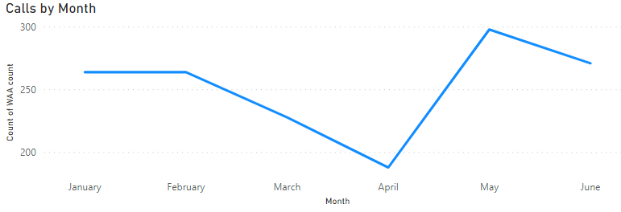
Figure 1 Monthly activity 2020

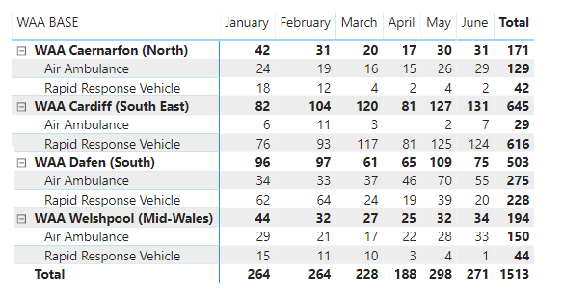
Figure 2 Monthly activity by base and response mode
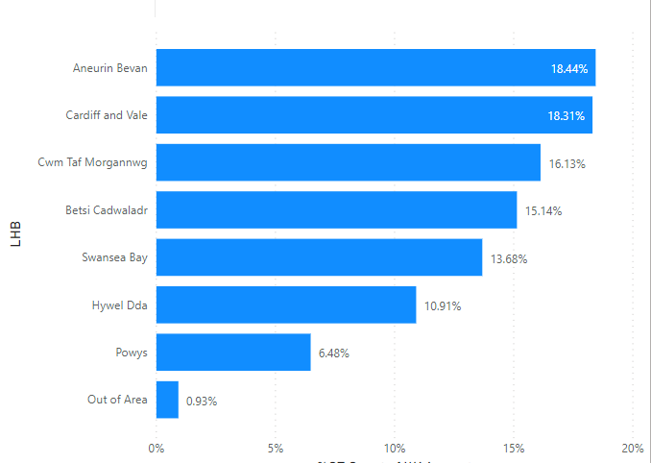
Figure 3 Incidents by Local Health Board (LHB)

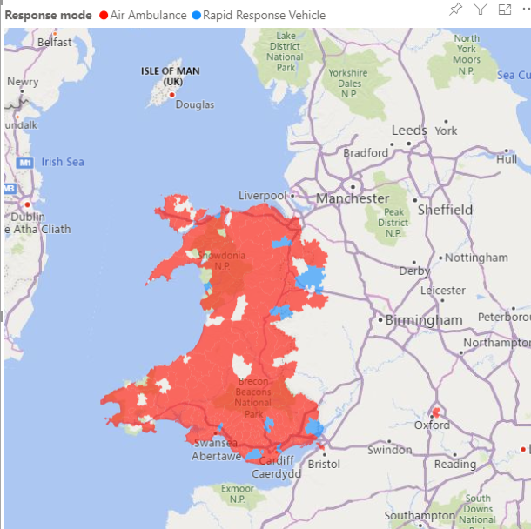
Figure 4 Map of activity by postcode area

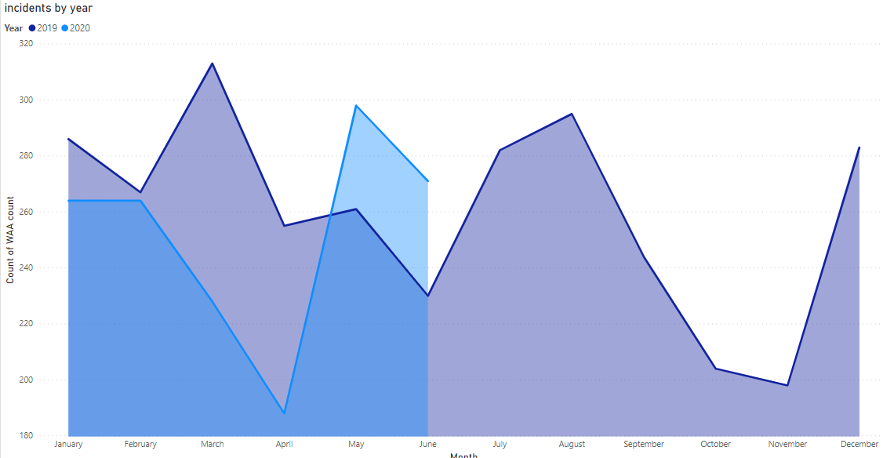
Figure 5 Annual activity comparison

Twilight Rapid Response Vehicle (RRV)
The service operated an extended ‘Twilight’ Critical Care RRV service with winter pressures funding from December 2019 - March 2020 between the hours 14:00-02:00.

Starting off 3 days per week and escalating to a 5 day service as staffing allowed. This resulted in 64 duty shifts, all staffed by a consultant & critical care practitioner (CCP).

In total the service reported 203 calls made during that period (average 3.2 calls per shift) with the Cardiff & Vale region recording the most calls (85) [1]. The vast majority (93.6%) of calls were made outside of hospital (e.g. patient’s home or scene of road traffic accident), whereas only 13 calls (6.4%) were requiring secondary transfer of patients to another specialist facility.

The Air Support Desk was staffed by an Allocator or Clinician from 20:00 – 02:00, rather than the usual configuration. The map below highlights the areas covered by the Twilight RRV in South Wales and the number of calls made by each health board (Figure 6).

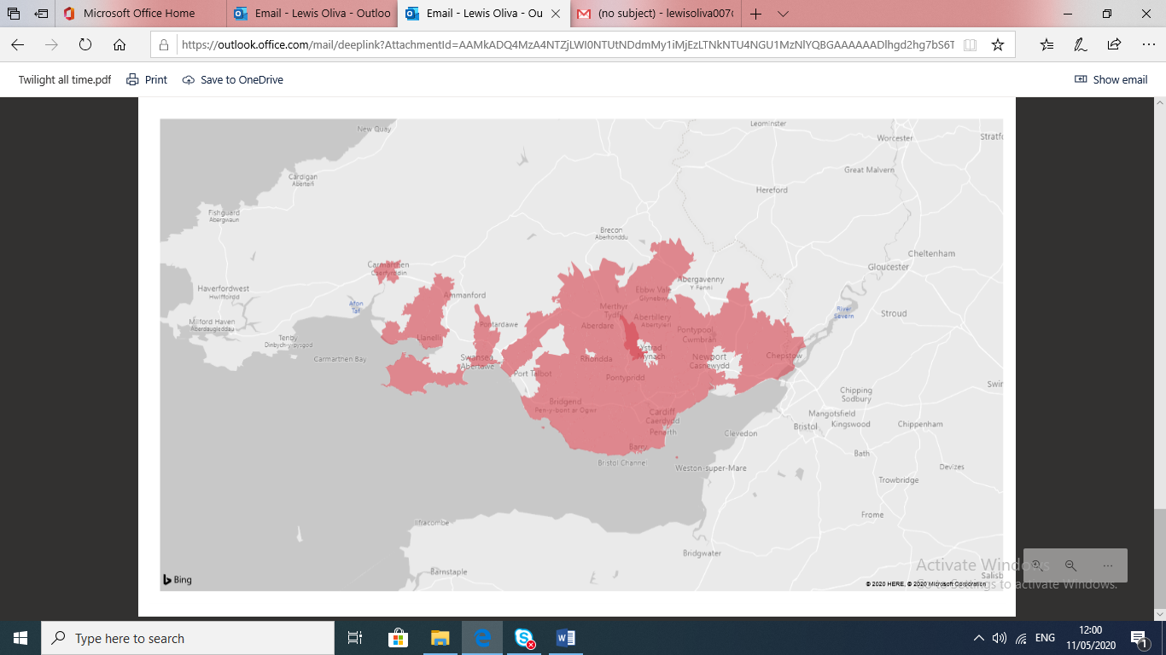
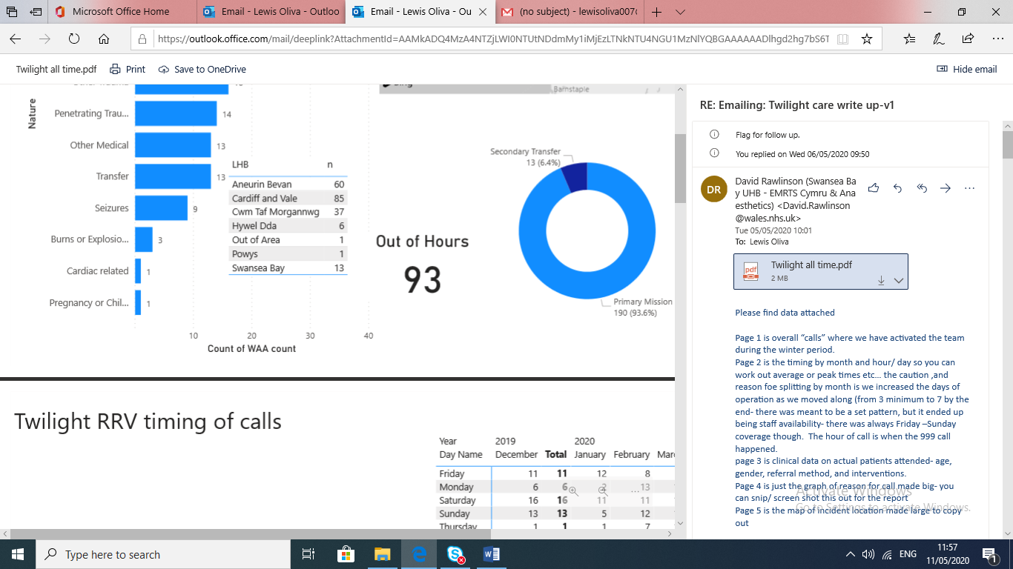

Figure 6 Areas covered and number of calls made during period of extended service by EMRTS Cymru
The vast majority of calls were made from the more densely populated areas of South Wales, supplied by the Cardiff and Vale (42%) and Aneurin Bevan (30%) health boards respectively.

Powys, only recorded one call during the period.

A large volume of calls were made on the weekend (45%), with Saturday being the most frequent (24%, n=49) followed closely by Sunday (21%, n=43).

The highest call volume was received between 14:00-15:00 when the team had just begun their shifts (11%, n=22).

The median age of the patients treated during the period was 43 (range 1-90 years), with 64.32% being male.
Figure 7 Nature of calls

Out of 203 calls made, 128 patients were attended by the EMRTS RRV. 38 (29.7%) of these patients required intubation, 28 (21.9%) required anaesthetics and 5 (3.9%) patients received blood products.

A breakdown of call nature is illustrated below in figure 7.

Cardiac arrests were the most common reported issue resulting in 39 (19.2%) of the calls made followed by road incidents which resulted in 27 calls (13.3%).

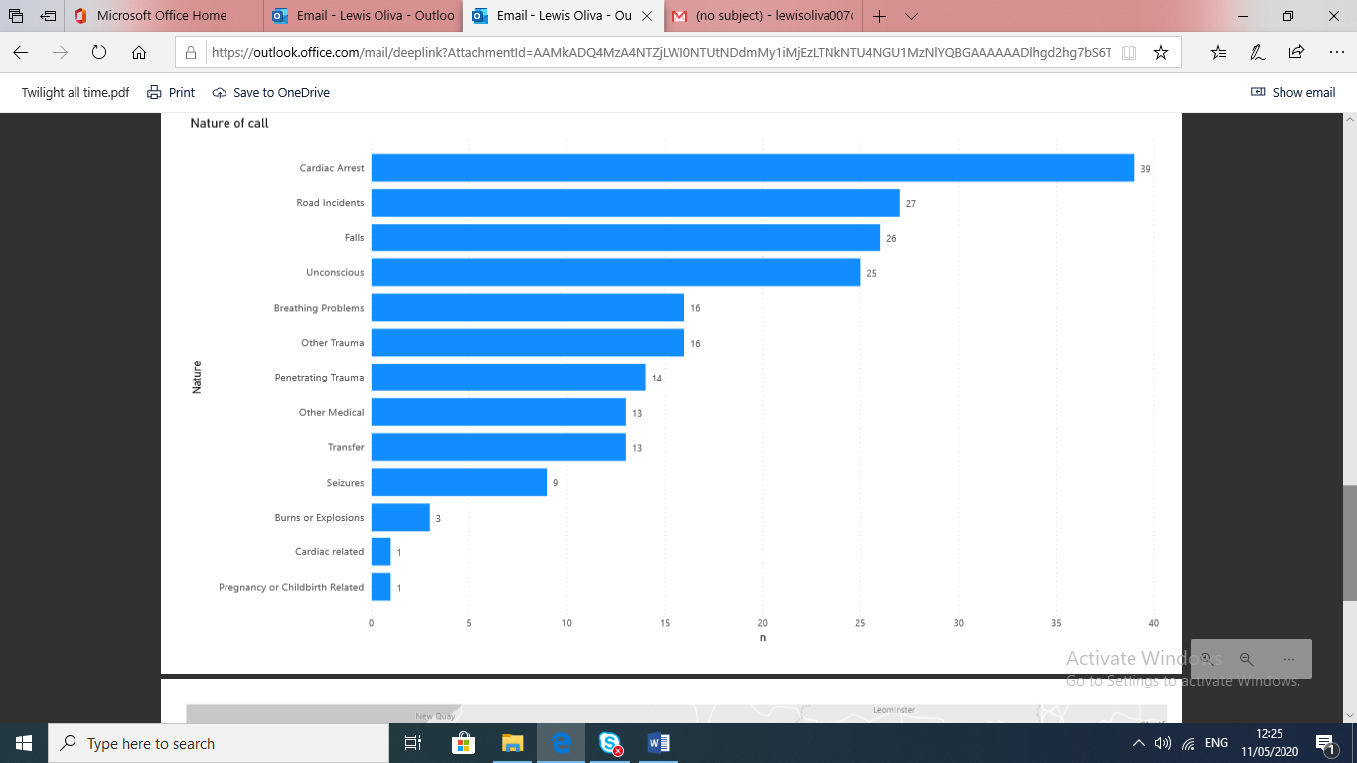

- SPECIFIC MATTERS FOR CONSIDERATION BY THIS MEETING (ASSESSMENT)

24/7 Service Expansion
Following postponement of the original 1st April expansion date, the service has provided a 7-day 1400-0200 twilight car throughout this period in order to effectively utilise its staff resources and to meet the demonstrated demand. Air support will follow asap, with the Charity working with the aircraft operator to progress this matter.

On 1st July, our service commenced night operations by car from Cardiff Heliport, following a significant recruitment, induction and training programme. This new service will now be reported on via the recently developed EMRTS Quality & Delivery Framework.

Frequent discussions are being held with WG capital colleagues regarding the outstanding capital allocation.

National Critical Care Transfer Service
In September 2019, the Deputy Chief Medical Officer formally requested that the Emergency Ambulance Services Committee (EASC) work with Welsh Ambulance Services NHS Trust (WAST) and the Emergency Medical Retrieval and Transfer Service (EMRTS) to prepare an implementation plan to develop a national transfer service for critically ill adults. An indicative allocation of £1.7m was allocated for this purpose.

EASC worked with relevant stakeholders to develop an implementation plan for the introduction of two regional assets (one each in North and South Wales) for submission to Welsh Government (WG) in November 2019. The plan included establishing the service as a division within EMRTS, with ring-fenced funding, appropriate governance arrangements and operating under a collaborative commissioning framework with EASC.

In addition to revenue and capital costs, the plan also included set-up costs including clinical leadership, project management, IT support, staff training and induction costs.

A 12 month set-up period was set out with the key milestones ahead of service delivery being:
- Capital and revenue funding approval
- Appointment of key set-up posts (clinical lead, project manager, commissioning and administrative support)
- Effective stakeholder engagement
- Appointment of the specified operational posts
- Roll-out of induction and training programmes
- Procurement and commissioning of equipment.

Following discussions with WG, confirmation of funding has now been provided by the Chief Ambulance Services Commissioner, along with a request to proceed with the appointment of the clinical lead and project manager support required to progress this work.

Job Descriptions have been matched for some of the key set-up costs, these adverts have now closed for shortlisting.

- KEY RISKS/MATTERS FOR ESCALATION TO THE COMMITTEE

Members should note:
- the Covid-19 escalation plan remains in place
- the impact of Covid-19 on the EMRTS activity to date
- the activity and coverage of the EMRTS twilight car
- the commencement of night operations from 1st July 2020
- the progress towards the establishment of the National Critical Care Transfer service and the selection of the Clinical Lead and Clinical Project Manager.

- IMPACT ASSESSMENT

Quality/Safety/Patient Experience implications | Yes (Please see detail below)
Related Health and Care standard(s) | ALL are relevant to this report
Equality impact assessment completed | Not required
Legal implications / impact | There are no specific legal implications related to the activity outlined in this report.
Resource (Capital/Revenue £/Workforce) implications /  Impact | Yes (Include further detail below)
 | Identified within the report
Link to Commissioning Intentions | The Committee’s overarching role is to ensure its Commissioning Strategy for Emergency Ambulance Services utilising the five step patient pathway outlined within the National Collaborative Commissioning Quality and Delivery Agreement and the related outcomes for each care standard aligned with the Institute of Healthcare Improvement's (IHI) ‘Quadruple Aim’ are being progressed.
Link to Main WBFG Act Objective | Service delivery will be innovative, reflect the principles of prudent health care and promote better value for users

- RECOMMENDATION

  - The Emergency Ambulance Services Committee is asked to:
    - DISCUSS and NOTE the report.

