AGENDA ITEM
2.3

EMERGENCY AMBULANCE SERVICES COMMITTEE (EASC)

welsh ambulance services nhs trust (WAST)
provider update

Date of meeting | 13 Jul 2021

FOI Status | Open/Public

If closed please indicate reason | Choose an item.

Prepared by | Rachel Marsh, Director of Strategy, Planning and Performance (WAST)
Presented by | Jason Killens, Chief Executive WAST
Approving Executive Sponsor | Chief Executive

Report purpose | FOR DISCUSSION / REVIEW

Engagement (internal/external) undertaken to date (including receipt/consideration at Committee/group)
Committee/Group/Individuals | Date | Outcome
(Insert Name) | (DD/MM/YYYY) | Choose an item.

ACRONYMS
ABUHB  CTMUHB  D&C  EMS  NCCU  NEPTS  SAI  WAST | Aneurin Bevan University Health Board  Cwm Taf Morgannwg University Health Board  Demand and Capacity  Emergency medical services  National Collaborative Commissioning Unit  Non-emergency patient transport services  Serious Adverse Incident  Welsh Ambulance Services NHS Trust
- SITUATION/BACKGROUND

  - The purpose of this report is to provide EASC with an update on key issues affecting quality and performance for Emergency Medical Services (EMS) and Non-Emergency Patient Transport Services (NEPTS) and to provide an update on commissioning and planning for EMS and NEPTS.

- SPECIFIC MATTERS FOR CONSIDERATION BY THIS MEETING (ASSESSMENT)

COVID-19

2.1 The Welsh Ambulance Services NHS Trust (WAST) is tracking COVID-19 and related metrics through its weekly COVID-19 Intelligence Pack. The Trust is now considering how to forecast for the 111 service and forecasting and modelling has commenced for winter planning.

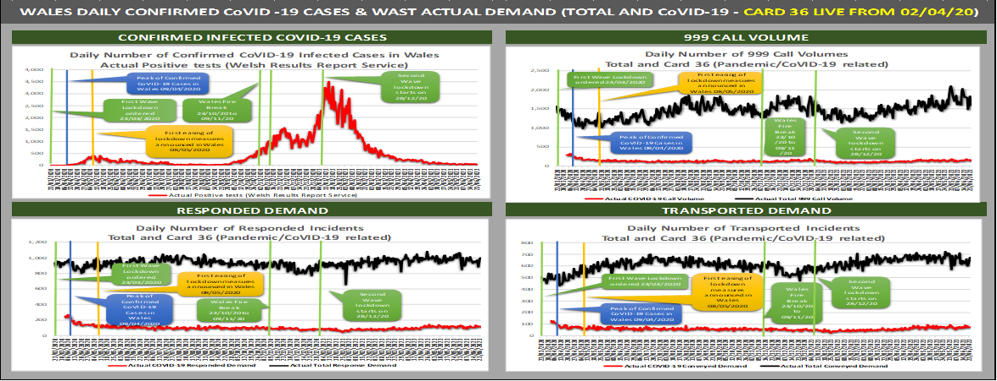

2.2 Tactical COVID-19 forecasting, modelling and planning was also undertaken for WAST’s Summer Plan, which is now active with further work now being undertaken on WAST’s Winter Plan, both of which are described in more detail later in the report.

EASC is asked to NOTE that: WAST has now entered its recovery phase (Pandemic Influenza Plan); the recent increase in positive test results has not had a significant impact on call demand, response demand or conveyance demand, but COVID-19 has had a significant impact on roster abstractions and capacity.
Quality, Safety & Patient Experience

Patient Response Times in the Community

2.3 One of the key indicators which measures the quality of the service provided is the timeliness of the response by WAST to patients waiting in the community. The graphs below show the current response times performance for Red calls and for Amber calls. Both graphs show that during the first wave of the pandemic, response times improved significantly, with Amber response times particularly improved; however, response times worsened during the second wave before beginning to recover again in quarter four. Inevitably these worsening times have had an impact on patient safety.

2.4 The Red 8-minute target was not achieved in Jun-21. The percentage of emergency responses to Red incidents within 8 minutes was 60.90% (target 65%) with 95% of Red calls receiving a response within 19 minutes. The Amber median percentile in Jun-21 was 59 minutes and the Amber 95th percentile was five hours.
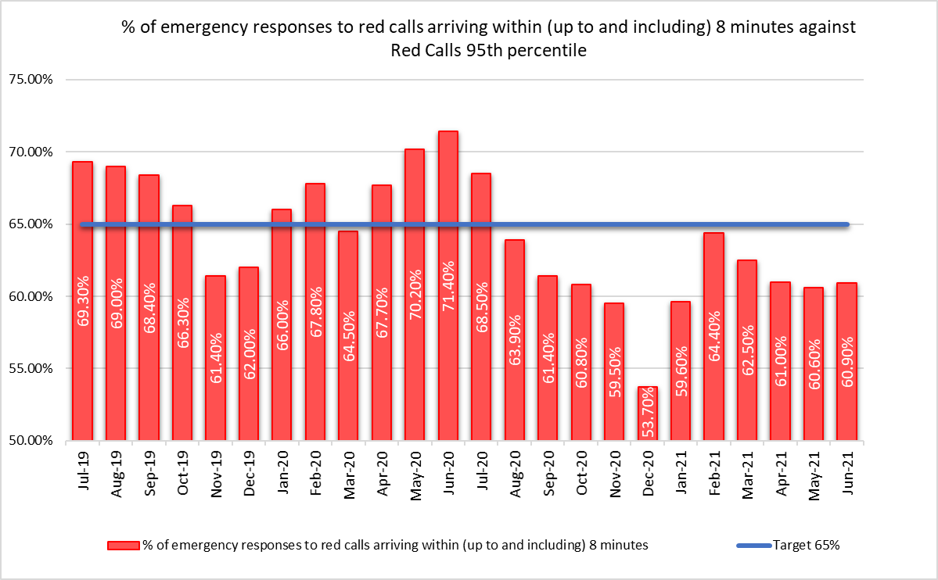

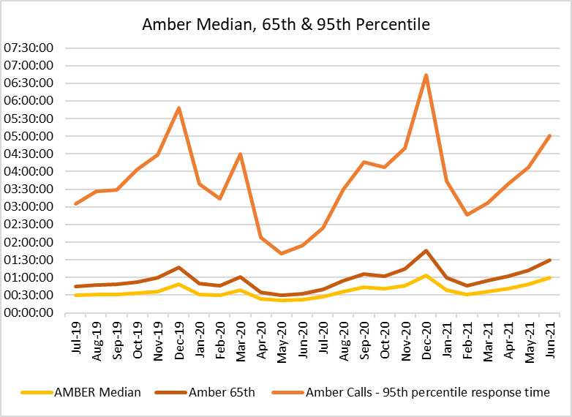

2.5 WAST also continues to monitor the longest patient responses. The table below shows the number of patients who had to wait 12 hours or over, and again, it shows that very long waits were almost eliminated during the first wave, but subsequently returned as system pressures increased. There were 303 long waits in Jun-21, overall wait times are again on an increasing trend.

2.6 These long response times impact on patient safety and outcomes. WAST has been supplying weekly information on quality, safety and patient experience to the Chief Ambulance Services Commissioner (CASC) and monthly information through the CASC Quality and Delivery Assurance Meeting mechanism. This information includes more detailed analysis, patient stories (positive and negative) and patient feedback from surveys.

2.7 In Nov-20 the Trust started producing monthly quality, safety & patient experience (QSPE) reports for each health board, detailing ambulance performance and patient safety concerns for each health board’s population.

2.8 In extreme cases, long response times can lead to Serious Adverse Incidents. In the last 3 months, 15 patient safety incidents have been passed to health boards as part of the joint investigation framework (Appendix B), compared to five for the three months: Apr-20 to Jun-20.
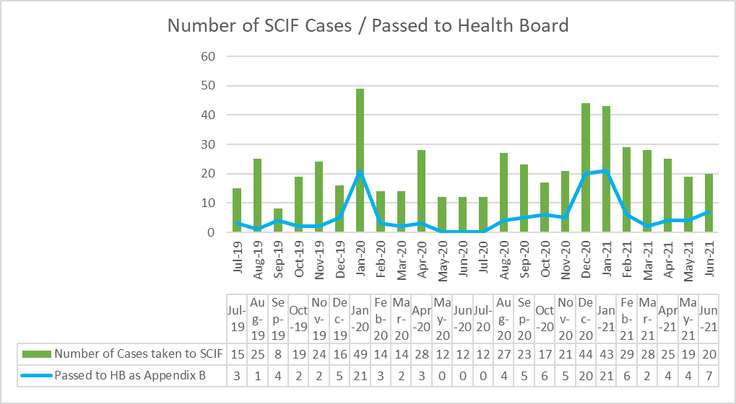

2.9 Whilst there are many factors affecting response times, which are described later in this report, one of the factors outside WAST’s control is the number of ambulances which wait longer than 15 minutes to transfer patients into secondary care at Emergency Departments (EDs). The graph overleaf shows the number of ambulance hours that are lost outside EDs which, if released earlier, would have reduced patient waits in the community. As with the other graphs, during the first wave of the pandemic, the number of lost hours decreased very significantly, but in quarter three built up again to pre-COVID-19 levels.
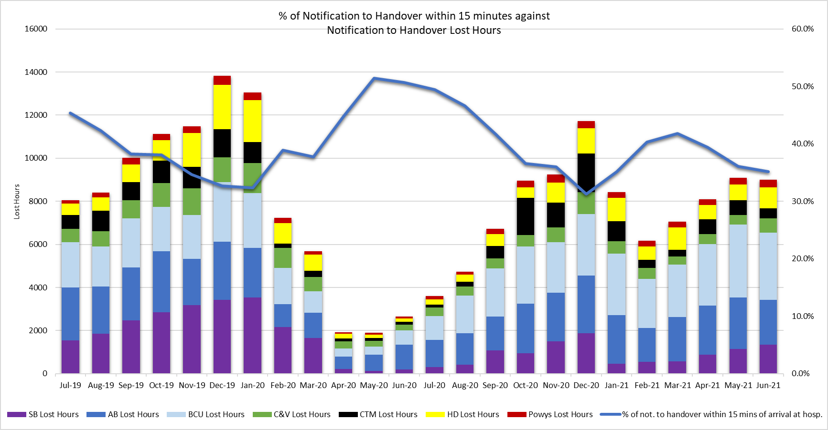
2.10 9,127 hours were lost to handover in Jun-21, compared to 11,708 in Dec-20 and 2,650 in Jun-20. 57% of these lost hours are attributable to two health boards. The 2021/22 EASC EMS commissioning intentions include: “NHS Wales is a significant outlier in the UK and Internationally for lost productivity due to extended notification to handover times. By the end of 2021/22 NHS Wales will have reduced 1 hour waits to less than 5% of total arrivals and ensured that total lost hours at Welsh Hospitals do not exceed 150 hours per day on 95% of the year”. Application of this commissioning intention would mean c.5,000 hours per month lost. Through the Chief Operations Officers (COOs) Group there has been a recent improvement in the application of the immediate release procedure for Red calls.

2.11 In the last three months WAST has reported 14 SAIs to the Delivery Unit and continues to have regular dialogue with EASC through the National Collaborative Commissioning Unit (NCCU).

Health & Safety
2.12 There have been 820 reported staff positive COVID-19 since the start of the pandemic (Mar-20 to Jun-21) with numbers stabilising in Apr, May and Jun-21, with 3 COVID-19 positive incidents reported for each month. All cases are investigated and reviewed and subsequently reported to the Health and Safety Executive (HSE) where applicable in line with the Reporting of injuries, Diseases and Dangerous Occurrences Regulations (RIDDOR) 2013. The HSE have made initial enquiries into one COVID-19 fatality as part of their investigation process.

2.13 The COVID-19 Workplace risk assessment priority schedule continues to be monitored with local risk assessments being undertaken in collaboration with health and safety practitioners. Subsequently the Health & Safety function and Trade Union Partners are providing further support via the undertaking of regular COVID-19 premise inspections with compliance reports submitted to the Trust’s Quality, Safety and Wellbeing Advisory Cell for noting and assurance.

2.14 The National Health and Safety Committee Terms of Reference has been reviewed with a proposal for refining membership and additionally the standardisation of reports submitted which will include a Trade Union partner activity report. This new Terms of Reference will be presented at National Health and Safety Committee in Jul-21 for approval.

2.15 The investigation into the serious road traffic collision in Apr-21 at Dolgellau continues. A progress report was submitted to the Executive management Team in Jun-21 and a further progress report is expected in Jul-21.

2.16 The interim Head of Risk and Health and Safety was appointed into the substantive role on 18 June 21. The appointment formally commences on the 12 July 21.

Clinical Outcomes

2.17 This report includes an update for the clinical indicator measures Oct-20 to March-21.

2.18 Currently, WAST reports on seven clinical indicators. Five of these are care bundles for specific conditions; a care bundle requires each and every specific criterion of care to be met. Six of the clinical indicators have a commissioning intention of 95%, the exception being the return of spontaneous circulation (ROSC) indicator.

2.19 Of the six, three achieved the 95% in the period Oct-20 to Mar-21 (quarter three & four), two others were above 80%. The ST segment elevation myocardial infarction (STEMI) indicator is an area of concern achieving less than 80% through quarters three & four. These percentages refer to the application of a whole bundle of care. For each of the individual elements, apart from Dec-20 and Feb-21 the percentage compliance is consistently above 84%. A deep dive of the STEMI compliance is being undertaken to inform focused improvement work.
2.20 The percentage of patients with attempted resuscitation following cardiac arrest, documented as having a ‘return of spontaneous circulation’ (ROSC) at hospital door was 6.6% in Mar-21. Rates of ROSC are complex and determined by a number of factors which contribute to the speed of response and the application of early defibrillation and chest compressions. These factors can include location of the incident, resource availability, public access defibrillation, willingness of bystanders to engage in resuscitation. As part of its plans for 2021/22, the Trust is developing the concept of Cymru High Acuity Response Units (CHARU) for implementation. This concept is in place in several areas across the UK and has been very successful in increasing ROSC rates. These units supplement the response to critical incidents and are crewed by a mix of Senior Paramedics and selected paramedics, maximising the provision of enhanced clinical care and ensure the consistent delivery of core critical care requirements across the whole of Wales. The Clinical Audit and Effectiveness Department are conducting a review of the ROSC rates to determine where future improvements can be made. This will report through the Clinical Intelligence Assurance Group to the Clinical Quality Governance Group (see 2.21 below).

2.21 A new chronic obstructive pulmonary disease (COPD) clinical indicator has been developed, to support the Band 6 Paramedic project. The specification for this indicator has been sent to Health Informatics to build the report. The onward referral aspect of this indicator is work in progress and forms part of the national COPD pathway development. The Clinical Indicator Review Group has recommenced with revised Terms of Reference and is now called the Clinical Intelligence Assurance Group. Further meetings are now scheduled and will report into the Clinical Quality Governance Group.

2.22 The longer term ambition for WAST is to link its patient and computer aided dispatch (CAD) data with health board patient data so that WAST can report on agreed time-based aspects of clinical indicators and track the eventual patient outcome once conveyed into a hospital. The ePCR project will be critical to delivering this ambition. The contract has now been awarded and the project is in delivery phase.

EASC is asked to NOTE that: Quarter one has seen an increase in the longest waits in the community and a further high numbers of SCIFs passed to health boards under the Appendix B arrangement; of the six clinical indicators with a 95% target three achieved the target and three missed, although two were above 80%; one – STEMI –is of particular concern which is being investigated; and the ePCR project has moved into the delivery phase with the appointment of the successful supplier.
2.23 WAST is EASC commissioned for two patient flows (journeys) within the unscheduled and scheduled care systems: the 999 Emergency Medical Services (EMS) and the Non-Emergency Patient Transport Service (NEPTS). These patient flows and their safety are now looked at in turn.

EMS Performance

Response Times

2.24 As outlined earlier in the report, response times for both Red and Amber calls saw little improvement in quarter one and waiting times remain too long.

2.25 There are a range of factors that affect response times:

- Demand: comparing demand is difficult because of the pandemic, but WAST has previously identified that Red demand has increased significantly over the last few years as a result of a change in the way the Medical Prioritisation Dispatch System (MPDS) treats breathing difficulty calls (an improved approach to patient safety). This is a major contributing factor in relation to Red performance.
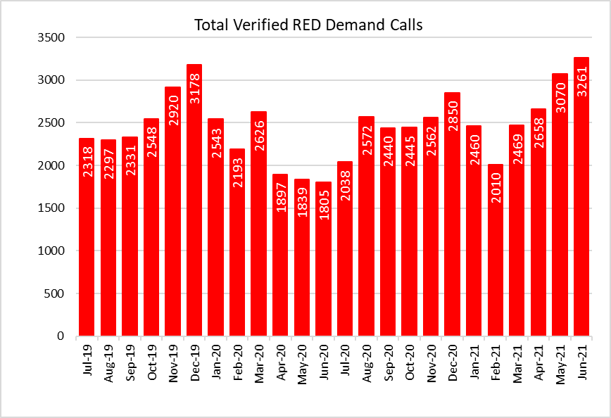

- It should be noted that overall demand has almost recovered to pre-pandemic levels, but this also includes COVID-19 demand so there is still some suppression in core demand, at this point in time.
- The Trust has now switched off Protocol 36 and is using EIDS monitoring of infection diseases to track COVID-19 related activity. This will not affect overall demand but how it appears in relation to disease type going forward.

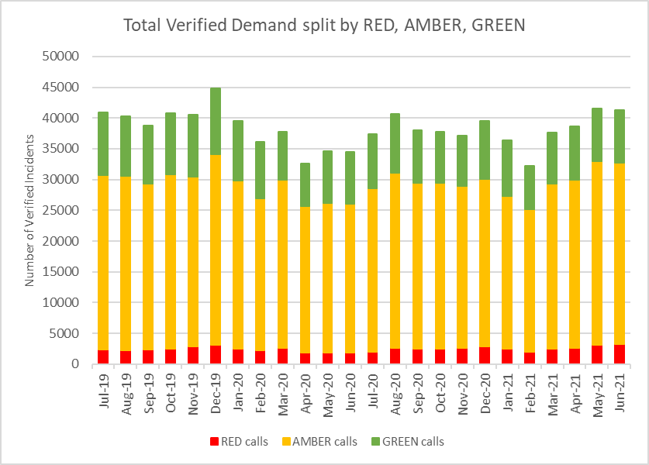
- The number of Response hours produced: whilst varying month on month, on average the Trust has produced 113,486 unit hours per month over the two years to Jun-21. Over the same period, a further 6,171 hours would have been needed to be produced each month to reach 95% unit hours production (UHP) (the benchmark) for the three main ambulance resource types. In Jun-21 the Trust produced 112,681 hours, falling just below the average. As the EMS Demand & Capacity Programme takes effect (see paragraph 2.32) EASC should expect to see the 95% UHP benchmark consistently achieved and an uplift in hours produced; however, it is difficult to evaluate the impact of the additional investment during a pandemic period with high abstractions and a focus on protecting conveying resource over Rapid Response Vehicles (RRVs), the support of the military ceased on 31st March 2021; in Jun-21 WAST received 598 unit hours from Fire and Rescue Services (FRS) and students, 170 of these hours were provided by students; FRS support ended on 27th June 2021.

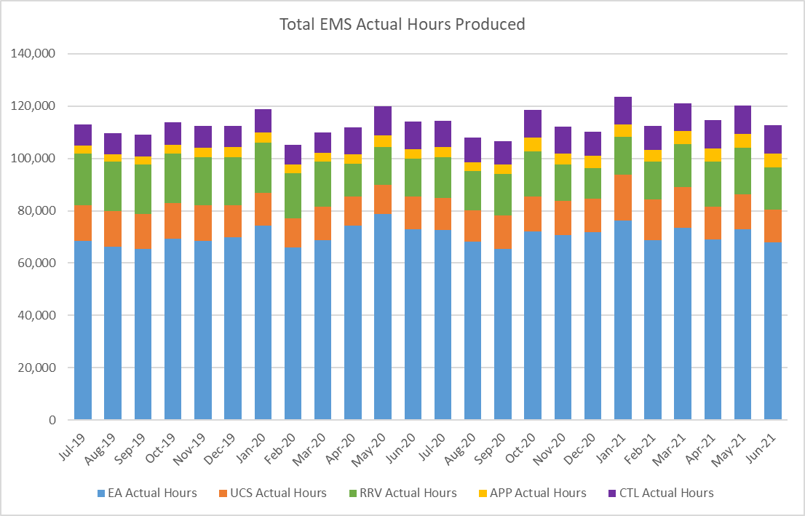
- The number of hours lost each month due to hospital handover delays. See paragraphs 2.9 and 2.10 above.

- Multiple “suspected” variables: for the CASC Quality and Delivery Assurance Meeting WAST provides in month data. The CASC has requested WAST to review the causes of in month day to day Red variation. 23 “suspected” variables have been identified by WAST, with four: demand, utilisation, handover and time as scene considered key. Further analysis is currently being undertaken around these variables as an aid to reducing variation and increasing performance and patient safety.

2.26 WAST is also engaged in a number of programmes across the unscheduled care system which are designed to shift left including: the National Respiratory Work Programme, 111 First, Consultant Connect and WAST continues the process of refining a proposal for EASC and Welsh Government on expanding the Clinical Support Desk (CSD) / 111 capacity to support psychiatric calls. 111 First successfully went live in Aneurin Bevan Health Board Step 1 (soft launch with no publicity) on 15th December 2020 and Step 2 (publicity about the service) on the 5th May. Swansea Bay has subsequently launched Step 1 on 23rd February. The next agreed implementation for 111 First Step 1 is on the 20th July for Hywel Dda.
With core 111 having launched in Betsi Cadwaladr Health Board on the 22nd June we are planning to launch 111 First Step 1 in early August and is subject to ongoing discussions with BCU followed by Step 2 launches in Swansea Bay and Hywel Dda planned for end of August / September. Cwm Taf Morgannwg (Step 1) is planned for end of September. Key roll out dates are subject to change aligned to compliance against the readiness and assurance checks to implement the service. The CSD and NHSDW (Hear & Treat) achieved a combined rate of 9.6% in May-21 compared to 9.9% in Apr-21 (NB: Jun-21 data unavailable). The EMS Demand & Capacity Review identified a benchmark of 10.2% (modelled to be achieved by Dec-21).
2.27 As shown in WAST’s Winter Plan forecasting and modelling, which was shared by WAST with health boards in Oct-20, if mitigating actions agreed / funded are not sufficient, the WAST demand management plan (DMP) will be enacted. The use of the DMP is now reported each month to the CASC Assurance meeting, WAST provided a detailed presentation to 18 Dec-20 EASC Management Group on the use of the DMP, which moves through a set of action cards (based on agreed triggers) with an increasing focus on patients most at risk during high periods of demand.

EASC is asked to NOTE that: WAST has not achieved the Red 8 minute 65% target for the last eleven months; that there are a range of factors affecting Red (and Amber) performance; WAST has sought to mitigate the impact of COVID-19 through a range of actions, in particular, boosting production, minimising lost hours to handover and shift left actions; abstractions due to COVID-19 remain a challenge; WAST has implemented internal actions to scrutinize and investigate factors affecting Red Performance in order mitigate contributing factors where possible.

Ambulance Care Performance (MH)

2.28 The Ambulance Care ambulance quality indicators have now resumed reporting. Key points about NEPTS are as follows:-

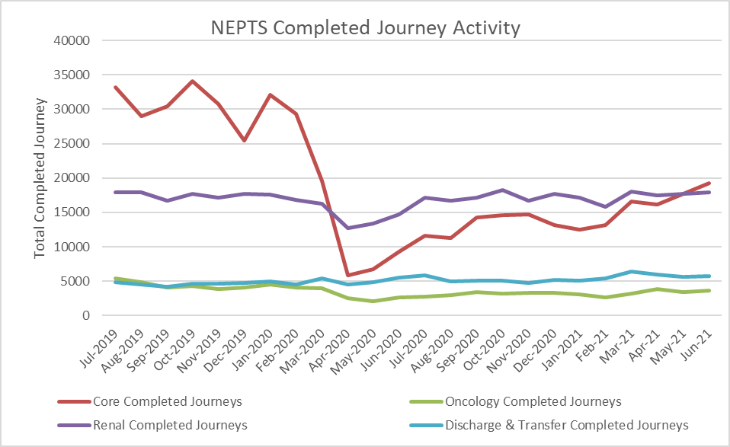
- COVID-19 saw a significant drop-in patient transport activity at the start of the pandemic. Levels have begun to increase, but they still have not recovered to pre-COVID-19 levels; in Jun-21 there were 46,527 completed journeys across the NEPTS service;
- COVID-19 abstractions and social distancing has been challenging, but NEPTS has seen a continued improvement in key areas of service delivery particularly discharge and transfer journeys;
- Enhanced services performance has improved with some tailing off in recent months;
- Social distancing means that the number of patients than can be transported per journey has reduced, which has a significant impact on NEPTS capacity;
- In the first wave there was a significant reduction in outpatient transport activity, which meant that the impact of COVID-19 on NEPTS capacity could be offset by the reduced demand; however, core demand is now on a clear upward trend;
- NEPTS capacity is also adversely affected by other COVID-19 factors: journeys taking longer due to PPE, staff sickness, staff shielding, staff training and testing, infection prevention and control arrangements and so on; and
- NEPTS continues to liaise closely with the commissioning process.

2.29 67% of core journeys arrived within 30 minutes (+/-) of their appointment time in Jun-21; 79% of enhanced renal journeys arrived within 30 minutes prior to their appointment time; and 51% of enhanced oncology journeys arrived within 30 minutes prior to their appointment time. Oncology has been identified as an area of focus from the Ambulance Care Demand & Capacity Review and will require changes in the way WAST works with the voluntary and community sector (VCS) to improve performance.

2.30 Whilst there is a Welsh Government ambition to see outreach appointments reduce by 50% “in time” (Health & Social Care in Wales – COVID-19: Looking Forward), the short term scenario is that as we emerge out of the pandemic response in 2021/22 and the health system is “re-set” EASC may see pent up demand for NEPTS as the system is switched back on and tries to catch up on certain services. This is a significant risk to the system as social distancing/PPE has reduced NETPS capacity. WAST is currently modelling this scenario and will report the results to the CASC as soon as they are available. In the interim the CASC has reiterated to health boards the need to collaborate with WAST on outpatient health boards services that have a transport dimension.

2.31 Finally, the NEPTS Demand & Capacity Review is complete and WAST has now established an Ambulance Care Transformation Programme Board (similar to the one in place arising from the EMS Demand & Capacity Review) to take forward the findings from the review alongside the wider NEPTS transformation projects that deliver improvements and commissioning intentions for NEPTS. The CASC’s team will be represented on the programme board. Any decisions arising from the programme that need EASC agreement will be brought forward to the re-constituted NEPTS DAG, EASC Management Group and, if required EASC itself.

EASC is asked to NOTE that: NEPTS has been able to maintain performance through the pandemic period; however, there is a concern that as we emerge from the pandemic and the system is “re-set” and switched back on the combined impact of continuing social distancing and pent up demand could mean a level of patient demand that NEPTS is unable to manage; tactical forecasting and modelling on this scenario is continuing; and the strategic NEPTS Demand & Capacity Review has been completed, has been formally reported to NEPTS DAG and EASC Management Group will be delivered through the Trust’s Ambulance Care Transformation Programme Board.

Commissioning, Planning and Service Change

Forecasting & Modelling: Strategic Demand & Capacity Reviews

2.32 The EMS Operational Transformation Programme (arising from the EMS Demand & Capacity Review) is the Trust’s main strategic response to patient safety and experience concerns for the EMS five step ambulance care pathway. In addition to the EMS Demand and Capacity the delivery of IMTP actions of Cymru High Acuity Response Unit (CHARU), Rural Model Pilot (in Powys) and Modernising Workplace Practices Implementation Plan has been brought under the umbrella of the programme.

2.33 EASC has supported WAST with investment which has enabled WAST to meet its ambulance response 2020/21 recruitment and training target of 136 FTEs. As part of the 2021/22 EASC commissioning intentions EASC has identified the closing of the relief gap as key and has provided further funding in 2021/22 to support the recruitment of a further 127 response FTEs in support of this intention. WAST has clear plans to deliver this further additionality. The programme board meets every three weeks (with the CASC’s team represented) and reports formally to EASC Management Group bi-monthly. Whilst the programme has made excellent progress on recruitment and training, elements of the programme timeframes have had to be re-cast due to the pandemic response and all of these are now back on making progress. Key areas of the programme for 2021/22 include:-

- Closing the “relief gap” (an EASC commissioning intention for 2021/22);
- Re-rostering the response workforce (WAST has a project board in place and has appointed a change agent third party, with support from EASC, to aid the delivery of this complex project);
- Deliver an estates contingency plan so that there is sufficient estate to take the FTE additionality planned for 2021/22;
- An expansion and reconfiguration of clinical services in 111 and CCC in support of hear & treat and see & treat services;
- CCC transformation, in particular, the reconfiguration of dispatch boundaries and changes to working practices, for example, the single allocator model; and
- A range of efficiencies (including the re-rostering above, but also reduced roster abstractions and post production lost hours).

2.34 Whilst the 2020/21 programme was disrupted as a result of the pandemic response and the recruitment and training process had to be digitalised, the 2021/22 programme is more complex; the 2021/22 programme has two key strategic risks: trade union support and estate availability, both of which are being actively managed. Estate contingency plan has identified 5 areas as the priority for further investment, proposals will now go through the Trust governance channels for approval.

2.35 As part of WAST’s 2021/22 workforce planning, WAST has identified that there is an opportunity to recruit Paramedics over and above the FTEs required to close the relief gap as above. WAST identified this in its 2021-24 IMTP and in subsequent discussions with the CASC. The CASC has confirmed that WAST should proceed to recruit over and above where this is possible, and further discussion is now required with commissioners as to how this additional resource is best utilized.

2.36 As per 2.31 above the NEPTS Demand & Capacity Review has been completed and reported to NEPTS DAG and EASC Management Group. Both NEPTS DAG and EASC Management Group identified the dynamic nature of forecasting and modelling for NEPTS, for example social distancing and the impact on capacity and future WG ambitions around reducing outreach appointments by 50%. Due to the restructure in WAST Operations Directorate, NEPTS sits within the “Ambulance Care” portfolio. An Ambulance Care Transformation Programme Board has now being established, along the lines of the EMS Operational Transformation Programme, which will take forward the findings of the D&C Review, but it is recognised that both the commissioning process and WAST will need to flex the programme to respond to the on-going changing nature of demand and capacity for this service: both the commissioning process and WAST are in a much stronger position to forecast and model future changes for this service, as a result of the review i.e. information is uploaded into powerful simulation software.

2.37 WAST has previously reported to EASC the outputs of forecasting and modelling for winter. The Trust has now moved to tactical seasonal planning, supported by forecasting and modelling. The latest summer plan (21 May-21 to 30 Sep-21) modelling has been shared with the CASC and his team and formally at EASC Management Group. The predicted demand has also been shared with health boards to support tactical planning, in particular, for primary care. The initial results indicate WAST will not achieve Red A8 performance through the summer plan period. WAST is putting in place mitigations including: boosting production (100% UHP), improved equipment and support for Community First Responders (CFRs) to aid targeting CFRs at Red demand hot spots, VCS support e.g. St John Ambulance an RNLI etc.
2.38 WAST is currently experiencing levels of demand above the worst case scenario modelled (noting the changes to Protocol 36 reporting highlighted above). Whilst the mitigations will help, consistently achieving the Red A8 65% target remains problematic. Planning has now commenced for winter. This will involve forecasting the impact of COVID-19, but also other respiratory infections that are expected to be higher this winter as well as core demand.

2.39 The 2021/22 EMS and NEPTS commissioning intentions include the development of a “Demand and Capacity Strategy” - a collaboratively developed demand and capacity strategy will set out the ongoing arrangements for proactively undertaking this work for the next decade, WAST Forecast and Modelling group will coordinate this piece of work to establish a framework that will include the use of forecasting, modelling and health economic evaluations.

Integrated Medium Term Plan (IMTP)

2.40 The Trust was not required by Welsh Government to re-submit an updated annual plan in Jun-21. WG feedback on the WAST IMTP was positive but picked out three areas for further information, which was provided in an accountable officer letter to Dr. Andrew Goodall:

- Measures to address performance, particularly Red A8 performance for which there are operational and tactical plans in place, particularly in respect of the summer planning, as set out above;
- Clarity around COVID-19 related costs and financial plan in 2021/22 to accommodate these;
- Collaborative working around ambulance handover delays, which continues to be a key focus for both internal WAST planning and externally working with Health Boards and the ministerial taskforce.

2.41 WAST’s IMTP sets out the Trust’s strategic ambitions, described in four integrated service offers, in support of the EMS and NEPTS five step models, as well as its offer to the wider health and care system as NHS Wales starts to recover from its prolonged pandemic response. This is supported by a set of enabling programmes including the realisation of the Trust’s important people, digital, estates and fleet strategies and underpinned by fundamental principles of clinical leadership, quality and value.

2.42 WAST has established a transformation delivery structure through its Strategic Transformation Board. The programmes in this structure have been aligned to key deliverables in the WAST IMTP, which in turn will be aligned to relevant commissioning intentions. The approach to delivering not only change but also benefits will be driven largely by a stronger focus on value based healthcare methodology. WAST is working closely with the EASC’s team to develop the framework for value based commissioning but also ensuring that value as a concept and a way of demonstrating wider patient, staff, system and sustainability benefits is embedded across WAST programme delivery.

Health Board Changes
2.43 The Grange University Hospital inter-site transfer service has been live since Nov-20. The Commissioning Agreement for the service has been signed by all parties and a 6month evaluation of the service has been drafted by the EASC’s team. WAST is currently reviewing the evaluation to provide a management response and once final version is published this will be taken to Finance and Performance Committee to sight board members on progress. The conclusion of the evaluation is positive albeit recognising some issues to be worked through to further improve the innovative model that has been developed.

2.44 The South Wales Trauma Network went live in Sep-20. WAST has now established regular reporting arrangements into the network for EASC / WHSSC assurance meetings. Compliance with eLearning as a business case deliverable continues to be good and the funded face to face training element is now being delivered across the Trust, albeit using mixed methods of delivery than solely face to face.

2.45 Regional developments including vascular centralisation in South Wales and Thrombectomy commissioning (North and South) have required WAST to model service provision for transfers and repatriation of patients across the regions and into England. We are working with Health Boards and the CASC team to develop these services and will seek to join up the model and methodology to inform the commissioning intention to develop an All Wales Transfer and Discharge model and commissioning framework.

2.46 WAST continues to maintain a line of sight across Health Board strategic and operational service changes. There is a particular need to ensure that WAST is able to support the pandemic recovery, particularly in respect of planned care recovery in Health Boards. WAST awaits Health Board annual plans, which were submitted on 30th June but will also work locally with Health Board planning teams to understand operational changes that are not detailed fully in high level plans.
2.47 A summary of the strategic Health Board service change initiatives that WAST is engaged with can be seen in the following map:

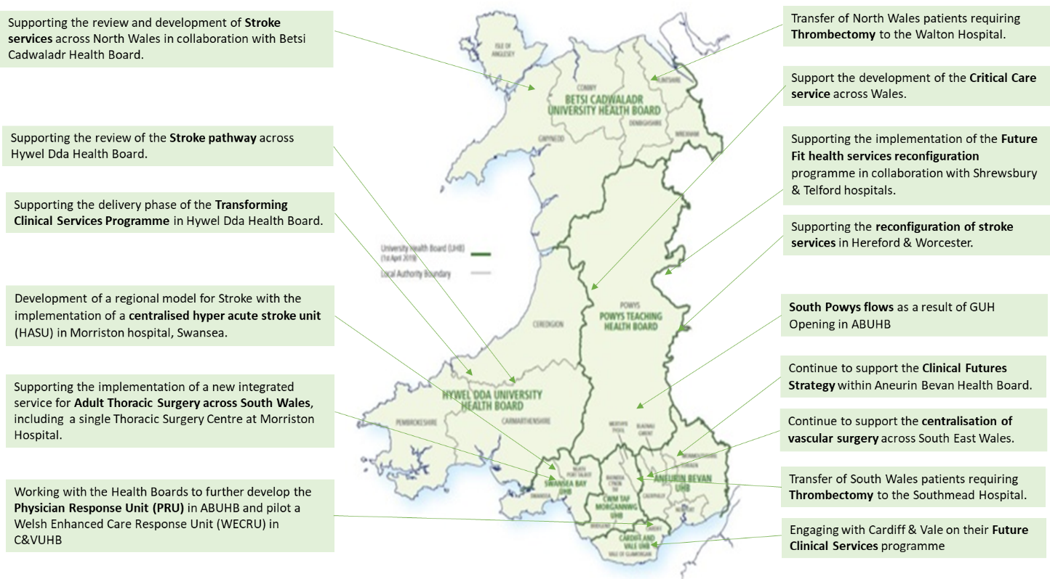

WAST has clear plans in place for year 2 of the EMS Demand and Capacity review through the development of the EMS Operational Transformation Programme (2021/22) and has established programme arrangements for implementation of the NEPTS Demand and Capacity Review alongside wider transformation projects within Ambulance Care; WAST has made further progress on forecasting and modelling informing our operational and tactical plans in 2021/22; transformation programme structures have also been set up to deliver service change in deliver of WAST’s clinical strategy and for 111/999 clinical service offer to commissioners and the NHS; WAST will review Health Board updated plans and continue to work with Health Boards in support of their recovery plans and strategic service changes.

Conclusions and Forward Look
2.48 Performance and patient safety has been challenging in quarter one as demand across all EMS categories has grown. Demand has been above the forecast levels which informed its summer plan. Red performance has remained below the 8 minute 65% target, and there has been a worsening position in the Amber median and the Amber tail has been lengthening. WAST is also continuing to review the variables impacting day to day Red Performance variation.
2.49 As we move into quarter two WAST will retain a focus on further tactical responses the growing demand profile as it moves into a pandemic recovery phase, notably in delivering its summer plan and supporting NHS Wales recovery. The continues to be focus on addressing the fundamentals in the EMS five step ambulance care pathway, in collaboration with health boards who have a critical role to play in supporting WAST with investment, holding WAST to account on delivering its planned efficiencies and delivering reductions in handover lost hours. For NEPTS the focus remains on a tactical response to the system “re-set” and potential pent up demand, whilst putting in programme arrangements for transformation linked to the NEPTS Demand & Capacity Review.

2.50 The WAST IMTP sets out the key programmes of work in support of EASC commissioning intentions, wider NHS Wales service pressures and WAST’s strategic change ambitions aligned to its long term strategy. Year 1 of the IMTP focusses both on recovery from the pandemic and supporting health boards and other partners in their recovery effort, but also in implementing change across its four main service lines, “shifting left” in the five step model where possible and safe to do so.

2.51 Overall WAST: has moved from a response phase, monitor position, to recovery phase; continues to monitor COVID-19 on its ability to maintain recovery, whilst mitigating the impact of demand growth in both EMS and Ambulance Care; will therefore maintain a strong focus and respond early to any predicted changes to demand or loss of capacity linked to COVID-19 whilst pushing ahead with its 2021/22 IMTP deliverables and addressing seasonal pressure through its tactical plans.

2.52 Further to the ‘focus on’ session at the last EASC meeting, WAST continues to work on its longer term strategy. Follow up meetings have been arranged in BCU and SB to test further the concept of national services linked to local pathways.

- KEY RISKS/MATTERS FOR ESCALATION TO THE COMMITTEE

Members of the EAS Committee are asked to note that:

  - WAST has now moved to recovery phase despite the increase in positive cases indicating a third wave based on a clear set of criteria indicating an improved position regarding COVID-19 related demand. WAST will monitor the impact of the third wave on its ability to respond to overall demand across EMS and NEPTS;
  - Quality, safety and patient experience monitoring arrangements have been crystalised for post-pandemic purposes. WAST remains very concerned at the patient safety risks associated with response times that are too long;

  - There was an increase in long waits in quarter one, in what has been a difficult period and 15 SCIF cases have been passed to Health Boards in the quarter;

  - The Red 8 minute 65% target has been missed for the last 11 months, with significant health board variation;

  - WAST is continuing to review day to day variation in Red performance to develop improvements that could move Red performance above target again;

  - The Amber tail (an area of focus e.g. the Amber Review) has increased again in quarter one as demand and lost hours have both increased;

  - WAST remains concerned at the number of hours lost outside EDs and their impact on patient safety, with two health boards being a particular concern (accounting for 57% of the losses), but notes that there is an explicit EASC 2021/22 commissioning intention to reduce handover lost hours, which WAST actively supports;

  - WAST will continue to seek to improve those efficiencies within its gift that contribute to reducing lost hours;

  - There is a continued focus on strengthening WAST’s health & safety arrangements;

  - Clinical indicator performance has been reported for quarter one with one indicator, STEMI, being significantly off target and subject to ongoing investigation;

  - The ePCR programme is in delivery phase and will enable the linking of ambulance patients with patient outcome data;

  - NEPTS capacity is a significant risk to the system as the system “re-sets” and demand is switched back on to pre-COVID-19 levels (or higher) as the system attempts to catch up. Modelling the impact of these increases is ongoing but the lack of detailed information on Health Boards plans makes ambulance planning difficult;
  - An Ambulance Care Transformation Programme Board has been established to take forward the findings of the NEPTS strategic Demand & Capacity Review and wider NEPTS and transfer and discharge projects;

  - Through the commissioning intention process there is a clear collaborative commitment to increasing capacity in the five step EMS ambulance care pathway through a combination of investment and efficiencies (WAST and health board);

  - The EMS Demand & Capacity Programme is making good progress, but estate and trade union engagement remain potential strategic risks to the programme, both of which are being actively managed;

  - There is opportunity to recruit over and above closing the relief gap in 2021/22 which is being taken forward, although numbers are not yet finalised;

  - WAST is experiencing higher demand than forecast for its summer plan and is working with the CASC and Health Boards to implement arrangements which are largely focussed on the impact of staycation demand and higher abstractions;

  - The outcome of the Grange University Hospital inter-site transfer service review may result in further work around a transfer and discharge model that is fit for purpose in Aneurin Bevan University Health Board, but also offers the opportunity for learning in developing national models and commissioning arrangements;

  - Change resulting from health boards’ pandemic recovery plans need to be factored into WAST operations and detailed analysis is critical at a health board level and will need to be undertaken to understand the impact of recovery plans on EMS and NEPTS, as well as the consequential impact on 999 and NEPTS control;

  - NEPTS has continues to provide patient critical journeys as determined by health board clinicians, but social distancing has significantly reduced NEPTS capacity and is a risk to the system.

- IMPACT ASSESSMENT

Quality/Safety/Patient Experience implications | Yes (Please see detail below)
Quality/Safety/Patient Experience implications | Identified within the report
Related Health and Care standard(s) | Timely Care
Related Health and Care standard(s) | And all health and care standards
Equality impact assessment completed | Not required
Legal implications / impact | There are no specific legal implications related to the activity outlined in this report.
Legal implications / impact | Included within the body of the report
Resource (Capital/Revenue £/Workforce) implications /  Impact | Yes (Include further detail below)
 | Included within the body of the report
Link to Main Strategic Objective | The Committee’s overarching role is to ensure its Commissioning Strategy for Emergency Ambulance Services utilising the five step patient pathway outlined within the National Collaborative Commissioning Quality and Delivery Agreement and the related outcomes for each care standard aligned with the Institute of Healthcare Improvement's (IHI) ‘Quadruple Aim’ are being progressed.  This report focuses on all the above objectives, but specifically on providing strong governance and assurance and safe and effective patient care
Link to Main WBFG Act Objective | Service delivery will be innovative, reflect the principles of prudent health care and promote better value for users

- RECOMMENDATION

  - The EASC Committee is asked to:

- DISCUSS and NOTE the WAST provider report.

