AGENDA ITEM
2.3

EMERGENCY AMBULANCE SERVICES COMMITTEE (EASC)

welsh ambulance services nhs trust (WAST)
provider update

Date of meeting | 12 July 2022

FOI Status | Open/Public

If closed please indicate reason | Choose an item.

Prepared by | Rachel Marsh, Director of Strategy, Planning and Performance (WAST)
Presented by | Jason Killens, Chief Executive WAST
Approving Executive Sponsor | Chief Executive

Report purpose | FOR DISCUSSION / REVIEW

Engagement (internal/external) undertaken to date (including receipt/consideration at Committee/group)
Committee/Group/Individuals | Date | Outcome
- | - | Choose an item.

ACRONYMS
ABUHB  CTMUHB  D&C  EMS  NCCU  NEPTS  SAI  WAST | Aneurin Bevan University Health Board  Cwm Taf Morgannwg University Health Board  Demand and Capacity  Emergency medical services  National Collaborative Commissioning Unit  Non-emergency patient transport services  Serious Adverse Incident  Welsh Ambulance Services NHS Trust

- SITUATION/BACKGROUND

  - The purpose of this report is to provide EASC with an update on key issues affecting quality and performance for EMS and NEPTS and to provide an update on commissioning and planning for EMS and Ambulance Care (including NEPTS).

- SPECIFIC MATTERS FOR CONSIDERATION BY THIS MEETING (ASSESSMENT)

CoVID-19 and Current Operational Pressures

  - WAST continues to track CoVID-19 and related metrics through its weekly Forecasting & Modelling Intelligence Pack. Wales is experiencing another wave with positive tests equating to 2.25% of the population. WAST is currently (04 Jul-22) at escalation level 3 (4 being the highest), with the continued need for WAST to use its second highest level in the Clinical Safety Plan, level 4a, which means the use of clinical screening for Amber 1 patients and unable to send for Amber 2. For the 30 days to 30 Jun-22 WAST was at level 4a for 13 of the 30 days. The reasons for this are complex, and not just CoVID-19 demand, and include high abstractions (linked directly to CoVID-19, but also workforce fatigue) and high system pressure, in particular, extreme handover lost hours.

  - WAST now undertakes seasonal forecasting and modelling as a matter of routine. The modelled results for the summer (defined as 20 May-22 to 30 Sep-22) have been made available to the Chief Ambulance Services Commissioner (CASC) and his team. The modelled results indicate a level of Red performance in the range 34% to 46%) and Amber One median in the range one hour and 47 minutes to five hours and 41 minutes. The modelling is based on realistic estimates of unit hours production and Apr-22 time at hospital and a sensitivity analysis (reasonable worst case) of a continuing upward trend in handover lost hours. Clearly these modelling results are very concerning and will require WAST to operate at high levels of escalation in terms of the Clinical Safety Plan. WAST has updated its tactical Performance Improvement Plan with specific summer actions, but there is limit to what WAST can do and it is beginning to exhaust actions it can take that are within its control to do so.

  - Further modelling on winter will now be started with the results available by early Sep-22 at the latest. WAST has received £3m for 2022/23 (letter from Welsh Government (WG) 06 Jun-22) which will enable WAST to recruit 100 FTEs this financial year; the impact of this recruitment will be felt in quarter 4 as those new staff complete their 18 weeks training.

2.3 WAST has stood down its pandemic structures (Pandemic Plan), but continues to operate a Trust wide Performance Improvement Plan (PIP), which sets out any action being taken to mitigate the risks highlighted in the spring and now summer modelling. The PIP is regularly reported on to the CASC. WAST has made good progress on the PIP and is continuing to receive financial support for cohorting (due to end 31 Jul-22), but is beginning to exhaust actions it can take that are within its control.

EASC is asked to NOTE that: WAST is currently at escalation level 3 (maximum 4), WAST continues to have to operate its Clinical Safety Plan up to level 4a (second highest level); summer forecasting and modelling results are very concerning. WAST will continue to tactically performance manage delivery against an organisational wide PIP (which is also regularly reported to the CASC); WAST is beginning to exhaust tactical patient safety mitigations it can take; and that WAST has been allocated a further £3m from WG which will enable WAST to recruit a further 100 FTEs this financial year, with the impact expected to be in quarter 4.

Quality, Safety & Patient Experience

Patient Response Times in the Community

2.4 One of the key indicators which measures the quality of the service provided is the timeliness of the response by WAST to patients waiting in the community. The graphs below show the current response time performance for Red calls and for Amber One calls. Both graphs show that response times remain significantly off target or off benchmark. Inevitably these times have had an impact on patient safety.

2.5 The Red 8-minute target was not achieved in May-22. The percentage of emergency responses to Red incidents within 8 minutes was 54.5% (target 65%) with 95% of Red calls receiving a response within 22 minutes. Red 9-minute performance was 60.5% and Red 10 minute performance 66.1%.

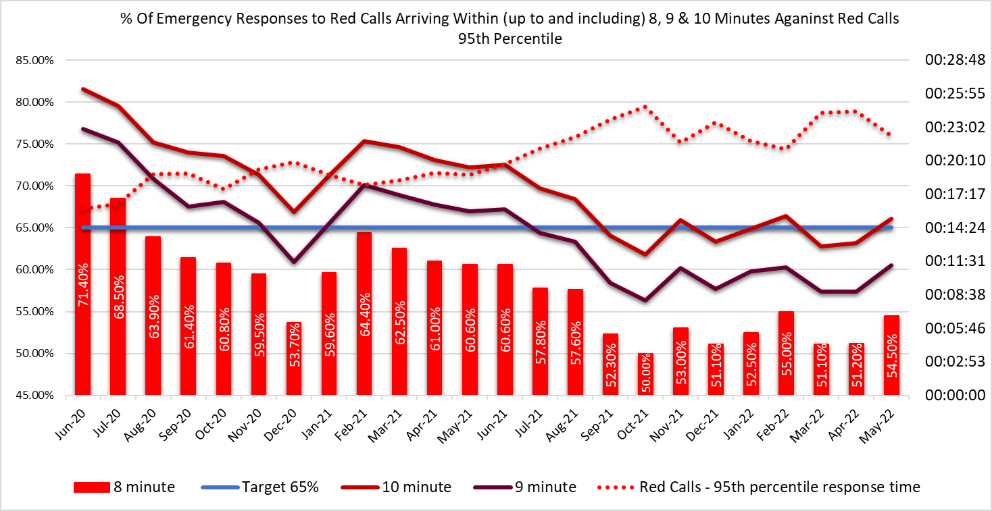

2.6 The Amber 1 median percentile in May-22 was one hour and 11 minutes and the Amber One 95th percentile was four hours 34 minutes. The Amber 1 performance parameters used in the EMS Demand & Capacity Review were 35 minutes (Dec-21 position) and 18 minutes (Dec-24 position) respectively. Amber 1 incidents include chest pains, strokes, unconscious patients etc.

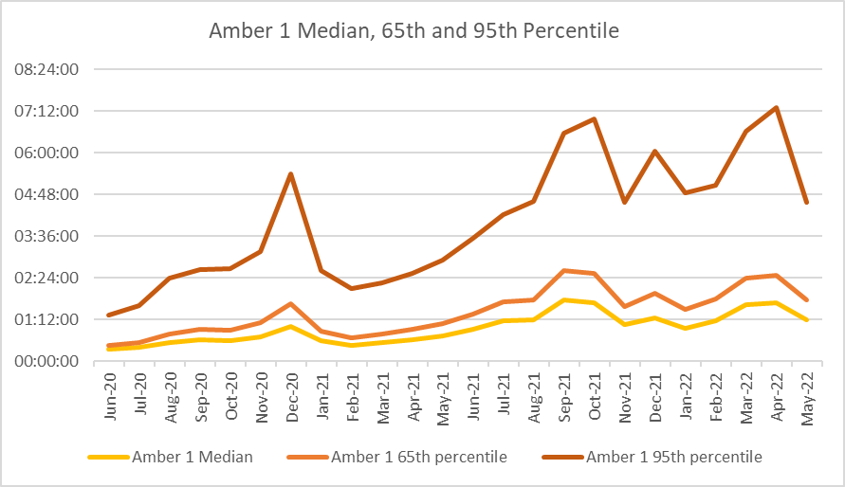
2.7 These very long Amber One median times mean that the patient waiting times in the “Amber tail” are a particular concern from a patient safety perspective; it is where the bulk of National Reportable Incidents (NRIs) occur.
2.8 As part of its quality, safety and patient experience arrangements, WAST continues to monitor the longest patient responses. The table below shows the number of patients who had to wait 12 hours or over. The table shows that very long waits were almost eliminated during the first wave, but subsequently returned as system pressures increased. There were 619 long waits in May-22, a reduction compared to Apr-22 (819).

2.9 These long response times impact on patient safety and outcomes. WAST has been supplying weekly information on quality, safety and patient experience to the CASC and monthly information through the CASC Assurance & Delivery meeting. This information includes more detailed analysis, patient stories (positive and negative) and patient feedback from surveys.

2.10 WAST supplies health boards with a monthly report on one hour and over patient waits.

2.11 In extreme cases, long response times can lead to National Reportable Incidents (NRIs). In the last 3 months, 33 patient safety incidents have been passed to health boards as part of the joint investigation framework (Appendix B). There are ongoing discussions being taken forward on how this framework needs to be updated, but in the meantime, it is important that each of these incidents is fully investigated and reported if required. 21 NRIs were reported directly by WAST to the Delivery Unit in the period Mar-May-22. 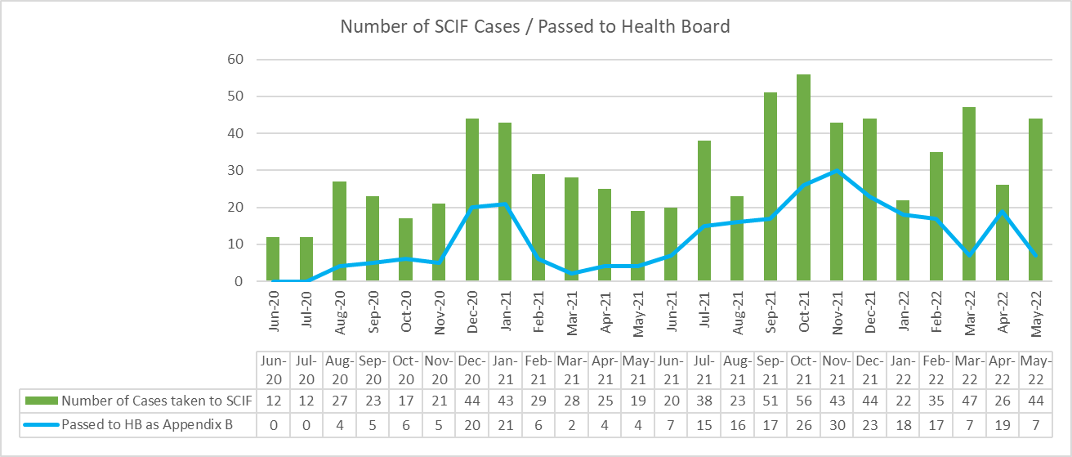

2.12 Whilst there are many factors affecting response times, which are described later in this report, one of the factors outside WAST’s control is the number of ambulances which wait longer than 15 minutes to transfer patients into secondary care at Emergency Departments (EDs). The graph below shows the number of ambulance hours that are lost outside EDs which, if released earlier, would have reduced patient waits in the community. As with the other graphs, during the first wave of the pandemic, the number of lost hours decreased very significantly, but they are now higher than those seen in the worst of winter and extreme.
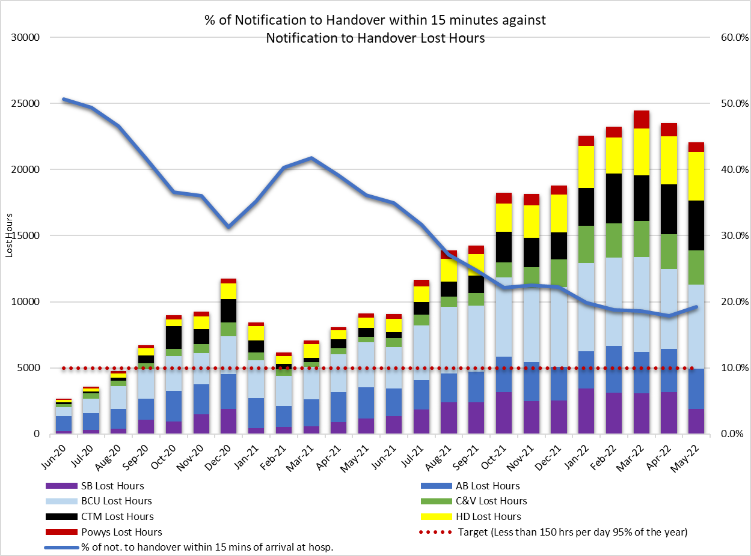
2.13 22,080 hours were lost to handover in May-22 (or 18% of WAST’s total capacity), compared to 9,099 in May-21, 1,900 in Mar-20 and 7,101 in Mar-19. The benchmark used in the 2019 EMS Demand & Capacity Review was to be no worse than the Dec-18 levels (6,038 hours). In May-22 WAST achieved Emergency Ambulance (EA) unit hours production (UHP) of 95% (benchmark 95%) and a Rapid Response Vehicle (RRV) of 80% (benchmark 95%). Handover lost hours were 366% above the benchmark. The 2022/23 EASC commissioning intentions include the development of improvement trajectories per ED site. Initial meetings have started in Apr-22 between the NCCU, health boards and WAST to work on the trajectories and supporting action plans. Further to meetings with senior leaders across Wales, there is an expectation as part of the mitigations that there will be a focus on immediate release, fit to sit and improvement trajectories.

Immediate Release Acceptance
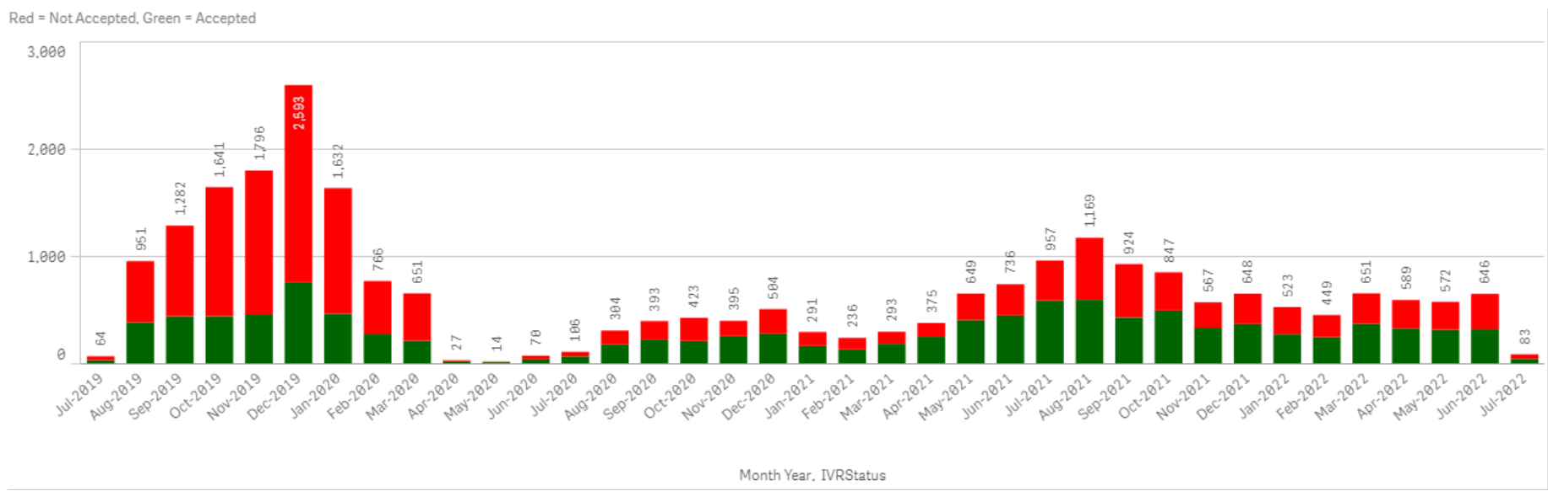
2.14 Ministerial direction indicates that the non-acceptance of Immediate Release is expected to become a Never Event with acceptance/non-acceptance being monitored weekly by the Chief Executive of NHS Wales.

2.15 There have been a recent high profile report which references handover, the Health & Social Care Committee report on Hospital Discharge and its Impact on Patient Flow through Hospitals (Hospital discharge and its impact on patient flow through hospitals (senedd.wales)), and includes recommendation six:-

“The Welsh Government should explain how the targets outlined in the Minister for Health and Social Service’s statement of 19 May 2022 on urgent and emergency care and the Six Goals Programme to eradicate ambulance patient handover delays of more than four hours and reduce the average ambulance time lost per arrival by 25 per cent (from the October 2021 level) have been set. It should also confirm the target dates for the achievement of these targets”.

2.16 EASC members may also find two reports on handover useful as part of their development of handover reduction plans: the Healthcare Safety Investigation Branch (HSIB) Interim bulletin Harm caused by delays in transferring patients to the right place of care June 2022 Publication ref: NI-004133/IB (hsib-interim-report-harm-caused-by-delays-in-transferring-patients-to-the-righ_EPeMfuS.pdf (hsib-kqcco125-media.s3.amazonaws.com) and Association of Ambulance Chief Executives (AACE) AACE and NHS Providers roundtable on tackling handover delays: note of discussion (circulated as background).

2.17 In the last three months WAST has reported 21 NRIs to the Delivery Unit and continues to have regular dialogue with EASC through the NCCU.

2.18 WAST has previously written (27 Jul-21) to the Director General detailing the clinical risk that WAST is carrying and the patient harm that is occurring in communities across Wales and more recently WAST has written to the CASC (24 Feb-22) on projected clinical risk into quarter 1 2022/23. WAST has reviewed and updated its Demand Management Plan, now Clinical Safety Plan.

Health & Safety

2.19 201 CoVID-19 positive cases for WAST staff were reported in Jan-22, 147 in Feb-22, 316 in Mar-22, 186 in Apr-22, 27 in May-22 and 44 in Jun-22. On 01 Apr-22 the Health and Safety Executive changed its position in relation to RIDDOR reporting with no requirement for reporting staff exposure required. 61 RIDDORS had been submitted to the HSE for potential exposure to CoVID-19 to date. The backlog of historic cases has been addressed to ensure all COVID positive reports to be closed out by Q2 2022.

2.20 The internal investigation into the serious NEPTS road traffic collision that occurred near Dolgellau (Apr-21) has been concluded with a report submitted to the Executive Management Team.

2.21 As part of the transformation of the function a business case for the health & safety function was presented to WAST’s Executive Management Team in Mar-22. A final position was agreed in Jun-22 with significant financial investment agreed to ensure sufficient capability to meet the forward requirements of the Trust. Four managerial appointments were made in Jun-22 with further vacancies to be filled in Aug-22.

2.22 The next planned deliverable of note for health and safety transformation are the revision of WAST’s Health and Safety Policy, the development of a suite of procedures to cover; Control of Substances Hazardous to Health (COSHH), Provision and Use of Work Equipment (PUWER), Lifting Operations Lifting Equipment Regulations (LOLER), New and Expectant Mothers Risk Assessment. Additionally actions include the rolling out Institute of Occupational Safety & Health (IOSH) Leading and Managing Safely training courses.

Clinical Outcomes
2.23 The last publication of clinical indicators was Jan-22 (Oct-21 and Nov-21 data) there was then an agreed temporary cessation of CI reporting as the Trust transitioned from Digital Pen to the electronic Patient Clinical Record (ePCR). The transition was completed at the end of Mar-22, with the final health board coming online with digital handover.

2.24 The first of the new ePCR data was published in May-22 (Apr-22 data) for Stroke and Fractured Neck of Femur. Compliance to the care bundles for Apr-22 were #NOF 43.4% (90.7% Oct-Nov 2021 Digital Pen data) and Stroke 67% (95.6% Oct-Nov 2021 Digital Pen data). The #NOF data for May-22 and into Jun-22 reflects an ongoing improvement. The STEMI, Hypoglycaemia and ROSC (at hospital) CIs are under development.

2.25 As a result of the predicted fall in clinical indicator compliance while the new system for creating clinical records becomes embedded, a risk has been raised with an associated action plan. The risk is managed through the Clinical Intelligence Assurance Group CIAG.

2.26 The transition to using non-validated data has led to the Clinical Audit Department designing specific clinical audits to support the clinical indicator reports. These audits are outlined in the Clinical Audit Plan which was agreed at the CIAG and approved by the Clinical Quality Governance Group, before going forward for presentation at QUEST Committee in Aug-22. The purpose of the audits is to determine where the data gaps are, and to assist clinical teams operationally to better utilise the ePCR software. In addition, the audits will help organisational understanding regarding where focused changes to the application can be recommended to improve use in the field. The #NOF and Stroke audits and individual actions plans have been approved at CIAG. The STEMI audit has commenced.

2.27 The longer-term ambition for WAST is to link its patient and CAD data with health board patient data so that WAST can report on agreed time-based aspects of clinical indicators and track the eventual patient outcome once conveyed into a hospital. The ePCR project is critical to delivering this ambition. Now that ePCR is live across WAST, the project team are continuing to roll-out of the necessary digital handover for hospital sites across the border into England.

EASC is asked to NOTE that: the Red 65% target was not achieved in May-22 (and has not been since Jul-20); Amber waiting times remain very long; these delayed responses are impacting on patient safety; 22,080 hours were lost to handover in May-22; there have been a number of reports on handover recently; there is an expectation that non-acceptance of Immediate Releases becomes a Never Event; there is WG requirement to reduce handover levels by 25% (from Oct-21 levels); in the last three months 33 patient safety incidents were reported to health boards (under the Appendix B arrangements), where the primary cause is considered to be handover lost hours; 21 NRIs were reported to Welsh Government directly by WAST; a new structure has been agreed for WAST’s Health & Safety Team, which is currently being recruited into; the final health board transition to ePCR was completed in quarter four with new reporting arrangements starting in quarter one; and the new reporting, which uses non-validated data, has led to a fall in clinical indicator compliance rates, which was a pre-identified risk and is being addressed through a series of actions.

2.28 WAST is commissioned by EASC for two patient flows (journeys) within the unscheduled and scheduled care systems: the 999 Emergency Medical Services (EMS) and the Non-Emergency Patient Transport Service (NEPTS). These patient flows and their safety are now looked at in turn.

EMS Performance

Response Times
2.29 As outlined earlier in the report, response times for both Red and Amber incidents remain too long.

2.30 There are a range of factors that affect response times:
- Demand: comparing demand is difficult because of the pandemic, but WAST has previously identified that Red demand has increased significantly over the last few years
Red demand for 2021/22 was 41,734 incidents, compared to 24,494 incidents in 2018/19 (base year used in EMS Demand & Capacity Review), an increase of 70%. This increase is a major contributing factor in relation to Red performance. In collaboration with the NCCU WAST reopened the EMS Demand & Capacity Review in 2021 to update the strategic modelling with this change which has led to the new CHARU resource being included in the roster review keys. Further investment of 95 FTEs (total relief gap all resource types is 148 FTEs) is required in order to produce the CHARU keys across Wales, meet the Red 65% Welsh Government target and deliver improved clinical outcomes through the CHARU parameters for clinical leadership on high acuity calls. WAST has received £3m for 2022/23 (letter from WG 06 Jun-22) which will enable WAST to recruit 100 FTEs this financial year; the impact of this recruitment will be felt in quarter 4. Recruitment will be to EMT and ACA2 posts. This will allow around 2/3 of the current relief gap to be closed.

- Overall demand has increased by 4% compared to the 2018/19 levels used in the EMS Demand & Capacity Review; consequently, the roster keys being used in the roster review project are appropriate (with the CHARU uplift) to meet the interim benchmarks for Red and Amber One, if handover lost hours were at their 2018/19 levels.

- The number of Response hours produced: the total actual ambulance hours (all resource types) was 123,092 hours in May-22 with emergency ambulance (EA) unit hours production at 95% in May-22 (benchmark 95%), unscheduled care service (UCS) production at 75% and Rapid Response Vehicles (RRVs) at 80%; RRV production was lower due to a tactical focus on conveying resource. Roster abstractions were their lowest since May-21.

- Operations Response roster abstractions were 38.58% in May-22, with a sickness absence rate of 10.13% and downward trend (benchmarks are 29.92% and 5.99% respectively).
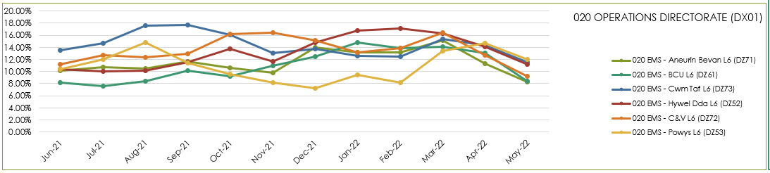
- WAST has recently introduced a new Managing Attendance Plan with seven work-streams and improvement trajectories. The Plan is being reported to Executive Management Team every two weeks.

- The number of hours lost each month due to hospital handover delays. See paragraph 2.13 above.

- Multiple variables: in dialogue with the CASC WAST has identified up to 23 “suspected” variables that impact on performance, with four: demand, utilisation, handover and time as scene considered key. This analysis has led to the innovative development of a pilot measure of ambulance unit hours utilisation (UHU), which the CASC has started to share more widely with stakeholders. There are some issues with data reliability here, in particular, post production lost hours (PPLH), which are currently under review.

- Post Production Lost Hours (PPLHs): 5,835 hours were lost post production in May-22. PPLHs include a range of reasons e.g. vehicle defect, trauma stand down, police interview, etc. which cannot be viewed as areas for potential efficiencies. The EMS Demand & Capacity Review identified that WAST benchmarked comparatively well on PPLHs with the exception of return to base meal breaks. EASC members will note the dark blue data in the graph which forms a significant proportion of the total, which relates to lost hours due to increased HALO duties, which are required and utilised at times of high pressure within EDs. WAST has undertaken some recent benchmarking with three other ambulance services, two of which WAST benchmarks favourably with whilst the third is significantly better.

WAST is working with the ambulance service that benchmarks lower, is developing internal benchmarks around the PPLH categories and is also in the final stages of dialogue with trade union partners on a range of efficiencies. Reducing PPLH for return to base meal breaks, is the third key efficiency for WAST, along with re-rostering and abstraction management reduction, in particular sickness.

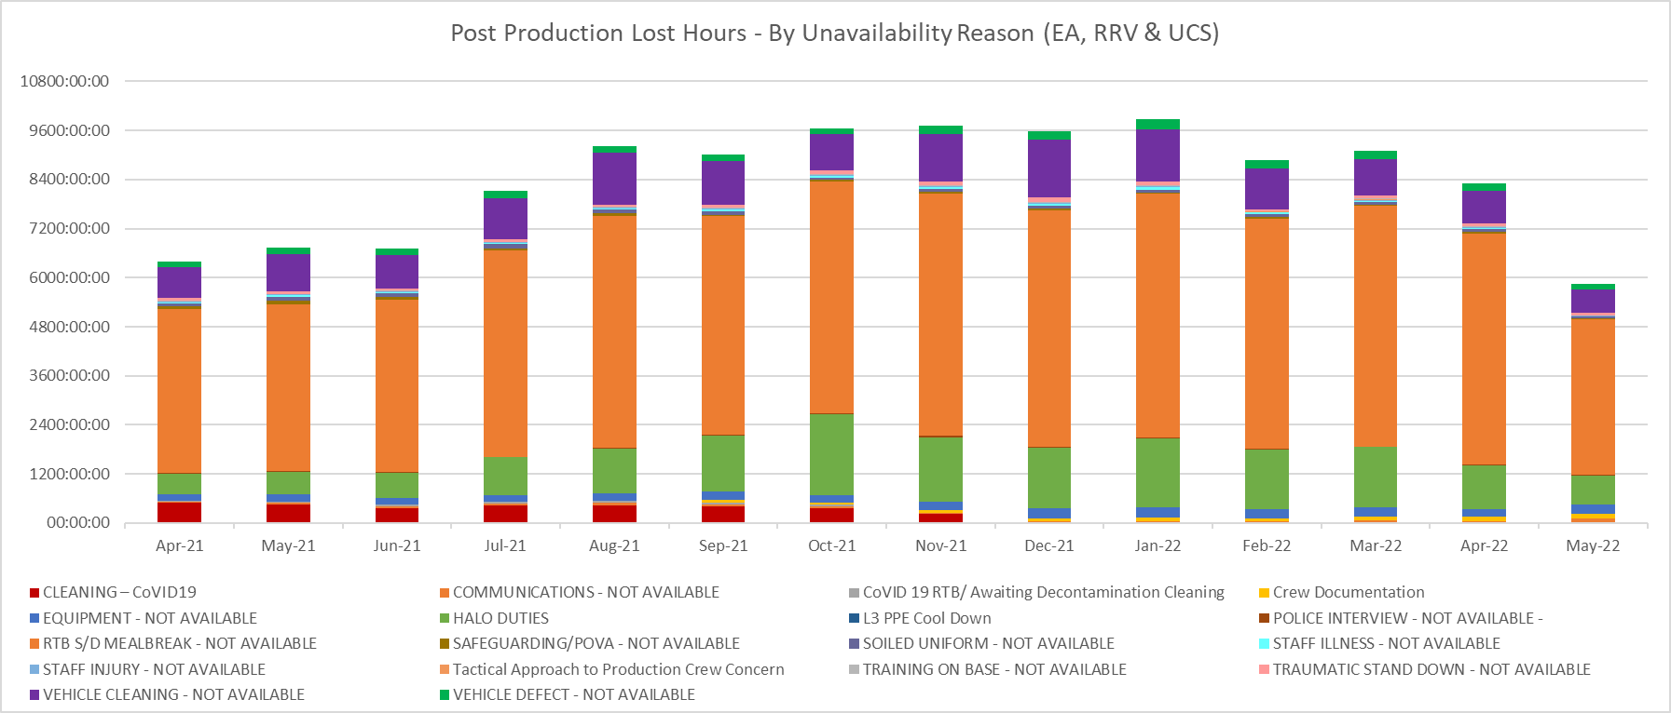

2.31 WAST is also engaged in a number of programmes across the unscheduled care system which are designed to shift demand left including: the core 111 service which is now live pan-Wales; however, the 111 First service has not received funding into 2022/23. WAST has received recurrent funding from EASC to support five mental health professionals into the Clinical Support Desk (CSD), all of whom are now either live or completing their training. WAST also expanded its CSD 36 FTE Paramedics during 2021/22; however, recurrent funding has not been made available; consequently, WAST will have to hold 46 ACA2 vacancies open in 2022/23 to close the financial gap caused by this i.e. re-open the relief gap for the Response workforce. These increases will support hear & treat, but also patient safety netting and other related activities. The CASC has requested an evaluation of the impact of these additional CSD FTEs. The CSD and NHSDW (Hear & Treat) achieved a combined rate of 12.2% in May-22 and 10.4% for 2021/22, exceeding the EMS Demand & Capacity Review identified a benchmark of 10.2% (modelled to be achieved by Dec-21) which will be revised up to 15% as a result of this increase.

2.32 ​If mitigating actions agreed / funded are not sufficient to manage patient demand (which currently they are not) WAST will enact its Clinical Safety Plan previously known as the Demand Management Plan. The CSP aligns with the Association of Ambulance Chief Executives (AACE) approved UK Clinical Safety Plan Framework requiring members to realign their existing plans to provide national consistency in the definition and reporting levels. WAST has seen increased use of the higher levels of the CSP (level 4) which means “unable to send” to Amber 2 and Green incidents (see also 2.1 above).
2.33 As previously discussed at EASC, WAST submitted a proposal in Dec-21 to increase core capacity in the short term to mitigate some of these extreme pressures, including the high levels of hospital handover lost hours. This plan included an increase in core ambulance resource and shift left (hear & treat, see & treat). This plan was not agreed to by EASC, but WAST has now received notification of funding for an additional 100 FTEs for this financial year. WAST has also made a bid to the Value Based Healthcare Fund for 50 APPs.
EASC is asked to NOTE that: WAST continues not to achieve the Red 8 minute 65% target; there are a range of factors coalescing to affect Red (and Amber) performance; ambulance production is increasing; this increase is linked to the introduction of a Managing Attendance Plan; WAST has expanded its CSD capacity to shift demand left, but funding for an element of this is not recurrent causing the relief gap for Response (along with the FTEs required for CHARUs) to re-open (148 FTEs); PPLHs are falling and WAST has a range of actions in place to deliver improvement in PPLH; WAST has received additional funding to enable 100 FTEs to be recruited into front line Operations Response this financial year, but will continue to need to operate its Clinical Safety Plan at its higher levels until such time as system pressures reduce, in particular, handover lost hours.

Ambulance Care (including NEPTS)

2.34 The NEPTS ambulance quality indicators have now resumed reporting. Key points about NEPTS are as follows:-
- CoVID-19 saw a significant drop-in non-emergency patient transport activity at the start of the pandemic. Levels have increased and are at or in excess of pre-pandemic levels for all journey types apart from outpatient journeys; however, the overall level of activity has still not recovered to pre-CoVID-19 levels due to the reduction in outpatient activity.
- Overall demand for the service has begun to plateau in May-22. Only outpatient activity remains supressed with all other areas at or in excess of pre-pandemic activity levels
- As WAST emerges out of pandemic response and the health system is “re-set” WAST is anticipating further demand increases at which point capacity may be an issue.
- Jun-22 was the first month in which WAST will be able to view demand and capacity in a post-pandemic world as social distancing travel restrictions on NEPTS transport are removed.

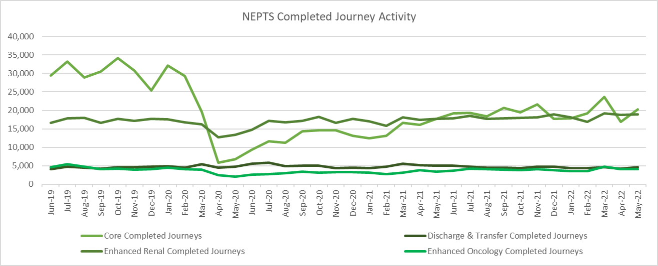

2.35 Following the cessation of additional CoVID-19 related funding at the end of Mar-22, outpatient performance has begun to decline as capacity has reduced. Whilst renal performance remains above target, Oncology transport is not performing equitably against the unfunded, enhanced standard:-
- 66.3% of core inward journeys arrived within 30 minutes (+/-) of their appointment time in Q1 22-23; 76.6% (May-22) of enhanced renal journeys arrived within 30 minutes prior to their appointment time but only 51% (May-22) of enhanced oncology journeys arrived 30 minutes prior to their appointment time. 90% of discharge and transfer patients were collected less than one hour after their booked ready time in May-22.
- Oncology has been identified as an area of focus from the NEPTS Demand & Capacity Review and will require changes in the way WAST works with the voluntary and community sector (VCS) to improve performance including a possible change in the target.

- The service is still impacted by the effects of physical distancing, although this is only where a patient is known or suspected to have Covid-19. All other journeys are operating without any social distancing restrictions.
- Performance has also been adversely affected by other CoVID-19 factors: journeys taking longer due to PPE, staff sickness, staff shielding, staff training and testing, infection prevention and control arrangements and so on.

2.36 There is a Welsh Government ambition to see outreach appointments reduce by 50% “in time” (Health & Social Care in Wales – CoVID-19: Looking Forward); however, the short term scenario is that as the health care system emerges out of the pandemic response in 2022/23 this may see pent up demand for NEPTS as the system is switched back on and tries to catch up on certain services. WAST has a set of proposed roster keys via the NEPTS Demand & Capacity Review, but it is acknowledged by the NCCU and WAST that these need to be revisited with data from 2022/23 i.e. post pandemic, over the coming months. This work is currently being undertaken. Since Apr-22 the service has been utilising a capacity management plan, which applies eligibility principles from the 2007 WHC for NEPTS services, to manage any peaks where demand exceeds capacity.

2.37 Finally, the NEPTS Demand & Capacity Review is complete and WAST has now established an Ambulance Care Transformation Programme Board, which includes recommendations from the Review and other key transformation work. Both health boards and the NCCU are represented on the Board. The programme is a significant body of work including pan-Wales roster reviews (ambulance transport and NET call centre), options for the oncology target, testing approaches for efficiency improvements linked to outpatient outbound ready times, CAD updated/replacement and so on. WAST is making good progress on the programme; however, and as above, the original plan to re-roster NEPTS transport in 2022/23 has changed because of the complexity of re-rostering against a demand pattern that is unstable. WAST has discussed this with the NCCU and the current plan is to undertake further work on agreeing a set of roster keys, with implementation now expected early in 2023/24.

EASC is asked to NOTE that: outpatient performance has declined in recent months as expected, with cessation of CoVID-19 funding in 2021/22; renal performance is above target; oncology performance is below target with work being undertaken on a potentially revised standard; Jun-22 was the first month of data in a post-pandemic state i.e. no social distance travel restrictions; demand is expected to increase as the system re-sets; the impact of this is being mitigated through the use of a Capacity Management Plan; WAST is working toward re-rostering NEPTS in 2023/24 using data from Jun-22 onwards to supplement the originally proposed roster keys; and the Ambulance Care Transformation Programme has been established and is making good progress, with health boards and the NCCU represented on the programme board.

Commissioning, Planning and Service Change

Forecasting & Modelling: Strategic Demand & Capacity Reviews
2.38 The EMS Operational Transformation Programme (arising from the EMS Demand & Capacity Review) is WAST’s main strategic response to patient safety and experience concerns for the EMS five step ambulance care pathway. In addition to the EMS Demand and Capacity Review recommendations three other IMTP actions – CHARUs, Rural Model Pilot (in Powys) and Leading Service Change Together (modernisation of working practices) have been brought under the umbrella of the programme.

2.39 EASC had delegated oversight of the delivery of the programme to EASC Management Group. WAST has made good progress on the recruitment and training aspect of this programme. The original 20-22 recruitment and training target i.e. closing the relief gap, was 1,691 FTEs. WAST expected to completely close the relief gap in May-22; however, it will need to hold open 46 ACA2 vacancies open to fund the uplift of 36 Paramedic FTEs into the CSD as funding as recurrent funding from EASC has not been made available for this uplift. WAST has also successfully recruited five mental health professionals funded by EASC. Further forecasting and modelling is being undertaken on the CCC call handler FTE requirement.

2.40 Other key aspects of the programme include re-rostering CHARU/EAs and UCAs pan-Wales and CCC reconfiguration. The re-rostering project has made good progress with implementation on-target for go live Sep-Nov-22; however, a further 95 FTEs are required to fully fund the CHARU roster keys and there will now be a shortfall of 46 ACA2s for UCS as explained above.
There are a number of other adjustments within the FTE control total, giving a revised relief gap of 148 FTEs. The CCC reconfiguration project has been stopped a number of times due to the pandemic, but has now been restarted.

2.41 As per 2.2 above WAST has received £3m for 2022/23 (letter from WG 06 Jun-22) which will enable WAST to recruit a further 100 FTEs this financial year; however, the impact of this recruitment will not really be felt until quarter 4 and they will be EMTs and ACA2s, not Paramedics, which are required for CHARUs.

Commissioning Intentions
2.42 The Apr-22 EASC Management Group received a report from the NCCU on WAST’s year-end position progress against the 2021/22 EASC commissioning intentions. WAST is considered to have made good progress.

2.43 WAST will make its first report on progress on the 2022/23 commissioning intentions to Aug-22’s EASC Management Group.

Integrated Medium Term Plan (IMTP)
2.44 WAST is still awaiting Ministerial approval of its IMTP, but continues to progress key deliverables based on the plan being endorsed by EASC and approved by its Board.

2.45 The WAST IMTP is delivered through a portfolio of transformation programmes supported by enabling programmes, projects and work-streams, which align to both WAST strategic ambitions and commissioning intentions. This year in recognition of the challenges facing both WAST and the wider NHS, the Trust has established four further key programmes:
• Financial sustainability – established with 4 work-streams (Best Practice, Efficiency, Income Generation and Benchmarking & Value) to address the current financial challenges to enable the WAST not only to meet its statutory requirement for breakeven, but also to establish the financial space to deliver efficiencies, savings and income streams to further strategic ambitions and transformation;
• Transformation Steering and Assurance Group – a senior forum with oversight of the wider programme of work to deliver on the “Inverting the Triangles” ambition, focusing strongly on partnerships and engagement required to bring this ambition to reality;
• Risk Improvement Programme – a comprehensive programme to enhance and develop our risk management and assurance processes to ensure that risk drives organisational transformation and improvement at a strategic level;
- Managing Attendance Programme – the programme plan pulls together the activities already being delivered across WAST and introduces new activities to support attendance in a connected, supportive and sensitive way. In the interest of making a difference quickly, seven work-streams are running in parallel where possible. WAST acknowledges that its target is to bring sickness abstractions down to 6%, in line with the original demand and capacity review, and has agreed with the CASC a trajectory for improvement over the course of the IMTP. Improvements are expected in 2022/23, albeit there will be seasonality to be factored in.

2.46 Quarter 1 was very much a quarter of establishing and re-establishing programmes of work in line with refreshed priorities set out in the IMTP. Delivery due dates on a number of priorities were pushed out to quarter 2 and beyond in recognition that quarter 1 would be challenging following withdrawal of military assistance. Progress on some of the priorities set out by WAST in its IMTP has slowed due to the need to establish funding sources, particularly in respect of the Trust’s EMS Transition Plan.

2.47 EMS
- WAST is working with the NCCU and Welsh Government to identify sources of funding for the core service increase required to deliver the Transition Plan (the £3m referred to above), and will rebase the workforce plan on the basis of available funding. A bid has also been put into the Value Based Health Care fund to seek funding for additional APPs which would start to transform the service from one that conveys the majority of patients to one that provides clinical assessment and care closer to home, with benefits across the whole system.

- The EMS Operational Transformation Programme therefore continues to progress key areas of its work programme, continuing to work with key stakeholders on the roster review project and revisiting the allocation of resources and rebasing of the Transition Plan FTEs, fleet and estate impact.

- WAST is in advanced facilitated dialogue with TU partners on a range modernisation proposals.

- The Clinical Transformation Programme is progressing work around care closer to home, ePCR, Older Persons & Falls and Mental Health & Dementia. Mental Health practitioners in CSD have been recruited and are live. ePCR has rolled out across most of Wales with some further work to fully embed the new system as per 2.20 – 2.24 above.

2.48 Ambulance Care
- NEPTS Roster Review: Surgeries are taking place with the Service Managers regarding reviewing the demand keys.
- Transport Solutions 'Contract Redesign and Renewal': the Schedule of Work (SoW) has been shared with providers for consideration as to the work providers wish to bid for. The tenders for the initial tranche of work have been released and a programme to extend the use of a dynamic procurement system has been agreed with NWSSP.
- Transfer and Discharge: The PID has been drafted for WAST’s internal project and WAST will commence the project from the beginning of Quarter 2. There are some key issues that have arisen across Wales in respect of time critical transfers, particularly in North Wales. Therefore, there will be a parallel work-stream to develop a model of service for North Wales alongside the development of a proposed all Wales model that will enable the WAST to work with the NCCU on the commissioning framework and business case in line with commissioning intentions. The clinical model will also take into account the requirements in other parts of Wales also experiencing difficulties as a result of delayed transfers. A solution for the South East Wales Vascular Transfers has been agreed at Implementation Board allowing a go live date in Jul-22, whereby ABUHB transfers will be undertaken by the Grange Transfer Service.
- Upgrade of Existing CAD: The extension to the contract for Cleric has been awarded and Cleric have advised with a 7 week building time. The date for the go live date is 24 Aug-22.
- NEPTS Operational Improvement: The trials of the oncology bookings process focused usage of discharge lounges have started. The first version of the post production lost hours reports are available to view within Qlik.

2.49 Six Goals
WAST is currently mapping the key relationships across the delivery of the 6 goals programme.
As well as the key relationships with goals 2 and 4, WAST will identify leads both nationally and locally within Health Boards to ensure the programme can take account of the offer that WAST can make to the system and to ensure WAST planning takes account of developments in each Health Board through its local delivery of the programme.

2.50 Value Based Healthcare
- WAST is further focusing its Value Based HealthCare Working Group around the commissioning intentions and the Welsh Health Circular around data requirements for PROMs and PREMs. There will be overlap and synergy with the Financial Sustainability Programme’s Benchmarking and Value work-stream. A key development will be the implementation of the Patient Level Information and Costing System (PLICS) as well as the data development work to support PROMs and PREMs.

Health Board Changes
2.51 WAST continues to support Regional developments including vascular centralisation and Cataract Surgery Recovery in South East Wales as key priorities. As set out above, the South East Wales Vascular Implementation Board have agreed mitigating actions including the use of ABUHB resources in order to confirm a go live date in July 2022.

2.52 WAST is fully engaged with the Neonatal ODN project and is maintaining open dialogue for the commissioning of CHANTS in South Wales with WHSSC and NCCU colleagues.

2.53 WAST continues to monitor changes in Shrewsbury and Telford cardiac services impacting on the primary conveyance destination of a number of areas of Powys.

2.54 WAST’s Integrated Strategic Planning Group has continued to maintain oversight of health board operational and strategic service changes to comprehend and coordinate implications on WAST and for WAST to support these plans. WAST is currently updating our service change map for inclusion in the IMTP.

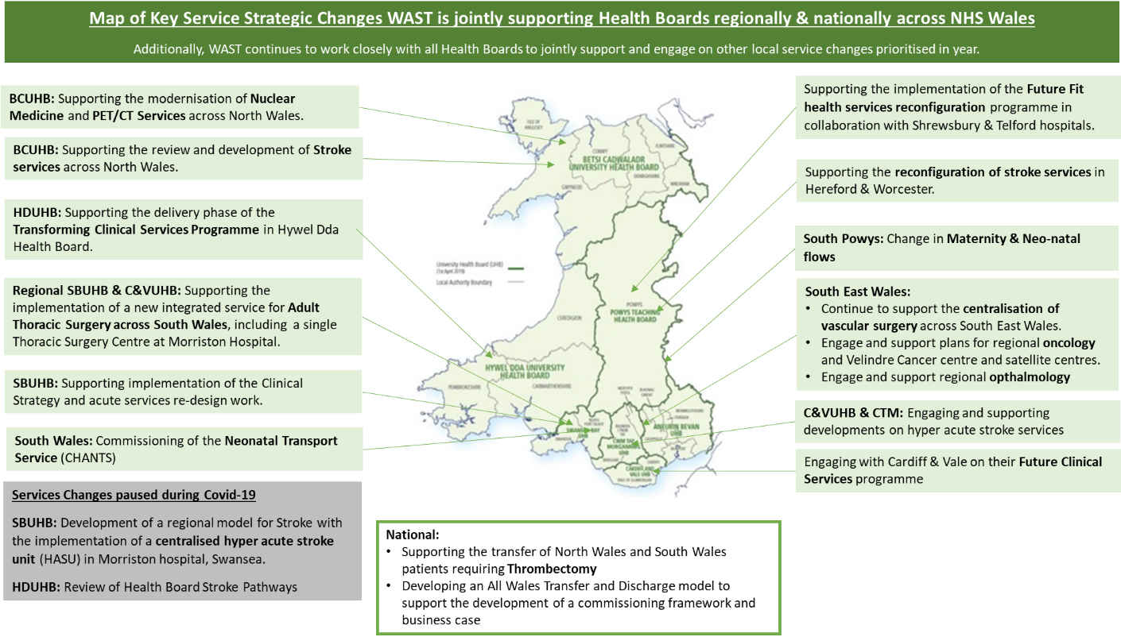

2.55 The key risks to the delivery of the WAST IMTP in 2022/23 include:
- Availability of revenue funding for core and transformational elements of the plan;
- The reduction in capital available to NHS Wales, which will impact on delivery of some of the core enabling plans such as WAST’s estates improvement plan, but also poses a risk in terms of transformational elements of the plan;
- Securing internal stakeholder support. Work will be ongoing within the next few months to find a way to work more effectively together with TU partners in the delivery of this plan, acknowledging the difficulties that have been evident over the last 12 months;
- Securing external stakeholder support, particularly for the EMS transition plan and Inverting the Triangles;
- Ongoing impacts of COVID-19 recovery both internally within WAST and as the Health Boards recover their activity;
- Capacity within the organisation to deliver the change required, within the resource envelope available. The previously planned growth in corporate support is not currently included in this plan.
- Demand for services increasing at a greater rate than the demand and capacity forecasts;
- Pressures on the service arising from external factors, particularly the continuing impact of hospital handover delays;
- Health and wellbeing of the workforce in the face of continued pressure.

EASC is asked to note that: WAST is making good progress on both its EMS Operational Transformation and Ambulance Care Transformation programmes; that WAST will receive a further £3m to enable the funding of an additional 100 FTEs in Operations Response; that progress on the 2022/23 commissioning intentions will be reported to Aug-22 EASC Management Group; the 2022-25 IMTP is awaiting Ministerial approval; that the IMTP includes four new work programme to reflect the challenges WAST faces post-pandemic; WAST is mapping its relationship to the Ministerial 6 goals; that WAST’s approach to Value Based Health Care is developing, in particular, the planned implementation of PLICS; there is significant planning work around changes in health board configurations, in particular, vascular centralization and time critical transfers; and WAST is actively managing its risks, including a Risk Implementation Programme.

Conclusions and Forward Look

2.56 Current performance levels and patient safety remain very challenging. System pressure, as expressed through handover lost hours, is extreme and can be expected to be even more challenging in the winter period.

2.57 WAST is focused at an organisational level on this challenge. WAST is currently as level 3 (maximum is 4) escalation, is pro-actively managing patient demand (and safety) through enacting its Clinical Safety Plan (demand management arrangements for EMS and its Capacity Management Plan for NEPTS. WAST also has a comprehensive range of transformational programmes, planned efficiencies and tactical actions to support both services. WAST will receive a further £3m to enable the funding of an additional 100 FTEs in Operations Response; however, WAST cannot achieve the patient safety parameters identified in the EMS Demand & Capacity Review, without a transformational reduction in hospital handover lost hours.

2.58 NEPTS is achieving most of its targets currently, however, demand has been suppressed and capacity was boosted in 2021/22. As demand increases as the system re-sets and the in-year capacity ends, EASC will need to consider options for balancing demand and capacity. WAST is looking at the balance of demand and capacity via the pre-work on the NEPTS roster review project.
- KEY RISKS/MATTERS FOR ESCALATION TO THE COMMITTEE

Members of the EAS Committee are asked to note that:
3.1 WAST is at escalation level 3 and expects to remain so for the foreseeable future
3.2 Patient safety in the emergency ambulance five step pathway is now very high risk for both EASC and WAST, with response times that are far too long
3.3 There were 619 12 hour and over patient waits in May-22, 33 patient safety incidents were referred to health boards under the Appendix B arrangements) over the last three months and 21 WAST NRIs were reported to Welsh Government
3.4 The Red 8 minute 65% target has not been hit since Jul-20 (66.1% of Red incidents were responded to in 10 minutes in May-22)
3.5 WAST produced 123,092 Operations Response hours in May-22 (all resource types), but lost 22,080 to handover delays, a level that WAST cannot offset without radical measures to shift left or improve system flow
3.6 There is a Ministerial expectation for Immediate Release non-acceptance to be a Never Event
3.7 There is also a Ministerial expectation for a 25% reduction in handover lost hours (from Oct-21 baseline)
3.8 WAST has produced a Transition Plan for 2022/23 to increase capacity, continue to make improvements in efficiency and to further increase numbers of APPs and has undertaken modelling on a radical shift left
3.9 WAST has been notified of further funding (£3m) in 2022/23, which will enable it to recruit a further 100 FTEs to help bolster the EMS
3.10 WAST has also made a bid to the Value Based Health Care Fund for 30 to 50 APPs to support the transformative shift left/triangle inversion
3.11 WAST continues to seek efficiencies, in particular, the pan-Wales EMS Response roster review, PPLH and abstractions/sickness absence reduction
3.12 The ePCR programme has gone live and operational in every health board, but compliance performance for the clinical indicators have been affected in the short term as the system changes over
3.13 Further dialogue on NEPTS is required between health boards, the NCCU and WAST, in particular, how to balance demand with capacity
3.14 An Ambulance Care Transformation Programme Board has been established to take forward the findings of the NEPTS strategic Demand & Capacity Review and wider NEPTS and transfer and discharge projects and is making good progress
3.15 WAST will report quarter 1 progress on EASC’s commissioning intentions to Aug-22’s EASC Management Group
3.16 WAST is awaiting Ministerial approval of its 2022-25 IMTP
3.17 WAST in engaged with health boards on a significant range of planning work for reconfigurations, in particular, vascular and time critical transfers, and
3.18 WAST is fully engaged in delivery of and support of the six goals programme.

- IMPACT ASSESSMENT

Quality/Safety/Patient Experience implications | Yes (Please see detail below)
Quality/Safety/Patient Experience implications | Identified within the report
Related Health and Care standard(s) | Timely Care
Related Health and Care standard(s) | And all health and care standards
Equality impact assessment completed | Not required
Legal implications / impact | There are no specific legal implications related to the activity outlined in this report.
Legal implications / impact | Included within the body of the report
Resource (Capital/Revenue £/Workforce) implications /  Impact | Yes (Include further detail below)
 | Included within the body of the report
Link to Main Strategic Objective | The Committee’s overarching role is to ensure its Commissioning Strategy for Emergency Ambulance Services utilising the five step patient pathway outlined within the National Collaborative Commissioning Quality and Delivery Agreement and the related outcomes for each care standard aligned with the Institute of Healthcare Improvement's (IHI) ‘Quadruple Aim’ are being progressed.  This report focuses on all the above objectives, but specifically on providing strong governance and assurance and safe and effective patient care
Link to Main WBFG Act Objective | Service delivery will be innovative, reflect the principles of prudent health care and promote better value for users

- RECOMMENDATION
5.1 The EASC Committee is asked to:
- DISCUSS and NOTE the WAST provider report.

