 | AGENDA ITEM 2.6  26 March 2019

Emergency Ambulance Services Committee (EASC) Report
EMERGENCY MEDICAL SERVICE
- 5 YEAR DEMAND & CAPACITY REVIEW -
WELSH AMBULANCE SERVICES NHS TRUST (WAST)

Executive Leads: Julian Baker, Director of National Collaborative Commissioning and Rachel Marsh, Interim Director of Planning & Performance (WAST)
Authors:
Hugh Bennett, Assistant Director Commissioning & Performance (WAST)
Ross Whitehead, Assistant Ambulance Services Commissioner (NCCU)
Contact Details for further information:
Hugh Bennett 07788 183961 hugh.bennett2@wales.nhs.uk
Ross Whitehead 07748 600242 ross.whitehead@wales.nhs.uk

Purpose of the Emergency Ambulance Services Committee Report

The purpose of this paper is to update the Committee on the progress with the five year Demand & Capacity Review for emergency medical services as part of the Amber Review Implementation Programme.

Governance
Link to the Commissioning Agreement | The Emergency Ambulance Services Committee’s overarching role is to ensure delivery of its Commissioning Strategy for Emergency Ambulance Services utilising the five step patient pathway outlined within the National Collaborative Commissioning Quality and Delivery Agreement and the related outcomes for each care standard aligned with the Institute of Healthcare Improvement's (IHI) ‘Triple Aim’ are being progressed.
Supporting evidence | The Collaborative Commissioning Quality and Delivery  Framework for Emergency Medical Services
Engagement – Who has been involved in this work?
Chief Ambulance Services Commissioner and WAST Chief Executive Officer.

Emergency Ambulance Services Committee Resolution to:
APPROVE |  | ENDORSE |  |  | DISCUSS | √ | NOTE | √
Recommendation |  | The Emergency Ambulance Service Committee is asked to:  - DISCUSS and NOTE the commissioning of a collaborative, whole system 5 year strategic demand and capacity review for WAST emergency medical services  - NOTE the establishment of a steering group to oversee the review  - NOTE the plan to receive the findings of the Review at the earliest opportunity.
Summarise the Impact of the Emergency Ambulance Services Committee Report
Equality and diversity |  |  | There are no implications arising directly from this report.
Legal implications |  |  | There are no legal implications arising directly from this report.
Population Health |  |  | The proposed review would improve population health through improved ambulance response times and the provision of care suitable to the individual patient need in the community where safe and appropriate to do so.
Quality, Safety & Patient Experience |  |  | The proposed review would improve quality, safety and patient experience through improved ambulance response times and the provision of care suitable to the individual patient need in the community where safe and appropriate to do so.
Resources |  |  | The proposed review would deliver a series of recommendations for the efficient use of WAST resources. If the collaborative efficiencies are not sufficient to deliver the required levels of performance (quality standards and response times), it will recommend additional investment.
Risks and Assurance |  |  | Risks are managed through the EASC risk register and WAST’s risk management framework and this report is relevant to “Red Risks” for example: CRR58 “unable to attend patients in the community…”.
Health & Care Standards |  |  | The 22 Health & Care Standards for NHS Wales are mapped into the 7 Quality Themes:  Staying Healthy; Safe Care; Effective Care; Dignified Care; Timely Care; Individual Care; Staff & Resources  http://www.wales.nhs.uk/sitesplus/documents/1064/24729_Health%20Standards%20Framework_2015_E1.pdf  This report relates to all themes, but in particular, timely care.
Workforce |  |  | The proposed review would impact on workforce, for example it will make recommendations round roster configuration and abstraction, workforce planning, skills mix etc.
Freedom of information status |  |  | Open

EMERGENCY MEDICAL SERVICE
- 5 YEAR DEMAND & CAPACITY REVIEW -
WELSH AMBULANCE SERVICES NHS TRUST (WAST)

1. SITUATION / PURPOSE OF REPORT

The recently published Amber Review found “that there are a number of patients in the Amber category that are waiting too long to receive a response. The overriding factor in improving this is the availability of ambulance resources and not the categorisation of the patients as Amber”.

The Amber Review made a number of whole system recommendations and outlined areas for further work, which, if actioned, could improve the availability of ambulance resources to respond to the presenting demand and reduce waiting times in particular for amber patients. These included:

  - There must be sufficient numbers of clinicians in the contact centres to ensure patients receive the most appropriate level of care.
  - The ambulance service must ensure that planned resources are sufficient to meet expected demand.
  - The ambulance service must deliver against its planned resource.
  - Health Boards must take appropriate actions to ensure that lost hours for ambulances outside hospitals reduce.

However, whilst the Amber review considered and analysed many factors affecting the system, it was not established to forecast future demand patterns, to anticipate the impact of strategies to produce a ‘shift left’ in system response, to establish and model reasonable and realistic levels of improvement in efficiency in WAST and Health Boards, or to identify the level and type of resources required to meet specified quality and response time standards.

An Implementation Programme has been established by the Chief Ambulance Services Commissioner (CASC) to oversee delivery of these recommendations and the further work identified.

In line with the Amber Review Implementation Programme and as agreed with the CASC, this report therefore sets out the intention for Health Boards and WAST to jointly commission a forward looking strategic Demand and Capacity Review, designed to model the optimal efficient level of ambulance resources that are required across the system to deliver agreed levels of performance for all categories of emergency calls against forecast demand for the next 5 years.

2. BACKGROUND / INTRODUCTION

Red performance is being maintained above the 8 minute in 65% of occasions (Emergency Ambulance Services Committee (EASC) and Welsh Government target), but is gradually declining as a result of increasing misalignment between demand and capacity. Intervention should therefore be planned and enacted now prior to performance falling below target.

Table 1 – Red Performance

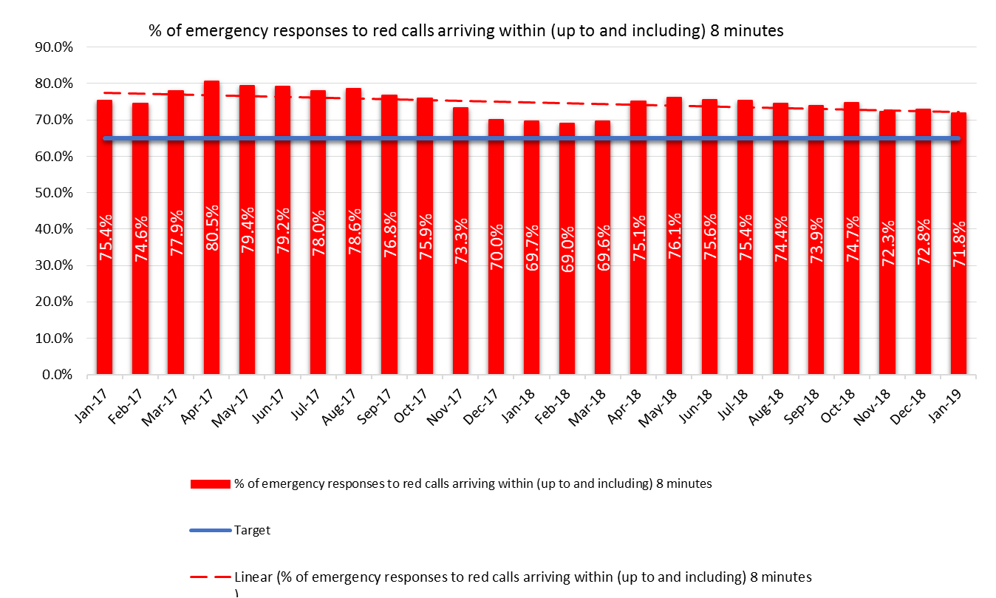

Response times to patients categorised as Amber are also declining for the same reasons, as shown in the graphs below. With activity having grown year on year in recent years this trend will only continue unless intervention is taken on a system wide strategic basis to intervene in a planned way to improve outcomes and experiences for patients. Whilst targets are not set nationally, reasonable response times should be expected for Amber 1 and Amber 2 calls.

Table 2 – Amber Median

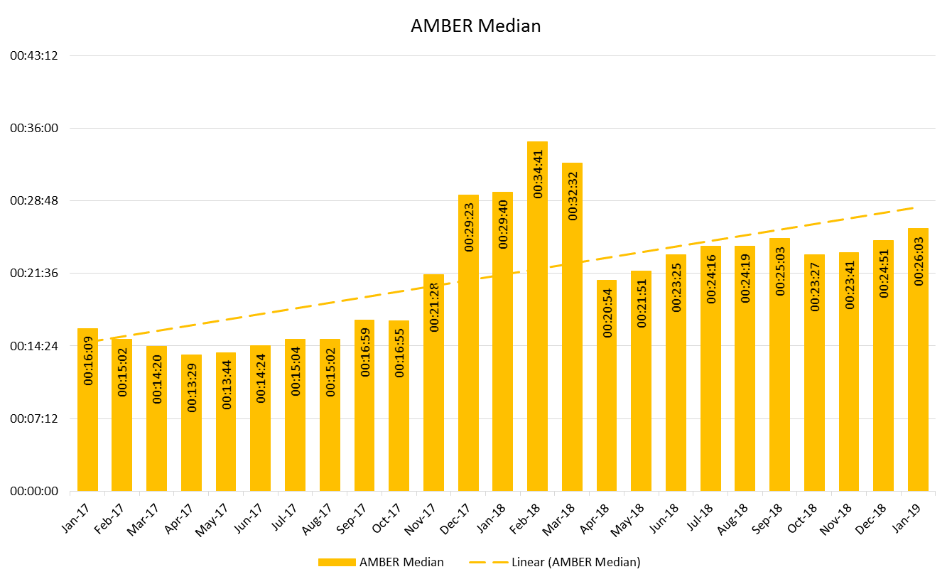

Table 3 – Amber 95th

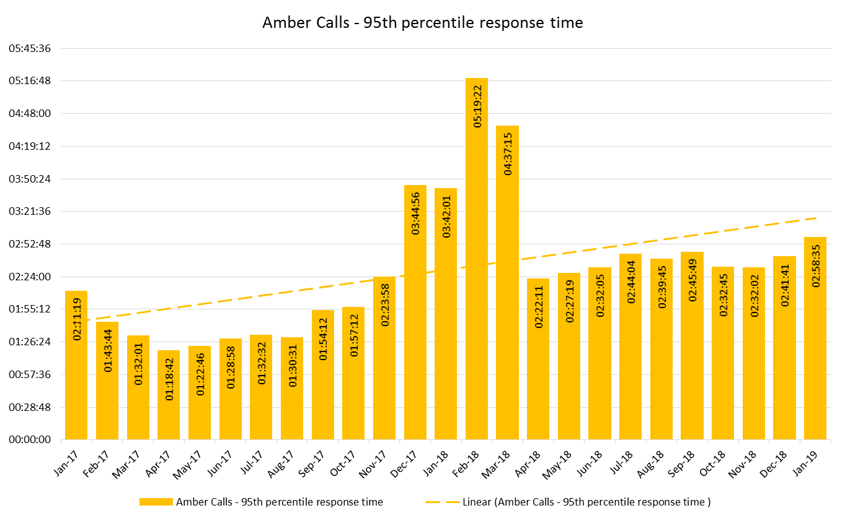

The worsening Amber response time performance is being driven by an increase in demand (the Amber Review identified a 2% increase in incidents over the time frame it used) and a reduction in the available resource to respond i.e. the gap between incidents and available resource is widening, which is reflected in the lengthening Amber waiting times for patients.

Table 4 – Incident Demand & Available Ambulance Response Hours

*note: available hours is the actual EA, RRV and UCS hours, time lost at hospital (notification and clear)

The number of serious adverse incidents with a common feature of delayed response has increased.

Table 5 – Serious Adverse Incidents

Similarly, the total level of interest in WAST from HM Coroners is increasing. In the period 01 Nov-17 to 31 Oct-18 WAST was approached 266 times by HM Coroners for statements, information or attendance at inquests where delays were a feature of many of the cases.

WAST does have previous experience of undertaking demand and capacity forecasting and modelling work. The first key lesson from this previous experience is the need for up front collaboration with system partners in shaping and steering the review and the independence of the modelling capacity. The second key lesson is the level of forecasting and modelling sophistication that is available to WAST and NHS Wales. WAST is an information rich environment, which has been further enhanced through the commissioning process, which in turn means that the five step ambulance care pathway is particularly suitable to forecasting and advanced software scenario modelling, which is available in the market place.

3. ASSESSMENT / GOVERNANCE AND RISK ISSUES

It is therefore clear that there is a requirement for a collaborative, forward looking strategic Demand and Capacity Review, designed to model the optimal efficient level of ambulance resources that are required across the system to deliver agreed levels of performance for all categories of emergency calls against forecast demand for the next 5 years, as agreed with EASC and Welsh Government.

This review would form part of a three phase process, which will also include:
Phase 1 – Demand & Capacity Review (WAST Lead)
Phase 2 – Health Economic Case (EASC Lead)
Phase 3 – Future Modelling & Expertise (EASC/WAST Joint Lead)

This initial Review will have seven main components:

- Forecast all incident demand by type and location over the next 5 years
- Agree the required levels of quality and time performance for each type of patient
- Model the required resources to deliver ii above by hour of day, day of week and geographical location
- Identify and quantify WAST efficiencies including new models of response such as APPs, abstraction reduction and roster realignment
- Identify and model unscheduled care system efficiencies
- Model the impact of planned service changes affecting patient flows, and
- Model required resources for Clinical Contact Centres including call handling and clinical staff delivering hear and treat services to meet forecast activity and quality and performance requirements.
The estimated cost of this externally commissioned work is £100,000 to £150,000, to be jointly funded by the EASC and WAST. This estimate is based on experience from previous reviews, but will be confirmed via a tendering process.

In order to ensure up front collaboration and independence, a formal project approach to the delivery of the Review will be adopted, with the WAST Chief Executive Officer being the Senior Responsible Officer for a project Steering Group. The Steering Group would also include representatives from:
- Health Board Chief Executives – Steve Moore (Vice Chair of EASC has agreed to represent)
- Welsh Government
- The National Collaborative Commissioning Unit
- The Welsh Ambulance Services NHS Trust (WAST) to include the Medical Director, Director of Operations, Director of Planning & Performance and Trade Unions / staff side organisations.

It is planned that this work will go out to the tender in the first week of April 2019, with the contract to be awarded in May 2019.

Progress reports will be made to EASC from the Steering Group throughput the process. The review will aim to complete its work as quickly as possible with a formal report potentially available for discussion at the EAS Committee meeting on 10 September 2019, although final timescales will be confirmed once the contract has been placed.

4. RECOMMENDATION

The Emergency Ambulance Service Committee is asked to:

- DISCUSS and NOTE the commissioning of a collaborative, whole system 5 year strategic demand and capacity review for WAST emergency medical services
- NOTE the establishment of a steering group to oversee the review
- NOTE the plan to receive the findings of the Review at the earliest opportunity.

Freedom of information status | Open

