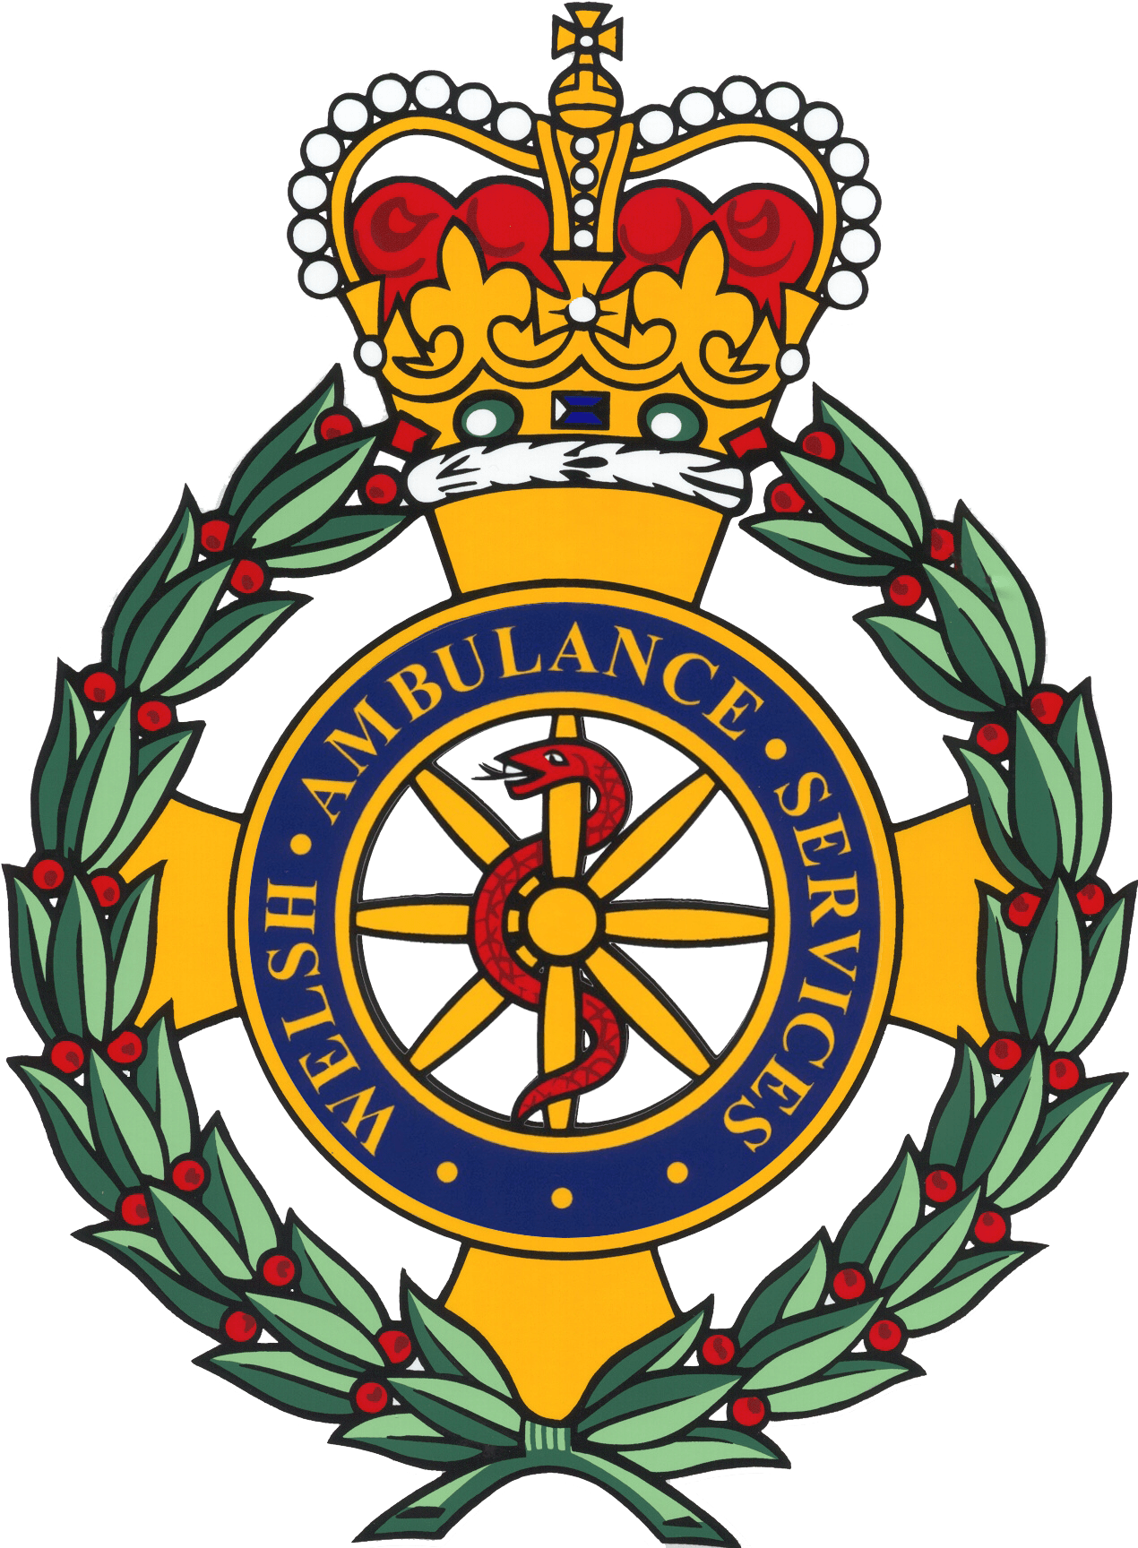

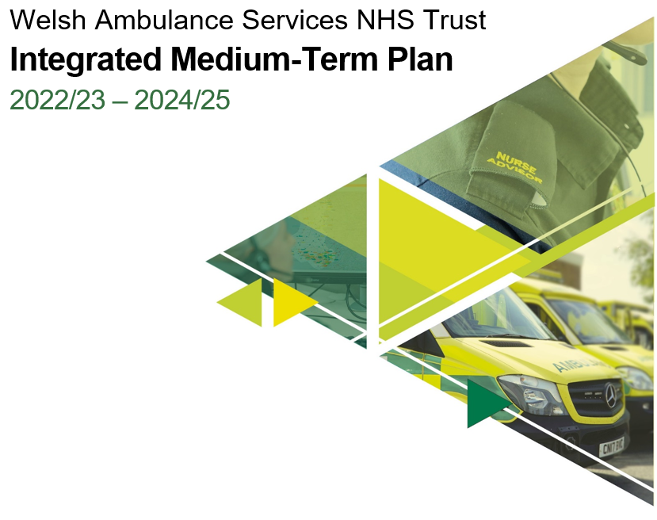
Contents
Foreword from the Chairman and Chief Executive 3
1.0 Executive Summary 4
2.0 Introduction 7
3.0 Our Key Achievements in 2021/22 7
4.0 Challenges and Opportunities Shaping our Plan 8
4.1 How will we respond to and recover from the COVID-19 pandemic? 8
4.2 What do our patients say about our service? 9
4.3 What are our colleagues’ priorities? 10
4.4 What are our legislative, strategic, financial and policy drivers? 11
4.5 How well have we performed? 13
4.6 What do our commissioners and partners say? 17
4.6 How will Health Board plans affect us? 19
4.8 What are the operational risks that we are managing? 20
5.0 Our Service Offers to Patients and the System 21
5.1 Our Long-Term Strategy 21
5.2 Gateway to Care – 111 and CSD 22
5.3 Emergency Medical Services 25
5.4 Ambulance Care 29
5.5 Emergency Preparedness, Resilience and Response (EPRR) & Specialist Operations 31
6.0 Our Enablers 32
6.1 Our people 32
6.1.1 Equality, Inclusion and the Welsh Language 34
6.2 Innovation and Technology 35
6.2.1 Research and Innovation 37
6.3 Infrastructure 38
6.4 Partnerships and Engagement 40
7.0 Our Fundamentals 41
7.1 Quality Driven, Clinically Led, Value Focused 41
8.0 Our Workforce Plan 43
8.1 Current workforce profile 43
8.2 Our Plan 44
9.0 Our Financial Plan 45
10.0 Delivering Our Plan 46
10.1 Managing transformation 46
10.2 Risks to delivery 47
11.0 Conclusion 47

Foreword from the Chairman and Chief Executive

Executive Summary

The challenges throughout 2021/22 have once again been significant, as the Trust has continued to respond effectively to the second year of the COVID-19 pandemic. Staff across the organisation have risen to the challenge and worked across traditional directorate and organisational boundaries to deliver change at pace throughout the year. Many staff are tired, and our plan takes account of the need for a continued emphasis on staff well-being and support.

Alongside the many actions we had to take to respond effectively to the COVID-19 pandemic, we also made very good progress towards delivering the key strategic commitments and deliverables in our 2021/24 IMTP. Achievements have included: the recruitment of an additional 127 FTE staff into the EMS service; a doubling of capacity within the Clinical Support Desk including appointment of our first mental health practitioners; completion of the roll out of core 111 services across Wales, conclusion of the transfer of services from Health Boards, making WAST the sole provider of non-emergency transport for Wales; and a complete refresh of our values and behaviours.

This plan is the vehicle by which we articulate the steps we will be taking over the next 3 years to move us towards our long term strategic ambitions and goals. ‘Delivering Excellence’, our Long Term Strategy Framework, was agreed in 2019 and sets out an ambition to ensure that patients receive the right advice and care, in the right place, every time. Through the last year, we have worked to express what this might mean in practice for a transformed and modernised ambulance service, with presentations on our ‘Inverting the Triangle’ ambition well received at EASC and in Welsh Government. A key deliverable in this year’s IMTP is the establishment and delivery of a wide-ranging, collaborative programme of work to take this forward at pace. Similar energy will be needed to work with commissioners and partners over the coming months to identify how the 111 and Ambulance Care services can transform to meet these longer term goals.
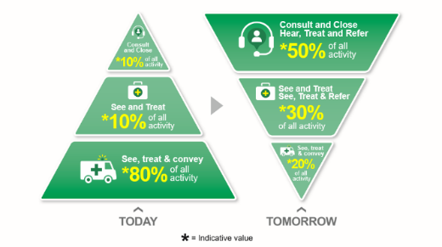
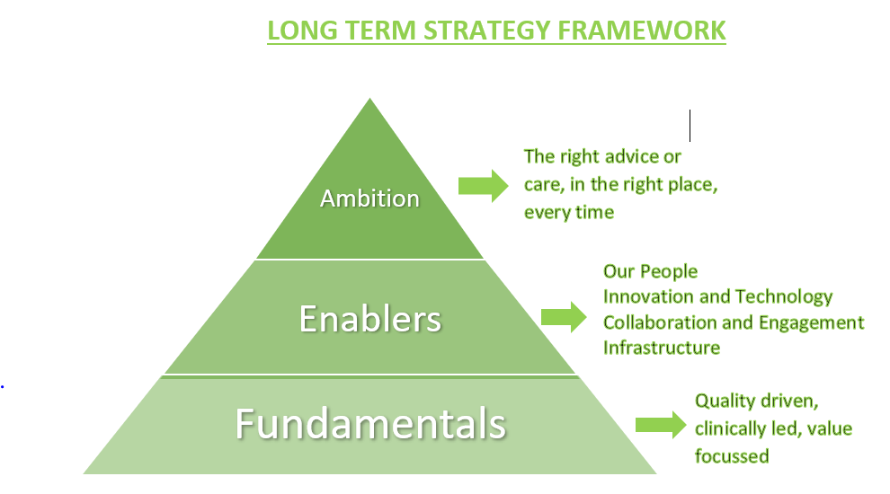

In addition, our 2022/25 plan is shaped by several other key factors including intelligence on what is important to our patients, staff and commissioners (including commissioning intentions), a review of our own performance and the risks we are managing, and the opportunities presented by emerging strategies and plans from Welsh Government, key partners and groups across Wales. This year, Welsh Government have published their Six Goals for Urgent and Emergency Care, and our plan sets out clearly how we will contribute to delivery of these.

We are particularly conscious of the need to take action with others to bring down the unacceptably long waiting times for an ambulance. The lengthening waits for both red and amber categories of patients have led directly to patient harm, resulting in National Reportable Incidents and this must be addressed sustainably in partnership with commissioners and health board partners. There are several immediate actions that can be taken, alongside and in parallel with the transformative work being taken forward through our strategy.

Within our ‘Gateway to Care’ services (111 and 999 clinical assessment), our key agreed and funded priorities will be to:
- Stabilise and sustain the core 111 service, now operational across the whole of Wales, by maintaining numbers of call takers and clinicians at funded levels, taking steps to improve productivity and deliver improved call answering and clinical ring back times;
- Roll-out the 111 press 2 service to ensure patients with urgent mental health needs get immediate access to 24/7 mental health services;
- Implement the new SALUS system within 111;
- Maximise the impact and benefit of the increased number of clinicians within the Clinical Support Desk and their new clinical assessment tool (ECNS), with a target of a 15% consult and close rate
- Develop and agree a Remote Clinical Assessment Strategy with commissioners and partners.

We would like to make further significant strides in improving the 111-website, and maximising the benefit of a ‘digital first’ offer for people in Wales, but this will be subject to additional funding being made available. We will work with others to develop a more robust case for change for consideration.

For our Emergency Medical Services, the immediate priority is to stabilise our core service, improving response times to patients and reducing patient harm. This is pressing in the light of sustained growth in red demand, and a need in the short term to mitigate losses in capacity through ongoing system / pandemic pressures including very high levels of hospital handover delays and sickness absence. An offer has been made through our Transition Plan to significantly increase capacity by up to 294 WTE, and we are ready to mobilise recruitment and training plans if funding is made available. This additional capacity would allow us to:

- Implement a Cymru High Acuity Response Unit (CHARU) model which has been shown to improve clinical outcomes for the most time critical incidents, improve ROSC rates and provide a boost to red performance;
- Review opportunities to develop services for specific groups of patients, such as Level 2 Falls response services;
- Support the numbers of hours produced in the core rosters, increasing UHP levels towards 100%.

We are also committed to improving the internal use of resources. This includes:

- a renewed focus on reducing abstractions due to sickness absence. Our target is to bring abstractions down to 6%, in line with the original demand and capacity review, with a trajectory for improvement over the course of the IMTP to be agreed with commissioners. Significant improvements are, however, expected in 2022/23;
- the implementation of new rosters designed to better align capacity with demand, to be implemented between September and November 2022, and which will have the equivalent performance improvement effect of 72 WTE;
- the Leading Service Change Together project, which continues to consider opportunities for modernising workforce patterns, seeking to collaboratively identify an accurate baseline of post-production lost hours and identify appropriate and achievable reductions.

Work also continues with Health Boards and with WG to increase the alternative pathways available to provide care for patients closer to home and to avoid an ED attendance or hospital admission where appropriate. Work is progressing on a national referral pathway into Same Day Emergency Services, on the development of 24/7 single points of access for mental health in each Health Board, and local pathways for specific groups of patients such as fallers, chest pain and breathing difficulties.

Whilst we will make progress at pace in these improvement areas, it is highly probably that, without additional capacity funded, response times will remain unacceptably long and patients will continue to come to harm. Our expectation is that Health Boards will be continuing to work at pace to delays outside hospital.

In parallel, we will also establish and take forward a formal programme of work to implement the ‘inverting the triangles’ model, which will deliver a more sustainable service for the future. Some of this will be achievable and deliverable within existing resources, but to accelerate the pace of change, some pump priming is required. We want to develop a workforce that is skilled and equipped with the right resources and information to be able to increase levels of see, treat and refer, enabling patients to be treated closer to home and avoiding a conveyance to EDs where appropriate. This will include:

- the continued development of the Advanced Paramedic Practitioner (APP) rotational model, supporting not just WAST but the wider health care system. Up to 50 APPs could commence training this year subject to funding being available;
- the Older People and Falls Framework development;
- review and refinement of our Public Health Plan; and
- further exploration of our offer for people in mental health and dementia crisis, with the intention of testing and implementing a new model within the life of this IMTP.

Within our NEPTS service, as well as continuing to make improvements in productivity and efficiency following the Demand and Capacity review and developing improved quality assurance mechanisms to manage external providers, we will also actively seek to engage commissioners and wider partners in how to effectively manage demand and support patients in the light of the extant eligibility criteria. We will also be working closely with commissioners on the development of a national transfer and discharge model, considering carefully how this could bring coherence to a potentially fragmented offering at present and improve services for the benefit of patients and flow across the system.

Supporting the growth and transformation of our core services will be a series of extensive enabling programmes and strategies including our Quality Strategy, Clinical Strategy, People and Culture Strategy, Digital Transformation Strategy and Volunteering Strategy. The Estates and Fleet Strategic Outline Programmes will be driven forward as well as, importantly, work to deliver on our Environmental Sustainability Plan taking us towards carbon neutrality by 2030.

Our plan cannot be delivered by us in isolation. It will be ever more important for us, in what is an increasingly complex landscape, to collaborate with partners – Health Boards, Regional Partnership Boards, Welsh Government, Commissioners, Trade Union Partners, staff, patients and the public – to both create and implement the best solutions and services for the people of Wales. We want to continue to engage on how we can play a strengthened role within the urgent and emergency care system, turning the current way of working on its head, increasing the numbers of patients whose needs are met through our integrated remote clinical assessment service, our see and treat services or collaborative community referral pathways, and reducing the numbers conveyed to hospital.

Financial summary to be included once position concluded.

The scale of change required to deliver on this plan and to achieve our ambition is significant, particularly for our people across the service. We will continue utilising a robust programme management approach to support the transformation programme and manage and mitigate identified risks, together with structures to support ongoing strategy development. The key, however, will be continued dialogue and engagement internally and externally, which we are committed to doing in pursuit of a better service for the people of Wales.

Introduction
This document sets out the Welsh Ambulance Services NHS Trust’s (WAST) Plan for 2022-25, written in line with the NHS Wales Planning Framework for 2022-2025 and the Emergency Ambulance Services Committee (EASC) Commissioning Intentions.

The document is supported by the Minimum Data Set as required by WG, along with a number of appendices which provide more detail on areas of our plan and also provide detail on planned actions in years 2 and 3. Further information is available on request.

Our Key Achievements in 2021/22
Alongside the many actions we have continued to take to respond effectively to the COVID-19 pandemic and seasonal surges in demand, we also made very good progress towards delivering our key strategic and commissioning commitments and deliverables in our 2021-24 IMTP. These initiatives prepare the environment for further strategic change in WAST as we strive to improve performance, outcomes and wellbeing for both our patients and our people, whilst also adding value to the wider urgent and emergency care system.

Some of our key achievements are highlighted in the infographic below.

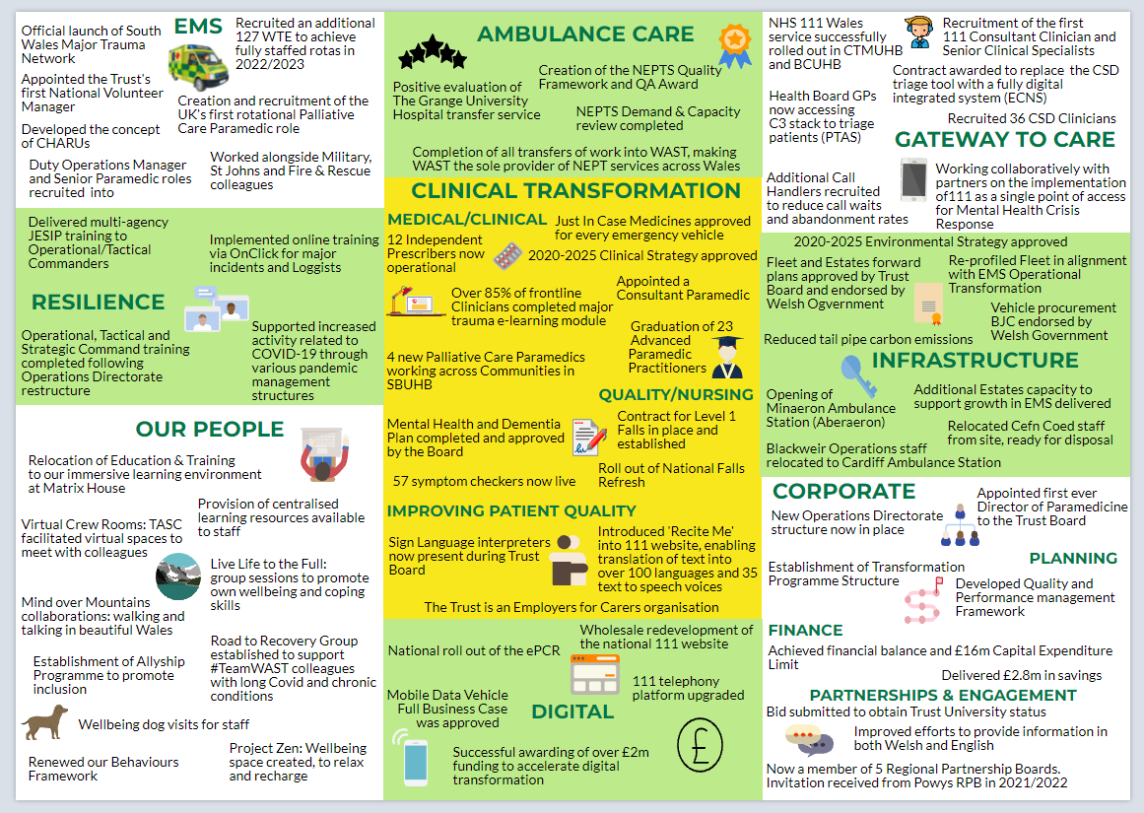

Challenges and Opportunities Shaping our Plan
In developing our plans for 2022/23 and beyond, we have gathered intelligence on what is important to our patients, our people and commissioners, reviewed our own performance and the risks we are managing, and carefully considered the opportunities presented by emerging strategies and plans from key partners and committees across Wales. A short summary of what we have learnt and how our plan responds to these influences is set out in the sections below.

4.1 How will we respond to and recover from the COVID-19 pandemic?
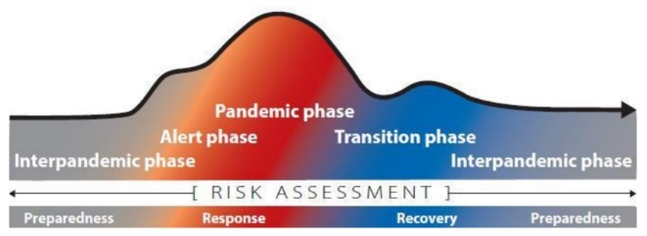
WAST’s planning over the last two years has been responsive to a rapidly changing environment. There has been a significant amount of learning about the role of ambulance services and NHS 111 Wales in responding to a health crisis, but also, with a focus on recovery, how our plans can shape and influence the way in which people in Wales access and receive urgent and emergency care in the future.

The last year has been particularly challenging with waves of COVID-19 community transmission, including more recent variants, driving either direct or indirect pressure on flow across the health and care system. At the same time, the wider community is unlocking and pressure has built around the need to recover planned care and manage growth in urgent and emergency presentations. Seasonal pressures, some not experienced before, alongside waves of COVID-19 transmission, have contributed to pressures.


The response has required (and will continue to require) difficult decisions to be made about the way we prioritise our resources. We re-established our response structures in a Monitor position on 13 September 2021 and, considering a worsening picture in terms of the Omicron variant, escalated to a full response structure on 8 December 2021. We have subsequently de-escalated to a Monitor position and expect to enter Recovery soon.

Our learning from this last year suggests that we, and the system, need to do something fundamentally different as we recover from the pandemic, to ensure that we can deliver safe and effective services in the short, medium, and longer term. Our strategic ambitions set out in this plan are our offer to the system as it recovers across all areas of the health economy. We therefore need to plan ambitiously but cautiously, considering the likelihood that COVID-19 will be with us now and into the future, alongside other endemic and seasonal infections.

A further concern for WAST, and NHS Wales in general, is staff health and wellbeing and the rise in sickness rates leading to high abstractions from our 111, Clinical Contact Centres, frontline EMS response and ambulance care services. This is not only the result of COVID-19 transmission itself, but also the physical and mental strain that our people have been experiencing in meeting the challenge of a prolonged response, alongside surges in seasonal pressure throughout the year.

Over the last three years WAST has significantly invested in and developed its wellbeing offer to staff from the introduction of the WAST Keep Talking Portal to growing its Occupational Health and Wellbeing Teams to changing to a trauma informed Employee Assistance Programme (EAP) and these foundations have been vital to provide support where and when people need it most. There are multiple platforms from digital apps and programmes, text services, phonelines and face to face sessions, group support and our two significant achievements – the Road to Recovery Group for Long Covid and more recently Project Zen, providing an oasis of calm for colleagues to take time out when service pressures were at their height.

WAST has welcomed the support of the military, fire and rescue services, St. John Cymru and student paramedics alongside other partners over the last two years to support our EMS service. However, it has not always been easy for our people to adjust to working with non-clinical colleagues. Furthermore, such levels of support are unsustainable and military support will be withdrawn at the end of March 2022.

This plan therefore sets out our priorities for recovery, transition and transformation which have taken account of the continued and growing pressure that is anticipated both as a result of COVID-19 and the wider health profile of our communities in Wales. WAST will also support the recovery of the NHS Wales system in general, ensuring that our EMS, Ambulance Care and Transfer & Discharge offers align to both the recovery of urgent, emergency, and planned care in Health Boards and strategic local and regional plans for change across NHS Wales.

Key areas of recovery planning for the Trust include:
- Recovery within our Estate, addressing NEPTS displacement and re-accommodating corporate and clinical staff who have been working from home during the pandemic, in an agile way;
- How Infection Prevention & Control measures continue to apply in a post-pandemic phase taking account of national and AACE guidance, particularly in our contact centres;
- Ensuring the lessons learnt during COVID-19 and establishing the systems that have been put in place that need to continue as business as usual;
- Taking a quarterly approach to tactical planning, using forecasting & modelling to guide decision making around capacity in frontline resources and consideration of how we monitor future COVID-19 clusters and outbreaks following closure of national early warning and reporting mechanisms;
- Planned care recovery in Health Boards, and its impact on WAST service delivery.

4.2 What do our patients say about our service?

Due to the pandemic, we had moved our continuous engagement with people across Wales online whilst maintaining contact with those not digitally connected through more traditional methods. Through engagement with communities and citizens we have been able to provide evidence to a number of forums on the ongoing impact of the pandemic, in particular around people’s access to services. We have been able to feedback to communities on how their experiences have been shared and their voices heard.

For example, people’s concerns around safe practices during the pandemic and their appetite for digital systems has influenced our approach to capturing patient experiences/stories through the establishment of an online system enabling people to submit their experiences themselves. Furthermore, people wanting to be more involved has meant that we have refreshed and relaunched the Trust’s ‘People and Community’ Network offering people the opportunity to participate in a range of service improvement activities.

Using a variety of methods to capture feedback including surveys, face-to-face online events, a dedicated ‘have your say’ facility and email / phone service, public and patient feedback and observations have been captured and summarised as follows:

Table 1: Patient Feedback
What we have heard from our patients in the last year… | What we will do to respond…
- People contacting 999 are experiencing long waits for an ambulance for good care.  - People accessing NHS 111 Wales have said they are generally satisfied with the service received, they followed the advice given and would use the service again if they needed to. However, people are still reporting long waits for their calls to be answered  - People found the NHS 111 Wales website useful for quick access to online self-help symptom checkers.  - Those with sensory loss (Deaf) felt they faced barriers to accessing information and emergency service.  - Patients and their carers have continued to tell us that long waits for hospital handover outside EDs can be very distressing for all involved.  - People have told us they appreciate the work of the ambulance service and praised staff for their dedication and commitment to working through the pandemic.  - Carers have told us that our staff recognise them and involve them in the care and treatment being delivered to the person they care for.  - People from communities where English or Welsh are not the main languages spoken have told us they appreciate our efforts to make information available to them in their language. | - There are a range of actions in the plan designed to improve performance in EMS response times to improve patient safety (see section 5.3)  - We have a stabilisation and transformation plan for 111 which will likely see expansion of the workforce (subject to funding) to improve call answering performance. We will also further develop the NHS 111 Wales website to help people to access advice to support them to safely care for themselves or access services in the community (see section 5.2).  - We co-produced a service improvement plan with members of the deaf community and set up a dedicated ‘task and finish’ group to implement the plan, monitor the introduction and impact of Sign Video in NEPTS, Complaints and Patient Experience teams as well as preparing for the introduction of Sign Video for emergency service access in June 2022.  - We continue to work with Health Boards on improvements to handover times. Our transformational plans in EMS response aim to reduce conveyance to ED which will have positive impact on handover delays (see section 5.3)  - Our colleagues are our biggest asset and we have a range of plans to ensure their wellbeing is prioritised (see section 6.1)  - We have pledged an annual commitment to undertaking a carers survey and online event is built into the National Carers day activities. The Trust is also an Employers for Carers organisation supporting staff who are themselves carers.  - We are committed to equality of access to our services and we have taken practical steps to ensure language is not a barrier to access including increasing to 172 bilingual symptom web guides on 111 website (see section 6.1.1).

4.3 What are our colleagues’ priorities?
The most recent NHS staff survey in 2020 indicated that our colleagues felt we had demonstrated good collaboration and communication and a positive service mindset. This was supported by the findings from the work undertaken in 2021 to reset our behaviours and culture. WAST has been working in partnership with an external agent and our people to refresh our behaviours and as we hopefully emerge from the pandemic, the new refreshed behaviours are due to be launched in February 2022 with a plan to address the key findings and recommendations from the report which include a focus on wellbeing, leadership and inclusion.

Through this work there was a real sense of belonging and commitment to the service experienced by many. However, the areas identified as priorities in 2020 continue to be so: improved development for our leaders; greater chance to be hear; an increased focus on staff wellbeing; putting an end to bullying and harassment; and increased professionalism and positive behaviours. Clarity of vision and purpose about our shared future is also high on colleagues’ list of priorities.

WAST also held a series of Chief Executive Roadshows across Wales and a Leadership Symposium in 2021, inviting colleagues from all parts of the organisation to come together to discuss directly with the Executive Team the concerns, challenges and issues they face on a day-to-day basis. It was also an opportunity to share the strategic ambitions for our services. Some key areas of feedback included the concern over the sustained need for mutual aid such as military support and a general feeling that we cannot sustain the way we are currently working, particularly the experience many have of delays outside hospitals. There was general support for WAST’s strategic ambitions, with broad agreement that something needs to change across the system and we cannot continue to do things the way we have been doing in the current operating environment.

Table 2: Feedback from our colleagues
What we have heard from our people in the last year… | What we will do to respond…
- Colleagues recognise and want to see the promotion of positive behaviours and a sense of psychological safety across the Trust  - People are not always aware of where they can access wellbeing support  - There is a continued desire for leadership development  - There is a need to focus on inclusion  - Colleagues continue to feel the negative impact of handover delays outside hospitals  - Support from colleagues in the military and other partners was generally welcome, but there were some concerns about working with non-clinicians  - Colleagues who attended CEO roadshows generally supported the need for change | - Plan to launch and embed our refreshed behaviours to foster a culture of belonging, wellbeing and engagement (see section 6.1)  - Continue to implement strategies to support the health and wellbeing of colleagues to help them stay in work (see section 6.1)  - Implement leadership development programmes from aspiring leaders to shadow board development (see section 6.1)  - We are continuing to deliver our strategic equality objectives including delivering the Allyship programme (see section 6.1)  - We continue to work with Health Boards on improvements to handover times. Our transformational plans in EMS response aim to reduce conveyance to ED which will have positive impact on handover delays (see section 5.3)  - Our plans for quarter 1 set out to address the immediate impact of the military withdrawing. Our transition plan for EMS identifies an increase in core capacity to reduce the need for mutual aid in future years, funding is required. (see section 5.3)  - We have a set of strategic ambitions for clinical transformation within EMS (see section 5.3), increased awareness and use of NHS 111 Wales and our integrated care offer as the Gateway to Care in Wales (see section 5.2) and further transformation in Ambulance Care (see section 5.4)

4.4 What are our legislative, strategic, financial and policy drivers?
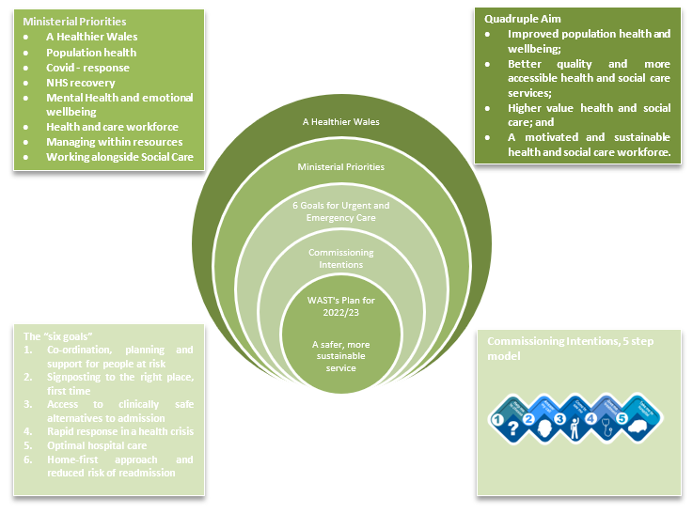
Our plan must support the delivery of relevant national strategies and policies. The Wellbeing of Future Generations (Wales) Act underpins the Programme for Government, and ‘A Healthier Wales’ remains the long-term strategy for the health and social care system. In its new term, the Welsh Government (WG) appointed a new Minister for Health and Social Care, and in July 2021 she set out her priorities for the wider NHS, as well as specifically establishing ‘six goals for urgent and emergency care’ which, together, will enable delivery of the Programme for Government and ‘A Healthier Wales’ commitments.

To accompany this WG has set out Phase 1 of a set of Ministerial measures, including a specific measure for WAST around reduction in conveyances to emergency departments.
The Urgent and Emergency Care system is struggling to cope with growing patient needs resulting in increased demand on secondary care. There is a renewed focus nationally on driving forward the Six Goals programme which focuses on strengthening signposting, clinically safe alternatives to admission, rapid emergency care response, good discharge practice and preventing readmission. Our strategic ambitions for EMS, 111 and Ambulance Care align closely to this national ambition to provide the right care, in the right place, every time.

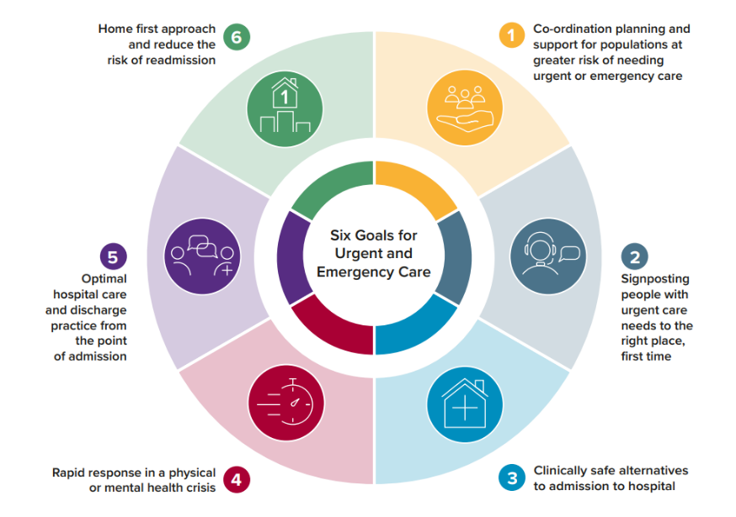
Each of the six goals includes a quality statement that sets out ambitions for consistent and reliable delivery by health and social care organisations across Wales. They describe the outcomes and standards individuals should expect when they may need urgent and emergency care services, and will inform national oversight of service provision through planning frameworks and the Welsh Government quality, planning and delivery assurance system. The COVID-19 pandemic and associated challenges make delivery of every element of each quality statement testing and some elements are considered as aspirational.

Set out in the table below is a summary of the immediate priorities that we will need to deliver on within the timeframe of this IMTP, specifically in relation to Goals 2, 3 and 4.

Goal | Immediate Priorities | What we will do to respond…
Goal 2: Signposting people with urgent care needs to the right place, first time  - When people need or want urgent care they can access a 24/7 urgent care service via the NHS 111 Wales online or telephone service where they will be given advice and, where necessary, signposted or referred to the right community or hospital-based service, first time. | - Following national roll out of NHS 111 Wales:  - significantly improve the 111 digital offer and increase use of web or app access  - improve access to urgent dental provision  - establish a palliative care pathway to access a specialist 24/7 after dialling 111  - establish the 111 press 2 pathway supporting people with emotional health, mental illness and wellbeing issues  - develop the 111 Clinical Support Hub at a national and regional level.  - Implement a 24/7 urgent care service, accessible via NHS 111 Wales, to provide clinical advice remotely. This should integrate services and schedule arrival slots in MIUs, EDs or SDECs. | Section 5.2  - Additional funding sought to continue digital improvements  - Work with 111 Programme Board to agree a new strategy for the service after roll-out of core 111 service  - Plans in place to deliver 111 press 2  - Continue to develop our clinical teams to provide excellent clinical advice remotely  - Implement SALUS
Goal 3: Clinically safe alternatives to admission to hospital  - People access appropriate and safe care close to home. Admission to an acute hospital bed should only occur if clinically necessary. | - Implementation of SDEC services so that they support 100% of type 1 emergency departments, allowing for the rapid assessment, diagnosis, and treatment, and discharge home same day where clinically appropriate  - Effective community infrastructure model for intermediate care, based upon the principles of ‘right sizing’ available capacity in the community, | Section 5.3  - Work with Health Boards to ensure access to SDECs for paramedics, through national referral pathway
Goal 4: Rapid response in physical or mental health crisis  - Individuals who are seriously ill or injured or in a mental health crisis should receive the quickest and best response commensurate with their clinical need – and, if necessary, be transported to the right place for definitive care to optimise their experience and outcome. | - Deliver safe alternatives to ambulance conveyance to Emergency Departments.  - Procurement of a new 999 remote clinical triage system to support more accurate clinical assessment, increasing ‘hear and treat’ capacity, and video and text triage and follow-up advice.  - Increasing ambulance availability to ensure people in danger of loss of life or with time-sensitive complaints are prioritised, receive the right kind of rapid response and are transported to the right place.  - Improving ambulance patient handover. | Section 5.2  - Implementation of ECNS  Section 5.3  - Work with HBs to expand alternative pathways as a key element of our ambitions for the EMS service transformation  - Actions to improve hours available to respond, including sickness management, roster reviews and growth in WTEs if funding available.

There are many other legislative, policy, strategic and financial drivers, not mentioned above, which shape our approach to planning and delivery as a Trust. Some of the more recent include (but not limited to):

- Health and Social Care (Quality and Engagement (Wales)) Act 2020 (Link)
- ISO14001 (Link) and the Welsh Government ambition for carbon neutrality by 2030 (Link)
- Socio-Economic Duty (Link)

4.5 How well have we performed?
We are committed to improving the quality of our services based on a clear understanding of what is driving current performance levels. We do this in a way that is consistent with the Quadruple Aim set out ‘A Healthier Wales’. Our Board and its sub committees receive a monthly report on a series of agreed, balanced, key indicators which provide a lens on the quality of our services to patients, how our staff are supported, the value we offer, and the contribution we make to the wider system. This section of the IMTP summarises some of the key elements of this report, but the latest version is available here (link).

Our Patients

Patients have not been receiving the quality of service they require and patient safety has been compromised by a difficult operating environment across the urgent and emergency care system in Wales.
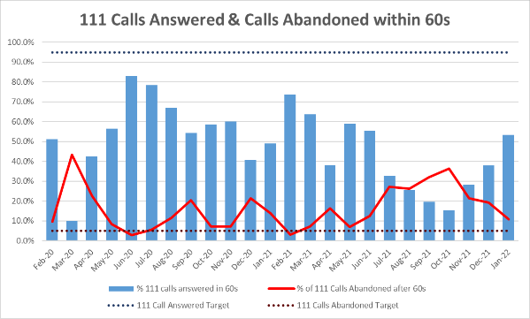
In the 111 service, we measure the quality of the service we provide through call answering times and clinical ring back times. We aim to answer 95% of calls within 60 seconds, and to have an abandonment rate of less than 5%, but the graph demonstrates that the service has been significantly off target during 2021/22. As a result of a concerted recruitment and training effort, as well as internal improvement and efficiency work, we have started to see improvements towards the latter part of the year.

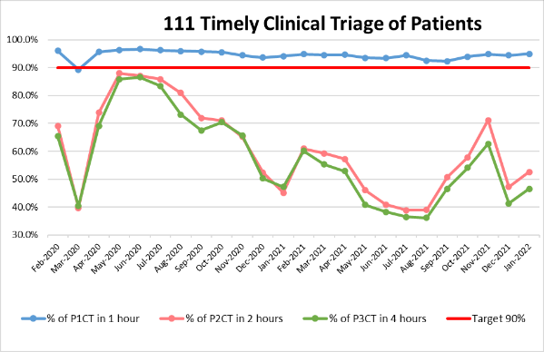
In relation to clinical ring back for triage, we consistently achieve the one hour target for highest priority patients, but did not achieve the targets for other patient acuity categories. Patients have provided feedback on long waits and there is potential for these waits to have a knock on impact to both 999 and the rest of the urgent and emergency care system. We are therefore currently undertaking a strategic demand and capacity review of 111 at the time of writing this plan, and the actions set out in section 5.2 seek to further address and improve the quality of the service we provide.

One of the factors in our response times is demand. 111 demand has increased significantly, but this can be attributed to the service going live across Wales alongside government announcements relating to the pandemic, which have the effect of creating spikes in demand, and also an increasing use of the service which is increasingly seen as the “Gateway to Care” across the system.

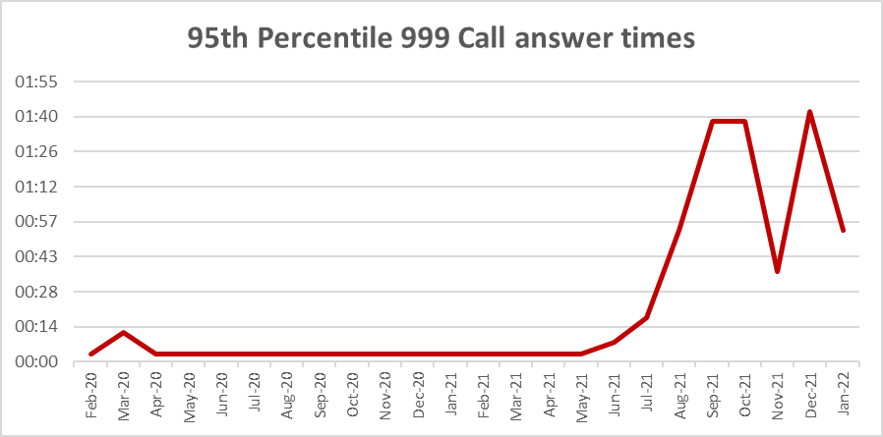
Within the 999 service, we assess the quality of the service we provide through a range of response times metric, clinical indicators, and outcome measures. Call answering performance began to worsen during the summer as the Trust moved to a sustained period of maximum escalation. This could have a significant impact for patients who dial 999 for the most life threatening incidents. Some additional call taking capacity was built through the year, and may be required into the future, subject to funding availability.
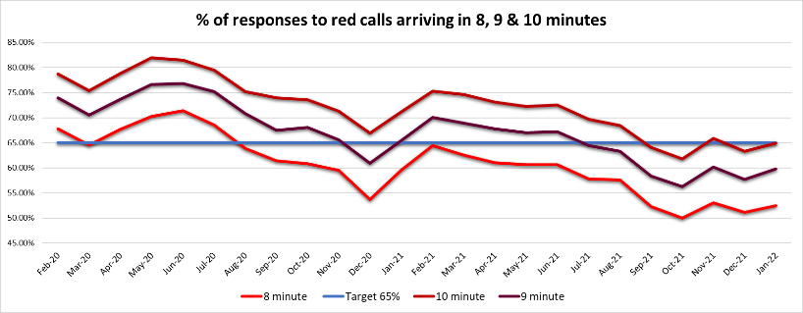
We have unfortunately seen a continued deterioration in performance against the Red 8 minute target, together with lengthening response times for our amber calls which includes stroke and heart attacks. We know that the bulk of patient safety incidents occur in the Amber category, and that these long response times directly impact on patient outcomes. We believe strongly that this is one of the greatest clinical risks that the system faces, and that we need to collaboratively and urgently address this so that patients are not left alone for hours in the community with no clinical assessment or treatment.

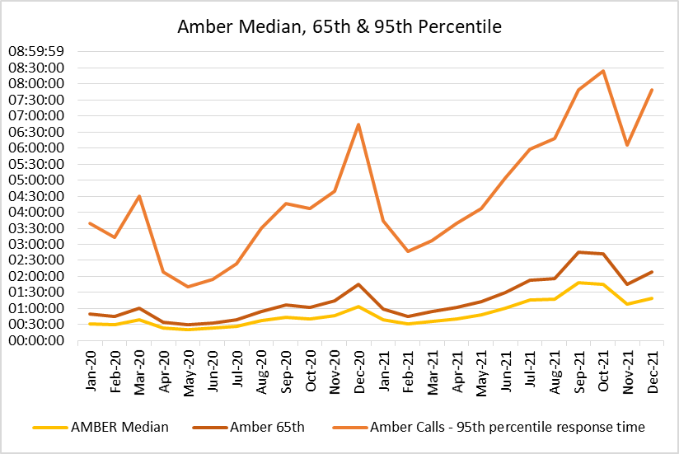
There are many reasons for these longer response times, which include increases in red demand and overall acuity, a loss of capacity through increased sickness absence, and a loss of capacity through hospital handover delays. During the pandemic, we have also prioritised our conveying capacity (Emergency Ambulances EAs) over Rapid Response Vehicles (RRV) which has an effect on red response times, and staff are also required to don and doff Level 3 PPE in line with Infection Prevention and Control (IPC) guidance, which can add minutes to the response time.
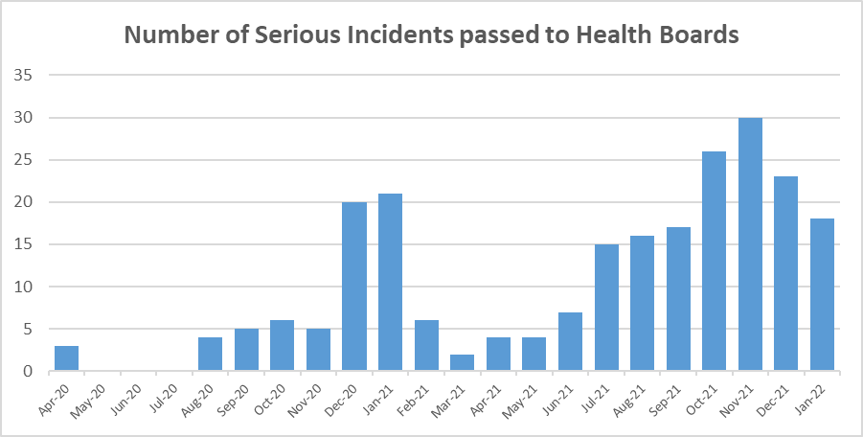
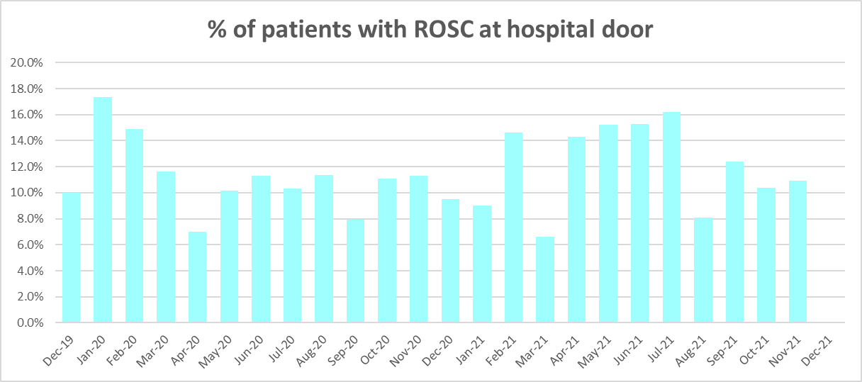
We are seeing higher levels of National Reportable Incidents (NRIs); and also higher levels of National Reportable Incidents referred to health boards. Incidents referred to health boards are often due to long waits in the community as a result of handover delays at hospitals. In the period April - December 2021 there were 4,020 patient waits of 12 hours or over, compared to 1,634 in the same period in 2020.
One of the clinical outcome we measure is the % of patients who have return of spontaneous circulation, and this remains lower than we would want. Whilst there are many factors outside our direct control, we have developed a new service response – Cymru High Acuity Response Unit – to improve outcomes in this area, but these changes are currently not fully funded at this time (see section 5.3 for the plan).
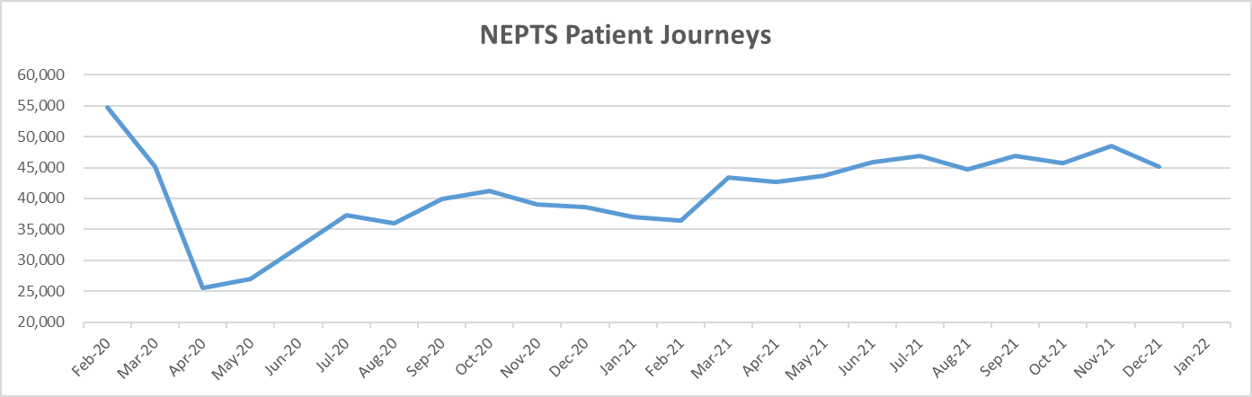
In relation to our NEPTS service, demand has not recovered to pre-pandemic levels. Whilst renal and oncology demand has been stable, outpatient demand is down and discharge and transfer variable. A further consideration for NEPTS is that social distancing reduces the number of patients who can be conveyed per journey.

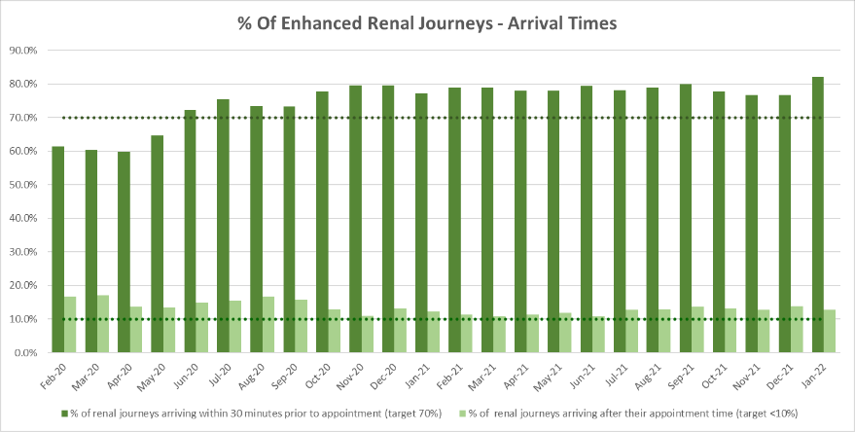
This has impacted on transport capacity and led to in year investment of £2m as part of winter planning, which will cease on 31 Mar-22. As a result, the quality of the service as measured through the various arrival / collection times indicators has been more stable with in-bound renal performance being achieved in every month in 2021/22. Oncology performance is a recognised area of concern, which is being addressed through the Ambulance Care Transformation Programme (see section 5.4).

Our People

In relation to our workforce, the indicators we review at Board relate to whether or not we have the right workforce capacity in place to meet demand, how we are keeping staff safe and well, and how they are being developed. More detailed and numerous indicators are also considered at the People and Culture Committee.

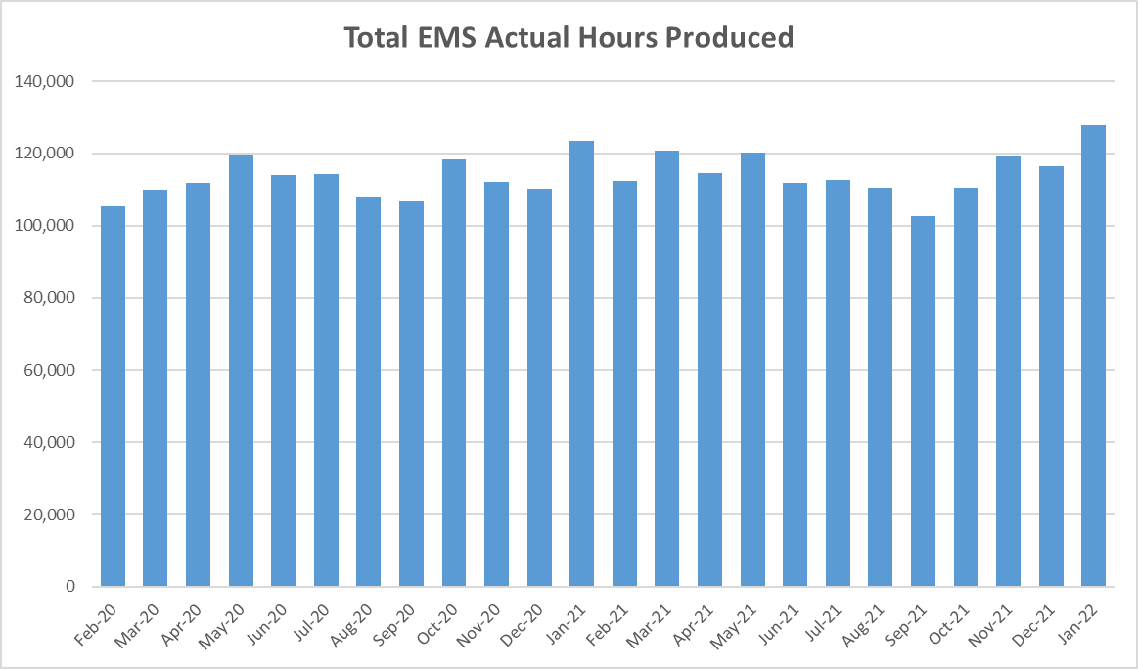
In relation to the EMS service, the EMS Demand and Capacity review in 2019 determined the required capacity to respond to demand based on a 30% abstraction assumption, with levels of investment provided by commissioners to increase WTEs by 263 over 2 years. The Trust is on target to broadly achieve this growth by the end of March 2022. This is a significant milestone for the Trust that will bear fruit in the medium term. However, as the graph to the side demonstrates, despite having more staff in post, we have not been able to produce many more hours, other than in the last quarter as a result of military aid.

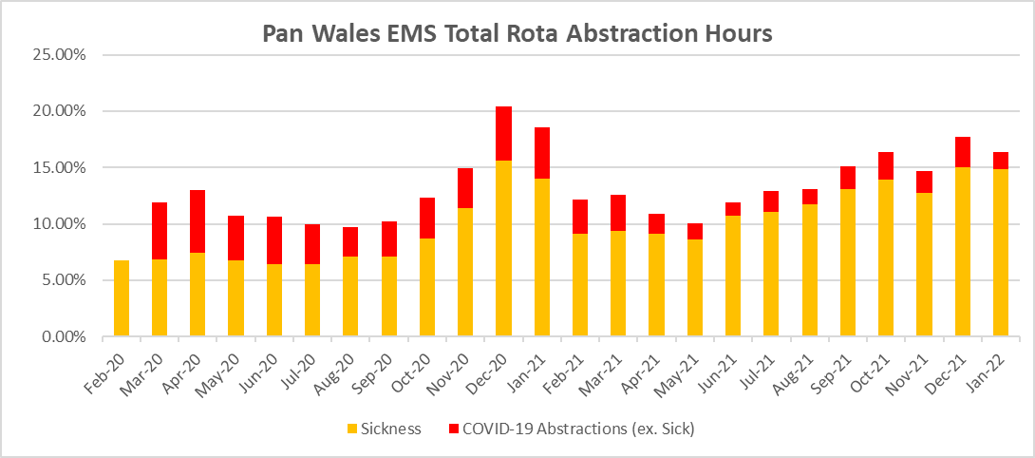
A key factor in our ability to ensure capacity to meet the demand is the impact of abstractions, and this also provides an indicator of our people’s well-being. The significant impact of the last two years on our people at all levels in the organisation cannot be underestimated. To support the workforce there has been an ongoing focus on wellbeing activities across all areas of the Trust including those in frontline and support roles. Despite this sickness has remained one of the key causes for rota abstraction. The graphs show the levels of abstraction due to sickness and also due to COVID-19 factors. Similar pictures are seen in 111 and Ambulance Care, with a 17% abstraction due to sickness in the 111 service in January. We know that this will need to be a major focus of our plan going forward and actions are set out in sections 5.2 to 5.4.

Other indicators of how we are keeping our staff safe and well include vaccination rates and statutory / mandatory training levels. As at 07 February 2022 84% of patient facing staff have received a COVID-19 booster vaccine and 94% are double jabbed. However, the flu vaccination level for the Trust is 40.57% and whilst flu has not significantly affected the Trust this year, we would aim to increase the figure going forward. In January 2022 Statutory & Mandatory Training rates had not achieved the 85% target overall, with levels of 61% for Fire Safety, and 72% for Moving & Handling. The Working Safely Transformation Plan sets out to improve this, and more detail is seen in section 7.1.

In terms of staff development, we review levels of Personal Appraisal and Development reviews (PADR) as a high level proxy, and in January 2022 levels remained largely static at 59%. They continue to remain below the 85% target, despite a revised ‘lite’ approach during the pandemic.

Finance & Value

We review a number of indicators which aim to demonstrate how we provide a service in line with statutory financial duties, and of high value and efficiency. Clearly, we have managed and delivered all aspects of our statutory financial duties in 2021/22.

In relation to the value and efficiency of our service, we have developed in the last year, a utilisation measure for the EMS service, which we are working on with commissioners to make best use of it both as a tool to review retrospective performance, but also to look ahead, forecast performance and take mitigating actions where necessary.

We measure the number of hours that are lost post production as these potentially indicate areas where we could improve efficiency. There are many legitimate reasons for crews needing to stand down post production and we benchmarked well on Post Production Lost Hours (PPLHs) in the 2019 EMS Demand & Capacity Review with the exception of return to base meal breaks. Some concerns have been raised about the accuracy of the data which we are reviewing, and hope to conclude soon. Further internal modelling work is ongoing to quantify any potential efficiency gain (see section 5.3).

System Contribution

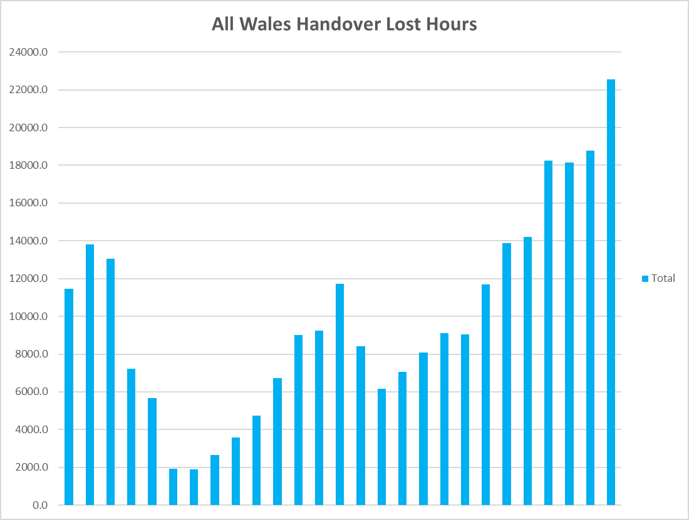
We aim to consider both our impact on the wider system, but also the wider system’s impact on our service. Handover lost hours were already extremely high and Wales was an international outlier even before the pandemic. The levels seen this winter are unprecedented and have had catastrophic outcomes. In December 2021 the Trust lost over 18,000 ambulance hours, equivalent to 36,000 people hours or 3,000 twelve hours shifts. The Trust is aware that health boards are introducing urgent and emergency care escalation frameworks, and that there has been strong messaging from Welsh Government and the Minister that this must be tackled as a matter of priority. However, given the scale of the challenge and its links to wider system pressures, we are planning on the basis that these levels will remain high for many months. The 6 goals policy handbook sets out an expectation of no handover being longer than an hour by 2025.

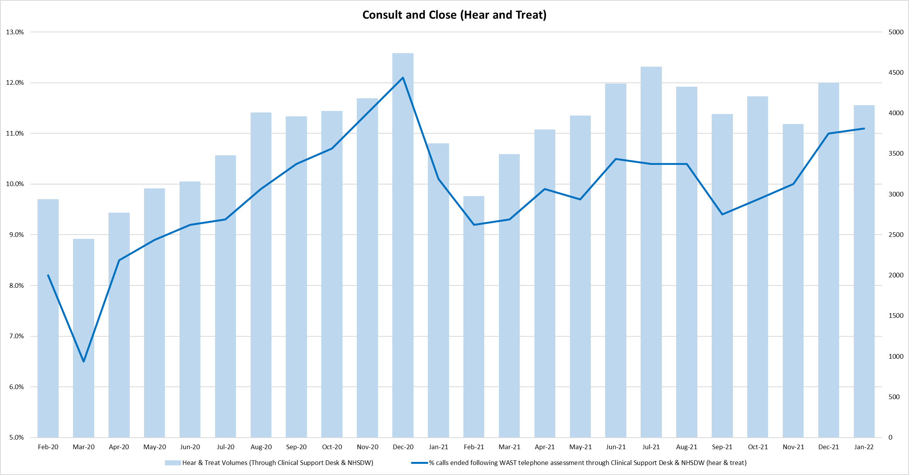
We are committed to transforming our services to become more sustainable, to get patients to the right service, in the right place, every time, and to reduce the reliance on emergency departments as the default location for definitive urgent and emergency care. One of the areas where we already support the system in reducing demand is in consult and close (hear and treat previously) through the work of the Clinical Support Desk (CSD). Through investment from commissioners, the CSD has expanded this year to include an additional 36FTE paramedics and 6FTE mental health practitioners. The 2019 EMS Demand and Capacity review assumed the Trust should achieve around 11% hear and treat rates, which has largely been achieved, and with the expansion as described, we are planning to increase to 15% in 2022/23. We also monitor our ‘see and treat’ rates which have broadly remained static. Our ambition, articulated through the ‘inverting the triangle’ work we have been doing, again is to increase this shift left activity, and more can be found in section 5.3.

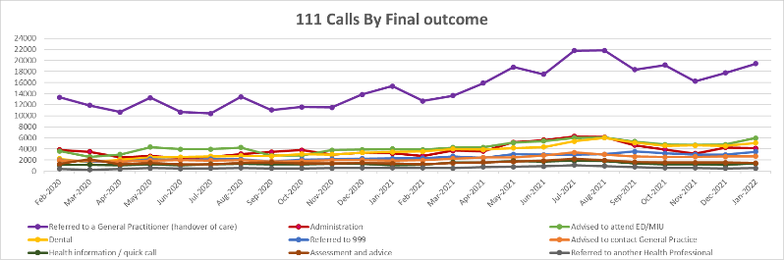
In relation to our 111 service, one of the success factors for NHS 111 Wales is getting the patient to the right service, first time. At the moment, we measure outcomes in terms of where patients are directed, but further work is required to identify whether these are the most appropriate and best outcomes.

Forecasting Performance

As well as reviewing historic quality and performance measures, we have made huge strides in our forecasting and modelling capabilities within the EMS service in particular, in partnership with Optima. Looking forward to 2022/23, we have undertaken a forecasting and modelling exercise for Quarter 1 which allows us to determine a detailed tactical plan to ensure capacity is available across all service areas. This will complement the medium term plan set out in this IMTP. The outlook is bleak, and the modelling suggests that without a change in the current levels of abstractions, lost hours or demand, the waits for patients in the community will be at unacceptable levels. The alternative, shown in the table below, is that we would have to escalate to the higher levels within our clinical safety plan (CSP), the consequence of which is that many patients would not receive a response at all, and some will likely come to harm.

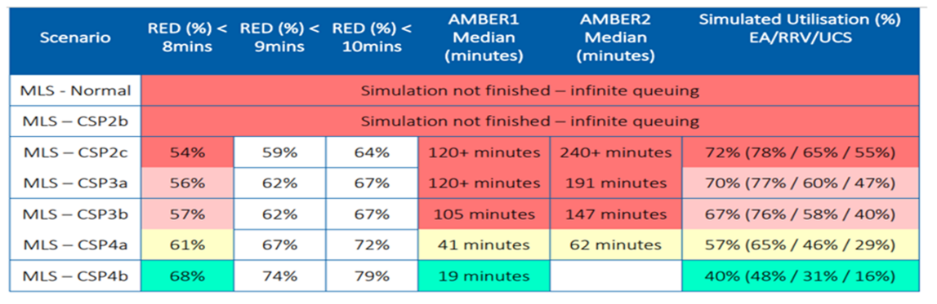
Actions being taken within the EMS service are set out in Section 5.3.

4.6 What do our commissioners and partners say?
The Emergency Ambulance Services Committee (EASC) commissioning intentions are not intended to set out all activity that will be undertaken this year by commissioners or the Trust, but provide a clear indication of the key strategic priorities of the Committee for the Trust in 2022/23.
Some of the commissioning intentions have been rolled forward from 2021/22. However, we regularly report progress on them to EASC Management Group and it is considered that we have made good progress within the context of the pandemic. The following table provides a summary of some of the key commissioning intentions for 2022/23. A full reflection of commissioning intentions and how this plan addresses them can be seen in appendix x.
Commissioned Service | Summary of Priorities | Outcomes | Response in this IMTP
Emergency Medical Services | - Increase the proportion of activity resolved at Step 2.  - Right response first time and optimising conveyance  - Workforce: stability, growth & modernisation of practices.  - Efficiency: resources aligned to patient demand, reduced lost hours.  - Value.  - Improving clinical outcomes and reducing harm pro-actively.  - Support to the wider health care system | - Significant increase in hear & treat rate.  - Improvement in the multiple response rate  - Transformative reduction in conveyance to EDs  - Increased capacity, improved staff well-being and reduced patient harm.  - Maintenance of the increased staff base following closure of the relief gap  - Improvement in availability of staff through reducing sickness levels  - Further growth in the workforce in line with the strategic ambition, subject to agreed financial allocations  - Completion of roster reviews, with increased capacity aligned to patient demand  - Reduced hospital handover delays (health board actions, WAST will support where required)  - Improved levels of efficiency in use of resources  - Value-based approach embedded enabling better collective decision making across the whole urgent and emergency care system  - Investment in initiatives that provide value (and disinvestment in those that do not).  - Appropriately shared clinical safety risk across the whole system.  - Delivery of a national discharge & transfer service model. | - Section 5.2 & 5.3  - Section 5.3  - Section 5.3  - Section 5.3  - Section 5.3  - Section 6.1  - Section 5.3  - Section 5.3  - Section 5.3  - Section 5.3  - Section 7.1  - Section 7.1  - Section 5.3  - Section 5.4
Ambulance Care (NEPTS) | - Efficiency: benefits from national service, resources aligned to demand, reduced lost hours.  - Plurality: expand and improve availability of providers.  - Improved dynamic planning processes  - Demand management: effective use or resources, effective rostering and appropriate transport.  - Transforming and increasing capacity from within current resources.  - Reducing lost capacity including minimising lost time at hospitals | - The best patient transport model for Wales ensuring value and efficiency of utilisation.  - A procurement strategy which determines the best mix of provision to ensure NEPTS objectives and standards are met.  - More dynamic flexibility to respond to demand.  - A range of quality assured providers that deliver improved patient outcomes, experience, value and sustainability.  - More effective utilisation of capacity to ensure stability and resilience to meet future demand.  - Increased understanding of demand from patients and stakeholders and more effective management of that demand.  - Improved quality and performance.  - Continuous learning based on patient feedback and data.  - Effective use of internal and external resources.  - Improved collaboration and communication with Health Boards to ensure timely, equitable, integrated and efficient service provision. | - Section 5.4  - Section 5.4  - Section 5.4  - Section 5.4  - Section 5.4  - Section 5.4  - Section 5.4  - Section 5.4  - Section 5.4  - Section 5.4

As set out previously, handover times in our EMS service are extreme and put us as an international outlier. Reference is included in the Six Goals Policy Programme to reducing handover delays through driving improvements in urgent and emergency care system, by 2025. Given the urgency of this situation, WAST welcomes EASC’s position that individual improvement trajectories will be agreed for each site and will be included in the new EMS Commissioning Framework.

The NEPTS commissioning intentions do not identify any increase in capacity during 2022/23. Currently, the Trust is in receipt of additional non-recurring investment (£2m) to support NEPTS capacity; consideration between EASC and the Trust needs to be given to levels of performance post the 31 March 2022 when this investment stops whilst social distancing, which affects NEPTS capacity, continues.

4.6 How will Health Board plans affect us?
The NHS Wales Planning Framework sets out a need for Health Boards to work together, across organisational boundaries, to plan and deliver on a regional basis. The framework also sets out the need for a whole system approach to recovery from the pandemic and for NHS organisations to build on the learning and experiences across health and care. We will engage fully with the continuing development and implementation of the National Clinical Framework in respect of its key workstreams and how WAST can play its part in facilitating regional working, improvements in quality, clinical pathways and higher value healthcare.

There has been significant disruption to “normal” Health Board activity over a sustained period but also significant progress across the system in delivering care differently to ensure NHS Wales could reduce the impact of the pandemic. Services have changed and adapted at pace including the use of remote and mobile solutions for outpatient and primary care appointments. The framework asks Health Boards to go further with accelerating and embedding digital technology and innovation.

Such operational and strategic changes at local, regional, and national level can often have an impact on our EMS and Ambulance Care services but also on NHS 111 Wales, as the location, frequency or priority of services or pathways change. A consequence of these rapid and emerging changes is often a change and/or increase in emergency, transfer, and discharge ambulance activity. We will have a key role to play in delivering solutions to support these changes, and it is imperative that Health Board plans are shared at the earliest opportunity.

We continue to work collaboratively and proactively with Health Boards to support strategic, transformational service changes (regional and local) across Wales to ensure the best possible outcomes and experience for the people of Wales. However, this cannot be a set of fragmented service developments and need to be scoped, quantified, and aggregated in some cases to develop a consistent transfer and discharge model that could be rolled out across Wales.

Some of the priorities emerging include:
- Final go-live of the South East Wales Vascular Network
- Recovery of regional cataract services
- Emerging plans for the regional configuration of specialist stroke services
- Acute services redesign in Swansea Bay UHB
- Cardiac pathways in Cardiff and Vale UHB

The map below provides an overview of the main service change proposals we are working on collaboratively with partner organisations to drive forward sustainable changes in health provision. Our service needs to remain flexible to change but realistic in the context of the demand on our service and the capacity to deliver change at pace.

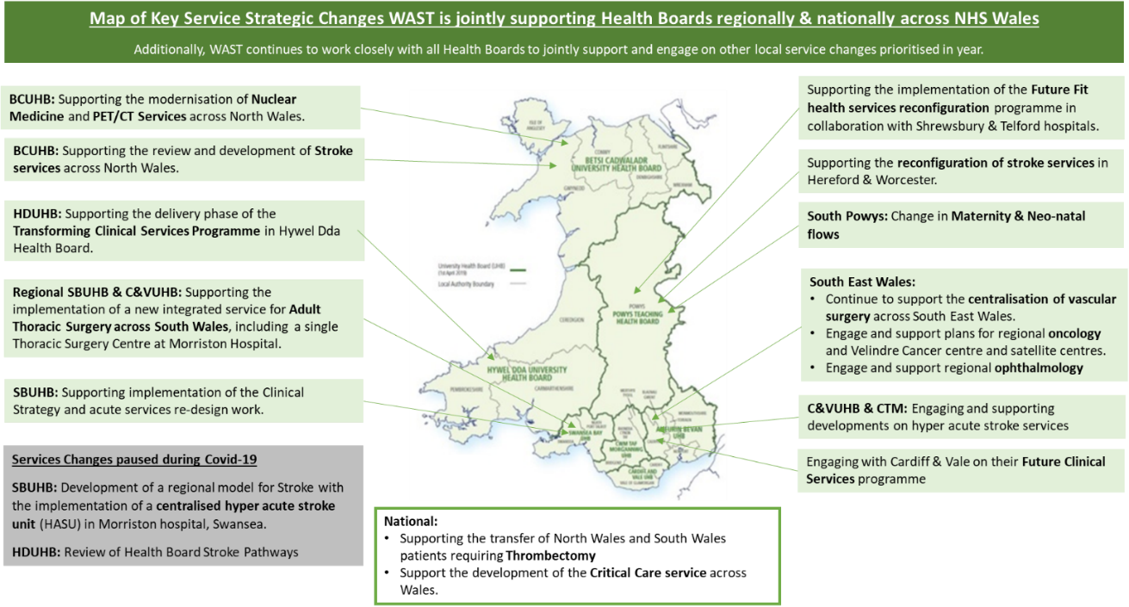

4.8 What are the operational risks that we are managing?
We are mindful of our role in supporting NHS Wales to mitigate the harms experienced by the people of Wales during the pandemic over the last two years. The direct and indirect impact of COVID-19 will continue to be prevalent as we move forward out of the pandemic and our plan has taken this continued impact into account. This includes the continued pressure that has resulted from abstractions, lost hours and increases in demand in different patterns (compared with pre-pandemic seasonal patterns) throughout the year.

This will be underpinned by our internal approach to risk management through regular review of our Corporate Risk Register and the Trust’s Board Assurance Framework that provides a clear line of sight to the controls and related assurances on those controls, and the actions we are able to take (and that are within our gift) to mitigate the risks. We know that there are several high scoring risks within the service that need to be managed and mitigated.

The Trust’s highest corporate risks are described in the table below, including a brief description of what we will do to contribute to the mitigation and reduction of these risks through this plan.

Table 3: Our highest Corporate Risks
Risk | Level | What we will do in this plan to respond…
ID 223: Unable to attend patients in community who require See & Treat | 25 | A key part of our IMTP is transition plan for EMS (see section 5.3) which is focussed on the patient safety benefits of further implementing the operational and clinical transformation in this key part of our service offer.  A range of actions in our Gateway to Care programme focus on a further shift left in the pathway to improve hear and treat rates, whereby patients can have their needs resolved without the need to send a physical response (see section 5.2).
ID 224: Patients delayed on ambulances outside A&E Departments | 25
ID 199: Compliance with Health and Safety Legislation | 20 | Having set up the programme structure and recruited to key posts during 2021/22, the Trust will deliver its “Working Safely” Health & Safety Transformation Plan to support and foster a culture of safe working across the Trust (see section 7.1).
ID 160: High sickness absence rates | 16 | The plans set out in Our People (see section 6.1) include a programme approach to reducing sickness absence. We have several established support mechanisms in place specifically around COVID-19 related absence including long COVID support and we regularly review the Test Trace and Protect guidance to inform our Infection Prevention and Control policies and staff action cards.
ID 311: Failure to manage the cumulative impact on estate of the Demand & Capacity Review and the NEPTS Demand & Capacity Review | 16 | Our Infrastructure plan (see section 6.3) details the Estates and Fleet SOPs which were updated in line with recommendations from the EMS Demand and Capacity Review and the implications of the NEPTS Demand and Capacity Review. However, capital constraints in 2022/23 may impact on our ability to mitigate this particular risk.

The Trust remains committed to implementing a positive Risk Management culture through our Risk Management improvement plan. The plan has been developed and is a key part of the Fundamentals of a Quality Driven, Clinically Led, Value Focussed organisation (see section 7.1).

Our Service Offers to Patients and the System
The Right Care in the Right Place Every Time

5.1 Our Long-Term Strategy
Following publication of our long-term strategic framework “Delivering Excellence” which set out an exciting vision for the service in Wales up to 2030, we have developed and continue to evolve strategic ambitions for an integrated set of service offers for the people of Wales over the next 3-5years.

We live in a world where the needs of our population are changing. People are living longer, and care needs are becoming more complex, placing different demands on ambulance and NHS 111 Wales services. We do not underestimate the challenge that this creates and recognise that this is not something that we can meet wholly on our own.

In 2021/22 we established two new groups to help the organisation to continue to develop its strategy, one of which is a Board level Strategy Advisory Group. A model of strategy development has been agreed which we will continue to work through, recognising that in this changing world, strategy cannot be immoveable.
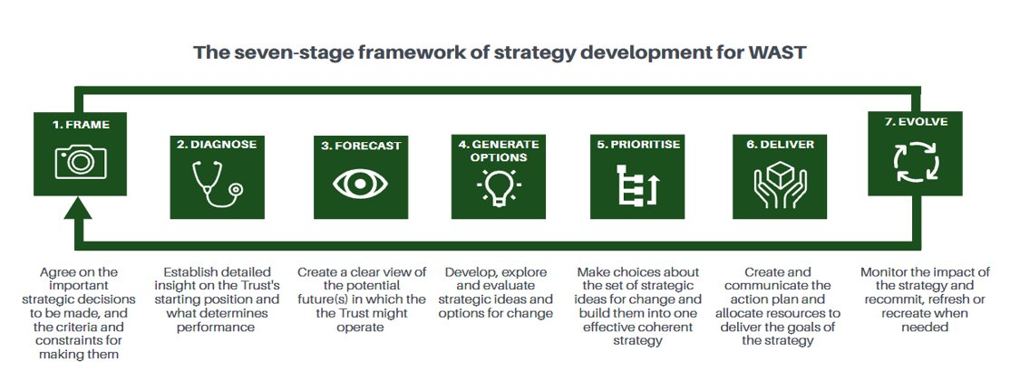
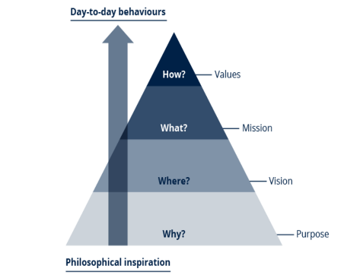
Alongside the evolution of our longer term strategy, we will be taking forward two other substantial areas of supporting work. Firstly, we will be undertaking continuous engagement, talking to staff about framing our ‘Purpose’ as an organisation, as this is something we believe will bid and unite the organisation towards a common goal. This provides the ‘why’ of our existence as an organisation, with vision and mission statements providing the where and the what.

We will also be thinking about and engaging with key players. This will involve undertaking a reputation audit with our partner stakeholders (either by commissioning support or through an in-house project), and working to refine our thinking about who our key players are in respect of strategy development and design appropriate engagement methodologies.

Secondly, we will continue our work to further develop our strategic ambitions and models for each of our service offers: NHS 111 Wales; EMS; and Ambulance Care. This will involve bringing internal and external partners together through collaborative workshops and specific programmes, and more detail is set out in the sections below.

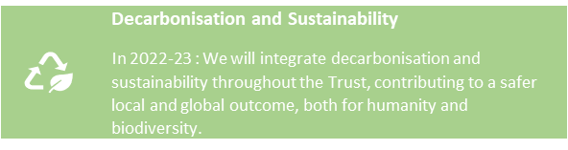
In each section of the plan, we will describe what we aim to deliver over the next three years (our ‘deliverables’) and the priority actions/milestones that we will need to achieve (in some cases subject to funding) in 2022/23 towards those medium term deliverables and how we will measure progress. We will also include in each section a decarbonisation statement that links to our decarbonisation action plan, setting out what each service or enabler can do to reduce or offset carbon emissions.

Appendix 1 then has further detail about the timescales for delivery in year 1 and the actions/milestones we are developing for years 2 and 3 of this plan. Following our learning from the last two years, where pressure has escalated and de-escalated at points in the year, Appendix 1 sets out a forward view of our priorities during escalation where Tier 1 priorities would need to be achieved, even at our highest escalation levels (REAP 3&4) and Tier 2 priorities could be paused at REAP 4 (and possibly 3) if required.

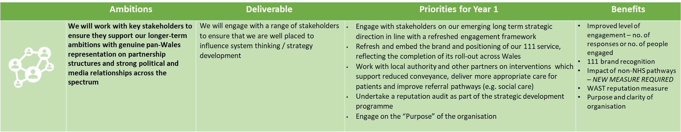

5.2 Gateway to Care – 111 and CSD
WAST operates Clinical Contact Centre call handling and clinical triage/assessment nationally for both the 111 and 999 services 365 days a year, 24/7 hours a day. Patients ringing 999 either receive advice over the phone (Consult and Close / Hear and Treat) or a response to scene from our Emergency Medical Service (EMS). Callers ringing the 111 service, which is now live across all Health Boards, receive advice over the phone and broadly receive self-care guidance, advice to attend an Emergency Department or a referral into local urgent primary care or Out-Of-Hours services for further clinical assessment and treatment.

Having completed the roll out of the core 111 service across the whole of Wales, the next three-year planning cycle is a pivotal period for WAST and the system as we seek to set out on the next stage of transformation of the service. Goal 2 of the Six Goals (Signposting people with urgent care needs to the right place, first time) signals that ‘when people need or want urgent care, they will be able to access a 24/7 urgent care service via the NHS 111 Wales online or telephone service’. This is consistent with our strategic ambition to become the ‘Gateway to Care’ for patients to seamlessly access urgent & emergency care services. In developing our priorities, we have carefully considered the relationship between our ambition to formalise the Gateway model and the emerging plans being identified as we commence our transformational plans to ‘Invert the Triangle’ as described in section 5.3. A key priority for us will be to work with the 111 Programme Board to develop a national strategy for the 111 service, which delivers on the commitments within the 6 goals framework, and clearly sets out priorities for development and transformation over the next 3 years.

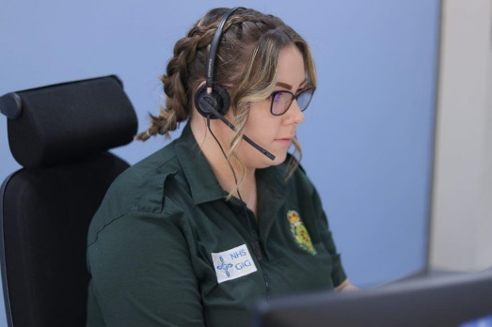
In last years IMTP we set out 5 strategic ambitions and deliverables, which remain consistent with national direction of travel.

The first is to continue to take action with partners to promote and expand the use of 111 across Wales. In the next year, we will be evaluating delivery of the core 111 service, as well as implementing the 111 Press 2 service, to ensure those with urgent mental health needs can access local services quickly. Subject to funding being available, we are also working with partners to develop a communication campaign to ensure consistent and robust messaging to the public about the service. Over the last year, the Think 111 First pathway has been introduced into 3 health board areas. This was originally designed, because of the pandemic, to encourage people to ring 111 first rather than attend an ED department, with pathways from 111 into health board clinical assessment hubs to determine the most appropriate local service. Whilst consistent with the longer-term statements in the six-goal framework, there is further work to be undertaken nationally before any further roll-out.

The second ambition is that callers (111 or 999) with urgent care needs should be able to access a timely, high quality clinical assessment, either on the phone or by video. In the future, we anticipate that for many callers, no further intervention will be needed. We currently have two groups of clinicians undertaking these assessments for 111 callers and 999 callers, and we are keen to work with commissioners to explore how best to utilise this scarce resource, potentially considering ways in which these teams could work more closely together over time.

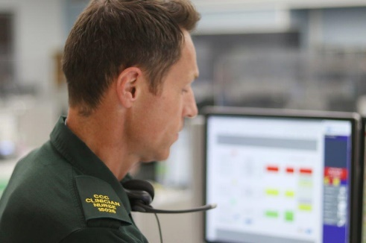
Remote clinician decision-making is fast being recognised as a clinical speciality within the UK and internationally. Remote clinical decision-making (RCDM), commonly referred to as ‘telephone triage’ and/or ‘hear and treat’, describes clinicians’ non‑face-to-face involvement in patient care. This remote interaction is typically undertaken by telephone or visual‑audio format, by paramedics, nurses, doctors and pharmacists.

To be recognised as a clinical speciality a clear educational foundation and clearer framework is needed. This does not currently exist for RCMD in Wales, and we will be working with HEIW to develop thinking in this area.

We have had a significant investment in the clinical team supporting 999 callers, with an increase of 36 WTE paramedics and 6 WTE mental health practitioners. This doubling of capacity, coupled with the implementation of the new clinical assessment software (ECNS) will allow for a transformation of this service, with an expectation that we will be able to increase consult and close rates to 15% over the next year. We will be working over the next 12 months on how we can also increase rates of consult and close within the 111 clinical team.

The fourth ambition is to continuously improve the quality of the service we provide to patients, and this links to earlier sections of the IMTP which set out the poor call answering and ring back times within the 111 service. We developed a Stabilisation and Transformation plan in 2021/22, with actions to continue through into 2022/23, targeting recruitment and training efforts and implementing performance and process improvement measures to effectively manage current demand, whilst also putting in the foundations to implement the exciting transformation ideas to enhance our service offer to patients and the wider system.

The fifth ambition is to improve accessibility, content and user experience of the 111 digital front end, which is in line with the urgent priorities set out in Goal 2 of the six goals. In many areas of modern life, websites and applications provide the front door to major services such as banking and taxation. As part of our transformation, we plan to significantly increase the accessibility of services via digital means. This will initially be through continued development of the 111.wales website, but over time will also leverage the new SALUS platform for 111 and the new NHS Wales App with NHS Login, delivered by Digital Healthcare Wales (DHCW). These new services will work together to significantly increase access to, and interaction with NHS Wales and WAST through digital means, including the ability to book into some services direct. However, this cannot be achieved within existing resources, and cases for investment are being developed for consideration by WG and commissioners.

Implementation of SALUS will also deliver a fully integrated and modernised 111 and OOHs system across Wales. The new platform will allow seamless access to a single patient record by CCC clinicians and GPOOH, whilst also integrating seamlessly with national systems to ensure patient data is accurate and as up to date as possible. As part of its functionality, SALUS will provide 160 new clinical algorithms, or webguides. These will allow patients to begin their assessment on the website, transferring seamlessly to the phone where required. If needed, a video consultation will then be available, along with electronic prescription of any medication and dispatch of and liaison with a GP where necessary. This will be a first of type in terms of the level of integration it offers across, digital, telephony and traditional clinical platforms.

The strategic development of our 111 workforce will be pivotal to help stabilise the service whilst enabling our transformational plans. The outcome from the recent 111 Demand & Capacity review will help inform and shape our future workforce profile, ensuring service capacity is aligned to future demand profiles. We will be undertaking a strategic review of our workforce plans ensuring a consistent service across 7 days of the week, reviewing skill mix and career progression opportunities, and realising the benefits from the SALUS implementation. Further consideration is required to also look at the model and makeup of the 111 Clinical Hubs as these are expanded and to identify the wider opportunities across the whole system to optimise virtual clinical assessment across Wales.

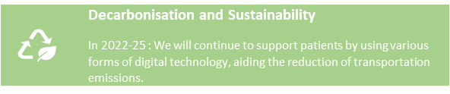
What will this mean for patients?
- Over time, more patients will access the service as their preferred first point of call to help meet their urgent health care needs.
- Increasing numbers will also be able to access the digital 111 front end to meet their routine and urgent health care needs.
- Patients will be able to access a timely, high quality clinical assessment to meet their needs.
- Patients who do need further specialist or face to face assessment or treatment will be booked directly into the right service to meet their needs, with more care delivered closer to home.
- The quality of the service will be that of a leading service, with excellent patient outcomes and experience.

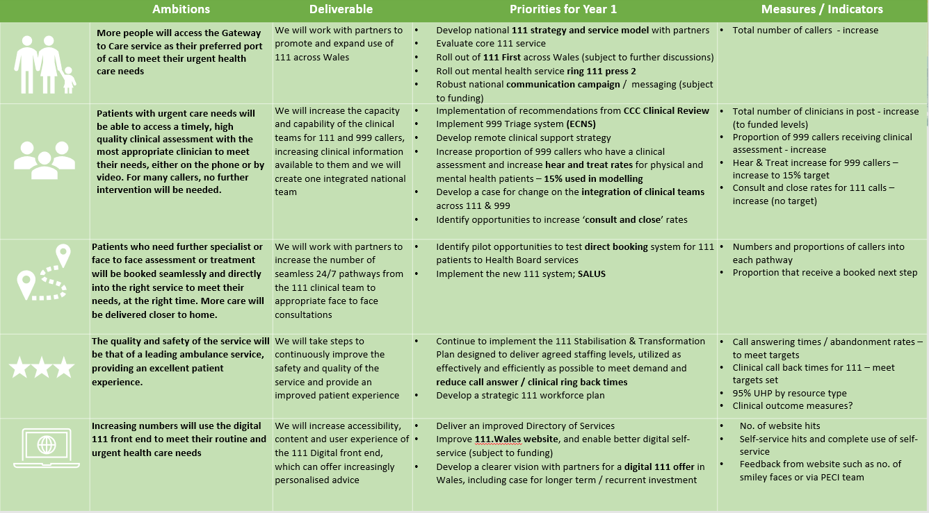

5.3 Emergency Medical Services
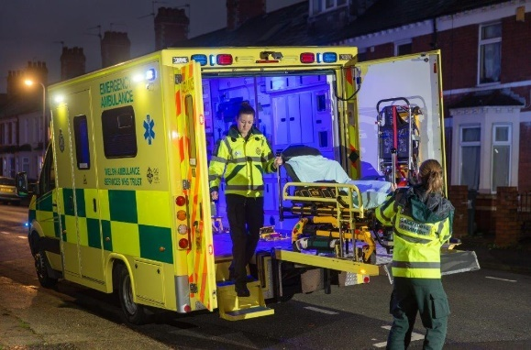
As outlined in an earlier section of the IMTP, significant pressures within the 999 service in the last 12 months have led to very poor patient experience and outcomes, with response times lengthening for all categories of patients, and too many patients coming to serious harm as a result.

This has been because of a number of factors, some of which are related to (directly and indirectly) or exacerbated by the continuing impacts of the COVID-19 pandemic. These include:

- increases in overall demand, but more importantly a significant shift in the acuity of demand;
- an increase in sickness levels and other abstractions, which has meant that hours produced have not increased, despite the successful recruitment of almost 263FTE over the last two years following commissioner investment;
- a continued rise in the numbers of hours lost waiting for hospital handover to levels never previously seen, reducing capacity to respond to patients waiting in the community, and bringing with it further harm, as evidenced in the recent national AACE report;
- resources not being utilised or deployed as effectively and efficiently as they could be;
- a continuing traditional response model which sees ambulances dispatched to the majority of 999 calls and large numbers of patients conveyed to ED, contributing to overall system pressures, and not always getting patients to the right service at the right time to meet their needs.

In mitigation and in the short term the Trust has secured significant levels of additional temporary capacity during the winter from the military, Fire and Rescue Services and St John Cymru. However, this is not sustainable, and the military resource will not be available into 2022/23, which will lead to a large drop in responding resource in April 2022. As outlined, if current levels of demand, abstraction and handover lost hours continue into the first quarter of the year, we will see a worsening picture, and it is imperative that action is taken where this is possible, to mitigate these risks. This is consistent with the statements in Goal 4 which requires ‘rapid response in a physical or mental health crisis’.

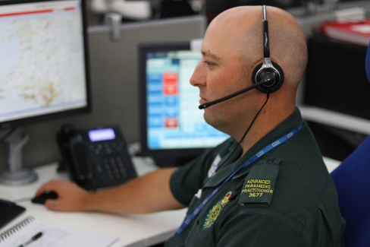
The response to the challenges we face, however, is complex and multi-faceted, requiring both an acceleration of the WAST focused clinical transformation work, alongside a collaborative approach with Health Boards and wider partners to enhance access to appropriate services within primary, community, mental health, and social care settings along with voluntary and third sector providers.

The ambition for the EMS service is to be an integral part of a community based national urgent and emergency care system which will bring together the increasing expertise of our clinicians, together with specialised primary, community and mental health resources across the NHS, local authorities and third sector to See, Treat and Refer or Discharge people such that only life-threatening calls to 999 or calls of a sufficiently serious nature require immediate response and conveyance.

This ambition is commonly known within WAST as “inverting the triangle”. Full transformation of the service offer will not be possible in one step.

In the light of these issues, we have developed a transition plan which has been submitted and considered by commissioners. The plan identifies actions which are required in the immediate and short term to stabilise the core service model, enabling us to mitigate the loss of capacity from the military and other partners and the losses due to sickness absence and hospital handover lost hours, which despite all best efforts are not going to be resolved immediately. The plan also identifies the next steps in delivery of a transformed service which are required now in order that the system and patient benefit can be seen in year 2 and 3 of the IMTP, with these being changes that will take time to enact.

Elements of the plan can be actioned within existing resource, but other elements would require additional resource, which at the current time is not available. Elements of the plan can be delivered by WAST on its own, other elements will require Health Board engagement and action.

Stabilisation of the core service

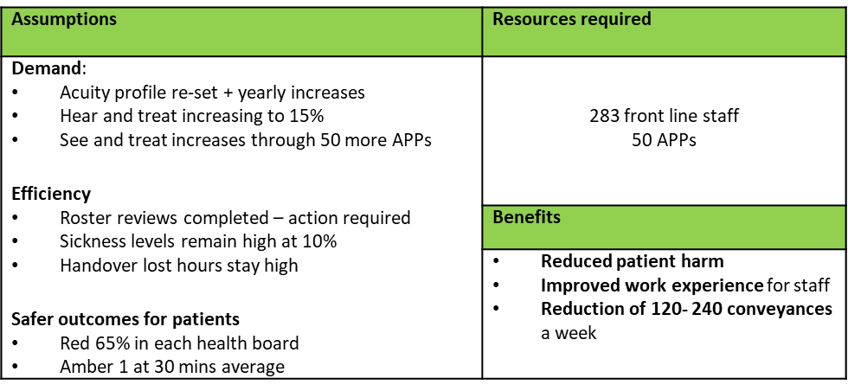
The Trust has used further modelling, with updated assumptions agreed with commissioners, to help it to determine what level of resource would be required to improve response times given current levels of demand and lost capacity. This determined that around 333 additional frontline staff would be required, and a series of efficiency improvements would need to be delivered.

The original demand and capacity review assumed a level of efficiencies which are not currently being achieved across the whole system and internally within WAST, including sickness absence, rosters aligned to demand, working practices and handover delays.

The Trust has considered its ability to recruit and train staff to this level and acknowledges that this would not be possible. In developing a plan to deliver additional capacity, a variety of options were appraised, and it was concluded that by maximising recruitment and training effort and capacity, the front-line establishment could be increased by up to 294 WTE by the end of 2022/23, requiring the recruitment and training of over 500 WTEs in total. Training would need to be undertaken by both internal and external providers to deliver at this level.

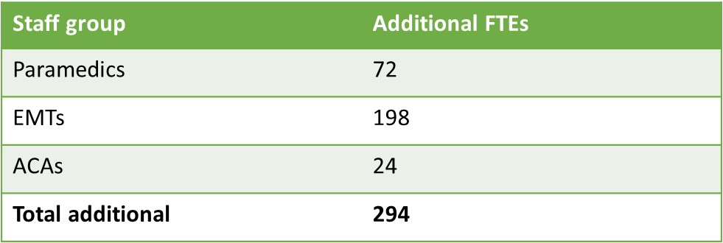
This is not an absolute number and there are risks and variables including variations to modelled planning assumptions for areas such as turnover, the availability of people with the right qualifications to recruit, the number of internal candidates seeking promotion, and availability and capacity of external provider to support the training plan.

No resources are currently available to increase capacity in this way, but we are moving ahead, where we can, with plans to accelerate recruitment and training, in the knowledge that this can be scaled back if resources do not become available.

If resources did become available, the way in which they would be deployed has also been considered:

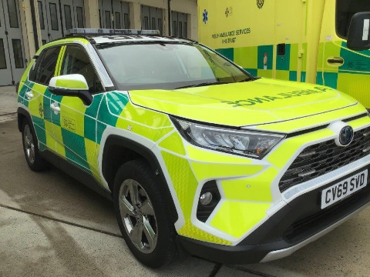
- Implementing a Cymru High Acuity Response Unit (CHARU) model which has been shown in other parts of the UK to improve clinical outcomes for the most time critical incidents such as ROSC and trauma and would also provide a boost to red performance. Around 100 paramedics would be refocused to deliver this required if this were implemented across Wales;
- Reviewing with health boards the opportunities to develop services for specific groups of patients, such as Level 2 Falls response services;
- Supporting the numbers of hours produced in the core rosters, increasing UHP levels towards 100%. The increased use of paramedics for CHARU cars may mean that there are slightly more double EMT crews, and any impact on conveyance rates is currently being assessed.

Improvement is not just about increasing numbers of staff in post. The transition plan also sets out the work that is already underway, and committed to, to improve the internal use of resources. This includes:

- the implementation of new rosters designed to better align capacity with demand which will be implemented between September and November 2022, and which will have the equivalent performance improvement effect of 72 WTE. Whilst we are currently on track, this project is not without its risks. The increasing numbers of Emergency Ambulances that this will bring are balanced by decreasing numbers of RRVs, and this change in model which will deliver improved performance is not well understood. We are working to develop better briefing materials to support discussions with staff and with external stakeholders
- the Leading Service Change Together project, which continues to consider opportunities for modernising workforce patterns, seeking to collaboratively identify an accurate baseline of post-production lost hours and identify appropriate and achievable reductions. There are risks here too, as any changes will impact staff and will need to be implemented sensitively with TU support.
- A renewed focus on reducing abstractions due to sickness absence, with a comprehensive action plan having been developed which will be performance managed through the Executive Management Team. The Trust acknowledges that its target is to bring abstractions down to 6%, in line with the original demand and capacity review, and is working to develop and agree with commissioners a trajectory for improvement over the course of the IMTP. Improvements are expected in 2022/23.

Work also continues with Health Boards and with WG to increase the alternative pathways available to WAST to provide care for patients closer to home and to avoid an ED attendance or hospital admission where appropriate. Work is progressing on a national referral pathway into Same Day Emergency Services, on the development of 24/7 single points of access for mental health in each Health Board, and local pathways for specific groups of patients such as fallers, chest pain and breathing difficulties. Despite efforts over recent years, the numbers and proportions of patients referred into alternative pathways has remained stubbornly low, and it needs to be acknowledged that changes in this area are unlikely to be of a scale to meet the challenge in the short term.

As alluded to earlier, we are aware that Health Boards have also been asked to focus on improving the current extreme levels of hospital handover, and any improvements will be very welcome. Again, our view is that improvements are unlikely to be made at sufficient pace to mitigate risks in the short term.

Transformation

One of our main priorities in the next year is to establish and take forward a formal programme of work to implement the ‘inverting the triangles’ model. Some of this will be achievable and deliverable within existing resources, but to accelerate the pace of change, some pump priming is required.

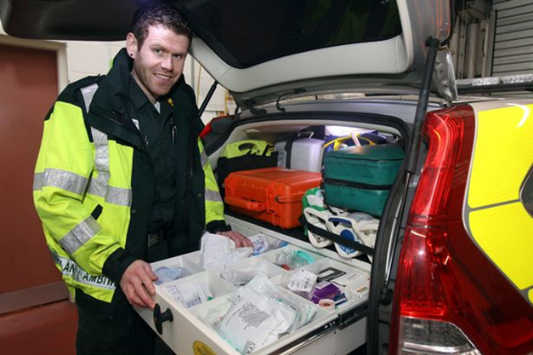
In relation to the top part of the inverted triangle, we want to work to provide greater numbers of callers with a remote clinical assessment before making any decision on dispatch. As set out in the previous ‘Gateway to Care’ section, the investment provided in 2021/22 to double the size of the CSD will stand us in good stead in making progress in this area, with a target of a 15% consult and close rate being achieved in the next 12 months.

Within the middle section of the inverted triangle, for those callers who need a face to face assessment, we want to develop a workforce that is skilled and equipped with the right resources and information to be able to increase levels of see, treat and refer, enabling patients to be treated closer to home and avoiding a conveyance to EDs where appropriate. This will include continued development of the Advanced Paramedic Practitioner (APP) rotational model, Independent Prescribing (IP) capability, Older People and Falls Framework development and our Public Health Plan, and will form a programme of work to drive forward the scaling up of successful services in support of the urgent and emergency care system. We will continue to explore our offer for people in mental health and dementia crisis, with the intention of testing and implementing our model within the life of this IMTP.

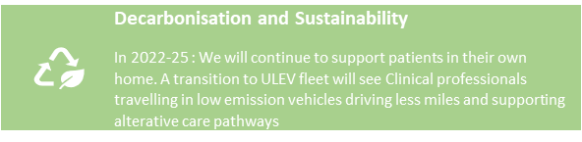
To make progress, proposals are set out in the transition plan to put 50 paramedics into a 12 month full time APP course in the coming year and to put existing APPs through the independent prescribing course, so that they become available to support the system in 2023/24. This will require additional resource and would also need to be carefully planned in the light of the immediate pressures and risks as outlined above. However, if no investment is available, limited progress will be made, and a sustainable service will not be able to be delivered into the future.

In the medium term (2023/24 and 2024/25) the Trust’s ambition is to make significant progress on the full inversion of the triangle. The Trust has recently completed initial collaborative modelling of this strategic shift, which considers the impact of further expansion of consult and close and further increases in advanced practice alongside reductions in lost capacity through sickness and hospital handovers. Significant reductions in ED conveyances are seen in the modelling, alongside dramatic improvements in response times for those that need an ambulance. Further consideration of the modelling results is required between the Trust and its stakeholders, but the initial results indicate significant scope for further shift left and optimisation of conveyance in support of the wider urgent and emergency care system.

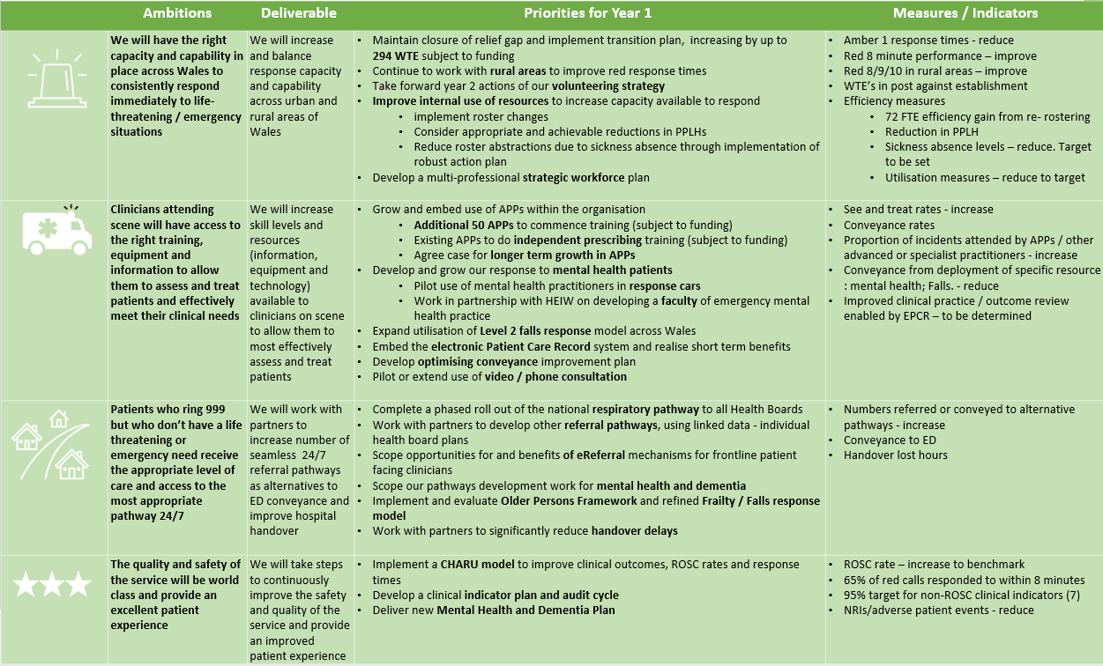

5.4 Ambulance Care
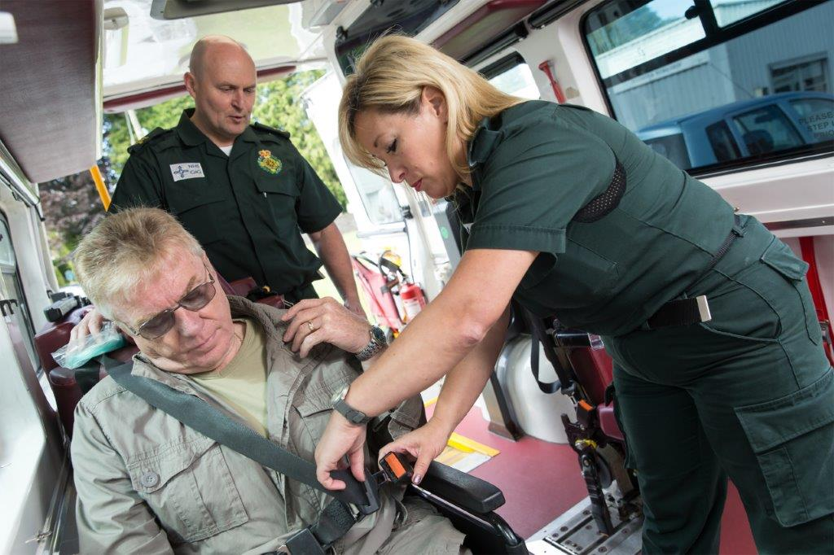
Ambulance Care comprises the Non-Emergency Patient Transport Service (NEPTS) and from 1st July 22 the Urgent Care Service. It is also the area of the service that will work with commissioners to develop and deliver a joined up and consistent Transfer and Discharge model for the whole of Wales. These services have a fundamental role to play in both the recovery and reconfiguration of planned care services in Wales, as well as a critical role in enabling system flow in urgent and emergency care. NEPTS particularly plays a vital role in goals 5 and 6 of the Six Goals.

The plan for Ambulance Care builds on the progress made in 2021/22 which saw the final transfers of NEPTS activity from Health Boards.

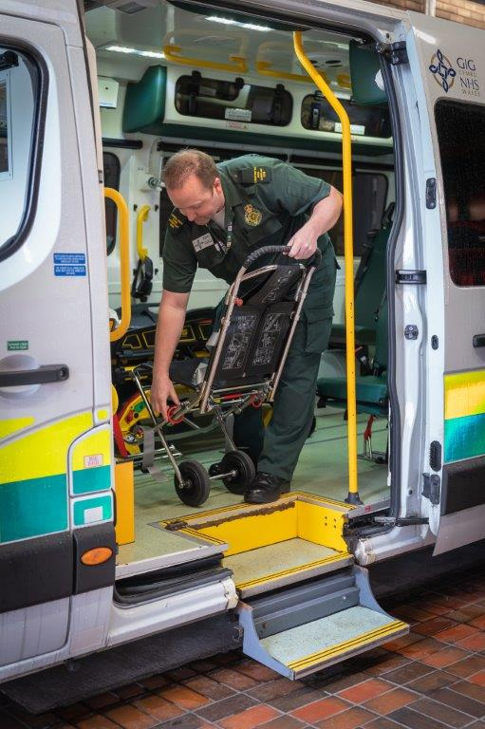
Whilst the NEPTs service is already the sole provider of non-emergency transport across Wales, there is also a future ambition for Ambulance Care and WAST to be the provider of choice for NEPTS and transfer & discharge services across Wales.

The NEPTS service aims to ensure that the right capacity and capability exists across Wales to:
- transport eligible people efficiently and safely to and from their planned outpatient appointments at hospital;
- transfer them between hospitals in a safe and timely manner when they need to access specialist treatment;
- repatriate them from specialist centres to local hospitals when they have ongoing care needs;
- And to take them home when they are discharged.

With our help and in partnership with the third sector, patients who are not eligible for our service will be assisted to access suitable alternative transport provision to meet their healthcare needs.

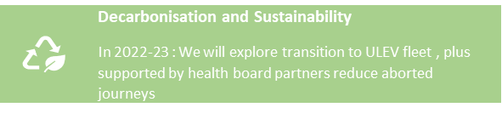
The NEPTS Demand and Capacity Review identified that NEPTS has higher levels of activity than EMS and more complexity (types of demand, resource types, plurality of providers, multiple patients on journeys and return journeys). The outcome of the review has helped the service to refine and develop a number of service improvement initiatives.

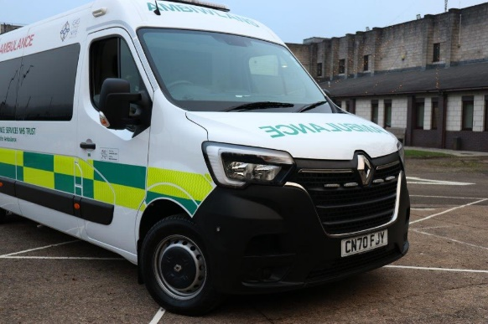
Development of a Transfer and Discharge model will require an integrated approach with EMS, as the most time critical transfers for specialist treatment may require a blue light, paramedic response. The ability to respond to these requests is often hampered by the delays experienced across the system and so we plan to work with commissioners to source an interim solution in year one of this plan whilst the model for Transfer and Discharge is developed during 2022/23 and implemented in 2023/24.

The key areas of focus in NEPTS over the next year are:

Efficiency
- Delivering on efficiencies within the NET Centre through automation and re-rostering;
- Driving out efficiencies from the now completed transfer of all remaining heath board non-emergency transport services (Transfer of Works) (an area of focus for EASC);
- Consider any potential improvements to delayed inter-hospital transfers and discharges to support system flow;
- T1 walker eligibility and sourcing alternative options – currently we know that a significant proportion of patients are not eligible for the service we provide. In the current financial climate, it is our view that this is an area of service that could reasonably, and with little clinical risk, be reduced and will enable us to provide an improved service for those that are eligible, also recognising the context of increasing demand and implications of COVID. We have in place the systems to be able to source alternative appropriate transport options to support these patients. This would also reduce costs and contribute to the overall Trust’s financial plan.

Capacity
- Re-rostering within NEPTS (rightsizing) which will align capacity to changing patterns of demand, noting that the modelling was based on 5.99% sickness and may therefore need to be adjusted;
- Proposed additional 12 FTEs planning/day control to provide the capacity for planning the levels of activity.

Recovery and service reconfiguration
- COVID-19 Recovery - recognising the shifting models of outpatient care and health board recovery plans, the impact on our capacity and funding beyond 31/03/22;
- Supporting strategic reconfigurations in health boards to provide and implement appropriate inter hospital transfers, repatriations and discharges (impact of / funding for) (an area of focus for EASC with potential funding in future years).

Transfer and discharge
- Develop a Transfer & Discharge National Model to match commissioning intention and WAST strategic ambition – it is WAST’s ambition that it be the provider of choice for transfers and discharge to ensure it is joined up and consistent, but which recognises the way in which we work with other providers. As such we will support the NCCU in developing the model, commissioning framework and any required business case.

In quarter 1, the Trust will undertake a strategic review of the Ambulance Care services to determine the next steps and strategic direction for the service. This will likely drive further transformation in years 2 and 3 of the plan which will be brought through in next year’s IMTP.

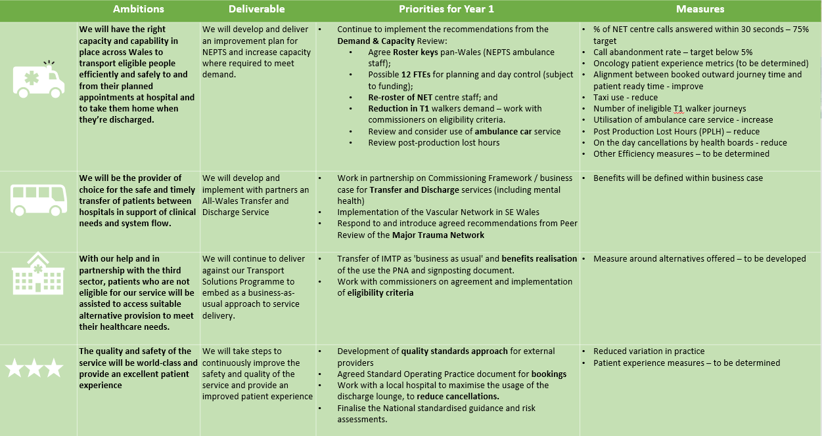

5.5 Emergency Preparedness, Resilience and Response (EPRR) & Specialist Operations
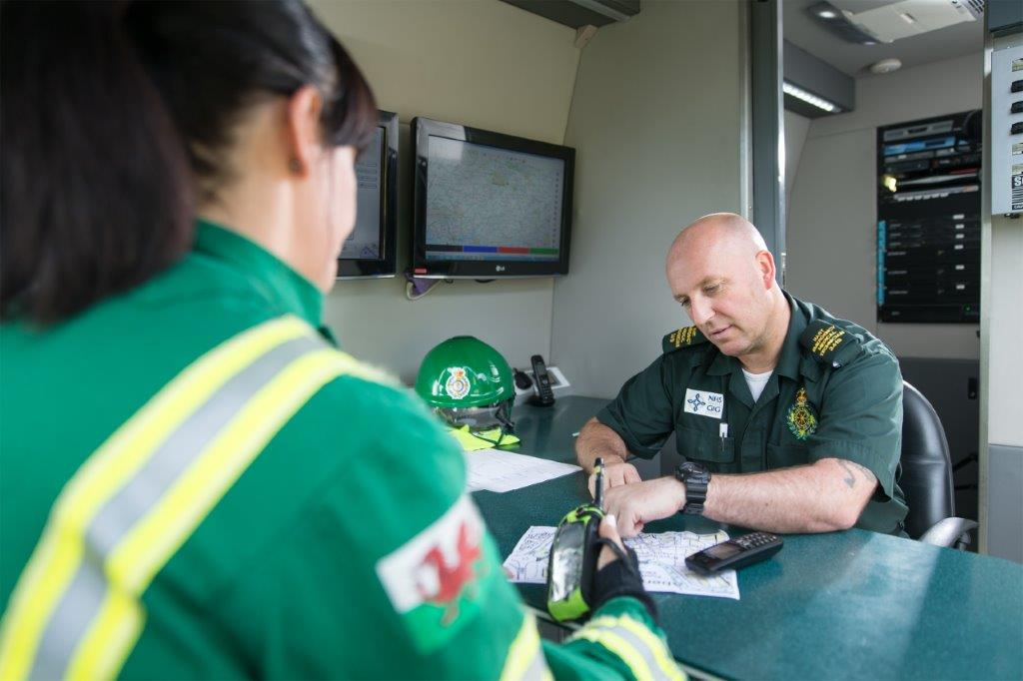
Since the beginning of the pandemic in 2020 the EPRR & Specialist Operations team have been providing ongoing support and advice to the Trust’s Senior Pandemic Team (SPT), Executive Pandemic Team (EPT) and the Business Continuity and Recovery Team (BCRT) as part of the Trusts Pandemic response.

Now forming part of the National Operations and Support function of the Operations Directorate, in parallel with the above the team have also maintained their business-as-usual responsibilities including managing the potential impacts of Brexit, reinforcing the Business Continuity arrangements, supporting day to day Local Resilience Forum (LRF) business, provision of a National Interagency Liaison Officer (NILO) role to support our commanders. We have also taken forward more training for Operational, Tactical and Strategic Commanders and delivered virtual JESIP training with partner organisations in order to ensure we remain capable of managing the challenging situations we are faced with. Following significant learning during the pandemic we intend to embed business continuity within our routine planning cycle to enhance the existing preparedness across all parts of the organisation.
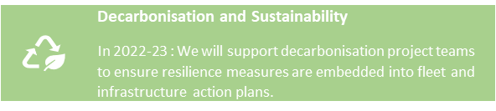
Looking ahead we anticipate that there will be significant pressure on the team due to a number of issues identified through our horizon scanning process, such as:

- Potential impacts on us from the review of the UK Civil Contingencies Act (CCA) and the likely legislative implications on our workstreams
- Review of the Civil Contingencies structures in Wales as the Welsh Government fully embed Part One of the CCA which has been devolved to Wales, the impact of this on LRF structures and also any enhanced governance and assurance processes that will need to be met
- Implementation of a Protect duty (relates to counter-terrorism preparedness) on all public bodies
- Outcomes of the UK Covid Inquiry and implementing lessons identified
- Outcomes of the Manchester Arena inquiry and implementing lessons identified
- Taking online management responsibility for the Trusts Make Ready teams

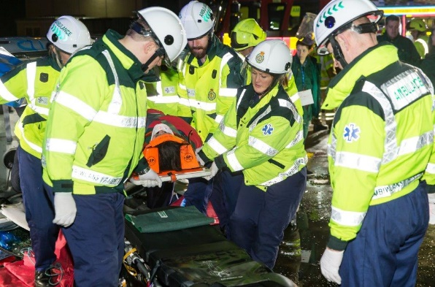
Our partnership work with the Wales Resilience Partnership Forum, the Wales Resilience Team, the CONTEST Cymru Board, Prepare and Protect Board, the four LRFs, Wales Learning and Development Group, LRF sub groups, the Wales Extremism and Counter-terrorism Unit (WECTU), the UK Ambulance EPRRG and its sub groups and a multitude of other partnership forums will continue, and this will ensure that WAST is formally represented with skilled, experienced and capable individuals at the highest levels both in Wales and the wider UK.

Our Enablers

6.1 Our people
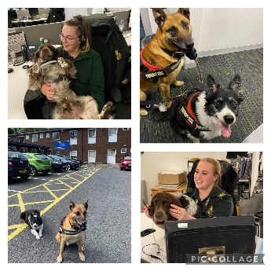
The challenge of Covid continues to impact on our people directly and indirectly, having a significant effect on personal and organisational wellbeing. By building on our organisation development journey, our 2022/23 deliverables support our strategic ambitions which are based on well-evidenced and researched practice. With our solid foundations in place, giving our people many avenues of support, we will grow further in this space to meet our aspiration where our people feel psychologically safe, included, have access to development so that they are competent to deliver their roles, well led and fully engaged.

Our aim is to ensure a strong and resilient organisation with every person in our workforce feeling connected and comfortable to bring their whole selves to work. We will launch and embed our new behaviours to continue to build a diverse, inclusive and compassionate culture where our people can be the best they can be and fulfil their potential, providing outstanding care to patients. A key enabler for this is meaningful, effective partnership working with Trade Union partners and ensuring the voices of our people are heard and amplified.

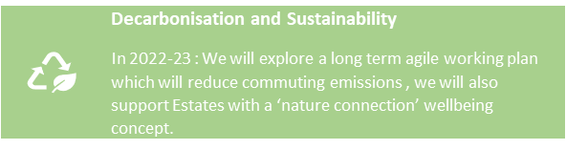
The themes from the behaviours and culture reset and our wellbeing challenges have created the prospect of innovative plans, with a unique opportunity to be proactive in creating a healthy working environment, including providing agile working opportunities from a location and role perspective, rotational and rostering options, decompression breaks and interesting career pathways. Successful achievement of this would be a true first for ambulance services.

Our organisational journey transitioning to a new model of delivery will demand the introduction of new roles and responsibilities to WAST and broader skills sets. This demands that the WAST team understand change and its impact, therefore change management skills will be front and centre. There will be a focus on creating the capacity we need to deliver a different service model and ensure that our teams are well trained and well led. Development of our Strategic Workforce Plan will enable us to outline the actions necessary to deliver our future workforce, with expansion of Hear and Treat services and development of See and Treat to reduce conveyance to hospital. We need to take steps to ensure our teams have the skills, knowledge and experience the need to deliver the future service offer.

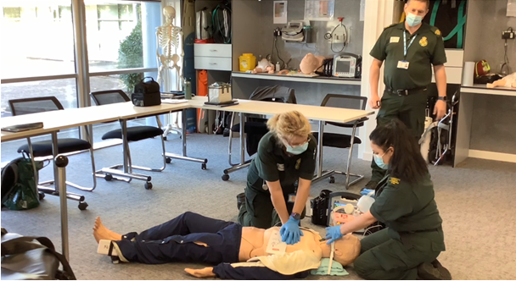
Our strategic workforce planning will be at the centre of this to ensure operational staffing needs are met, especially in the context of a ‘fallow year’ for graduates (i.e. where the university course structure has changed so no paramedics will graduate from Welsh universities in 2022). We are exploring new recruitment routes such as apprenticeship development and career pathways to ‘grow our own’ and testing overseas recruitment opportunities to fulfil demand. Our work on succession planning supported by strong leadership and management development including assessment centres ensures that we have a pool of internal candidates for senior vacancies who can compete with the wider market.

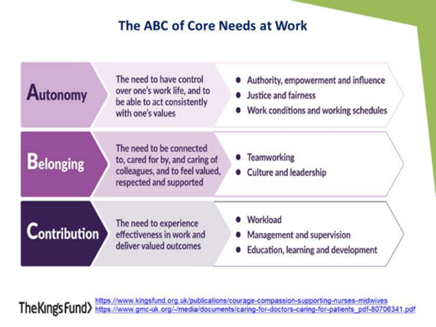
In order to support the transition required in EMS and to achieve our strategic ambitions across all services we need to ensure we are meeting the “core needs of work” for our people to ensure a productive, inclusive and innovative workforce; the ABC – autonomy, belonging and contribution (source: The King’s Fund). The staff survey and behaviours refresh work demonstrated that these areas were a priority for our people, and we know that striving to meet these core conditions will positively impact on wellbeing and engagement. The People and Culture strategy incorporating our leadership philosophy and coaching framework will be reviewed in the coming year.

We will provide education and development interventions for our existing and aspiring leaders and managers, developing coaching and mentoring skills and positive influencing to manage multi-disciplined teams across an integrated, collaborative system of care. Every person plays a role in creating our culture, especially leaders, who need to demonstrate compassion, inclusivity and fairness recognising they set the conditions for wellbeing and happiness for themselves and their teams.

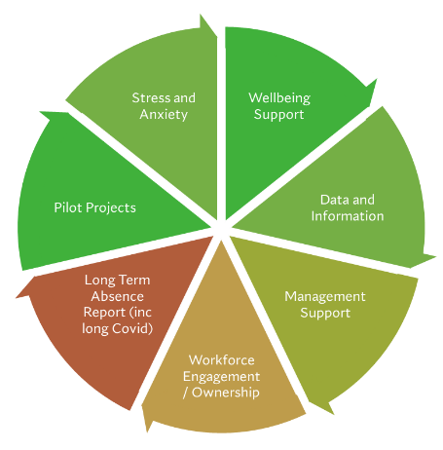
Reducing sickness absence is a key organisational priority. A project plan with a range of workstreams has been developed to support the reduction in sickness absence. The leadership and management teams are fully engaged in the approach and will be key in supporting the progression of the workstreams. In terms of impact, there is an expectation of limited impact in the first quarter of 2022/23 as the project gets up and running with an increasing impact during the rest of 2022/23 and into 2023/24. The aim is to achieve a significant and sustained reduction in figures over the next three years to bring WAST into line with other UK ambulance services and into the median quartile with aspirations to be in the top quartile in three years. This will be achieved by ensuring our people understand the expectations upon them and where and how they can access support, managers are effective and well trained to support their team regarding attendance, policy is implemented in the right way, and we continue to work on creating a culture where people can do their best work.

There are a range of caveats around achieving our aims including the obvious risk of further COVID variants and the uncertainty of the impact of the pandemic on population health and therefore our workforce health, REAP levels and events outside of the control of WAST such as the length of time employees are waiting for medical treatment and the impact on wellbeing to frontline staff of handover delays. There will also be the impact of normal seasonal trends. The work of the project will be regularly discussed and reviewed at our Executive Management Team meetings.

We want all our people to know they are valued and experience a true sense of belonging at WAST. We will continue to celebrate and promote the diversity of all our people, to ensure they feel safe, valued, and respected at work.

6.1.1 Equality, Inclusion and the Welsh Language

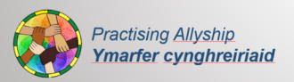
Our Strategic Equality Objectives drive the inclusion agenda and the launch at board development in December 2021 of the Allyship Programme with the commitment of Trust Board to continue their allyship journey with 30 days of allyship demonstrates WAST’s view of the importance of ensuring a diverse and inclusive organisation. A faith panel is ready to launch, providing a forum for all colleagues to ask questions to increase their knowledge and confidence at working with people from different faiths within WAST and those we serve. We have an interactive neurodiversity resource accessible to all on our learning launchpad and a growing inclusion network.

Great strides have been made in meeting the Welsh Language Standards in 2021/22, however given the significant increase in demand for translation to meet compliance with the Standards, and to provide a well-rounded and more strategic outlook, a case has been prepared for an in-house Welsh language translator. The intention is to centralise those translation services where that would provide value for money, and quality and speed of service to the Trust.

With the increase in calls to the 111 service since the Betsi Cadwaladr University Health Board roll out in July 2021 the Trust has identified times where the concentration of Welsh language callers to the 111 service is higher and as a result more Welsh speaking Call Handlers are being deployed at these identified times to meet the demand. In addition, the 111 service are actively recruiting Welsh speakers. As part of the National 111 programme SALUS solution, 172 bilingual symptom web guides are being developed for the public to access and will be hosted on the 111 website.
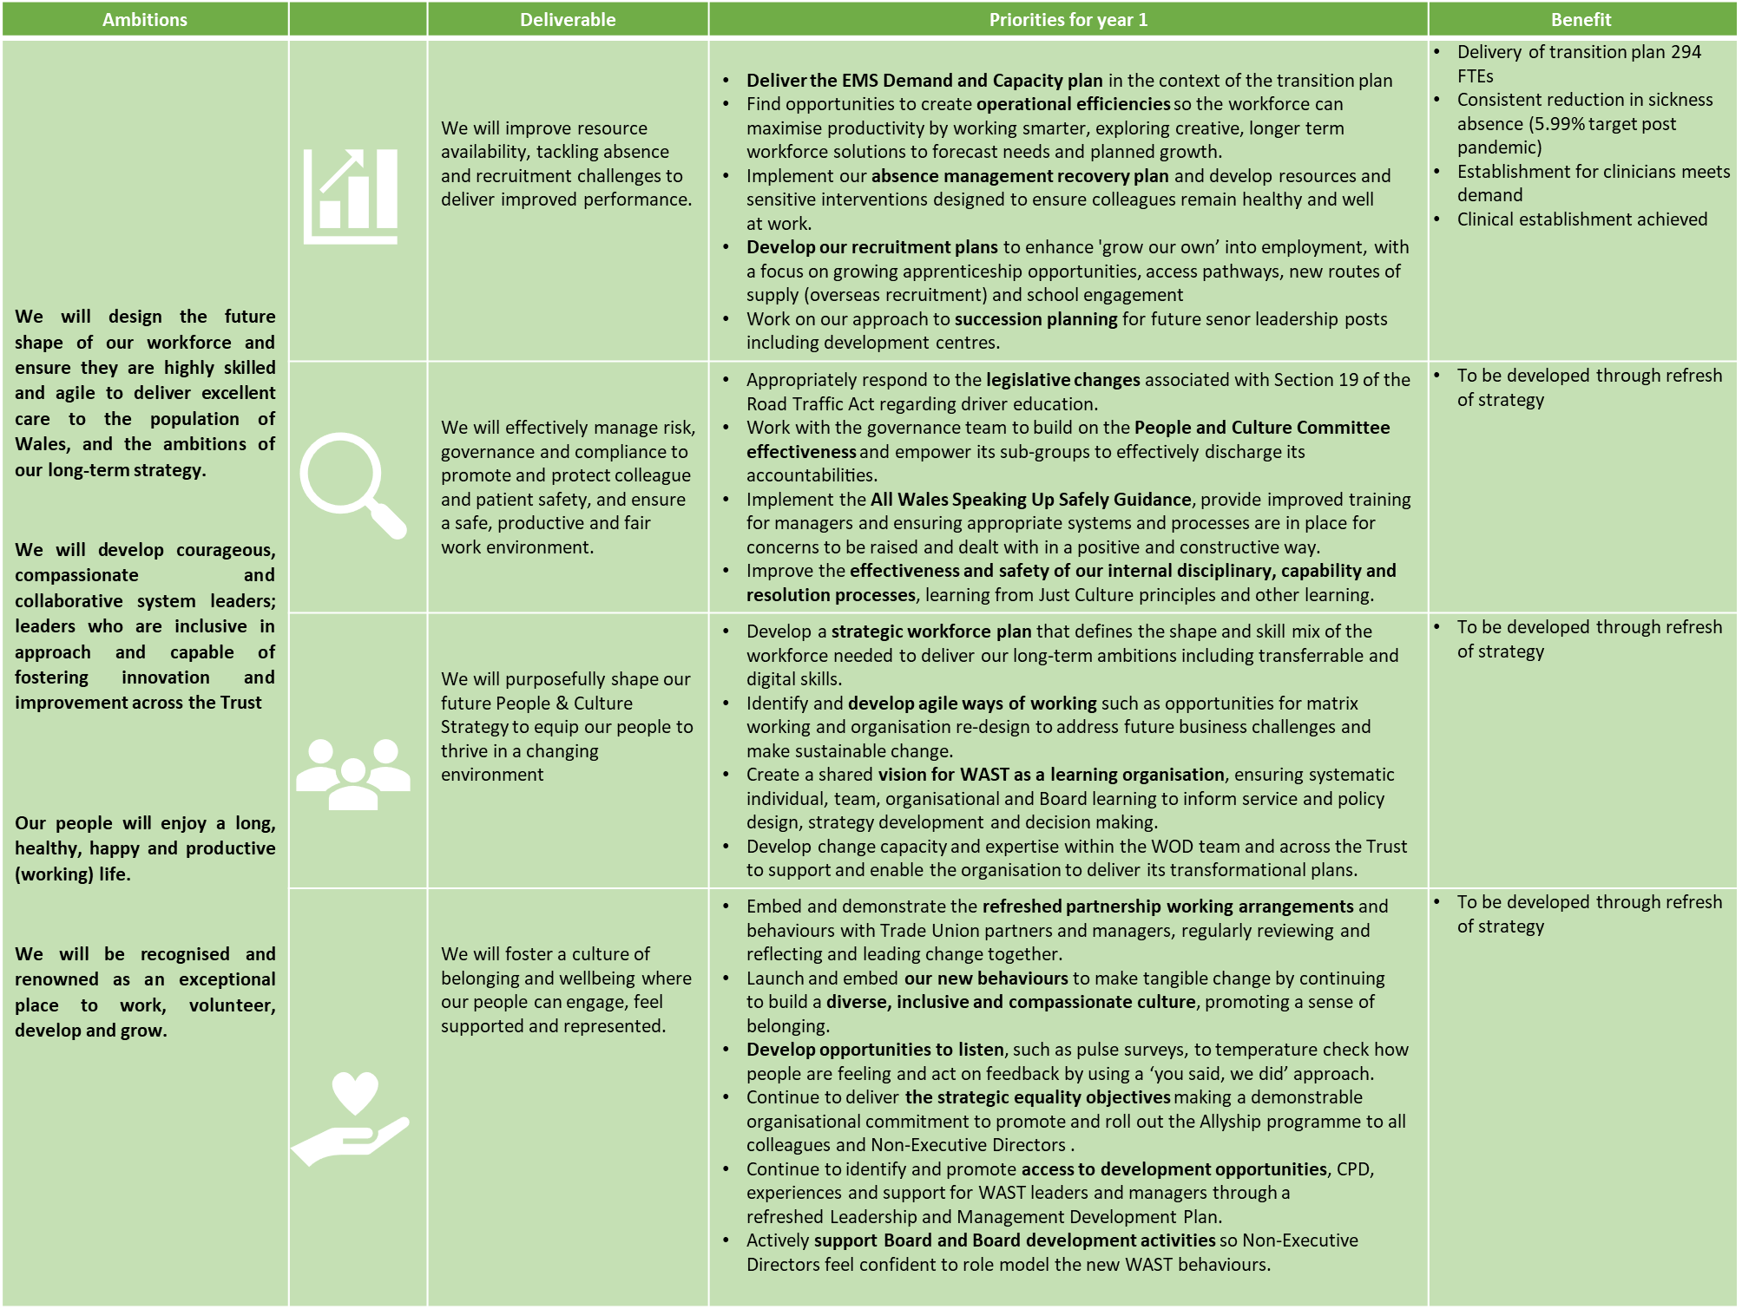

6.2 Innovation and Technology
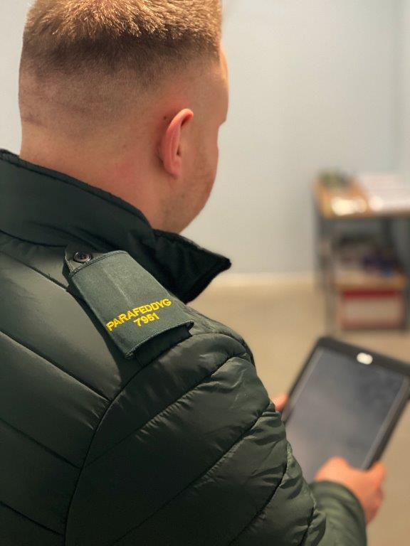
Innovation and technology are increasingly seen as one of the most important enablers of transformation within urgent and emergency care and particularly across our ambulance and NHS 111 Wales service offers. Over the course of the next year, we will be embedding and deploying digital platforms and services that will fundamentally change the way we conduct our business. These are;

Electronic Patient Clinical Record (EPCR)
Whilst the Terrapace Application went live in 2021 and completed its initial rollout last financial year, 2022/23 is the first full year that the Trust has used an EPCR at scale. The App will be developed throughout the year with big milestones including the integration with GP records and the pilot of a fully digital handover within Swansea Bay UHB. In addition, 2022/23 is the first year we will have EPCR data at scale on a rolling monthly basis for analysis.

Integrated Information Solution (IIS) / SALUS
Whilst it has been delayed significantly from its original implementation date, the SALUS product delivered into WAST by the 111 national programme represents a step change in capability for our 111 teams and GP Out of Hours (GPOOH) across NHS Wales. The new system will enhance our ability to employ remote staff, enable prescribing, as well as providing a seamless link from symptom checkers on the internet to the telephony service.

111.wales.nhs
Our 111.wales website is used by millions of people across Wales as the first point of contact in their journey within the health and care system. In 2021, work began to improve the site’s accessibility and usability and is planned to continue this year with a new homepage, ability to use location services on a mobile device to see local services relevant to your search and improved content. This will prepare the way for a more significant programme of improvements that will integrate the site with the new SALUS platform, the NHS Wales App and the new NHS Wales Login, allowing for much more interactive, personalised content.

Electronic Clinical Nursing System (ECNS)
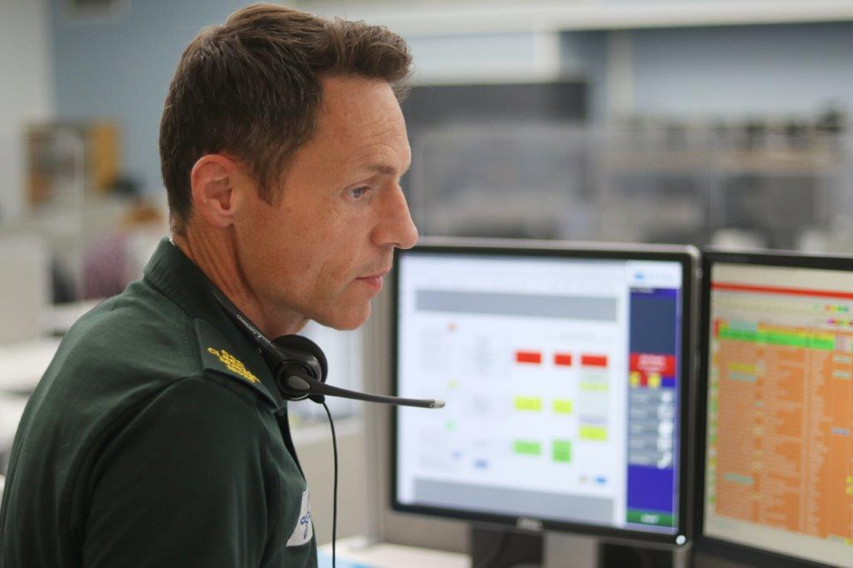
ECNS achieves a similar transformation for our 999 clinical desk, moving it from paper to a fully digital record. As with EPCR, the system going live is only the first step and 2022/23 will see significant work undertaken by WAST Digital teams to integrate with national services and glean important insights from the available data.

Control Room Solution (CRS)
Part of the UK wide Emergency Services Mobile Communication Programme (ESMCP), CRS will replace the ageing Integrated Command and Control System (ICCS) used by dispatchers in our control rooms. The upgrade to this critical system will allow us to operate more easily with other services, whilst readying us for the replacement of the Airwave communication service.

Mobile Data Vehicle Solution (MDVS)
Again, as part of ESMCP, later in 2022/23, we will replace the Mobile Data Tablets (MDT) across our Emergency Ambulance Fleet. The new technology provides a suite of increased capability above our existing MDTs, whilst also equipping our Ambulances with vehicle wi-fi.

Core Infrastructure
In terms of physical infrastructure, WAST ICT is heavily involved in both the expansion of our Fleet and our Estates. All new buildings require fitting out with the latest ICT equipment, networking and audio-visual equipment to enable hybrid working, whilst we continue to modernise the digital offer within both our EMS and NEPTS fleet to provide connected workspaces wherever our people need to be. In terms of digital infrastructure, there is also a constant requirement to ensure that our critical services are supported by modern, resilient, and secure technology.

Robotic Process Automation (RPA) pilot
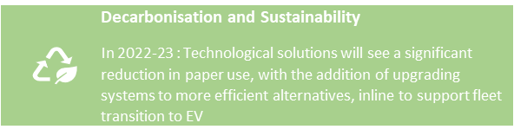
WAST has been successful in gaining funding from the Welsh Government Digital Priorities Investment Fund (DPIF) and we will use this to test RPA in support functions within the Trust enabling our people to focus time on high value activity.

Other Projects and Programmes
In addition to the major programmes mentioned above, WAST will also continue to be part of the £60 million National Data Resource (NDR) Programme, run by Digital Health Care Wales (DHCW) and will continue to deliver component activity supporting the 4 missions of the Digital Strategy.

6.2.1 Research and Innovation
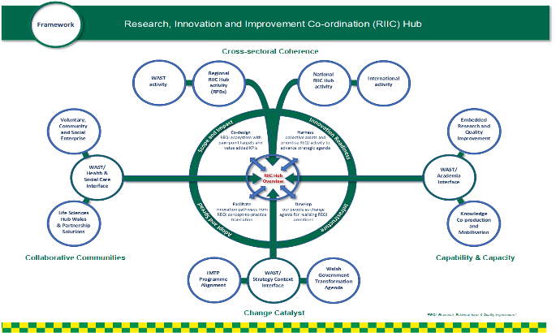
During the COVID-19 pandemic studies were paused across the health and care system and we have now fully recovered our research portfolio in line with National Institute for Health Research (NIHR) guiding principles. We supported two COVID-19 urgent Public Health studies, and whilst organisational challenges continue, these remain our research priorities. It has been challenging to strike a balance between restoring our active portfolio against the need to continue to support the COVID-19 effort. Our COVID-19 recovery planning recognises the need for resilience, growth and the potential high-value environment of WAST for clinical research. We continue to reflect Wales and UK wide research strategic aims, set out in the Health and Care Research Wales Strategic Plan and Support and Delivery Service Strategic Framework 2017-2022.

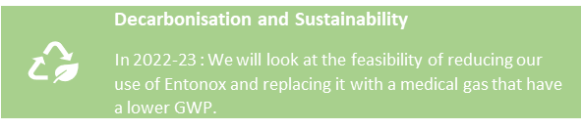
We continue to increase opportunities for patients and the public to participate in research, build our research community, attract and deploy appropriately skilled staff, and embed our shared values and behaviours. During our recent clinical restructure, we purposefully included R&I as a core element within job descriptions, and are therefore well placed to realise and release further research capacity through our clinical leadership teams. Whilst competing operational pressures continue, we remain steadfast in our aspirations for R&I in clinical leadership, along with the research paramedic role which is vital to support safe and efficient delivery of studies.
We are glad to have continued to support and influence UK research and have representation on Research Specialty Lead, ambulance research groups, funding committees such as HCRW RfPPB and NIHR HTA. We also continue to support our current Chief Investigators who have continued to work with research teams to develop and submit high quality grant applications to programs such as HCRW RfPPB and NIHR HTA. We are encouraged by two of our Advanced Paramedic Practitioners successfully securing RCBC Wales PhD Fellowships, and whilst we have faced challenges securing their operational release, we are keen to address such issues in response to the results of the HCRW Review of Research Career Pathways in health and social care in Wales.

We have continued to build on longstanding partnerships such as those with PRIME Centre Wales, Warwick University, and others to develop and deliver high quality studies, and as we recover, we look forwards to delivering large studies which we have developed with partners such as PARAMEDIC 3 and RAPID 2. We are also seeking out new partnerships and emerging opportunities to conduct innovative research in faster and more efficient ways. We have worked with local, national, and international partners to explore Innovative digital tools and infrastructure, and continue to seek and secure funding in areas such as Assuring Safe artificial Intelligence in ambulance Service 999 Triaging (ASSIST). We have developed effective partnerships on the use of drones in healthcare, including Beyond Line of Visual Sight deployment of a defibrillator by drone with Snowdonia Aerospace and the 3D project with Warwick University. We are also developing high quality research on Violence and Aggression directed towards Ambulance staff which is a high priority.

Key priority areas:
- WAST is actively pursuing University Trust Status (UTS) (see section 6.4) which recognises that being a research active organisation is a distinguishing characteristic of, and a key enabler for NHS Wales to deliver ‘A Healthier Wales’.
- We recognise the need for sound financial management and planning, and continue to benefit from WAST R&I Finance policy which is based on the WHC (2018) 005 – NHS R&D Finance Policy. We will review our finances to provide more resilience in roles.
- We will continue to deliver our portfolio including the PARAMEDIC 3 Trial which is now close to final set across all Wales.
- We will explore future innovative collaborations such as those with Drones, AI and Virtual Reality.

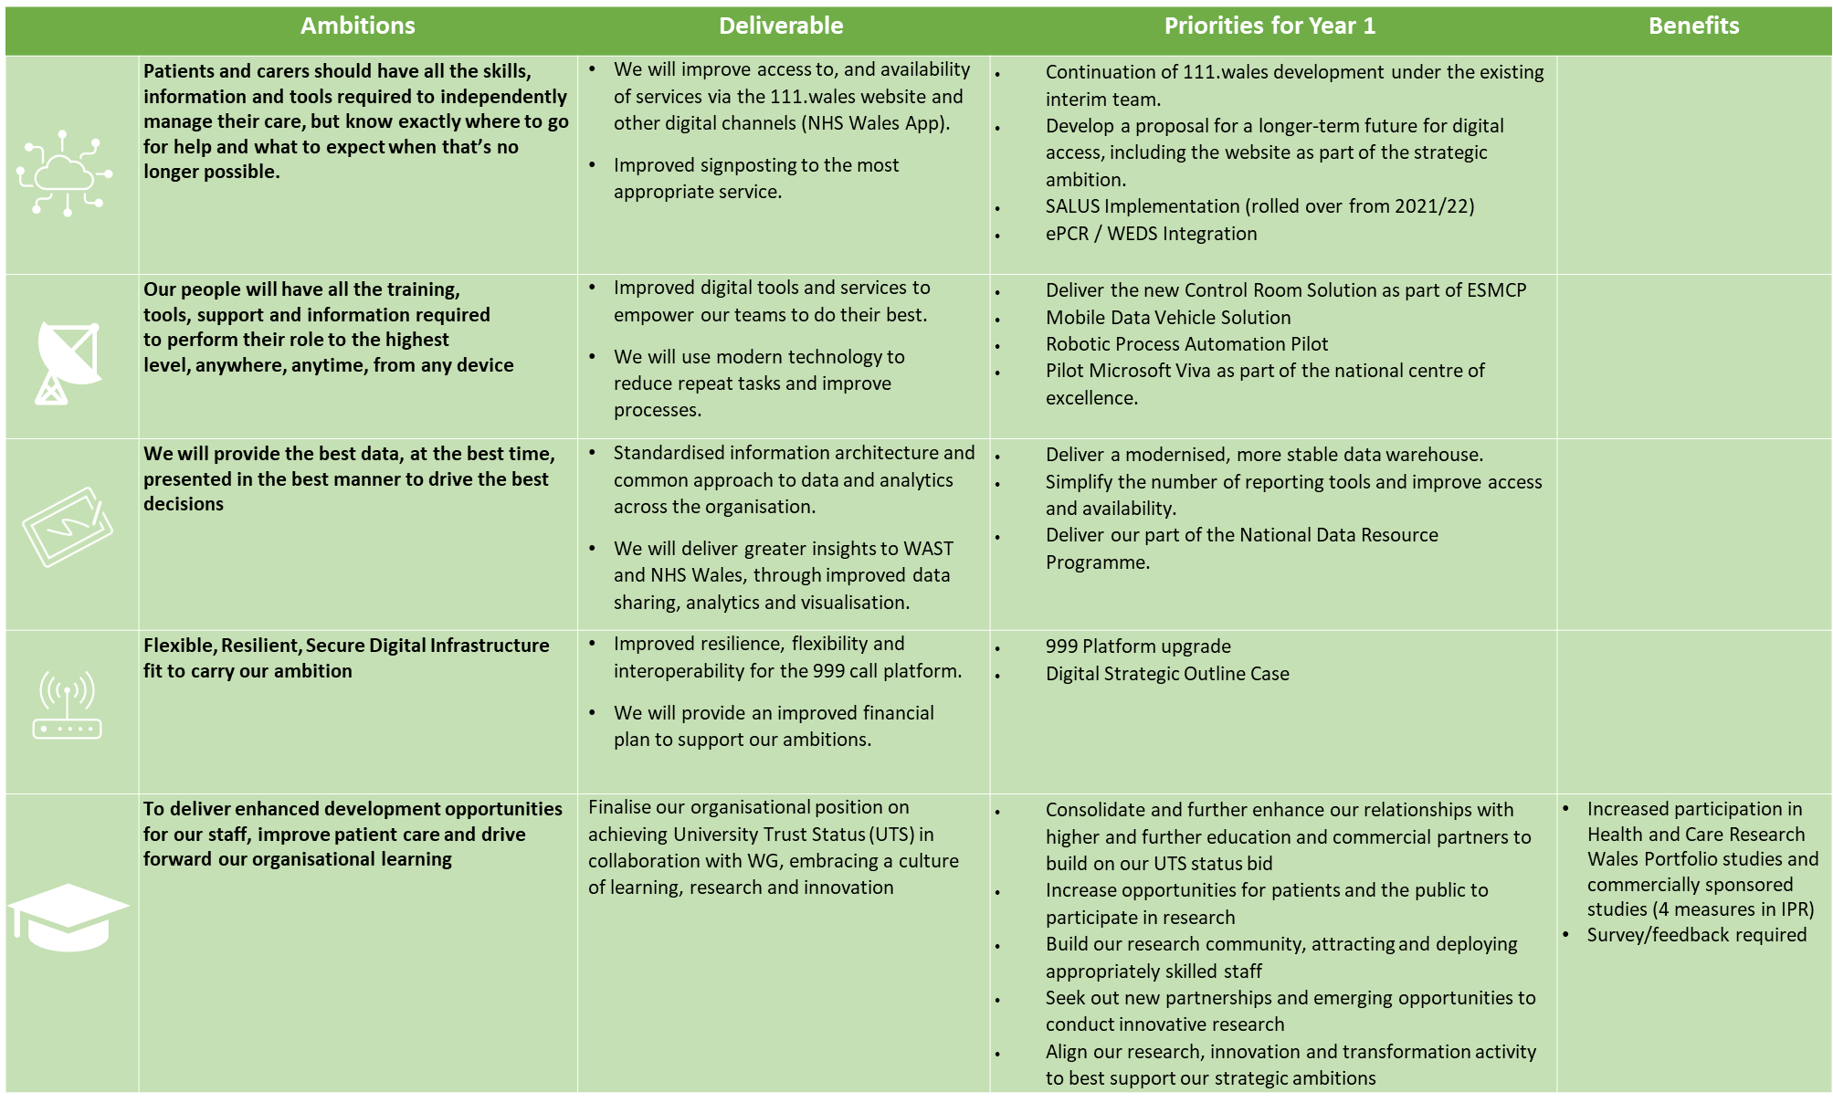

6.3 Infrastructure
Key to the ambition for the design and infrastructure of the organisation to be at the forefront of innovation and technology are our estates and fleet.

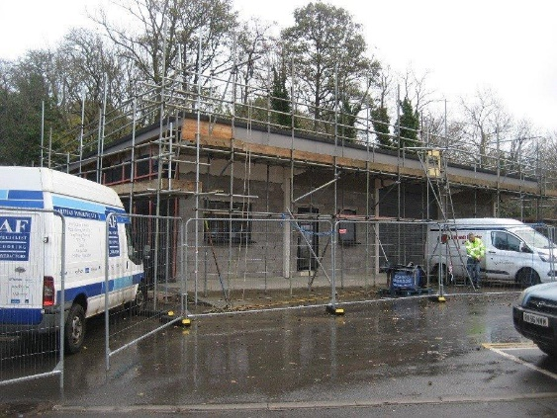
The continued growth in the number of people we will employ throughout this plan, as well as changes driven by the COVID-19 pandemic and recovery and wider system pressures, mean that we will need to respond flexibly to ensure we have the right buildings and vehicles in the right place for our staff to provide best and safest care across Wales. Our continued increased focus on the start of the patient pathway and improvements in 999, 111 and Contact First call handling is supported by significant improvement schemes across all of our main sites; for example, significant work is underway at VPH, Cwmbran and Ty Elwy, St Asaph to improve facilities for our staff. A key component of a modern infrastructure is that it supports the Trust’s and Welsh Government ambition for carbon neutrality by 2030. The Trust-wide ownership of actions in support of the decarbonisation is demonstrated throughout this IMTP, with all directorates taking ownership of actions to improve the Trust’s position and working towards Welsh Government targets.

In 2021/22 we refreshed, and received Welsh Government endorsement for, our Estates SOP and Fleet SOP and have commenced work on a series of business cases to begin to realise this vision. The SOPs were updated in line with the recommendations of the EMS Demand and Capacity (D&C) Review, responding to the major challenges and risks to ensure we have the right estate in the right place to support the growth in the EMS service, and we continue to consider the implications of the NEPTS D&C Review.

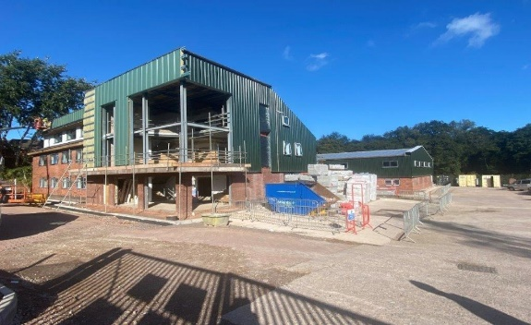
We have made significant progress in supporting additional capacity for increased numbers of EMS staff in 2021/22 and the future years of this plan will see this embedded within the Capital Programme, as we consider large schemes of work in key locations. In refreshing the SOPs, the “Make Ready” concept continues to be at the forefront of operational site business case development and operational teams are a vital component in ensuring our premises are fit for the future. We are demonstrating delivery on realising this concept including the opening of Cardiff Ambulance Station in Q4 of 21/22. COVID-19 impacts continue to exacerbate the risk around space to accommodate growth and challenges us to provide further space to enable social distancing, without compromising the facilities available to our staff. A further challenge has been the deteriorating condition of some of our estate and the impact that this has on our colleagues. This plan will take us on a journey to start addressing these challenges.


A modern and efficient fleet is vital to ensure that we provide a high-quality service to our patients and a comfortable environment for our people to work within. We have submitted the Business Justification Case to Welsh Government for the next year of our ongoing vehicle replacement scheme and, subject to approval, over the next 12 months we will be replacing 111 vehicles across our fleet including EMS and NEPTS. As part of our commitment to reducing our carbon and vehicle emissions, we have focused procurement on smaller and more efficient vehicles to reduce our CO2 vehicle emissions. In 2021/22 we have taken delivery of 15 plug-n petrol hybrid RRVs as part of an accelerated programme for 22/23 and reinforcing our commitment to low carbon emission vehicles. In support of further decarbonisation of the fleet, we continue to explore opportunities for lighter and/or electric vehicles particularly for our cars and NEPTS vehicles and considering use of technology. As part of this, we will continue to develop our electric vehicle charging network across Wales.

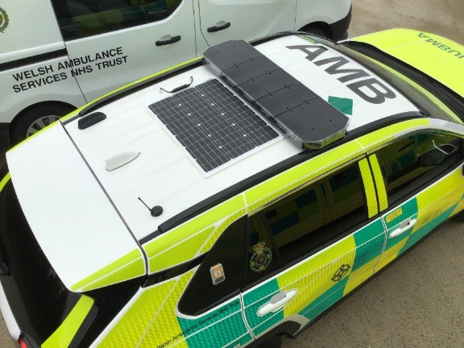
The Welsh Government targets of a net-zero position by 2030 pose real and complex challenges for WAST. In response to this, we have a key action next year to develop our Sustainability and Infrastructure Strategic Outline Programme, which will outline the financial and resource implications for the move to a carbon-neutral ambulance Trust. This will need significant input from our colleagues across the Trust, and will require additional investment within the Finance and Corporate Resources Directorate to manage this. The relevant business cases in support of Estates and Fleet developments will continue to reinforce the importance of this agenda, and to push us towards a position of carbon neutrality, maximising our use of new technology and responding in a flexible and agile way to the changing external environment.

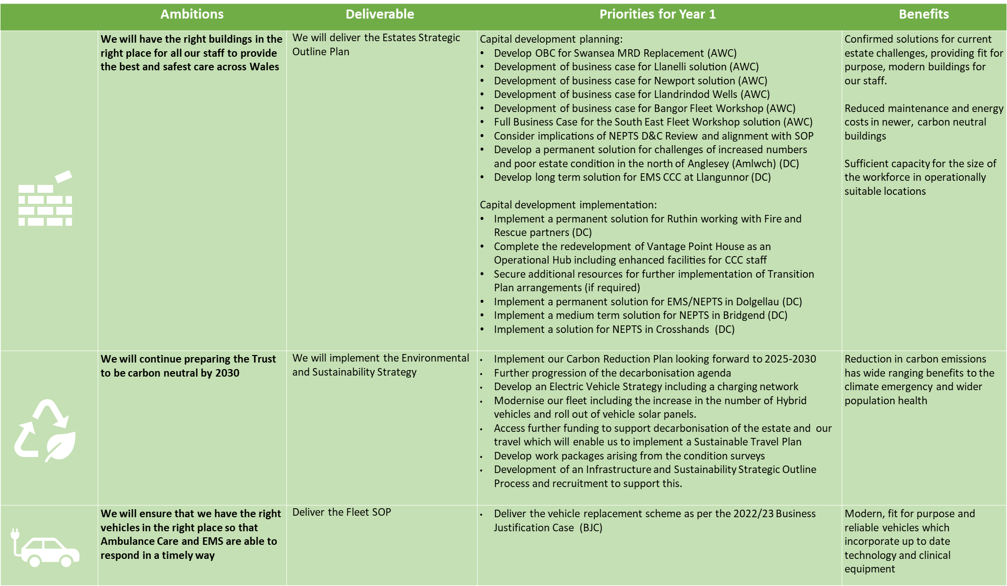

6.4 Partnerships and Engagement
It has been clear for many years that no single organisation can operate in isolation within the NHS and this has been made even more obvious over the last two years, where working collaboratively, particularly during the early days of the pandemic, was critical. As we now move forward, there are a number of areas where we want to capitalise on existing, and build renewed relationships, to support our ambitious programme of transformation which will see the Welsh Ambulance Service “invert the triangles” of its delivery.

This will mean a sharpened focus on working with organisations within and beyond the NHS on managing many more patients in the community, with referral access to a range of health and care services provided by both statutory services (NHS and local government), as well as the Third Sector.

It will also mean using our most skilled clinical staff in new and different ways, whether that be via remote clinical triage, including the use of video, or at scene, managing more complex patients or those with particular needs, such as mental health, more effectively often involving a number of professionals from different partner organisations.

Our work with Regional Partnership Boards will look at how we are able to work more effectively on a regional footprint to establish proofs of concept. For example, initial work is currently being scoped with local authorities in the Aneurin Bevan University Health Board area to look at which services are currently available, how our colleagues could use them better. The health board will also be involved in this work, particularly in respect of identifying any relevant gaps in health and social care provision which, if filled, could reduce conveyance, and improve patient experience and outcomes.

In terms of stakeholders, we will consolidate and improve our relationships with partners in higher and further education, reflecting our commitment to being a learning organisation and in line with the organisation’s current submission to Welsh Government to be accredited as a “university trust”.

While formal confirmation of university trust status (UTS) is awaited, initial feedback has been positive and our recently established Academic Partnership Committee will now drive development and delivery of our plans, in line with our submitted priorities, regardless of outcome of that submission. The UTS priorities as submitted to Welsh Government comprise:

Priority One: Digitisation enabling better outcomes (see section 5.2 and 6.2)
- Deployment of our digitised patient record system (ePCR) resulting in reduced reliance on paper records and improved capability to share secure information with other healthcare providers.
- Improved access to integrated intelligent information, enhancing opportunity for research/clinical audit working with academic partners to understand patient profile and outcomes
- Explore development and deployment of artificial intelligence and machine learning to reduce clinical risk and improve optimisation of operations.
- Introduction of video triage in the remote clinical assessment environment (111/999 Clinical Support Desk) to assist in assessing patients, resulting in improved patient management and system benefit. Partnering opportunity with industry and academia to integrate systems and identify patient and system-level impacts to evaluate benefit and continue to refine and develop accordingly

Priority Two: Advanced practice and specialist working, consult and close and service transformation, including research (see section 5.3):
- Significantly enhance quota of clinicians working at advanced practice level (with ongoing professional development), both in community and clinical contact centre environments, requiring extensive continued engagement with academic partners, including for example curriculum development and opportunity for PhD level study and beyond.
- In addition to advanced practice, further development of clinicians working in specialist roles, to further enhance the Trust’s current portfolio that includes paramedics specialising in trauma and critical care as well as the Trust’s new palliative care paramedics.
- Mobilise and grow research capacity & capability in our workforce and develop research leaders for the future.
- Development of the “consult and close” clinical triage approach within clinical contact centres, with appropriate opportunities for academic review of audit data and resultant research into patient experience and outcome to inform future steps
- Reduced conveyance as a result of a) and b) above, with an opportunity to work with academic partners on ongoing data collection, review and interrogation as part of action research in the live environment
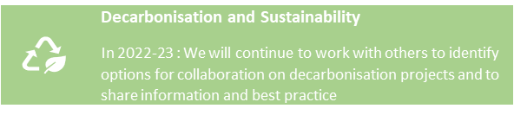
Priority Three: Decarbonisation, fleet modernisation and sustainability (see section 6.3)

- Work with academic and commercial partners on options in relation to further decarbonisation of fleet and estate, including alternative fuel vehicles etc
- Work with academic and commercial partners on further approaches to sustainable working practices, reduced consumption, eco building design etc.

Our Fundamentals

7.1 Quality Driven, Clinically Led, Value Focused
The NHS Quality and Safety Framework was published on 17 September 2021. The framework provides guidance and direction for all NHS organisations with a focus on having a strong quality management system in place at all levels, in turn reducing variation in quality. It also serves to provide a stepping stone to the new legal duties of quality and candour expected to be enforced from April 2023 as part of the Health and Social Care (Quality and Engagement) (Wales) Act 2020.

Our revised Quality Strategy, ratified in April 2021 at Quality, Experience and Safety Committee (QuESt) sets out how WAST will comply with the Act. Aiming for a culture of candour across our workforce, creating an environment that is transparent, honest, and open to learning which enables citizens across Wales to have a voice, underpinned by a culture of quality and quality improvement. We continue to listen to our communities through a continuous engagement model and this will be crucial to informing and shaping our future strategic ambitions.

Our Quality and Clinical Strategies outline the Trust’s strategic direction towards an integrated quality driven, clinically led, value-based organisation. The general theme is towards integration I.e. a move away from departmental responses to a whole organisation/whole system approach to planning and delivery which drives improved performance, outcomes and benefits and deliver upon our statutory duties.

In 2022/23 a key response to our statutory requirements will be the agreement and on-going delivery of an Integrated Quality & Performance Framework (in effect the quality management & control system), supported by two new key Trust wide groups:

- Integrated Quality & Performance Management Steering Group; and
- A pilot Integrated Governance Group

The Trust has made significant strides over the last five years in improving its approach to both quality and performance management, with a good grip on both issues. The Framework will formalise these improvements by writing them up, an “as is”, and prioritise areas for further improvement, that will be discharged through the Integrated Quality & Performance Management Steering Group.

We have now developed our “Working Safely” Health & Safety Transformation Plan to support and develop a culture of safe working across the Trust. Key roles to support this transformation programme have been appointed to and this year the Working Safely programme will deliver significant improvements in Health and Safety, Occupational Health and Well-being.

Both our Clinical and Quality Strategies play an important role to lead our ambitions to shift left in the patient pathway. We are creating and building on a culture of strong clinical leadership, strengthened partnerships and engagement with key clinical leaders and teams within health boards and Welsh Government, and smarter ways of working that allow us to embrace technology and develop our clinical offering to deliver on our ambition for an integrated system of care across all our service offers. This will be supported by developing our value based healthcare offer within the urgent and emergency care sector.

Internally, a key enabler to this has been the establishment of the Clinical Quality Governance Group, jointly led by our Director of Paramedicine, Medical Director and Director of Quality and Nursing.

DN - do we need to expand in light of AACE roundtable discussion on public health interventions

This year, we will review our existing Public Health Plan. This will be influenced by the context of the pandemic and its effect on public health (because of the virus itself, the impact of the lockdown of society and the harm of behaviours as a result). We will work in partnership with colleagues in PHW to understand our priorities and where we can have the most impact on population health.

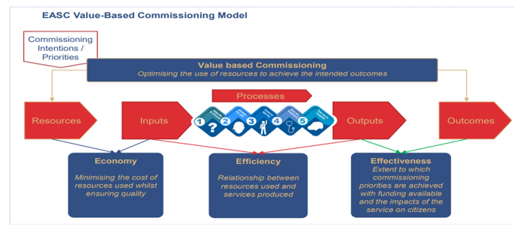
We will also continue our development of Value Based Healthcare within the Trust. In 2021/22 we developed a collaborative approach to Value Based Commissioning with the NCCU, with the aim of further developing our internal approach within WAST. Whilst some of the work on developing tools, techniques and training was paused during the Omicron wave, our general ethos and approach to Value remains integral within the quality and performance management framework and our balanced scorecard approach to benefits realisation and performance management. We will further embed a culture of Value through:

- Ensuring alignment with the Quality and Performance Management framework so that Value is not seen as an “add on” but an integral part of how we understand the impact of the services we provide;
- The implementation of the Patient Level Information Costing System (PLICS) tool to understand where variation exists across the services we provide;
- Embedding value based techniques into evaluation of key service investments and revenue business cases;
- Delivering training across the organisation to support a Value based approach.

Risk management is an integral part of the Trust’s governance arrangements, and the Trust Board has a responsibility to ensure that the principles of good governance are underpinned by such frameworks for risk and assurance, performance, and quality improvement to provide safe and effective care for patients and staff and ensure the safety of the environment around them.

A risk management transformation programme has been developed to support this which will further strengthen and positively impact the development of the Trust’s future strategic ambition and provide clarity on the risks that would prevent us from achieving our organisational objectives.

A revised risk management strategy and framework will be developed with a focus on strengthening the articulation and management of risks.

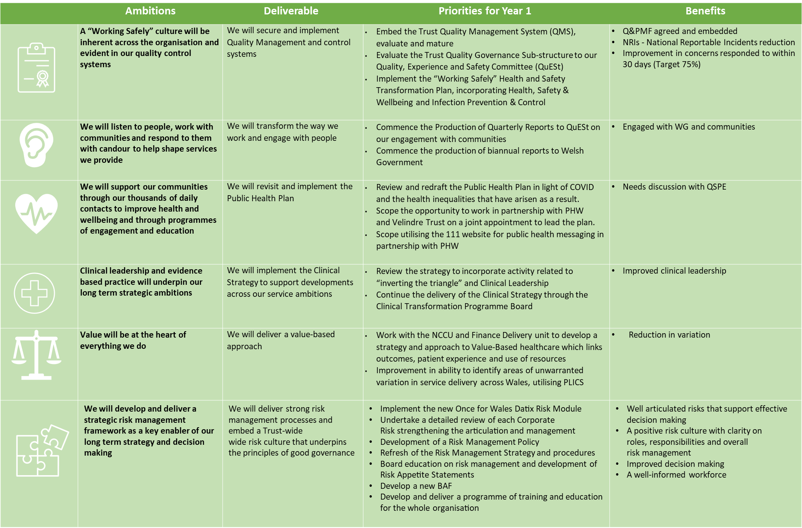

Our Workforce Plan

8.1 Current workforce profile
WAST currently employs approximately 4,000 people (December 2021). The largest staff group is Additional Clinical Services at 52%, which includes our ACAs/UCAs, EMTs, and Call Operators, followed by our Allied Health Professional staff group at 26%, which includes our paramedics. This is an increase of 5.6% (211 FTE) in post compared to December 2020.

48% of our workforce are female, which is an increase of 2% since December 2020. 21% of the workforce are part-time, which is a 1% reduction compared to the previous year. 21% of our workforce are aged 56 or over, suggesting an ageing workforce profile. Our hard to recruit roles for 2021/22 will be Trainee Emergency Medical Technicians, Paramedics, 111 Clinical Advisors (nurses) and Digital Specialists.

8.2 Our Plan
WAST’s vision and aspiration to expand services to reduce demand on the wider health and social care system is underpinned by an ambitious workforce transformation programme. This programme creates a demanding workforce plan which will be challenging to fulfil as well as having a range of identified workforce challenges which will need to be addressed. Where there are Workforce and OD solutions to these challenges these are recognised in the service priorities.

Workforce Challenges
- Delivering a robust workforce transformation plan to deliver on the Trust’s strategic ambition incorporating sufficient education commissioning numbers, workforce redesign, service expansion and redistribution activities.
- Creating a culture where workforce transformation becomes the norm and is underpinned by supportive and enabling workforce policies and processes.
- Supporting our existing Emergency Medical Service staff to have the right skills and behaviours to deliver our expanding remote consult and close services and face to face see and treat services in the community (e.g. developing advanced paramedics with prescribing skills).
- Sourcing a supply of additional EMS staff to meet increased demand on our existing conveyance services, which is particularly challenging this year for our paramedic workforce due to it being the fallow year of their education programme.
- Attracting applicants for entry level roles into the EMS service where a C1 category is held on their driving licence, given the costs and requirements associated with obtaining this.
- Focussing on the wellbeing and retention of our staff given the pressures experienced due to increased pressures in the health and social care system.
- Improving resource availability by reducing sickness and abstractions.
- Expanding and maintaining the 111 First service, if funded. This is currently a nurse led service who are in low supply across the health and social care system.
- Meeting the demand for our non-emergency transport services as the Trust continues to support Health Boards with the effects of the pandemic and beyond.
- Equipping staff to utilise new digital technologies.

Transformation Programmes – Workforce Plans
The Trust has four programmes delivering transformative change across the services areas of EMS Operational and Clinical response, our Gateway to Care services (comprising NHS 111 Wales and CSD) and Ambulance Care (comprising NEPTS, Urgent Care Service and transfer & discharge services):

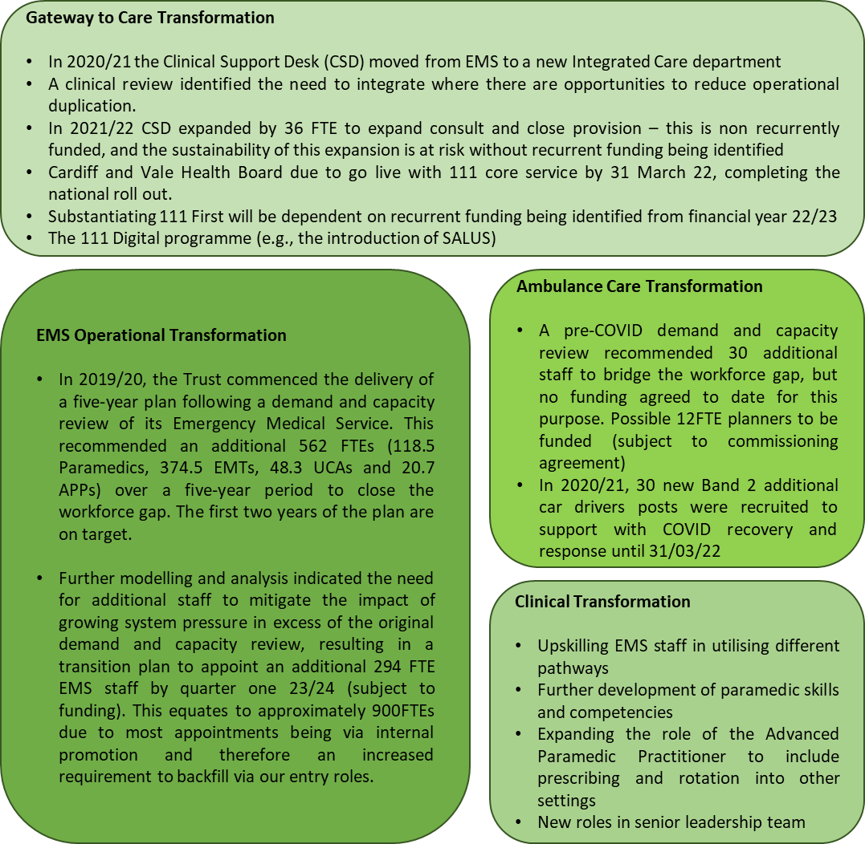

Education Commissioning Requirements
Our education commissioning submission continues to reflect our assumptions regarding the anticipated long term effect of COVID-19 and our aging workforce profile, likely resulting in a higher turnover rate and greater number of internal movements and reductions in working hours. Final numbers will be confirmed in mid-February when Health Boards have shared their paramedic requirements with WAST.

Notes to Accompany Minimum Dataset Workforce Numbers:
- Nursing & Midwifery projections: incorporates additional nurses required to complete the national roll out of 111 First plus mental health clinicians for the Clinical Support Desk (CSD).
- Allied Health professional projections: includes the new Practice Educator team for the CSD and the newly funded paramedic and senior paramedic posts to support the delivery of year 2 of the EMS demand and capacity review. It excludes the 36 newly funded CCC clinicians for CSD as these were filled using existing paramedics and backfilled with 36 additional EMTs.
- Additional Clinical Services projections: incorporates additional call handlers required to complete the national roll out of 111 First, the temporary (12m) funding for 32.15FTE 999 call handlers to support increased demand, additional ACA2 and EMT roles to support the delivery of year 2 of the EMS demand and capacity review and 36 newly funded EMT posts to backfill the 36 FTE paramedics moving across to CSD. Assumes the 80 funded posts for the Mobile testing Units (MTUs) will cease as of year 1, Q2. No additionality agreed for Ambulance Care ACS posts.
- Admin and clerical projections: includes 12 newly funded team leader roles for Ambulance Care to support the movement of UCAs from EMS to Ambulance Care. Includes 2 A&C roles for CSD and 19 corporate roles from CASC monies (all other CASC roles on hold so have been omitted).

Our Financial Plan

NK– to be updated in February once plan takes shape (need to know what is happening on Transition Plan)

Delivering Our Plan

10.1 Managing transformation
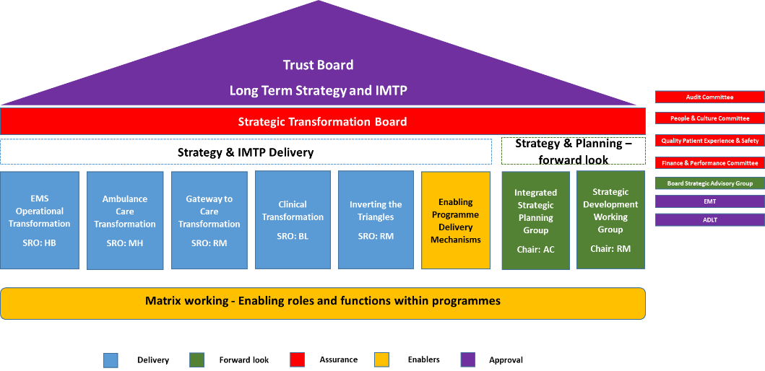
The Trust Board remains the overarching accountable committee for delivery of the Trust’s IMTP and long-term strategic plans, with individual sub-committees maintaining oversight and scrutiny of specific deliverables. In 2022 a new programme board will be established (identified in the delivery structure as “Inverting the Triangles”) to take forward the further development of our strategy.

Assurance is provided through the Board Assurance Framework (BAF) and further work will take place in 2022/23 to ensure the BAF reflects the refinement of our strategic objectives and assures the Board around mitigations to the key strategic risks held on the corporate risk register. Thereby the BAF ensures that our approach to managing risk aligns with our long-term strategy, delivered through the IMTP. To further support the Trust Board to retain an overarching view of IMTP delivery, the Strategic Transformation Board (STB) chaired by the Chief Executive, will continue to provide monitoring, oversight and governance over the implementation of the deliverables in this IMTP.

STB has a portfolio management approach and overview to enable and govern IMTP delivery through core service transformation and enabling programmes, underpinned with proportionate programme and project documentation. These programmes were established in 2021 and have embedded themselves as the delivery vehicles for change and transformation.

We will re-commence work which was paused during the pandemic to develop portfolio, programme and project management software that will link with Microsoft 365 and Power Business Intelligence (BI) to support the strategic and programme level oversight of our IMTP delivery.

The Transformation Support Office will continue to support the strategic transformation agenda across the organisation, developing the organisation’s capacity and capability to manage large complex programmes internally and across the system. We will synergise our quality improvement and transformation resources and approach under the STB to ensure our strategy development and transformation agenda is underpinned by a value based, data driven, evidence based, and patient focussed quality improvement methodology.

In 2021, we reviewed our programme and project management framework to have a pragmatic and uniform approach to applying MSP® (Managing Successful Programmes) and PRINCE2® (Projects In Controlled Environments) methodologies and closely linking in with approach set out in the Quality and Performance Management Framework as set out above and in section 7.1. This work will also focus on further developing a robust value-based benefit realisation methodology.
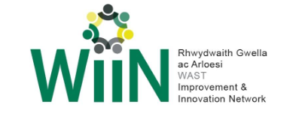
The way in which we can seamlessly link improvement activity through research and innovation activity, particularly through our networks, notably WIIN, to the transformative programmes of work overseen by STB will enable the scale up of improvements seen in local and regional initiatives to support the challenges in and delivery of this IMTP and EASC’s commissioning intentions.

10.2 Risks to delivery
The scale of change required to deliver on this plan and to achieve our ambition is significant, particularly for our people across the service. Whilst, as described above, we will be putting in place a robust programme management approach to support the transformation programme, there will nevertheless be risks to delivery which we will need to identify, manage, and mitigate.

Managing risk is a key organisational responsibility and remains an integral part of our governance arrangements that will further strengthen and positively impact the development of the Trust’s future strategic ambition and provide clarity on the risks that would prevent us from achieving our organisational objectives.

The Trust Board receives a report on the highly scored operational risks and the Board Assurance Framework at every meeting, and the Board Committees receive reports on risks within their remit for oversight, scrutiny, and challenge. The Audit Committee has oversight of the risk systems and processes in place.

Risks to the delivery of key programmes of work within this IMTP will be monitored by individual programme boards, escalating to STB where necessary and raising to the Corporate Risk Register if Board level awareness and scrutiny is required.

The key risks to delivery of this IMTP will be:

- Availability of revenue funding for core and transformational elements of the plan;
- The reduction in capital available to NHS Wales, particularly to support the transformational elements of the plan;
- Securing stakeholder support including internal and external partners, particularly for the EMS transition plan;
- Ongoing impacts of COVID-19 recovery both internally within WAST and as the Health Boards recover their activity;
- Capacity within the organisation to deliver the change required, within the resource envelope available;
- Demand for our services increasing at a greater rate than the demand and capacity forecasts;
- Pressures on the service arising from external factors, particularly the continuing impact of hospital handover delays;
- Health and wellbeing of the workforce in the face of continued pressure.

These risks will be captured on the corporate risk register, with mitigating actions and controls aligned to this IMTP and operational level plans.

Conclusion

ADD CONCLUSION ONCE ALL NARRATIVE COMPLETE - AC

