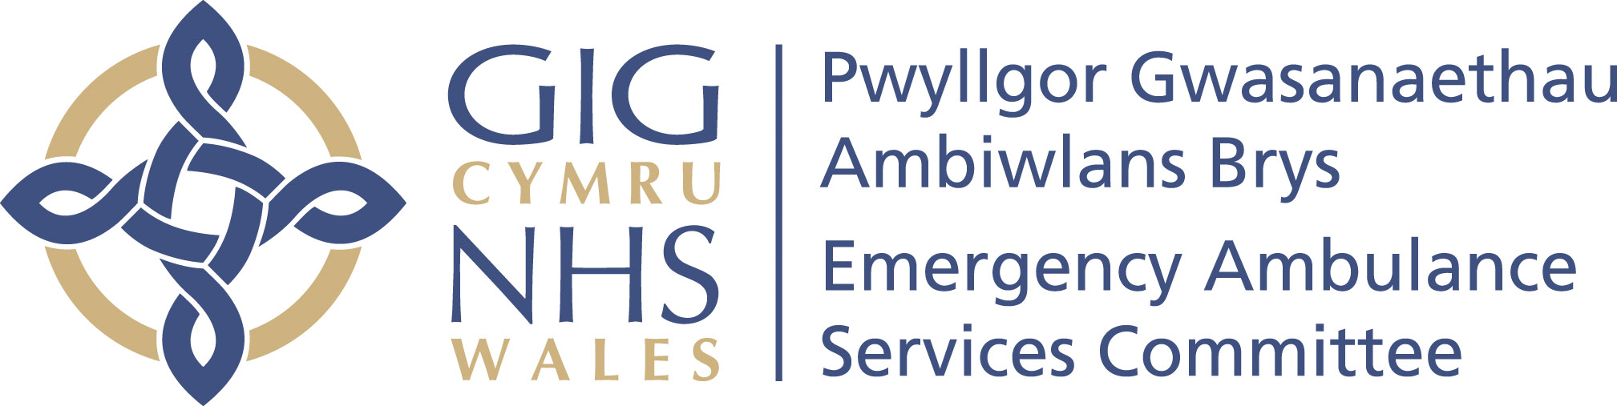

Emergency Ambulance Services Committee

Integrated Medium Term Plan:
2022-2025
DRAFT
Published date: xx 2022
Revised: xx 2022
Review date: xx 2022

Table of Contents
Table of Figures 4
Foreword 5
Executive Summary 6
Resetting Services and Driving Recovery 7
Emergency Ambulance Services Committee 8
Background 8
EASC Governance 8
Governance and Assurance 9
EASC Joint Committee 9
EASC Team 9
Risk Management Framework 10
EASC Commissioning Cycle 11
Commissioned Services 2021-22 14
Commissioning Priorities 2022-25 15
Strategic Priorities for Commissioned Services in 2022-23 15
EASC Commissioning Priorities 2022-25 19
Informatics and Ambulance Quality Indicators 19
Commissioner Ambulance Availability Taskforce 19
Increasing transparency and accountability of the Committee 19
Wider System Work Programmes 2022-25 20
Development and delivery of the vision for a modern emergency ambulance service 20
Six goals for Urgent and Emergency Care (Goal 4) 21
National Transfer and Discharge Services 21
NHS Wales 111 22
Emerging system transformational change 22
Commissioning Priorities Summary 2022-25 23
EASC Financial Plan 2022-23 26
Emergency Ambulance Services Allocation 26
Demand and Capacity Programme in 2022-23 26
Operational Delivery Unit 26
Grange University Hospital 27
Non-Emergency Patient Transport Services (NEPTS) Allocation 27
Emergency Medical Retrieval and Transfer Service (EMRTS) Allocation 27
EASC Ring-Fenced Commissioning Allocations 27
EASC Specialist Commissioning Allocation 27
EASC Team Resourcing 27
EASC Commissioned Services – Efficiency Programmes 27
Conclusion 29
EASC Integrated Medium Term Plan - Appendices 30
Appendix 1-EASC Commissioning Cycle 31
Appendix 2-EMS Performance Overview 2021 32
Appendix 3-NEPTS Performance Overview 2021 33
Appendix 4-EMRTS Performance Overview 2021 34
Appendix 5-EMS Commissioning Intentions 2022-23 35
Appendix 6-NEPTS Commissioning Intentions 2022-23 46
Appendix 7-EMRTS Commissioning Intentions 2022-23 51

Table of Figures
Figure 1: EASC Governance Process 8
Figure 2: Key Achievements in 2021-22 14
Figure 3: Overview of Commissioning Intentions for 2022-23 16
Figure 4: WAST’s Vision for a Modern Ambulance Service 20
Figure 5: Overview of EASC Commissioning Priorities 2022-25 24
Figure 6: EASC Allocation 26

Foreword
Welcome to the Emergency Ambulance Services Committee’s Integrated Medium Term Plan for 2022-25.

In developing this plan, the Committee acknowledges and values the effort made by frontline staff across the urgent and emergency care system in responding to the pandemic.

Recognising the extraordinary pressures placed upon the system, the Committee has taken a pragmatic approach during this period, adopting a supportive and enabling role, prioritising work that both reduces harm and improves patient outcomes and experience.

This plan will describe the Committee’s approach and priorities for commissioned services, with a particular focus on supporting the wider transformation of the urgent and emergency care system over the duration of this planning cycle.

We are confident that this plan strikes the appropriate balance between a continued focus on core service provision, strengthening the role of commissioning and enabling transformation.

The Committee has aligned the commissioning cycle to the 3 year planning cycle adopted across NHS Wales and will continue to work with stakeholders to ensure that existing and new services commissioned via the Committee are integrated and add value at the patient and system level.

We will continue to work collaboratively to enable providers to effectively deliver and improve services and to contribute to the required transformation agenda that is underway across NHS Wales.

  Christopher Turner | Stephen Harrhy
Chair  Emergency Ambulance Services Committee | Chief Ambulance Services Commissioner

Executive Summary

The Emergency Ambulance Services Committee (the Committee) Integrated Medium Term Plan (IMTP) for 2022-25 sets out the work programme expectations and deliverables for EASC for the next 3 years.
The portfolio of EASC commissioned services includes:
- Emergency Ambulance Services (EMS)

- Non-Emergency Patient Transport Services (NEPTS) and the

- Emergency Medical Retrieval and Transfer Service (EMRTS Cymru), including the Adult Critical Care Transfer Service (ACCTS).

EASC recognises its role in enabling commissioned services to support the wider urgent and emergency care system. This plan also identifies a number of wider system work programmes to support transformation over the life cycle of this plan.
In developing this plan, the overarching Ministerial priorities set out in the NHS Wales Planning Framework 2022-25 have been considered. In addition, alignment with the work of the Six Goals for Urgent and Emergency Care in Wales is included, in particular Priority Delivery Measure 11 (Phase One), contributing to the development of measures as part of phases two to four and the Goal 4 Action Plan.
These work programmes have also been developed to respond to the plans for transformational change that are being developed across the Health Boards. The Committee will continue to adapt and respond to changing service models at a local, regional and national level.
This plan will focus on:
- Commissioning intentions for commissioned services (2022-23)

- Commissioning priorities (2022-25) including:

  - Informatics and Ambulance Quality Indicators with an increased focus on data integrity and quality assurance

  - Development and delivery of the vision for a modern emergency ambulance service

  - Supporting the implementation of the Six Goals for Urgent and Emergency Care

  - National Transfer and Discharge Services

  - NHS Wales 111

  - Emerging System Transformational Change

- EASC Financial Plan

The commissioning priorities that have been described are aligned to a number of the overarching priorities and relevant national programmes. These priorities are in addition to the ongoing delivery of agreed commissioning actions, the focus on essential operational service provision and the prioritisation of the core responsibility to minimise risk and harm through the provision of timely responses to patients, both virtually and physically.
The details within this plan are consistent with those of the Welsh Ambulance Services NHS Trust, EMRTS Cymru and Health Boards.
The plan focuses on the services currently commissioned by EASC. However, the Committee recognise that work will be undertaken during the life of this plan regarding the commissioning arrangements of NHS 111 Wales and is committed to supporting this work.

Resetting Services and Driving Recovery
This plan describes the pragmatic and considered approach that the Committee has taken to resetting services and ensuring a renewed focus on driving recovery across our commissioned services over the next three years.
The plan will drive a refocusing of efforts on ensuring commissioned services deliver their core and fundamental roles to a standard and consistency that meets the needs of the population.
From the EASC Team perspective, the impact of the pandemic on day to day activities has been successfully mitigated and the team’s core enabling function has been maintained during this time of significant service change. During this period, the team has developed a commissioning cycle with stakeholders, this has strengthened the collaborative commissioning approach.
The team will continue to utilise this approach to support the work to improve service delivery, service quality, patient safety and performance with a view always to optimise patient outcomes and the patient experience.

Emergency Ambulance Services Committee

Background
The Committee comprises the Chief Executives of the seven Local Health Boards, an Independent Chair and a Chief Ambulance Service Commissioner (CASC). The NHS Trusts in Wales are represented as Associate Members.
The seven Local Health Boards in Wales are required under the legislation to work jointly to exercise functions relating to the planning and securing of emergency ambulance services. The CASC exercises these duties on behalf of the Committee.
Working with providers on behalf of the Committee, the CASC and the EASC Team enacts the priorities of the Committee for their populations, with benefits delivered to patients and the Welsh public, Welsh Government, Clinical Networks, Health Boards and other elements of the NHS Wales system.
Work will also be undertaken with commissioned services to ensure compliance with Ministerial priorities and statutory requirements including Welsh Health Circulars, the decarbonisation agenda and Covid-19 inquiry.

EASC Governance
The EASC Model Standing Orders outline the expectation that safe, effective and timely services are delivered, robust quality assurance and risk management systems support this. An overview of the governance process is provided in the chart below:

  - Figure 1: EASC Governance Process

Governance and Assurance
The established EASC Management Group and NEPTS and EMRTS Delivery Assurance Groups are the key governance and assurance mechanisms that ensure robust partnership arrangements with key stakeholders. These groups enable detailed oversight of delivery, performance and the strategic direction of commissioned services.
This the mechanism through which Health Boards and commissioned services will jointly plan and take collective action to deliver the Committee’s priorities. Partnership working and a whole system approach is at the heart of these arrangements, ensuring that there is appropriate challenge, collaboration and a drive to build on the learning and experiences across the system and to improve integration, quality of care and patient outcomes.
These groups are tasked with enacting the commissioning responsibilities of the Committee to ensure the provision of safe, effective, equitable and sustainable services for the population of Wales.
Membership of these groups is regularly reviewed in order to ensure appropriate representation of Health Boards and Trusts.

EASC Joint Committee
It is important to recognise the opportunities arising from a Joint Committee mechanism. The Committee is independently chaired and has strong governance and accountability frameworks as already described. These arrangements have been demonstrated to provide an appropriate forum for making decisions with national or regional implications.

Supported by the independence and expertise of the EASC Team, the Committee provides a system-wide view ensuring valuable insights in to the whole patient pathway and appropriate challenge to the system.

EASC Team
In terms of the wider system, the EASC Team is well-positioned in terms of its partnership arrangements with WAST and Health Boards and therefore is able to support, negotiate and arbitrate on new and existing services. This system-wide collaboration ensures that the team is able to engage the wider system both locally and nationally in order to support the work to improve service delivery, quality, patient safety and performance with a view always to optimise patient outcomes and the patient experience.

The EASC Team deliver:

- Collaborative commissioning quality and delivery frameworks which enable the planning and securing of ambulance services

- Monthly CASC Quality and Delivery meetings with WAST, focusing on patient safety and feeding into quarterly Welsh Government and EASC Integrated Quality, Planning and Delivery meetings

- Incidents, complaints reporting and reviews

- Performance reviews

- Clinical and risk assurance reviews

- Facilitation of collaborative working across the system

- Facilitate the Ambulance Services Indicator Group

- Publication and analysis of a comprehensive suite of Ambulance Quality Indicators (AQI), including enhanced and interactive user friendly reporting of AQIs

- Development of a comprehensive suite of performance and outcome measures across clinical services, patient experience and value for money which are regularly reported

- Working in collaboration develop, implement and monitor commissioning intentions

- On behalf of the Committee manage commissioning funding allocations, work in collaboration to deliver cost effective, safe services

- Deliver bespoke reviews and work programmes commissioned by the Committee or by other bodies

- Provide expert independent advice as required across the system

- Support the Committee to discharge its responsibilities in line with the legislation and regulatory framework.

Risk Management Framework
EASC and its supporting structures are hosted by Cwm Taf Morgannwg University Health Board (CTMUHB) and utilise the CTMUHB risk management approach.
The risk management framework for EASC strengthens the control environment and sustains good corporate governance, implementing effective internal controls and monitoring activities which support the running of EASC.
The EASC Risk Register is reviewed and updated throughout the year and approved by the Committee.

EASC Commissioning Cycle
The EASC Team has capitalised on the current transitionary year and, by working with the EASC Management Group, has developed a commissioning cycle. The cycle will ensure appropriate engagement with stakeholders in a timely manner in relation to the update and refresh of EASC commissioning frameworks and in the development and review of EASC commissioning intentions.
The commissioning cycle has already supported the update of the EMS commissioning framework during this financial year. In line with the commissioning cycle, the refresh of NEPTS (2022-23), EMRTS (2023-34) and again EMS (2024-25) commissioning frameworks will be undertaken during this IMTP period. The update and refresh of each framework will require early engagement and collaborative discussions with commissioned services and Health Boards.
The commissioning cycle will also ensure a timely and collaborative approach to the development of commissioning intentions on an annual basis. Commissioning intentions will build on the progress made in the previous year and, while not setting out the full work programme for our commissioned services, will continue to reflect the strategic priorities of the Committee.
The agreed EASC commissioning cycle is included at Appendix 1.

Quality and Delivery Frameworks
These frameworks are a key element of EASC’s collaborative commissioning approach and are in place for each of the commissioned services.
Frameworks are designed to support system leaders to work in a collaborative way, encouraging open and transparent discussions between commissioners and providers and to ensure engagement with other key stakeholders in the wider urgent and emergency care system. The aim is to support an improvement in service delivery, quality, patient safety and performance with a view always to optimise patient outcomes and the patient experience.
There are a number of proven benefits to utilising the commissioning framework approach as part of the collaborative commissioning process, these include:
- Delivery of safe and timely care to all patients
- Improved patient outcomes with patients directed to the right service, first time
- Clear commissioning expectations
- Ensuring a value-based approach which enables an equitable, sustainable and transparent use of resources to achieve better outcomes for patients.
- Reduction of unwarranted variation in service operational delivery
- Facilitation of collaborative and integrated commissioning as part of a system-wide response across the urgent and emergency care services system
- The adoption of a consistent commissioning process and approach and improved sharing of best practice. This will support sustainable service delivery and commissioning going forward
- Development and use of alternative pathways ensuring an integrated approach across the health and social care system

The updated EMS commissioning framework incorporates a value-based commissioning model to more effectively identify the connectivity of factors that influence quality and performance from resource allocation through to outputs and outcomes. It is felt that this approach will support the decision-making of the Committee, the EASC Management Group and sub-groups in terms of investment and ambition for the service.
These changes will also be reflected as we update and refresh the frameworks of the other commissioned services during the life time of this plan.

Commissioning Intentions
Commissioning intentions are set for each of our commissioned services to provide a clear indication of the strategic priorities of the Committee for the next financial year. Intentions focus on outcomes, value, quality and safety of service delivery and aim to ensure reasonable expectations for the ongoing improvement of these services.
Following discussion at EASC Management Group, a pragmatic approach has been agreed in the development of commissioning intentions for 2022-23. The principle of the incremental development of previous commissioning intentions, updated to reflect the progress made during 2021-22, has been adopted.
In developing these intentions, the Committee has sought to recognise the challenges of resetting in the post Covid-19 environment and to limit the additional asks on commissioned services to focus on the pandemic response, stabilisation and recovery of services. However, where possible, opportunities to fast track service transformation have also been embraced.
It is important to note that commissioning intentions are not intended to set out all activity that will be undertaken by commissioners or the provider during the year and, therefore, other projects to deliver short term operational improvements will also be undertaken.
To complement the strategic focus of intentions, detailed service deliverables and metrics are included within the relevant commissioning framework, as part of the EASC collaborative commissioning approach.
EASC Management Group will continue to hold responsibility for the development, monitoring and reporting of progress against intentions to ensure the strategic intent is achieved. The agreement of the EASC commissioning cycle has already ensured increased engagement and a more timely approach to the agreement of commissioning intentions for 2022-23.

Commissioned Services 2021-22

Supported by the EASC collaborative commissioning approach and in response to the agreed commissioning intentions, each of our commissioned services has addressed the significant challenges presented over the course of the last year and made good progress in the following key areas.

  - Figure 2: Key Achievements in 2021-22
Emergency Medical Services | Delivery Date
Delivery of additional front line staff in line with the year 2 recruitment and training plan | Quarter 1-4
Expansion of the clinical support desk including mental health practitioners | Quarter 4
Implementation of ECNS clinical triage software | Quarter 4
Clinical support desk roster implementation | Quarter 4
Non-Emergency Patient Transport Services
Completion of Transfers of Work | Quarter 3
Continue to improve the availability of plurality providers underpinned by quality assurance approach | Ongoing
Emergency Medical Retrieval and Transfer Service
Consolidation of EMRTS service expansion (24/7 response) | Quarter 1-4
Implementation of Adult Critical Care Transfer Service | Quarter 3

A performance overview is provided for each:

- Emergency Ambulance Services – Appendix 2

- Non-Emergency Patient Transport Services – Appendix 3

- Emergency Medical Retrieval and Transfer Service – Appendix 4

Commissioning Priorities 2022-25

Strategic Priorities for Commissioned Services in 2022-23

The priorities for our commissioned services are set out within the commissioning intentions for each service. As a collaborative commissioner, EASC recognise the responsibility of the wider system to enable the commissioned services to deliver these intentions.
Commissioning intentions for 2022-23 have been agreed by both the EASC Management Group and EAS Committee. The table below provides a brief summary of the priorities for each commissioned service:

  - Figure 3: Overview of Commissioning Intentions for 2022-23
Commissioned Service | Summary of Priorities | Outcome | Performance Ambitions
Emergency Ambulance Service | - Focus on delivering improved patient and system outcomes at Step 2 (Answer my call) of the ambulance care pathway  - Optimising conveyance and patient outcomes  - Completion of actions arising from the Demand and Capacity Review including workforce stability and availability  - Maximise productivity from resources, specifically:  - reducing post-production lost hours (PPLH)  - reducing notification to handover times  - Ongoing development of the value based approach to service commissioning and delivery  - Reducing and preventing harm and improving outcomes  - Support the wider system to reset services and drive recovery | Improving patient experience and outcomes by ensuring that they receive the right care at the earliest possible opportunity in their episode of care  Optimisation of decisions about conveyance, reduced unnecessary conveyance and reduction in variation  Ensuring the maximum number of front line staff are available to respond to demand  Addressing the drivers that lead to suboptimal productivity and delivering significant gains for emergency ambulance provision and the wider system. This will also include refining the approach and reporting of the unit hour utilisation metric  Making the best and most efficient use of the resources available and improve patient experience  Continuous improvement based on learning from errors and adverse events, supported by robust audit cycle  Integrated and proactive management of system flow escalation across the system | Development of the remote clinical support strategy (Qtr 4) and the reporting of clinical support desk outcomes (Qtr 2)  Implementation of conveyance improvement plan (Qtr 3)  Response Roster Project to deliver rosters aligned with service demand (Qtr 2)  Set an agreed PPLH baseline and monitor against improvement trajectories (Qtr 4)  Monitor and report performance for each site against the set improvement trajectories (Qtr 1)  Development of value-based approach (Qtr 2)  Implement a process for identifying harm prior to a complaint being logged (Qtr 4)  Development of an aligned system-wide escalation and clinical safety plan (Qtr 2)  Development of case for national transfer and discharge service (Qtr 4)
Non-Emergency Patient Transport Services (NEPTS) | - Demonstrate that resources are being utilised effectively following the transfers of work and the implementation of the full plurality model  - Understand and mitigate demand  - Maximise capacity  - Support system transformation | Improve the efficiency, quality of service and outcomes for patients  Closer working with the patient and Health Boards to deliver effective, safe and people-centred care  Increase and diversify capacity (internal and external resources) to meet the changes in patient demand and individual patient needs  Responsive to the new emerging demands and wider system transformation to enhance service delivery and improve patient experience | Re-design and renewal of patient contracts to deliver the best patient transport model (Qtr 2)  Continuous improvement based on learning from data and feedback (Qtr 4)  Deliver improvement plans to reduce lost capacity due to system inefficiencies (Qtr 2)  Development of forecasting and modelling framework setting out the work required over the next decade (Qtr 4)
Emergency Medical Retrieval and Transfer Service (EMRTS)  (including ACCTS) | - Implementation of enhanced CCP-led response  - Adult critical care transfer service (ACCTS) - Ongoing service delivery and service evaluation | Building on the findings of recent winter initiatives, ensuring more effective use of resources, improved patient experience and workforce development opportunities  Review and strengthen existing service model(s) to maximise clinical outcomes, value, quality and safety of service delivery | Service implementation (Qtr 2)  Year 1 service evaluation (Qtr 4)

Detailed content of the commissioning intentions, are available in the following appendices.

- Emergency Ambulance Services – Appendix 5

- Non-Emergency Patient Transport Services – Appendix 6

- Emergency Medical Retrieval and Transfer Service – Appendix 7

EASC Commissioning Priorities 2022-25

Informatics and Ambulance Quality Indicators
The original Ambulance Quality Indicators (AQI) were revised in October 2015 to reflect changes to the Welsh Ambulance Services NHS Trust’s (WAST) Clinical Response Model. The AQIs provide detailed statistical information to the general public following quarterly publication on the EASC and StatsWales websites.
The Ambulance Services Indicators Group (ASIG) has now been established with membership from Welsh Government, Digital Health Care Wales, WAST, EASC Team, EMRTS and Community Health Councils. The group will ensure a strategic view with regard to issues surrounding ambulance service indicators and the collection and reporting of data, including data integrity and quality assurance.
The ASIG will oversee the implementation, management and ongoing development of the ambulance indicators. This will include responding to any adaptations to models of care by supporting the development of measures that provide assurance on clinical and operational performance and defining and reviewing the agreed indicators to ensure relevance and alignment to the six domains of health care quality.
During this planning cycle, the ASIG will initially focus on reviewing existing indicators. The focus will then move on to the development, publication and ongoing review of relevant and appropriate indicators, ensuring an increasing focus on quality.

Commissioner Ambulance Availability Taskforce
The Taskforce is made up of senior organisational representatives and experts in relevant fields. The Taskforce is jointly chaired by Stephen Harrhy (CASC / Managing Director, National Collaborative Commissioning Unit [NCCU]) and Professor David Lockey (National Director, EMRTS Cymru).
Having taken time to build an understanding of the current position in terms of the commissioning and provision of ambulance services in Wales, the Taskforce has now considered some key aspects relating to the vision for a modern ambulance service. The Taskforce will now continue to provide an independent advisory and scrutiny forum in relation to the development of the vision for a modern ambulance service.

Increasing transparency and accountability of the Committee
During the second half of 2021-22, at the request of the Minister for Health and Social Services, the EASC Team have developed and submitted monthly updates relating to the improvement actions being taken by the Committee in relation to commissioned services. This approach has been welcomed by the Committee and by Welsh Government officials and it is our intention to build on this during the course of this planning cycle.
The EASC Work Programme Status Update will include the delivery of operational improvements across the system in the short term as well as the progress made against strategic priorities. This status update will be presented at each Committee meeting, enabling Health Board colleagues to be regularly updated with regard the progress that EASC is making in these areas. Following the Committee meeting, this status update will also be circulated to relevant stakeholders, including Welsh Government, to ensure that they are sighted on the progress made.

Wider System Work Programmes 2022-25

Development and delivery of the vision for a modern emergency ambulance service
The current model for emergency ambulance services in Wales reflects the delivery of a traditional ambulance service that ultimately results in a conveyance to hospital. It is widely recognised that there is a need to adapt this model to reflect the vision for a modern ambulance service in Wales.

Work has been undertaken during 2021-22 during Committee ‘Focus On’ sessions regarding the emergency ambulance service’s ambition to play a wider role across the system.

The following high level model shown below outlines this ambition.
  - Figure 4: WAST’s Vision for a Modern Ambulance Service

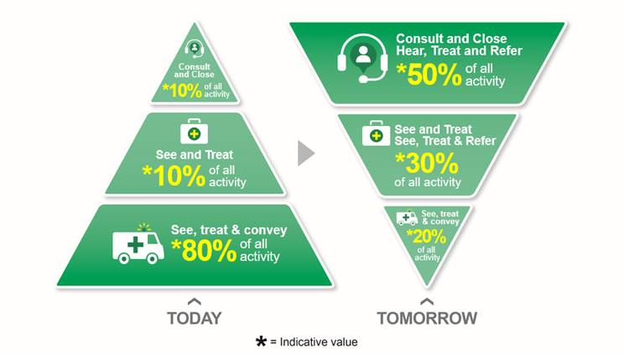
The model aims to place the ambulance service at the heart of the urgent and emergency care system and maximises the benefits of a co-hosted 111 and 999 service.
Whilst the Committee is broadly supportive of the model, further work is required to develop consensus around this approach, recognising that the challenges of commissioning and operationalising this model cannot be underestimated. A radical approach to the performance management and oversight of the ambulance service will be required in order to drive this change.
Delivery of a modern ambulance service will require a substantial change programme. This change must ensure robust workforce planning and modernised workforce practices to ensure that improvements in efficiency, effectiveness and safety of service delivery are realised.

Six goals for Urgent and Emergency Care (Goal 4)
Building on the Six Goals Priority Delivery Measure 11 (Phase One) and focusing on the percentage of total conveyances taken to a service other than a type one emergency department, EASC will ensure that local models and plans are developed within agreed timeframes to ensure that the fastest and best response is provided for people who are seriously ill or injured.
Complementing the work that is being undertaken within emergency ambulance services to optimise conveyance and patient outcomes, these plans will include arrangements for Health Board staff to provide advice and guidance to colleagues on the most appropriate pathway in to their services for 999 and 111 patients.
This work will explore the benefits of national, regional and local models in order to provide gains across the system that will underpin sustainable change and improvements in population outcomes.
As part of a whole system approach, the aim is to optimise capacity, efficiency and effectiveness, supporting the ambition to deliver seamless care and tackle fragilities across the system.
Year 1 will focus on scoping the commissioning arrangements for this important element of work, followed by the implementation of a pilot area to test this concept. The EASC Team will support this work to ensure robust commissioning frameworks are in place.

National Transfer and Discharge Services
Effective transfer and discharge services will be required to ensure that increases in specialisation and regionalisation of services as part of clinical transformational change programmes meet the needs of the population. Historically transfers and discharges have been undertaken by emergency ambulance services and non-emergency patient transport services as an addition to their core work.
During 2022-23, the EASC Team will facilitate the development of a business case for the delivery of a national transfer and discharge service. The scope of this work will cover both existing and future transfer requirements and will bring consistency and oversight to a fragmented system and improve responsiveness and quality for patients and the wider system.
This work will specifically support the aspirations of the national clinical networks and will utilise the key enabling function of EASC and the importance of transport to improve patient flow within the system in support of the Six Goals for Urgent and Emergency Care.
It is expected that additional income will be required to fund the implementation of the business case. This will be taken through EASC in line with governance arrangements, no additional financial implications are anticipated for 2022-23.

NHS Wales 111
The Committee recognises that 2022-23 will be a key year for NHS 111 Wales as the programme transitions in to the phase of ‘business as usual’ service delivery.
The Committee will ensure that NHS 111 Wales and the emergency ambulance 999 system are complementary to each other in enabling an effective and efficient services for the population. During the first year of this plan, the Committee will undertake a collaborative programme of work with WAST and the 111 programme team to explore and develop proportionate and appropriate commissioning arrangements for NHS 111 Wales in line with Welsh Government and Ministerial expectations.

Emerging system transformational change
The Committee and its sub groups play a key role in terms of discussing the plans for transformational change that are being developed across organisations.
These governance arrangements will ensure the involvement of Health Boards and Trusts, facilitating discussions regarding these plans at the earliest opportunity and ensuring that implications for our commissioned services and the wider health and social care system are understood and addressed.
The Committee is well-placed to ensure that commissioned services are an enabler to innovation and the development of new services where required. The EASC Team will continue to support and engage with the wider system and will work with Committee (and sub group) members to understand, to adapt and to respond to changing service models at a local, regional and national level ensuring that services are integrated and add value to the system.

Commissioning Priorities Summary 2022-25

The commissioning priorities that have been described are aligned to a number of the overarching priorities and relevant national programmes. This includes:
- an improvement in population outcomes
- working together, across organisational boundaries, to plan and ensure equitable delivery of services on a regional or national basis
- taking local, regional and national actions to deliver sustainable change
- optimising conveyance and patient outcomes
- the development of national pathways to support local improvement in the quality of services and address unwarranted variations in care
- a whole system approach building on the learning and experiences across health and care
- the use of prudent health care principles and value based healthcare as the basis for planning and delivering services in order to optimise capacity, efficiency and effectiveness

These priorities are in addition to the ongoing delivery of agreed commissioning actions, a focus on essential operational service provision and the prioritisation of the core responsibility to minimise risk and harm through the provision of timely responses to patients, both virtually and physically.
The table below provides an overview of these commissioning priorities for 2022-25:
  - Figure 5: Overview of EASC Commissioning Priorities 2022-25
Work Programme | Summary of Priorities | Outcome
EASC Commissioning Priorities
Informatics and Ambulance Quality Indicators | - Review existing indicators  - Development and ongoing review process to ensure relevant and appropriate indicators | Refinement of existing AQIs to ensure an increased focus on quality
Commissioner Ambulance Availability Taskforce | - Utilise the expertise of stakeholders  - Act as an independent advisory and scrutiny forum | Development of the vision for a modern ambulance service
Increasing the transparency and accountability of the Committee | - Build on the existing monthly EASC Action Plan updates  - Include the delivery of operational improvements and progress against strategic priorities | Development of the EASC Work Programme Status Update for presentation at each EASC Committee meeting and circulation to relevant stakeholders
Wider System Work Programmes
Vision for a modern emergency ambulance service | - Continue to engage and to develop the consensus around the vision  - Develop the key elements of the vision including workforce planning, digital transformation | An agreed approach for the development and delivery of a modern emergency ambulance service that is sustainable and ensures that improvements in efficiency, effectiveness and safety of service delivery are realised
Six goals for Urgent and Emergency Care (Goal 4) | - Development of plans that ensure access to the most appropriate pathway in to services for 999 and 111 patients  - Scoping any commissioning arrangements | Plans that ensure seamless care and improvements in population outcomes
National Transfer and Discharge Services | - Scope the scale of transfer and discharge activity and providers by the end of Quarter 2  - Develop the business case for the establishment of a national transfer and discharge service by Quarter 4 | A consistent, timely and adaptable national transfer and discharge service for Wales that is responsive to the changing health care system and service provision.
NHS 111 Wales | - Exploration of options for commissioning of NHS 111 Wales  - Robust analysis of commissioning options  - Establish commissioning arrangements for NHS 111 Wales | Appropriate commissioning arrangements in pace for NHS 111 Wales.
Emerging system transformational change | - To utilise the Committee and its sub groups to ensure timely discussions around plans for transformational change  - To ensure that the implications of the plans across NHS Wales are understood | A system that is able to adapt and respond to change, ensuring that services are integrated and add value with a view to ultimately improving patient outcomes and the patient experience.

EASC Financial Plan 2022-23

The 2022-23 Annual Planning allocations for EASC commissioned services are consistent with the details set out in the Welsh Government allocation letter.
This is an initial allocation and additional funding for key priorities will be allocated as appropriate when costs are confirmed.

  - Figure 6: EASC Allocation
Emergency Ambulance Services Committee  2022-23 Summary | Total
Emergency Ambulance Services Committee  2022-23 Summary | £m
EAS Allocation | 198.238
NEPTS Allocation | 26.911
EMRTS Allocation | 6.215
Ring-Fenced Commissioning Allocations | 2.340
Specialist Commissioning Allocation | 0.155
EASC Commissioning Funds from LHBs | 233.174
EASC Team resourcing | 0.627
EASC Total Funds from LHBs | 234.486

A detailed breakdown of the funding requirements by Health Board is provided in Appendix 2 along with more detailed financial assumptions in Appendix 3.
The following section provides an overview of the key initiatives included in 2022-23 Financial Plan to support the delivery of the commissioning intentions.

Emergency Ambulance Services Allocation

Demand and Capacity Programme in 2022-23

- £5.640m recurrent funding included to sustain the additional 127 WTE front line staff in 2021-22 as part of a successful Phase 2 delivery.
- £0.685m non recurrent funding is included to support front line resource allocation as emergency military support required during Covid will cease from 1st April 2022.

Operational Delivery Unit

- £0.883m recurrent funding to support the continued commissioning of the Operational Delivery Unit.

Grange University Hospital

- £4.420m included in the Aneurin Bevan UHB allocation to fund EAS delivery to The Grange University Hospital as per the Service Level Agreement.

Non-Emergency Patient Transport Services (NEPTS) Allocation

- The NEPTS funding position reflects the in year 2021-22 transition of services. NEPTS funding will be requested as an allocation to EASC for 2022/23 in line with commissioning arrangements.

Emergency Medical Retrieval and Transfer Service (EMRTS) Allocation

- £1.257m recurrent funding allocated to EMRTS for continued commissioning of the 24/7 expansion following successful scale up in 2021/22.
- £1.700m Adult Critical Care Transfer Service ring fenced commissioning allocation will be fully allocated to EMRTS service from 2022/23.

EASC Ring-Fenced Commissioning Allocations

- £1.700m recurrent funding to deliver the Adult Critical Care Transfer Service
- £0.640m recurrent funding to deliver the Major Trauma Network service development
- EASC will allocate these funds across the EASC commissioned services in order to meet the service delivery objectives.

EASC Specialist Commissioning Allocation

- £0.155m recurrent funding from Cardiff and Vale, Aneurin Bevan and Cwm Taf Morgannwg UHBs to continue the delivery of the South-East Wales Regional Acute Coronary Syndrome Treat and Repatriate Service.

EASC Team Resourcing

- No assumption has been made for additional EASC Team resourcing wider than the normal uplift position.

EASC Commissioned Services – Efficiency Programmes

- EASC commissioned services are expected to deliver an efficiency programme in line with those of Health Boards, Trusts and Special Health Authorities. Any savings resulting from these programmes will be re-invested in service development opportunities in agreement with the Commissioner on behalf of the Committee and in line with the commissioning intentions for the service.

Where appropriate, the EASC Team will work with commissioned services on behalf of Health Boards to realise these opportunities.

It is expected that WAST will deliver a cost reduction programme equivalent to at least 1% of the EASC Commissioning Funds allocated from LHBs.

Conclusion

The EASC IMTP describes the Committee priorities for commissioned services, with a particular focus on supporting the wider transformation of the urgent and emergency care system over the duration of this planning cycle. The plan also describes the pragmatic and considered approach to resetting services and ensuring a renewed focus on driving recovery across our commissioned services.
The plan will drive a refocusing of efforts on ensuring commissioned services deliver their core and fundamental roles to a standard and consistency that meets the needs of the population.
The plan focuses on:
- Commissioning intentions for commissioned services (2022-23)
- Commissioning priorities (2022-25) including:
  - Informatics and Ambulance Quality Indicators with an increased focus on data integrity and quality assurance
  - Development and delivery of the vision for a modern emergency ambulance service
  - Supporting the implementation of the Six Goals for Urgent and Emergency Care
  - National Transfer and Discharge Services
  - NHS Wales 111
  - Emerging System Transformational Change
- EASC Financial Plan

The details within this plan are consistent with those of the Welsh Ambulance Services NHS Trust and Health Boards.

EASC Integrated Medium Term Plan - Appendices

Appendix 1-EASC Commissioning Cycle
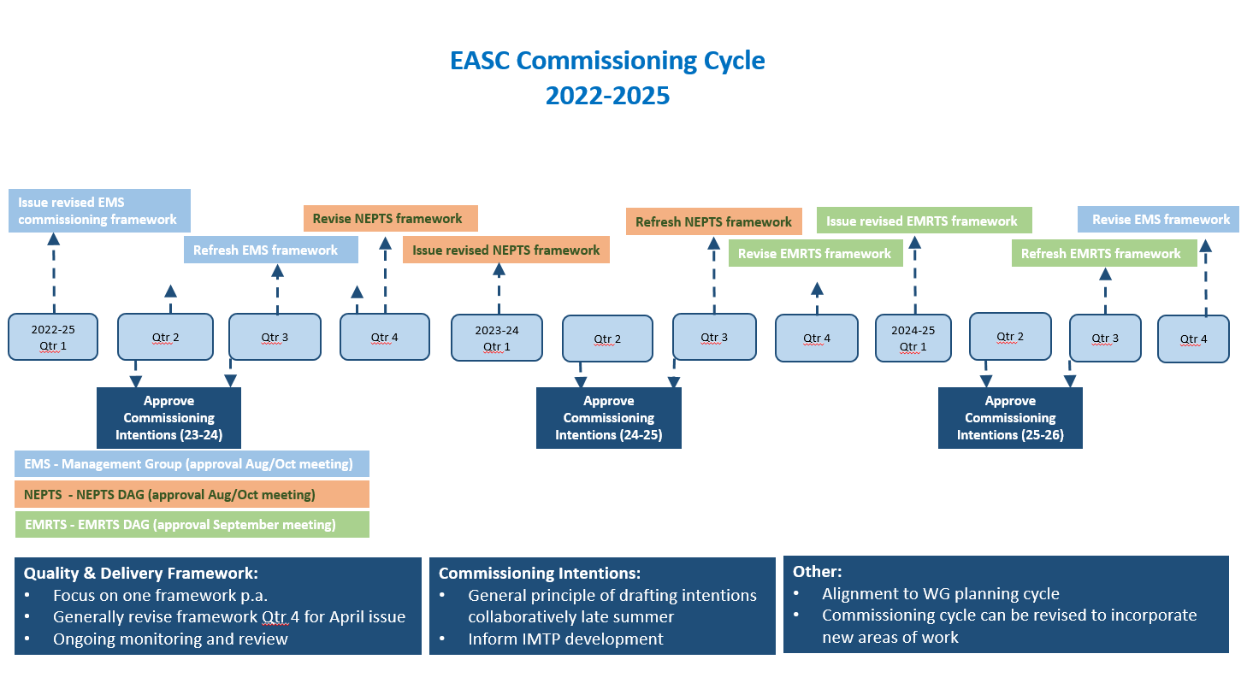

Appendix 2-EMS Performance Overview 2021
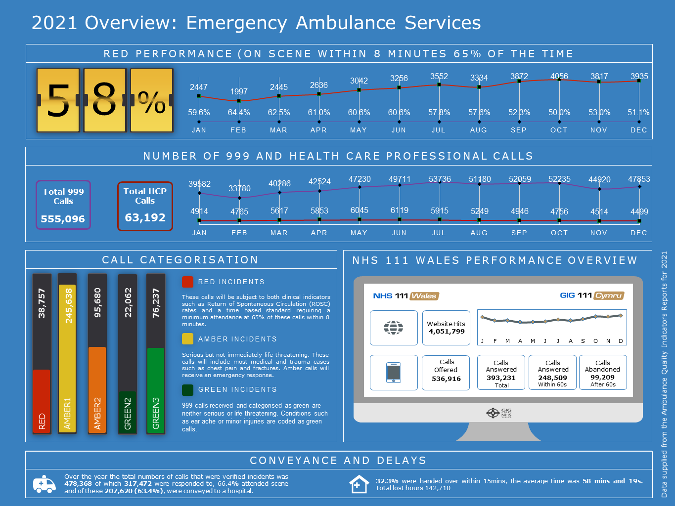

Appendix 3-NEPTS Performance Overview 2021
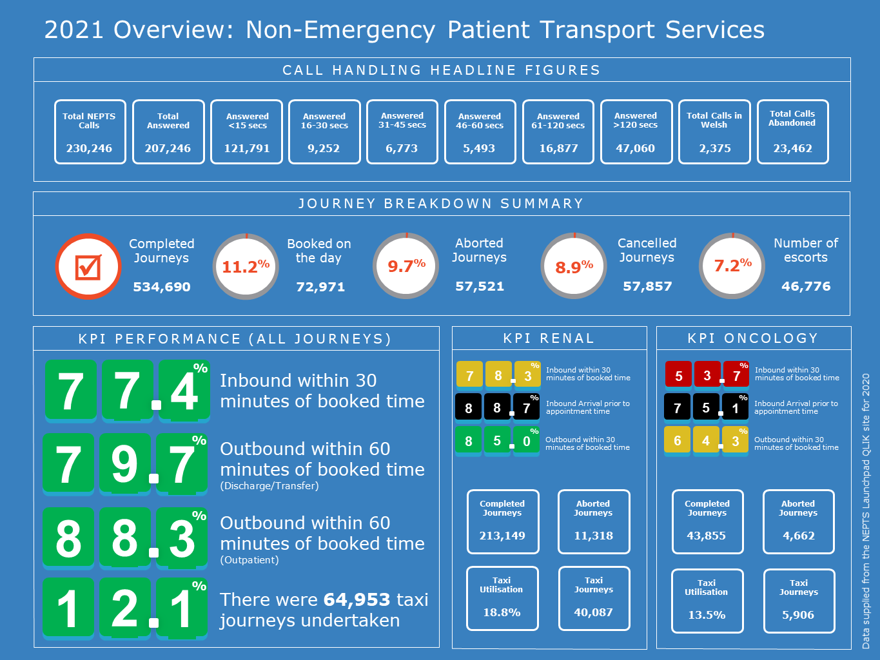

Appendix 4-EMRTS Performance Overview 2021
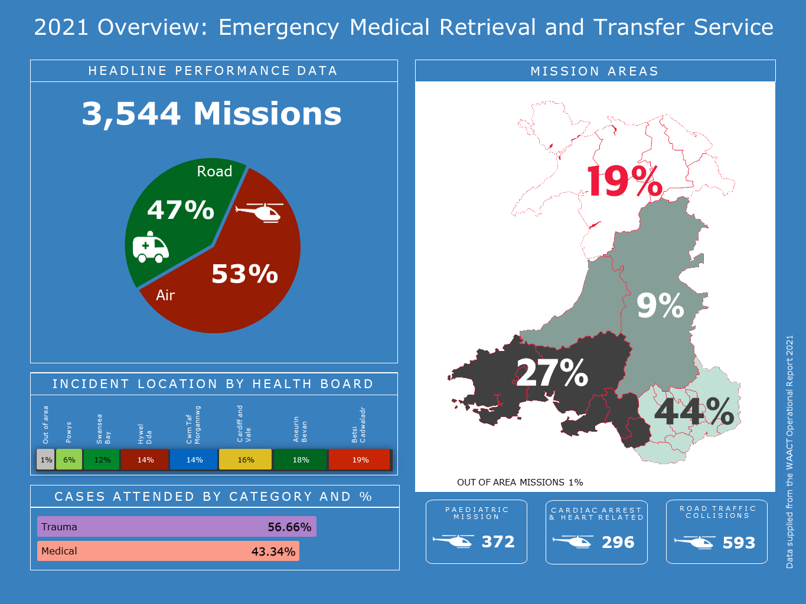

Appendix 5-EMS Commissioning Intentions 2022-23
Emergency Ambulance Services Committee – Emergency Ambulance Services Commissioning Intentions 2022-23
This document sets out the revised approach and guiding principles to the Emergency Ambulance Services commissioning intentions for 2022-23 and beyond.
These intentions aim to reflect the direction from Committee members to limit the additional asks on commissioned organisations this year including, but not limited to, minimising meetings, reporting and developments in order to allow for commissioned organisations to focus on the pandemic response, stabilisation and recovery of services.
Intentions aim to support the implementation of the new commissioning framework and transition of performance management arrangements to focus on outcomes, value, quality and safety of service delivery.
These commissioning intentions are not intended to set out all activity that will be undertaken this year by commissioners or the provider, but to provide a clear indication of the strategic priorities of the Committee for the provider of Emergency Ambulance Services in Wales for 2022-23.

Guiding Principles for 2022/23
- Intentions will:
  - be at the strategic level and will be extant for a minimum of 3 years
  - focus on outcomes, value, quality and safety of service delivery
  - support the delivery of the quadruple aims
  - have annually agreed aim(s), product(s) and indicator(s) that will provide an outline of what will be provided within each intention
  - ensure reasonable expectations for the improvement of Emergency Ambulance Services
  - recognise the challenges of resetting in the post-covid environment and the opportunities to fast track service transformation
- Ongoing engagement and review between WAST and Commissioners will allow the detail of each intention to be refined during the period, if required
- Intentions will not replace or override extant requirements within the commissioning framework or statutory targets or requirements
Development and monitoring
- In line with the agreed commissioning cycle, organisations have been asked for their view on the priorities for next year and consequently a principle of the incremental development of existing commissioning intentions has been adopted.
- Intentions have been developed in alignment with the 6 Goals for Urgent and Emergency Care
- EASC Management Group will hold ultimate responsibility for the development and monitoring of progress against intentions to ensure the strategic intent is achieved
- Regular updates will be provided against commissioning intentions to EASC Management Group
- Future intentions will continue to be developed in a collaborative and timely manner in line with the agreed commissioning cycle

Commissioning Intention – CI1: Clinical Response Model
The Emergency Ambulance Service and its Commissioners will seize the opportunities afforded by the Welsh Clinical Response Model and the 5 Step Ambulance Pathway (EMS).

Commissioning Statement
The 5 step Ambulance Pathway (EMS) provides a simplified framework for health systems to collaborate to optimise the care patients receive at each step. A high performing health system will enable services and practitioners at each step to resolve a patient episode of care without the need to progress further along the pathway. Maximising the potential of this opportunity will require system wide collaboration that transcends traditional organisational and professional boundaries.

Aims
CI1-A1 | Increase the proportion of activity resolved at Step 2 – Using the activity within the demand and capacity review as a baseline, this aim requires the proportion of activity resolved at step 2 to increase.  The improvement trajectory will be included in the new commissioning framework that will be collaboratively agreed ahead of 1st April 2022.
CI1-A2 | Right response first time – Optimising multiple responses at Step 3 – Using activity within the demand and capacity review as a baseline, this aim requires an improvement in the multiple response rate and the resolution of that episode of care by a single resource (excluding red response as multiple responses are expected).  The improvement trajectory will be included in the new commissioning framework.
Products
CI1-P1 | Remote Clinical Support Strategy – The first element will be to finalise an integrated remote clinical support strategy and infrastructure that outlines the organisational ambition for remote clinical support at the forefront of ambulance service care.
CI1-P2 | Optimising Conveyance Improvement Plan – Development and implementation of an improvement plan or programme that supports the optimisation of decisions about conveyance. This will include non-conveyance as well as improving conveyance destination decisions and reducing variation for example.
Indicators
CI1-I1 | Clinical Support Desk Outcomes – The development of quarterly reports that describe the patient level outcomes for clinical support desk care episodes.
CI1-I2 | Outcome by Response Type – The development of quarterly reports will be available that describe the patient level outcomes for different response types.

Commissioning Intention – CI2: Availability
The Emergency Ambulance Service and its Commissioners will optimise the availability and flexibility of front line resources to meet demand.

Commissioning Statement
The Emergency Ambulance Services Committee holds statutory responsibility for the planning and securing of sufficient ambulances services for the population of Wales. Discharging this responsibility requires close collaboration between commissioners and the provider to ensure that all available resources are used effectively.

Aims
CI2-A1 | Workforce Stability - Maintaining the increased staff base following closure of the relief gap identified in the ORH Demand and Capacity Review (2019). Maximising the availability of these staff through reducing sickness levels and abstractions by ensuring that their wellbeing needs are appropriately supported.
CI2-A2 | Workforce Availability - Grow the workforce in line with the strategic ambition, agreed forecasting and modelling and within financial allocation when made available by Commissioners.
CI2-A3 | Rosters Aligned to Demand - The current demand profile is not matched by available resource. This has a significant impact on quality of service for patients and wellbeing of staff. Roster reviews have been undertaken with partners throughout 2021-22 to agree core principles and working parties have progressed the design and building of rosters. Rosters aligned to demand will be available for each area in 2022-23 and an implementation programme will be developed and delivered.
Products
CI2-P1 | Forecasting and Modelling Framework - A collaboratively developed forecasting and modelling framework that underpins a demand and capacity approach that will set out the ongoing arrangements for proactively undertaking this work for the next decade, this will include demand-led iterative forecasting and modelling and health economic evaluations. This will ensure the required strategic, tactical and operational focus to plan and forecast seasonal fluctuation and to ensure resource and resilience during times of system pressure.
Indicators
C2-I1 | Workforce Additionality Measure – A collaboratively agreed baseline and workforce additionality requirement will continue to be reported and refined, including vacancy factors, turnover and other confounders.

Commissioning Intention – CI3: Productivity
The Emergency Ambulance Service and its Commissioners will maximise productivity from resources and demonstrate continuous improvement.

Commissioning Statement
Ensuring appropriate levels of productivity from the resources available is a key component of delivering an effective ambulance service. There are a number of external and internal drivers leading to suboptimal productivity. Addressing these areas has the potential to deliver significant gains for emergency ambulance provision and the wider emergency and urgent care system.

Aims
CI3-A1 | Reducing Post-Production Lost Hours – Post-production lost hours have long been a significant contributor to reduced productivity. Using an agreed baseline measurement period, post-production lost hours will be reduced in line with a quarterly agreed improvement trajectory.  The improvement trajectory will be included in the new commissioning framework that will be collaboratively agreed ahead of 1st April 2022.
CI3-A2 | Reducing Notification to Handover Time – NHS Wales is a significant outlier in the UK and internationally for lost productivity due to extended notification to handover times. EASC is committed to delivering less than 150 hours per day across Wales and 95% of handovers completed within 1 hour, with a backstop of no handover taking more than 4 hours.  Individual improvement trajectories will be agreed for each site and will be included in the new commissioning framework.
Indicators
CI3-P1 | Modernising Workplace Practices Implementation Plan – There will be an implementation plan and supporting structures in place to ensure workforce practices and policies are reviewed, modernised and improved. The wellbeing of the workforce and safety of patients will be paramount within this.  The improvement trajectory will be included in the new commissioning framework.
Indicators
CI3-I1 | Unit Hour Utilisation Metric – continue to refine the approach and reporting in order to actively improve patient safety, performance and efficiency.
Commissioning Intention – CI4: Value
The Emergence Ambulance Service and its Commissioners will develop a value-based approach to service commissioning and delivery, which enables an equitable, sustainable and transparent use of resources to achieve better outcomes for patients.
Commissioning Statement
Value is created when we achieve the best possible healthcare outcomes for the Welsh population with the most efficient and effective use of available resources. We also recognise that value can be depleted and therefore the development of a value-based strategy will need to identify ways to effectively manage and mitigate the risks of value depletion in addition to identifying opportunities for value creation.
Aims
CI4-A1 | Value-Based Healthcare for the Welsh Ambulance Service  Building on the engagement already undertaken, develop and embed a value-based approach for the Welsh Ambulance Service which enables better collective decision making across the whole urgent and emergency care system and accounts for WAST’s use of, and impact on, economic, social and environmental resources over the short, medium and long term. This will include:  - Development of WAST’s strategy and approach to Value-Based healthcare which links outcomes, patient experience and use of resources  - Implementation of a costing model for “5 step” pathway  - Improvement in ability to identify areas of unwarranted variation in service delivery across Wales
Products
CI4-P1 | Value-Based Strategy  The Trust will develop a strategy to implement a value-based approach across the organisation and outline its role in delivering value across the wider UEC system. The value-based strategy will be integrated with and align to existing organisational strategies (e.g. clinical, quality, long term, digital, environmental etc) and the Commissioning Intentions outlined in this document in order to ensure goal congruence.
CI4-P2 | Value-Based Tools and Methods  In order to monitor and measure value-based performance, the Trust will need to design, develop and implement a range of tools including, but not limited to, the following:  - Patient Level Costing Model  - Benchmarking Dashboard(s)
CI4-P3 | Value-Based Reporting  WAST will enable a clear line of sight from commissioner allocation through to utilisation and the outcomes delivered by the services. WAST will holistically demonstrate through its reporting all separate revenue streams and associated costs of broader service provision (e.g. 111, NEPTS etc.).  WAST receives a capital allocation directly from Welsh Government. The utilisation of the capital budget and the use of the ring-fenced depreciation allocation will need to be clearly identified in any report. As a result, WAST will be able to demonstrate how its capital allocation is being invested to deliver on the commissioning intentions.
Indicators
CI4-I1 | Value-Based Core Requirement to be agreed with Commissioner by the end of quarter 2:  - WAST Value Based Strategy  - Plan for Value Based Tools and Methods design, development and implementation  - Value Based Reports developed for revenue and capital  - Value-Based indicators developed in line with broader indicators outlined in CI1 to CI5  - Connections to system-wide urgent and emergency care performance measures as identified in CI6 – Wider Health System

Commissioning Intention – CI5: Harm & Outcomes
The Emergency Ambulance Service and its Commissioners will collaborate to reduce and prevent harm, and improve quality of service and outcomes for patients.

Commissioning Statement
Emergency ambulance services operate in complex and challenging environments. The delivery of a quality ambulance service requires effective, safe and people-centred care. To realize the benefits of quality health care, ambulance services must be timely, equitable, integrated and efficient. A mature health system proactively seeks opportunities to reduce and prevent harm. Continuous improvement based on learning from errors and adverse events must be a cornerstone of emergency ambulance provision.
Aims
CI5-A1 | Proactively Identifying Harm – There will be a process for identifying harm/near misses prior to a complaint or report being logged. This will include process for reviewing patient clinical records and engagement with the wider health system (i.e. sharing information around patients impacted by CSP levels).
Products
CI5-P1 | Clinical Indicator Plan and Audit Cycle – Implementation of the clinical indicator plan and audit cycle, this will provide a forward view of the type, content and regularity of clinical indicator and audit reporting. Specific seasonal and responsive (to emerging trends) reports and audits will be included within the plan.
Indicators
CI5-I1 | Call to Door Times – Call to door times for STEMI and stroke will be produced on a monthly basis.

Commissioning Intention – CI6: Wider Health System
The Emergency Ambulance Service and its Commissioners will collaboratively develop and deliver services that allow the ambulance service to contribute to the wider health system and the ambition to reset services and drive recovery.

Commissioning Statement
The Emergency Ambulance Services has a unique role as the only all Wales operational service. Today, ambulance services provide mobile urgent treatment services with staff educated and trained to deal with a wide range of emergency and urgent conditions. Maximising both of these opportunities will benefit the whole of NHS Wales and will be an important part of the pandemic response.
Aims
CI6-A1 | System Flow – Optimise the flow of ambulances in to hospital sites in Wales, reducing batching and increasing the timeliness of patients accessing secondary care. The implementation of rosters aligned to demand for each area in 2022-23 will address this, with the improvement trajectory included in the new commissioning framework that will be collaboratively agreed ahead of 1st April 2022.
CI6-A2 | Transfer and Discharge Service – To reduce the number of transfers and discharges being undertaken by the EMS fleet. This will include the development of a case for a new national transfer and discharge service.
Products
CI6-P1 | Aligned Escalation and Clinical Safety Plan – A single WAST escalation and clinical safety plan will be in place that is aligned with system-wide escalation processes, responding to areas of greatest clinical risk.
CI6-P2 | National Transfer and Discharge Commissioning Framework – A collaborative commissioning framework for a national transfer and discharge service will be agreed following the development of the business case.
Indicators
CI6-I1 | System Pressures Dashboard – WAST and Health Boards will collaborate to ensure that a live system pressures dashboard is in place that enables users to understand current and emerging pressures.

Appendix 6-NEPTS Commissioning Intentions 2022-23
Emergency Ambulance Services Committee – Non-Emergency Patient Transport Services Commissioning Intentions 2022-23

This document sets out the approach and guiding principles to the Commissioning Intentions for Non-Emergency Patient Transport Services (NEPTS) for the period 2022-23 and beyond.

These intentions aim to reflect the strategic direction from Committee Members to limit the additional asks on commissioned organisations this year including, but not limited to, minimising meetings, reporting and developments in order to allow for NEPTS to focus on the pandemic response, stabilisation and recovery of services but also to begin the next phase of the transformation and modernisation of NEPTS, following completion of the transfers of work.

Intentions aim to support the transition of performance management arrangements to focus on outcomes, value, quality and safety of service delivery.

These intentions are not intended to set out all activity that will be undertaken this year by commissioners or the provider, but to provide a clear indication of the strategic priorities of the Committee for NEPTS for 2022-23.

Guiding Principles for 2022-23
- Intentions will:
  - be at the strategic level
  - focus on outcomes, value, quality and safety of service delivery
  - support the delivery of the quadruple aims
  - have annually agreed aim(s), product(s) and indicator(s) that will provide an outline of what will be provided within each intention
  - ensure reasonable expectations for the improvement of NEPTS
  - recognise the challenges of resetting in the post-covid environment and the opportunities to fast track service transformation and modernisation
- Ongoing engagement and review between WAST, commissioners and Health Boards will allow the detail of each intention to be refined during the period, if required.
- Intentions will not replace or override extant requirements within the Quality and Delivery Framework or statutory targets or requirements.
- Intentions will recognise that some elements of work have taken longer than expected and next year will include an element of consolidation and review.

Development and monitoring
- In line with the agreed commissioning cycle, organisations have been asked for their view on the priorities for next year and consequently a principle of the incremental development of existing commissioning intentions has been adopted
- EASC Management Group will hold responsibility for the development and monitoring of progress against these intentions to ensure the strategic intent is achieved
- Regular updates will be provided to the NEPTS DAG
- Future intentions will continue to be developed in a collaborative and timely manner in line with the agreed commissioning cycle

NEPTS Commissioning Intention – CI1: Plurality Model
The Trust and its Commissioners will collaborate to improve the efficiency, quality of service and outcomes for patients.

Commissioning Statement
The delivery of a quality ambulance service requires effective, safe and people-centred care. To realize the benefits of quality health care, ambulance services must be timely, equitable, integrated and efficient. The plurality model creates a single national market place that sources a range of patient transport providers that are quality assured by a robust governance framework, creating opportunities to deliver a more efficient, timely and people-centred service.

CI1a | Resource Efficiency - Demonstrate that resources are being utilised effectively following transfer of work. This will include the re-design and renewal of patient contracts inherited via the transfers of work to deliver the best patient transport model for Wales ensuring value and efficiency of utilisation. The second phase will of this work will focus on the procurement strategy, fully reviewing who is best placed to deliver the various aspects of patient transport in accordance with NEPTS objectives and standards.
CI1b | Plurality Providers - Continue to expand and improve the availability of plurality providers and to increase the focus on quality, improved patient experience, value and sustainability.

NEPTS Commissioning Intention – CI2: Demand
The Trust and its Commissioners will collaborate with stakeholders to understand system requirements in order to align resources to effectively manage service demand.

Commissioning Statement
Non-emergency patient transport services operate in a complex environment. The delivery of a quality ambulance service requires effective, safe and people-centred care. To realize the benefits of quality health care, ambulance services must be timely, equitable, integrated and efficient. A mature health system proactively seeks opportunities to improve quality and performance. Continuous improvement based on learning from data and feedback must be a cornerstone of ambulance provision.

CI2a | Planning - Implement improved and dynamic planning process that maximises the utilisation of resources and ensure stability and resilience for future demand.
CI2b | Demand Management - Utilise a range of options including effective use of resources, effective rostering and closer working with the patient and Health Board colleagues to deliver appropriate transport requirements.

NEPTS Commissioning Intention – CI3: Capacity
The Trust and its Commissioners will collaborate with stakeholders to understand system requirements in order to create, align and maximise resource capacity.

Commissioning Statement
Non-emergency patient transport services operate in a complex environment. The delivery of a quality ambulance service requires effective, safe and people-centred care. To deliver the benefits of a quality health care service, ambulance services must be timely, equitable, integrated and efficient. To ensure delivery of these benefits the Trust and stakeholders must work collaboratively to create, align and maximise resource capacity.

CI3a | Transforming Capacity - Implement processes to increase NEPTS capacity within current internal and external resources including workforce and fleet.
CI3b | Reducing Lost Capacity - Implement improvement plans and oversight arrangements to deliver reduction in lost capacity due to system inefficacies. This includes a requirement on WAST to ensure more effective use of internal resources (workforce, fleet and estates), there is also a requirement for improved collaboration and communication with Health Boards to minimise lost time at hospital sites.

NEPTS Commissioning Intention – CI4: System Transformation
The Trust and its Commissioners will work collaboratively to transform internal systems and will work with stakeholders to understand the wider system transformation that is taking place.

Commissioning Statement
WAST and stakeholders will work collaboratively through the NEPTS Delivery Assurance Group to identify areas for improvement across WAST’s internal operating systems and to understand the impact of reconfiguration across the wider health system.
CI4a | Forecasting and Modelling Framework - A collaboratively developed forecasting and modelling framework will set out the ongoing arrangements for proactively undertaking this work for the next decade, this will include demand-led forecasting and modelling and health economic evaluations. This will ensure the required strategic, tactical and operational focus to tactically plan and forecast seasonal fluctuation and to ensure resource and resilience during times of system pressure.

Appendix 7-EMRTS Commissioning Intentions 2022-23
Emergency Ambulance Services Committee – Emergency Medical Retrieval and Transfer Service Commissioning Intentions 2022-23

This document sets out the approach and guiding principles to the Commissioning Intentions for the Emergency Medical Retrieval and Transfer Service (EMRTS) for the period 2022-23 and beyond.

These intentions aim to reflect the strategic direction from Committee members to limit the additional asks on commissioned organisations this year including, but not limited to, minimising meetings, reporting and developments in order to allow for EMRTS to focus on consolidating following recent service expansion projects and embracing the findings of the EMRTS Service Evaluation.

These intentions are not intended to set out all activity that will be undertaken this year by commissioners or the provider, but to provide a clear indication of the priorities of the Committee for the Emergency Medical Retrieval and Transfer Service for 2022-23.

Guiding Principles for 2022-23
- Intentions will:
  - be at the strategic level
  - focus on outcomes, value, quality and safety of service delivery
  - support the delivery of the quadruple aims
  - have annually agreed aim(s), product(s) and indicator(s) that will provide an outline of what will be provided within each intention
  - ensure reasonable expectations for the improvement of EMRTS
  - recognise the challenges of resetting in the post-covid environment and the opportunities to fast track service transformation and modernisation
- Ongoing engagement and review between EMRTS, commissioners and Health Boards will allow the detail of each intention to be refined during the period, if required
- Intentions will not replace or override extant requirements within the EMRTS Quality and Delivery Framework or statutory targets or requirements

Development and monitoring
- In line with the agreed commissioning cycle, organisations have been asked for their view on the priorities for next year and consequently a principle of the incremental development of existing commissioning intentions has been adopted
- EASC Management Group will hold responsibility for the development and monitoring of progress against these intentions to ensure the strategic intent is achieved
- Regular updates will be provided to the EMRTS DAG
- Future intentions will continue to be developed in a collaborative and timely manner in line with the agreed commissioning cycle

EMRTS Commissioning Intention – CI1: Service Expansion
CI1a | Enhanced CCP-led response – Building on the findings of recent winter initiatives and demand and capacity planning undertaken within the service, support the implementation of an enhanced daytime response that will ensure more effective use of resources, improve service quality and the patient experience and provide opportunities for workforce development.
CI1b | Planning – Build on the implementation and consolidation of Phase 1 of the EMRTS Service Expansion project, working collaboratively with commissioners to plan the implementation of the remaining phases of the EMRTS Service Expansion programme.

EMRTS Commissioning Intention – CI2: Adult Critical Care Transfer Service (ACCTS)
CI2a | Service Delivery – The ACCTS team will continue to manage ongoing service delivery and will ensure robust performance management with a focus on outcomes, value, quality and safety of service delivery.
CI2b | Engagement – Building on established relationships, continue to engage with all stakeholders to review and strengthen the service model(s) implemented to maximise the clinical outcomes, value, quality and safety of service delivery.
CI2c | Evaluation and Review – Undertake evaluation and review relating to the implementation of the ACCTS, reporting on lessons learned, service activity and providing the required assurance regarding the realisation of anticipated outcomes and benefits going forward.

EMRTS Commissioning Intention – CI3: Service Evaluation
CI3a | Improvement Plan – Develop and implement an improvement plan in response to the EMRTS Service Evaluation Report.

EMRTS Commissioning Intention – CI4: System Transformation
CI4a | Demand and Capacity Strategy – To continue with the work on a collaboratively developed demand and capacity strategy will set out the ongoing arrangements for proactively undertaking this work for the next decade, this will include the use of forecasting, modelling and health economic evaluations.

