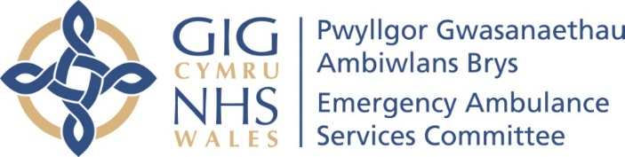

EASC ACTION PLAN –January 2022 Update
Ref | Issue | Action | Lead | Start Date | End Date | Current Position
1 | Enhancing Ambulance Capacity | Additional Emergency Medical Technicians recruitment | WAST | Now | March 2022 | Current Position  104 currently going through training:  17 will be operational in mid-March from the November cohort.  11 will be operational on 2nd May from the December cohort.  76 will be operational in early May from the January cohort.  1 deferred sickness, 3 withdrew.  Previous Position  108 Trainee EMTs will commence training in the coming months:  18 started training on 8 November.  13 will commence training on 13 December.  78 will commence training on 4 January 2022 due to the candidate’s prior experience.
1 | Enhancing Ambulance Capacity | Relief gap recruitment | WAST | Apr 21 | March 2022 | Current Position  Overall, the relief gap closed target figure is 1,691 FTEs (of which 262 FTEs required to close relief gap). The Trust, in collaboration with the EASC agreed to prioritise an expansion of the CSD. The current year end estimate is 1,713.25 FTEs compared to the original ambitious target of 1,691 FTEs.  Previous Position  On track to deliver year 2 of the Demand and Capacity Review.
1 | Enhancing Ambulance Capacity | Agency staffing | WAST | Now | March 2022 | Current Position  Welsh Ambulance Service NHS Trust (WAST) are currently using agency staff to support with cohorting at Grange University Hospital and Morriston Hospital. Recently the issue around sourcing agency staff has improved with the addition of agency nurses to the rota. Weekly meeting between WAST and agency currently taking place.  Transfer vehicle - Seeking to source from dynamic purchasing agreement in England. WAST are working through technical aspects of specification and ensuring the Welsh legislation is reflected in the mini tenders. Final checks of specification being made, arrangements within CCC processes being made and communications equipment being sourced. Arrangements for due diligence and compliance for blue light driving being finalised. WAST will go out to market within the next few weeks to ensure service is operational in this financial year. Ongoing discussion between EASC Team and WAST regarding further funding availability in quarter one due to the MACA ending. WAST aim to put a bid through.  Previous Position  NHS England Procurement Framework identified and being utilised to progress transfer vehicle.
1 | Enhancing Ambulance Capacity | Increase payment to double time | WAST | Now | March 2022 | Current Position  Actioned currently stopped.  Previous Position  No Change.
1 | Enhancing Ambulance Capacity | Military support | WAST | Now | March 2022 | Current Position  220 personnel due to 10 being withdrawn from tasks. Weekly hours target approximately 8,600 with a plan to backfill the 10 withdrawn from w/c 7 February.  Previous Position  Expanded to 251 personnel. Support Exe to 31 March 2022  MACA in place until the 17 December, update on extension anticipated.
1 | Enhancing Ambulance Capacity | Fire service support | WAST | Now | Ongoing | Current Position  Currently being offered 3-4 shifts per week due to the increased military support.  Previous Position  SLA for Cardiac Arrest Response agreed with MAWWFRS – signing and communications due imminently.  SLA for Falls Response provided to MAWWFRS w/c 6 December, and currently being considered.
1 | Enhancing Ambulance Capacity | Reduce post production lost hours | WAST | Sep 21 | Ongoing | Current Position  WAST currently working through a series of workshops with Trade Union partners. Due to increased escalation levels and omicron progress has been slower. Modelling on four options is expected by mid-February. WAST has undertaken benchmarking with a number of Trusts. The modelling and benchmarking will enable a more nuanced position on the estimated efficiency. The Trade Union position on the application of a proposed new approach to return to base/meal breaks is not known. WAST may need to consult and then apply the new approach.  WAST is also undertaking work on the data input/reporting of post-production lost hours (PPLHs) as the workshops with Trade Unions partners has identified a legitimate concern about data accuracy. 13,099 PPLHs in Dec-21, the lowest since May-21. Return to base meal breaks accounted for 51% of the Dec-21 PPLH.  Previous Position  WAST have held two formal workshops that were independently facilitated. Workshops focussed on Return to Base Meal Break and issues identified with Trade Union partners. A five step framework has been develop by WAST, currently at step 3 to 4.  Temporary arrangements remain in place.
1 | Enhancing Ambulance Capacity | Roster review | WAST | Sept 21 | 22/2023 | Current Position  The programme has recommenced as planned so that the roster keys will go live in time for next winter (implementation planned for Sep to Nov 22). Some rosters coming on line sooner if this can be agreed locally.  Increased political interest in station level change as a result of the roster review.  Previous Position  Roster Review programme due to restart end of January  2022. Transition plan options paper being considered at WAST Board development session on 16 December.
 |  | St John support | WAST | Sep 21 | Mar 2022 | Current Position  Commissioned for the provision of an average five 12 hour crews per day. There is also additional funding for three 12 hour crews to cover Saturday and Sundays to support HDUHB, PTHB, BCU in providing additional cover. Currently this has been limited due to additional crews supplied as they are covered by St John volunteers.  Previous Position  Additional St John volunteers being explored for Emergency Department discharge support at WM, GUH and Morriston. Go live aim for January 2022 subject to volunteer capacity.
2 | Winter Forecast | Winter forecast - using optima predict software to understand forecast demand, performance and escalation levels | WAST | Sept 21 | Oct 21 | Current Position  Forecasting and modelling for Q1 for 22-23 has begun.  Previous Position  Forecast available and in use for planning.
3 | System Escalation | Emergency Department Escalation Tool and Demand Management Plans | NCCU | In development |  | Current Position  Continuing to work on the EDQDF implementation towards the goal 4 priorities. Linking in with Health Boards (HBs) to ensure their IMPTs are aligned to the goal 4 strategic priorities.  Previous Position  Broad stakeholder engagement underway as part of the EDQDF programme including COOs and senior clinical leaders. The tool looks at four areas, these are  - Status (current occupancy and ED performance levels),  - Staffing (the current ED workforce position),  - Patients waiting (the number of patients that are waiting in ED to be moved to a ward or seen by a specialism [the ED episode is complete]) and  - Comments – allows the user to add context (Major incident / Resus full / Minors full / decontamination incident etc).  This is being rolled out via the EDQDF support clinics which is attended by frontline staff from each ED with a view to going live in Quarter 4 (21-22).
3 | System Escalation | System wide escalation | NCCU | In development |  | Current Position  Continuing with wide stakeholder engagement including with HBs, WAST and Social Services. Will be taken to NHS Wales Leadership Board for approval.  Previous Position  Presented at NHS Leadership Board 23 November. Broad agreement across all HBs on the principles  - Transparency.  - Equity of risk across the system.  - Data driven.  - Early escalation triggers.  - Dedicated roles.  Some ongoing concerns around effect on planned care of wider health board activity.  Work currently being undertaken to identify a number of HBs to pilot the approach on a regional basis, to support further refinement and confidence building in the process.  Further discussions planned for NHS Leadership Board 21 December.
3 | System Escalation | WAST Clinical Safety Plan | WAST | Live |  | Current Position  Revised CSP including an Emergency Rule process for call takers to disconnect from calls in order to be available for the next 999 call was introduced on the 13 of January.  Previous Position  Ongoing monitoring. Links to system wide escalation development.
4 | Cohorting | Cohorting - Utilising ambulance service staff to hold multiple patients, allowing ambulances to return to community response | Ysbyty Glan Clwyd, BCUHB | TBC |  | Current Position  Handover remains extremely challenging.  Letter from CASC to CEOs regarding handover improvement plans sent on 4 February 2022.  Previous Position  External capacity unit design being developed for YGC.  Significant improvement in minutes lost per arrival and handovers over 4 hours in November.  Improvement delivery plans being discussed at EASC Management Group 16 December.
4 | Cohorting |  | Grange University Hospital, ABUHB | Live |  | Current Position  Issues sourcing agency staff remain but the position has improved with the addition of agency nurses to the rotas. Weekly meetings held by WAST with agency to deal with live issues.  Previous Position  Vehicles on site. Agency staff due to start w/c 13 December subject to staff availability.  EASC Team supporting front door improvement process for handover.  Improvement delivery plans being discussed at EASC Management Group 16 December.
4 | Cohorting |  | Morriston, SBUHB | Live |  | Current Position  Issues sourcing agency staff remain but the position has improved with the addition of agency nurses to the rotas. Weekly meetings held by WAST with agency to deal with live issues.  Previous Position  Cohorting live. Improvement apparent during November.  Improvement delivery plans being discussed at EASC Management Group 16 December.
4 | Cohorting |  | System Deployable Assets | As per above. |  | Current Position  Private provider has units available, interested HBs made aware.  Previous Position  Project currently paused. Alternative arrangements in place and additional vehicles available on a temporary basis if required.  Cost benefit analysis of undertaken, on capital purchase. Alternative provider quotes received. Capital case being submitted to WG official’s w/e 19 November.
5 | Handover Delays | Reduce to sustainable levels | ABUHB | Current Position  Handover remains extremely challenging.  Letter from CASC to CEOs regarding handover improvement plans sent on 4 February 2022.  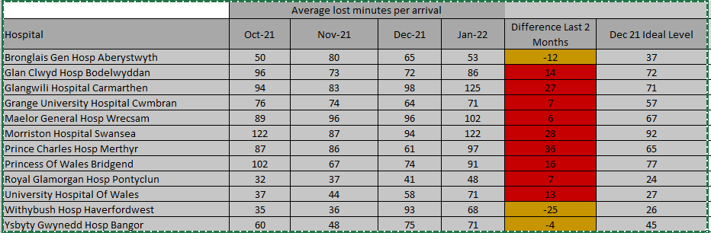  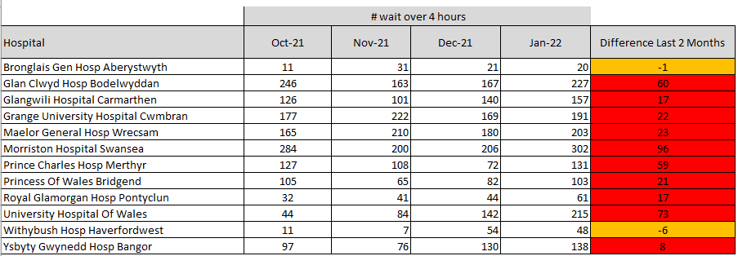  Agreed Commitment  The committee agreed to the following deliverables as the start point of their commitment to reducing handover delays:  - No ambulance handover will take more than 4 hours.  - We will reduce the average lost time per arrival by 25% from the October 2021 level at each site (from 72 minute to 54 minutes at an all Wales level).
5 | Handover Delays | Reduce to sustainable levels | C&VUHB
5 | Handover Delays | Reduce to sustainable levels | CTMUHB
5 | Handover Delays | Reduce to sustainable levels | HDUHB
5 | Handover Delays | Reduce to sustainable levels | SBUHB
5 | Handover Delays | Reduce to sustainable levels | BCUHB
6 | Demand & Capacity Review Update | Demand & Capacity Review Update modelling to reflect system changes since 2018 | WAST/EASC | 19-Aug-21 | Complete | Current Position  Following discussions regarding additional capacity requirements in 22-23 at the most recent Emergency Ambulance Services Committee, CEOs have requested wider scrutiny and assurance to be undertaken on the Transition Case developed by the WAST.  A Meeting with EASC Management Group members, Directors of Finance, Directors of Planning and Chief Operating Officers will take place on February 8th to understand the case and opportunities being presented by WAST. This process will inform the recommendations on the enactment of the case through the Committee structure.  Previous Position  Transition plan options paper being considered at WAST Board development session on 16 December. Joint discussion with WAST and EASC Team following this discussion.
7 | Remote Clinical Support | Emergency Communications Nurse System (ECNS) - Implementation | WAST | 01-Sept –21 | 31–Mar 22 | Current Position  Phase one (Planning) completed. WAST currently working on the second phase around the installation and configuration. ECNS training completed at the end of January with 10 members successfully passing. Training for the north region will commence on 2nd February.  CSD has grown significantly recently through the recruitment of 36 FTE Paramedics and the total number of staff requiring training is now 109. As there is a cap on the number of people who can attend ECNS training (10 people per course), WAST have asked Priority Solutions for additional training courses to get everybody through.  WAST will go live with ECNS on 29th March via a phased go live approach. WAST staff who have passed there MPDS and ECNS exam will use ECNS as their triage tool from 29th March. Any WAST staff not successful following the exam will continue to use MTS until November due current software contract. It is WAST’s aim that all staff will be using ECNS as soon as possible.  Previous Position  Remains on track. Some emerging risks around IT infrastructure and training capacity, but mitigation plans in place or being developed.
8 | Physician Triage, Assessment and Screening | PTAS (Physician Triage, Assessment and Screening) provides direct access to the WAST incident stack to manage appropriate patients | ABUHB | TBC | Mar 22 | Current Position  Documentation has been signed off. A date for training update is being arranged between AB and WAST. Indicative plan to go live week commencing 15th February.  Previous Position  AB are currently signing off of the MOU, DPIA and JCA as well as reviewing the list of users set up on the system.
8 | Physician Triage, Assessment and Screening |  | BCUHB | Live | Mar 22 | Current Position  Went live on 25th January. The documentation is with the Caldicott Guardian for sign off. WAST awaiting information on additional users before arranging training.  Previous Position  Documentation awaiting executive sign off.
8 | Physician Triage, Assessment and Screening |  | C&VUHB | TBC | Mar 22 | Current Position  WAST awaiting documentation C&V. Arrangements being made for training within the next two weeks for approximately 25 users.  Previous Position  Documentation still outstanding. Ongoing discussions with HB about role of PTAS within their model.
8 | Physician Triage, Assessment and Screening |  | CTMUHB | TBC | Mar 22 | Current Position  CTM are developing implementation plan.  Previous Position  A bid has been submitted for funding and awaiting the outcome of this before seeing if they can proceed with PTaS.
8 | Physician Triage, Assessment and Screening |  | HDUHB | Live | Mar 22 | Current Position  Training took place for an additional users 26 January. Arrangements ongoing for additional IT equipment and training.  Previous Position  System is live as of the 9 September 2021.
8 | Physician Triage, Assessment and Screening |  | SBUHB | TBC | Mar 22 | Current Position  WAST have received confirmation that Acute GP Unit will be proceeding with PTaS and this will provide 8 hours of PTaS support every week day. WAST have contacted AGPU to request an update on the documentation and to request users for training.  Previous Position  Documentation awaiting approval at next board meeting. Meeting to plan training on 15 December.
8 | Physician Triage, Assessment and Screening |  | PTHB | TBC | Mar 22 | Current Position  Powys have requested data relating to demand. WAST currently sourcing this data internally.  Previous Position  Introductory meeting 7 December.
8 | Physician Triage, Assessment and Screening |  | Health Boards | Now | 3 Nov 2021 | Current Position  Firewall issue resolved.  Previous Position  Current firewall issue preventing some HBs access to the system, WAST working with DHCW to explore national solution.
8 | Physician Triage, Assessment and Screening |  | EASC Team |  |  | Current Position  EASC Team has engaged with WAST and HBs colleagues to expedite the delivery of PTAS model across Wales.
9 | Mental Health | Mental Health Support to CSD | WAST | Now | Ongoing | Current Position  Start dates are pending due to awaiting completion of pre employments checks by WAST. They have recruited into all but two positions due to recruits having dropped out, these posts have been advertised. An estimated go live date is start of April.  Previous Position  Mental Health clinicians have been recruited. The exact start dates and training dates are currently being discussed. The estimated go live is February 2022.
10 | Same day emergency Care | Increase opportunities for direct access to same day emergency care | NCCU | Now | Ongoing | Current Position  The All Wales WAST (Paramedic) Direct Referral to SDEC Policy had been finalised and sent to Andrew Sallows and Frank Atherton for approval. Health Boards first set of returns on the SDEC investments were due back at the end of January. The measurements to be reported were agreed with Health Boards in their investment letters.  The 2021 SDEC benchmarking project opened on 15th November 2021 for all Welsh HBs and Trusts. Data collection closed on 10th January 2022. NHS Benchmarking are in the process of producing a comparison report for each Health Board based on each hospital footprint. The Benchmarking team will host a webinar on 1 March to present the SDEC findings.  Previous Position  WAST practitioner referral into Same Day Emergency Care: Policy writing group have completed the 3 task and finish meetings and the text of the policy has been agreed. The final draft has gone to COOs, MDs and CEOs for comment with a deadline of 14 December.  NHS Benchmarking for SDEC Services opened in November with a deadline for data entry of mid-January.
11 | Specialist Advice and Guidance | Specialist Advice and Guidance (Consultant Connect) | Joint WAST /EASC | Now | Ongoing | Current Position  WAST call volumes continue to increase with the highest month to date recorded in December 2021. Approx 3,000 calls placed by WAST staff (including 652 calls to WAST bypass numbers) during the month. A consistent connection rate of 90% has been recorded over the last 12 months. The EASC team continue to attend the SAG Project Group to monitor WAST usage and to identify further opportunities. This work is reflected across the Six Goals to Urgent and Emergency Care.  Previous Position  Role of specialist advice and guidance as part of optimising response and conveyance currently being discussed between EASC Team and WAST.  Ongoing meetings with Consultant Connect taking place in December. Plans being developed for a collaborative workshop between WAST and HBs facilitated by the EASC Team.
12 | Utilisation | Utilisation measure development | WAST | Now | Ongoing | Current Position  WAST have been working with Optima on their utilisation calculation which to date has not factored in post-production lost time. Utilisation is a measure of use of available time. The logic is developing; however, regularity of reporting is not yet in place from Optima due to capacity issues around a number of modelling requests.  WAST has also has also continued to refine and improve post-production lost time reporting. A new approach is now in testing which uses vehicle resource logs. This approach may then lead to better informing of post-production lost time, in turn enhancing the utilisation reporting.  Previous Position  Being used by WAST as part of weekly operational planning. Wider role of utilisation as a measure for improvement being taken forward through commissioning intentions and EASC commissioning framework.

