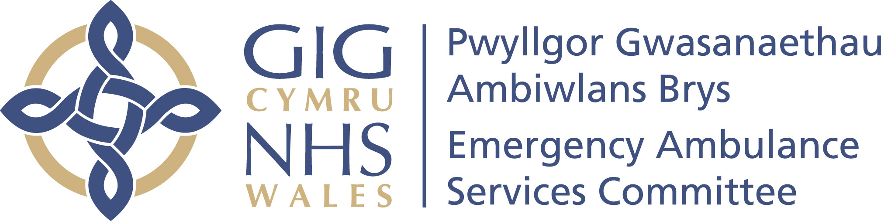 | Your ref/eich cyf:
 | Our ref/ein cyf:
 | Date/dyddiad: | 4 February 2022
 | Tel/ffôn: | 01443 744945
 | Fax/ffacs:
 | Email/ebost: | Stephen.Harrhy@wales.nhs.uk

By email

Dear EASC Members,

You will recall at our November meeting of the Committee we discussed the challenges related to ambulance handover. At the meeting we saw that over 18,000 hours were lost in October, which was a growth of 4,000 hours on September. We had previously committed to delivering a maximum of a 150 hours lost a day, or circa 5,000 hours a month.

We recognised that in the current climate we were unable to achieve our previous commitments, we collectively agreed to introduce “red lines” as the start point of our efforts to reducing handover delays:

- No ambulance handover will take more than 4 hours

- We will reduce the average lost time per arrival by 25% from the October 2021 level at each site (from 72 minute to 54 minutes at an all Wales level)

Whilst we did see some progress towards delivery of these commitments during the end of November and beginning of December. We have unfortunately seen quite a significant deterioration in the handover position during January 2022, which resulted in over 22,500 hours being lost at hospital sites within Wales. Already in February, we have seen daily lost hours reaching new highs.

Waits over 4 hours for patients on board ambulances have increased to just under 1,800 in January, from 1,425 in October.

Average lost minutes per arrival have increased at a national level to 84 minutes with some significant variation across sites. A small number of hospitals have either managed to reduce or maintain the October levels, but this has been outweighed by the almost a doubling of lost minutes per arrival at other sites.

You will recall from our discussions around ambulance capacity at the January Committee meeting that there is no level of additional capacity that we can turn on quickly within the emergency ambulance service to mitigate the current levels of handover delay.

Whilst reductions in demand and support from the military, are mitigating the response performance picture to some extent, community response times are still far in excess of what any of us would consider reasonable. Military support to the ambulance service will end on the 31 March 2022, so we must act now to ensure that we are able to release ambulance capacity.

I have held discussions with your Chief Operating Officers on this and will continue to engage directly with them at their peer group meetings over the coming weeks.

I would ask that you emphasise the commitments we have collectively made to improve handover within your organisations and ask you to bring forward improvement plans for each site. I have attached the EDQDF Pathway Improvement Project documentation for Ambulance Handover to assist in guiding the development of improvement plans.

I would ask that your plans draw particular attention to how each site monitors and reacts to growing levels of lost minutes per arrival and your stepwise approach to escalating delays that are moving toward the 4 hour mark in order to eradicate waits beyond this time, as soon as possible.

We will hold further discussions on this issue at the EASC management group on the 24 February, and it would be helpful if your representatives are able to share your improvement plans at that meeting.

As a Committee we are reaching the point where our ability to discharge our statutory functions to plan and secure sufficient ambulance services for the population is at significant risk without a material and sustainable reduction in handover levels.

Yours sincerely,

Stephen Harrhy

Prif Gomisiynydd Gwasanaethau Ambiwlans | Chief Ambulance Services Commissioner

Cc
Judith Paget
Nick Wood
Chief Operating Officers

Enc: EDQDF Pathway Improvement project documentation for ambulance handover

