AGENDA ITEM
2.6.1

EMERGENCY AMBULANCE SERVICES COMMITTEE (EASC)

provider update
welsh ambulance services nhs trust (WAST)

Date of meeting | 14 March 2023

FOI Status | Open/Public

If closed please indicate reason | Choose an item.

Prepared by | Rachel Marsh, Executive Director of Strategy, Planning and Performance (WAST)
Presented by | Jason Killens, Chief Executive WAST
Approving Executive Sponsor | Chief Executive

Report purpose | FOR DISCUSSION / REVIEW

Engagement (internal/external) undertaken to date (including receipt/consideration at Committee/group)
Committee/Group/Individuals | Date | Outcome
- | - | Choose an item.

ACRONYMS
ABUHB  CTMUHB  D&C  EMS  NCCU  NEPTS  NRI  WAST | Aneurin Bevan University Health Board  Cwm Taf Morgannwg University Health Board  Demand and Capacity  Emergency medical services  National Collaborative Commissioning Unit  Non-emergency patient transport services  National Reportable Incident  Welsh Ambulance Services NHS Trust

- SITUATION/BACKGROUND

  - The purpose of this report is to provide EASC with an update on key issues affecting quality and performance for EMS and Ambulance Care (including NEPTS).

- SPECIFIC MATTERS FOR CONSIDERATION BY THIS MEETING (ASSESSMENT)

Current Operational Pressures
2.1 WAST is currently (06 Mar-23) at escalation level 2 (4 is the maximum) and for the 28 days to 28 Feb-23 WAST spent four days at CSP level 3b (the third highest level). The levels of escalation and Clinical Safety Plan (CSP) were lower in Feb-23, compared to the previous months, which is reflected in the lower levels of patient cancellations and “no sends”. In Feb-23 these were 6,816 and 122 respectively, compared to 11,614 and 1,942 in Dec-22.

2.2 WAST has stood up specific command structures for industrial action, which have worked well, and briefed senior stakeholders on these and the resultant performance and patient safety on the strike days. The GMB/Unite strike action on the 06 Mar-23 was paused due to “significant progress” in the negotiations. The planning to manage and mitigate patient risk on these days has been extremely resource intensive affecting staff from all areas of WAST. A verbal update on the latest position will be provided at EASC.

EASC is asked to NOTE that: WAST is currently at escalation level 2 (maximum 4) and in Feb-23 has had to operate its Clinical Safety Plan up to level 3b (the third highest level).

Quality, Safety & Patient Experience

Patient Response Times in the Community
2.4 One of the key indicators which measures the quality of the service provided is the timeliness of the response by WAST to patients waiting in the community. The graphs below show the current response time performance for Red and Amber One calls. Both graphs show that response times, although still off target or off benchmark, have improved since a significant drop in performance during Dec-22. Dec-22’s performance was attributable to three key factors: a demand spike particularly for breathing difficulties, a commissioned level of rapid response that is below the modelled requirement and extreme handover levels. Inevitably, these below target times have had an impact on patient safety.
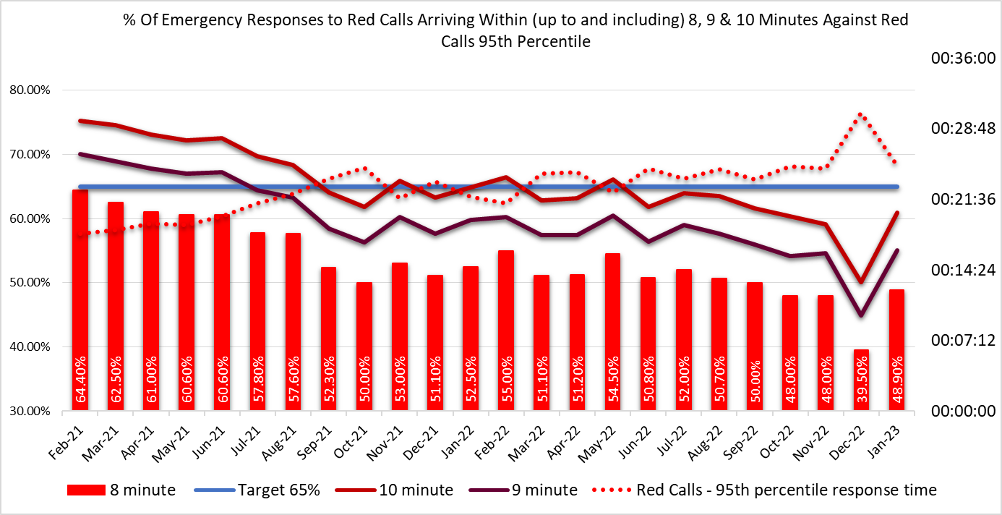

2.5 The Red 8-minute target was not achieved in Jan-23. The percentage of emergency responses to Red incidents within 8 minutes was 48.9% (target 65%) with 95% of Red calls receiving a response within 25 minutes. Red 9-minute performance was 57.5% and Red 10-minute performance 63.4%. This equates to 1,997 patients receiving an eight minute response (64 per day) and 2,589 received a ten minute response (84 per day). The picture is improved from Dec-22, but still significantly below target. The Trust recognises that more needs to be done to improve response times for Red calls, as well as continuing to work on overall response times in every category. It has therefore committed to work on a range of improvement actions in collaboration with the Chief Ambulance Services Commissioner (CASC) and the EASC team, including:
- Full roll out of Cymru High Acuity Response Unit (CHARUs). Currently no additional funding is available, so this will be achieved through redistribution of existing resource (resulting in lower Emergency Ambulance (EA) unit hours production);
- Review and change to the responses provided to Red calls based on clinical requirement and need. Red incidents currently require a higher multiple attendance ratio; however, as the Red category has grown, capacity may be released by reducing multiple attendances where clinically appropriate. All Red calls still require a response within 8 minutes;
- Clinical review of Red breathing problem shows up to half those incidents do not require a Red response. Plans to ‘hot transfer’ these patients for immediate clinical review to assess the prioritisation are being explored;
- Using the electronic patient clinical record (ePCR) data to clinically review certain Red chief complaints (chest pain and stroke) with a potential outcome that a certain proportion may be more appropriately clinical assessed as Amber;
- These changes are currently being modelled to determine the overall effect on response times across all categories.

2.6 It should be noted that the reason for the introduction of CHARUs is improved on scene clinical leadership for critical incidents, in particular cardiac arrest and trauma, with the aim being to deliver improved clinical outcomes, consistent with the introduction of the Clinical Response Model.

2.7 The Amber One median in Jan-23 was 51 minutes, a significant improvement on the 3 hours and 30 minutes seen during Dec-22. The Amber One 95th percentile was 7 hours 1 minute. Amber One incidents include chest pains, strokes, unconscious patients, etc.

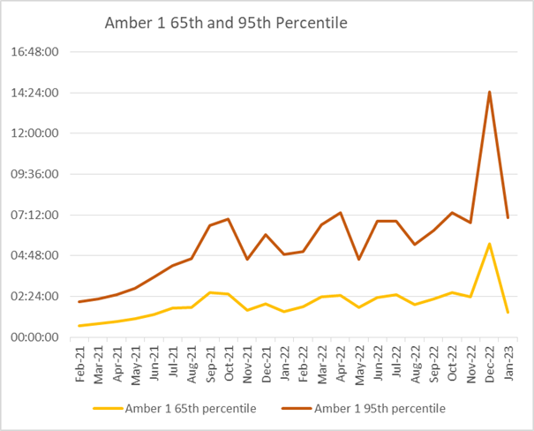

2.8 These longer than ideal response times in Amber One (with the ideal being within 18 minutes) are a particular concern from a patient safety perspective, as it is where the bulk of National Reportable Incidents (NRIs) occur.

2.9 As part of its quality, safety and patient experience arrangements WAST continues to monitor the longest patient responses. There were 447 long waits in Jan-23 i.e. waits 12 hours and over considerably below the 2,064 seen during Dec-22.

2.10 As well as looking at the data on response times, care is taken in internal and external fora to listen to how this impacts on patients through patient stories and feedback from surveys.
2.11 In the last three months, 60 patient safety incidents have been passed to health boards as part of the joint investigation framework (previously Appendix B). Five NRIs were reported directly by WAST to the Delivery Unit in Jan-22.
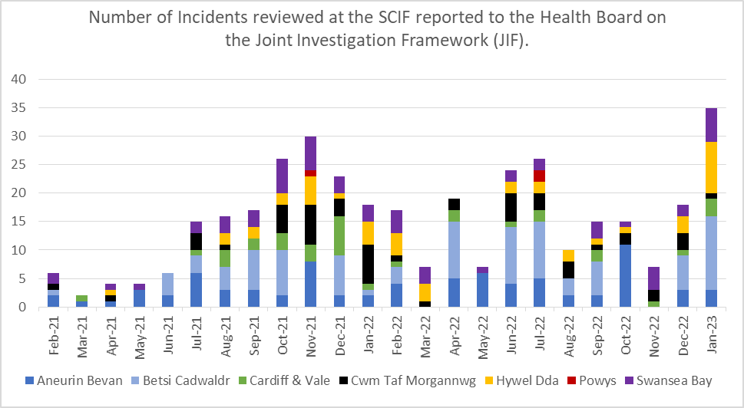
2.12 WAST has escalated and continues to articulate its concerns about patient outcomes and experience to commissioners and to Welsh Government, with Trust Board now receiving a specific paper on patient harm at every meeting, detailing harm, predicted harm and what mitigations the Trust can take as well as wider system mitigations.

Capacity (Production & Hospital Handover)

2.13 Total hours produced within EMS dipped slightly in Feb-23 (it will be lower due to less days in the month and due to strike days), after steadily increasing for four straight months from Aug-22 to Jan-23, but the EA unit hours production (UHP) still achieved the target of 95%. UHP should see a further increase as the remaining full time equivalents (FTEs) linked to the 100 come on stream towards the end of the month.

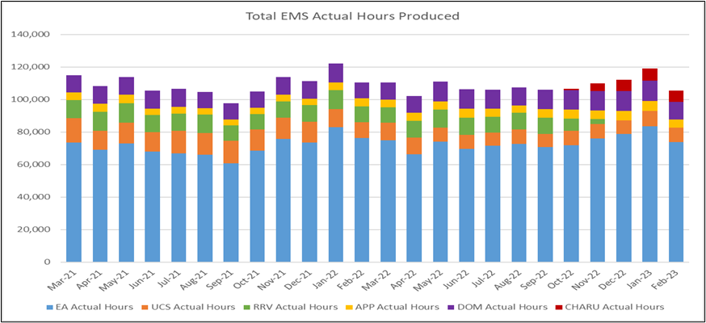
2.14 Lost Handover hours have been steadily increasing over many years with a record high in Dec-22 with 32,098 being lost, which equated to 37% of total conveying capacity. These levels are extreme. Since Dec-22 there have been improvements in several health boards, with lost hours across Wales in Jan-23 reducing to 23,525; however, this level of loss is still extreme and has a significant impact on patient safety.

2.15 As with other metrics, immediate Red release spiked in Dec-22, with 88 incidents of a request for a Red release not being accepted. As demand has reduced this figure has fallen, with Feb-23 seeing only five Red requests being declined.
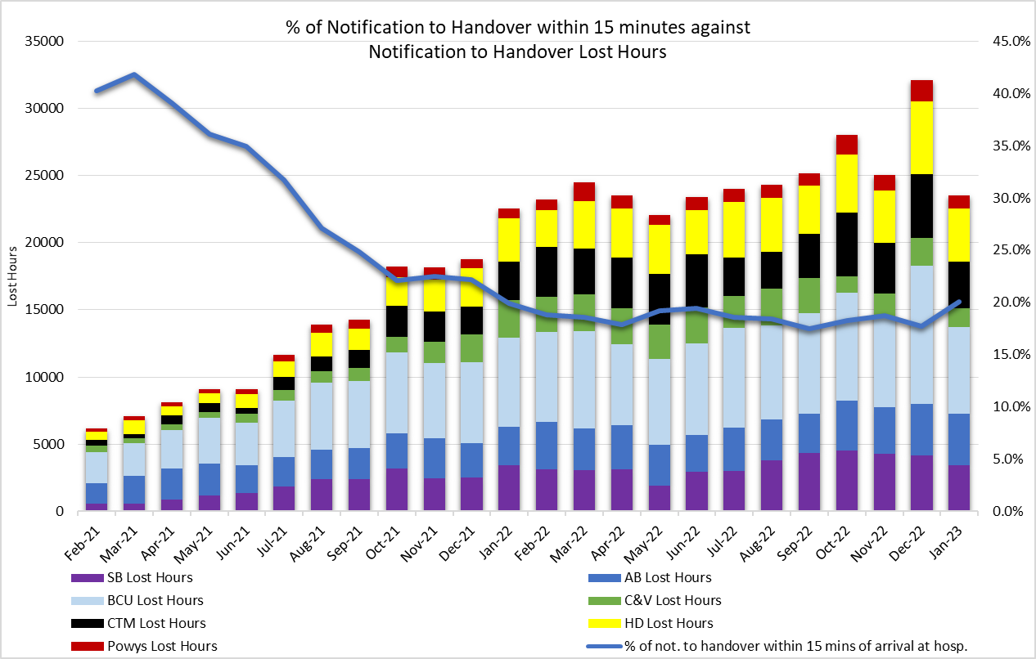
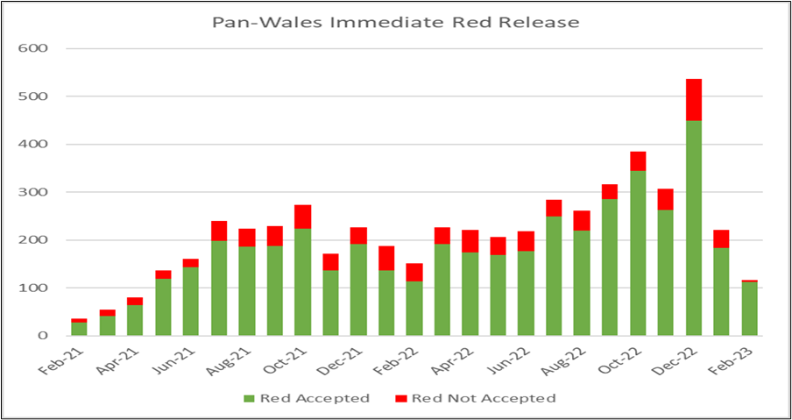
2.16 The emergency medical service (EMS) sickness level is on a downward trend and was 9.49% in Jan-23 with the WAST wide position at 8.85%. The Trust’s 2023/24 IMTP ambition is 8% and 6% for 31 Mar-24. The 6% was the sickness benchmark identified in the 2019 EMS Demand & Capacity Review.
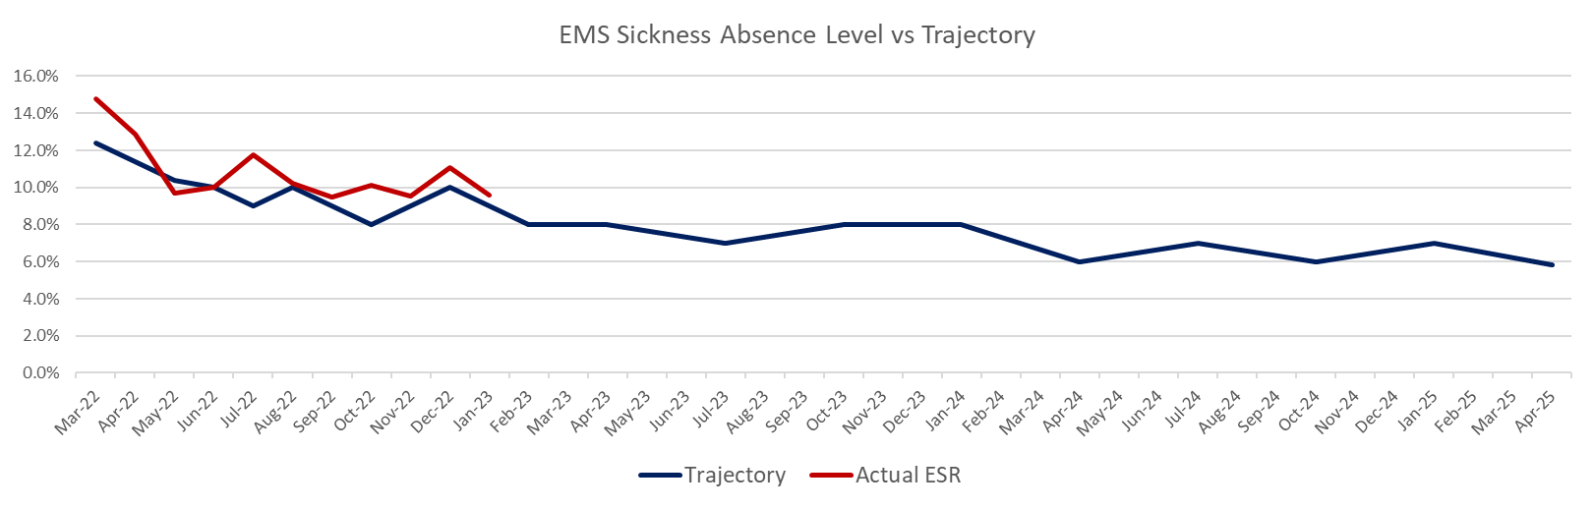
Shift Left/Inverting the Triangle

2.17 WAST achieved a consult & close rate of 14.7% in Jan-23, just shy of its 2023/24 IMTP ambition of 15%.

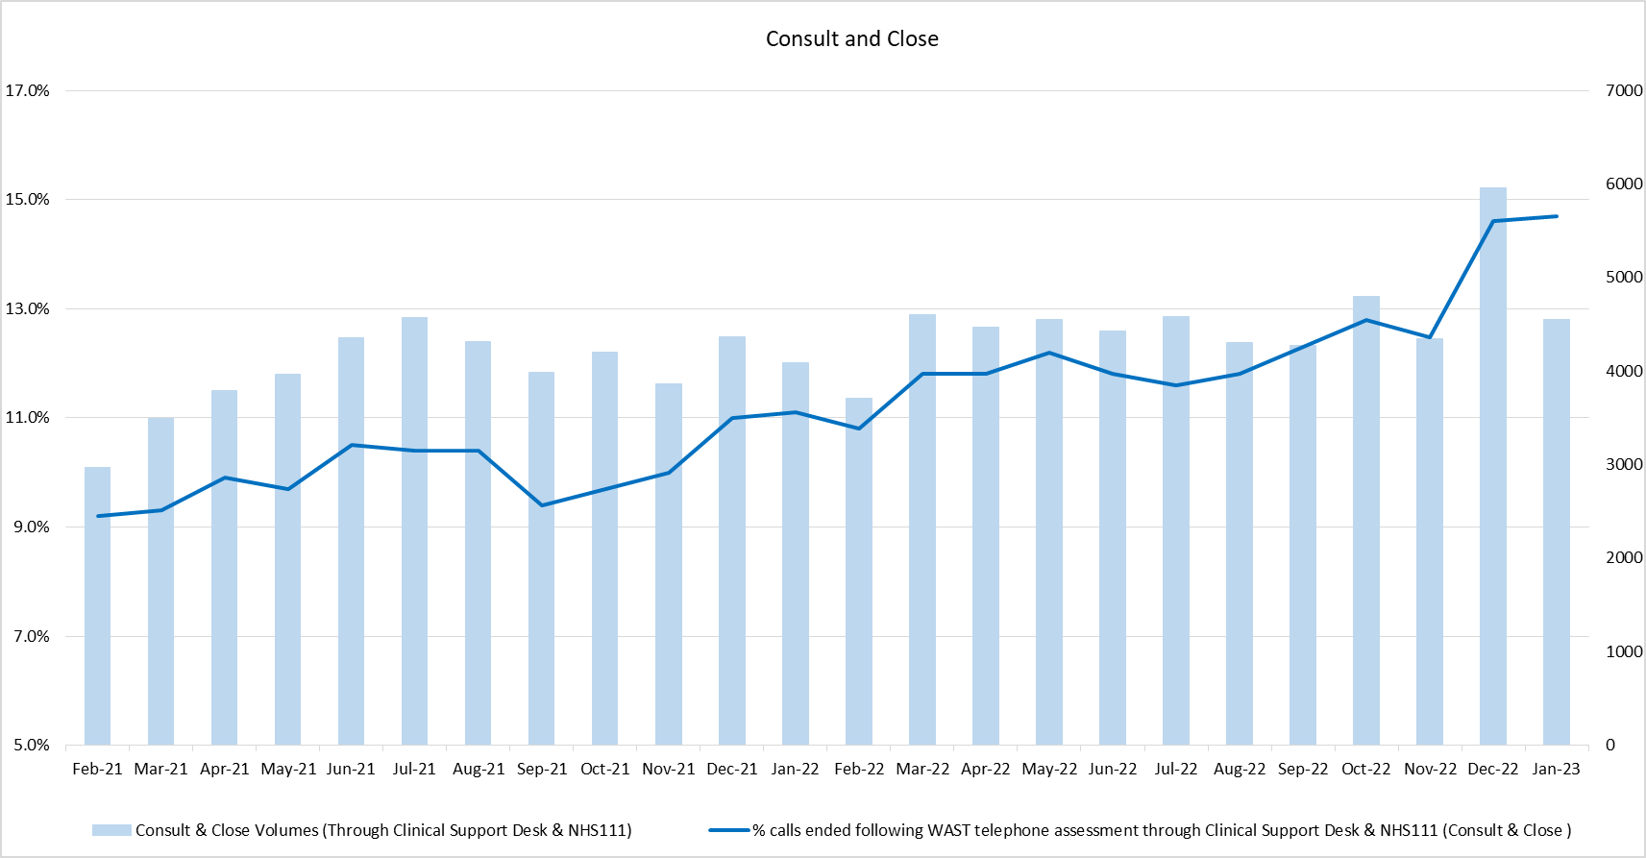

2.18 Overall, WAST conveyed 39% of its patients into emergency departments (EDs) in Jan-23 (27% in Dec-22, with the Clinical Safety Plan affecting this). WAST is now working at pace on engaging stakeholders and articulating its “inverting the triangle” concept, which would see WAST move from an essentially transport driven model of patient care to a digitally enabled virtual/community based model with wider health economic benefits for the unscheduled care system.

Health & Safety
2.19 Increased rates of incidents and concerns reported in relation to excessive diesel fumes outside emergency departments (EDs) continued during Q3 2022/23. Atmospheric monitoring was previously undertaken during Q3-Q4 2021/22 and found to be within Workplace Exposure Limits. Further surveys are to be undertaken during early Q4 2022/23.

2.20 Concerns have been formally raised with all Health Boards asking for continued support in the reduction of fume exposure. Workshops have been established Pan Wales and continue working in collaboration with Health Boards to seek pragmatic solutions which has resulted in the fitting of additional shorelines in some areas. Good practice advice to reduce fume exposure has been communicated across WAST to be adopted by staff during hospital delays.

Clinical Outcomes
2.21 Following the transition to ePCR, and a temporary cessation of clinical indicator reporting, data is now available for Stroke, Fractured Neck of Femur, Hypoglycaemia, ST elevation myocardial infarction (STEMI) and Return of Spontaneous Circulation at Hospital. Deep dive audits have been completed for these clinical indicators and are available online. Improvement work as a result of the deep dive audits is underway to improve compliance (lower compliance was an identified risk based on experiences of English ambulance trusts who have moved to ePCR systems). Improvements include supporting users and Senior Paramedics and updates to the user interface are planned for delivery by the end of Q4. 2022/23 compliance to the published care bundles are as follows:
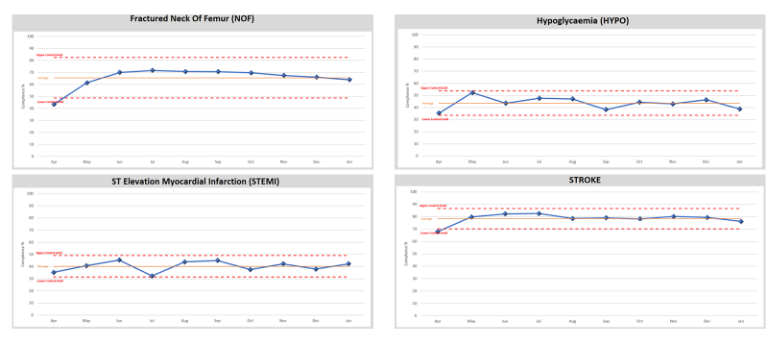
  - As a result of the predicted fall in clinical indicator compliance whilst the new system for creating clinical records becomes embedded, a risk has been raised with an associated action plan internally. The longer-term ambition for WAST is to link its patient and Computer Aided Dispatch (CAD) data with health board patient data so that WAST can report on agreed time-based aspects of clinical indicators and track the eventual patient outcome across their whole pathway. The ePCR project is critical to delivering this ambition.

EASC is asked to NOTE that: Red and Amber response times have improved since Dec-22, but remain too long and these continue to impact on patient safety. In the last three months 60 patient safety incidents were reported to health boards (under the Joint Investigation Framework) where the primary cause is considered to be handover lost hours. WAST is taking a range of actions to improve Red performance. Handover reduction remains critical to achieving acceptable response times and improved patient safety

Ambulance Care (including NEPTS)
  - Levels of NEPTS patient demand have increased and are at or in excess of pre-pandemic levels for all journey types apart from outpatient journeys; however, the overall level of activity has still not recovered to pre-CoVID-19 levels.

  - 74% (target 70%) of enhanced renal journeys arrived within 30 minutes prior to their appointment time in Jan-23. 90% (target 90%) of discharge & transfer journeys were collected within 60 minutes of their booked ready time. WAST is planning to amend the performance measure for Oncology from Apr-23 moving it from -30/+30 minutes to -45/+15 minutes. WAST is making good progress on its transformation of NEPTS and expects to re-roster both the NET Centre and NEPTS transport in 2023/24.

EASC is asked to NOTE that: both renal and discharge & transfer performance were on target; that an amended oncology performance standard will go live from Apr-23; that good progress is being made on Ambulance Care (including NEPTS) transformation; and WAST is planning to re-roster the NET Centre and NEPTS transport in 2023/24.

Commissioning, Planning and Service Change

Forecasting & Modelling
  - WAST, at the Welsh Government (WG) request, has recently modelled the potential impact of Same Day Emergency Care (SDEC) units receiving suitable patients from WAST between 08-00 and 18-00 each day with a time at SDEC of 30 minutes. The modelling estimates that 4% of WAST’s verified incident demand could be diverted to SDECs (currently less than 0.5%) with a five-percentage point gain in Red performance and a 29 minute reduction in the Amber 1 median. The CASC briefing paper to EASC identified WAST access to SDECs as a priority along with the development of further national pathways in 2023/24. The SDEC modelling is the first time WAST has been able to model a specific pathway using ePCR data, an approach which could be developed further through the strategic 2023 EMS Demand & Capacity Review.

Commissioning Intentions
  - WAST recently reported its quarter three progress on the EMS and NEPTS commissioning intentions to EASC Management Group (16 Feb- 23), with good progress being made. WAST is currently finalising its detailed responses to the 2023/24 intentions through the Integrated Medium Term Plan (IMTP process).
  - The CASC briefing to Jan-23 EASC included a range of options for EASC to commission further improvements for managing demand, addressing Red performance and continuing to “shift left” consistent with the “inverting the triangle” ambition to improve patient safety, staff well-being and reduce pressure on emergency departments.

2.28 Key improvements for WAST, identified by the CASC included:-
- Clinical screening of high priority calls;
- Improving the impact of CHARUs through their full roll out;
- Further improvement of the consult and close to above 17%; and
- A Night Sitting Service.

2.29 WAST estimates that it will need the following clinicians to deliver 1 to 4 above:-
- 19 Paramedics for clinical screen of higher acuity calls;
- 101 Paramedics for the CHARU roll out (backfill EMT3s);
- 21 Paramedics in the Clinical Support Desk for moving the consult and close rate beyond 17%, pushing for 20%; and
- 6 Paramedics in the Clinical Support Desk for delivery of the Night Sitting Service (there are other resource aspects to the service).

2.30 WAST also has the option of further expanding its APP workforce as a university cohort (17 FTEs) will be available during 2023/24 and could be commissioned by EASC.

2.31 Supported by EASC, WAST has made excellent progress on workforce additionality over the last three years with the establishment to staff in post gap being almost 0 as forecast for 31 March 2023 i.e. there is no vacancy factor, which includes closing and exceeding the “relief gap” (including the +100) and almost doubling the capacity of the Clinical Support Desk.
2023-26 IMTP

  - Progress against WAST’s IMTP approval accountability conditions are set out in the following table:-

Six Goals | WAST now has a presence on goals 2, 5 & 6 at delivery board level and on the clinical advisory board, with further ongoing discussion about engagement/representation on goals 1, 3 and 4 with the national team. The ICAP process is starting to take shape and WAST is developing a set of service offers for each health board based on successful implementation in other areas of Wales.
Value Based Healthcare | The Value Based Healthcare Working Group continues to develop its work programme alongside the Financial Sustainability Programme.  There has been some slippage in implementation of PLICs, this is not anticipated to have any adverse impact on next year’s IMTP. The work to trial Patient Reported Experience Measures (PREMS) with Aneurin Bevan University Health Board has gone live.
Minimum Data Set | This is now being refreshed quarterly with the required data applied. A new MDS is being prepared as part of the IMTP development for 2023/26.
Improvement in sickness absence | The Managing Attendance Programme is working through the actions required to address absences with regular reporting and assurance provided at People and Culture Committee (see 2.16 above).
Delivery of workforce efficiencies | A range of efficiencies in EMS have been delivered and resulted in the increase of around 1,200 additional shifts. This includes the EMS re-rostering, sickness absence reduction, additional WTEs and increase in consult and close rates.

Transformational change
  - As a result of industrial action (IA) throughout Q4 WAST has had to re-prioritise some of its IMTP delivery, rolling some of the delivery into Q1 2023/24 , this includes for example the development of a Transfer and Discharge services model for Wales (work is ongoing, but at a slower pace due to operational focus on IA).

  - WAST therefore set out five key priority areas of focus and has continued to make good progress on the deliverables that sit under these domains:
- Reducing waiting times, avoidable harm and death – this includes the Integrated Commissioning Action Plan meetings which have replaced handover improvement meetings alongside other key performance improvement initiatives across Red and Amber response particularly;
- Focusing on our Gateway to Care programme – progressing with the impact of 111 and the commissioning infrastructure under Goal 2;
- Safely managing industrial action;
- Looking after our people’s wellbeing and maintaining recruitment – including finalising the recruitment of the 100 WTE in EMS and working to reduce sickness to the target level set out in our IMTP; and
- Focusing on the longer term, including our financial sustainability – preparing the way for our inverting the triangle ambitions taking into account the challenging financial outlook for NHS Wales over the next 3 years.

Health Board Changes
  - WAST continues to engage with the regionalisation agenda across Wales. A key area of focus for the end of Quarter 4 2022/23 is supporting the Hywel Dda University Health Board public consultations on its strategic programme and potential new hospital.

  - WAST is currently engaged in the following live strategic service change programmes with Health Boards in Wales and Trusts in England:
- Swansea Bay Acute Services Reconfiguration;
- A Healthier Mid & West Wales (AHMMW);
- Stroke reconfiguration in Swansea Bay and Hywel Dda;
- Stroke reconfiguration in Cwm Taf Morgannwg and Cardiff & Vale;
- Stroke reconfiguration in Hereford and Worcester;
- South Wales Thoracic Surgical Services Programme;
- The Spinal Network;
- South East Wales Collaborative regional portfolio - orthopaedics, diagnostics, pathology, endoscopy and ophthalmology programmes;
- Aneurin Bevan Clinical Futures; and
- Radiotherapy Satellite Centre, Nevill Hall Hospital
2.37 WAST is also monitoring progress of the following service changes and will engage as and when required:
- Regional Treatment Centre in Betsi Cadwaladr UHB;
- Future Fit (Shrewsbury & Telford Hospitals);
- Cwm Taf Morgannwg Maternity & Obstetrics (South Powys Flows); and
- Cardiff and Vale – Future Clinical Services Programme.

  - WAST’s Integrated Strategic Planning Group has continued to maintain oversight of health board operational and strategic service changes to comprehend and coordinate implications on WAST and for WAST to support these plans. WAST is currently updating our service change map for inclusion in the IMTP.

IMTP 2023-26
  - WAST is continuing to develop its next IMTP. Key priorities are emerging around the improvement in quality and safety of services for our patients, the wellbeing and experience of our people and value & sustainability in the context of a challenging financial outlook next year. An update was brought to EASC Management Group in Feb-23 ahead of a final draft IMTP being brought to EASC for endorsement in Mar-23. During this time there has been continued engagement with NCCU and Health Board commissioners to ensure alignment of IMTPs and Commissioning Intentions.

EASC is asked to note that: modelling of SDECs indicates they could make a material contribution to performance; due to industrial action WAST has focused on five priorities for Q3 & Q4, but has made progress across its range of IMTP deliverables; the 2022-25 IMTP approval conditions are being monitored and there is progress against each condition; there continues to be significant planning work around changes in health board configurations; WAST is progressing the development of its 2023-2026 IMTP with regular engagement with NCCU and Health Boards.

Conclusions and Forward Look
  - Current quality and performance levels and patient safety remain very challenging in EMS. NEPTS quality and performance is stable.

  - WAST is currently finalising a response to the CASC metrics and targets set out in the previous EASC briefing, linked to the commissioning intentions and IMTP processes, on what it could to further support patient safety and system pressures in 2023/24. Handover reduction remains key.

- KEY RISKS/MATTERS FOR ESCALATION TO THE COMMITTEE

Members of the EAS Committee are asked to note that:
  - EMS quality and performance remain below acceptable levels which in turn is causing levels of avoidable patient harm that are too high.
  - Ambulance Care (including NEPTS) quality & performance is stable.
  - Through the commissioning intentions and IMTP processes, WAST has is considering a range of options on what it could do to improve quality and performance in the EMS five step patient pathway.
  - WAST has a strong track record of delivery on improvements commissioned by EASC.
  - The Ambulance Care (including NEPTS) transformation programme is progressing well and WAST expects to re-roster the service in 2023/24.
  - Due to industrial action WAST has had to re-prioritise its IMTP deliverables and focus on five in Q3 & Q4.
  - WAST remains on track for developing its IMTP 2023-26 in collaboration with the CASC and his team.

- IMPACT ASSESSMENT

Quality/Safety/Patient Experience implications | Yes (Please see detail below)
Quality/Safety/Patient Experience implications | Identified within the report
Related Health and Care standard(s) | Timely Care
Related Health and Care standard(s) | And all health and care standards
Equality impact assessment completed | Not required
Legal implications / impact | There are no specific legal implications related to the activity outlined in this report.
Legal implications / impact | Included within the body of the report
Resource (Capital/Revenue £/Workforce) implications /  Impact | Yes (Include further detail below)
 | Included within the body of the report
Link to Main Strategic Objective | The Committee’s overarching role is to ensure its Commissioning Strategy for Emergency Ambulance Services utilising the five step patient pathway outlined within the National Collaborative Commissioning Quality and Delivery Agreement and the related outcomes for each care standard aligned with the Institute of Healthcare Improvement's (IHI) ‘Quadruple Aim’ are being progressed.  This report focuses on all the above objectives, but specifically on providing strong governance and assurance and safe and effective patient care
Link to Main WBFG Act Objective | Service delivery will be innovative, reflect the principles of prudent health care and promote better value for users

- RECOMMENDATION

  - The EASC Committee is asked to:
- DISCUSS and NOTE the WAST provider report.

