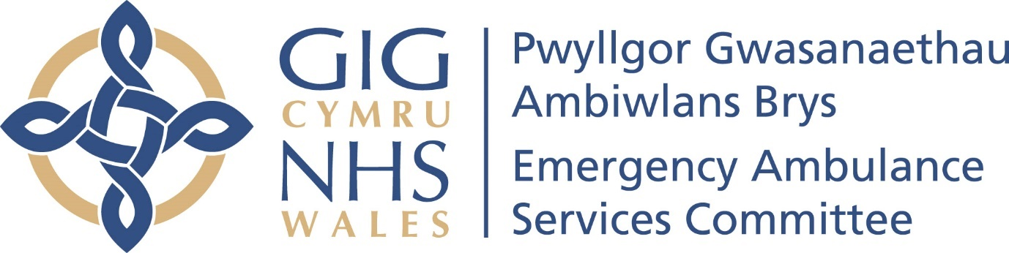

Emergency Medical Retrieval and Transfer Service (EMRTS) Service Review – Engagement Report

01 March 2023 – 29 February 2024

This report has been prepared by the Emergency Ambulance Services Committee Team to summarise the process and findings of engagement on the “EMRTS Service Review” led by the Chief Ambulance Services Commissioner from March 2023 to February 2024. The preferred option, following the conclusion of the full engagement period, is set out in the EMRTS Service Review document and if adopted, also details how the service would operate.
Contents
 |  | Page
Executive Summary |  | 3
Introduction |  | 7
Background and Context |  | 8
Planning for the Future Service |  | 11
Engagement Scope and Purpose |  | 13
Stakeholders |  | 16
Engagement Methods |  | 17
Outcomes and Responses |  | 28
Engagement Findings |  | 36
Governance and Risk Issues |  | 55
Follow Up Actions |  | 57
Conclusions |  | 58
Next Steps |  | 60
Contact Details |  | 61
Appendices |  | 62

1.Executive Summary
This engagement report provides a comprehensive overview of the public engagement process undertaken during the Emergency Medical Retrieval and Transfer Service (EMRTS) Service Review in Wales.
The Review was initiated due to public interest in potential changes to air bases, aiming to address unmet patient needs, make effective use of resources, provide effective geographical coverage and solve emerging challenges. It is led by the Chief Ambulance Services Commissioner (CASC/Commissioner) on behalf of the Emergency Ambulance Services Committee (EASC), made up of Health Boards across Wales (see sections 3 and 4).
The Review’s engagement processes sought to address queries and gather feedback for consideration in the Review process (see section 5).
The engagement involved citizens, stakeholders, professionals, community leaders, and government officials throughout the process in discussions about how the air ambulance service could be developed (see section 6).
Various engagement methods were employed, including drop-in sessions, public meetings (both in-person and virtual) and online surveys, as well as using Health Boards existing engagement mechanisms. Communication efforts were bilingual and accessible. Feedback mechanisms were in place to capture stakeholders' input and their protected characteristics under the Equality Act 2010 (where they were happy to share these), which was used to refine the engagement process and Equality Impact Assessment continuously. Adjustments were made based on feedback to enhance user experience and participation (see section 7).

Over the course of three phases, spanning 23 weeks, a total of 45 engagement sessions were conducted, supplemented by Health Board engagement mechanisms. Each phase built upon the previous one. Across all engagement phases there has been more than 1000 engagement session attendances and more than 2,500 responses submitted via all feedback routes, plus two petitions objecting to any base changes affecting Caernarfon and Welshpool reflecting public sentiment garnered significant support. Of the 2500 responses, a total of 999 were received from a representative panel (via You.Gov hosted by The Picker Institute). While geographical demographic data was not collected uniformly across all engagement methods, analysis of available data reveals insights into the geographical distribution of respondents, most recently in Phase 3 where the majority of feedback came from individuals within the Powys Teaching Health Board (PTHB) and Betsi Cadwaladr University Health Board (BCUHB) areas. Additionally, a higher participation rate was observed in this phase among older age groups, particularly those aged 55 and above, while younger age groups were less represented. However, it should be noted that this is where data was provided (see section 8).

The engagement process has yielded valuable insights from both the public and stakeholders, revealing a nuanced understanding of service priorities, concerns and suggestions. Feedback has been collected through representative surveys as well as localised engagement sessions, highlighting national perspectives as well as those specific to Caernarfon and Welshpool areas (see section 9).
The Picker Institute’s report highlights the Welsh public's priorities for EMRTS, emphasising the importance of effective road response, adequate training and support for staff, equal access to services for all citizens and a commitment to maintaining current standards of care. These findings align with the overarching values and aims of the EMRT Service and EAS Committee.

It is evident from feedback that there are several common themes and concerns regarding the proposed changes to air ambulance services in Wales, particularly for citizens in the surrounding areas of Caernarfon and Welshpool (i.e. BCUHB and PTHB respectively):
- That current bases should not change due to the impacts on rural areas
- Dissatisfaction and opposition to the closure of air bases in Welshpool and Caernarfon.
- Concerns about longer response times, reduced coverage, and compromised emergency care, especially in rural and remote areas.
- Criticism of the proposed new location for air ambulance services and doubts about its effectiveness.
- Belief of the impact on rural communities, aging populations, and workers in hazardous professions.
- Risk of decreased donations to the Wales Air Ambulance charity, potentially threatening its sustainability.
- Advocacy for maintaining current air ambulance bases and providing additional Rapid Response Vehicle (RRV) coverage to other areas as an alternative to closure.
- Emphasis on equitable access to pre-hospital critical care across all regions of Wales.
- Calls for decision-makers to reconsider proposed options and prioritise the health and safety of residents.
Concerns have also been raised about EMRTS's specialisation and the potential loss of experienced staff due to base relocations. Stakeholders express a desire for a more adaptable clinical model and emphasise the vital role of EMRTS in providing critical care services, particularly in rural communities.

Notwithstanding the concerns of the public and stakeholder feedback in these areas from where it was expressed that citizens feel more vulnerable, there is a consensus of understanding that:
  - Un-met patient need must be provided for by the service; and
  - Highly skilled clinical teams need to be used in the best way to provide for patients.
  - And that rural communities should not be disadvantaged in order to achieve this.
Additional feedback regarding Health Boards, the Welsh Government and other emergency responders highlights scepticism about service developments and funding arrangements, alongside calls for enhanced engagement and consideration of rural healthcare needs more broadly. The importance of maintaining openness and transparency throughout the decision-making process also emerges.
Feedback highlighted perceived negative impacts on various equality characteristics. It is unlikely that the Review will have any specific impact on this, as the service is provided to all based on clinical need alone. However, as data regarding EMRTS missions is not available in a format that enables further detailed analysis by equality, protected characteristics this cannot be discounted (see Section 10).
In conclusion, the emerging themes of feedback has been consistent throughout all three phases of engagement with little variation between phases. The engagement findings show the complexity of balancing national priorities with localised concerns, emphasising the necessity of ongoing engagement to shape the future of EMRTS effectively in Wales.

- Introduction
This engagement report provides:
• An outline of the background and context of service development of the EMRTS Service Review
• An overview of the engagement approach plan and process / actions undertaken with stakeholders
• An analysis of the engagement responses received.
• Summary conclusions drawn from the engagement process.

Please note that the Engagement Report is solely a report on the engagement process and what was heard. The EMRTS Service Review document contains details of the recommendations being made to the EAS Committee.

- Background and Context
The air ambulance service in Wales is a partnership between the Wales Air Ambulance Charity and the EMRTS of NHS Wales. It is a highly specialised service providing pre-hospital critical care across Wales, taking the emergency department to the scene of an incident for life and limb trauma. It is complementary to the emergency service delivered by the Welsh Ambulance Services Trust.
The Wales Air Ambulance Charity provides the bases, helicopters, cars, pilots, fuel and maintenance. EMRTS is made up of the clinical teams from NHS Wales, with four bases at Caernarfon, Welshpool, Dafen (Llanelli) and Cardiff. All 4 teams work together to serve the population of Wales.
In August 2022, public and press interest was triggered by a leaked document about potential changes to air bases (namely Caernarfon and Welshpool) being discussed by the Wales Air Ambulance Charity and the EMRTS team.
In September 2022, a ‘Focus On’ session was held at the EASC (the Joint Committee of all Health Boards in Wales which commissions the air ambulance service), on the EMRTS Service and potential opportunities to develop the service.
The original EMRTS Service Development Proposal (EMRTS and the Wales Air Ambulance Charity) was received at the EAS Committee meeting on 8 November 2022. A number of comments and queries had already been received from key stakeholders from Caernarfon and Welshpool areas and the Committee Members agreed that further scrutiny was required in a few key areas. It was agreed that this scrutiny would be undertaken by the Commissioner and the EASC Team in the form of the EMRTS Service Review.
The EMRTS Service Review was to start the work afresh and be independent of the initial EMRTS Service Development Proposal. The Review, led by the Commissioner, was to include public engagement considering the queries, concerns and suggestions from public and stakeholders, focusing on how to further improve the air ambulance service in Wales.
The purpose of the EMRTS Service Review is to:
- Help more people. The service already does a great job saving lives and helping those needing critical care. But not everyone who needs this help can get it currently (this is unmet patient need). Historical data from the service showed that there are patients who need the service but are not receiving it currently, right across Wales. On average, there are approximately 2-3 patients per day across Wales who have an ‘unmet need’ for the service. The Review looks at ways to make sure more people can get the help they need, which means saving even more lives and helping people get the best possible critical care at scene, no matter where they are.

- Use resources better. Right now, some clinical teams in Wales are busier than others. There are different reasons why the teams may not be able to respond to the current unmet need, such as teams may already be tasked, weather factors, vehicle maintenance or the base team may be offline (i.e. no shifts operating at that time). Additionally, some clinical teams are not being used to their full capacity when they are available on shift (this is called ‘under-utilisation’). This under-utilisation happens across different bases and calendar years, suggesting that crews could attend emergency calls in various parts of Wales or at different times of the day if their location or shift times were adjusted. A better way to make the best use of these highly skilled clinical teams is needed so everyone gets the help they need, no matter where they live or when they need it.
- Spend money wisely: The Charity has an obligation to its donors and the Charity Commission to make the best use of the money it receives to continually improve the service with EMRTS. Similarly, NHS Wales needs to make sure that the public money to pay for these clinical teams is used in the best way possible.
- Solve problems: Some people worry that changing things might cause new problems, like making it take longer for help to arrive. The Review looked at this carefully to understand worries and find solutions that work for everyone.
While "unmet need" refers to the existing demand for the service that is not currently being met, "lives saved" typically pertains to the impact of the service in providing critical care and saving lives.
To clarify, the proposed change aims to address the unmet need by enhancing the service's capacity and coverage, thereby potentially saving more lives. By ensuring that the service can effectively respond to the existing demand and reach more patients in need, it is anticipated that more lives can be saved. Therefore, the focus is on improving the service to meet the identified needs and enhance outcomes rather than directly equating unmet need with lives saved.
The Commissioner committed to four elements shaping his considerations throughout the Review, they are:
- Modelling data – a helpful guide using historical data but not to be taken on its own
- Evaluation framework – using commissioning goals and metrics that were tested during engagement Phases 1 and 2
- Feedback – giving conscientious consideration to the issues raised through the engagement process with public and stakeholders
- ‘Red lines’ and ‘common sense’ test; for example:
  - not to position assets with worse flying conditions; or
  - more people will get the service across Wales; not only would more people get the service but if anyone who gets a service now will still get a service in the future.)

- Planning for the Future Service
In response to the above findings, the Review has considered a number of options for future service development.
An iterative process throughout the engagement identified and modelled a number of options which included:
- Phase 1 – three broad options of proposed model options were discussed:
  - Existing bases and changes to these
  - Having a new base in the centre of North Wales (by closing other bases)
  - Other ideas or scenarios (by asking for suggestions in Phase 1 engagement)

- Phase 2 – a ‘long list’ of 20 options (from option 1 to option 6c) were developed from the 3 broad areas, based on feedback and suggestions in Phase 1

- Phase 3 – six options were shortlisted (from the long list of 20) with two identified ‘highest scoring’ options from an options appraisal workshop of NHS Wales representatives using the agreed evaluation framework
The long list of 20 options were modelled by an external provider (Optima). A combined dataset from the period 1 June 2022 to 31 May 2023 was used. This time period was chosen to reflect the developments in EMRTS (since 2015 at its start). It gave the best way to use the data based on how the service is currently set up.
The aim has been to ensure optimal matching of capacity to demand and develop the most robust and sustainable model for the future of the service. The preferred option following the conclusion of the full engagement period, is set out in the EMRTS Service Review document and if adopted, also details how the service would operate.
Due to the predominance of feedback from the engagement stating that ‘no change’ in service bases would be optimal, the status quo option was considered as part of this process and was carried forward as part of the long and shortlisting process for comparison purposes. This was discounted before Phase 3 based on the level of unmet need, unequal and low levels of utilisation (including no-arrival days) alongside the lack of night time capacity and population coverage. Every modelled scenario was able to deliver an improvement from the baseline “do nothing” position, as such demonstrating that the current service operating model is not optimised.
- Engagement Scope and Purpose
The Review and this document use the terms 'engagement/engage' to mean the continuous involvement of, and informal consultation and discussions with, citizens, staff, staff representative and professional bodies, stakeholders and third sector and partner organisations regarding service development. (N.B development is used to reflect that there are no proposed changes to the ways the patients receive the service although technically the Welsh Government Guidance does not differentiate between ‘development’ and service ‘change’) .
The rationale for conducting public engagement was to have a constructive and meaningful conversation with public and stakeholders about how to further improve the air ambulance service in Wales in response to the queries and concerns raised to the initial EMRTS Service Development Proposal, that were emanating from Caernarfon and Welshpool areas specifically.
The engagement would enable public and stakeholder views and concerns to be fully understood and responded to as part of the overall Review led by the Commissioner.
An internal steering group was established in EASC and in September 2022, the EASC Team approached the (then) Community Health Councils (now Llais) for advice on the suitable engagement model for the EMRTS Service Review.
The Community Health Councils across Wales asked the Commissioner to undertake a formal engagement process of no fewer than 8 weeks across Wales. This included a review of the process after 6 weeks. This engagement approach reflected the Welsh Government’s Guidance on NHS Service Change, which was extant at that time, specifically for a ‘moderate service change’ as it exhibited some of the following characteristics detailed in the guidance:
- change of location from which a service is delivered within a health board area
- partial service withdrawal
- anticipated moderate number of people affected or small change with moderate impact
- moderately sensitive issue locally
- closure of small facility with limited facilities (such as branch surgery or small community clinic)

The engagement process has been presented and detailed in every EAS Committee meeting to sight Members on the overall progress of the delivery of the engagement programme, as well as the emerging themes from public and stakeholder feedback.

From 1st April 2023, the guidance on engagement was changed along with the establishment of Llais as an independent body. A letter from Llais CEO was received by the Commissioner on 29 November 2023 that formally raised concerns about the next steps of the Review recommending that this Review was taken to further stage of engagement (the new guidance does not differentiate between engagement and consultation). Following discussions between the Commissioner and Llais on 15 December where Llais accepted the proposed additional ‘Phase 3 engagement’ augmenting the original planned approach. The letter of recommendation was considered at the EAS Committee on 21 December the EAS Committee agreed to go to a third and final stage of engagement in February 2024 based on the Commissioner’s 15 December discussions with Llais. This would include engagement on shortlisted Options following the Options Appraisal process.

The third and final engagement period was agreed as a 4-week period, online during February 2024 and in order to address the needs of the digitally excluded, the health board engagement teams would provide local opportunities for their populations to be supported to contribute to this important opportunity through non-digital as well as digital means.

The purpose of engagement was:
- To inform and engage with all stakeholders and the general public about how air ambulance service in Wales could be improved
- To set out the analysis undertaken of current service usage patterns, the conclusions reached as a result and to explain the possible options for future service operations.
- To provide full opportunity to receive feedback, queries, suggestions, alternative options and concerns.
- To collate all feedback as the basis for reporting back to Health Boards, Llais and the EAS Committee.
- To consider feedback in developing options to further improve the air ambulance service as a result.
The Commissioner has had an ongoing dialogue with Llais since autumn 2022, attending formal meetings (such as their Senior Management Team) and informally with the CEO and Deputy CEO as the national leads.

Some senior Llais regional officers have also attended in-person and online sessions in Phases 1 and 2.

To keep abreast of emerging themes from the Phase 3 engagement feedback as it was received and maintain the timescales for recommendation to EASC in March 2024, the EASC Team provided Llais with regular feedback updates to demonstrate that due consideration is being given to feedback.

- Stakeholders
Stakeholder mapping was completed that identified potential stakeholders including:
- Residents within the PTHB and BCUHB footprint areas
- Opposition campaign groups/Community leaders
- The general public
- EASC Members
- EMRTS staff
- Wales Air Ambulance Charity (staff and trustees)
- Local MPs, MSs and Councillors
- Welsh Government officials
- Voluntary sector
- NHS Wales Health Boards (Comms & Engagement leads, service change leads etc. Stakeholder Reference Groups and Partnership Boards)
- Welsh Ambulance Services NHS Trust (staff and patient panels)
- Community Health Councils/Llais
- Local, hyperlocal, regional and national media

Anyone who contacted the Commissioner and his team about the EMRTS Service Review were added to the Stakeholder Distribution List to receive regular updates about this issue with a request that they let the EASC Team know if they wished to be removed from the list (in line with Information Governance requirements).

- Engagement Methods
Approach
The communication and engagement plan sought to build trust and confidence in the engagement process. As well as creating a conducive climate for constructive dialogue, the engagement approach aimed to:

- Provide fact-based information to clarify and aid understanding of how the extant service is provided in partnership between the Charity and EMRTS;
- Enable a transparent and thorough public engagement process to help inform a final EASC recommendation, Health Board consideration and decision;
- Provide reassurance to stakeholders about future service operations and opportunities around service developments;
- Meet the Welsh Government guidance, enacted by the (then) Community Health Council (now Llais) and their resultant requirements and recommendations.

The Gunning Principles were considered in underpinning the communications and engagement approach, and delivered in the following key activity phases:
Phase | Stage | Purpose | Timing
0 | Brief  (We are asking…) | Pre-engagement phase to aid understanding and create optimal conditions for engagement dialogue in Phase 1. | October 2022 – March 2023
1 | Engage  (You are telling us…) | Listening phase and gathering of feedback on factors, weightings, and other suggestions to inform options to be developed. | March-June 2023
2 | Share  (We are doing…) | Outline of options developed, and work done (data and information requested etc.) from Phase 1 to explain options being considered and ultimately going forward to EASC for decision. | October -November 2023
3 | Commenting… | Asked for views on:  - The six options shortlisted and evaluated in the Options Appraisal workshop  - The two shortlisted options - Options A and B  - The additional actions identified to address the public and stakeholder feedback from Phases 1 and 2. | February 2024

Communication and PR
A dedicated area on the EASC website was created and a substantial amount of information was published in readiness for the engagement process to start. This took account of information and queries in order to clarify the facts for participants recognising the technical and service operational complexities involved. This included Frequently Asked Questions (FAQs) and an explainer video.

A campaign visual identity and supporting assets were developed for the engagement and communications packs were supplied to all Health Boards, in all phases, for consistent messaging and promulgating within respective Health Board footprints.

The engagement programme was dependent on the localised promotion of events being shared through Health Boards’ channels, local media outlets, and community leaders such as the Facebook campaign groups - which both have substantial followers totalling almost 17 thousand people at its height.

This onward cascade was encouraged in all formal EASC communications by asking interested stakeholders to speak to their friends, families, neighbours and colleagues about the engagement, and the many ways people can provide their feedback.

Health Board Communication and Engagement teams, and Service Change leads, supported the engagement programme in their respective areas. This included sharing through normal practice and existing networks, ensuring inclusion on key meetings and using digital and social media channels.

Regular updates (EMRTS Service Review Stakeholder Briefings) were issued electronically on a regular basis via the Stakeholder Distribution List and published on the EASC website. As of 04 March 2024, 17 Stakeholder Updates have been published.

For any misunderstood or misinterpreted information circulating about this complex issue, this was clarified by the EASC team on the website so that everyone had access to the same information and the campaign group organisers were helpful conduits to sharing this via their social feeds as well as through hyperlocal sites.

The Commissioner received national and local media interest about the EMRTS Service Review, with interviews and statements provided to all media bids received, as well as issuing media releases to media outlets proactively.

All erroneous and inaccurate media coverage was followed up with factual clarification and offers of additional interviews with the Commissioner.

Engagement Materials
The EASC Team worked with Health Board engagement, communication and service change leads in developing engagement materials at the outset of Phase 1 and again in Phase 3. These materials were shared with Community Health Councils/Llais colleagues, to test the initial drafts and comments received and considered recognising the level of detail needed to clarify complex information.

Phase 2 materials were developed from Phase 1 materials and were also shaped by the feedback from participants during Phase 1.

Despite this being a clinically and operationally complex service, efforts were made to make information as simple as possible including FAQs and glossary of terms throughout the engagement.

For those wanting to see the more detailed and technical information and data, all EAS Committee meeting papers and updates related to the EMRTS Service Review, as well as supporting documents, were published on the EASC website.

A core bilingual engagement documents pack was produced for each engagement phase, published on the website and also shared within sessions:

Engagement Materials
Phase 1 | Phase 2 | Phase 3
- Full technical document  - Everyday summary document (main engagement document)  - Easy Read document | - Commissioner’s Phase 2 Report  - Plain language version  - Supporting Documents (containing full technical details and breakdown of information, signposted in the Commissioner’s Report) including:  - History of EMRTS  - Engagement - What We Did and What We Heard  - The Picker Institute Report  - Historical Data Information Pack  - Drive Time and Population Coverage  - Weather Data  - Optima Modelling  - Presentation Slides (presentation with audio | - Commissioner’s Phase 3 Report  - Easy Read version
Supplementary materials were also made available and updated throughout the engagement, including:

- FAQs
- Presentation slides
- Video explainer of EMRTS services
- Signposting to organisational websites and formal corporate documents (annual reports and plans etc.)
- Equality Impact Assessments (EAI’s)

The Commissioner’s Phase 2 Report and engagement documents were factual in that the options modelled had not been assessed or interpreted, meaning that there was no ‘preferred’ option, and therefore no ‘recommendation’ at Phase 2 of the engagement.

The Commissioner’s Phase 3 Report included details of the shortlisted options and the options appraisal workshop outcome where two of the six options had scored the highest against the evaluation criteria.

Hard copies of all the bilingual documents were taken to the in-person engagement sessions (Phases 1 and 2) and anyone needing alternative formats was encouraged to contact the EASC Team directly who would help.

For in the in-person sessions in Phases 1 and 2, a ‘question slip’ was made available on entry to session for attendees to detail their question on if they felt uncomfortable asking questions themselves.

Engagement Sessions Format (Phases 1 and 2)
The engagement format covered a mix of different formats and times to suit as many people as possible. For example, virtual sessions for those with travel and access issues, and informality of drop-ins compared to the formality of public meetings. Emphasis was placed on giving people options to engage in the way that felt most comfortable to them, and local community leads were engaged at the formative stage of localised arrangements, in terms of locations, venues and timings.

There were three types of engagement sessions:
- Drops-ins – this format allowed for more informal 1:1 conversations. Respondents could ask questions and provide feedback to the Commissioner and EASC Team.
- Virtual/online public meetings
- In-person public meetings

All public meeting sessions followed the same format which included a presentation by the Commissioner, followed by ‘open floor’ Question and Answer time, regardless of whether this was in person or online.

The presentation slides used in the public meeting sessions were available on the EASC website and participants were reminded of all the ways in which their feedback could be provided along with the core engagement materials and supporting documentation that was publicly available.

Whilst the engagement was all-Wales to reflect the national remit of the service, much of the interest and concern emanated specifically from within BCUHB and PTHB areas. Therefore, the face to face engagement sessions focussed the footprint where there were more concerns of localised positions and perspectives.

The offer to meet with anyone, or any groups, who may be interested in hosting a specific event remained in place since the engagement began and were worked through to effect this, added into the timetables as they were confirmed. (The timetables for the public engagement sessions can be seen at Appendices A and B)

In addition, virtual private meetings have been held throughout the engagement (for example, politician’s sessions, internal staff sessions).

Welsh Language and Accessibility
All documents were produced bilingually and online to increase accessibility with screen readers and Easy Read versions were produced.

Simultaneous Welsh translation was provided by an external supplier at the public meetings, whilst bilingual members of the EASC Team were available at all public meetings, drop-ins, and the virtual sessions online.

Whilst venues were chosen for accessibility, people who were intending joining a session were also encouraged to contact the EASC Team with any specific accessibility requests for each venue, although none were received.

The virtual sessions and online Picker survey, promoted by Health Boards was open to everyone across Wales, not just the localities to the Caernarfon and Welshpool bases.

To aid participants joining the virtual/online public meetings, the EASC Team produced a guide on how to use Microsoft (MS) Teams and simultaneous Welsh translation was available on the MS Teams platform.

Capturing Feedback
The intention was to provide as many options as possible for stakeholders to provide their feedback that suited them best which included:

Feedback Routes/ Response Mechanisms | Phase 1 | Phase 2 | Phase 3
Attending a drop-in engagement session |  |  | n/a
Attending a public meeting |  |  | n/a
Attending a virtual public meeting |  |  | n/a
Completing an online survey  Phase 1- Picker Institute hosted  Phase 3 – EASC hosted |  | n/a
Telephone answer line: 01443 471520

Email: EASCServiceReviewQueries@wales.nhs.uk

Online Query Form: https://easc.nhs.wales/engagement/sdp/ for any specific queries, requests or suggestions.

Online questionnaire - Easy Read version |  | n/a
Completed downloaded Easy Read questionnaire emailed to EASCServicereviewqueries@Wales.nhs.uk
Letters
Hard copy questionnaires  *Phase 1 via Freepost (the Picker Institute) |  | n/a
Via Health Boards
Via CHC/Llais representatives

In Phases 1 and 2 notes were made by the EASC Team at each of the drop-ins, public meetings, and online sessions. Online sessions were also recorded, all public meetings in Phase 2 were professionally video recorded for note-taking purposes.

Online Survey and Representative Sampling

The Picker Institute was the external supplier that provided questionnaire design, data collation, analysis and reporting in Phase 1. This included a representative sample via You.Gov, to complement the engagement activities delivered by the EASC Team. The Picker Institute was commissioned to host, collate, and analyse the questionnaire response comprising:
- Online survey
- Hard copy survey data entry (via freepost)
- Co-ordinate representative sample responses (online).

Their remit was to provide an expert review, host an online survey, and provide a representative view of public perceptions on what constitutes high quality care.

Other than commissioning the external supplier, the Commissioner and EASC Team was not involved in the work done by the external supplier (data collection or analysis from online and hard copy responses).

Listening and Learning
Feedback about the engagement process itself was encouraged to help the EASC Team continually improve and make the engagement as effective as possible. This was done through a feedback form on the EASC website that was promoted within engagement sessions, as well as informally and anecdotally with participants at events and through third parties.

All feedback received was considered and acted upon, for example:
- The MS Teams function was adjusted based on some user feedback, to enhance user participation
- Times of some events were adjusted
- How materials were set out and the information explained was adapted.

Summary of Engagement Activity
Phase | Time Period | Duration | Drop-In  Sessions | Face to Face Public Meetings | Virtual Public Meetings | Total Sessions
1 | 15 March 2023 - 16 June 2023 | 14 weeks | 8 | 14 | 11 | 33
2 | October 9 and November 12, 2023 | 5 weeks | 5 | 5 | 2 | 12
3 | 01 -29 February 2024 | 4 weeks | n/a | n/a | n/a | n/a
TOTAL | n/a | 23 weeks | 13 | 19 | 13 | 45

As this table summarising the activity shows:
- In Phase 1 there were 14-weeks of engagement,
- In Phase 2 there were 5 weeks,
- In Phase 3 there were 4 weeks
- There has been 23 weeks with 45 engagement sessions.
It should be noted that each phase of engagement built on the previous one(s) and did not disregard any of feedback received in the previous phases.

- Outcomes and Responses
Representative Panel (You.Gov via Picker) 999
Online Survey (Picker Institute) 198
Freepost questionnaire returns (Picker) 53
Online questionnaire (EASC) 568
Hard copy (letters, questionnaires) 15
Correspondence (e-mails, e-forms) 735
Telephone messages 24

Sessions Attendance
Phase 2 Sessions Attendance
Date | Area | Number
12 October | Welshpool | 52
3 October | Newtown | 51
16 October | Machynlleth | 25
17 October | Bangor | 6
19 October | Pwllheli | 53
20 October | Virtual/online | 4
21 October | Virtual/online | 7
 | TOTAL | 198

Phase 1 Sessions Attendance
Date | Area | Number
04 April | Newtown | 127
11 April | Virtual/online | 10
13 April | Welshpool | 15
13 April | Builth Wells | 24
17 April | Virtual/online | 12
18 April | Knighton | 60
20 April | Virtual/online | 9
26 April | Welshpool | 180
27 April | Dolgellau | 15
27 April | Caernarfon | 28
28 April | Pwllheli | 27
03 May | Wrexham | 20
04 May | Colwyn Bay | 15
04 May | Tywyn | 40
15 May | Virtual/online | 5
17 May | Aberystwyth | 11
18 May | Virtual/online | 0
22 May | Virtual/online | 2
23 May | Machynlleth | 150
24 May | Tywyn | 31
25 May | Anglesey | 27
31 May | Virtual/online | 0
05 June | Newtown | 62
 | TOTAL | 870
There was a decline in session attendance for Phase 2 compared to Phase 1 but a combined total attendance of just over 1000 people.
Attendance at the engagement sessions and participation in providing feedback is shown in the tables.

Petitions

The following petitions were shared with and noted by the Commissioner:

Route | Petition Statement | No of signatures:
Via Rhun ap Iorweth’s MS office | “Save Dinas Dinlle Air Ambulance Base.  Plans are being made to close the Dinas Dinlle Air Ambulance Base as part of the plans to restructure the service that also includes the closing of Welshpool base and relocate to a site which is yet to be announced further up the North Wales Coast.  The re-structure will lead to a reduction in staff, medical and technical and a reduction in the resources available which will inevitably lead to response times to the most rural areas of Gwynedd and Anglesey.  The Air Ambulance service has proved to be invaluable to our rural communities In Gwynedd and Anglesey and to the Agricultural sector by being able to respond quickly to accidents and illnesses.  The Dinas Dinlle base is central for Rural Gwynedd and Anglesey and an increase of only minutes in response times to accidents and serious illnesses will threaten lives.” | 108
Cllr Joy Jones | “HANDS OFF Our Air Ambulance base in Welshpool.  There is a proposal to move the Air Ambulance service from its base in Welshpool Powys, this is a vital service which saves many lives… This service is extremely important to Powys due to the rural areas & huge distances we have to travel for emergency care. With lack of road ambulances in our area, it is important that we keep the air ambulance in Powys where it can be scrambled quickly to reach patients. If this moves & serves a larger area it will have a serious impact on patient’s health and urgent treatment… Many families & patients value the service from the air ambulance based in Welshpool. Please don’t move it away from its base in Welshpool…. This proposal needs to be stopped.” | 37, 844 (as at August 10, 2023)

Who We Heard From
The Commissioner’s offer to meet with anyone, or any groups, who may be interested in hosting a specific remained in place since the engagement began and were worked through to effect this, added into the timetables as they were confirmed. Virtual private meetings have been held throughout the engagement (for example, politician’s sessions, internal EMRTS staff sessions, Charity Trustees, opposition campaign group organisers etc.).

The survey conducted by the Picker Institute in Phase 1 used a representative sample for the population of Wales through You.Gov methods.

Additionally, in Phase 3’s online questionnaire survey, providing personal data was optional. The following data shows the range of respondents for Phase 3, where they chose to provide this data.

Health Board Analysis

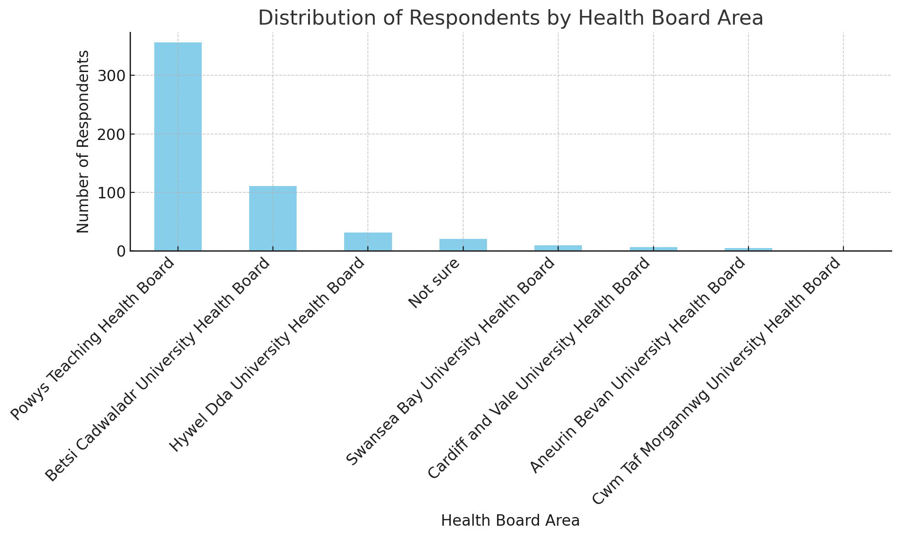
The analysis of the Health Board areas based on the feedback data reveals the distribution of respondents across different Health Boards in Wales. The graph and the data indicate the following distribution:
- PTHB has the highest number of respondents, with 356 entries, indicating a significant interest or concern among individuals in this area regarding the subject of the feedback.
- BCUHB follows with 111 respondents, showing notable engagement from this region as well.
- Hywel Dda University Health Board (HDUHB) has 31 respondents, indicating a moderate level of participation.
- A small number of respondents are Not sure of their Health Board area, totalling 20.
- Other Health Boards like Swansea Bay, Cardiff and Vale, Aneurin Bevan, and Cwm Taf Morgannwg Health Boards have fewer responses, with 9, 6, 5, and 1 respondent respectively.
This distribution highlights a predominant interest and concern among individuals in the PTHB and BCUHB areas. The significantly lower numbers in other Health Board indicate either a lesser awareness of the Review or differing levels of concern about the issues addressed in the feedback.
Age Analysis
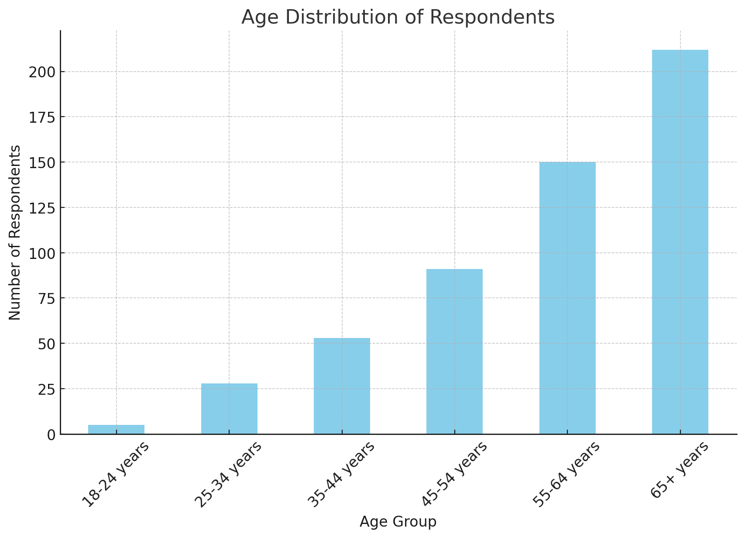
18-24 years: 5 respondents
25-34 years: 28 respondents
35-44 years: 53 respondents
45-54 years: 91 respondents
55-64 years: 150 respondents
65+ years: 212 respondents

The data indicates a higher participation rate among the older age groups, particularly those aged 55 and above, which comprise the majority of the dataset with 362 respondents.

The younger age groups, especially those between 18 and 34 years, have significantly lower representation, with only 33 respondents combined.

The predominant age group, 55-64 years, followed by the 65+ years category, suggests that the feedback collected might be particularly reflective of the priorities, concerns, and perspectives of the older population.

Gender Analysis
The data shows the high levels of feedback from women at 55.9%, followed by 38.8% male, 5.0% preferred not to say, and 0.2% non-binary.
Religion Analysis
The highest proportion of respondents (51.7%) selected Christian, followed by 32.5% with ‘no religion’ and 11.4% selecting ‘prefer not to say’. The data shows lower participation levels among other religious groups as shown in the chart:
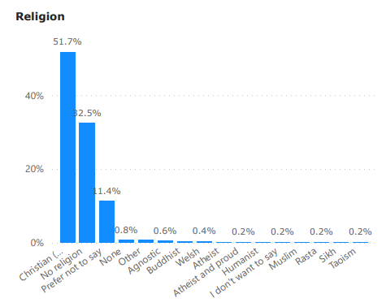

Sexual Orientation Analysis
Data shows a higher participation rate among the ‘Straight or Heterosexual’ group at 82.1% compared to 13.4% who selected ‘prefer not to say’. There is lower participation from groups including bisexual, gay or lesbian,

Disability Analysis
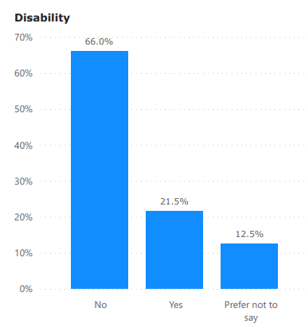
The data indicates that the majority of respondents did not have a disability (66%) compared to 21.5% who answered ‘yes’. 12.5% chose ‘prefer not to say’.

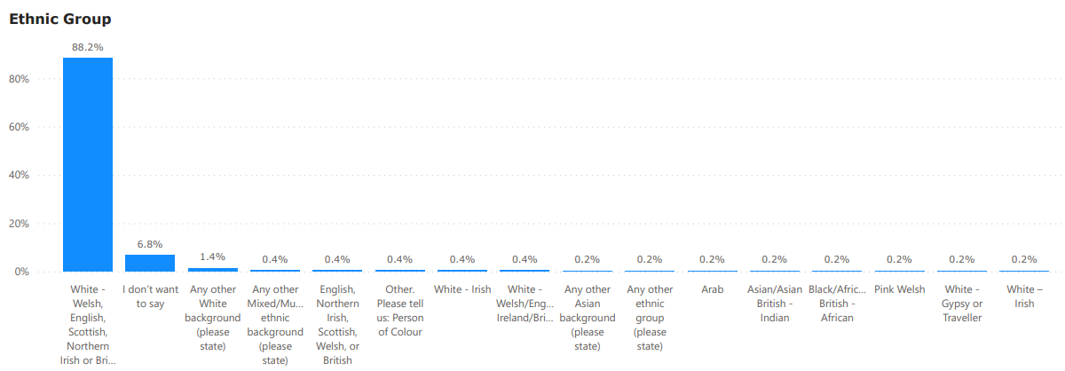
Ethnic Group Analysis

The data shows high participation levels with ‘white’ ethnic groups at 88.2% compared to any other other ethnic group and only followed by respondents ‘preferring not to say’ at 6.8%.

- Engagement Findings

What Public and Stakeholders Said (Thematic Analysis)

Feedback throughout the overall engagement falls into two general categories:
- You.Gov representative sample reflecting a national perspective
- Feedback from all routes and engagement sessions shown in emergent themes reflect localised perspectives from Caernarfon and Welshpool surrounding areas predominantly.

Conclusions of The Picker Institute’s report on feedback (Supporting Document)

This report represents the data collected and collected by Picker for the Emergency Medical Retrieval and Transfer Service Review where the Welsh public were invited to respond, to provide a representative view of public perceptions on what constitutes high quality care relating to the EMRTS. The Picker Institute’s report details the feedback collated and analysed and does not include the feedback gathered by the Commissioner and the EASC Team at the engagement sessions held in person or virtually.

The survey data provides insight into the Welsh public’s priorities for this service. The most important priorities to the Welsh public when considering changes to EMRTS include:
- An effective road response is important to provide cover during the hours of darkness and/or when aircraft can’t fly for any reason;
- If services change, there should be good training and support available for staff to make the best use of their advanced skills;
- Everyone in Wales should have equal access to the service
- Before any change happens, there must be a plan for the service to support patients to the same standard as it does today.
- When asked to prioritise a selection of priority statements, the three top priority statements selected by respondents were:
  - Everyone in Wales should have equal access to the service;
  - The service should be structured to treat as many people as possible
  - before any change happens, there must be a plan for the service to support patients to the same standard as it does today.
These findings highlight that strategic changes should ensure equity and equality of provision of care, with forethought for contingencies incorporated into the planning.
These findings align with the EASC’s overarching values and aims.

Conclusions from EASC led engagement feedback
The feedback gathered by the EASC Team reflect localised perspectives from Caernarfon and Welshpool surrounding areas:
About the first EMRTS Service Development Proposal…
- Feedback – There’s a perception that the proposed changes are driven by cost-saving measures, which raises concerns about potential service cuts. Concerns have been raised about funding any relocation or new base, with worries about resources being redirected from frontline services. There are concerns regarding the initial EMRTS Service Development Proposal, with scepticism about the Rhuddlan model being based on assumptions rather than historical data that could support its coverage and scepticism about the effectiveness of the Rhuddlan base due to its proximity to the coast. There’s a significant concern that relocating base locations from Caernarfon and Welshpool could result in fatalities in those localities due to decreased accessibility to emergency medical services.

About weather and environment…
- Feedback – Concern that merging air bases in north Wales into one could limit service capacity during adverse weather conditions, when flying is restricted and that weather in Rhuddlan base is worse compared to Caernarfon and Welshpool bases. Some suggest relocating the Dafen (Llanelli) base instead, citing weather impacts shared in a weather data report. Concern about continued deterioration of environmental factors (such as flooding) affecting timely response by car to rural areas. Another suggestion is to conduct flood mitigation works at Welshpool to enhance its utilisation.

About the data…
- Feedback – Perception that the original data time reference period was in a ‘Covid pandemic’ year and therefore would not be typical in its demand because of the lockdowns imposed on the public. There was also a perception that the initial EMRTS Proposal was ‘flawed’ and now ‘discredited’ by data modelled and shared in Phase 2 and 3.

About response times…
- Feedback - For those in localities near to Caernarfon and Welshpool bases, there are concerns that the service will take longer to respond if it originates from bases other than Caernarfon or Welshpool. Additionally, there are concerns about the current Rapid Response Vehicle (RRV) locations and their ability to respond effectively. There's also apprehension about the mental and emotional stress patients may experience while waiting for an emergency response from "out of area" if base locations are moved and response times are prolonged. Rural mobile phone coverage is seen as adding delays when calling 999 compared to urban areas. There's a reliance on air support to provide a response within the "golden hour" compared to road response. The perception is that a local base always provides a local response, and any move would impact EMRTS response times for rural patients. Moreover, there's a perception that a base location in mid Wales can reach everywhere quicker across all of Wales due to its central position.

About emergency healthcare needs relating to rural versus urban areas…
- Feedback - There is a perception that if bases move, current local base communities will no longer receive any service from EMRTS. Concerns have been raised about the vulnerability and inequality faced by mid, rural, and coastal communities compared to those closer to better road infrastructures and hospitals. The current bases are perceived as a local lifeline, providing reassurance through their visual presence. Road infrastructure limitations can impede emergency road response by the Welsh Ambulance Service Trust (WAST) due to weather and road closures. There are concerns about the proportion of high-risk jobs and activities in rural areas leading to a higher incidence of need compared to urban areas. Additionally, there's concern about air assets' ability to reach rural areas from north Wales, such as crossing the Eryri (Snowdonia) and Berwyn mountains. Lastly, there's a call for equity to be considered in the evaluation process and framework, given the variable access to health services across Wales.

About EMRTS...
- Feedback - There is overwhelming appreciation for the individuals providing critical-care emergency services. However, there persists a perception that EMRTS primarily operates as a 'fast ambulance/scoop and run service.' Concerns have been raised about EMRTS's specialisation, with suggestions for a more adaptable clinical model to respond to a wider range of conditions in rural and remote areas. There are worries about potential staff turnover if base relocations occur, leading to skill loss and financial expenses in recruitment, as well as local economic impacts. Suggestions for renaming EMRTS to options such as "Flying Doctors," "Air Hospital," or "Flying Hospital" have been proposed. There's also concern about staff morale due to frustrations about not reaching more patients and maintaining clinical competencies. Staff also express a desire to support the critical care hub more.

About Health Boards, Welsh Ambulance Service and other emergency responders…
- Feedback - There is scepticism about service developments made by Health Boards and Local Authorities, with the perception that they are resulting in a worse service. Emergency Medical Retrieval and Transfer Service is seen as providing comfort to communities, especially as delays in handovers affect the Welsh Ambulance Service Trust's ability to respond. There's concern that any base moves could negatively affect other emergency responders in the Powys area. Additionally, there's concern about paramedic staffing levels in mid and rural Wales.

About EMRTS Staff…

- Feedback – All staff are driven by serving patients who need the EMRTS critical care. There appeared to be more interest amongst staff from north and mid Wales than from south based teams based on session attendance. Responses from participants generally fell in two categories: support for developments that would enable as many patients to receive the service as possible, and those who want to maintain the current base arrangements. Staff have different views on how the current high under-utilisation levels affect staff as some feel that not responding to enough jobs adversely affected their clinical proficiency whilst others feel that training scenarios are sufficiently maintain clinical competencies. Some concern expressed about working different shift patterns and the potential loss of skilled staff should any changes take effect and staff did not want to change their base arrangements. Some staff also concerned about optics of ‘leaving communities’ where they have been for some time. Some staff also expressed support for Option 6c.

About the Charity…
- Feedback - There are concerns that the Charity will lose the goodwill of support in base location areas, potentially leading to a decrease in charitable donations and destabilising the partnership service. Additionally, there's concern that the Charity may not support the decision of the EAS Committee. Stakeholder relations and potential reputational damage are also concerning. However, there is expressed support for working with the Charity and Emergency Medical Retrieval and Transfer Service on initiatives such as addressing flooding risks in Welshpool and fundraising efforts. There's a strong sense of support and passion for the service, with a feeling of local "ownership". Moreover, there's a perception that communities in rural and mid Wales are the most generous donors to Charity fundraising efforts.

About Welsh Government and Policy Makers…
- Feedback - There are concerns about the funding of the air ambulance service in Wales, with a view that it should be entirely funded by the Welsh Government. There's a request to consider additional bases and funding rather than relocating existing base locations. Additionally, there's a perception that citizens in mid and rural Wales are disadvantaged compared to those in urban areas in the north and south by public services generally. There's also concern that the new 20mph speed limit will negatively impact road ambulance response times, exacerbating existing challenges. Citizens were keen to see more engagement from Welsh Government.

About the engagement and decision-making processes…
- Feedback - supports the proposed evaluation factors and suggested adjusted weightings for them. There has been a mix of positive and negative sentiment: acknowledgment of the thoroughness, transparency, and delivery of the engagement process; and criticism for alleged ‘bias’ in questionnaire design, and pre-determined decision making. The feedback reflects how the Commissioner has been trusted and seen as someone who keeps promises and is true to their word in this Review. The clear presentation of complex information is appreciated, as is the use of different data ranges and the development of options. The level of detail provided is also appreciated and maintaining openness and transparency throughout was requested. However, feedback received later during the engagement sees some criticism for information being too complicated and some queries and scepticism about the engagement, purpose and approach to the Options Appraisal and decision-making processes.

About Options Developed…
- Feedback - The feedback indicates support for Option 1 (do nothing), suggesting that maintaining the current setup is preferred by majority of respondents from areas near to Caernarfon and Welshpool bases. However, in Phases 2 and 3 there is support for Option 6c (neither option A or B) from PTUHB and BCUHB areas specifically. Option 6c proposes the consideration of a 'forward operating base' for Caernarfon and Welshpool to utilise in any occurrence, including fuel and clinical stock, for added resilience (i.e. for teams to operate from different locations when on shift). There is support for making Welshpool or Caernarfon bases operational 24 hours a day, which would provide an additional night service to better serve the needs of the communities.
There is a consistent view from stakeholders that the gains illustrated in the modelling are too marginal to justify any reconfiguration, especially considering the margin of error with modelled data.
Feedback about Options A and B are set out below.
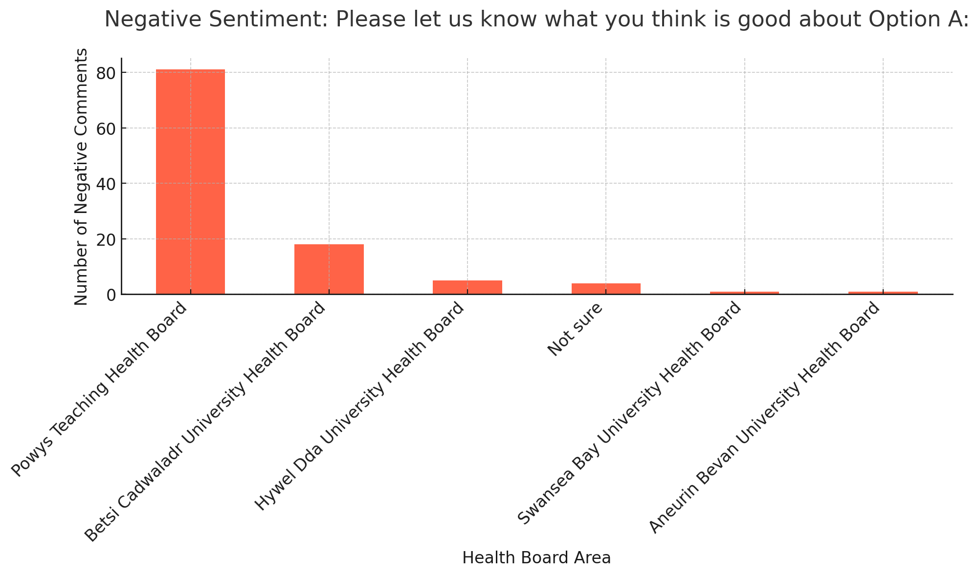
.
‘Good’ about Option A: Despite being a prompt for positive comments about Option A, there was a substantial number of negative sentiments, particularly from the PTHB (81) and BCUHB (18). This indicates that respondents from this area struggled to identify positive aspects of Option A, and their comments were instead reflective of underlying concerns or dissatisfaction. Age groups with the most negative sentiment were predominantly 65+ years (53) and 55-64 years (29).

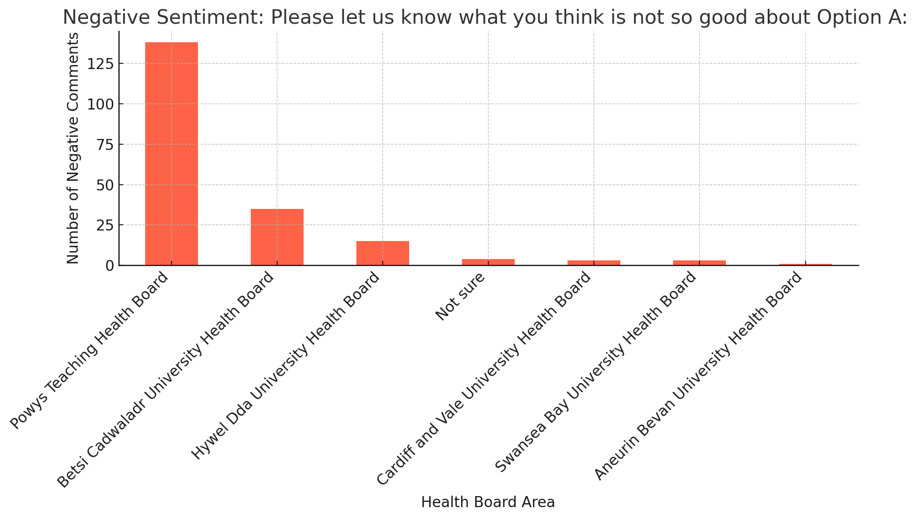
‘Not So Good’ about Option A: A large number of negative comments were noted, again with PTHB leading significantly (138), followed by BCUHB (35. This suggests that the concerns in this area are particularly strong regarding Option A. The age groups 65+ years (72) and 55-64 years (56) showed the most negative sentiment.
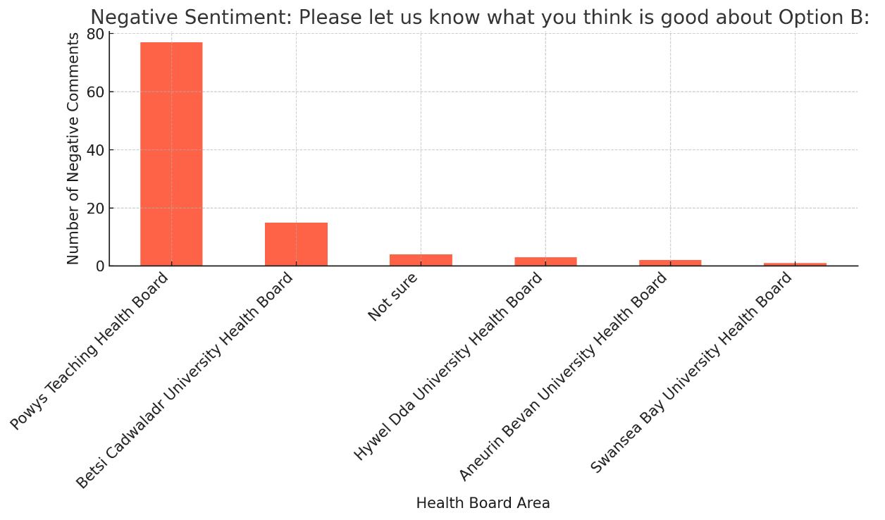
‘Good’ about Option B: Similar to Option A, the prompt for positive comments about Option B still attracted negative sentiments, predominantly from PTHB (77) and BCUHB (15). Older age groups showed more negativity with 65+ years (42) and 55-64 years (33) leading.
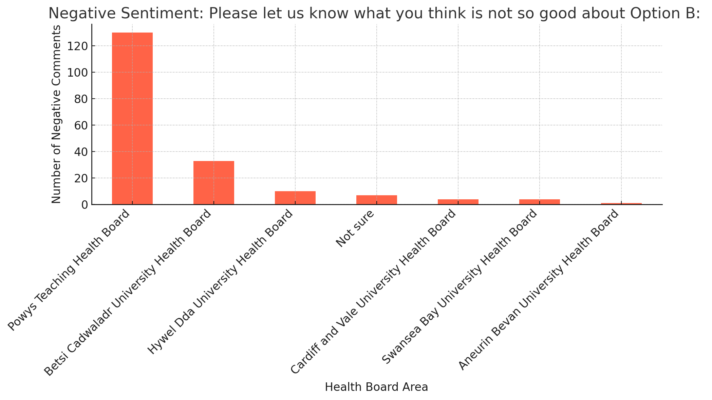
‘Not So Good’ about Option B: This aspect also revealed a high volume of negative comments from PTHB (130) and BCUHB (33). They highlight specific areas of concern or dissatisfaction with Option B among residents, which may require further attention and action. The 65+ years (74) and 55-64 years (51) age groups were again the most represented.
Across all categories, PTHB area consistently stands out with the highest number of comments. This suggests a strong level of dissatisfaction or concern in this area regarding both Options A and B.
The BCUHB area also shows considerable concerns, although less than Powys, indicating it is another key area of concern.
Age-wise, most feedback is from the older age groups, particularly those aged 65+ years and 55-64 years. This trend suggests that these age groups may have specific concerns or expectations that are not met by Options A and B.
The concentration of negative sentiment in these specific Health Board areas and among older age groups could be indicative of areas where additional focus is needed to address concerns, possibly related to healthcare access, quality of services, or communication about the changes proposed in Options A and B.

Equalities Impacts…
- Feedback – Feedback showed a perception of negative impacts for those equalities characteristics including age, disability, gender reassignment, marriage and civil partnership, pregnancy and maternity, race, religion or belief, sex, sexual orientation, carer responsibilities and Welsh Language. There is a belief that changes to operational arrangements would include changes to clinical decision-making and dispatch from 999.

Impact on Well-Being of Future Generations Act
This section summarises some of the impacts on wellbeing that we have heard during the engagement from respondents in the Caernarfon and Welshpool bases surrounding areas:
Wellbeing Goal | Considerations | Examples of Feedback
A globally responsible Wales | People in terms of macro-economic, environmental and sustainability factors: consider the impact of government policies; gross domestic product; economic development; biological diversity and climate  A nation which, when doing anything to improve the economic, social, environmental and cultural well-being of Wales, takes account of whether doing such a thing may make a positive contribution to global well-being. | People regularly expressed concern about the loss of services in their area, often wider than health services but believed that the EMRTS service made them feel safe and secure; often, people supported the need for change to help more people but only if it didn’t mean moving the air base from their locality  Concerns about weather, more frequent flooding affecting ability for road responses.
A resilient Wales | People in terms of their use of the physical environment: consider the impact on the availability and accessibility of transport, healthy food, leisure activities, green spaces; of the design of the built environment on the physical and mental health of patients, staff and visitors; on air quality, exposure to pollutants; safety of neighbourhoods, exposure to crime; road safety and preventing injuries/accidents; quality and safety of play areas and open spaces  A nation which maintains and enhances a biodiverse natural environment with healthy functioning ecosystems that support social, economic and ecological resilience and the capacity to adapt to change (for example, climate change). | Feedback suggested investing in training citizens in healthy lifestyles, first aid/community resilience, and improved driver education to alleviate overall demand on emergency services.  During the engagement process, people regularly raised concerns about the road infrastructure and the high level of road accidents in the local area. They raised concerns about the local industries of farming and forestry work being dangerous with high levels of accidents and incidents.  Less was mentioned about green spaces and the mental health /wellbeing of local people although the potential move of the air base did make them feel less safe.  Some shared another air ambulance consultation - Hampshire Air Ambulance who were consulting with the public to move of the base of their helicopter to an area closer to the densest population, from a rural area. The environmental impacts and shorter journey times for patients were highlighted as well as the ability to provide a better service to the previously location area. This was a topic of interest within the social media groups who believed that the consultation being held was fairer and more open. The work was considered and overwhelmingly provided a very similar set of issues (to the EMRTS Service Review) in trying to get to see more patients but not excluding rural areas. This service provided one helicopter to 1.8million people. The service in Wales operates 4 helicopters to 3.1million people.
A healthier Wales | People being able to improve/ maintain healthy lifestyles: consider the impact on healthy lifestyles, including health eating, being active, no smoking/smoking cessation, reducing the harm caused by alcohol and or non-prescribed drugs plus access to services that support disease prevention (e.g. immunisation and vaccination, falls prevention). Also consider impact on access to supportive services including smoking cessation services, weight management services etc.  A society in which people’s physical and mental well-being is maximised and in which choices and behaviours that benefit future health are understood. | Scepticism expressed about service developments made by Health Boards and Local Authorities, with the perception that they are resulting in worse services. There's concern that any base moves could negatively affect other emergency responders in the Powys area.  Overwhelmingly, local people to the air bases considered themselves much safer in terms of having a local air base. Frequently people misunderstood that EMRTS did not provide a fast ambulance and regularly suggested that this was all that was required. The pre-hospital critical care service meant that many felt this was very important as they did not have a district general hospital
A more equal Wales | A society that enables people to fulfil their potential no matter what their background or circumstances (including their socio-economic background and circumstances).  People being able to access the service offered: consider access for those living in areas of deprivation and or those experiencing health inequalities | Wider discussion was heard in relation to primary care services as well as ambulance services. The low level of performance in the areas was a topic of concern and the potential change for this high-end service seemed to escalate the perceived impact.  A range of potential perceived equality impacts have been identified in the previous  section about emergency health needs for rural communities – with mitigation actions agreed as  appropriate – as part of any decision-making process.
A Wales of cohesive communities | People in terms of social and community influences on their health: consider the impact on family organisation and roles; social support and social networks; neighbourliness and sense of belonging; social isolation; peer pressure; community identify; cultural and spiritual ethos  Attractive, viable, safe and well-connected communities. | Local communities visited had a high-level belonging and use of social networks. The responses reflect the sense of a community asset and the strength of feeling to maintain this. There was balance, that the service should see as many people as possible, as long as this did not move the base.  Many local (to base) respondents suggested that if the base was moved that they would no longer contribute to the Wales Air Ambulance Charity. This was a frequent response which suggested that they felt the service was closing and there would not be a service. Despite reassurances this message appears to be unheard.  Respondents have identified concerns about overall community viability and cohesiveness about public services generally.  They have identified concerns about an erosion of public services that believe will affect people’s choices around moving to or staying in rural areas, and this might affect overall community sustainability.
A Wales of vibrant culture and thriving Welsh language | A society that promotes and protects culture, heritage and the Welsh language, and which encourages people to participate in the arts, and sports and recreation.  People in terms of their use of the Welsh Language and maintaining and strengthening Welsh cultural life | No examples were shared; however, every session had simultaneous translation and 121s had bilingual staff ready to engage with the public. All documents were produced bilingually  There are opportunities to continue to support and develop the service through the medium of Welsh.
A prosperous Wales | An innovative, productive and low carbon society which recognises the limits of the global environment and therefore uses resources efficiently and proportionately (including acting on climate change); and which develops a skilled and well-educated population in an economy which generates wealth and provides employment opportunities, allowing people to take advantage of the wealth generated through securing decent work.  People in terms of their income and employment status: consider the impact and availability and accessibility of work, paid and unpaid employment, wage levels, job security, working conditions | People raised the dangerous occupations regularly.  Respondents expressed concerns that the loss of EMRTS and other health services primary care GP practice premises would affect the number of jobs in the community and also affect the overall attractiveness of the community for businesses, residents etc.

Summary of Emergent Themes
There was good quality dialogue and/or feedback in all sessions - drop-ins, in-person public meetings, and virtual/on-line.

Whilst the focus of the engagement has been on the EMRTS Service Review and how to develop the air ambulance service that is provided in partnership by the Wales Air Ambulance Charity and Emergency Medical Retrieval and Transfer Service Cymru (NHS Wales), throughout the dialogue feedback surfaced that covered health and social care issues more broadly. This has provided rich intelligence shared with colleagues across NHS Wales and Welsh Government.

Many personal experiences and testimonials were shared during the engagement through all response routes. This feedback highlights the value placed on the service and the general sense of anxiety over any proposed base move amongst respondents living in the Caernarfon and Welshpool areas (BCUHB and PTHB.)

It is evident from feedback that there are several common themes and concerns regarding the proposed changes to air ambulance services in Wales, particularly for citizens in the surrounding areas of Caernarfon and Welshpool (i.e. BCUHB and PTHB respectively):
- Dissatisfaction and opposition to the closure of air bases in Welshpool and Caernarfon.
- Concerns about longer response times, reduced coverage, and compromised emergency care, especially in rural and remote areas.
- Criticism of the proposed new location for air ambulance services and doubts about its effectiveness.
- Belief of the impact on rural communities, aging populations, and workers in hazardous professions.
- Risk of decreased donations to the Wales Air Ambulance charity, potentially threatening its sustainability.
- Advocacy for maintaining current air ambulance bases and providing additional RRV coverage to other areas as an alternative to closure.
- Emphasis on equitable access to pre-hospital critical care across all regions of Wales.
- Calls for decision-makers to reconsider proposed options and prioritize the health and safety of residents.
These themes highlight the importance identified by the respondents to the need to address the needs of rural communities and protected characteristic groups, ensuring timely access to pre-hospital critical care and maintaining essential life-saving services across Wales.
Notwithstanding the concerns of the public and stakeholder feedback in these areas there is a consensus of understanding that:
- Un-met patient need must be provided for by the service; and
- Highly skilled clinical teams need to be used in the best way to provide for patients.

In addition, the national feedback concluded the following priorities:
- everyone in Wales should have equal access to the service;
- the service should be structured to treat as many people as possible
- before any change happens, there must be a plan for the service to support patients to the same standard as it does today.

After the engagement phase had concluded, further questions have been raised that are detailed in Appendix C for completeness.
10. Governance and Risk Issues
In conducting this engagement, the EASC Team has followed the Welsh Government’s extant guidance on engagement, with advice from the national leads of Llais, as well as working with communication and engagement and service change leads of NHS Wales Health Boards.
Equality Impact Assessments (EIA’s) were produced at intervals throughout the engagement and were made available to the public. The EIA has been done in line with Cwm Taf Morgannwg University Health Board’s (CTMUHB) process, as the host organisation for EASC.
Feedback from the engagement on equality impacts have been identified and are reflected in the Engagement Findings section and noted in the updated EIA. The themes highlight the importance identified by the respondents to the need to address the unique needs of rural communities, those with protected characteristics under the Equality Act 2010 and those who are socially and economically disadvantaged, ensuring timely access pre-hospital critical care, and maintaining essential life-saving services across Wales. The extra mitigating actions detailed in the Follow Up Actions section detail the mitigations being proposed to address the potential impacts on these groups.
Feedback highlighted perceived negative impacts on various equality characteristics. It is unlikely that the Review will have any specific impact on this as the service is provided to all based on clinical need alone. However, as data regarding EMRTS missions is not available in a format that enables further detailed analysis by equality protected characteristics this cannot be discounted.
Because of the importance of the issues under consideration as a result of this engagement and the strength and breadth of concerns raised, the EAS Committee decided that the preferred and recommended option going to Committee for decision would also be taken back to each respective Health Board for individual Board consideration before a collective Joint Committee decision is made.

The Committee has noted the following risks throughout the Review:
- There is an ongoing risk of delaying service reconfiguration in delivering more critical care to patients across Wales where unmet patient need has been identified as approximately 2-3 patients per day across Wales.
- There is also the matter of ongoing under-utilisation of clinical teams across EMRTS in the context of ongoing unmet patient need across Wales.
- Staff morale within EMRTS as detailed in the feedback.
- Any changes to the planned and agreed engagement and decision-making process and ensuing adjusted timeline could affect the Wales Air Ambulance Charity’s position within the partnership arrangement.
- Potential loss of good will and fundraising support for the Charity.

11. Follow Up Actions
Some of the emerging issues are not within the scope of the Review such as the ‘loss of public services in rural communities’. However, the Commissioner’s role presents a unique opportunity to recommend some mitigations to address some of the issues raised in the engagement.
These mitigations could help to address the issues heard in the public engagement about concerns that:
- WAST services are regularly being pulled out of area and lengthy handover delays negatively affecting ability to respond to communities
- Mid, rural, and coastal communities are more vulnerable and ‘less equal’ than those in urban areas (that are found closer to better road infrastructures and general hospitals) and therefore need something more tailored to suit their rural needs
- EMRTS is too specialised. The service could respond to a wider range of conditions in rural and remote areas through a more tailored clinical response model
- Paramedic staffing levels in mid and rural north Wales are difficult
- EMRTS staff retention could be negatively affected with any base moves
- The Charity could lose the goodwill of support in base location areas. The impact on charitable donations could reduce and destabilise this important service
- The vulnerability of rural communities generally (the sense of ‘all other services have been lost already’)
- Current bases seen as a ‘local lifeline’ and seeing the air ambulance is reassuring to communities.
These mitigations have developed throughout the engagement process. They have surfaced in response to the extensive listening during earlier engagement phases, as detailed in the list above. The mitigations involve placing bespoke road-based enhanced and/or critical care services in rural and remote areas. This could give better geographical coverage. These mitigations could be taken within normal ‘business as usual’ arrangements and therefore with no added costs. This forms Recommendation 4 in the Review.

12. Conclusions
The engagement exercise has engendered considerable public interest and significant overall numbers of participants/responses between March 2023 and February 2024 inclusive.
The emerging themes of feedback has been consistent throughout all three phases of engagement with little variation between phases. The feedback received in the most recent engagement – Phase 3 – has not identified anything materially different from earlier phases.
A number of key issues and themes have been identified, which have been useful in informing future plans and actions:
- The majority of responses from PTHB and BCUHB areas specifically have expressed concern about any base location changes to Welshpool and Caernarfon respectively, believing that they would have a detrimental impact on people living in these areas being able to receive the service.
- The representative sample survey of Wales (via the Picker Institute) presented a national perspective and showed support for everyone in Wales having equal access to the service, structured to treat as many people as possible, with a plan for the service to support patients to the same standard as it does today.
Feedback from all engagement phases have been considered at each stage and has helped the development of a preferred and recommended option for Health Board consideration and Committee decision as detailed in the EMRTS Service Review document.

If the operational base changes do go ahead there is potential for adverse impact on some EMRTS staff, who may not want to change their operational bases; and the Charity, which may lead to a reduction on charitable donations.
The Committee, EMRTS and the Charity should consider options for monitoring these potential impacts so that action to address this service sustainability can be kept under review. A schedule for reporting to EMRTS staff, Llais and communities on progress to deliver agreed mitigations and on monitoring these possible impacts should be agreed.

13. Next Steps
This Engagement Report will be shared with the EAS Committee at the meeting on 19 March 2024 along with the EMRTS Review document, updated EIA, written feedback from Llais and Committee paper. All Health Boards will consider the same papers prior to an extraordinary committee meeting being held on 28 March 2024 to consider feedback from these meetings and to make a decision on the way forward.
A review and learning session will be held to reflect on the experience of this engagement and help inform the wider development of the Committee’s approach to continuous engagement and involvement.

Contact Details

The Chief Ambulance Services Commissioner and the Emergency Ambulance Services Committee team can be contacted in the following ways:

In writing: Emergency Ambulance Services Committee
Unit 1,
Charnwood Court,
Billingsley Road,
Nantgarw Park,
Cardiff, CF15 7QZ

Email: EASCServiceReviewQueries@wales.nhs.uk

Phone: 01443 471520

Website: www.easc.nhs.wales

APPENDIX A - Phase 1 Sessions Timetable

Venue | Format | Date | Times
Bear Lanes Shopping Centre, Broad St, Newtown SY16 2QZ  Tesco, Pool Rd, Newtown SY16 1DW | Drop-Ins | Tue 04 April | 9.30am-1.30pm  11am-3pm
The Monty Club, 11 Broad St, Newtown  SY16 2LU | Public Meetings | Tue 04 April | (2 sessions)  5.30pm-6.30pm  7pm-8pm
Microsoft Teams | Virtual Public Meeting | Tuesday 11 April | 12.30pm-1.30pm
Microsoft Teams | Virtual Public Meeting | Tuesday 11 April | 6pm-7pm
Welshpool Town Hall,  High Street, Welshpool  SY21 7JQ | Drop In | Thursday 13 April | 11-2pm
Royal Welsh Showground – Members Centre Builth Wells | Public Meeting | Thursday 13 April | (2 sessions)  5.30pm-6.30pm  7pm-8pm
Microsoft Teams | Virtual Public Meeting | Monday 17 April | 12.30pm-1.30pm
Microsoft Teams | Virtual Public Meeting | Monday 17 April | 6pm-7pm
The Community Hall, Bowling Green Ln, Knighton LD7 1DR | Public Meeting | Tuesday 18 April | 6pm-7pm
Microsoft Teams | Virtual Public Meeting | Thursday 20 April | 12.30pm-1.30pm
Microsoft Teams | Virtual Public Meeting | Thursday 20 April | 6pm-7pm
Welshpool Town Hall, High Street, Welshpool SY21 7JQ | Drop In | Wed 26 April | 11-3pm
Welshpool Town Hall, High Street, Welshpool SY21 7JQ | Public Meeting | Wed 26 April | (2 sessions)  5.30pm-6.30pm  7pm-8pm
Byw'n Iach Glan Wnion (Fitness & Sports) Dolgellau, Arran Rd, Dolgellau, LL40 1LH | Drop In | Thursday 27 April | 12-3pm
The Celtic Royal Hotel Caernarfon | Public Meeting | Thursday 27 April | 5.30pm-7pm
Ysgol Glan Y Mor, Pwllheli, LL53 5NU | Public Meeting | Friday 28 April | 7-8pm
Eagles Meadow Shopping Centre, Smithfield Rd, Wrexham LL13 8DG | Drop In | Wed 03 May | 12pm-3pm
Holt Lodge, Wrexham Rd, Holt, Wrexham  LL13 9SW | Public Meeting | Wed 03 May | 5.30pm-7pm
Bayview Shopping Centre, Sea View Rd, Colwyn Bay LL29 8DG | Drop-In | Thursday 04 May | 10am-2pm
Byw'n Iach Bro Dysynni, High St, Tywyn  LL36 9AE | Drop-In | Thursday 04 May | 10am-2pm
Microsoft Teams | Virtual Public Meeting | Monday 15 May | 1pm – 2pm
Microsoft Teams | Virtual Public Meeting | Monday 15 May | 6pm – 7pm
Aberystwyth Football Club Park Avenue, Aberystwyth SY23 1PG | Public Meeting | Wednesday 17 May | 6pm – 7pm
Microsoft Teams | Virtual Public Meeting | Thursday 18 May | 12.30pm – 1.30pm
Microsoft Teams | Virtual Public Meeting | Monday 22 May | 1pm – 2pm
Y Plas, Machynlleth, Powys, SY20 8ER | Public Meeting | Tuesday 23 May | (2 sessions)  5.30pm-6.30pm  7pm-8pm
Byw'n Iach Bro Dysynni (Fitness Centre), High Street, Tywyn, LL36 9AE | Public Meeting | Wednesday 24 May | 6.30pm-7.30pm
Ysgol Uwchradd Bodedern, Bro Alaw, Bodedern, Ynys Môn, LL65 3SU | Public Meeting | Thursday 25 May | 6pm-7.30pm
Microsoft Teams | Virtual Public Meeting | Wednesday 31 May | 1pm – 2pm
The Monty Club, 11 Broad St, Newtown  SY16 2LU | Public Meeting | Monday 05 June | 6pm-7.30pm

APPENDIX B - Phase 2 Sessions Timetable

Venue | Format | Date | Time
Welshpool Town Hall  42 Broad St, Welshpool, SY21 7JQ | Public Drop-in | Thursday 12 October 2023 | 12:00 - 15:00
Welshpool High School  Salop Rd, Welshpool, SY21 7RE | Public Meeting | Thursday 12 October 2023 | 18:30 - 19:30
Theatr Hafren - Newtown Campus  Llanidloes Rd, Newtown, SY16 4HU | Public Drop-in | Friday 13 October 2023 | 12:00 - 15:00
Newtown High School  Dolfor Road, Newtown, SY16 1JE | Public Meeting | Friday 13 October 2023 | 18:30 - 19:30
Machynlleth Rugby Club  Plas Grounds, Bank Lane, Machynlleth, SY20 8EL | Public Drop-in | Monday 16 October 2023 | 12:00 - 15:00
Ysgol Bro Hyddgen  Greenfields, Machynlleth, SY20 8DR | Public Meeting | Monday 16 October 2023 | 18:30 - 19:30
Bangor City Council Offices  Ffordd Gwynedd, Bangor, LL57 1D | Public Drop-in | Tuesday 17 October 2023 | 12:00 - 15:00
Bangor City Council Offices  Ffordd Gwynedd, Bangor, LL57 1D | Public Meeting | Tuesday 17 October 2023 | 18:30 - 19:30
Plas Heli  Glan y Don Industrial Estate, Yr Hafan, Pwllheli, LL53 5YT | Public Drop-in | Wednesday 18 October 2023 | 12:00 - 15:00
Ysgol Glan Y Mor  Pwllheli, LL53 5NU | Public Meeting | Wednesday 18 October 2023 | 18:30 - 19:30
Microsoft Teams Live Event (Joining Link) | Virtual Public Meeting | Thursday 19 October 2023 | 18:30 - 19:30
Microsoft Teams Live Event (Joining Link) | Virtual Public Meeting | Friday 20 October 2023 | 13:00 - 14:00

APPENDIX C – Further Queries

Following the engagement phase – further questions have been raised: | CASC/Commissioner Response
Mission Creep / Narrative slippage Case for change and not understanding why; use of old data | The EMRTS Service Review has comprehensively reviewed the EMRTS service which was started afresh.  The level of unmet need for patients remains between 2 and 3 people per day.  The review identifies clearly why doing nothing is not a viable option.
Fait accompli of options provided for the ‘desired result’ | As requested by EASC – HB representatives were nominated and attended the Option Appraisal workshop where all six options were assessed.  Two clear top scoring options emerged and additional criteria were identified as needing to be developed
The Unmet Need – questioning the numbers and how these vary across Wales | This is correct – the change, if approved, will not meet all unmet need but will make inroads into reducing the level. The issue of unmet need is addressed in the Review document.
Lack of clarity on additional scene attendances (not worth the effort of moving a base) | 5 criteria have been used to assess options and additional factors identified in the engagement process – have also been taken into account. As stated, this is not just about chasing numbers.
No robust evidence of clinical outcomes for the unmet need cohort | Service evaluation report included in the Review which clearly described beneficial clinical outcomes.
Underutilisation and dispatch protocols disadvantaging mid /north assets | Utilisation and dispatch protocols included in the Review.
No rationale for reorganisation | Case for change and rationale included in the Review.
The ‘additional extras’ – no opportunity for the public to comment on the detail (within the consultation process) | Recognised and included in the Review.
Separate additional critical care provision in rural Wales from this unnecessary centralisation | It is difficult to separate the issue, but considered in the Review
The Scoring/Ranking Workshop - why hold a workshop? And only identify 2 preferred options and challenge on the impartiality of the process and the ‘experts’ in attendance | Phase 1 and 2 recognised the need to evaluate options against a range of key criteria - factors and weightings. EASC agreed that health boards should participate and nominated key senior staff to attend, from a range of disciplines
Members of the Air ambulance charity and EMRTS were present at the workshop to answer technical questions and did not take part in the scoring of the options. Details of the workshop are included in the Review
The workshop was well evaluated by the representatives
Detailed information was made available prior to the workshop
Option appraisal workshops are a key element to Review processes
The EASC team and myself did not participate in the scoring of the options.
No public participation in the Option Appraisal Workshop | The public were asked to comment on the factors, weightings and options in phase 2 prior to the workshop. The weightings were amended in line with the feedback received.
The Preferred Options - little variation between option A and B | This was the result of the Option Appraisal Workshop which I carried out fairly and consistently
Claims of improved services being unsubstantiated and reduced population coverage | This is factually incorrect
Risk of both aircraft off line at once and weather issues | Weather information previously shared, risk of consolidating assets in one base understood
Potential loss of skilled staff, impacting recruitment and retention | Recognised and included as a factor in the option appraisal
The loss of the aircraft as an ‘anchor’ for Critical Care services in Mid and North West Wales | Not clear what this means as aircraft will not be lost - this is an all Wales pre hospital critical care service
Irreversibility of the change | Recognised and understood
The lack of a proven, sustainable model for RRV provision to/in Mid and North West Wales when the aircraft is offline, and the inability of the RRVs to attend incidents across a substantial area of Mid/North West Wales if centrally based at Rhuddlan. | Agree - the location of RRVs is critical for the population of the whole of mid and north Wales
Additional flying time and topography | These are taken into account in the report
The Questionnaire was ‘leading’ and the document was overly long at 80+ pages and did not meaningfully engage with the public; suggestions for other ways of engaging were provided | Every effort was made to ensure that all of the relevant information was shared. Engagement leads in health boards supported the work and it was in line with best practice  An easy read version was produced to help all members of the communities and there were 11 ways of responding to the engagement including by telephone and email
Ministerial Oversight – Llais asked to take up concerns raised with the Minister | Noted
Need for ongoing monitoring, benchmarking and appraisal of the new operating model to be independent of EMRTS and Charity management | Agree - commissioning approach
Raised issues in relation to the Wales Air Ambulance Charity; damage to the brand; raising funds | These are matters for the Charity – however, they are trusted and key partners and provide 2/3 of the funding for this amazing service
Our preferred option from the consultation shortlist continues to be Option 6. We strongly believe that the only acceptable option would see the retention of 4 separate crewed air bases, with helicopters and RRV backup, at their current geographical distribution, and would wish to see this provision enhanced in order to meet the unmet need identified, especially through the development of a ‘late shift’ (or potentially 24 hour operation) in Mid/North Wales and the provision of a RRV capable of responding to the needs of the more urban-based population of North East Wales. | Noted
Following consideration of points raised in your most recent report however, we understand and appreciate the shortcomings of Option 6. | Noted
Preferred options – additional new options for Caernarfon and Welshpool including relocation of Caernarfon | Recommendations have been made in the Review

