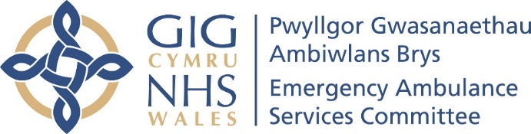

Equality Impact Assessment Tool
EASC EMRTS Service Review

EMRTS SERVICE REVIEW – FINAL REPORT

This EIA builds on the previous iterations during Phases 1, 2 and 3 of the formal engagement processes held during 2023 and 2024.

Section 1 – Preparation
1. | Title of service -  EMRTS Service Review Final Report | Emergency Ambulance Services Committee (EASC) Service Review of the Emergency Medical Retrieval and Transfer Service (EMRTS Cymru) who are commissioned to provide advanced decision-making and critical care for life or limb-threatening emergencies that require transfer for time-critical treatment at an appropriate facility.  It is important to note that the way patients receive the EMRTS Service will not change (from the current position) – this is a specialist emergency pre hospital critical care all Wales service which is provided by bringing expertise to the patient wherever the incident occurs. The service is accessed by ringing 999 for the ambulance, the call is screened and the appropriate emergency response is provided depending on clinical need.  The EMRTS Service Review, led by the Chief Ambulance Services Commissioner was commissioned by EASC in December 2022 following receipt of the EMRTS Service Development Proposal which was presented to EASC on 8 November 2022. Members of EASC asked for additional scrutiny which led to the EMRTS Service Review.  The (then) Community Health Councils in Wales requested that an 8 week formal engagement process should take place to allow opportunity for the public to engage with the work.  This EIA updates the previous iteration developed for Phases 1, 2 and 3 of public engagement and are attached for ease of reference.  Phases of engagement  Phase 0 – October 2022 to March 2023  This was a pre engagement phase to aid understanding and create optimal conditions for engagement dialogue.  Phase 1 – March - June 2023 (14 weeks) (now working with Llais) The engagement (you are telling us) was to gather feedback on factors, weightings and other suggestions to inform the options to be developed.  Phase 2 – October 2023 – December 2023 (5 weeks)  This was about sharing (what we are doing) outlining the options developed from Phase 1 feedback, seeking public and stakeholder comments on options developed, before recommended option going forward to EASC for decision.  Phase 3 – 1 to 29 February 2024 (4 weeks)  Seeking views on the six options shortlisted and evaluated in the Options Appraisal Workshop and allowing the public to comment on the two shortlisted options – Options A and B. It also included the additional actions that had been identified to address the public feedback received from Phase 1 and 2.  In summary  - 23 weeks of formal engagement was undertaken  - 45 engagement sessions  - more than 1000 engagement session attendances  - more than 2,500 responses submitted via all feedback routes.  Update reports have been provided to every meeting of the Emergency Ambulance Services Committee  https://easc.nhs.wales/the-committee/meetings-and-papers/  The Joint Committee of all health boards in Wales agreed to a phased approach to the work to develop the EMRTS Service Review, led by the Chief Ambulance Services Commissioner.  The EIA for the Phase 3 engagement which followed the Phase 2 Chief Ambulance Services Commissioner’s Report that set out the developed Options based on the feedback from the first phase of engagement that took place between March and June 2023. It was a summary overview document of the work undertaken and was accompanied by several detailed factual and technical documents that provided further information, all of which remain available on the EASC website.  A report was also commissioned from the Picker Institute to provide an all Wales Public Engagement Survey which was undertaken using YouGov. The aim of this work was to provide a representative view of public perceptions on what constitutes high quality care (further information included in section 7).  Phase 2 engagement continued in listening to the public and stakeholders of the public engagement in October and November 2023 where developed options were shared from what was heard in Phase 1. Both EMRTS staff and the Wales Air Ambulance Charity (WAAC) were stakeholders in this Review and their feedback has been considered within the process alongside all feedback received.  Phase 2 gathered more feedback on the options that were developed to further improve the air ambulance service in Wales, and this had been considered alongside taking each option through the agreed evaluation framework in an Options Appraisal Workshop.  The Options Appraisal Workshop took place on 12 January 2024 and involved representatives from Health Boards and NHS Trusts in Wales. This resulted in a short list of two options that included a preferred option and the Phase 3 engagement aimed to gather feedback from the public in line with the previous approach.
1. | Options Workshop – identified Six Shortlisted options  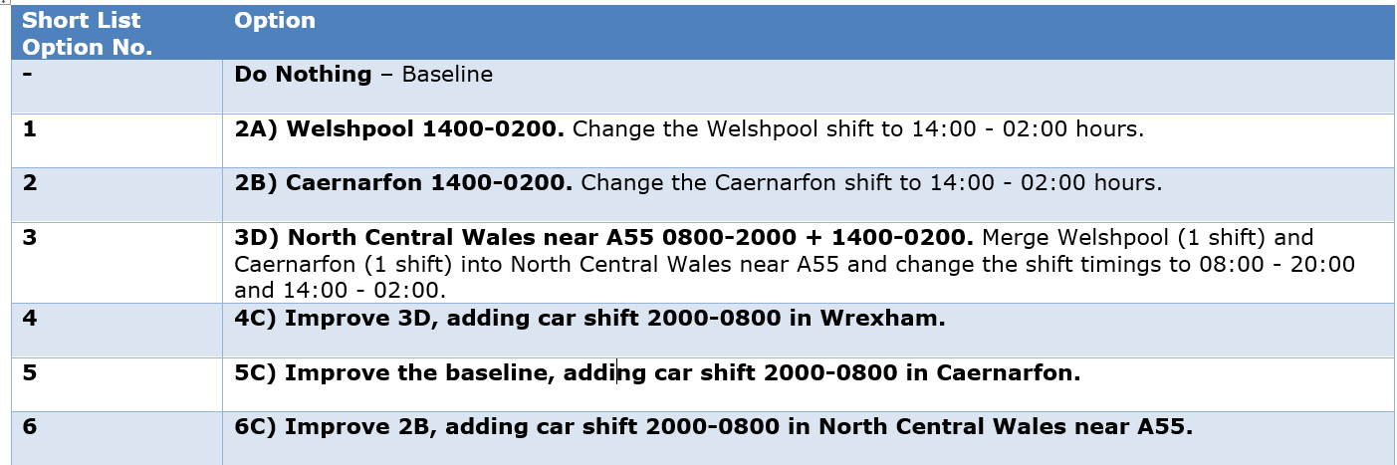  Best scoring Options were 3 & 4 which in phase 3 are referred to as Option A and B within the Phase 3 documentation.  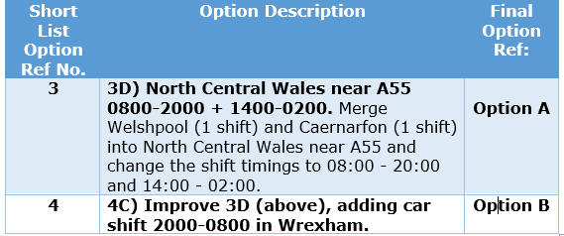  Phase 3 engagement asked for comments on the six options shortlisted, the two highest scoring options, and feedback about the process.  CASC Response to Phase 3 Engagement  Each week a snapshot report was developed for EASC Members, which was shared with Llais and also the communication, engagement and service change leads in health boards. Each week, information was provided within a PowerBI in order than information could be examined by each health board. A summary was also provided of any engagements undertaken by the Chief Ambulance Services Commissioner.  Email attached of weekly emails sent to EASC members and health boards  Composite PowerBI report attached of all feedback received  Summary of all engagement carried out in Phase 3 by the Chief Ambulance Services Commissioner  Summary of Phase 3 - overall 568 responses  Feedback was received in a number of ways – all feedback was considered equally important no matter which way it was submitted:  - the online questionnaire  - completed questionnaire emailed toEASCServicereviewqueries@Wales.nhs.uk  - hard copy questionnaire received at the National Collaborative Commissioning Unit  - telephone messages  - online query form from the EASC website (SDP query)  https://easc.nhs.wales/engagement/sdp/  - direct emails to the EASCServicereviewqueries@Wales.nhs.uk  - Letters  - Online questionnaire - easy read version  - a completed easy read questionnaire emailed to  EASCServicereviewqueries@Wales.nhs.uk  Consistent feedback was received in Phase 3 (as with Phases 1 & 2) concerns included opposition to closing bases, closing services, distance from hospitals, would lead to a loss of lives, impact on Charity donations, timely treatment affected, whether decision already made, no consideration for rural areas, hazardous occupations, roads, accessibility and geography, quick ambulance response, personal stories emphasise life-saving impact – frustration, disappointment and plea to reconsider the proposal – particularly from the communities near to Caernarfon and Welshpool bases. Questions were also raised about the engagement process and the questionnaires.  It is evident from the public feedback in phase 3 that there were several common themes and concerns regarding the proposed changes to air ambulance services in Wales. Here are the key themes:  - Dissatisfaction and opposition to the closure of air bases in Welshpool and Caernarfon.  - Concerns about longer response times, reduced coverage, and compromised emergency care, especially in rural and remote areas.  - Criticism of the proposed new location for air ambulance services and doubts about its effectiveness.  - Belief of the impact on rural communities, aging populations, and workers in hazardous professions.  - Risk of decreased donations to the Wales Air Ambulance charity, potentially threatening its sustainability.  - Advocacy for maintaining current air ambulance bases and providing additional Rapid Response Vehicle (RRV) coverage to other areas as an alternative to closure.  - Emphasis on equitable access to pre-hospital critical care across all regions of Wales.  - Calls for decision-makers to reconsider proposed options and prioritize the health and safety of residents.  These themes highlight the importance identified by the respondents to the need to address the needs of rural communities, ensuring timely access pre hospital critical care, and maintaining essential life-saving services across Wales.
1. | Is this a new policy/service or a policy/service development? | EMRTS is an existing service which is clinically led and managed. EMRTS Cymru has been commissioned by the Emergency Ambulance Services Committee since 2015 and as part of their commissioning are required to meet specific commissioning intentions to review and improve services. The EASC EMRTS Service Review has scrutinised the:  - Geographical coverage  - Rapid Response Vehicle Usage (RRV)  - Utilisation (some bases are busier than others)  - Unmet need (2-3 people a day would benefits from the EMRT Service but do not received one).  The Review has recommended that the service could be developed to provide EMRT services to more people if changes were made to bases. The final 4 recommendations are as follows:  Recommendation 1 – The Committee approves the consolidation of the Emergency Medical Retrieval and Transfer Services currently operating at Welshpool and Caernarfon bases into a single site in North Wales.  Recommendation 2 - The Committee requests that the Charity secures an appropriately located operational base in line with the findings of the EMRTS Service Review Report.  Recommendation 3 - The Committee requires that a joint plan is developed by EMRTS and the Charity, that maintains service provision across Wales during the transition to a new base and that this plan is included within the Committee’s commissioning arrangements.  Recommendation 4 – The Committee approves the development of a commissioning proposal for bespoke road-based enhanced and/or critical care services in rural and remote areas.
2. | Service Aims and Brief Description | EMRTS Cymru working with the Wales Air Ambulance Charity has been reviewing its service to comply with the Commissioning Intentions set by the Emergency Ambulance Services Committee  The service aim is to:  - provide advanced decision-making and critical care for life or limb-threatening emergencies that require transfer for time-critical treatment at an appropriate facility.  This highly specialist critical care service is about 0.7% of all 999 emergency calls to the Welsh Ambulance Services NHS Trust.  The Service Development Proposal presented to EASC on 8 November 2022 identified opportunities to significantly improve services, although, this would involve closing two air bases and opening a new combined base in mid north Wales.  The EASC agreed that more scrutiny was required and the EASC Team, led by the Chief Ambulance Services Commissioner were asked to scrutinise the work. This has led to the EASC Service Review of EMRTS.  The EIA of the original service development proposal is added here:  Mission Data for EMRTS  Information from the EMRTS Annual Reports (below) https://emrts.nhs.wales/about-us/key-documents1/
Overview of the EMRTS Services – Annual Missions

 | Male | Female | Paediatric | Median | Age Range
2015-2016 | 69% | 31% | 16% | 47 | 0-97
2016-2017 | 70% | 30% | 27% | 46 | 0-98
2017-2018 | 68% | 32% | Not available | 46 | 0-96
2018-2019 | 67% | 33% | 12% | 45 | 0-97
2019-2020 | 66% | 34% | 12% | 49 | 0-101
2020-2021 | 66% | 34% | 9% | Not available | Not available
2021-2022 | 68% | 32% | 14% | Not available | Not available
2022-2023 | 67% | 33% | Not available | Not available | Not available
Patient incident location by Health Board
AB – Aneurin Bevan University Health Board; BCU – Betsi Cadwaladr University Health Board; CV – Cardiff and Vale University Health Board; CTM – Cwm Taf Morgannwg University Health Board; HD – Hywel Dda University Health Board; ABM / SB now Swansea Bay University Health Board (previously Abertawe Bro Morgannwg – which ended in 2019); P - Powys Teaching Health Board.

 | AB | BCU | CV | CTM | HD | ABM/SB | P | England
2015-2016 | 10% | 14% | 7% | 7% | 18% | 23% | 19% | 2%
2016-2017 | 12% | 16% | 6.5% | 4.5% | 19% | 21% | 19% | 2%
2017-2018 | 10% | 31% | 8% | 6% | 15% | 14% | 15% | 1%
2018-2019 | 13% | 27% | 13% | 6% | 15% | 15% | 10% | 1%
2019-2020 | 13% | 25% | 14% | 10% | 14% | 13% | 9% | 2%
2020-2021 | 19% | 16% | 19% | 15% | 11% | 13% | 6% | 1%
2021-2022 | 18% | 20% | 19% | 14% | 13% | 12% | 6% | 2%
2022-2023 | 20% | 17% | 17% | 14% | 13% | 10% | 7% | 2%
Patient destination by Health Board
AB – Aneurin Bevan University Health Board; BCU – Betsi Cadwaladr University Health Board; CV – Cardiff and Vale University Health Board; CTM – Cwm Taf Morgannwg University Health Board; HD – Hywel Dda University Health Board; ABM / SB now Swansea Bay University Health Board (previously Abertawe Bro Morgannwg – which ended in 2019); P - Powys Teaching Health Board.

 | AB | BCU | CV | CTM | HD | ABM  SB | P | NHS England | Left in community
2015-2016 | 6% | 8% | 21% | 5% | 9% | 26% | 1% | 24% | 19%
2016-2017 | 7% | 8% | 21% | 4% | 9% | 28% | 1% | 22% | 26%
2017-2018 | 6% | 25% | 16% | 6% | 9% | 21% | <1 | 17% | 23%
2018-2019 | 7% | 21% | 20% | 6% | 10% | 19% | <1 | 17% | 15%
2019-2020 | 4% | 18% | 24% | 5% | 7% | 18% | <1 | 24% | 29%
2020-2021 | 4% | 18% | 24% | 5% | 7% | 18% | <1 | 24% | 29%
2021-2022 | 7% | 12% | 38% | 7% | 7% | 14% | 1% | 14% | 32%
2022-2023 | 9% | 12% | 38% | 7% | 7% | 11% | <1 | 16% | 19%

The table below shows the year age profile by bands/percent for 2019-2023 inclusive
(Source – EMRTS Team mission information). Age profile per HB area attached at Appendix 3.
Age group | Percentage in age groups 2019-2023
0-4 | 6.3%
5-9 | 1.9%
10-14 | 3.0%
15-19 | 4.6%
20-24 | 5.2%
25-29 | 5.4%
30-34 | 5.6%
35-39 | 6.1%
40-44 | 5.8%
45-49 | 6.3%
50-54 | 7.3%
55-59 | 8.8%
60-64 | 8.0%
65-69 | 7.2%
70-74 | 6.1%
75-79 | 6.3%
80-84 | 3.6%
85-89 | 1.7%
90-94 | 0.6%
95-99 | 0.1%
Total | 100.0%

Data regarding EMRTS missions is not available in a format that enables further detailed analysis by equality protected characteristics.
However, the main mission categories (as below) are:
- Road incidents: there is evidence that socio-economically deprived areas suffer more than affluent areas in terms of road incidents. Road traffic related injuries, particularly for child pedestrians, are among the greatest of all health inequalities, with much higher rates in children from families led by parents in unskilled employment or from deprived neighbourhoods (source: EM template for sub leg (senedd.wales))
- Cardiac arrest: the risk of cardiac arrest increases with age and is also associated with higher levels of deprivation
- Other trauma: this is a broad category including multiple trauma incidents and equality profiling information is not available
- Falls: the risk of falling increases with age and can be more common amongst those experiencing disabilities and health conditions associated with gait and mobility including neurological conditions.
Types of incidents
Incidents attended include the following:
(Source: Service Evaluation of the Emergency Medical Retrieval & Transfer Service (EMRTS) Cymru (nhs.wales) page 20).
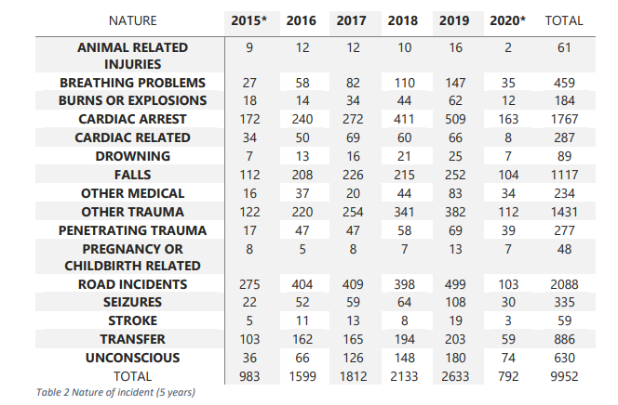
Cases attended by category are also included in the Information from the EMRTS Annual Reports (below) https://emrts.nhs.wales/about-us/key-documents1/

Summary information setting out the demographic profile of the people of Wales based on 2021 census information is available from the NOMIS website: 2021 Census Profile for Wales.
Information at local authority level is also available from the NOMIS website and from the StatsWales website at StatsWales Equality data.

Given that there is some evidence that mission categories attended by EMRTS may have a direct association with equality factors such as age, deprivation and disability, the EASC team co-ordinated engagement activity at a national level primarily through digital and stakeholder channels, and health boards were also asked to amplify this through their local channels with a particular focus on key audiences who may not have digital access. Materials were provided in a range of formats including easy read in order to increase opportunities for participation.
3. | Who Defines the Service? - | The EASC EMRTS Service Review is being led by Stephen Harrhy, Chief Ambulance Services Commissioner on behalf of the Emergency Ambulance Services Committee. EASC also has an independent Chair, Dr Chris Turner.  - The national director for EMRTS Cymru is Professor David Lockey.  - The Wales Air Ambulance Charity Chief Executive is Dr Sue Barnes.  Together, working in partnership the EMRTS Cymru service has developed to its current position.
4. | Who is Involved in undertaking this EqIA? | Gwenan Roberts, EASC Committee Secretary  Stephen Harrhy, Chief Ambulance Services Commissioner  Ross Whitehead, Deputy Chief Ambulance Services Commissioner, EASC Team  Lee Leyshon, Deputy Director of Communication and Engagement, EASC Team  Matthew Edwards, Head of Commissioning and Performance EASC Team  Ricky Thomas, Head of Informatics, National Collaborative Commissioning Unit.  Advice given by members of the All Wales Health Board Communications, Engagement and Service Change Group
5. | Other Policies and Services | Phase 3 engagement completed on 29 February 2024 and the Chief Ambulance Services Commissioner has taken into account the feedback received and made recommendations for presentation at the EASC meeting on 19 March 2024. This meeting will take place prior to consideration by health boards and therefore a further meeting of EASC has been arranged on 28 March 2024 for the final decision making, taking into account the views of all health boards in Wales.  The aim of the recommendations will be to enhance the EMRTS ability to provide advanced decision-making and critical care for life or limb-threatening emergencies that require transfer for time-critical treatment at an appropriate facility.  This is an all-Wales pre hospital critical care service provided from four bases across Wales.  EASC agreed on four specific areas related to base activity, these were:  - Geographical coverage  - Rapid Response Vehicle Usage (RRV)  - Utilisation (some bases are busier than others)  - Unmet need (2-3 people a day would benefits from the EMRT Service but do not received one).  These have been completed and have been presented during the phases of public engagement and there has been significant feedback particularly from Powys and Betsi Cadwaladr health board residents.  The service works closely with the Welsh Ambulance Services NHS Trust (also commissioned by the EASC) and with health boards. There is also mutual aid between the air ambulances services in the UK where they help each other at time of need and where it is possible to do so.
7. | What might help/hinder the success of the service? | The impact of the original service development proposal was to raise concerns in local rural communities in mid and north west Wales and that they would lose their air base and they believed therefore the service itself. This led to the development of Facebook social media pages in support of maintaining the status quo – Welshpool page has over 10,000 followers and over 6,000 followers for the Caernarfon base.  The public feedback has not changed throughout the engagement phases despite assurance given that ‘if patients receive a service now, they will also receive if a change were made’.  The service is highly valued by the people of Wales and the Wales Air Ambulance Charity is very successful and well supported.  To provide an unbiased view for the all Wales service, a report was commissioned from the Picker Institute to provide an all Wales Public Engagement Survey which was undertaken using YouGov. The aim of this work was to provide a representative view of public perceptions on what constitutes high quality care. The most important priorities to the Welsh public when considering changes to the EMRTS service included:  - an effective road response is important to provide cover during the hours of darkness and/or when aircraft can’t fly for any reason  - if services change, there should be good training and support available for staff to make the best use of their advanced skills  - everyone in Wales should have equal access to the service  - before any change happens, there must be a plan for the service to support patients to the same standard as it does today.  When asked to prioritise a selection of priority statements, the three top priority statements selected by respondents were:  - everyone in Wales should have equal access to the service  - the service should be structured to treat as many people as possible  - before any change happens, there must be a plan for the service to support patients to the same standard as it does today.  The CASC recommendations will impact on the staff who currently work in the specific air bases of Welshpool and Caernarfon if EASC approve that the bases move to a different location.  If the change is approved, an implementation plan will be required and local line EMRTS managers and the EMRTS Cymru senior team would deal with these matters in line with all Wales NHS Workforce policies.  The Wales Air Ambulance Charity will have their own arrangements for change within their organisation.  The service currently provided by the partnership between the EMRTS Cymru and the Wales Air Ambulance is widely supported and well thought of throughout Wales. This world leading service has been independently evaluated and has been found to lead to:  - Increased chance of survival (37% reduction in mortality after 30 days)  - Taking the patients to the right place first time (42% bypassed local hospitals to get to specialist care)  - Flying emergency department 63% of patients had treatments at scene previously only available in hospital  - Attracting new consultants into Wales - 12 new consultant recruited, attracted to work with the service (as at 2020).
8. | Is the policy/service relevant to “eliminating discrimination and eliminating harassment?” | It is unlikely that this Service Review will have any specific impact on this as the service is provided to all based on clinical need alone.  However, as data regarding EMRTS missions is not available in a format that enables further detailed analysis by equality protected characteristics this cannot be discounted.  During Phase 3, the feedback received primarily came from mid and north Wales - over 86% of responses were received from the Powys and Betsi Cadwaladr health board areas. Overall, respondents have indicated that they believed there would be an effect on those with protected characteristics, most significantly for disability, pregnancy and age.  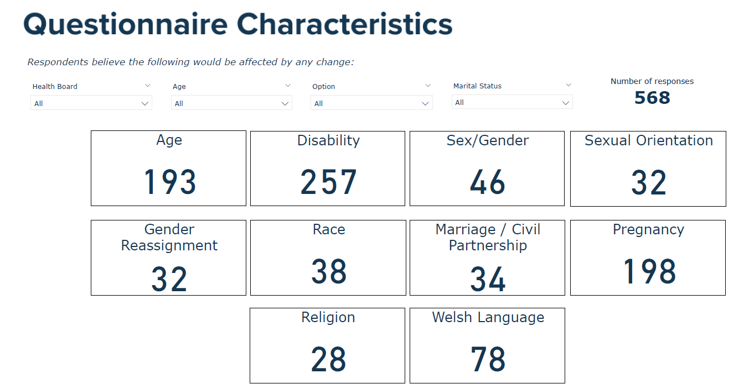  The responses received during phase 3 showed a perception amongst responders, particularly from mid and north Wales of adverse impacts for those equalities characteristics including age, disability, gender reassignment, marriage and civil partnership, pregnancy and maternity, race, religion or belief, sex, sexual orientation, carer responsibilities and Welsh language.  There remains a belief that changes to operational arrangements would include changes to clinical decision-making and dispatch from 999. There is a perception that those living rurally would also be disadvantaged.  The Review has examined how crews were tasked and were assured that there were no questions within the dispatch protocols that related to equalities characteristics or impacted on those living in rural areas across Wales.  Dispatch is based on clinical need alone – decisions are made by EMRTS critical care practitioners.  The EMRT Service responds to the highest clinical urgency regardless of any protected characteristics. This is in line with the policies and procedures approved by the Welsh Ambulance Services NHS Trust who operate the clinical control centre in Cwmbran where the EMRTS Critical Care Hub is based.  In the event of an EMRTS resource not being available, incidents are ‘highlighted’ as the potential next tasking. However, that decision is dynamic and is dependent on many factors including when the next resource is available, the location of the incident and the clinical need of incoming calls through the 999 system.  It is unlikely that adverse impacts relating to people with protected characteristics would impact differently from the general population should the bases be moved. However, as data regarding EMRTS missions is not available in a format that enables further detailed analysis by equality protected characteristics this cannot be discounted.  However, the CASC recognises the strength of belief in specific areas in relation to the impact on people with protected characteristics and also specifically in relation to rural areas. It is anticipated that the EMRT Service will have specific commissioning intentions to improve the communications to the population of Wales to better understand what the service is and how the service is provided. The issues raised in relation to rural services will also be an area of focus for the commissioning of all ambulance services.  The recommendations do not change the way patients receive the EMRTS Service. This is a clinically led service, it accounts for about 1% of all of the 999 calls received by the Welsh Ambulance Services NHS Trust (WAST) and provides pre hospital critical care services to the population of Wales. All calls are screened at the EMRTS Critical Care Hub based in the WAST call centre where an EMRTS critical care practitioner and dispatcher work together to dispatch crews.  However, in terms of the rapid response vehicle usage (when helicopters are unable to fly) for the population coverage at 90 minutes further mitigation is required to ensure no diminution of service compared to the status quo.  For example, if there is a risk that for example parts of western Betsi Cadwaladr or north Powys areas may experience reduced access to the service when the helicopter cannot fly due to bad weather and because the RRV is now located further away – the mitigation for this risk is identified within recommendation 4 as follows:  Recommendation 4 – The Committee approves the development of a commissioning proposal for bespoke road-based enhanced and/or critical care services in rural and remote areas.
9. | Is the policy/service relevant to “promoting equality of opportunity?” | It is unlikely that this Service Review will have any specific impact on those with protected characteristics as the service is provided to all based on clinical need alone.  However, as data regarding EMRTS missions is not available in a format that enables further detailed analysis by equality protected characteristics this cannot be discounted.  The original service development proposal suggested that more patients could receive a service and this could be argued as promoting equality of opportunity. This finding has also be identified within the EMRTS Service Review and the impact on those people not receiving a service which has been investigated further.  As part of the formal engagement process held in Phase 1, EASC agreed and the following reasons were used with the public agree as a way to help decide what to do next:  - Health gain  - EMRTS should be as efficient and effective as possible and as many people as possible should get a service  - Before any change happens, there must be a plan for EMRTS to be able to carry on as now  - Equity  - Everyone in Wales should have fair / same (equitable) access to the service  - An effective road response is important especially when the helicopters can’t fly and to provide improved cover during the hours of darkness.  - We should have more aircraft able to land wherever needed when it is dark.  - Clinical skills and sustainability  - It is very important that we look after the staff and make sure there is good training available for staff to make the best use of their advanced skills  - Value for money  - If we want to develop services, we must make sure they provide value for money  - Affordability  - As a minimum, we should spend the same as we do now.  Phase 1 provided the following documents in Welsh and English  https://easc.nhs.wales/engagement/sdp/engagement-documents-phases-1-2/  - EMRTS Service Review Technical Document  - Everyday summary  - Easy Read version  - Engagement presentation slides  Supporting documents included  https://easc.nhs.wales/engagement/sdp/supporting-documents-phase-1/ :  - EMRTS Service Development Proposal (as presented to EASC 8 November 2022)  - EMRTS Service Development Proposal cover report  - EMRTS Service Development proposal.  At the phase 1 meetings a presentation was used and was provided to all meetings in English only. Simultaneous translation into Welsh was available at all meetings.  A bilingual handout (Have your say / Dweud eich Dweud) was offered to all members of the public with all of the ways to get in touch with the team and register their issues.  Hard copies of the questionnaire developed by the Picker Institute were provided in Welsh and English which included a freepost address. The questionnaire was also available online.  Phase 2  The offer was made for anyone who had specific accessibility requirements to aid participation in the engagement to contact the EASC Team with details for ongoing help and support.  Phase 2 provided the following documents in Welsh and English except where identified:  https://easc.nhs.wales/engagement/sdp/engagement-documents-phases-1-2/  - Chief Ambulance Services Commissioner’s Report  - Plain Language Version  - Engagement Slides  - Frequently asked questions  Supporting documents available in Welsh and English except where identified included:  https://easc.nhs.wales/engagement/sdp/sdp2/  - 1 History of EMRTS  - 2 Engagement What we did and what we heard  - 3 Picker Institute Report (English only)  - 4 EMRTS Historical Data information pack  - 5 Drive time and population coverage  - 6 Weather Data (English only)  - 7 Optima modelling (English only)  At the phase 2 meetings  - All venues were accessible; microphones were used to ensure the Public could hear questions and this was checked at venues (mobile microphones purchased in Phase 1 to ensure equity at meetings) hearing loops were used wherever possible  - a presentation was used and provided to all meetings in English only (CASC cannot speak Welsh).  - Drop in meetings had bilingual staff to meet with members of the public  - Bilingual staff provided meet and greet services at all venues  - Simultaneous translation into Welsh was available at all public meetings.  - Hard copies and other formats of the documents were available on request  - A bilingual handout (Have your say / Dweud eich Dweud) was offered to all members of the public with all of the ways to get in touch with the team and register their issues  - Anyone who had specific accessibility requirements to aid participation in the engagement were asked to contact the EASC Team with details for assistance.  Phase 3  In building on the work in Phase 1 and 2, the Option Appraisal Workshop used the Factors and Weightings discussed with the public (in Phases 1 and 2) and agreed by EASC to undertake the work with health boards and develop the Preferred Option. The Phase 3 engagement asked the public to ‘Have your say on the Preferred Options A and B’.  Documents available:  Chief Ambulance Services Commissioners Report Phase 3 (Engagement Document) Here  https://easc.nhs.wales/engagement/sdp/p2ep1/phase-3-final-document/  Equality Impact Assessment - Here  https://easc.nhs.wales/engagement/sdp/p2ep1/final-equality-impact-assessment-easc-emrts-service-review-phase-3/  Phase 3 Engagement Document Easy Read version Here  https://easc.nhs.wales/engagement/sdp/p2ep1/welsh-air-ambulance-consultation-easy-read/  Phase 3 Engagement Questionnaire Easy Read version  Members of the Public were able to respond using a number of formats identified on Page 4.
10. | Is the policy/service relevant to “promoting good relationships and positive attitudes?” | It is unlikely that the EMRTS Service Review will have any specific impact on this. However, the approach to all of the engagement phases has been open, honest and transparent and every effort made to engage meaningfully with the public in the language of their choice.  The strength of public feeling particularly in Powys and the Caernarfon area is recognised and valued. It is understood that change is concerning for people and the service is highly valued and ‘owned’ in these locality areas.  However, the service commissioned by EASC is an all Wales highly specialist pre hospital critical care service and hence the Service Review is being considered by the Emergency Ambulance Services Committee to consider if any changes need to be made for the benefit of the whole population of Wales.  Updates to EASC meetings (all available online) at https://easc.nhs.wales/the-committee/meetings-and-papers/:  May 2023  July 2023 – emerging themes reported  September 2023 – plans for Phase 2 engagement  November 2023 – received feedback from Phase 2  December 2023 – approved Phase 3  January 2024 -  Other arrangements  All EASC meetings apart from May 2023 were live streamed (since November 2022) and remain available on the website. The recording for the May meeting was corrupt and could not be used.  Engagement Report (Link to follow)  EMRTS Service Review (Link to follow)  EMRTS Service Review EASC report (link to follow)  Data regarding EMRTS missions is not available in a format that enables further detailed analysis by equality protected characteristics.  As part of the work, a report was commissioned from the Picker Institute to provide an all Wales Public Engagement Survey which was undertaken using YouGov (see Section 7). The aim of this work was to provide a representative view of public perceptions on what constitutes high quality care. This was reported in August 2023 and is available here:  easc.nhs.wales/engagement/sdp/sdp2/supporting-document-3-picker-institute-report/

Section 2. Impact
Do you think that the policy/service impacts on people because of their age? (This includes people of any age but typically focusing on children and young people up to 18 and older people over 60)

It is unlikely that the EASC EMRTS Service Review will have a specific impact on people due to their age. The all-Wales highly specialist critical care service is provided to the patient whenever or wherever they need it. An easy read or plain language version was developed for the engagement materials to support people of any age.

During the feedback on the Phase 3 engagement, of the 568 respondents, 193 believed that people would be affected due to their age (third largest group). Despite reassurances given during public meetings in the previous phase, the public who responded believed there would be an impact. This was identified in the previous EIA as the risk of cardiac arrest (one of the main mission categories) increases with age and is also associated with higher levels of deprivation. This concern is recognised and understood. The service provided is based on clinical need and assessed by an expert critical care practitioner within the EMRTS Critical Care Hub. However, data regarding EMRTS missions is not available in a format that enables further detailed analysis by equality protected characteristics although the age range of all patients is provided below from actual mission data. The public should feel assured that should they require the service it would attend to each and every patient regardless of age. The aim of the Review is to provide services to as many people as possible and particularly meet those people who current do not receive a service.

From Appendix 3 – the age profile of the most numerous responders in Powys (last 2 columns) appears to be a consistently higher percentage than the remainder of Wales.
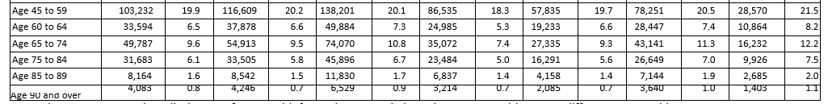
The table below shows the year age profile by bands/percent for 2019-2023 inclusive
(Source – EMRTS Team mission information). Age profile per HB area attached at Appendix 3.
Age group | Percentage in age groups 2019-2023
0-4 | 6.3%
5-9 | 1.9%
10-14 | 3.0%
15-19 | 4.6%
20-24 | 5.2%
25-29 | 5.4%
30-34 | 5.6%
35-39 | 6.1%
40-44 | 5.8%
45-49 | 6.3%
50-54 | 7.3%
55-59 | 8.8%
60-64 | 8.0%
65-69 | 7.2%
70-74 | 6.1%
75-79 | 6.3%
80-84 | 3.6%
85-89 | 1.7%
90-94 | 0.6%
95-99 | 0.1%
Total | 100.0%

The age range of responders in Phase 3 was as follows:
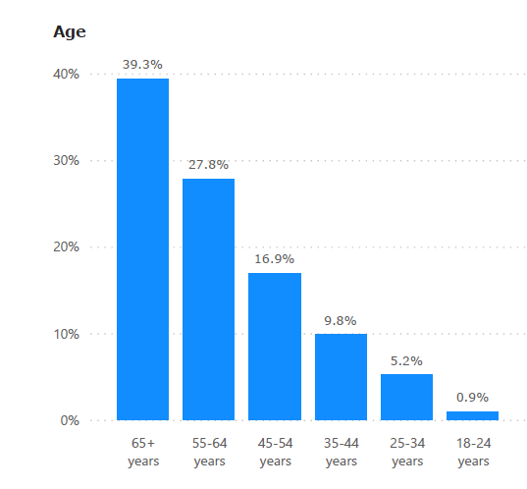
Low numbers of responses were received from people aged less than 45 years, amounting to 15.9% of all responses although this age group are over 28% of those who have needed the EMRT Service. Health board engagement leads were part of the engagement process and received weekly updates on the progress of the engagement. These snapshot weekly reports throughout the 4 weeks recognised that the highest age group of responders was over 65 years which was of interest particularly considering the concerns in relation to this age group potentially being digitally excluded. The composite number included all methods of response and therefore may reflect positively on the choices offered to call, email, write or use the online opportunities.
In terms of those in the below 45 years age group, the health boards shared the engagement opportunity with their local groups as per their local arrangements. The Chief Ambulance Services Commissioner also attended a number of health board Stakeholder Reference Groups to explain the work and answer queries and questions.
Do you think that the policy/service impacts on people because of their disability? (This includes sensory loss, physical disability, learning disability, some mental health problems, and some other long term conditions such as Cancer or HIV)

It is unlikely that the EASC EMRTS Service Review will have an adverse impact on people because of their disability. However, data regarding EMRTS missions is not available in a format that enables further detailed analysis by equality protected characteristics. The all-Wales service is provided to the patient whenever or wherever they need it.

Engagement resources were developed in line with the requests from the public during all Phases – for example, summary documents, plain language documents and all of the supporting information, particularly that data should be provided unredacted which was met. Venues used for engagement activities were accessible and all engagement materials were available in whatever format members of the public required. The main resources were (at least) bilingual and had a summary, plain language and more comprehensive documentation which was in line with the requests heard during the engagement.

During the feedback on the Phase 3 engagement, 257 respondents (almost ½) believed that people with disabilities would be adversely affected. This could include as previously identified in relation to the EMRTS mission categories that for Falls: there was an increased risk of falling with age and could be more common amongst those experiencing disabilities and health conditions associated with gait and mobility including neurological conditions. Responses were are follows:
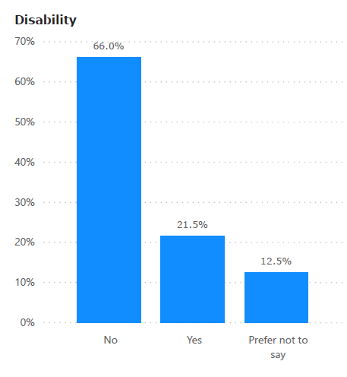
This concern is recognised and understood. The EMRT Service provided is based on clinical need and assessed by an expert critical care practitioner within the EMRTS Critical Care Hub. However, data regarding EMRTS missions is not available in a format that enables further detailed analysis by equality protected characteristics. The public should feel assured that should they require the service it would attend to each and every patient regardless of any disability. The aim of the Review is to provide services to as many people as possible and particularly meet those people who current do not receive a service.

Health board engagement leads were part of the engagement process and received weekly updates on the progress of the engagement. These snapshot reports throughout the 4 weeks identified that at least 20% of respondents consistently identified themselves as having a disability.

The health boards shared the engagement opportunity with their local groups as per their local arrangements. The Chief Ambulance Services Commissioner also attended a number of health board Stakeholder Reference Groups to explain the work and answer queries and questions.

Does the policy impact on people because of their caring responsibilities?

The service will not have specific impact on people due to caring responsibilities. However, a small number of staff could be affected if the base changed (no decision has yet been made); this would managed on an individual basis in line with the reasonable adjustments requirements.

The EASC EMRTS Service Review itself does not impact as it is a review of the EMRTS service which is an all-Wales service provided to the patient whenever or wherever they need it.

Health board engagement leads were part of the engagement process and received weekly updates on the progress of the engagement. These snapshot reports were shared throughout the 4 weeks of engagement with a composite report at the end. The health boards shared the engagement opportunity with their local groups as per their local arrangements. The Chief Ambulance Services Commissioner also attended a number of health board Stakeholder Reference Groups to explain the work and answer queries and questions.

Do you think that the policy/service impacts on people because of Gender reassignment? (This includes all people included under trans* e.g. transgender, non-binary, gender fluid etc.)

It is unlikely that EMRTS Service Review will have specific impact on people because of gender reassignment. However, data regarding EMRTS missions is not available in a format that enables further detailed analysis by equality protected characteristics including gender reassignment. The all-Wales service is provided to the patient whenever or wherever they need it.

During the feedback on the Phase 3 engagement, 32 respondents believed that the change would impact on people because of gender reassignment and they would be adversely affected by the change.

This concern is recognised and understood as a belief held by some members of the public. However, the service provided is based on clinical need and assessed by an expert critical care practitioner within the EMRTS Critical Care Hub.
The public should feel assured that should they require the service it would attend to each and every patient regardless whether have undergone gender reassignment. The aim of the Review is to provide services to as many people as possible and particularly meet those people who current do not receive a service.

Health board engagement leads were part of the engagement process and received weekly updates on the progress of the engagement. These snapshot reports were shared throughout the 4 weeks of engagement with a composite report at the end. The health boards shared the engagement opportunity with their local groups as per their local arrangements. The Chief Ambulance Services Commissioner also attended a number of health board Stakeholder Reference Groups to explain the work and answer queries and questions.

Do you think that the policy/service impacts on people because of their being married or in a civil partnership?
Impacts in this area are rare, but it can intersect with gender discrimination. Whether an individual is married or not should not impact any aspect of the way they are treated.

It is unlikely that the EASC EMRTS Service Review will have specific impact on people because of their being married or in a civil partnership. However, data regarding EMRTS missions is not available in a format that enables further detailed analysis by equality protected characteristics. The all Wales service is provided to the patient whenever or wherever they need.

During the feedback on the Phase 3 engagement, 34 respondents believed that people being married or in a civil partnership would be adversely affected by the change. This concern is recognised as a belief that some members of the public hold. However, the service provided is based on clinical need and assessed by an expert critical care practitioner within the EMRTS Critical Care Hub.
The public should feel assured that should they require the service it would attend to each and every patient regardless of their marital or civil partnership status. The aim of the Review is to provide services to as many people as possible and particularly meet those people who current do not receive a service. Health board engagement leads were part of the engagement process and received weekly updates on the progress of the engagement. These snapshot reports were shared throughout the 4 weeks of engagement with a composite report at the end. The health boards shared the engagement opportunity with their local groups as per their local arrangements. The Chief Ambulance Services Commissioner also attended a number of health board Stakeholder Reference Groups to explain the work and answer queries and questions.
Do you think that the policy/service impacts on people because of their being pregnant or having recently had a baby? (This applies to anyone who is pregnant or on maternity leave, but not parents of older children)

It is unlikely that EASC EMRTS Service Review will have specific impact on people because of their being pregnant or having recently had a baby. However, data regarding EMRTS missions is not available in a format that enables further detailed analysis by equality protected characteristics including related to pregnancy or recent birth. The all-Wales service is provided to the patient whenever or wherever they need it. Should a pregnant woman have a life threatening condition the impact could be positive for the individual.

During the feedback on the Phase 3 engagement, 198 respondents (the second largest area) believed that the service would impact women because of their being pregnant or recently having a baby and they would be adversely affected by the change.

This concern is recognised and understood. It is feasible that this relates to the belief that any change would lead to a loss of an emergency service which is currently provided. However, the service provided is based on clinical need and assessed by an expert critical care practitioner within the EMRTS Critical Care Hub.

The public should feel assured that should they require the service it would attend to each and every patient regardless of whether pregnant or having recently had a baby. The aim of the Review is to provide services to as many people as possible and particularly meet those people who current do not receive a service.

Health board engagement leads were part of the engagement process and received weekly updates on the progress of the engagement. These snapshot reports were shared throughout the 4 weeks of engagement with a composite report at the end. The health boards shared the engagement opportunity with their local groups as per their local arrangements. The Chief Ambulance Services Commissioner also attended a number of health board Stakeholder Reference Groups to explain the work and answer queries and questions.

Do you think that the policy/service impacts on people because of their race? (This includes colour, nationality and citizenship or ethnic or national origin such as Gypsy and Traveller Communities, Welsh/English etc.)

It is unlikely that the EASC EMRTS Service Review will have specific impact on people because of their race. However, data regarding EMRTS missions is not available in a format that enables further detailed analysis by equality protected characteristics The all-Wales service is provided to the patient whenever or wherever they need it.

During the feedback on the Phase 3 engagement, 38 respondents believed that the service would impact on people because of their race. The ethnicity of respondents was collected and showed that 88.2% of respondents identified themselves as being White (Welsh, English, Scottish or Northern Irish/British) 6.8% preferred not to say; other groups had very low numbers.
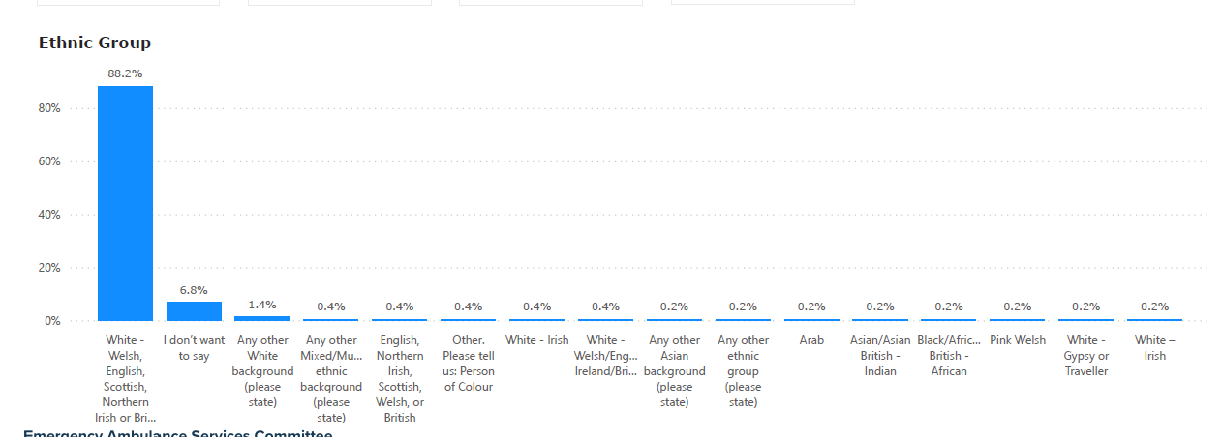
This concern is recognised and understood. It is feasible that this relates to the belief that any change would lead to a loss of an emergency service which is currently provided. However, the service provided is based on clinical need and assessed by an expert critical care practitioner within the EMRTS Critical Care Hub. The public should feel assured that should they require the service it would attend to each and every patient regardless of their race or ethnicity. The aim of the Review is to provide services to as many people as possible and particularly meet those people who current do not receive a service.

Health board engagement leads were part of the engagement process and received weekly updates on the progress of the engagement. These snapshot reports throughout the 4 weeks recognised that the majority of responders identified as being white, with very low numbers for black, Asian or other ethnic groups. The health boards shared the engagement opportunity with their local groups as per their local arrangements. The Chief Ambulance Services Commissioner also attended a number of health board Stakeholder Reference Groups to explain the work and answer queries and questions.

Do you think that the policy/service impacts on people because of their religion, belief or non-belief? (Religious groups cover a wide range including Buddhist, Christians, Hindus, Jews, Muslims, and Sikhs as well as atheists and other non-religious groups)
It is unlikely that the EASC EMRTS Service Review will have specific impact on people because of their religion, belief or non-belief. However, data regarding EMRTS missions is not available in a format that enables further detailed analysis by equality protected characteristics including relating to religion. The all-Wales service is provided to the patient whenever or wherever they need.

During the feedback on the Phase 3 engagement, 28 respondents believed that the service would impact on people because of their religion, belief or non-belief.

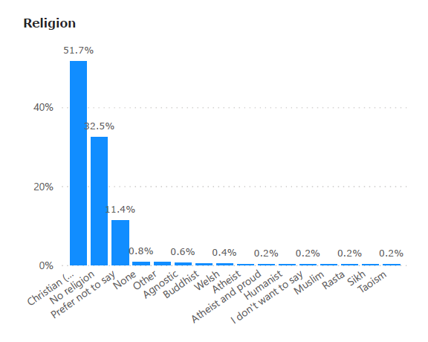
This concern is recognised and understood as something members of the public believe. It is feasible that this relates to the belief that any change would lead to a loss of an emergency service which is currently provided. However, the service provided is based on clinical need and assessed by an expert critical care practitioner within the EMRTS Critical Care Hub. The public should feel assured that should they require the service it would attend to each and every patient regardless of religion, belief or non-belief. The aim of the Review is to provide services to as many people as possible and particularly meet those people who current do not receive a service.

Health board engagement leads were part of the engagement process and received weekly updates on the progress of the engagement. These snapshot reports were shared throughout the 4 weeks of engagement with a composite report at the end. The health boards shared the engagement opportunity with their local groups as per their local arrangements.
The Chief Ambulance Services Commissioner also attended a number of health board Stakeholder Reference Groups to explain the work and answer queries and questions.

Do you think that the policy/service impacts on men and women in different ways? Do men and women have different needs and commitments that need to be considered. Are their respective roles fully considered in work-life balance policies etc.

It is unlikely that the EASC EMRTS Service Review will have specific impact on women or men. However, data regarding EMRTS missions is not available in a format that enables further detailed analysis by equality protected characteristics related to gender. The all-Wales service is provided to the patient whenever or wherever they need it.

The service does impact on men and women in slightly different ways in terms of actual missions, almost consistently 2/3rd of all patients are men. However, more women than men responded to the engagement and gave feedback

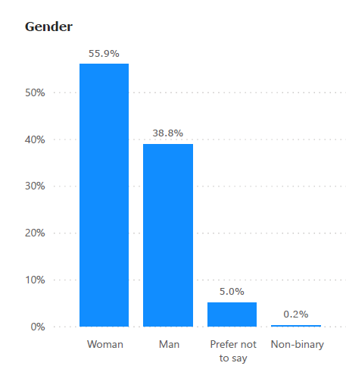
Missions
 | Male | Female | Paediatric | Median | Age Range
2015-2016 | 69% | 31% | 16% | 47 | 0-97
2016-2017 | 70% | 30% | 27% | 46 | 0-98
2017-2018 | 68% | 32% | Not available | 46 | 0-96
2018-2019 | 67% | 33% | 12% | 45 | 0-97
2019-2020 | 66% | 34% | 12% | 49 | 0-101
2020-2021 | 66% | 34% | 9% | Not available | Not available
2021-2022 | 68% | 32% | 14% | Not available | Not available
2022-2023 | 67% | 33% | Not available | Not available | Not available

It is feasible that this relates to the belief that any change would lead to a loss of an emergency service which is currently provided. However, the service provided is based on clinical need and assessed by an expert critical care practitioner within the EMRTS Critical Care Hub. The public should feel assured that should they require the service it would attend to each and every patient regardless of gender. The aim of the Review is to provide services to as many people as possible and particularly meet those people who current do not receive a service.

Health board engagement leads were part of the engagement process and received weekly updates on the progress of the engagement. These snapshot reports were shared throughout the 4 weeks of engagement with a composite report at the end. The health boards shared the engagement opportunity with their local groups as per their local arrangements. The Chief Ambulance Services Commissioner also attended a number of health board Stakeholder Reference Groups to explain the work and answer queries and questions.

Do you think that the policy/service impacts on people because of their sexual orientation? (This includes Gay men, heterosexual, lesbian and bisexual people)

It is unlikely that the EASC EMRTS Service Review will have specific impact on people because of their sexual orientation. However, data regarding EMRTS missions is not available in a format that enables further detailed analysis by equality protected characteristics including for sexual orientation. The all-Wales service is provided to the patient whenever or wherever they need it.

During the feedback on the Phase 3 engagement, 32 respondents believed that the service would impact on people because of their sexual orientation.
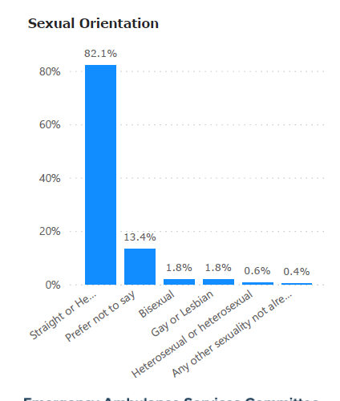
It is feasible that this relates to the belief that any change would lead to a loss of an emergency service which is currently provided. However, the service provided is based on clinical need and assessed by an expert critical care practitioner within the EMRTS Critical Care Hub. The public should feel assured that should they require the service it would attend to each and every patient regardless of sexual orientation. The aim of the Review is to provide services to as many people as possible and particularly meet those people who current do not receive a service.

Health board engagement leads were part of the engagement process and received weekly updates on the progress of the engagement. These snapshot reports were shared throughout the 4 weeks of engagement with a composite report at the end. The health boards shared the engagement opportunity with their local groups as per their local arrangements.
The Chief Ambulance Services Commissioner also attended a number of health board Stakeholder Reference Groups to explain the work and answer queries and questions.

Do you think that the policy/service impacts on people because of their Welsh language? (e.g. the active offer to receive services in Welsh, bilingual information etc).
It is unlikely that the EASC EMRTS Service Review will have specific impact on people because of their use of the Welsh language. However, data regarding EMRTS missions is not available in a format that enables further detailed analysis by equality protected characteristics including for the Welsh Language. The all-Wales service is provided to the patient whenever or wherever they need.
As the service is provided by highly trained specialist staff not all can speak in Welsh. All posts recruited have the ability to speak Welsh as desirable and every effort would be made to accommodate patients in the language of choice. However, this is a critical care life-saving service and this would be paramount. All engagement documents are bilingual.
During the feedback on the Phase 3 engagement, 78 respondents believed that the service would impact on people because of their Welsh Language.

It is feasible that this relates to the belief that any change would lead to a loss of an emergency service which is currently provided. However, the service provided is based on clinical need and assessed by an expert critical care practitioner within the EMRTS Critical Care Hub. The public should feel assured that should they require the service it would attend to each and every patient regardless of their Welsh language. The aim of the Review is to provide services to as many people as possible and particularly meet those people who current do not receive a service.
Health board engagement leads were part of the engagement process and received weekly updates on the progress of the engagement. These snapshot reports were shared throughout the 4 weeks of engagement with a composite report at the end. The health boards shared the engagement opportunity with their local groups as per their local arrangements. The Chief Ambulance Services Commissioner also attended a number of health board Stakeholder Reference Groups to explain the work and answer queries and questions.

The Welsh government has introduced a new Socio-economic duty effective from April 2021. It asks us to consider the impact of our decisions on inequality experienced by people at socio-economic disadvantage.
It is unlikely that the EASC EMRTS Service Review will have specific impact on people because of their socio-economic disadvantage. The all Wales service is provided to the patient whenever or wherever they need.
The service does attract new consultants to Wales, which may have a socioeconomic impact on specific localities.

During the feedback on the Phase 3 engagement, many respondents believed that there would be an impact on rural areas.
As previously raised in terms of the main mission categories for the EMRT Service Road incidents: there is evidence that socio-economically deprived areas suffer more than affluent areas in terms of road incidents. Road traffic related injuries, particularly for child pedestrians, are among the greatest of all health inequalities, with much higher rates in children from families led by parents in unskilled employment or from deprived neighbourhoods (source: EM template for sub leg (senedd.wales))

It is feasible that this relates to the belief that any change would lead to a loss of an emergency service which is currently provided specifically in rural areas. However, the service provided is based on clinical need and assessed by an expert critical care practitioner within the EMRTS Critical Care Hub. The public should feel assured that should they require the service it would attend to each and every patient regardless of where they live. The aim of the Review is to provide services to as many people as possible and particularly meet those people who current do not receive a service.

Health board engagement leads were part of the engagement process and received weekly updates on the progress of the engagement. These snapshot reports were shared throughout the 4 weeks of engagement with a composite report at the end. The health boards shared the engagement opportunity with their local groups as per their local arrangements. The Chief Ambulance Services Commissioner also attended a number of health board Stakeholder Reference Groups to explain the work and answer queries and questions.
Other considerations
- Future Generations Act
Wellbeing Goal | Considerations | Examples of Feedback
A globally responsible Wales | People in terms of macro-economic, environmental and sustainability factors: consider the impact of government policies; gross domestic product; economic development; biological diversity and climate  A nation which, when doing anything to improve the economic, social, environmental and cultural well-being of Wales, takes account of whether doing such a thing may make a positive contribution to global well-being. | People regularly expressed concern about the loss of services in their area, often wider than health services but believed that the EMRTS service made them feel safe and secure; often, people supported the need for change to help more people but only if it didn’t mean moving the air base from their locality  Concerns about weather, more frequent flooding affecting ability for road responses.
A resilient Wales | People in terms of their use of the physical environment: consider the impact on the availability and accessibility of transport, healthy food, leisure activities, green spaces; of the design of the built environment on the physical and mental health of patients, staff and visitors; on air quality, exposure to pollutants; safety of neighbourhoods, exposure to crime; road safety and preventing injuries/accidents; quality and safety of play areas and open spaces  A nation which maintains and enhances a biodiverse natural environment with healthy functioning ecosystems that support social, economic and ecological resilience and the capacity to adapt to change (for example, climate change). | Feedback suggested investing in training citizens in healthy lifestyles, first aid/community resilience, and improved driver education to alleviate overall demand on emergency services.  During the engagement process, people regularly raised concerns about the road infrastructure and the high level of road accidents in the local area. They raised concerns about the local industries of farming and forestry work being dangerous with high levels of accidents and incidents.  Less was mentioned about green spaces and the mental health /wellbeing of local people although the potential move of the air base did make them feel less safe.  Some shared another air ambulance consultation - Hampshire Air Ambulance who were consulting with the public to move of the base of their helicopter to an area closer to the densest population, this from a rural area. The environmental impacts and shorter journey times for patients were highlighted as well as the ability to provide a better service to the previously location area. This was a topic of interest within the social media groups who believed that the consultation being held was fairer and more open. The work was considered and overwhelmingly provided a very similar set of issues (to the EMRTS Service Review) in trying to get to see more patients but not excluding rural areas. This service provided one helicopter to 1.8million people. The service in Wales operates 4 helicopters to 3.1million people.
A healthier Wales | People being able to improve/ maintain healthy lifestyles: consider the impact on healthy lifestyles, including health eating, being active, no smoking/smoking cessation, reducing the harm caused by alcohol and or non-prescribed drugs plus access to services that support disease prevention (eg immunisation and vaccination, falls prevention). Also consider impact on access to supportive services including smoking cessation services, weight management services etc  A society in which people’s physical and mental well-being is maximised and in which choices and behaviours that benefit future health are understood. | Scepticism expressed about service developments made by Health Boards and Local Authorities, with the perception that they are resulting in worse services.  There's concern that any base moves could negatively affect other emergency responders in the Powys area.  Overwhelmingly, local people to the air bases considered themselves much safer in terms of having a local air base. Frequently people misunderstood that EMRTS did not provide a fast ambulance and regularly suggested that this was all that was required. The pre hospital critical care service meant that many believed this was very important as they did not have a district general hospital
A more equal Wales | A society that enables people to fulfil their potential no matter what their background or circumstances (including their socio-economic background and circumstances).  People being able to access the service offered: consider access for those living in areas of deprivation and or those experiencing health inequalities | Wider discussion was heard in relation to primary care services as well as ambulance services. The low level of performance in the areas was a topic of concern and the potential change for this high end service seemed to escalate the perceived impact.  A range of potential perceived equality impacts have been identified in the previous  section about emergency health needs for rural communities – with mitigation actions agreed as  appropriate – as part of any decision-making process.
A Wales of cohesive communities | People in terms of social and community influences on their health: consider the impact on family organisation and roles; social support and social networks; neighbourliness and sense of belonging; social isolation; peer pressure; community identify; cultural and spiritual ethos  Attractive, viable, safe and well-connected communities. | Local communities visited had a high level belonging and use of social networks. The responses reflect the sense of a community asset and the strength of feeling to maintain. There was balance, that the service should see as many people as possible, as long as this did not move the base.  Many local (to base) respondents suggested that if the base was moved that they would no longer contribute to the Wales Air Ambulance Charity. This was a frequent response which suggested that they believed the service was closing and there would not be a service. Despite reassurances this message appears to be unheard.  Respondents have identified concerns about overall community viability and cohesiveness about public services generally.  They have identified concerns about an erosion of public services that believe will affect people’s choices around moving to or staying in rural areas, and this might affect overall community sustainability.
A Wales of vibrant culture and thriving Welsh language | A society that promotes and protects culture, heritage and the Welsh language, and which encourages people to participate in the arts, and sports and recreation.  People in terms of their use of the Welsh Language and maintaining and strengthening Welsh cultural life | No examples were shared; however, every session had simultaneous translation and 121s had bilingual staff ready to engage with the public. All documents were produced bilingually  There are opportunities to continue to support and develop the service through the medium of Welsh.
A prosperous Wales | An innovative, productive and low carbon society which recognises the limits of the global environment and therefore uses resources efficiently and proportionately (including acting on climate change); and which develops a skilled and well-educated population in an economy which generates wealth and provides employment opportunities, allowing people to take advantage of the wealth generated through securing decent work.  People in terms of their income and employment status: consider the impact and availability and accessibility of work, paid and unpaid employment, wage levels, job security, working conditions | People raised the dangerous occupations regularly  Respondents expressed concerns that the loss of EMRTS and other health services primary care GP practice premises would affect the number of jobs in the community and also affect the overall attractiveness of the community for businesses, residents etc.
- Duty of Quality – clearly a consideration as we know that the EMRTS provides life saving pre hospital critical care services and the aim to see as many patients as possible.
- Healthcare Impact Assessment – to be confirmed and considered further
- Social Wellbeing Wales Act 2014
- Public sector equality duty (under the Equality Act 2010)
Section 3 Outcome
Summary of Assessment:  Please summarise Equality issues of concern and changes that will be made to the service development accordingly. | It is recognised that people in protected characteristic groups are likely to be impacted by any change more than the general population and that in particular children, older people, disabled people and those living with social & economic disadvantage could be disproportionately affected.  Intersectionality can also mean that some people receiving the service will have more than one of these protected characteristics and so the impacts on them would be disproportionately greater.  Data regarding EMRTS missions is not available in a format that enables further detailed analysis by equality protected characteristics and therefore any potential impact cannot be discounted.  Also, there are significant numbers of those who responded during Phase 3 who believe that there are adverse impacts on those with protected characteristics.  Whilst there is clear evidence of an overall health gain to the people of Wales from the preferred option, there is a possible likelihood of a moderate downside impact as it is recognised that during periods when the air ambulance helicopter is unable to fly (e.g. due to very poor weather conditions) then communities located closer to the current bases in Welshpool and Caernarfon may experience a reduced service during these “no fly” periods than now because of the increased distance for RRV response.  An implementation plan will need to be developed if the recommendations are approved by EASC particularly in recognition that increased need for EMRTS may be associated with factors such as age, deprivation and disability. Importantly, the implementation plan would need to consider the impact on EMRTS staff.  Also, the plan will need to specifically include communications and engagement with the public to better understand and trust the partnership service once more.  The aim of the Review is to use the existing resources to provide services to those who currently need it but don’t receive it (2-3 a day) and therefore this consideration is influential for decision making (those ‘unmet need’ patients may also have protected characteristics).  An example of this would be that approximately 530,000 people in north Wales would not receive a response during the hours of darkness within 60 minutes.  Given the responses from the public there is a need for commissioners to address this matter and the strong beliefs of the public during this recent engagement phase.
Please indicate whether these changes have been made. | This document and equality impact assessment has provided an opportunity to demonstrate that any potential downside impacts have been considered with particular reference to protected characteristics so that proportionate mitigating actions can be considered. Also, to clarify whether there was any suggestion that any parts of Wales would see any aspect of a diminution of service compared to now.  The final 4 recommendations are as follows:  Recommendation 1 – The Committee approves the consolidation of the Emergency Medical Retrieval and Transfer Services currently operating at Welshpool and Caernarfon bases into a single site in North Wales.  Recommendation 2 - The Committee requests that the Charity secures an appropriately located operational base in line with the findings of the EMRTS Service Review Report.  Recommendation 3 - The Committee requires that a joint plan is developed by EMRTS and the Charity, that maintains service provision across Wales during the transition to a new base and that this plan is included within the Committee’s commissioning arrangements.  Recommendation 4 – The Committee approves the development of a commissioning proposal for bespoke road-based enhanced and/or critical care services in rural and remote areas.  These recommendations will be presented and considered by the Emergency Ambulance Services Committee (a joint committee of health boards) on 19 March 2024 prior to consideration by health boards. A final meeting of EASC will be held on 28 March 2024.
Please indicate where issues have been raised but the service development has not been changed and indicate reasons and alternative action (mitigation) taken where appropriate. | As a result of the engagement process, the Chief Ambulance Services Commissioner was struck by what he heard primarily in small community areas in mid and north Wales.  As the process has evolved further mitigations have been considered and are shared as recommendations in the EMRTS Service Review as above.
Who will monitor this EIA and ensure mitigation is undertaken | This remains a partnership approach between the commissioners at EASC (Health Boards), EASC Team, EMRTS Team and Wales Air Ambulance Charity
CTMUHB Equality Team | Sent to CTMUHB  Signed Gwenan Roberts  Date 11 March 2024  Actioned:

Appendix 1

Equity Table 1: Population Coverage – Road (Population of Wales 3.137m)

Option | Hours | Bases Available | Population 30m | Population 60m | Population 90m
2A Welshpool 14:00 – 02:00 | 08:00 – 14:00 | Cardiff (7am start), Dafen (7am start), Caernarfon | 1,447,276 | 2,343,954 | 2,471,716
2A Welshpool 14:00 – 02:00 | 14:00 – 20:00 | Cardiff, Dafen, Caernarfon, Welshpool | 1,496,240 | 2,434,594 | 2,607,555
2A Welshpool 14:00 – 02:00 | 20:00 – 02:00 | Cardiff, Welshpool | 927,155 | 1,569,711 | 1.619,843
2A Welshpool 14:00 – 02:00 | 02:00 – 08:00 | Cardiff | 878,191 | 1,479,071 | 1,484,004
2B Caernarfon 14:00 – 02:00 | 08:00 – 14:00 | Cardiff (7am start), Dafen (7am start), Welshpool | 1,419,482 | 2,264,179 | 2,235,983
2B Caernarfon 14:00 – 02:00 | 14:00 – 20:00 | Cardiff, Dafen, Caernarfon, Welshpool | 1,496,240 | 2,434,594 | 2,607,555
2B Caernarfon 14:00 – 02:00 | 20:00 – 02:00 | Cardiff, Caernarfon | 954,949 | 1,649,487 | 1,655,576
2B Caernarfon 14:00 – 02:00 | 02:00 – 08:00 | Cardiff | 878,191 | 1,479,071 | 1,484,004
3D North Central Wales near A55 08:00 – 02:00 | 08:00 – 1400 | Cardiff (7am start), Dafen (7am start), North Central Wales near A55 | 1,616,598 | 2,430,303 | 2,556,938
3D North Central Wales near A55 08:00 – 02:00 | 14:00 – 20:00 | Cardiff, Dafen, North Central Wales near A55 | 1,616,598 | 2,430,303 | 2,556,938
3D North Central Wales near A55 08:00 – 02:00 | 20:00 – 02:00 | Cardiff, North Central Wales near A55 | 1,124,271 | 1,735,836 | 1,740,798
3D North Central Wales near A55 08:00 – 02:00 | 02:00 – 08:00 | Cardiff | 878,191 | 1,479,071 | 1,484,004
4C Improve 3D, add car shift 2000-0800 (Wrexham) | 08:00 – 14:00 | Cardiff (7am start), Dafen (7am start), North Central Wales near A55 | 1,616,598 | 2,430,303 | 2,556,938
4C Improve 3D, add car shift 2000-0800 (Wrexham) | 14:00 – 20:00 | Cardiff, Dafen, North Central Wales near A55 | 1,616,598 | 2,430,303 | 2,556,938
4C Improve 3D, add car shift 2000-0800 (Wrexham) | 20:00 – 02:00 | Cardiff, North Central Wales near A55, Wrexham | 1,362,413 | 1,982,722 | 1,987,698
4C Improve 3D, add car shift 2000-0800 (Wrexham) | 02:00 – 08:00 | Cardiff, Wrexham | 1,116,333 | 1,725,957 | 1,730,904
5C Improve baseline, add car shift 2000-0800 (Caernarfon) | 08:00 – 20:00 | Cardiff (7am start), Dafen (7am start), Caernarfon, Welshpool | 1,496,240 | 2,434,594 | 2,607,555
5C Improve baseline, add car shift 2000-0800 (Caernarfon) | 20:00 – 08:00 | Cardiff, Caernarfon | 954,949 | 1,649,487 | 1,655,576
6C Improve 2B, add car shift 2000-0800 (North Central Wales near A55) | 08:00 – 14:00 | Cardiff (7am start), Dafen (7am start), Welshpool | 1,419,482 | 2,264,179 | 2,235,983
 | 14:00 – 20:00 | Cardiff, Dafen, Welshpool, Caernarfon | 1,496,240 | 2,434,594 | 2,607,555
 | 20:00 – 02:00 | Cardiff, Caernarfon, North Central Wales near A55 | 1,201,029 | 1,906,252 | 1,912,370
 | 20:00 – 08:00 | Cardiff, North Central Wales near A55 | 1,124,271 | 1,735,836 | 1,740,798

Appendix 2
Equity Table 2: Population coverage – Air

Option | Hours | Bases Available | Population 30m | Population 40m (night) | Population 60m
2A Welshpool 14:00 – 02:00 | 08:00 – 14:00 | Cardiff (7am start), Dafen (7am start), Caernarfon | 3,136,070 (99.97%) | 3,137,127 | 3,137,127
2A Welshpool 14:00 – 02:00 | 14:00 – 20:00 | Cardiff, Dafen, Caernarfon, Welshpool | 3,137,127 | 3,137,127 | 3,137,127
2A Welshpool 14:00 – 02:00 | 20:00 – 02:00 | Cardiff, Welshpool | - | 3,137,127 | -
2A Welshpool 14:00 – 02:00 | 02:00 – 08:00 | Cardiff | - | 2,606,214 (83.1%) | -
2B Caernarfon 14:00 – 02:00 | 08:00 – 14:00 | Cardiff (7am start), Dafen (7am start), Welshpool | 3,098,068 (98.75%) | 3,137,127 | 3,137,127
2B Caernarfon 14:00 – 02:00 | 14:00 – 20:00 | Cardiff, Dafen, Caernarfon, Welshpool | 3,137,127 | 3,137,127 | 3,137,127
2B Caernarfon 14:00 – 02:00 | 20:00 – 02:00 | Cardiff, Caernarfon | - | 3,137,127 | -
2B Caernarfon 14:00 – 02:00 | 02:00 – 08:00 | Cardiff | - | 2,606,214 (83.1%) | -
3D North Central Wales near A55 08:00 – 02:00 | 08:00 – 1400 | Cardiff (7am start), Dafen (7am start), North Central Wales near A55 | 3,137,127 | 3,137,127 | 3,137,127
3D North Central Wales near A55 08:00 – 02:00 | 14:00 – 20:00 | Cardiff, Dafen, North Central Wales near A55 | 3,137,127 | 3,137,127 | 3,137,127
3D North Central Wales near A55 08:00 – 02:00 | 20:00 – 02:00 | Cardiff, North Central Wales near A55 | - | 3,137,127 | -
3D North Central Wales near A55 08:00 – 02:00 | 02:00 – 08:00 | Cardiff | - | 2,606,214 (83.1%) | -
4C Improve 3D, add car shift 2000-0800 (Wrexham) | 08:00 – 14:00 | Cardiff (7am start), Dafen (7am start), North Central Wales near A55 | 3,137,127 | 3,137,127 | 3,137,127
4C Improve 3D, add car shift 2000-0800 (Wrexham) | 14:00 – 20:00 | Cardiff, Dafen, North Central Wales near A55 | 3,137,127 | 3,137,127 | 3,137,127
4C Improve 3D, add car shift 2000-0800 (Wrexham) | 20:00 – 02:00 | Cardiff, North Central Wales near A55, Wrexham | - | 3,137,127 | -
4C Improve 3D, add car shift 2000-0800 (Wrexham) | 02:00 – 08:00 | Cardiff, Wrexham | - | 3,137,127 | -
5C Improve baseline, add car shift 20-08 (Caernarfon) | 08:00 – 20:00 | Cardiff (7am start), Dafen (7am start), Caernarfon, Welshpool | 3,137,127 | 3,137,127 | 3,137,127
5C Improve baseline, add car shift 20-08 (Caernarfon) | 20:00 – 08:00 | Cardiff, Caernarfon | - | 3,137,127 | -
6C Improve 2B, add car shift 20-08 (North Central Wales near A55) | 08:00 – 14:00 | Cardiff (7am start), Dafen (7am start), Welshpool | 3,098,068 (98.75%) | 3,137,127 | 3,137,127
 | 14:00 – 20:00 | Cardiff, Dafen, Welshpool, Caernarfon | 3,137,127 | 3,137,127 | 3,137,127
 | 20:00 – 02:00 | Cardiff, Caernarfon, North Central Wales near A55 | - | 3,137,127 | -
 | 20:00 – 08:00 | Cardiff, North Central Wales near A55 | - | 3,137,127 | -

Appendix 3

KS102EW - Age structure
ONS Crown Copyright Reserved [from Nomis on 31 January 2024]
population All usual residents
units Persons
date 2011
rural urban Total
Age | Abertawe Bro Morgannwg |  | Aneurin Bevan |  | Betsi Cadwaladr |  | Cardiff and Vale |  | Cwm Taf |  | Hywel Dda |  | Powys Teaching
 | number | % | number | % | number | % | number | % | number | % | number | % | number | %
All usual residents | 518,013 | 100.0 | 576,754 | 100.0 | 687,937 | 100.0 | 472,426 | 100.0 | 293,212 | 100.0 | 382,138 | 100.0 | 132,976 | 100.0
Age 0 to 4 | 28,436 | 5.5 | 34,890 | 6.0 | 40,037 | 5.8 | 29,711 | 6.3 | 18,079 | 6.2 | 20,566 | 5.4 | 6,582 | 4.9
Age 5 to 7 | 16,611 | 3.2 | 19,663 | 3.4 | 22,050 | 3.2 | 15,392 | 3.3 | 10,015 | 3.4 | 11,739 | 3.1 | 3,959 | 3.0
Age 8 to 9 | 10,723 | 2.1 | 12,685 | 2.2 | 14,049 | 2.0 | 9,606 | 2.0 | 6,244 | 2.1 | 7,662 | 2.0 | 2,681 | 2.0
Age 10 to 14 | 29,603 | 5.7 | 35,750 | 6.2 | 38,980 | 5.7 | 26,440 | 5.6 | 17,361 | 5.9 | 21,667 | 5.7 | 7,947 | 6.0
Age 15 | 5,948 | 1.1 | 7,359 | 1.3 | 8,237 | 1.2 | 5,658 | 1.2 | 3,555 | 1.2 | 4,687 | 1.2 | 1,724 | 1.3
Age 16 to 17 | 12,569 | 2.4 | 15,795 | 2.7 | 17,148 | 2.5 | 11,317 | 2.4 | 7,453 | 2.5 | 9,366 | 2.5 | 3,463 | 2.6
Age 18 to 19 | 14,449 | 2.8 | 14,497 | 2.5 | 16,965 | 2.5 | 17,047 | 3.6 | 7,698 | 2.6 | 11,405 | 3.0 | 2,780 | 2.1
Age 20 to 24 | 36,866 | 7.1 | 35,396 | 6.1 | 42,001 | 6.1 | 45,560 | 9.6 | 20,137 | 6.9 | 25,499 | 6.7 | 6,465 | 4.9
Age 25 to 29 | 32,700 | 6.3 | 34,298 | 5.9 | 37,376 | 5.4 | 37,484 | 7.9 | 18,988 | 6.5 | 19,005 | 5.0 | 5,877 | 4.4
Age 30 to 44 | 99,565 | 19.2 | 110,728 | 19.2 | 124,684 | 18.1 | 94,084 | 19.9 | 56,745 | 19.4 | 63,270 | 16.6 | 21,818 | 16.4
Age 45 to 59 | 103,232 | 19.9 | 116,609 | 20.2 | 138,201 | 20.1 | 86,535 | 18.3 | 57,835 | 19.7 | 78,251 | 20.5 | 28,570 | 21.5
Age 60 to 64 | 33,594 | 6.5 | 37,878 | 6.6 | 49,884 | 7.3 | 24,985 | 5.3 | 19,233 | 6.6 | 28,447 | 7.4 | 10,864 | 8.2
Age 65 to 74 | 49,787 | 9.6 | 54,913 | 9.5 | 74,070 | 10.8 | 35,072 | 7.4 | 27,335 | 9.3 | 43,141 | 11.3 | 16,232 | 12.2
Age 75 to 84 | 31,683 | 6.1 | 33,505 | 5.8 | 45,896 | 6.7 | 23,484 | 5.0 | 16,291 | 5.6 | 26,649 | 7.0 | 9,926 | 7.5
Age 85 to 89 | 8,164 | 1.6 | 8,542 | 1.5 | 11,830 | 1.7 | 6,837 | 1.4 | 4,158 | 1.4 | 7,144 | 1.9 | 2,685 | 2.0
Age 90 and over | 4,083 | 0.8 | 4,246 | 0.7 | 6,529 | 0.9 | 3,214 | 0.7 | 2,085 | 0.7 | 3,640 | 1.0 | 1,403 | 1.1
In order to protect against disclosure of personal information, records have been swapped between different geographic areas. Some counts will be affected, particularly small counts at the lowest geographies.

