Agenda Item
2.8

Emergency Ambulance Services Committee

EASC FINANCIAL PERFORMANCE REPORT
MONTH 11 2023/24

Dyddiad y Cyfarfod /  Date of Meeting | 19/03/2024
Statws Cyhoeddi / Publication Status | Open/ Public
Statws Cyhoeddi / Publication Status | Not Applicable
Awdur yr Adroddiad / Report Author | Assistant Director of Finance
Cyflwynydd yr Adroddiad / Report Presenter | Director of Finance
Noddwr yr Adroddiad /  Report Sponsor | Chief Ambulance Services Commissioner

Pwrpas yr Adroddiad /  Report Purpose | For Noting

Engagement (internal/external) undertaken to date
(including receipt /consideration at Committee/Group)
Committee / Group / Individuals | Date | Outcome
EASC Management Group (Month 10) | 07/03/2024 | Noted

Acronyms / Glossary of Terms
EMS | Emergency Medical Services (Emergency Ambulances)
EMRTS | Emergency Medical Retrieval and Transfer Services (Air Ambulance)
IMTP | Integrated Medium Term Plan
NCCU | National Collaborative Commissioning Unit
NEPTS | Non-Emergency Patient Transport Services
SLA | Service level agreements
WAST | Welsh Ambulance Services NHS Trust
WG | Welsh Government

- SITUATION

  - The purpose of this report is to set out the financial position for EASC for the 11th month of 2023/24 together with any actions required.
Table 1 - financial summary
 | Annual Budget | Budgeted to Date | Actual to Date | Variance to Date | Movement in Var to date | Current EOYF | Movement in EOYF position
 | £'000 | £'000 | £'000 | £'000 | £'000 | £'000 | £'000
WAST EMS | 231,761 | 212,448 | 212,081 | (367) | (33) | (400) | 0
Renal NEPTS | 1,242 | 1,138 | 1,138 | 0 | 0 | 0 | 0
EASC - EMRTS | 8,290 | 7,599 | 7,599 | 0 | 0 | 0 | 0
EASC Ring Fenced Allocations | 9,992 | 9,159 | 9,167 | 8 | 1 | 9 | 0
EASC Team | 627 | 575 | 547 | (28) | (3) | (30) | 0
Total EASC | 251,912 | 230,919 | 230,533 | (386) | (35) | (421) | 0

Background

  - The financial position is reported against the 2023/24 baseline following approval of the 2023/24 Integrated Medium Term Plan (IMTP) by the EASC Joint Committee in March 2023.

  - The National Collaborative Commissioning Unit (NCCU) baseline has been dis-aggregated from this report as it has a separate governance structure to EASC.

  - Please note that as LHBs cover any EASC variances, any over/under spends are adjusted back out to LHBs. Therefore, although this document reports on the effective position to date, this value is actually reported through the LHB monthly positions, and the EASC position as reported to Welsh Government (WG) is a nil variance.

  - In relation to the current financial position members agreed:

    - All members of the Committee have supported the EASC IMTP.

    - EASC has agreed with WAST financial support for overtime to fill operational vacancies included as part of the planned 100WTE recruitment. EASC has identified £3.485m through IMTP contingency funding and non-recurrent reserves, which will be available for WAST to increase overtime from September. A further £2m has been identified within the 6 Goals for Urgent and Emergency Care Programme taking the combined planned tapered funding support for WAST to £5.485m in 2023/24.

- SPECIFIC MATTERS FOR CONSIDERATION BY THIS MEETING (ASSESSMENT)

Governance & Contracting
All budgets have been updated to reflect the 2023/24 approved IMTP. The IMTP sets the baseline for all the 2023/24 contract values.

Emergency Medical Services (EMS) Contract

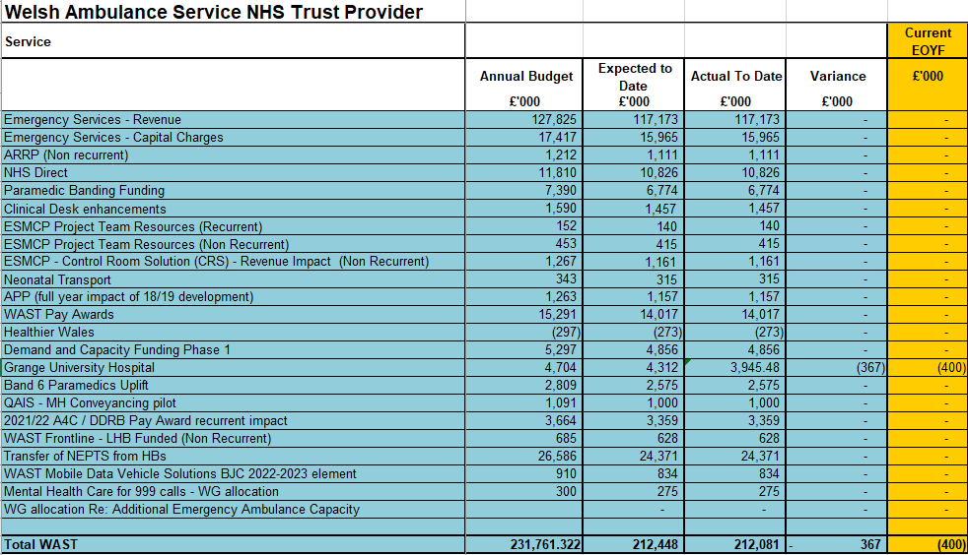

  - The current financial position of WAST is reported (£0.367m) underspent to date, in relation to a handback of the Aneurin Bevan commissioned Grange Hospital transport contract. The forecast year end position is (£0.4m) underspent.

  - The Welsh Ambulance Services NHS Trust (WAST) provider baseline assumptions are agreed with EASC and aligned to the IMTP as at the end of June 2023, in line with the Welsh Government deadline for confirmed Service Level Agreements.

  - The budget reported includes frontline support of £1.8m which is has been made recurrent in the IMTP and contributed to by all Health Boards.

  - The funding for Renal NEPTS has been separated from the WAST baseline and is reported separately.

EMRTS

  - The EMRTS provider baseline is agreed with EASC and aligned to the IMTP as at the end of June 2023 and is covered in the Heads of Agreement document signed between the Welsh Health Specialised Services Committee (WHSSC) & Swansea Bay UHB for 2023/24.

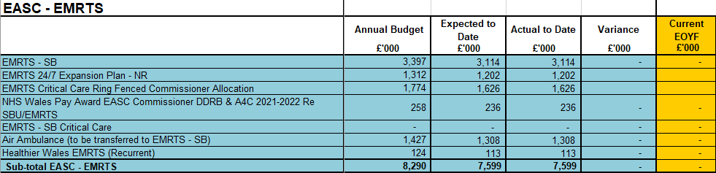

EASC Core Running Costs Budget

  - The 23/24 annual budget has been uplifted to £0.627m to reflect the 22/23 recurrent pay award

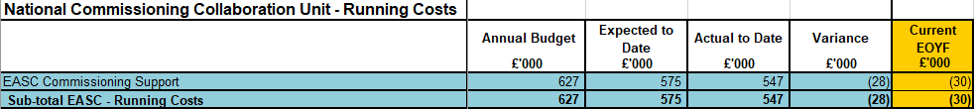

EASC Commissioning

  - An additional provision was made in the development of the 2022/23 EASC IMTP for the recurrent funding of the South East Wales Acute Coronary Syndrome pathway.

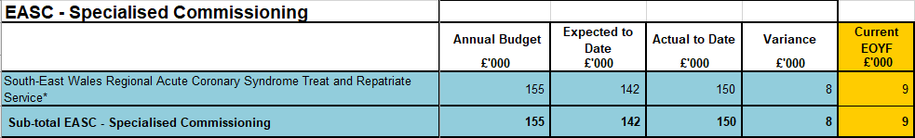

Actual Year to Date and Forecast Over / Underspend (Provider positions)

  - There is a reported variance of £8k related to inflation against the South East Wales Acute Coronary Syndrome Service budget.

WAST:
  - The current financial position of WAST is reported (£0.367m) underspent to date, in relation to a handback of the Aneurin Bevan commissioned Grange Hospital transport contract. The forecast year end position is (£0.4m) underspent.

Direct Running Costs (Staffing and non-pay):
  - Team costs are based on expected staffing levels. EASC have committed to apply a £30k cost reduction to the running cost budget as part of the system deficit reduction, this is reported as achieved in M11 hence the (£28k) underspend in commissioner financial positions.

Actual Yearend Over/(under)spend 2023/24 (Commissioner positions)

EASC variances:
 | Allocation of Variance
 | Total | Cardiff and Vale | SB | Cwm Taf Morgannwg | Aneurin Bevan | Hywel Dda | Powys | Betsi Cadwaladr
 | £'000 | £'000 | £'000 | £'000 | £'000 | £'000 | £'000 | £'000
Variance M11 | (386) | (3) | (3) | 0 | (369) | (4) | (2) | (7)
Variance M10 | (351) | (2) | (3) | 0 | (335) | (3) | (2) | (7)
Movement | (35) | (1) | 0 | 0 | (34) | (1) | 0 | 0
Table 3 – End of Year Forecast by LHB
 | Allocation of Variance
 | Total | Cardiff and Vale | SB | Cwm Taf Morgannwg | Aneurin Bevan | Hywel Dda | Powys | Betsi Cadwaladr
 | £'000 | £'000 | £'000 | £'000 | £'000 | £'000 | £'000 | £'000
EOY forecast M11 | (421) | (2) | (3) | 0 | (402) | (4) | (2) | (8)
EOY forecast M10 | (421) | (2) | (3) | 0 | (402) | (4) | (2) | (8)
EOY movement | 0 | 0 | 0 | 0 | 0 | 0 | 0 | 0

Income / Expenditure Assumptions

Income from LHBs:
  - Income for Month 11 is in line with the anticipated expectations. This is as EASC cannot overspend and health board contributions must balance to expenditure.

Overview of Key Risks / Opportunities

None

Public Sector Payment Compliance

  - The WHSSC/EASC payment compliance target is consolidated and reported through the Cwm Taf Morgannwg UHB monitoring process.

- KEY RISKS/MATTERS FOR ESCALATION TO THE COMMITTEE

  - None to report

- Responses to Action Notes from WELSH GOVERNMENT MONTHLY MONITORING RETURN responses

  - WG M10 Reply Letter: No action notes require addressing from the M10 monitoring returns.

5. Assessment
Objectives / Strategy
Dolen i Nod (au) Strategol BIP CTM /  Link to CTMUHB Strategic Goal(s) | Improving Care
 | If more than one applies please list below:
Dolen i Feysydd Strategol BIP CTM /  Link to CTMUHB Strategic Areas | Living Well
If more than one applies please list below:
All are applicable
Dolen i Ddeddf Llesiant Cenedlaethau'r Dyfodol – Nodau Llesiant /  Link to Wellbeing of Future Generations Act – Wellbeing Goals  150623-guide-to-the-fg-act-en.pdf (futuregenerations.wales) | A Healthier Wales
 | If more than one applies please list below:
Dolen i Hwyluswyr Ansawdd  (Canllawiau Statudol Dyletswydd Ansawdd (llyw.cymru)) /  Link to Enablers of Quality  (Duty of Quality Statutory Guidance (gov.wales)) | Data to Knowledge
If more than one applies please list below:
Whole system perspective
Dolen i Feysydd Ansawdd  (Canllawiau Statudol Dyletswydd Ansawdd (llyw.cymru)) /  Link to Domains of Quality  (Duty of Quality Statutory Guidance (gov.wales)) | Effective
If more than one applies please list below:
All apply
Effaith Amgylcheddol/ Cynaliadwyedd (5R) /  Environmental /Sustainability Impact (5Rs) | No - Not Applicable
 | If more than one applies please list below:

Impact Assessment
Ansawdd  Ydych chi wedi ymgymryd â Sgrinio Asesiad o’r Effaith ar Ansawdd? /  Quality  Have you undertaken a Quality Impact Assessment Screening? | Yes: ☐ | No: ☒
 | Outcome: | If no, please include rationale below:
Cydraddoldeb  Ydych chi wedi ymgymryd â Sgrinio Asesiad o'r Effaith ar Gydraddoldeb? /  Equality  Have you undertaken an Equality Impact Assessment Screening? | Yes: ☐ | No: ☒
 | Outcome: | If no, please include rationale below:
Cyfreithiol / Legal | There are no specific legal implications related to the activity outlined in this report.
Enw da / Reputational | There is no direct impact on the reputation of the Joint Committee as a result of the activity outlined in this report.
Effaith Adnoddau  (Pobl /Ariannol) /  Resource Impact  (People / Financial) | There is no direct impact on resources as a result of the activity outlined in this report.
 | Finance report

- RECOMMENDATION

  - The Emergency Ambulance Services Committee is asked to:

- NOTE the current financial position and forecast year-end position.

- Confirmation of position report by the Chief Ambulance Services Commissioner and the Director of Finance:

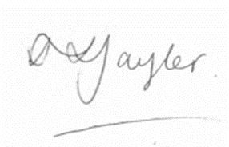  Stacey Taylor,  Director of Finance, EASC and WHSSC |   Stephen Harrhy,  Chief Ambulance Services Commissioner, EASC

