AGENDA ITEM
2.1

EMERGENCY AMBULANCE SERVICES COMMITTEE

EASC PERFORMANCE REPORT

Date of meeting | 10/05/2022

FOI Status | Open/Public

If closed please indicate reason | Not Applicable - Public Report

Prepared by | Ross Whitehead, Deputy Chief Ambulance Services Commissioner
Presented by | Ross Whitehead, Deputy Chief Ambulance Services Commissioner
Approving Executive Sponsor | Chief Ambulance Services Commissioner

Report purpose | FOR DISCUSSION / REVIEW

Engagement (internal/external) undertaken to date (including receipt/consideration at Committee/group)
Committee/Group/Individuals | Date | Outcome

ACRONYMS
DAG  EMRTS  NEPTS  WAST | Delivery Assurance Group  Emergency Medical Retrieval and Transfer Service  Non-Emergency Patient Transport Service  Welsh Ambulance Services NHS Trust

- SITUATION/BACKGROUND

  - The purpose of the report is to provide an update on current emergency ambulance performance for Committee Members.

  - Further iterations of this report will include performance information for Non-Emergency Patient Transport Services and the Emergency Medical Retrieval and Transfer Service.

  - This report presents information in line with the most recent publications of the Ambulance Quality Indicators.

  - In response to feedback from Members, additional management information has been appended to this report to support discussions at the Committee meeting. This information is un-validated and subject to change prior to publication, therefore use of this information outside of the meeting should be treated with caution.

- SPECIFIC MATTERS FOR CONSIDERATION BY THIS MEETING (ASSESSMENT)

  - This report will set out activity and performance across Calls, Incidents, Response and Output.

  - The chart below shows call volume versus the 95th percentile answer time. Whilst the median and 65th percentile answer times continue to perform well at 2 and 3 seconds, there is a clear deterioration in the 95th percentile time.

Chart 1 – 999 Calls vs 95th Percentile answer times

  - Not all calls received by the 999 clinical contact centres (CCCs) will generate an incident. The chart below shows the relationship between call volumes and incident generation.

  - There is a growing gap between the number of calls answered and the number of incidents generated, this is often seen at times of escalation related to individuals calling back due to a delayed response.

Chart 2 – Calls v Incident volumes

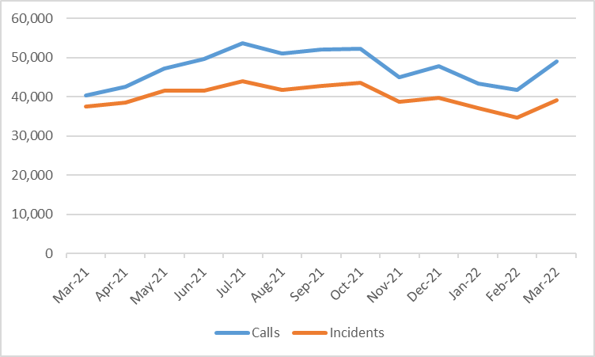

  - The Committee Members have recognised the importance of remote clinical support for patients and increasing the numbers of patients receiving an outcome of hear and treat.

  - The chart overleaf demonstrate the volume of incidents resolved by hear and treat. Recent investment in both staff and technology within the clinical support desk should support improvements in this level as well as more granular data on the outcomes for patients.

  - This chart contains information for 999 calls resolved by the emergency ambulance services clinical support desk as well as incidents passed to 111 for resolution.

Chart 3- Hear and Treat Volumes.

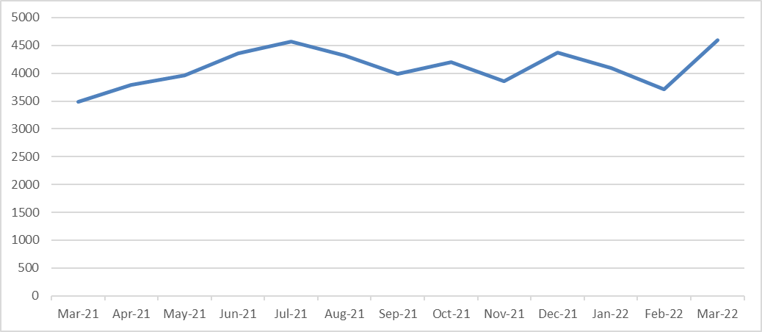

  - The chart below demonstrates the categories of incidents receiving at least 1 ambulance response. Whilst there is a clear reduction in the number of incidents receiving a response overall, it should be noted that much of this reduction is driven by escalation actions.

  - Committee Members should also note the increase in Red incident volume. By their nature, red incidents often require multiple responses at scene and so have a disproportionate effect on resource availability for other incidents.

Chart 4 – Categories of incidents receiving a response

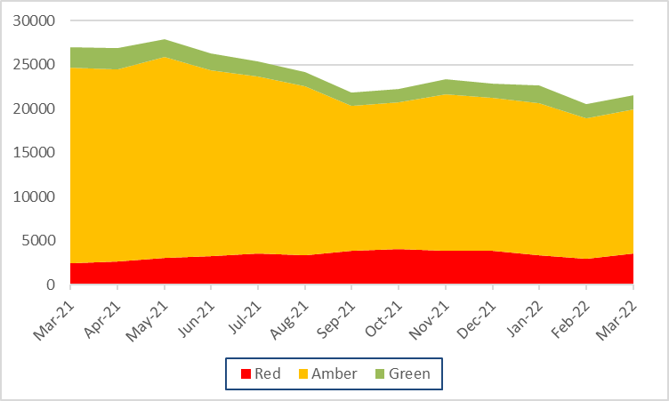

  - At the last meeting, Members requested information on the number of hours produced by the ambulance service each month. The chart below demonstrates this.

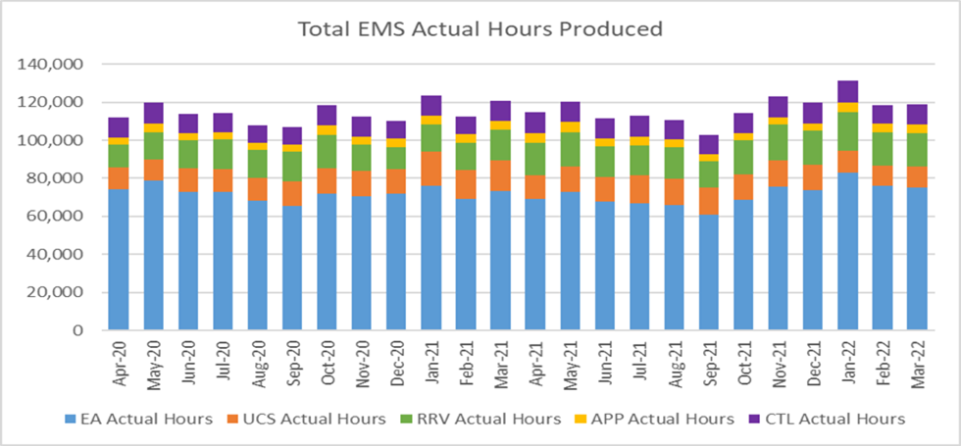

  - The chart overleaf demonstrates Red performance alongside the range of response times that have been achieved. The lack of delivery of the target has been well documented, however committee members should note the increasing response times that underpin this.

Chart 5 – Red Response and Performance

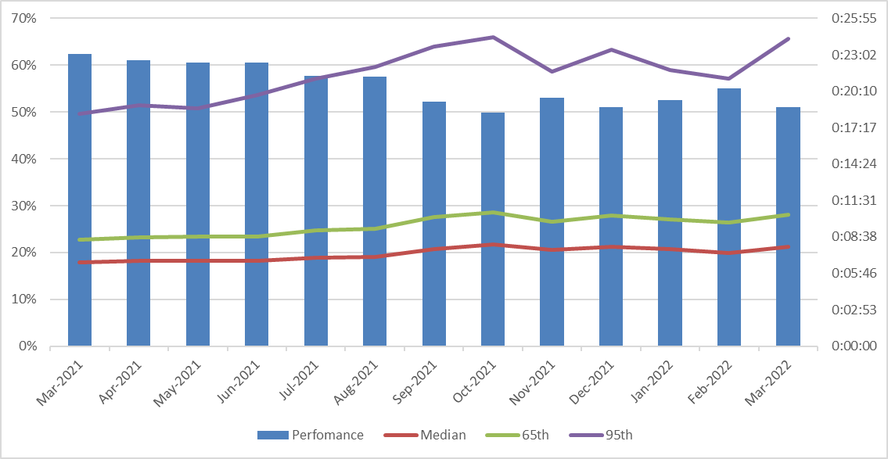

  - The chart below shows the response times for Amber patients. Whilst there is no time target for Amber patients, it’s accepted that these patients still require a timely response. The current response times for this category are significantly above the level that would be considered appropriate.

  - The key to delivery of appropriate response within Amber is the availability of ambulance resource. The development of the ambulance utilisation metric will be a key enabler for the committee and operational teams to understand and improve this area of response.

Chart 6 – Amber responsiveness

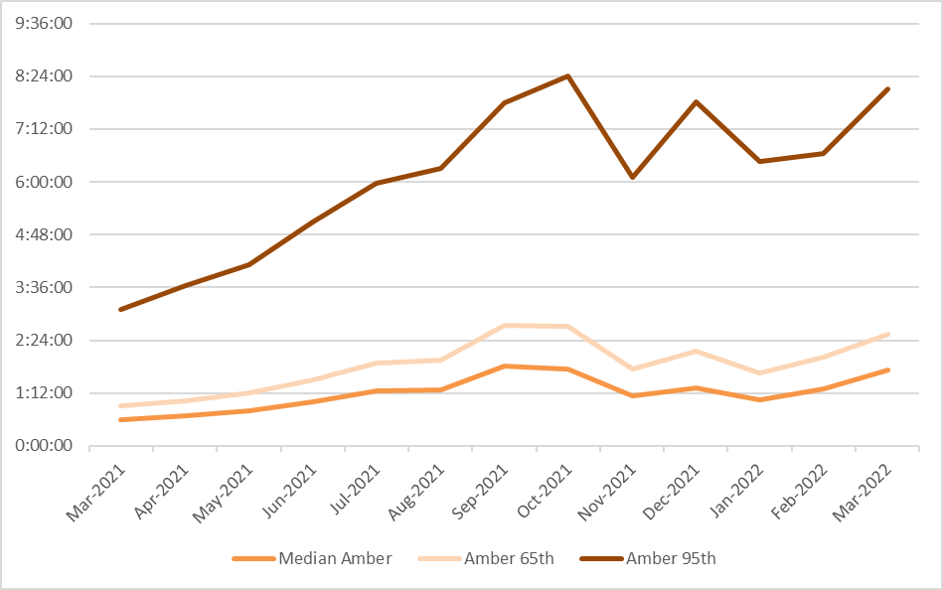

  - Optimising conveyance is a key aim of the urgent and emergency care programme. Whilst the chart below shows a reduction in both conveyance volume and percentage, this impact must be considered in light of the information provided earlier in this report which showed the reduction in attendance in response to escalation decisions.

Chart 7 – Conveyance volumes

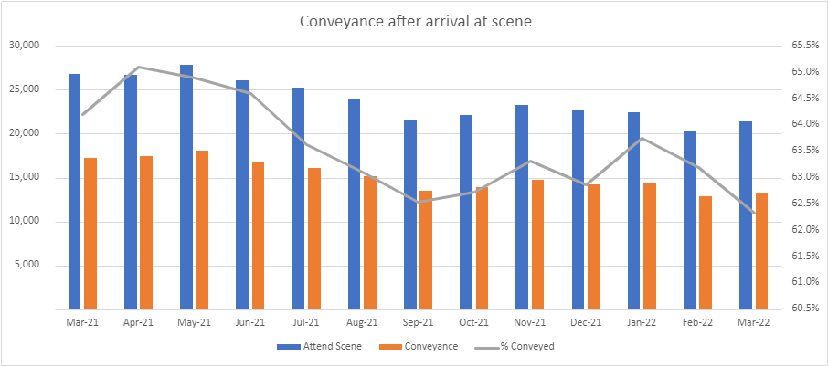

  - The chart below demonstrates the level of lost hours to handover outside emergency departments (ED) in Wales.

Chart 8 – Handover Lost Hours

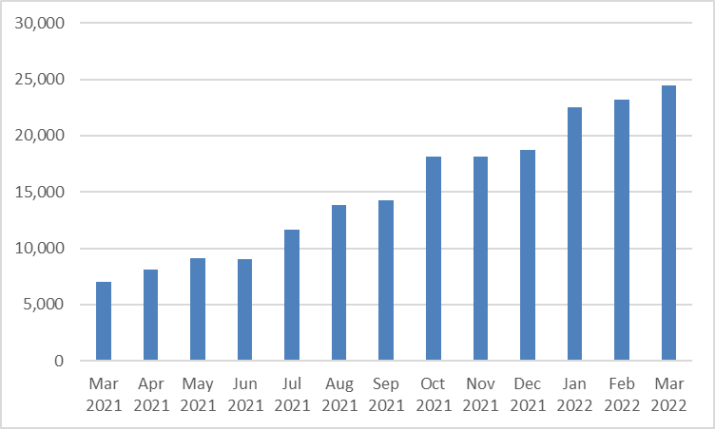

- KEY RISKS/MATTERS FOR ESCALATION TO THE COMMITTEE

  - Committee Members will note from the information within this report that there has been a deterioration in a range of performance indicators.

  - Due to the time sensitive nature of some type of incidents presenting to the ambulance service, response performance can be used as a proxy for harm and as such the committee should anticipate increase levels of harm and reductions to patient safety if these performance trajectories are not reversed.

- IMPACT ASSESSMENT

Quality/Safety/Patient Experience implications | There are no specific quality and safety implications related to the activity outined in this report.
Related Health and Care standard(s) | Governance, Leadership and Accountability
Equality impact assessment completed | Not required
Legal implications / impact | There are no specific legal implications related to the activity outlined in this report.
Resource (Capital/Revenue £/Workforce) implications /  Impact | There is no direct impact on resources as a result of the activity outlined in this report.
Link to Commissioning Intentions | The Committee’s overarching role is to ensure its Commissioning Strategy for Emergency Ambulance Services utilising the five step patient pathway outlined within the National Collaborative Commissioning Quality and Delivery Agreement and the related outcomes for each care standard aligned with the Institute of Healthcare Improvement's (IHI) ‘Quadruple Aim’ are being progressed.
Link to Main WBFG Act Objective | Commitment to corporate social responsibility and improving health & social equity, work with our staff, partners and communities to build strong local relationships and solid foundations of the past

- RECOMMENDATION

  - The Emergency Ambulance Services Committee is asked to:

- NOTE the content of the report.
- DISCUSS additional actions that the committee could take to improve performance delivery of commissioned services

MANAGEMENT INFORMATION FOR DISCUSSION – THIS INFORMATION SHOULD NOT BE USED OUTSIDE OF THE MEETING AND IS SUBJECT TO CHANGE
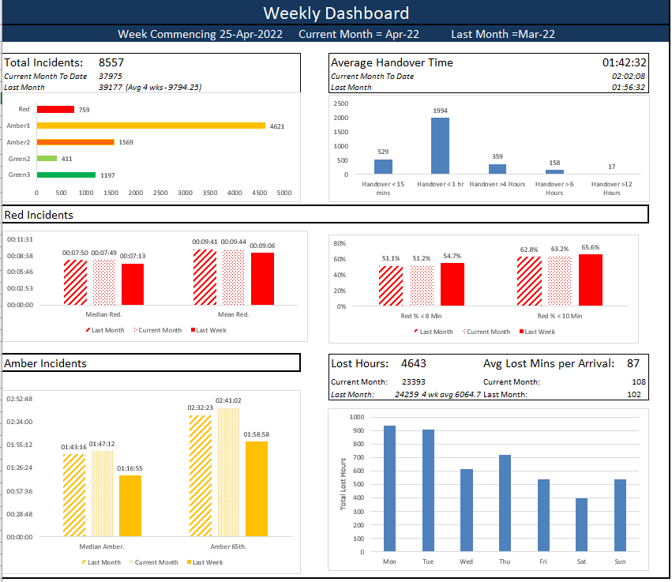
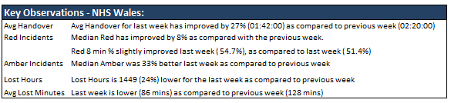

MANAGEMENT INFORMATION FOR DISCUSSION – THIS INFORMATION SHOULD NOT BE USED OUTSIDE OF THE MEETING AND IS SUBJECT TO CHANGE
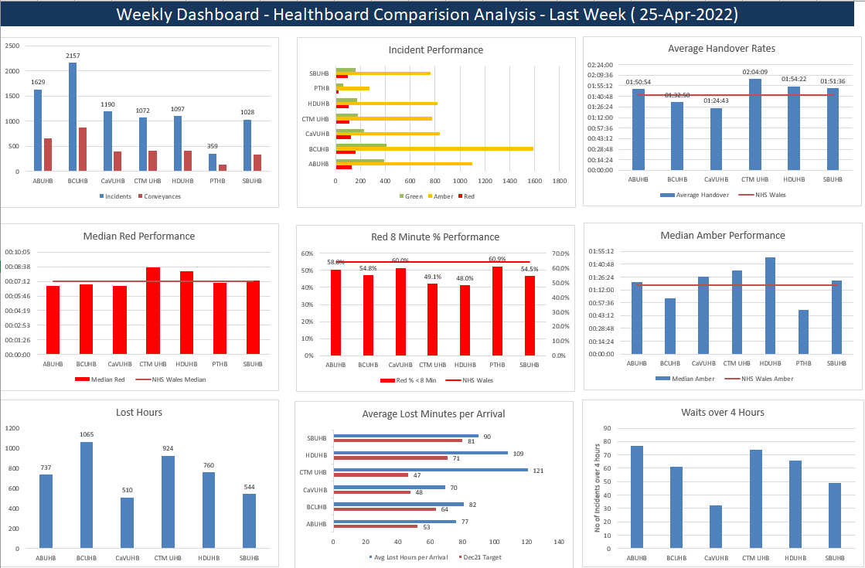

MANAGEMENT INFORMATION FOR DISCUSSION – THIS INFORMATION SHOULD NOT BE USED OUTSIDE OF THE MEETING AND IS SUBJECT TO CHANGE
