AGENDA ITEM
2.2

EMERGENCY AMBULANCE SERVICES COMMITTEE

AMBULANCE HANDOVER DELAYS

Date of meeting | 10/05/2022

FOI Status | Open/Public

If closed please indicate reason | Not Applicable - Public Report

Prepared by | Ross Whitehead, Deputy Chief Ambulance Services Commissioner
Presented by | Ross Whitehead, Deputy Chief Ambulance Services Commissioner
Approving Executive Sponsor | Chief Ambulance Services Commissioner

Report purpose | FOR DISCUSSION / REVIEW

Engagement (internal/external) undertaken to date (including receipt/consideration at Committee/group)
Committee/Group/Individuals | Date | Outcome

ACRONYMS
DAG  EMRTS  NEPTS  WAST | Delivery Assurance Group  Emergency Medical Retrieval and Transfer Service  Non-Emergency Patient Transport Service  Welsh Ambulance Services NHS Trust

- SITUATION/BACKGROUND

  - The purpose of the report is to provide an update on Ambulance Handover Delays for Committee Members.

  - The level of ambulance handover delays in Wales are at unsustainable levels and are resulting in an inability to deliver safe and effective ambulance responses for the population of Wales.

  - It is recognized that handover delays are a sign of wider system pressures; however, the Committee has previously committed to delivering a maximum of a 150 hours lost a day, or circa 5,000 hours a month (9 November 2021). The original intention of ambulance handover times was 15 minutes following the arrival of the vehicle, this remains to be reported in the Ambulance Quality Indicators; the most recent figures were reported as being at 18.7%.

  - At the EAS Joint Committee meeting in November 2021, Members recognised that due to system pressures they were unable to achieve the previous commitments, but collectively agreed to introduce “red lines” as the start point of efforts to reducing ambulance handover delays:

- No ambulance handover will take more than 4 hours
- We will reduce the average lost time per arrival by 25% from the October 2021 level at each site (from 72 minute to 54 minutes at an all Wales level).

  - Delivery of improvements towards these “red lines” has been difficult, and the current handover position is significantly above the levels seen in November 2021.

  - To support the work required to deliver this improvement a series of tripartite meetings have been set up with WAST, health boards and the EASC team to explore additional collaborative approaches to improving the position on handover delays. As part of this process, each health board has been asked to submit plans and trajectories for improvements at the local emergency department level.

- SPECIFIC MATTERS FOR CONSIDERATION BY THIS MEETING (ASSESSMENT)

  - The chart below demonstrates the level of lost handover delays since November 2017.
Whilst there have been numerous months where handover delays have spiked, there has been a consistent growth trend since February 2021.
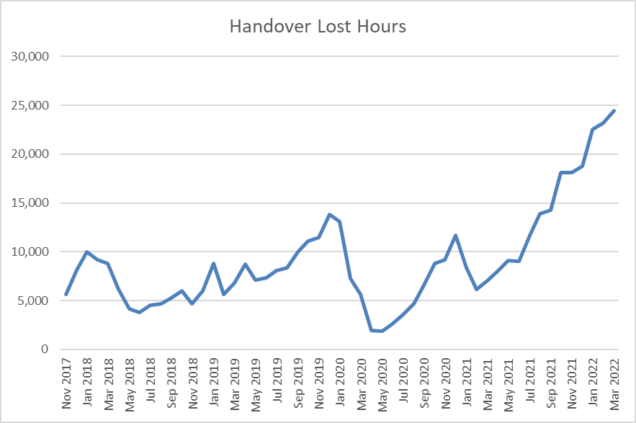
  - The average lost minutes per arrival have continued to grow alongside the growth in handover delays.

  - The Emergency Medical Services (EMS) Demand and Capacity Review undertaken in 2019 assumed approximately 6,000 lost hours per month for planning purposes and proposed capacity requirements to mitigate this.

  - The chart below demonstrates the number of individual waits over 4 hours across Wales.
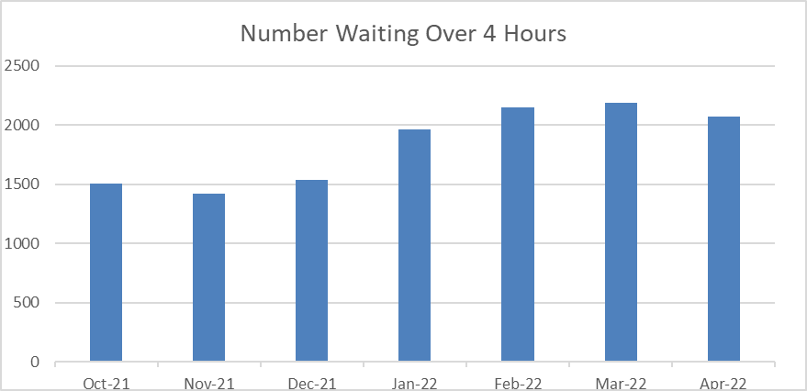
  - The table below demonstrates the total available hours for Emergency Ambulances (EA) and Urgent Care Services (UCS) resources, handover lost hours and the percentage of total production lost to handover.

Month | EA/UCS  Hours Produced | Handover hours Lost | % Lost
January 2022 | 94,533 | 22,712 | 24%
February 2022 | 86,450 | 23,216 | 26.9%
March 2022 | 86,163 | 24,259 | 28.2%

  - Whilst the improvement trajectories provided by health board vary in recognition of the different challenges faced, there is a broad trajectory toward 20-25% reduction per quarter.

  - If the delivery of these plans and trajectories are maintained each quarter, then we would reach the modelled demand and capacity level of circa 6,000 hours lost per month in September 2023 with 20% improvements or in June 2023 for 25% improvements (quarter on quarter).

  - However, it is recognised that handover improvements are unlikely to have linear improvement trajectories and will likely see deterioration during winter periods, or accelerated improvements in response to wider system flow work.

- KEY RISKS/MATTERS FOR ESCALATION TO THE COMMITTEE

  - Members will note from the information within this report that there has been a deterioration in level of handover delays across Wales.

  - Ambulance handover lost hours are absorbing over 25% of response capacity, with consequential delays for patients awaiting and ambulance response in the community.

  - Current handover improvement plans and trajectories will result in levels of handover lost hours above the demand and capacity modeling for a minimum of 14 months.

- IMPACT ASSESSMENT

Quality/Safety/Patient Experience implications | There are no specific quality and safety implications related to the activity outined in this report.
Related Health and Care standard(s) | Governance, Leadership and Accountability
Equality impact assessment completed | Not required
Legal implications / impact | There are no specific legal implications related to the activity outlined in this report.
Resource (Capital/Revenue £/Workforce) implications /  Impact | There is no direct impact on resources as a result of the activity outlined in this report.
Link to Commissioning Intentions | The Committee’s overarching role is to ensure its Commissioning Strategy for Emergency Ambulance Services utilising the five step patient pathway outlined within the National Collaborative Commissioning Quality and Delivery Agreement and the related outcomes for each care standard aligned with the Institute of Healthcare Improvement's (IHI) ‘Quadruple Aim’ are being progressed.
Link to Main WBFG Act Objective | Commitment to corporate social responsibility and improving health & social equity, work with our staff, partners and communities to build strong local relationships and solid foundations of the past

- RECOMMENDATION

  - The Emergency Ambulance Services Committee is asked to:

- NOTE the content of the report.
- DISCUSS additional actions that could be taken by the Committee to mitigate the handover lost hours position

