AGENDA ITEM
2.3

EMERGENCY AMBULANCE SERVICES COMMITTEE (EASC)

welsh ambulance services nhs trust (WAST)
provider update

Date of meeting | 10 May-22

FOI Status | Open/Public

If closed please indicate reason | Choose an item.

Prepared by | Rachel Marsh, Director of Strategy, Planning and Performance (WAST)
Presented by | Jason Killens, Chief Executive WAST
Approving Executive Sponsor | Chief Executive

Report purpose | FOR DISCUSSION / REVIEW

Engagement (internal/external) undertaken to date (including receipt/consideration at Committee/group)
Committee/Group/Individuals | Date | Outcome
(Insert Name) | (DD/MM/YYYY) | Choose an item.

ACRONYMS
ABUHB  CTMUHB  D&C  EMS  NCCU  NEPTS  SAI  WAST | Aneurin Bevan University Health Board  Cwm Taf Morgannwg University Health Board  Demand and Capacity  Emergency medical services  National Collaborative Commissioning Unit  Non-Emergency Patient Transport Services  Serious Adverse Incident  Welsh Ambulance Services NHS Trust
- SITUATION/BACKGROUND

  - The purpose of this report is to provide EASC with an update on key issues affecting quality and performance for EMS and NEPTS and to provide an update on commissioning and planning for EMS and NEPTS.

- SPECIFIC MATTERS FOR CONSIDERATION BY THIS MEETING (ASSESSMENT)

CoVID-19 and Current Operational Pressures

  - WAST continues to track CoVID-19 and related metrics through its weekly CoVID-19 Intelligence Pack. A fourth wave appears to have peaked and the trend is now downward (positive tests). WAST is currently (28 Apr-22) at escalation level 4 (4 being the highest), with the continued need for WAST to use its highest level in the Clinical Safety Plan, level 4, which means the use of clinical screening for Red and Amber 1 patients and unable to send for Amber 2. For the 30 days to 30 Mar-22, WAST was at level 4 for 15 of the 30 days. The reasons for this are complex, and not just CoVID-19 demand, and include high abstractions (linked directly to CoVID-19, but also workforce fatigue) and high system pressure, in particular, extreme handover lost hours.

2.2 WAST now undertakes seasonal forecasting and modelling as a matter of routine. The modelled results for Apr-22, post military aid, have been made available to the Chief Ambulance Services Commissioner (CASC) and the team. The modelled results indicate that WAST would have needed to operate at high levels of escalation in terms of the Clinical Safety Plan to bring Red 8 minute performance above 60% and Amber 1 median under one hour. Further modelling is now being undertaken to aid seasonal planning for the summer.

2.3 WAST has stood down its pandemic structures (Pandemic Plan), but continues to operate a Trust wide Performance Improvement Plan (PIP), which sets out the actions being taken to mitigate the risks highlighted in the spring modelling. The PIP is regularly reported on to the CASC. WAST has written to the CASC requesting continued support for a number of mitigations that would require funding e.g. cohorting, continued use of St John Ambulance etc. and this has now been agreed for the first 4 months of the year.

EASC is asked to NOTE that: WAST is currently at maximum escalation, WAST continues to have to operate its Clinical Safety Plan up to level 4 (maximum), military aid had ended; WAST will continue to tactically performance manage delivery against an organisational wide PIP (which is also regularly reported to the CASC); and that WAST is in receipt of some funding for patient safety mitigations for the first 4 months of 2022/23.

Quality, Safety & Patient Experience

Patient Response Times in the Community

2.4 One of the key indicators which measures the quality of the service provided is the timeliness of the response by WAST to patients waiting in the community. The graphs below show the current response time performance for Red calls and for Amber One calls. Both graphs show that response times remain significantly off target or off benchmark. Inevitably these times have had an impact on patient safety.

2.5 The Red 8-minute target was not achieved in Mar-22. The percentage of emergency responses to Red incidents within 8 minutes was 51% (target 65%) with 95% of Red calls receiving a response within 22 minutes. Red 9-minute performance was 57% and Red 10 minute performance 63%.
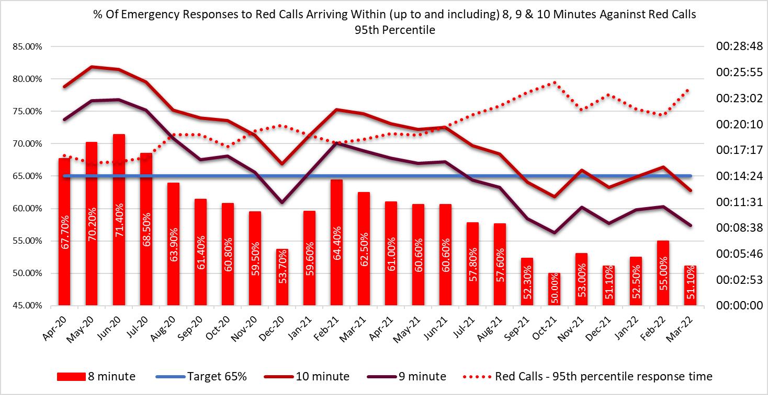
2.6 The Amber One median percentile in Mar-22 was one hour and 38 minutes and the Amber One 95th percentile was six hours 38 minutes. The Amber 1 performance parameters used in the EMS Demand & Capacity Review were 35 minutes (Dec-21 position) and 18 minutes (Dec-24 position) respectively. Amber 1 incidents include chest pains, strokes, unconscious patients etc.
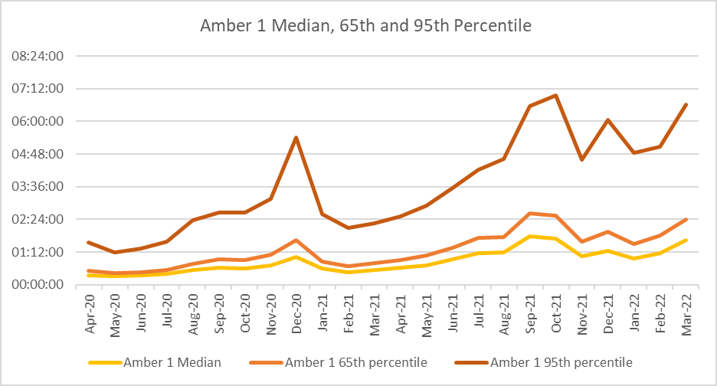

2.7 These very long Amber One median times mean that the patient waiting times in the “Amber tail” are a particular concern from a patient safety perspective; it is where the bulk of National Reportable Incidents (NRIs) occur.

2.8 As part of its quality, safety and patient experience arrangements, WAST continues to monitor the longest patient responses. The table below shows the number of patients who had to wait 12 hours or over. The table shows that very long waits were almost eliminated during the first wave, but subsequently returned as system pressures increased. There were 802 long waits in Mar-22, the highest ever recorded (previous high 662 Oct-21).

2.9 These long response times impact on patient safety and outcomes. WAST has been supplying weekly information on quality, safety and patient experience to the CASC and monthly information through the CASC Assurance & Delivery meeting. This information includes more detailed analysis, patient stories (positive and negative) and patient feedback from surveys.

2.10 WAST supplies health boards with a monthly report on one hour and over patient waits.

2.11 In extreme cases, long response times can lead to National Reportable Incidents (NRIs). In the last 3 months, 42 patient safety incidents have been passed to health boards as part of the joint investigation framework (Appendix B). 14 NRIs were reported by WAST to the Delivery Unit in quarter four.
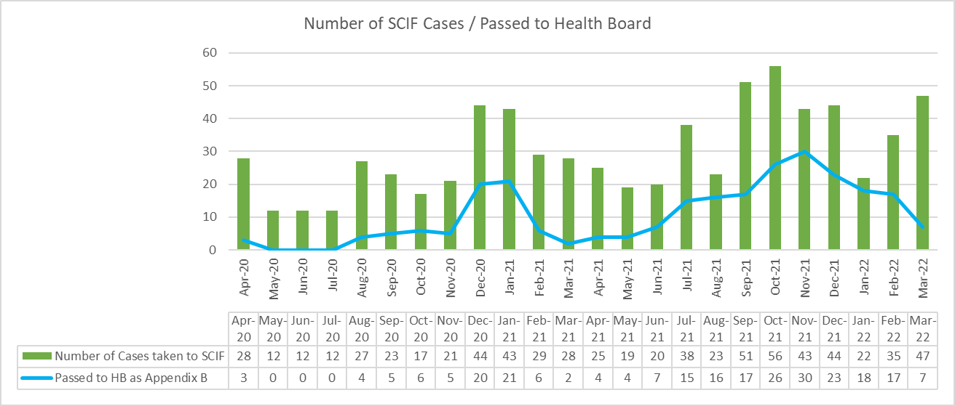

2.12 Whilst there are many factors affecting response times, which are described later in this report, one of the factors outside WAST’s control is the number of ambulances which wait longer than 15 minutes to transfer patients into secondary care at Emergency Departments (EDs). The graph below shows the number of ambulance hours that are lost outside EDs which, if released earlier, would have reduced patient waits in the community. As with the other graphs, during the first wave of the pandemic, the number of lost hours decreased very significantly, but they are now higher than those seen in the worst of winter.
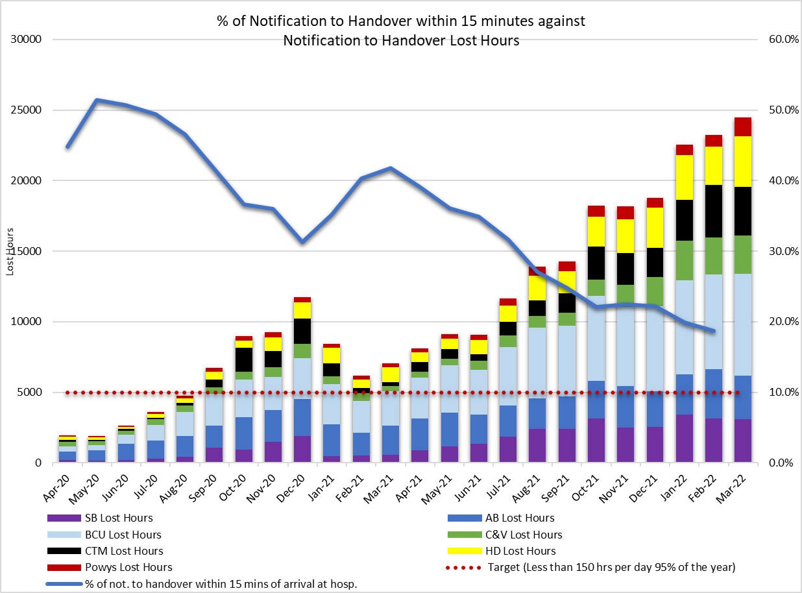
2.13 24,479 hours were lost to handover in Mar-22 (or 29% of the conveying capacity), compared to 7,052 in Mar-21, 5,670 in Mar-20 and 6,833 in Mar-19, the benchmark used in the 2019 EMS Demand & Capacity Review. In Mar-22 WAST achieved Emergency Ambulance (EA) unit hours production (UHP) of 98% (benchmark 95%) and a Rapid Response Vehicle (RRV) of 71% (benchmark 95%). Handover lost hours were 358% above the benchmark, with the benchmark being not to worsen from the Dec-18 position. The 2022/23 EASC commissioning intentions include the development of improvement trajectories per ED site. Initial meetings have started in Apr-22 between the NCCU, health boards and WAST to work on the trajectories and supporting action plans.

2.14 In the last three months WAST has reported 14 NRIs to the Delivery Unit and continues to have regular dialogue with EASC through the NCCU.

2.15 WAST has previously written (27 Jul-21) to the Director General detailing the clinical risk that WAST is carrying and the patient harm that is occurring in communities across Wales and more recently WAST has written to the CASC (24 Feb-22) on projected clinical risk into quarter 1 2022/23. WAST has reviewed and updated its Demand Management Plan, now Clinical Safety Plan. A health board escalation policy is currently in development nationally that connects with the WAST CSP and that there is a clear system wide approach to shared risk and patient safety. WAST has supported this work by providing health boards with access to its modelling software. This system wide approach to clinical safety went live in Apr-22.

Health & Safety

2.16 201 CoVID-19 positive cases for WAST staff were reported in January-22, 147 in Feb and 316 in Mar-22. 61 RIDDORS have been submitted to the HSE for potential exposure to CoVID-19 to date.

2.17 The internal investigation into the serious NEPTS road traffic collision that occurred near Dolgellau (April 2021) has been concluded with a report submitted to the Executive Team in Mar-22.

2.18 As part of the transformation of the function a business case for the health & safety function was presented to WAST’s Executive Management Team in Mar-22. This is currently being evaluated alongside other priorities.

2.19 The next planned deliverable of note for health and safety transformation are the revision of WAST’s Health and Safety Policy and construction of an investigation training package to assist staff undertaking investigations of Datix reports.

Clinical Outcomes

2.20 Since the January 2022 publication, no further Clinical Indicators have been published as the Trust transitioned from Digital Pen to ePCR. The transition was completed at the end of March 2022, with the final Health Board coming on line with digital handover. The first of the new data is due to be published in May 2022 and will include Clinical Indicators for Stroke and Fractured Neck of Femur.

2.21 The Trust has raised a risk with an associated action plan predicting a fall in indicator compliance as the new system for creating clinical records becomes embedded. The risk is managed through the Clinical Intelligence Assurance Group. The risk is based on intelligence from other UK ambulance services and is predicated on the transition from validated to non-validated data.

2.22 The transition to using non-validated data has led to the Clinical Audit Department designing a number of specific clinical audits to support the Clinical Indicator reports. These audits are outlined in the Clinical Audit plan which was agreed at the CIAG and approved by the Clinical Quality Governance Group, before being presented at QUEST in August 2022.

The purpose of the audits is to determine where the data gaps are and to assist the clinical teams operationally to educate their team members to better utilise the ePCR software. In addition, the audits will help organisational understanding regarding where focused changes to the application can be recommended in order to improve use in the field.

2.23 The longer term ambition for WAST is to link its patient and CAD data with health board patient data so that WAST can report on agreed time-based aspects of clinical indicators and track the eventual patient outcome once conveyed into a hospital. The ePCR project is critical to delivering this ambition. Now that ePCR is live across WAST, the project team are continuing to roll-out of the necessary digital handover for hospital sites across the border into England.

EASC is asked to NOTE that: the Red 65% target was not achieved in Mar-22 (and has not been since Jul-20); Amber waiting times remain very long; these delayed responses are impacting on patient safety; in the last three months 42 patient safety incidents were reported to health boards (under the Appendix B arrangements), where the primary cause is considered to be handover lost hours, and 14 NRIs were reported to Welsh Government by WAST; and the final health board transition to ePCR was completed in quarter 4 with new reporting arrangements starting in quarter one.

2.24 WAST is EASC commissioned for two patient flows (journeys) within the unscheduled and scheduled care systems: the 999 Emergency Medical Services (EMS) and the Non-Emergency Patient Transport Service (NEPTS). These patient flows and their safety are now looked at in turn.

EMS Performance

Response Times

2.25 As outlined earlier in the report, response times for both Red and Amber incidents remain too long.

2.26 There are a range of factors that affect response times:

- Demand: comparing demand is difficult because of the pandemic, but WAST has previously identified that Red demand has increased significantly over the last few years; Red demand for 2021/22 was 41,734 incidents, compared to 24,494 incidents in 2018/19 (base year used in EMS Demand & Capacity Review), an increase of 70%. This increase is a major contributing factor in relation to Red performance. In collaboration with the NCCU, WAST reopened the EMS Demand & Capacity Review in 2021 to update the strategic modelling with this change which has led to the new CHARU resource being included in the roster review keys. Further investment of 95 FTEs is required in order to produce the CHARU keys across Wales, meet the Red 65% Welsh Government target and deliver improved clinical outcomes through the CHARU parameters for clinical leadership on high acuity calls.

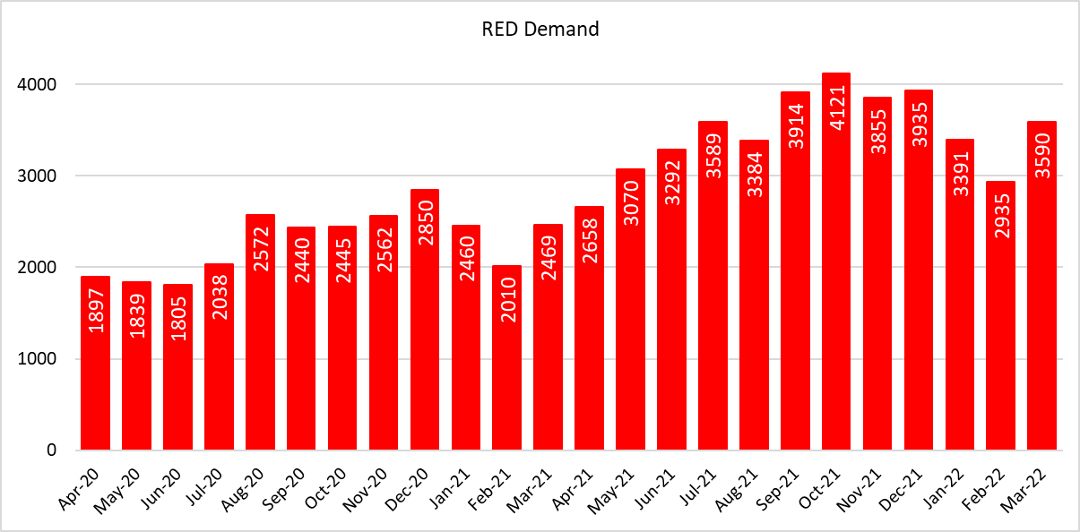

- Overall demand has increased by 4% compared to the 2018/19 levels used in the EMS Demand & Capacity Review; consequently, the roster keys being used in the roster review project are appropriate (with the CHARU uplift) to meet the interim benchmarks for Red and Amber One, if handover lost hours were at their 2018/19 levels.

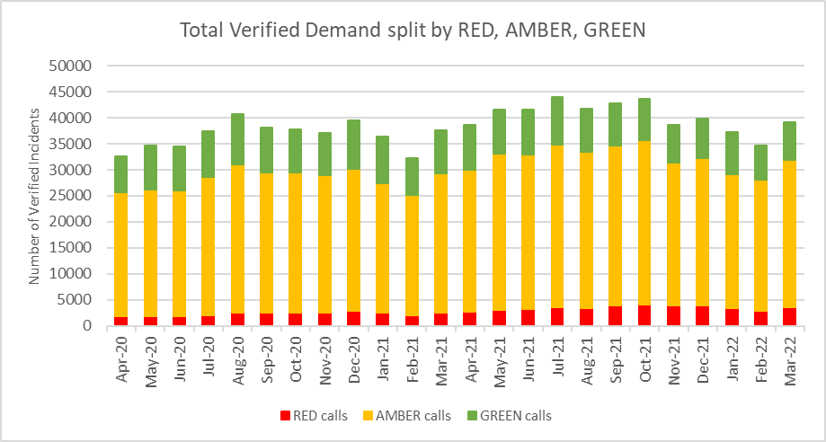

- The number of response hours produced: with the continued implementation of the PIP and support from the military, fire & rescue services and St John total actual ambulance hours (all resource types) was 118,840 hours in Mar-22 with emergency ambulance (EA) unit hours production at 98% in Mar-22, unscheduled care service (UCS) production at 92% and Rapid Response Vehicles (RRVs) at 71%; RRV production was lower due to a tactical focus on conveying resource. Whilst conveying resource production is holding up with the support from external partners, EASC can expect the situation in 2022/23 to worsen, as this support will largely stop.

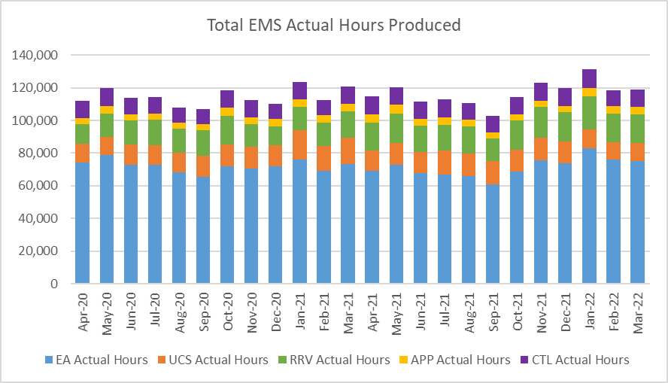

- Roster abstractions, in particular, sickness absence: the Operations Response sickness absence rate in Mar-22 was 14.22%. There is significant variation within this overall percentage.
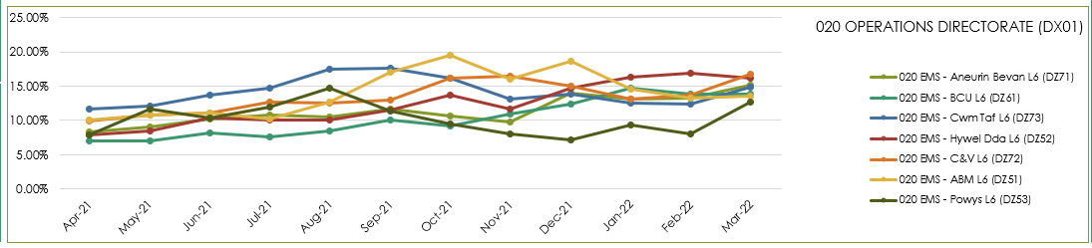

- WAST has recently introduced a new Managing Attendance Plan with seven work-streams and improvement trajectories. The Plan is being reported to Executive Management Team every two weeks.

- The number of hours lost each month due to hospital handover delays. See paragraph 2.13 above.

- Multiple variables: in dialogue with the CASC WAST has identified up to 23 “suspected” variables that impact on performance, with four: demand, utilisation, handover and time as scene considered key. This analysis has led to the innovative development of a pilot measure of ambulance unit hours utilisation (UHU), which the CASC has started to share more widely with stakeholders. There are some issues with data reliability here, in particular, post production lost hours (PPLH), which are currently under review.

- Post production lost hours (PPLHs): 11,452 hours were lost post production in Mar-22. PPLHs include a range of reasons e.g. vehicle defect, trauma stand down, police interview, etc. which cannot be viewed as areas for potential efficiencies. The EMS Demand & Capacity Review identified that WAST benchmarked comparatively well on PPLHs with the exception of return to base meal breaks. EASC members will note the dark blue data in the graph which forms a significant proportion of the total, which relates to lost hours due to increased HALO duties, which are required and utilized at times of high pressure within EDs. WAST has undertaken some recent benchmarking with three other ambulance services, two of which WAST benchmarks favourably with whilst the third is significantly better. Reducing PPLH for return to base meal breaks, is the third key efficiency for WAST, along with re-rostering and abstraction management reduction, in particular sickness.
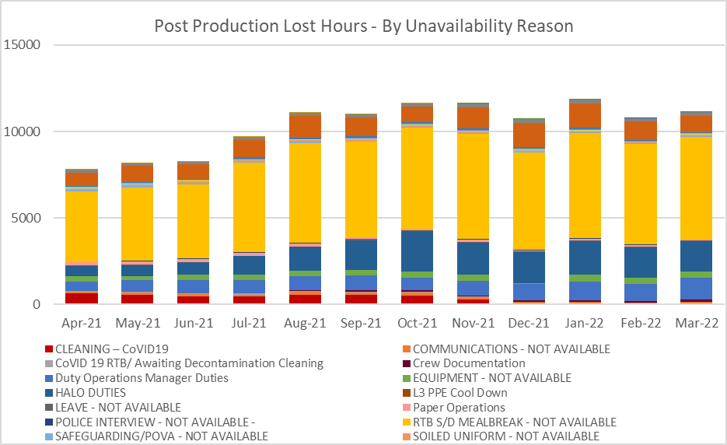

2.27 WAST is also engaged in a number of programmes across the unscheduled care system which are designed to shift demand left including: the core 111 service which is now live pan-Wales; however, the 111 First service has not received funding into 2022/23. WAST has received recurrent funding from EASC to support five mental health professionals into the Clinical Support Desk (CSD), all of whom are now either live or completing their training. WAST also expanded its CSD 36 FTE Paramedics during 2021/22; however, recurrent funding has not been made available; consequently, WAST will have to hold 46 ACA2 vacancies open in 2022/23 to close the financial gap caused by this i.e. re-open the relief gap for the Response workforce. These increases will support hear & treat, but also patient safety netting and other related activities. The CASC has requested an evaluation of the impact of these additional CSD FTEs. The CSD and NHSDW (Hear & Treat) achieved a combined rate of 11.8% in Mar-22 and 10.4% for 2021/22, exceeding the EMS Demand & Capacity Review identified a benchmark of 10.2% (modelled to be achieved by Dec-21) which will be revised up to 15% as a result of this increase.

2.28 ​If mitigating actions agreed / funded are not sufficient to manage patient demand (which currently they are not) WAST will enact its Clinical Safety Plan previously known as the Demand Management Plan. The CSP aligns with the Association of Ambulance Chief Executives (AACE) approved UK Clinical Safety Plan Framework requiring members to realign their existing plans to provide national consistency in the definition and reporting levels.
WAST has seen increased use of the higher levels of the CSP (level 4) which means “unable to send” to Amber 2 and Green incidents; for the 30 days to 30 Mar-22 WAST was at level 4 for 15 of the 30 days.
2.29 As previously discussed at EASC, WAST submitted a proposal in Dec-21 to increase core capacity in the short term to mitigate some of these extreme pressures, including the high levels of hospital handover lost hours. This would have brought about a reduction in response times and reduced clinical harm. At present, this plan has not been supported. The plan also proposed funding to start to move to a new and sustainable model of ambulance provision, including an increased use of advanced practice.
EASC is asked to NOTE that: WAST continues not to achieve the Red 8 minute 65% target; there are a range of factors coalescing to affect Red (and Amber) performance; WAST has boosted ambulance production through support from external partners; WAST has introduced a Managing Attendance Plan; WAST has expanded its CSD capacity to shift demand left, but funding for an element of this is not recurrent causing the relief gap for Response to re-open; and patient safety into quarter one is expected to worsen as military aid ends, but system pressure, in particular, handover lost hours are expected to remain extreme; no additional funding is available to increase core capacity to mitigate these pressures.

Ambulance Care (including NEPTS)

2.30 The NEPTS ambulance quality indicators have now resumed reporting. Key points about NEPTS are as follows:-
- CoVID-19 saw a significant drop-in patient transport activity at the start of the pandemic. Levels have increased, and are at or in excess of pre-pandemic levels for all journey types apart from outpatient journeys; however, the overall level of activity has still not recovered to pre-CoVID-19 levels due to the reduction in outpatient activity, although there was a sharp increase in Mar-22;

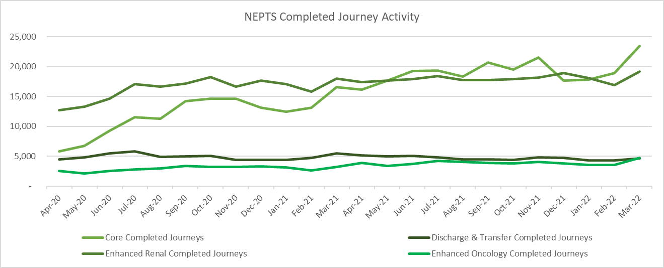

- CoVID-19 abstractions and social distancing have been challenging, but NEPTS has seen a continued improvement in key areas of service delivery particularly discharge and transfer journeys;
- Enhanced services performance is above target for renal with the oncology target being an area of review;
- The service is still impacted by the effects of physical distancing, although in Apr-22 steps have been taken to begin to move towards a new ‘Living with CoVID’ position by increasing maximum patient loading by 1 per vehicle, which will positively impact NEPTS capacity;
- Capacity has also been adversely affected by other CoVID-19 factors: journeys taking longer due to PPE, staff sickness, staff shielding, staff training and testing, infection prevention and control arrangements and so on;
- Overall demand for the service continues to increase across all areas and in Mar-22, overall demand was at 90% of the equivalent month in 2019 and was 10% busier than any month since Feb-2020. Only outpatient activity remains supressed with all other areas at or in excess of pre-pandemic activity levels
- As WAST emerges out of pandemic response and the health system is “re-set” WAST is anticipating further demand increases at which point capacity will be an issue.

2.31 70% of core journeys arrived within 30 minutes (+/-) of their appointment time in Mar-22; 81% of enhanced renal journeys arrived within 30 minutes prior to their appointment time; and 56% of enhanced oncology journeys arrived within 30 minutes prior to their appointment time.
Oncology has been identified as an area of focus from the NEPTS Demand & Capacity Review and will require changes in the way WAST works with the voluntary and community sector (VCS) to improve performance including a possible change in the target. 88% of discharge and transfer patients were collected less than one hour after their booked ready time in Mar-22

2.32 There is a Welsh Government ambition to see outreach appointments reduce by 50% “in time” (Health & Social Care in Wales – CoVID-19: Looking Forward); however, the short term scenario is that as the health care system emerges out of the pandemic response in 2022/23 this may see pent up demand for NEPTS as the system is switched back on and tries to catch up on certain services (there is a sharp spike in the Mar-22 demand). This is a significant risk to the system as social distancing/PPE has reduced Ambulance Care capacity. WAST modelled this scenario and reported the results and impacts to the CASC. WAST subsequently received in year investment to boost NEPTS capacity, in particular, the recruitment of drivers and procurement of external providers. This additional capacity has now ended. Further consideration needs to be given by EASC, the NCCU and WAST to demand management and capacity management options in order to balance demand with capacity within the existing resource envelope for NEPTS.

2.33 Finally, the NEPTS Demand & Capacity Review is complete and WAST has now established an Ambulance Care Transformation Programme Board, which includes recommendations from the Review and other key transformation work. Both health boards and the NCCU are represented on the Board. The programme is a significant body of work including pan-Wales roster reviews (ambulance transport and NET call centre), options for the oncology target, testing approaches for efficiency improvements linked to outpatient outbound ready times, CAD updated/replacement and so on. WAST is making good progress on the programme; however, the original plan to re-roster NEPTS transport in 2022/23 has changed because of the complexity of re-rostering against a demand pattern that is unstable. WAST has discussed this with the NCCU and the current plan is to undertake further work on agreeing a set of roster keys, with implementation now expected early in 2023/24.

EASC is asked to NOTE that: the 21/22 in-year investment to boost NEPTS capacity to mitigate the risk of reduced capacity caused by CoVID-19 and to aid system flow has ended; performance has been maintained, but with oncology being an area of review; the Ambulance Care Transformation Programme has been established and is making good progress; the revised plan is now to undertake more detailed pre-work on NEPTS re-rostering in 2022/23 with the potential go live being in 2023/24; capacity will not be sufficient to meet the demands on NEPTS into 2022/23 and beyond; and further dialogue is therefore required between EASC, the NCCU and WAST on the options available to determine how best to align demand and capacity.

Commissioning, Planning and Service Change

Forecasting & Modelling: Strategic Demand & Capacity Reviews

2.34 The EMS Operational Transformation Programme (arising from the EMS Demand & Capacity Review) is WAST’s main strategic response to patient safety and experience concerns for the EMS five step ambulance care pathway. In addition to the EMS Demand and Capacity Review recommendations three other IMTP actions – CHARUs, Rural Model Pilot (in Powys) and Leading Service Change Together (modernisation of working practices) have been brought under the umbrella of the programme.

2.35 EASC had delegated oversight of the delivery of the programme to EASC Management Group. WAST has made good progress on the recruitment and training aspect of this programme. The original 20-22 recruitment and training target i.e. closing the relief gap, was 1,691 FTEs. WAST expected to completely close the relief gap in May-22; however, it will need to hold open 46 ACA2 vacancies open to fund the uplift of 36 Paramedic FTEs into the CSD as funding as recurrent funding from EASC has not been made available for this uplift. WAST has also successfully recruited five mental health professionals funded by EASC. WAST has also boosted its 999 CCC call handling capacity; however, attrition remains a risk and further work is now required within the existing funding envelope on the proposed structure for CCC. Further forecasting and modelling is being undertaken on the CCC call handler FTE requirement.

2.36 Other key aspects of the programme include re-rostering CHARU/EAs and UCAs pan-Wales. The project has made good progress with implementation on-target for go live Sep-Nov-22; however, a further 95 FTEs are required to fully fund the CHARU roster keys and there will now be a shortfall of 46 ACA2s for UCS as explained above.

2.37 In Aug-21 the CASC agreed to re-open the EMS Demand & Capacity Review to look at the period 2022-25. Initial modelling on the CHARU concept has been completed (and built into the re-rostering project) with a Transition Plan business case developed for 2022/23, designed to put CHARU, APP and EA capacity into the system, to help offset the impact of extreme handover lost hours and mitigate the impact on patient safety. WAST does have an ability to recruit if funding were made available. Further forecasting and modelling on a maximization of shift left (hear & treat, see & treat) has also been completed and shared with the NCCU.

Commissioning Intentions

2.38 The Apr-22 EASC Management Group received a report from the NCCU on WAST’s year-end position progress against the 2021/22 EASC commissioning intentions. WAST is considered to have made good progress.

2.39 Work will start on the 2023/24 commissioning intentions as the next EASC Management Group.

Integrated Medium Term Plan (IMTP)

2.40 The WAST IMTP is delivered through a portfolio of transformation programmes supported by enabling programmes, projects and workstreams, which align to both WAST strategic ambitions and commissioning intentions. Despite the continued operational pressure and the need to pause some work on the IMTP there has been continued progress across our major programmes of work.

2.41 EMS Operational Transformation Programme:-

- Recruitment and training was on track to close the relief gap early in 2022/23, but funding issues mean that there will be a relief gap now in 2022/23;

- The roster review project has been re-commenced and due to go live during September to November; and

- Leading Service Change Together project requires further discussion with Trade Union partners as we understand outcomes of benchmarking, modelling and a data quality review.

2.42 WAST completed and submitted its IMTP to Welsh Government on 31st March 2022, with support from the CASC following EASC in March 2022. The plan has been submitted as a balanced plan based on a set of assumptions agreed with commissioners set out in the financial plan. The key elements of the plan going forward are:

EMS

- An offer to the system for increased capacity and resilience in our core service to meet the needs of the population of Wales in a safe and timely way, improving outcomes for patients and reducing clinical risk and harm. At this time this remains unfunded but will remain an ambition within the IMTP;
- An improvement in the working lives of our frontline staff, alleviating the causes of stress and aiming to reduce sickness absence, further improving our ability to provide the required capacity;
- Agreeing a baseline for PPLH and working with stakeholders to establish opportunities for improvement where capacity can be improved;
- A transition away from the traditional model of ambulance services, towards a transformed state in which patients are increasingly treated at or near home, avoiding unnecessary conveyance to an Emergency Department (ED), improving patient outcomes, and relieving pressure within the urgent and emergency care system;
- A realignment of resources, ensuring that their value is maximised in the most effective and efficient way to meet patient needs.

2.43 Ambulance Care:-
- Taking forward the NEPTS Demand and Capacity Review an initial PID has been developed for a Roster Review project, but a decision to under further work on the roster keys in 2022/23 before revisiting the PID, and a case developed for additional 12 FTEs in planning and day control subject to funding through the EASC commissioning mechanism (not funded at this time);

- Following the completion of health board transfers of work, the next stage of the Plurality Model project is to develop a Procurement Strategy, for which work has already commenced;

- The extension to the Grange Hospital Commissioning Agreement is nearing its end, and meetings have commenced to take forward the recommendations from the NCCU’s service evaluation including the commissioning arrangements for the transfer service within ABUHB;

- Development of a model and framework for Transfer and Discharge services across the whole of Wales, in collaboration with commissioners and other key stakeholders;

- The refreshed PNA (Patient Needs Assessment) launched on 01 Dec-21 and an alternative options search tool has been added to the NEPTS website; and

- The operational improvement plan is making steady progress in its four key domains.

2.44 Strategic ambition programmes:-

- The transformation programmes for EMS and Ambulance Care are supported by two further core service transformation programmes: Gateway to Care focusing on 111 and the implementation of the CCC Clinical Review; and Clinical Transformation with a focus on the clinical transformation required to shift left in the five step model for EMS;

- Our enabling programmes and workstreams are focusing on our people, estates, fleet and digital enhancements required to support IMTP delivery and commissioning intentions as well as the strong partnerships required to support system wide improvement across Wales, research and innovation activity and our;

- The ECNS is on track and the CSD Roster Review complete;

- ePCR has rolled out across Wales with some final adjustments to be made to align to local health board systems as DigiPen came to the end of its commissioned life at the end of March 2022;

- WAST will play a key role in delivery of and supporting the national Six Goals for Urgent and Emergency Care Programme;

- There has been continued engagement with the WG and health boards in relation to Same Day Emergency Care (SDEC) proposals and how WAST can support the six goals programme in delivering SDEC;

- There have been ongoing discussions with ABUHB to explore the option to expand the COPD pathway to breathlessness; and the development of a SOP and flowchart with SBUHB;

- Non-Injury Falls Pathway: Digital Solution agreed and updated via TerraPACE app, but will require testing in Q4 prior to implementation;

- Other enabling programmes: Beacon House (our new corporate offices for South East Wales) and Cardiff MRD were both on track to complete

- The Trust moved from Response to Recovery in March 2022 and Business Continuity and Recovery Team are driving forward a range of actions within a “Living with COVID” programme of work, which will aim to bring the service to its new normal position. The Trust is also tracking the recovery actions within health boards alongside ongoing strategic service changes.

2.45 Value Based Healthcare:-

- WAST has re-established its Value Based HealthCare working group. There is now a renewed focus on this following the Welsh Health circular and the group will consider the balance of work required across efficiency, value, and patient outcomes and experience as we develop a programme to take this forward.

Health Board Changes

2.46 WAST continues to support Regional developments including vascular centralisation in South Wales. Following a readiness assessment it has been agreed by the programme board that the go live date be pushed back to July-22. There have been concerns raised by Medical Directors about delays to transfers. This is not unique to vascular in the South, but also affects transfers in North Wales, South Wales Major Trauma, primary PCI transfers, spinal surgery and a range of other time critical transfers.
Whilst the underlying issue remains lost hours at hospital, the Trust is working with commissioners on the short, medium and longer term plans to address this issues, including at its Transfer and Discharge project board. Market testing brought forward no suitable providers for a private sector EMS provider to undertake these transfers as a short term measure.

2.47 WAST is fully engaged with the Neonatal ODN project and is maintaining open dialogue for the commissioning of CHANTS in South Wales with WHSSC and NCCU colleagues.

2.48 The Trust continues to monitor changes in Shrewsbury and Telford cardiac services impacting on the primary conveyance destination of a number of areas of Powys. WAST is engaged with Powys to monitor the impact of the changes and agree clinical safeguards to ensure patients can access emergency care as close to home as possible, in a timely way. To date no significant issues have been identified.

2.49 WAST’s Integrated Strategic Planning Group has continued to maintain oversight of health board operational and strategic service changes to comprehend and coordinate implications on WAST and for WAST to support these plans. WAST is currently updating our service change map for inclusion in the IMTP.

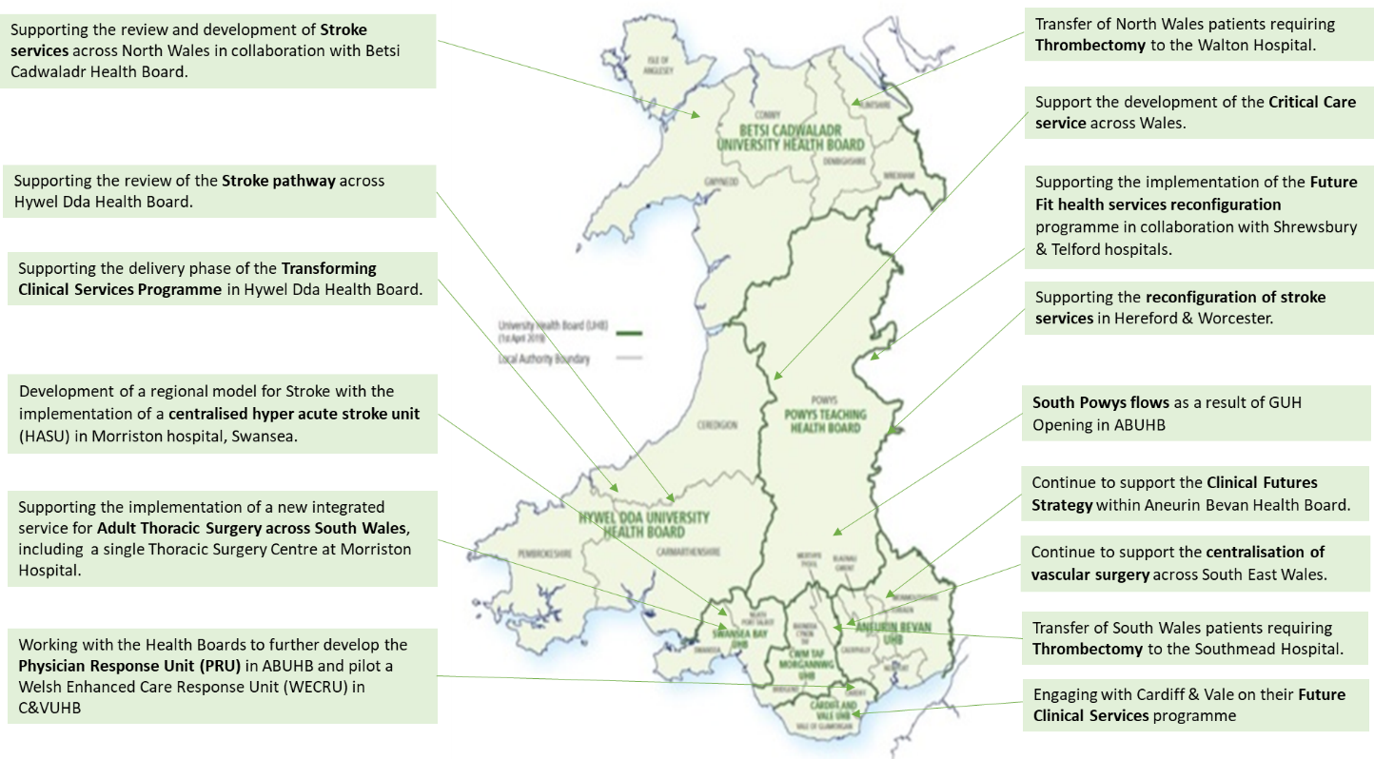

2.50 The key risks to the delivery of the WAST IMTP in 2022/23 include:

- Availability of revenue funding for core and transformational elements of the plan. At present, no revenue has been identified to support any growth or transformation;
- The reduction in capital available to NHS Wales, which will impact on delivery of some of our core enabling plans
- Securing internal stakeholder support. Work will be ongoing within the next few months to find a way to work more effectively together with TU partners in the delivery of this plan, acknowledging the difficulties that have been evident over the last 12 months;
- Securing external stakeholder support, particularly for the EMS transition plan;
- Ongoing impacts of COVID-19 recovery both internally within WAST and as the Health Boards recover their activity;
- Capacity within the organisation to deliver the change required, within the resource envelope available.
- Pressures on the service arising from external factors, particularly the continuing impact of hospital handover delays;
- Health and wellbeing of the workforce in the face of continued pressure.

EASC is asked to note that: WAST delivered a significant number of IMTP deliverables in 2021/22 despite challenges caused by the ongoing pandemic and system pressures; the re-rostering project is due to go live between Sep-22 and Nov-22; WAST has submitted a financially balanced IMTP to Welsh Government with a range of deliverables across EMS, 111, CCC and Ambulance Care supported by enabling programmes of work; some of the transitional and transformational programme delivery is dependent on funding being identified throughout the year; WAST is fully engaged in delivery of and support of the six goals programme as well as recovery and strategic service changes being developed by Health Boards; there are key risks to delivery of the WAST IMTP which are being managed through its Strategic Transformation Board, and raised through the Corporate Risk Register as strategic risks where applicable.

Conclusions and Forward Look

2.51 Current performance levels and patient safety remain very challenging. System pressure, as expressed through handover lost hours, is very high, but military aid ended in Mar-22 making the outlook into quarter one 2022/23 even more challenging than the winter period.

2.52 WAST is focused at an organisational level on this challenge. WAST is currently as level 4 (maximum) escalation, is pro-actively managing patient demand (and safety) through enacting its Clinical Safety Plan (demand management arrangements) and shift left actions. WAST has clearly identified that more capacity is required (95 FTEs) for it to meet Red demand now. WAST has three key efficiencies that it can make to boost capacity: re-rostering, reducing abstractions and reducing post production lost hours. WAST is on-target for the first, has clear plans for the second and continues to work with TU partners on the third; however, these efficiencies will not be sufficient to offset the extreme levels of handover lost hours and their impact on patient safety. The NCCU is leading on dialogue between health boards and WAST on handover reduction plans, plus WAST has made the Transition Plan offer to the system.

2.53 NEPTS is achieving most of its targets currently, however, demand is suppressed and capacity was boosted in 2021/22. As demand increases as the system re-sets and the in-year capacity ends, EASC will need to consider options for balancing demand and capacity.

- KEY RISKS/MATTERS FOR ESCALATION TO THE COMMITTEE

Members of the EAS Committee are asked to note that:

3.1 WAST has stood down its Pandemic Plan structures;
3.2 WAST is at escalation level 4 and expects to remain so for the foreseeable future;
3.3 Quality, safety and patient experience monitoring arrangements have continued (and been enhanced) through the pandemic. WAST remains very concerned at the patient safety risks associated with response times that are too long;
3.4 There were 802, 12 hour and over patient waits in Mar-22 (the highest recorded), 42 patient safety incidents were referred to health boards under the Appendix B arrangements) over the last three months and 14 WAST NRIs were reported to Welsh Government;
3.5 The Red 8 minute 65% target has not been hit since Jul-20 (63% of Red incidents were responded to in 10 minutes in Mar-22);
3.6 With support from external partners WAST has been able to deliver its highest recorded level of ambulance hours (all resource types), but in Mar-22 WAST lost 24,479 to handover delays), a level that WAST cannot offset without radical measures to shift left or improve system flow;
3.7 WAST has produced a Transition Plan for 2022/23 to increase capacity, continue to make improvements in efficiency and to further increase numbers of APPs and has undertaken modelling on a radical shift left;
3.8 WAST continues to seek efficiencies, in particular, the pan-Wales EMS Response roster review and abstractions/sickness absence reduction;
3.9 The ePCR programme has gone live and operational in every health board;
3.10 Further dialogue on NEPTS is required between health boards, the NCCU and WAST, in particular, how to balance demand with capacity;
3.11 An Ambulance Care Transformation Programme Board has been established to take forward the findings of the NEPTS strategic Demand & Capacity Review and wider NEPTS and transfer and discharge projects and is making good progress;
3.12 WAST is making good progress on its IMTP ambitions (including the EASC 21/22 commissioning intentions);
3.13 WAST has submitted a financially balanced 2022-25 IMTP to Welsh Government with a range of deliverables across EMS, 111, CCC and Ambulance Care supported by enabling programmes of work;
3.14 Some of the transitional and transformational programme delivery is dependent on funding being identified throughout the year;
3.15 WAST is fully engaged in delivery of and support of the six goals programme as well as recovery and strategic service changes being developed by Health Boards; and
3.16 Patient safety in EMS is now a very high risk for both EASC and WAST.

- IMPACT ASSESSMENT

Quality/Safety/Patient Experience implications | Yes (Please see detail below)
Quality/Safety/Patient Experience implications | Identified within the report
Related Health and Care standard(s) | Timely Care
Related Health and Care standard(s) | And all health and care standards
Equality impact assessment completed | Not required
Legal implications / impact | There are no specific legal implications related to the activity outlined in this report.
Legal implications / impact | Included within the body of the report
Resource (Capital/Revenue £/Workforce) implications /  Impact | Yes (Include further detail below)
 | Included within the body of the report
Link to Main Strategic Objective | The Committee’s overarching role is to ensure its Commissioning Strategy for Emergency Ambulance Services utilising the five step patient pathway outlined within the National Collaborative Commissioning Quality and Delivery Agreement and the related outcomes for each care standard aligned with the Institute of Healthcare Improvement's (IHI) ‘Quadruple Aim’ are being progressed.  This report focuses on all the above objectives, but specifically on providing strong governance and assurance and safe and effective patient care
Link to Main WBFG Act Objective | Service delivery will be innovative, reflect the principles of prudent health care and promote better value for users

- RECOMMENDATION

5.1 The EASC Committee is asked to:
- DISCUSS and NOTE the WAST provider report.

