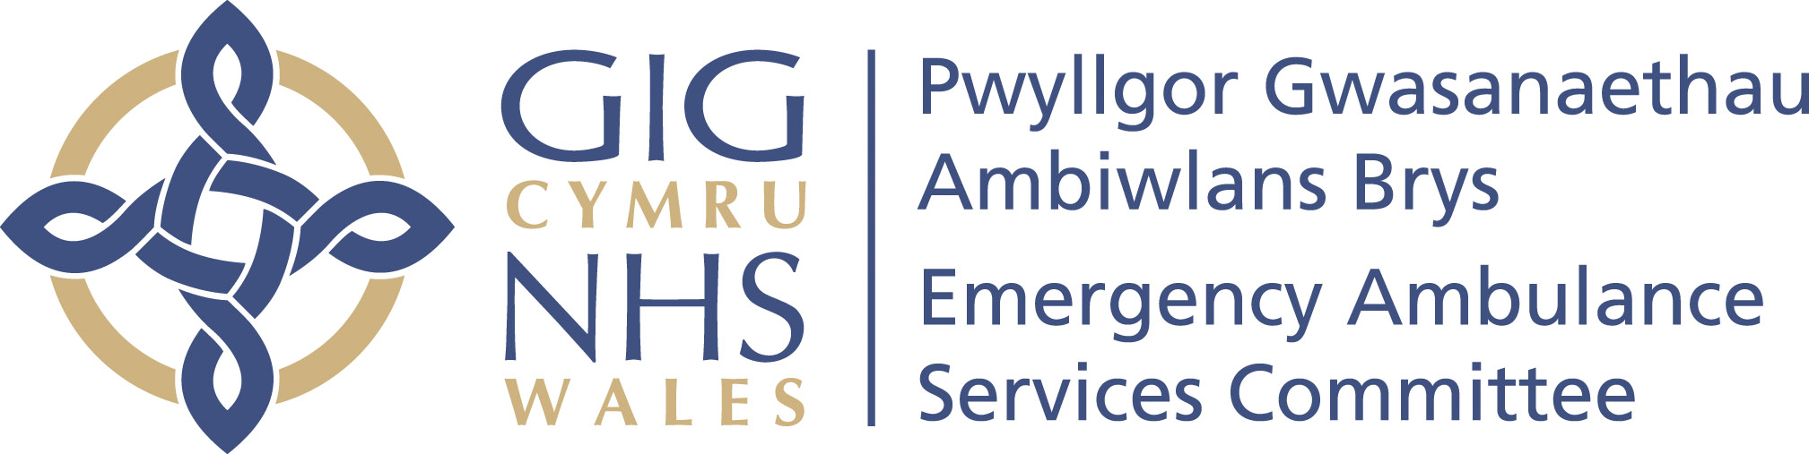 | Your ref/eich cyf:
 | Our ref/ein cyf:
 | Date/dyddiad: | 31 March 2023
 | Tel/ffôn: | 01443 744945
 | Fax/ffacs:
 | Email/ebost: | Stephen.Harrhy@wales.nhs.uk

Judith Paget
Director General Health and Social Services
NHS Wales Chief Executive

By email

Dear Judith,

EMERGENCY AMBULANCE SERVICES COMMITTEE INTEGRATED MEDIUM TERM PLAN (EASC IMTP)

Dear Judith

Please find attached a copy of the EASC IMTP for your consideration.

The IMTP has been agreed by the EAS Committee and the assumptions contained within it are consistent with those in both the WAST IMTP and Health Boards IMTP’s and Plans.

I addition the financial uplift and consolidation of funds contained within the financial tables are agreed by Health Boards and consistent with assumptions contained within the WAST IMTP. The plan assumes £6million additional income from central sources. This sum is required to fund the full year impact of the non-recurrent sum made available from central resources to EASC to fund 100wte additional front line ambulance staff in 2022/23.

Performance improvement trajectories have been included in the IMTP which are consistent with the planning guidelines and ministerial expectations. The delivery of these is contingent on WAST delivering specific service improvements which are described in the IMTP and health board delivery actins agreed with them in the integrated commissioning action plans. The improvement trajectories are also contingent on the 100wte referred to above.

WAST have agreed to deliver a cost reduction programme consistent with health boards and in addition make the cost savings needed to fund the difference between the assumed £6m additional income for the 100wte and the £9m gap identified in their plan. They have committed to do this in their plan. No other additional income has been assumed to fund additional developments and these would only be supported following confirmation of funding from other sources.

The EASC IMTP is consistent with the commissioning intentions previously agreed by EASC and shared with Welsh Government colleagues. It also demonstrated how we will adopt a value based approach and balance the operational delivery of targets with improvements in patient safety and quality in line with existing and new duties placed on us.

If you require any further information or clarification please do not hesitate to contact us.
Yours sincerely,

Chris Turner  Chair / Cadeirydd | Stephen Harrhy  Prif Gomisiynydd Gwasanaethau Ambiwlans / Chief Ambulance Services Commissioner
Pwyllgor Gwasanaethau Ambiwlans Brys / Emergency Ambulance Services Committee

