AGENDA ITEM
2.8

EMERGENCY AMBULANCE SERVICES COMMITTEE

EASC Financial Performance Report – Month 12
2022/23

Date of meeting | (16/05/2023)

FOI Status | Open/Public

If closed please indicate reason | Choose an item.

Prepared by | James Leaves, Assistant Director of Finance
Presented by | Stuart Davies, Director of Finance
Approving Executive Sponsor | Chief Ambulance Services Commissioner

Report purpose | FOR NOTING

Engagement (internal/external) undertaken to date (including receipt/consideration at Committee/group)
Committee/Group/Individuals | Date | Outcome
EASC Management Group |  | Choose an item.

ACRONYMS
EMS | Emergency Medical Services

- SITUATION

  - The purpose of this report is to set out the final yearend financial position for EASC for the 12th month of 2022/23 together with any actions required.
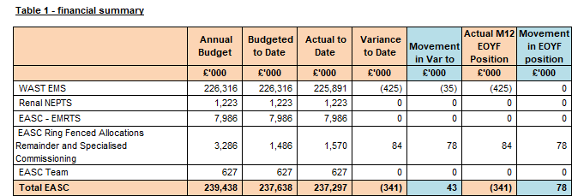

Background

  - The financial position is reported against the 2022/23 baselines following approval of the 2022/23 IMTP by the EASC Joint Committee in March 2022.

  - The National Collaborative Commissioning Unit (NCCU) baseline has been dis-aggregated from this report as it has a separate governance structure to EASC.

  - Please note that as LHBs cover any EASC variances, any over/under spends are adjusted back out to LHB’s. Therefore, although this document reports on the effective position to date, this value is actually reported through the LHB monthly positions, and the EASC position as reported to WG is a nil variance.

  - In relation to the current financial position members agreed:

      - All members of the Committee have supported the EASC IMTP.

      - Welsh Government has issued a non-recurrent allocation of £3m in year for the recruitment of an additional +100 front line staff. The recruitment process for these staff has been commenced and the commitment from WAST is for the staff to be fully operational by the end of December.

The £3m additional payment was actioned to WAST was in March 2023 after submitting monitoring returns to EASC demonstrating the progress in recruitment

      - For IMTP purposes it is assumed the full year effect of the £3m (estimated at £5.7m) funding will be made available recurrently.

- SPECIFIC MATTERS FOR CONSIDERATION BY THIS MEETING (ASSESSMENT)

Governance & Contracting

All budgets have been updated to reflect the 2022/23 approved IMTP. The IMTP sets the baseline for all the 2022/23 contract values.

EMS Contract

  - The year-end financial position of WAST is (£347k) underspent. This position predominately relates to the (£425k) handback of funding to Aneurin Bevan UHB for the Grange Hospital Transport contract, but there is an offsetting variance of £78k arising from the West Wales dialysis transport patient re-imbursement.

  - The WAST final reported spend of £230,323k is reported as the total of the following service lines:
- WAST £219,163k
- Renal NEPTS £1,223k
- EASC Ring Fenced Allocations
  - D&C Phase 2 Front Line In Year Allocation Reserve) £5,798k
  - Major Trauma Ring Fenced Allocation £640k
  - Mental Health Service Improvements (inc. Clinical Service Desk Enhancements) £631k
  - West Wales Dialysis Transport (patient re-imbursement) £138k
  - Operational Delivery Unit £908k
  - Additional Front Line Support £1,800k
A number of the above commissioner allocations are deemed recurrent for 2023/24 IMTP assumptions.

  - The additional frontline support of £1,800k has been contributed to by all Health Boards.

  - The funding for Renal NEPTS has been separated from WAST and will be reported separately. Air Ambulance (EMRTS) has been transferred from WAST and now sits within EMRTS and will be paid directly to Swansea Bay UHB.

EMRTS

  - There is a breakeven yearend position reported against the EMRTS baseline funding of £7,986k. This budget consists of the following service lines:
- EMRTS £4,946k
- EASC Ring Fenced Allocations:
  - EMRTS 24/7 Expansion Plan – NR £1,292k
  - EMRTS Critical Care Ring Fenced Allocation £1,748k

Core running costs budget

  - Costs are reported against two separate lines to reflect the original investment by LHB’s.

EASC Commissioning

  - An additional provision was made in the development of the 2022/23 EASC IMTP for the recurrent funding of the SE Wales Acute Coronary Syndrome pathway.

Summary of Key Movements and Issues

  - There is a £6k overspend in the year end forecast for the South-East Wales Regional Acute Coronary Syndrome Treat and Repatriate Service due to an inflation uplift applied.

Actual Year To Date and Forecast Over/Underspend (Provider positions)

WAST:

  - The agreed handback to Aneurin Bevan UHB of Grange transport funding is reported with an underspend of (£425k)

Direct Running Costs (Staffing and non-pay):

  - Team costs are based on expected staffing levels, including filling vacancies.

Actual Yearend Over/(under)spend 2022/23 (Commissioner positions)

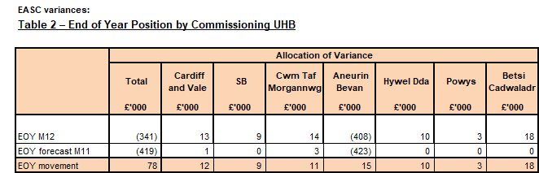

Income / Expenditure Assumptions

Income from LHB’s:
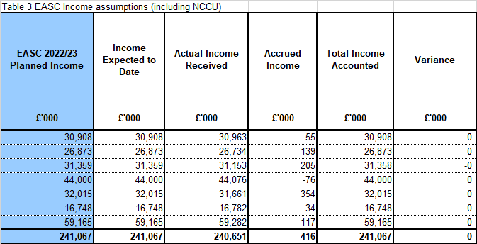

  - Income for Month 11 was in line with the anticipated expectations. This is as EASC cannot overspend and HB contributions must balance to expenditure.

Overview of Key Risks / Opportunities

None

Public Sector Payment Compliance

  - The WHSSC/EASC payment compliance target is consolidated and reported through the Cwm Taf monitoring process.

- KEY RISKS/MATTERS FOR ESCALATION TO THE COMMITTEE

  - None to note.

- IMPACT ASSESSMENT

Quality/Safety/Patient Experience implications | There are no specific quality and safety implications related to the activity outined in this report.
Related Health and Care standard(s) | ALL are relevant to this report
Equality impact assessment completed | Not required
Legal implications / impact | There are no specific legal implications related to the activity outlined in this report.
Resource (Capital/Revenue £/Workforce) implications /  Impact | There is no direct impact on resources as a result of the activity outlined in this report.
Link to Commissioning Intentions | The Committee’s overarching role is to ensure its Commissioning Strategy for Emergency Ambulance Services utilising the five step patient pathway outlined within the National Collaborative Commissioning Quality and Delivery Agreement and the related outcomes for each care standard aligned with the Institute of Healthcare Improvement's (IHI) ‘Quadruple Aim’ are being progressed.
Link to Main WBFG Act Objective | ALL are relevant

- RECOMMENDATION

  - The Emergency Ambulance Services Committee is asked to:

NOTE the current financial position and forecast year-end position.

- Confirmation of position report by the MD and DOF:


Stuart Davies,
Director of Finance, EASC and WHSSC



Stephen Harrhy,
Chief Ambulance Commissioner, EASC

