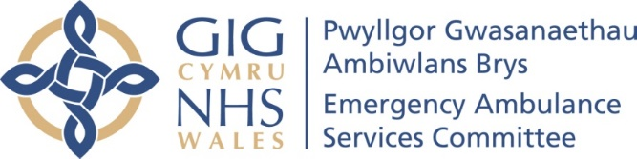 | AGENDA ITEM 2.4  12 November 2019

Emergency Ambulance Services Committee (EASC)
WELSH AMBULANCE SERVICES NHS TRUST (WAST)
PROVIDER UPDATE

Executive Lead: Jason Killens, Chief Executive Officer (WAST)
Author: Hugh Bennett, Assistant Director of Commissioning and Performance (WAST)
Contact Details for further information: hugh.bennett2@wales.nhs.uk

Purpose of the EASC Report

The purpose of this report is to provide EASC with an update on key issues affecting quality and performance for Emergency Medical Services (EMS) and Non-Emergency Patient Transport Services (NEPTS) and also to provide an update on strategy and planning for EMS and NEPTS respectively.

Governance
Link to the Commissioning Agreement | The Committee’s overarching role is to ensure its Commissioning Strategy for EMS and NEPTS utilising the respective five step patient pathways outlined within the National Collaborative Commissioning Quality and Delivery Agreements and the related outcomes for each care standard aligned with the Institute of Healthcare Improvement's (IHI) ‘Quadruple Aim’ are being progressed. This report focuses on the above objectives, but specifically on providing an update on quality, performance, strategy and planning in WAST on these steps.
Supporting evidence | The Collaborative Commissioning Quality and Delivery  Frameworks: EMS and NEPTS.
Engagement – Who has been involved in this work?
WAST, Chief Ambulance Services Commissioner (CASC)
Emergency Ambulance Services Committee Resolution to:
APPROVE |  |  | ENDORSE |  |  | DISCUSS | √ | NOTE | √
Recommendation |  |  | The Emergency Ambulance Services Committee is asked to:  - DISCUSS the contents of the report.  - NOTE the work being undertaken.
Summarise the Impact of the Emergency Ambulance Services Committee Report
Equality and diversity |  |  |  | There are no implications arising directly from this report.
Legal implications |  |  |  | There are no legal implications arising directly from this report, but Coroner’s activity in relation to EMS is identified in the report.
Population Health |  |  |  | EMS ambulance response times are a key determinant of population health, particularly, for Red – immediately life threatening calls – the report provides information on Red and Amber performance.
Quality, Safety & Patient Experience |  |  |  | The report details the level of serious adverse incidents (SAIs) for EMS and root cause of these.
Resources |  |  |  | The report provides information on: the deployment of ambulance resources, the EMS Demand & Capacity Review, the funding of key initiatives, in particular, Advanced Paramedic Practitioners (APPs) and Healthier Wales funding.
Risks and Assurance |  |  |  | WAST has a Risk Management Framework and Corporate Risk Register. The two key risks relevant to this report are: - 1) Unable to attend to patients in the community who require see and treat services 2) Patients unable to access secondary care assessment and treatment (Patients being delayed in ambulances prior to clinical handover at Accident & Emergency departments).
Health & Care Standards |  |  |  | The 22 Health & Care Standards for NHS Wales are mapped into the 7 Quality Themes:  Staying Healthy; Safe Care; Effective Care; Dignified Care; Timely Care; Individual Care; Staff & Resources  http://www.wales.nhs.uk/sitesplus/documents/1064/24729_Health%20Standards%20Framework_2015_E1.pdf  The work reported in this summary and related annexes take into account many of the related quality themes.
Workforce |  |  |  | The report identifies active workforce planning by WAST and over recruiting against future predicted vacancies.
Freedom of information status |  |  |  | Open

WELSH AMBULANCE SERVICES NHS TRUST (WAST)
PROVIDER UPDATE
- SITUATION

- The purpose of this report is to provide EASC with an update on key issues relating to quality, performance, resources and strategy across the EMS and NEPTS services.

- BACKGROUND

- The EASC meets on a bi-monthly basis, and it has been agreed that it would be helpful for EASC members to receive a written report. This report is the third of such written briefings, designed to enable a more comprehensive update to be received and improve understanding of the issues being managed by the Trust in relation to quality, performance, resources and strategy.

- ASSESSMENT

Quality, Safety & Patient Experience

Serious Adverse Incidents

- The Trust continues to review and discuss potential Serious Adverse Incidents (SAIs) at its Serious Case Incident Forum. The themes and trends from those cases reported as SAI’s are long handover and response delays, call categorisation, missed allocation and clinical practice issues.

- The following table shows the total numbers of SAIs reported to Welsh Government by the Trust, by Health Board area. It is evidenced below that there has been a reduction in the total number of SAIs reported to Welsh Government in the current year to date.

SAIs Reported to WG
 | ABHB | SBHB | BCUHB | CVHB | CTHB | HDHB | POHB | Total
2017/18 | 17 | 10 | 12 | 6 | 2 | 1 | 0 | 48
2018/19 | 11 | 7 | 13 | 15 | 1 | 4 | 0 | 51
2019/20 to date | 9 | 7 | 0 | 0 | 1 | 3 | 0 | 20

- The data shows that 80% of the reported SAIs year to date are across the Aneurin Bevan and Swansea Bay University Health Board areas.

- Following a Patient Safety event held in October 2018 with Welsh Government and the Delivery Unit, a Joint Investigation Framework has been developed and implemented.

Since ratification this has clarified the process to be followed where a potential SAI relates to a delayed ambulance response as a consequence of identified hospital notification to handover delays. This was agreed at the Directors of Nursing forum, and outlines which organisation will be responsible for the investigation and the potential reporting of the SAI.

- In addition to the volumes reported above, the Trust has passed 18 incidents to the Health Boards for investigation. A further 5 cases are being reviewed, 1 relating to SBUHB and 4 in CTMUHB (relating to delays at POWHB).

Coroners’ Activity

- The Trust is also continuing to receive large numbers of requests for information from HM Coroners. The impact of the numbers received through the winter of 2017/18 is still being felt. Since January 2019, a further 207 requests have been received relating to HM Coroner requests for information / requesting staff attendance / informing WAST they are an interested party. Again, the majority of these cases relate to incidents where there was a delayed ambulance response to a patient in the community. Work will be underway in the near future to reconcile Datix, ensuring that we hold up to date and accurate information.

Longest Waits

- The Patient Safety Team are now undertaking regular reviews of the longest responses to patients, even where no complaint or concern has been received or raised, this is to provide assurance around the quality of the care that they received. The following table details patient waits 12 hours and over.

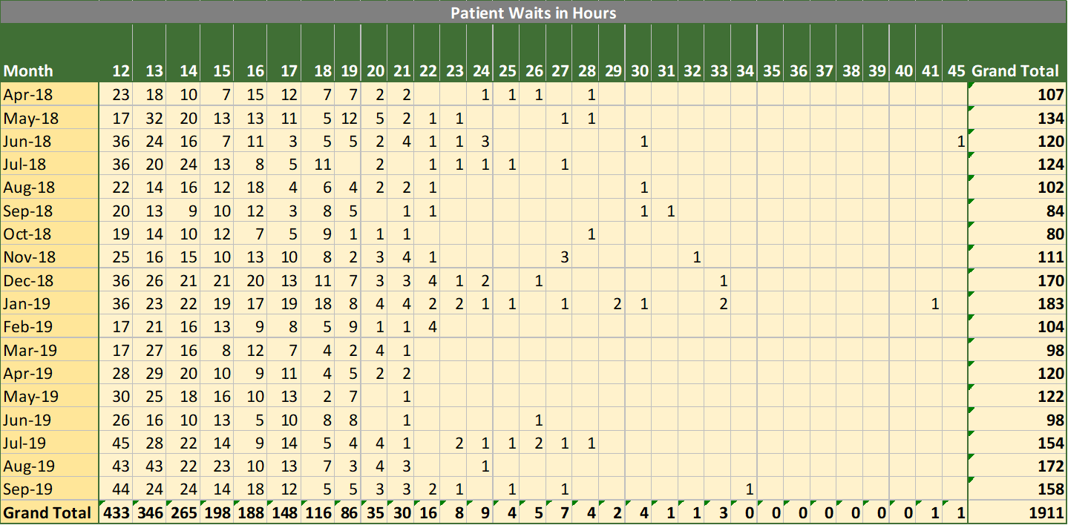

- In the first 6 months of 2019/20, 824 patients waited over 12 hours, compared to 671 in the same period last year i.e. the numbers are worsening (although the very longest waits are reducing). Revised escalation procedures have been introduced in the Clinical Contact Centres. As part of the Amber Review Implementation Programme assurance mechanisms, a community back stop of 18 hours has been agreed with the NCCU. Breach reporting will be introduced for any patient waits longer than 18 hours to ensure patient safety procedures have been followed and no patient has slipped through the net. Previous modelling work has identified that the Amber tail is particularly sensitive to small changes to in ambulance resource availability (see section on handover lost hours below).

EASC is asked to note the increase in numbers waiting over 12 hours for a response, and the continuing risks and number of SAIs and coroners requests that are being dealt with by WAST, which relate in the main to incidents where there was a delayed ambulance response to patients in the community.
Performance

Demand

- Year on year (Oct-18 to Sep-19 compared to same period previous year) verified demand has decreased by 1.56%. However, red demand has increased by 7.5%, amber demand decreased by 1.26% and Green demand decreased by 2.70%. A Powys Diagnostic undertaken with data to Aug-19 identified that red demand in Powys has increased by 22% year on year. Previous analysis identified Red is increasing across all incident categories.

Red Performance

- RED performance is being maintained above the 65% formal national Welsh Government target, but there continues to be variation in health board performance, in particular, Hywel Dda and Powys. Despite consistently achieving the 65% target, as the graph below shows, there has been a gradual decline in the monthly performance, linked in part to increasing Red incident demand and the reduction in the number of running calls recorded as previously outlined to EASC.

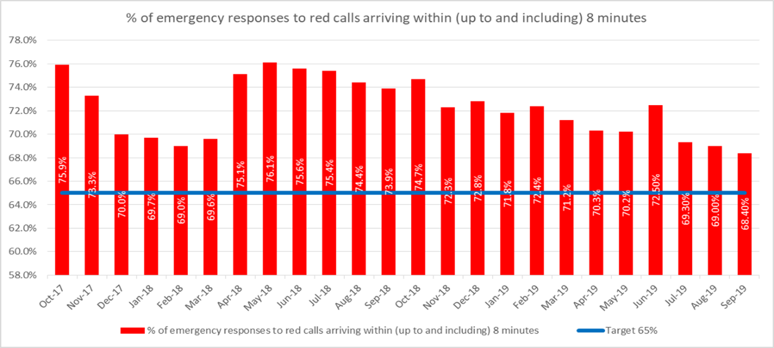

- The Trust acknowledges that there is scope to improve performance, particularly in respect of reducing variation between health board areas, with the graph below highlighting the difference between the highest and lowest performing health boards each month.

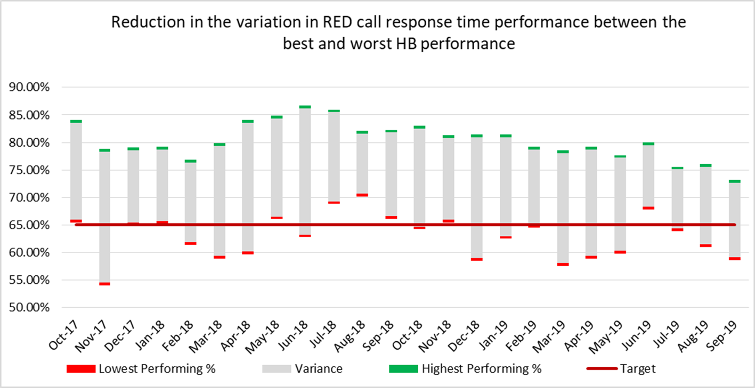

- Historically, Powys and Hywel Dda have consistently been the lowest performing health boards. Specific performance plans are in place for Hywel Dda and Powys, the two health boards that have most difficulty in achieving 65% Red performance: Powys 58.9% Apr-19, Powys 59.8% May-19, Hywel Dda 59.9% May-19, Hywel Dda 63.9% Jul-19, Powys 61.0% Aug-19, Powys 58.6% Sep-19. By comparison both Hywel Dda and Powys Amber performance compares favourably because the ambulance resource per head of population is significantly higher.

- Because of the decline and variation in Red performance the Trust went into “enhanced performance management” from April 2019 by the NCCU on the instruction of Welsh Government with the ambition of delivering Red performance at 70% pan Wales and 65% per health board.

- WAST is complying with a requirement for “enhanced performance management”, in particular, a Red Improvement Plan and the supply of regular data and scrutiny with the NCCU. A Weekly Red Improvement Plan meeting chaired by Director of Operations has been introduced plus a weekly call between NCCU and WAST. A Red Performance Dashboard is also now shared on a weekly basis with key stakeholders.

- Whilst accepting that there are many actions which can be taken as set out in paragraphs below, the three key determinants of Red performance are: demand (which is increasing), actual resource deployed and lost hours to handover.

- The informal commissioning intention for Emergency Ambulance (EA) Unit Hours Production (UHP) has been 90%. Whilst overall hours produced comparing the last 12 months with the previous 12 months is up by 2%, the main factor affecting hours produced is the number of budgeted staff, which is the subject of a separate paper on the outcome of the Demand and Capacity review.

- Aneurin Bevan and Cwm Taf Morgannwg roster reviews are now complete.

- The third key determinant of Red performance is handover lost hours. The Quarter 2 Ambulance Quality Indicators (AQIs) were recently published which showed that notification to handover lost hours increased by 82.83% (compared to the same period last year), from their already high levels. WAST lost 26,481 hours to handover delays or 25 shifts per day in Quarter 2 or 12.74% of our conveying capacity (EA/UCS ambulance resource). The impact will be higher in some health board areas. This situation has continued into October and there has been an uplift in patient safety concerns and serious incidents.

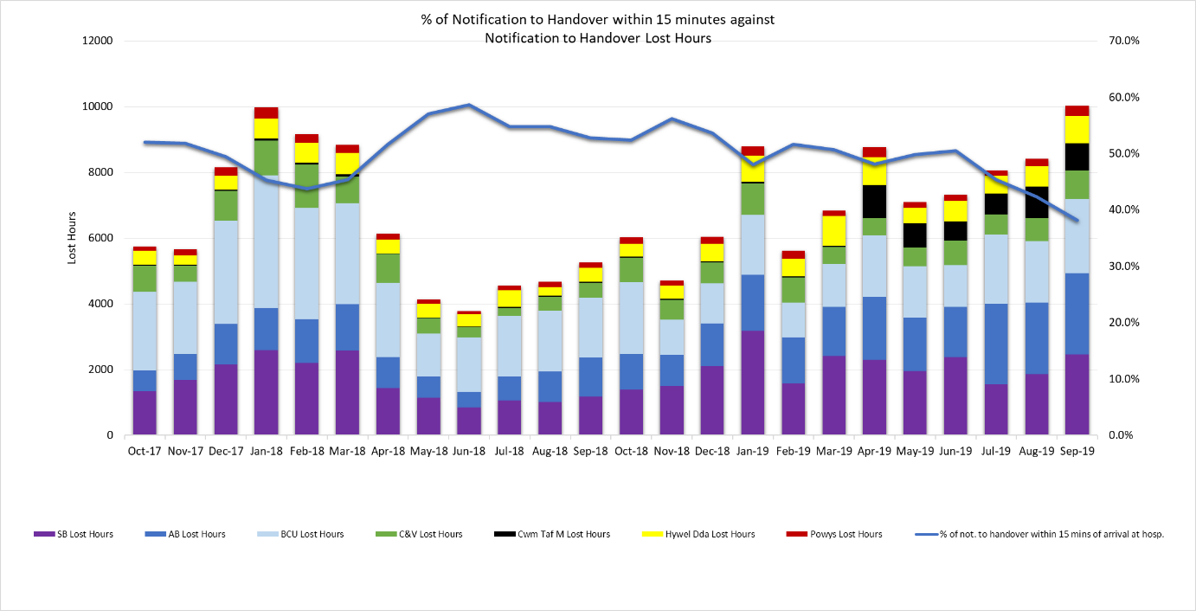
Note: the total number of patients conveyed to EDs by WAST decreased by -1.67% in Q2, compared to same period last year, which needs to be set within the context of incident demand increasing by +2.89%. Also, ambulances stopped as a result of hear & treat increased by +17.47% (1,499 actual ambulances).

- WAST has a comprehensive Red Improvement Plan in place (with 23 key themes supported by more detailed actions), which is being reviewed weekly by the Director of Operations. Key highlights from the Red Improvement Plan include:

  - Continuing to develop and utilise information on demand, capacity and efficiency to inform action planning. This includes the use of sophisticated performance analysis and modelling software (QlikSense and Optima Predict) to support Operations. One of the actions for Optima Predict will be to start producing a forward prediction of Red performance (weekly, monthly, seasonal e.g. winter, which will start for Dec-19);
  - A Clinical Review of the Clinical Contact Centre;
  - A review of station estate/highway access to improve mobilisation times;
  - Overproducing on RRV unit hours at times when Red performance is poor (twilight shifts);
  - Increasing the number of Community First Responders (CFRs), in particular, in Hywel Dda with an additional 36 CFRs currently being trained and coming on stream;
  - Continuing work to reduce abstraction rates;
  - Reviewing deployment points, moving them where possible to reduce response times (this work has been completed for Aneurin Bevan, Cwm Taf Morgannwg, Hywel Dda and Powys, with some adjustments being made, but the extent of adjustment is limited by the relief gap).
- For the detailed live actions: one is red (significantly off target), 6 are amber (off target) and 25 are green (on-target). The PAD sites and GoodSam is the one red action. An additional 52 actions are complete and nine stopped.

- At the Sep-19 EASC meeting there was a paper on system leadership, in particular, considering changes to escalation processes and dynamic ambulance deployment. Since the meeting a workshop has been held between health boards, NCCU and WAST, and two further regional meetings at CEO level are planned for the 9th and 13th November, at which agreements will need to be reached and finalised.

- The current proposal is to change and enhance the usefulness of the daily Gold Calls. The call would be chaired by WAST, include a loggist, maintain an action log, and focus on agreed inter-organisation actions (using an action card) to support capacity and flow e.g. cohorting, ambulance deployment, increased discharge capacity. Consideration is being given to whether 2 calls may be more useful than 1 (north / south). The workshop identified that the National Escalation and De-escalation Framework needs to be updated with individual site capacity and escalation plans to be updated within this Framework, which would be a separate stream of work to changing the 11-00 call. Gold command training has also been identified as a key enabler and that the training is required of sufficiently senior clinical and operations colleagues in health boards.

- As reported to Sep-19 EASC, WAST has recently revised its process for Managing Immediate Release Requests. The revised process has allowed improved accuracy of reporting with effect from 30th July 2019. The graph below shows the number of requests split by those declined and accepted.

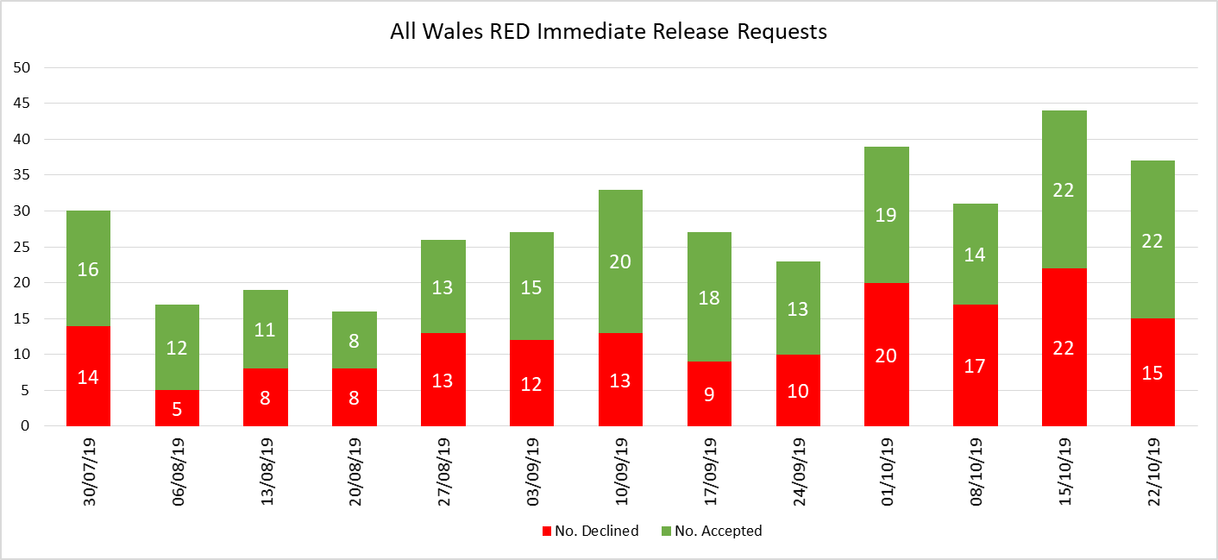

Amber Response times / Amber Review

- Amber response times remain an area of concern with Amber median, 65th centile and 95th centile times on an upward trend. The median has increased by 5 minutes and 47 seconds (comparing Sep-19 with Sep-18) and the 95th percentile by 42 minutes and 26 seconds (same comparison period). Again, there is a strong correlation between Amber waits and notification to handover lost hours.

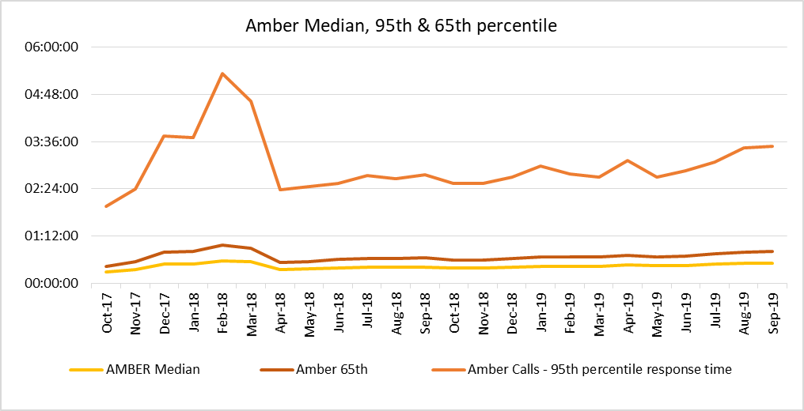

- WAST established an internal WAST Amber Delivery Group with the NCCU co-opted onto the Group (see separate report from NCCU on Amber Review). NCCU/WAST had to deliver on nine “assurance mechanisms” agreed by EASC. Of these nine: two are complete, four are on-target, one is amber (off target) and two are red (significantly off target). The Amber is the gap between WAST’s EA UHP and the interim commissioning intention of 95% UHP (see above) and the two red assurance mechanisms are: lost hours at hospital to reduce and longest waits in the community to reduce.

- The key action in the Amber Review Implementation Programme is the EMS Demand & Capacity Review (see separate report) which will enable EASC to consider options for improving the response to amber patients (and other categories). The Review forecasts a year on year increase in verified call demand of 2.3%, includes a range of agreed performance parameters for modelling purposes, a range of agreed efficiencies and shift left service initiatives and a modelled two phase implementation. The modelled FTEs required to achieve the response parameters at Dec-24, based on the forecast demand and the delivery of the agreed efficiencies is an increase of 537.4 FTEs above 2018/19 budgeted establishment.

- The Trust have also been working to reduce hours lost from handover to clear. As part of this work to cleanse and refine the data, a dual pin system for handover was rolled out in each ED with all hospitals live in August 2019. This has had a significant impact on to clear lost hours, with the number of hours reducing from 2,713 in Q2 2018/19 to 925 in Q2 2019/20, a reduction of 65.89% (ORH identified that WAST already benchmarked favourably for this indicator, prior to the reduction of dual pin).

Winter Planning

- Over the last six months WAST has been working on its tactical winter plans and is putting in place the following initiatives:

- An approved WAST National Winter Plan, underpinned by WAST area (health board) level plans

- Working with St John Cymru Wales to increase the Trust’s unscheduled care service capacity and help backfill the lost hours from handovers through expanded St John Cymru Wales cover over the next 12 months: an additional 67 hours per day, starting 04 Nov-19

- Improve patient facing colleagues’ access to clinical information and senior decision making in support of on scene clinical assessment via the Clinical Support Desk (CSD), in particular, patient clinical records supported by more clinicians in the CSD. We are currently working through the recruitment process

- The utilisation of third party providers as an interface at key acute hospital sites where handover delays are particularly prominent (Glan Clwyd, Morriston, Prince of Wales and Royal Gwent) to improve handover of WAST patients and provide care under WAST supervision to the point of handover to the hospitals, thereby freeing up WAST colleagues to respond to patients in the community. We are currently finalising the specification for this and then will embark on a procurement process, whilst also confirming local arrangements at each site;

- Increasing staffing capacity in our Patient Safety, Concerns & Learning Team to help us manage the expected increase in the volume of concerns and SAIs through the winter period; and

- We have also updated our Resource Escalation Action Plan (REAP) Toolkit and held a Winter Plan desk top exercise on 14 Oct-19 to test our local arrangements based on current plans. The exercise was well attended and enabled us to evidence that our plans are robust.
- NEPTS has also offered every health board the option of funding additional discharge and transfer capacity from WAST.

- WAST has collaborated with EASC on funding some of the above initiatives and Area Operations Managers have worked with health board colleagues on health board level plans (each WAST health board level plan has been peer reviewed and a checklist of good practice issued). WAST will seek to increase the collaboration with NCCU colleagues through the next cycle of seasonal planning.

- A range of staff welfare initiatives will also be put in place, in particular welfare vans (not yet funded) and the flu vaccination programme is being actively managed by the Medical Directorate.

EASC to note the actions that are being taken to deliver the assurance mechanisms for the Amber Review Implementation Programme, but that there will be a time lag between these process and project actions being delivered and improvement in Amber performance, which continues to deteriorate.

EASC to note the ongoing work to improve Red performance through a national Red Improvement Plan, work to support capacity and flow in the wider unscheduled care system and the significant drain on ambulance resources from handover lost hours.

Resources

- The EMS Demand & Capacity Review has identified a Response relief gap of 262.5 FTEs i.e. the gap between budgeted establishment and the number of FTEs to fill the roster lines with a targeted efficient relief rate. EASC have agreed to initially fund 46 FTES now and WAST is currently recruiting these FTEs (over and above normal workforce planning/turnover recruitment). To recruit at pace i.e. by 31 Mar-20 WAST has focused recruitment from: bank staff, part time staff, retire and returns and other ambulance services.

- As we move into the winter plan period (01 Nov-19 to 31 Mar-20) WAST is retaining a strong focus on workforce planning e.g. recruiting against predicted vacancies in order to maintain UHP on rosters. This needs to take account of the normal turnover, but also the increase in APPs. Also, whilst not turnover, WAST is increasing its bank of driving instructors and clinical tutors now (as the option to train these colleagues would not be available for another 18 months) to enable WAST to flex its Training School capacity should EASC/WAST decide to close the relief gap. The current level of vacancies is less than 5% and predicted at 5.8% through the Winter Plan period (note: all workforce planning is based on assumptions, forecasts and judgements).

- The Demand & Capacity Review identified that WAST benchmarked above the average for abstractions from its CCC and Response rosters, so a Resource Availability Programme has been established which consists of eight work streams. These are; Improving Attendance, Improving Recruitment Timescales, Modernising Bank Arrangements, Transforming Resource Policy & Practice, Other Workforce Efficiencies, Implementation of Electronic Timesheet, Reducing Lost Hours – Return to Base, Reducing Lost Hours – Handover to Clear. The work stream leads will report progress on a monthly basis via a highlight report to the Senior Operations Team and on a quarterly basis to the People and Culture Committee in order to monitor progress and delivery

- A proportion of the Healthier Wales funding has now been approved recurrently. Further discussions are required into 2020/21 about the remaining allocation. The Trust has four approved bids which are being actively managed through the Trust’s Strategic Transformation Board:

- Falls Framework’ Healthier Wales bid approved by EASC enabling the continuation and expansion of the Falls Assistant provision (Level 1) to provide operational cover across all Health Boards by January 2020.

- The Healthier Wales bid that will support the developments for the transport solution model within NEPTS has been approved. This will enable the work on the design and implementation of improved booking and call taking processes and procedures to progress.

- The Healthier Wales bid that will support the progression of the Older Peoples Framework has been approved. This will enable the appointment of an Improvement Lead to progress with the Framework & associated programmes of work.

- Healthier Wales funding has been secured to recruit a Consultant Psychologist to fulfil the role of Workplace Wellbeing Lead.
EASC to note: the funding received and actioned for 46 FTEs over the existing establishment, the active workforce planning and predicted vacancy level through the winter, the total FTE requirement from the EMS Demand & Capacity Review and the four funded Healthier Wales initiatives.

Developments/Planning

Health Board Service Changes

- The most imminent strategic service change which is of material importance to WAST relates to the launch of a South Wales and South Powys Major Trauma network on the 01 Apr-20. The WAST business case has previously been considered by EASC and ‘in year’ funding was provided to support the establishment of the Major Trauma desk in the Clinical Contact Centre, Vantage Point House, Cwmbran.

- The outstanding requirements identified by WAST are due to be considered at the joint WHSCC / EASC meeting in Dec-19. Due to the lead in time required to train staff and recruit to a transfer and discharge service, a timely commissioning decision is required to ensure WAST is fully prepared for the network go live date.

- The other key system wide service change relates to the development of The Grange hospital. The proposed clinical model will fundamentally alter flows in the area and significantly increase demand on transfer and discharge activity. The expectation is that the proposed all Wales transfer and discharge model will provide a solution.

- WAST remains fully engaged in fortnightly meeting with both Health Board leads and officers from the NCCU to understand and agree the activity implications for the new hospital.

- All currently known changes to NHS services and configurations are being modelled through the EMS Demand & Capacity Review. The key criteria for service changes to form part of the D&C review include;

  - A definitive service model being known;
  - Service changes which are not internal to a single health board; and
  - Impact is known to be on EMS services i.e. not NEPTs

All Wales Transfer and Discharge Service

- Both the WAST and EASC Integrated Medium Terms Plans (IMTP) articulate a commitment to develop a single “All Wales” transfer and discharge service.

- It is proposed that the establishment of the major trauma network on the 01 April provides the opportunity to pilot this service. This is contingent of the transfer and discharge element of the major trauma business case being supported by EASC/WHSCC in Dec-19. Further discussions will take place at the EASC Management group on the 22nd November 2019.
Electronic Patient Clinical Records (ePCR)

- The ePCR Outline Business Case (OBC) was submitted to Welsh Government (WG) in June 2019. The preferred option in the OBC is to procure a commercial product from the frameworks available to NHS Wales. The Trust’s original business case was considered for funding from the NHS Capital provision, however a change in Government arrangements means the case is now being considered as part of the Digital Transformation Funding arrangements. Welsh Government feedback in August, requested further work on the OBC, in particular, to scope the feasibility of an additional fifth option to “extend the Welsh Clinical Portal out of hospital” by developing an in-house portal solution for the Trust’s ePCR rather than purchasing a commercial product.

- In September, the Trust gained WG support to procure specialist services to complete this work. The Trust has undertaken a procurement process for consultancy services to undertake the feasibility study and awarded a contract to EY and Channel 3 Alliance. The feasibility report will be produced by the end of Nov-19. The findings of the study will determine the scope of the revision of the OBC required and if the preferred option in the case will change or not. It is envisaged that these findings will be worked into the OBC for re-consideration by WG in early January 2020.

- Subject to endorsement of the business case and commitment of funding in Jan-20, the project timescales will be back on track to implement the core scope of ePCR before our digital pen contract ends on 31 Mar-21. The key benefits of this project are in the removal of issues associated with the digital pen system and the establishment of a stable digital platform for AQI reporting and development of clinical indicators to improve patient experience and outcomes. The Trust has a corporate risk associated with the business continuity of recording patient records digitally, for which the Executive Management Team have established an ePCR Project Board to gain external funding and deliver this project.

NEPTS (Non-Emergency Patient Transport Service)

- NEPTS is supported with a unique 5 step model and a set of NEPTS AQIs. WAST has recently updated its Board Quality & Delivery Report with improved information on NEPTS using these NEPTS AQIs.

- The NEPTS management team are focused on delivering key elements of the NEPTS Business Case and the NEPTS Commissioning Intentions:

  - Completing the remaining transfers of work:
Swansea Bay was the latest health board to transfer non-emergency patient transport activity to NEPTS (transfer completed on 01 Sep-19). The remaining transfers (AB, BCU, Powys and CTB) are timetabled to be completed by the 31 Mar-20. Each remaining health board has a range of complexities and issues which are being considered and worked through:

- ABUHB is currently undertaking extensive service change through the development of the Critical Care Centre (CCC) at The Grange Hospital site. This includes reconfiguration of primary and secondary care services which will impact on transport requirements. ABUHB has some challenges in identifying transport spend across the organisation. This is due to departments booking and funding their own transport requirements with no data capture in place.

- CTMUHB has recently completed the Bridgend boundary change. The Trust played a key role in the analysis of non-WAST transport spend and activity identified as part of the boundary change. CTMUHB have been requested to provide transport activity and spend data, along with copies of contracts and service level agreements. To date, this has not been received. CTMUHB have advised this is in the process of being collated.

- PTHB are in contractual cross-border arrangements and two contracts have recently been re-tendered. New contracts are due to commence April 2020. There are a number of other transport providers being utilised by Powys. These have been identified and we are currently analysing activity data and levels of financial spend.

- BCUHB remains in discussion with the Trust to resolve an outstanding AS3 issue. This needs to be resolved before the transfer of work can take place.

  - Reducing bookings made by fax:
The planned cut-off date is 31 Mar-20. To date, significant work has been undertaken to reduce fax bookings by approximately 50%. Eradicating bookings by fax will improve information governance and reduce risks in relation to sharing patient data.

  - Reducing aborted journeys: (Cardiff & the Vale is a significant outlier).
Working with Health Boards through the EASC Delivery Assurance Group to collaboratively develop plans and interventions focussed on joint-working to reduce aborted journeys.
  - Reducing non-eligible patient journeys:
NEPTS has been awarded funding from Healthier Wales to develop a Transport Solutions Service to support patients who may not be eligible for NEPTS services. NEPTS resource needs to be focussed on patients who are eligible for transport as described in WHC 2007(05). To support this, a new Transport Solutions Model, designed in partnership with Health Boards and the NCCU, will be fully implemented. The Transport Solutions Model focuses on Step 1 of the NEPTS 5-Step Pathway, identifying key messages for patients to enable them to make informed decisions about NEPTS to access healthcare provision. The Model will introduce NEPTS ‘help me choose’ messaging to meet patient need and deliver a system that is clear, well publicised and reflects actual service provision. The Model will signpost non-eligible patients to alternative transport options.

  - Improving performance levels for discharge and transfer journeys across wales:
Health boards that have enacted the plurality model have already seen improvements in discharge and transfer performance. To support this work we are working with Health boards through the EASC Delivery Assurance Group to develop interventions to reduce failed discharges. We are also working collaboratively with EMS and Health Boards to develop a National Discharge and Transfer Model.

  - National Call Taking:
We are committed to developing a ‘Once for Wales’ National Call Taking Service to ensure patients and Health Care Professionals (HCP’s) can access NEPTS provision in a clear and consistent way. We have successfully amalgamated three WAST regional call centres into a National Call Taking Service improving patient experience and standardising booking information and processes. The next phase is to consider, in partnership with Cwm Taf Morgannwg and Powys Health Boards, to transfer their individual call taking services into ours to achieve the ambition of ‘Once for Wales’. This will improve patient experience by creating a single point of access with a consistent and standardised process to accessing NEPTS services.

  - Local Performance Measures
New local performance measures have been agreed with the Renal Network and all Health Boards. Provided on a monthly basis this will give a more local deep-dive into performance with each health board area.

- The NEPTS management team are also about to procure a NEPTS Demand & Capacity Review, in collaboration with the NCCU, to aid understanding of this complex logistics business and help further develop the service.

IMTP 2020/23

- WAST’s 2020/21 internal planning cycle will support the update of the Trust’s current IMTP. WAST’s IMTP will need to be submitted by the 31 January 2019. WAST will need engagement with the NCCU, in particular, on the 2020/21 commissioning intentions in order to meet the required deadline, and time will need to be built into the NCCU and EASC work programme to consider and approve the plan.

- WAST’s IMTP last year involved a substantial re-write in line with its emerging long term strategic aims. This year, it is envisaged that much of the document will be an update on the current document. However, there are a number of areas where either the detail will be strengthened, or where new issues have arisen which will need to be referenced. Key issues in these categories will include:
- Agreements reached on the phased implementation of the outcome of the D&C review, including a developing workforce plan
- Further detail on our red improvement programme;
- Agreements reached with Health Boards on national scale up schemes including APPs, falls services, SICAT type models and alternative referral pathways (noting that the Minister is expecting details of these areas of work in December, in advance of IMTP submissions)
- Developing our strategic intent in relation to call taking, clinical triage and assessment models
- Articulating our strategy for a national discharge and transfer service
- Health and Social Care (Quality and Engagement) (Wales) Bill;
- Learning from the Cwm Taf Morgannwg Maternity services review;
- Wellbeing of Future Generations (WBFGA) - Sustainability, including environmental sustainability.
- Preparations for the opening of the Grange Hospital.
EASC to note: the engagement and modelling by WAST on strategic service changes, in particular, the Major Trauma Network, The Grange and All Wales Transfer & Discharge Service; the appointment of supplier for the ePCR solution; the outstanding transfers of NEPTs activity to be completed by 31 Mar-20 and forthcoming procurement of a NEPTS Demand & Capacity Review; and the requirement to approve WAST’s 2020/23 IMTP by 31 Jan-20.

- RECOMMENDATION

The Emergency Ambulance Services Committee is asked to:

- DISCUSS the contents of the report.
- NOTE the work being undertaken.

Freedom of information status | Open

