AGENDA ITEM
2.2

EMERGENCY AMBULANCE SERVICES COMMITTEE (EASC)

welsh ambulance services nhs trust (WAST)
provider update

Date of meeting | 10 November 2020

FOI Status | Open/Public

If closed please indicate reason | Choose an item.

Prepared by | Rachel Marsh, Director of Strategy, Planning and Performance (WAST)
Presented by | Jason Killens, Chief Executive WAST
Approving Executive Sponsor | Chief Executive

Report purpose | FOR DISCUSSION / REVIEW

Engagement (internal/external) undertaken to date (including receipt/consideration at Committee/group)
Committee/Group/Individuals | Date | Outcome
(Insert Name) | (DD/MM/YYYY) | Choose an item.

ACRONYMS
ABUHB  CTMUHB  D&C  EMS  NCCU  NEPTS  SAI  WAST | Aneurin Bevan University Health Board  Cwm Taf Morgannwg University Health Board  Demand and Capacity  Emergency medical services  National Collaborative Commissioning Unit  Non-emergency patient transport services  Serious Adverse Incident  Welsh Ambulance Services NHS Trust
- SITUATION/BACKGROUND

  - The purpose of this report is to provide EASC with an update on key issues affecting quality and performance for Emergency Medical Services (EMS) and Non-Emergency Patient Transport Services (NEPTS) and to provide an update on commissioning and planning for EMS and NEPTS.

- SPECIFIC MATTERS FOR CONSIDERATION BY THIS MEETING (ASSESSMENT)

CoVID-19

2.1 The Welsh Ambulance Services NHS Trust triggered its Pandemic Influenza Plan on 04 Mar-20. The Trust suspended all Trust activity with the exception of actions to support its response to CoVID-19 and the recruitment and training project in the Emergency Medical Service (EMS) Demand & Capacity Programme.

2.2 After this initial pandemic response phase, the Trust moved briefly into a recovery phase, which saw a prioritised resumption of normal business and improvement programmes. The Trust has now moved back into a response phase as the second wave of CoVID-19 begins to impact. However, at this point in time, the Trust is continuing with normal business and improvement programmes – this will be kept under review.

2.3 The Trust is tracking CoVID-19 and related metrics through its CoVID-19 Intelligence Pack. In early Sep-20, a significant spike in the number of confirmed CoVID-19 infected cases across Wales started to be seen (actual positive tests). There was a spike in 111 call demand; however, there was no material change in 999 call volumes, EMS response or conveyance, which is potentially a reflection of the positive test results being amongst the younger population, rather than the older population. There may be a time lag and an eventual feeding through of this increase into EMS activity and the older population. The two week pan-Wales lockdown is designed to act as a “fire-break” and break this potential transmission and protect the unscheduled (and scheduled care) system.

2.4 In Oct-20 there were 3,927 incidents (or 126 incidents per day) related to CoVID-19 (Card-36) demand, compared to 3,916 in Sep-20.

2.5 Tactical CoVID-19 forecasting, modelling and planning has also been undertaken which is described in more detail later in the report.

EASC is asked to NOTE that: WAST is now back in response mode as a result of the CoVID-19 second wave; the increase in positive test results has not yet fed through into an increase in 999 calls, response or conveyance demand in Oct-20; and that tactical forecasting and modelling on the second wave, linked to core winter demand has been completed by WAST.

Quality, Safety & Patient Experience

Patient Response Times in the Community

2.6 One of the key indicators for the Trust which indicates the quality of the service provided is the timeliness of the response to patients waiting in the community. The graphs below show the current response times performance for red calls and for amber calls. Both graphs show that during the first wave of the pandemic, response times improved significantly, with amber response times particularly improved. However, response times are now increasing again, with particular concerns around very long amber tails.

2.7 The red 8 minute target was not achieved in October. The percentage of emergency responses to red incidents within 8 minutes was 60.8%, 95% of calls receiving a response within 17 minutes. The Amber median percentile in Oct-20 was 41 minutes compared to 33 minutes in Oct-19. The Amber 95th percentile was just over four hours in October.
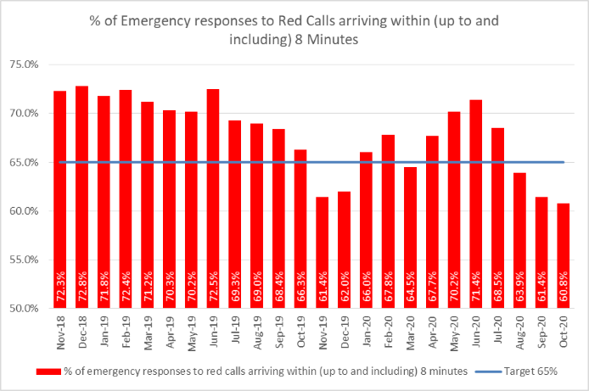

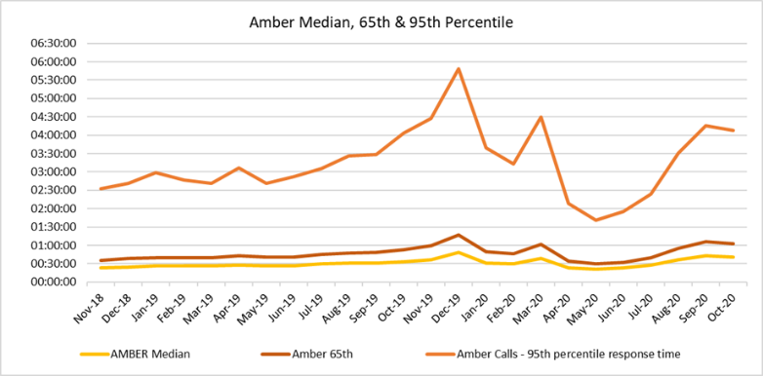

2.8 The Trust also continues to monitor the longest patient responses. The table below shows the number of patients who have had to wait for over 12 hours, and again, it can be seen that these very long waits were almost eliminated during the height of the pandemic, but have subsequently returned as system pressures increase. In Oct-20 there were 226 patient waits for an ambulance of 12 hours or over.

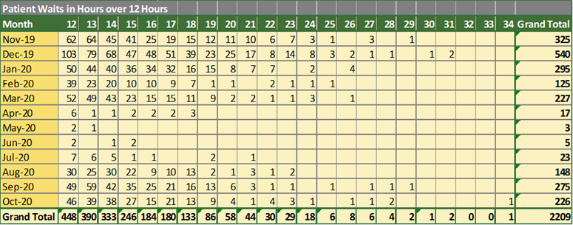

2.9 These long response times impact on patient safety and outcomes. The Trust has been supplying weekly information on quality, safety and patient experience to the Chief Ambulance Services Commissioner (CASC) and monthly information through the CASC Quality and Delivery meeting mechanism. This information includes more detailed analysis, patient stories (positive and negative) and patient feedback from surveys. A number of specific patient stories relating to long response times are included in Appendix 1 to this report.

2.10 In Nov-20 the Trust will start producing monthly quality, safety & patient experience (QSPE) reports for each health board, detailing ambulance performance and patient safety concerns for each health board’s population, in particular, the impact of handover lost hours on these.

2.11 In extreme cases, long response times can lead to Serious Adverse Incidents. In the last 3 months, 15 cases have been passed to health boards as part of the joint investigation framework.
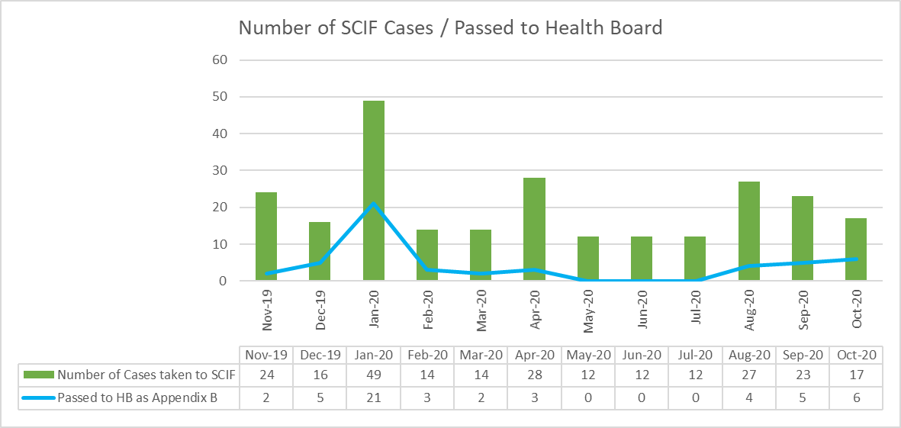

2.12 Whilst there are many factors affecting response times, which are described later in this report, one of the factors outside WASTs control is the number of ambulances that have to wait longer than 15 minutes to transfer patients into secondary care at Emergency Departments. The graph below shows the number of ambulance hours that are lost outside Emergency Departments (EDs) which, if released earlier would have reduced patient waits in the community. As with the other graphs, during the height of the pandemic, the number of lost hours decreased very significantly, but is now building up again to pre-COVID levels. The CEO has written to Health Boards on this matter asking for urgent action to be taken.
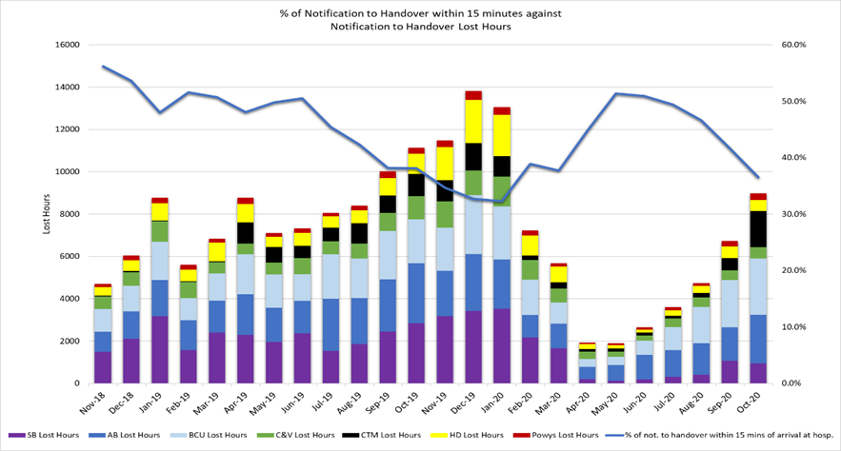
Health & Safety

2.13 In Jul-20, the Trust received two Notifications of Contravention from the Health and Safety Executive (HSE). These were in relation to extended wear of personal protective equipment (PPE) and management of needle sticks. Stakeholder groups were immediately established to undertake remedial actions to address these. As such the HSE confirmed that they were satisfied with all actions taken to address extended PPE use but required further information in relation to needle-stick management. Further work is being undertaken with the final position to be submitted to HSE on 30 Oct-20.

2.14 The HSE have also requested information in relation to the passing of a paramedic who died with COVID 19.

Clinical Outcomes

2.15 Currently, the Trust reports on eight clinical indicators. Five of these are care bundles for specific conditions; a care bundle requires each and every specific criterion of care to be met. Seven of the clinical indicators have a commissioning intention of 95%, the exception being the return of spontaneous circulation (ROSC) indicator.

2.16 Of the seven, three achieved the 95% in the period Jul-20 to Sep-20 (Quarter 2), three others were above 80%. The ST segment elevation myocardial infarction (STEMI) indicator is an area of concern achieving less than 80% through quarter 2. These percentages refer to the application of a whole bundle of care. For each of the individual elements the percentage compliance is consistently above 86%. Targeted improvement work is required to improve consistency, which will improve care bundle reporting.

2.17 The percentage of patients with attempted resuscitation following cardiac arrest, documented as having a return of spontaneous circulation (ROSC) at hospital door was 7.91% in Sep-20 (11.37% Aug-20 and 10.30% Jul-20). Rates of ROSC are complex and determined by a number of factors which contribute to the speed of response and the application of early defibrillation and chest compressions. These factors can include location of the incident, resource availability, public access defibrillation, willingness of bystanders to engage in resuscitation.

2.18 A new chronic obstructive pulmonary disease (COPD) clinical indicator has been developed, to support the Band 6 Paramedic project. The specification for this indicator has been sent to Health Informatics to build the report. The onward referral aspect of this indicator is work in progress and forms part of the national COPD pathway development. The Clinical Indicator Review Group has not met due to the pandemic but meetings form part of the recovery process within the Medical and Clinical Services Directorate.

2.19 The longer term ambition for the Trust is to link the Trust’s patient data with health board patient data so that we can track the eventual patient outcome once conveyed into a hospital.

2.20 The Trust has identified a preferred supplier through a procurement process for the delivery of electronic patient clinical records (ePCRs). The full business case was endorsed by the Trust Board (01 Oct-20) and the Digital Investment Proposal was presented to the Welsh Government Digital Scrutiny Panel (28 Oct 2020) with a final decision awaited.
The ePCR will provide a range of benefits framed around four investment objectives including: (IO1) to use better data and access to information to improve the quality of patient care, (IO2) to increase data sharing in a collaborative whole system approach to health and care provision, (IO3) to improve efficiency using high quality data and (IO4) to increase the value of our clinical data though quality and timeliness.

EASC is asked to NOTE that: lengthening response times in the community mean that there will be increasing patient safety risks; there has been a significant increase in the longest patient waits over the last three months; there were six SAIs passed to health boards in Oct-20; the Trust is enhancing its QSPE reporting arrangements to health boards with patient stories attached at Appendix 1; the Trust is in dialogue with the HSE regarding a number of incidents including the passing of a Paramedic; and that work continues on development of clinical indicators including moving towards deployment of an ePCR.

2.21 The Trust is commissioned by the EAS Joint Committee for two patient flows (journeys) within the unscheduled and scheduled care systems: the 999 Emergency Medical Services (EMS) and the Non-Emergency Patient Transport Service (NEPTS). These patient flows and their safety are now looked at in turn.

EMS Performance

Response Times

2.22 As outlined earlier in the report, response times for both red and amber calls are increasing and waiting times are too long.

2.23 There are a range of factors that affect response times:

- Demand: Red demand has increased significantly over the last 2 years. This is a major contributing factor in relation to performance. Comparison of demand in 2020 compared to 2018 shows demand is up by c500 calls per month, which is around a 25% increase. For other categories of calls, demand is now returning to pre-COVID levels. Demand graphs are shown below.

- The number of response hours produced: whilst varying month on month, the number of hours that WAST has produced has stayed broadly static over the last 2 years. Over the last year, on average, 112,000 hours have been produced each month.
Over the same period, a further 7,400 hours would have needed to be produced to reach 100% UHP (i.e. to staff 100% of rosters). However, the graph below does demonstrate a big increase now in October 2020, which is largely a result of the additional investment following the D&C review. The number of hours we produce is dependent on a number of factors including:
  - Funded establishment: this has now started to increase following additional funding this year.
  - Overtime take-up: this has varied and has tended to be higher when incentives or higher payments are made
  - Sickness levels: These have been high for a number of years but have reduced significantly over the pandemic period, although it is not clear whether this will be maintained. In August, sickness level was 6.39%.
  - Other abstractions (training, annual leave etc), with COVID abstractions other than sickness likely to remain for some time.

- The number of hours lost each month due to hospital handover delays. In the last year, on average, 7,300 hours have been lost each month.

- Specific factors affecting red performance:
  - As a result of the pandemic staff are required to don level 3 PPE for all red calls which is taking between 3-6 minutes based on a number of timed audits. This is a significant factor when trying to achieve an 8 minute target.
  - During the pandemic, Emergency Ambulance (EA) production has been prioritised over Rapid Response Vehicle (RRV) production, in order to protect conveying resource;
  - Community First Responders (CFRs) were not deployed at the start of the pandemic due to a need for Level 3 (L3) PPE training, for example, in Sep-20 Community First Responders (CFRs) only contributed 0.8% to the overall Red performance, compared to 2% in Sep-19. This is now being addressed through roll out of training and PPE kit.

2.24 The Trust has undertaken some forecasting and modelling on a variety of scenarios over the winter period, and in all scenarios, even with action being taken to reduce demand or increase hours produced, performance levels will be challenged for both red and amber patients. A letter was sent to CEOs of Health Boards detailing the implications of this scenario modelling and the actions being planned within WAST to mitigate some of these risks, all of which are included in the Q3/4 plan.

2.25 The analysis, which is consistent with the outcomes of the D&C review, is that, fundamentally, capacity needs to increase in order to improve red and amber response times. The Trust’s Q3/4 plan therefore focuses predominantly on:
- Maximising/ increasing hours produced up to and beyond 100% UHP (circa additional 7000 hours a month)
- Working with partners to reduce hours lost at hospital
- Reducing or defraying activity through increasing hear and treat and see and treat rates.

2.26 Some of the actions are underway and are revenue neutral or already funded, but some proposed actions will additional funding, again which has been detailed in the Q3/4 plan.

2.27 In relation to maximising the number of hours produced, actions will include
- EMS Demand and Capacity Review programme – this programme is on track, is fully funded via EASC, and is designed to deliver an additional 136 WTE by the end of March 2021. Each month over the winter will see an increase to the bottom line number of staff available to fill rosters.
  - Additional UCS resource has been commissioned from St. John Ambulance Cymru.
  - Additional support will be sought from ambulance trained Fire and Rescue Services personnel;
  - The use of overtime incentives could be explored as utilised in the first wave of the pandemic, although there are risks associated with the sustainability of this type of approach;
  - Consideration could be given to the use of other private ambulance resources – this is unlikely to be palatable and would require additional funding;
  - Military support could be explored, but would likely only be available if all other options have been excluded or exhausted and again would require additional funding.

2.28 WAST are engaged in a number of programmes across the unscheduled care system which are designed to reduce or schedule demand, as outlined below.

- National Respiratory Work Programme – we have been asked to lead on the work to implement alternative pathways for respiratory patients as outlined in the urgent and emergency care goals and deliverables. We have proposed a four phased approach across 3 years.
The first phase across this winter will be to be implement a referral pathway for patients with exacerbations of COPD to avoid ED conveyance and more appropriately treat within the community, closer to home. The pathway was piloted in ABUHB earlier this year.
- WAST has also been asked to lead on the development of the front end of the Phone First approach to scheduling Emergency Department demand for non-life threatening incidents. The benefit of this from an EMS perspective is that the reduction / scheduling of ED appointments could lead to improved flows for ambulances arrivals. Funding has been secured for an element of the 2020/21 costs but recurrent funding is required.
- WAST have been heavily engaged in supporting the implementation of Consultant Connect and would wish to see its use maximised in all health board areas.
- During the height of the pandemic, staff from the National Collaborative Commissioning Unit (NCCU) were deployed as mental health practitioners in the clinical support desk. The scheme worked well and helped to reduce ambulance dispatch to psychiatric calls and to free up other clinicians to deal with non-mental health demand. We are keen to put in place a similar service over the winter period, but this will require additional funding. In addition, we will continue to build on the good work internally to increase hear and treat rates, which in September stood at 10.4%.

2.29 As shown in the modelling, if mitigating actions agreed / funded are not sufficient, there may be a need to enact the demand management plan (DMP) and/or card 36 for high COVID-19 demand. This would potentially require a no send policy to be enacted for lower priority calls, which would have a significant impact again on the populations we serve. This would only be triggered in line with the agreed criteria contained within the plan.

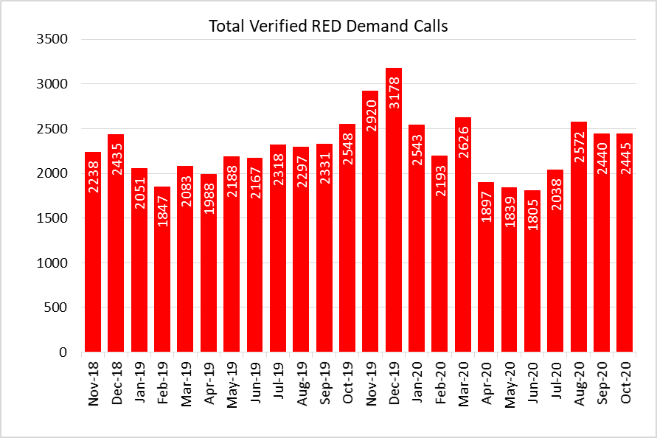

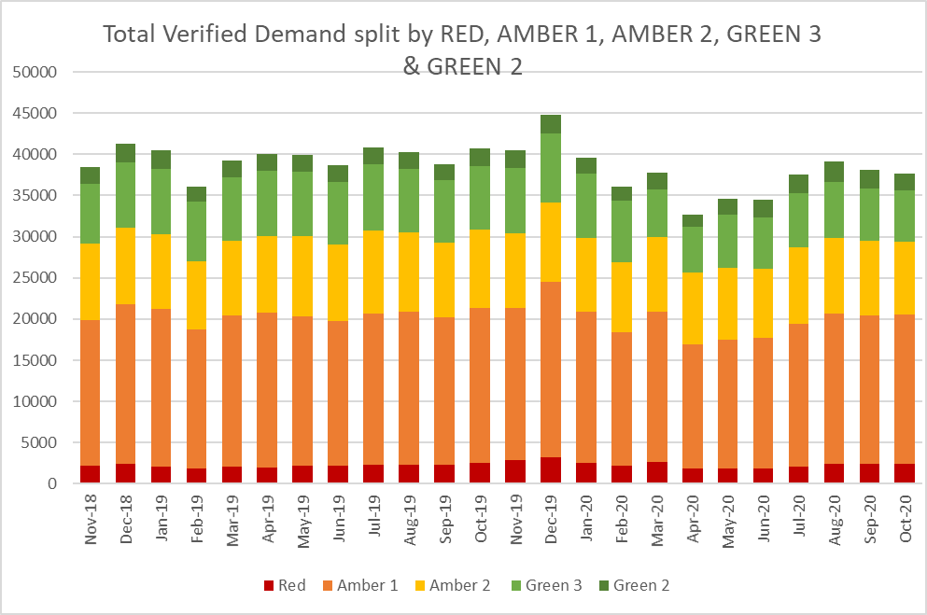

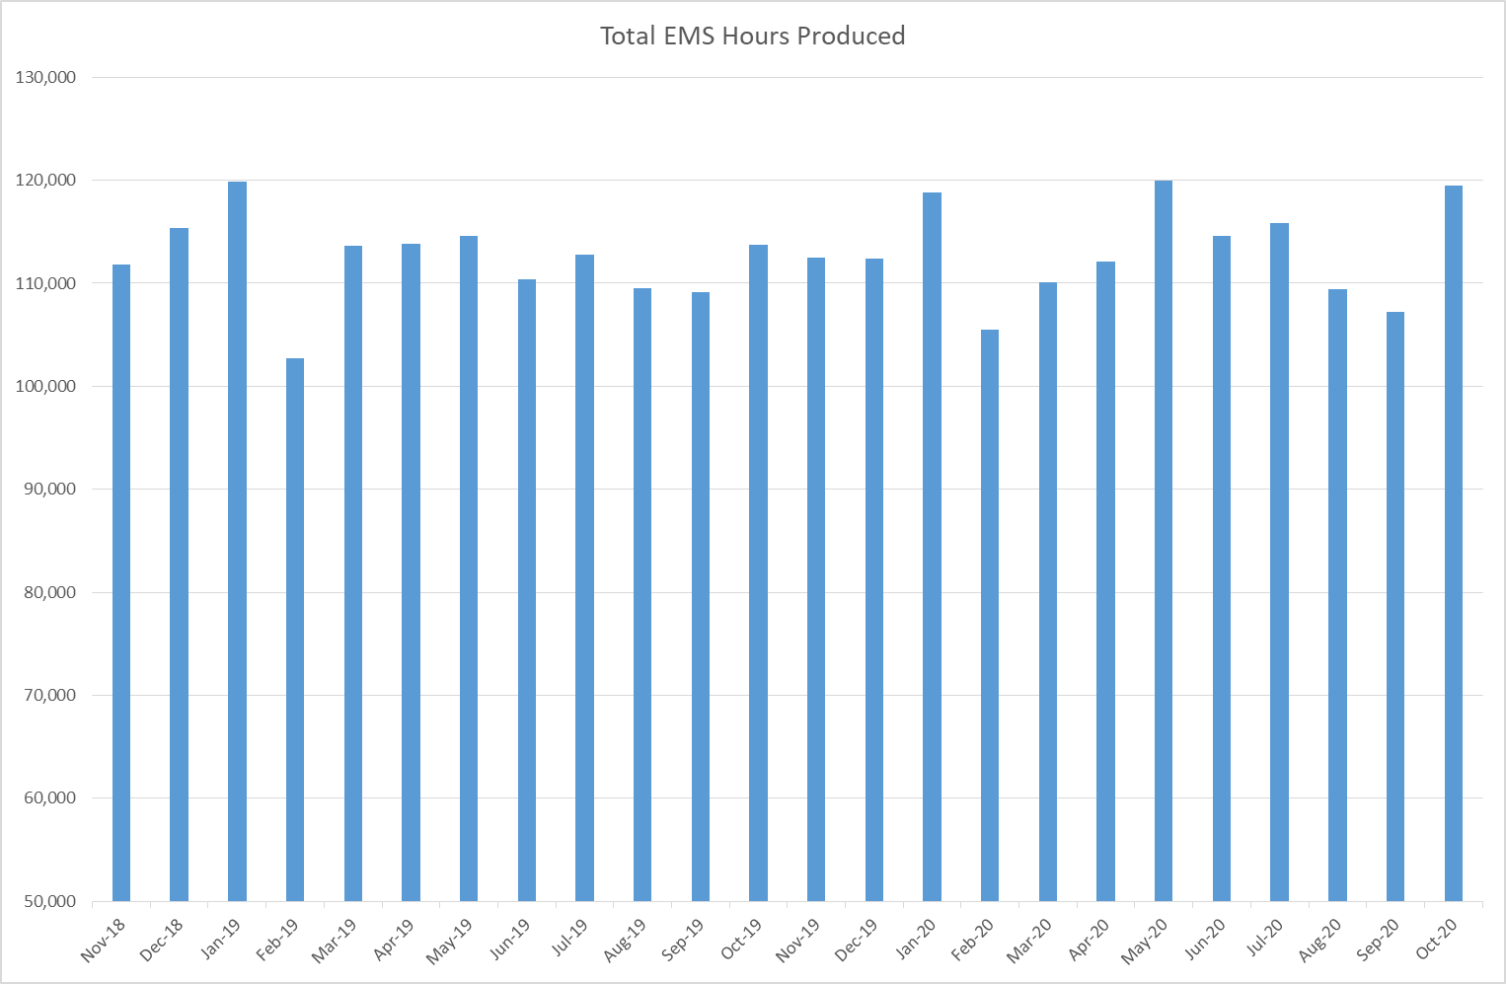

EASC is asked to NOTE that: the Trust has not achieved the Red 8 minute 65% target for the last three months; a range of factors are affecting Red performance (and Amber); the Trust is seeking to mitigate these through a range of actions, in particular, boosting production, minimising lost hours to handover and shift left actions.

NEPTS Performance

2.30 The publication of the NEPTS ambulance quality indicators are suspended at this point in time due to CoVID-19; however, there is some internal reporting. Key points to note in relation to NEPTS are set out below:

- CoVID-19 saw a significant drop in patient transport activity. Levels have begun to increase, but they have not recovered to pre-CoVID-19 levels
- CoVID19 abstractions and social distancing has been challenging, but NEPTS has seen a continued improvement in key areas of service delivery particularly discharge and transfer. Enhanced services have improved with some tailing off in recent months
- Social distancing means that the number of patients that can be transported per journey has reduced, which has a significant impact on NEPTS capacity
- In the first wave there was a significant reduction in outpatient transport activity, which meant that the impact of CoVID-19 on NEPTS capacity could be offset by the reduced demand
- NEPTS capacity is also adversely affected by other CoVID-19 factors: journeys taking longer due to PPE, staff sickness, staff shielding, staff training and testing, infection prevention and control arrangements and so on
- We do not expect to see a reduction in core activity (outpatients) in the second CoVID-19 wave in the same way that we did in the first CoVID-19 wave, and
- NEPTS continues to liaise closely with the commissioning process through NEPTS Delivery Assurance Group and recent presentations to the EASC Management Group and EASC (Sep-20).

2.31 The presentation to Sep-20 EASC, jointly with the EASC Team identified the good progress being made on NEPTS, in particular, the now national call taking service, the end of life service and transfers for work from health boards. Areas for focus include: the remaining health board transfers (Aneurin Bevan, Betsi Cadwaladr, Cwm Taf Morgannwg and Powys), reducing aborted journeys and application of the transport eligibility criteria.

2.32 As we start to move into a second wave another key consideration for NEPTS (and EMS) is the transport requirements for the field hospital sites (currently estimated at eight across Wales). One of these was open during Oct-20; however, if all eight were to open the transport requirements would be significant and NEPTS would not be able to service the transport needs due to the reduction in their capacity as above. The following actions have been agreed:

- Move the Collaborative Health Care System Transport meeting to weekly
- Review and update the WAST standard operating procedures (SOPs) for each site
- Obtain information from health boards on estimated peak patient flow into the field hospital sites), and
- Seek to buy up external transport provider capacity in Wales (on a regional basis) to support the potential opening of the field hospitals.

2.33 For the last bullet, monies would need to be forthcoming from health boards in order for this to be actioned. The EASC Team are supporting WAST in the feasibility of this option.

EASC is asked to NOTE that: due to social distancing, NEPTS does not have the capacity (and there is no EMS capacity) to support a reasonable worst case scenario of all the field hospital sites being open to peak capacity; and that additional external capacity needs to be procured to mitigate this eventuality .

Commissioning, Planning and Leading Change

Forecasting & Modelling: Strategic Demand & Capacity Reviews

2.34 The EMS Demand & Capacity Programme (arising from the EMS Demand & Capacity Review) is the Trust’s main strategic response to patient safety and experience concerns.

2.35 In Sep-20 the Trust secured outstanding funding for the balance of the 136 FTE additionality planned this year (the Trust has increased its Response establishment by 108 FTEs at this point in time). The critical path for the programme has been re-cast in response to the impact of the first phase of the CoVID-19 response. The Trust has also gone out to tender for a third party supplier to support Response roster reviews pan-Wales in 2021 with pre-work in Quarter 4.

2.36 Whilst the programme is currently RAG rated green, the high utilisation (and quality) of the existing estate is considered a possible strategic barrier (and risk) to the programme. A detailed report will be taken to the Finance & Performance Committee (12 Nov-20) to consider the impact and potential solutions (fleet is not viewed as a problem for this year or next financial year).

2.37 The NEPTS Demand & Capacity Review has recommenced with the draft report expected Dec-20. A focus in the review has been on modelling parameters that consider the whole patient journey (systems thinking), from initial pick up, treatment and return to home.

2.38 An internal 111 Demand & Capacity Review has also been completed.
Forecasting & Modelling: Tactical Seasonal Planning (winter).

2.39 The Trust has undertaken innovative forecasting and modelling in support of the seasonal plan (winter) combining CoVID-19 forecasts with assumptions about core demand and other system variables.
A letter was sent (14 Oct-20) by the Trust CEO to health boards and Welsh Government on the patient safety results of this modelling.

2.40 The modelling focused on Dec-20, traditionally the month with the highest demand. In all the scenarios modelled Red performance was less than the 65% Red Welsh Government target and Amber waiting times too long from a patient safety and experience perspective. This modelling has been shared with stakeholders and has led to decisions to maximise ambulance production, with further reserve options of military aid, incentivised overtime and the use of private ambulance providers.

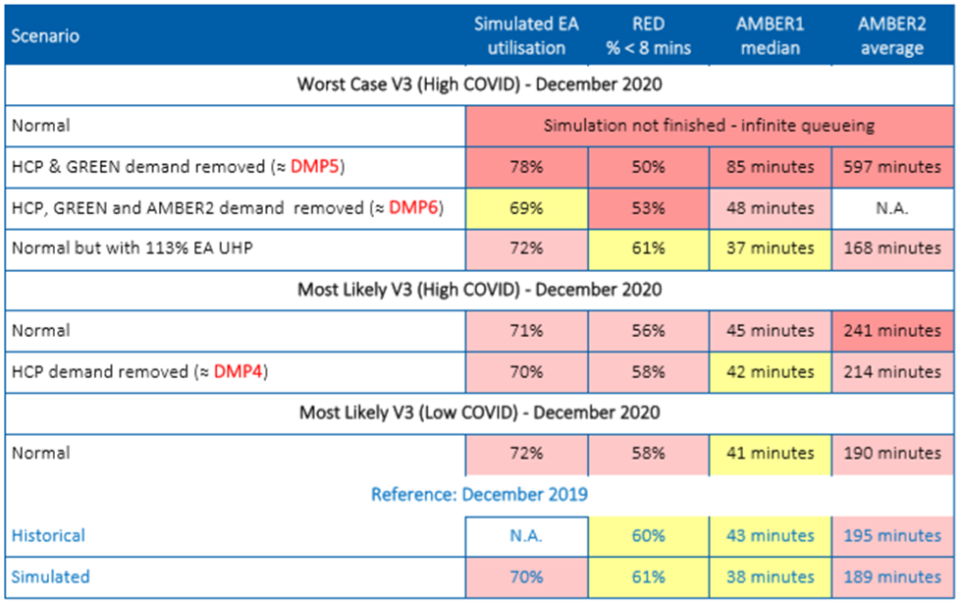

2.41 The Trust’s Demand Management Plan and Resource Escalation Action Plan have been revised (based on learning from the first phase of CoVID-19) and a winter planning exercise (using the above scenarios) was completed on the 30 Sep-20.

Integrated Medium Term Plan (IMTP)

2.42 The Trust submitted its Board approved Q3/Q4 Operational Framework on the 19 Oct-20 (Welsh Government deadline). The plan focuses on four themes:

- Respond flexibly
- Lead important programmes
- Support our staff, and
- Learn from and keep what’s worked.

2.43 Quality and patient experience run through all these themes as do four behaviours.

2.44 The respond flexibly theme starts with protecting core and essential ambulance services which are crucial to the operation of safe and reliable unscheduled and scheduled care systems. The Trust has identified these as:

- Ambulance response (EMS, Urgent Care Services (UCS) and NEPTS) – arrangements to generate the required capacity to respond to growing demand from both COVID-19 and seasonal forecasted activity
- Fleet – arrangements to ensure maximum fleet and equipment availability
- Information and Communication Technology – arrangements to protect mission critical systems and support remote and flexible working
- Supply chain – arrangements to ensure sufficient supplies of necessary equipment and materials such as Personal Protective Equipment (PPE)
- Resource Centre - arrangements to facilitate greater numbers of staff being deployed and maintain core rostering services, and
- Clinical Contact Centre (999, 111, CSD and NEPTS) – arrangements to protect mission critical control functions, grow their capacity and diversify tasks.

2.45 A number of corporate support services have also been identified as critical to supporting these core services, including: HR, Occupational Health and Well-being, Education and Training, Safeguarding, the Patient Safety, Concerns and Learning Team and the Infection Prevention and Control Team.

Health Board Changes

2.46 The opening of the Grange University Hospital (GUH) is the major health board change and a significant event for a health care system.

The Trust will complete this project in Quarter 3, delivering an additional 84 staff on top of those planned as part of the EMS Demand & Capacity Programme, a joint Flow Centre model with ABUHB, 13 new transfer vehicles and a plan for associated estate within Vantage Point House (VPH) and the Aneurin Bevan UHB area. There remain a number of risks to delivery of the project and the Trust continues to work closely and collaboratively with the Health Board and the NCCU to mitigate these risks and bring this to fruition.

2.47 The South Wales Trauma Network went live in Sep-20. WAST is now working with the network to ensure surge plans are in place to support the network during a second wave and over winter.

2.48 In the second CoVID-19 wave the Critical Care Network’s preference is to move both patients and staff as required to maintain capacity (the opposite of the first CoVID-19 wave) as the demand for critical care will come not only from CoVID-19 but also trauma, elective & emergency surgery and other emergency presentations. The Trust is working with the NCCU to consider the options to support such moves, without impacting on core capacity to respond in the community. Options will be developed early in Quarter 3 (to be implemented by the end of Quarter 3) which may include sourcing provision through the 365 platform (subject to compliance with WAST standards and funding).

2.49 The Welsh Health Specialised Services Committee (WHSSC) is also seeking to commission a 24/7 neonatal transport and retrieval solution for South Wales in 2021, with an interim 24/7 service in place by the end of Quarter 3. Currently CHANTS operates a 12/7 service. WAST will develop and implement an interim 24/7 transport solution in Quarter 3 and will prepare to work with a commissioned lead provider throughout Quarters 3 and 4 to develop a full 24/7 model and service.

Leading Changes across Wales

2.50 The programme to lead on the delivery of the front end of the 111 Phone First solution resonates strongly with the Trust’s ambition, articulated in its Long Term Strategy and IMTP, to become the ‘call handler of choice’ and to strengthen and integrate clinical triage and assessment services. This has therefore been prioritised as a key programme of work during Quarters 3 and 4. Plans are already underway to recruit the required call handlers and clinical staff to support the increase in activity that will result from this approach.

The scale of the programme is significant and requires co-ordination through both the 111 Programme Board and the National Phone First Programme Board as well as with Health Boards providing the later stages of the pathway. Timescales will be adjusted for design and delivery in Quarters 3 and 4.

2.51 Since the start of Aug-20 the Trust has recruited and trained 94 staff to provide four mobile CoVID19 Mobile Testing Surge Capacity Units (MTU) to increase testing capacity across Wales. Additional training has been arranged for Quarter 3 for additional MTU operatives to fill vacancies and build bank resilience in the South East. The Trust is still awaiting a position on increasing the current four MTU’s to take on an additional 15 across Wales. A decision from Welsh Government is expected soon and a plan will be developed to recruit additional staff as required in Quarters 3 and 4.

2.52 Throughout the first half of 2020/21 the Trust has supported the unscheduled care system through the Operational Delivery Unit (ODU) which has provided minute by minute system leadership and patient safety oversight across Wales. The Trust’s ambition was to secure permanent funding for an ODU structure. This has not been secured at this point in time, but funding to the year-end has, which will enable the Trust to put in place a number of fixed term contracts to support the ODU through the winter period.

2.53 The Trust has developed an initial proposal for a four phased approach to implementing community respiratory pathways across Wales. This will build on a pilot in ABUHB in Feb-20, linking paramedic response to community respiratory resources, supported by Advanced Paramedic Practitioners (APPs). The scale of the work requires dedicated project support and clinical leadership, which require funding in order to deliver phase 1 (readiness assessment and health board level pathway development) during Quarters 3 and 4. The Trust is currently seeking funding support from stakeholders for this important initiative. The Trust is also heavily engaged in supporting the implementation of Consultant Connect and would wish to see its use maximised in all health board areas.

EASC is asked to NOTE that: the Trust is making good progress on the EMS Demand & Capacity Programme; the Trust’s estate may be a strategic barrier to the programme (which is currently being worked through); winter forecasting and modelling predicts compromised patient safety unless there are a significant mitigations put in place; mitigations are being put in place, but handover lost hours are a serious drain on these mitigations; the opening of the GUH in Q3 will have a considerable impact on the Trust which is being actively managed; and the Trust continues to provide system leadership on a range of projects.

Conclusions and Forward Look

2.54 Oct-20 quality and performance metrics plus the tactical forecasting and modelling undertaken for the tactical seasonal (winter) plan both indicate that patient safety could be compromised this winter. It is clear that we are in a second CoVID-19 wave with “circuit breakers” i.e. Welsh Government restrictions, currently being applied.

2.55 The Trust has acted on this data and is seeking to maximise EA production through a variety of actions identified in the report. Handover lost hours are a significant drain on ambulance hours produced and prevent ambulances responded to incidents in our community in a timely manner. The Trust has written to health boards with the results of its forecasting and modelling and will also start health board level monthly QSPE reports from Nov-20.

2.56 The GUH will open in Nov-20. The opening of a new district general hospital (DGH) is a major event for any health care system. The opening is not without risk to the Trust with these risks being closely managed and mitigated on a daily basis currently.

2.57 Overall, it is clear that the next six months are going to require a particularly strong managerial focus within the Trust in order to protect our services and mitigate the impact on patient safety.

- KEY RISKS/MATTERS FOR ESCALATION TO THE COMMITTEE

Members of the EAS Committee are asked to note:
  - WAST’s Pandemic Influenza Plan/ business continuity arrangements have been effective, that WAST continues to work within the framework of these plans/arrangements and WAST is now back in a period of response as a second CoVID-19 wave feeds through the health care system.
  - Quality, safety and patient experience monitoring arrangements have remained in place through the CoVID-19 response and are currently being enhanced, in particular, monthly reporting to health boards. The Trust remains very concerned at the patient safety risks associated with response times that are too long
  - There were six SCIF cases passed to Health Boards in the last month
  - The Red 8 minute 65% target has been missed for the last three months, with significant health board variation
  - The Amber tail (an area of focus e.g. the Amber Review) has started to increase as handover lost hours have increased
  - WAST is concerned at the rising number of hours lost outside EDs, particularly at certain hospitals, with risks emerging again around patient safety and response times
  - WAST has a clear approach for tactical seasonal planning (winter) linked to forecasting and modelling and boosting production
  - The EMS Demand & Capacity Programme is making good progress, but estate is a potential strategic barrier/risk to the programme
  - WG has approved the early opening of the GUH which is not without risk to WAST as the inter-site provider; however, these risks are being actively mitigated
  - WAST continues to monitor Health Board requirements for additional ambulance transport required to service revised clinical models/hospital footprints in each Health Board
  - NEPTS has continued to provide patient critical journeys as determined by Health Board clinicians, but social distancing has significantly reduced NEPTS capacity and is a risk to the system;
  - Early engagement by health boards with WAST on transport needs is critical, particularly, for the field hospital sites to flow properly
  - WAST has submitted its Q3/4 Operating Framework with a focus on protecting core services
  - WAST continues to provide system leadership on a range of projects: 111 Phone First, MTUs, ODU etc.

- IMPACT ASSESSMENT

Quality/Safety/Patient Experience implications | Yes (Please see detail below)
Quality/Safety/Patient Experience implications | Identified within the report
Related Health and Care standard(s) | Timely Care
Related Health and Care standard(s) | And all health and care standards
Equality impact assessment completed | Not required
Legal implications / impact | There are no specific legal implications related to the activity outlined in this report.
Legal implications / impact | Included within the body of the report
Resource (Capital/Revenue £/Workforce) implications /  Impact | Yes (Include further detail below)
 | Included within the body of the report
Link to Main Strategic Objective | The Committee’s overarching role is to ensure its Commissioning Strategy for Emergency Ambulance Services utilising the five step patient pathway outlined within the National Collaborative Commissioning Quality and Delivery Agreement and the related outcomes for each care standard aligned with the Institute of Healthcare Improvement's (IHI) ‘Quadruple Aim’ are being progressed.  This report focuses on all the above objectives, but specifically on providing strong governance and assurance and safe and effective patient care
Link to Main WBFG Act Objective | Service delivery will be innovative, reflect the principles of prudent health care and promote better value for users

- RECOMMENDATION

  - The EASC Committee is asked to:

- DISCUSS and NOTE the WAST provider report.

Appendix 1

Patient Stories

