AGENDA ITEM
2.4

EMERGENCY AMBULANCE SERVICES COMMITTEE (EASC)

welsh ambulance services nhs trust (WAST)
provider update

Date of meeting | 09 Nov 2021

FOI Status | Open/Public

If closed please indicate reason | Choose an item.

Prepared by | Rachel Marsh, Director of Strategy, Planning and Performance (WAST)
Presented by | Jason Killens, Chief Executive WAST
Approving Executive Sponsor | Chief Executive

Report purpose | FOR DISCUSSION / REVIEW

Engagement (internal/external) undertaken to date (including receipt/consideration at Committee/group)
Committee/Group/Individuals | Date | Outcome
(Insert Name) | (DD/MM/YYYY) | Choose an item.

ACRONYMS
ABUHB  CTMUHB  D&C  EMS  NCCU  NEPTS  SAI  WAST | Aneurin Bevan University Health Board  Cwm Taf Morgannwg University Health Board  Demand and Capacity  Emergency medical services  National Collaborative Commissioning Unit  Non-emergency patient transport services  Serious Adverse Incident  Welsh Ambulance Services NHS Trust
- SITUATION/BACKGROUND

  - The purpose of this report is to provide EASC with an update on key issues affecting quality and performance for EMS and NEPTS and to provide an update on commissioning and planning for EMS and NEPTS.

- SPECIFIC MATTERS FOR CONSIDERATION BY THIS MEETING (ASSESSMENT)

CoVID-19

2.1 WAST continues to track CoVID-19 and related metrics through its weekly CoVID-19 Intelligence Pack. There is a clear third wave (positive tests). WAST has been at maximum escalation since 24 Aug-21, however, the reasons for this are complex and not just CoVID-19 demand, and include high seasonal demand, high abstractions (linked directly to CoVID-19, but also workforce fatigue) and high system pressure, in particular, handover lost hours.

2.2 WAST now undertakes seasonal forecasting and modelling as a matter of routine. WAST collaborates with the NCCU on this work via its Forecasting & Modelling Group and the modelling results for winter have been shared with senior stakeholders. The modelling indicates that it will continue to be very difficult to respond to patients in a timely way throughout the winter period. The Trust tracks actuals against the modelling. The current tracking suggests the modelling is more optimistic than the actuals.

2.3 In addition to being at maximum escalation WAST has again stood up its pandemic structures (Pandemic Plan) and introduced an organisation wide Performance Improvement Plan (PIP), which sets out the actions being taken to mitigate the risks highlighted in the modelling, including increasing capacity where possible (re-engaging with the military and fire & rescue services) and deployment when required of the Clinical Safety Plan.

EASC is asked to NOTE that: as a result of CoVID-19 and the cumulative impact on CoVID-19 on WAST and the wider health care system, WAST has been at maximum escalation since 24-Aug-21; WAST has forecasted and modelled patient safety for the period 01 Oct-21 to 31 Mar-22; and WAST has introduced a Trust wide PIP which includes increased capacity and deployment of its Clinical Safety Plan.

Quality, Safety & Patient Experience

Patient Response Times in the Community

2.4 One of the key indicators which measures the quality of the service provided is the timeliness of the response by WAST to patients waiting in the community. The graphs below show the current response times performance for Red calls and for Amber calls. Both graphs show that response times have continued to worsen throughout 2021. Inevitably these worsening times have had an impact on patient safety.

2.5 The Red 8-minute target was not achieved in Sep-21 (and is expected to be similar in Oct-21). The percentage of emergency responses to Red incidents within 8 minutes was 52% (target 65%) with 95% of Red calls receiving a response within 23 minutes. Red 9 minute performance was 58% and Red 10 minute performance 64%.

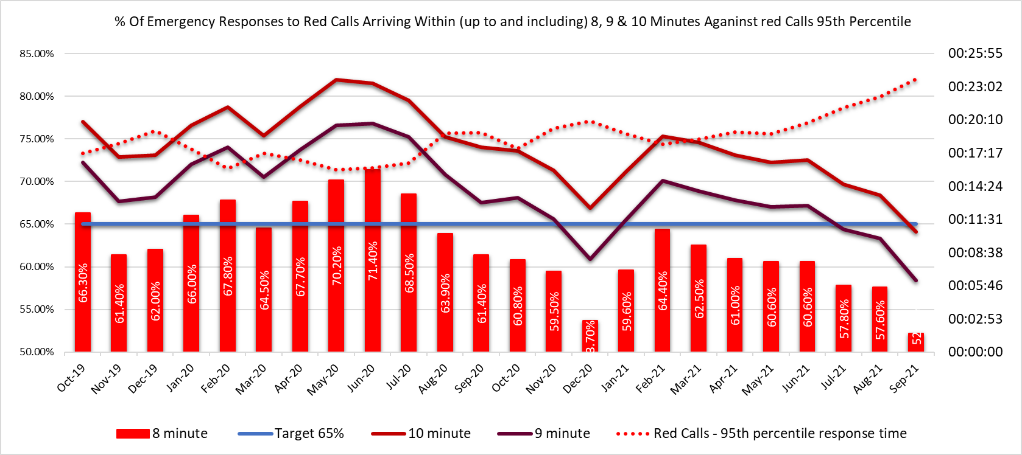

2.6 At its last meeting EASC asked for missed Red information by time of day. The following infographic shows the missed Red incidents by day and hour (Sep-21).
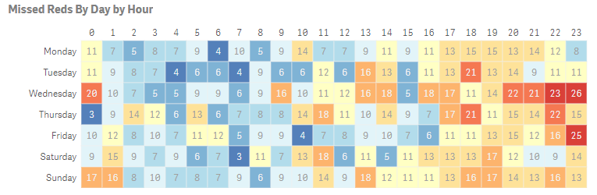

2.7 WAST reviews missed Red incidents as a matter of routine and is aware of the increase in missed Reds overnight and also in the twilight hours. WAST has undertaken modelling which has identified four demand hotspots. Under more normal conditions WAST would target Rapid Response Vehicles (RRVs) at these times; however, due to CoVID-19 and the level of abstractions WAST is currently operating a tactical approach to ambulance production with a focus on Emergency Ambulances, which can convey patients and have a higher utilisation.

2.8 The Amber median percentile in Sep-21 was one hour 48 minutes and the Amber 95th percentile was seven hours 48 minutes. The Amber 1 performance parameters used in the EMS Demand & Capacity Review were 35 minutes (Dec-21 position) and 18 minutes (Dec-24 position).

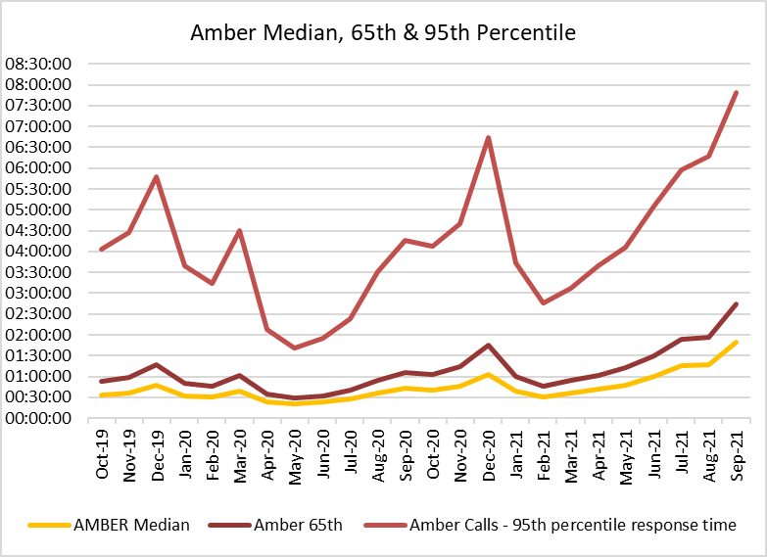

2.9 These very long Amber median times mean that the patients waiting times in the “Amber tail” are a particular concern from a patient safety perspective (it is where the bulk of serious adverse incidents occur). As part of its quality, safety and patient experience arrangements, WAST continues to monitor the longest patient responses. The table below shows the number of patients who had to wait 12 hours or over. The table shows that very long waits were almost eliminated during the first wave, but subsequently returned as system pressures increased. There were 586 long waits in Sep-21, the third highest and a level that is normally seen in winter (the first and second highest were in Dec-20 and Dec-19 respectively).

2.10 These long response times impact on patient safety and outcomes. WAST has been supplying weekly information on quality, safety and patient experience to the Chief Ambulance Services Commissioner (CASC) and monthly information through the CASC Assurance & Delivery meeting. This information includes more detailed analysis, patient stories (positive and negative) and patient feedback from surveys.

2.11 WAST supplies health boards with a monthly report on one hour and over patient waits.

2.12 In extreme cases, long response times can lead to Serious Adverse Incidents. In the last 3 months, 48 patient safety incidents have been passed to health boards as part of the joint investigation framework (Appendix B).

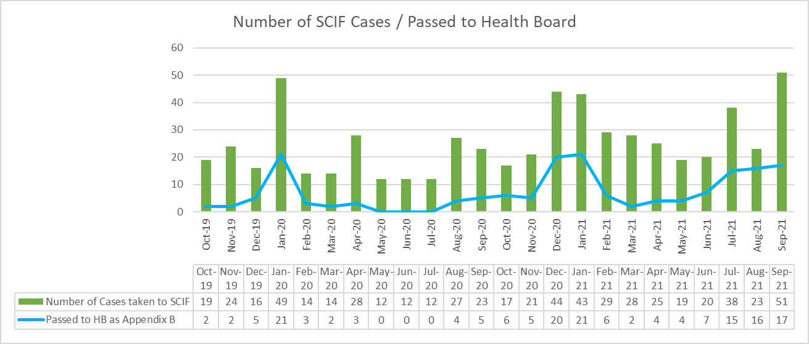
2.13 Whilst there are many factors affecting response times, which are described later in this report, one of the factors outside WAST’s control is the number of ambulances which wait longer than 15 minutes to transfer patients into secondary care at Emergency Departments (EDs). The graph overleaf shows the number of ambulance hours that are lost outside EDs which, if released earlier, would have reduced patient waits in the community. As with the other graphs, during the first wave of the pandemic, the number of lost hours decreased very significantly, but they are now higher than those seen in the worst of winter.

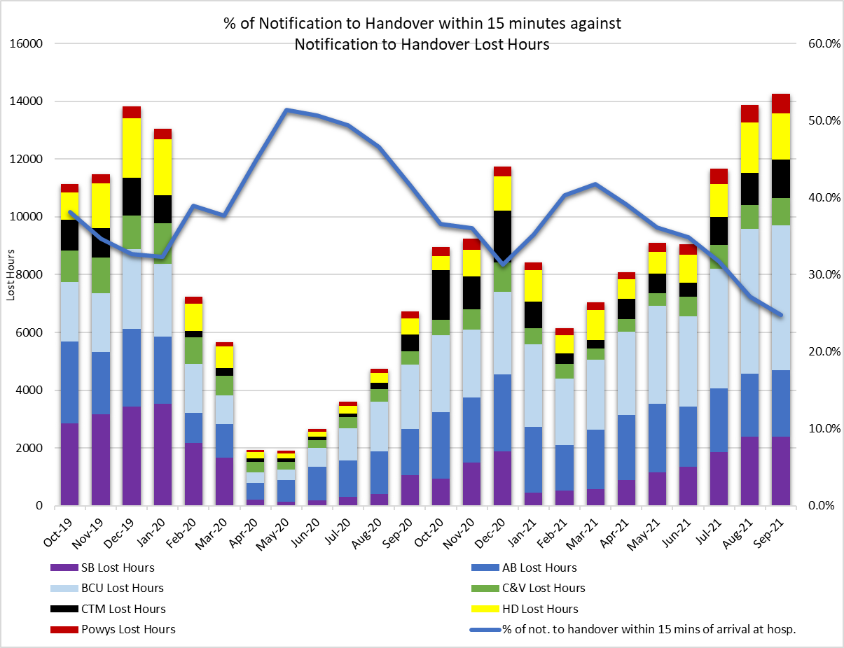
2.14 14,202 hours were lost to handover in Sep-21, compared to 11,708 in Dec-20 and 6,728 in Sep-20. The 2021/22 EASC EMS commissioning intentions include: “NHS Wales is a significant outlier in the UK and Internationally for lost productivity due to extended notification to handover times. By the end of 2021/22 NHS Wales will have reduced 1 hour waits to less than 5% of total arrivals and ensured that total lost hours at Welsh Hospitals do not exceed 150 hours per day on 95% of the year”. Application of this commissioning intention would mean c.5,000 hours per month lost and 9,552 ambulance hours returned to the system in Sep-21.

2.15 In the last three months WAST has reported 17 SAIs to the Delivery Unit and continues to have regular dialogue with EASC through the National Collaborative Commissioning Unit (NCCU).

2.16 The WAST CEO has previously written (27 Jul-21) to the Director General detailing the clinical risk that WAST is carrying and the patient harm that is occurring in communities across Wales. As part of its preparations for winter, WAST has reviewed and updated its Demand Management Plan, now Clinical Safety Plan. Health Boards have also been asked to develop a health board escalation policy that connects with the WAST Clinical Safety Plan and that there is a clear system wide approach to shared risk and patient safety.

Health & Safety

2.17 There have been 968 reported staff positive COVID-19 since the start of the pandemic (Mar-20 to Oct-21). 42 positive cases were reported in Oct-21. All cases continue investigated and reviewed and subsequently reported to the Health and Safety Executive (HSE) where applicable in line with the Reporting of injuries, Diseases and Dangerous Occurrences Regulations (RIDDOR) 2013. 38 RIDDORS have been submitted to the HSE for potential exposure to CoVID-19 to date. The HSE have informed WAST that we only need to report incidents where there is a high degree of certainty that the infection was acquired as part of the work undertaken by WAST staff.

2.18 The investigation into the serious road traffic collision in Apr-21 at Dolgellau continues with work undertaken to risk assess the restraints required for service user journey via EMS and NEPT vehicles. In addition a video outlining the requirements for restraining service user in Trust vehicles has been communicated to all staff. We are still waiting for the Police to interview the driver of the NEPTS vehicle to progress the investigation to completion.

2.19 The “Pump Prime” phase of the Working Safely Programme started on the 1st of October with the appointment of the Working Safely Programme Manager. The Working Safely Programme Plan has been agreed by the Working Safely Programme Dynamic Delivery Group and is awaiting further approval to be fully implemented.

Clinical Outcomes

2.20 This report includes an update for the clinical indicator measures July-21 to Sept-21.

2.21 Currently, WAST reports on seven clinical indicators. Five of these are care bundles for specific conditions; a care bundle requires each and every specific criterion of care to be met. Six of the clinical indicators have a commissioning intention of 95%, the exception being the return of spontaneous circulation (ROSC) indicator.

2.22 Of the six, three achieved the 95% in the period July-21 to Sept-21 (quarter two), two others were above 85%. The ST segment elevation myocardial infarction (STEMI) indicator was previously an area of concern with a temporary low of 62.3% in Feb-21, this has now improved. The Clinical Audit and Effectiveness Department (CA&ED) undertook a deep dive of the STEMI compliance, and an improvement plan was agreed and is being progressed. These percentages refer to the application of a whole bundle of care. For each of the individual STEMI care bundle elements, apart from Sept -21 the percentage compliance was consistently above 85%.

2.23 The percentage of patients with attempted resuscitation following cardiac arrest, documented as having a ROSC at hospital door was 6.8% in Mar-21. For quarter two, the rates were July -16.2%, Aug - 8.1%, Sept - 12.4%. Rates of ROSC are complex and determined by a number of factors which contribute to the speed of response and the application of early defibrillation and chest compressions. These factors can include location of the incident, resource availability, public access defibrillation, willingness of bystanders to engage in resuscitation. As part of its plans, WAST is developing the concept of Cymru High Acuity Response Units (CHARU) (see section: Forecasting & Modelling: Strategic Demand & Capacity Reviews). This concept is in place in several areas across the UK and has been very successful in increasing ROSC rates. These units supplement the response to critical incidents and are crewed by a mix of Senior Paramedics and selected paramedics, maximising the provision of enhanced clinical care and ensure the consistent delivery of core critical care requirements across the whole of Wales. The Clinical Audit and Effectiveness Department are conducting a review of the ROSC rates to determine where future improvements can be made. This will report through the Clinical Intelligence Assurance Group (CIAG) to the Clinical Quality Governance Group.

2.24 A new chronic obstructive pulmonary disease (COPD) clinical indicator has been developed to support the Band 6 Paramedic project. The onward referral aspect of this indicator is work in progress and forms part of the national COPD pathway development. The Clinical Audit & Effectiveness Department have undertaken a benchmarking exercise to test the COPD Clinical Indicator which has been presented to the Clinical Intelligence Assurance Group. The testing highlighted the requirement for manual scrutiny of all COPD Patient Clinical Records and the need to refine the criteria to automatically capture more of the data. Feedback from the Group will finalise the required criteria, Health Informatics can then develop the reporting dashboard.

2.25 Discussions have commenced with EASC for the transition from Digipen to ePCR data when reporting AQIs. Seven areas for future clinical indicators have been suggested and will be processed through the appropriate governance route before a more detailed plan can be developed.

2.26 The longer term ambition for WAST is to link its patient and CAD data with health board patient data so that WAST can report on agreed time-based aspects of clinical indicators and track the eventual patient outcome once conveyed into a hospital. The ePCR project will be critical to delivering this ambition. The contract has now been awarded with initial go live in Nov-21.

EASC is asked to NOTE that: the Red 65% target was not achieved in Sep-21; WAST reviews missed Reds as a matter of routine; Amber waiting times remain very long; these delayed responses are impacting on patient safety; in the last three months 48 patient safety incidents were reported to health boards (under the Appendix B arrangements) and 17 SAIs were reported to Welsh Government by WAST; and of the six clinical indicators with a 95% compliance target, two achieved the target, one was above 90%, two were above 80% and one was above 75%.

2.27 WAST is EASC commissioned for two patient flows (journeys) within the unscheduled and scheduled care systems: the 999 Emergency Medical Services (EMS) and the Non-Emergency Patient Transport Service (NEPTS). These patient flows and their safety are now looked at in turn.

EMS Performance

Response Times

2.28 As outlined earlier in the report, response times for both Red and Amber incidents remain too long.

2.29 There are a range of factors that affect response times:

- Demand: comparing demand is difficult because of the pandemic, but WAST has previously identified that Red demand has increased significantly over the last few years as a result of a change in the application of the Medical Prioritisation Dispatch System (MPDS) for breathing difficulty calls (an improved approach to patient safety). This is a major contributing factor in relation to Red performance.

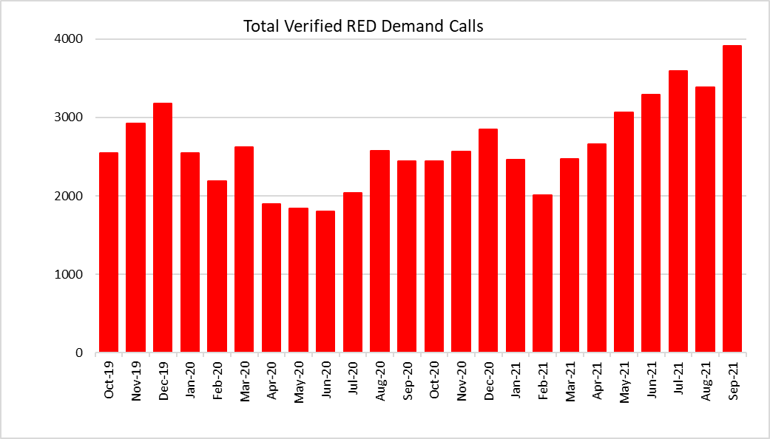

- Overall demand increase is also a major contributory factor. There were 42,725 verified incidents in Sep-21, compared to 38,776 in Sep-19, an increase of 9.2% (double the forecast in the EMS Demand & Capacity Review). WAST is experiencing very high seasonal demand – this has particularly affected 999 call demand, with a planned 32.25 FTE additional 999 call handlers currently being recruited.

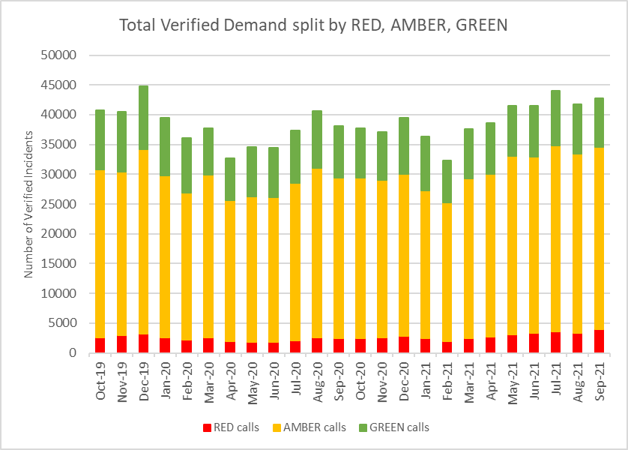

- The number of Response hours produced: whilst varying month on month, on average WAST has produced 113,222 unit hours per month over the two years to Sep-21. Over the same period, a further 1,844 hours would have been needed to be produced each month to reach the 95% unit hours production (UHP) (the benchmark) across all ambulance resource types. In Sep-21 the Trust produced 102,647 hours, falling below the average. As the EMS Demand & Capacity Programme takes effect EASC should expect to see the 95% UHP benchmark consistently achieved and an uplift in hours produced; however, it is difficult to evaluate the impact of the additional investment during a pandemic period with high abstractions and a recent focus on protecting conveying resource over RRVs. The support of the military will recommence in Oct-21

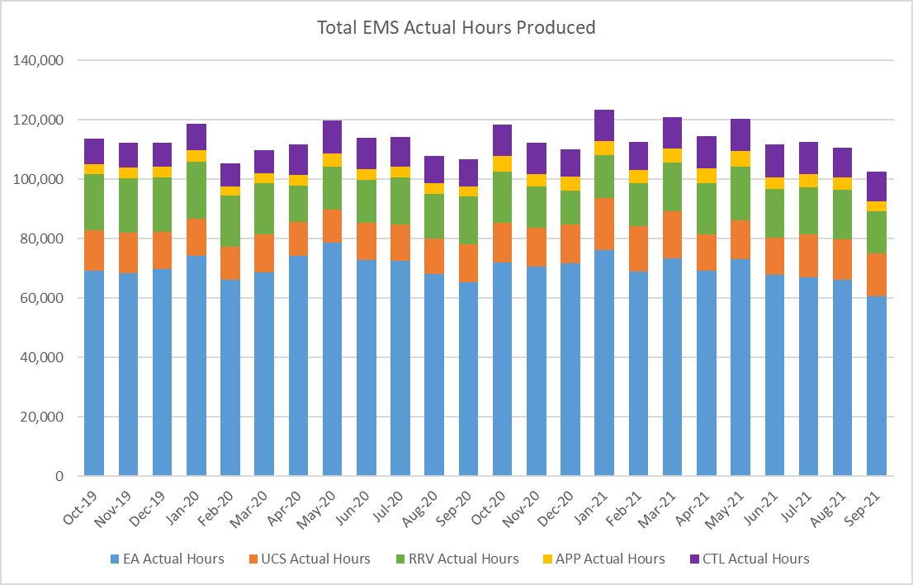

- Roster abstractions, in particular, sickness absence: Operations Response sickness absence rate in Sep-21 was 13.17%. There is significant variation within this overall percentage with CTM and SB being above 17%. The biggest cause of sickness is anxiety/stress/depression/other psychiatric illnesses, accounting for 28%, followed by musculoskeletal problems, accounting for 16%. WAST is concerned about the burnout and mental fatigue in its workforce, which is a particular concern as the unscheduled care system moves towards winter. WAST has extensive and comparatively good arrangements for managing absence and well-being including access to psychological support and a long CoVID-19 programme. Whilst WAST seeks support a further analysis is required into why the absence rates are so much higher in some health board areas. For Sep-21 total abstractions off Response rosters were 45.5% (benchmark 30%). Prior to CoVID-19 WAST was achieving a downward trajectory and a rate of c.32.5%.

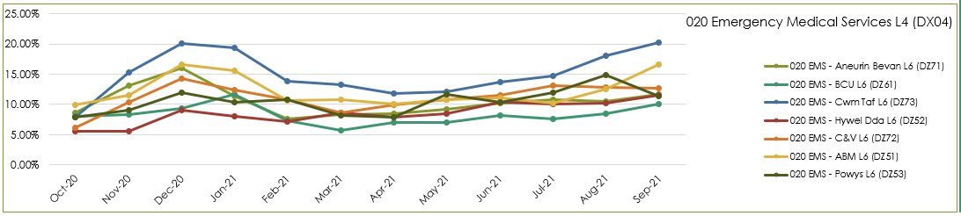

- The number of hours lost each month due to hospital handover delays. See paragraphs 2.14 above.

- Multiple variables: in dialogue with the CASC WAST has identified up to 23 “suspected” variables that impact on performance, with four: demand, utilisation, handover and time as scene considered key. This analysis has led to the innovative development of a pilot measure of ambulance unit hours utilisation (UHU), which the CASC has started to share more widely with stakeholders in Sep-21.

- Post production lost hours (PPLHs): 16,747 hours were lost post production in Sep-21. PPLHs include a range of reasons e.g. vehicle defect, trauma stand down, police interview, return to base meal breaks etc. The EMS Demand & Capacity Review identified that WAST benchmarked comparatively well on PPLHs with the exception of return to base meal breaks, which the Review identified accounted for 72% of PPLHs. WAST re-started (08 Sep-21) negotiations with TU partners on a collaborative solution; this is expected to take 3 – 4 months. If this proves unsuccessful further consideration will need to be given as to next steps, as it is acknowledged that this is an area where improvement is required. WAST has also modelled a short term approach for improving PPLHs, which it intends to pilot Q3.

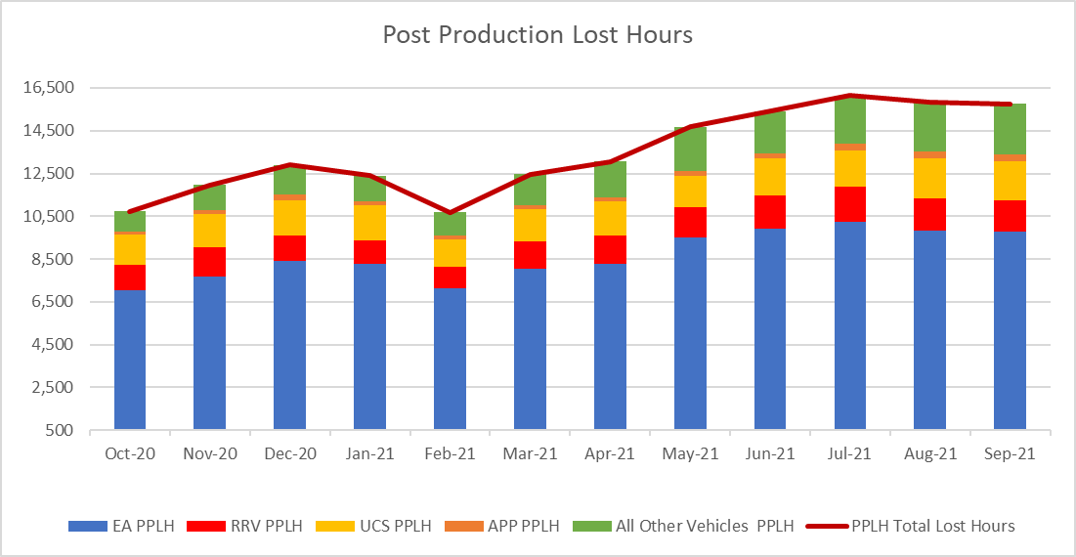

2.30 WAST is also engaged in a number of programmes across the unscheduled care system which are designed to shift demand left including: The core 111 service was launched in BCUHB on the 22 Jun-21. The roll out of the core 111 service in C&VUHB has been prioritised and currently planned to be implemented in Dec-21. 111 First HDUHB (Step 1) is planned to be launched in Q3 (date to be agreed following MOU approval). WAST has received support from EASC to expand the Clinical Support Desk (CSD) including mental health. These increases will support hear & treat, but also patient safety netting and other related activities. The CASC has requested an evaluation of the impact of these additional CSD FTEs. Their recruitment is on-target. The CSD and NHSDW (Hear & Treat) achieved a combined rate of 9.4% in Sep-21. The EMS Demand & Capacity Review identified a benchmark of 10.2% (modelled to be achieved by Dec-21).
2.31 ​If mitigating actions agreed / funded are not sufficient to manage patient demand WAST (which currently they are not) WAST will enact its Clinical Safety Plan (CSP) previously known as the Demand Management Plan (DMP). The CSP aligns with the Association of Ambulance Chief Executives (AACE) approved UK Clinical Safety Plan Framework requiring members to realign their existing plans to provide national consistency in the definition and reporting levels.

EASC is asked to NOTE that: WAST continues not to achieve the Red 8 minute 65% target; that is likely to continue into the winter period; that there are a range of factors coalescing to affect Red (and Amber) performance – very high demand, high abstractions and high system pressure (all linked to CoVID-19); the CASC is engaging with stakeholders on the use of a unit utilisation measure to improve ambulance performance; WAST is re-engaging with trade union partners on negotiations to introduce new working practices that reduce PPLHs; WAST is further expanding CSD capacity to shift demand left; and that the CSP provides the backstop for managing patient demand should agreed actions/funding prove insufficient which they are not at this time.

NEPTS

2.32 The NEPTS ambulance quality indicators have now resumed reporting. Key points about NEPTS are as follows:-
- CoVID-19 saw a significant drop-in patient transport activity at the start of the pandemic. Levels have begun to increase, and are at or in excess of pre-pandemic levels for all journey types apart from outpatient journeys; however, the overall level of activity has still not recovered to pre-CoVID-19 levels due to the reduction in outpatient activity;

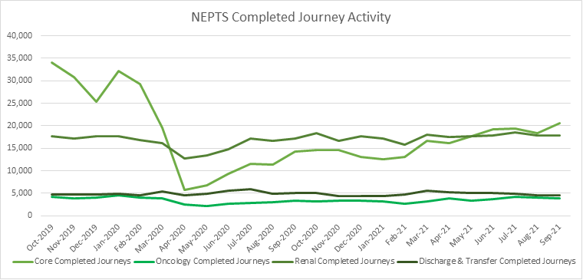

- CoVID-19 abstractions and social distancing has been challenging, but NEPTS has seen a continued improvement in key areas of service delivery particularly discharge and transfer journeys;
- Enhanced services performance has improved with some tailing off in recent months;
- Social distancing means that the number of patients than can be transported per journey has reduced, which has a significant impact on NEPTS capacity;
- In the first wave there was a significant reduction in outpatient transport activity, which meant that the impact of CoVID-19 on NEPTS capacity could be offset by the reduced demand; however, core demand is now on a clear upward trend;
- NEPTS capacity is also adversely affected by other CoVID-19 factors: journeys taking longer due to PPE, staff sickness and need to provide alternative duties to high-risk staff, staff training and testing, infection prevention and control arrangements and so on; and
- NEPTS continues to liaise closely with the commissioning process and the final transfer of works (CTMUHB) has recently been completed.

2.33 67% of core journeys arrived within 30 minutes (+/-) of their appointment time in Sep-21; 80% of enhanced renal journeys arrived within 30 minutes prior to their appointment time; and 50% of enhanced oncology journeys arrived within 30 minutes prior to their appointment time. Oncology has been identified as an area of focus from the NEPTS Demand & Capacity Review and will require changes in the way WAST works with the voluntary and community sector (VCS) to improve performance.

2.34 Whilst there is a Welsh Government ambition to see outreach appointments reduce by 50% “in time” (Health & Social Care in Wales – CoVID-19: Looking Forward), the short term scenario is that WAST emerge out of the pandemic response in 2021/22 and the health system is “re-set” EASC may see pent up demand for NEPTS as the system is switched back on and tries to catch up on certain services. This is a significant risk to the system as social distancing/PPE has reduced Ambulance Care capacity. WAST modelled this scenario and has reported the results and impacts to the CASC. WAST has subsequently received investment to boost NEPTS capacity, in particular, the recruitment of drivers and procurement of external providers. The procurement and recruitment are on target and expected to go live on the 01 Nov-21 and 08 Nov-21 respectively.

2.35 Finally, the NEPTS Demand & Capacity Review is complete and WAST has now established an Ambulance Care Transformation Programme Board, which includes recommendations from the Review and other key transformation work. Both health boards and the NCCU are represented on the board. Potentially, the programme is a significant body of work including pan-Wales roster reviews (ambulance transport and NET call centre), options for improving oncology performance times, testing approaches for efficiency improvements linked to outpatient outbound ready times, CAD updated/replacement and so on. There are options for efficiencies, investment and links to fleet planning and estate planning, all of which require detailed discussion with the CASC and his team as part of the 22/23 commissioning process and programme initiation.

EASC is asked to NOTE that: Ambulance Care capacity is being boosted through investment to mitigate the risk of reduced capacity caused by CoVID-19 and to aid system flow as the system moves into the winter period; the last transfer of works has been completed; performance has been maintained, but with oncology being an on-going area of concern; the Ambulance Care Transformation Programme has been established; and that detailed discussions will be required between the CASC and WAST in Nov-21 on the efficiency, investments and benefits from this emerging programme, linked to the 22/23 commissioning intention process.

Commissioning, Planning and Service Change

Forecasting & Modelling: Strategic Demand & Capacity Reviews

2.36 The EMS Operational Transformation Programme (arising from the EMS Demand & Capacity Review) is WAST’s main strategic response to patient safety and experience concerns for the EMS five step ambulance care pathway. In addition to the EMS Demand and Capacity Review recommendations three other IMTP actions - CHARUs, Rural Model Pilot (in Powys) and Leading Service Change Together (modernisation of working practices) have been brought under the umbrella of the programme.

2.37 EASC had delegated oversight of the delivery of the programme to EASC Management Group. The Group received the most recent programme highlight report on 21 Oct-21. WAST is making good progress on the recruitment and training aspect of this programme. The original 20-22 recruitment and training target i.e. closing the relief gap, was 1,690 FTEs. This target has been amended up in 21/22, to reflect the EASC supported decision to boost Clinical Support Desk (CSD) capacity (including Mental Health Professionals) and to boost the 999 Clinical Contract Centre (CCC) call handling capacity (32.25 FTE call takers), giving a revised target of 1,773 FTEs. WAST is on-target to deliver the increases in the CSD, CCC and the relief gap, with the backfill (ACA2s) for the Paramedics into CSD being completed in Q1 2022/23.

2.38 Other key aspects of the programme include re-rostering RRVs/EAs and UCAs pan-Wales and reducing post production lost hours (PPLHs). The rostering project has been paused to consider further modelling information linked to changing demand and lost hours in the system and feedback from stakeholders, but is expected to restart in Jan-22. WAST has developed and modelled an approach for reducing PPLHs which it expects to pilot shortly. WAST is also in facilitated co-productive engagement with TU partners on modernising working practices (linked to PPLH), the outcomes from which should be factored into the 2022 IMTP.

2.39 In Aug-21 the CASC agreed to re-open the EMS Demand & Capacity Review to look at the period 2022-25. Initial modelling on the CHARU concept has been completed with further modelling currently being undertaken on shift left options (hear & treat, see & treat) and EAs. WAST anticipates providing the CASC and his team with a worked up proposal linked to this modelling in Dec-21.

Commissioning Intentions

2.40 The 21 Oct-21 EASC Management Group received a joint report from the NCCU on 2022/23 commissioning intentions.

2.41 WAST is broadly supportive of the EMS commissioning intentions, recognises that further detailed discussions are required for EMS commissioning intention 2 (CI2-A1), which was closing the relief gap, but now needs to consider what the intention is beyond the gap closing (linked to 2.39 above). The intentions also reflect the “innovative” ambulance utilisation metric WAST has developed, with the focus in 22/23 being on how this metric can be used by the NCCU, health boards and WAST to optimise utilisation and improve patient performance and patient safety. Equally, WAST is broadly supportive of the NEPTS intentions and is anticipating more detailed conversations with the CASC and his team during Nov-21 around the options for efficiencies, investment an time frames particularly linked to demand & capacity modelling.

Integrated Medium Term Plan (IMTP)

2.42 The IMTP is delivered through a portfolio of transformation programmes supported by enabling programmes, projects and workstreams, which align to both WAST strategic ambitions and commissioning intentions. Given the current pressure across the system, a prioritisation exercise has been undertaken by all of the transformation programmes and enabling workstreams with some work paused on those IMTP deliverables that are less likely to impact in the short term on current operational pressures i.e. those largely contained within the PIP or work that has externally set or contractual deadlines. Some of the paused deliverables may need to be factored into next year's IMTP delivery cycle; however, strong progress has been made in the first half of the year and WAST would highlight the following progress:

2.43 EMS Operational Transformation Programme

- As above WAST expects to exceed the original 2022-24 recruitment target for this programme and the EMS Demand & Capacity Review has been reopened to look at patient safety beyond 2021/22.

  - Ambulance Care

- Again, as above the final transfer of works has been completed and the Ambulance Care Transformation Programme established, with the programme largely being at the initiation stage currently.

2.45 Strategic ambition programmes:

- The transformation programmes for EMS and Ambulance Care are supported by two further core service transformation programmes: Gateway to Care focusing on 111 and the implementation of the CCC Clinical Review; and Clinical Transformation with a focus on the clinical transformation required to shift left in the five step model. The enabling programmes and workstreams are focusing on our people, estates, fleet and digital enhancements required to support IMTP delivery and commissioning intentions as well as the strong partnerships required to support system wide improvement across Wales.

- In line with the Health & Social Care Minister’s expectations for the 111 service the C&V service is planned to be launched before Christmas 2021. Roll out 111 First HDdaUHB Step 1 is nearly complete and will conclude in Oct-21.

- CCC Clinical Review continues to make good progress. Funding for system elements of the ECNS has been approved by EASC and the project is on track although lead time for SQL servers required is a risk to timeline of the project. PTaS is an enabler for a number of policy goals within the Urgent and Emergency Care and has received ministerial interest. Good progress is being made with all the health boards and a meeting for further engagement is being organized in Nov 21. CSD Roster Review is on track.

- WAST’s Clinical Strategy has been reviewed considering lessons learnt from CoVID-19 and remains fit for purpose. COPD Alternative pathway now been implemented in ABUHB and CTMUHB and engagement continues to review data. National Non-Injury Falls Pathway refreshed Paramedic Field guide approved by CC2HG based on information sent from Health Boards. Digital Solution to be rolled out in line with ePCR rollout (Phase 2 end Nov-21).

- Other enabling programmes continue to make good progress supporting staff and delivery of IMTP. Estate SOP continues to support the different short term contingency plans and long term strategic ambitions. Delivery of the vehicle replacement scheme as per the approved business justification case is in progress. The Trust has approved its first Environmental Strategy. This Strategy highlights the ongoing work, future requirements, plus a commitment to retaining the ISO14001 accreditation. Purchase of 15 PHEV RRVs has been accelerated this year and ordered E.V plug in ULEV RRVs for delivery in March 2022. The next focus is on EV infrastructure.

- WAST is supporting the review of national, regional and local escalation arrangements through Urgent and Emergency Care Delivery Group workstream led by NCCU. BCUHB and Grange identified as pilot sites for ED Site Specific Escalation Actions, continuing the work of EDQDF programme USC dashboard being updated to be able to reflect ED Escalation Level, ED Staffing Level, ED Risk Level and associated Mitigating Actions aligned to levels of escalation. Escalation actions being made available to ODU in order to support delivery of the actions locally. Power BI dashboard now available across all HB areas and being used to inform management of escalation and risk across the system. A series of ODU virtual roadshows being scheduled for the Autumn to continue to raise awareness of purpose, scope of ODU as WAST transition to a 24/7 service. NEPTS dashboard being developed and will focus on the areas where ODU can support putting capacity back into the system with a particular focus on discharge and transfer and job cycle efficiencies.

2.46 Value Based Healthcare

- WAST has been fully engaged with NCCU in development of Commissioning for Value and internally will align the development of its own value based approach to demonstrate value for investment, whilst widening the remit to include quality improvement, staff and patient outcomes and experience and sustainability as measures of value. This is a difficult area for an unscheduled care service, but WAST will work closely with NCCU and draw on good practice seen across Wales. Whilst the approach has been agreed, this work may need to pause as part of the measures taking place to address performance and safety directly, but WAST recognises the importance of understanding the value delivered through service developments and will continue to work with NCCU on this.

Health Board Changes

2.47 The evaluation of the Grange University Hospital inter-site transfer service provides valuable learning both for the service itself and the wider work to develop an all wales Transfer and Discharge model. It also provides valuable learning as Hywel Dda further develops the Programme Business Case around its Transforming Clinical Services strategy.

2.48 WAST is fully engaged with Hywel Dda on this stage of its strategy and as a key stakeholder we are supporting the development of the Programme Business Case and a key member of its transport sub-group. WAST have provided high level travel time analysis to inform the long list site selection process that is currently underway. WAST is also engaged with Cardiff and Vale in the continuing development of its clinical strategy.

2.49 WAST is linked into the Major Trauma Network evaluation of year 1 of the ODN, and had intended to undertake a focused evaluation of its elements of the business case before the end of Q2; however, resource has been identified to start this in Q3. There remains some difficulty with linked data being able to provide a full picture of the business case model in operation. There has been some concern from the network about the impact of system delays in turn delaying secondary trauma transfers into UHW. Key to the plan for improvement would be reduction in handover delays, but WAST is continuing to deliver training to staff and further developing processes to improve identification of major trauma for primary conveyance into UHW to reduce the need for secondary transfers.

2.50 WAST continues to support Regional developments including vascular centralisation in South Wales, Thrombectomy commissioning (North and South), as well as an emerging case to develop Thrombectomy in Cardiff, and working with Powys THB to understand the future clinical model and commissioning arrangements linked to the Stroke reconfiguration plans across Hereford & Worcester. We are working with Health Boards and the CASC team to develop these services and will seek to join up the model and methodology to inform the commissioning intention to develop an All Wales Transfer and Discharge model and commissioning framework.

2.51 WAST has reviewed HB annual/recovery plans submitted to Welsh Government in March and June 2021. There is limited detail on the impact of plans for WAST and therefore WAST will continue to engage through local operational teams and through the all Wales Directors and Assistant Directors of Planning networks to seek further detail as it affects EMS and NEPTS service delivery.

2.52 WAST continues to support the work for Thoracic Surgery Centre in Swansea Bay and awaiting further confirmation of the next steps from the health board dependent on WG approval of SOC to proceed to next stage. Concerns regarding a potential increase in NEPTS activity have been raised and NEPTS thoracic activity will reviewed across UHW Ward C5 Cardio Thoracic and Morriston Cyril Evans Ward.

2.53 WAST’s Integrated Strategic Planning Group has been re-established and will have oversight of HB operational and strategic service changes to comprehend and coordinate implications on WAST and for WAST to support these plans. A summary of the strategic Health Board service change initiatives that WAST is engaged with can be seen in the following map:

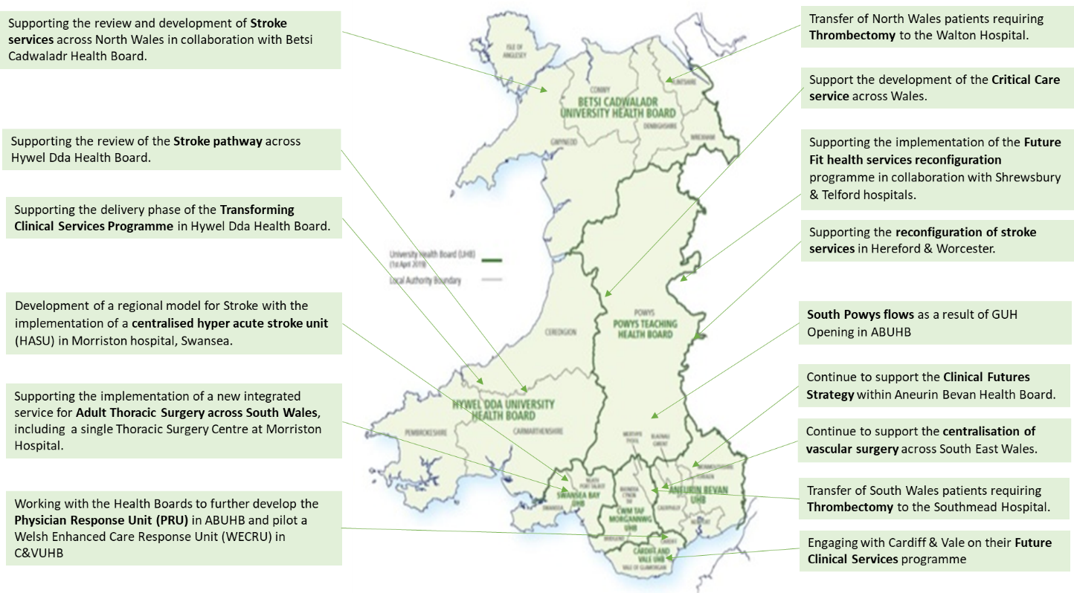

EASC is asked to note that: WAST is expecting to exceed the original recruitment and training target for EMS; WAST is making good progress on its 21/22 commissioning intentions; the re-rostering project has been paused, but is expected to re-start in Jan-22; negotiations with TU partners on modernising working practices are expected to conclude in Dec-21; the EMS Demand & Capacity Review has been re-opened to look beyond the closure of the relief gap i.e. 2022-25; detailed discussions are anticipated in Nov-21 and Dec-21 on the 2022/23 commissioning intentions linked to the IMTP process; and WAST continues to make good progress on a range of transformation programmes and actions designed to improve patient safety for EMS and Ambulance Care and support the wider health care system, despite continued pressure requiring some IMTP actions to be paused.

Conclusions and Forward Look

2.54 Current performance levels and patient safety are very challenging. The tactical forecasting and modelling undertaken by WAST indicates the situation will get more severe as WAST moves into the most difficult winter period (15 Nov-21 to 15 Jan-22).

2.55 WAST is focused at an organisational level on this challenge and is being supported through the commissioning process. WAST is at maximum escalation (and expects to remain so for the foreseeable future), is pro-actively managing patient demand (and safety) through enacting its Clinical Safety Plan (demand management arrangements) and shift left actions, has stood back up its Pandemic Plan structures, is boosting capacity through a range of investments, is boosting capacity through the support of key partners (military and Fire & Rescue Services) and boosting capacity through the delivery of efficiencies. All of this work is brought together into WAST’s PIP, which is formally reported on every two weeks to the CEO with the CASC reporting to the Minister each month.

2.56 Whilst WAST must have a focus on immediate operational pressures and its tactical response (Oct-21 to Mar-22), it is also critical that WAST continues look further ahead. Q3 will see a focus on working with the CASC and his team on the detail underpinning the 2022/23 commissioning intentions, the 2022-25 IMTP and supporting analysis, in particular, demand & capacity modelling

- KEY RISKS/MATTERS FOR ESCALATION TO THE COMMITTEE

Members of the EAS Committee are asked to note that:

3.1 CoVID-19 and the impact of CoVID-19 is having a severe impact on WAST, in particular, very high EMS demand, high roster abstractions, high handover lost hours and social distancing on NEPTS transport;
3.2 WAST is at maximum escalation and expects to remain so for the foreseeable future and has stood up its’ Pandemic Plan structures again;
3.3 Quality, safety and patient experience monitoring arrangements have continued (and been enhanced) through the pandemic. WAST remains very concerned at the patient safety risks associated with response times that are too long;
3.4 There were 586 12 hour and over patient waits in Sep-21 (the third highest recorded), 48 patient safety incidents were referred to health boards under the Appendix B arrangements) over the last three months and 17 WAST SAIs were reported to Welsh Government;
3.5 The Red 8 minute 65% target has been missed for the last 14 months, with significant health board variation (almost 65% of Red incidents were responded to in 9 minutes);
3.6 WAST reviews missed Reds as a matter of routine and is monitoring performance very closely;
3.7 WAST remains concerned at the number of hours lost outside EDs, with 14,402 hours lost in Sep-21;
3.8 WAST continues to seek to efficiencies, in particular, the pan-Wales EMS Response roster review (temporarily paused) and modernising working practices (negotiations re-started with TU partners in Sep-21), in particular, PPLHs return to base meal breaks;
3.9 There is a continued focus on strengthening WAST’s health & safety arrangements;
3.10 Clinical indicator performance improved in Q2;
3.11 The ePCR programme is in delivery phase with initial go live in Nov-21;
3.12 NEPTS has received £2.5m investment to boost capacity to support system flow;
3.13 An Ambulance Care Transformation Programme Board has been established to take forward the findings of the NEPTS strategic Demand & Capacity Review and wider NEPTS and transfer and discharge projects;
3.14 WAST is making good progress on its IMTP ambitions (including the EASC 21/22 commissioning intentions), but the impact of winter is a concern;
3.15 The outcome of the Grange University Hospital inter-site transfer service review offers valuable learning for both ABUHB and WAST and other health boards; and
3.16 WAST continues to engage with health boards on a range of service re-configurations that affect ambulance provision.

- IMPACT ASSESSMENT

Quality/Safety/Patient Experience implications | Yes (Please see detail below)
Quality/Safety/Patient Experience implications | Identified within the report
Related Health and Care standard(s) | Timely Care
Related Health and Care standard(s) | And all health and care standards
Equality impact assessment completed | Not required
Legal implications / impact | There are no specific legal implications related to the activity outlined in this report.
Legal implications / impact | Included within the body of the report
Resource (Capital/Revenue £/Workforce) implications /  Impact | Yes (Include further detail below)
 | Included within the body of the report
Link to Main Strategic Objective | The Committee’s overarching role is to ensure its Commissioning Strategy for Emergency Ambulance Services utilising the five step patient pathway outlined within the National Collaborative Commissioning Quality and Delivery Agreement and the related outcomes for each care standard aligned with the Institute of Healthcare Improvement's (IHI) ‘Quadruple Aim’ are being progressed.  This report focuses on all the above objectives, but specifically on providing strong governance and assurance and safe and effective patient care
Link to Main WBFG Act Objective | Service delivery will be innovative, reflect the principles of prudent health care and promote better value for users

- RECOMMENDATION

5.1 The EASC Committee is asked to:
- DISCUSS and NOTE the WAST provider report.

