AGENDA ITEM
2.5

EMERGENCY AMBULANCE SERVICES COMMITTEE (EASC)

welsh ambulance services nhs trust (WAST)
provider update

Date of meeting | 08 November 2022

FOI Status | Open/Public

If closed please indicate reason | Choose an item.

Prepared by | Rachel Marsh, Executive Director of Strategy, Planning and Performance (WAST)
Presented by | Jason Killens, Chief Executive WAST
Approving Executive Sponsor | Chief Executive

Report purpose | FOR DISCUSSION / REVIEW

Engagement (internal/external) undertaken to date (including receipt/consideration at Committee/group)
Committee/Group/Individuals | Date | Outcome
- | - | Choose an item.

ACRONYMS
ABUHB  CTMUHB  D&C  EMS  NCCU  NEPTS  NRI  WAST | Aneurin Bevan University Health Board  Cwm Taf Morgannwg University Health Board  Demand and Capacity  Emergency medical services  National Collaborative Commissioning Unit  Non-emergency patient transport services  National Reportable Incident  Welsh Ambulance Services NHS Trust
- SITUATION/BACKGROUND

  - The purpose of this report is to provide EASC with an update on key issues affecting quality and performance for EMS and Ambulance Care (including NEPTS) and to provide an update on commissioning and planning for EMS and Ambulance Care (including NEPTS).

- SPECIFIC MATTERS FOR CONSIDERATION BY THIS MEETING (ASSESSMENT)

CoVID-19 and Current Operational Pressures

  - The Welsh Ambulance Services NHS Trust (WAST) continues to track CoVID-19 and related metrics through its weekly Forecasting & Modelling Intelligence Pack. Wales is currently experiencing positive tests equating to 4% of the population.

  - WAST is currently (31 Oct-22) at escalation level 3. In addition, WAST continues to have to move to higher levels of its Clinical Safety Plan (CSP). For the 30 days to 30 September-22 WAST spent five days at CSP level 4a, resulting in clinical screening of Amber 1 calls and WAST being unable to respond to calls in the Amber 2 and Green categories. 14 days were spent at CSP level 3b, with Amber 2 calls being clinically screened and WAST being unable to respond to Green and health care professional (HCP) calls. WAST is also in the process of revising its CSP, with the changes going live during Nov-22. Key changes include: an ability to undertake remote clinical screening, estimated time of arrivals (ETA) for health care professionals and revised triggers and approval for escalation.

  - WAST has stood down its pandemic structures (Pandemic Plan), but continues to operate a Trust wide rolling tactical seasonal Performance Improvement Plan, which sets out any tactical actions being taken to mitigate the patient safety risks highlighted in its tactical seasonal forecasting and modelling. WAST is currently considering putting in places specific tactical structures for winter.

EASC is asked to NOTE that: WAST is currently at escalation level 3 (maximum 4) and continues to have to regularly operate its Clinical Safety Plan up to level 4a (second highest level).

Quality, Safety & Patient Experience

Patient Response Times in the Community

2.4 One of the key indicators which measures the quality of the service provided is the timeliness of the response by WAST to patients waiting in the community. The graphs below show the current response time performance for Red calls and for Amber One calls. Both graphs show that response times remain significantly off target or off benchmark. Inevitably these times have had an impact on patient safety.

2.5 The Red 8-minute target was not achieved in Sep-22. The percentage of emergency responses to Red incidents within 8 minutes was 50.0% (target 65%) with 95% of Red calls receiving a response within 24 minutes. Red 9-minute performance was 56.0% and Red 10 minute performance 61.6%.

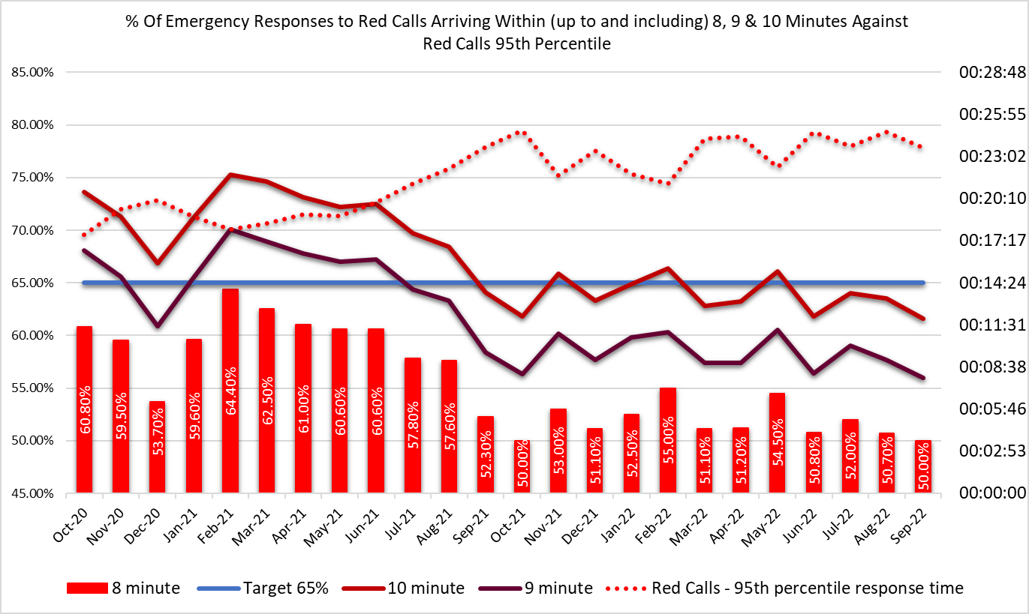

2.6 The Amber 1 median in Sep-22 was one hour and 30 minutes and the Amber One 95th percentile was six hours 16 minutes. Amber 1 incidents include chest pains, strokes, unconscious patients etc.

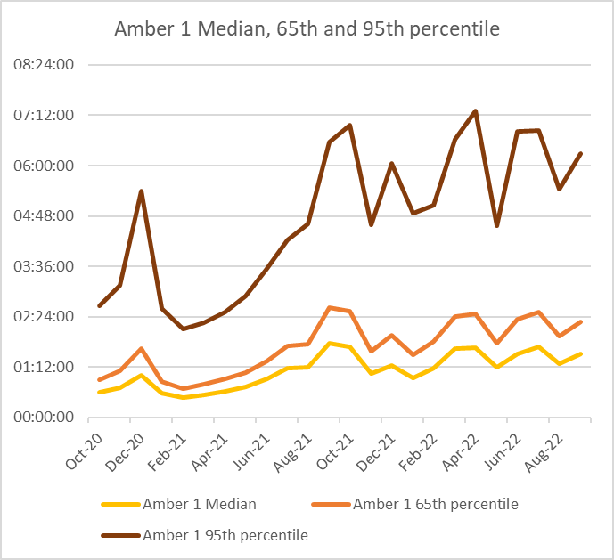

2.7 These very long response times in the “Amber tail” are a particular concern from a patient safety perspective; it is where the bulk of National Reportable Incidents (NRIs) occur.

2.8 As part of its quality, safety and patient experience arrangements, WAST continues to monitor the longest patient responses. The table below shows the number of patients who had to wait 12 hours or over. There were 890 long waits in Sep-22.
2.9 As well as looking at the data on response times, care is taken in internal and external fora to listen to how this impacts on patients through patient stories and feedback from surveys.

  - In the last 3 months, 51 patient safety incidents have been passed to health boards as part of the joint investigation framework (Appendix B). There are ongoing discussions being taken forward on how this framework needs to be updated, in particular, joint investigations, but in the meantime, it is important that each of these incidents is fully investigated and reported if required. 19 NRIs were reported directly by WAST to the Delivery Unit in the period Jul-Sep-22.
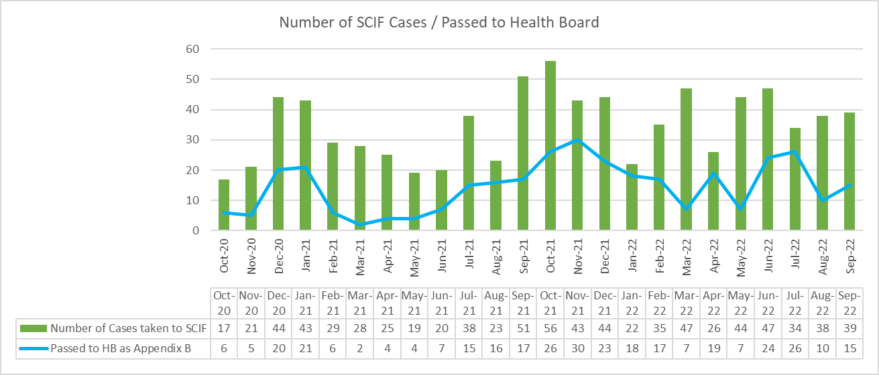

  - WAST has escalated and continues to articulate its concerns about patient outcomes and experience to commissioners and to Welsh Government, with a full paper presented to its Board meeting in September 2022. The focus on improvement through the EASC action plan is very much welcomed.

Health & Safety.

  - The continued delivery of Working Safely Programme outputs has positively impacted on the Trust’s Corporate Health and Safety risk (199 - Failure to embed a culture of Interdependency impacting on breach of legislation and or harm) by allowing for a reduction of the risk from 20 to 15.

  - The implementation of the revised workforce model (commenced on 03 Oct-22) will provide capacity to support WAST in an enhanced way. Two new roles have been introduced into the function to focus on manual handling and violence and aggression.

  - For increased rates of incidents and concerns reported in relation to excessive diesel fumes outside A&E departments, atmospheric monitoring was previously undertaken during Q3-Q4 2021/22 and found to be within Workplace Exposure Limits. Discussions are being held with some Health Boards in relation to fitting additional shorelines to reduce the amount of fume exposure. Additionally, further work is ongoing to give consideration for the requirement for further atmospheric surveys to be undertaken at areas reporting the highest level of incidents and concerns.

  - Missed meal breaks and shift over runs continue to be the WASTs highest trending health & safety incidents since May 2022 with 327 meal break reported incidents during the period August and September 2022. The highest area is Betsi Cadwaladr University Health Board (BCUHB). Working Time Regulations 1998 Regulation 12(1) requires “where an adult worker’s daily working time is more than six hours, he is entitled to a rest break”. A new working group has been established in relation to this on-going concern.

Clinical Outcomes

  - The last publication of the full suite of clinical indicators was Jan-22 (Oct-21 and Nov-21 data); there was then an agreed temporary cessation of clinical indicator reporting as WAST transitioned from the Digital Pen to the electronic patient clinical record (ePCR). The transition was completed at the end of Mar-22.

  - New ePCR data is now available for stroke, fractured neck of femur, hypoglycaemia and ST elevation myocardial infarction (STEMI). Deep dive audits have been completed for these clinical indicators and the return of spontaneous circulation (ROSC) (at hospital door) deep dive audit is ongoing with this clinical indicator scheduled to be published over the coming months. Improvement work as a result of the deep dive audits is underway to improve compliance (lower compliance was an identified risk based on experiences of English ambulance trusts who have moved to ePCR systems). Compliance to the published care bundles are as follows:

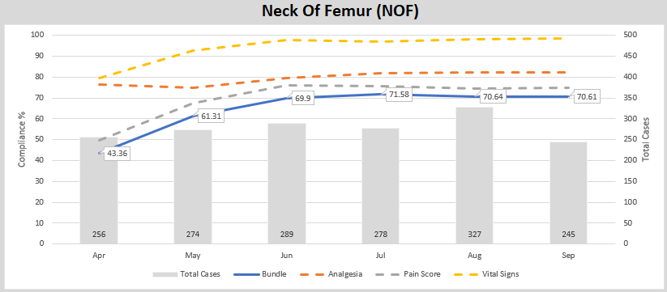
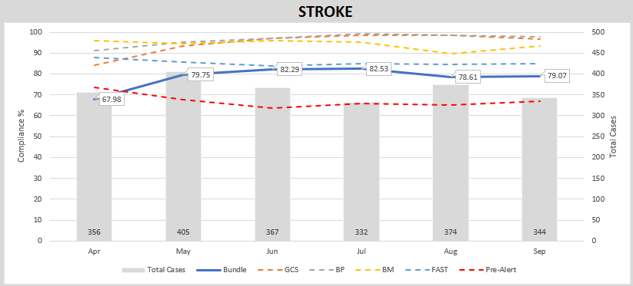
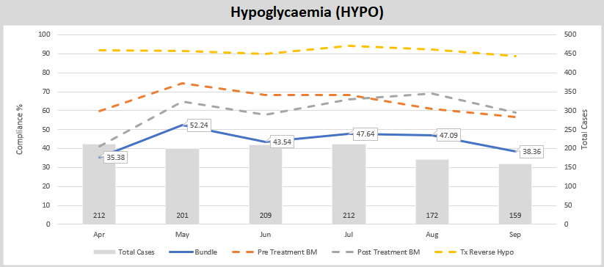
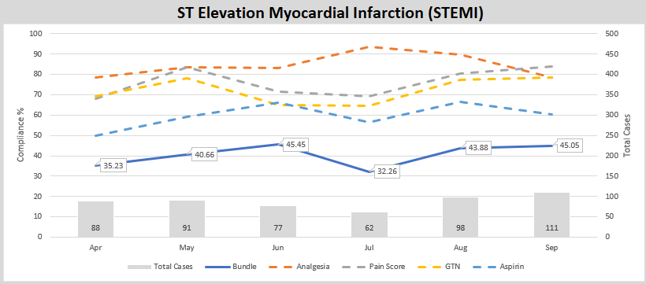
  - As a result of the predicted fall in clinical indicator compliance whilst the new system for creating clinical records becomes embedded, a risk has been raised with an associated action plan internally.

  - The longer-term ambition for WAST is to link its patient and computer aided dispatch (CAD) data with health board patient data so that WAST can report on agreed time-based aspects of clinical indicators and track the eventual patient outcome across their whole pathway. The ePCR project is critical to delivering this ambition.

EASC is asked to NOTE that: Red and Amber response times remain unacceptably long; these delayed responses are impacting on patient safety; in the last three months 51 patient safety incidents were reported to health boards (under the Appendix B arrangements) where the primary cause is considered to be handover lost hours; clinical indicators have started to be published again after the move to the ePCR.

EMS Performance

Response Times

  - As outlined earlier in the report, response times for both Red and Amber incidents remain too long.

  - There are a range of factors that affect response times:

- Demand:
Comparing demand is difficult because of the pandemic, but WAST has previously identified that Red demand has increased significantly over the last few years. In collaboration with the NCCU, WAST reopened the EMS Demand & Capacity Review in 2021 to update the strategic modelling with this change which has led to the agreement of new roster keys including the Cymru High Acuity Response Unit (CHARU) resource (partially funded at this time).

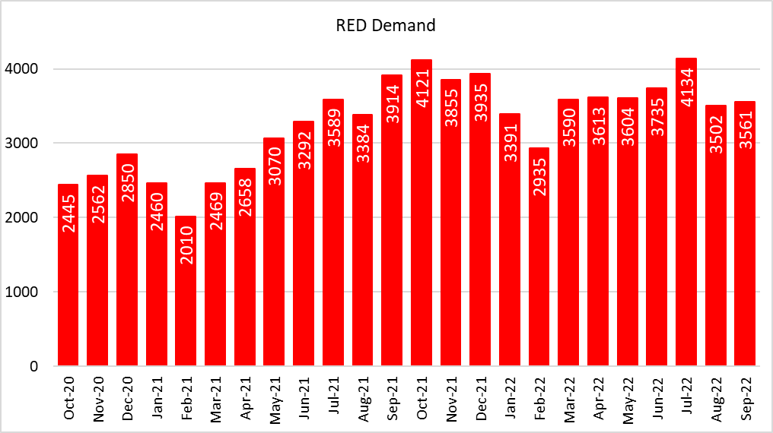

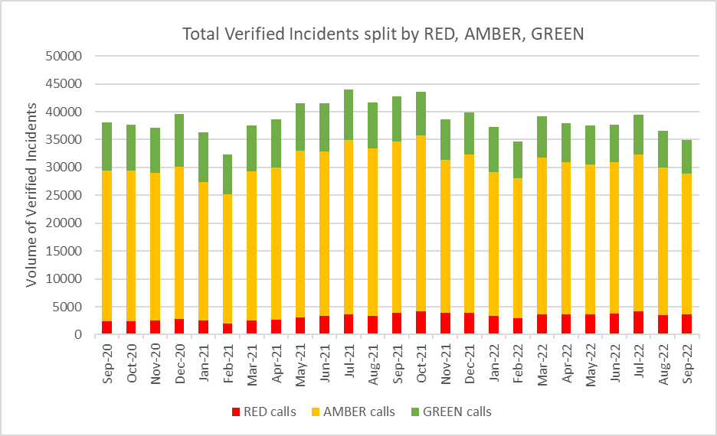

- Capacity produced:
The total actual ambulance hours produced was 114,353 hours in Sep-22 with emergency ambulance (EA) unit hours production at 96% in Sep-22 (benchmark 95%), unscheduled care service (UCS) production at 71% and rapid response vehicles (RRVs) at 76%.

Capacity produced is a product of the number of staff in post less the hours lost through abstractions. An additional £3m has been made available to WAST in 2022/23 to recruit an additional 100 frontline staff. Whilst this is welcome, there will remain a gap of 64 WTE against the number of staff required to fill the WAST’s new Response rosters, including the new CHARU service. WAST has plans in place to deliver on this additional 100 WTE, although there are some risks associated with the Band 3 Ambulance Care Assistants (ACA) recruitment, as most applicants do not currently have the C1 driving license. A scheme is being piloted in which WAST funds this whilst staff are in post; this has mitigated this recruitment barrier.

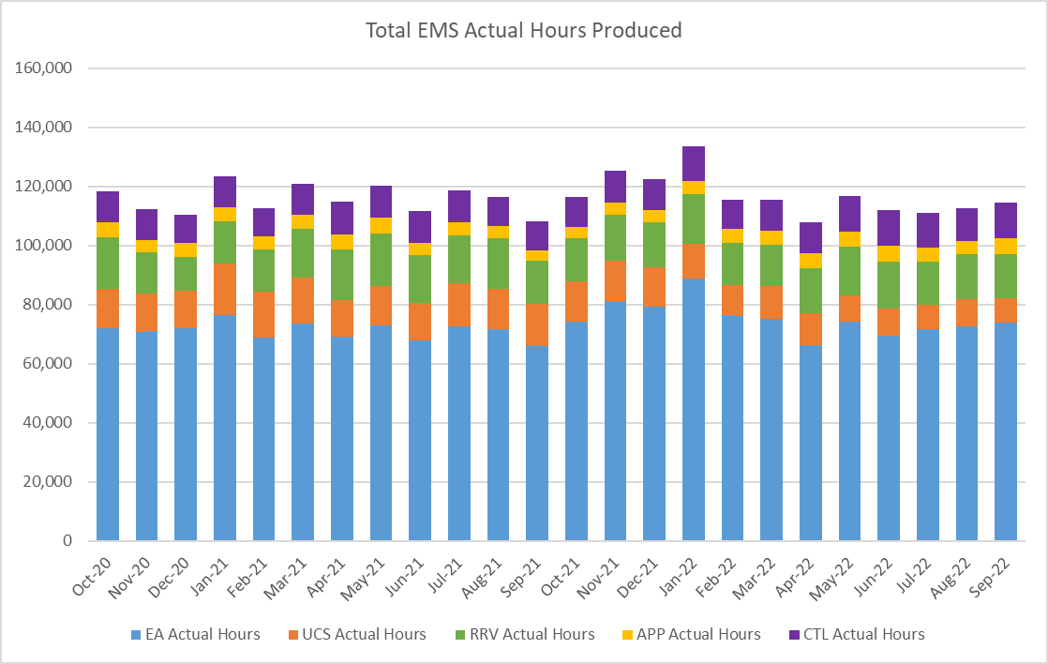
There was a 40.81% abstraction rate in Sep-22. This includes a sickness absence abstraction rate of 9.26%, a decrease compared to Aug-22; and a 6.49% training induction abstraction, which is higher than usual linked to the recruitment of the +100 FTEs. WAST has introduced a Managing Attendance Plan with seven work-streams and improvement trajectories. The Plan is being reported to Executive Management Team every two weeks.
There was initially a clear reduction trend, which reversed in Jun-22 linked to CoVID-19, but has subsequently started reducing again. It remains difficult to manage absence effectively in the light of the remaining CoVID-19 allowances.

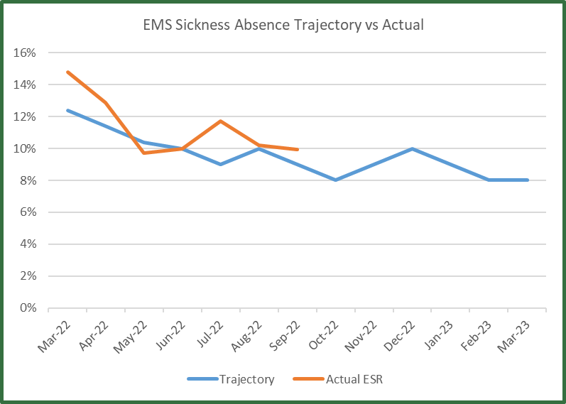

- Capacity Lost
One of the factors affecting response times outside WASTs control is the number of ambulances which wait longer than 15 minutes to transfer patients into secondary care at Emergency Departments (EDs). The graph below shows the number of ambulance hours that are lost outside EDs which, if released earlier, would have reduced patient waits in the community. 25,167 hours were lost to handover in Sep-22, which equates to 30% of WASTs conveying capacity. This increased further to 28,598 in October.
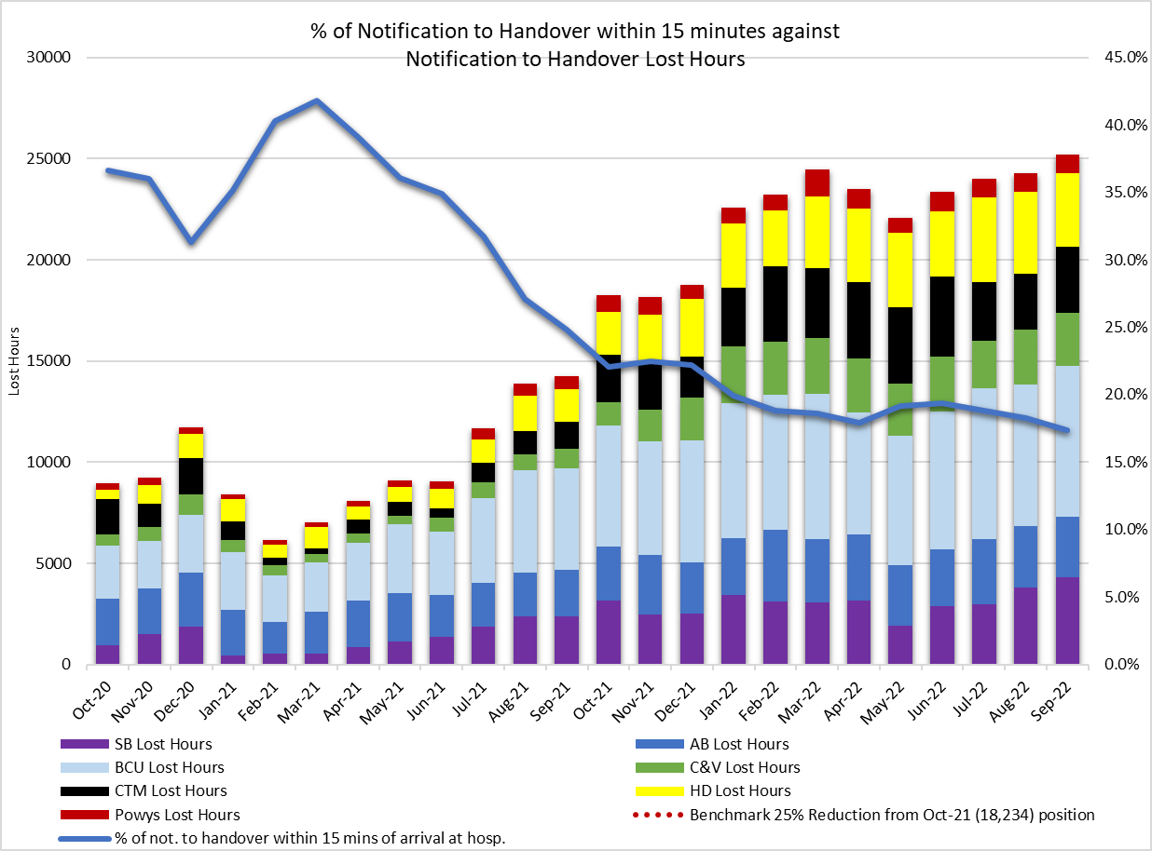
There is now a Ministerial requirement of a 25% reduction in minutes per handover with a four hour back stop, with a related focus on immediate release and handover reduction plans for each ED site. Performance against these targets is monitored by the NCCU and improvement plans are included in the EASC action plan. Whilst the increased focus is welcomed, as the data above shows, the plans are not yet delivering the reductions required.

The impact of handover is clearly demonstrated in the following graph:-

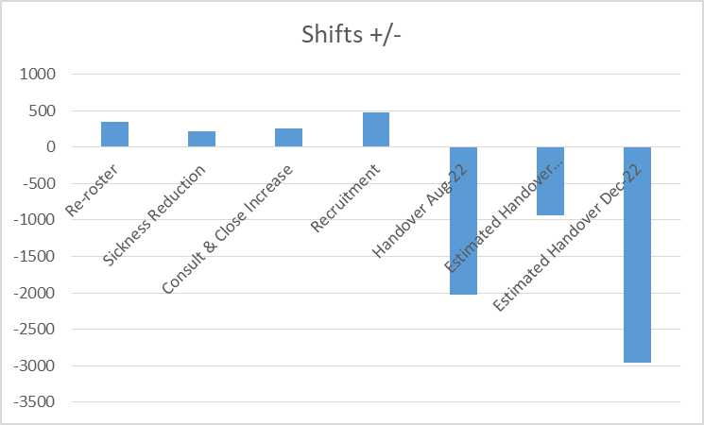
This graph shows the 12 hour EMS ambulance shifts put back into the system by re-rostering, sickness reduction, consult and close increasing from 10% to 15% and increasing the Response workforce by +100 FTEs versus the lost shifts from handover in August 2022 and an estimate for December 2022, if handover increases from summer to winter in the way it has in previous years.

Immediate Release Acceptance

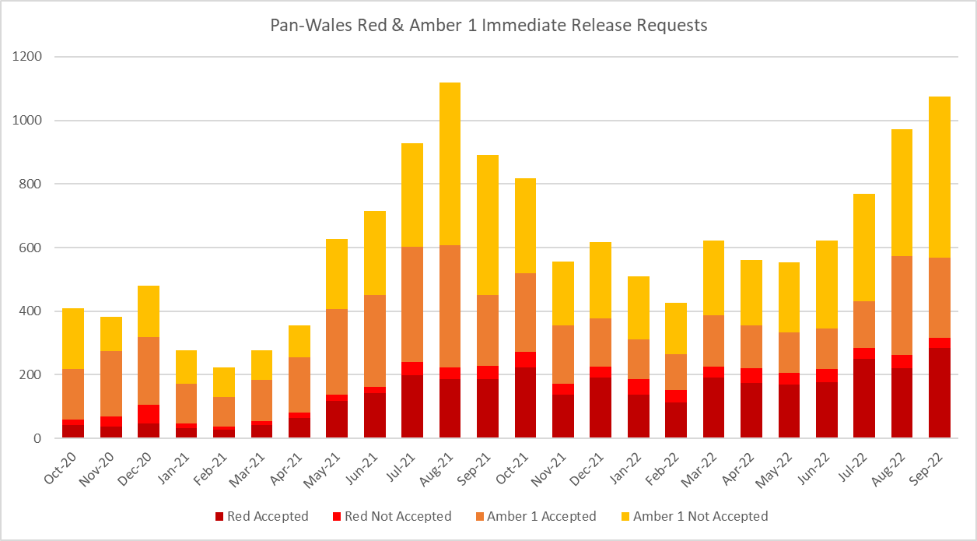

Data on immediate release acceptance/non-acceptance is now being monitored weekly by the Chief Executive of NHS Wales, with improvements being seen in the last couple of weeks. There were 1,075 request made to Health Board EDs for immediate release of Red or Amber 1 calls in September 2022. Of this, 285 were accepted and released in the Red category, 31 were not accepted. In conjunction to this, 251 ambulances were released to respond to Amber 1 calls, but 508 were not.

The loss of hours post-production (PPLH) is also an area of focus. In Sep-22, 8,520 hours were lost post production. PPLHs include a range of reasons e.g. vehicle defect, trauma stand down, police interview, etc. which cannot be viewed as areas for potential efficiencies. WAST continues to be in dialogue with Trade Union partners on modernising working practices, particularly around meal breaks and shift overruns.

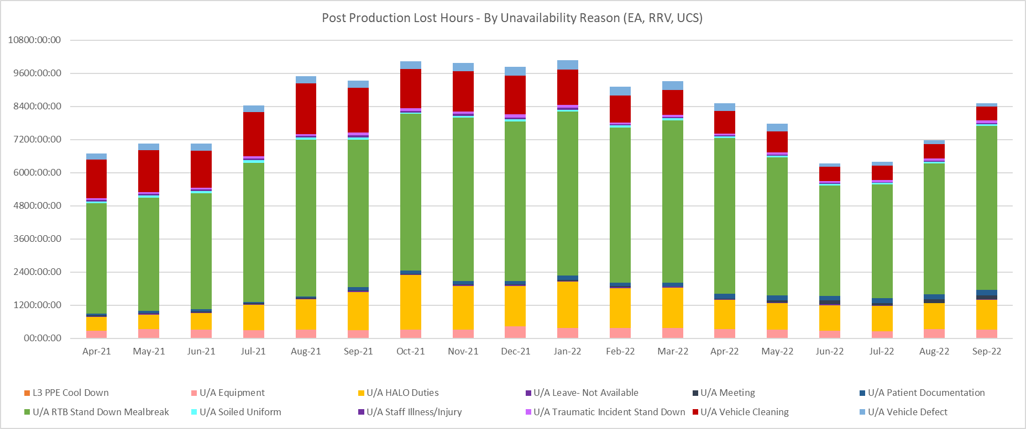

- Efficient and Effective use of resource:
WAST continues with its roster review project which, by more appropriately aligning hours produced with demand patterns, will have a performance improvement effect equivalent to 72 WTE additional staff. The project remains on track with all rosters due to be implemented between September and November 22. There continues to be a significant political interest in this project.
WAST is also engaged in a number of programmes across the unscheduled care system which are designed to shift demand left including:
  - the core 111 service which is now live pan-Wales;
  - WAST has received recurrent funding from EASC to support five mental health professionals into the Clinical Support Desk (CSD), all of whom are now live;
  - WAST also expanded its CSD by 36 FTE Paramedics during 2021/22. These increases will support consult and close rates, but also patient safety netting and other related activities. The Trust achieved a consult and close rate of 12.3% in September-22 and continues to work towards the target it had set itself to achieve 15% in the second half of 2022/23.

  - WAST now undertakes seasonal forecasting and modelling as a matter of routine, using information on demand, capacity and efficiency to forecast performance. The modelled results for winter (March 2023) have been made available to the CASC and his team.
The modelling assumes the impact of the 100 additional staff that will be in post and the 25% reduction in minutes per handover arrival with a four hour back stop. The modelled results predict a level of Red performance of 59% and Amber 1 median of less than 40 minutes only with the application of the CSP at levels 3a and 3b. This would be an improvement to the current position, but still far short of achieving the Red 65% Welsh Government target and the Amber 1 performance parameter of 30 minutes (ideal is 18 minutes). Modelling for December 2022, with handover levels at their current levels, indicates a level of Red performance of less than 50%.

  - In the longer term, WAST is looking to work with health boards to transform its services, in line with the ‘inverting the triangle’ ambition, which will see fewer patients conveyed to an ED and more patients receiving appropriate care closer to their home. The recent bid for additional advanced paramedic practitioners (APPs) was unfortunately unsuccessful, and this will need to return for discussion as part of next year’s IMTP.

  - All these actions are included in the rolling tactical seasonal Performance Improvement Plan (PIP) internally and in the EASC action plan.

EASC is asked to NOTE that: WAST continues not to achieve the Red 8 minute 65% target; there are a range of factors coalescing to affect response times, in particular, abstractions and extreme levels of handover lost hours; there is a Managing Attendance Plan to reduce abstractions with a downward trend in sickness absence; WAST has made good progress on the Response roster review and recruitment into the CSD, WAST has received additional funding to enable 100 FTEs this financial year, but will continue to need to operate its CSP at its higher levels until such time as system pressures reduce, in particular, handover lost hours.

Ambulance Care (including NEPTS)
  - The NEPTS ambulance quality indicators have now resumed reporting. Key points about NEPTS are as follows:-
- CoVID-19 saw a significant drop-in non-emergency patient transport activity at the start of the pandemic. Levels have increased and are at or in excess of pre-pandemic levels for all journey types apart from outpatient journeys; however, the overall level of activity has still not recovered to pre-CoVID-19 levels due to the reduction in outpatient activity.
- Overall demand for the service had begun to plateau in May-22. Only outpatient activity remains supressed with all other areas at or in excess of pre-pandemic activity levels
- As WAST emerges out of pandemic response and the health system is “re-set” WAST is anticipating further demand increases at which point capacity may be an issue.
- Jun-22 was the first month in which WAST was able to view demand and capacity in a post-pandemic world as social distancing travel restrictions on NEPTS transport were removed.

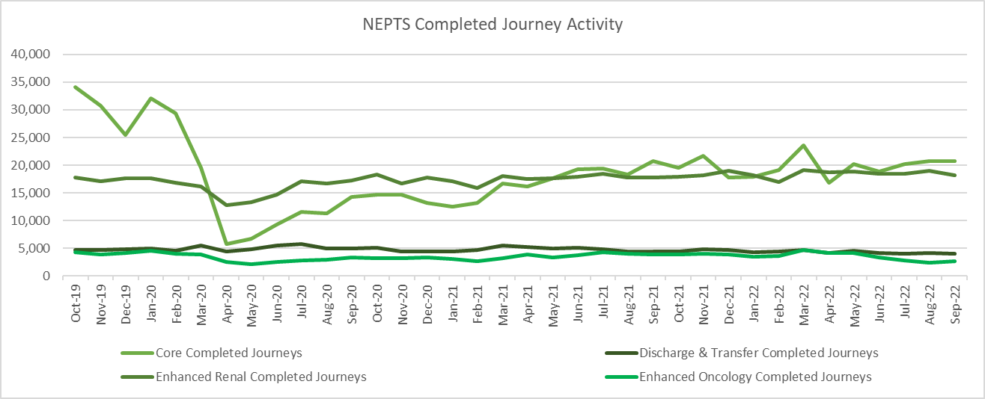

  - 74.4% of enhanced renal journeys arrived within 30 minutes prior to their appointment time, achieving the 70% target in September 2022. 87.7% of discharge & transfer journeys were collected within 60 minutes of their booked ready time, therefore not achieving the 90% target. Core inbound performance is below target. WAST has been advised by the NCCU that it will receive additional monies for winter to support increased discharge and transfer capacity to support patient flow.

  - WAST is expecting to bring forward proposals in Q4 for revised performance standards for NEPTS, including Oncology transport. This has been identified as an area of focus from the NEPTS Demand & Capacity Review.

  - The NEPTS Demand & Capacity Review identified two key efficiencies for NEPTS; aligning patient ready times with ambulance availability and re-rostering (NET Centre and NEPTS ambulances). WAST is now in the process of revising the accuracy of patient ready times, is expecting to re-roster the NET Centre during the second half of 2022/23 and bring forward proposals for re-rostering NEPTS ambulances in Nov-22, with a view to undertaking this work in 2023/24.

  - There is a Welsh Government ambition to see outreach appointments reduce by 50% “in time” (Health & Social Care in Wales – CoVID-19: Looking Forward); however, the short term scenario is that as the health care system emerges out of the pandemic response in 2022/23 this may see pent up demand for NEPTS as the system is switched back on and tries to catch up on certain services. Since Apr-22 the service has been utilising a capacity management plan, which applies eligibility principles from the 2007 WHC for NEPTS services, to manage any peaks where demand exceeds capacity. WAST anticipates bringing forward proposals on demand and capacity management in Q4.

  - All of the above work is captured through an established Ambulance Care Transformation Programme Board, which includes recommendations from the NEPTS Demand & Capacity Review and other key transformation work. Both health boards and the NCCU is represented on the Board.

EASC is asked to NOTE that: outpatient performance is below target; renal performance is above target; discharge & transfer is close to target and oncology performance remains below target; WAST expects to bring forward proposals in Q4 for revised performance standards for NEPTS; demand remains below pre-pandemic levels, but is expected to increase as the system re-sets; the impact of this is being mitigated through the use of a Capacity Management Plan; WAST is on target with a range of efficiencies linked to the NEPTS Demand & Capacity Review.

Commissioning, Planning and Service Change

Forecasting & Modelling: Strategic Demand & Capacity Reviews
  - The EMS Operational Transformation Programme (arising from the EMS Demand & Capacity Review) is WAST’s main strategic response to patient safety and experience concerns for the EMS five step ambulance care pathway.

There is continued work to refine and update the demand and capacity modelling and forecasting, which informs commissioning discussions. WAST is currently developing a terms of reference for a next iteration of the demand & capacity review.

Commissioning Intentions

  - WAST recently reported its quarter two progress on the EMS and NEPTS commissioning intentions to EASC Management Group (20 October 2022), with good progress being made. EASC Management identified good progress with a small number of exceptions, for which WAST has corrective actions in place.

Integrated Medium Term Plan (IMTP)

  - WASTs IMTP has been approved by the Minister with the following conditions:
- The need to articulate how WAST’s contribution to the Six Goals programme will translate into improved outcomes and performance.
- The adoption of Value Based Health Care needs to be strengthened and progress in reducing variation and removing harm demonstrated clearly.
- Further expansion and completion of the Minimum Data Set in the quarter refresh exercises is required.
- Improvement in sickness and absence rates across the WAST workforce needs to be demonstrated clearly.
- Delivery of workforce efficiencies and the implementation of roster review by end of December 2022.

Progress against these conditions are set out in the following table:-

Six Goals | A mapping exercise has been undertaken to understand WAST linkages into the programme at both a national and local health board level. Through these mechanisms we would aim to determine the value, outcomes and benefits to the system of WAST deliverables that are linked to the Six Goals programme. We will measure the outcomes and benefits through our Quality and Performance Management Framework.
Value Based Healthcare | Finance and Performance Committee received an update on Value Based Healthcare with a focus on Patient Level Information and Costing (PLIC) at its September meeting.  The Value Based Healthcare working group has established a programme of work with project support now in place. Progress has been made on the PLICs implementation. Furthermore, it has been agreed with Aneurin Bevan University Health Board to pilot Patient Reported Experience Measures (PREMs) relating to the Grange Hospital Transfer Service.  Our bid through the Value Based Healthcare Fund from Welsh Government for additional APPs was not funded. A key issue is WASTs ability to demonstrate Patient Reported Outcome Measures (PROMs) and WAST is seeking to work with Value in Health colleagues to consider how PROMs can be applied to emergency services.
Minimum Data Set | WAST has proposed a revised set, which is currently under consideration by Welsh Government.
Improvement in sickness absence | The Managing Attendance programme is working through the actions required to address absences with regular reporting through EMT and assurance provided at People and Culture Committee. This will also be a key metric at Board level through the Monthly Integrated Quality and Performance Report.
Delivery of workforce efficiencies | The EMS Roster Review project remains on track for delivery by end of November.

  - The WAST IMTP is delivered through a portfolio of transformation programmes supported by enabling programmes, projects and work-streams, which align to both WAST strategic ambitions and commissioning intentions. This year in recognition of the challenges facing both WAST and the wider NHS, the Trust has established four further key programmes:

• Financial sustainability – established with four work-streams (Best Practice, Efficiency, Income Generation and Benchmarking & Value) to address the current financial challenges to enable WAST not only to meet its statutory requirement for breakeven, but also to establish the financial space to deliver efficiencies, savings and income streams to further strategic ambitions and transformation;
• Transformation Steering & Assurance Group – a senior forum with oversight of the wider programme of work to deliver on the “Inverting the Triangles” ambition, focusing strongly on partnerships and engagement required to bring this ambition to reality. In support of this programme of work a Transformation Delivery Network has been established to drive forward those actions that can be taken as the programme develops, including key aspects of stakeholder engagement;
• Risk Improvement Programme – a comprehensive programme to enhance and develop WAST’s risk management and assurance processes to ensure that risk drives organisational transformation and improvement at a strategic level together with a refreshed Board Assurance Framework to provide the Board with assurance around risks associated with our strategic objectives;
- Managing Attendance Programme – the programme plan pulls together the activities already being delivered across WAST and introduces new activities to support attendance in a connected, supportive and sensitive way.

  - The final Quarter 2 position across these programmes of work are as follows.

  - EMS Operational Transformation
- Relief gap closed to the extent that funding would allow.
- CSD 10.2% hear & treat benchmark exceeded in 2021/22 with 36 FTE Paramedic uplift and 5 MHP uplift complete, with revised target of 15% for second half of 2022/23.
- Good progress on interim estate plan.
- Further funding for +100 FTEs made available and on target for delivery.
- Response rosters now going live as planned.

  - EMS Clinical Transformation

- APP Developments: Agreement at WAST EMT for 18 people to undertake full time MSc which started in Sep-22. In addition, Health Education and Improvement Wales (HEIW) provided funding for 10 Independent Prescribers, 5 started in Sep-22 and the remaining 5 FTEs to start in Jan-23 / Mar-23. Further APP developments are linked into the Optimising Conveyance Workstream and Inverting the Triangles Programme.
- Optimising Conveyance: (linked to the Inverting the Triangle Programme). Initial discussions held to define each of the segments. Initial interim Evaluation Report complete on the APP Navigator Pilot in Swansea Bay (SBUHB), further support needed by Health Information to cleanse data to ensure accuracy of impact and initial scoping within the Pre-Dispatch Outcome workstream.
- Same Day Emergency Care (SDEC): four available services and five services in development with final details to be agreed. Continue to engage on the remaining. A high-level benchmarking exercise had demonstrated that the SDEC services are not in line with the agreed National Policy and have local variances in place.
- Non-Falls Injury Pathway: TerraPACE Change Request Form approved by CC2HG (16/08/22) to reflect updated Paramedic Fieldguide criteria within the application. Further API and web development work is required as a result of the form change before Terrafix are able to complete their software development & testing. Web development work change is being instigated by the product owners. Recommended Remote Process Automation (RPA) solution to be scoped to mitigate against the Health Information capacity risk and the management of referral. Meeting with Outsource Automated Solution to further develop the requirement of an RPA to automatically manage the referral.
- Technical platform to access senior clinical support (currently Consultant Connect): Current providers contract in place until Mar-23. Tender exercise and evaluation panel complete. Awaiting outcome on the provider awarded the contract.
- Clinician/Therapist (Level 2) Response: Continued discussions with CVUHB and CTMUHB to implement model and initial discussions with HDUHB (Pembrokeshire only) to undertake 6-month pilot.
- Initial scoping of the forecasting and modelling for the Falls Resources, with Commissioning & Performance Team
- Initial scoping of National Falls Evaluation and data required, with Health Informatics Team
- Older Persons Framework: Powys Value Based Health Care Bid approved for additional resources to support Falls Prevention and use of the iStumble Tool in Care Home. 1 x B6 Paramedic to provide training per week.
- 111 Press 2 Service: This service live in HDUHB. The wider roll out across other Health Boards is being led as part of UEC Goal 2.
- Faculty of Emergency Mental Health Practice: Work ongoing to develop faculty with contingency plans being developed should funding not be available.
- Mental Health Response Vehicles: Work ongoing with Betsi Cadwaladr (BCUHB) to determine the scope, role, location and funding for this service.
- Mental Health Practitioners: Recruitment complete (6FTEs) and have started on the rota. Approach to undertake evaluation to be developed in Q4.
- Mental Health & Dementia Plan: Delivery on track. Key updates include; Dementia Dashboard developed with data ePCR. Suicide First Training has commenced.

  - Ambulance Care

- Demand and Capacity (D&C) Project: The revised keys are currently being developed. A PDSA has been written to test the ORH keys against the revised keys (ORH++) and the project initiation document (PID) is expected in November 2022.
- NEPTS Operational Improvement, Resource Downtime workstream: It has been agreed at ACT programme board that this workstream is complete; the new report is in place and is being reviewed regularly as 'business as usual'.
- Major Trauma Network: This workstream is now complete. WAST has responded to the peer review paper and the recommendations from this are being considered within the Transfer and Discharge project.
- Transfer and Discharge Service: The PID is approved at programme board. A meeting was held with ORH in October 2022. Data around demand is crucial in clarifying the specification and understanding timescales and costs for modelling, alongside the demand and capacity review of the current and future role for the UCS service.
- Vascular Network in SE Wales: This workstream is complete as the network went live on 18 July 2022. Ongoing attendance at operational meetings have not identified any significant issues.
- Vascular North Wales: WAST is currently liaising with BCUHB on accurately quantifying the demand as a precursor to developing options.
- Transport Solutions: Health Boards have been engaged with training for the online booking system, in line with the deadline of December 2022 after which telephone bookings will no longer be accepted.
- NEPTS Plurality Model: The procurement process has continued and whilst this has taken longer than expected, contracts less than 12 months in length will be awarded by 30th November. Providers have been procured for the interim period.

- NEPTS CAD Upgrade: Whilst there have been challenges to the timeline for this project, the new go live date is confirmed as 30th November and ACT have received assurance that this will not change.

Health Board Changes

  - WAST will fully engage with the integrated commissioning action plans in each local health board in line with the EMS commissioning framework, these will likely incorporate both strategic and operational changes that impact on patient flow across the system.

  - WAST is currently engaged in the following live strategic service change programmes with Health Boards in Wales and Trusts in England:

- A Healthier Mid & West Wales (AHMMW) – WAST has been heavily involved in supporting the site selection work stream, providing detailed travel time analysis using the Optima ambulance modelling software, to compare the impacts for each of the shortlisted site options. This analysis included exploring non-blue light and blue light travel times by Lower Super Output Area for each of the proposed site locations.
- Stroke reconfiguration in Swansea Bay and Hywel Dda - established under the ARCH programme infrastructure which recommenced in June 2022. WAST clinical, operational, and planning leads are continuing to engage as part of the revised programme arrangements.
- Stroke reconfiguration in Cwm Taf Morgannwg and Cardiff & Vale - Discussions have re-commenced between Cwm Taf Morgannwg UHB and Cardiff and Vale UHB on the development of a High Acuity Stroke Unit (HASU). WAST clinical and planning colleagues engaged in discussions on the clinical model and conveyance implications.
- Stroke reconfiguration in Hereford and Worcester - WAST & Powys Health Board have worked collaboratively with the Stroke re-design group to support the development of the future model of care. Historical data projects circa 120 query stroke patients are conveyed to Hereford per year. The Health Board and Trust will continue to engage to understand implications for the population of Powys of any of the changes proposed.
- South Wales Thoracic Surgical Services Programme - WAST is represented at project level as an enabling partner and in recognition of the potential impact of longer journeys for ambulance care particularly.
- The Spinal Network is developing clinical guidance for management of spinal trauma. It is also establishing a Spinal Operational Delivery Network (ODN) for South Wales, West Wales and South Powys. WHSCC will be funding the network with SBUHB hosting the network. WAST has been invited to join the ODN and is attending and supporting the development of the clinical guidance which will have some impact on hear and treat, face to face and 111.
- South East Wales Collaborative - Collaborative programmes across the South East will now be led by a Programme Director, recently appointed and will be supported by dedicated Programme Managers to enable these programmes to progress; collaborative regional programmes are recommencing and reinvigorating with this additional support for orthopaedics, diagnostics, pathology, endoscopy and ophthalmology programmes. The new programme structures will enable further engagement from a WAST perspective.
- Aneurin Bevan Clinical Futures Strategy - Continue to liaise with ABUHB on further implementation of their strategy post opening of The Grange University Hospital and any implications including the review of demand for transfers in the future as part of the GUH Evaluation recommendations.
WAST is also monitoring progress of the following service changes and will engage as and when required:
- Regional Treatment Centre in BCU
- Future Fit (Shrewsbury & Telford Hospitals)
- Cwm Taf Morgannwg Maternity & Obstetrics (South Powys Flows)
- Swansea Bay Acute Services Reconfiguration
- Cardiff and Vale – Future Clinical Services Programme
- Velindre & Aneurin Bevan (ABUHB) – Satellite Radiotherapy Unit.

  - WASTs Integrated Strategic Planning Group has continued to maintain oversight of health board operational and strategic service changes to comprehend and coordinate implications on WAST and for WAST to support these plans. WAST is currently updating our service change map for inclusion in the IMTP.

  - The key risks to the delivery of the WAST IMTP in 2022/23 include:

- Availability of revenue funding for core and transformational elements of the plan;
- The reduction in capital available to NHS Wales, which will impact on delivery of some of the core enabling plans such as WAST’s estates improvement plan, but also poses a risk in terms of transformational elements of the plan;
- Securing internal stakeholder support. Work is ongoing ensuring effective collaboration with TU partners in the delivery of its plans;
- Securing external stakeholder support, particularly for the Inverting the Triangles ambitions;
- Ongoing impacts of CoVID-19 recovery both internally within WAST and as the Health Boards recover their activity;
- Capacity within the organisation to deliver the change required, within the resource envelope available. The previously planned growth in corporate support is not currently included in this plan.
- Demand for services increasing at a greater rate than the demand and capacity forecasts;
- Pressures on the service arising from external factors, particularly the continuing impact of hospital handover delays;
- Health and wellbeing of the workforce in the face of continued pressure.

IMTP 2023-26

  - WAST is currently developing its next IMTP. A collaborative planning workshop was held on 04 Oct-2022 with colleagues from NCCU in attendance on behalf of EASC. The workshop looked at the key priorities for 2023 and onwards in the context of a challenging financial outlook. Further engagement has taken place with WAST colleagues at a series of CEO Roadshow events. The aim will be to share the key priorities in WASTs IMTP with the CASC in Nov-22.

EASC is asked to note that: WAST is making good progress on both its EMS Operational and Clinical Transformation and Ambulance Care Transformation programmes, albeit challenged by available funding for transition and transformation; the 2022-25 IMTP approval conditions are being monitored and there is progress against each condition; and there is significant planning work around changes in health board configurations some of which feed into the national project to develop transfer and discharge services; WAST is progressing development of its 2023-2026 IMTP with a view to sharing priorities with the CASC in November.

Conclusions and Forward Look

  - Current performance levels and patient safety remain very challenging. System pressure, as expressed through handover lost hours, is extreme and can be expected to be even more challenging in the winter period.

  - WAST is focused at an organisational level on this challenge. It has a comprehensive range of transformational programmes, planned efficiencies and tactical actions to support its services. WAST has received a further £3m to enable the funding of an additional 100 FTEs in Operations Response; however, WAST cannot achieve the patient safety parameters identified in the EMS Demand & Capacity Review, without a transformational reduction in hospital handover lost hours i.e. a reversal of trend.

2.58 NEPTS is achieving most of its targets currently, however, demand has been suppressed and capacity was boosted in 2021/22. As demand increases as the system re-sets and the in-year capacity ends, EASC will need to consider options for balancing demand and capacity. WAST is looking at the balance of demand and capacity via the pre-work on the NEPTS roster review project.

- KEY RISKS/MATTERS FOR ESCALATION TO THE COMMITTEE

Members of the EAS Committee are asked to note that:

  - WAST is at escalation level 3 and expects to remain so for the foreseeable future;
  - During September WAST had to move into level 4a of its CSP, the second highest level, which means screening of Amber One calls and unable to send to lower incident categories;
3.2 Patient safety in the emergency ambulance five step pathway is now very high risk for both EASC and WAST, with response times that are far too long;
3.3 There were 890 12 hour and over patient waits in September-22, 51 patient safety incidents were referred to health boards under the Appendix B arrangements over the last three months and 19 WAST NRIs were reported to Welsh Government;
3.4 The Red 8 minute 65% target has not been hit since Jul-20 (62.0% of Red incidents were responded to in 10 minutes in September-22);

3.5 WAST produced 114,353 Operations Response hours in September-22 (all resource types), but lost over 25,000 ambulance unit hours to handover delays, a level that WAST cannot offset without radical measures to shift left or improve system flow;
3.6 There is a Welsh Government expectation that Immediate Release Directions are always accepted;
3.7 There is also a Welsh Government expectation for a 25% reduction in handover lost hours (from Oct-21 baseline);
3.8 WAST has been notified of further funding (£3m) in 2022/23, which will enable it to recruit a further 100 FTEs to help bolster the EMS (on target);
3.9 WAST continues to seek efficiencies, in particular, the pan-Wales EMS Response roster review (on-target), PPLH and abstractions/sickness absence reduction (on-target);
3.10 The ePCR programme has gone live and operational in every health board, but compliance performance for the clinical indicators have been affected in the short term as the system changes over;
3.11 An Ambulance Care Transformation Programme Board has been established to take forward the findings of the NEPTS strategic Demand & Capacity Review and wider NEPTS and transfer and discharge projects and is making good progress;
3.12 WAST has reported quarter 2 progress on EASC’s commissioning intentions to Oct-22’s EASC Management Group, with good progress being made;
3.13 WAST’s IMTP has been approved;
3.14 WAST in engaged with health boards on a significant range of planning work for reconfigurations, in particular, vascular and time critical transfers; and
3.15 WAST is fully engaged in delivery of and support of the six goals programme.

- IMPACT ASSESSMENT

Quality/Safety/Patient Experience implications | Yes (Please see detail below)
Quality/Safety/Patient Experience implications | Identified within the report
Related Health and Care standard(s) | Timely Care
Related Health and Care standard(s) | And all health and care standards
Equality impact assessment completed | Not required
Legal implications / impact | There are no specific legal implications related to the activity outlined in this report.
Legal implications / impact | Included within the body of the report
Resource (Capital/Revenue £/Workforce) implications /  Impact | Yes (Include further detail below)
 | Included within the body of the report
Link to Main Strategic Objective | The Committee’s overarching role is to ensure its Commissioning Strategy for Emergency Ambulance Services utilising the five step patient pathway outlined within the National Collaborative Commissioning Quality and Delivery Agreement and the related outcomes for each care standard aligned with the Institute of Healthcare Improvement's (IHI) ‘Quadruple Aim’ are being progressed.  This report focuses on all the above objectives, but specifically on providing strong governance and assurance and safe and effective patient care
Link to Main WBFG Act Objective | Service delivery will be innovative, reflect the principles of prudent health care and promote better value for users

- RECOMMENDATION

  - The EASC Committee is asked to:

- DISCUSS and NOTE the WAST provider report.

