NON-EMERGENCY PATIENT TRANSPORT SERVICES
DELIVERY ASSURANCE GROUP
4 August 2022
10:00 – 11:30
Via Microsoft Teams
Confirmed notes of the meeting
Present
Name | Representing
Ross Whitehead (Chair) | Emergency Ambulance Services Committee Team
Steve Bonser | Aneurin Bevan University Health Board
Elinor Mercer | Cardiff and Vale University Health Board
Elizabeth Beadle | Cwm Taf Morgannwg University Health Board (CTMUHB)
Andrew Quarrell | Powys Teaching Health Board (PtHB)
Joanne Jones | Swansea Bay University Health Board (SBUHB)
Susan Spence | Renal Network WHSSC
Deborah Kingsbury | Welsh Ambulance Services NHS Trust (WAST)
James Haley | Welsh Ambulance Services NHS Trust (WAST)
Mark Harris | Welsh Ambulance Services NHS Trust (WAST)
Karl Hughes | Welsh Ambulance Services NHS Trust (WAST)
Sarah Jones | Welsh Government
Matthew Edwards | Emergency Ambulance Services Committee (EASC) Team
Richard Baxter | Emergency Ambulance Services Committee (EASC) Team
Phill Taylor | Emergency Ambulance Services Committee (EASC) Team
Gwenan Roberts | National Collaborative Commissioning Unit
Ricky Thomas | National Collaborative Commissioning Unit
Apologies
Stephen Harrhy | Gillian Milne | Gareth Skye
Jeff O’Sullivan | Wayne Lewis | Andrew Walsh

Item |  | Actions
Welcome, Introductions, Apologies and Declarations of Interest
The Chair welcomed everyone to the meeting and thanked them for their time.

There were no additional declarations of interest.

Notes of previous meeting
The notes from the previous meeting held on 6 June 2022 were confirmed as an accurate record.

Matters arising
There was none.

 | ACTION LOG  Members noted that the Action Log had been updated and a number of actions closed.  Following areas updated:  - Briefing in relation to the Capacity Management Plan (CMP) – further information would be shared  - ‘Focus on’ volunteers to take place at the next meeting (Forward Look)  - Additional work to do in relation to the Ambulance Care Programme Board – particularly on cancellations and telephony etc (to remain on Action Log)  - Qliksense and Power BI presentation to provide information for HBs to make decisions (next meeting)  - Schematic to show arrangements across Wales to be provided at the next meeting  Members noted the ongoing work to develop the new Emergency Medical Services Framework which would capture the work in health boards and would also be rolled out for the NEPT Services Framework.  Members RESOLVED to NOTE the Action Log. | WAST  Chair  WAST  Forward Look  EASC T
 | NEPTS IMTP UPDATE  Mark Harris and Deborah Kingsbury gave a presentation at the meeting which related to how WAST were planning to deliver their Integrated Medium-Term Plan (IMTP). The presentation would be shared following the meeting (Action Log).  Members noted:  - The work of the Ambulance Care Programme Board  - Key elements of the WAST IMTP 2022-25 – recovery, efficiency, system, transformation, our people and infrastructure, quality and value  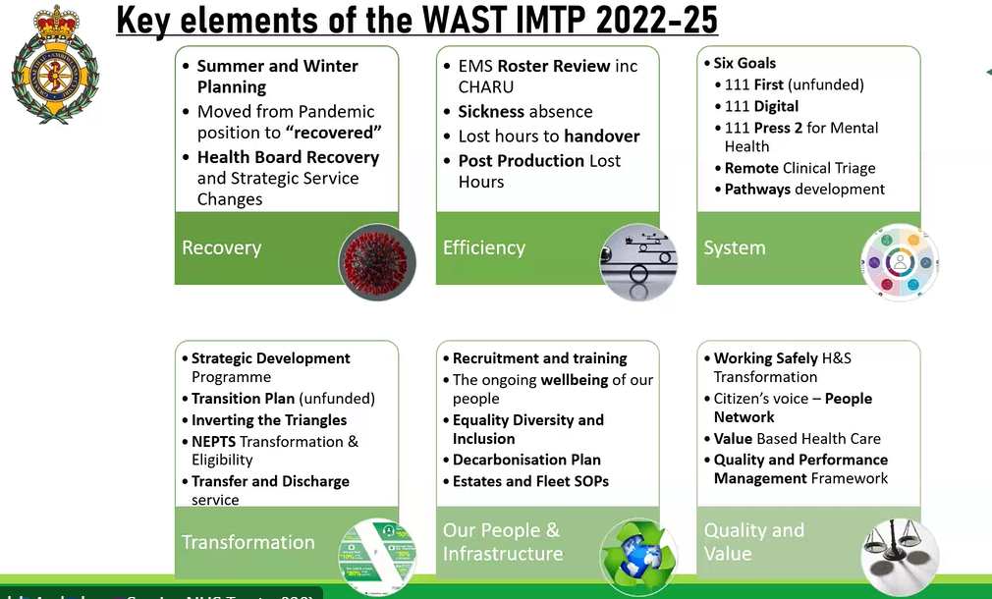  - The WAST IMTP was approved on 13 July 2022; the implementation was being overseen by the Strategic Transformation Board which was chaired by the Chief Executive at WAST  - Transformation areas within the ambulance care programme included:  - improving rosters to address relief gap  - delivering the work identified by ORH in the NEPTS Demand and Capacity work during 2021  - that the eligibility criteria continued to be actively managed  - the important work in the next few months included ‘rural’ issues.  - Highlights included:  - Identification of actions relating to the demand and capacity work  - operational improvement  - transfer and discharge  - the trial with BCUHB on the use of the discharge lounge  - the tenders for contracts (for the plurality model) had been received and would be evaluated. The aim would be to reshape the provision and be more efficient providing better value services  - Vascular services went live in July 2022  - Programme Summary areas highlighted in amber included:  - roster work related to Demand and Capacity work  - the challenges posed by eligibility criteria  - the operational improvements and the ongoing weekly review to identify benefits  - the progress made on standardisation  - the transformation of transport solutions  Members noted that no red areas had been identified.  Members asked:  - In terms of the ongoing work relating to improvement for various HB areas, how were HB partners being engaged in making any changes – what were the arrangements at the local level? Responses included:  - Involvement in roster changes  - Oncology services (Velindre)  - Outbound ready times (Hywel Dda)  - Members felt it would be helpful to work together to attempt small changes which could be developed and reused on a regional or national basis.  - Members noted that the IMTP update to EASC Management Group would include the NEPTS information (WAST)  Members resolved to note the update. | EASC T  All to share
 | EXCEPTION UPDATES FROM HEALTH BOARDS  Issues raised by health boards included:  - Recognition of the new approach by WAST to Tier 3 which was welcomed and was leading to meaningful and helpful dialogue. WAST were thanked for their work in delivering this.  - System wide responses to ‘Decarbonisation action plans’ Discussion took place in relation to the potential to have a way to share the WAST NEPTS plans and all HB plans by linking together as an all Wales approach. Deb Kingsbury explained that Assistant Directors of Planning had also been discussing this matter. Members noted that Joanne Williams was the WAST lead on decarbonisation and potentially could be invited to a future meeting. Members also noted that other meetings were already taking place across Wales which would also need to be considered. Steve Bonser offered to share information following the meeting.  - An operational matter from SBUHB related to mental health provision for those in crisis. Members noted that there was also a mental health team within WAST to support this client group.  - The ongoing acute medical services redesign in SBUHB and ongoing meetings regarding implications for changes in flow (all medical admissions to Morriston) and the potential impact on ambulance services (which had been raised at the Tier 2 meeting) Members noted that other meetings were taking place in the system regarding this matter and Ross Whitehead and Deb Kingsbury agreed to catch up outside of the meeting.  Following discussions, Members felt it would be helpful to capture the current position in relation to the decarbonisation work and would receive a short report at the next meeting. Added to Action Log and Forward Look.  Members resolved to:  - Receive a short paper at the next meeting and consider what role the NEPTS has in the decarbonisation agenda. | Steve Bonser  Ross Whitehead / Deb Kingsbury  EASC T
 | WAST PROVIDER REPORT  The WAST Provider report was received. In presenting the report Mark Harris highlighted:  - Capacity management plan (CMP) and the eligibility criteria (provisional and non-provisional bookings)  - T1 activity and potentially different choices patients were making; would be helpful to capture the whole patient journey in case patients not attending appointments  - A chart showing CMP cancellations; Members noted a ‘deep dive’ had been undertaken which would impact on the information shown and potentially showing the wrong codes had been used  - That performance was fairly consistent; Oncology journeys were back to pre pandemic levels and was equivalent to renal services; more work was required on the Oncology programme initiation document (PID)  - renal work and pleased to report that BCUHB had provided funding for 6 day service and plans to implement would impact on the performance and improve patient experience  - Lost hours at discharge, although not much impact in this area and continual delays above the 20min target; focused work to be undertaken particularly in the Grange University Hospital which may require a different target  - Covid – no specific issues and back to pre pandemic journeys but continued to use PPE  - Journey booking; some staffing issues recruitment underway  - Healthcare professional calls to be asked to use online booking means and reserve calls for patients  - An update would be provided following the awarding of the contract for the new providers for plurality model  - Increasing costs paid to volunteers to £0.45 per mile; challenging time with the cost of living crisis  - Urgent Care Service and NEPTS managed together since 1 July 2022 and looking to use the synergy with the new arrangements to improve services.  Members raised:  - Reimbursement costs (cost of living crisis) and asked if there were any plans to review the patients self-conveying? – Members noted that this was not being considered at the moment, but it was agreed that WAST and the Renal Network would discuss outside of the meeting (Action Log)  Members RESOLVED to NOTE the report and updates. | WAST / Renal Network
 | TIER 2 AND 3 REPORTS  The Tier 2 and Tier 3 Report was received. Mark Harris presented the report and gave an overview of the structure and approaches across Wales. WAST’s aim was to have a consistent approach across Wales and provide clarity for HBs. Members noted the different practices and the impact on the ability to work together effectively.  Members were asked to agree a consistent approach and the importance of regular and committed membership and suggested that terms of reference (including an agenda) be developed to clarify the expectation of those attending. This would also allow for clarity where Tier 2 and Tier 3 meetings take place. Members were keen that the importance of local determination for Tier 3 within the Tier 2 arrangements was recognised. Members noted the aim that operational matters would be managed at the Tier 2 and 3 level.  Members raised their:  - support for a ‘core’ consistent approach but this would also need to be flexible for local requirements (e.g ABUHB and the additional contract for the Grange University Hospital)  - value of the information already provided and the data sets were felt to be very helpful  - concerns that additional discussions would need to take place with some health boards (ABUHB identified at the meeting)  - suggestions that meetings already in place may provide an opportunity to learn lessons and contribute to the collaborative commissioning approach  - Agreement for robust Tier 2 attendance, senior level and confident that local meetings are taking place  Following discussion, it was agreed that WAST would work on the Hywel Dda and ABUHB approaches with an aim to develop a useful core approach which could be adopted across Wales.  Members resolved to note the work to date and receive an update on progress at the next meeting. | WAST/ HDUHB /ABUHB
STANDARD OPERATING PROCEDURE FOR QUALITY AND SAFETY – UPDATE

Mark Harris provided an oral update on work to discharge and convey the appropriate patient to the right address. Members noted that a local internal Standard Operating Procedure had been developed and WAST staff had been reminded on a regular basis.

Members noted that Hywel Dda UHB (Improvement Team) were working with WAST to develop a checklist on a handover of patients commissioned by the Directors of Nursing in Wales. Members noted that the work had been prolonged and as yet no final product was available to share. A further update would be provided at the next meeting (Forward Look).

Members resolved to note the work to date.

 | QUALITY AND SAFETY (STANDARD AGENDA ITEM)  Ross Whitehead reminded Members that Quality and Safety matters were being routinely received at the EAS Joint Committee and all sub groups were required to adopt the same approach.  Specific issues would be brought to future meetings and would be reported to EASC Management Group and to the EAS Joint Committee. Members noted the intention that more time would be spent on quality and safety matters in line with time spent on performance and finance matters within meetings.  The aim will be to  - Have specific NEPTS issues relating to quality and safety  - Receive the numbers of Concerns, complaints and adverse incidents within NEPTS  - Receive any wider issues relating to quality and safety which would include by health board particularly any joint investigation process  - Develop by an iterative process a comprehensive approach towards quality and safety (including within specific service areas like renal services).  Members noted that WAST already had a comprehensive quality dashboard which was updated quarterly and would be shared following the WAST governance processes. This would be shared at the next meeting (Forward Look).  Members NOTED the update. | WAST
SIX GOALS FOR URGENT AND EMERGENCY CARE

Ross Whitehead gave an overview of the connected nature of the work of NEPTS DAG to the Six Goals for Urgent and Emergency Care.

Members received the Handbook and noted that this would form one of the standard agenda items to support the work to deliver the goals.

Members noted:
- the quality statement (within Goal 5) to deliver non-emergency patient transport services.
- Stephen Harrhy, Chief Ambulance Services Commissioner was the lead for Goal 4
- That updates would be required from the NEPTS DAG to deliver the quality statement
- Health board specific actions would be required at future meetings

Members resolved to note the update and the actions planned.
TERMS OF REFERENCE

Members noted the final version of the Terms of Reference.

EASC KEY ORGANISATIONAL CONTACTS

The EASC Key Organisational Contacts was received. Members noted that they would be required to inform the EASC Team where changes occurred.

Members resolved to note the update

 | FORWARD LOOK  The Forward Look was received and the Chair suggested that Members send further suggestions to develop the plan for the next year.  Members resolved to note the forward look. | Chair  All
ANY OTHER URGENT BUSINESS

Andrew Quarrell (Powys) asked whether it remained the intention to novate the two large cross border contracts (Hereford and Shropshire) at the earliest opportunity.
Further discussions would be needed with WAST and this was circa 50% of the Powys activity (which was not being managed by the WAST contract).

Mark Harris agreed to contact the team at Powys to work closely (meeting planned for September).

Richard Baxter was thanked for his work in the EASC Team over the last year and best of luck in his new role in WAST.

Date of next meeting
6 October 2022 at 10:00 – 11:30 by Microsoft Teams

