EASC Joint Committee
21 November 2023
Agenda Item
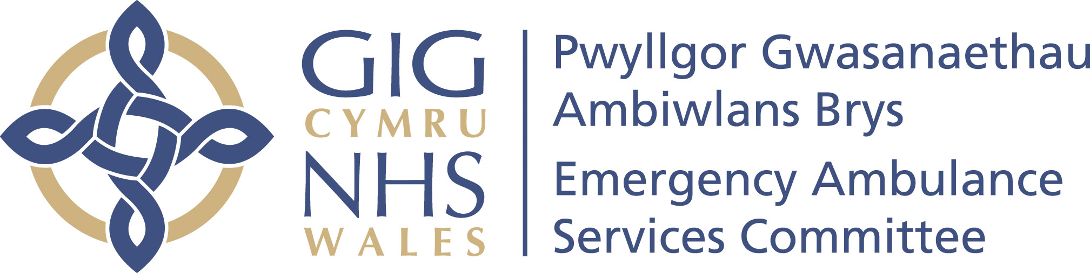

CTMUHB Audit and Risk Committee – Part 2
Assurance Report

Reporting Committee | CTMUHB Audit and Risk Committee – Part 2
Chaired by | Patsy Roseblade, Chair of the Audit & Risk Committee
In attendance for EASC | Gwenan Roberts, EASC Committee Secretary
Date of Meeting | 24 October 2023
Report Author | Jacqui Maunder Evans, WHSSC Committee Secretary
Summary of key matters considered by the Committee and any related decisions made
The CTMUHB Audit & Risk Committee (ARC) provide assurance to the Joint Committee of the effectiveness of its arrangements for handling reservations and delegations. The Memorandum of Agreement states that the Audit Lead will provide reports to the Joint Committee following the Host Audit & Risk Committee meetings. This assurance report sets out the key areas of discussion and decision.
1.WHSSC Corporate Risk Assurance Framework (CRAF)
Helen Tyler (HT), presented the Corporate Risk and Assurance Framework (CRAF). Members noted that:
- As at 30 September 2023, there were 22 risks on the CRAF with a risk score of 15 and above
- There were 18 commissioning risks, which included three new commissioning risks
- There were 4 organisational risks.

The Committee noted the report.

2.WHSSC Internal and External Audit Recommendations Tracker
James Leaves (JL), gave a progress report on the implementation of internal and external audit recommendations.

Members noted:
- the summary of internal audits undertaken during 2022-2023 and the assessment ratings
- that two recommendations were outstanding in relation to the report on Risk Management, the due dates had been revised to March 2024 due to competing work pressures
- the progress made against the seven external audit recommendations outlined in the Audit Wales report “WHSSC Committee Governance Arrangements”.
Members noted that a full progress report on the Audit Wales recommendations will be presented to the Joint Committee in November 2023 and a further progress report will be shared with the NHS Wales Board Secretaries thereafter.

The Committee noted the report.

3.WHSSC Model Standing Orders
Jacqui Maunder-Evans presented the revised WHSSC Model Standing Orders (SOs) and provided assurance that the model SOs and Standing Financial Instructions (SFIs) were presented to and approved by the WHSSC Joint Committee at its meeting on 19 September 2023. Members noted that the documents had been sent to Health Boards (HBs) for inclusion as schedule 4.1 within the respective HB SO’s.
The Committee noted the report.

4.WHSSC Welsh Kidney Network Internal Audit Report
Emma Samways presented the final internal audit report following an internal audit assessment of the Welsh Kidney Network (WKN). Member noted that the report gave a substantial assurance assessment rating and that there were only very minor recommendations to update the terms of reference.
The Committee noted the report.

5.EASC Update (including an update on Non-Emergency Patient Transport Services and the Integrated Commissioning Action Plan)
Gwenan Roberts (GR), EASC Committee Secretary and Deputy Director Corporate gave an update on the EASC business including:
- EASC Risk Register
- EASC Performance Dashboard
- Plans for the vision for Non-Emergency Patient Transport Services (NEPTS)
- Integrated Commissioning Action Plans (ICAPs) and progress to date
- EASC Integrated Medium Term Plan (IMTP) including the Tracker
- Closure of the investigation by the Welsh Language Commissioner
- Emergency Medical Retrieval and Transfer Service (EMRTS) Service Review
- National Commissioning Review.

The Committee noted the report.

6. National Imaging Academy Risk Register
Tracy Norris, National Imaging Academy (NIA) presented the NIA risk register.

The Committee noted the report.

Matters referred to other Committees
None
Date of next scheduled meeting |  | 19 December 2023

