AGENDA ITEM

EMERGENCY AMBULANCE SERVICES COMMITTEE (EASC)

welsh ambulance services nhs trust (WAST)
provider update

Date of meeting | 21/11/23

FOI Status | Open/Public

If closed please indicate reason | Choose an item.

Prepared by | Rachel Marsh, Executive Director of Strategy, Planning and Performance (WAST)
Presented by | Jason Killens, Chief Executive WAST
Approving Executive Sponsor | Chief Executive

Report purpose | FOR DISCUSSION / REVIEW

Engagement (internal/external) undertaken to date (including receipt/consideration at Committee/group)
Committee/Group/Individuals | Date | Outcome
- | - | Choose an item.

ACRONYMS
ABUHB  CTMUHB  D&C  EMS  NCCU  NEPTS  NRI  WAST | Aneurin Bevan University Health Board  Cwm Taf Morgannwg University Health Board  Demand and Capacity  Emergency medical services  National Collaborative Commissioning Unit  Non-emergency patient transport services  National Reportable Incident  Welsh Ambulance Services NHS Trust
- SITUATION/BACKGROUND

  - The purpose of this report is to provide EASC with an update on key issues affecting quality and performance for EMS and Ambulance Care (including NEPTS) delivered by WAST.

- SPECIFIC MATTERS FOR CONSIDERATION BY THIS MEETING (ASSESSMENT)

Current Operational Pressures
  - At an organisational level, WAST is currently at escalation level two (four being the highest) of the Resource Escalation Action Plan (REAP).
  - The levels of organisational escalation and deployment of the Clinical Safety Plan (CSP) are significantly lower than those seen last winter. In Sep-23 WAST spent 3% of the time at CSP level 4a (the second highest level). This is reflected in lower levels of patient cancellations and “no sends”, with 9,736 patient cancellations in Sep-23 compared to 11,614 in Dec-22.
  - WAST declared an extraordinary incident on Sunday 22 Oct-23. Demand was high that day but was not the highest seen within the 30 days preceding and ambulance production was good (94% pan-Wales all resource and 102% in Swansea Bay all resource). An incident debrief is being completed.

EASC is asked to NOTE that: Sep-23’s patient cancellations and no sends are significantly below last winter’s levels; and there was an extraordinary incident declared in Oct-23.

Quality, Safety & Patient Experience
Patient Response Times in the Community
2.4 One of the key indicators which measures the quality of the service provided is the timeliness of the response by WAST to patients waiting in the community. The graphs overleaf show the current response time performance for Red calls. Red performance has been declining since Jun-23.
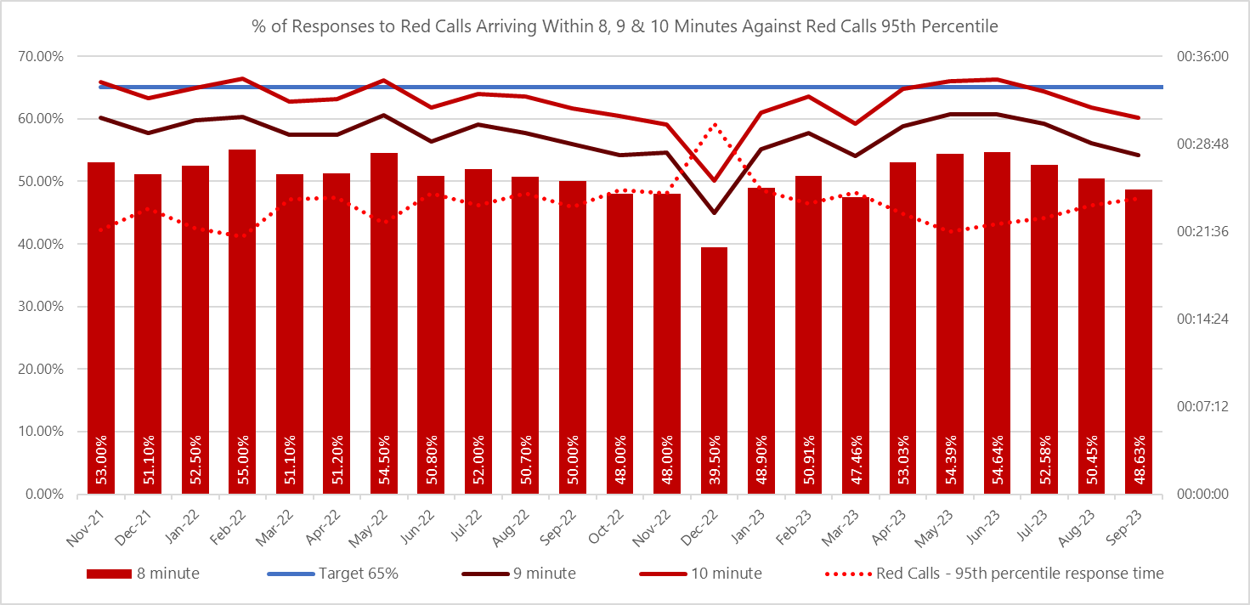

  - WAST is actually reaching more red incidents in eight minutes year on year, but red demand is higher, so the denominator is bigger which impacts on the percentage. In Sep-23 WAST reached 2,277 red incidents in eight minutes, compared to 1,753 in Sep-22.

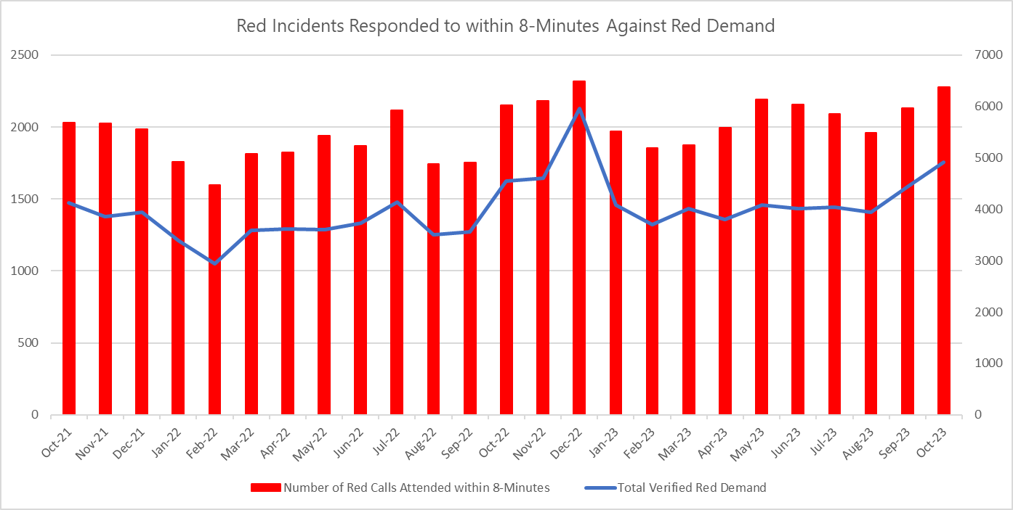

2.6 The graph below shows Amber 1 performance for Sep-23. The Amber 1 median was one hour and 17 minutes (ideal 18 minutes) with the 95th percentile at six hours and 6 minutes. Inevitably, these below target response times have had an impact on patient safety with Amber 1 delays a particular concern from a patient safety perspective, as it is where the bulk of National Reportable Incidents (NRIs) occur.

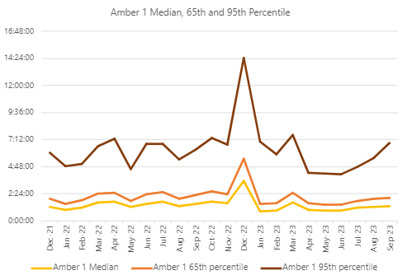

  - WAST is taking actions within its gift to improve response times, including:

- Full roll out of Cymru High Acuity Response Unit (CHARUs). This is being achieved through a redistribution of existing resource, resulting in lower Emergency Ambulance hours. Currently WAST has 127 CHARU FTEs live or in training against the requirement for 153 FTEs;
- Change to the dispatch logic for Red calls, based on clinical requirement and need. Red incidents currently require a higher multiple attendance ratio; however, as the Red category has grown, capacity is being released by reducing multiple attendances where clinically appropriate. All Red calls still require a response within 8 minutes. This change went live on 19 Jun-23;
- Supporting health boards with handover reduction e.g. advanced paramedic practitioner (APP) navigator, falls vehicles, mental health vehicle etc., from their current extreme levels.

2.8 It should be noted that the primary reason for the introduction of CHARUs is improved on-scene clinical leadership for critical incidents, in particular cardiac arrest and trauma, with the aim being to deliver improved clinical outcomes, consistent with the introduction of the Clinical Response Model. The Aug-23 return to spontaneous circulation rate (ROSC) of 23.8% was the highest recorded by WAST with Sep-23’s at 22.1%. This is the ROSC rate on arrival at hospital. There is an important outstanding action for WAST regarding linking this clinical information to the Wales cardiac database so that survival rates can be monitored. This action is now being progressed between WAST and Digital Health and Care Wales (DHCW).
2.9 As part of its quality, safety and patient experience arrangements WAST continues to monitor the longest patient responses. There were 609 long waits over 12 hours in Sep-23, considerably below the 2,064 seen during Dec-22, and a decrease on the 892 reported in Sep-22.
2.10 In Sep-23, seven patient safety incidents were passed to health boards as part of the joint investigation framework. 10 NRIs were reported directly by WAST to the Delivery Unit for the three months to the end of Sep-23.
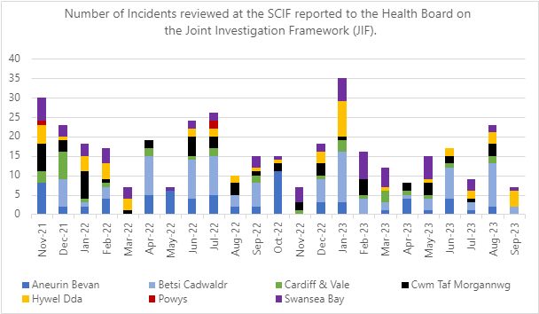

2.11 WAST has escalated and continues to articulate its concerns about patient outcomes and experience to commissioners and to Welsh Government, with Trust Board continuing to receive a specific paper on patient harm at every meeting, detailing harm, predicted harm and what mitigations WAST can take as well as wider system mitigations.

Capacity (Production & Hospital Handover)
2.12 The total number of ambulance unit hours produced in Sep-23 by WAST was 113,409, compared to 105,919 in Sep-22.
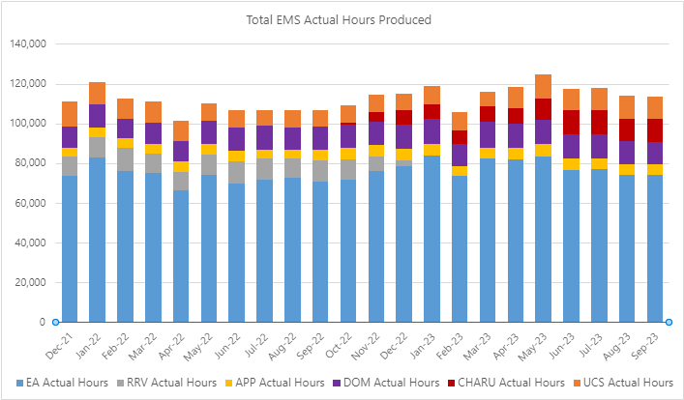
2.13 There were over 19,000 ambulance unit hours lost across Wales in Sep-23, the equivalent of 23% of WAST’s conveying ambulance resource. There is a clear downward trend in Cardiff & Vale UHB with no waits over four hours. This overall level of lost hours is extreme and remains deeply concerning for patient safety as we start to move towards winter 2023/24. It should be noted the 2019 EMS Demand & Capacity Review and subsequent investment and re-roster, were predicated on 6,000 handover lost hours and the roster keys being fully funded.
2.14 It is worth noting that as handover hours reduce, the initial impact is for responded demand to increase, with fewer patients cancelling their ambulance, which means that performance improvements will take longer to become evident.
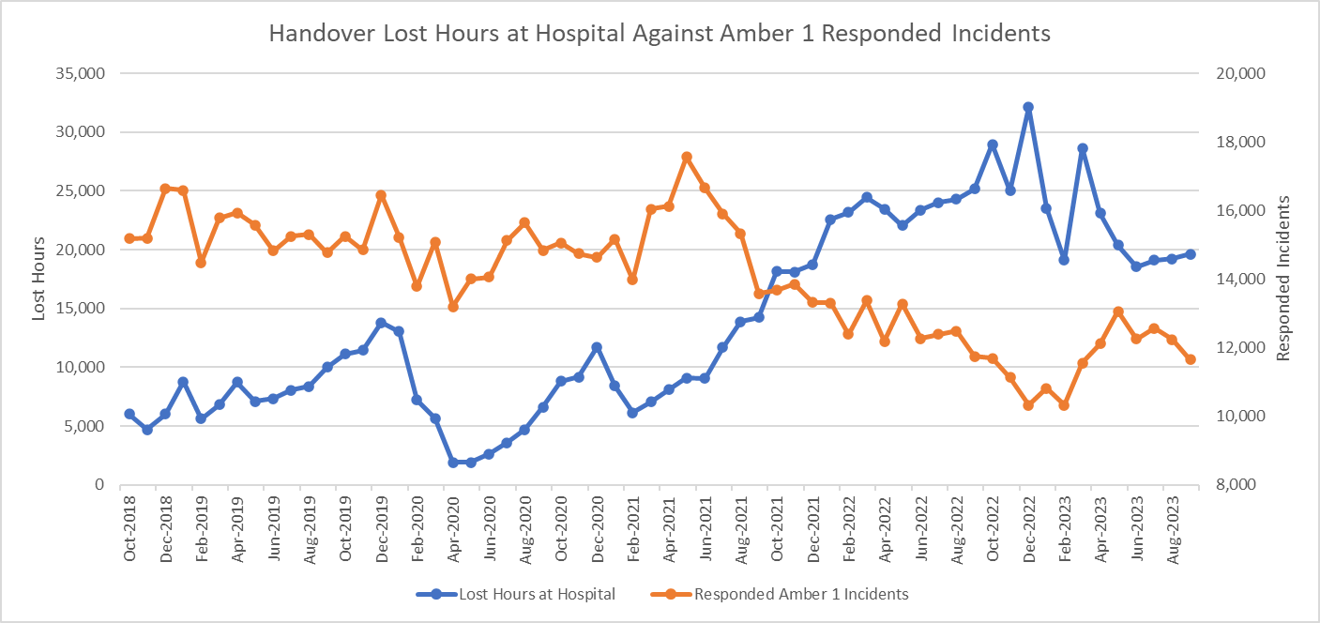
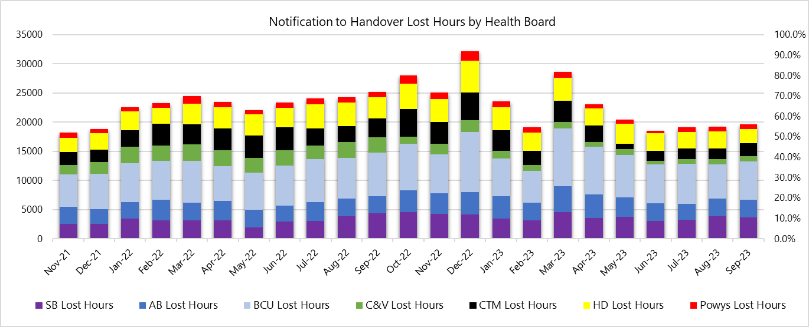

2.15 In Sep-23 only 5 Immediate Red requests were declined. 156 Amber 1 requests were accepted, but 291 were declined in Sep-23. There was some health board challenge as the accuracy of requests at Oct-23’s EASC Management Group. The EASC Team has organised a collaborative meeting to review WAST and health board processes. Clearly, if handover lost hours were much lower, immediate release would be much less of an issue.

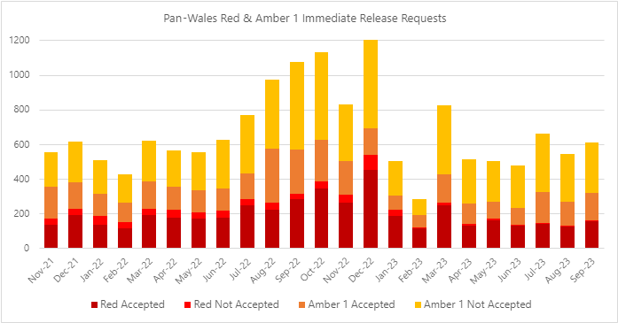

2.16 WAST continues to see an improvement in sickness absence, which positively impacts on resources available to respond. WAST achieved 8.3% in Sep-23. The 2023/24 IMTP ambition is to achieve 6% by Mar-24.
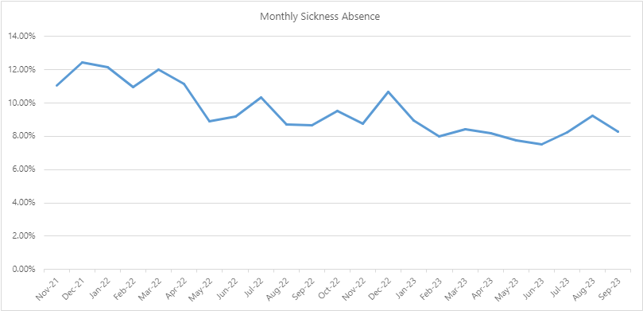

Shift Left
2.17 WAST achieved a consult & close rate of 12.6% in Sep-23. WAST has a 2023/24 IMTP ambition to achieve 17% by the start of quarter four. A corrective action plan is in place. WAST is also in receipt of a review of its remote clinical assessment of 999 incidents by the EASC Team. The review identifies improvements centering around benefits realization (assessment of and driving out benefits). WAST will formally respond in Nov-23 to the recommendations made, but broadly accepts them.

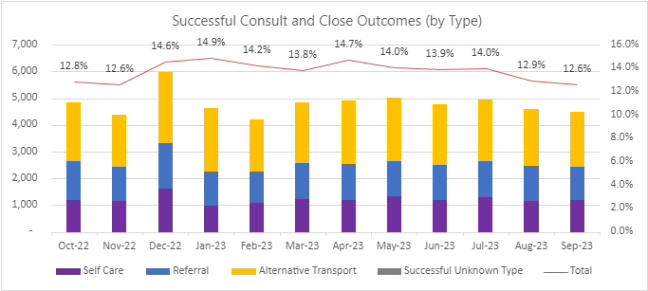
Health & Safety
2.18 Rates of incidents and concerns reported in relation to diesel fumes outside emergency departments (EDs) continue to be reported during Q2-Q3 2023/24 with a slight increase in Aug-23 and continuing to rise in Oct-22 and Nov-23. This remains a key focus within WAST.
Clinical Outcomes
2.19 Data is now available for Stroke, Fractured Neck of Femur, Hypoglycaemia, ST elevation myocardial infarction (STEMI) and Return of Spontaneous Circulation at Hospital. Improvement work, as a result of deep dive audits is underway to improve compliance (lower compliance was an identified risk based on experiences of English ambulance trusts who have moved to ePCR systems). Improvements include supporting users and Senior Paramedics and updates to the ePCR user interface are planned for delivery during Q3 2023/2024. The STEMI and stroke bundle compliance were 46% and 76% respectively in Sep-23 and the ROSC rate is as follows:

2.20 As a result of the predicted fall in clinical indicator compliance whilst the new system for creating clinical records becomes embedded, a risk has been raised with an associated action plan internally.

EASC is asked to NOTE that: Red and Amber response times remain too long and these continue to impact on patient safety. In Sep-23 seven patient safety incidents were reported to health boards (under the Joint Investigation Framework), where the primary cause is considered to be handover lost hours. WAST is taking a range of actions to improve Red performance, in particular, the full roll-out of CHARUs. Handover reduction remains critical to achieving acceptable response times and improved patient safety

Ambulance Care (including NEPTS)
2.21 Levels of NEPTS patient demand have increased and are at or in-excess of pre-pandemic levels for all journey types apart from outpatient journeys; however, the overall level of activity has still not recovered to pre-pandemic levels. A particular concern is the increase in patients requiring ambulance transport, with Sep-23 activity 10% higher than any other September in the last five years. This activity is putting significant pressure on Ambulance resource availability.
  - 73% (target 70%) of enhanced renal journeys arrived within 30 minutes prior to their appointment time in Sep-23. 78% (target 90%) of discharge & transfer journeys were collected within 60 minutes of their booked ready time.
  - This performance is against a background of volumes of completed renal journeys being higher in Sep-23 than at any time in the past five years. Again, patients requiring ambulance transport also seem to have increased more than walking patients, with the quarters completed journeys total a third higher than those recorded in the same quarter of 2018 & 2019. As renal patients form WAST’s highest priority patient, this impacts across overall service delivery.
  - To maintain current levels of performance and to protect the delivery of the service for those patients that need it most, i.e. enhanced service (renal & oncology) and discharge and transfer patients, the service has developed a refreshed approach to the way that the eligibility criteria set out in WHC 2007 (005) is ascertained and how transport requests for those patients not eligible are managed. A draft of this has previously been shared with commissioners via the NEPTS DAG, where it was supported.
  - WAST have been modelling the re-basing the Unscheduled Care Service, now part of Ambulance Care, and subject to internal approval and further discussion with the CASC and his team, is intending to tighten the scope of practice of UCS, so that it focuses on its core HCP 1-4 hour work and discharge and transfers.

EASC is asked to NOTE that: renal performance is on target; that discharge & transfer performance is close to target; and subject to formal governance WAST is intending to tighten the UCS scope of practice.

Commissioning, Planning and Service Change

Forecasting & Modelling
  - WAST is now well advanced with the next iteration of the collaborative and independent strategic demand & capacity review and expects the review to be available in Jan-24.
  - WAST has completed its winter forecasting and modelling. The modelling estimates a most likely scenario (MLS) of Red 8-minute performance of 50% (Oct-23 & Nov-23), declining to 45% in Dec-23 and early Jan-23, before recovering somewhat in Q4. The modelling estimates that the 65% Red 8-minute target will not be achieved at any point through the winter with Amber waits being too long.

  - The modelling is based on a range of variables including demand and time at hospital. The modelling is based on WAST’s assessment of handover lost hours, not EASC ambitions. The modelling also includes planned improvements during this Oct-23 to Mar-24 time frame, for example full roll out of CHARU (Jan-24), 17% consult and close (Jan-24) and 6% sickness levels (Mar-24).
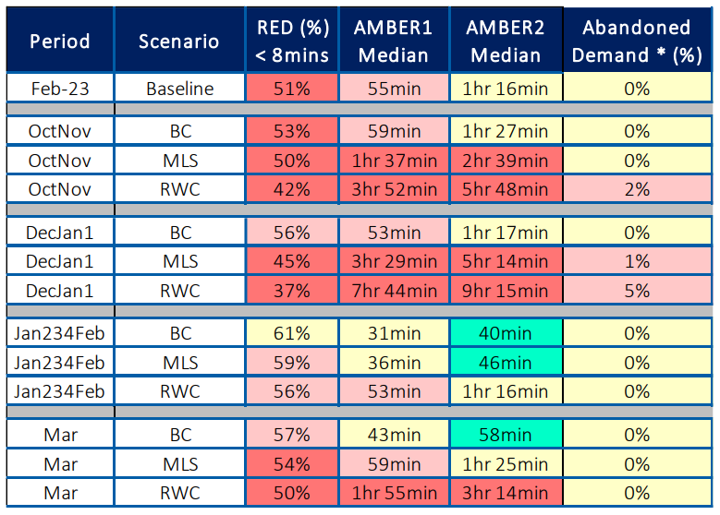
  - WAST continues to take action to manage pressures across winter, including an offer to health boards about boosting NEPTS discharge capacity. WAST will also review its escalation arrangements, review its clinical safety plan (both of which are already considered robust), plan winter communications, and set up a winter cell.

Manchester Arena Inquiry
  - WAST has recently undertaken two desk top scenario exercises linked to its work in responding to the recommendations from the Manchester Arena Inquiry. Various lessons have been learnt, which are now being acted on.

  - Clearly the levels of system pressure are a concern with regard to WAST’s capability to respond to a mass casualty incident. WAST has agreed with the EASC Team to undertake collaborative modelling of a mass casualty incident using advanced ambulance simulation software. WAST will continue to update EASC and also Welsh Government of its findings.

2023-26 IMTP
  - WASTs IMTP has been approved. Work is underway in terms of developing next years plan.

Financial Sustainability
  - WAST continues to focus on its financial plan through the Financial Sustainability Programme, in particular, its £6m targeted savings level. WAST is currently forecasting a breakeven position.

Health Board Engagement
  - WAST is continues to engage in the Integrated Commissioning Action Plan (ICAP) process and is updating its joint action plans across all Health Boards. WAST is also linked into most Health Board Six Goals for Urgent and Emergency Care Programme boards and it continues to work to ensure links between operational, clinical and strategic discussions around the Six Goals and ICAP agendas. These discussions are based on a set of key strategic objectives and a ‘menu of options’ for alternatives to conveyance.
  - Clinical pathway development continues to be a key agenda item for health boards, with identified need for pathways particularly around breathlessness and chest pain, linking in with six goals ambitions.
  - WAST continues to engage with the regionalisation agenda across Wales. Emerging priorities include the changes to critical care and services in Cwm Taf Morgannwg (CTM), requiring an approach to transfer and discharge.
  - In addition, WAST is currently engaged in the following live strategic service change programmes with Health Boards in Wales and Trusts in England:
- Swansea Bay Acute Services Reconfiguration;
- A Healthier Mid & West Wales (AHMMW);
- Stroke reconfiguration in Swansea Bay and Hywel Dda;
- Stroke reconfiguration in Cwm Taf Morgannwg and Cardiff & Vale;
- Stroke reconfiguration in Hereford and Worcester;
- South Wales Thoracic Surgical Services Programme;
- The Spinal Network;
- South East Wales Collaborative regional portfolio - orthopedics, diagnostics, pathology, endoscopy and ophthalmology programmes;
- Aneurin Bevan Clinical Futures; and
- Radiotherapy Satellite Centre, Nevill Hall Hospital.
2.38 WAST is also monitoring progress of the following service changes and will engage as and when required:
- Regional Treatment Centre in BCU;
- Future Fit (Shrewsbury & Telford Hospitals);
- Cwm Taf Morgannwg Maternity & Obstetrics (South Powys Flows); and
- Cardiff and Vale – Future Clinical Services Programme.

EASC is asked to note that: WAST continues to make reasonable progress against its IMTP deliverables. WAST continues to develop ICAPs with health boards and will continue to develop strategic actions aligned to Six Goals policy; WAST has begun planning for the 2024-27 planning cycle.

Conclusions and Forward Look

  - Current quality and performance levels and patient safety remain very challenging in EMS. NEPTS quality and performance is stable. Handover lost hours remain extreme and are a serious drain on WASTs capacity, which has increased, and ability to respond to patients and therefore patient safety. WAST has undertaken winter modelling and has winter resilience plans in place.
  - At a more strategic level WAST continues to develop its transformation programme designed to see more patients safely cared for at or near home; has started a new strategic EMS demand & capacity review; and will shortly start work on the next iteration of its IMTP.

- KEY RISKS/MATTERS FOR ESCALATION TO THE COMMITTEE

Members of the EAS Committee are asked to note that:

  - EMS response times remain below acceptable levels which in turn is causing levels of avoidable patient harm that are too high. WAST continues to take a range of actions within its gift to reduce response times and mitigate risk and harm;
  - Handover reduction remains the critical component to any material change in patient safety in the EMS;
  - Ambulance Care (including NEPTS) quality & performance is stable.

- IMPACT ASSESSMENT
Quality/Safety/Patient Experience implications | Yes (Please see detail below)
Quality/Safety/Patient Experience implications | Identified within the report
Related Health and Care standard(s) | Timely Care
Related Health and Care standard(s) | And all health and care standards
Equality impact assessment completed | Not required
Legal implications / impact | There are no specific legal implications related to the activity outlined in this report.
Legal implications / impact | Included within the body of the report
Resource (Capital/Revenue £/Workforce) implications /  Impact | Yes (Include further detail below)
 | Included within the body of the report
Link to Main Strategic Objective | The Committee’s overarching role is to ensure its Commissioning Strategy for Emergency Ambulance Services utilising the five step patient pathway outlined within the National Collaborative Commissioning Quality and Delivery Agreement and the related outcomes for each care standard aligned with the Institute of Healthcare Improvement's (IHI) ‘Quadruple Aim’ are being progressed.  This report focuses on all the above objectives, but specifically on providing strong governance and assurance and safe and effective patient care
Link to Main WBFG Act Objective | Service delivery will be innovative, reflect the principles of prudent health care and promote better value for users

- RECOMMENDATION

5.1 The EASC Committee is asked to:
- DISCUSS and NOTE the WAST provider report.

