AGENDA ITEM
2.7

EMERGENCY AMBULANCE SERVICES COMMITTEE

EASC FINANCIAL PERFORMANCE REPORT – MONTH 7
2023/24

Date of meeting | 21/11/2023

FOI Status | Open/Public

If closed please indicate reason | Choose an item.

Prepared by | Assistant Director of Finance
Presented by | Director of Finance
Approving Executive Sponsor | Chief Ambulance Services Commissioner

Report purpose | FOR NOTING

Engagement (internal/external) undertaken to date (including receipt/consideration at Committee/group)
Committee/Group/Individuals | Date | Outcome
 |  | Choose an item.

ACRONYMS
EMS | Emergency Medical Services (Emergency Ambulances)
EMRTS | Emergency Medical Retrieval and Transfer Services (Air Ambulance)
IMTP | Integrated Medium Term Plan
NCCU | National Collaborative Commissioning Unit
NEPTS | Non-Emergency Patient Transport Services
SLA | Service level agreements
WAST | Welsh Ambulance Services NHS Trust
WG | Welsh Government
- SITUATION

  - The purpose of this report is to set out the financial position for EASC for the 7th month of 2023/24 together with any actions required.

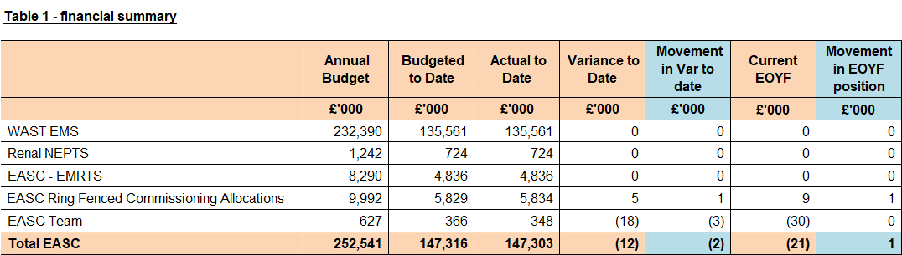

Background

  - The financial position is reported against the 2023/24 baselines following approval of the 2023/24 Integrated Medium Term Plan (IMTP) by the EASC Joint Committee in March 2023.

  - The National Collaborative Commissioning Unit (NCCU) baseline has been dis-aggregated from this report as it has a separate governance structure to EASC.

  - Please note that as LHBs cover any EASC variances, any over/under spends are adjusted back out to LHBs. Therefore, although this document reports on the effective position to date, this value is actually reported through the LHB monthly positions, and the EASC position as reported to Welsh Government (WG) is a nil variance.

  - In relation to the current financial position members agreed:

      - All members of the Committee have supported the EASC IMTP.

      - EASC has agreed with WAST financial support for overtime to fill operational vacancies included as part of the planned 100WTE recruitment. EASC has identified £3.485m through IMTP contingency funding and non-recurrent reserves, which will be available for WAST to increase overtime from September. A further £2m has been identified within the 6 Goals for Urgent and Emergency Care Programme taking the combined planned tapered funding support for WAST to £5.485m in 2023/24.
- SPECIFIC MATTERS FOR CONSIDERATION BY THIS MEETING (ASSESSMENT)

Governance & Contracting

All budgets have been updated to reflect the 2023/24 approved IMTP. The IMTP sets the baseline for all the 2023/24 contract values.

Emergency Medical Services (EMS) Contract

  - The current financial position of WAST is reported at breakeven.

  - The Welsh Ambulance Services NHS Trust (WAST) provider baseline assumptions are agreed with EASC and aligned to the IMTP as at the end of June 2023, in line with the WG deadline for confirmed Service Level Agreements.

  - The budget reported includes frontline support of £1.8m which is has been made recurrent in the IMTP and contributed to by all Health Boards

  - The funding for Renal NEPTS has been separated from the WAST baseline and is reported separately. Air Ambulance (EMRTS) has been transferred from WAST and now sits within EMRTS and will be paid directly to Swansea Bay University Health Board (UHB).

  - EASC and WAST have jointly agreed potential financial improvement options of up to £1.2m in year as a contribution to the deficit reduction. This will be developed and monitored with further savings returned through the commissioner riskshare as they materialise in the latter part of the year.

EMRTS

  - The EMRTS provider baseline is agreed with EASC and aligned to the IMTP as at the end of June 2023 and is covered in the Heads of Agreement document signed between the Welsh Health Specialised Services Committee (WHSSC) & Swansea Bay UHB for 2023/24.

EASC Core Running Costs Budget

  - The 23/24 annual budget has been uplifted to £0.627m to reflect the 22/23 recurrent pay award

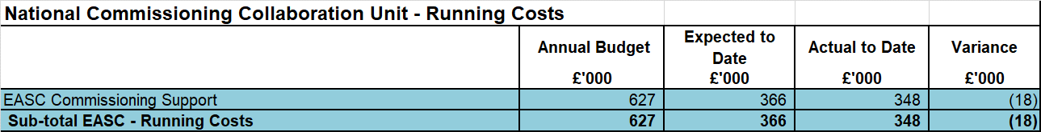

EASC Commissioning

  - An additional provision was made in the development of the 2022/23 EASC IMTP for the recurrent funding of the South East Wales Acute Coronary Syndrome pathway.

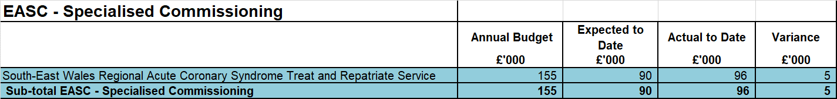

Summary of Key Movements and Issues

  - There is a reported variance of £5k related to inflation against the SEW Acute Coronary Syndrome Service budget.

Actual Year To Date and Forecast Over/Underspend (Provider positions)

WAST:

  - None reported to date

Direct Running Costs (Staffing and non-pay):

  - Team costs are based on expected staffing levels. EASC have committed to apply a £30k cost reduction to running cost budget as part of the financial improvement options, this is reported as achieved in M7 hence the (£18k) underspend in commissioner financial positions.

Actual Yearend Over/(under)spend 2023/24 (Commissioner positions)

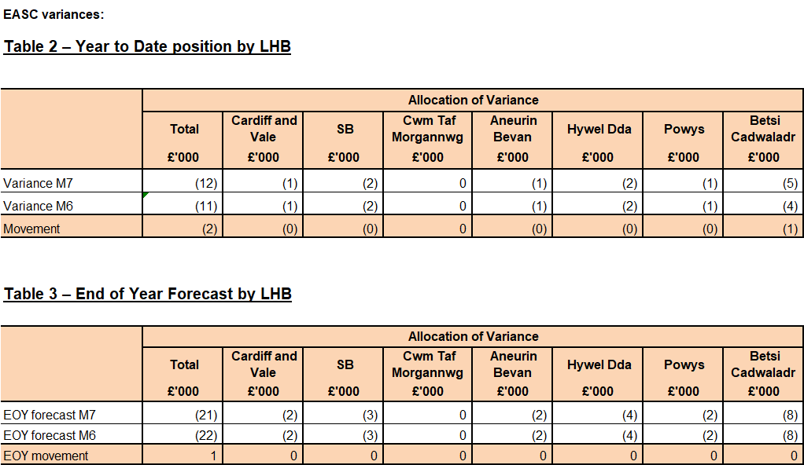

Income / Expenditure Assumptions

Income from LHBs:

  - Income for Month 7 is in line with the anticipated expectations. This is as EASC cannot overspend and health board contributions must balance to expenditure.

Overview of Key Risks / Opportunities

None

Public Sector Payment Compliance

  - The WHSSC/EASC payment compliance target is consolidated and reported through the Cwm Taf monitoring process.

- KEY RISKS/MATTERS FOR ESCALATION TO THE COMMITTEE

  - None to report

- Responses to Action Notes from WELSH GOVERNMENT MONTHLY MONITORING RETURN responses

  - WG M6 Reply Letter: No action notes require addressing from the M6 monitoring returns.

- IMPACT ASSESSMENT

Quality/Safety/Patient Experience implications | There are no specific quality and safety implications related to the activity outined in this report.
Related Health and Care standard(s) | ALL are relevant to this report
Equality impact assessment completed | Not required
Legal implications / impact | There are no specific legal implications related to the activity outlined in this report.
Resource (Capital/Revenue £/Workforce) implications /  Impact | There is no direct impact on resources as a result of the activity outlined in this report.
Link to Commissioning Intentions | The Committee’s overarching role is to ensure its Commissioning Strategy for Emergency Ambulance Services utilising the five step patient pathway outlined within the National Collaborative Commissioning Quality and Delivery Agreement and the related outcomes for each care standard aligned with the Institute of Healthcare Improvement's (IHI) ‘Quadruple Aim’ are being progressed.
Link to Main WBFG Act Objective | ALL are relevant

- RECOMMENDATION

  - The Emergency Ambulance Services Committee is asked to:

- NOTE the current financial position and forecast year-end position.

- Confirmation of position report by the Chief Ambulance Services Commissioner and the Director of Finance:
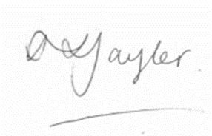

Stacey Taylor,
Director of Finance, EASC and WHSSC



Stephen Harrhy,
Chief Ambulance Services Commissioner, EASC

