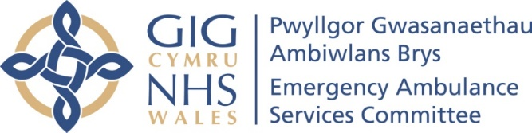 | AGENDA ITEM  10 September 2019

Emergency Ambulance Services Committee (EASC)
WELSH AMBULANCE SERVICES NHS TRUST (WAST) – SERVICE TRANSFORMATION PROPOSALS

Executive Lead: Jason Killens, Chief Executive Officer (WAST)
Author: James Houston (Planning & Performance Business Partner)
Contact Details for further information: James.houston@wales.nhs.uk

Purpose of the EASC Report

To provide EASC with an overview of the key discussion points to be raised at the meeting with the Minister for Health & Social Services and NHS Chairs on 23 September regarding a range of scalable service transformation opportunities and pre-hospital care pathways proposal for pan-wales implementation.

Governance
Link to the Commissioning Agreement | The development of pan Wales service transformation initiatives supports delivery against the EMS Commissioning Intentions to improve patient care the delivery of an effective and efficient clinical service.
Supporting evidence | Supporting evidence is included in the appendix for information
Engagement – Who has been involved in this work?
This paper has been shared and discussed with WAST Executive Management Team (28 August) and with Directors of Planning (6 September).
Emergency Ambulance Services Committee Resolution to:
APPROVE |  |  | ENDORSE |  |  | DISCUSS | √ | NOTE | √
Recommendation |  |  | EASC is asked to:  - Endorse proposed three service transformation initiatives suitable for scale up.  - Endorse the ongoing work regarding alternative care pathways and.  - Endorse that the agreed output of the pathway work (and any identified resource implication for Heath Boards) should be included within 2020/21 Health Board IMTPs
Summarise the Impact of the Emergency Ambulance Services Committee Report
Equality and diversity |  |  |  | There are no implications arising directly from this report.
Legal implications |  |  |  | There are no legal implications arising directly from this report.
Population Health |  |  |  | EMS ambulance response times are a key determinant of population health, particularly, for Red – immediately life threatening calls – the report provides proposals for service transformation initiatives focussed upon improving ambulance response and enable wider improvement across the unscheduled care system
Quality, Safety & Patient Experience |  |  |  | There are no specific references to SAIs or Quality concerns.
Resources |  |  |  | The report provides information on proposed service transformation initiatives with reference to possible resource implications.
Risks and Assurance |  |  |  | WAST has a Risk Management Framework and Corporate Risk Register. No corporate risks are directly flagged in this paper.
Health & Care Standards |  |  |  | The 22 Health & Care Standards for NHS Wales are mapped into the 7 Quality Themes:  Staying Healthy; Safe Care; Effective Care; Dignified Care; Timely Care; Individual Care; Staff & Resources  http://www.wales.nhs.uk/sitesplus/documents/1064/24729_Health%20Standards%20Framework_2015_E1.pdf  The work reported in this summary and related annexes take into account many of the related quality themes.
Workforce |  |  |  | The report indicates possible workforce implications to enable the proposed service transformation initiatives.
Freedom of information status |  |  |  | Open

WELSH AMBULANCE SERVICES NHS TRUST (WAST) – SERVICE TRANSFORMATION PROPOSALS

- SITUATION

The purpose of this paper is to:
- Seek endorsement from EASC to share three service transformation initiatives suitable for national scale up with the Minister at the Chairs meeting with the Minister at the end of September, in line with his expectations;
- Seek endorsement from EASC that these three service transformation initiatives will be included in 2020/23 IMTPs, noting that further work will be undertaken in the coming months to determine the financial implications;
- Seek endorsement from EASC to support the ongoing work regarding alternative care and referral pathways from WAST to Health Board services.

- BACKGROUND

At the NHS Wales Chairs’ Peer Group meeting in December 2018 the outcome and recommendations of the Amber Review, which had been published in November 2018, were considered. This led to a discussion around some of the ways in which the Welsh Ambulance Service NHS Trust (WAST) and Health Boards (HBs) could work together to develop pathways and services which avoided Emergency Department attendances or hospital admissions and reduced demand for such, which in turn would free up WAST resources to respond more appropriately to the amber category calls.

A paper was requested from WAST for the Chairs and Chief Executives on these issues.

A paper was presented at the 7 February 2019 meeting which outlined a range of service improvement initiatives being delivered by WAST in collaboration with Health Board partners to improve patient care and reduce pressures across the wider unscheduled care system through collaboration and joint working.

A further paper was subsequently requested for the Chairs and Ministerial meeting in September 2019 to put forward;
- An approach to standardising and rolling out All Wales Pathways.
- A refined list of initiatives from those initially identified in February as being ‘scalable’ across Wales and which initial evaluation is suggesting there are system wide benefits to scale up.

- ASSESSMENT / GOVERNANCE AND RISKS

Nationally Scalable Service Transformation Initiatives

Building on the paper presented on the 7 February a longlist of service transformation initiatives were considered for scaling up pan Wales (table 1).
Table 1:
Area | Scheme
National | Roll Out of National 111 service
National | Clinical Desk – Expansion of Hear and Treat
National | Roll out of Advanced Paramedic Practitioners
National | Level 1 Falls Response - Falls Assistant Trial
National | Managing Non-Injury Falls Patients in Nursing / Residential Homes
National | Management of Frequent Callers
SBHB | Paramedics Supporting Out of Hours Service
SBHB | Joint Working with Acute Clinical Team
ABUHB | Level 2 response to Possible Injury Falls
ABUHB | Joint Response Unit
BCU | Pacesetter – APPs in primary care
BCU | Single Integrated Clinical Assessment and Triage (SICAT) Service
Cwm Taf Morgannwg | Community Paramedic St John medical practice
Cardiff and Vale | Joint working with Care Home Integrated Support Team
Cardiff and Vale | Falls Response Team
Hywel Dda | Provision of APP Support to Primary Care Services
Hywel Dda | Provision of APP support to GP Out of Hours Services
Powys | Clinical Support in Welshpool MIU
Powys | Community Admission Avoidance Pathway

Further detailed information on many of these schemes can be found in annex 1.

This long list was subsequently reduced and refined into three opportunities that are suitable for scaling up at pace across Wales, with early/emerging evaluations showing very positive outcomes and benefits to the wider health system.

A brief summary of these opportunities is shown below with Annex 2 providing a more detailed proposal on a page for each.

WAST has long since championed the increased role it could play in supporting the wider unscheduled care system in Wales, and these are set out it its Long Term Strategy. As such, these three opportunities do not represent the full extent of the potential transformation that could be taken forward. However in recognising that any organisation and/or system has a finite capacity for the amount of change it can progress at one time, these opportunities represent a pragmatic first step, with further system changes to be proposed and put forward in due course once these initiatives are bedded in.

Scheme 1 - Falls Response Model

WAST has developed a Framework for falls which encompasses five elements;
- Prevention: Recognizing the opportunities within WAST to contribute to the prevention of falls
- Supporting Community Resilience: Working with Nursing and Residential Homes so that they are able and equipped to assist people who fall
- Assessment (Hear and Treat): Ensuring we make the right assessment of the fall (uninjured, possibly injured, injured) so that we deploy the right level of resource
- Response (See and Treat): A falls Response model
- Avoiding Further Harm: Falls Referral pathways/ awareness of the development of pressure ulcers.

In addition the framework advocates three levels of falls response;

Level 1- Non injury faller attended by a falls assistant
Level 2 – Possible injury as a result of a fall needing assessment
Level 3- Injury fall requiring emergency response

A comprehensive Level 1 response service, currently provided by St John Ambulance, is now in place across South Wales funded on a non-recurrent basis. A bid has been put forward to expand this to the whole of Wales on a recurrent basis, through the EASC Healthier Wales funding, to be considered under separate agenda item. There is therefore the potential to have scaled this service up nationally by the end of this financial year.

Early evaluations of a level two pilot within Aneurin Bevan Health Board suggest significant benefits exist to moving towards the scale up of Level two falls. EASC are asked to support further work to evaluate and develop proposals further for a scale up of Level 2 response across Wales, to be included in Integrated Medium Term Plans (IMTPs) next year.

Scheme 2- Advanced Paramedic Practitioners

An Advanced Paramedic Practitioner (APP) is a paramedic with additional clinical and diagnostic skills to manage complex and frail patients in a community setting. WAST has developed an innovative rotational model with which sees these paramedics rotate across three areas;

(i)Working within the community on an Ambulance Rapid Response Vehicle (RRV)
(ii) Working within Clinical Control Centres (CCCs)
(iii) Working within Primary Care / out of hours (OOH)

This full APP rotational model is in place within parts of a number of Health Boards including Hywel Dda, Betsi Cadwaladr and Aneurin Bevan, although the primary care component varies in each Health Board.

Additional resources have been agreed on shared funding basis between WAST and Health Boards for an additional 26 APPs to move this model forward across Wales, and these will commence their APP training in September 2019.

A significant amount of work has been undertaken on the evaluation of the RRV element of the rotation model, which shows a major impact in being able to treat patients at home or refer to alternative pathways, avoiding conveyance to hospital in around 65% of cases (Band 6 paramedics typically convey around 65% of the same call codes). However, it is recognised that further evaluation is required on the CCC and primary care aspects of this model, and a formal evaluation will now be completed in Quarter 3 of this financial year.

Having received the results of the evaluation, and also having received the outcome of the D&C review which will model the maximum impact of the APPs in the RRV element of the rotation, it will then be possible to determine the most beneficial model for APP expansion within each Health Board area, for inclusion in IMTPs.

Scheme 3- WAST as a Call Handler of Choice (this represents a ‘blend’ of SICAT in BCU and AGPU in SBHB)

Building on the excellent collaborative relationships which exist between local WAST and Health Boards clinicians and managers a series of local initiatives have been piloted that, whilst all slightly different in their approach and/or composition, have a common theme of providing integrated clinical assessment & triage of calls coming into WASTs clinical contact centres, with the aim of reducing unnecessary ambulance dispatches and ultimately demand on A&E departments.

Local evaluations are showing significant benefits and positive outcomes for patients and the system to the extent that an opportunity exists for WAST to develop a ‘blended’ model which can be standardised and rolled out across Wales. A model which starts to see WAST being described as a call handler of choice.

This model should include consideration of mental health practitioners to support the assessment and triage, as a large number of calls on the ‘stack’ require this specialist input, and a conveyance to an ED is typically far from the ideal response.

It is proposed that the scale up of these models across Wales should be funded from winter pressures funding, so that benefits can be felt at pace and to improve system performance this winter. Any recurrent funding requirements would then be factored into IMTPs.

Pre-hospital Clinical Pathways / Wider system referral pathways

In 2012/13 WAST led a joint work stream with all Health Boards across Wales to develop and implement three national ACPs for non-injury falls patients and patients with a resolved hypoglycaemic or resolved epileptic episode.

Over an 18 month period the three clinical pathways were implemented within each of the seven Health Boards across Wales. The success of the project was predicated on the principle of implementing a standardised pathway process with clear clinical guidelines and robust referral process.

Since then WAST has continued to implement new ACPs, however this has focused upon establishing more local pathways at a Health Board or locality level. Whilst this has increased the number of ACPs in place, covering a wide range of different clinical conditions, this has meant that there is variation in the type of pathways available across Health Board boundaries with different clinical criteria and underpinning referral processes.

As a result of this variation it can mean that frontline clinicians are unclear of the local pathways available and how to access them, especially if they are responding to a 999 call outside of their Health Board boundary. This can result in patients being unnecessarily conveyed to hospital when they were clinically suitable to be safely referred to an ACP.

To address these challenges and in response to deliver against the EMS Commissioning Intention ‘Step 5 – Fewer conveyances and more conveyance to other locations i.e. non Major Emergency Departments’ the Trust has formalised a programme of work to take this work forward.

A Pathways Development Group has been established to oversee and set out a clear vision for the future development of ACPs. The founding principle of this work stream is to identify and implement a range of standardised ACPs for the high volume / high activity patient groups, which can implemented on an all-Wales basis.

To progress this work stream a workshop with Operational and Clinical leads has been arranged for the 9 September to review the activity data and identify a range of national ACPs for consideration and discussion with wider system partners.

Whilst this work is ongoing the table below provides an indication of the condition specific pathways and wider system referral pathways that may be identified as part of this work.

Possible condition specific pathways
- Chest Pain
- Respiratory
- Falls
- End of Life
- Mental Health.
Proposed standardised access pan Wales to system wide clinical services
- Standardised access to Minor Injury Units
- Standardised access to refer into Primary Care services (GPs)
- Standardised referral pathway into social services (e.g. frailty)
- Standardised referral pathway to Community / District Nursing teams for an agreed set of patient conditions (e.g. blocked catheter).
- Standardised access to secondary assessment pathways, avoiding ED and allowing for the treatment of higher risk patients in a non-ED setting.

In order for progress to be made across these areas and opportunities to be realised it is vital that a collaborative approach between WAST and Health Boards is taken. As such Health Boards are asked to signal not only their commitment to this work in their 2020/21 IMTPs but also to take the opportunity to identify the resources which they may require to subsequently implement those pathways which have been developed.

It is anticipated that a number of these referral pathways will be implemented within this financial year.

- RECOMMENDATIONS

The Emergency Ambulance Services Committee is asked to:
- ENDORSE the proposal to share three service transformation initiatives suitable for national scale up with the Minister at the Chairs meeting with the Minister at the end of September, in line with his expectations;
- ENDORSE the requirement to include these three service transformation initiatives in 2020/23 IMTPs, noting that further work will be undertaken in the coming months to determine the financial implications;
- ENDORSE and support the ongoing work regarding alternative care and referral pathways from WAST to Health Board services.

Freedom of information status | Open

Annex 1: Longlist background information

NATIONAL INNOVATIONS
- Roll out of the National 111 Service
Status: Live – Phased roll out
Steps: Step 1 - Help Me Choose & Step 2 - Answer My Call

The 111 service is a free-to-call single number non-emergency medical helpline, available 24 hours a day, seven days a week. Patients can access 111 for health information, advice and access to urgent care.
The 111 service is currently live in 4 of the 7 health boards across Wales. Work is underway in readiness to roll out the 111 service to Aneurin Bevan Health Board in April 2019 and Cwm Taf Health Board in September 2019.
The following table provides the 111 implementation timetable:

Health Board | Go Live Date
Abertawe Bro Morgannwg UHB | October 2016
Hywel Dda UHB (Carmarthen Only) | May 2017
Hywel Dda UHB (Pembs & Ceredigion) | October 2018
Powys THB | October 2018
Aneurin Bevan UHB | April 2019
Cwm Taf UHB | Proposed September 2019/20
Betsi Cadwaladr UHB | Planned for 2020/21 onwards
Cardiff & Vale UHB | Planned for 2020/21 onwards

The benefits of 111 include:
- Access to 24/7 health information and urgent clinical advice;
- Helping patients choose the right care and reducing hospital admission where appropriate;
- Improved ability to stream activity between emergency and urgent handling and response.
It is anticipated that WAST’s provider role in this service will be recognised formally in the near future.

- Clinical Desk: Increasing Hear and Treat
Status: Live – recruitment ongoing
Steps: Step 2 – Answer my call

There are a number of patients who dial 999 and do not require an ambulance response. Some of these patients are suitable for a clinical assessment over the phone from a clinician based in one of the contact centres on the ‘clinical desk’ (known as Hear & Treat). The clinician will assess the patient and, based on the patients’ needs, will determine the most appropriate ongoing care, which could include referral to a local community based service.
The clinical desk plays an important role in assessing patients over the phone and, in recognition of this, funding has been agreed by EASC and Health Boards to recurrently expand the clinical desk capacity through recruiting an additional 11 clinicians. The monthly combined hear and treat rate (proportion of calls that do not require an ambulance response) is currently around 8% and, following the investment, the Trust’s target is to reach 12%.
Recruitment to these additional posts is currently on-going and all are expected to be filled by Spring 2019.
The benefits of the clinical desk include:
- Increasing the number of calls resolved through hear and treat;
- Reducing unnecessary ambulance dispatch;
- Increasing ambulance resource availability.

- Roll out of Advanced Paramedic Practitioners
Status: Live – recruitment ongoing
Step 3 Come to See Me & Step 4 Give Me Treatment)

An Advanced Paramedic Practitioner (APP) is a paramedic with additional clinical and diagnostic skills to manage complex and frail patients in a community setting. APPs are trained to a Master’s degree level following the completion of a two-three year academic and clinical education programme.
The APP role is becoming increasingly important in providing care for patients with complex chronic conditions in a community setting.
In 2017 WAST piloted a new framework in Betsi Cadwaladr which tested the effectiveness of utilising Advanced Practice resources in a rotational model with the aim of safely reducing conveyance to Emergency departments, and allowing more patients to be cared for in the community, closer to home. A team of APPs were in place 12 hours a day, rotating between the Clinical Contact Centre and two operational Rapid Response Vehicles (RRV), and they dealt with 1045 incidents over the five month pilot period.
- Of the patients the APPs attended, 307 conveyances to ED were prevented, compared with the conveyance rates of conventional paramedics.
- This represented a 70% reduction in A&E attendance.
- Only 13% of patients seen by an APP required an Emergency Ambulance vehicle.
- 98% of patient survey responses showed a high level of satisfaction with the service that they had received.
The net effect for patients was that they had access to the right care from the right clinician at a much earlier point than they may have done otherwise.
Through discussion and collaboration with Health Boards, WAST have added a further rotation into the model, with placement into the Primary Care or Out of Hours settings. These highly educated clinicians can work effectively to support the wider health community, whilst also further developing their proficiency in managing complex patients with multiple comorbidities. The model as now planned is set out below.
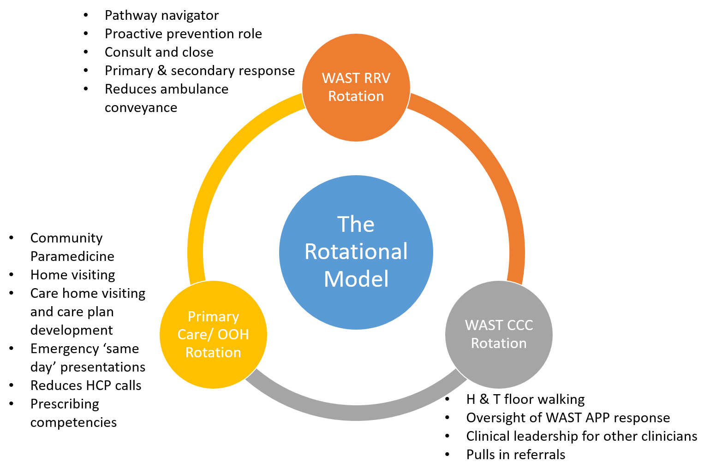

A Business Case was submitted to EASC in autumn 2018 (embedded below), which set out a plan to substantially increase APP service delivery year upon year until 2023 in order that these benefits could be extended across Wales. Recurrent funding has been confirmed by Health Boards for a first phase of expansion, with recruitment to an initial cohort of 20 APPs. These will start to be operational from February 2019, with the full cohort expected to be in place by Spring 2019.
As well as making the North Wales APP team permanent, the new investment will allow for the formation of a new team in South East Wales and expanding the existing APP team in ABM and HD Health Board areas. This will create a consistent and reliable APP presence across each area for a minimum of 12 hours each day.
WAST will be closely monitoring and evaluating the impact that this change has across Wales, in order to ensure that the patient and system benefits are established. If additional benefits continue to be demonstrated, discussions will continue with EASC and Health Boards in terms of any further expansion.
There are a range of different APP initiatives that have been trialled and developed at a Health Board level.
These scheme have illustrated not only a dramatic increase in the number of patients being managed within a community setting but also supporting the wider unscheduled care system in providing highly skilled and competent clinicians, increasing the capacity within primary care provision, in and out-of-hours.

Upscaling this initiative will require support in respect of increased throughput on the requisite educational pathway and support for WAST in ensuring that existing service provision is maintained during the expansion. The addition of non-medical prescribing for these clinicians, further develops the potential for this role by adding greater autonomy to their practice and reducing hand offs between clinicians.

Significant interest in the role exists within the WAST paramedic workforce and as such, with the correct support, increasing the number of APPs to substantiate this system wide working could be undertaken over the medium to long term.

- Management of Falls Patients
Status: Live
Steps: Step 3 - Come to See Me, Step 4- Give Me Treatment and Step 5 -Take me to Hospital

Falls account for a high demand on WAST services, second only to breathing problems and in 2017/18 WAST received over 62,000 calls relating to falls, of which 50% resulted in attendance at a hospital.
In response to this, WAST has developed a Falls Response Framework to provide a holistic approach to falls, from prevention to avoiding further harm as set out in the diagram below.
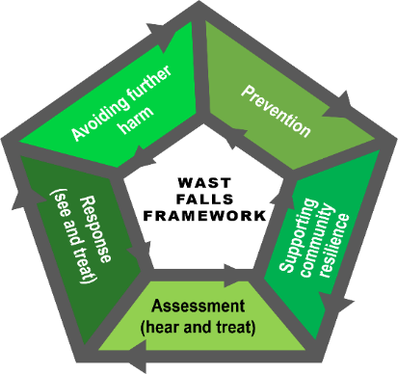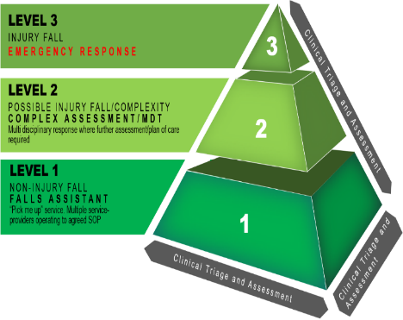

Level 1 Falls Response - Falls Assistant Trial
In relation to the Falls Response Model, WAST have received additional non-recurrent funding in Winter 2018 which has allowed the Level 1 Falls Assistant Model to be expanded across most of Wales. The Falls Assessment Trial is a collaborative initiative with St John Ambulance, Wales providing a response to clinically suitable low acuity falls patients. An evaluation report for this pilot is appended below.
The Falls Assistant is a non-clinical role that attends the patient (who has been determined to be a non/minor injury fall) to pick them up safely from the floor and undertake a further assessment of the situation at scene, supported by the Clinical Support Desk where a Paramedic or Nurse provides clinical advice and direction.
There are now seven vehicles across South Wales covering five Health Boards. These are based from Llanelli to Chepstow. In North Wales, there has been a Falls Assistant Model in place for some time, provided by WAST Community First Responders. A full evaluation is underway using a set of measures focusing on patient outcomes, process measures and balancing measures, and some data will be available in February, once 2 full months of data is available.
Data to date, notwithstanding the limited amount, appears to show a relatively low conveyance rate to hospital and a quicker response time than would have been achieved otherwise. Continuing these Level 1 services on a recurrent basis will be one of WAST’s priorities for 2019/20, and this will be discussed further with the Commissioner as part of the discussions on the allocation of the ‘A Healthier Wales’ funding.

Managing Non-Injury Falls Patients in Nursing / Residential Homes
It was recognised that high volumes of 999 calls from nursing and care homes were for patients who had fallen and requested an ambulance response. Following a clinical assessment it was identified that many of the patients did not sustain any injuries, but did require picking up off the floor.
To better manage patients who have fallen, WAST have rolled out training and education to care and nursing home staff across Wales. This has included the ISTUMBLE falls assessment tool. ISTUMBLE is a supportive decision making tool to help identify the right care for a falls patient and determine if an ambulance response is required. An example of the impact of this initiative is demonstrated in ABHB whereby the pilot achieved a 41% reduction in calls to 999 and has led to greater staff confidence within care homes and better outcomes for patients.
The main benefits include:
- Patients receive the right care to meet their needs;
- Reduction in 999 calls for an ambulance response;
- Improved ambulance availability.

Moving forward, funding has been identified to procure lifting equipment to enable staff to safely lift non-injured falls patients off the floor and therefore not require an ambulance response.
EASC have procured assisted lifting aids for use by care and nursing homes. The Trust is working with the Chief Ambulance Services Commission to provide training for care and nursing home staff to use the assisted lifting aids and therefore reduce ambulance responses to low acuity falls patients and subsequent conveyance to ED.

- Management of Frequent Callers
Status: Live – Business As Usual
Steps: Step 3- Come to See Me & Step 4- Give Me Treatment

A pan-Wales initiative has been taken forward to improve the management of frequent callers. This initiative has been developed in collaboration with each Health Board whereby WAST, Health Board and other service leads have developed a multi-disciplinary approach to identify, review and put into place robust care plans for frequent service users.
The benefits of this initiative include:
- Improved care and support for service users with previously unmet needs;
- Collaborative approach to better manage high frequency service users;
- Reduction in 999 calls and ED attendances.

SERVICE INNOVATIONS BY HEALTH BOARD AREA

- ABERTAWE BRO MORGANNWG UNIVERSITY HEALTH BOARD

Paramedics Supporting Out of Hours Service
Status: Live
Steps: Step 3- Come to See Me & Step 4 -Give Me Treatment

This initiative was developed in partnership with ABMU in response to the capacity challenges facing the Out of Hours Services. The initiative involves paramedics providing clinical support to the GPOOHs, undertaking routine home visits on their behalf during the out of hour’s period.
A trial was undertaken in November 2018 that demonstrated a range of patient and system benefits including:
- More timely patient responses requiring an out of hours face to face assessment;
- Additional clinical capacity thus freeing up capacity of the OOH GPs to meet incoming demand.
Arrangements are in place to formalise the trial to provide permanent support to the OOHs, 7 days a week. Abertawe Bro Morgannwg University Health Board have also funded 2.8 WTE Band 6 Paramedic equivalent positions to rotate through GP out of hours at night to undertake home visits. This is currently run as a Rapid Response Vehicle (RRV) model which includes red call response.
There is scope to replicate this model in other areas to strengthen and enhance fragile OOH services, particularly as we expand Advanced Paramedic Practitioners and pilot paramedic prescribing later this year.

Joint Working with Acute Clinical Team
Status: Live
Steps: Step 3 -Come to See Me & Step 4- Give Me Treatment

The Acute Clinical Team (ACT) is an acute intervention service designed to prevent admission from hospital or to support/facilitate early discharge from hospital. Arrangements are in place with the Acute Clinical Team in Bridgend to access and respond to clinically appropriate 999 calls. This pathway enables patients to be cared for in the community and helps to free up ambulance capacity to respond to incoming 999 calls that require an ambulance response.

This model has been successfully embedded within the Bridgend locality. The main benefits include:
- Patients receive the right care to meet their needs;
- More patients treated and cared for in the community;
- Reduction in 999 calls requiring an ambulance response;
- Supports a reduction in the number of patients conveyed to ED.
Opportunities have been explored to roll out this model across Swansea and Neath Port Talbot localities. At present, due to capacity constraints experienced by the Acute Clinical Teams in Swansea & Neath Port Talbot, it is not possible to roll out the initiative in these areas.

- ANEURIN BEVAN UNIVERSITY HEALTH BOARD

Level 2 response to Possible Injury Falls
Status: Live
Steps: Step 3 - Come to See Me & Step 4 - Give Me Treatment

A Level 2 falls response is required where it is unclear if there is an injury or where the patient has co-morbidities or complex needs. In this initiative, a multi-disciplinary team is used to undertake a comprehensive assessment of the person in their own home and implement an appropriate care plan according to their individual need. Within the ABUHB area, a Falls Response Service (FRS) has been operating since October 2016 and consists of a Paramedic and Physiotherapist operating daily between 8.00am and 8.00pm. This has been supported by the Welsh Government Integrated Care Fund.
The Falls Response Service has had involvement with 1,961 falls incidents received via the 999 system from October 2016 to 31st December 2018. 1,475 people (75%) have remained at home following assessment and/or treatment by the team with the appropriate care being provided by community based services. Only 486 individuals (25%) required further treatment and/or treatment at hospital, and only 17% of individuals required treatment within an Emergency Department.
The benefits of this model include:
- Improved response to falls patients;
- Increased number of falls patients care for at home or referred to community services;
- Reduced number of patients conveyed to ED.

Joint Response Unit
Status: Live
Steps: Step 3 -Come to See Me, Step 4- Give Me Treatment and Step 5- Take me to Hospital

WAST receives around 24,000 emergency calls per annum from the Police, equating to 80 calls per day. Analysis has shown that the majority of these calls (78%) are for low acuity problems.
Within ABUHB, WAST works alongside Gwent Police using the Joint Response Unit (JRU). The JRU is an initiative to provide a single joined-up response to instances where both organisations need to attend an incident (e.g. RTC’s, assaults, mental health patients at risk of harm) with the key objective being to improve patient outcomes, experience and improve efficiencies between the two organisations. Variations on the Gwent JRU exist in other Health Board areas including Pembrokeshire, Cwm Taf and ABM.
The JRU commenced in July 2016 and, following a joint activity analysis, operates between 16:00 and 02:00 hours every Friday, Saturday and Sunday. The JRU has an experienced Paramedic and Police Officer on a WAST Rapid Response Vehicle and covers the Gwent West area.
The JRU can be dispatched by either control rooms or can self-task; Police will process requests for WAST assistance as normal although the JRU may be dispatched simultaneously. The JRU will only deploy to incidents that require a joint response to an incident unless they are nearest to a Red call then the JRU can be dispatched.
JRU activity from 01/08/17 – 31/07/18 is outlined below:

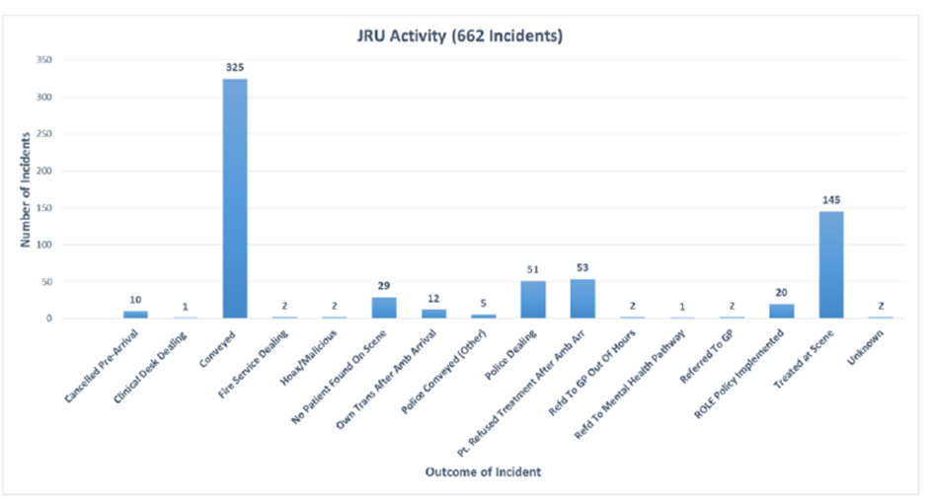

Continuing and expanding JRU schemes on a recurrent basis will be one of WAST’s priorities for 2019/20, and this will be discussed further with our Commissioner as part of the discussions on the allocation of the ‘Healthier Wales’ funding.

BETSI CADWALADR UNIVERSITY HEALTH BOARD
Pacesetter
Status: Implementation stage
Steps: Step 3 Come to See Me & Step 4 Give Me Treatment

Welsh Government have provided funding for a ‘Pacesetter’ trial. The Project involves placing APPs into primary care as part of the full rotational model. The Project Board is established and working towards establishing the initial wave of APPs into the primary care rotation by 1 April 2019. The intention is to offer 8 APPs at 0.5WTE for a 2 year period, supported with a bespoke education framework developed by GP educators. The APPs will be offered to North Gwynedd, South Gwynedd, and Central and Eastern Clusters. The proposal has to be presented to and ratified by the Project Board.

Single Integrated Clinical Assessment and Triage (SICAT) Service
Status: Implementation stage
Steps: Step 2 – Answer my call

WAST is supporting the implementation of the SICAT service into the Llanfairfechan Clinical Contact Centre. This project forms part of the Betsi Cadwaladr University Health Board 90 day plan with the funding for the GPs coming from them.

CARDIFF AND THE VALUE UNIVERSITY HEALTH BOARD

Joint working with Care Home Integrated Support Team
Status: Live
Step 3 Come to See Me & Step 4 Give Me Treatment

To improve the management of low acuity fallers in care homes, WAST & C&V Health Board have worked collaboratively to better manage and reduce this demand. The scheme involves an integrated approach between WAST and the CHIST and the aim of the initiative is to provide collaborative education and support to Care Homes across Cardiff and increase the confidence of Care Home staff to self-manage residents in the home environment. This initiative was piloted in 8 care homes within C&V Health Board.
The benefits of this initiative include:
- Improved care for patients in care homes;
- Reduction in 999 calls to care homes;
- Reduction in the number of patients conveyed to ED.

Building on a successful pilot the UHB are planning to expand from 8 care homes to 11 care homes. Further development of the CHIST team is linked to C&Vs bid for Transformation Funding.

Falls Response Team
Step 3 Come to See Me, Step 4 Give Me Treatment and Step 5 Take me to Hospital

To support the management of falls patient, a Falls Response Team has been developed jointly between WAST & the Health Board.
The Falls Response team consists of a Paramedic and a therapist from the Community Response Team providing a same day urgent response and home based clinical assessment. The service is in place and operating weekdays (08:30 – 16:30).The assessment looks to provide confirmation of physical injury and provide advice and signposting to community based services as appropriate.
The benefits of this initiative include:
- Improved response to falls patients;
- Increased number of falls patients care for at home or referred to community services;
- Reduced number of patients conveyed to ED.

CWM TAF MORGANNWG UNIVERSITY HEALTH BOARD
Community Paramedic St John medical practice
Status: Pilot Finished
Step 3 Come to See Me, Step 4 Give Me Treatment and Step 5 Take me to Hospital

The pilot was a joint initiative developed in partnership with St Johns General Practice and CTUHB. The purpose of the pilot was to explore the potential to reduce conveyance, A&E attendance, hospital admissions and to increase GP capacity.

It was a 12 month pilot where Advanced Paramedics supported the multi-disciplinary team model. The model used a ‘virtual ward’ with reference to their frailty, multiple complex health and social care needs. Individual care plans were developed using an MDT approach and advanced paramedics undertook home visits to develop packages of care on behalf of the medical practice. The pilot was a Bevan exemplar project and founded on the principles of prudent healthcare.
The pilot indicated a number of benefits:
- Increased GP capacity:
- Reduced attendances at A&E:
- Potential for reduction in admissions to secondary care.

HYWEL DDA UNIVERSITY HEALTH BOARD

Provision of APP Support to Primary Care Services
Status: Live – ad hoc
Step 3 Come to See Me, Step 4 Give Me Treatment and Step 5 Take me to Hospital

Arrangements were put into place for WAST APPs to support the delivery of Primary Care (GP) services in Hywel Dda. Under this initiative, the HD Primary Care Support Team would contact WAST to request APPs to support GP surgeries during periods of peak demand or provide additional clinical capacity when required. The scope of the APP was to undertake appropriately triaged home visits, and also to undertake pre-triaged consultations in the surgery on behalf of the GP in line with the daily patient schedule. The APP would carry out a comprehensive patient assessment in-line with their scope of practice and determine the best treatment options for the patient. A detailed SOP was developed with the Health Board setting out the operational arrangements. APP / Primary Care Support initiatives have been in place in Hywel Dda since 2014, however APP support to in-hours services has been recently diverted to Out of Hours (OOH) services to provide additional capacity (see initiative below). Ad hoc arrangements remain in place to provide APP support to GP services as and when required, and any ad-hoc support is recharged directly to the Primary Care Services within the Health Board.

The benefits of this model include:
- Increased GP capacity to care for patients in a primary care setting (in hours);
- Collaborative approach to managing patients in the community and avoid conveyance to hospital where clinically appropriate.

Provision of APP support to GP Out of Hours Services
Status: Live
Step 3 Come to See Me, Step 4 Give Me Treatment and Step 5 Take me to Hospital

Arrangements are in place for Advanced Paramedic Practitioners (APPs) to provide rostered hours supporting the delivery of the Out of Hours (OOH) service in Hywel Dda. The scope of the APP is to undertake patient consultations and home visits as identified by the OOHs GP. The core rostered hours are Monday – Friday 19:00 – 06:00 and Saturday & Sunday 09:00 – 21:00.
The benefits of this model include:
- Increased GP capacity to care for patients in a primary care setting (out of hours);
- Collaborative approach to managing patients in the community and avoid conveyance to hospital where clinically appropriate

This initiative is currently live and a detailed MOU has been developed with the Health Board setting out the operational arrangements. This initiative is funded directly by the Health Board and request for additional support are recharged and invoiced separately.

Minor Injury Unit Admission Criteria Development
Status: Initiative Underway
Step 3 Come to See Me, Step 4 Give Me Treatment and Step 5 Take me to Hospital

Work is ongoing to improve access and increase the number of clinically appropriate patients being conveyed to a Minor Injury Unit (MIU) across Hywel Dda. As part of this work stream the admission criterias for a number of the MIUs were reviewed to understand the access criteria for conveying ambulance patients directly to the unit. To date, the admission criteria has been reviewed and approved for Tenby MIU, and work is ongoing to communicate this and increase the number of clinically appropriate patients conveyed there. Work is also ongoing to establish a similar admissions criteria for Cardigan MIU.
The benefits of this initiative are:
- Clear admission criteria in place for Paramedics to convey appropriate patients to the MIU;
- Increase in the number of patients conveyed to an MIU;
- Reduction in the number of patients conveyed to ED who would have been suitable for treatment at an MIU.
POWYS TEACHING HEALTH BOARD
Clinical Support in Welshpool MIU
Status – Trial completed
Step 3 Come to See Me & Step 4 Give Me Treatment

A trial was undertaken in April to June 2018 whereby an Advanced Practitioner Paramedic provided clinical support in Welshpool Minor Injury Unit. The scope of the trial was twofold in terms of the APP providing clinical support caring for ‘walk in’ patients and secondly reviewing the 999 stack to identify ambulance patients suitable to be treated in the MIU.
The trial proved successful in terms of increasing the range of patients who were clinically appropriate and could be safely treated in the MIU in line with the APPs clinical scope of practice. This therefore enabled more patients to be treated in the MIU and avoided the need for treatment in ED. It also meant that more ambulance patients could be treated locally, not requiring a long journey to the nearest ED. One example of this initiative working in practice was the APP diverting a patient from Shrewsbury ED to be treated in the MIU closer to the patient’s home.
The benefits of this initiative include:
- Increased scope of practice for patients to be treated in the MIU;
- Reduced ambulance job cycle and journey times;
- Increase the number of patients treated in an MIU;
- Reduced the number of patients conveyed to ED.
This trial was undertaken to test the concept and the APP was on a bank contract. Currently there are no APPs in Powys, however if funding is identified as part of the wider APP initiative, this initiative could be fully embedded.
Community Admission Avoidance Pathway
Status – Live
Step 3 Come to See Me & Step 4 Give Me Treatment

A Community Admission Avoidance pathway has been developed for WAST clinical staff to refer clinically appropriate patients directly to the local district nursing teams.
The purpose of the pathway is to provide care closer to home by accessing and referring patients directly to the district nursing team who arrange to visit the patient at home. This pathway helps to avoid patients being conveyed to ED through accessing community based services.
The pathway was introduced into North & Mid Powys in summer 2018. To date circa 5-6 patients are referred via this pathway to the district nursing team per month. Work is ongoing to embed this pathway in South Powys and work is continuing to increase the number of patients referred using this pathway.
The benefits of this initiative include:
- More patients cared for in their own home / community setting;
- Reduction in the number of patients conveyed to ED;
- Improves ambulance availability to respond to incoming 999 calls.

