IMPROVING MANAGING PATIENT FLOW ACROSS
THE UNSCHEDULED CARE SYSTEM

A DISCUSSION PAPER
August 2019

INTRODUCTION
- The purpose of this paper is to set out a proposition for consideration which would improve the arrangements for managing patient flows and system risk across NHS Wales at all times and, in particular, during period of increased escalation and pressure, ensuring that the quality and safety of patient care is maintained.

- The Chief Ambulance Service Commissioner and Director of Unscheduled Care has requested that these proposals be prepared in the light of on-going pressures subsequent to discussions at EASC in July.

- In summary, WAST are well placed as a national provider with pan Wales system oversight and local in reach to every Local Health Board and Emergency Department to support the unscheduled care system across Wales, leading changes which are urgently required to provide solutions to the ongoing challenges of escalation and high pressure through:

  - Leading and strengthening the arrangements for the daily conference call;
  - Developing and agreeing intelligence-led protocols for the proactive movement of patients across the system;
  - Building an improved, system-wide, intelligent and live information base as an aid to decision making;
  - Coordinating the system wide management and response during periods of extreme pressure.

BACKGROUND

- A series of policies and practices are in place across Wales which were originally designed to support the wider unscheduled care system to effectively manage demand and capacity, particularly at times of high pressure.

- A national emergency pressures escalation and de-escalation action plan was agreed in March 2014 and is still extant. Its stated aim is to ‘enhance the effectiveness of patient flow and maintain patient safety through implementation of procedures that support best practice through proactive management’.

- This action plan sets out the criteria / measures that are used to determine the escalation status of each Health Board, and Health Boards are required to report on their escalation status each day.

- An integrated unscheduled care dashboard is in place, drawing key information on activity and performance automatically from Health Board and Ambulance service systems, and displaying these visually. All organisations are able to access and utilise this dashboard.

- A national teleconference call is held each day at 11 a.m., attended by Health Boards, WAST and Welsh Government. All organisations provide information on their current escalation status and highlight any areas of concern. The meeting is chaired in rotation by Executive leads from each Health Board, and additional calls can be scheduled at any time, dependent on pressures faced across the system.

- Each Health Board and Trust has its own internal escalation policies and procedures, along with an on-call system. At any point, on-call leads are able to liaise with their counterparts in other organisations to seek agreement on support required.

- As a result of these arrangements, agreement is reached at times to divert ambulances from one hospital to another. This is always as a result of discussions between Health Board leads, and Executive level approval is usually required. WAST’s Health Informatics function does not record the use of diverts, but the Ambulance Daily Occurrence Log for August 2019 (to 18 August 2019) has 97 entries relating to diverts (entries is not the same as the number of diverts or the number of ambulances diverted, but it does give a flavour of the level of activity).

CASE FOR CHANGE

- Whilst policies and procedures are in place as referenced above, there is more that could be done to coordinate both the improvement of proactive management action and the response at all times and, in particular, during periods of increased escalation to improve patient safety and patient experience across the system. Some of the on-going issues are set out in the paragraphs below.

- From an ambulance perspective, there continues to be significant numbers of patients who are conveyed to hospital that are delayed in their transfer into the Emergency Department in a timely fashion. This has a two-fold effect for patients: the patients in the back of the ambulances are not able to access the care and treatment that they require; and with ambulance resource thus tied up, there are insufficient ambulances to respond to patients waiting for an ambulance in the community. The graphs below show:

  - the number of lost hours month by month, which is showing a deteriorating trend, despite the fact that fewer patients were conveyed to EDs in Apr – June 2019 compared to the same period last year (45,979 patients v 55,740);
  - the increasing response times for red category patients;
  - the increasing response times for amber category patients. As an example, in April 2019, the 95th centile response time was 3:06 hours, compared with 2:22 hours the year before.

- There are around 100 patients each month who wait over 12 hours for an ambulance response (amber and green categories).
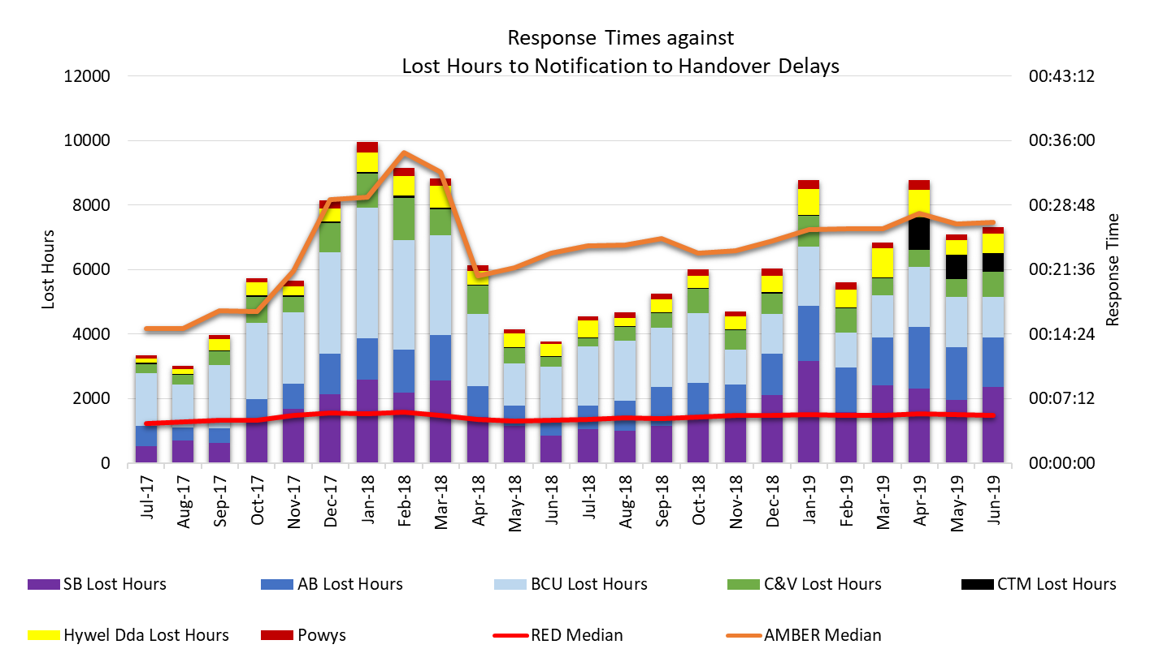

- WAST continues to deal with high numbers of serious adverse incidents, which, in the main, relate to these delayed ambulance responses to patients in the community.

- The following table shows the total numbers of serious adverse incidents reported to Welsh Government by Health Board area. The high level of SAIs in 2017/18 was a key trigger for the Amber Review, but it can be seen that the level of SAIs was actually higher in 2018/19.

SAIs Reported to WG
 | ABHB | SBHB | BCUHB | CVHB | CTHB | HDHB | POHB | Total
2017/18 | 17 | 10 | 12 | 6 | 2 | 1 | 0 | 48
2018/19 | 11 | 7 | 13 | 15 | 1 | 4 | 0 | 51
2019/20 to date | 6 | 5 | 0 | 0 | 1 | 1 | 0 | 13

- A number of key strategic actions are underway across Wales to support the unscheduled care system and EDs. These include:

    - WAST’s EMS Demand & Capacity Review, which will forecast future incident demand (over five years) and model the maximum impact WAST can have on reducing conveyance to major EDs through “shift left” activities;
    - Work within WAST to identify and develop national clinical and process pathways that could avoid conveyance to an ED;
    - the NCCU’s development of the ED QDF; and
    - Transformation work in the primary care sector designed to keep patients away from emergency departments and avoid hospital admission.

- At a tactical level Health Boards and WAST will also continue to focus on tactical planning, for example, winter planning.

- However, despite all of the good work being undertaken, the pressures continue to be evident across most parts of Wales with the majority of circumstances likely to be forecastable with the opportunity for proactive mitigating management action to be taken.

- In relation to the systems and processes put in place to address these pressures, it is evident that they do not function effectively. In relation to the daily teleconference call, the following observations are offered:

  - The meeting is used in the main as a mechanism for sharing information, as opposed to taking action;
  - The rotation of the chair means that there is little consistency in how the meetings are run, and there no record of the discussion is kept;
  - Accountability for the delivery of actions is limited with no action log being maintained; and
  - In the main, the meetings are also used to discuss the immediate problems presenting in the system, rather than proactively looking ahead 24/48 hours, or further.

- At a more fundamental level, individual Health Boards and WAST are held directly accountable by Welsh Government for a range of performance targets specific to their organisation. This performance management system does not generally lend itself to organisations freely supporting others, where this support could affect their own performance.

PROPOSED OPPORTUNITIES

- It is therefore proposed that action is taken to refocus the systems and processes between Health Boards and WAST and to address some of the long standing challenges set out above. Three linked proposals are set out for consideration.

Strengthening the Arrangements for the Daily Conference Call

- There is an opportunity to improve the management of the daily Conference Call between Health Boards, WAST and Welsh Government. WAST is proposing the following:

  - Call to be chaired by a system leader (rather than a rotating chair) to improve continuity, with the call being serviced and supported by WAST;
  - Purpose of call to be clarified through development of a terms of reference;
  - Set agenda (see Appendix 1 for example agenda, which also includes template report for each organisation on the call) to be agreed in three parts:
    - Review of last 24 hours (agreed actions, demand, capacity, performance, patient safety etc.);
    - Consideration of current position;
    - Look forward to next 24 hours (demand, capacity, performance, patient safety and agreed actions – initial focus to be 24 hours;
  - Call notes to be recorded and supplied by the system leader and action log updated.

- These arrangements will bring a consistency to the management of the call, and would be designed to be more action focused and proactive, with an expectation of an increased level of support across Health Boards and WAST in responding to pressures across the system.

- As a national provider, WAST is well placed to understand pressures across Wales, and as a service commissioned collaboratively by all Health Boards, would operate in the best interests of all Health Boards.

Developing and Agreeing Intelligence-led Protocols for Movement of Patients across the System

- It is proposed that protocols are developed and agreed which would allow for the movements of ambulances across the system, where there are excessive delays in ambulance turnarounds and / or A&E demand that might highlight potential patient safety concerns.

- Any such protocols would be dependent on agreed and intelligent escalation or trigger points, rather than lengthy negotiations between organisations. As an example, one health system in England is currently piloting a similar approach, with the following trigger points identified:

  - Two or more ambulance handover delays exceeding 60 minutes in the last 2 hours
  - Wait to be seen in A&E exceeding 3 hours.
  - Potential 12 hour breaches identified in the A&E.
  - Disproportionate number of ambulances on single site or potentially inbound

- Key issues to take into account in the development of such an approach would include:

  - The need to ensure that decisions are taken in context and with the support of wider data metrics;
  - Consideration of the development of a ‘hub’ where decisions would be made. This could be developed within WAST, with virtual links to appropriate operational colleagues within Health Boards;
  - The need for the rationale for decisions to be captured, shared and utilised to build trust and support learning where required.

- Consideration would also have to be given to the patients to be diverted to alternative hospitals. Options would include temporarily moving the traditional catchment boundaries for each hospital or to select patients for diversion based on clinical presentation e.g. selecting patients who are less likely to require admission, thereby avoiding difficulties encountered when patients are admitted to hospitals a distance from their families / support mechanisms. There would clearly be certain patients, again based on clinical presentation, who could not be diverted and would need to continue to be taken to their nearest hospital or to the hospital with the required services provided (e.g. major trauma / stroke).

- It is recognised that, in a system as complex as healthcare, decisions of this type are not simple, and any proposal will be worked up collaboratively with colleagues from all stakeholders.

Building an improved, system-wide, intelligent and live information base as an aid to decision making

- The main live information source for unscheduled care is the Integrated Unscheduled Care Dashboard. This contains data on ambulance handover delays, ambulances inbound, numbers in A&E, numbers of hospital admissions and beds occupied, potential numbers fit for discharge and numbers of delayed transfers of care.

- However, it is currently very secondary-care based. There would be a significant benefit in developing this further to include the position within Primary Care, Community Care or Social Care. As an example, shortfalls in OoHs services are likely to impact on ED and the hospital but are not included currently. Ambulance waits in the community are also not currently included, and provide an indicator of potential short term demand, but also highlight potential system wide risks.

- There may also be benefit in supplementing this with other information. For example, WAST has invested in powerful modelling software, Optima Predict. Whilst the use of Optima Predict is at the pilot stage, if linked to weekly demand forecasts and rostering information, it offers the potential to provide a performance forecast and ambulance conveyance forecast by destination. Similarly WAST is currently undertaking an Emergency Medical Services Demand & Capacity Review. An output of this Review could be the daily conveyance demand pattern for each ED, which can be used to aid roster design. The emerging ED Quality & Delivery Framework also includes a focus on ED demand forecasting capability. Systems are also being developed in other parts of the UK which appear to be adding value e.g. SHREWD (a just-in-time framework/software/app for health and social care organisations that re-organises actions around the urgent care process, rather than by organisational hierarchy. Escalation pushes alerts to pre-designated teams when pressure changes and tracks the response in real time. This enables an instant view of how each system is responding to unplanned increases in demand and provides assurance to health system leaders. The actions can be tracked live and the aim is that you never have to write another escalation plan). These maximise the use of technology to push information across the system and also to track actions that are being taken in response to levels of escalation. These may be worthy of further exploration.

- Improvements will be required in order to aid decision making described in the section above to facilitate the protocols for the movement of patients, as the current dashboard does not include sufficient information in relation to likely triggers; however, there are significant benefits to a sustained focus on improving the information available versus the risks of not acting.

Improved System-Wide Intelligent and Live Information Base as an Aid to Decision-Making
Benefits (of acting) | Risks (of not acting)
Prediction and pro-active management of emerging problems.  Co-ordinated system led responses.  Improved utilisation of available capacity.  Improved patient safety.  Improved understanding of drivers of system and how to manage them. | Reactive and historic focus.  Uncoordinated separate responses.  Available capacity not used to support areas of higher escalation and/or additional capacity not put in place.  Further deterioration in patient safety.  Ad-hoc, un-evidenced responses that may not work.

NEXT STEPS

- Chief Executives are asked to endorse the proposals contained within this discussion paper to enable WAST to lead a small task and finish group with representatives from each organisation to develop the proposals further.

- Due consideration will need to be given to the work already underway across the system, and it is therefore proposed that the Unscheduled Care Board would provide the most appropriate forum to agree these proposals. They would ensure that this work complemented work already underway.

- There may be resource implications initially in completing this work, which will be worked through by the proposed task and finish group.

Appendix 1
NHS Wales Daily Gold Call
11:00 – 12:00, Insert Date
VC Bridge VC xxxxx Audio Dial in xxxxx
Chair: WAST Gold
AGENDA
Item No. |  | Lead | Papers/ Item
 | Confirmation of Gold Representatives | Chair
 | Review of Last 24 Hours (By Site, WAST, By Exception)  - Review of Agreed Actions (include capture of benefits, good practice and lessons)  - Review of Key Issues e.g. escalation Levels, demand, capacity performance, patient safety etc.  - Other | Each Gold to Provide Update | Insert Notes from Previous Call  Reports Per HB  EMS Daily  Action Log
 | Current Position | Each HG Gold to Provide Update | http://nww.iuscdash.wales.nhs.uk/activity/home
 | 24 Hour # Forward Look (By Site, WAST, By Exception)  - Forward look e.g. demand, escalation levels, capacity, performance, patient safety etc.  - Agreed Actions  - Other  # 24 hours initially | Each Gold to Provide Update
 | Any Other Business | Chair | -
 | Next Meeting: 11-00 Following Day (Mon-Fri) |  | -

