AGENDA ITEM
2.2

EMERGENCY AMBULANCE SERVICES COMMITTEE (EASC)

welsh ambulance services nhs trust (WAST)
provider update

Date of meeting | 08 September 2020

FOI Status | Open/Public

If closed please indicate reason | Choose an item.

Prepared by | Rachel Marsh, Director of Strategy, Planning and Performance (WAST)
Presented by | Jason Killens, Chief Executive WAST
Approving Executive Sponsor | Chief Executive

Report purpose | FOR DISCUSSION / REVIEW

Engagement (internal/external) undertaken to date (including receipt/consideration at Committee/group)
Committee/Group/Individuals | Date | Outcome
(Insert Name) | (DD/MM/YYYY) | Choose an item.

ACRONYMS
ABUHB  CTMUHB  D&C  EMS  FTE  NCCU  NEPTS  SAI  WAST | Aneurin Bevan University Health Board  Cwm Taf Morgannwg University Health Board  Demand and Capacity  Emergency medical services  Full Time Equivalent  National Collaborative Commissioning Unit  Non-emergency patient transport services  Serious Adverse Incident  Welsh Ambulance Services NHS Trust
- SITUATION/BACKGROUND

  - The purpose of this report is to provide EASC with an update on key issues affecting quality and performance for EMS and NEPTS and also to provide an update on strategy and planning for EMS and NEPTS respectively.

- SPECIFIC MATTERS FOR CONSIDERATION BY THIS MEETING (ASSESSMENT)

CoVID-19

Pandemic Influenza Plan/Business Continuity
  - At the Jul-20 EASC WAST reported that it triggered its Pandemic Influenza Plan on 4 Mar-20 with two clear corporate objectives. These were:
- Take all reasonable, necessary and proportionate measures in all the circumstances to fulfil the objectives set in our pandemic strategy, and
- Continue with recruitment to fulfil the minimum of 136 FTE growth of the EMS service as agreed with EASC for 2020/21. All other, non-essential WAST activity would cease to enable the Trust to focus solely on these two critically important tasks.

  - WAST undertook planning around six key areas of business in response to i. above and delivered a range of tactical responses to increase capacity across 111, EMS and NEPTS.

  - As the rate of CoVID-19 incidents has reduced, WAST has now moved to the recovery phase and also switched back on a range of key projects (see IMTP 20/23 section below).

  - WAST has maintained a weekly dialogue with the CASC on quality, performance, governance and financial commitments.

  - The current focus is on managing a return to business as “usual”, recognising that this will be a changed “usual”. WAST will continue to monitor the system’s requirement from an ambulance transport perspective and flex its capacity in response to changes in demand. In line with other organisations across Wales, WAST has had to develop operational plans for Q1 and Q2, which articulate in more detail the priorities through this initial phase.

  - WASTs Pandemic Influenza Plan has proved effective and WAST has responded in a coordinated manner and in collaboration with the NCCU. Initial lessons were captured by 31 May-20 with a full lessons learnt and evaluation to go to Board in due course.

EASC is asked to NOTE: WASTs Pandemic Influenza Plan/ business continuity arrangements continue and that WAST is now in a period recovery as the wider health care system returns to “normal”.
Quality, Safety & Patient Experience

Serious Adverse Incidents (SAIs)
  - WAST continues to review and discuss potential SAIs at its Serious Case Incident Forum (SCIF). Following the outbreak of the Pandemic, WAST has witnessed a reduction in the volume of adverse incidents being reported by staff though Datix. This has had an impact on the volume of cases being discussed at SCIF and consequently a reduction in cases being reported as WAST SAIs or being passed to the relevant health board for investigation as a Patient Safety Incident or under the umbrella of the Joint Investigation Framework.

  - The tables below are illustrative of the following:
- Cases being discussed at SCIF and WAST reported SAIs, and
- Cases being discussed at SCIF and either passed to health boards as Patient Safety Incidents or under the Joint Investigation Framework.

  - The figures are representative of the health board area in which the incidents occurred.

  - There were three WAST SAIs in Jul-20. WAST currently has 16 open SAIs (data correct at 19 Aug-20), with the high level themes and trends being:

- Call categorisation issue – 4;
- Clinical practice issues – 5;
- Missed allocation opportunity – 1;
- Delayed response in attending – 2;
- Other – 4.

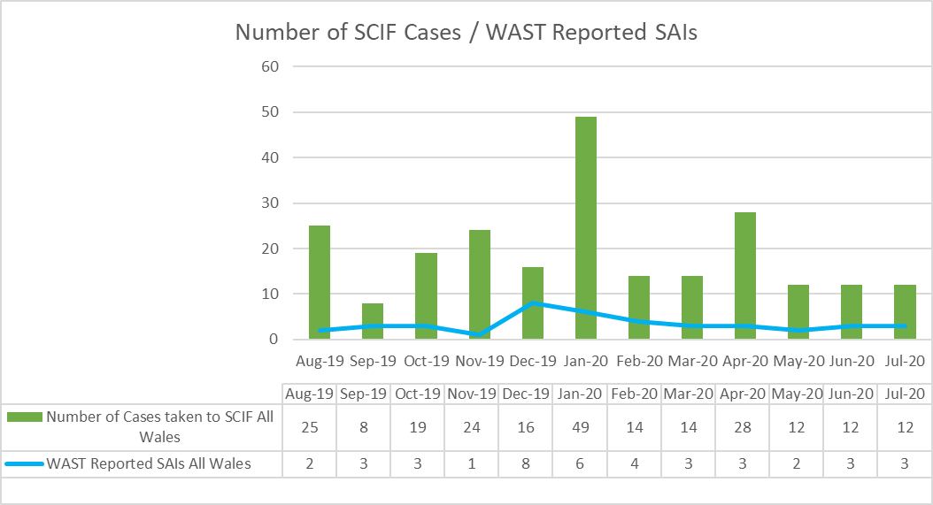

Serious Adverse Incidents (SAIs) reported to Welsh Government
 | ABUHB | SBUHB | BCUHB | CVUHB | CTMUHB | HDUHB | PTHB | Total
2017/18 | 17 | 10 | 12 | 6 | 2 | 1 | 0 | 48
2018/19 | 11 | 7 | 13 | 15 | 1 | 4 | 0 | 51
2019/20 | 13 | 15 | 1 | 6 | 5 | 3 | 1 | 44
2020/21 (Apr to Jul) | 2 | 1 | 2 | 4 | 1 | 1 | 0 | 11

  - Since the last report to EASC no SCIF cases have been passed to health boards:

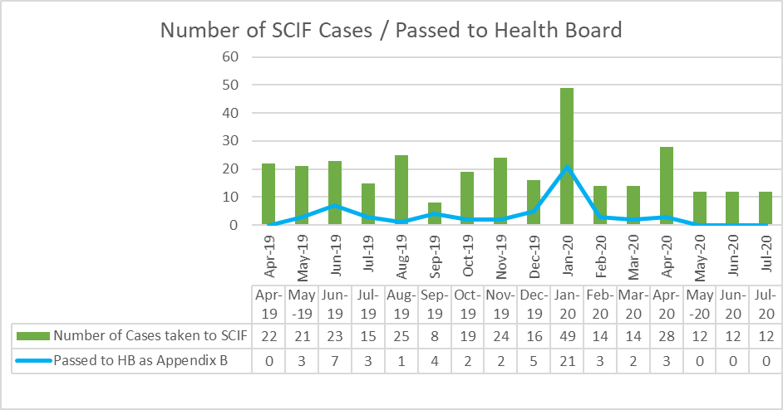

  - It is noticeable that since the onset of the pandemic and the significant reduction in handover lost hours there have been no SCIF cases passed to health boards in the last three months. The EMS Demand & Capacity Review did not forecast or model the potential improvement in patient safety, but these figures are an indicator of how patient safety may improve if the Review’s outputs are implemented (a key efficiency is handover lost hours at their 2018/19 levels).
Coroners’ Activity
  - As of the end of Jul-20 WAST has 71 open coroner cases, of which it is known that the Trust is or is likely to be an interested party in 15 Inquests pan-Wales at this time. These are at various stages of investigation from statement disclosure to date(s) listed for full hearing later in the year.
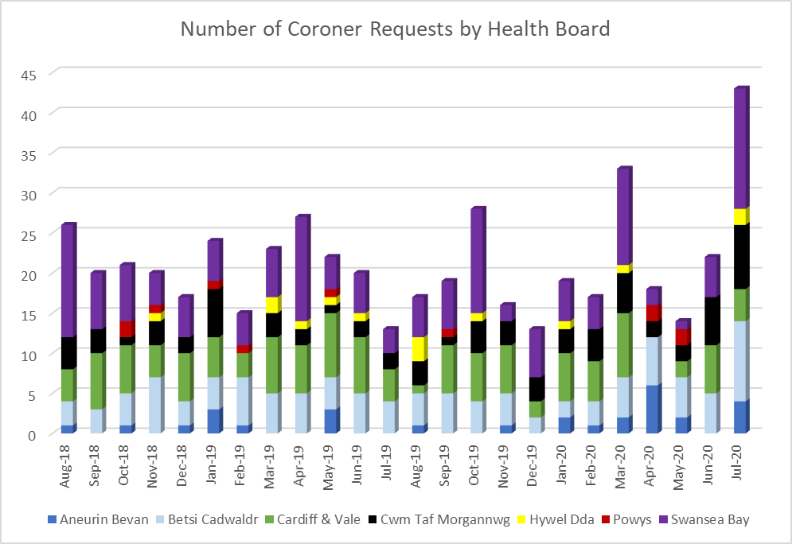

Longest Waits
  - The Patient Safety Team undertake regular reviews of the longest responses to patients, even where no complaint or concern has been received or raised, this is to provide assurance around the quality of the care that these patients received. The following table details patient waits 12 hours and over.

  - Numbers increased during the winter months with a significant reduction from Apr-20 onwards triggered by “lockdown” and the significant reduction in demand and increase in ambulance capacity (ambulance units produced and reduction in lost hours). There were 23 long waits in Jul-20, compared to 154 in Jul-19. Prior to CoVID-19 the Trust agreed with the CASC (as part of the Amber Review Programme) to dip sample five long waits per month, always including the longest wait. The Trust is now sampling every day and this information will start to be available to the NCCU in September.

Focus on Quality, Safety & Patient Experience
  - At the 14 Aug-20 CASC Quality & Delivery meeting there was a “focus on quality, safety & patient experience”. Key points to emerge from this focus are set out in the following paragraphs.

  - Throughout the pandemic, the Trust has continued to engage with service users and member of the community; this has often been achieved through virtual connections and surveys.
Key findings that have emerged include; feelings of isolation and fear, difficulty accessing appropriate information in a format services users require, concerns regarding the availability of health & care services generally, and challenges in accessing 111 during the pandemic. Positively, perceptions of emergency staff and call centre staff were good.

  - The Trust safeguarding team is preparing for the launch DocWorks, an application to replace paper-based safeguarding referral processes. The system has been trialed in the CCC/111 environments, and will provide additional efficiency benefits to the service once fully implemented.

  - In response to Covid-19, the Safeguarding Team have responded to the need to innovate training to ensure knowledge and skills across the workforce. Training has been delivered virtually to maintain social distancing requirements and accessibility of the course to staff.

  - The Trust has received two notifications of contravention from the Health & Safety Executive (HSE), firstly in relation to a sharps injury; secondly, in relation to extended wear of personal protective equipment. The Trust has taken appropriate action on these matters and will comply with requirements from the HSE. Furthermore, concentrated work will commence in relation to the Trust health and safety function.

  - Mental health will be a priority for the Trust with work streams continuing in dementia care, mental health, and substance misuse. Following redeployment of the mental health team into the Clinical Support Desk, an evaluation is underway to articulate the benefits of specialist mental health support within this environment. Furthermore, a focus upon workforce training and staff wellbeing are key work streams for the Trust. It is acknowledged through engagement with CASC, that provision of care to service users experiencing mental health problem is a priority.

  - The Trust Infection Prevention and Control Team was supported through internal redeployment during the pandemic. It is evident that additional investment in this small, critical key is required to ensure resilience and adequate provision of the function across Wales. An additional 2.5WTE has been invested into the establishment.

  - The Infection Prevention and Control Team, in partnership with Welsh Government and the Small Business Research Initiative (SBRI) Centre of Excellence (SBRI COE), led a research project seeking to identify rapid ambulance sanitising technologies. The project has concluded, with results and outputs of the work shared with Public Health Wales and infection control networks across Wales. Additionally, the Trust is partaking in addition trials to understand operationalisation of these technologies.

  - The Trust Quality Strategy is undergoing revision. Over quarter 2 and 3, the Strategy will be developed and seek engagement across stakeholder groups. The Strategy will ensure WAST compliance with the Health and Social Care (Quality and Engagement) (Wales) Act, embedding the duty of quality and duty of candour across the organization. As part of this work, the Trust will look to strengthen and implement quality management systems across functions – in turn refining the quality assurance metrics and measures of teams and functions across the Trust.

  - As part of efforts to improve quality across the health and care system, the WAST Improvement & Innovation Network (WIIN) is commencing recovery from the pandemic. The Trust has fully engaged in the Research, Innovation & Improvement (RII) hubs through a dedicated, Welsh Government funded, lead. The RII lead continues to engage with regional partnership board, health boards and social care providers to identify opportunities for research, innovation or improvement that will release system-wide benefit for patients.

  - The Patient Safety Team report is provided in Appendix 1, proving details on the Trust performance in relation to Patient Safety Incidents (Internal and external); Formal Concerns; Serious Case Incident Forum (SCIF) activity; serious incidents reported by WAST; incidents considered at SCIF and passed to Health Boards either as a patient safety incident through the serious incident framework; and, potential adverse media attention.

EASC is asked to NOTE: that there are currently 16 open SAIs with no SCIFS passed to health boards in the last three months. There were 23 12 hour and over patient waits in Jul-20, compared to 154 a year ago. WAST currently has 71 Coroner’s cases open.

The CASC monthly Quality & Delivery meeting (14 Aug-20) included a “focus on” WAST’s quality, safety and patient experience arrangements which identified that WAST now has in place good arrangements, which have been adjusted in response to CoVID-19 and are being further enhanced as WAST responds to the Health & Social Care (Quality & Engagement) Wales Act.

Performance

Red Performance
  - Red performance has been maintained above the 65% target for the first four months of 2020/21 (it should be noted that the current Welsh Government advice is that there is no formal publication of the monthly statistical release or Ambulance Quality Indicators, so the data is not formally verified at this point in time).

  - There continues to be variation in health board performance with Cardiff & the Vale traditionally the highest performer, closely followed by Swansea Bay in Jul-20 with Hywel Dda and Powys missing the 65% target respectively (62.8% and 60.3%). The reduction in single crewed Rapid Response Vehicles (RRVs) will be a factor in these three health board areas missing the 65% target; however, WAST has completed performance deep dives on Hywel Dda and Powys respectively (particularly after Powys only achieved 51.6% in Jun-20), both of which have been shared with the NCCU and health boards.

  - The Hywel Dda analysis identified the need to focus ambulance resource in the semi-urban area: Ammanford to Milford Haven and that the “additionality” coming from the EMS Demand & Capacity Programme (and APP expansion) should enable this during 2020/21 with a range of short term measures before the “additionality” takes effect.

  - For Powys there are no “low hanging fruit”. The low level of Red demand means every missed Red has a disproportionate impact on performance. The analysis identified a need to focus on: reducing the response duration, a geographical focus on Newtown and Welshpool, turning back on the CFRs (this has now been actioned) and local recruitment.

  - In both cases the deep dives have highlighted that achieving the Red A8 target in rural localities is problematic and further collaborative work on rurality is currently being scoped.

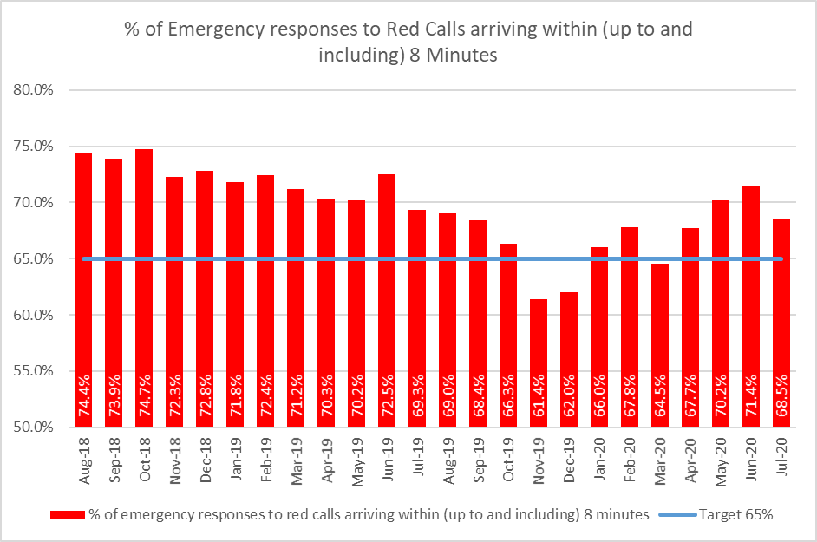

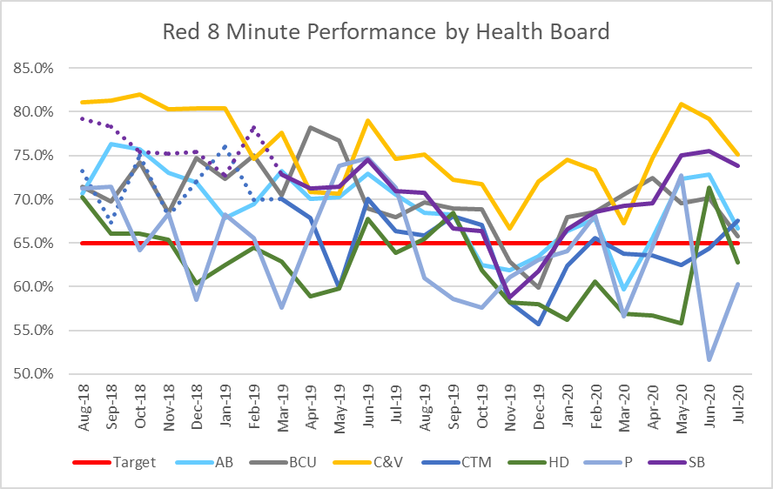
  - Demand changes are one of the main factors affecting performance for all categories of calls. Red demand is shown in the graph below. Red demand increased through 2019/20 as a result of a change in application of the Medical Priority Dispatch System (MPDS) which is seeing a greater proportion of breathing difficulties coded as Red, as previously reported to EASC. Red demand saw an initial reduction in Q1 2020/21, but in Jul-20 was 2,038, compared to 2,318 in Jul-19 i.e. it is back to its pre-CoVID-19 levels.

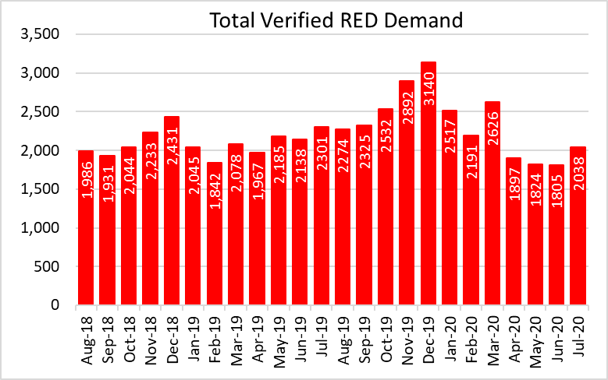

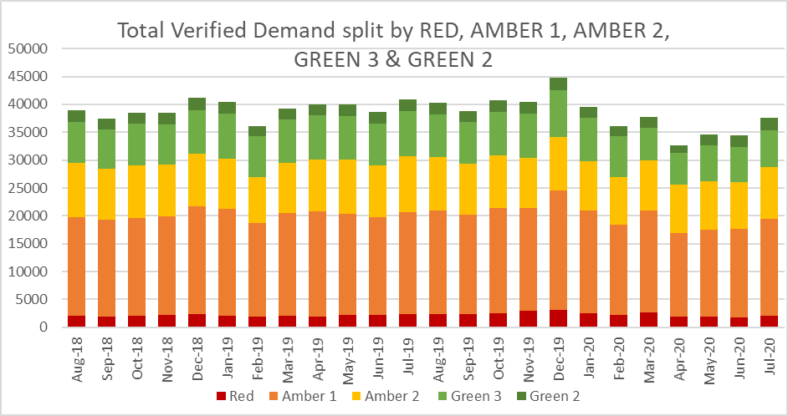

  - Overall demand was 8% lower in Jul-20 compared to Jul-19 with the reduction being mainly seen in the Amber 2 and Green 2 categories. This gap is lower than the 12% reported to the last EASC. Demand is returning and initial figures for Aug-20 are: verified demand 39,098 (Red 2,465) compared to 40,230 and 2,297 respectively in Aug-19.

  - The number of hours produced by WAST is a second major determinant of performance. WAST reported to the last EASC that with the advent of “lockdown” and the possibility of increased demand and reduced hours produced as a result of staff sickness a decision was made to continue to boost unit hours produced through overtime/use of bank staff and also to increase/maintain our conveying resource by switching Paramedics from RRV to Emergency Ambulances (EA) (increasing EA actual hours produced and reducing RRV actual hours produced). WAST produced 115,884 hours (all responding resource) in Jul-20, compared to 112,803 in Jul-19 an uplift of 2.7%.

  - The third key determinant of performance is handover lost hours. The graph below shows the increasing levels of lost hours over the past year, but a significant reduction in Feb-20, with big improvements seen in AB and CTM UHBs as a result of the cohorting initiatives deployed. As CoVID-19 took effect and core unscheduled care system demand was suppressed there were dramatic reductions in handover lost hours during Q1. In Jul-20 3,596 hours were lost to handover, compared to 8,048 in Jul-19 and 4,563 in Jul-18. The EMS Demand & Capacity Review modelled an efficiency of 18/19 handover lost hours, which is approximately what we are seeing now. It should be noted that delays have risen again in August, with delays particularly concerning at certain locations. A letter has been sent to all Health Boards alerting them to this issue, seeking urgent action to ensure that the delays of last year do not return.

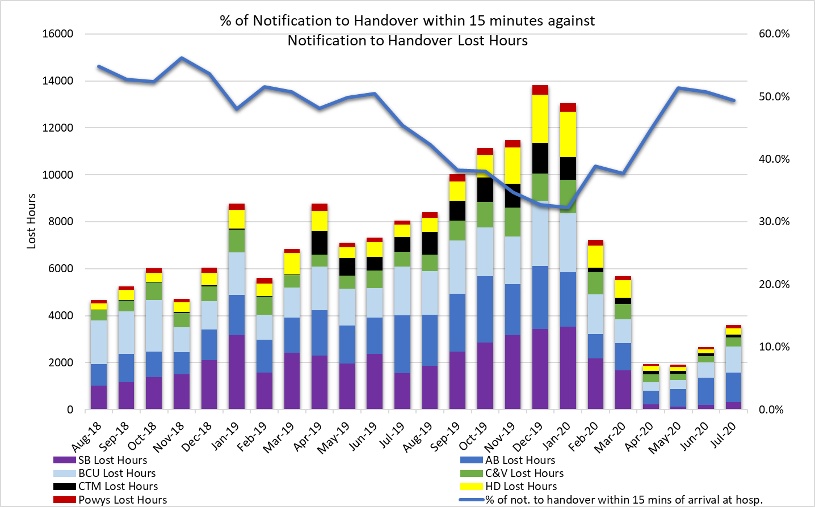
Amber Response times / Amber Review
  - Amber response times are a significant concern and a key issue to be addressed by the EMS Demand & Capacity Programme; however, during the initial phase of the CoVID-19 response there has been a significant improvement in the Amber median, 65th centile and 95th centile times. The reduction in demand, increase in ambulance hours produced and reduction in handover lost hours had a significant impact on Amber times, in particular, the Amber tail (the 95th percentile) which is sensitive to changes in demand and capacity; however, the chart overleaf clearly indicates an upward trend in the 95th percentile as the system returns to normal.

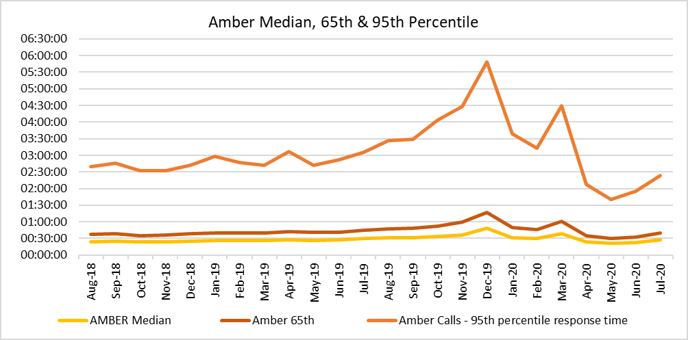

  - The key action in the Amber Review Implementation Programme was the EMS Demand & Capacity Review, which is now a key action in the Ministerial Ambulance Taskforce. A summary of progress to date in implementing the outcome of the EMS Demand & Capacity Review is included later in this report.

Tactical Seasonal Planning
  - WAST held a tactical seasonal planning workshop on 01 Jul-20. Due to CoVID-19 there will be no formal evaluation of winter 2019/20; however, the workshop reviewed quality and performance through winter 2019/20 and identified the need to undertake some “quick and dirty” evaluations of various 2019/20 initiatives.

  - WAST understands that the Q3/Q4 operational frameworks will act as winter plans and Welsh Government guidance is to follow. WAST has taken the decision to produce a tactical seasonal plan (winter), which will be based on Welsh Government’s six goals for urgent and emergency care and five enablers. WAST has already undertaken a range of forecasts and scenario modelling in support of this plan, but these are currently being updated with more recent information from the National Modelling Forum and current data on core demand and handover lost hours. The tactical seasonal plan (winter) will go to WAST’s Trust Board (01 Oct-20) and will be shared with the CASC in Sep-20, including a range of initiatives identified to support the plan.

EASC is asked to NOTE that the Red 8 minute 65% target has been met through the first four months of 2020/21; however, there is variation between health boards with underlying performance issues in Hywel Dda and Powys, with actions being identified to address these.

EASC is asked to NOTE the reduction in the Amber tail (the 95th percentile), which is an on-going area of patient safety/experience concern for EASC and WAST, but how the tail is beginning to climb back towards pre-CoVID-19 levels as demand returns to normal and similarly handover lost hours are already close to their 2018/19 levels.
Demand and Capacity Review – Implementation

  - EASC noted the final full report of the independent collaborative EMS Demand & Capacity Review at its Jan-20 meeting. EASC has agreed to provide non-recurrent funding in 2020/21 to WAST to support the increase in its front line establishment by 136 full time equivalents (FTEs) by Mar-21 (made up of 11.5 Paramedics, 102.4 Emergency Medical Technicians (EMTs) and 22.1 Unscheduled Care Staff (UCS)). The Trust is also contributing to the funding of this increased number of staff.

  - The planned recruitment forms part of a wider EMS Demand & Capacity Programme (with seven projects). During the initial phase of CoVID-19 only the recruitment & training project remained switched on; however, WAST is now in the process of switching back on the whole programme. The NCCU are represented on the EMS Demand & Capacity Programme Board and WAST provides regular updates to EASC including a “one off” EASC Management Group on 27 Jul-20.
  - Despite CoVID-19 WAST has made good progress on the recruitment and training project:-

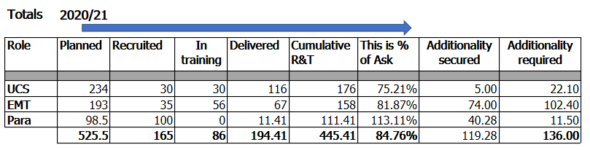

Note: Information accurate as per 23 Jul-20 i.e. 31 Jul-20 programme board.

  - The current estimated costs of the EMS Demand & Capacity recruitment & training for 20/21 is £4.712m with recurrent costs of £5.427m excluding the recurrent impact of the Advanced Paramedic Practitioners (APPs) expansion of £1.000m. Current funding arrangements for 20/21 are £1.8m recovered via EASC from health boards, maximise all resources and WAST contributions of £2.435m: overall total of £4.235m. The current cost of the recruitment and training is £5.712m leaving a shortfall of £1.477m.

  - Key feedback from the “one off” EASC Management Group on the programme includes:
- The impact of CoVID-19 on the programme
- Further work on the targeted rated of abstractions, in particular, the treatment of continuing professional development (CPD), and
- Benefits realisation, in particular, efficiencies, for example roster reviews.

  - The impact of CoVID-19 will be factored into the proposed gateway reviews for the programme, but it is not proposed to re-cast the review at this point in time because a) the cost of doing so b) it is too early to determine whether some of the changes we have seen in the unscheduled care system are permanent; and c) current data (demand/handover lost hours) suggest the system is returning to pre-CoVID-19 levels. A paper will be brought forward to WAST’s Executive Management Team in Sep-20 with proposals on the treatment of CPD (this will then be shared with the CASC). WAST has agreed to re-roster in 2021 (as planned) predicated on the relief gap being closed in 2021/22.

  - There are currently two red rated risks (score of 16) on the programme’s risk register 1) failure to confirm the FTEs (20/21) and beyond and 2) impact of CoVID-19. For 1) the funding for 2020/21 is not secured at this time and in order for the Trust to take strategic capital decisions, in particular, on estate more certainty is required on the future size of the EMS workforce. For 2), WAST is in the process of recalibrating the programme which the Trust now needs to discuss with the CASC and his team. Whilst not a red risk yet, the Trust’s estate is an emerging strategic risk and potentially a significant barrier to the programme. The Trust’s estate has high levels of utilisation and the property condition is mixed. Detailed work should be completed over the next two months on the impact of the programme on estate (and fleet) which can feed into the respective standards operating procedures (SOPs).

EASC is asked to NOTE that: a programme management approach has been adopted to implement the recommendations of the EMS Demand & Capacity Review; good progress has been made on recruitment & training, but urgent consideration is now required on the underpinning financial plan; WAST has agreed (as planned) to undertake roster reviews pan-Wales in 2021 predicated on the relief gap being closed; there are currently two red (score of 16) red risks on the programme risk register and WAST’s estate has been identified as a strategic risk to the programme, with detailed work due to be completed in Sep-20 that will quantify this risk.

Developments / Planning
Health Board Service Changes
  - WG has approved the early opening of the Grange University Hospital (GUH) and ABUHB’s Board approved the commissioning of WAST as the intersite transfer provider in July. WAST and ABUHB have reached agreement on the principles of the model. The Health Board, NCCU and WAST are finalising the commissioning agreement and the support from NCCU in finalising the service has been of huge benefit.
  - The service will initially be operated by 3rd party urgent care and NEPTS provider/s as WAST trains its own workforce during Oct-20 and Nov-20. WAST has now made offers of employment to 68 urgent care staff to deliver the majority of transfers and is proceeding to offer for CCC staff. A new supervisory structure has been developed in recognition of the new model of transfer and repatriation provided by the GUH intersite transfer service, and new roles will be out to advert shortly. Vehicle and staff accommodation and fleet specifications are being finalised with a timeline to go live in Nov-20. Work is ongoing urgently to secure the capital required for the fleet programme.
  - WAST has made final preparations for the go live of the South Wales Major Trauma network on 14 Sep-20. Key issues are e-Learning compliance for staff familiarisation with the major trauma triage tool, co-location of the Major Trauma desk with Air Support Desk and a consistent Standard Operating Procedure. Assurance has been provided to the network team that WAST is ready for go live and the e-Learning compliance trajectory should deliver the minimum requirement for go live, supported by local messaging, a trauma pocket book, social media and other communications, and a staff webinar in early Sep-20.
  - WAST is moving into the recovery phase of its pandemic strategy. This requires the Trust to prioritise its IMTP ambitions, recovery plans and key commissioning issues alongside the need to plan for seasonal pressures and support ongoing COVID related priorities from commissioners and Welsh Government. WAST continues to collaborate with the NCCU to monitor service changes and changes to surge capacity within health boards and the regional operational cells are being maintained into the recovery period. It is important that Health Boards continue to ensure that WAST is kept appraised of all plans that will impact on transport requirements.

NEPTS (Non-Emergency Patient Transport Service)
  - Following the decision to suspend much of the normal health board activity, the NEPTS teams areas of work have been focused on ensuring that a high quality service continues to be provided to essential outpatients (as determined by health board clinicians), patients requiring transport to access renal dialysis and oncology treatment and ensuring a timely service for patients requiring discharge home or transfer to an alternative place of care.

  - In order to respond to Welsh Government advice on social distancing and to ensure staff and patient safety the service has had to make or respond to several changes to its normal methods of service delivery, these are:
- Limits on the numbers of patients per vehicle. Maximum loading is now 2 patients per ambulance (previously max of 5) and 1 per car type vehicle (previous max of 3)
- Vehicle screens between the cab and saloon of the vehicle
- Separating suspected & confirmed CoVID-19 patients to travel alone
- Additional Personal Protective Equipment (PPE) requirements
- New booking, planning and allocation processes
- Reductions in the levels of available volunteers; and
- Increased sickness levels due to a high proportion of staff within the shielded category.

  - These changes have reduced the ability of the service to maximise vehicle utilisation, which has dropped from an average of 2.1 patients per run in April 2019 to 1.3 patients per run in May 2020.

  - Whilst the overall reduction in demand has offset this loss of efficiency during the initial phase of the pandemic, the service’s ability to manage a resumption of business as usual activity without significant additional investment in additional resources is likely to be compromised. It is therefore imperative that health boards ensure that they engage at the earliest possible stage of service planning and include transport support as an integral part of any planning work undertaken. Without meaningful engagement there is a significant risk that an appropriate transport support provision will not be able to be delivered to support health board service delivery. In recognition of this risk and to provide a formal mechanism for engagement and oversight, the NEPTS Delivery Assurance Group (DAG) has recommenced meeting fortnightly on a virtual basis. In addition, simulation modelling is currently being undertaken on the revised demand pattern for NEPTS and revised capacity to transport.

  - Following a pause in progress WAST has turned back on the NEPTS Demand & Capacity Review, with a revised completion date of Nov-20 (original data: Jul-20).

IMTP 2020/23 & Operating Framework
  - WAST’s IMTP was submitted on the 31 Jan-20, endorsed by EASC on 28 Jan-20 with written support from the CASC. The IMTP integrates EASC’s commissioning intentions for EMS and NEPTS into a plan which clearly articulates a commitment to quality and delivery of ‘A Healthier Wales’ Quadruple Aim.
  - Whilst the IMTP was not approved formally, the Trust Board maintains a keen interest in the IMTP’s highest priority programmes and a number these are directly linked to EASC commissioning intentions. These have therefore been incorporated into WAST’s quarterly operational planning cycle.
  - The key elements of WAST’s quarterly operational framework are to:
- Respond flexibly – a set of actions that maintains the Trust’s preparedness for future spikes in COVID-19 related demand and in support of NHS Wales Essential Services. This incorporates our collaborative approach to modelling demand and capacity, our approach to tactical seasonal planning and monitoring of health board surge capacity, business as usual and operational service changes.
- Lead important programmes internally and across the system – this includes restarting our IMTP priorities but also our lead role across some of the national Unscheduled Care programme’s six goals.
- Support our staff – this is a vitally important component of our plan, as we ensure staff are safe and well both on the frontline but also working from home. We have received significant feedback from a Trust wide staff survey and we will be using the results of the survey to inform our plans to support staff over the coming months as we plan how we can safely return staff to the workplace as well as managing infection control, PPE and the impact of Test, Trace and Protect.
- Learning from what has worked – like all NHS bodies, WAST has learnt an enormous amount from its response to COVID-19 so far and we are seeking to amplify those service changes, systems changes or digital and technological advancements where these are in line with our strategic ambition and commissioning intentions.

  - WASTs current IMTP priorities are:
- Recruit the agreed staffing numbers to deliver the EMS Demand and Capacity Review;
- Respond to major service changes such as the opening of the GUH, the South Wales Major Trauma Network and surge capacity changes across Wales;
- Continue planning for the electronic Patient Care Record and 111 ICT systems;
- Continue to work on those major capital schemes prioritised within the reduced capital allocation;
- Complete the CCC Clinical Review and NEPTS Demand and Capacity Review; and
- Replace fleet within available resources and refresh our fleet plans.

  - Whilst the COVID-19 threat is still very real, demand for EMS and other WAST services is rising as “business as usual” and the economy starts to switch back on across Wales. Delivery of the Quarter 2 plan, inclusive of key EASC priorities and WAST Board’s ambition in its IMTP to deliver its Long Term Strategy requires choices to be made about where resources are directed across the Trust’s major work programmes.
  - A prioritisation exercise has taken place, led by the Assistant Directors Leadership Team to be reviewed at Strategic Transformation Board on 28 August, to establish the key areas of focus for WAST over the remainder of the quarter and into quarters 3 and 4, using a set of planning principles and criteria.
This work is concluding and will allow WAST to focus its resources to deliver a balance between the requirement to continue to respond to the pandemic, its strategic ambition and delivery against the EMS and NEPTS commissioning frameworks.

  - Key risks in the plans include the competing priorities emanating from service change within Health Boards. This is reflected in WAST’s priorities in its Quarter 2 plan.

  - Key decisions within the Critical Path presented at EASC in July are around the capital funding elements and commissioning agreement for GUH.
Leading Service Change across Wales

  - Acknowledging that EASC collectively are not currently the commissioners of the 111 service in Wales, nevertheless, it is helpful to set out one of the key priorities identified by WAST in its Q2 plan.

  - In support of the 6 goals for Unscheduled Care, WAST is working closely with WG and other colleagues in developing plans for the ‘phone first’ service. WAST is also working with Welsh Government to re-establish the programme of work to develop community respiratory pathways aligned to the developing Welsh Access Model.

  - These developments are in keeping with WAST’s IMTP commitments and are priorities within the Trust and work will continue to develop at pace around these key commitments, which also align closely with the Trust’s Tactical Seasonal Plan.

  - WAST has further developed its proposal for implementation of the Operational Delivery Unit in support of system leadership and regional escalation. The proposal sets out the benefits that the unit brings to maintaining flow and escalation both during CoVID-19 and as demand has been increasing following the initial CoVID-19 response. The proposal has been circulated to Chief Operating Officers and discussions are ongoing with the CASC to determine the appropriate and funding route. This will be a key element of system stability during winter and aligned fully with WAST’s tactical seasonal plans.

  - In order, to support the intelligence led, Covid-19 Trace Test and Protect UK policy, the Department of Health & Social Care (DHSC) are working with the devolved Governments to provide an equitable asset to test symptomatic patients.

Fixed sites have been initiated across the UK for testing patients, this has been enhanced with extra Mobile Testing Units, backed up by surge capacity mobile testing units (MTU’s).

  - The model in Wales agreed by the Welsh Government, and DHSC, is for WAST to take over the running of the three CoVID-19 surge capacity MTU’s from the start of Sep-20.

  - WAST has made progress since having received confirmation on 20 Aug-20 including recruitment, training and on boarding of MTU teams and establishing an end to end process to provide this service and are on target to commence service delivery on the 01 Sep-20.

EASC is asked to note that:
- WAST will be commissioned as the intersite transport provider for the Grange University Hospital and 68 of the 84 staff required to deliver the service have been offered posts as Urgent Care staff. Delivery of the GUH service is not without risk, but work is ongoing with NCCU and ABUHB to mitigate those risks.
- WAST is ready for go live of the Major Trauma Network, with close monitoring of commissioned aspects of the service including e-Learning compliance.
- The impact of social distancing on the number of patients NEPTS can transport per journey is significant and a risk as patient journeys increase.
- Proposals for phone first, respiratory pathways and ODU are in development and circulation and work to finalise these proposals and implement with pace to support tactical seasonal plans is fully underway.
- WAST is the provider for 3 surge MTUs in Wales in support of the CoVID-19 Trace Test and Protect UK policy.

- KEY RISKS/MATTERS FOR ESCALATION TO THE COMMITTEE

Members of the EAS Committee are asked to note:

  - WAST’s Pandemic Influenza Plan/ business continuity arrangements have been effective, that WAST continues to work within the framework of these plans/arrangements and WAST is now in a period of recovery as the wider health care system returns to “normal”
  - Quality, safety and patient experience monitoring arrangements have remained in place through the CoVID-19 response
  - There were 3 SAIs in Jul-20 and there have been no SCIF cases passed to Health Boards in the last three months, which is a useful marker for the potential patient safety benefit of delivering the findings of the EMS Demand & Capacity Review
  - There was a recent “focus on quality, safety & patient experience” by the CASC and his team
  - Red 8 minute 65% target has been met since the start of 2020/21, but there are underlying performance issues in Hywel Dda and Powys, which have been analysed in detail, with short term performance plans and longer term plans in place to resolve these
  - The Amber tail (an area of focus e.g. the Amber Review) has started to increase at the system returns to normal
  - WAST is concerned at the rising number of hours lost outside EDs, particularly at certain hospitals, with risks emerging again around patient safety and response times
  - WAST has a clear approach for tactical seasonal planning (winter)
  - The EMS Demand & Capacity Programme has been restarted and is it at a critical juncture in terms of funding for the 20/21 recruitment and training project
  - A strategic steer will be needed from EASC in the second half of 2020/21 on its future recruitment and training commissioning intentions for EMS, so that WAST can make timely decisions on fleet and estate, with estate being identified as a strategic risk (barrier) to the programme
  - WG has approved the early opening of the GUH which is not without risk to WAST as the inter-site provider; however, these risks are being actively mitigated
  - The Major Trauma Network is also set to go live on 14 Sep-20 with WAST ready to go live
  - WAST continues to monitor Health Board requirements for additional ambulance transport required to service revised clinical models/hospital footprints in each Health Board
  - Early engagement with WAST on transport needs is key
  - NEPTS has continued to provide patient critical journeys as determined by Health Board clinicians, but social distancing has significantly reduced NEPTS capacity and is a risk to the system (risk currently being quantified through modelling)
  - WAST has submitted its Q2 Operating Framework with a focus on four areas and is currently completing a detailed prioritisation exercise
  - WAST is currently also finalising plans for 111 in support of the “phone first” approach
  - WAST has developed a clear business case for the ODU and is currently exploring funding routes for this initiative, and
  - WAST is the provider in Wales for the CoVID-19 Trace Test and Protect UK policy surge MTUs which commences on 01 Sep-20.

- IMPACT ASSESSMENT

Quality/Safety/Patient Experience implications | Yes (Please see detail below)
Quality/Safety/Patient Experience implications | Identified within the report
Related Health and Care standard(s) | Timely Care
Related Health and Care standard(s) | And all health and care standards
Equality impact assessment completed | Not required
Legal implications / impact | There are no specific legal implications related to the activity outlined in this report.
Legal implications / impact | Included within the body of the report
Resource (Capital/Revenue £/Workforce) implications /  Impact | Yes (Include further detail below)
 | Included within the body of the report
Link to Main Strategic Objective | The Committee’s overarching role is to ensure its Commissioning Strategy for Emergency Ambulance Services utilising the five step patient pathway outlined within the National Collaborative Commissioning Quality and Delivery Agreement and the related outcomes for each care standard aligned with the Institute of Healthcare Improvement's (IHI) ‘Quadruple Aim’ are being progressed.  This report focuses on all the above objectives, but specifically on providing strong governance and assurance and safe and effective patient care
Link to Main WBFG Act Objective | Service delivery will be innovative, reflect the principles of prudent health care and promote better value for users

- RECOMMENDATION

  - The EASC Committee is asked to:
- DISCUSS and NOTE the WAST provider report.

