Emergency Medical Retrieval Transfer Service (EMRTS)
Quality & Delivery Framework

Version 1



INDEX
INDEX 2
Foreword 4
Document Control 5
Signatories to the Quality and Delivery Framework 7
Introduction 8
Scope 8
Strategic Context 8
Purpose 9
Principles 9
Production Methodology 10
CAREMORE® 10
Governance Arrangements 11
Commissioning Arrangements for EMRTS 12
Quality and Delivery Framework Delivery 13
Interpretations 15
Care Standards 17
An evidenced set of care standards for EMRTS to ensure that the right expectations are defined for quality and safety. 17
Care Standard Schedules 19
Care Standards information within the Framework Blueprint 19
C1 Schedule: Care Standards 20
Activity 23
An accurate description of the activities to ensure that the right capacity is available to meet the right demand. 23
Activity Schedules 24
Activity information within the Framework Blueprint 24
A1 Schedule: Activity Descriptors 25
Resource Envelope 27
A comprehensive description of the assets which may be utilised and affected with the ambition of making the best use of all existing resources. 27
Resource Envelope Schedules 28
Resource Envelope information within the Framework Blueprint 28
RE1 Schedule: Resource Management Descriptors 29
RE2 Schedule: Income; Expenditure; Savings and reinvestment plan 30
RE3 Schedule: Capital Value 31

Model of Care 32
A common high level model of care to ensure that people can access the right staff, at the right place, at the right time. 32
Model of Care Schedules 33
Model of Care information within the Framework Blueprint 33
M1 Schedule: Emergency Medical Retrieval and Transfer Services EMRTS) High Level Model of Care 34
M2 Schedule: Emergency Medical Retrieval and Transfer Services (EMRTS) Major Incident Response 35
Operational Arrangements 36
The establishment of robust local mechanisms to ensure effective delivery with the right interaction between patients, professionals and organisations. 36
Operational Arrangements Schedules 37
Operational Arrangements information within the Framework Blueprint 37
O1 Schedule: Commissioning and IMTP Alignment 38
O2 Schedule: Application of the Model of Care 39
O3 Schedule: Extant policies, protocols, pathways 40
O4 Schedule: Continuous Improvement and Service Change 41
Review of Performance 42
An agreed system of performance measurement to ensure the right monitoring and management to deliver continuous improvement. 42
Review of Performance Schedules 44
Review of Performance information within the Framework Blueprint 44
R1 Schedule: Performance Measurement Descriptors 45
R2 Schedule: Data Sources 52
R3 Schedule: Integrated Reporting 53
Evaluation 54
An agreed set methods and criteria for judging the achievement of the right patient outcomes, from the right patient experience, at the right cost. 54
Schedules & Version control 55
Evaluation information within the Framework Blueprint 55
E1 Schedule: Evaluation Methods 56
E2 Schedule: Evaluation Programme 57
E3 Schedule: Evaluation Reports 58
Framework Blueprint 59
Contents 59
List of Standard Schedules 60
Benefits of using CAREMORE® 61
CAREMORE® Plan on a Page 62
EMRTS Business Case 63
EMRTS 24-7 Service Expansion Review 64
Schedule Development History / Baseline Data 65

Foreword

Document Control
CAREMORE® Component | Schedule reference and name | Version | Schedule Status | Schedule Review / Completion date
Care Standards | C1 Care Standards | V1 | To be completed
Activity | A1 Activity Descriptors | V1 | Final
Resource Envelope | RE1 Resource Management Descriptors | V1 | Final
Resource Envelope | RE2 Revenue Value (Spend across the Model |  | Final
Resource Envelope | RE3 Capital Value (Spend across the Model of care) |  | Final
Model of Care | M1 Model of Care Description (high level) | V1 | Final
Model of Care | M2 Model of Care wiring diagram (for each HB/Region) | V1 | Final
Operational Arrangements | O1 Commissioning and IMTP alignment | V1 | Final
Operational Arrangements | O2 Application of the Model of Care |  | To be completed
Operational Arrangements | O3 Extant Policies, Protocols, Pathways |  | To be completed
Operational Arrangements | O4 Continuous Improvement and Service Change (IMTPs) | V1 | To be completed
Review of Performance | R1 Performance Measurement Descriptors
Review of Performance | R2 Data Repository |  | To be completed
Evaluation | E1 Evaluation methods |  | To be completed  Draft v1
Evaluation | E2 Evaluation programme |  | To be completed
Evaluation | E3 Evaluation reports |  | To be completed

Signatories to the Quality and Delivery Framework

EASC and EMRTS have sanctioned this Quality and Delivery Framework operational from June 2020 or a minimum of a three (3) year period that is 1st June 2020 to 31st April 2023.

A decision will be made by EASC in advance of April 2023 to determine whether to extend the period of the Quality and Delivery Framework.

SIGNED by or on behalf of the Parties on the date which first appears in this Quality and Delivery Framework:-

Signed by and on behalf of the Emergency Ambulance Services Committee (the Commissioning Collaborative) |   [Dr Chris Turner, EASC Chair]  Date 22/05/2020  [Mr Stephen Harrhy, Chief Ambulance Services Commissioner]  Date 22/05/2020
Signed by and on behalf of the EMRTS Cymru (the Provider) | .................................................................  [Professor David Lockey, National Director]  Date  .................................................................  ................................................................  [Mark Winter, Operations Director]  Date  ..................................................................

Introduction

This Framework Agreement is entered on this day of________________2020 by and between:

1. Emergency Ambulance Services Committee (“Commissioning Collaborative”); and
2. EMRTS Cymru (“Provider & Contractor”).

Scope
The scope of services covered by this Quality and Delivery Framework is commissioning arrangements for Emergency Medical Retrieval & Transfer Service (EMRTS), including:

- all Emergency Medical Retrieval & Transfer Services provided by EMRTS;
- all Emergency Medical Retrieval & Transfer Services commissioned by Welsh Health Boards from EMRTS;

Strategic Context
EMRTS went live on the 27th of April 2015. The service was commissioned “to provide advanced decision making & critical care for life or limb threatening emergencies that require transfer for time critical specialist treatment at an appropriate facility.”

The service represents a joint partnership between NHS Wales, The Wales Air Ambulance Charity Trust (WAACT) and Welsh Government.

The service was initially commissioned by the Welsh Health Specialised Services Committee, however this function transferred to the Emergency Ambulance Services Committee on the 1st of April 2016.

EMRTS has been developed to bring specific benefits to Wales, there is also a service provision for the enhancement of neonatal and maternal pre-hospital critical care (both for home deliveries and deliveries in free-standing midwifery-led units (MLUs)), specifically:

• Reductions in geographical inequity for patients with critical care needs
• Health gains by improving clinical outcomes, and
• Improved clinical and skills sustainability – improving the clinical skills, recruitment and retention in key acute care areas.
The service provides a highly-trained Critical Care team comprising Consultants (from an emergency medicine, anaesthesia and intensive care background) and Critical Care Practitioners (including paramedics and nurses). The service has two main areas of activity:

• Pre-hospital critical care for all age groups (i.e. interventions/decisions that are outside standard paramedic practice).
• Undertaking time-critical, life or limb-threatening adult and paediatric transfers from peripheral centres for patients requiring specialist intervention at the receiving hospital.

Purpose
This Quality and Delivery Framework details the areas of service agreed between NHS Wales Health Boards and EMRTS through a Collaborative Commissioning process. It details:

- what is required (commissioning);
- how assurance is given for ‘what is required’ (quality); and
- how the ‘what is required’ will be achieved (delivery).

Principles
The Framework Agreement will enable the philosophy of Prudent Healthcare and its associated values to be applied. The underpinning principles for the Framework Agreement being that all parties shall promote effective and efficient collaboration by acting in accordance with the principles of:

- consistency;
- reasonableness;
- fairness;
- transparency; and
- commitment to deliver.

A standing operational principle shall be that any collaborative opportunities which may improve the efficiency and effectiveness of any parties to the agreement will be exploited.

Production Methodology

CAREMORE®

CAREMORE® is structured approach to health and social care commissioning.

CAREMORE® aims to simplify the commissioning process, to provide better quality care for patients, and to respond to the needs for evidence-based practice and transparency in resource allocation, decision making and the provision of health and social care.

The following sections of the Quality and Delivery Framework represent a component of CAREMORE® as follows:

C Care standards
A Activity
RE Resource Envelope
M Models of care
O Operational arrangements
R Review of performance
E Evaluation

Each section comprises a schedule(s) developed and created by stakeholders using a CAREMORE® workbook.

The introduction section of each schedule summarises its contents within the Quality and Delivery Framework; it includes the reason for each schedule and the guiding principles by which each Schedule was developed.

Schedules may take the following formats:

- Completed schedules: titled final and version controlled in the document control section.
- Draft schedules: are under development or not in final version are marked draft and version controlled in the document control section.
- Reference schedules: can be in final or draft format and are contained within the Framework Blueprint.

Governance Arrangements

The governance arrangements for the development of the framework are as follows:

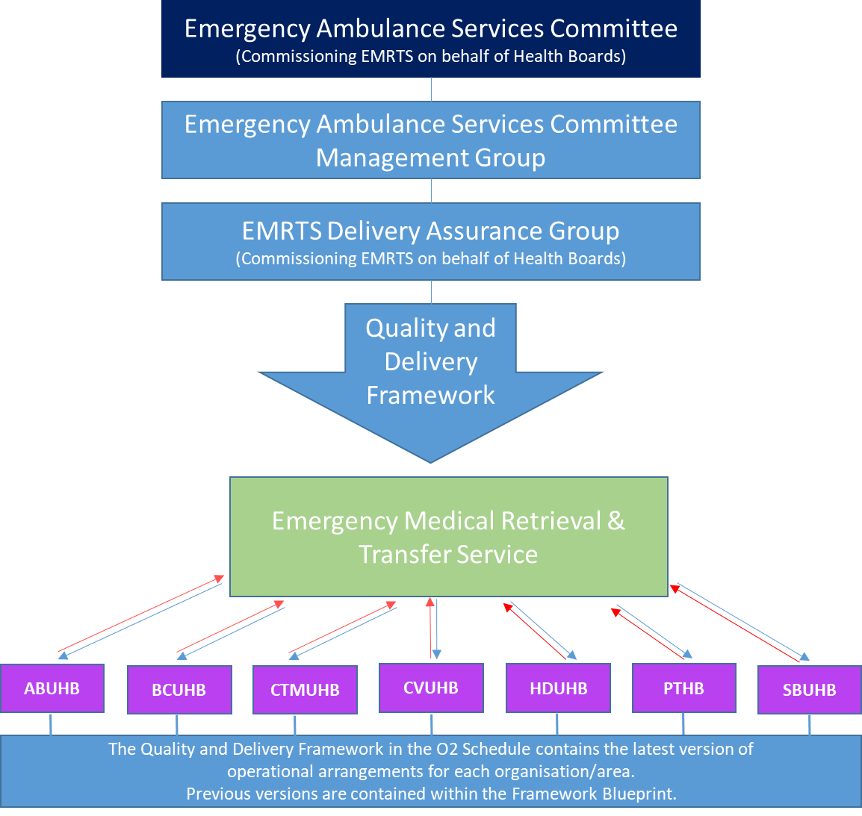
Commissioning Arrangements for EMRTS

Quality and Delivery Framework Delivery

It is recognised that the Quality and Delivery Framework will be a “live” document to enable updating to take place as collaborative relationships/understandings of service provision and required improvements between stakeholders develop.

Updates to the Framework agreement (Table 1a) as well as changes to Performance (Table 1b) and the Joint initiatives (Table 2) required to deliver the commissioning intentions documented through the IMTP process. These are documented in the O1 Schedule.

If refreshes are required they will be completed and the updated elements of the Quality and Delivery Framework issued and reported to EASC.

Updates to the Quality and Delivery Framework documentation will only be made following agreement by the EMRTS Delivery Assurance Group (DAG).

Any disputes will be managed in accordance with EASC Governance arrangements published in the EASC Annual Governance Statement.

EASC Governance Framework.

Governance arrangements to be kept under review by EASC.

An EMRTS Delivery Assurance Group (DAG) will support the ongoing development and successful operation of Quality and Delivery Framework. This will be chaired by the Chief Ambulance Service Commissioner on behalf of EASC; each CEO has nominated an EMRTS Representative who will also be their organisation’s member of the DAG.

The role of each representative will be to be their organisation’s representative for the successful design, development and ongoing operation of the Quality and Delivery Framework.

The EMRTS DAG will make recommendations to the EASC Chair and/or CASC on behalf of EASC. The membership of the EMRTS DAG is shown in the following table:

Organisation | Post
EASC | Chief Ambulance Service Commissioner [ Chair ]
EASC | Assistant Director of Quality and Performance
EASC | Assistant Director of Commissioning & Programme Management
EASC | Assistant Director of Finance
WAST | EMRTS Lead
ABUHB | EMRTS Lead
BCUHB | EMRTS Lead
CTMUHB | EMRTS Lead
CVUHB | EMRTS Lead
HDUHB | EMRTS Lead
PTHB | EMRTS Lead
SBUHB [ Host ] | EMRTS Lead
Welsh Government | Assurance r:e EMRTS meeting Ministerial expectations
Wales Air Ambulance | CEO
EMRTS | National Director
EMRTS | Operations Director
EMRTS | Clinical Informatics & Research Manager
EMRTS | Head of Communication & Engagement
EMRTS | Programme Manager

Interpretations

CAREMORE® | CAREMORE® is a commissioning method, focusing on Care standards, Activity, Resources Envelope, Model of care, Operational arrangements, Review of performance and Evaluation. It is a registered trademark belonging to Cwm Taf University Health Board UK2630477;
CASC | CASC is the Chief Ambulance Services Commissioner who acts on behalf of EASC to support efficient & effective commissioning, planning and delivery of emergency ambulance services in a collaborative and transparent manner between Health Boards and WAST;
Collaborative Commissioning EMRTS Delivery Assurance Group (DAG) | The EMRTS DAG has been established as a sub-group of EASC to support the production, ongoing development and maintenance of the Framework;
Commissioning Intentions | Commissioning Intentions provide a basis for constructive engagement between Health Boards and providers of services, to inform business plans and contracts. They are intended to drive improved outcomes for patients, and transform the design and delivery of care, within the resources available;
Commissioning Model for EMRTS | The commissioning model for EMRTS is that EASC will outline its requirements for EMRTS within NHS Wales. EASC takes responsibility for designing the commissioning model and EMRTS is responsible for the patient pathway.
EASC | EASC is the Emergency Ambulance Services Committee which acts as the commissioner of Emergency and Non-Emergency Ambulance Services on behalf of NHS Wales Local Health Boards. In April 2016 the Minister for Health & Social Service amended the directions for EASC allowing the committee to be responsible for the commissioning of Non-Emergency Patient Transport Services. It is hosted by Cwm Taf Morgannwg University Health Board;
Emergency Ambulance Services | Means services which relate to: responses to emergency calls via 999; urgent hospital admission requests from general practitioners; high dependency and inter-hospital transfers; major incident response and urgent patient triage by telephone; NHS Direct Wales Services;
Emergency Medical Retrieval & Transfer Service (EMRTS) | Means all Wales service that provides advanced decision making & critical care for life or limb threatening emergencies that require transfer for time critical specialist treatment at an appropriate facility.
Health Board | Means any Local Health Board as defined in the National Health Service (Wales) Act 2006 or any successor body to any of them exercising its or their functions;
IMTP | The IMTP is a requirement of Welsh Government for all Health Boards and Trusts in NHS Wales and it sets out the direction for the next three years, outlining organisations priorities, challenges and main risks.
Performance on a page | The criteria and method for setting performance standards using CAREMORE®;
Plan on a Page | To support the development of the Quality and Delivery Framework there is a CAREMORE® Plan on a Page which identifies the leads and timings for completing/updating/reviewing the Schedules (products) to ensure the Quality and Delivery Framework is successfully maintained. The Plan on a Page is found in the Plan on a Page section of the Framework Blueprint.
Quality and Delivery Framework | Quality and Delivery Framework is the overarching document which will outline the expectations and provide assurance to EASC for the commissioning and delivery of Emergency Medical Retrieval & Transfer Services in accordance with the Ministerial announcement and supporting business case;
Reference Schedule | Schedule(s) within the Quality and Delivery Framework that provide information or reference material to support the operational delivery of the service or the supporting evidence throughout the development of the Quality and Delivery Framework.
Schedule(s) | Schedule(s) within the Quality and Delivery Framework display the products created through the use of CAREMORE® and are the key documents of the Quality and Delivery Framework ;
WAST | Welsh Ambulance Services NHS Trust as the provider of Emergency Ambulance Services and the prime contractor of Non-Emergency Patient Transport Services to EASC and its Health Boards.
Wales Air Ambulance Charity | Welsh Air Ambulance Charitable Trust; Company number 04036600 of Ty Elusen Ffordd Angel, Llanelli Gate, Dafen, Llanelli, Wales, SA14 8LQ  Registration Charity Number: 1083645

Care Standards

An evidenced set of care standards for EMRTS to ensure that the right expectations are defined for quality and safety.

To describe Service Requirements from a patient’s perspective the EMRTS steps have been developed as follows.

The products in this Care Standards Section take the form of ‘Schedules’ which describe Service Requirements and Core Requirements for Emergency Medical Retrieval & Transfer Services.

What are the Care Standards Schedules?

Schedule C1: Care Standards
The C1 schedule has 2 components:
- Service Requirements: these describe the obligations of EMRTS to deliver the EMRTS steps.
- Core Requirements: the governance arrangements for Emergency Medical Retrieval & Transfer Services across the EMRTS steps.

The reason for defining Care Standards

The EMRTS steps describe the pre and inter hospital critical care service and patient pathway and will be known as the ‘Model of Care’. Its creation enables other key components of the framework relating to Activity, Resources and Performance to be established.

To describe Core Requirements to the public which act in accordance with good practice, relevant statutory legislation, codes of practice, guidance and policies published or endorsed by the Welsh Government.

The guiding principles for developing Care Standards

A Baseline Assessment exercise has been undertaken to determine the current standards used by Emergency Medical Retrieval & Transfer Services and commissioners.

The criteria for determining Care Standards:

- to be consistent with Prudent Healthcare;
- to give assurance around quality and safety of service delivery;
- to be evidence/best practice based;
- to be understandable, realistic and achievable;
- to be transparent;
- to be ‘balanced’ i.e. outcomes for patients and qualitative standards not just ‘time’ requirements;
- to keep to the discipline of a patient care pathway / patient journey approach for the use of services;
- to use language from the perspective of the public / service user(s) not necessarily the provider/commissioner when constructing the pathway;
- to have a minimum number of standards to provide appropriate assurance;
- to ensure they support the provider or professional to be “fit to be commissioned” or “fit to practice” i.e. core infrastructure or core professional requirements are included; and
- to enable performance measures / service levels to be varied depending upon service circumstances / developments, this assumes that the Care standards will remain static.

Maintaining Care Standards

The Emergency Medical Retrieval and Transport Service must ensure that services covered by these standards - including those which may be provided by an agent appointed by EMRTS - maintain the requirements covered by Sections A and B of this framework and alert EASC as soon as possible to any circumstance that has or may result in a failure to maintain such standards.

Section i) – Service Requirements

EMRTS must ensure that the service is able to deliver the Pre and inter hospital critical care service and patient pathway detailed across the EMRTS Steps.

Section ii) – Core Requirements

The public must receive an Emergency Medical Retrieval and Transport Service that acts in accordance with good practice. [Good practice means the exercise of that degree of skill, diligence, prudence, risk management, quality management and foresight which would reasonably and ordinarily be expected from an Emergency Medical Retrieval and Transport Service engaged in the provision of similar services to those covered by these standards; including in accordance with any codes of practice or guidance published by any Health Board, the Welsh Government, UK Parliament or otherwise.]

The public must receive an Emergency Medical Retrieval and Transport Service in accordance with any relevant statutory legislation –specifically SBUHB’s responsibilities as a Category 1 responder under the Civil Contingencies Act 2004, plus any relevant codes of practice, guidance and policies published or endorsed by the Welsh Government.

Care Standard Schedules

Schedule (s) | Schedule Name | Schedule status:
C1 Schedule | Care Standards | Completed
Section i) | Service Requirements | Completed
Section ii) | Core Requirements | Completed

Care Standards information within the Framework Blueprint

The Care Standards Section of the Framework Blueprint does not currently contain any information.

C1 Schedule: Care Standards
Reference |  | Care Standard
Section A - Service Requirements

Apply in each of the 5 steps across the patient care pathway

Step 1 We will help partners understand how we work

PCP1 | EMRTS must engage with all healthcare providers to ensure that operational hours, eligibility criteria, and the nature of the service are well understood. This includes EMRTS attendance at NHS engagement events, and attendance at EMRTS events by non-EMRTS personnel.
PCP2 | EMRTS must participate in relevant service development initiatives at national, regional and local level, to ensure that it can effectively contribute to the future delivery of healthcare services in Wales.
PCP 3 | EMRTS must engage fully with its third sector partner, the Wales Air Ambulance Charity Trust.
PCP4 | EMRTS must maximise training opportunities provided by its specialist staff and transport platforms.
PCP5 | EMRTS must work with relevant stakeholders in WAST, Local Health Boards, and the Health Education & Improvement Wales, to ensure that training opportunities are maximised.
Step 2 We will actively identify critical cases

PCP6 | EMRTS must have robust procedures in place to identify those patients who would benefit the most from an EMRTS response. This includes answering calls from healthcare providers, and identifying cases on the WAST electronic dispatch system.
PCP7 | EMRTS must ensure that it has a procedure to provide immediate, high-level advice to healthcare professionals, including its own duty teams.
Step 3 We will respond quickly and efficiently

PCP8 | EMRTS must ensure that the right resource(s) are dispatched to provide the right type of care for patients.
PCP9 | EMRTS must ensure that, when a response is appropriate, a resource is dispatched without delay.
PCP10 | Aircraft and vehicles must be fit for purpose and meet the required safety standards.
Step 4 We will provide high quality critical care

PCP11 | EMRTS must ensure that all interventions adhere to current best practice (e.g. EMRTS Standard Operating Procedures (SOPs) and Relevant Professional Guidelines).
Step 5 We will handover care safely and efficiently

PCP12 | EMRTS must ensure that patients are taken to the most appropriate hospital critical care facility, first time.
PCP13 | EMRTS should only convey patients who require specialist support, or expedited transfer (only do what only EMRTS can do).
PCP14 | EMRTS must ensure that appropriate communication takes place, at all levels, to ensure that a patient’s reception and transfer into hospital care is seamless.
PCP15 | All patients determined by EMRTS not requiring conveyance are appropriately ‘safety netted’, and a record of the consultation and decision is left with the patient or appropriate representative.
PCP16 | EMRTS must ensure that resources are available to respond to their next call without delay.
Section B - Core Requirements

Underpin service delivery across all of the 5 steps

CR1 | Governance  EMRTS must ensure:-  (i) that there are effective systems and processes in place to assure, patients, commissioners and other stakeholders;  (ii) that they are providing high quality, evidence-based care through services that are patient focussed;  (iii) external validation of governance arrangements through NHS Wales Shared Service Partnership (NWSSP).
CR2 | Patient experience & satisfaction  EMRTS must ensure:-  (i) it undertakes Patient satisfaction surveys;  (ii) systems are in place to collect feedback from Patients and their families or carers on the experience of care;  (iii) a record of all complaints of whatever nature regarding the Emergency Medical Retrieval and Transport Service is maintained.  EMRTS must ensure that the views and comments are gathered through (i), (ii) & (iii) using effective engagement mechanisms which are then actively used to inform service improvement and development;  EMRTS must ensure it has a system in place to record, investigate, report and learn from incidents and accidents.
CR3 | Equity  EMRTS must ensure that patients have equal access to services regardless of their location.
CR4 | Clinical Care  EMRTS must ensure:-  that all activities and programmes are developed from:  using a model that has measurable outcomes; and delivered by appropriately qualified and experienced staff educated in their use; that the health, safety and wellbeing of patients who receive transport is not adversely affected by inadequate training, accountability, operational systems or arrangements.  EMRTS must develop clinically led national strategies for services which are then locally delivered.
CR5 | Staffing  EMRTS must ensure:-  staff members are appropriately recruited, educated and qualified for the services they provide; staff have health & wellbeing support; there are workforce planning arrangements in place that identify staffing requirements and action plans such as recruitment and training to meet those requirements; there are staff appraisal processes in place an adequate and safe establishment with the correct skill mix of staff to ensure the needs of the patients are met; systems are in place to manage unplanned absenteeism, holidays, vacancies, and emergencies.
CR6 | Safety  EMRTS must ensure that any services it provides to the public, and any patient intervention it undertakes, protects public / patients from avoidable harm and clinical risk.

Activity

An accurate description of the activities to ensure that the right capacity is available to meet the right demand.

The products in this Activity Section take the form of ‘Schedules’ which detail the things to be counted (currencies) across each step of the EMRTS patient care pathway.

What are the Activity Schedules?

Schedule A1: Activity Descriptors
Provides activity descriptors across each step of the EMRTS steps.

The reason for defining Activity

To understand the workload or demand related to each individual step for a patient’s journey across the EMRTS steps. The patient journey or patient care pathway will be described through the ‘Model of Care.’

To enhance consistency of reporting for activity and have a baseline from which to track the impact of service changes, efficiencies and improvements within and across each step of the patient care pathway.

What are the guiding principles in developing Activity?

A Baseline Assessment exercise has been undertaken September 2019 to determine the current activity recorded by Emergency Medical Retrieval & Transfer Services and commissioners, and also to support 24/7 expansion.

The development work was shaped by the EMRTS Transformation Project documentation and the business case for the future of EMRTS. It has been assumed that Activity requirements must:
- be consistent with Prudent Healthcare;
- be relevant to improving performance and outcomes;
- be understandable and measurable;
- be recorded, with information sources identifiable;
- be able to provide clarity around patient flow and demand & capacity;
- be able to be benchmarked with similar services / organisations.

Activity Schedules

Schedule (s) | Schedule Name | Schedule status:
A1 Schedule | Activity Descriptors | Completed

Activity information within the Framework Blueprint

The Activity Section of the Framework Blueprint does not currently contain any information.

A1 Schedule: Activity Descriptors
Step 1 – We will help partners understand our work

1 | S1/A1 | Number of EMRTS engagement events & EMRTS CPD events attended by non EMRTS personnel.
3 | S1/A2 | Number of Local Health Board/ WAST engagement events attended by EMRTS.
4 | S1/A3 | Number of attendances by EMRTS at National, Regional and Local Health Board events where focus is on service redesign and developments that may impact upon delivery of high acuity patient transfer.
6 | S1/A4 | Proportion of WAACT board meetings attended by EMRTS representative.
7 | S1/A5 | Number of EMRTS duty shifts completed by healthcare professionals in training (PHEM).
9 | S1/A6 | Number of training (Observer/ Clinical attendant/ Fellow) shifts or formal base visits completed within the previous 12 months by trained healthcare professionals.
10 | S1/A7 | Proportion of Specialty Training Committee meetings in Pre hospital Emergency Medicine at which EMRTS provides a representative.
Step 2 – We will actively identify critical cases

11 | S2/A1 |  |  | Number of incidents reviewed by an EMRTS Practitioner/Dispatcher.
12 | S2/A2 |  |  | Number of EMRTS contacts made by WAST on-scene personnel (i.e. requests for advice and/or direct clinical support)
13 | S2/A3 |  |  | Number of EMRTS contacts made by hospital personnel (i.e. requests for advice and/or direct clinical support)
14 | S2/A4 |  |  | Number of calls answered by Air Support Desk (ASD)
15 | S2/A5 |  |  | Number of EMRTS Top cover consultant calls
Step 3 – We will respond quickly and efficiently

16 | S3/A1 |  | Number of stand downs following engine start.
17 | S3/A2 |  | Number of incidents responded to by transport modality (WAACT air ambulance, EMRTS RRV, others), and by base.
18 | S3/A3 |  | Number of incidents responded to by health board area.
19 | S3/A4 |  | Number of incidents responded to by nature
20 | S3/A5 |  | Mission type by LHB

Step 4 – We will provide high quality care

19 | S4/A1 | Number of patients undergoing general anaesthesia
20 | S4/A2 | Number of patients receiving procedural sedation
21 | S4/A3 | Number of cases entering an appropriate audit pathway
22 | S4/A4 | Number of patients receiving blood or blood products
23 | S4/A5 | Number of patients receiving interventions outside the scope of current WAST practice (e.g. Joint Royal College Ambulance Liaison Committee)
Step 5 – We will handover care safely and efficiently

24 | S5/A1 | Number of responded incidents that result in a non-conveyance to hospital.
26 | S5/A2 | Number of patients transported to hospital with EMRTS escort
27 | S5/A3 | Number of patients transported to hospital by Health Boards / NHS Trust

Resource Envelope

A comprehensive description of the assets which may be utilised and effected with the ambition of making the best use of all existing resources.

The products in this Resource Envelope Section take the form of ‘Schedules’ which detail the resource utilisation descriptors across each step of the pathway and the revenue and capital information related to each step of the pathway.

What are the Resource Envelope Schedules?

Schedule RE1: Resource management descriptors
Provides resource utilisation descriptors across each step of the pathway.

Schedule RE2: Revenue information
Provides revenue information related to:
- Income – the financial value payable by commissioners plus other specified income for non-commissioned EASC services.
- Expenditure – the planned spend across steps of the pathways for commissioned services plus other specified spend headings.
- Savings and any reinvestment plans.

Schedule RE3: Capital information
Related to EASC commissioned services and steps of their pathways where possible.

The reason for defining Resource Envelope.

To understand the resources available and their utilisation for each of the services provided under each step of the pathway and be able to triangulate with activity and performance.

To enhance consistency of reporting for resources and have a baseline from which to track the impact of service changes, efficiencies and improvements within and across each step of the patient care pathway.

What are the guiding principles in developing the Resource Envelope?

A Baseline Assessment exercise has been undertaken to determine the current resource information available to WAST and commissioners.

The Resource Envelope should include the direct or complementary services which impact upon the effective and efficient delivery of Emergency Medical Retrieval & Transfer Services, by the identification of all opportunities from:

- the application of Prudent Healthcare principles;
- whole system resource regardless of resource-holder;
- areas of perceived waste;
- areas of perceived variation;
- capital investment;
- an approach to enable a baseline for tracking the impact of future service changes and efficiencies.

Resource Envelope Schedules

Schedule (s) | Schedule Name | Schedule status:
RE1 Schedule | Resource Management Descriptors
RE2 Schedule | Revenue Information  Includes:  - Income  - Expenditure  - Savings and reinvestment plans.
RE3 Schedule | Capital Value

Resource Envelope information within the Framework Blueprint

The Activity Section of the Framework Blueprint does not currently contain any information.

RE1 Schedule: Resource Management Descriptors
The resource management descriptors contained within this schedule are currently in draft form. have been drafted. The measures and recording of data across each of the steps will be available following enactment of the plurality model on an individual Health Board basis.

Step 1 – We will help partners understand our work

1 | S1/RE1 | Direct Costs Associated with management of engagement activities
2 | S1/RE2 | Direct Costs associated with EMRTS operational/administrative support
Step 2 – We will actively identify critical cases

3 | S2/RE1 |  |  |  | Direct Costs Associated with Air Support Desk (EMRTS)
4 | S2/RE2 |  |  |  | Direct Cost Associated with Top Cover provision
5 | S2/RE3 |  |  |  | Sickness Figures ASD (Based on hours lost when planned on roster)
6 | S2/RE4 |  |  |  | Resource Unit Hours of ASD lost
Step 3 – We will respond quickly and efficiently

8 | S3/RE1 |  | Direct Costs Associated with Individual EMRTS Bases by shift
9 | S3/RE2 |  | Sickness figures for each Individual EMRTS Base by shift
10 | S3/RE3 |  | Resource unit hours for each Individual EMRTS Base by shift
Step 4 – We will provide high quality care

12 | S4/RE1 |  |  | Direct cost associated with clinical equipment
13 | S4/RE2 |  |  | Direct cost associated with consumables
14 | S4/RE3 |  |  | Direct cost associated with blood products
15 | S4/RE4 |  |  | Direct cost associated with medication

Step 5 - We will handover care safely and efficiently, will be included as part of the Commissioning Intentions 2021/22 and following completion of phase 1 of the EMRTS 24-7 expansion.

RE2 Schedule: Income; Expenditure; Savings and reinvestment plan

EASC: EMRTS Provision 2020/21 | Swansea Bay UHB | Aneurin Bevan UHB | Betsi Cadwaladr UHB | Cardiff & Vale UHB | Cwm Taf UHB | Hywel Dda UHB | Powys THB | EASC
Quality & Delivery Framework Agreement |  |  |  |  |  |  |  | Requirement
 | £m | £m | £m | £m | £m | £m | £m | £m
2019/20 EMRTS Requirement through EASC | 0.468 | 0.716 | 0.897 | 0.588 | 0.544 | 0.491 | 0.190 | 3.893
Healthier Wales 1% System Reallocation (recurrent) | - 0.004 | - 0.007 | - 0.008 | - 0.006 | - 0.005 | - 0.004 | - 0.002 | - 0.036
Healthier Wales 1% System Reallocation (recurrent) | 0.016 | 0.025 | 0.039 | 0.018 | 0.020 | 0.021 | 0.011 | 0.150
19/20 EMRTS Revised Baseline | 0.479 | 0.735 | 0.928 | 0.600 | 0.558 | 0.507 | 0.199 | 4.007
2 % uplift | 0.010 | 0.015 | 0.019 | 0.012 | 0.011 | 0.010 | 0.004 | 0.080
EMRTS Expansion Plan | 0.070 | 0.106 | 0.126 | 0.089 | 0.080 | 0.069 | 0.024 | 0.563
2020/21 EMRTS Requirement through EASC | 0.558 | 0.855 | 1.072 | 0.702 | 0.650 | 0.586 | 0.227 | 4.650
Funding allocation by LHB per WHSSC tables | SB | AB | BC | C&V | CTM | HD | Po
 | 12.42% | 18.75% | 22.29% | 15.83% | 14.20% | 12.29% | 4.21%

RE3 Schedule: Capital Value

To be completed

Model of Care

A common high level model of care to ensure that people can access the right staff, at the right place, at the right time.

The products in this Model of Care Section take the form of ‘Schedules’ which provide a description of the high level Model of Care for EMRTS and major incident response.

What are the Model of Care Schedules?

M1 Schedule: Emergency Medical Retrieval and Transfer Services (EMRTS) High Level Model of Care
M2 Schedules: Emergency Medical Retrieval and Transfer Services (EMRTS) Major Incident Response

The reason for defining Model of Care

To simplify an understanding of a patient’s journey in the form of a series of steps shown in a wiring diagram.

To establish a simple construct for the model of care which enables an enhanced understanding of the expectations and workings for each step to be described i.e. its standards, activity, associated resources, performance and operational management. This in turn enables opportunities for improvement both within and between steps to be identified.

What are the guiding principles in developing the Model of Care?

A Baseline Assessment exercise has been undertaken to determine the current model of delivery, contract and commissioning by EMRTS and commissioners.

A high Level Model of Care for EMRTS has been developed using the following principles:
- to be consistent with Prudent Healthcare
- to be constructed in a way which enable descriptions of:
  - the patient journey in the form of steps
  - the care standards along the steps of the patient journey
  - the activities within a step of the patients’ journey
  - the resources associated with the step of the patients’ journey
  - the performance measures within a step of the patients’ journey
- to highlight, complement, and support new developments / opportunities in clinical practice, care pathways and operational policies
- to be underpinned by an acceptance that there may be different models of delivery across Health Boards dependent upon epidemiological, demographic or geographical factors.
Schedule (s) | Schedule Name | Schedule status:
M1 Schedule | Emergency Medical Retrieval and Transfer Services (EMRTS) High Level Model of Care | Final
M2 Schedule | Emergency Medical Retrieval and Transfer Services (EMRTS) Major Incident Response | Final

Model of Care Schedules

Model of Care information within the Framework Blueprint

The Model of Care Section in the Framework Blueprint currently contains no information.

M1 Schedule: Emergency Medical Retrieval and Transfer Services EMR TS) High Level Model of Care
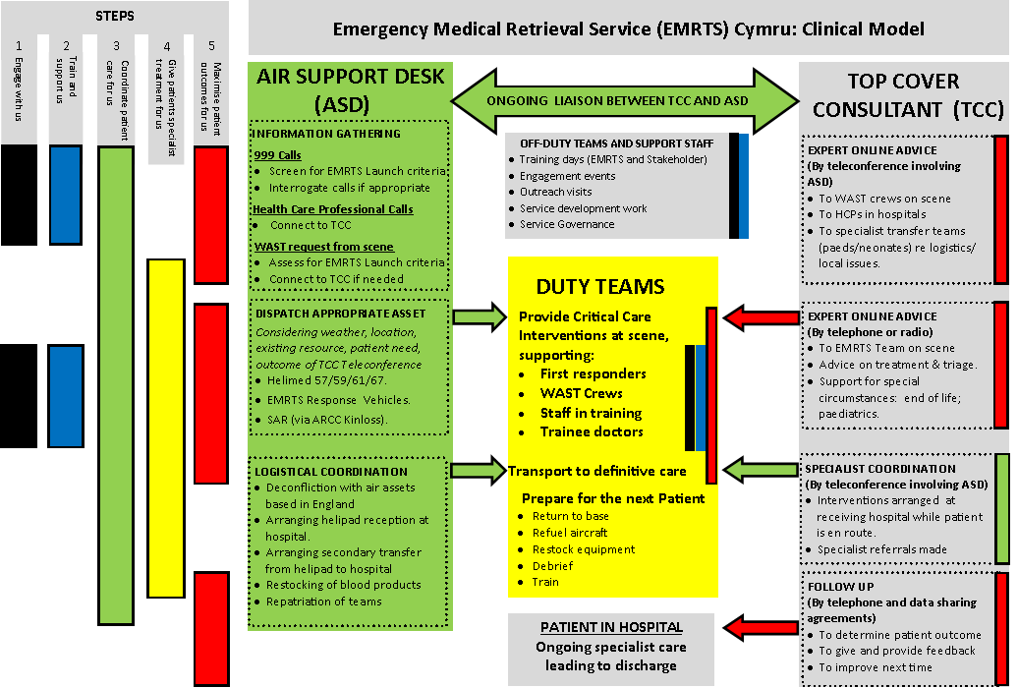
EMRTS Clinical Model for CAREMORE V1.3 JG 13Nov16

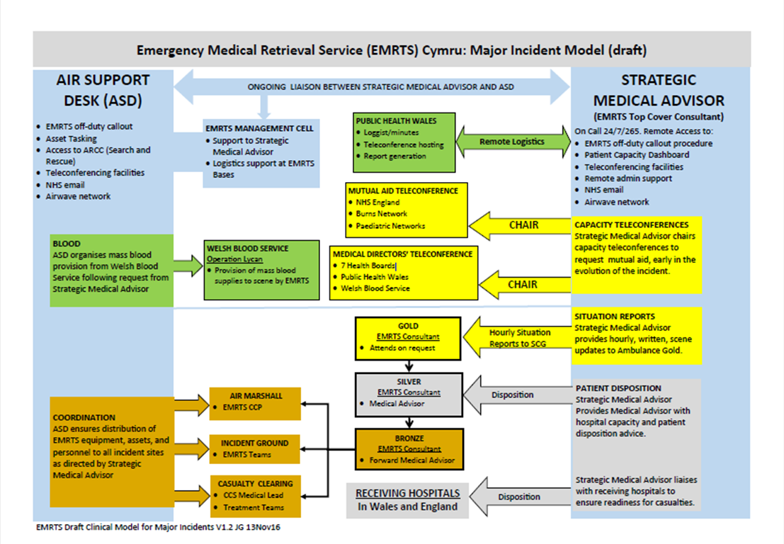
M2 Schedule: Emergency Medical Retrieval and Transfer Services (EMRTS) Major Incident Response

EMRTS Clinical Model for Major Incidents V1.2 JG 13Nov16

Operational Arrangements

The establishment of robust local mechanisms to ensure effective delivery with the right interaction between patients, professionals and organisations.

The products in this Operational Arrangements Section take the form of ‘Schedules’ which describe how the framework is intended to operate and how it fits with commissioning intentions, policy and IMTPs. It will also document the details of continuous improvements both from the framework itself and from service changes.

What are the Operational Arrangements Schedules?

Schedule O1 Commissioning and IMTP alignment: A process flowchart detailing the process of CAREMORE®
Schedule O2 Application of the Model of Care
Schedule O3 Extant Policies, Protocols, Pathways
Schedule O4 Continuous Improvement and Service Change

The reason for defining Operational Arrangements
To align processes and relationships both within and outside EMRTS which relate to the: management of the framework itself; the efficient and effective running of EMRTS: and opportunities for continuous improvement.

The guiding principles for developing Operational Arrangements

A Baseline Assessment exercise has been undertaken to determine the current operational arrangements for supporting delivery, contracting and commissioning.

The development of the Operational Arrangements Schedules indicates that they are:
- to be consistent with Prudent Healthcare;
- to include who is accountable and responsible for what;
- to provide clarity around who does what across relevant parts of the health and social care system;
- to clarify performance improvement arrangements;
- to ensure continuous improvement;
- to link with commissioning intentions, policy and Welsh Government expectations from IMTPs.

Operational Arrangements Schedules

Schedule (s) | Schedule Name | Schedule status:
O1 Schedule | Commissioning and IMTP alignment | Final
O2 Schedule | Application of the model of care | To be completed
O3 Schedule | Extant policies, protocols, pathways | To be completed
O4 Schedule | Continuous Improvement and Service Change | Final

Operational Arrangements information within the Framework Blueprint

The Operational Arrangements Section in the Framework Blueprint currently contains no information.

O1 Schedule: Commissioning and IMTP Alignment

This Schedule outlines how the EMRTS Quality and Delivery Framework links into the IMTP Process via Commissioning Intentions.
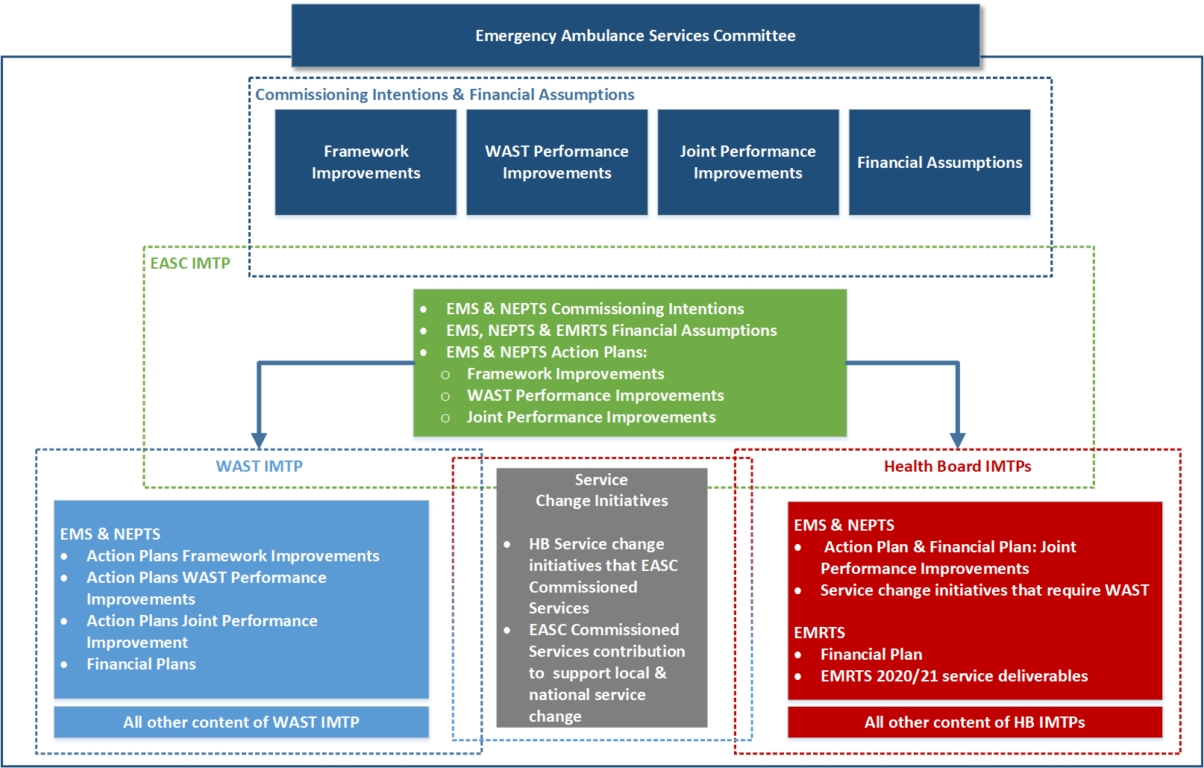

O2 Schedule:
Application of the Model of Care

This schedule sets out the relevant EMRTS provision delivered for each Health Board under this Quality and Delivery Framework. The services documented within this schedule can be quality assured.

O3 Schedule:
Extant policies, protocols, pathways

This schedule sets out the relevant EMRTS provision delivered for each Health Board under this Quality and Delivery Framework. The services documented within this schedule can be quality assured.

O4 Schedule:
Continuous Improvement and Service Change

This Schedule is a Reference Schedule and contains specific links to EMRTS supporting major service change across NHS Wales.

Review of Performance

An agreed system of performance measurement to ensure the right monitoring and management to deliver continuous improvement.

The final product will take the form of ‘Schedules’ which will provide:

- descriptions of the performance measures which will give assurance against delivery of the care standards for service requirements – following the patient care pathway; and core requirements;
- a comprehensive suite of activity, resources and performance measures from which: what, who, when and how reporting arrangements can be determined.

What are the Review of Performance Schedules?

Schedule R1: Performance Measurement Descriptors
(eg including patient and staff expectations and experience)

Schedule R2: Data Repository
(Note: this consists of A1 + RE1 + R1 and will be linked to “quadruple aim” outcomes and include reporting requirements)

They also detail a comprehensive suite of activity, resources and performance measures from which: what, who, when and how reporting arrangements can be determined.

The reason for defining Review of Performance

To bring together the key performance measures (A1, RE1 & R1 Schedules) that give assurance on the meeting of the Care Standards (C1 Schedule) applicable at each step of the EMRTS steps.

Service Requirements: EMRTS must ensure that the service is able to deliver the Pre and inter hospital critical care service and patient pathway detailed below.

In contrast to the EMS and EMRTS pathways, the first two steps of the EMRTS pathway relate to other healthcare services, while the last 3 steps relate to the individual citizen.

This Section seeks not to review performance but to describe how performance should be measured, monitored and reviewed.

The guiding principles for developing Review of Performance

A Baseline Assessment exercise has been undertaken to determine the current performance measures recorded and reported across EMRTS and commissioners.

The principles followed are as follows:

- to be consistent with Prudent Healthcare;
- to include measurements which cover infrastructure measures, process measures, outcome measures and enable trend analysis;
- identify extant performance metrics;
- to relate to the quadruple aim where relevant and appropriate to do so.

Reviewing Performance

The provider of services (EMRTS) must ensure those services covered by these measures, including those which may be provided by an agent appointed by EMRTS, have appropriate systems and processes to maintain the requirements covered by Sections i) and ii) of the Care Standards Schedules contained within this document. EMRTS must alert the commissioners as soon as possible to any circumstance that have or may result in the ability to not maintain such standards.

Review of Performance Schedules

Schedule (s) | Schedule Name | Schedule status:
R1 Schedule | Performance measurement descriptors.
R2 Schedule | Data Sources
R3 Schedule | Integrated Reporting

Review of Performance information within the Framework Blueprint

The Review of Performance Section in the Framework Blueprint currently contains no information.

R1 Schedule: Performance Measurement Descriptors
Ref | Care Standard |  | Required Outcome | Measure
Service Requirements

PCPs |  | Service requirements apply across the 5 step EMRTS patient care pathway | PE Patient’s Experience  CO Clinical Outcome  VM Value for Money | Extant Measures  Proposed Measures
Step 1 We will help partners understand how we work

PCP1 |  | EMRTS must engage with all healthcare providers to ensure that operational hours, eligibility criteria, and the nature of the service are well understood. This includes EMRTS attendance at NHS engagement events, and attendance at EMRTS events by non-EMRTS personnel. | NHS Wales organisations know the services provided by EMRTS and access them appropriately. [VM] | Proposed Measures:  PCP1. – Annual Audit of Health Board Switchboards availability of EMRTS contact details
PCP2 |  | EMRTS must participate in relevant service development initiatives at national, regional and local level, to ensure that it can effectively contribute to the future delivery of healthcare services in Wales. | Pro-active effective & efficient planning of Emergency Medical Retrieval and Transfer Services to support Local Health Board led service redesign programmes and developments. [VM] | Proposed Measures:  PCP2 – S1/A4 Number of attendances by EMRTS at National, Regional and Local Health Board events where focus is on service redesign and developments that may impact upon delivery of high acuity patient transfer.
PCP3 |  | EMRTS must engage fully with its third sector partner, the Wales Air Ambulance Charity Trust. | Effective collaboration to deliver high quality services. [VM] | Proposed Measures:  PCP3 – To be agreed
PCP4 |  | EMRTS must maximise training opportunities provided by its specialist staff and transport platforms. | Shared knowledge and skills across NHS Wales. [PE, CO] | Proposed Measures:  PCP4 - TO BE AGREED
PCP5 |  | EMRTS must work with relevant stakeholders in WAST, Local Health Boards, and the Health Education & Improvement Wales, to ensure that training opportunities are maximised. (e.g PHEN Training) | Staffs are appropriately skilled to deliver patient care. [CO] | Proposed Measures:  PCP5 - TO BE AGREED
Step 2 We will actively identify critical cases

PCP6 |  | EMRTS must have robust procedures in place to identify those patients who would benefit the most from an EMRTS response. This includes answering calls from healthcare providers, and identifying cases on the WAST electronic dispatch system. | The prompt identification of critical care incidents. [PE, CO]  Inappropriate disparities are minimised. [VM] | Proposed Measures:  PCP6 – Critical Care Intervention Rates and ASD working group. Also linked to PCP8
PCP7 |  | EMRTS must ensure that it has a procedure to provide immediate, high-level advice to healthcare professionals, including its own duty teams. | Senior clinical support is always available. [CO] | Proposed Measures:  PCP7 - % of advice requests unable to be responded to by top cover consultant
Step 3 We will respond quickly and efficiently

PCP8 |  | EMRTS must ensure that the right resource(s) are dispatched to provide the right type of care for patients. | The correct EMRTS resources are always available, to meet patients clinical needs. [PE, CO] | Proposed Measures:  PCP8 - % of calls where critical care interventions provided by EMRTS following arrival on scene
PCP9 |  | EMRTS must ensure that, when a response is appropriate, a resource is dispatched without delay. | Patient receives the quickest response possible to meet their clinical needs. [PE] | Proposed Measures:  PCP9 – Total time to allocation of EMRTS resource from interrogation/request  PCP9i – Mobilisation time by Aircraft/Road Vehicle
PCP10 |  | Aircraft and vehicles must be fit for purpose and meet the required safety standards. | Resources are available to attend patients. [PV, VM] | Proposed Measures:  PCP10 - % hours of each operational duty period during which aircraft is unavailable by reason
Step 4 We will provide high quality critical care

PCP11 |  | EMRTS must ensure that all interventions adhere to current best practice (e.g. EMRTS Standard Operating Procedures and relevant professional guidelines) | The best practice intervention has been undertaken to meet the patient’s clinical needs. [CO] | Proposed Measures:  PCP11 - Number of cases undergoing review, broken down by Audit pathway, debrief, formal debrief, m&m, external review  PCP11i - Analysis of EMRTS database to include patients’ clinical outcomes  PCP11ii – Percentage of patients undergoing general anaesthesia who are entered into RSI audit pathway  PCP11ii - Percentage of patients receiving blood or blood products, who are entered into the blood transfusion audit.  PCP11iv – Percentage of post-ROSC patients receiving full care bundle.
Step 5 We will handover care safely and efficiently

PCP12 |  | EMRTS must ensure that patients are taken to the most appropriate hospital critical care facility, first time. | Patients receive definitive treatment. [CO]  Secondary transfers for treatment are minimised. [VM] | Proposed Measures:  PCP12 – Percentage of attendances where EMRTS bypass the nearest hospital to take a patient direct to definitive care
PCP13 |  | EMRTS should only convey patients who require specialist support, or expedited transfer (only do what only EMRTS can do). | Critical care availability is maximised. [VM] | Proposed Measures:  PCP13 – Percentage of calls where patients are passed to WAST for transport to hospital following EMRTS intervention
PCP14 |  | EMRTS must ensure that appropriate communication takes place, at all levels, to ensure that a patient’s reception and transfer into hospital care is seamless. | Patients receive the right care in the right place first time. [PE] | Proposed Measures:  PCP14 – Percentage of conveyed cases by EMRTS where a pre-alert call is made to the receiving facility  PCP14i - Percentage of inter-hospital transfers where a discussion takes place between EMRTS personnel and the receiving unit to ensure availability of specialist care
PCP15 |  | All patients determined by EMRTS not requiring conveyance are appropriately ‘safety netted’, and a record of the consultation and decision is left with the patient or appropriate representative. | An accurate and timely referral or plan is made to support each patient’s ongoing care. [PE] | Proposed Measures:  PCP15 - TO BE AGREED
PCP16 |  | EMRTS must ensure that resources are available to respond to their next call without delay. | EMRST resources are managed to maximise availability to attend the next call. [VM] | Proposed Measures:  PCP16 – Time Spent on scene for EMRTS pre-hospital attendances broken down by patient chief condition  PCP16i – Time Spent at the referring facility for EMRTS inter-hospital transfers  PCP16ii – Time from notification to handover by hospital  PCP16iii – Time from handover to clear, by Aircraft or Road Vehicle
Core Requirements

CRs |  | Core Requirements underpin service delivery across the 5 step EMRTS patient care pathway | PE Patient Experience  CO Patient’s Clinical Outcome  VM Value for Money  (All of the above) | Extant Measures:  Proposed Measures:  (EMRTS to provide assurance that they have the capability and capacity to deliver high quality, safe, effective, evidence based treatment and clinical care through services that are patient focussed)
CR1 |  | Governance  EMRTS must ensure:-  that there are effective systems and processes in place to assure, patients, commissioners and other stakeholders, that they are providing high quality, evidence based treatment and care through services that are patient focussed; external validation of governance arrangements. | The health and experience of patients is improved by providing safe, effective and efficient Emergency Retrieval and Transfer services. [PE CO VM] | Proposed Measures:  CR1a -Number of cases being reviewed by External Clinical Advisors  CR1b – Number of cases reviewed by SBUHB quality and safety committee
CR2 |  | Patient experience & satisfaction  EMRTS must ensure:-  it undertakes Patient satisfaction surveys;  systems are in place to collect feedback from Patients and their families or carers on the experience of care;  a record of all complaints of whatever nature regarding any of its Emergency Medical Retrieval and Transport Service is maintained  EMRTS must ensure that the views and comments are gathered through (i), (ii) & (iii) using effective engagement mechanisms which are then actively used to inform service improvement and development;  EMRTS must ensure it has a system in place to record, investigate, report and learn from incidents and accidents. | Patient centred and responsive services are consistently planned provided and reviewed and take into account patients views and experiences. [PE] | Proposed Measures:  CR2a – Number EMRTS complaints  CR2b – Number EMRTS compliments  CR2c – Number of EMRTS patient satisfaction surveys undertaken  CR2D – Number of EMRTS complaints investigated by SBUHB
CR3 |  | Equity  EMRTS must ensure that patients have equal access to services regardless of their location or the location of the incident. | The health and experience of patients is improved by providing safe, effective and efficient ambulance services regardless of location or time. [PE CO VM] | Proposed measures:  CR3a - Number of calls available to be attended due to resource availability
CR4 |  | Clinical Care  EMRTS must ensure:-  that all activities and programmes are developed from:  using a model that has measurable outcomes; and  delivered by appropriately qualified and experienced staff educated in their use; that the health, safety and wellbeing of patients who receive treatment is not adversely affected by inadequate training, accountability, operational systems or arrangements.  EMRTS must develop national strategies for services which are then locally delivered. | Services provided are always clinically safe and effective. [CO] | Proposed Measures:  CR4a – Number of audits undertaken annually  CR4b – % of total cases reviewed at monthly governance days  CR4c - Number of patient follow ups undertaken
CR5 |  | Staffing  EMRTS must ensure:-  staff members are appropriately recruited, educated and qualified for the services they provide;  staff have health & wellbeing support;  there are workforce planning arrangements in place that identify staffing requirements and action plans such as recruitment and training to meet those requirements;  there are staff appraisal processes in place  an adequate and safe establishment with the correct skill mix of staff to ensure the needs of the patients are met; systems are in place systems to manage unplanned absenteeism, holidays, vacancies, and emergencies. | Optimal planning and use of staff resources. [VM] | Proposed Measures:  CR5a - % of planned training delivered  CR5b - % of sickness absence  CR5c - Number of violence & aggression incidents reported by staff  CR5d - Number of injuries reported by staff  CR5e - Number of grievances
CR6 |  | Safety  EMRTS must ensure that any services it provides to the public and any patient interventions it undertakes protects public / patients from avoidable harm and clinical risk. | The health of patients is improved by providing safe services. [CO] | Proposed Measures:  CR6a - Number of adverse incidents

R2 Schedule: Data Sources

This Reference Schedule sets out the data sources to be utilised for performance management and reporting.

It identifies and enables:
- The data sources for Emergency Medical Retrieval and Transfer service and the relationship between the data sources and integrated reporting.
- Information returns / sources as the A1 RE1 R1 which are mapped to C1 & M1.
- What is required for reporting: what we want to report, to whom we want it reported, and the how of it getting reported.
- Performance reporting and management including; tolerances and the actions or escalation routes for breach of tolerances.
- Patient Experience and Staff Engagement reporting to be included.
- Evaluation against the quad aim.

R3 Schedule: Integrated Reporting
This Reference Schedule sets out the integrated performance reporting mechanisms.

It identifies and enables:
- The relationship between the data sources and integrated reporting.
- Performance reporting and management including; tolerances and the actions or escalation routes for breach of tolerances.
- Patient Experience and Staff Engagement reporting.

Evaluation

An agreed set methods and criteria for judging the achievement of the right patient outcomes, from the right patient experience, at the right cost.
The products in this Evaluation Section take the form of ‘Schedules’ which describe methodologies to evaluate the impact of service changes; an evaluation programme of work and relevant evaluation reports to be recorded.

What are the Evaluation Schedules?

Schedule E1: Evaluation Methods

Schedule E2: Evaluation programme

Schedule E3: Evaluation reports

The reason for defining Evaluation
To ensure that the impact from the creation of the framework itself and the impact of the products and changes it enables has a robust way of being evaluated. This ensures that benefits may be quantified, with lessons learnt and shared.

What are the guiding principles in developing Evaluation?
These are as follows:
- meet Prudent Healthcare expectations;
- draw upon learning gathered from previous reviews / evaluations;
- identify baseline positions before and after an intervention is undertaken;
- evidence impact using a variety of methods;
- standardise evaluation methods proportionate to the scale of intervention, including qualitative and quantitative impacts and their sources.

Schedules & Version control

Schedule (s) | Schedule Name | Schedule status:
E1 Schedule | Evaluation Methods | Not completed
E2 Schedule | Evaluation programme | Not completed
E3 Schedule | Evaluation reports | Not completed

Evaluation information within the Framework Blueprint

The Evaluation Section in the Framework Blueprint currently contains no information.

E1 Schedule: Evaluation Methods

This Schedule will contain the mixed methods to evaluate service change initiatives.

This Schedule is not complete. Completion of this Schedule forms part of the 2020/21 Work Programme for the C3 Faculty.

E2 Schedule: Evaluation Programme

The evaluation programme for CAREMORE® Quality and delivery Frameworks is delivered by Swansea University under a separate agreement.
The Schedule is not complete. Completion of this Schedule forms part of the 2020/21 Work Programme for the C3 Faculty.

E3 Schedule: Evaluation Reports

This Schedule will reference all of the completed evaluation reports for service changes completed since the ‘Go Live’ date of the EMRTS Quality and Delivery Framework.
This Schedule will be a Reference Schedule with the completed reports available as part of the Framework Blueprint.
The Schedule is not complete. Completion of this Schedule forms part of the 2020/21 Work Programme for the C3 Faculty.

Framework Blueprint

Contents

- List of Standard Schedules
- Benefits of Using CAREMORE®
- CAREMORE® Plan on a Page (POaP)
- EMRTS Business case
- EMRTS 24/7 Business Case
- Schedule Development History / Baseline Data

List of Standard Schedules

CAREMORE® Component | Schedules
Care Standards | C1 Care Standards  C2 Bibliography of Relevant Publications
Activity | A1 Activity Descriptors  A2 Data Repository
Resource Envelope | RE1 Resource Management Descriptors  RE2 Revenue Value (Spend across the Model of care)  RE3 Capital Value (Spend across the Model of care)
Model of Care | M1 Model of Care Description (high level)  M2 Model of Care wiring diagram (for each HB/Region)
Operational Arrangements | O1 Commissioning and IMTP alignment  O2 Application of the Model of Care  O3 Extant Policies, Protocols, Pathways  O4 Continuous Improvement and Service Change
Review of Performance | R1 Performance Measurement Descriptors (eg including patient and staff expectations and experience)  R2 Data Sources  R3 Integrated Reporting
Evaluation | E1 Evaluation methods  E2 Evaluation programme  E3 Evaluation reports

Benefits of using CAREMORE®

Coproduction with service providers and users is a core tenet of the Project. CAREMORE was designed explicitly as a method of increasing and capitalising on coproduction in the development of commissioning and the design of large scale quality and delivery frameworks.

Research has been undertaken to explore stakeholder experience of CAREMORE®, perceptions of how it has been implemented and whether it has achieved, or is beginning to achieve the intended objectives and improvements. Attached is a copy of the manuscript which is an accepted publication in the Journal of Integrated Care.

The journal itself is not open access and so the paper has been made available on the Swansea University database known as CRONFA to enable those without a subscription to access it via the link below.

http://cronfa.swan.ac.uk/Record/cronfa39898

Participants reported positive experiences in the facilitated approach within the collaborative commissioning process; the most coveted function was that it allowed for the organisation of complex service design and delivery and the collection of relevant, rather than arbitrary, information. In using the structure of CAREMORE®, complex issues could be communicated simply, within and across organisations, to ensure a mutual understanding between key stakeholders.

Overall the stakeholders who were interviewed saw CAREMORE as fulfilling an important gap in facilitating complex service change, particularly when this change had come about in response to a review or report suggesting a need for improvement. Most felt it was successful in bringing together the relevant stakeholders, thus enhancing collaborative commissioning. However, due to the early stage of implementation, some stakeholders felt that there was still some work to be done in order to be fully collaborative. This is a common finding among quality improvement projects.

Some stakeholders thought the use of CAREMORE as a commissioning tool would be enhanced with the involvement of an impartial third party to provide relevant stakeholder engagement and allow both providers and commissioners to be held accountable. Increased transparency of information brought with it some unanticipated concerns around how to manage the plethora of newly exposed inefficiencies but generally participants saw this exposure as a positive in terms of providing context and moving forward with service change.

The Project team are committed to continuous improvement of the Collaborative Commissioning Approach and learning from and further developing the concepts, methods and tools within CAREMORE. As such the framework itself may be subject to change as a consequence of the continued application, learning and independent evaluation of CAREMORE.

CAREMORE® Plan on a Page

Care Standards | Activity | Resource Envelope | Model | Operations | Review | Evaluate
Output: An evidenced set of care standards for emergency department services to ensure that the right expectations are defined for quality and safety | Output: An accurate description of the activities within emergency departments to ensure that the right capacity is available to meet the right demand | Output: A comprehensive description of the assets which may be utilised and affected with the ambition of making the best use of all existing resources | Output: A common high level model of care for emergency departments to ensure that people can access right staff, at the right place, at the right time | Output: The establishment of robust local mechanisms to ensure effective delivery with the right interaction between patients, professionals and organisations | Output: An agreed system of performance measurement to ensure that the right monitoring and management to deliver continuous improvement | Output: An agreed set methods and criteria for judging the achievement of the right patient outcomes from the right patient experience at the right cost
Action Planned
Action Taken
Schedules
C1 Care Standards | A1 Activity Descriptors | RE1 Resource Management Descriptors  RE2 Revenue Value  Spend across the Model of care  RE3 Capital Value  Spend across the Model of care | M1 Model of Care Description  (high level)  M2 Model of Care wiring diagram  (for each area) | O1 Commissioning and IMTP alignment  O2 Application of the Model of Care  O3 Extant Policies, Protocols, Pathways  O4 Continuous Improvement and Service Change | R1 Performance Measurement Descriptors  (eg including patient and staff expectations and experience)  R2 Data Repository  (Note: this consists of A1 + RE1 + R1 and will be linked to “quadruple aim” outcomes and include reporting requirements) | E1 Evaluation methods  E2 Evaluation programme  E3 Evaluation reports

EMRTS Business Case

EMRTS 24-7 Service Expansion Review

Schedule Development History / Baseline Data

CAREMORE® Component | Schedules / Baseline data
Care Standards

Activity

Resource Envelope

Model of Care

Operational Arrangements

Review of performance

Evaluation

