Attendees
Stephen Harrhy, Chair (SH, EASC)  Rachel Marsh (RM, WAST)  Kath McGrath (KMc,CTMUHB)  Hugh Bennett (HB, WAST)  Jamie Marchant (JM, PTHB)  Lee Davies (LD, C&VUHB)  Kath Smith (KS, ABUHB) Chris Turley (CT, WAST)  Gavin MacDonald (GMc, BCUHB)  Lee Brooks (LB, WAST) |  |  | Ross Whitehead (RW, EASC)  Claire Roche (CR, WAST)  Craige Wilson (CW, SBUHB)  James Rodaway (JR, EASC)  Gwenan Roberts (GR, EASC)  Stuart Davies (SD, EASC)  Nicola Johnson (ND, SBUHB)  Brendan Lloyd (BL, WAST)  Jonathan Jones (JJ, EASC)  David Hanks (DH,ABUHB)
Apologies
Meinir Williams (MW, BCUHB)  Adele Gittoes (AG, CTMUHB)  Andrew Carruthers (AC, HDdUHB) |  | Claire Birchall (CB, ABUHB)  Chris Moreton (CM, NCCU)  Alex Crawford (AC, WAST)
Item |  |  |  | Actions
 | WELCOME, INTRODUCTIONS & APOLOGIES  Stephen Harrhy welcomed all present to the Special meeting of the EASC Management Group and gave an overview of the meeting; he was pleased to note that all health boards apart from one were represented at the meeting. |  |  | Ongoing
IMPLEMENTATION OF THE DEMAND AND CAPACITY REVIEW UPDATE

Rachel Marsh presented the report which had been sent out to Members on the previous Friday. Stephen Harrhy suggested that as Members had not had the opportunity to read the report that Rachel Marsh present the report on a page by page basis.

Members noted the purpose of the report.

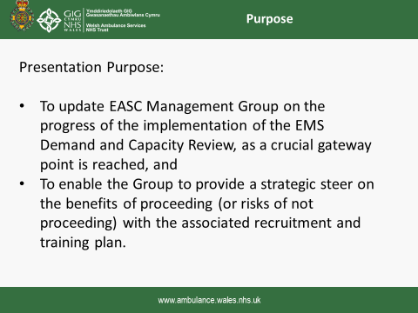

Members noted the background and findings of the D&C Review including:
- Sickness absence target of 5.99%
- The amount of continuous professional development hours for all staff at 52 hours
- Re-rostering work to reduce numbers required by 72WTE
- Efficiencies required in control centres
- Health board reductions in handover delays
- ORH indicated that the relief gap by Dec 21 at 262.5WTE

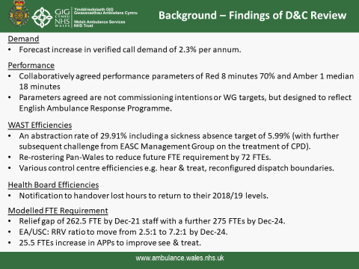

Members noted the EASC Commissioning Intentions
- Links for payment to delivery milestones
- Achieving the 65% red performance and 95% Amber to reduce
- Various CCC and abstraction efficiencies
- Need to shift to front line spend
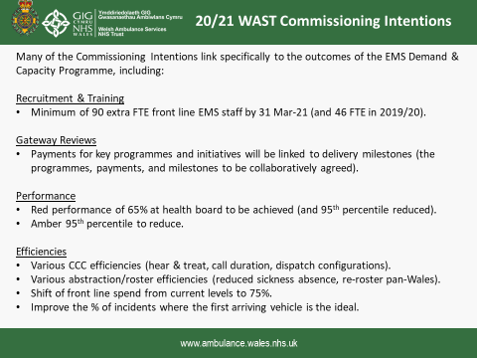
Members noted aim of WAST IMTP:
- Transform Emergency Medical Services
- Increase front line staff
- Agree milestones (TBC)
- Identify timescales (TBC)
- Close the relief gap
- 136WTE in post by March and deliver year 1 efficiencies
- Fleet and estate
- Cost resourced £1.8m from HBs
- WAST had identified a £1.5m gap
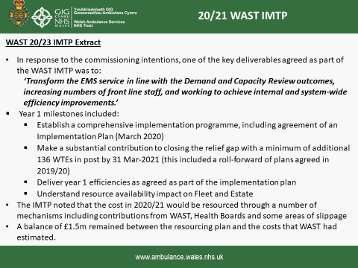
Members asked regarding the abstraction level:
- No agreement how this might be further reduced
- Impact of sickness levels; training; annual leave etc
- Need to better understand that the CPD hours (52) are included
- WAST internal work to report to programme board in a couple of weeks – would be shared as would be helpful to have the agreed plan to include in the next steps.
{Lee Brooks joined the meeting}

Members noted the 8 Programme Benefits identified so far:
- Benefits workshop had been planned but had to be postponed, would be revisited
- Most important benefit to improve response times
- Reduction in serious adverse incidents (SAIs) – not seen during Covid related to delays
- Many benefits for staff health and well being
- Wider USC benefits to do this programme of work
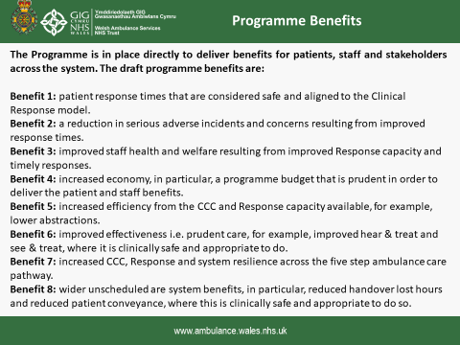

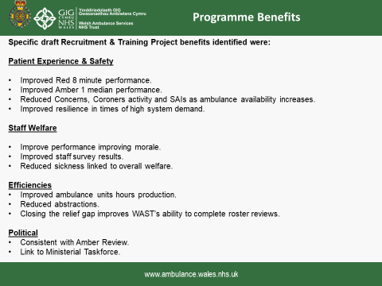
Members noted the specific areas of work and the high level indicators in 5 year programme of work.

Members asked about the improvement in the performance particularly in rural areas – no ED delays and over the last 2 months not good performance:

{David Hanks joined the meeting}

Members noted:
- that the model from ORH: the resources would deliver 70% overall and at least 65% everywhere.
- Reducing the variation is key for WAST
- Developing a pack of info for Powys as performance poor

Members suggested:
- Should the data be reviewed to learn lessons from the Covid response?
- WAST had learned lessons during Covid – these needed to be shared
- Clarifying the impact of reduced handovers
- Identifying the significant benefits
- Improved conveyance percentage
- More information related to hear and treat and reaching 10%
- Improved WAST team local knowledge of services provided to offer different pathways (such as CTM Stay Well @Home 2)

In summarising this section of presentation and discussion Stephen Harrhy confirmed:
- Need to use the learning from the response to Covid to shape the service
- Conveyance rates had improved but variation in what happened and need to identify the relevant factor why
- Need to strike a balance between red and amber performance as some patients waited a long time in the Amber category
- Need to balance the 65% in all areas and 70% overall
- Expectation of 90WTE additional (as agreed at EASC) and the WAST figure of 136WTE
- That the additionality would need to be confirmed
- Additional funding would be received for Covid and important not to double count
- WAST to be clear what was Covid costs and what was needed to deliver the ORH D&C Report

Members noted the Programme management structure slide – which would be responsible for delivering the work.

Members would have a key role in terms of handover delays and it was noted that they were increasing slightly in June.
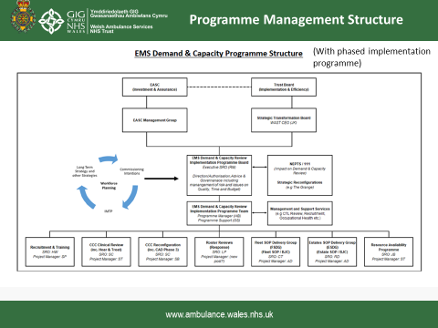

Members noted the Programme of works and progress to date
All workstreams had been paused during Covid apart from recruitment and training. Now aiming to restart work.

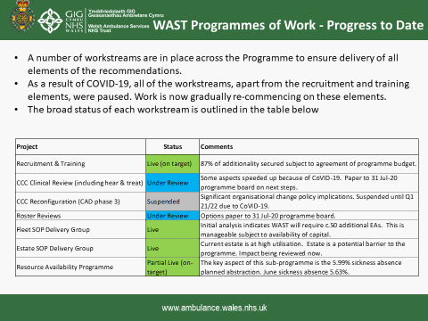
Members noted the Recruitment and Training plan
- Plan in place – core recruitment (turnover) plus the 136WTE but the training programmes had continued and plan was on track.
- Forecast – will hit 136WTE target before the end of the year
- Additionality – overtime levels consistent with previous levels and plan that overtime levels would not reduce
- How the 136WTE would be phased and used.
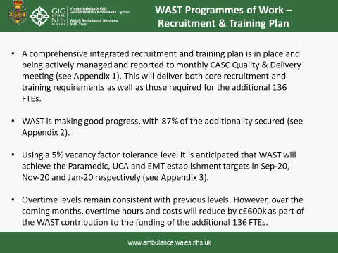
Members noted costs and funding - 136 staff £4.7m this year.
Detailed discussions on funding costs and identified in January and shortfall of £1.477m. Next recruitment in WAST would take over the cost envelope – choice to make to proceed?
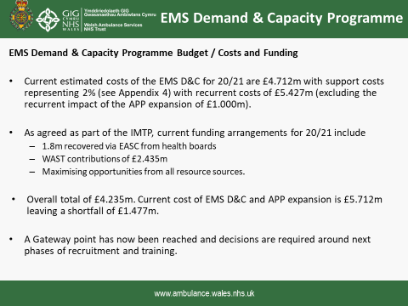
Members noted the Financial plan and:
- Information about specific areas
- If WAST pause recruitment now – an additional 73 staff would be in in post at the end of March
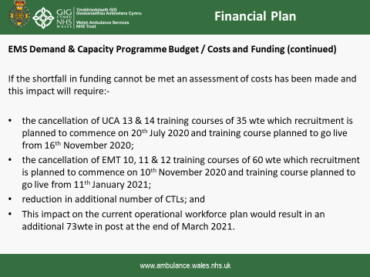

Members noted the Gateway review slide:
- Try to start to link delivery with payment
- What are the milestones? Additionality
- Sickness absence level (haven’t agreed a detailed trajectory) but the level has been met during Covid
- Roster reviews – haven’t agreed the trajectory yet and recommence planning
- CCC improvements – not yet agreed (off schedule)

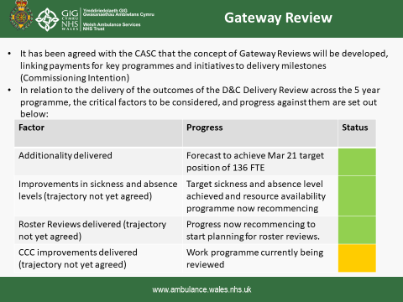
Members noted the Programme Risks
- Year 1 – programme budget
- 2-5 years – estates capacity staff and vehicles
- Only agreed a one year programme and the MAAT will be looking at the longer term
- Operational delivery risks.

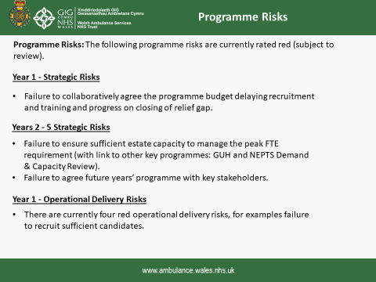

In summary Members noted:
- WAST Looking for a view and a steer on next steps
- Acknowledged that this is first step in a change programme to benefit patients across Wales
- Where next?

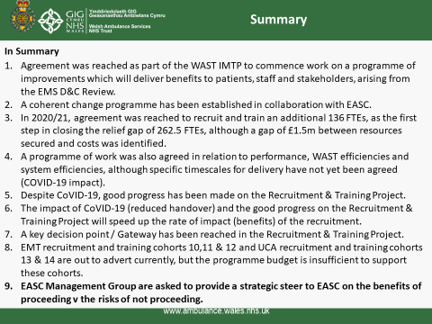

Members asked:
- Regarding the recruitment – WAST currently out to advert at risk as funding not secured. This was known in January and within the WAST IMTP – felt to be minimal risk as may not progress in the potential numbers anticipated
- Regarding the likelihood of HBs providing additional resource as NHS Wales deficits over £600m

The Chief Ambulance Services Commissioner summarised the position at the end of the meeting:
- There were a number of areas in the presentation that required further clarification such as the abstraction rate and the CPD hours for each member of staff – need a clear set of assumptions to work from (WAST to provide)
- Need to be clear about the actual status of the information in the Gateway Review and all Members would need to be sighted on the detail and would have an accurate position of issues (WAST to provide)
- Number of risks which WAST identified – need to agree what the risks are, the mitigations and level of risk for the key issues (WAST to provide)
- The ongoing work needs to consider the impact of Covid on the D&C Report and the service; need to see if the model needs to be revisited; the impact on performance is key and need to make sure that this is understood by all and is factored in for both rural and urban services – will this model work or will it now need to be tweaked? (WAST to develop information for further discussion)
Members were clear that the EASC Management Group should provide a view to advise the EAS Committee in their deliberations.

Members noted that:
- Benchmarking with other ambulance services had taken place by ORH and the abstraction rate was similar to ambulance services but not health boards. Important for decision making process.
- WAST would be recruiting band 3 staff for the Grange and therefore it would be easier to recruit and train and a plan was in place for both.

Members discussed the point of principle – if money was not an issue would supporting the request be the right thing to do?

Members asked why would they say no and what information would be required for the WAST request to be supported.

Members felt it was important to know whether demand had changed as a result of Covid and what other system changes would happen to change the requirements.

Members noted that new information was expected from the Welsh Government in terms of predictions and for planning purposes. Members noted that the demand on the WAST services was and had been steady.

The team from WAST explained that it was difficult to model although the Optima resource used internally by WAST was looking at a variety of scenarios. Health boards were also asked to share any modelling they were using for their services.

Stephen Harrhy reiterated the expectation from EASC that an additional 90 staff would be provided in this financial year.

In closing the special meeting, Stephen Harrhy thanked the team from WAST and members for the helpful discussions.

It was agreed that the missing information would be provided to Members in the spirit of the discussion at the meeting ‘why would they not support the request’.

Further information would be provided at the next meeting to further discuss the D&C Report and its implementation.

Members were reminded that the CASC was not seeking additional expenditure by stealth but supporting open and transparent discussions regarding the ambulance services provided to the residents of Wales.

AOB
3. | There was none
Future Meetings – Bi monthly
4. | Date of next meeting –27 August 2020  By Microsoft Teams  NCCU, Unit 1, Charnwood Court, Parc Nantgarw, Cardiff CF15 7QZ |  |  | SH  All

