Minister’s Report – July 2021

Ambulance Availability Taskforce

Introduction

This paper has been prepared to outline the transition of the Ministerial Ambulance Availability Taskforce into a group to advise the Chief Ambulance Services Commissioner (CASC) and the Emergency Ambulance Service Committee (EASC) to support development of a modern ambulance service that is fit for the future and that plays a wider role in the Urgent and Emergency Care system.
The paper will cover the following areas:
- Background to the Ministerial Ambulance Availability Taskforce
- Progress to Date – Interim Report
- Development of a Modern Ambulance Service
- Commissioner Transformation Fund
- Ambulance Handovers
- Summary and next steps

Background

On 16 January 2020, the former Minister for Health and Social Services established an Ambulance Availability Taskforce to lead:
- the implementation of recommendations from a recently commissioned independent “Demand and Capacity” review
- rapid delivery of alternative pathways and community-based solutions to prevent avoidable conveyance to emergency departments
- optimisation of the ambulance patient handover process
- improvement in Red performance, and to
- build on progress made by the Amber Review Implementation Programme.

The Taskforce is made up of senior representatives and experts with a knowledge of ambulance availability. The Taskforce is jointly chaired by Stephen Harrhy (Chief Ambulance Services Commissioner / Director of the National Programme for Urgent and Emergency Care) and Professor David Lockey (National Director, Emergency Medical Retrieval and Transfer Service Cymru).

Interim Report

The Taskforce prepared its Interim Report in February 2021 and submitted the report to the new Minister for Health and Social Services. This was followed by a meeting between the Minister and the Taskforce Co-chairs on the 24th of June.
At the meeting the following actions were agreed on the back of the interim report:
- The work should be continued but be reframed a Commissioner Taskforce, this will allow the taskforce to advise and strengthen the existing collaborative commissioning arrangements in place through the CASC and EASC
- The Taskforce will provide an external advisory role for the delivery and enactment of a citizen centred vision for a modern ambulance service and its role within a clearly defined wider health and social service system in Wales.
- The Minister would financially support the development of a commissioner transformation fund that would support the planning, education, welfare and recruitment of staff to meet the needs of the modern ambulance service over the next 5 years.
- Strengthening the Commissioner role; to promote collaborative delivery of value-based improvements; to focus on improved service delivery and a wider suite of measures and to ensure ownership accountability and risk sharing across the system. These may include:
- Enhanced controls that ensure additional funding is used to deliver the agreed priorities
- Incentives that enable delivery of efficiencies
- Identification of organisational inefficiencies or under delivery and addressing these at pace through the implementation of mitigating actions, and
- Development of a clear and transparent approach to monitoring performance across the system, with a focus on improving outcomes and delivering value.

Modern Ambulance Service

The Ambulance Service in Wales is commissioned across a 5 Step ambulance patient pathway. The overarching aim of the pathway is to ensure that patients only move to the next step if required, and that every opportunity to ensure the patients receive the right care, at the right time, in the right place is utilised at every step.
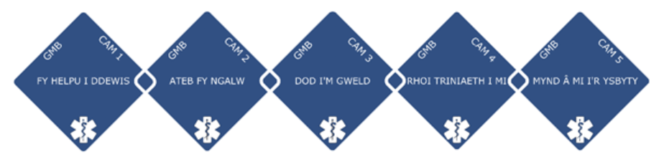
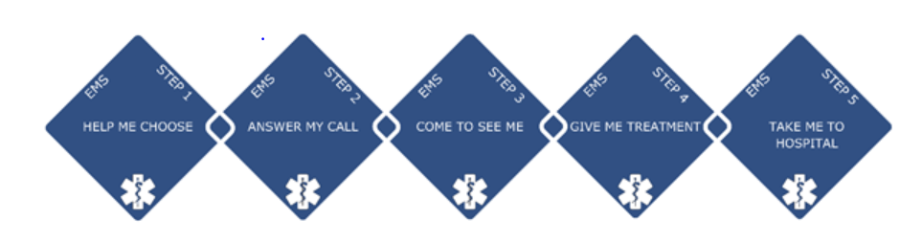
Some progress has been made against this ambition, however, more needs to be done if the service is to meet the needs of patients within the wider urgent or emergency care system moving forward.
It is important to note the emerging consensus that is developing between EASC and Welsh Ambulance Services NHS Trust (WAST) and the following high level model shown below that outlines this.
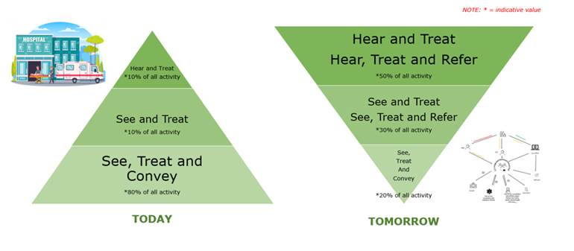
The model provides an opportunity to place the ambulance service at the heart of the urgent and emergency care system, to maximise the benefits of a co-hosted 111 and 999 service and to align with the future vision for urgent and emergency care services in Wales through initiatives such as contact first services and flow centres offering alternatives to individuals other than attending an Emergency Department.
The challenge of commissioning and operationalising this model cannot be underestimated and a radical approach to the performance managements and oversight of the ambulance service will be required in order to drive this change in the next 3-5 years.
The work will be supported by the development of a revised commissioning framework that will be enacted from the 1st of April 2022. This framework will focus on measuring and delivering improved outcome for patients presenting to the ambulance service as part of the contribution to better outcome for patients through the Urgent and Emergency care system.
In order to deliver this the ambulance service will need to deliver a substantial change programme, which must include modernising historical workforce practices. They will also need to ensure that improvements in efficiency, effectiveness and safety of service delivery are realised.
The CASC should oversee this and use existing accountability arrangements to ensure successful delivery of these important changes.
The focus on collaborative commissioning, the role of the CASC and the Commissioner Taskforce are key to overseeing and monitoring this transition to the delivery of a modern ambulance service.
Commissioner Transformation Fund

Given the scale of change and ambition for ambulance services in Wales over the next 3-5 year, a commissioner transformation fund will be an essential catalyst to realising this.
The CASC via EASC will ensure that the fund will be used to support proposed initiatives that contribute to the vision set out previously with funding allocated to support the initial set up and delivery of these initiatives.
Should the initiatives prove to be successful and, if additional funds are required, then EASC and / or Welsh Government (WG) would receive appropriate business cases in line with due process. An outline of the targeted use of the commissioner transformation fund and any planned additional investment would be set out each year through the Integrated Medium Term Plan (IMTP) process. The fund would not be used to support business as usual.
This year the fund would be targeted at Step 2 “Answer My Call”. The pandemic has seen an unprecedented shift towards remote clinical support for patients and it is evident from an ambulance service perspective that many patients can be supported and advised remotely on appropriate care for their condition without the need for an ambulance attendance.
Specifically in the 2021-22 financial year, it is proposed that following initiatives are progressed, with the aim of ensuring as many as possible are delivered in time for Winter:
- Supporting the implementation of an audit and education function to the Clinical Support Desk
- Increasing the Whole Time Equivalent (WTE) workforce of the clinical desk – this will allow many more patient to be assessed by a clinician in the contact centre, not only improving patient safety during waits but also increasing the likelihood of an alternative dispositions – this will also be supported by the investment in new clinical assessment software
- Augmenting specialist clinical support to the Clinical Support Desk (CSD) such as falls and mental health specialists – this will support patients and ambulance crews to access the right care, in the right place at the right time.
- Developing of a clinical oversight desk to provide a stack safety function.
- Investing in the commissioning team to expedite the development of an outcomes and value approach to commissioning and enhancement of performance oversight. This will support the radical change that is required to deliver the modern vision for the ambulance service, and allow for investment decision to be defined by measurable improvements to patient outcomes.
- Exploring the acceleration of the Senior Paramedic rollout – this should drive improvements in consistency of clinical practice, use of alternative pathways and maximising the use referral tools such as consultant connect.

Ambulance Handovers

Following a call for evidence to a range of all stakeholders with an understanding of handover delays the Taskforce held an evidence gathering session on the 21st of June. Evidence was received from a range of groups and organisations that consisted of service providers, national programmes and work streams, stakeholder groups/representatives and support services.

The approach used by the National Integrated Clinical Governance Group was adapted to guide the Taskforce discussion.
Following consideration of the evidence, the Taskforce agreed the following key requirements for optimising ambulance handover delays:
- System Expectations – The Taskforce considered the Welsh Health Circular (WHC) ‘NHS Wales Hospital Handover Guidance’ (WHC/2016/029), these principles include the need to plan for handover, ensuring effective communication before the patient arrives, providing appropriate triage / signposting, management of delays and the need to flex hospital capacity accordingly. It was agreed that in order for Welsh Government / NHS Executive expectations around handover to be clear there was a need for the circular to be streamlined and refreshed and to include a mechanism for review and enforcement.
The role of the CASC and the EASC team in holding Health Boards and WAST to account within existing accountability mechanisms for delivery of the WHC should be clarified and strengthened as required.
- System Leadership – Health Boards and WAST must identify and empower specific individuals/teams to take ownership of the handover issue and be responsible for the oversight and delivery of improvement on a daily basis.

Board members of University Health Boards (UHBs) and Trusts must set out clearly the organisations expectations around handovers and ensure these are enacted and be held to account for their delivery

- System Understanding - The use of digital capability and information to support system wide understanding of emerging pressures was considered a key element of driving improvement in handovers. The use of modelling and forecasting should be enhanced to support system planning and proactive response to emerging pressure both for demand and handovers.
A single dashboard with an agreed data set should be available to all organisations to support the understanding and management of system pressures.
Summary and Next Steps

The Ministerial Ambulance Availability Taskforce has proven to be an effective and functional mechanism of providing independent and external scrutiny to the delivery of ambulance availability in Wales.

Whilst the progress made by the Taskforce was severely impacted by the pandemic the work undertaken by the taskforce since its re-establishment in November 2020 has been rapid.

Consider the content of this report and welcome further discussions on its content and implementation.

