AGENDA ITEM
(INSERT NUMBER)

EMERGENCY AMBULANCE SERVICES COMMITTEE (EASC)

welsh ambulance services nhs trust (WAST) provider update
Clinical Response Model (CRM),
and the categorisation of the Medical Priority Dispatch System (MPDS) codes within the Dispatch Cross Reference (DCR) Table

Date of meeting | 6 September 2022

FOI Status | Open/Public

If closed please indicate reason | Choose an item.

Prepared by | Vince Baglole, Jon Edwards, Dr Jonathan Whelan, Lee Brooks, Grayham Mclean
Presented by | Jason Killens, Chief Executive WAST
Approving Executive Sponsor | Executive Medical Director

Report purpose | FOR NOTING

Engagement (internal/external) undertaken to date (including receipt/consideration at Committee/group)
Committee/Group/Individuals | Date | Outcome
- | - | Choose an item.

ACRONYMS
WAST  DCR  EMT  ARP  MPDS  PDA  CPAS  CRM  RRV  APP  REAP | Welsh Ambulance Services NHS Trust  Dispatch Cross Reference  Executive Management Team  Ambulance Response Programme  Medical Priority Dispatch System  Pre-Determined Attendance  Clinical Prioritisation Assessment Group  Clinical Response Model  Rapid Response Vehicle  Advanced Paramedic Practitioner  Resource Escalation Action Plan

- SITUATION/BACKGROUND

  - The purpose of this report is to provide EASC with an update on key issues affecting the current WAST Clinical Response Model (CRM), and specifically about the categorisation of the Medical Priority Dispatch System (MPDS) codes within the Dispatch Cross Reference (DCR) Table.

  - This CRM was introduced in October 2015 and represented a very significant shift from the previous model, both in terms of time-based targets, and with the introduction of clinical indicators as a primary marker of care quality.

  - Response priorities are determined locally by the DCR Table, which maps individual call codes to an appropriate priority (RED / AMBER1 etc.)

  - Pre-Determined Attendance (PDA) codes are assigned to each MPDS Code defining the type of resource / response that it will receive.

  - Following the introduction of the CRM in Wales (October 2015), NHS England introduced the Ambulance Response Programme (ARP) in 2016.

  - It is recognised that the WAST DCR Table and the ARP DCR Tables differ, both in terms of possible response ‘outputs’ and relative priorities.

  - To ensure that WAST maintains a clinically safe response to patients, the Clinical Prioritisation and Assessment Software Group (CPAS) undertakes regularly scheduled reviews of both WAST’s DCR Table and that of England’s ARP DCR Table.

  - Any updates and priority differences are reviewed and discussed. A decision is then made on whether to match ARP or set a different priority. The decision is a clinical one supported by activity data. This data includes number of incidents, number of conveyances, Hear & Treat percentage, and See & Treat percentage.

  - CPAS was asked by WASTs Executive Management Team (EMT) to undertake an exercise to map out the differences between the DCR Tables utilised by WAST and England and scope out the implications of updating the WAST DCR Table.

  - All 999 calls received by WAST are processed through Medical Priority Dispatch System (MPDS). MPDS is an internationally validated system, in widespread use across the UK, Western Europe and North America.

  - Each call will generate an MPDS code. This code is then mapped against the locally determined DCR Table, the output of which is a priority reflected in WAST as a colour (Table 1) and a suggested Pre-Determined Attendance (PDA) code. This determines the type of resource / response the call will get, for example Emergency Ambulance, rapid response vehicle (RRV), advanced practice paramedic (APP) or Clinical Telephone Assessment.

  - A fundamental difference between the DCR Tables of WAST and England’s ARP is the name given to the call categories. These are illustrated below in Table 1:-

Table1: WAST CRM & ARP England
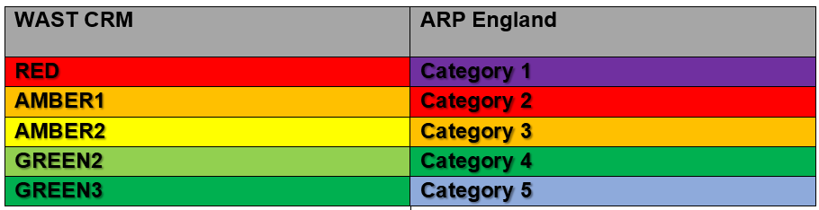
  - The 2015 DCR Table was constructed, and continues to be maintained, based on data supplied by WAST Health Informatics and consensus opinion using a multi-disciplinary panel of internal subject matter experts, with colleagues from a clinical and operational background, along with MPDS experts, supported by clinical and operational staff-side representation.

  - During DCR reviews, each individual code is considered, in terms of the types of patients who should be within that category, as well as historical data on call volume, conveyance rates, adverse incidents, and where available, data on success rates of secondary triage, etc.

  - Crucially, this is a similar process to the one used to determine priorities and outcomes in the English ARP model. WASTs Assistant Medical Director participates in the advisory group which considers the codes for ARP.

- SPECIFIC MATTERS FOR CONSIDERATION BY THIS MEETING (ASSESSMENT):

  - When mapping calls between the WAST CRM and the English ARP models, a comparison of the codes is undertaken to identify any differences in the priorities set out in each Table.

  - In the mapping exercise, particular attention was paid to ARP Categories 1 and 2, which map to WASTs RED and AMBER1 categories respectively. These are the highest clinical priorities in both DCR Tables. Any difference in priority (higher or lower) are discussed within the review and a clinical rationale reached when deciding its priority.

  - A DCR review was undertaken on 31 August 2021 where a number of codes were considered and discussed.

  - The detail of this is contained in the ANNEXES of this paper.

  - Each code was considered comparing WAST DCR with ARP and outcome data from 2019 and 2020. A recommendation and clinical rationale is offered for each code change proposal.

  - WAST can provide a clinical rationale for the priorities assigned in the WAST DCR Table.

  - When reviewing the specific codes where differences exist, it is evident that ARP includes codes in the highest priority which are potentially very serious, but where it could be argued that higher priority calls still exist.

  - Following this review on 31 August 2021, CPAS has identified a clinical rationale for each code where a difference has been identified.

  - The full clinical rationale is contained within the original CPAS papers, however, three code sets (main code + some or all suffixes) represent the vast majority of call volume which would change priority under these recommendations.

These are 12D02 (continuous/multiple fitting) and 21D03 (serious haemorrhage & not alert) which are proposed to change from AMBER-1 to RED priority; 23D02 (overdose/poisoning & unconscious) which is proposed to change from RED to AMBER-1 priority; and 10C03 (chest pain, breathing normally), which is proposed to move from AMBER-1 to AMBER-2.

  - 12D02 and suffixes represent patients with seizures, who are noted to be having multiple fits without recovery between, or who are continuing to have seizure activity. This is the predominant code by call volume in the proposed changes, representing over 5,000 unique 999 calls in 2019. This is a unique code in WAST, as it starts as an AMBER-1 priority, but re-categorises to RED after 20 minutes of seizure activity. This change was introduced around 2016, when other services re-categorised this as a category 1 call.

  - Critically, the upgrade process to RED is a manual one, which requires action by the emergency medical dispatcher. This process cannot be automated, so if the Emergency Medical Dispatch (EMD) forgets to manually upgrade (or if the call is taken by another service on behalf of WAST), then it will remain erroneously at AMBER 1.

  - Continuous or multiple seizure activity is a medical emergency which can have serious & long-term consequences for patients. Traditionally, the point at which such seizures were considered to be ‘continuous’ was if they persisted for 20 minutes. This clinical guidance changed in 2021, with a diagnosis of ‘status epilepticus’ requiring just 5 minutes of seizure activity. If WAST were to continue to code as AMBER-1, but upgrade after ‘x’ minutes, this time would need to drop from 20 minutes to 5 minutes. Pragmatically therefore, virtually 100% of these calls would end up a RED priority.

  - For 21D03 (serious haemorrhage / not alert) consideration was given to the clinical rationale used in ARP to prioritise this as a category 1 (RED) call. These is evidence of a high level of intervention to control major haemorrhage, as well as clinical risk & harm in this code. Additionally, 21D04 (dangerous haemorrhage) is already categorised as RED, and this is a code which can require manual intervention by the EMD to reach 21D04 if the patient is also “not alert” (as MPDS can then generate the 21D03 code, which WAST treats as a lower priority). A review of outcomes shows a high level of conveyance & significant clinical intervention in this code set.
  - For 23D02 (overdose/poisoning – unconscious), the proposal is to move from RED to AMBER 1. This is a high-volume code (1,200 to 1,300 calls per year). Under ARP this was recategorised as a category 2 call, due in part to a relatively low level of clinical intervention by crews, and a high ‘refusal of treatment’ rate at scene. Furthermore, other ‘protocol 23’ codes were felt to be a higher clinical priority, including a new 23 ‘echo’ code (23E01 - RED) for patients who are not breathing. While ‘unconsciousness’ is a concerning clinical feature, and serious consideration was given to keeping this as RED priority, it was felt by CPAS that they could support the ARP position, with 23D02 code not representing as high a clinical priority as 23E01. In the context of 23D02, the call is from a 3rd party with the patient (as the patient is unconscious) so monitoring can continue, and the patient must also be breathing normally.

  - 10C03 is one of the ‘lower’ priority chest pain calls. WAST has traditionally had this at AMBER-1 priority along with the vast majority of the chest pain (protocol 10) Charlie & Delta codes; however, in view of the evidence from England, and a clinical review of the types of patients held within this code (who, by definition, need to have normal breathing, normal colour, normal conscious level, and no shortness of breath), it was felt appropriate from the clinical standpoint that 10C03 sit at a lower priority than the 10’D’ codes which comprise chest pain plus an additional feature of concern. It was also noted by CPAS that 10C03 is used for patients over 35 years of age. The same symptom set in a patient under 35 years of age is a GREEN-3 code (Category 5 in England) and passed to 111 without concerns.

ANALYSIS

  - Table 2 below illustrates the number of MPDS codes within the current WAST DCR Table categories versus the number of codes in the proposed / updated WAST categories: -

Table 2: Current & Proposed DCR by CRM Category
Category | Current DCR | Proposed DCR
RED | 366 | 392
AMBER1 | 582 | 604
AMBER2 | 589 | 568
GREEN2 | 99 | 84
GREEN3 | 273 | 261
  - There are 164 codes (including 10 suffices) that are proposed for change. These codes are illustrated in Appendix 1, together with clinical rationale and data activity for each proposed code change.

  - An analysis of WAST’s operational period 01 January 2022 to 30 June 2022 provides an illustration of the actual activity (WAST current DCR Table) and how it would shift (proposed WAST DCR Table). This comparison (shift) is shown in Table 3 and Table 4: -

Table 3:

Table 4:

  - Based upon the analysis of the shift illustrated above in Tables 4 and 5, it is possible to show the variance between the proposed DCR Table versus the current DCR Table. As shown below in Table 5: -

Table 5:
  - Furthermore, as highlighted in points 26 and 27 of this paper, code 12D02 has been identified as requiring further analysis. As a result of a review during the same operational period as Tables 4, 5, and 6, illustrates the following.

  - Of the 3034, 12D02 codes, only 376 (12% of total activity for this code) were responded to within the recognised clinical safety timeline of 20 minutes.

  - An assumption can be made, therefore, that 88% (n = 2427) of the current 12D02 (AMBER 1) codes were upgraded to a RED response via the manual process (as described above in points 26 and 27 of this paper).

  - On the 22 September 2021, the original DCR / ARP Comparison Review paper recommended that consideration was given to modelling being undertaken to scope out a transition from the current WAST DCR Table to match the ARP DCR Table. A more recent modelling exercise was complete for the calendar year 2021, and period of 01 January 2022 to 31 May 2022. The findings of this updated data is attached to this paper as an ANNEX. Summary findings are shown in Table 6: -

Table 6 – Performance Impact of ARP Alignment
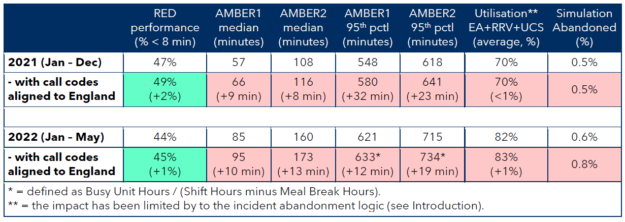
Conclusions and Forward Look

  - It should be noted that both CPAS and Clinical Quality Governance Group (CQGG) have approved the changes to the DCR Tables from a clinical perspective.

  - There is ongoing urgent work reviewing the feasibility / potential to develop a separate DCR Table, which can be activated when WAST are in high levels of escalation (REAP 4). A key issue emerging from this key work is the need to refresh and update the business as usual (BAU) WAST DCR Table, as described in detail within this paper. Providing a separate DCR table for high levels of escalation that is not based upon clinical updates agreed for the BAU DCR Table (within this paper), will introduce far too much risk to patients.

  - Potential deployment of these changes has been considered operationally and clinically. On 10 August 2022, WASTs EMT reviewed these clinical and operational recommendations for change and approved that the updated DCR Table will be implemented by 3rd October 2022. This affords sufficient time to manage system change and testing, provide communication to WAST’S workforce, formally advise stakeholders (including EASC) of the necessary adjustments and their consequences, and also consequently time the change to commence at the start of Q3 (which makes for ‘cleaner’ performance/data reporting).

- KEY RISKS/MATTERS FOR ESCALATION TO THE COMMITTEE

Members of the EAS Committee are asked to note that:

3.1 Based upon the clinical review undertaken it has been identified that patients prioritised as 12D02 (continuous/multiple fitting) and 21D03 (serious haemorrhage & not alert) are at risk of significant harm, if not responded to as RED calls.

3.2 As per Table 6 modelling impact above, it is indicated that AMBER 1 MEDIAN (minutes) will increase by 10 minutes with the implementation of WAST’s revised DCR Table.

3.3 As a result of the impact on response times, consideration will need to be given to further action or resource that is required to mitigate this impact, likely through the IMTP discussions in coming months.

3.3 WAST require this update to the business as usual DCR Table, before any other work can be completed to develop a high level escalation REAP 4 DCR Table, which can be utilised during severe pressures within the NHS Wales’ Unscheduled Care System.

- IMPACT ASSESSMENT

Quality/Safety/Patient Experience implications | Yes (Please see detail below)
Quality/Safety/Patient Experience implications | Identified within the report
Related Health and Care standard(s) | Timely Care
Related Health and Care standard(s) | And all health and care standards
Equality impact assessment completed | Not required
Legal implications / impact | Yes (Include further detail below)
Legal implications / impact | Potential Coroner Inquests
Resource (Capital/Revenue £/Workforce) implications /  Impact | Yes (Include further detail below)
 | To be further discussed, reviewed and proposed via a separate WAST report
Link to Main Strategic Objective | The Committee’s overarching role is to ensure its Commissioning Strategy for Emergency Ambulance Services utilising the five step patient pathway outlined within the National Collaborative Commissioning Quality and Delivery Agreement and the related outcomes for each care standard aligned with the Institute of Healthcare Improvement's (IHI) ‘Quadruple Aim’ are being progressed.  This report focuses on all the above objectives, but specifically on providing strong governance and assurance and safe and effective patient care
Link to Main WBFG Act Objective | Service delivery will be innovative, reflect the principles of prudent health care and promote better value for users

- RECOMMENDATION

The EAS Committee is asked:

- NOTE the content of the paper including the agreement and approval of the WAST EMT and WAST clinical governance groups to adopt the recommended changes
- NOTE the operational implications of the proposed changes to the DCR Table – forecasted to go-live by 3rd October 2022
- DISCUSS any further actions or resources required to mitigate the impact of this change.

ANNEXES:
DCR/ARP review and recommendations.

Pre-Determined Attendance (PDA) matrix:
PDA | UCS | EA | RRV | Specialist | APP
60
61
62
63
64
65
66
67
68 | No response attached PDA 68. Column Q (PDA key) within the DCR Table cannot be left blank. In instances where a PDA is not requiRED PDA 68 is enter (e.g., codes suitable for NHSDW/CSD).

OPTIMA DCR Table implications report.

