AGENDA ITEM
2.1

EMERGENCY AMBULANCE SERVICES COMMITTEE

PERFORMANCE REPORT

Date of meeting | 21/11/2023

FOI Status | Open/Public

If closed please indicate reason | Not Applicable - Public Report

Prepared by | Phill Taylor, Head of Commissioning & Performance
Presented by | Stephen Harrhy, Chief Ambulance Services Commissioner
Approving Executive Sponsor | Chief Ambulance Services Commissioner

Report purpose | FOR DISCUSSION / REVIEW

Engagement (internal/external) undertaken to date (including receipt/consideration at Committee/group)
Committee/Group/Individuals | Date | Outcome

ACRONYMS
CASC  DAG  EMRTS  IQPD  NEPTS  WAST  WG  EMS | Chief Ambulance Services Commissioner  Delivery Assurance Group  Emergency Medical Retrieval and Transfer Service  Integrated Quality, Planning and Delivery Meeting  Non-Emergency Patient Transport Service  Welsh Ambulance Services NHS Trust  Welsh Government  Emergency Medical Services

- SITUATION/BACKGROUND

  - The purpose of the report is to present to the Members of EASC the most recent publication of the:
    - Ambulance Service Indicators (ASIs) – Attached at Appendix 1
    - EASC Performance Dashboard – Attached at Appendix 2

- SPECIFIC MATTERS FOR CONSIDERATION BY THIS MEETING (ASSESSMENT)

Ambulance Service Indicators

  - The narrative and overview document for the latest reporting period – September 2023 is available at Appendix 1.

  - Full access to the ASI information for all publication is available at https://easc.nhs.wales/asi/

EASC Performance Dashboard

  - The Performance Dashboard is available at Appendix 2.

  - The dashboard presents time series information across a number of periods, including daily, monthly and annual time periods.

  - Of particular note within the dashboard for this reporting period:
- 999 call volumes in September 2023 were 1.8% lower than September 2022
- 1.9% increase in incidents in September 2023 compared to September2022
- Hear and Treat levels are 3.9% higher in September 2023 compared to September 2022
- Red incidents in September 2023 were 24.8% higher compared to September 2022.
- Amber incidents in September 2023 were 5.6% higher compared to September 2022.
- Ambulance handover lost hours over 15 minutes were 4.8% higher in September 2023 compared to September 2022. There have been incremental improvements for some % metrics in some health boards but total lost hours have been increasing since June 2023. Between June 2023 and September 2023 there has been a 5.7% increase in handover lost hours.

EASC Action Plan

  - In line with the requirements set out in the IMTP response letter, the EASC action plan is undergoing a further review to better reflect the challenges in 2023/24 and the requirement set out within the letter.

  - A revised draft will be shared through ICAP meetings and management group for comment and amendments.

Immediate Release Requests

  - Within the EASC Weekly performance dashboard, the dashboard includes data on immediate release request compliance. In addition to this, WAST circulate a weekly immediate release request report. Via the ICAP meetings, health boards have raised questions regarding the data and validity of the data. This matter has also been raised by health boards at the EASC Management Group meeting.

  - In response to this matter, the EASC Team have facilitated a meeting between health boards and WAST to understand the issues raised and look to identify opportunities for improvement.

  - The outcomes of this work will be shared with the EASC Management Group and reported to EASC Joint Committee.

Resource Flow

  - Within the ICAP meetings, a review of performance within each health board is undertaken. In those health boards where improvements have been made in reducing ambulance handover delays, health boards have sought to identify the correlating improvements in WAST’s community response performance.

  - With the exception of CVUHB, although there have been some improvements at individual sites within health boards, the level of improvement in ambulance handover delays do not provide sufficient ambulance capacity to deliver significant improvements in ambulance community response performance.

  - It is recognized that there had been improvements within some handover performance metrics between December 2022 and June 2023 but from July 2023 the total cumulative handover lost hours have continued to increase month on month. In September 2023, the total ambulance lost hours were 19,617. To note, the EASC IMTP performance ambition for ambulance handover delays, were 15,000 lost hours by the end of Q2 and 12,000 lost hours by the end of Q3. Additionally, the 2019 EMS Demand and Capacity Review was predicated on 6000 lost hours per month.

  - In response to the question raised by health boards regarding the correlation in a reduction in ambulance handover delays and ambulance community response performance, the EASC Team have worked with WAST to review this matter.

  - An initial exercise was undertaken within the south east Wales region to review CVUHB ambulance performance, aligned to the health boards’ significant reduction in handover delay lost hours. The key outcome of this exercise identified that even though CVUHB had significantly reduced their handover lost hours, which resulted in ambulance resources becoming more readily available, these available ambulance resources were then responding to incidents with ABUHB and CTMUHB.

  - With high handover levels with ABUHB and CTMUHB, limiting ambulance availability within those areas, ambulance resources from CVUHB are therefore responding to patients within the community in ABUHB and CTMUHB. The exercise identified that since 2020, the number of CVUHB and ABUHB ambulance resources responding to incidents outside of their health boards has increased year on year, but the number of CTMUHB resources responding to health boards outside of their health board has remained consistent.

  - Table 1 shows the number of health board incidents responded to by an ambulance resource outside of their originating health board since 2019.

Table 1.

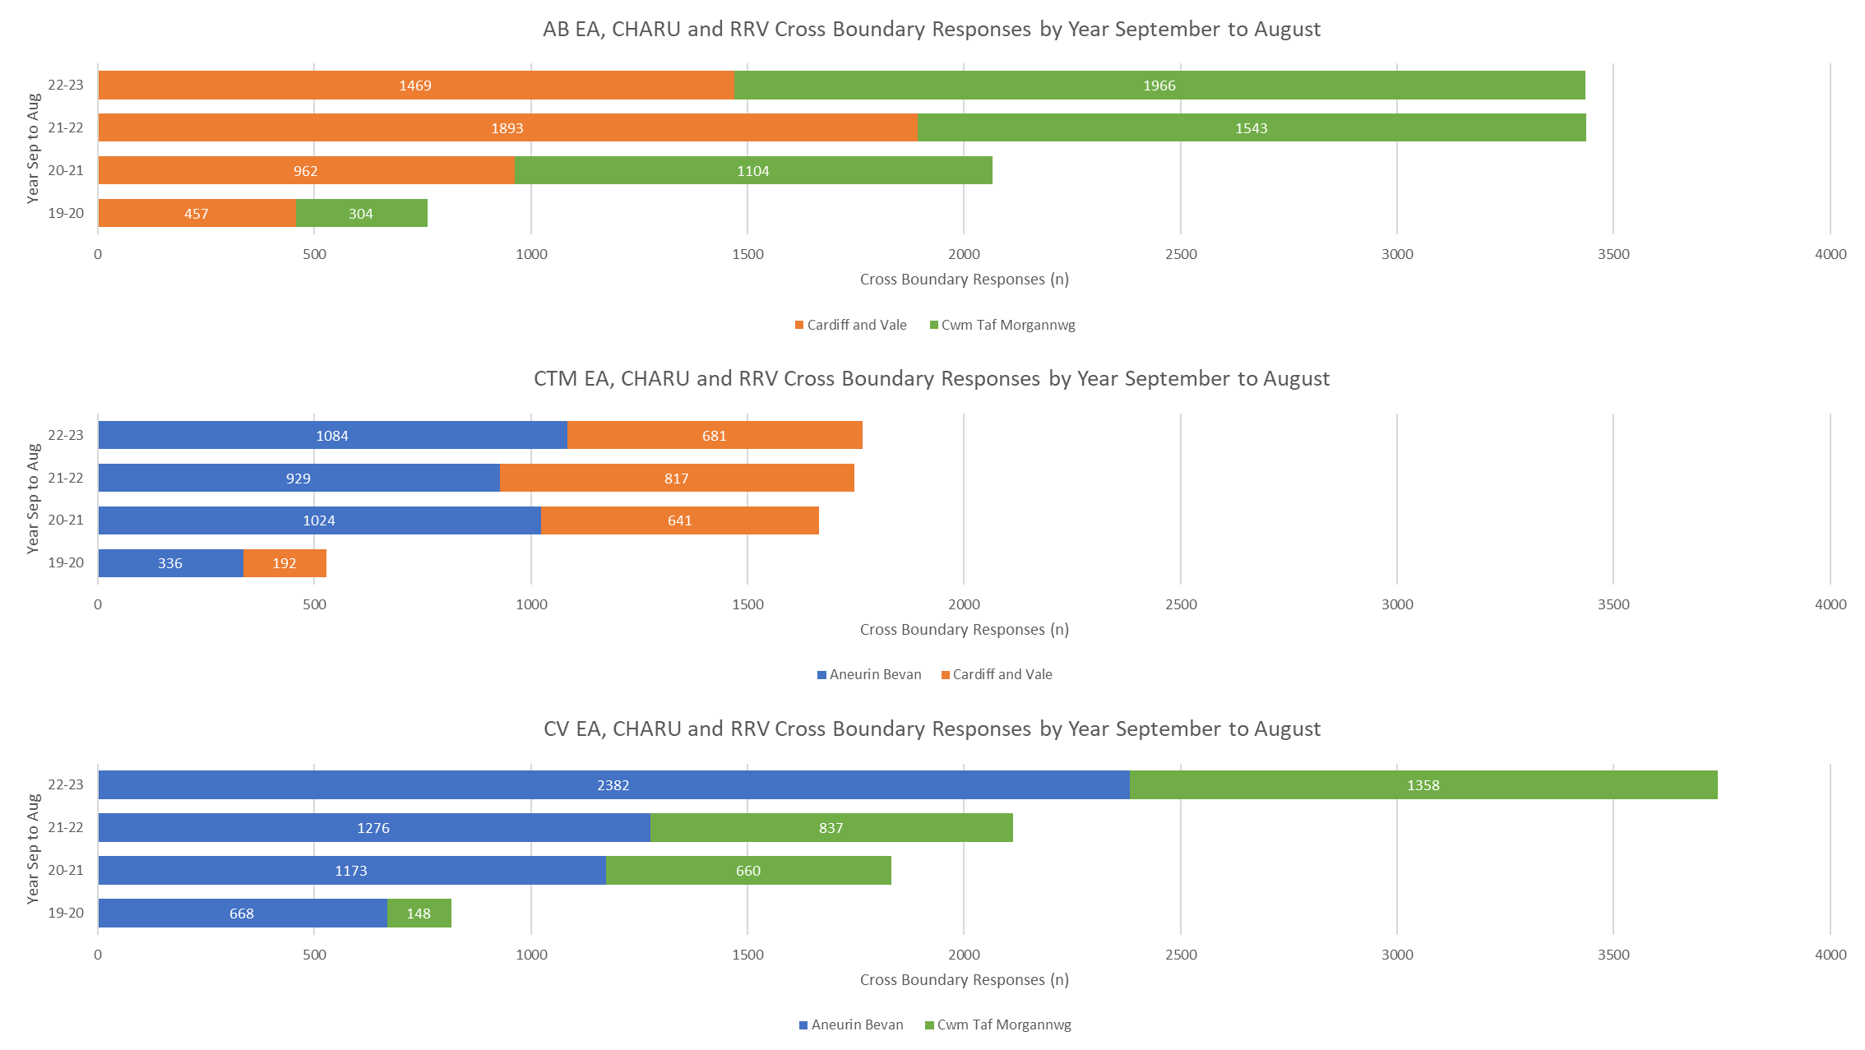

- KEY RISKS/MATTERS FOR ESCALATION TO THE COMMITTEE

  - Whilst improvements are being made, members will note that within the ASIs and the Performance Dashboard there are a number of areas of concern regarding response performance and lost hours.

- IMPACT ASSESSMENT

Quality/Safety/Patient Experience implications | Yes (Please see detail below)
Quality/Safety/Patient Experience implications | The impact of handover delays is affecting patient experience including quality and safety aspects and is leading to unsatisfactory service for the people of Wales (or within specific health board areas) with increased likelihood of harm, disability and death.
Related Health and Care standard(s) | ALL are relevant to this report
Equality impact assessment completed | Not required
Legal implications / impact | There are no specific legal implications related to the activity outlined in this report.
Resource (Capital/Revenue £/Workforce) implications /  Impact | There is no direct impact on resources as a result of the activity outlined in this report.
Link to Commissioning Intentions | The Committee’s overarching role is to ensure its Commissioning Strategy for Emergency Ambulance Services utilising the five step patient pathway outlined within the National Collaborative Commissioning Quality and Delivery Agreement and the related outcomes for each care standard aligned with the Institute of Healthcare Improvement's (IHI) ‘Quadruple Aim’ are being progressed.
Link to Main WBFG Act Objective | Commitment to corporate social responsibility and improving health & social equity, work with our staff, partners and communities to build strong local relationships and solid foundations of the past

- RECOMMENDATION

  - The Emergency Ambulance Services Committee is asked to:

- NOTE the content of the report.
- NOTE the Ambulance Services Indicators
- DISCUSS and NOTE the information within the performance dashboard.
- NOTE the revision of the EASC Action Plan.

