AGENDA ITEM
2.10

EMERGENCY AMBULANCE SERVICES COMMITTEE

EASC GOVERNANCE INCLUDING RISK REGISTER

Date of meeting | 19/09/2023

FOI Status | Open/Public

If closed please indicate reason | Not Applicable - Public Report

Prepared by | Gwenan Roberts, Committee Secretary / Assistant Director Corporate
Presented by | Gwenan Roberts, Committee Secretary / Assistant Director Corporate
Approving Executive Sponsor | Chief Ambulance Services Commissioner

Report purpose | FOR APPROVAL

Engagement (internal/external) undertaken to date (including receipt/consideration at Committee/group)
Committee/Group/Individuals | Date | Outcome
Cwm Taf Morgannwg Audit and Risk Committee (Risk Register) | August 2023 | For assurance

ACRONYMS
CTMUHB  DAG  EMRTS  NEPTS  WAST | Cwm Taf Morgannwg University Health Board  Delivery Assurance Group  Emergency Medical Retrieval and Transfer Service  Non-Emergency Patient Transport Service  Welsh Ambulance Services NHS Trust

- SITUATION/BACKGROUND

  - The purpose of the report is to provide an update on the following:
- EASC Risk Register
- EASC Assurance Framework
- EASC updated model Standing Orders
- Investigation by the Welsh Language Commissioner
- Key organisational contacts
- Sub Group Annual Reports for 2022-23
- Reports to the Audit and Risk Committee at CTMUHB for assurance.

- SPECIFIC MATTERS FOR CONSIDERATION BY THIS MEETING (ASSESSMENT)

  - The Risk Register has been reviewed in line with the new Cwm Taf Morgannwg (CTMUHB) Risk Management Policy.

  - The risk register includes information related to the ongoing system pressures and the impact on patients and the increasing risk of harm.

  - The updated Risk Register is attached at Appendix 1.

  - The Red risks are as follows:
- Failure to deliver the Ministerial direction that EASC effectively plans, commissions and secures services within its remit; and failure to maintain collaborative relationship with providers (4503)
- Failure to achieve agreed performance standard for category red calls (4506)
- Failure to achieve agreed performance standard for amber category calls (4507) this risk has been reduced to 20.
- Failure to take appropriate commissioning actions to support the provider in their management of patient safety and to minimise clinical risk during times of escalation (5005)
- Failure to secure sufficient ambulance capacity to meet the needs of the population (5370).

  - All of the risks are included on the Datix Risk Management System in line with the requirements of the host body Cwm Taf Morgannwg UHB. The Committee agreed at the last meeting to adopt the CTMUHB approach to risk appetite until new Joint Committee arrangements were developed.

EASC Assurance Framework
  - The updated EASC Assurance Framework is attached as Appendix 2 which reflects the current EASC Risk Register.
  - This Framework is in line with the requirements of the host body and has been updated following the review of the Risk Register.

EASC Updated Model Standing Orders
  - The updated model Standing Orders for EASC are attached as Appendix 3. The changes made to the document are highlighted in red. The letter sent by the Minister to Chairs is attached at Appendix 3.1.
  - The Model Standing Orders once approved will be form part of the schedule for Health Board Standing Orders as with previous iterations
  - Areas of specific changes include some typographic issues and more relevant as per the following pages:
- Page 7
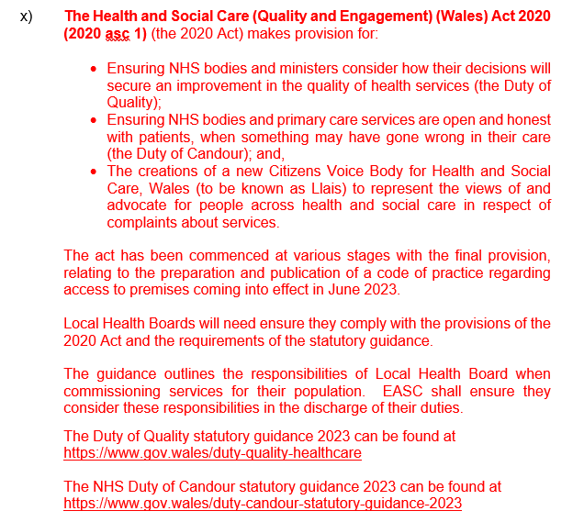
- Page 8 (and page 49) to include the Health and Care Quality Standards 2023
- Page 9 to include reference to the EASC Standing Financial Instructions approved by the Joint Committee in March 2023.
- Page 12 – please note the role of the Committee remains unchanged
- Page 21 – Working with Llais (the Citizen Voice Body)
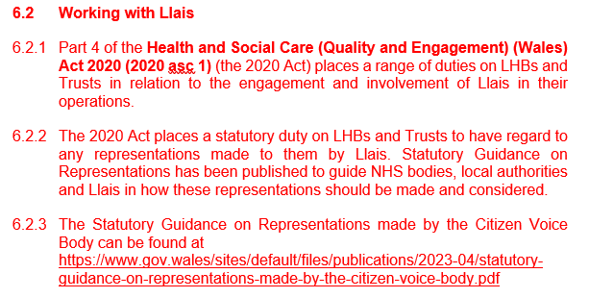
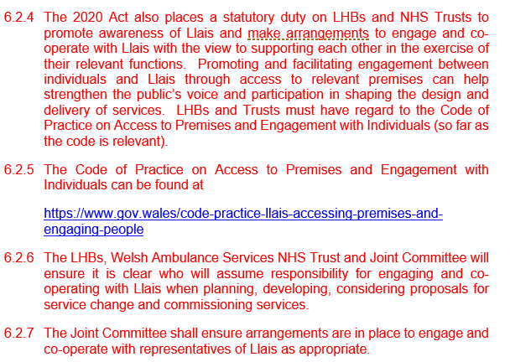
- Page 30 (and page 33 & 46) confirming the use of the CTMUHB Values and Standards of Behaviour document.
- Page 51 – sub committee information added
- Page 52 – Scheme of Delegation added from EASC Standing Orders approved at the March 2023 meeting
- Page 55 – updated sub group Terms of Reference in line with EASC approval.

Investigation by the Welsh Language Commissioner
  - Ongoing work is taking place supported by the Welsh Language Team at Cwm Taf Morgannwg UHB.
  - The Commissioner has asked that changes are made to the website software and work has started with Digital Health and Care Wales to ensure this is completed.
  - A further update will be provided at a future meeting.

Key organisational contacts
  - Appendix 4 provides the EASC Key Organisational Contacts which was received at the last EASC and Members are asked to note the contacts and provide updates where applicable.

Sub Group Annual Reports (for approval)
  - The aim of the Annual Reports is to provide an overview of the business undertaken by the EASC Sub Groups.
  - The Emergency Medical Retrieval and Transfer Service Delivery Assurance Group Annual Report for 2022-2023 is attached at Appendix 5.
  - The Non-Emergency Patient Transport Services Delivery Assurance Group (NEPTS DAG) Annual Report for 2022-203 is attached at Appendix 6.
  - There are no concerns related to governance to report for either of the sub groups and they are operating within their scope and terms of reference.

Audit and Risk Committee (Cwm Taf Morgannwg) for assurance
  - A summary is attached at Appendix 7 of the Audit and Risk Committee meeting which took place on 16 August 2023.

- KEY RISKS/MATTERS FOR ESCALATION

  - The updated EASC risk register captures the key actions being taken to mitigate and control the risks relating to red performance. Additional information had been included and related to the ongoing system pressures and the impact on patients and the increasing risk of harm.

  - The controls that are in place are included in the WAST Performance Improvement Plan (PIP) and the EASC Action Plan / ICAP meetings coordinated by the Chief Ambulance Services Commissioner (CASC) these are monitored at:
- bi-monthly Quality and Delivery meetings between the EASC Team and WAST.
- The PIP focuses on the actions being taken by WAST to mitigate risks and to increase capacity and emergency ambulance performance including red performance
- monthly meetings with Welsh Government officials with a focus on the actions being taken across the urgent and emergency care system (including the commissioning of additional emergency ambulance clinician capacity, system escalation and demand management).

  - As reported above the work to mitigate and control the risks relating to red performance is ongoing with progress monitored on a commissioner-provider level, via the EASC governance arrangements and also with oversight by Welsh Government.

  - Members should note that the Integrated Commissioning Action Plan meetings continue to take place between the EASC Team, key operational health board staff and WAST to further develop and monitor progress of health board handover improvement plans. The process to date has delivered:
- Collaborative Infrastructure to develop thinking, identify innovation and establish local commissioning arrangements for emergency ambulance services
- Local ambulance handover improvement plans for each local health board in Wales
- Commitment through board structures to deliver ambulance handover actions operationally
- An all Wales composite handover delay plan that identifies similarity and areas for targeted investment
- Weekly dashboards to support and monitor performance against agreed trajectories
- Internal Audit have recently provided substantial assurance on the process and the report will be taken through the EASC governance routes.

  - Work is being continued to deliver Goal 4 for the Six Goals for Urgent and Emergency Care Programme (Goal 4 lead Stephen Harrhy). The Integrated Commissioning Action Plans (iCAPS) for each health board have been developed and will support the national delivery of Goal 4.

  - Work is continuing to quantify the level of harm to patients and concerns regarding the safety of patients due to the number of handover delays and lost hours in the previous six months, although these have reduced.

  - Further updates will be provided in relation to the investigation by the Welsh Language Commissioner.

- IMPACT ASSESSMENT
Quality/Safety/Patient Experience implications | Yes (Please see detail below)
Quality/Safety/Patient Experience implications | The impact of red and amber performance and the extremely high levels of handover delays will inevitably affect the patient experience with increased likelihood of harm, disability and death
Related Health and Care standard(s) | Governance, Leadership and Accountability
Equality impact assessment completed | Not required
Legal implications / impact | There are no specific legal implications related to the activity outlined in this report.
Resource (Capital/Revenue £/Workforce) implications /  Impact | There is no direct impact on resources as a result of the activity outlined in this report.
Link to Commissioning Intentions | The Committee’s overarching role is to ensure its Commissioning Strategy for Emergency Ambulance Services utilising the five step patient pathway outlined within the National Collaborative Commissioning Quality and Delivery Agreement and the related outcomes for each care standard aligned with the Institute of Healthcare Improvement's (IHI) ‘Quadruple Aim’ are being progressed.
Link to Main WBFG Act Objective | Commitment to corporate social responsibility and improving health & social equity, work with our staff, partners and communities to build strong local relationships and solid foundations of the past

- RECOMMENDATIONS
  - The Emergency Ambulance Services Committee is asked to:
- APPROVE the risk register
- APPROVE the EASC Assurance Framework
- APPROVE the Model Standing Orders for onward circulation to all health boards
- NOTE the ongoing investigation by the Welsh Language Commissioner.
- NOTE the information within the EASC Key Organisational Contacts
- APPROVE the Annual Reports for 2022-23 for the two subgroups – the EMRTS DAG and the NEPTS DAG
- NOTE the overview report from the Audit and Risk Committee at Cwm Taf Morgannwg for assurance.

